**Original Research Article**

**Assessment of the level of heavy metal contamination of the soil in the Bobo-Dioulasso industrial zone**

**Abstract**

The expansion of human activities has led to the accumulation of heavy metals in various ecosystem compartments. Contamination of soils with these heavy metals poses a significant public health risk because of the various pathologies they can cause. This assessment took into account the levels of heavy metals (As, Cd, Cr, Cu, Ni, Pb and Zn) and some pollution indicators such as the contamination factor (FC), the potential risk of heavy metals (Er), the ecological risk index of heavy metals (IR_ML), the pollution index (IP) and the degree of contamination (Cdeg). A systematic square mesh grid was used to collect 121 soil samples from the three areas occupation of the industrial zone. These samples were analyzed for heavy metal contents. The results show a wide variation in metal concentrations and land use patterns in the industrial zone (P<0.001). Zinc is the metal with the highest concentration in all three zones. Analysis of contamination factors indicated high contamination of As and Cd and high potential for risk of the same elements for all soils at the study site. Ecological risk on living organisms growing in soils is very high (above 300) regardless of the area. The pollution index is higher than 1 (1.09) in the landfill area. Therefore, the soils at the study site can be considered as soils with poor quality in terms of heavy metal content.

**Keywords: Heavy metals, contamination, pollution, industrial zone, Bobo-Dioulasso**

**1. Introduction**

The expansion of human activities has led to new forms of pollution (Lebourg *et al*., 2020). Harmful substances released by industry or introduced through agricultural practices gradually accumulate in the soil and undergo various physical, chemical and biological processes (Kebir, 2012). These mechanisms may lead to the migration of certain biocidal compounds to groundwater or their integration into the food chain (Lebourg *et al*., 2020). Harmful substances or biocidal compounds include heavy metals, also known as Metal Trace Elements (ETM). Contamination of soils and plants with heavy metals (Senou *et al*., 2018) poses a significant public health risk due to the various pathologies that these elements can cause. Heavy metals are known to have adverse effects on consumer health at certain concentrations (Norbert *et al*., 2004; Oskarson *et al*., 2004). The accumulation of heavy metals in plants poses a risk to humans, as cultivated plants are the entry point into the food chain (Ouattara *et al*., 2021). For this reason, it is essential to have means of measuring the heavy metal content in soils (Sirven, 2007), in order to provide reliable information on the content of these elements. Furthermore, the presence of heavy metals in soil is a major environmental issue affecting many cities around the world, including that of Bobo-Dioulasso in Burkina Faso. Industrial activities result in a significant emission of heavy metals into the environment through the production of waste and the emission of pollutants into the atmosphere (Ouattara *et al*., 2021; Coulibaly *et al*., 2022). Bobo-Dioulasso industrial zone, which is characterized by intense industrial activity, is not marginalized from the proliferation of heavy metals in its environmental compartments. In the face of these environmental problems caused by heavy metals, studies should be carried out to assess the level of contamination in the areas around the factorises (Aduayi-Akué, 2014). Thus, regardless of the heavy metal, it is important to specify the extent to which its presence constitutes a risk to the various links of the food chain (*Lebourg et al*., 2020). Heavy metals such as arsenic (As), cadmium (Cd), chromium (Cr), copper (Cu), nickel (Ni), lead (Pb) and zinc (Zn) are mineral elements present at different levels of concentration in the environment. It is to address these concerns that this study was conducted. The general aim of this study is to contribute to a better knowledge of the level of soil contamination in Bobo-Dioulasso industrial zone. The concern is all the more justified because these metals have the capacity to accumulate in the body and therefore the effect may not be immediate but long-term.

**2. *Materials and methods***

***2.1. Presentation of the study area e***

Bobo-Dioulasso is located between longitude 4°18 west and latitude 11°10 north. The climate is South Sudanese, characterized by alternating between a long dry season (November-May) and a short rainy season (June-October) marked by a spatio-temporal irregularity of precipitation (MEEA, 2023). Soils are predominantly leached tropical ferruginous, with pH values generally ranging from 5 to 6.5 (Pallo *et al*., 2008). Ferralitic soils, hydromorphic soils and curasse and sandstone lithosols are also found (BUNASOLS, 2002). Located between 900 and 1100 mm isohyetes, the average annual rainfall and temperature are 1027.15 mm and 27.8°C, respectively, with most groundwater lying between 10 and 20 m (Soumbougma *et al*., 2020). The industrial zone, which covers an area of approximately 447 ha with geographical coordinates of 4¹19’34.9” West and 11¹07’43.7” North (Fig.1), is located southwest of the urban municipality of Bobo-Dioulasso. Knowledge of the current state of soil in Bobo-Dioulasso industrial zone after 60 years of creation is also essential when it is full of a varieties activities including the agri-food industry, the chemical industry, mechanics, artisanal saponification, the cement industry…

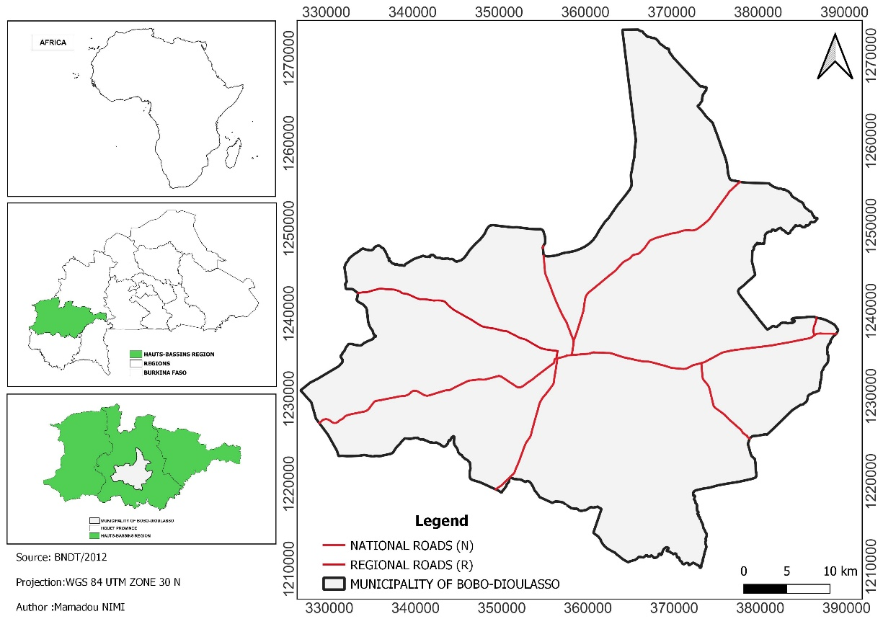

**Fig. 1.** Geographical location of the study area

***2.2. Sampling procedure***

The square mesh systematic sampling method was used in this study. It consists in taking samples according to a regular structure. This is a sampling mode in which the sampling points are equidistant from each other. Prior to sampling, codes were assigned to each study site area, i.e. IN for the factory area, R for the landfill area, and J for the crop area. On each zone, a square mesh that provides uniform coverage of the studied zone was applied. Samples are taken at each intersection of the mesh at a depth of 0-30 cm. The sampling plan was 100 m x 100 m for the crop area, 150 m x 150 m for the landfill area and 200 m x 200 m for the high concentration area of the factories. All samples were taken with a hand auger, placed in clean and hermetically sealed plastic bags to avoid contamination. The sampling points were geo-referenced using a MAP62 GPS.

***2.3. Preparation and analysis of soil samples***

The samples were dried in ambient air, ground with a porcelain mortar and sieved by a sieve column consisting of a bottom, a 125 µm sieve, a 150 µm sieve, a 250 µm sieve and a lid. The analysis of heavy metals was carried out at the laboratory of the Burkina Faso Bureau of Mines and Geology (BUMIGEB) in Bobo-Dioulasso. The samples were mineralized hot on a plate using a mixture of hydrochloric acid and nitric acid. The final solution was subjected to Agilent Atomic Absorption Spectrometer (Varian SpectrAA-240 FS) for the determination of heavy metals. It is equipped with a system for correcting background noise using a deuterium lamp. The heavy metals measured were arsenic (As), cadmium (Cd), chromium (Cr), copper (Cu), nickel (Ni), lead (Pb) and zinc (Zn). Prior to sample analysis, the instrument was calibrated by selecting the specific wavelength for each metal and using certified standard solutions of the element to be determined. After calibration, the validity and acceptance of the calibration curve was achieved using the correlation coefficient (R ≥ 0.999) and the linearity of the curve.

***2.4. Calculations of indicators***

Five indicators have been calculated:

* the contamination factor (CF), to evaluate the level of pollution (Silva *et al*., 2021) of the various heavy metals. It has been calculated from the following equation (Hakanson, 1980, Kao *et al*., 2007, Yang *et al*., 2023):

$$FC_{i}=\frac{HM_{s_{i}}}{HM_{b_{i}}}$$

**HMsi** et**HMbi**are the concentrations of the heavy metal « i » in the sample and the earth’s crust, respectively. In the Earth's crust, concentrations of metals studied are (Arti and Mehra, 2023): As (7.9 ppm), Cd (0.2 ppm); Cr (71 ppm), Cu (32 ppm), Ni (ppm), Pb (16 ppm) and Zn (127 ppm).

* the potential risk of heavy metals (Er) and the ecological risk index of heavy metals (IR_ML). These were estimated from the Hakanson formula (1980):

$$E_{r}^{i}=T_{r}^{i}×FC_{i}$$

$$IR=\sum_{i=1}^{n}{E_{r}^{i}}$$

$E_{r}^{i}$ is the potential hazard for i and $T_{r}^{i}$ is the toxicological response factor for a given metal i. For the different metals $T_{r}^{i}$ are (Keshavarzi and Kumar, 2020): As (10), Cd (30); Cr (2), Cu (5), Ni (5), Pb (5) and Zn (1).

* the Pollution Index (IP), to make an overall assessment of the soils at a contaminated site. IP is determined using the formula of Nishida et al. 1982:

$$IP=\frac{\sum_{i=1}^{n}{\left[\frac{HM_{i}}{LT_{i}}\right]}}{n}$$

HMi is the content of a given metal « i » n the soil sample; **LTi** is the tolerable limit value of this metal in the soil; n = total number of metals studied in the soil. The limit values used in our study are those of the AFNOR U44-41 standard (Kabata-Pendias, 2001, Tankari dan-Badjo *et al*., 2013, Ye *et al*. 2020): As (6), Cd (2); Cr (150), Cu (100), Ni (50), Pb (100) and Zn (300).

* the degree of contamination index (Cdeg). To have a global idea of the level of pollution by all heavy metals studied (Silva *et al*., 2021). It is calculated from the contamination factors (CF) of the various heavy metals studied (Hakanson, 1980):

$$c_{deg}=\sum_{i=1}^{n}{FC_{i}}$$

***2.5. Statistical treatment of data***

The data collected was entered on Excel 2016 spreadsheet. Statistical analyzes were performed using R version 4.3.1 software (R Core Team, 2024). Mean values were determined for each area of the study site based on depth levels and compared using an analysis of variance (ANOVA) at the 5% significance level. R's "ggplot2" package was used to visualize the results in a graphical format.

**3. Results**

***3.1. Heavy metal levels in each zone***

A total of 242 samples were collected from the study site at 120 samples for the factory area, 94 samples for the landfill area and 34 samples for the crop area. All samples were analyzed. Fig. 2, 3 and 4 respectively show the heavy metal concentrations of the soils in the high concentration zone of the factorises, the landfill zone and the crop zone. The lowest (2,110 mg/kg) and highest (94,910 mg/kg) chromium content was observed in soils with high factories concentrations. The average chromium contents of the site areas were below the chromium thresholds in agricultural soils (150 mg/kg) according to French standard AFNOR NF U44-041 (1985). The analysis showed a significant difference in copper levels between zones. It is found that the average copper content of soils in all areas was below the AFNOR standard (100 mg/kg). The average copper content was lowest in landfill soils (14.292 mg/kg). However, the highest copper content was observed in soils with high factorises concentrations (21,040 mg/kg). The results of the analysis also showed a very highly significant difference for nickel in the soils of the areas. However, the average levels are below the thresholds for nickel in agricultural soils according to the AFNOR standard (50 mg/kg). The lowest average nickel content (16.603 mg/kg) was recorded in crop soils. On the other hand, the highest content (24,780 mg/kg) was found in soils with a high concentration of factorises. There is also a significant difference in the lead content of soils in the study site areas. Lead levels in the soils of the zones are also below the AFNOR standard (100 mg/kg). The highest lead content was found in soils with high factorise concentrations (23.51 mg/kg). However, the lowest content was recorded in the landfill soils (14.019 mg/kg). As for zinc, there was also a significant difference in the soils of the areas studied. According to the AFNOR standard (300 mg/kg), the average zinc contents in soils are below the threshold values of the standard. Soils with high plant concentrations had the highest average content (107,490 mg/kg). The lowest average content was observed in landfill soils (55.132 mg/kg). The Cd and As contents remained the lowest regardless of the zone with significant differences. The average levels of arsenic in soils with high concentrations in factories (16,940 mg/kg) and crops (10,795 mg/kg) were above the thresholds for arsenic in agricultural soils (6 mg/kg) according to AFNOR NF U44-041. As for cadmium, the highest content was recorded in crop soils (1.169 mg/kg) and the lowest in landfill soils.

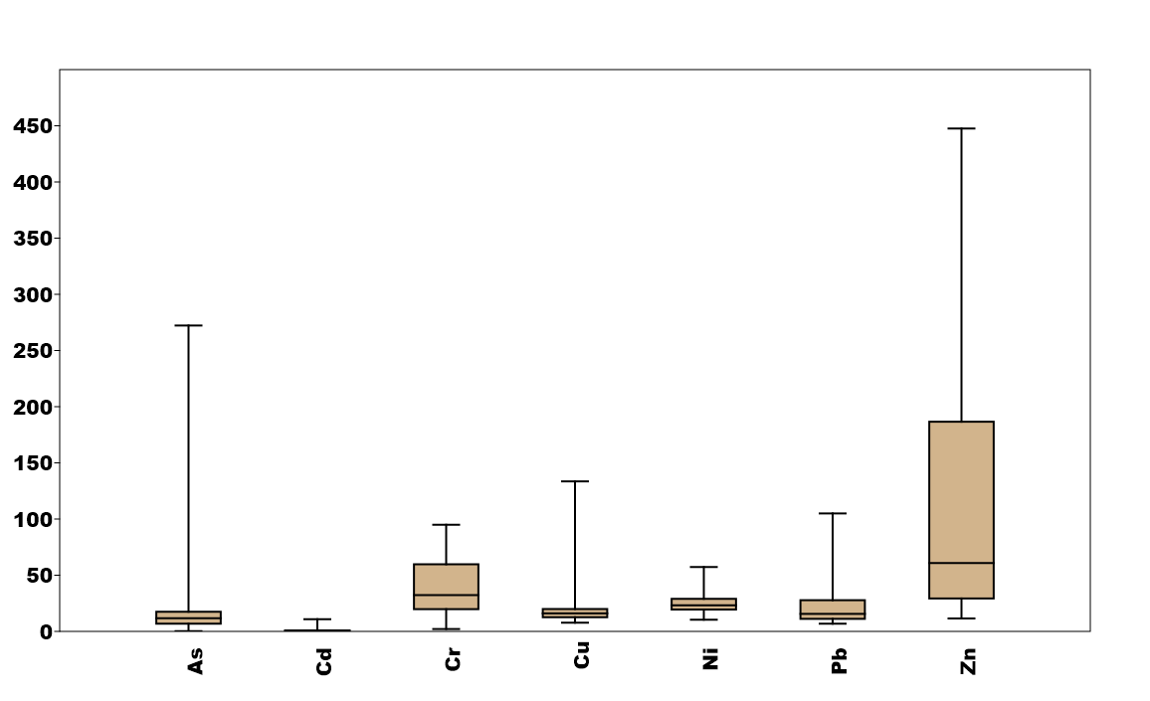

As: arsenic, Cd: cadmium, Cr: chromium, Cu: copper, Ni: nickel, Pb: lead and Zn: zinc.

***Fig. 2. Heavy metal levels in the high concentration area of the factorises***

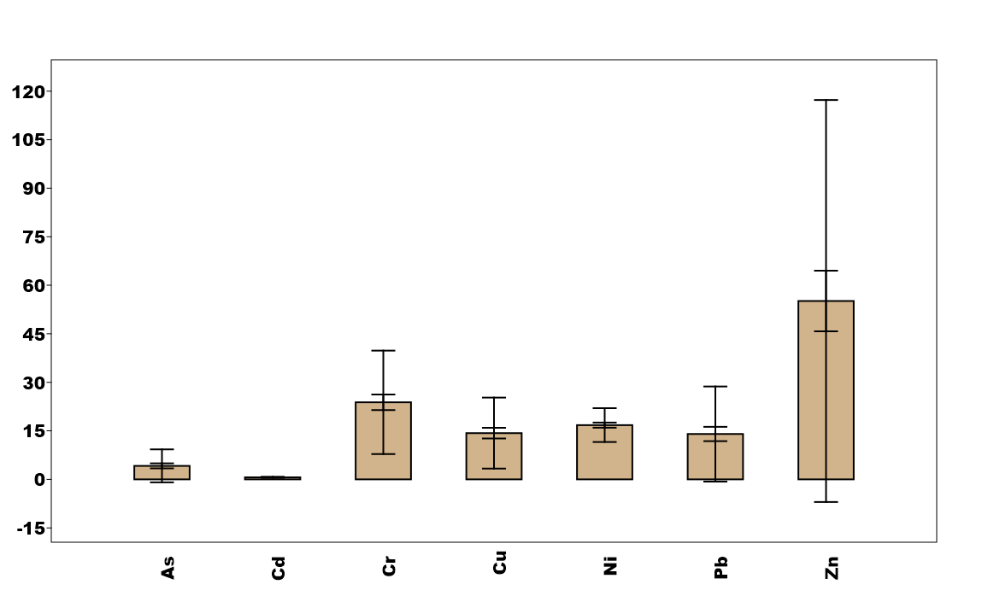

As: arsenic, Cd: cadmium, Cr: chromium, Cu: copper, Ni: nickel, Pb: lead and Zn: zinc

***Fig. 3. Heavy metal levels in the landfill area***

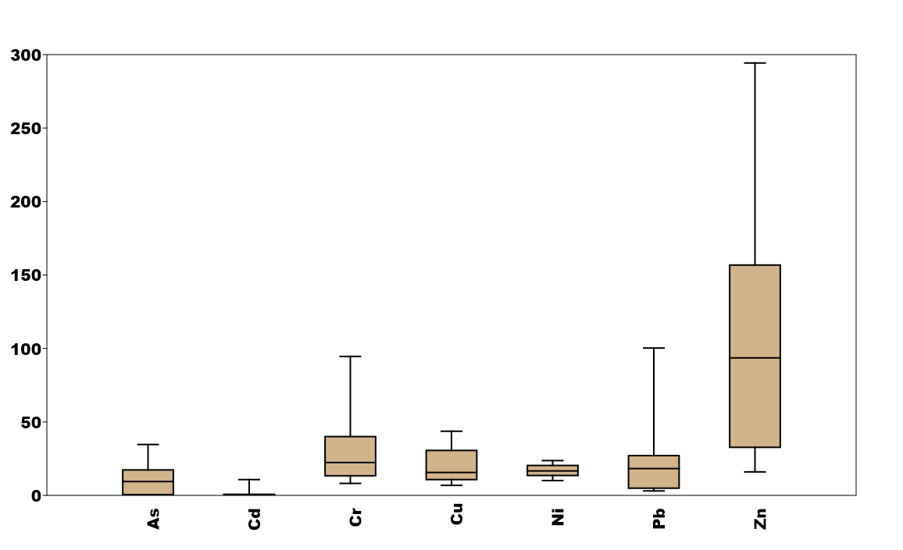

As: arsenic, Cd: cadmium, Cr: chromium, Cu: copper, Ni: nickel, Pb: lead and Zn: zinc

***Fig. 4. Heavy metal levels in the crop area***

* 1. ***Comparison of metal contents between the three areas of occupancy***

Fig. 5 shows the comparisons of the contents of each metal element as a function of the zone. For soil metal concentrations, mean values showed a variation in concentrations with zone and metal (P<0.001). The analysis showed that there are significant differences (P<0.1) for the metal elements Cu, Pb, Ni, Cr and Zn. Cu and Cr concentrations were significantly higher in soils near industrial areas and landfills (sources of releases). On the other hand, Pb, Ni and Zn concentrations were significantly higher in areas dominated by industrial and agricultural activities. Nickel (Ni) concentrations were significantly higher in the high industrial density area compared to the landfill area (p < 0.001). On the other hand, no significant difference is observed between the industrial zone and the agricultural zone (ns). Copper (Cu) is highly accumulated in the industrial zone, with an extremely significant difference compared to other zones (p < 0.0001), while there is no significant variation between agricultural and landfill zones (ns). Chromium (Cr) concentrations were also significantly higher in the industrial zone (p < 0.0001), with a significant difference between the landfill and crop zones (p < 0.01). Although cadmium (Cd) and arsenic (As) levels are higher in the industrial zone, no statistically significant difference was observed between the different zones (ns). For zinc (Zn), a particular trend is noted: a significant difference is observed between agricultural areas and landfills (p < 0.001), as well as a very significant difference between industrial areas and landfills (P < 0.0001); however, no difference is found between industrial and agricultural areas (ns). Finally, lead (Pb) is mainly concentrated in the industrial zone, with a highly significant difference compared to the landfill zone (p < 0.0001), while no significant difference is found between agricultural and industrial zones (ns).

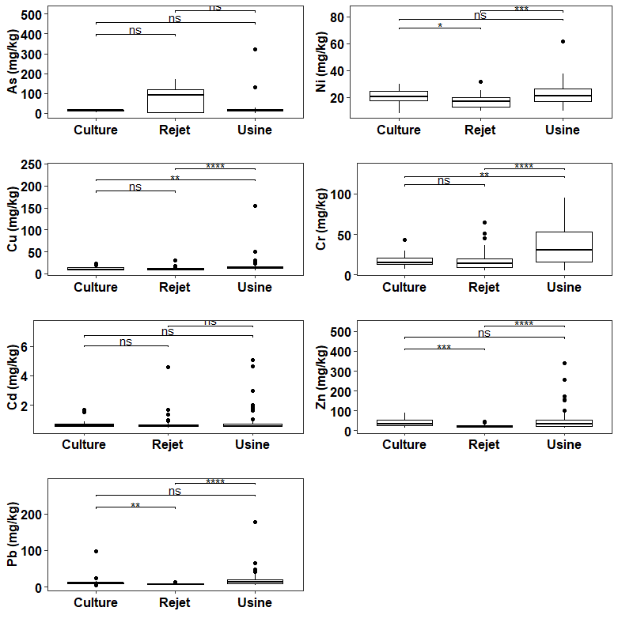

As: arsenic), Cd: cadmium, Cr: chromium, Cu: copper, Ni: nickel, Pb: lead and Zn: zinc.

NB: a > ab >b; *; **; *** = significant difference at the 5% probability threshold based on the Student-Newman-Keuls (SNK) test. ns: not significant; *: significant; **: highly significant; ***: very highly significant.

***Fig. 5. Comparison of heavy metal levels in the study area***

**3.3. Assessment of soil pollution indicators**

Table 1 shows the evolution of heavy metal contamination factors according to the areas of occupation of the study site. Our results indicate that the level of heavy metal contamination varies with land use and heavy metal. However, regardless of the zone, As and Cd showed very high contamination (FC ≥ 6). For the remainder of the heavy metals, the contamination factors remain low (FC<1) or moderate (1≤FC<3). The statistical analysis shows a very highly significant difference in terms of contamination for As, Cr, Ni, Pb and Zn between the three areas of occupancy (P<0.001). However, no significant difference was observed in terms of Cd contamination between the three zones (ns). Table 1 presents the potential risks for each metal element studied. The potential risk for all heavy metals studied except As and Cd is low (< 40) regardless of the mode of occupancy in the area. It is higher for metal Cd followed by As of 287.83 in the high concentration zone of the factories and 193.64 in the landfill zone, respectively. The results of the statistical analysis showed that there is a very significant difference in the potential risk of heavy metals in the different zones (P<0.001) with the exception of Cd (ns). Table 3 gives the status of the ecological risk index of heavy metals (IR_ML), the pollution index (IP) and the degree of contamination (Cdeg) in the three areas of occupation of the study site. The results show a very high ecological risk of the heavy metals studied regardless of the mode of occupancy in the study area. The pollution index (PI) is above 1 (1.09) in the landfill area, followed by the high concentration area of the factorises (0.72) and the crop area (0.52). Statistical analysis of the data shows a highly significant difference between the three zones (P<0.01). The contamination index is also higher in the landfill area (30.21), followed by the high concentration area of the factorises (26.14) and the crop area (21.43). However, no significant difference was found between land use patterns in the study area (ns).

**Table 1. Soil Contamination Factors at the Study Site**

|  |  |  |  |  |  |  |  |  |
| --- | --- | --- | --- | --- | --- | --- | --- | --- |
| **Paramètres** | | **FC_As** | **FC_Cd** | **FC_Cr** | **FC_Cu** | **FC_Ni** | **FC_Pb** | **FC_Zn** |
| **Zone** | **Crop** | 6.15±3.66 | 9.35±2.03 | 0.67±0.10 | 1.13±0.18 | 0.99±0.06 | 1.70±0.29 | 1.43±0.24 |
| **Landfill** | 19.36±2.28 | 6.71±1.26 | 0.59±0.06 | 0.90±0.11 | 0.90±0.04 | 1.00±0.18 | 0.75±0.15 |
| **Factorise** | 9.40±1.95 | 9.59±1.08 | 1.05±0.05 | 1.35±0.10 | 1.27±0.03 | 1.93±0.16 | 1.55±0.13 |
|  | **Pr(>F)** | 0.0008261 | 0.204 | 1.04e-7 | 0.009353 | 1.32e-11 | 0.000645 | 0.000314 |
|  | **Signification** | VHS | ns | VHS | HS | VHS | VHS | VHS |

NB: a > ab >b; *; **; *** = significant difference at the 5% probability threshold based on the Student-Newman-Keuls (SNK) test.

The figures represent the average of the contamination factors for the different metals, followed by the standard deviation. Pr: Observed probability; ns: not significant; HS: highly significant; VHS: very highly significant.

**Table 2. Potential risks of metallic elements**

|  |  |  |  |  |  |  |  |  |
| --- | --- | --- | --- | --- | --- | --- | --- | --- |
| **Paramètres** | | **ErAs** | **ErCd** | **ErCr** | **ErCu** | **ErNi** | **ErPb** | **ErZn** |
| **Zone** | **Crop** | 61.53±36.61 | 280.61±61.04 | 1.33±0.20 | 5.63±0.90 | 4.97±0.31 | 8.51±1.47 | 1.43±0.24 |
| **Landfill** | 193.64±22.76 | 201.24±37.94 | 1.18±0.12 | 4.49±0.56 | 4.49±0.19 | 5.01±0.91 | 0.75±0.15 |
| **Factorise** | 94.03±19.49 | 287.83±32.49 | 2.09±0.11 | 6.76±0.48 | 6.34±0.17 | 9.65±0.78 | 1.55±0.13 |
|  | **Pr(>F)** | 0.000826 | 0.204 | 1.04e-07 | 0.009353 | 1.32e-11 | 0.000645 | 0.000314 |
|  | **Signification** | VHS | ns | VHS | HS | VHS | VHS | VHS |

NB: a > ab >b; *; **; *** = significant difference at the 5% probability threshold based on the Student-Newman-Keuls (SNK) test. The figures represent the average of the contamination factors for the different metals, followed by the standard deviation. Pr: Observed probability; ns: not significant; HS: highly significant; VHS: very highly significant.

**Table 3. Ecological Hazard Index for Heavy Metals (IR_ML), IP: Pollution Index (PI) and Contamination Level Index (Cdeg)**

|  |  |  |  |  |
| --- | --- | --- | --- | --- |
|  | **Paramètres** | IR_ML | IP | Cdeg |
| **Zone** | **Crop** | 364.02±72.42 | 0.52±0.17 | 21.43±4.25 |
| **Landfill** | 400.38±45.01 | 1.09±0.11 | 30.21±2.64 |
| **Factorise** | 408.24±38.55 | 0.72±0.09 | 26.14±2.26 |
|  | **Pr(>F)** | 0.864 | 0.00618 | 0.191 |
|  | **Signification** | ns | HS | ns |

NB: a > ab >b; *; **; *** = significant difference at the 5% probability threshold based on the Student-Newman-Keuls (SNK) test. The figures represent the average of the indices, followed by the standard deviation. Pr: Observed probability, ns: not significant; HS: highly significant

1. **Discussion**

Analysis of the data in this study on the level of heavy metal contamination in the industrial zone shows that the levels of heavy metals in the soils vary according to the type of occupation. These results are consistent with those of several authors (Ilboudo, 2014; Yé *et al*., 2020) who have shown that total levels of metallic trace elements (TMEs) in soils vary according to soil type, metallic element, sampling depth and sources of contamination (fertilizers, plant protection products, atmospheric deposition). Analysis of the concentrations of heavy metals (As, Cd, Cr, Cu, Ni, Pb, Zn) in the different zones (crop, landfill, factorise) reveals significant disparities (P<0.01) that can be attributed to the different activities and waste management practices in each of these zones. Landfill soils have average heavy metal contents (Cd, Cr, Cu, Ni, Pb and Zn) below the limit values of AFNOR NF U44-041 (1985). Similar results were found at a dump at Kuinima in the same town of Bobo-Dioulasso (Da, 2023). However, our results are contrary to those found in landfills in Akouédo, Côte d’Ivoire (Kouamé *et* *al*., 2006) where heavy metal concentrations are higher than permitted. Although below the limit values, the presence of these metals in landfill soils could be attributed to the nature and composition of the waste. The presence of household waste, old lead paints, tires, batteries, plastics and rubbers at the landfill can be the basis for the presence of its metals in the soil (Kouamé *et* *al*., 2006). At the crop zone, the presence of heavy metals (Cd, Cr, Cu, Ni, Pb, Zn) was also detected. This presence on the site is said to be due to the use of fertilizers and pesticides used by market gardeners for production. Indeed, in the face of soil degradation and the costs of mineral fertilizers, the use of organic substances, particularly from landfills, has become an alternative for some vegetable farmers in order to increase agricultural yields (Senou, 2014). Thus, solid urban waste has significant agronomic potential. Their use on agricultural soils would allow organic matter and certain nutrients to be recycled for the benefit of plants. However, their use remains limited due to the risks associated with the presence of undesirable elements (Yé *et al*., 2020; Nimi *et al*., 2025) and would increase the heavy metal content of soils (Senou *et al*., 2023). Analysis of the data indicates that soils in the crop area have heavy metal contents (Cd, Cr, Cu, Ni, Pb and Zn) below the limit values of AFNOR NF U44-041 (1985). Our results are consistent with those of Yé *et al*. (2020) on land subject to the use of solid waste on farm plots in the Dindérésso forest. Our results also confirm those of Ilboudo (2014), which studied the effect of different types of waste on the availability of heavy metals in soil and found that all soils were low in heavy metal contamination by standards (AFNOR NF U44-041,1985). However, our results differ from those of Lock and De Zeeuw (2001), which showed that soils in most cities in developing countries contain enough heavy metals to cause symptoms of acute poisoning. Like the other two zones, the soils of the high concentration zone of the factorises have low contents compared with the limit values of the standard AFNOR NF U44-041 (1985). These results could be explained, on the one hand, by the embryonic development of our industries which pollute less than developed countries and, on other hand, by the absence of mining site in the area (Ouedraogo, 2019). The majority of the industries at the study site are agri-food industries. Our results are contrary to those found by Smouni *et al*. (2010) in an eastern Moroccan mining area where concentrations of heavy metals very high above the standard limit were found. Tankari dan-Badjo *et al*. (2013) had also found heavy metals in urban Niamey soils, some of which, like Pb, Cu, and Zn, have levels above the permitted limit. However, the average value of the various heavy metals determined is substantially identical to that of its study area. Analysis of data showed that the contamination factor is a function of the metal. Heavy metal contamination overall is low for most and moderate for lead and zinc. Thus, the pollution index is higher than 1 in the landfill area, suggesting that there has been multiple contamination of their soils by trace metals in this area. Pollution indices greater than 1 have been obtained in the soil of landfills in the city of Kinshasa in Democratic Republic of Congo (Gizanga *et al*., 2022), the soil of the city of Niamey in Niger (Tankari dan-Badjo *et al*., 2013) and in a mining area in Morocco (Smouni *et al*., 2010). For the same index, it is less than 1 in the other two zones. Our results corroborate those of Yé *et al*. (2020) found pollution indices of less than 1 in their study on the assessment of the metal trace element levels of soil subjected to the input of solid urban waste in the protected forest of Dindérésso in the town of Bobo-Dioulasso. Pollution indices of less than 1 were also found at the Kuinima landfill in the same town of Bobo-Dioulasso (Da, 2023). Measures should be taken to limit the accumulation of these metals in the soil in order to reduce the contamination of the food chain by these heavy metals.

1. **Conclusion**

The general objective of this study was to contribute to a better knowledge of the level of soil contamination in the Bobo-Dioulasso industrial area. The results obtained show that the values of heavy metal concentrations in the soils are very varied. They vary depending on the metal element and the land use in the study area. The study also found that heavy metal concentrations are below AFNOR limit threshold values. The highest levels were found on industrial and crop soils. Zinc is the metal with the highest concentration regardless of the area of occupancy. Analysis of contamination factors indicated low levels of chromium, copper and nickel contamination in all areas. Zinc contamination was low for landfill soils but moderate for factorises and crops. However, lead contamination is low in landfill and crop soils but moderate in soils in high-concentration factories. Thus, the polymetallic pollution examined with the index calculation showed a pollution greater than 1 on the landfill area. Therefore, the soils at the study site can be considered as soils with poor quality in terms of heavy metal content. However, it is necessary to implement preventive actions by the municipal authorities to limit new contamination, in particular by improving waste management in the industrial zone and ensuring that landfills are properly controlled. The implementation of projects for the rehabilitation of the most affected or least affected soils by techniques such as phytoremediation could be envisaged for the depollution of soils.

**COMPETING INTERESTS DISCLAIMER:**

Authors have declared that they have no known competing financial interests OR non-financial interests OR personal relationships that could have appeared to influence the work reported in this paper.

**DISCLAIMER (ARTIFICIAL INTELLIGENCE)**

Author(s) hereby declare that NO generative AI technologies such as Large Language Models (ChatGPT, COPILOT, etc.) and text-to-image generators have been used during the writing or editing of this manuscript.

**REFERENCES**

**Aduayi-Akue A. A. and Gnandi K., 2014. Assessment of heavy metal pollution in soils and the local variety of Zea mays maize in the Kpémé phosphate processing area (Southern Togo), 9p.**

**Arti and Mehra, R. 2023. Analysis of Heavy Metals using ICP-MS in Soils around some Tannery Industries. Indian Journal of Pure & Applied Physics. https://doi.org/10.56042/ijpap.v61i6.2426**

**BUNASOLS, 2002. Technical Report No. 126: Morpho-pedological study of the Houet and Tuy provinces at a scale of 1:100,000, 75p.**

**Coulibaly A., Kassi K. J-C., Aloko N.J., 2022. Environmental Status of Industrial Zones in the District of Abidjan: Case of the Koumassi Industrial Zone (Ivory Coast). International Researcher's Review "Volume 3: Issue 2" pp. 521–542**

**Da S.O., 2023. Risk Assessment and Bioaccumulation of Heavy Metals at an Urban Landfill in Bobo-Dioulasso (Burkina Faso): Case of the Kuinima Site, 55p**

**Gizanga R., Jessica Bonya J., and Milau F., 2022. Assessment of Trace Metal Element (TME) Concentrations in Soils of Public Landfills in Kinshasa, Democratic Republic of Congo, 9p.**

**Hakanson, L., 1979. An Ecological Risk Index for Aquatic Pollution Control. A Sedimentological Approach. 27.**

**Ilboudo T. L. J., 2014. Effect of Different Types of Urban Solid Waste from the City of Bobo-Dioulasso on the Availability and Vertical Distribution of Heavy Metals in Soil. Master's Thesis in Soil Science, 62p.**

**Kabata-Pendias A. and Pendias H., 2001. Trace Elements in Soils, third ed. CRC Press, Boca Raton, London, New York, 413p.**

**Kao, T., Mejahed, K. E., & Bouzidi, A., 2007. Assessment of Metal Pollution in Agricultural Soils Irrigated by Wastewater in the City of Settat (Morocco).**

**Kebir T., 2012. Study of Contamination, Accumulation, and Mobility of Some Heavy Metals in Vegetables, Fruits, and Agricultural Soils Located Near an Industrial Landfill of the Zinc Plant in the City of Ghazaouet. Doctoral thesis in environmental chemistry, 282p.**

**Keshavarzi, A., & Kumar, V., 2019. Spatial distribution and potential ecological risk assessment of heavy metals in agricultural soils of Northeastern Iran. Geology, Ecology, and Landscapes, 4(2), 87-103.** [**https://doi.org/10.1080/24749508.2019.1587588**](https://doi.org/10.1080/24749508.2019.1587588)

**Kouame I., Gone K., D. L., Savane I., Kouassi E. A., Koffi K., Goula B. T. A., and Diallo M., 2006. Relative mobility of heavy metals from the Akouédo landfill and risk of contamination of the Continental Terminal aquifer (Abidjan, Ivory Coast). Afrique SCIENCE 02(1):39–56.**

**Lebourg A., Thibault Sterckeman T., Ciesielski H., Proix N., 2020. Value of different chemical extraction reagents for assessing the bioavailability of trace metals in soil, 16 p.**

**Lock K. and De Zeeuw H., 2001. Health risks associated with urban agriculture. Research Centre for Urban Agriculture and Forestry (RUAF)/Netherlands, 6 p. Ministry of the Environment, Energy, Water and Sanitation (MEEA), 2023. Yearbook of Environmental Statistics 2021.**

**Nimi M., Senou I., Somda I., & Nacro H. B., 2025. Typology, Composition and Characterization of Urban Solid Waste in the Industrial Area of ​​Bobo-Dioulasso, Burkina Faso. International Journal of Environment and Climate Change, 15(2), 271-285.**

**Nishida H., M. Miyai, F. Tada, S. Suzuki, 1982. Computation of the index of pollution caused by heavy metals in river sediment, Environmental Pollution Series B, Chemical and Physical, 4(4), 241-248. Ouattara A.A., Sangaré N., N’goran K.P., Yao K.M., Trokourey A. and Diaco T., 2021. Assessment of trace metal contamination in sediments of the N’zi River, Ivory Coast. Int. J. Biol. Chem. Sci. 15(5): 2199-2208.**

**Oskarson A., Widell A., Olsson I., Graw K. P., 2004. Cadmium in the food chain and health effects in sensitive population groups. Biometaux 17 (5): 531-534. Ouédraogo H., 2019. Assessment of the bioaccumulation and translocation of cadmium, copper, lead, and zinc by Zea mays L. grown on a tropical ferruginous soil in western Burkina Faso, 58p**

**Pallo, F. J. P., Sawadogo, N., Sawadogo, L., Sedogo, M. P., & Assa, A., 2008. Status of soil organic matter in the South Sudanese zone of Burkina Faso. Biotechnol. Agron. Soc. Environ.**

**Senou I., 2014. Phytoextraction of cadmium, copper, lead, and zinc by five plant species (Vetiveria nigritana (Benth.), Oxytenanthera abyssinica (A. Rich.) Munro, Barleria repens (Ness), Cymbopogon citratus (DC.) Stapf, and Lantana camara (Linn.)) grown on tropical and vertic ferruginous soils. Doctoral thesis, Polytechnic University of Bobo-Dioulasso (UPB). 170 p.**

**Senou I., Gnankambary Z., Some N. A., and Nacro H. B., 2018. Responses of five local plant species to metal exposure under controlled conditions. Int. J. Develop. Res. 8 (1): 18501–18506. Senou I., Nacanabo B., Nacro H.B. and Some A.N., 2023. Assessment and health risk of heavy metal bioaccumulation (cadmium, copper, lead and zinc) in cabbage (Brassica Oleracea L.) produced in urban agriculture: Case of the Dôgôna market gardening area (Bobo-Dioulasso). Journal of Applied Biosciences 188: 19783-19798.**

**Silva, H. F., Silva, N. F., Oliveira, C. M., & Matos, M. J., 2021. Heavy Metals Contamination of Urban Soils—A Decade Study in the City of Lisbon, Portugal. Soil Systems, 5(2), 27. https://doi.org/10.3390/soilsystems5020027**

**Sirven J.B., 2007. Detection of heavy metals in soils by laser-induced plasma emission spectroscopy (LIBS). Doctoral thesis, 253p.**

**Smouni A, Ater M, Auguy F, Laplaze L, El Mzibri M, Berhada F, Doumas P., 2010. Assessment of contamination by metallic trace elements in a mining area of ​​eastern Morocco. Cahiers Agricultures, 19 (4): 273-279.**

**Soumbougma, A., Kadeba, A., Compaore, N. F., & Boussim, J. I., 2020. Characterization of industrial effluents and the effects of their agricultural use on population health: Case of the commune of Bobo-Dioulasso. Tankari dan-Badjo, A., Guero, Y., Dan Lamso, N., Tidjani, A. D., Ambouta, K. J. M., Feidt, C., Sterckeman, T., & Echevarria, G., 2013. Evaluation of Soil Contamination by Trace Metal Elements in Urban and Peri-urban Areas of the City of Niamey (Niger). Journal of Bioresources, 3(2), 82‑95. https://doi.org/10.12816/0008874**

**Yang, D., Zhu, H., Liu, J., Zhang, Y., Wu, S., Xiong, J., & Wang, F., 2023. Risk Assessment of Heavy Metals in Soils from Four Different Industrial Plants in a Medium-Sized City in North China. Toxics, 11(3), 217. https://doi.org/10.3390/toxics11030217**

**Ye L., Lompo D., Sako A., Nacro H., 2020. Evaluation of trace metal element contents in soils subjected to the input of urban solid waste, International Journal of Biological and Chemical Sciences 14(9): 3361-3371.**