Original Research Article
Phenological Development and Shoot Growth of Calamansi (Citrus x microcarpa) Under Pruning and Waterlogging Conditions in a Tropical Agroforestry Context

Abstract
This study investigated the shoot growth and phenological development of containerized grafted calamansi (Citrus × microcarpa) seedlings under three cultivation treatments: control, waterlogging, and pruning. Conducted in the Philippines, a tropical country where calamansi is a high-value fruit crop, the experiment aimed to evaluate how abiotic stress and canopy management influence plant development. Using the BBCH scale for standardized phenological monitoring, the plant growth parameters such as the height, shoot length, and number of leaves were measured biweekly over a 54-day observation period. Results showed that pruned seedlings significantly exhibited enhanced vegetative growth, while waterlogged seedlings progressed more rapidly to reproductive stages. Control plants followed a moderate developmental trajectory. Early flowering and fruiting under waterlogging appeared to be a stress-induced survival response, whereas pruning delayed phenological progression but promoted vigorous vegetative growth. These findings highlight the potential of pruning as a management tool for off-season calamansi production and underscore the detrimental long-term effects of waterlogging. Overall, the study demonstrates the importance of phenological monitoring in guiding orchard management practices to improve crop resilience and productivity in tropical agroforestry systems.

Keywords

abiotic stress, BBCH scale, Calamansi, phenology, crop management, waterlogging, tropical horticulture.

INTRODUCTION

Plant development is a succession of ordered and logical changes that ultimately lead to physiological maturity (Peer et al., 2015). These changes involve shifts in the plant's functional capacity, strongly influenced by the interaction between genetic traits and environmental factors (Pereira et al., 2002). In perennial fruit crops like calamansi (Citrus × microcarpa), understanding seasonal phenological stages is essential for crop management, yield optimization, and adaptation strategies in response to climatic variability.

Phenology—the study of the timing and sequence of recurring biological events—offers critical insights into plant responses to both biotic and abiotic stimuli (Leith, 1974). In agricultural contexts, especially for fruit trees, phenological data provide a valuable basis for anticipating developmental phases, determining the ideal timing for management practices, and extrapolating experimental outcomes across climatic zones (Oliveira et al., 2017; Petri et al., 2008). These data are also essential for forecasting interannual changes in crop behavior under varying environmental conditions.

Research into crop phenology aims to identify the environmental drivers behind changes in developmental timing by analyzing the correlation between weather parameters and specific growth events (Keller et al., 2015). Critical phenological stages like those that significantly impact yield must be precisely identified, as many horticultural practices such as pruning, fertilizing, girdling, fruit thinning, hormone application, and pest management are most effective when timed appropriately (Favaro et al., 2014). Phenological scales like the BBCH scale (Meier, 2001) standardize the description of developmental stages across crops and are widely adopted in citrus phenology research. These scales enhance the accuracy of phenological monitoring and provide a framework for comparing developmental responses across treatments or environments.

This study provides scientifically relevant insights by characterizing the shoot growth and phenological development of grafted calamansi seedlings under waterlogging and pruning conditions in a tropical setting. Conducted in the, Philippines which is a country representative of tropical agroecosystems, this research addresses the growing need to optimize calamansi production under increasingly erratic climatic patterns. The findings contribute to a better understanding of how environmental stressors and canopy management practices influence crop phenology, offering practical implications for improving calamansi productivity and resilience. Ultimately, this study supports the scientific community’s broader efforts to develop adaptive horticultural strategies in the face of climate change.

OBJECTIVES

To describe the phenological development of containerized grafted calamansi (Citrus × microcarpa) seedlings using the BBCH scale.

To compare the shoot growth and phenological responses of containerized grafted calamansi seedlings under three treatments: control, waterlogging, and pruning.

METHODOLOGY
A total of forty-eight (48) containerized grafted calamansi (Citrus × microcarpa) seedlings were used in the study and evenly divided into three treatment groups, with sixteen (16) seedlings per group. The control group was maintained under standard growing conditions with regular watering and no interference in canopy structure or soil moisture.
For the waterlogging treatment, drainage holes at the bottom of each plastic grow bag were sealed, and the bags were placed inside buckets filled with water, ensuring that the water level remained approximately 3 cm above the soil surface. This water level was maintained for 7 to 14 days, or until visual symptoms of stress were observed such as leaf yellowing, leaf rolling, or premature leaf drop. Once these stress indicators appeared, the drainage holes were reopened to allow excess water to drain out, and the plants were monitored during the recovery phase for signs of flushing and resumption of normal shoot growth.
In the pruning treatment, selective canopy pruning was performed at the start of the observation period by removing approximately 50% of the shoot length and lateral branches. Only the main stem and a few primary branches were retained to simulate a reset in the phenological cycle and to stimulate vegetative regrowth. All seedlings were monitored biweekly for a period of 54 days, and plant growth parameters such as plant height, shoot length, and number of leaves were recorded.
Each seedling had four (4) tagged shoots designated for repeated observation throughout the study period. Phenological development was monitored using the BBCH scale for citrus (Meier, 2001), which provided a standardized framework for identifying and recording developmental stages. Observations were conducted biweekly, and the following growth parameters were measured: plant height, shoot length, number of leaves per tagged shoot, and phenological stage according to the BBCH scale. In addition, daily weather data, including minimum and maximum temperature and rainfall, were recorded to account for environmental influences.
Collected data were subjected to analysis of variance (ANOVA) using the STAR software, version 2.0.1 (2014). Treatment means were compared using the Least Significant Difference (LSD) test at a 5% significance level (p < 0.05). Graphical representations of the results were created using OriginPro version 8.5.

RESULTS AND DISCUSSION

Rainfall and Temperature

The study was conducted across three experimental sites that fell under different climate types in the Philippines. Type 1 climate experiences distinct wet and dry seasons, with the dry season occurring from November to April. Type 2 climate has no distinct dry season, though peak rainfall typically occurs from November to January, while Type 3 has more moderate seasonality, with dry spells from November to April. After 54 days of observation, seedlings in the Type 2 climate received significantly more rainfall compared to those in Type 1 and Type 3 (Figure 1). This is consistent with the agro-climatic characterization of Philippine regions, which indicates that Type 2 areas experience high and sustained rainfall (PAGASA, 2020). Calamansi, while tolerant of short dry periods, generally prefers evenly distributed rainfall of 1,500–2,000 mm annually and does not perform well under prolonged waterlogged conditions (PCARRD, 2006).

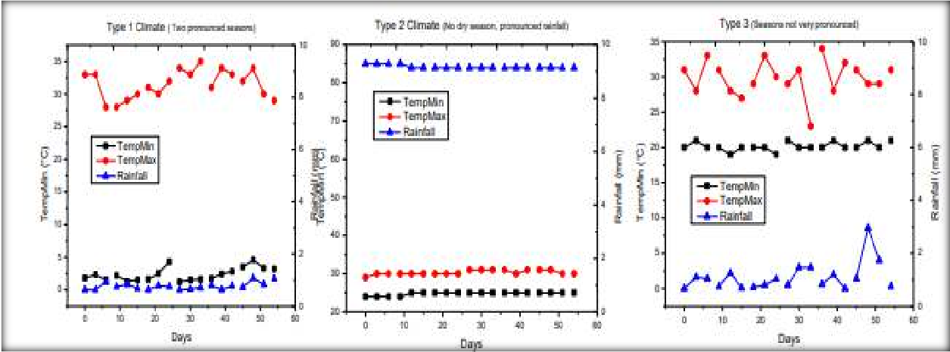

Figure 1. Daily weather data of the three (3) types of climates were the calamansi seedlings were established after 54 days of observation. Data for daily minimum and maximum temperature and rainfall were taken from https://www.accuweather.com/.

Calamansi seedling growth characteristics

In terms of growth characteristics, plant height differed significantly among treatments. Pruned seedlings exhibited greater height compared to waterlogged ones, although the difference between pruned and control seedlings was not statistically significant. Shoot length and number of leaves per shoot showed no significant differences across treatments. However, when absolute growth rate was considered, pruned seedlings outperformed both the control and waterlogged plants, indicating that pruning effectively stimulated vegetative regrowth. These findings align with the observations of Favaro et al. (2014), who reported that pruning in citrus enhances light penetration and promotes new shoot emergence, thereby improving overall growth performance. Moreover, canopy management practices such as pruning are known to reduce apical dominance, redirecting assimilates and hormonal signals toward lateral bud development. This is further supported by Barbosa et al. (2023), who found that moderate pruning in ‘Valencia’ orange trees resulted in increased shoot elongation and leaf production due to improved light distribution within the canopy. Similarly, Pérez-Jiménez et al. (2023) emphasized that pruning promotes the redistribution of growth hormones such as auxins, which enhances lateral shoot development and overall vegetative vigor. Collectively, these studies reinforce the role of pruning as an effective cultural practice to optimize shoot growth and promote balanced canopy architecture in citrus cultivation.
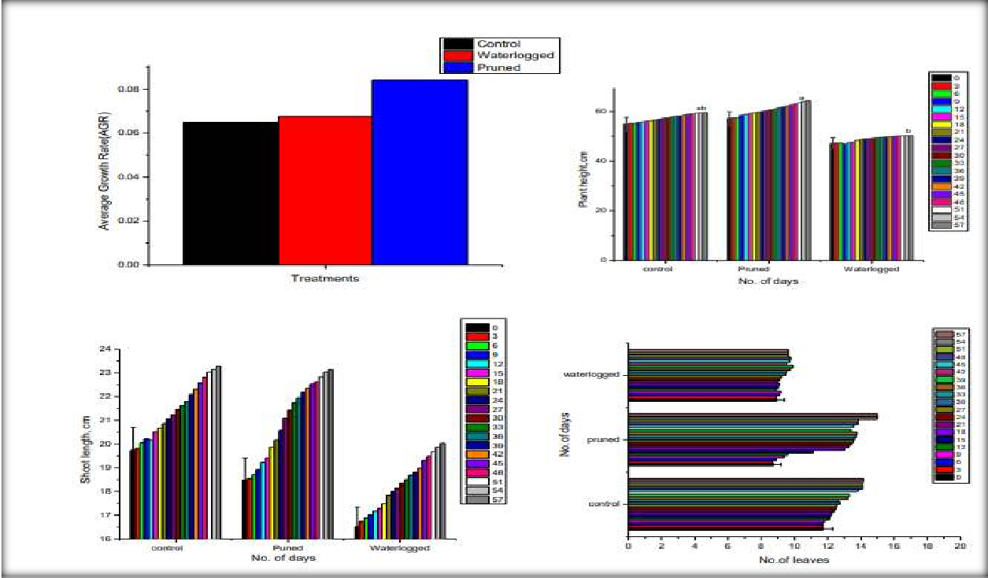

Figure 2. Plant height, shoot length, number of leaves and average growth rate of calamansi after 54 days under normal, pruned and waterlogged condition. Means with the same letter are not significantly different at LSD, 5%.

Phenological description

Phenological development was monitored using the BBCH scale. After 54 days, control seedlings exhibited phenological stages ranging from BBCH 34.85 to 61.42, representing late shoot development to early flowering. Waterlogged seedlings advanced more rapidly through the phenological stages, ranging from BBCH 47.30 to 74.71, with some entering principal growth stage 7, which corresponds to early fruit development. This accelerated phenological progression under waterlogged conditions may reflect a stress-induced strategy by the plants to complete their reproductive cycle earlier. This is a common physiological response in many fruit crops exposed to abiotic stress (Keller et al., 2015). In contrast, pruned seedlings were much earlier in development, ranging from BBCH 4.88 to 45.80, indicating they were largely in the vegetative stages of leaf and shoot development. These observations suggest that pruning effectively rejuvenates the trees, causing a delay in reproductive development while promoting new flushes of vegetative growth—a finding consistent with off-season calamansi management strategies that rely on full pruning to reset growth cycles (Sotto et al., 2005).
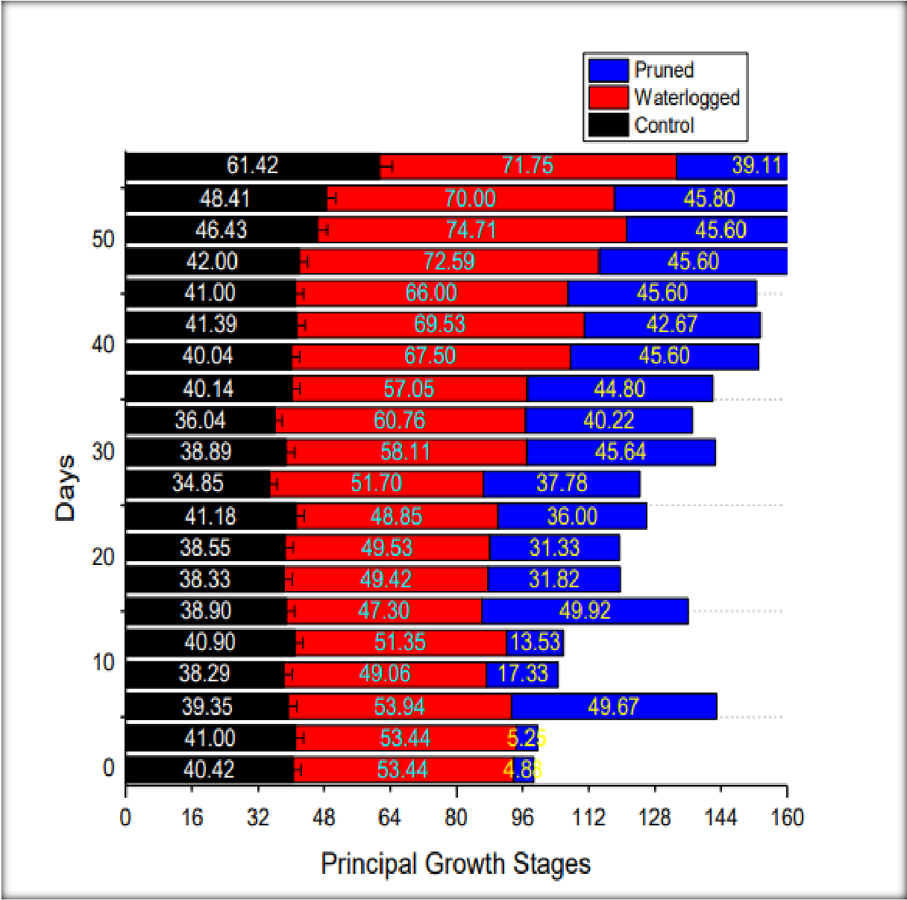

Figure 3. Principal growth stages of calamansi after 54 days under normal, pruned and waterlogged condition. Means with the same letter are not significantly different at LSD, 5%.

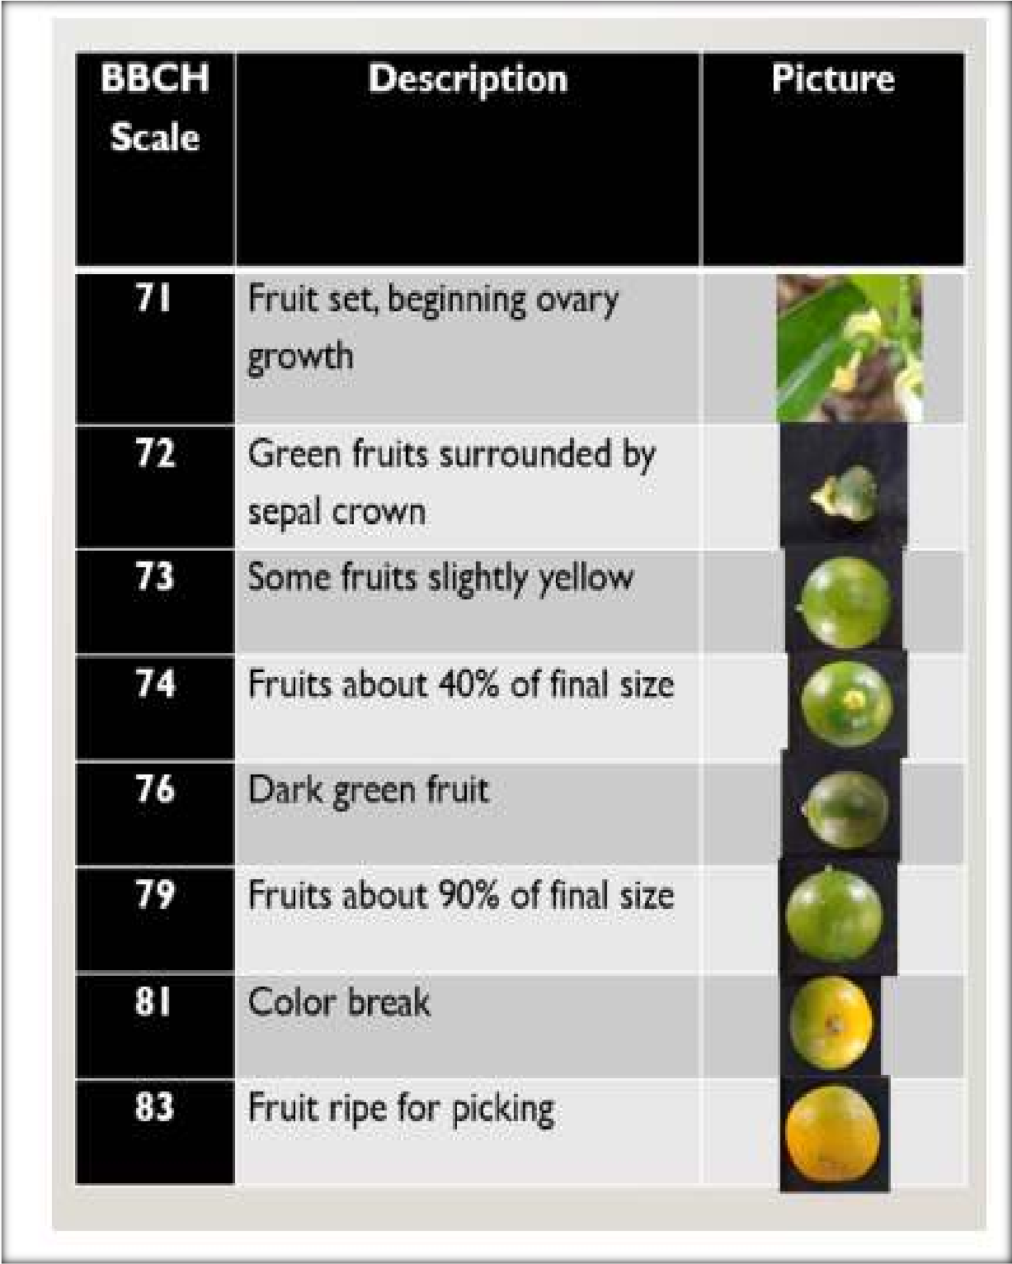
The results demonstrate that waterlogging induces early senescence and fruit development in calamansi, likely due to impaired root respiration and hormonal imbalances under saturated conditions, as reported in other citrus studies (Meier, 2001). On the other hand, pruning delayed phenological advancement, but enhanced overall vegetative vigor. This outcome supports findings from similar studies where citrus trees subjected to pruning exhibited extended vegetative phases and delayed flowering (Yeshitela et al., 2004). Moreover, the delayed phenology in pruned seedlings aligns with practical recommendations for off-season calamansi production, which utilize pruning as a management tool to time flowering and fruiting to meet market demand (PCARRD,2006).

Figure 4. Phenological growth stages of calamansi fruit with descriptions based on Meier, 2001.

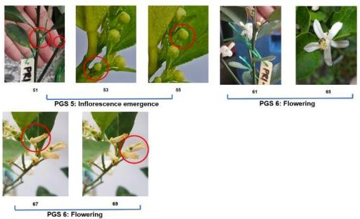
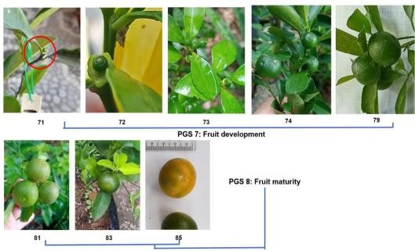
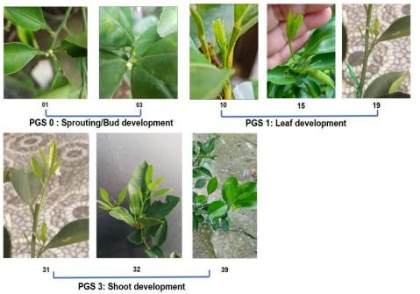

Figure 5. Representation of BBCH system for calamansi with scale descriptions based on Meier, 2001.

SUMMARY AND CONCLUSION

This study investigated the phenological development and shoot growth response of containerized grafted calamansi (Citrus x microcarpa) seedlings subjected to different treatments: control, waterlogging, and pruning. Results revealed that plant height varied significantly across treatments, with pruned seedlings showing greater height than those exposed to waterlogging, while both were statistically comparable to the control group. Although shoot length and leaf count showed no significant differences among treatments, absolute growth rates were significantly higher in pruned plants. This suggests that pruning stimulated more vigorous vegetative growth compared to both waterlogged and untreated seedlings.

Phenological development, measured using the BBCH scale, also varied substantially. Control plants exhibited BBCH stages ranging from 34.85 to 61.42 after 54 days, indicating development from late shoot growth to early flowering. Waterlogged seedlings advanced more rapidly, with BBCH stages ranging from 47.30 to 74.71, reflecting accelerated progression toward fruit development and early senescence—likely a response to abiotic stress. In contrast, pruned calamansi seedlings remained in earlier phenological stages (BBCH 4.88–45.80), indicating that pruning delayed reproductive development and induced new vegetative flushes.

The observed response to pruning aligns with the concept of apical dominance. As described by Mason (2014), the shoot apex suppresses lateral bud outgrowth through hormonal (auxin) and sugar competition mechanisms. Removing the apical bud reduces auxin flow and redistributes sugar demand, promoting lateral bud activation and shoot branching. This physiological shift supports the improved architecture, vigor, and growth observed in pruned trees. Pruning, therefore, plays a critical role in altering growth dynamics, delaying phenological progression, and rejuvenating tree structure—consistent with prior citrus management studies (Meier, 2001).

The variable response to waterlogging observed in this study may also be attributed to several external and experimental factors. Differences in seedling age, initial health status, and slight variations in microclimate likely influenced the responses among individual plants. Some waterlogged seedlings exhibited leaf yellowing and wilting within a week, while others took up to two weeks to show stress symptoms. Although most recovered, a few succumbed, suggesting that prolonged submersion and compromised initial vigor may have led to mortality. These observations are consistent with Zhang et al. (2008), who outlined that excessive soil moisture reduces oxygen availability, disrupting aerobic respiration and photosynthesis, which can result in inhibited growth and plant death. Indeed, the decline in photosynthetic capacity under hypoxic conditions has been extensively documented (Irfan et al., 2025; Wang et al., 2023) when stomatal closure, chlorophyll degradation, and ROS accumulation reduce energy production and physiologic activity. High temperatures further compound waterlogging stress; Striker (2012) noted that flowering and floral organ development are energy-intensive processes that plants often suppress during flooding to conserve resources. This pattern aligns with the findings of this study, as only minor flower flushes emerged during the recovery of waterlogged seedlings, reinforcing the notion that submergence stress severely limits energy allocation to reproduction.

Additionally, the relatively short observation period (54 days) limits the ability to fully assess longer-term physiological responses. Extending the monitoring period may reveal further insights into recovery dynamics, delayed phenophases, or eventual reproductive performance.

Calamansi phenology is highly influenced by both climate and cultural management. In tropical regions, rainfall patterns—not temperature—are the primary drivers of phenological events. Thus, understanding the timing and variability of critical growth stages enables more precise orchard interventions, such as pruning schedules, irrigation management, and stress mitigation strategies. Overall, phenological monitoring using standardized scales like BBCH offers valuable insights into crop development and resilience. This study affirms the importance of pruning for promoting vegetative growth and delaying phenological advancement, while also highlighting the detrimental impacts of prolonged waterlogging on calamansi physiology and productivity.

DATA AVAILABILITY STATEMENT

The data supporting the findings of this study on the phenological development and shoot growth of Calamansi (Citrus x microcarpa) under pruning and waterlogging conditions are available from the corresponding author upon reasonable request. The datasets include raw and processed measurements of plant height, shoot length, number of leaves, and BBCH phenological stages recorded biweekly over a 54-day period, as well as daily weather data from publicly accessible sources.

COMPETING INTERESTS:
Authors have declared that they have no known competing financial interests OR non-financial interests OR personal relationships that could have appeared to influence the work reported in this paper.

DISCLAIMER (ARTIFICIAL INTELLIGENCE)

Author hereby declare that NO generative AI technologies such as Large Language Models (ChatGPT, COPILOT, etc.) and text-to-image generators have been used during the writing or editing of this manuscript.

.

REFERENCES

Barbosa, R. H., Müller, M. M. L., & Soares, T. L. (2023). Effects of pruning intensity on shoot development and canopy light penetration in ‘Valencia’ orange trees. Agriculture, 13(9), 1720. https://doi.org/10.3390/agriculture13091720

Cheong, M. W., Zhu, D., Sng, J., Liu, S. Q., Zhou, W., Curran, P., & Yu, B. (2012).
Characterisation of calamansi (Citrus microcarpa). Part II: Volatiles, physicochemical
properties and non-volatiles in the juice. Food chemistry, 134(2), 696-703.

Favaro, A. C. R., Cecilio Filho, A. B., & Vieira Júnior, J. R. (2014). Phenological
stages of citrus and their application in crop management. Acta Horticulturae, 1058,
163–170. https://doi.org/10.17660/ActaHortic.2014.1058.20.

Irfan, M., Akhtar, M., & Nazir, U. (2025). A review of soil waterlogging impacts,
mechanisms, and adaptive strategies. Frontiers in Plant Science.
https://doi.org/10.xxxx/xxxxxx

Keller, M., Smithyman, R. P., & Mills, L. J. (2015). Interactive effects of deficit irrigation and crop load on Cabernet Sauvignon in an arid climate. American Journal of Enology and Viticulture, 66(1), 30–39. https://doi.org/10.5344/ajev.2014.14055

Mason, M. G. (2014). Apical dominance and shoot growth regulation in plants. Plant Growth Regulation, 73(3), 207–219. https://doi.org/10.1007/s10725-014-9946-0

Meier, U. (Ed.). (2001). Growth stages of mono- and dicotyledonous plants: BBCH Monograph. Federal Biological Research Centre for Agriculture and Forestry.

PAGASA. (2020). Climate types in the Philippines. Philippine Atmospheric, Geophysical and Astronomical Services Administration. https://bagong.pagasa.dost.gov.ph/information/climate-philippines

PCARRD. (2006). The Philippines recommends for calamansi. Philippine Council for
Agriculture, Forestry and Natural Resources Research and Development (PCARRD),
Department of Science and Technology.

Peer, W. A., Blakeslee, J. J., Yang, H., & Murphy, A. S. (2015). Seven things we think we know about auxin transport. Molecular Plant, 8(3), 299–311. https://doi.org/10.1016/j.molp.2014.11.013

Pérez-Jiménez, R. M., González-Molina, A., & García-Sánchez, F. (2023). Canopy management in citrus: Role of pruning in hormonal balance and vegetative development. Plants, 12(19), 3360. https://doi.org/10.3390/plants12193360

Striker, G. G. (2012). Flooding stress on plants: anatomical, morphological and physiological responses. Botany, 90(6), 535–552. https://doi.org/10.1139/b2012-043

Yeshitela, T., Robbertse, P. J., & Stassen, P. J. C. (2004). Paclobutrazol suppressed vegetative growth and improved yield as well as fruit quality of ‘Tommy Atkins’ mango (Mangifera indica) in Ethiopia. South African Journal of Plant and Soil, 21(2), 158–163. https://doi.org/10.1080/02571862.2004.10634936

Wang, L., Zhang, P., Xu, X., & Chen, J. (2023). Transcriptome sequencing uncovers
mechanisms of citrus rootstock seedlings under waterlogging stress. BMC Plant
Biology, 23, Article 123. https://doi.org/10.1186/s42897-023-00056-1

Zhang, J. H., Wei, X. L., & Liu, M. Z. (2008). Responses of citrus seedlings to flooding
stress. Acta Horticulturae Sinica, 35(5), 701–708.

Zhang, X., Zhou, J., & Huang, S. (2021). Waterlogging stress in plants: Unraveling the
mechanisms and impacts on growth, development, and productivity. Environmental
and Experimental Botany, 182, 104-127. https://doi.org/10.xxxx/xxxxxx

