**Seed bio-priming with *Trichoderma harzianum* isolates and its rhizosphere colonization in wheat**

**ABSTRACT**

**Aims:** In this study, the different isolates of *Trichoderma harzianum* have abilities like antifungal, insecticidal, soil- remediation, plant growth promoting and rhizosphere colonizing properties which assist its biocontrol action were investigated *in vitro*.

**Study design:** CRD (Completely Randomized Design).

**Place and Duration of Study:** An experiment was conducted at Plant Pathology Section, College of Agriculture, Nagpur during 2023-2024.

**Methology:** A seven days sporulated culture of *Trichoderma harzianum* isolates (ATH, BTH, CTH, DAG, Thdept) and wheat seeds were collected from Plant Pathology Section, College of Agriculture, Nagpur. The best isolate was identified by using biopriming technique on wheat seeds and the root colonization was also observed.

**Results:** Among all the isolates, the best treatment having highest germination per cent, root and shoot length and SVI is T5 (Thdept) i.e. 72.50%, 23.60 cm, 15.97 cm, 2854.50 respectively followed by T2 (BTH). These results showed that two isolates of *Trichoderma harzianum* could be used as effective biocontrol for promoting the growth of wheat crop *in vitro*.

**Conclusion:** The growth and yield will increase by adding *Trichoderma* spp. in soil and make it most resistant wheat crop against different fungus. So by identifying the best isolate or combination of isolates will improve the health and quality of the product.

***Keywords****: Trichoderma harzianum, Triticum aestivum, bio-priming, rhizosphere colonization.*

1. **INTRODUCTION**

*Trichoderma*, a biological fungus widely used for plant pest control, mainly exists in the soil, air, plant surface, and other ecological environments and can effectively control a variety of plant diseases5. *Trichoderma spp.* has been known to invade other fungi for more than six decades. They're also well-known among scientists as powerful biological control agents14,16. Biological control agents through seed treatment gets introduced into the soil environment which provides an opportunity for them to colonize the roots. Seed treatments do not guarantee protection against root diseases9,10,13, if these biocontrol agents are poor root surface colonizers12 or incapable of being transported by the root through the soil profile11.Biopriming is a process of biological seed treatment that refers to a combination of seed hydration and seed inoculation with beneficial organisms to protect seed. The technique helps seeds to evenly germinate even under adverse soil conditions17.

**2. MATERIALS AND METHODS**

The study was carried out on **“**Seed bio-priming of with *Trichoderma harzianum* isolates and its rhizosphere colonization in wheat**”** during year 2023-24 at Plant Pathology Section, College of Agriculture, Nagpur. Five isolates were obtained from department which were procured from different ICAR institutes or universities and these isolates were utilized in studying the effect on crop physiological characteristics.

**2.1 Biopriming of seed**

Wheat seeds were soaked in water for overnight. Mix the formulation of biocontrol agent (*Trichoderma harzianum* isolates with the pre-soak seeds at the rate of 10-15 g/kg of seeds)15. Mix well and incubate the seeds under room temperature and high humidity. Sterilized soil in petri plate was taken and kept bioprimed seeds on soil and sprayed autoclaved water. Incubate the seeds under room temperature. Observations were taken using stereobinocular microscope.

## 2.2 Root imprinting

The roots were washed with tap water for 5 min to remove adhering soil particles. They were surface sterilized by dipping in 75% ethanol for 2 min and then rinsing three times with sterile water, then placed in a 5% Sodium hypochlorite solution and shaking was performed for 5 min, followed by rinsing with 3 times in sterilized distilled water. After careful drying, the surface sterilized roots were cut into 1 cm sections and transferred to the *Trichoderma* specific medium (TSM) with four per thousand penicillin streptomycin (100X) to isolate the endophytic fungi. Roots were placed in petri plates, and the plates were maintained at 28⁰C for incubation3.

## CHART 1. Media used in present study and its composition

TSM (*Trichoderma* Specific Media)

|  |  |
| --- | --- |
| MgSO4.7H2O | 0.2g |
| KH2PO4 | 1.5g |
| KCl | 0.14g |
| NH4NO3 | 1g |
| Glucose | 3g |
| Agar | 20g |
| Rose Bengal | 0.15g |
| Distilled water | 1 litre |

**3. RESULTS AND DISCUSSIONS**

The seeds of wheat were treated with *Trichoderma harzianum* isolates simultaneously with untreated seeds. The outcomes are shown under

**3.1 Bio-priming of wheat with isolates of *Trichoderma harzianum***

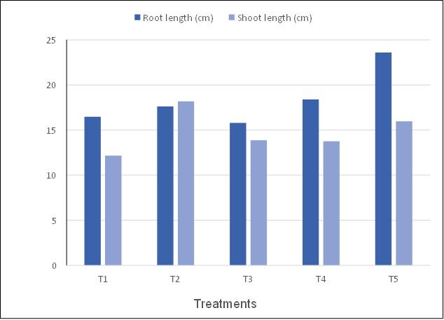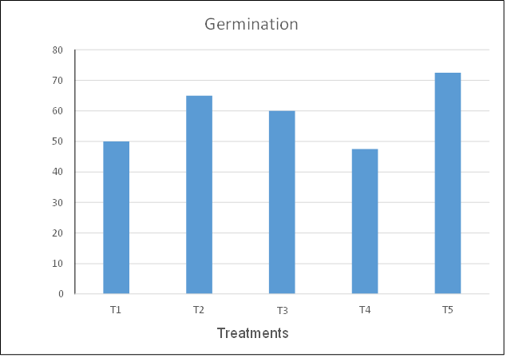The data revealed in Table.1 and depicted in figure.1,2,3,4 represent that *Trichoderma harzianum* isolates enhance the root, shoot elongation. Highest root enlongation was shown by T5 (23.6 cm) followed by T4 (18.4 cm), T2 (17.62 cm), T1 (16.47 cm), T3 (15.8 cm). Similarly, highest shoot elongation was shown by T2 (18.17 cm), T5 (15.97 cm), T3 (13.87 cm), T4 (13.75 cm), T1 (12.17 cm) whereas highest germination and also vigour index showed by T5 (72.5% and 2854.5) followed by T2 (65% and 2387.25), T3 (60% and 1526.25), T4 (47.5% and 1609.5). Among all isolates of *Trichoderma* T1 (50% and 1425) showed least germination and seedling vigour index. The result below agrees with15 alleviation of the adverse effects of salinity stress in wheat (*Triticum aestivum L*.) by seed biopriming with salinity tolerant isolates of *Trichoderma harzianum*. Plants obtained from bioprimed seeds showed higher shoot and root length. These results are in agreement with those of other workers8,1, who reported that *Trichoderma* strains produce plant growth hormones like cytokinin-like molecules, e.g. zeatin and gibberellin GA3 or GA3-related. It had been concluded by their experimentation that seed bioprimed with *T. harzianum* isolate Th- 14 increased the ability of germination by (1.87%), root length (1.61 cm) and shoot length (1.45 cm) as compared with the control.

**Figure 1. Germination Percentage of wheat seeds by *Trichoderma harzianum* isolates bio-priming**

**Figure 2. Root-shoot length of wheat seedling by bio-priming of *Trichoderma harzianum* isolates**

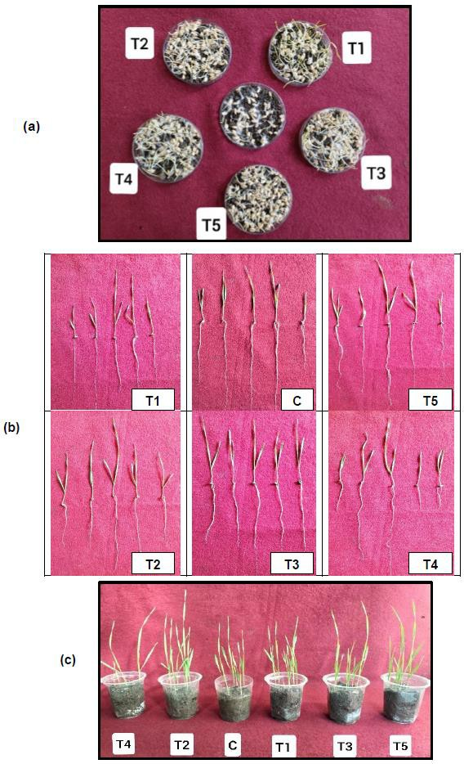

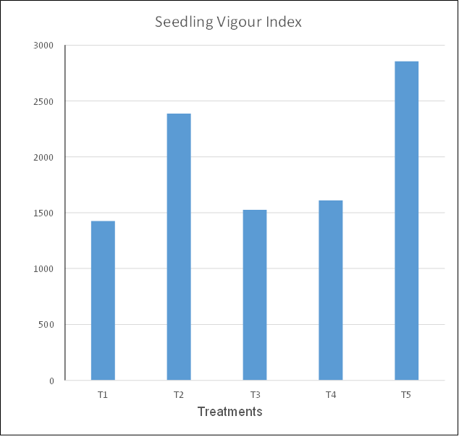

## Figure 3. Seedling Vigour Index of wheat seedling by bio-priming of *Trichoderma harzianum* isolates

**Figure 4. (a) represents germination of wheat bioprimed by different isolates of *T. harzianum*, (b) represents root- shoot length of wheat, (c) represents pots of wheat bioprimed by different isolates of *T. harzianum***

**Table.1: Effect of *Trichoderma harzianum* isolates on seedling vigour by biopriming of wheat seeds**

|  |  |  |  |  |  |
| --- | --- | --- | --- | --- | --- |
| Treatment No. | Germination of seed out of 10 seeds | Germination (%) | Root Length (cm) | Shoot length (cm) | SVI |
| T1 | 5.0 | 50 | 16.47 | 12.17 | 1425 |
| T2 | 6.5 | 65 | 17.62 | 18.17 | 2387.25 |
| T3 | 6.0 | 60 | 15.80 | 13.87 | 1526.25 |
| T4 | 4.75 | 47.50 | 18.40 | 13.75 | 1609.50 |
| T5 | 7.25 | 72.50 | 23.60 | 15.97 | 2854.50 |
| T6 - Control | 4.5 | 45 | 16.47 | 12.17 | 1425 |
| F test | Sig | - | Sig | Sig | Sig |
| SE (±m) | 0.49 | - | 2.56 | 1.81 | 326.84 |
| CD (P = 0.05) | 1.46 | - | 7.62 | 5.38 | 971.10 |

**3.2 Colonization of *Trichoderma harzianum* isolates in soil**

Colonization permits the bioprotectant to take possession of the substrate before either competitive microflora or plant- pathogenic fungi. Solid matrix priming (SMP) is a seed-treatment process6 in this process, seeds are first coated with the bioprotectant in a slurry procedure and immediately transferred to an organic matrix (coal or a lignaceous shale). At the physiological level, the positive effects of priming are due to specific metabolic changes induced in the seed when water up-take starts2. As a consequence of rehydration, main cellular processes are triggered. Pre-germinative metabolism, i.e., transition from the quiescent state of dry seeds to the active proliferating state of germinating seeds/seedlings18.We speculate that similar processes at physiological level of the introduced fungal spores (*Trichoderma harzianum* isolates) might also get initiated with the rehydration of quiescent state of dry seeds. Germination is transformation of a relatively inactive spore to the highly active vegetative thallus. This process is characterized by the absorption of water and by increases in respiration, changes in enzymic activity4 and biosynthesis of many cell components. Morphological changes also occur during the germination process; the spore generally swells and forms a germ-tube and eventually a mature thallus. That as a result of pre-germinative metabolism the fungal spores (introduced on the surface of the wheat seeds), germinates and develops into a web of mycelium and seed surface colonization initiates. Table 2 and Figure 5 determines the colonization in roots due to *Trichoderma* isolates they are imprinted. The data revealed in Figure 6 represents that germination and colonization of *T. harzianum* isolates on the soil just near the bio-primed seeds. The roots are cutted into small bits of 1 cm size and placed on TSM (*Trichoderma* Selective Media) and observations were taken after 3-4 days. The above description is similar with3 as sampled roots of the plant derived by the seed treatment with *Trichoderma virens* BARC G2 mutant from several spots. All the sampled were surface sterilized and were placed in TSM media. Growth of *T. virens* BARC G2 mutant was observed originating from the surface sterilized roots. It was observed significant differences in the root growth (root volume/ root length, secondary roots etc) in rice and wheat plants derived after seed treatment with *Trichoderma virens* BARC G2 mutant.

**Table 2. Mycelial growth of *Trichoderma harzianum* isolates on TSM by root imprinting**

|  |  |
| --- | --- |
| *Trichoderma harzianum* isolates | Appearance |
| T1 | Dark greenish sporulation with white mycelium web outside which covers 7.2 cm diameter. |
| T2 | Pale greenish sporulation was observed which cover 4.73 cm of diameter. |
| T3 | White web like mycelial network and no sporulation was observed that cover 4.36 cm diameter. |
| T4 | No mycelial web and sporulation were observed. |
| T5 | Dark greenish sporulation in the form of layers was observed which covers 4.15 cm diameter. |

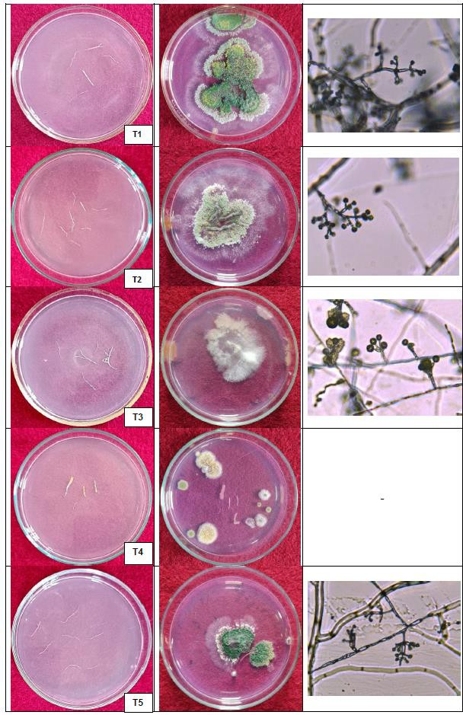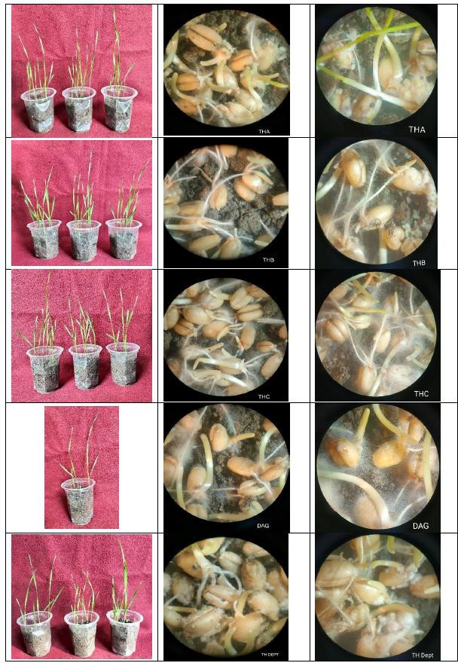

**Figure 6. Germination and Colonization of *T. harzianum* isolates on the soil just near the bio-primed seeds**

**Figure 5. Imprinting of wheat roots bioprimed by different isolates of *T. harzianum* and philiades observed in compound microscope (100X magnification)**

**4. CONCLUSION**

The present study evident that few isolates of *T. harzianum* was significantly effective over the other isolates. Among all the treatments, seed biopriming in wheat crop, the best treatment having highest SVI is Thdept (T5) followed by T2 (BTH). When the roots of wheat were placed on TSM, the morphological parameters were shown by all the isolates except T4 (DAG) i.e. mycelial growth rate, colony appearance, shape of conidia and conidiophore and branching pattern of phialides. The present research, offers a new approach to alleviate the growth of seedling effectively through seed biopriming with *Trichoderma* isolates. It could be concluded that seed biopriming with *T. harzianum* isolate Thdept (T5) increased the ability of wheat to grow successfully.

Disclaimer (Artificial intelligence)

Option 1:

Author(s) hereby declare that NO generative AI technologies such as Large Language Models (ChatGPT, COPILOT, etc.) and text-to-image generators have been used during the writing or editing of this manuscript.

References

1. Benitez, T., A. M. Rincon, M. C. Limon and A. C. Codon (2004). Biocontrol mechanism of *Trichoderma* strains. *International Microbiol*, 7: 249- 260.
2. Dell’Aquila A. and Bewley J. D (1989). Protein synthesis in the axes of polyethylene glycol treated pea seeds and during subsequent germination. *J. Exp. Bot.,* 40: 1001-1007.
3. Dole, A (2023). Developing *Trichoderma*-Plant-Pathogen interaction screening strategies in natural habitat to select potential bioagent. IGKV, Raipur.
4. Gottlieb, D. and Caltrider P. G (1963). Synthesis of enzymes during the germination of fungus spores. *Nature*, 197(4870): 916-917.
5. Haouhach S, Karkachi N, Oguiba B, Sidaoui A, Chamorro I, Kihal M, *et al*. (2020). Three new reports of *Trichoderma* in Algeria: *T. atrobrunneum* (South), *T. longibrachiatum* (South), and *T. afroharzianum* (Northwest). *Microorganisms*, 8:1455.
6. Harman, G. E. and Taylor A. G. (1988). Improved seedling performance by integration of biological control agents at favorable pH levels with solid matrix priming. *Phytopathology*, 78(5): 520-525.
7. Hornby, D. (1990). Root diseases. *The rhizosphere*., 233-258.
8. Howell, C. R. (2003). Mechanisms employed by *Trichoderma* species in the biological control of plant diseases: the history and evolution of current concepts. *Plant disease*, 87(1): 4-10.
9. Kraft, J.M. and Papavizas, G.C. (1983). Use of host resistance, *Trichoderma*, and fungicides to control soilborne diseases and increase seed yields of peas.
10. Liu, S. and E. K. Vaughan. (1965). Control of *Pythium* infection in table beet seedlings by antagonistic microorganisms. *Pythopathology*, 55: 986-989.
11. Madsen, E. L., and Alexander, M. (1982). Transport of Rhizobium and Pseudomonas through soil. *Soil Science Society of America Journal*, *46*(3), 557-560.
12. Mendez-Castro, F.A. and Alexander, M. (1983). Method for establishing a bacterial inoculum on corn roots. *Applied and Environmental Microbiology*., 45(1): 248-254.
13. Merriman, P. and Russell K. (1990). Screening strategies for biological control. *Biological control of soil-borne plant pathogens*, 427-435.
14. Naseby D.C., Pascual J.A., Lynch J.M. (2000). Effect of biocontrol strains of *Trichoderma* on plant growth, *Pythium ultimum* populations, soil microbial communities and soil enzyme activities. *J Appl. Microbiol*.88(1):161-169.
15. Rawat, Laxmi, Y. Singh, N. Shukla and J. Kumar. (2011). Alleviation of the adverse effects of salinity stress in wheat (*Triticum aestivum L.*) by seed biopriming with salinity tolerant isolates of *Trichoderma harzianum*. *An International Journal on Plant-Soil Relationships,* 343: 10.
16. Sharma P, Sharma M, Raja M, Shanmugam V. (2014). Status of *Trichoderma* research in India: A review. *Indian Phytopathol*. 67(1):1-19.
17. Singh US, Zaidi NW, Joshi D, Varshney S, Khan T (2003). Current status of Trichoderma as a biocontrol agent. In: Ramanujam B, Rabindra RJ (eds) Current status of biological control of plant diseases using antagonistic organisms in India. Project Directorate of Biological Control, Bangalore, pp 13–48
18. Wei, Z., Huang J., Tan S., Mei X., Shen Q. and Xu Y. (2013). The congeneric strain *Ralstonia pickettii* QL-A6 of *Ralstonia solanacearum* as an effective biocontrol agent for bacterial wilt of tomato. *Biological Control*, 65(2): 278-285.