**Original research article**

**Determining the Effect of Phosphorus and Micronutrients on Yield and**

**Economics of Rice (*Oryza sativa* L.)**

**ABSTRACT**

A fieid study took place in  *Kharif* 2022 at Crop Research Farm, Department of Agronomy, Sam Higginbottom University of Agriculture, Technology And Sciences, Prayagraj (U.P) to determine the “Effect of Phosphorus and Micronutrients on growth and yield of Rice (*Oryza sativa*L.). The results revealed that treatment 7 [Phoshorus (70 kg/ha)+ Zinc(10 kg/ha)] recorded significantly higher number of panicles/plant (12.76), number of grains/panicle (126.5), test weight (16.6 g), grain yield (5. 34 t/ha), straw yield (7.24 t/ha), harvest index (42.45 %) and maximum gross returns, (1,70,880.00 INR/ha), net return (1,18,075.50 INR/ha) and highest benefit cost ratio (2.23) was recorded compare to other treatments.

.

***Keywords:*** *Rice, Phosphorus, Micronutrients, Yield and Economics.*

**Introduction**

“Rice is a major staple food of (70%) of Indian population, it provide (21%) and (15%) per capita of dietary energy and protein, respectively” **(Maclean *et al.,* 2002).** And also which provides instant energy as its most important component is carbohydrate (starch). “Rice flour is rich in starch and is used for making various food materials. It is also used in some instances by brewers to make alcoholic malt. Likewise, rice straw mixed with other materials is used to produce porcelain, glass and pottery. Rice is also used in manufacturing of paper pulp and livestock bedding” (GOI, 2021).

“In world rice growing in 165.12 million ha, the production is 509.42 million tonnes and the yield is about 4.61 metric tons/ha” **(USDA, 2022). “**Among the rice growing countries of the world, India has the largest rice acreage and ranked second in production after wheat in the world. In India rice is grown in 45.07 million ha, the production level is 122.27 million tones and the yield is about 2713 kg/ha” **(GOI, 2021).** “In Uttar Pradesh state ranks third in the country in production of rice. it grown over area about 5.68 mha which comprise of (13.5%) of total rice in India. Annual rice production is around 15.66 million metric ton, the average yield is 2759 kg/ha” **(GOI, 2021).**

“Phosphorus deficiency is one of the major constraints to crop production. The unique feature of P is its low availability due to slow diffusion and high fixation in soils. Phosphorus is the second major nutrient for plant growth after nitrogen as it is an integral part of different bio chemicals like nucleic acid, nucleotides, phospholipids and phosphor proteins. Sufficient P nutrition improves several plant processes such as photosynthesis, nitrogen fixation, flowering, seed formation, root development and crop maturation**.** It has been observed that P fertilizer reduced the concentration of Na+ in shoots, resulting in better survival, growth and yield of rice” **(Naheed *et al.,* 2008).**

“Micronutrients are important nutrition to plant and the deficiency is considered one of the major causes of declining the productivity trends in rice growing countries, adequate supply improves nutrient availability and positively affects the cell physiology that is reflected in yield as well. When micronutrients are in short supply, the growth and yield of crops are severely depressed” (Rana and Kashif, 2014).

In India, zinc is considered as the fourth important yield limiting nutrient after nitrogen, phosphorus, and potassium respectively. Zinc plays an important role in the nutrition of rice, and also essential for the normal growth and metabolism of the plant like membrane integrity, synthesis of carbohydrates, enzyme activation such as dehydogenise, carbonic anhydride, super oxide dismutase, alkaline phosphatise etc.

zinc (Zn) deficiency is considered as a major threat to the global and regional food security **(Rana and Kashif, 2014). “**In high rice consuming areas, zinc deficiency caused yield reduction and Zn malnutrition in humans. It was subsequently found to be widespread phenomenon in lowland rice areas of Asia, next to N and P deficiencies. Zinc deficiency in rice appears right from seedling stage in nursery and three weeks after transplanting in main field. In rice, low plant available Zn in soil cause leaf bronzing and poor tillering at early growth stages, leading to delayed maturity and significant yield loss. Zinc deficiency is usually corrected by application of zinc sulfate (ZnSO4) before flooding or after transplanting to prevent Zn deficiency and increased grain yield” **(Naik and Das, 2007).**

Iron (Fe) is one of the essential elements required for plant growth and reproduction. Of the 7 micronutrients, Fe has the highest plant requirement **(Jones and Benton, 2012).** “It is involved in chlorophyll formation and degradation and in the synthesis of proteins and nucleic acids. Iron plays an important role in respiration and the production of healthy green leaves and also required for electron transport in photosynthesis and is a constituent of iron porphyrins and ferredoxins, both of which are essential components in the light phase of photosynthesis. It is an activator for several enzymes (e.g. catalase, succinic dehydrogenase, and aconitase), but inhibits K absorption” (**Meng *et al.*, 2005)** reported that improving the iron content and bioavailability in rice is a perspective and an effective way to alleviate or even solve the widespread iron deficiency in humans..

“Boron deficiency causes delay in flowering, induces flower bud abortion and causes panicle sterility” **(Rehman *et al.,* 2018). “**Boron deficient rice plants show white and rolled leaf tips of young leaves, death of growing points and unable to produce panicles if affected at panicle formation stage. Boron required for carbohydrate metabolism, sugar transport, lignification, nucleotide synthesis, respiration, and pollen viability. Boron can influence photosynthesis and activate number of enzymatic system of protein and nucleic acid metabolism in plants” **(Choudary *et al.,* 2020).** Keeping in view the above fact, the experiment was conducted to Determining the Effect of Phosphorus and Micronutrients on Yield and Economics of rice (*Oryza sativa* L.).

**MATERIALS AND METHODS:**

The experiment was conducted during *Kharif* season of 2022 at Crop Research Farm, Department of Agronomy, Sam Higginbottom University of Agriculture, Technology And Sciences, Prayagraj (U.P). The soil of the field constituting a part of central gangetic alluvium is neutral and deep. The soil of the experimental field was sandy loam in texture, nearly neutral in soil reaction (pH 7.8), low level of organic carbon (0.62%), available N (225 Kg/ha), P (38.2 kg/ha) and K (240.7 kg/ha). The experiment laid out in RBD with 10 treatment consists of 3 different Phosphorus *viz.* (50 kg/ha), (60 kg/ha) and (70 kg/ha) with combination of 3 micronutrients *viz*. Zinc (10 kg/ha), iron (15 kg/ha), and boron (4 kg/ha). The treatment combinations are T1- [Phosphorus (50 kg/ha) + Zinc(10 kg/ha), T2–

Phosphorus (50 kg/ha) + Iron (15 kg), T3–Phosphorus (50 kg/ha) + Boron (4 kg/ha), T4– Phosphorus (60 kg/ha) + Zinc (10 kg/ha), T5- Phosphorus (60 kg/ha) + Iron (15 kg), T6 – Phosphorus (60 kg/ha) + Boron (4 kg/ha), T7– Phosphorus (70 kg/ha) +Zinc (10 kg/ha), T8– Phosphorus(70 kg/ha)+ Iron (15 kg), T9- Phosphorus (70 kg/ha) + Boron (4 kg/ha). T10-120:60:60 (NPK Kg/ha). The data was collect on yield parameters (number of panicles/plant, number of grains/panicle, test weight (g), grain Yield (t/ha), straw Yield (t/ha), harvest index (%)] and economics ( gross return, net return, and benefit cost ratio).

Data were subject to stastical analysis of variance method.

**RESULT AND DISSCUSSION**

**Yield parameters:**

**Number of panicles/plant:**

The data recorded that significant and higher number of panicles/plant (12.76) was recorded in the treatment 7 [Phosphorus (70 kg/ha) + Zinc (10 kg/ha)] However, the treatment 9 [Phosphorus (70 kg/ha) + Boron (4 kg/ha)] was found to be statistically at par to the treatment 7 [Phosphorus (70 kg/ha) + Zinc (10 kg/ha)](Table 2). Thesignificant and higher number of panicles/plant was recorded with the application of Phosphorus (70 kg/ha) might be due to balanced fertilizer application and also phosphorus promoted normal growth of the plant, as a result number of panicles/plant increased. Similar result was reported by **Rehman *et al.* (1996)** and **Memon *et al.* (2005)** in wheat. Further, higher number of panicles/plant was recorded with the application of Zinc (10 kg/ha) may be due to adequate supply of zinc that might have increased the availability and uptake of other essential nutrients and thereby resulting in improvement of crop growth. Similar result was reported by **Sanzo *et al*. (1989).**

**Number of grains/panicle:**

The data showed that significantly highest number of grains /panicle (126.5) was recorded in the treatment 7 [Phosphorus (70 kg/ha) + Zinc (10 kg/ha)] among all the treatments. However, the treatment 9 [Phosphorus (70 kg/ha) + Boron (4 kg/ha)] was found to be statistically at par to the treatment 7 [Phosphorus (70 kg/ha) + Zinc (10 kg/ha)] ( Table 2). The significant and higher number of grains/panicle was recorded with the application of Phosphorus (70 kg/ha) may bedue tophosphorus plays an important role in the translocation of assimilates to the panicles and also as a constituent of protoplasm, resulted higher number of grains/ panicle. Similar result was reported by **Ishizuka (1971)**. Further, higher number of grains/panicle was observed with the application of Zinc (10 kg/ha) might be due to effect on enhancing the physiological function of crop like photosynthesis and translocation of plant nutrients which ultimately increased the number of grains/panicle**.** Similar result was reported by **lonova (1977).**

**Test weight (g):**

Significant and higher test weight (16.6 g) was recorded in the treatment 7 [Phosphorus (70 kg/ha) + Zinc (10 kg/ha)] However, the treatment 9 [Phosphorus (70 kg/ha) + Boron (4 kg/ha)] was found to be statistically at par to the treatment 7

[Phosphorus (70 kg/ha) + Zinc (10 kg/ha)] (Table 2). The significant and higher test weight was recorded with the application of Phosphorus (70 kg/ha) may be due to phosphorus plays an important role in enzyme reactions that depend on phosphorylase and also phosphorus is part of the cell nucleus, so it was important in cell division and also for the development of meristem tissue. Similar result was reported by **Juwita *et al.* (2021).** Further, “increase in test weight with the application of Zinc (10 kg/ha) might be due to more efficient participation of zinc in various metabolic processes involved in the production of healthy seeds” which is similar as described by **Ali *et al.*(2019).**

**Grain Yield (t/ha):**

The data revealed thatsignificant and higher grain yield (5.34 t/ha) was recorded in the treatment 7 [Phosphorus (70 kg/ha) + Zinc (10 kg/ha)] However, the treatment 9 [Phosphorus (70 kg/ha) + Boron (4 kg/ha)] was found to be statistically at par to the treatment 7[Phosphorus (70 kg/ha) + Zinc (10 kg/ha)] (Table 2).

“The significant and higher grain yield was recorded with the application of Phosphorus (70 kg/ha) might be due to more availability of phosphorus on root development, energy transformation and metabolic processes of the rice plant, which in turn resulted in greater translocation of photosynthates towards the productive part, resulted increased in grain yield” which is similar as reported by **Gharib *et al*. (2011).** Further, significant and higher grain yield was recorded with the application Zinc (10 kg/ha) may be dueto involvement in many metallic enzyme system, regulatory functions and auxin production enhanced synthesis of carbohydrates and their transport which increases grain yield. Similar result was reported by **Ali *et al.* (2019).**

**Straw Yield (t/ha):**

The data showed that significant and higher straw yield (7.24 t/ha) was recorded in the treatment 7 [Phosphorus (70 kg/ha) + Zinc (10 kg/ha)] However, the treatment 9 [Phosphorus (70 kg/ha) + Boron (4 kg/ha)] was found to be statistically at par to the treatment 7 [Phosphorus (70 kg/ha) + Zinc (10 kg/ha)] (Table 2). Thesignificant and higher straw yield was recorded with the application of Phosphorus (70 kg/ha) may be due to increasing phosphorus availability and subsequently increased its uptake, leading to more ATP formation that is the main stare for energy in plant and might encourage rice growth, metabolism, photosynthesis and nucleic acid and also improvement in biomass production and sink formation, resulted increases straw yield. Similar result was reported by **Gharib *et al.* (2011) and Yadav *et al.* (2015).** Further, significant and higher straw yield was recorded with the application of Zinc (10 kg/ha) might be due to favorable effect of zinc on the proliferation of roots and thereby increasing the uptake of plant nutrients from the soil, and supplying it to the aerial parts of the plant, ultimately enhancing the vegetative growth of plants. result was reported by **Khan et al. (2007).**

**Harvest Index (%):**

Data recorded that significant and higher harvest index (42.45 %) was recorded in treatment 7 [Phosphorus 70 kg/ha + Zinc (10 kg/ha)].However, the treatment 9 - [Phosphorus 70 kg/ha + Boron (4kg/ha)] (41.94%) was found to be statistically at par to the treatment 7[Phosphorus 70 kg/ha + Zinc (10 kg/ha)] (Table 2). The significant and higher harvest index was recorded with the application of Phosphorus (70 kg/ha) might be due to improved cell activities, enhanced cell multiplication and enlargement and luxuriant growth and yield attribute of the crops probably due to more absorption and utilization of available nutrients leading to overall improvement of crop growth reflected to source-sink relationship, which in turn enhanced the yield attributes that ultimately more yield. Similar result was reported by **Akram *et al.* (2022)** in wheat**.** Further, higher harvest index was recorded with the application of Zinc (10 kg/ha) may be due to maximum dry matter partitioning towards grain hence grain yield was more and also plant maintain a higher supply of photosynthates to reproductive parts as compare to vegetative biomass. findings similar to **Kadam *et al.* (2018) and Singh *et al*. (2018).**

**Economics:**

The result showed that maximum gross returns (1,70,880.00 INR/ha), higher net return (1,18,075.50 INR/ha) and highest benefit cost ratio (2.23) was recorded in treatment 7 [Phosphorus (70 kg/ha) + Zinc (10 kg/ha)].As compared to other treatments (Table 3).Higher gross return, higher net return, and highest benefit cost ratio was recorded with the application of Phosphorus (70 kg/ha) might be due to higher productivity as well as efficient use of fertilizer. Similar result was reported by **Devi *et al.* (2018).** Further, higher gross

return, higher net return, highest benefit cost ratio was recorded with the application of Zinc

(10

kg/ha) might be du

e to zinc is an essential plant nutrient and its involvement in the

physiological process is well pronounced, therefore increased in both grain and straw yield.

reported

by

Similar

result

was

**Reddy**

***et***

***al.***

**(202**

**0)**

**Table 1. Effect of Phosphorus and micronutrients on yield and yield parameters ofrice.**

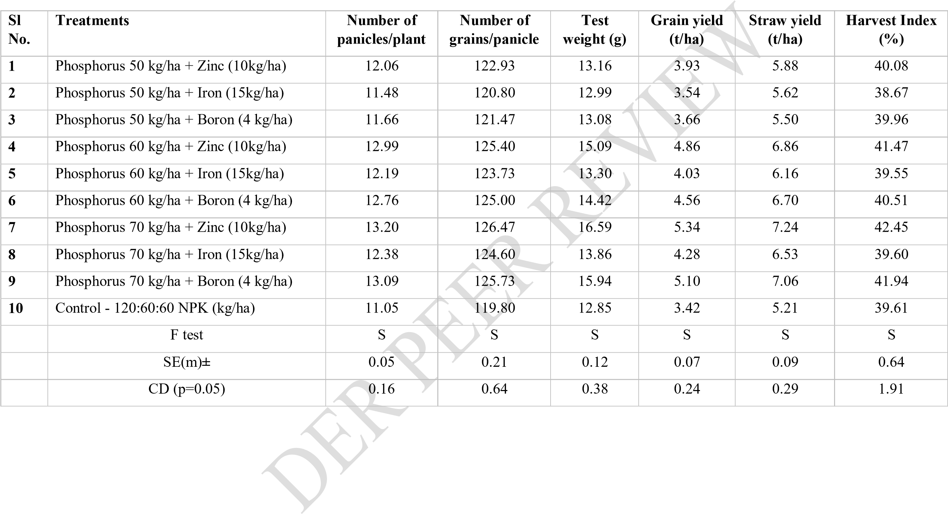

**Table 2. Effect of Phosphorus and micronutrients on the economics of rice.**

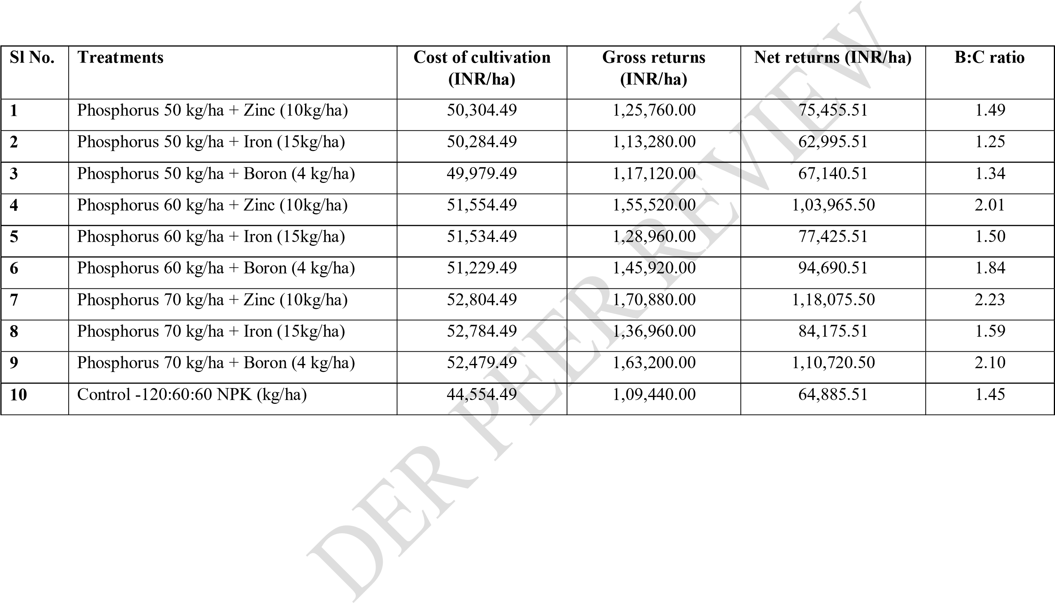

**CONCLUSION:**

Based on the aforementioned results it can be state that phosphorus 70 k g/ha combined with zinc 10 kg/ ha have improved in yield characteristics while also being economically viable.

-

-

pr

**Disclaimer (Artificial intelligence)**

**Option 1:**

**Author(s) hereby declare that NO generative AI technologies such as Large Language Models (ChatGPT, COPILOT, etc.) and text-to-image generators have been used during the writing or editing of this manuscript.**

**Option 2:**

**Author(s) hereby declare that generative AI technologies such as Large Language Models, etc. have been used during the writing or editing of manuscripts. This explanation will include the name, version, model, and source of the generative AI technology and as well as all input prompts provided to the generative AI technology**

**Details of the AI usage are given below:**

**1.**

**2.**

**3.**

**REFERENCES:**

1. **Atique-ur-Rehman & Muhammad Farooq & Abdul Rashid & Faisal Nadeem & Sabine Stuerz4& Folkard Asch & Richard W. Bell & Kadambot H. M. Siddique. (2018).** Boron nutrition of rice in different production systems. A review. Agronomy for Sustainable Development 38: 25.
2. **Bareddy Narendranath Reddy, C. Umesha, Pole Shiva kiran and Dhanush Reddy. (2020).** Effect of Zinc and Boron Levels on Growth, Yield and Economics of Rice (*Oryza sativa* L.) var. Shiats Dhan-1. International Journal of Current Microbiology and Applied Sciences.**9**(12):2319-7706.
3. **Choudhary, S., A. Zehra, M. Naeem, M. Khan and T. Aftab. (2020).** Effects of boron toxicity on growth, oxidative damage, antioxidant enzymes and essential oil fingerprinting in Mentha arvensis and Cymbopogon flexuosus. Chem. & Biol. Technol. in Agri., 7(1): 1-11.
4. **Devideen yadav, Y.V. singh , Dinesh kumar, Sunita gaind and Anil kumar.(2015).**Influence of sources and rates of phosphorus on plant growth, productivity and economics of aerobic rice (*Oryza sativa* L.).Indian Journal of Agronomy 60 (1): 157-159. **5. Fadma Juwita Nasution1,a), Hamidah Hanum, and Jonatan Ginting**. **(2021).** Effect of

Dose and Time Application of Phosphorus Fertilizer on Phosphorus Availability, Growth and Production of Rice (*Oryza sativa* L.) AIP Conference Proceedings 2342.

1. **Fanhua Meng, Youzhang Wei,** [**Xiaoe Yang.**](https://www.sciencedirect.com/author/23037753900/xiaoe-e-yang) **(2005).** Iron content and bio availability in rice. [Journal of Trace Elements in Medicine and Biology.](https://www.sciencedirect.com/journal/journal-of-trace-elements-in-medicine-and-biology) [**18** (4)](https://www.sciencedirect.com/journal/journal-of-trace-elements-in-medicine-and-biology/vol/18/issue/4): 333-338

1. **Ishizuka, Y. (1971).** Physiology of rice plant. Advs. Agro.,**23**:241-315
2. **Gharib, H. S.1 ; B. A. A. Zayed2 ; S. Gh. R. Sorour1 and Amira M. E. Okasha. (2011).** Effect of zinc and phosphorus fertilization on rice crop under saline soil conditions. Plant Production, Mansoura Univ., Vol. **2** (5): 755 – 771.
3. **Gulshan naheed, Muahmmad shahbazand Nudrat aisha akram. (2008).** Interactive effect of rooting medium application of phosphorus and nacl on plant biomass and mineral nutrients of rice (oryza sativa l.). Pak. J. Bot., **40**(4): 1601-1608.
4. **Jones, J. R. & Benton. J. (2012).** Fifth. Iron Chelation in Plants and Soil Microorganisms, 447.
5. **Ionov FV, Ionova VG.** (1977). Fertilization of rice under conditions of high phosphate level of chestnut soils. ShornilsStatei, DonskoiSel, sKokhozyais. **12**(1):107-111.
6. **M. Umar Khan, M. Qasim and Israrullah Khan. (2007).** effect of zn fertilizer on rice grown in different soils of dera Ismail khan. Sarhad J. Agric. **23** (4).
7. **Maclean, J.C., Dawe, D.C., Hardy, B. and Hettel, G.P. (2002).** Rice almanac (3rd
8. **Md. Ibrahim Ali1, M. A. Islam , Q. A. Khaliq and M. A. Rouf. (2019).** Effect of Zinc Fertilizer Application on Growth Yield and Yield Contributing Characters in Rice. Asian Journal of Advances in Agricultural Research **9**(2): 1-10.
9. **Memon, K. S. and H. K. Puno. 2005.** Effect of different nitrogen and phosphorus levels on the yield and yield components of wheat variety Pavan. Agriculture Research Station Dadu, Sindh, Pakistan. Indus. J. Plant Sci., **4(**3): 273-277
10. **Naorem Meena Devi and Edwin** Luikham**.(2018).** Influence of Phosphorus and Potassium on Growth and Yield of Black Aromatic Rice (*Chak-hao*). International Journal of Current Microbiology and Applied Sciences. **7**(8):2319-7706.
11. **Naik SK, Das DK (2007)**. Effect of split application of zinc on yield of rice (Oryza sativa

L.) in an inceptisol. Arch Agron. Soil Sci **53**(3):305–313.

1. **Rahman (1996)**. Effect of phosphorus applied as superphosphate on rate of development and spikelet number per ear of different cultivars of wheat. Australian. J. of Agr. Res., **28**(2): 183– 86.
2. **Rana, W.H. and S.R. Kashif (2014).** Effect of different zinc sources and methods of application on rice yield and nutrients concentration in rice grain and straw. Journal of Environmental and Agricultural Sciences, 1–9.
3. **Sanzo R, Saborit R, Yara VC.(1989).** Effect of zinc on the yield of rice cultivar J 104 and on plant iron and zinc content. Ciencia-YTencia-en-la. Agriclutura.**12**(1):123- 127
4. **S.R. Kadam, V.M. Bhale, A.B. Chorey and M.R. Deshmukh. (2018).** Influence of Zinc and Iron Fortification on Yield and Post-Harvest Studies of Different Rice Cultivars (Oryza sativa L.). Int.J.Curr.Microbiol.App.Sci **7(**1): 1878-1888.
5. **Shaik Wasim Akram, Rajesh Singh, Pratyasha Tripathi and Gera Roopa Lavanya. (2022).** Effect of Phosphorus and Sulphur on yield and economics of Wheat *(Triticum aestivum* L.). The Pharma Innovation Journal **11**(5): 599-602.
6. **Waikhom Jiten Singh, Mahua Banerjee1 and L. Nabachandra Singh. (2018).** Effect of Sulphur and Zinc on Yield Attributes, Yield and Economics of Rice.

Int.J.Curr.Microbiol.App.Sci **7**(3): 531-537.

1. Medha Shreya and Dr. Victor Debbarma. (2023). Effect of system of rice intensification and organic manure on yield attributes and economics of Rice (Oryza sativa L.) SP-8(3): 192-195.