Aerobic composting of antibiotic-contaminated manure: Degradation processes and their effects on greenhouse gas emissions

ABSTRACT

Introduction: The widespread use of antibiotics in livestock production results in significant excretion of unmetabolized residues in manure, posing risks such as the emergence of antibiotic-resistant bacteria (ARB), antibiotic resistance genes (ARGs), and elevated greenhouse gas (GHG) emissions. Composting has emerged as a promising strategy to mitigate these risks.
Aims: This review formed a foundation for manure incubation regarding the fate and effects of three antibiotics – Tylosin, Enrofloxacin, and Oxytetracycline on manure GHG ammonia (NH₃) emissions, and fertilizer quality. It synthesizes existing evidence on antibiotic degradation during composting, highlighting the influence of composting conditions and additives.
Methods: A comprehensive literature search was done following the PRISMA (Preferred Reporting Items for Systematic Reviews and Meta-Analyses) guidelines. Systematic searches were performed in three databases: Web of Science, PubMed, and Scopus, for original articles using a combination of Query terms and an established inclusion and exclusion criteria.
Results: The 66 studies that met the criteria were from 21 countries. Outcomes show that composting conditions (temperature, aeration, moisture), additive types (e.g., biochar, zeolite), and microbial inoculants play critical roles in antibiotic degradation and GHG emission dynamics. Thermophilic composting promotes degradation of labile antibiotics, while persistent compounds may require extended treatment.
Overall, the review identified that physicochemical and microbial processes drive antibiotic degradation, suggesting that specific additives enhance these pathways, influencing GHG emissions.
Conclusion: Composting is a viable strategy for managing antibiotic-laden manure and calls for further research into advanced treatments, bioaugmentation, and integration with other waste management technologies.

Keywords: Livestock manure, antibiotic-resistant genes, and composting additives
1. INTRODUCTION
Antibiotics are natural compounds derived from living organisms or created synthetically in the laboratory. They can be taken parenterally, orally, or applied topically to eliminate or hinder the growth of microorganisms (Hosain et al., 2021). They are used therapeutically to treat, control, and prevent diseases, while the non-therapeutic use is for growth promotion and feed digestibility enhancers (Bacanlı & Başaran, 2019) in other countries, but its use in food animals within the European Union has been banned since the year 2006 (Van Boeckel et al., 2015; Spielmeyer, 2018).
In a recent survey, found that in Africa 75% of the countries allow antibiotics to be used for growth promotion, with animals accounting for 50–80% of total antibiotic use (Van et al., 2020). Most of the available data on antimicrobial use across the continent has been collected since 2015, showing that tetracyclines β-lactams, aminoglycosides, lincosamides, quinolones, polypeptides, amphenicols, macrolides, and sulfonamides are among the most widely used antibiotic classes (Van et al., 2020; Hosain et al., 2021).
Animals eliminate a considerable portion of antibiotics through their faeces and urine, posing a significant risk of unchanged or active drug metabolites being present in the environment (Massé et al., 2014) through manure inputs or from the intensified production of livestock (Marutescu et al., 2022), and this leads to the presence of antibiotic-resistant bacteria in manure (Jadeja & Worrich, 2022). Antimicrobial resistance is a growing problem globally because every year, antibiotic resistance kills 7 million people worldwide, with up to 10 million fatalities anticipated by 2050. If nothing is done to mitigate this threat, AMR could render certain bacterial diseases substantially more lethal than they are now (Murray et al., 2022).
The application of manure with antibiotic residues may impact the soil microbial functions essential for nutrient cycling and climate regulation since greenhouse gas production is microbially mediated (Petersen et al., 2013). Composting has been proposed as an effective method to curb the spread of antimicrobial resistance in the environment. It helps minimize the likelihood of its transmission to crops and the food chain while also supplying essential fertilizer components (Zalewska et al., 2021; Zalewska et al., 2023) Although composting, driven by microbiological activity, is a preferred method for managing manure and biosolids (Wan et al., 2021), how it affects the degradation of antibiotic residues and greenhouse gas emissions is not clearly understood.
This review synthesizes existing research to evaluate (i) the impacts of antibiotic residues in cattle manure on greenhouse gas emissions during composting (ii) the processes and factors that affect antibiotic degradation during aerobic composting (iii) what additives are incorporated into the manure during composting. By consolidating current knowledge, this review aims to support informed decision-making for sustainable manure management and highlight research gaps needing further investigation.
2. Materials and methods

A comprehensive literature search was conducted following the PRISMA (Preferred Reporting Items for Systematic Reviews and Meta-Analyses) guidelines, as outlined by Liberati et al., (2009). The systematic searches were performed in three databases: Web of Science, PubMed, and Scopus, for original articles published between 2000 and 2024. We started the search from 2000 because this is when the antibiotic debate started in Europe. A combination of Query terms like greenhouse gas, methane, nitrous oxide, carbon dioxide and composts, and livestock or cattle or cow and dung or feces or slurry or manure and antibiotic or drug or antimicrobial were used. Articles retrieved from the search qualified to be included in the review if they were original articles published in English from studies done on laboratory or at field scale from any location globally describing the effects of antibiotic residues in the cattle manure on greenhouse gas emissions during composting or if they were studies on the effects of aerobic composting on antibiotic residues in the presence of additives. Specifically, the review focused on the impact of antibiotic residues in cattle, pig, and chicken manure on greenhouse gas emissions during aerobic composting, the processes and factors influencing antibiotic degradation, and the role of additives used during composting.
Studies were excluded if they were presented in book chapters or focused on composting manures from camels, ducks, horses, sewage sludge, food wastes, or human excreta. These exclusions were made to ensure consistency and relevance across the reviewed studies, as such sources either lacked peer-reviewed rigor (e.g., book chapters) or involved waste types with different chemical compositions, microbial communities, or antibiotic usage patterns that could bias comparisons with cattle, pig, and chicken manure.

3. results and discussion
3.1. The PRISMA flow chart outcomes
A systematic literature search that was conducted using PubMed, Web of Science, and Scopus to identify studies examining the processes by which aerobic composting influences the degradation of antibiotic residues and its effects on greenhouse gas emissions using a predefined inclusion criterion resulted in 66 publications that were deemed relevant. These studies focused on livestock manure (cattle, pig, and chicken), addressing composting processes, antibiotic residue degradation, GHG emission outcomes, and the role of composting additives. The study selection process is summarized in the PRISMA flow diagram in Figure 1.
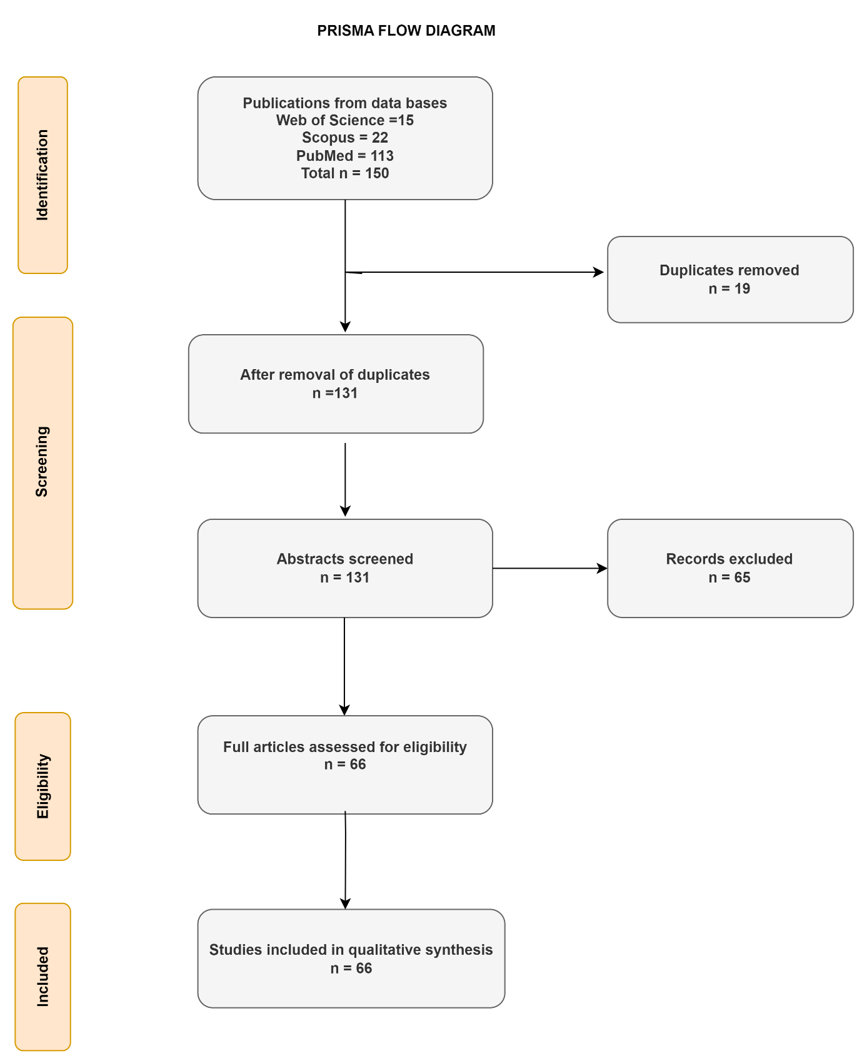
Figure 1. Flowchart showing the selection process for included studies
The 66 studies included in the review were from 21 countries. The study locations were distributed across the globe except South America as follows: 5 studies from Canada, 14 studies from the USA, 3 from Africa, 4 from Australia, 3 from Europe, 2 from the Middle East, and 35 from Asia, as shown in Figure 2.

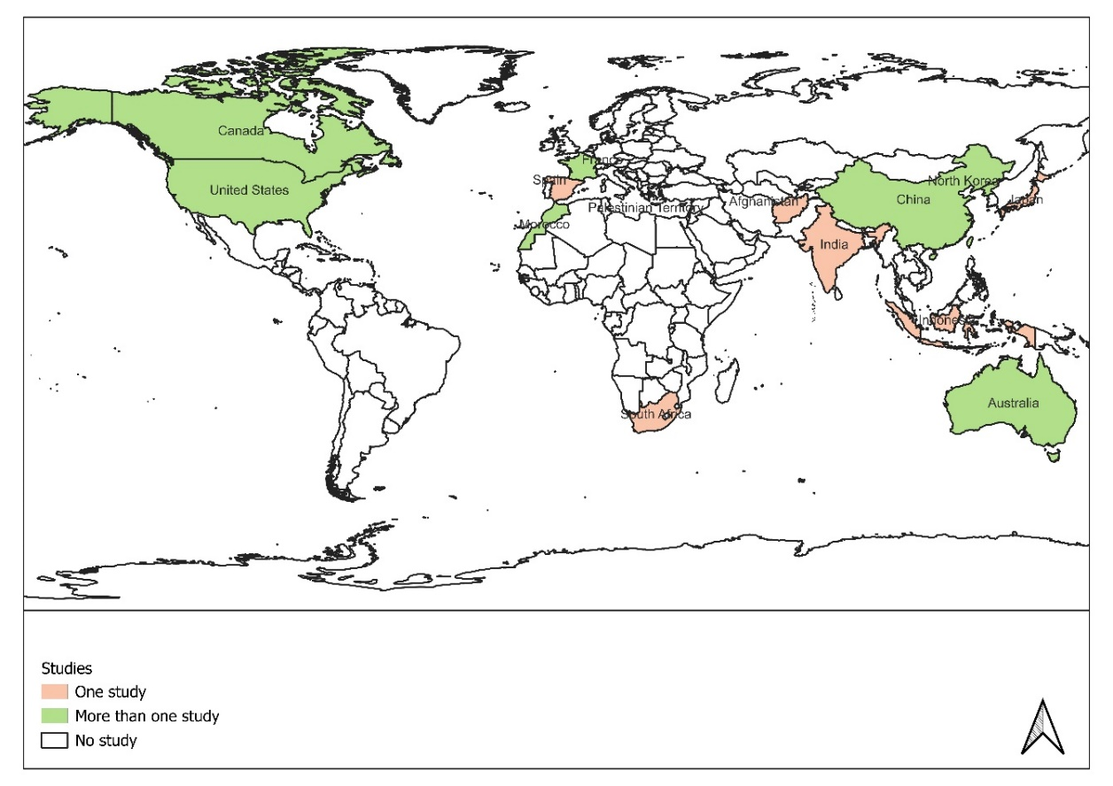
Figure 2. Global distribution of studies that met inclusion criteria. The shades of different colors represent the number of original article publications from each country.
3.2 The impacts of antibiotic residues in cattle manure on greenhouse gas emissions during composting
It was found that during the composting experiments, the manure was co-composted with four categories of materials. The first category is the plant materials that are found on the farm like wood chips and rice husks (Arikan et al., 2006), wheat, and barley straws (Esperón et al., 2020), sawdust (Chen et al., 2019), rice husks (Wang et al., 2022), corn straws (Staley et al., 2020; Ren et al., 2021; Pei et al., 2021; Staley et al., 2020), tea stalks ( Chen et al., 2022) mushroom spent residues, bamboo charcoal, and biochar (Lin et al., 2021). The second category of co-composting materials consisted of chemical amendments like phosphogypsum (Hao et al., 2005), Zeolite, attapulgite activated carbon composite, lime (Lin et al., 2021) and 3-nitrooxypropanol (Owens et al., 2020) which is a pharmaceutical material that has been developed to reduce enteric CH₄ production. The 3-Nitrooxypropanol works by specifically inhibiting the methyl-coenzyme M reductase, an enzyme in methanogenic archaea that catalyzes the CH₄-forming reaction in the rumen.
The third category the manure was co-composted with pharmaceutical fermentation residues like the penicillin (Ren et al., 2021; Zhang et al., 2015) vinegar wastes (Liu et al., 2022) and Chinese herbal medicine (Guo et al., 2022 ; Zhang et al., 2017). Lastly, the fourth category consisted of composting of manure with commercial decomposers like the antibiotic-degrading bacteria and a consortium of cellulolytic fungi (Salma et al., 2021) like the Aspergillus niger and Trichoderma spp.
The literature search showed that 24% of the included studies mentioned the effects of veterinary antibiotics on greenhouse gas emissions during composting. The studies varied from those that caused an increase, a decrease and no effect on greenhouse gas and ammonia emissions. A study by Kang et al., (2022) found that aerobic composting in presence of penicillin G transformed biological nitrogen fixation by reducing the abundance of denitrifying bacteria. This causes a reduction in Nitrous oxide (N₂O) emissions. Penicillin G was beneficial in enhancing manure fertilizer quality due to reduced N losses through gaseous losses. Contrary findings were observed by Sun et al., (2022) who observed an elevated gaseous loss of NH₃ during aerobic composting of manure in the presence of spiramycin residues. Research by Chen et al., (2019) showed that adding sulfamethoxazole and norfloxacin increased cumulative CO₂ emissions while reducing total NH₃ loss via volatilization. Further, he discovered that sulfamethoxazole alone decreased cumulative CO₂ emissions but significantly (p < 0.05) increased N₂O emissions during the initial 7 days. In contrast, the individual addition of norfloxacin inhibited CO₂, CH₄, and N₂O emissions while increasing cumulative NH₃ loss through volatilization. More studies on the effects of composting on greenhouse gas emissions are presented in Table 1.
Table 1. Effects of composting with various additives on greenhouse gas emissions from chicken, pig, and cattle manure over varying durations.
No. | Animal waste | Composting additive | Composting duration (days) | Effects on GHG | Reference
1 | Cattle manure | Lignite | 90 | Decreased NH₃ emissions during composting by 54% while elevating overall greenhouse gas by 2.6 times | (Bai et al., 2020)
2 | Chicken pig and cattle manure | Corn stovers | 28 | Negligible CH₄ emissions at the end of composting | ( Liu et al., 2021)
3 | Pig manure | wheat straw | 24 | Reduction of N₂O and CH₄ through effective aeration | (Zeng et al., 2018)
4 | Cattle and swine manure | Wheat straw | 33 | Reduced 50.8 and 40.9% of N₂O and CH₄ emissions, respectively | (Zeng et al., 2018)
5 | Dairy manure | - | 42. | Increased CO₂ and CH₄ emissions due to high temperature | (Mulbry & Ahn, 2014)
6 | Cattle manure | - | 44 | NH₃ volatilization decreased by 52.4% | (Cui et al., 2019)
7 | Cattle manure | Saw dust | 22 | Denitrification caused rapid N₂O emissions when the oxygen content was reduced. | (Ahn et al., 2011; Tsutsui et al., 2013)

3.3. The processes and factors influencing antibiotic degradation in livestock manure during composting
Composting relies on a succession of microbial communities that thrive in thermophilic and mesophilic conditions. During the thermophilic phase, temperatures can reach 55°C to 70°C, creating an environment conducive to the breakdown of complex organic compounds, including antibiotics (Agga et al., 2022). Elevated temperatures enhance the degradation of thermolabile antibiotics, such as tetracyclines and macrolides, by denaturing their chemical structures as observed by Yu et al., (2019). In addition, composting fosters enzymatic activity that can further catalyze the breakdown of antibiotic molecules.
According to Cycoń et al., (2019) microbial activity is crucial for degrading antibiotics, with bacteria and fungi metabolizing them as carbon sources. Enzymes like beta-lactamases hydrolyze antibiotic compounds, influenced by temperature, aeration, moisture, and the compost's carbon-to-nitrogen ratio.
At a temperature of 55 ºC, the degradation of chlortetracycline was rapid, reaching up to 99% in 30 days in a study by Arikan et al., (2006). Thermophilic conditions are critical for the degradation of heat-sensitive antibiotics, whereas mesophilic conditions may facilitate the breakdown of more persistent compounds, as observed by Mitchell et al., (2015).
Aerobic composting (Gou et al., 2018) enhances microbial activity and enzymatic degradation by providing optimal oxygen levels for aerobic microorganisms. Proper aeration is essential for maintaining these conditions, as it supports the growth of aerobic and facultative anaerobic microbes, which play a key role in organic matter decomposition. While some strict anaerobes may decline due to increased oxygen availability, composting promotes microbial succession, favouring groups such as Actinobacteria and Proteobacteria. Gou et al. (2018) observed significant shifts in microbial community composition after composting, including reductions in the abundance of certain Chloroflexi, Firmicutes, and Bacteroidetes phyla, depending on the composting stage and environmental conditions.
Moisture levels of 50-60% are ideal for microbial activity (Kim et al., 2016). Excessive moisture can lead to anaerobic conditions, slowing degradation, while low moisture levels can inhibit microbial processes. However, for some antibiotics like tylosin, breakdown occurs rapidly through hydrolysis (Zhang et al., 2019). The presence of hydroxyl ions also makes it form strong ionic bonds with the organic component, ensuring that the antibiotic is not detectable after a short period (Loke et al., 2002). A balanced C:N ratio (typically between 25:1 and 30:1) supports microbial growth and activity, promoting efficient decomposition of organic matter and associated contaminants. Bulking agents like rice straw, maize straw, and biochar promote antibiotic degradation, as most antibiotics are unstable in thermophilic conditions (Lin et al., 2021). Additionally, they absorb nutrients, binding them and preventing access to microbial degradation (Kim et al., 2012). Sorption plays a key role in this removal, driven by the abundance of divalent cations in organic matrices and their ability to form chelate complexes with organic substances (Ezzariai et al., 2018).
The time taken or duration to compost manure plays a key role. Time mainly affects the degradation of sulfamethazine during composting. In a study by (Dolliver et al., 2008), extractable sulfamethazine levels remained unchanged after 35 days, and no additional analyses were done. Similarly, (Kim et al., 2012) reported that extractable sulfamethazine in swine manure showed no change after 35 days of commercial composting, but significant reductions were observed in 80 days. In another study, Cessna et al., (2011) noted minimal degradation of sulfamethazine in composted manure from feedlots after 36 days; however, reductions of approximately 88% and 93% were achieved after 63 and 126 days, respectively. A related study on sulfamethazine dissipation in stockpiled feedlot manure indicated that degradation rates were slow during the first 28 days, but extractable sulfamethazine levels decreased by 98% after 77 days as observed by Sura et al., (2014).
3.4. The types of additives used during composting.
Additives are materials incorporated into composting systems to enhance the composting process's efficiency, quality, and environmental performance. The review showed that the manure was co-composted with four categories of materials. The first category is the plant materials that are found on the farm like wood chips and rice husks (Arikan et al., 2006), wheat, and barley straws (Esperón et al., 2020), sawdust (Chen et al., 2019), rice husks (Wang, Chu, et al., 2022), corn straws (Staley et al., 2020; Ren et al., 2021; Pei et al., 2021; Staley et al., 2020), tea stalks ( Chen et al., 2022) mushroom spent residues, bamboo charcoal, and biochar (Lin et al., 2021).
The second category of co-composting materials consisted of chemical amendments like phosphogypsum (Hao et al., 2005), Zeolite, attapulgite, activated carbon composite, lime (Lin et al., 2021) and 3-nitrooxypropanol (Owens et al., 2020) which is a pharmaceutical material that has been developed to reduce enteric CH₄ production. The 3-Nitrooxypropanol works by specifically inhibiting the methyl-coenzyme M reductase, an enzyme in methanogenic archaea that catalyses the CH₄-forming reaction in the rumen.
The third category, the manure was co-composted with pharmaceutical fermentation residues, like the penicillin (Ren et al., 2021; Zhang et al., 2015) vinegar wastes (Liu et al., 2022) and Chinese herbal medicine (Guo et al., 2022 ; Zhang et al., 2017).
Lastly, the fourth category consisted of composting of manure with commercial decomposers like the antibiotic-degrading bacteria and a consortium of cellulolytic fungi (Salma et al., 2021) like the Aspergillus niger and Trichoderma spp.
3.5. The role of additives used during composting.
The use of conditioning agents in composting has been shown to improve the degradation rates of antibiotic residues significantly by Chen et al., (2022). Research indicates that mixing biochar with zeolite during composting enhances the degradation rates of tetracycline antibiotics (Lin et al., 2021). This combination not only increases adsorption but also provides additional nutrients that support microbial growth as observed by Marutescu et al., (2022). The microbial inoculants of specific microbial strains like Aspergillus niger and Trichoderma spp. known for their antibiotic-degrading capabilities can further enhance the degradation process. Studies by Dela Cruz et al., (2022) have demonstrated that inoculating compost with these strains leads to higher removal efficiencies for various antibiotics. The regulation or maintenance of optimal temperature through active management can also promote more effective degradation. Thermophilic composting processes have been shown to reduce heat-sensitive antibiotic residues more effectively than mesophilic conditions which degrade persistent antibiotics ( Chen et al., 2022).
3.6. Implications for greenhouse gas emissions

Composting has the potential to mitigate greenhouse gas emissions associated with organic waste management: traditional waste management practices, such as landfilling or lagoon storage, can lead to significant methane emissions due to anaerobic decomposition. According to Nordahl et al., (2023) composting, being an aerobic process, minimizes methane production by promoting aerobic microbial activity and stabilizing organic matter
By effectively degrading antibiotic residues and converting organic waste into compost (Marutescu et al., 2022), this process contributes to nutrient recycling in agriculture. Healthy soils enriched with compost can enhance carbon sequestration (Lhaj et al., 2024; Schueler et al., 2021) and reduce the need for synthetic fertilizers, which are often associated with higher greenhouse gas emissions during production and application (Sun et al., 2022)
Properly managed compost can improve soil health (Sarwari et al., 2024) by fostering a diverse microbial community that enhances soil resilience against pathogens and reduces reliance on chemical inputs. This shift can contribute to sustainable agricultural practices that further lower greenhouse gas emissions (Yasmin et al., 2022)
3.7. Environmental and Agricultural Implications
Effective composting of antibiotic-contaminated manure reduces the risk of introducing residual antibiotics into soil and water systems (Xu et al., 2016). By minimizing antibiotic residues, composting also helps mitigate the proliferation of antibiotic-resistant bacteria (ARB) and resistance genes (ARGs). Furthermore, the resulting compost is safer for agricultural use, improving soil fertility without posing significant ecological or public health risks. In a related study, a substantial portion of organic degradation is aerobic, inhibiting methanogenesis and leading to lower emission factors (EFs) values (Moller et al., 2004) compared to Intergovernmental Panel on Climate Change (IPCC) estimates for closed systems (IPCC, 2021)
While composting shows promise in degrading antibiotic residues, challenges remain. Some antibiotics, such as fluoroquinolones and sulfonamides, exhibit high persistence and may require advanced treatments for complete degradation. Additionally, the effectiveness of composting varies depending on the initial concentration of antibiotics and the specific composting conditions (Ray et al., 2017).
3.8. Limitations of this study
This study on composting antibiotic-laden manure has several limitations. First, composting conditions vary significantly, affecting the degradation of antibiotics and the persistence of antibiotic resistance genes (ARGs). While high temperatures can reduce ARGs and antibiotic-resistant bacteria (ARBs), thermophilic microbes that harbour ARGs may still thrive, potentially leading to unintended resistance gene proliferation.
Additionally, certain antibiotics, such as fluoroquinolones and sulfonamides, are highly persistent and may not fully degrade during composting. This required comparative studies to assess the risks associated with their continued presence in manure.
Another limitation is the variable effectiveness of composting additives, such as biochar, zeolite, and microbial inoculants, which depend on composting conditions and manure composition. This raises concerns about scalability and cost. Finally, even when antibiotic residues are reduced, residual ARGs may persist in compost, posing potential long-term environmental and agricultural risks.

4. Conclusion

Composting is a viable and effective strategy for degrading antibiotic residues in livestock manure while simultaneously addressing greenhouse gas emissions. The effectiveness of this process is enhanced by employing conditioning agents and optimizing microbial communities within the compost matrix. As agricultural practices evolve towards sustainability, integrating efficient composting techniques will be essential in managing antibiotic residues and promoting environmental health. Further research is needed to optimize composting parameters for effective antibiotic degradation while maximizing ecological and agricultural benefits. Studies should explore bioaugmentation with specialized microbial consortia, assess the long-term environmental impact of residual antibiotics in compost-amended soils, and integrate composting with other waste treatment technologies like anaerobic digestion or biochar application. Advancing these strategies will enhance antibiotic residue management in agriculture, reducing environmental and public health risks associated with antibiotic use.

Disclaimer (Artificial intelligence)

Option 1:
Author(s) hereby declare that NO generative AI technologies such as Large Language Models (ChatGPT, COPILOT, etc.) and text-to-image generators have been used during the writing or editing of this manuscript.

Competing interests

The authors declare no competing interests.

Authors’ Contributions

Author AC wrote the systematic review protocol, Author WN and SK managed the literature searches and data extraction. Author AC wrote the first draft of the manuscript. All authors read and approved the final manuscript

References
Ahn, H. K., Mulbry, W., White, J. W., & Kondrad, S. L. (2011). Pile mixing increases greenhouse gas emissions during composting of dairy manure. Bioresource Technology, 102(3), 2904–2909. https://doi.org/10.1016/j.biortech.2010.10.142
Arikan, O. A., Sikora, L. J., Mulbry, W., Khan, S. U., Rice, C., & Foster, G. D. (2006). The fate and effect of oxytetracycline during the anaerobic digestion of manure from therapeutically treated calves. Process Biochemistry, 41(7), 1637–1643. https://doi.org/10.1016/j.procbio.2006.03.010
Bai, M., Flesch, T., Trouvé, R., Coates, T., Butterly, C., Bhatta, B., Hill, J., & Chen, D. (2020). Gas emissions during cattle manure composting and stockpiling. Journal of Environmental Quality, 49(1), 228–235. https://doi.org/10.1002/jeq2.20029
Chen, X., Wu, C., Li, Q., Zhou, P., Chen, Z., Han, Y., Shi, J., & Zhao, Z. (2022). Effect of Thermophilic Microbial Agents on Antibiotic Resistance Genes and Microbial Communities during Co-Composting of Pig Manure and Tea Stalks. Sustainability (Switzerland), 14(19). https://doi.org/10.3390/su141912593
Chen, Z., Wu, Y., Wen, Q., Ni, H., & Chai, C. (2019). Effects of multiple antibiotics on greenhouse gas and ammonia emissions during swine manure composting. Environmental Science and Pollution Research, 27(7), 7289–7298. https://doi.org/10.1007/s11356-019-07269-2
Cui, P., Liao, H., Bai, Y., Li, X., Zhao, Q., Chen, Z., Yu, Z., Yi, Z., & Zhou, S. (2019). Hyperthermophilic composting reduces nitrogen loss via inhibiting ammonifiers and enhancing nitrogenous humic substance formation. Science of the Total Environment, 692, 98–106. https://doi.org/10.1016/j.scitotenv.2019.07.239
Dela Cruz, R. S. J. P., Ballesteros, F. C., r, J., Undan, J. R., Lopez, L. L. M. A., Cortez, M. E. F. C., & Porciuncula, F. L. (2022). Assessment of Aspergillus niger and Aspergillus flavus in Inoculant Induced Composting to Remove Antibiotics in Poultry Manure. Ecology, Environment and Conservation, 28(2), 677–684. https://doi.org/10.53550/eec.2022.v28i02.015
Esperón, F., Albero, B., Ugarte-Ruíz, M., Domínguez, L., Carballo, M., Tadeo, J. L., del Mar Delgado, M., Moreno, M. Á., & de la Torre, A. (2020). Assessing the benefits of composting poultry manure in reducing antimicrobial residues, pathogenic bacteria, and antimicrobial resistance genes: a field-scale study. Environmental Science and Pollution Research, 27(22), 27738–27749. https://doi.org/10.1007/s11356-020-09097-1
Guo, Z., Lv, L., Liu, D., He, X., Wang, W., Feng, Y., Islam, S., Wang, Q., Chen, W., Liu, Z., Wu, S., & Abied, A. (2022). A global meta-analysis of animal manure application and soil microbial ecology based on random control treatments. PLOS ONE, 17(1), 1–17. https://doi.org/10.1371/journal.pone.0262139
Hao, X., Larney, F. J., Chang, C., Travis, G. R., Nichol, C. K., & Bremer, E. (2005). The Effect of Phosphogypsum on Greenhouse Gas Emissions during Cattle Manure Composting. Journal of Environmental Quality, 34(3), 774–781. https://doi.org/10.2134/jeq2004.0388
Hosain, M. Z., Lutful Kabir, S. M., & Kamal, M. M. (2021). Antimicrobial uses for livestock production in developing countries. Veterinary World, 14(1), 210–221. https://doi.org/10.14202/VETWORLD.2021.210-221
IPCC. (2021). Climate Change 2021: The Physical Science Basis. Contribution of Working Group I to the Sixth Assessment Report of the Intergovernmental Panel on Climate Change [Masson-Delmotte, V., P. Zhai, A. Pirani, S.L. Connors, C. Péan, S. Berger, N. Caud, Y. Chen,. https://doi.org/10.1017/9781009157896.
Kang, J., Yin, Z., Pei, F., Ye, Z., Sun, Y., Song, G., & Ge, J. (2022). Driving factors of nitrogen conversion during chicken manure aerobic composting under penicillin G residue: Quorum sensing and its signaling molecules. Bioresource Technology, 345(October 2021), 126469. https://doi.org/10.1016/j.biortech.2021.126469
Lhaj, M. . ., Moussadek, R., Zouahri, A., Sanad, H., Saafadi, L., Mdarhri Alaoui, M., & Mouhir, L. (2024). Sustainable Agriculture Through Agricultural Waste Management: A Comprehensive Review of Composting’s Impact on Soil Health in Moroccan Agricultural Ecosystems. Agriculture (Switzerland), 14(12). https://doi.org/10.3390/agriculture14122356
Lin, H., Sun, W., Yu, Y., Ding, Y., Yang, Y., Zhang, Z., & Ma, J. (2021). Simultaneous reductions in antibiotics and heavy metal pollution during manure composting. Science of the Total Environment, 788, 147830. https://doi.org/10.1016/j.scitotenv.2021.147830
Liu, C., Zhang, X., Zhang, W., Wang, S., Fan, Y., Xie, J., Liao, W., & Gao, Z. (2022). Mitigating gas emissions from poultry litter composting with waste vinegar residue. Science of the Total Environment, 842(April), 156957. https://doi.org/10.1016/j.scitotenv.2022.156957
Liu, T., Kumar Awasthi, M., Verma, S., Qin, S., Awasthi, S. K., Liu, H., Zhou, Y., & Zhang, Z. (2021). Evaluation of cornstalk as bulking agent on greenhouse gases emission and bacterial community during further composting. Bioresource Technology, 340(August), 125713. https://doi.org/10.1016/j.biortech.2021.125713
Marutescu, L. G., Jaga, M., Postolache, C., Barbuceanu, F., Milita, N. M., Romascu, L. M., Schmitt, H., de Roda Husman, A. M., Sefeedpari, P., Glaeser, S., Kämpfer, P., Boerlin, P., Topp, E., Gradisteanu Pircalabioru, G., Chifiriuc, M. C., & Popa, M. (2022). Insights into the impact of manure on the environmental antibiotic residues and resistance pool. Frontiers in Microbiology, 13(September), 1–18. https://doi.org/10.3389/fmicb.2022.965132
Moller, H. B., Sommer, S. G., & Ahring, B. K. (2004). Biological Degradation and Greenhouse Gas Emissions during Pre‐Storage of Liquid Animal Manure. Journal of Environmental Quality, 33(1), 27–36. https://doi.org/10.2134/jeq2004.2700
Mulbry, W., & Ahn, H. (2014). Greenhouse gas emissions during composting of dairy manure: Influence of the timing of pile mixing on total emissions. Biosystems Engineering, 126, 117–122. https://doi.org/10.1016/j.biosystemseng.2014.08.003
Nordahl, S. L., Preble, C. V., Kirchstetter, T. W., & Scown, C. D. (2023). Greenhouse Gas and Air Pollutant Emissions from Composting. Environmental Science and Technology, 57(6), 2235–2247. https://doi.org/10.1021/acs.est.2c05846
Owens, J. L., Thomas, B. W., Stoeckli, J. L., Beauchemin, K. A., McAllister, T. A., Larney, F. J., & Hao, X. (2020). Greenhouse gas and ammonia emissions from stored manure from beef cattle supplemented 3-nitrooxypropanol and monensin to reduce enteric methane emissions. Scientific Reports, 10(1), 1–14. https://doi.org/10.1038/s41598-020-75236-w
Pei, F., Sun, Y., Kang, J., Ye, Z., Yin, Z., & Ge, J. (2021). Links between microbial compositions and metabolites during aerobic composting under amoxicillin stress was evaluated by 16S rRNA sequencing and gas chromatography-mass spectrometry: Benefit for the plant growth. Bioresource Technology, 340(June), 125687. https://doi.org/10.1016/j.biortech.2021.125687
Ray, P., Chen, C., Knowlton, K. F., Pruden, A., & Xia, K. (2017). Fate and Effect of Antibiotics in Beef and Dairy Manure during Static and Turned Composting. Journal of Environmental Quality, 46(1), 45–54. https://doi.org/10.2134/jeq2016.07.0269
Ren, J., Deng, L., Li, C., Dong, L., Li, Z., Huhetaoli, Zhang, J., & Niu, D. (2021). Effects of added thermally treated penicillin fermentation residues on the quality and safety of composts. Journal of Environmental Management, 283(August 2020), 111984. https://doi.org/10.1016/j.jenvman.2021.111984
Salma, S., Junita, R. E., Handayanto, E., Husnain, Irawan, Nurida, N. L., & Husen, E. (2021). Biodegradation of antibiotic residues in chicken manure by composting processes. IOP Conference Series: Earth and Environmental Science, 648(1). https://doi.org/10.1088/1755-1315/648/1/012179
Sarwari, A., Abdieva, G. Z., Hassand, M. H., Mohammad, U. K., & Niazi, P. (2024). Role of Microbial Communities in Compost and Plant Growth: Structure and Function. European Journal of Theoretical and Applied Sciences, 2(2), 23–37. https://doi.org/10.59324/ejtas.2024.2(2).03
Schueler, J., Naas, K., Hurst, J., Aga, D., & Lansing, S. (2021). Effects of on-farm dairy manure composting on tetracycline content and nutrient composition. Antibiotics, 10(4). https://doi.org/10.3390/antibiotics10040443
Staley, Z. R., Schmidt, A. M., Woodbury, B., Eskridge, K. M., Durso, L., & Li, X. (2020). Corn stalk residue may add antibiotic-resistant bacteria to manure composting piles. Journal of Environmental Quality, 49(3), 745–753. https://doi.org/10.1002/jeq2.20017
Sun, J., Wang, G., Liu, H., Zhang, Y., Sun, H., & Dai, X. (2022). Influence of thermally activated peroxodisulfate pretreatment on gaseous emission, dissolved organic matter and maturity evolution during spiramycin fermentation residue composting. Bioresource Technology, 363(September), 127964. https://doi.org/10.1016/j.biortech.2022.127964
Tsutsui, H., Fujiwara, T., Matsukawa, K., & Funamizu, N. (2013). Nitrous oxide emission mechanisms during intermittently aerated composting of cattle manure. Bioresource Technology, 141, 205–211. https://doi.org/10.1016/j.biortech.2013.02.071
Van, T. T., Hao, Yidana, Z., Smooker, P. M., & Coloe, P. J. (2020). Antibiotic use in food animals worldwide, with a focus on Africa: Pluses and minuses. Journal of Global Antimicrobial Resistance, 20, 170–177. https://doi.org/10.1016/j.jgar.2019.07.031
Wang, Y., Chu, L., Ma, J., Chi, G., Lu, C., & Chen, X. (2022). Effects of multiple antibiotics residues in broiler manure on composting process. Science of the Total Environment, 817, 152808. https://doi.org/10.1016/j.scitotenv.2021.152808
Xu, S., Sura, S., Zaheer, R., Wang, G., Smith, A., Cook, S., Olson, A. F., Cessna, A. J., Larney, F. J., & McAllister, T. A. (2016). Dissipation of Antimicrobial Resistance Determinants in Composted and Stockpiled Beef Cattle Manure. Journal of Environmental Quality, 45(2), 528–536. https://doi.org/10.2134/jeq2015.03.0146
Yasmin, N., Jamuda, M., Panda, A. K., Samal, K., & Nayak, J. K. (2022). Emission of greenhouse gases (GHGs) during composting and vermicomposting: Measurement, mitigation, and perspectives. Energy Nexus, 7(June). https://doi.org/10.1016/j.nexus.2022.100092
Zeng, J., Yin, H., Shen, X., Liu, N., Ge, J., Han, L., & Huang, G. (2018). Effect of aeration interval on oxygen consumption and GHG emission during pig manure composting. Bioresource Technology, 250(September 2017), 214–220. https://doi.org/10.1016/j.biortech.2017.11.010
Zhang, L., Gu, J., Wang, X., Sun, W., Yin, Y., Sun, Y., Guo, A., & Tuo, X. (2017). Behavior of antibiotic resistance genes during co-composting of swine manure with Chinese medicinal herbal residues. Bioresource Technology, 244, 252–260. https://doi.org/10.1016/j.biortech.2017.07.035
Zhang, Z., Zhao, J., Yu, C., Dong, S., Zhang, D., Yu, R., Wang, C., & Liu, Y. (2015). Evaluation of aerobic co-composting of penicillin fermentation fungi residue with pig manure on penicillin degradation, microbial population dynamics and composting maturity. Bioresource Technology, 198, 403–409. https://doi.org/10.1016/j.biortech.2015.09.005

SUPPLEMENTARY MATERIALS

SYSTEMATIC REVIEW PROTOCOL
AEROBIC COMPOSTING: PROCESSES OF ANTIBIOTIC RESIDUE DEGRADATION AND ITS EFFECTS ON GREENHOUSE GAS EMISSIONS A SYSTEMATIC REVIEW.
SYSTEMATIC REVIEW PROTOCOL
RATIONALE | Antibiotics have been engaged as “insurance” to counter disease-related livestock fatalities. This leads to the presence of administered antibiotic residues in manure. The residues have environmental threats like the selection pressure on microbes and impacts on greenhouse gas emissions. The study aims to determine if composting can degrade antibiotic residues and reduce Greenhouse Gas (GHG) emissions from manure.
AIM | To study the results of publications about (i) the impacts of antibiotic residues in cattle manure on greenhouse gas emissions during composting (ii) the processes and factors that affect antibiotic degradation during aerobic composting (iii) what additives are added to the manure during composting.
RESEARCH QUESTIONS | - Globally, what impact do antibiotic residues in cattle manure have on greenhouse gas emissions during composting?  - What are the processes and factors that affect antibiotic degradation during aerobic composting?  - What are the effects of additives during composting
POPULATION | Domesticated livestock – cattle, pig and poultry.
INTERVENTION/  METHOD | Composting
CONTROL | Manure heap with no treatment
OUTCOME | - Examine the efficiency of the intervention in reducing the residues of antibiotics by looking at the percentage reduction in the concentration of antibiotics.  - Experimental outcomes on reduced greenhouse gas emissions after composting manure.  - Examine additive's effects on manure physicochemical characteristics
SETTING | Worldwide
Eligibility criteria | Inclusion criteria  - Publications on all studies done on laboratory and field scales.  - Original articles describing the effects of antibiotic residues in cattle manure on greenhouse gas emissions during composting.  - Original studies on the effects of aerobic composting and composting in the presence of additives like biochar, wheat straw, maize stovers, bean trash, lime, magnetite, rice straw, antibiotic fermentation residues, and Bentonite on antibiotic residues.  - Working papers, thesis, conference proceedings, and research reports  - The language of publication should be English.  - The articles should be published from 2000-2025.  - Exclusion criteria  - Studies that were done on horses, camel, and duck manure.  - Studies of composting effects on antibiotic residues and ARB in aquatic environments and wastewater treatment plants.  - Studies of composting effects on antibiotic residues and sewage sludge.  - Exclude manure from food waste.  - Human waste  - Book chapters
Information sources | Online data sites: Scopus, PubMed.gov, and Web of Science
Search string | See below
Study design | Experimental studies, cross-sectional studies
Data collection | Title/Abstract  The download of titles and reading through abstracts to remove duplicates.  The author is to review abstracts and titles according to inclusion and exclusion criteria.  Selection of articles considered eligible.  Full papers  Full papers downloaded.  Full paper review for eligibility criteria.  Full paper single review for quality criteria.  The second author to confirm eligible papers.  Data extraction  Data origin- Standardized data extraction file
Assessment of bias of single studies (quality criteria) | https://training.cochrane.org/handbook/current/chapter-08

SEARCH STRINGS
No | Search string/query link | Search site | Document outcome
1 | https://www.webofscience.com/wos/woscc/summary/0a918771-9be3-4fdc-af2a-4359e50bb9e3-85cb8bae/relevance/1 | Web of science | 15 publications
2 | (((((((((((((((Greenhouse gas) OR (Methane)) OR (carbon dioxide)) OR (nitrous oxide)) AND (composting)) AND (cow)) OR (cattle)) OR (livestock)) AND (manure)) OR (dung)) AND (faeces)) OR (antibiotic residues)) OR (antimicrobial residues)) OR (drug residues)) AND (composts)) AND (antibiotic residues in manure) | PubMed | 113 publications
3 | (TITLE-ABS-KEY ( methane ) OR TITLE-ABS-KEY ( nitrous AND oxide ) OR TITLE-ABS-KEY ( carbon AND dioxide ) AND TITLE-ABS-KEY ( compost* ) AND TITLE-ABS-KEY ( cow ) OR TITLE-ABS-KEY ( livestock ) OR TITLE-ABS-KEY ( cattle ) AND TITLE-ABS-KEY ( slurry ) OR TITLE-ABS-KEY ( dung OR excreta ) OR TITLE-ABS-KEY ( faeces ) OR TITLE-ABS-KEY ( manure ) AND TITLE-ABS-KEY ( antibiotic ) OR TITLE-ABS-KEY ( antimicrobial ) OR TITLE-ABS-KEY ( drug ) ) | Scopus | 22 publications

