A Study on Distribution and Diversity of major Non-Wood Forest Produce (NWFP) Species in Sal & Teak Dominated Forests of Madhya Pradesh in Central India

Abstract: Mandla district of Madhya Pradesh is a transitional zone between Tropical dry deciduous forest to Tropic moist deciduous forest, making it a unique and biologically rich landscape. The dominant tree species here are Tectona grandis (Teak) and Shorea robusta (Sal) which form the backbone of these forests, each supporting a distinct set of associated flora shaped by local climate and soil conditions. These forest ecosystems are home to a wide variety of Non-Wood Forest Produce (NWFP) species that are intricately linked to the livelihoods of local tribal and rural communities. Among the most significant NWFPs found in the region are Madhuca species (commonly known as Mahua), Diospyros melanoxylon (Tendu), Buchanania lanzan, Boswellia serrata, and Embelia basal. This study attempts to explore the plant diversity and distribution patterns of key NWFP species across the major forest types of central India. The research methodlogy involves laying of total of 237 sampling plots using systematic random sampling and 10 by 10 meter square quadrats, covering two territorial forest divisions and one wildlife-protected area. Data analysis was carried out using tools like QGIS, Microsoft Excel, and PAST software. The findings revealed high levels of biodiversity in both Teak and Sal forests, with Shannon-Weiner and Simpson diversity indices indicating robust species richness (Teak: 4.835, 0.99; Sal: 4.167, 0.98). Among the NWFP species, Shorea robusta showed the highest density, while Madhuca species were frequently found near agricultural fields on the outskirts of villages, highlighting their close link to community life. Diospyros melanoxylon was more frequently recorded in Teak forests than in Sal forests. The Importance Value Index (IVI)—a measure of a species' ecological significance—was also higher for Madhuca species (3.26 in Teak vs. 2.82 in Sal) and Diospyros melanoxylon (28.41 in Teak vs. 11.10 in Sal), suggesting their stronger presence and role in Teak-dominated areas. The result implies that both Teak and Sal forests in Mandla are rich in NWFP species and play a vital role in supporting the livelihoods of local communities. Species like Mahua and Tendu are not just forest products they are lifelines for many families in the region. However, their distribution tends to be more prominent in Teak forests, likely due to microclimatic conditions that favor their growth and could be a matter of further investigation. These insights emphasize the importance of tailoring forest management practices to specific forest types, in order to sustainably harness the livelihood potential of NWFPs while conserving the ecological richness of the region.

Keywords: - Tropical dry deciduous forest, Tropical moist deciduous forest, Tree Diversity, Associated species, Diversity index
Introduction
Non-Wood Forest Products (NWFPs), often referred to as Minor Forest Products (MFPs), encompass a wide range of plants, fungi, and animal-based products harvested from forests for various uses excluding timber. These resources are vital for meeting essential household needs, providing food, medicinal items, fibers, and cultural products, thereby playing a crucial role in both commercial and sustainable livelihoods, particularly in developing regions (Matta, A.F., 2019; FAO, 2018). The Food and Agriculture Organization (FAO) defines NWFPs as biological goods derived from forests, wooded lands, and trees outside forests, excluding wood, and highlights their significance in food security and subsistence (FAO, 2018). The importance of NWFPs was emphasized during the United Nations Conference on Environment and Development (UNCED) in Rio de Janeiro in 1992, where they were recognized as essential for environmentally sound and sustainable development (Singhal, 2000). In India, the economic and cultural significance of NWFPs is profound, with approximately 3,000 such products integrated into the economy. In some regions, NWFPs contribute to about 50% of the total earnings from forest-related trade (ICFRE, 2000). However, the increasing economic importance of NWFPs has led to intensified harvesting, raising concerns about the sustainability of these resources. Madhya Pradesh was the first Indian state to nationalize key NWFPs in 1964, including tendu leaves (Diospyros melanoxylon), sal seeds (Shorea robusta), harra (Terminalia chebula), and gum, under the Madhya Pradesh Vanopaj Adhiniyam, 1969, as a measure to regulate and control the exploitation of these valuable forest products (Prasad, 1999; Singhal, 2000).
The economic significance of NWFPs in Mandla district is evident from our quantification of their production. A recent study conducted by MPSMFP cooperative Federation, 2023 suggest that the production potential of Mahua Flower is 16059 quintals Sal seed is 28,484 quintals across the district's forest divisions and the Kanha Tiger Reserve (KTR) buffer zones. These figures show Madhya Pradesh's significant contribution to national NWFP production. Madhya Pradesh is a leading state in the production of Tendu patta (Diospyros melanoxylon leaves), contributing approximately 25% (25 lakh Standard Bags) of the national output. This sector alone employs an estimated 1.5 million people during the lean summer period. Similarly, the state is the foremost producer of Mahua (Madhuca longifolia), with an average trade volume of 5,730 tonnes valued at approximately INR 8.4 million. The report "Rapid Assessment of Production Potential of Minor Forest Produce in Madhya Pradesh" shows an important difference in where key NWFPs are found. For example, Sal seeds are mostly collected from within the forest, with East Mandla alone having a production potential of 26,700 quintals. In contrast, Mahua flowers are largely collected from outside forest areas, such as common lands or farms, with West Mandla OFA (Outside Forest Area) contributing 3,250 quintals. This highlights the need to manage not just forests, but also surrounding areas like village lands and agroforestry zones, which play a major role in NWFP production.
Madhya Pradesh is home to diverse forest types, including tropical dry deciduous, moist deciduous, subtropical semi-evergreen, and tropical moist evergreen forests (Krishnen P, 2013; FSI, 2021). These forests are predominantly classified into teak, sal, and miscellaneous forest formations, each supporting a unique set of plant species and playing a critical role in maintaining biodiversity. Teak and Sal forests, which are particularly rich in plant diversity, are vital to the ecological health of the region (MFP Federation Scheme report, 2011). Sal forests, in particular, are noted for their species richness and their role in climax-level succession, which is influenced by favorable climatic conditions (Kumar & Saikia, 2018). Studies conducted in other regions, such as the tropical moist deciduous sal forests of Assam (Dutta & Devi, 2013) and the Terai of Nepal (Webb & Sah, 2003), have also highlighted the high species diversity within these ecosystems, often emphasizing patterns of dominance (Tripathi & Shankar, 2014). Additionally, sal-dominant forests contribute significantly to the natural regeneration of rare species, aiding in the conservation of associated forest vegetation (Pandey & Shukla, 2003). Given the ecological and economic importance of these forest types, it becomes crucial to understand the presence and variability of Non-Wood Forest Products (NWFPs) that form the basis of forest-dependent livelihoods and sustainable resource management strategies. This understanding can aid in targeted conservation, value chain development, and livelihood enhancement programs. Keeping this in consideration an attempt has been made with the objective to assess the distribution and diversity of major NWFP species in Sal & Teak dominated forests of Central India.

Material and methods
Study area
Central Indian highlands are climatically defined by two major forest types i.e. 1. Tropical dry deciduous forest and 2. Tropical moist deciduous forest. Madhya Pradesh shows the clear distinction between these two forest types. At the northern and western parts of the state which is fairly dry with less precipitation Teak (Tectona grandis) is the dominating tree species while the Southern and eastern parts are dominated by Sal (Shorea robusta). Mandla is one the tribal dominated district of Madhya Pradesh residing between 22⁰30’ N−23⁰15’ N and 79⁰45’ E −80⁰30’ (Srinivas et. al., 2019) with forest cover of 48.79% (FSI,2021) of its total geographical area consisting of both major forest types of Central India (Working Plan East Mandla FD; Working Plan West Mandla FD;). The district with approximately half of its area under forest cover with both Teak and Sal dominated areas makes it important for the study.
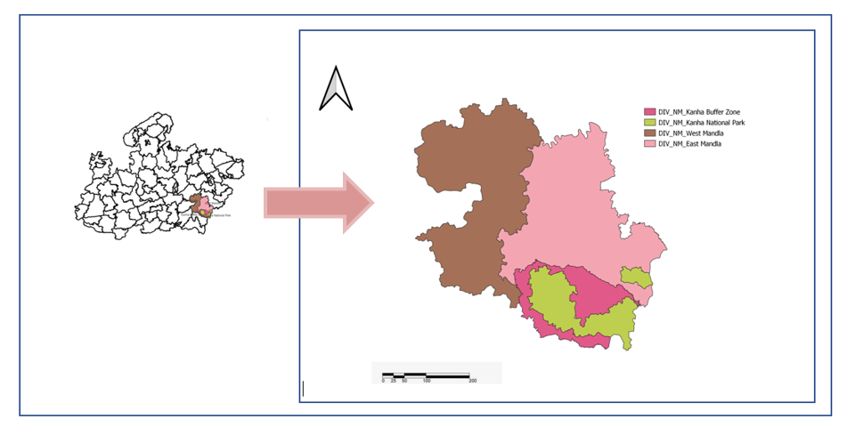
Phen WLS (KTR

Fig.1:- Forest Divisional Map of Mandla district, Madhya Pradesh, India

Sample Distribution
The samples were taken from the two territorial divisions and one protected area i.e. 1. East Mandla forest division (EMFD), 2. West Mandla forest division (WMFD) and 3. Kanha Tiger Reserve (KTR). This district has 17 forest ranges consisting of 74 forest villages and many revenue villages. A total of 237 sampling plots have been laid in the district, separated in two major groups i.e. Teak (160 sampling plots) and Sal (77 sampling plots) dominated forest. Data has been collected through quadrat method. Square quadrat of 10m*10m was used. The targeted areas were designated forests for the forest villages. Systematic random sampling method was used and quadrats have been laid in every 500meter.
Parameters taken
For the analysis of the data PAST software was used. Comparative analysis has been done for the two forest types & key NWFPs. Distribution and Diversity indices such as Shannon-Weinner index (H) of diversity accounting for both the number of species (richness) and their relative abundance (evenness), providing a comprehensive measure of diversity and Simpson’s(1-D) index measuring the probability that two individuals randomly selected from a sample will belong to different species were calculated. A higher value indicates greater diversity and less dominance by any single species. To understand the relative importance of species, Importance Value Index (IVI) has been calculated using frequency, density and abundance values (Schweik,1998; Gosain et.al, 2015; Ishoro & Isha, 2017). The formula for all the parameters are given below:
Distribution of Species both in Teak and Sal dominated forests assessed by-
- Frequency and Relative frequency:
Frequency:
(Occurrence of species in sampling plots/ Total number of quadrats)*100
Relative Frequency (RF):
(Frequency of a species/ Total Frequency of all species)*100
- Density and Relative Density:
Density:
(Total no. of individuals of a species / area sampled in hectare)

Relative Density (RD):
(Density of a species / Total density of all species) * 100
- Abundance and Relative Abundance:
Abundance:
(Total no. of individuals a species/Occurrence of that species)
Relative Abundance (RA):
(Abundance of species / Total abundance of all species) * 100

- Importance Value Index:
Summation of (RF + RD + RA)

For understanding of Diversity different parameters were used:
5. The Shannon-Weinner Diversity Index, often denoted as H or H′, is calculated using the following formula:
(H) = -∑i​(Pi​LnPi​)
Where: H = the Shannon-Weaver Diversity Index
pi​ = the proportion of individuals belonging to the i-th species (calculated as the number of individuals of species i divided by the total number of individuals in the community)
ln = the natural logarithm
- The formula for Simpson's 1-D (also known as the Gini-Simpson index) is:
(1−D) = 1−(∑N(N−1)ni​(ni​−1)​)
Where:ni​ = the number of individuals of species i
N = the total number of individuals of all species
∑ = the sum over all species
- Evenness_e^H/S (Buzas and Gibson's Evenness): This index is calculated as: EvennesseH/S​ = SeH​
Where: e = Euler's number (the base of the natural logarithm, approximately 2.71828)
H = is the Shannon-Weinner Diversity Index
S = is the total number of species (Taxa_S)
Result
During this study, it has been seen that 93 species belonging to 35 families are widely present in the Mandla district. A total of 23151 individuals including tree, shrub and seedling were counted for all the species. Samples were taken in teak(160) & sal(77) dominated forests and the total no. of plants excluding the seedlings are 7070 and 4699 found respectively. In the Tropical dry deciduous teak dominated forest 71 species were found whereas 66 species were found in Tropical moist deciduous sal dominated forest. In Sal forest both Tendu & Mahua is rarely found whereas sal alone dominated the forest with the relative density of 46.47. On the other hand in teak dominated forest Tendu and Mahua plants are comparatively more in number.
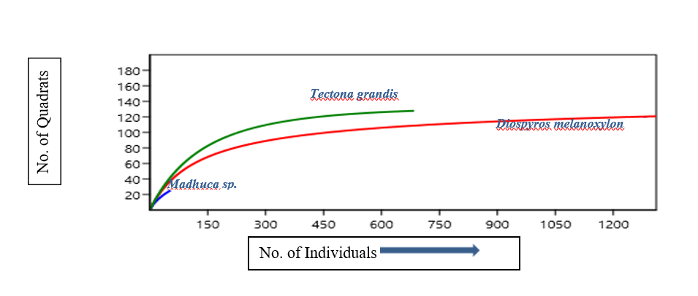

Fig.2: Species area curve of major NWFPs in Teak dominated forest

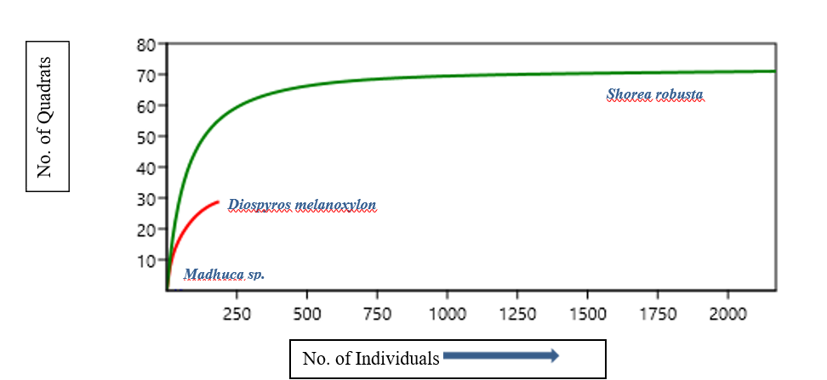

Fig.3: Species area curve of major NWFPs Sal dominated forest

Fig:3. Species area curve of major NWFPs in Sal dominated forest

Figure 2 and 3 illustrate the relationship between the number of individuals and the number of quadrats for different NWFP species in teak and sal-dominated forests. The curves for each species indicate how the species richness accumulates with increasing sampling effort. In both forest types, Tectona grandis and Shorea robusta show a higher number of quadrats compared to Diospyros melanoxylon and Madhuca sp., suggesting these species are more dominant or widely distributed within their respective forest types.
Distribution: In figure 4 and 5 compares three diversity indices between Moist Deciduous Sal Forest (MDSF) and Dry Deciduous Teak Forest (DDTF). The indices measured are Simpson's Diversity Index (Simpson_1-D), Shannon Diversity Index (Shannon_H), and Evenness (Evenness_e^H/S). The bars represent the indices for the two forest types, with blue for MDSF and yellow for DDTF.
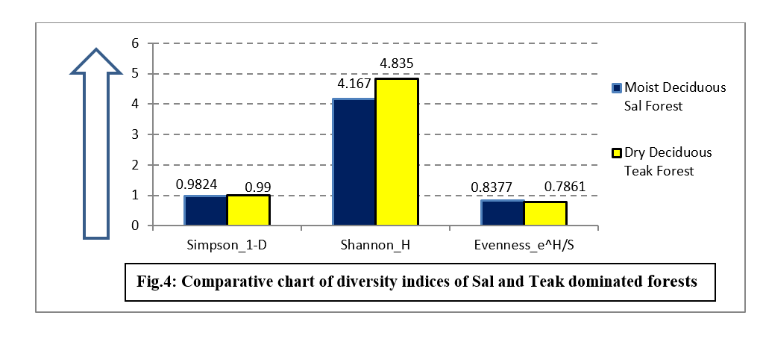
- Simpson's Diversity Index (Simpson_1-D): This index shows a slightly higher diversity in the DDTF(0.99) compared to the MDSF(0.9824), indicating a more even distribution of species in the teak forest.
- Shannon Diversity Index (Shannon_H): The Shannon index is higher in the DDTF(4.835), suggesting greater species richness and diversity in the teak forest compared to the sal(4.167) forest.
- Evenness (Evenness_e^H/S): The evenness index is slightly higher in the MDSF(0.8377) than DDTF(0.7861) indicating a more uniform distribution of individuals among the species present in the sal forest.
The comparative chart effectively highlights the differences in biodiversity between the two forest types, with the DDTF showing higher overall diversity but slightly lower evenness compared to the MDSF. These findings are crucial for understanding the ecological dynamics and management practices required for these forest ecosystems.

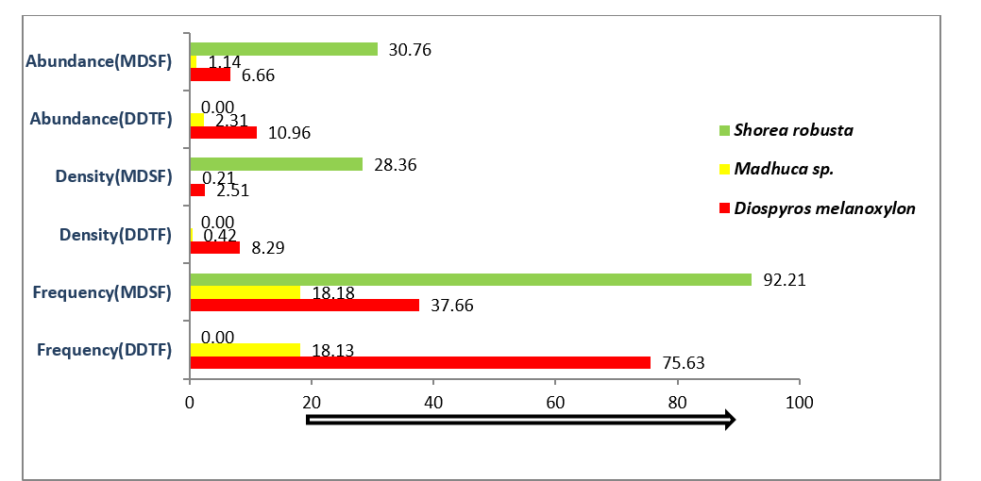
Fig.5: Comparative chart of Frequency, Density and Abundance of major NWFPs in Sal & Teak forest of Central India

Mandla district being the transitional zone from Tropical dry deciduous to Tropical moist deciduous forest, Mavai range of EMFD is the place where shift from Tectona grandis to Shorea robusta can be seen. Shorea robusta is a Key NWFP of the district which shows a frequency of 92.21 as it is found only in fewer places of the district. While Madhuca sp. being one of the most important NTFP shows only 18.18 and 18.13 frequency in Sal & Teak forest respectively. Diospyros melanoxylon shows a very high frequency (75.63) in teak forest than in Sal forest (37.66). This comparative chart highlights the significant differences in the distribution and ecological importance of these NWFP species between the two forest types. Shorea robusta is highly dominant in the MDSF but absent in the DDTF. In contrast, Diospyros melanoxylon shows higher frequency and density in the teak forest. Madhuca sp. is moderately present in both forests with relatively consistent values across all parameters.

Importance value index indicates the relative importance of a species in the community in a particular area. The aggregation of relative frequency, relative density, and relative abundance are used here. This figure illustrates the importance value (IV) index of three major NWFP species in two types of forests: Dry Deciduous Teak Forest (DDTF) and Moist Deciduous Sal Forest (MDSF). The y-axis represents the IV index, while the x-axis lists the species. Diospyros melanoxylon shows a higher (28.41) IVI in the teak forest, indicating its greater ecological significance in this forest type compared to the sal forest (11.10). The IVI for Madhuca sp. is relatively low in both forest types, with a slightly higher value (3.26) in the teak forest than sal forest (2.82), suggesting it has a minor but comparable ecological role in both forest ecosystems. Shorea robusta is highly dominant in the MDSF forest, as indicated by its high (69.84) IV index, whereas it is absent in the DDTF. This highlights its critical ecological importance and prevalence in the ecosystem.
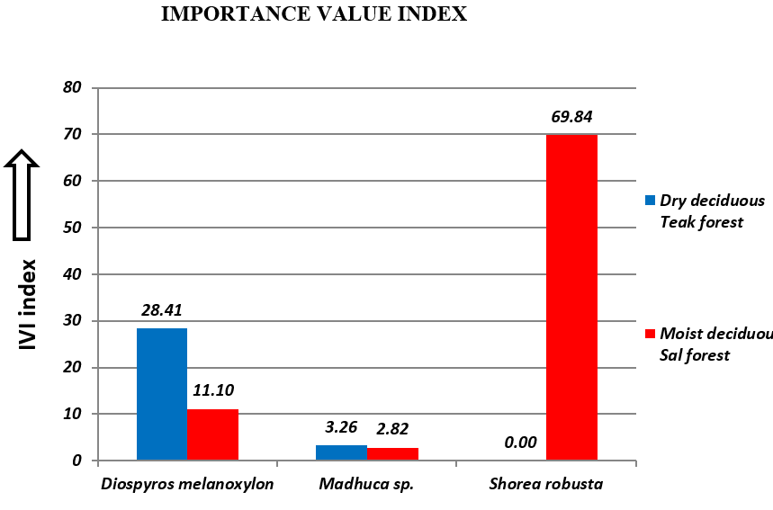
Fig.6: Comparative Importance value index of major NWFPs in Sal and Teak forest

The table below shows the species in both the forest types present very high in numbers. In Moist deciduous forest the maximum plants found is Shorea robusta (2184), while the number of other species ranges from 378 to 100. However, in Dry deciduous forests the plants a more homogenously distributed. The numbers range from 1756 to 115 starting with Anogeissus latifolia. Tectona gradis comes at third (696) in the list.

Table 1. Tree species found highest in Sal forest
Scientific Name | Usage | Parts used | NW usage
Shorea robusta | T/NT | Timber/ Seed | Seed oil in food and cosmetic industries
Mallotus philippensis | NT | Fruit | Dye
Diospyros melanoxylon | T/NT | Timber/Leaf/Fruit | Leaf as Indian cigarette wrap/Fruit as food
Embelia basal | NT | Fruit | Medicines
Catunaregam spinose | NT | Bark/Fruit/Leaf | Medicine/Food
Phoenix sylvestris | NT | Leaves/Fruits | Handicraft/Food
Terminalia elliptica | T | Timber | -
Syzgium cumini | T/NT | Timber/ Fruit | Food
Terminalia chebula | T/NT | Timber/ Fruit | Medicines
Table 2. Tree species found highest in Teak forest
Scientific Name | Usage | Parts used | NW usage
Anogeissus latifolia | T | Timber | Resin in confectionaries and medicinal purposes
Diospyros melanoxylon | T/NT | Timber/Leaf/Fruit | Leaf as Indian cigarette wrap/Fruit as food
Tectona grandis | T | Timber | -
Terminalia elliptica | T | Timber | -
Langerstroemia parviflora | NT | Timber | -
Carissa opaca | NT | Fruit | Food/Medicines
Miliusa tomentosa | NT | Fruit/Leaf | Leaf oil in medicines
Cassia fistula | NT | Bark/Fruit/Leaf/Flower | Medicine/Food
Butea monosperma | NT | Flower | Dye/Medicine
Flacourtia indica | NT | Fruit/Root | Medicine
Casearia graveolens | NT | Fruit/Leaf | Traditional fishing/ Medicine
Catunaregam spinose | T | Bark/Fruit/Leaf | Medicine/Food
Diospyros montana | T | Timber | -

Household survey results
A total of 188 households were surveyed in 45 forest villages of the district of Mandla. It has been observed that among the respondents, 82% were male and only 18% were female. Among the respondents 70% of them belong to a medium family size, which is 5-6 people in a family. The major population is Scheduled tribe (72%), dominated by Gond (97%) & Baiga (3%), and the others are OBC (18%). Among the respondents, 57% of the families have an LPG connection (Liquid Petroleum Gas) after the intervention “Ujwala Yojana”. The average Mahua flower and Tendu patta collection in the year 2022 was 193 kg and 1767 gaddi per household, respectively. The average selling price per unit of Mahua and Tendu patta is Rs. 35 and Rs. 4. While the market price for Mahua flower fluctuates based on the production, demand-supply dynamics and quality, whereas the price of Tendu patta is fixed by the forest department and private companies through a specific government route where forest department plays the role of a facilitator.

Discussion
The study conducted in the forests of Mandla district, Madhya Pradesh, offers significant insights into the distribution and diversity of Non-Wood Forest Products (NWFPs) within two distinct forest types, the Tropical Dry Deciduous Teak Forest (DDTF) and the Tropical Moist Deciduous Sal Forest (MDSF). While both forest types exhibit high diversity in both Shannon(H) (Teak forest: 4.835, Sal forest: 4.167) and Simpson's(1-D) (Teak forest: 0.99, Sal forest: 0.98), the nuances in their species composition and distribution hold significant implications for livelihood strategies and ecosystem resilience. The results indicate that Teak-dominated forests (DDTF), despite being characterised by Tectona grandis, actually present a more even distribution of species (Evenness: 0.7861) and a higher overall species richness. These findings are in line with recent research emphasising the importance of diverse natural assets for rural livelihood resilience, especially in the face of socio-economic and environmental changes (Bora & Mahanta, 2022; Mahedi et al., 2025). The comparatively higher frequency of Diospyros melanoxylon (Tendu) in Teak forests (75.63%) with a substantial Importance Value Index (IVI) of 28.41 further solidifies its socio-ecological importance in these areas, confirming its "lifeline" status as noted in our conclusion. In contrast, the Sal-dominated forests (MDSF), while still diverse, exhibit a pronounced dominance by Shorea robusta, as evidenced by its overwhelming relative density (46.47) and a very high IVI (69.84). This high dominance, although indicating the ecological significance of Sal, contributes to a slightly lower overall diversity (Shannon H: 4.167) and a higher evenness (0.8377), which could imply a less heterogeneous understory. While Shorea robusta is a major NWFP species (Sal seed), such high dominance can indicate a less resilient ecosystem, potentially more vulnerable to species-specific threats like pests, diseases, or the targeted impacts of climate change (Patasaraiya et al., 2023). Our observation aligns with research indicating that communities, while stable, can sometimes be more susceptible to large-scale disturbances if dominated by a single species (Dutta & Devi, 2013; Kumar & Saikia, 2018). The findings reveal that while both forest types harbour a rich diversity of species, Shorea robusta in Sal forests and Diospyros melanoxylon in Teak forests emerge as ecologically significant and economically vital. Interestingly, Madhuca sp. (Mahua), another "lifeline" NWFP, shows consistently low frequency in both forest types' interior plots, despite its immense economic and cultural value.
The high frequency and IVI of Diospyros melanoxylon in Teak forests directly correlate with its importance as Tendu leaf, a critical livelihood source for many households, as reflected by the reported average collection of 1767 gaddi per household. This localised abundance contrasts with its lower frequency in Sal forests, suggesting that micro-climatic or edaphic conditions favour its presence in drier teak-dominated landscapes, as stated in our conclusion. This also emphasises the need for forest management strategies that are ecologically tailored to specific forest types (Gosain et al., 2015; Ishoro & Isha, 2017). Observation that Madhuca sp. is "majorly present near the agricultural lands surrounding the villages" rather than deep within the sampled forest plots is crucial. This highlights a significant "Outside Forest Area" (OFA) contribution to NWFP production, a dimension increasingly recognised in forest resource assessments (Forest Survey of India, 2021). This spatial distribution suggests that sustainable management strategies for Mahua must extend beyond traditional forest boundaries to include agroforestry systems and village common lands, where a substantial portion of this resource is likely harvested. Such integrated landscape approaches are vital for comprehensive resource management and livelihood security (Mahedi et al., 2025). This holistic perspective is gaining prominence in contemporary sustainable forest management paradigms, recognising the interconnectedness of different land uses for resource availability and community resilience (FAO, 2018). A recent study (Dishan et al., 2022) on forest reserves in Adamawa State, similarly highlights the crucial importance of assessing the diversity and regeneration potential of Non-Timber Forest Product species for sustainable use and community livelihoods.
The household survey results highlight the human dimension of NWFP reliance. The high percentage of Scheduled Tribe households (72%), particularly Gond and Baiga, reinforces the deep cultural and economic ties to these forest products. The average Mahua flower and Tendu patta collection figures provide concrete evidence of their ongoing economic significance for direct consumption and income generation. The presence of LPG connections in 57% of households (due to the "Ujwala Yojana") indicates a potential shift away from fuelwood dependency, which might reduce pressure on certain forest resources.
Conclusion:
The study demonstrates that both Teak and Sal forests in the Mandla district are highly diverse in NWFP species, collectively providing vital alternative livelihoods to local communities. Findings clearly show that while both forest types are ecologically rich, their species composition and distribution patterns are significantly different. The Teak forests exhibit higher overall diversity and species richness, contributing to a more even distribution of species and greater potential for livelihood diversification. In contrast, Sal forests, while diverse, show a pronounced dominance by Shorea robusta, which contributes to their unique ecological character but may also create livelihood vulnerabilities due to a heavier reliance on a single species. The higher diversity and evenness in Teak forests suggest opportunities for promoting a broad portfolio of NWFPs, fostering diversified value chains, and potentially developing community-based enterprises that leverage this ecological breadth. For Sal forests, the dominance of Shorea robusta necessitates targeted interventions to reduce over-reliance. This could involve promoting the sustainable harvest of lesser-known or underutilised NWFPs in the understory, or actively exploring the cultivation of high-value species in suitable areas to ease pressure on wild populations. These approaches align with modern forest conservation efforts that seek to balance ecological integrity with community needs (ICFRE, 2020-2024). The research highlights the varying ecological and economic importance of different NWFP species in these forests. The study results imply that there is a need for tailored forest management strategies that consider the specific ecological characteristics of each forest type and the spatial distribution of key NWFP species. By recognising these distinctions and integrating a landscape-level approach that includes areas outside traditional forest boundaries, Mandla can move towards more resilient and equitable forest-dependent communities, ensuring the sustainable utilisation and conservation of these invaluable natural resources. This research provides a robust baseline for future targeted conservation, value chain development, and livelihood enhancement programs in Central India. Future management plans should encompass not only reserved forests but also community forests, village common lands, and agroforestry systems, where a substantial portion of NWFPs are harvested. Further research is required to delve deeper into how climatic shifts impact the phenology and yield of specific NWFPs like Mahua and Tendu, and how communities are adapting their collection strategies. The challenge of accurately quantifying "personal consumption" also highlights the need for participatory research methodologies that can capture the full subsistence and cultural value of NWFPs, beyond their commercial metrics, ensuring a more comprehensive understanding for policy development.

Disclaimer for Preprint:

This paper is an extended version of a preprint document of the same author.
The preprint document is available in this link: https://www.researchsquare.com/article/rs-4944221/v1
[As per journal policy, preprint /repository article can be published as a journal article, provided it is not published in any other journal]

Disclaimer (Artificial intelligence)
Author(s) hereby declare that generative AI technologies such as Large Language Models, etc. have been used during the writing or editing of manuscripts. This explanation will include the name, version, model, and source of the generative AI technology and as well as all input prompts provided to the generative AI technology
Details of the AI usage are given below:
1. Use of Elicit AI for finding relevant reviews
2. Use if Grammarly to check for grammar errors
3.

References:
- Bora, M., & Mahanta, R. (2022). Rural livelihood diversification among tribal communities of North-Eastern Region of India: A systematic review. ResearchGate.
- Dishan, E. E., Abdullahi, U., Nasiru, Y., & Gujja, A. A. (2022). Diversity and regeneration potentials of some non-timber forest product species (NTFPS) in Bagale Hill Forest Reserve, Girei Local Government Area of Adamawa State. Asian Journal of Research in Agriculture and Forestry, 8(4), 1–14. https://doi.org/10.9734/ajraf/2022/v8i430160
- Dutta, G., & Devi, A. (2013). Plant diversity and community structure in tropical moist deciduous sal (Shorea robusta Gaertn.) forest of Assam, Northeast India. Journal of ISSN, 2319, 8745.
- Dutta, R., & Devi, S. (2013). Phytosociological analysis of tropical moist deciduous forests in Assam, India. Journal of Forestry Research, 24(3), 517–526.
- FAO. (2018). Management of non-wood forest products. Food and Agriculture Organization of the United Nations. https://www.fao.org/sustainable-forest-management/toolbox/modules/management-of-non-wood-forest-products/basic-knowledge/en/
- FAO. (2018). Non-wood forest products: Their contribution to sustainable livelihoods and biodiversity conservation (FAO Forestry Paper). Food and Agriculture Organization of the United Nations.
- Forest Survey of India. (2021). India state of forest report 2021. Ministry of Environment, Forest and Climate Change, Government of India.
- Gosain, B. G., Negi, G. C., Dhyani, P. P., Bargali, S. S., & Saxena, R. (2015). Ecosystem services of forests: Carbon stock in vegetation and soil components in a watershed of Kumaun Himalaya, India. International Journal of Ecology and Environmental Sciences, 41(3–4), 177–188.
- Gosain, V., Singh, K. P., & Singh, J. S. (2015). Importance Value Index (IVI) and its application in ecological studies. International Journal of Environmental Sciences, 5(6), 947–954.
- Indian Council of Forestry Research and Education (ICFRE). (2000). Draft national forestry research plan. ICFRE.
- Indian Council of Forestry Research and Education (ICFRE). (2020–2024). Annual reports. (Please cite specific year(s) or relevant report when referencing particular data.)
- Ishoro, A. P., & Aja, E. E. (2017). Forests of Northern Cross River State, Nigeria. International Journal.
- Ishoro, D., & Isha, N. N. (2017). Importance Value Index (IVI) as a tool for characterization of plant communities in Southern Ethiopia. Journal of Ecosystem & Ecography, 7(1), 1–5.
- Krishnen, P. (2013). Jungle trees of Central India. Penguin Books.
- Kumar, A., & Saikia, P. C. (2018). Status of diversity and distribution of non-timber forest products in tropical moist deciduous forest of Bodoland Territorial Council, Assam, India. Journal of Pharmacognosy and Phytochemistry, 7(3), 209–213.
- Kumar, R., & Saikia, P. (2021). Population structure and regeneration status of Shorea robusta and associated trees in sal forests of Ranchi, Eastern India. Tropical Ecology, 62(1), 34–51.
- Mahedi, M., Pervez, A. K. M. K., Rahman, S. M. M., Sheikh, M. M., & Shaili, S. J. (2025). Emerging trends in livelihood diversification in rural communities: A bibliometric and systematic review. Asian Journal of Agricultural Extension, Economics & Sociology, 43(4), 162–177.
- Matta, A. F. (2019). Collection of non-timber forest products and dynamics of forest dependence. International Journal of Social Science and Economic Research, 4(3), 2455–8834.
- Matta, A. F. (2019). Non-timber forest products: Challenges and opportunities for sustainable rural livelihoods. Journal of Forest Science, 65(3), 89–98.
- MFP Federation, MP, & National Planning Commission. (2011). Report of the Sub‐Group‐II on NTFP and their sustainable management in the 12th Five‐Year Plan. Government of India.
- Pandey, S. K., & Shukla, R. P. (2003). Plant diversity in managed sal (Shorea robusta Gaertn.) forests of Gorakhpur, India: Species composition, regeneration and conservation. Biodiversity and Conservation, 12, 2295–2319. https://doi.org/10.1023/A:1024558617085
- Patasaraiya, M. K., Parihar, J. S., Kumar, D., & Pathak, V. (2023). Predicting impacts of climate change on teak and sal forests in Central India using maximum entropy modeling: An approach for future conservation and silvicultural strategies. Journal of Applied Meteorology and Climatology, 62(5), 717–734.
- Prasad, R. (1999). Joint forest management in India and the impact of state control over non-wood forest products. Unasylva, 198, 58–62.
- Schweik, C. M. (1998). Social norms and human foraging: An investigation into the spatial distribution of Shorea robusta in Nepal. Forest Resources and Institutions, Working Paper 3. Forest, Trees and People Programme.
- Singhal, R. M. (2000). Minor forest products and their role in rural economy of India. Journal of Tropical Forest Science, 12(4), 720–730.
- Srinivas, K. N. S. S. S., Kishore, P. P., & Rao, D. S. (2019). The geological site characterization of the Mandla region, Eastern Deccan Volcanic Province, Central India. Journal of Earth System Science, 128, Article 79. https://doi.org/10.1007/s12040-019-1096-7
- Tripathi, A. K., & Shankar, U. (2014). Patterns of species dominance, diversity and dispersion in ‘Khasi hill sal’ forest ecosystem in Northeast India. Forest Ecosystems, 1(1), 23.
- Webb, E. L., & Sah, R. N. (2003). Structure and diversity of natural and managed sal (Shorea robusta Gaertn. f.) forest in the Terai of Nepal. Forest Ecology and Management, 176(1–3), 337–353.

