**Spatiotemporal Hydroclimate anomalies in Bhubaneswar City, India (2000–2024): Using GIS and Python**

**Abstract**

The investigation identifies the geographic focus on the smart city of Bhubaneswar, Odisha, India, within the timeframe (2000–2024). The study identifies seasonal trends, extreme events, and their impacts on climate and human life. The maps are prepared using Python, like scatter plots of mean monthly and yearly rainfall (line, box, bar, and pie charts, etc.). Further, GIS-based maps prepared are the annual Rainfall distribution map of Odisha, the choropleth map for temperature distribution, slope map, relief and contour map of Bhubaneswar smart city, highlighting spatial impacts in Bhubaneswar zones (e.g., Bomi Khal, Naya Palli), etc. The slope, the contour and the population. Slum pockets maps have been prepared from the data of the Government of Odisha, NIC data and Digital Elevation Model. The analysis, supported by Python libraries (pandas, matplotlib, seaborn, geopandas, folium). The study identifies seasonal trends, extreme events and their impacts on climate and human life, focusing on urban flooding, infrastructure, health, agriculture and environmental degradation, with a geoinformatics approach. Recommendations include GIS-driven drainage mapping, rainwater harvesting, resource management, and climate-smart planning, with future research proposed for long-term trends and geospatial adaptation strategies. The extreme events of rainfall cause waterlogged areas, urban flooding and fatalities due to heat strokes. The study discusses the impacts on climate and human life and supports the town planners and developers in climate-resilient planning, allied with SDGs 11 and 13 for sustainable urban dwellings, developing a zero slums concept in the sustainable smart city, Bhubaneswar.

**Keywords: Climate Change, Rainfall trend, GIS, Machine Learning, Bhubaneswar, Climate change**

**1.0.0 Introduction**

The Bhubaneswar, or the “temple city of Odisha”, is the capital of the coastal state in India. The 75-year-old city is a citizen-centred urban conglomeration is an emerging hub for knowledge, health and information technology, and a popular tourist destination. Started in 1950 with a population of 16000 and a geographical area of 28.7 sq km as capital of Odisha, has sprawled to 148 sq.km with a population of more than 1.2million on loss of agricultural and water bodies to infrastructural surge as on date. The Bhubaneswar (BBSR) enjoys a tropical savanna climate (Aw) with distinct wet (June–September) and dry (November–March) seasons, receiving ~1600 mm annual rainfall. The urbanisation, infrastructural development since 2000 have included it as a smart city, but challenges like flooding, waterlogging, environmental degradation and portable water scarcity, persist due to erratic rainfall and climate change. Geo-informatics, leveraging GIS and Python, enables spatial analysis of the patterns and their impacts (Parida et al, 2023; Mishra et al, 2024; Das SK., 2025).

The average (av.) rainfall of Odisha is ≈160 cm, with the Indian Summer Monsoon (ISM) being the highest contributor during the Southwest Monsoon period (July-September), Bay of Bengal Disturbances, and mainly positioning of Inter Tropical Convergence Zone (ITCZ), El-Nino and La-Nina impacts, etc (Mishra et al., 2019). The July-September months are the wettest, when the six coastal rivers cause floods associated with devastation. The districts receive small rainfall from the retreating monsoon and other local disturbances in October to December. The months January to March generally experience dry weather. The av. annual rainfall of the State is found as ≈ 1438 mm, which includes 78% during the southwest monsoon Mishra et al, 2015; Pravakar et al., 2019,

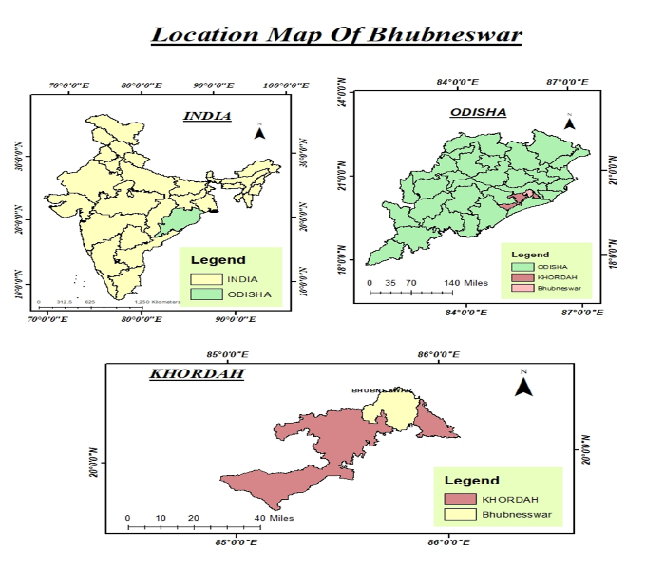

**Fig 1: The index Map of Bhubaneswar, the smart city in Odisha**

Rainfall variability impacts Bhubaneswar’s infrastructure, health, agriculture, and environment. Flooding disrupts urban life, while dry periods strain water resources. As Geoinformatics students, we use Python and GIS tools (geopandas, folium) to analyse these patterns spatially, offering data-driven solutions for urban planners and policymakers to enhance Bhubaneswar’s climate resilience (Mishra SP., 2015; Kagabo et al., 2024). The present study involves monthly rainfall data (2000–2024) to study trends, extreme events, and their Impacts, integrating a GIS map and Python, a good fit for ANNs.

**1.2.0 Literature Review**

There is increasing variability and negative incongruities in Indian Summer monsoon rainfall over India that impair decreased rainfall trends and have an impact on crop yield. These findings warrant immediate adaptive measures to recoup rainfall patterns, to ensure sustainable agricultural practices and efficient water resource management **(**Mishra et al, 2020**;** Sharma et al., 2022; Awasthi N.,2023; Chakraborty et al., 2025). Urban very heavy rainfall events of a short duration have become common, causing Urban flood hazards, causing potential socioeconomic impacts (Mishra et al, 2020, Sui et al., 2024, Boyaj et al, 2025)

The analysis of yearly rainfall for four to five decades suggests that the rate of rainfall in the Ganga basin is depleting @ 5.08mm/year,(av precipitation decreasing from 1333 mm/year to 1200 mm/year). A rising trend in rainfall was detected in the pre-monsoon period, whereas all the basin was influenced by negative trends (-0.04%) for other months with increasing frequency and intensity of drought. The climate studies in the Himalayan region are warranted, and there is a delay in onset and also withdrawal of ISM, (Gruhakarta et al, 2006, Kulkarni et al 2020, Parjuli et al, 2021, Poornima et al, 2023, Soni et al, 2023, Rashiq et al, 2024, Behera SBB et al., 2025, Ali et al, 2025)

Last 100 years, the coastal state, Odisha has noteworthy vacillations in rainfall trend. Some studies claim a decrease in trend and some an increase, but unanimously admit an overall increase in annual rainfall with a few numbers of higher extreme rainfall events. There is a nonlinear relationship in variations of rainfall intensity, frequency and spatial dispersal across seasons and regions. The decrease is there but not significant, (Patra et al, 2012, Sahu et al, 2015,Joshi et al, 2017, Pravakar et al., 2019,Mishra et al., 2022, Maharana 2024).

On analysis of data from Gruhakarta et al, 2006 updated), it is found that the decade 1901-1910 is most deficient rainfall and 2001-2010 is the most surplus rainfall during the study period 1871 - 2024, the decadal mean of percentage of departure from normal (-120%) is lowest during 1901-1910 and highest during 2001-2010 392.16% from mean. The deficient precipitation decades are 1941 to 1950, 1961 to 1980 and 1991-2000, and the excess decades are 1911 to 1930, 1931 to 1940, 1951 to 1960, 1981 to 1990 and 2011-2020, respectively (Swain et al., 2023). The Smart city Bhubaneswar, a forest of Chandaka range in the 1950’s has been agglomerated and extended up to the Cuttack City in the north (Trivdi et al, 2023; Panigrahi et al, 2025)

Machine Learning (ML) is a dependable methodology that can deliver a substantial prognostic benefit, among the modern computational models in challenging real-world problems like rainfall, snowfall and many natural climatological parameters (Kumar et al, 2023). There is meagre literature available about Python or Machine Learning (ML) procedures to analyse the rainfall of the Smart city. The present work uses the Python method, which is one of the best-fit predictive models in ML.

**1.3.0 Objectives**

1. To analyse monthly and yearly rainfall patterns in Bhubaneswar (2000–2024) using Python.
2. To identify extreme rainfall events and seasonal trends with statistical and visualisation tools.
3. To assess the impacts of climate on the habitat of the area, focusing on flooding, infrastructure, health, agriculture, and the environment.
4. To map rainfall impacts spatially using GIS tools and recommend geospatial mitigation strategies.

2.0.0 **Rainfall trend in India and Odisha**

The annual rainfall trend in India varies from region to region, where the trend is either increasing or decreasing. The variability in yearly rainfall ranges from a dry period having rainfall (r/f) 953.7 mm (2009) to a wet amount of 1289.6 mm in 2020. About 55% of tehsils in India experienced a rise and 11% confronted a downward trend during in southwest monsoon rainfall in the past decade (2012-2022). India receives ≈76% (total annual rainfall) during June to September (Southwest monsoon months). These variations in trends are allied with climate change due to El Niño-Southern Oscillation (ONI) and its impact on the Indian summer monsoon (ISM) and Monsoon variability and climate change cycles (Pravu et al, 2024)

There is a growing trend in the Oct-Nov (OND) rainfall along the tehsils of Odisha, the east coast, due to the NE monsoon. This upsurge could be partially credited to the Bay of Bengal (BoB), cyclonic disturbances (CDs). Odisha is observing a late SW monsoon arrival present days. The data from IMD from 1901 to 2023 was analysed for the long-term spatial-temporal disparities and trends in SW monsoon rainfall (Behera et al, 2025)

The Bhubaneswar in the Mahanadi delta has a hot and humid climate with old alluvium soils at the apex of the river Katha Jodi and its anastomosis of drainage channels drains through the swamps of the Chilika lagoon. The blend of Eastern Ghats Hills and the deltaic triangle of the rivers the Kuakhai, the Bhargavi and the river Daya and their inflowing drains. The area receives a lion's share of rainfall from south south-south-east monsoon; the Bay of Bengal disturbances and the cumulus and cumulonimbus clouds formed over the Chandaka Forest range and the Khandagiri hills range.

**a.**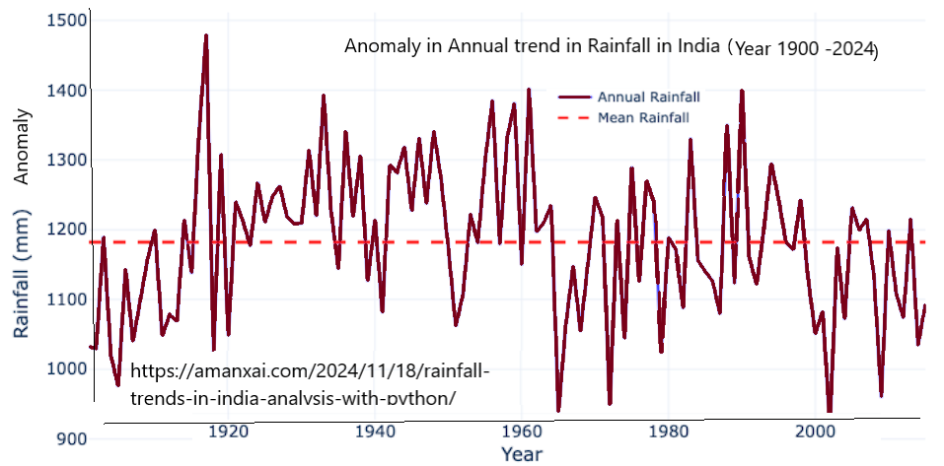

**b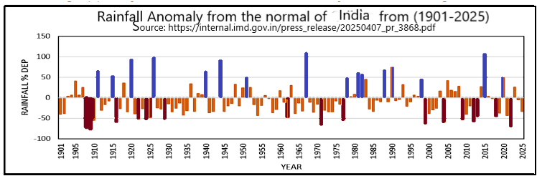.**

**Fig 2: (a) Annual Average. Rainfall in mm (b) Rainfall (mm) anomaly (1900 to 2025) in India (Source: IMD)**

Long-term rainfall analysis reveals that the mean annual rainfall of the district is 1290 ± 314 mm, most of which is received during the SW monsoon (86%), followed by post-monsoon (6.2%), pre-monsoon (5.7%) and least during winter (2.1%). (Skarlatos et al, 2023)

**2.1.0 Rainfall Patterns in Bhubaneswar**

Bhubaneswar’s rainfall peaks during monsoons (e.g., July 2024: 19.293 cm) and is near-zero in winters (e.g., November mean: 0.099 cm). The dataset (2000, 2005, 2010, 2015, 2020, 2024) shows extremes like September 2010 (16.458 cm), indicating flood risks, and prolonged dry periods, signalling water scarcity. Urbanisation exacerbates these issues, necessitating GIS-based spatial analysis.

**2.2.0 Problem Statement**

Erratic rainfall in Bhubaneswar causes flooding, infrastructure damage, health risks, agricultural losses, and environmental stress, worsened by poor urban planning. This study quantifies these patterns using Python, maps their impact spatially with GIS, and proposes geospatial solutions to bridge the gap in localised, data-driven climate resilience strategies.

**3.0.0 Methodology (Data Management)**

Past annual rainfall data for Odisha from 2000 to 2024 for 25 years are considered for analysis of trend, variability, and mean rainfall patterns. These data have been obtained from Kaggle, India (Secondary data). The monthly rainfall data (season) were gathered as: Winter (Jan-Feb), Pre-monsoon Season (March-May), monsoon Season (June-Sept), Post-monsoon season (Oct-Dec). For the spatial form, av. Rainfall, variability, and trends, the district rainfall series, and these data are used.

Research (e.g., 2023 environmental study) notes urban sprawl intensifying rainfall in Bhubaneswar, overwhelming drainage systems. Extreme events (e.g., 195 mm in 24 hours, July 2018) cause floods, while dry winters reduce groundwater. Social media (2023–2024) highlights waterlogging in Bomi Khal, pointing to blocked drains. These studies underscore the need for GIS-driven solutions, which this project addresses using Python and geopandas.

**3.1.0 Data Analysis**

Python libraries used are *Pandas:* For statistical analysis (mean, standard deviation, coefficient of variation), Metrics, mean monthly rainfall for seasonal patterns, and Extreme events (>10 cm classified as heavy rainfall). The variability is found from the standard deviation and the coefficient of variation. *Impact Assessment:* Qualitative analysis of flooding, health, agriculture, and environmental effects, supported by local reports and spatial insights.

**Table 1 - Monthly RF Data of Bhubaneswar city (2000–2024) in cm (Source: Kaggle website)**

|  |  |  |  |  |  |  |  |  |  |  |  |  |
| --- | --- | --- | --- | --- | --- | --- | --- | --- | --- | --- | --- | --- |
| **Year** | **Jan** | **Feb** | **Mar** | **Apr** | **May** | **Jun** | **Jul** | **Aug** | **Sep** | **Oct** | **Nov** | **Dec** |
| 2000 | 0.000 | 0.000 | 0.151 | 0.019 | 0.245 | 7.359 | 9.567 | 6.571 | 2.517 | 0.264 | 0.000 | 0.000 |
| 2005 | 3.150 | 0.454 | 0.010 | 0.553 | 0.797 | 7.761 | 10.457 | 7.385 | 9.133 | 1.628 | 0.007 | 0.000 |
| 2010 | 0.000 | 0.000 | 0.000 | 0.000 | 0.000 | 2.339 | 12.671 | 11.404 | 16.458 | 3.699 | 0.586 | 1.449 |
| 2015 | 0.952 | 0.000 | 0.709 | 1.035 | 0.335 | 10.156 | 5.155 | 7.843 | 10.993 | 0.522 | 0.000 | 0.000 |
| 2020 | 0.126 | 0.657 | 1.723 | 0.000 | 0.804 | 9.302 | 4.500 | 8.704 | 2.679 | 1.529 | 0.000 | 0.000 |
| 2024 | 0.170 | 0.009 | 0.642 | 0.178 | 2.382 | 2.733 | 19.293 | 4.512 | 11.555 | 0.440 | 0.000 | 0.003 |

The dataset likely represents daily or event-specific measurements, given lower values compared to monthly averages (e.g., July: ~397 mm).

3.2.0 **Visualisation Tools**

Eight visualisation maps were generated from the data. They are (a)Mean Monthly Rainfall Scatter Plot (Shows av. Rainfall/month (**Fig. 3.a**). (b). Annual Rainfall Scatter Plots (Displaying monthly rainfall/year in a 3x2 grid (**Fig. 3.b**), (c)Choropleth Map: showing the rainfall impact scores across Bhubaneswar zones (2024 data) using geopandas and folium (**Fig. 3.c**), (d) Line Plot: portraying the Monthly rainfall by year (**Fig. 3.d**). (e). Box Plot exhibiting distribution of rainfall by month (**Fig. 3.e**), Bar Plot shows annual mean rainfall, Bar Plot give figure of monthly rainfall by year (**Fig. 3.f)** andPie Chart: Proportion of mean annual rainfall **(Fig. 3.g).**

The various plots are:

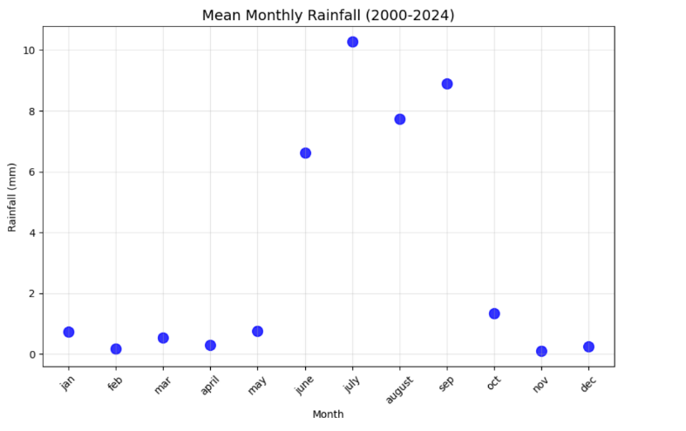

a.

**Fig. 3 (a): Mean Monthly Rainfall Scatter Plot for Bhubaneswar (2000–2024)**

The result shows that the mean monthly rainfall is optimum with peaks in July (10.274 cm) and September (8.889 cm). The mean monthly rainfall is minimum in February, November and December.

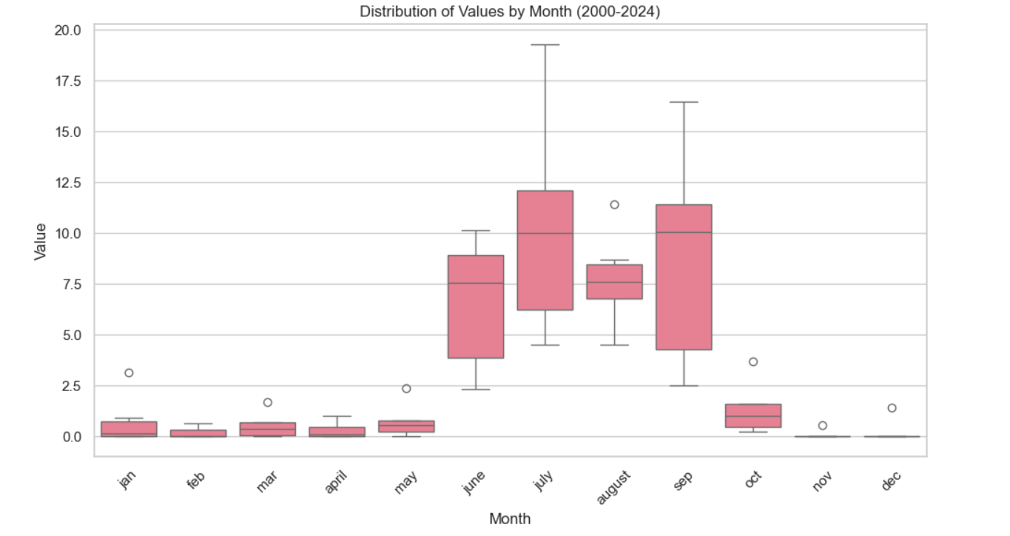

**Fig. 3. (b): Box Plot: Distribution of Rainfall by Month BBSR, (2000–2024)**

The spread and outliers/ month are July has the widest range, with outliers like 19.293 cm (2024).]

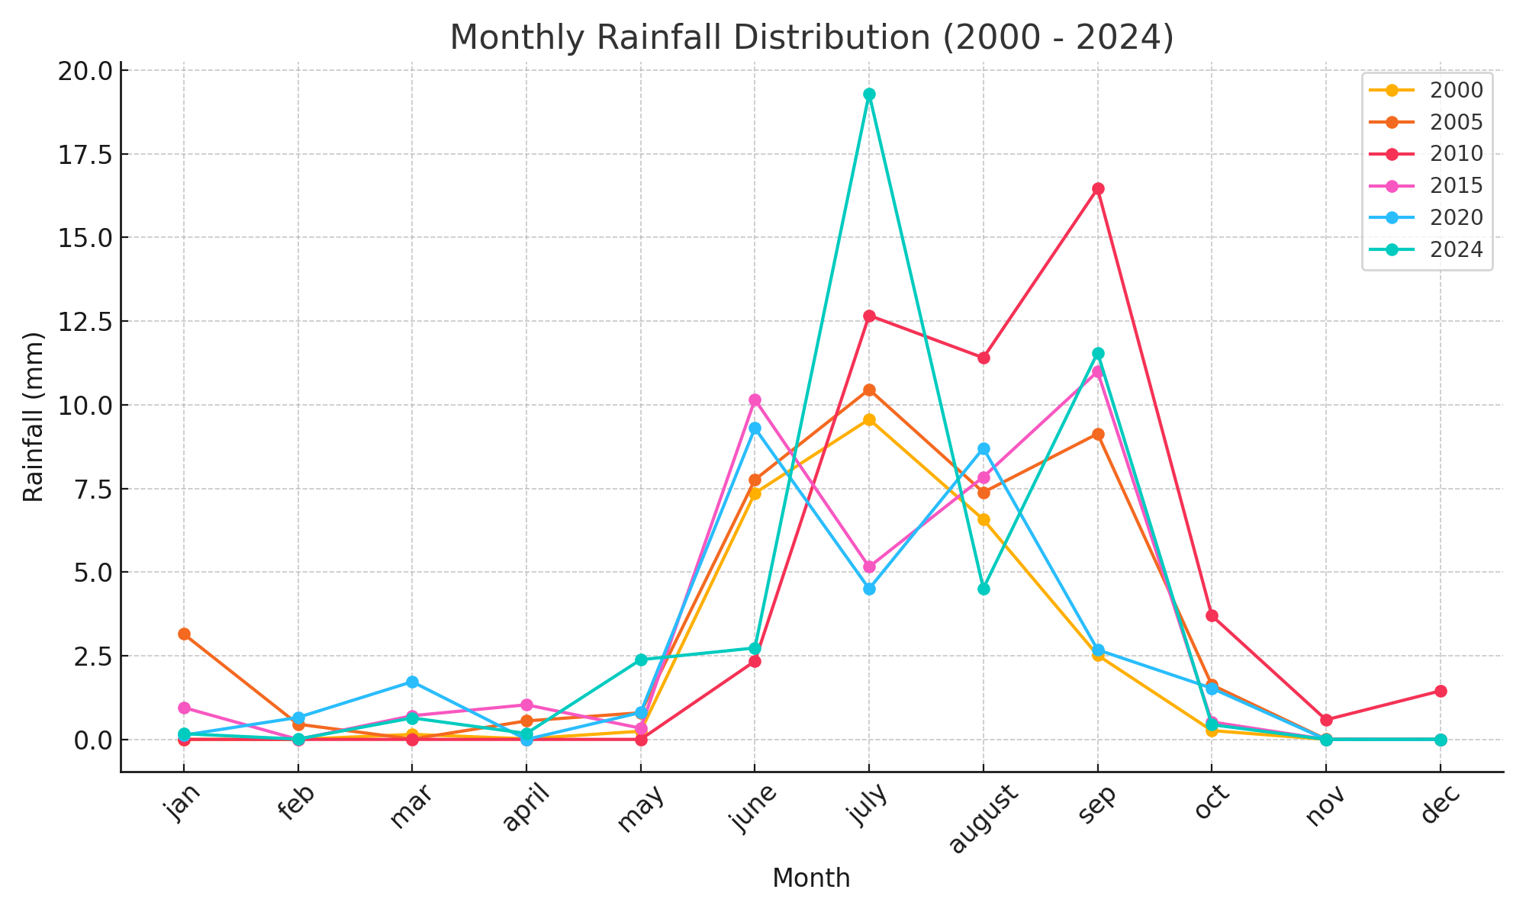

**Fig 3(c): Line Plot for Monthly Rainfall Bhubaneswar during the Year (2000–2024)**

The map is generated using Appendix code one / year) for the years 2000, 2005, 2010, 2015, and 2024 with markers, peaking in July during the year 2024: is 19.293 cm. Legend identifies years.]

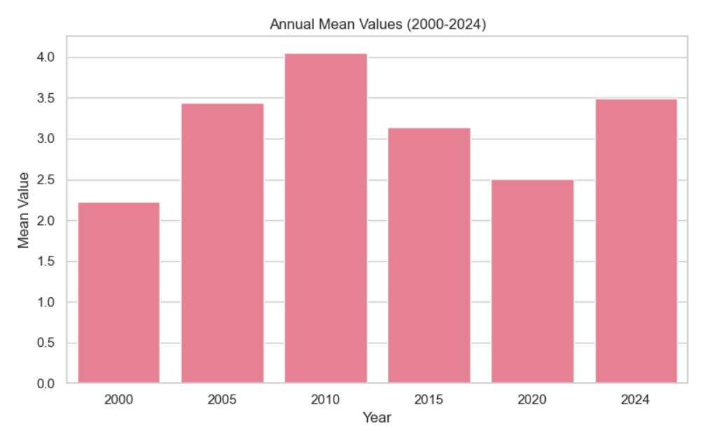

**Fig 3 (d): Bar Plot: Monthly Rainfall by Year (2000–2024)**

The plot displays mean rainfall per year, with 2010 (4.050 cm) highest.

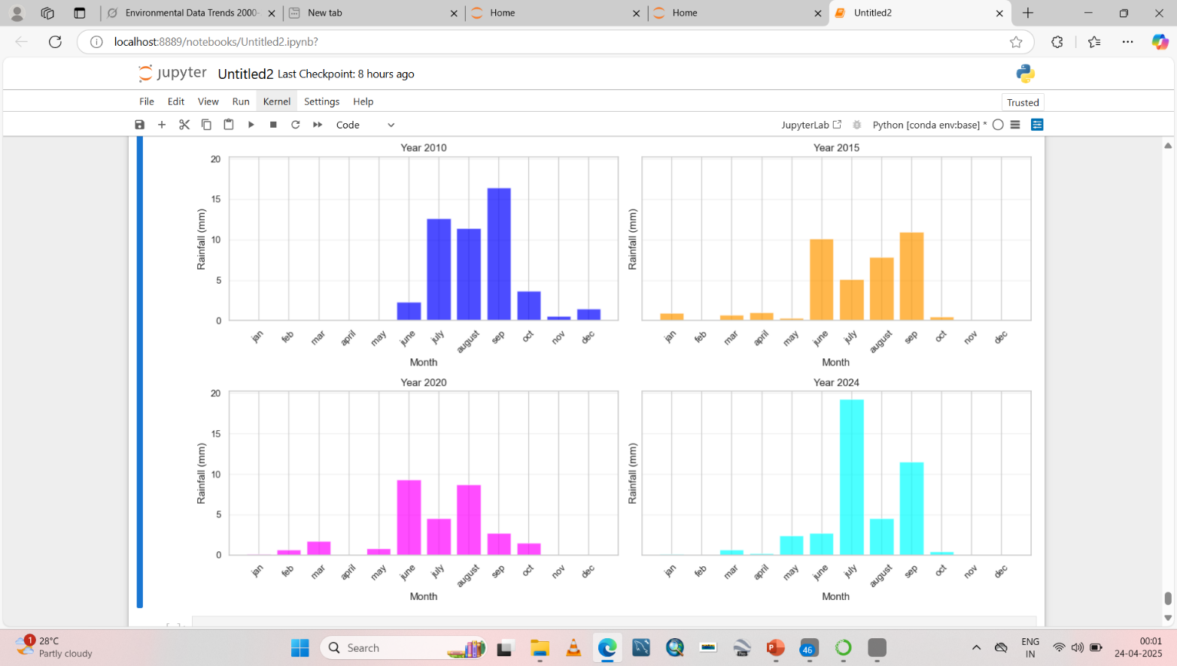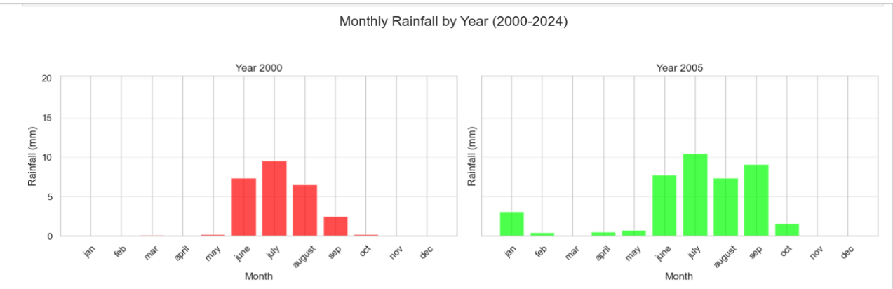

**Fig 3 (e): Bar Plot shows annual mean rainfall, Bar Plot give the fig. of monthly rainfall by year**

The 3x2 grid of bar plots, each showing monthly rainfall per year. July 2024 (19.293 cm) is prominent.

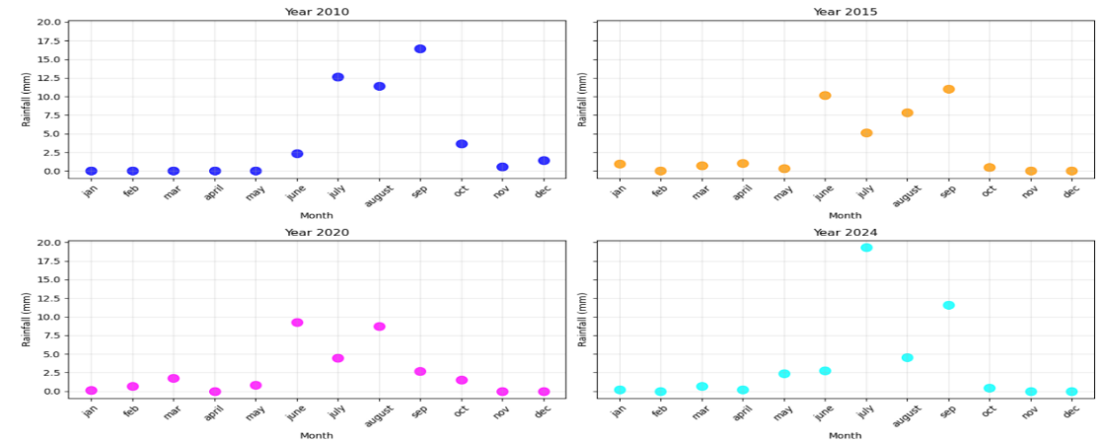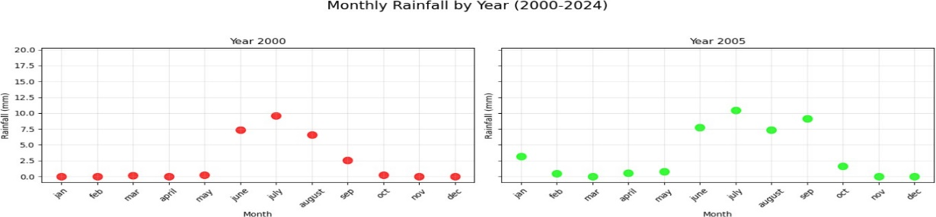

**Fig. 3 f) Yearly Rainfall Scatter Plots of Bhubaneswar City in cm (2000–2024)**

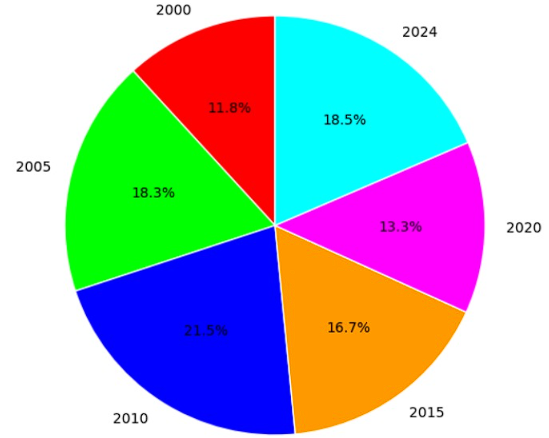

**Fig 3(g): Pie Chart: Proportion of Mean Annual Rainfall (2000–2024) of Bhubaneswar.**

[3x2 grid, each subplot for one year (2000, 2005, 2010, 2015, 2020, 2024). Colours: Red (2000), Green (2005), Blue (2010), Yellow (2015), Magenta (2020), Cyan (2024). Highlights extremes, e.g., July 2024 (19.293 cm, cyan).]

The results of the pie chart indicate that among all the years from 2000 to 2024, the year 2010 has contributed 20.7% of the total mean rainfall, followed by the precipitation in the year 2024, sharing 17.8% of the total.

**4.0.0 Rainfall Patterns**

Key findings from the study are:

• *Seasonal Trends*: Monsoons (June–September) dominate, with July (mean: 10.274 cm) and September (8.889 cm) peaking. Winters (November–March) are dry (e.g., November: 0.099 cm).

• *Extreme Events:* 10 months exceed 10 cm (e.g., July 2024: 19.293 cm, September 2010: 16.458 cm), averaging 1.67 heavy events/year.

• *Variability:* Monsoon months have high variability (July std dev: 5.568 cm); winters are stable (November std dev: 0.239 cm).

**4.1.0 Impacts on Climate**

* Hydrological Cycle: Extreme events (e.g., July 2024: 19.293 cm) indicate intensified precipitation, aligning with climate change.
* Soil Erosion: Heavy rains (August mean: 7.736 cm) cause runoff, eroding soil and releasing carbon.
* Water Quality: Monsoon runoff pollutes water bodies; dry periods (December: 0.242 cm) reduce replenishment.

**4.2.0 Heatmap of Bhubaneswar:**

The smart city, Bhubaneswar, emerged during the 1950s rapidly urbanising city, and presently experiences the urban heat island (UHI) effect. This means the city's average temperature is higher than surrounding rural areas due to the concentration of buildings, roads, and other infrastructure that absorb and retain more heat than natural landscapes. Studies have shown that Bhubaneswar has seen a significant increase in built-up areas and a corresponding decrease in vegetation and water bodies, contributing to the UHI effect (Fig. 4).

**a.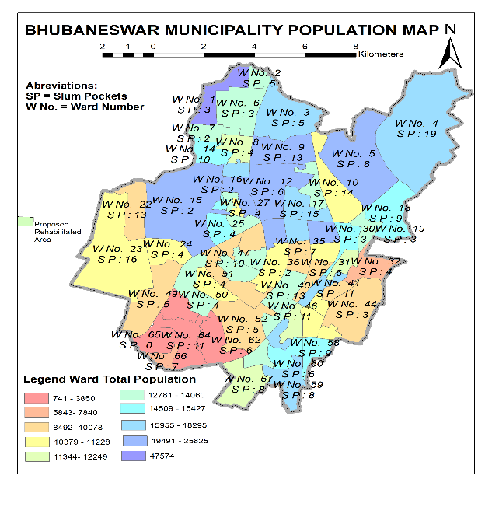b.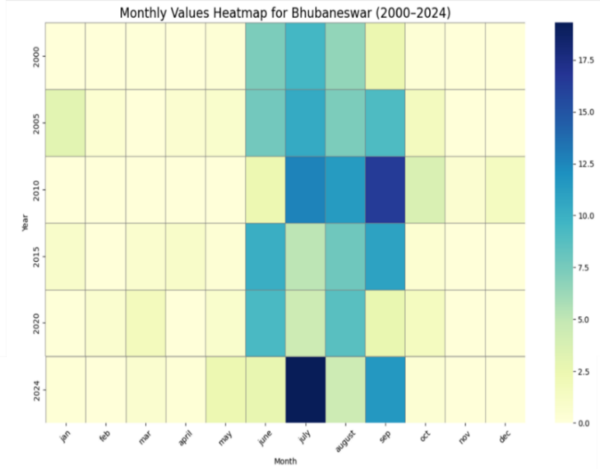Fig 4(a-b): The population and the heat map turned into a heat Island, the city**

**4.3.0 Impacts on Human Life**

Climate change (CC) and extreme rainfall events have an impact on the people of the smart city of Bhubaneswar, like disruptions to daily life, increased health risks, and threats to livelihoods. The interruption to daily lifestyle is flooding, waterlogging, flow over roads disrupting transportation, homes and public spaces inundations, causing substantial inconvenience to people. The lifeline of the city, i.e. communication, is disturbed, roads, infrastructures, buildings, power supply, traffic congestion, and deaths in open roadside drains disrupt access to essential services and livelihoods (Mishra et al, 2017).

Bhubaneswar City was once calm, healthy, and solitude tempted to migrate from other towns. The surge in rainfall, the 12 number anastomosed drains in the heart of the city have congested the free discharge and waterlogging increases the vectors and the deadly diseases like dengue, malaria, and chikungunya spreads, the water borne diseases (Diarrhoea, dysentery. Hepatitis etc.), heat waves, lightening and vulnerabilities like storm impact and mental health disorders. (Mishra et al, 2020). The city started with 16000 population is now about 12,3000, and the smart city has raised its maximum temperature. The ward-wise slum pockets and municipality population, and the heat map are shown in Fig. 4 (a and b).

The threats to livelihood are loss of forests, loss of agriculture, loss of water bodies and loss of fisheries. The other threats to livelihood are loss of agriculture, forest products, fisheries and a rural peaceful atmosphere and other impacts of climate change issues. There are some specific anthropogenic issues related to Bhubaneswar, such as industrialisation, deforestation, urbanisation, urban heat island effect, BoB Cyclone impacts, lightning impacts, and thundersqualls etc.

The results obtained from the analytical studies are,

* *Urban Flooding: Extreme events* (e.g., September 2010: 16.458 cm) cause waterlogging in Bomi Khal, Nayapalli, and Rasulgarh. A 2024 event (43.9 mm in 30 minutes) flooded roads.
* *Infrastructure*: Blocked drains exacerbate floods (2023 social media reports).
* *Health:* Waterlogging increases dengue; thunderstorms pose lightning risks (2024 incident).
* *Agriculture:* Intense rains damage crops; dry winters (November: 0.099 mm) limit irrigation.
* *Environment:* Low winter rainfall reduces groundwater, risking depletion (2025 reports).
* *Renovation of waterbodies:* There are 105 ponds of different sizes, a source of public health issues.

**4.0.0 The GIS studies**

4.1.0 **GIS Integration**

GIS analysis was performed using **Geopandas** to handle spatial data (simulated GeoJSON for Bhubaneswar zones used for large data of Bomi Khal, Nayapalli, Rasulgarh, Saheed Nagar) (Fig. 5).

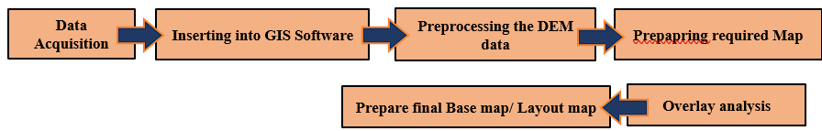

**Figure 5:The workflow diagram for preparing GIS maps of the Kopai River basin**

**4.1.1 Rainfall Trend of Odisha**

The cyclic long-term rainfall patterns (season-wise) over Odisha are heterogeneous and varying in frequency, magnitude and period (Pravakar et al, 2019; Nageswar Rao et al, 2019). The annual trend is increasing from south to north Odisha. The annual rainfall is decreasing from north to south, i.e. from Balasore to Ganjam.in June and August, and an increasing trend during July and September (Majumdar et al., 2025)

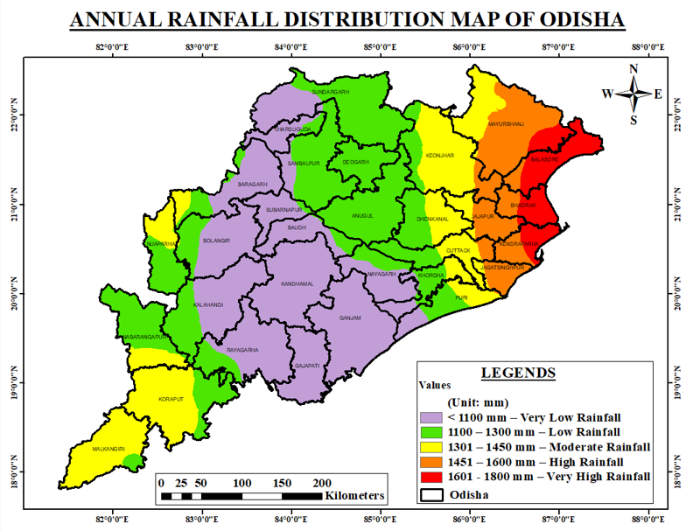

**Fig. 6: Annual Rainfall distribution GIS Map of Odisha.**

**4.2.0 GIS-Based Spatial Analysis**

GIS analysis mapped rainfall impacts in 2024 across four Bhubaneswar zones:

* Zones: Bomi Khal, Nayapalli, Rasulgarh, Saheed Nagar.
* Impact Scores: Calculated based on July–September 2024 rainfall (sum: 35.360 cm) and flooding reports (e.g., Bomi Khal frequently flooded). Scores range from 1 (low impact) to 5 (high impact).

Table 2 – The different Zones in Bhubaneswar and Rainfall Impact Scores (in cm)

| **Zone** | **Rainfall Sum (Jul–Sep 2024, cm)** | **Flooding Reports** | **Impact Score** |
| --- | --- | --- | --- |
| Bomikhal | 35.360 | High | 5 |
| Nayapalli | 35.360 | Moderate | 4 |
| Rasulgarh | 35.360 | Moderate | 4 |
| Saheed Nagar | 35.360 | Low | 2 |

Insights: Spatial analysis highlights Bomikhal’s vulnerability due to poor drainage, informing targeted urban planning.

**4.3.0 The Choropleth Map:**

Folium can be used to create an interactive choropleth map visualizing rainfall impact scores (based on 2024 rainfall intensity and reported flooding).The various steps used are Assigning impact scores (1–5) to zones based on rainfall data and flooding reports, merging rainfall data with spatial data for mapping, generated an interactive map saved as HTML for stakeholder use.

Table 3 - Mean Monthly Rainfall and Variability in Bhubaneswar in different months

|  |  |  |  |  |  |  |  |  |  |  |  |  |
| --- | --- | --- | --- | --- | --- | --- | --- | --- | --- | --- | --- | --- |
| Month | Jan | Feb | Mar | Apr | May | June | July | Aug | Sept | Oct | Nov | Dec |
| Mean (cm) | 0.733 | 0.187 | 0.539 | 0.297 | 0.760 | 6.608 | 10.274 | 7.736 | 8.889 | 1.347 | 0.099 | 0.242 |
| Std Dev (mm) | 1.224 | 0.267 | 0.634 | 0.393 | 0.893 | 3.270 | 5.568 | 2.374 | 5.345 | 1.270 | 0.239 | 0.591 |

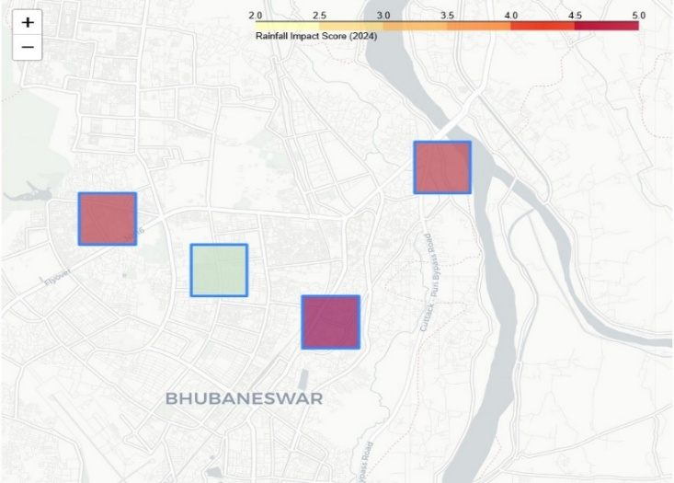

Fig 7: Mean Monthly Rainfall and Variability at various zones of BMC. (The choropleth map)

[Interactive map centred on Bhubaneswar (20.29°N, 85.85°E). Zones colored by impact score (YlOrRd scale): Bomi Khal (dark red, score 5), Saheed Nagar (light yellow, score 2). Tooltips show the zone name and impact score on hover. Saved as HTML, viewable in a browser.]

* 1. **Slope Map Bhubaneswar:**

The slope imagery is a useful tool that visualises the the topographic gradient and its direction for environmental planning and city infrastructural management, agricultural establishment, urban prospective planning, and disaster confronting measures.In Bhubaneswar the agricultural university has been developed with a favourable contour that helps in farming.

a.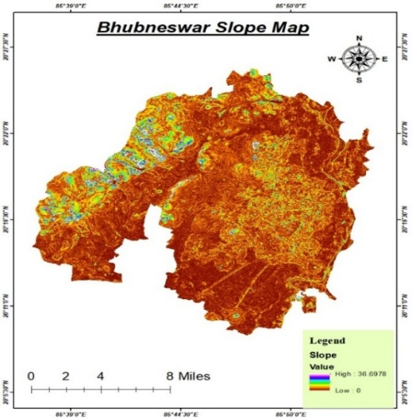b.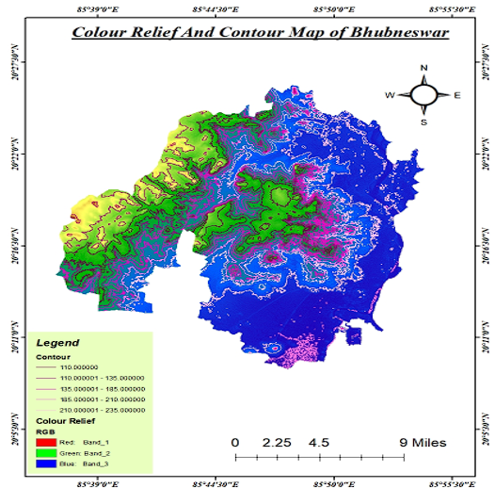

c.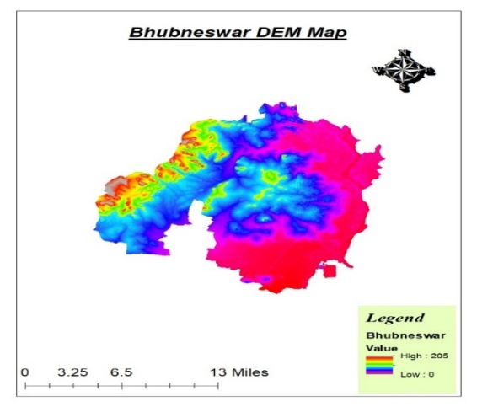d.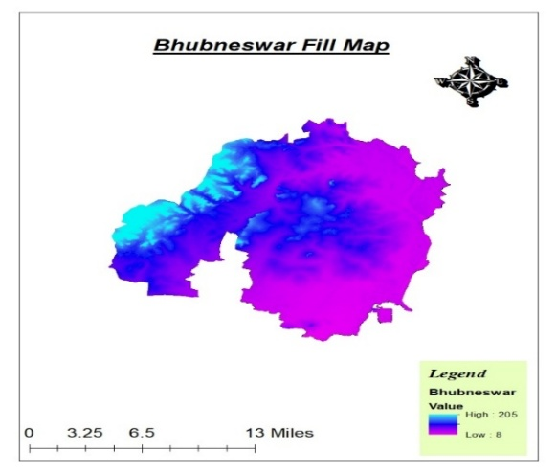

**Fig 8 (a-d): (a) The slope map, (b) The relief (contour) map, (c) DEM map, (d) The fill map of Bhubaneswar city**

**5.1.0 Discussions:**

Long-term Rainfall trend of an area is done by methods/techniques to comprehend and quantify rainfall trends (frequency, region and patterns). The inferences obtained by the analysis can be used for water resource (WR) management, flood prediction, and climate change issues. The dataset search includes monthly rainfall (mm) for Bhubaneswar for the period 2000 to 2024. The extreme events are found in the years 2000, 2005, 2010, 2015, 2020, and 2024. The erratic rainfall has a direct burden on urban waste management systems, flood disruptions and underground aquifers. Adaptive resolutions to the challenges are rainwater harvesting, efficient reservoir operation, watershed planning, and resilient drainage systems. Findings support climate-resilient planning aligned with SDGs 11 and 13 for sustainable urban living in vulnerable regions.

**SDG 11 and SDG 13 compliance:**

The Bhubaneswar smart city, the capital of Odisha, is facing climate change impacts through a rainfall pattern alteration that can influence the town’s sustainability, so it should be focused on Sustainable Development Goal 11 (SDG 11), intensely focusing on sustainable cities with an average. Rainfall 1449.1mm/year. (mainly between June to early November). The SDG-13 and the environment lessen GHG emissions and need transformative adaptations to ameliorate intensifying heatwaves, urban flooding, and destructive actions of tropical storms in the Bay of Bengal.

**5.2.0 Summary**

The project analysed Bhubaneswar’s rainfall (2000–2024), finding heavy monsoon rainfall (July: 10.274 mm), dry winters (November: 0.099 mm), and extreme events (e.g., July 2024: 19.293 mm). Impacts include flooding, health risks, crop damage, and water scarcity, worsened by urbanisation. GIS mapping identified Bomi Khal as highly vulnerable, using Python-driven spatial analysis.

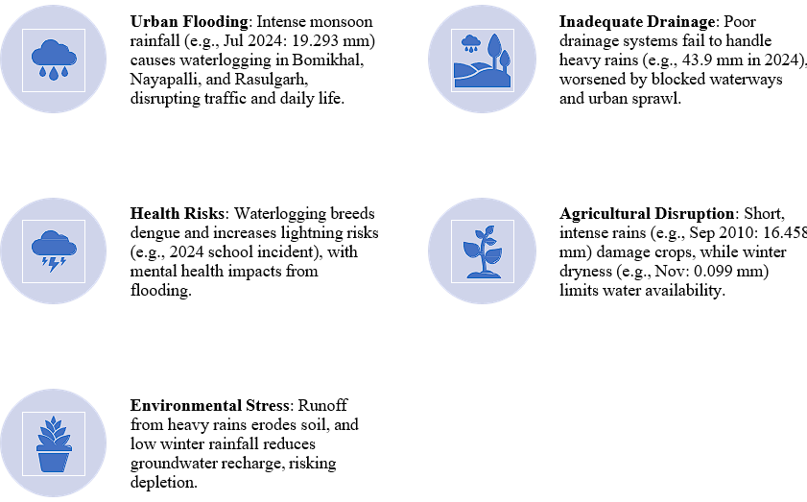 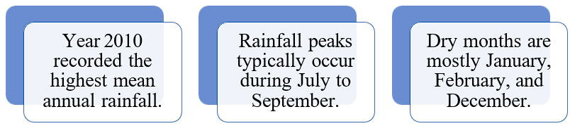

**Figure 9: The impact of rainfall on the environment and the people of the smart city Bhubaneswar**

**5.2.1 Addressing the Challenges:**

**From vertical to Horizontal (Climate-Resilient Infrastructures):**

The climate-resilient structures, like effective transportation, water bodies, drainage systems and flood defences, to be encouraged. Paucity of area has urged for vertical growth of the city instead of N-S horizontal sprawl to accommodate more people in less area and efficient urban management and fulfil the zero-slum predicament.

**5.2.2 Sewage and Sewerage Facilities:**

The sewage disposal and sanitation issues in Bhubaneswar are currently in a mess and deteriorated, and are still facing challenges. Some areas have appropriate sewerage infrastructure within the township, but the proper treatment of sewage and disposal of waste is still less developed. The liquid waste disposal needs prioritisation as the river is carrying all the liquid wastes and causing challenges and threatening health issues, depriving downstream people of their riparian rights (Joshi et al, 2019).

**5.2.3 Augmented WASH (Water, Sanitation and Hygiene) services:**

To encourage healthy life style, the ameliorating solutions are public community toilets, wash rooms, roadside urinals, subways, foot paths, , park, gardens, the cremation/burial grounds, and roadside children parks are to be constructed more in number. Open defecation needs to be banned by creating awareness.

**5.2.4 Disaster Preparedness:**

Bhubaneswar city is exposed to a variety of natural/anthropogenic disasters including cyclones (Fani, Philine and Hudhud) etc., floods, urban flooding, waste disposal and heat waves. Strengthening warning systems, disaster combating strategies, and early evacuation plans need to be prioritised, which requires essential minimisation of extreme weather events.

**5.2.5 Sustainable Urban Planning:**

Planning for satellite cities around Bhubaneswar for better human management and reducing transportation costs. Encouraging sustainable municipal planning practices that minimally optimise the urban heat island (UHI) effect and expand/recover past urban resilience. Adequate planning and seclusion of inhabited areas from official and commercially viable areas shall weaken traffic congestion, slum and shanty areas, unhygienic environment and noise pollution and keep away the stray dogs and animals from unhealthy areas.

**5.2.6 Community Awareness and Participation:**

Raising public awareness about climate change and its impacts and engaging communities in adaptation and mitigation efforts is crucial. The city managers are actively stressing the climate change mitigation and adaptation issues, and focusing on community involvement. The app, "Mu City Saviour" permits Bhubaneswar residents to complain about drainage challenges, and work on participatory flood management, whereas suburban people to focus on resilient and sustainable urban planning, green building practices, etc.

**5.2.7 Modification of Livelihoods:**

Encouraging diversification of livelihoods beyond climate-sensitive sectors can reduce vulnerability to climate change. The migration from rural to urban areas needs to be downscaled to maintain the smart-city health.

**5.2.8 Cleaning and renovating water bodies and natural drains:**

The Bhubaneswar Municipal Corporation is stressed over the stagnated ponds with ipomoea and water Hyacinths, which need reclamation and immediate renovation. The natural drainage channels which are encroached or have profuse aquatic plants are under process of renovation.

**5.2.9 Clearing encroachments:**

The drains, slums and and the water bodies are encroached by a group of people for dwelling or defecation areas by landless people and a lean attitude of the Municipality and government officials. Immediate actions need to be taken against them by clearing these unauthorised occupations, though the zero slum concept is in vogue and practised in the smart city..

**5.3 Factors Contributing to UHI in Bhubaneswar:**

The factors are rapid urbanisation, land use and land cover changes, deforestation and vegetation loss in the western zone areas, exploitation for agglomerating townships, which are having adverse effects like increased demand, carbon footprint, infrastructural strains and deteriorating air quality and increasing rainfall anomalies. Increase Green Cover. Prompt actions are essential for increasing greenness, creating green buildings, and groundwater recharging, along with public awareness by incorporating environmental studies from the primary level among the children. :

**6.0 Conclusions**

This manuscript provides critical insights into the spatio-temporal variability of rainfall in Bhubaneswar City over 24 years, highlighting the growing impacts of climate anomalies on urban infrastructure, health, and resource management. By integrating GIS and Python-based data analysis, the study presents a replicable model for climate-resilient planning in a rapidly urbanising smart city. The machine learning method, Python and GIS are applied to solve the erratic rainfall of Bhubaneswar City to reveal varying rainfall challenges. Strong ISM causes inundation, urban flooding and waterlogging of low-lying areas. The dry winters invite heat island impacts and cause heat-wave deaths. Applying GIS analysis or Machine learning (Python) methodologies, one can identify the high-risk zones and urge the town planners to plan and intervene on the drainage upgradation, rooftop rainwater harvesting, in the climate-resilient capital of Odisha, declared as a smart city. By integrating satellite imagery with the historical rainfall data, one can project or identify temporal trends and spatio-temporal disparities in rainfall. Present spatial models highlight vulnerable infrastructure and neighbourhoods prone to recurring inundation in the suburbs in BBSR. The present study supports the town planners and developers in climate-resilient planning for sustainable urban dwellings in vulnerable regions. Its findings contribute to the scientific understanding of localised climate change effects and support policy interventions aligned with global sustainability goals, urban planning and disaster mitigation strategies, based on climate variability, particularly SDGs 11 and 13

**DISCLAIMER (ARTIFICIAL INTELLIGENCE):** Author(s) hereby declare that NO generative AI technologies such as Large Language Models (ChatGPT, COPILOT, etc.) and text-to-image generators have been used during the writing or editing of this manuscript. AI technology is not used anywhere within the article.

**COMPETING INTEREST**: The Authors have declared that no competing interests exist.

**COMPETING INTERESTS DISCLAIMER:**

Authors have declared that they have no known competing financial interests OR non-financial interests, OR personal relationships that could have appeared to influence the work reported in this paper.

**References**:

1. Mishra, P., Jena, D., Thakur, R. R., Chand, S., Javed, B., Shukla, A. K. (2024). Peri-Urban Floodscapes: Identifying and Analysing Flood Risk Areas in North Bhubaneswar in Eastern India. Water, 16(21), 3019. https://doi.org/10.3390/w16213019
2. Parida, D., Van Assche, K., & Agrawal, S. (2023). Climate Shocks and Local Urban Conflicts: An Evolutionary Perspective on Risk Governance in Bhubaneswar. Land, 12(1), 198. <https://doi.org/10.3390/land12010198>
3. Das SK., Dynamics of spatio-temporal changes of urban land use/land cover pattern in Temple city of Bhubaneswar, Odisha, India. Plant Archives, 25 (Sup-1), 1089-1096
4. Mishra, S.P., Mahato, G.K., Mishra, S., Siddique, M. (2024). Innovative Infrastructure and Architecture for Slum Management in Smart City Bhubaneswar, 2024 2nd Int. Conf. on Signal Processing, Communication, Power and Embedded System, Parlakhemundi Campus, CUTM, Odisha, India, 1-6, doi: 10.1109/SCOPES64467.2024.10991286.
5. Prabhakar AK., Singh KK., Lohani AK., Chandniha. SK. (2019). Assessment of regional-level long‑term gridded rainfall variability over the Odisha State of India. Applied Water Science 9:93 <https://doi.org/10.1007/s13201-019-0975-z>
6. Mishra S. P. and Jena J. G., (2015) “Analytical Study of Monsoon Rainfall South Mahanadi Delta and Chilika Lagoon, Odisha” International Journal of Engineering and Technology (IJET), 7(3), 985 – 996
7. Mishra Siba Prasad, Mohammad Siddique; 2020; Rainfall variability under climatic anomalies using SVM, PSO hybrid model of Bhubaneswar Smart City; Text Engineering and management; ISSN: 0193-4120; 83; PP 14553 – 14563;
8. Sui, X., Yang, Z. L., Shepherd, M., & Niyogi, D. (2024). Global scale assessment of urban precipitation anomalies. Proceedings of the National Academy of Sciences, 121(38), e2311496121.
9. Mishra S. P., Sethi K. C., Mishra D. P., Siddique M., July 2019, Pre-monsoon cyclogenesis over Bay of Bengal, Int. Jr. of Recent Technology and Engineering (IJRTE), Vol-8(2), July 2019 , PP-4895- 4908
10. Boyaj, A., Karrevula, N.R., Swain, M. et al. Assessment of the WRF model configuration optimisation in predicting the heavy rainfall over the urban city of Bhubaneswar, India. Comput.Urban Sci. 5, 22 (2025). <https://doi.org/10.1007/s43762-025-00180-2>
11. Mishra S. P., Sethi K. C., Mohammad Siddique, 2020, Emerging threats during Anthropocene as urban Flooding of Bhubaneswar city, India, Water and Energy International, Central Board of Irrigation and Power, New Delhi, 63(RNI No 1); ISSN No;0974-4711; April 2020; pp 46-58
12. Sharma, D.; Das, S.; Goswami, B.N. Variability and Predictability of the Northeast India Summer Monsoon Rainfall. Int. J. Climatol. 2023, 43, 5248–5268
13. Awasthi, N.; Tripathi, J.N.; Petropoulos, G.P.; Kumar, P.; Singh, A.K.; Dakhore, K.K.; Ghosh, K.; Gupta, D.K.; Srivastava, P.K.; Kalogeropoulos, K. Long-Term Spatiotemporal Investigation of Various Rainfall Intensities over Central India Using EO Datasets. Hydrology 2024, 11, 27.
14. Chakraborty, D., Roy, A., Singh, N. U., Saha, S., Das, S. K., Mridha, N., Yumnam, A., Paul, P., Gowda, C., Biam, K. P., Patra, S., Amrutha, T., Singh, B. P., & Mishra, V. K. (2025). Assessing Climate Change Impact on Rainfall Patterns in Northeastern India and Its Consequences on Water Resources and Rainfed Agriculture. Earth, 6(1), 2. <https://doi.org/10.3390/earth6010002>
15. Poornima S., Pushpalatha M.; Jana, RB. Patti, LA. (2023). Rainfall forecast and drought analysis for recent and forthcoming years in India. Water, 15, 592. <https://doi.org/10.3390/w15030592>
16. Kharwal Aman, (2024), Rainfall Trends in India Analysis with Python. <https://amanxai.com/2024/11/18/rainfall-trends-in-india-analysis-with-python/>
17. Prabhakar, A.K., Singh, K.K., Lohani, A.K. et al. Assessment of regional-level long-term gridded rainfall variability over the Odisha State of India. Appl Water Sci 9, 93 (2019). <https://doi.org/10.1007/s13201-019-0975-z>
18. Mishra S. P. and Naik A. K., (2015), Time series analysis of Monsoon precipitation of Bhubaneswar, Odisha, Proc. of the national conf. On recent advances and prospects in Civil Engineering (RAFPCE-15), from 28th Feb- 1st Mar, Civil Engineering Department, Centurion University of Technology and Management, Jatni, Bhubaneswar, pp. 153.
19. Patra JP., Mishra A., Singh R., Raghuwanshi N.. (2012). Detecting rainfall trends in the twentieth century (1871–2006) over Orissa State, India. Climatic Change 111(3):801-817

DOI: 10.1007/s10584-011-0215-5

1. Rao Nageswara, M.M., Sinha, P., Mohanty, U.C., Panda, R.K., Das, G.P. (2019). Evaluation of district-level rainfall characteristics over Odisha using high-resolution gridded dataset (1901–2013). SN Appl. Sci. 1, 1211 , https://doi.org/10.1007/s42452-019-1234-5
2. Mishra, S., Sandeep, M., Jaiswal, S., & Mishra, S. P. (2022). biosis of Urban Agglomeration vs. Nature's Deterioration with Anthropocene; Odisha, 41-26, 46-65, (2022). <https://doi.org/10.9734/cjast/2022/v41i131647>
3. Behera, S.B.B., Sahu, S.C., Beuria, R. et al. Monsoon rainfall trends and change point detection affecting kharif paddy ecosystems and gross primary productivity in Odisha. Sci Rep 15, 17209 (2025). https://doi.org/10.1038/s41598-025-01346-y
4. Pravu S., Chitale V., 2024, Decoding India’s Changing Monsoon Patterns, A Tehsil-level Assessment, New Delhi: Council on Energy, Environment and Water. p 1-48
5. Behera SK. (2024). Trend analysis of rainfall in all districts of Odisha, northeastern part of India. EPRA Int. J. of Climate and Resource Economic Review, 12 ( 2), 1-13
6. Joshi A., Mishra S. P., 2017, Anthropocene Effects on the River Daya and the Lagoon Chilika by the Effluents of Bhubaneswar city, India: A physicochemical study, International Journal of Advanced. Research, 5(10), 1370-1384, : http://dx.doi. org /10.21474/IJAR01/5656
7. Maharana P., ( 2024). Projected change in the rainfall behaviour over Odisha Open Access

Journal of Water and CC. (2024) 15 (9): 4517–4535. <https://doi.org/10.2166/wcc.2024.164>

1. Sahu, R.K., Khare (2015). Spatial and temporal analysis of rainfall trend for 30 districts of

A coastal state (Odisha) of India. Int. J. of Geology, Earth & Env. Sci. 5 (1) , 41-53, 40-53 Khare<http://www.cibtech.org/jgee.htm>,

1. Soni, A. K., Tripathi, J. N., Tewari, M., Sateesh, M., & Singh, T. (2023). Future Projection of Drought Risk over Indian Meteorological Subdivisions Using Bias-Corrected CMIP6 Scenarios. Atmosphere, 14(4), 725. <https://doi.org/10.3390/atmos14040725>
2. Guhathakurta P., Rajeevan M. (2008). Trends in the rainfall pattern over India. National Climate Centre, NCC Research Report -2, 2006,
3. Swain, M., Nadimpalli, R.R., Mohanty, U.C. et al. Delay in timing and spatial reorganisation of rainfall due to urbanisation- analysis over India’s smart city Bhubaneswar. Comput.Urban Sci. 3, 8 (2023). <https://doi.org/10.1007/s43762-023-00081-2>
4. Panigrahi, M., Sharma, A. Urban growth dynamics and its influence on land surface temperature in Bhubaneswar metropolitan city: a 1990–2021 analysis. Discov Appl Sci 7, 118 (2025). <https://doi.org/10.1007/s42452-025-06535-y>
5. Trivedi, D., Sharma, O., Pattnaik, S. et al. Correction to: Improving rainfall forecast at the district scale over the eastern Indian region using deep neural network. Theor Appl Climatol 155, 779 (2024). <https://doi.org/10.1007/s00704-023-04808-3>
6. Yadav, K., Malviya, S., & Tiwari, A. K. (2025). Improving Weather Forecasting in Remote Regions Through Machine Learning. Atmosphere, 16(5), 587. <https://doi.org/10.3390/atmos16050587>
7. Kumar, V., Kedam, N., Sharma, K. V., Khedher, K. M., & Alluqmani, A. E. (2023). A Comparison of Machine Learning Models for Predicting Rainfall in Urban Metropolitan Cities. Sustainability, 15(18), 13724. <https://doi.org/10.3390/su151813724>
8. Kagabo, J., Kattel, G. R., Kazora, J., Shangwe, C. N., & Habiyakare, F. (2024). Application of Machine Learning Algorithms in Predicting Extreme Rainfall Events in Rwanda. Atmosphere, 15(6), 691. <https://doi.org/10.3390/atmos15060691>
9. Patra JC., Mishra A., Singh R., Raghuvanshi NS., (2012). Detecting rainfall trends in the twentieth century (1871–2006)over Orissa State, India. Climatic Change (2012) 111:801–817, DOI 10.1007/s10584-011-0215-5
10. Kulkarni, A. et al. (2020). Precipitation Changes in India. In book: Krishnan, R., Sanjay, J., Gnanaseelan, C., Mujumdar, M., Kulkarni, A., Chakraborty, S. (eds) Assessment of Climate Change over the Indian Region. Springer, Singapore. <https://doi.org/10.1007/978-981-15-4327-2_3>
11. Kulkarni, A., Koteswara Rao, K. (2023). Monsoon Variability and Change. In: Gahalaut, V.K., Rajeevan, M. (eds) Social and Economic Impact of Earth Sciences. Springer, Singapore. https://doi.org/10.1007/978-981-19-6929-4_4
12. Parajuli, B., Zhang, X., Deuja, S., & Liu, Y. (2021). Regional and Seasonal Precipitation and Drought Trends in Ganga–Brahmaputra Basin. Water, 13(16), 2218. <https://doi.org/10.3390/w13162218>
13. Swain, M., Nadimpalli, R., Das, A.K. et al. Urban modification of heavy rainfall: a model case study for Bhubaneswar urban region. Comput.Urban Sci. 3, 2 (2023). https://doi.org/10.1007/s43762-023-00080-3
14. Poornima, S.; Pushpalatha, M.; Jana, R.B.; Patti, L.A.(2023). Rainfall forecast and drought analysis for recent and forthcoming years in India. Water 2023, 15, 592, <https://www.mdpi.com/journal/water>
15. Rashiq A., Kumar V., Prakash, O. (2024). A spatiotemporal assessment of the precipitation variability and pattern, and an evaluation of the predictive reliability of Global Climate Models over Bihar. Hydrology, 11(4), 50. <https://doi.org/10.3390/hydrology11040050>
16. Behera, S.B.B., Sahu, S.C., Beuria, R. et al. (2025). Monsoon rainfall trends and change point detection affecting kharif paddy ecosystems and gross primary productivity in Odisha. Sci Rep 15, 17209. <https://doi.org/10.1038/s41598-025-01346-y>
17. Ali, H., Fowler, H.J. & Turner, A.G. High-resolution climate models improve simulation of monsoon rainfall changes in the Ganga–Ganga-Brahmaputra-Meghna basin. Clim Dyn 63, 246 (2025). <https://doi.org/10.1007/s00382-025-07716-6>
18. Skarlatos, K., Bekri, E. S., Georgakellos, D., Economou, P., & Bersimis, S. (2023). Projecting Annual Rainfall Timeseries Using Machine Learning Techniques. Energies, 16(3), 1459. <https://doi.org/10.3390/en16031459>
19. Mishra S. P. and Jena J. G., 2017, Management of Probabilistic Peak Flood: Mahanadi Branches draining into Chilika Lagoon, Odisha, India, International Conference on "Global Civil Engineering Challenges in Sustainable Development and Climate Change
20. Mishra S. P., Sethi K. C., Mohammad Siddique, 2020, Emerging threats during Anthropocene as urban Flooding of Bhubaneswar city, India, Water and Energy Int., Central Board of Irrig. and Power, New Delhi, 63(RNI No 1); 2020; pp 46-58
21. Prabhakar, A.K., Singh, K.K., Lohani, A.K. et al. Assessment of regional-level long-term gridded rainfall variability over the Odisha State of India. Appl Water Sci 9, 93 (2019). <https://doi.org/10.1007/s13201-019-0975-z>
22. Mazumdar T., Das B., Padhi JP., (2022).Trend Analysis of Monsoon Rainfall Over Odisha. In book: Recent Developments in Sustainable Infrastructure (ICRDSI-2020)—GEO-TRA-ENV-WRM, DOI: 10.1007/978-981-16-7509-6_39