**Geological influence on stream sediments geochemistry from Precambrian terrains of Uruguay**

**Abstract**

The National Mining and Geology Directorate of Uruguay (DINAMIGE) recovered, in 2020, geochemical data of Uruguayan Precambrian terrains collected in the 80’s, involving 31,874 soil and stream sediment samples. These samples were analyzed for 22 elements (Ag, As, B, Ba, Be, Cd, Co, Cr, Cu, Fe, Mn, Mo, Nb, Ni, P, Pb, Sb, Sn, V, W, Y and Zn) by direct current plasma spectrometry. Multivariate statistical methods and geographic information system (GIS) procedures applied on a set of 20786 geochemical samples, 84% of total geochemical regional sampling from Uruguay, aiming characterization of geochemical signatures. The work focused on analyzing the influence of geology on the geochemical signature, considering 34 geological formations. The Chuy Formation appeared as the most impoverished and five geological formations stood out from the rest.

**Key-words:** Anomaly, Background, Environment, Geochemical exploration, Outliers, Trace elements.

1. **Introduction**

Uruguay is an agricultural country with little interest in mining and mineral resources. Anyway, a geochemical exploration program initiated in the 1980s, covered around 20,000 km2 on Precambrian terrains of Uruguay, named the “Inventario Minero” focusing on precious and base metals. The main territories prospected located in Lavalleja, Maldonado and Rivera Departments. Today, other territories were incorporated to mining activities, involving agate, amethyst, base metals, gold, limestone, sand, syenite and fragmented rocks (CEIC, 2025) reaching 8 to 64 million of metric tons of mineral production in the period 2011 to 2022.

Statistical methods and GIS strategy applied on these geochemical data, overlaying the respective geological units are presented here, focusing to understand the geochemical signatures and its sources. Special attention was given to the relation “geology by geochemistry”, which affected significantly the geochemical reply of stream sediments. These geological materials have been used extensively for prospecting mineral resources, so, original reports were written with that focus. However, they are also extremely useful in an environmental context, in the way that this contribution aims to add, rescuing geological aspects involved.

**Brief description of Uruguayan Geology**

The Rio de la Plata Craton (RPC) is the oldest and southernmost geological core of South America and it underlies almost all Uruguayan territory, parts of Argentina and Brazil. The study area locates in the east border of the RPC including west part of Dom Feliciano Belt. Two Shear Zones, identified as YIZ to West and SBZ to East (Table 1) delimited the Nico Perez Terrane (NIC) and the NeoProterozoic domains (BNG, LAV, MOG, etc.). RPC is composed by The Tierra Alta Terrain, located to West of YIZ and, NIC located to East of SBZ and between both Shear Zones. A set of metavulcano-sedimentary rocks, the NeoProterozois (NPro) domains (Table 1), occur adjacent to NIC and it is delimited by SBZ. Mineral occurrences of gold and base metals are usually associated to NIC and LAV.

Table 1. Geological summary of research area (Fesefeldt Et al, 1988).

|  |  |  |  |
| --- | --- | --- | --- |
| **Symbol** | **Name** | **Description** | **Geological Time** |
| HOS | No specific name | Actual Sediments | Ce |
| DOL | Dolores Formation | Mudstones and clayey sandstones | Ple |
| LIB | Libertad Formation | Mudstones and loess | Ple |
| CHU | Chuy Formation | Yellowish-white and reddish sandy sediments and sandy clays | Ple |
| RAI | Raigon Formation | Fine, conglomerate sandstones with parallel cross-stratification of light color | Pli |
| PUE | Paso del Puerto Formation | Poorly sorted and massive fine to conglomeratic sandstone with brown and red clay intercalations | Pli |
| BNG | Barriga Negra Group | Pelitic-volcanic rocks | C-N |
| MIG | Migues Formation | Stratified clays, calcareous sandstones and black or brown shales | CIN |
| ARE | Arequita Formation | Rhyolites, dacites and micro-pegmatites. | CIN |
| VCH | Valle Chico Formation | (Micro)sienites, trachyte porphyries. | CIN |
| PGO | Puerto Gomez Formation | Tholeiitic basalts and andesites | Jur |
| F3I | Tres Islas Formation | Clear regularly sorted massive clays and conglomeratic sands. | Jur |
| SGR | San Gregorio Formation | Fluvic-torrential, lacustrine and glacial sediments. | P-C |
| CSA | Sierra de las Animas Complex | Eruptive rocks granites and syenites (CSAG) and basalt (CSAB) | CO? |
| BNG | Barriga Negra Group (Demarco Et al, 2019) | Sedimentary rocks of low grade metamorphism | NPro |
| SBZ | Sierra Ballena Shear Zone | Diversified milonites | NPro |
| RKG | Rapakivi granites | It is characterized by large, rounded crystals of orthoclase each with a rim of oligoclase | NPro |
| GMB | Brazilian milonitic granites | Syntectonic and tardi and post-tectonic granites | NPro |
| LAG | Brazilian Granites | Post-late-tectonic bodies | NPro |
| MOG | No specific name | Migmatite, orthogneiss and undifferentiated granites | NPro |
| NIC | Nico Perez granites (Bettucci Et al, 2021) | Mosaic of tectonic different blocks | NPro |
| SYG | No specific name | Calc-alcaline granites and granodiorites | NPro |
| COL | Cerro Olivo Complex | Migmatitic paragneiss and orthogneiss hosting granites of ca. 600–540 Ma. | NPro |
| MAL | Maldonado Group | Mafic and acidic volcanic rocks, pyroclastic rocks, diamictite, sandstone, conglomerate and pelites | NPro |
| RCH | Rocha Group (Abre Et al, 2020). | Siliciclastic turbidite sequence with a regional NNE trend. | NPro |
| BRZ | Brazilian Shear Zone | Cataclasites and milonites | NPro |
| LAV | Lavalleja Group | Volcano-sedimentary rocks | NPro |
| YIZ | Sarandi Del Yi formation | Shear zone, milonites and granites. | NPro |
| ZTI | Zanja Del Tigre Complex | Metavolcano – sedimentary, amphibolite facies | NPro |
| CCA | Cerro Catedral Unit | Volcanic eruptive rocks | NPro |
| CAM | Campanero Unit | Deformed and heterogeneous pre-tectonic granites | PPro |
| PAV | Pavas Block | Amphibolite-facies metamorphic rocks | PPro |
| VAL | Valentines-Rivera Complex | Granulitic complex | PPro |
| RPC | Rio de la Plata Craton | Acid and basic orthogneiss and granitoids (Tierra Alta Terrain) | A-P |

*Ce=Cenozoic; CIN= Cretáceo inferior; Ple=Pleistocene; Pli=Pliocene; Jur=Jurassic; P-C= Permiano-Carbonífeor; CO?= Cambro-Ordoviciano?; Pam = Paleozoico médio; C-N=Cambriam-Neoproterozoic; NPro=NeoProterozoic; PPro=Paleoproterozoic; A-P=Archean–Paleoproterozoic.*

1. **Data sources AND RESEARCH METHODS.**

**Data sources**

This study considered 26786 samples collected in the period 1979-1984 by “Inventario Minero”, in a total area of 17500 km2, with sampling density of 1 or 2 samples/km2, involving 3181 soft depression soils, 619 residual soils, 20982 bed and flat sediments, and 2004 samples of unknown material. Geochemical sampling considered the 1:50,000 scale cartographic sheets of the National Cartographic Program of Uruguay (about 17,500 km2 each). The set of 38 cartographic sheets formed an irregular polygon delimited by Piriapolis city to the south; Treinta y Tres city to east; Fraile Muerto town to North and, Sarandí del Yi town to west.

**Analytical procedures**

Chemical analyses on 80 mesh fractions of samples considered addition of HClO4 at 140°C and a mixture of HCl and HF at 80°C. So, Ag, As, B, Ba, Be, Cd, Co, Cr, Cu, Fe, Mn, Mo, Nb, Ni, P, Pb, Sb, Sn, V, W, Y and Zn, 22 elements, were analized by DCP emission atomic spectrometry (Valente & Schrenk, 1970) in the Laboratory of BRGM (France) at first, and at Laboratory of DINAMIGE (Uruguay) in the final phase. Filippini-Alba (1998) classified the analytical precision of Uruguayan data according to two groups: (1) Large number of samples below the detection limit and analytical error greater than 15% (Ag, As, B, Be, Cd, Mo, Nb, Sb, Sn and W); (2) Samples with analytical error lesser than 10%, few affected by detection limits (Ba, Co, Cr, Cu, Fe, Mn, Ni, Pb, V, Y and Zn).

**Data processing**

The means of each geological domain and related statistical procedures were determined using the Statistical Package for Social Sciences (SPSS), IBM (2017). Samples related to each geological domain were designed by the Geographic Information System (GIS) ARCGIS (ESRI, 2011).

1. **Results & DISCUSSION**
   1. **Pre-treatment of Data**

Minimum, median, maximum and standard deviation for each variable are presented in Table 2, considering 26786 samples. Standar deviation was low for Ag, As, B, Cd, Mo, Sb, Sn and W oscillating between 0.01 ppm (Ag) and 8 ppm (As). Remaining elements have significant standard deviation with variation coefficients of 37% (Fe2O3, V) to 117% (Ni).Usually, the mean overcoming the median due to the influence of anomalies, except for Fe2O3.

Table 2. Statistical parameters for 26786 stream sediment samples of Uruguay.

|  |  |  |  |  |
| --- | --- | --- | --- | --- |
| Variable | Minimum | Median | Maximum | SD |
| Fe2O3, % | 1 | 4.2 | 22 | 1.7 |
| Mn, ppm | 44 | 787 | 20000 | 733 |
| Ag, ppm | 0.2 | 0.2 | 1.4 | 0 |
| As, ppm | 20 | 20 | 453 | 8 |
| B, ppm | 10 | 10 | 58 | 4 |
| Ba, ppm | 53 | 514 | 6300 | 233 |
| Be, ppm | 1 | 2 | 22 | 1.4 |
| Cd, ppm | 1 | 1 | 3 | 0 |
| Co, ppm | 10 | 12 | 953 | 9 |
| Cr, ppm | 10 | 30 | 1980 | 45 |
| Cu, ppm | 10 | 19 | 532 | 12 |
| Mo, ppm | 2 | 2 | 10 | 0,1 |
| Nb, ppm | 10 | 10 | 335 | 13 |
| Ni, ppm | 10 | 14 | 1033 | 24 |
| P, ppm | 28 | 308 | 3614 | 182 |
| Pb, ppm | 10 | 16 | 406 | 9 |
| Sb, ppm | 20 | 20 | 24 | 0 |
| Sn, ppm | 20 | 20 | 77 | 0,7 |
| V, ppm | 10 | 61 | 430 | 24 |
| W, ppm | 10 | 10 | 26 | 0,2 |
| Y, ppm, | 5 | 21 | 802 | 17 |
| Zn, ppm | 10 | 60 | 359 | 23 |

SD = Standard Deviation

Two indicators help us to evaluate the quality of data: I1, the standard deviation expressed as percentage of the median and I2, the minimum expressed as percentage of the median. Ag, Cd, Mo, Sb, Sn and W showed values lesser than 6 of I1 and I2 equal to 100. Then, this elements presented a lot of data affected by the detection limits and they were discarded from the posterior process. By other side, Fe2O3, Mn, As, B, Ba, Be, Co, Cr, Cu, Nb, Ni, P, Pb, V, Y and Zn showed good I1 values, varying between 38 % (As) and 171 % (Ni). However, As, B, Co and Nb presented I2 values greater or equal than 83 %, due to the influence of detection limits on several samples. As, B, Be, Co, Cr, Cu, Nb, Ni and Pb presented deformed distributions laws, with 8% to 82% of samples in the first class of the histogram. Ba, Fe2O3, Mn, P, V, Y and Zn showed near-log-normal behavior.

* 1. **Reply of sampling materials**

Bed and flat sediments were the richest sampling materials for Fe2O3, Mn, Ba, Co, Cr, Cu Ni, Pb, V, Y and Zn, with the soft depression soils similar in occasions. The residual (in situ) soils were the poorest, so, these samples were discarded. Some characteristic quartets of means in the sequence “soft depression soil” (3181 samples), “bed sediments” (546 samples), “flat sediments” (20436 samples) and “residual soils” (619 samples) were: Fe­2O3: 3.9 %, 4.6, 4.6 and 3.5; Mn: 740 ppm, 1074, 964, 643; Ba: 519 ppm, 597, 581, 473; Co: 13 ppm, 116, 15, 12; Cr: 37 ppm, 42, 42, 31; Pb: 17 ppm, 20, 18, 16; V: 60 ppm, 65, 66, 57; Y: 22 ppm, 22, 27, 18; Zn: 58 ppm, 64, 65, 51.

* 1. **Dependence Analysis**

Significant Pearson correlation occurred mainly to the elements of Fe-group: V, Cr, Mn, Fe, Co, Ni, Cu and Zn, reaching values of 0.36 (Cu-Cr), 0.43 (Cu-Zn), 0.57, (Fe2O3-Zn), 0.64 (Cu-V), 0.71 (Fe2O3-V) and 0.91 (Cr-Ni). Correlation between other elements, by instance, Ba-Pb, As-Nb, Nb-Pb, P-Zn and Zn-Y varying between 0.3 and 0.4. Thus, the scatter-grams showed the involvement of two or more sub-populations (Fig. 1).

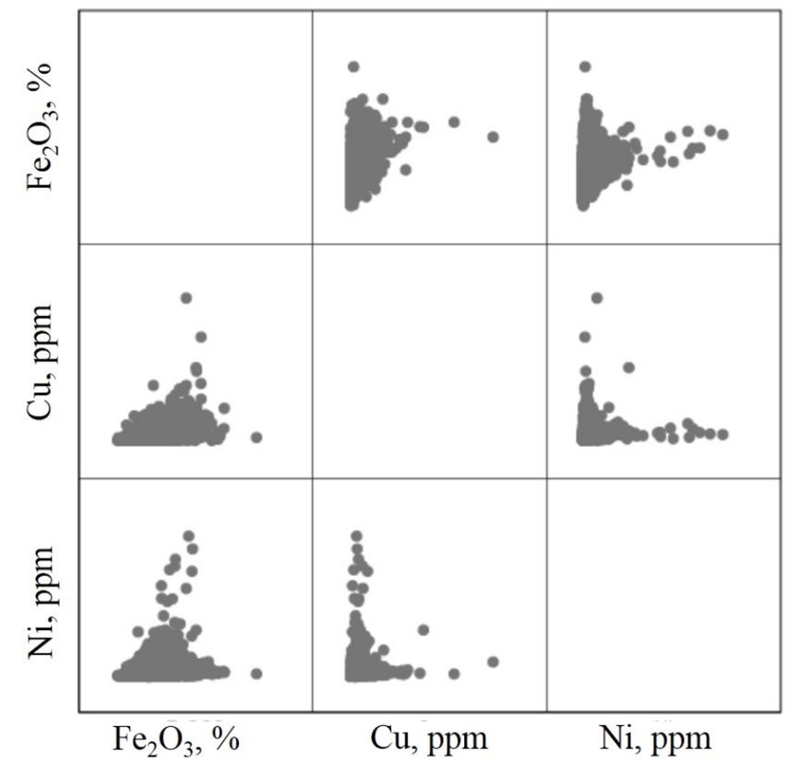

**Fig. 1.** Scatter-grams for Fe2O3, Cu and Ni showing the occurrence of two or more subpopulations. Conventional scale.

* 1. **Geological Influence On Geochemical Signature**

A file without anomalies, that is, values greater than three times the mean, overlaid to the digital geologic map and the attribute tables of each layer joined by ArcGIS®. Geological units with less than 30 samples and undefined cases discarded. Number of samples of each geological group varied between 48 and 4430 samples with mean of 677 samples. The mean of the geochemical data corresponding to each geological group was expressed as a percentage of the total mean (Fig. 2, Table 3). Chuy Formation (CHU) was the poorest domain, with low values for all the elements, especially Be, Cr, Fe2O3 and Y. Maldonado Formation (MAL) represented a moderately geochemical signature, with similar behavior for PUE, DOL, F3I, LIB, HOS, RKG, RAI, CCA, MOG, SBZ, PGF, GMB, MIG, RCH, COL, BRZ, ARE, CRP, GTP, BNG, NIC, GPS, YIZ, GLA, VAL and ZTI what can be interpreted as the geochemical background. Fe2O3 and Mn contents are high for some geological domains (CSAB, CSAG, PAV and VCH), but, As and Cu stand out for CAM; As, Ba, Co and P for CSAB; As, Nb and Pb for CSAG; Cr, Ni and V for PAV and, Be, Y and Zn in the case of VCH. This suggests specific signatures for each geological domain, fact confirmed by the difference between the extreme terms of the “Sierra de las Animas” Complex (CSAB and CSAG), that is, mafic rocks and felsic rocks respectively.

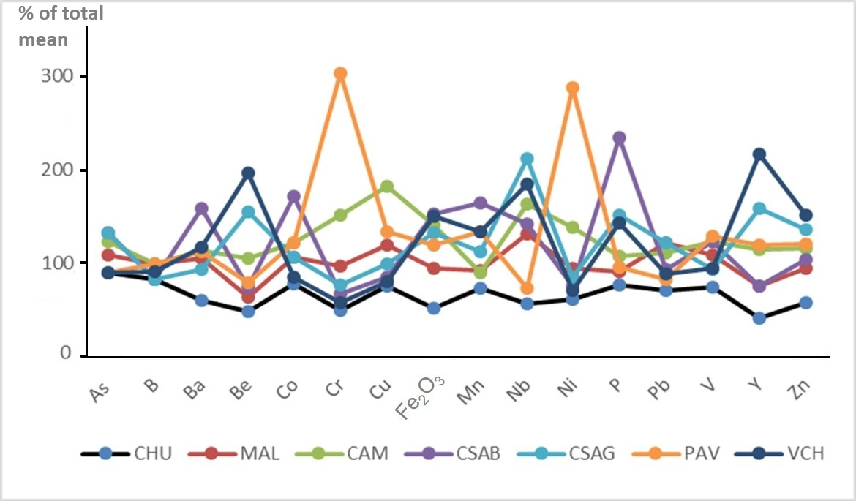

**Figure 2.** Line graphic with the means of the main each geological domain expressed as % of the total mean (TM), 19959 samples. MAL represent several groups (see text).

|  |  |  |  |  |  |  |  |  |  |
| --- | --- | --- | --- | --- | --- | --- | --- | --- | --- |
| **Variable** | **Unit** | **CHU** | **MAL** | **CAM** | **CSAB** | **CSAG** | **PAV** | **VCH** | **TM\*** |
| **As** | ppm | 20 | 24 | 27 | 29 | 29 | 20 | 20 | 22 |
| **B** | ppm | 10 | 12 | 12 | 10 | 10 | 12 | 11 | 12 |
| **Ba** | ppm | 348 | 600 | 651 | 902 | 537 | 645 | 668 | 571 |
| **Be** | ppm | 1,0 | 1,3 | 2,1 | 1,5 | 3,1 | 1,6 | 3,9 | 2 |
| **Co** | ppm | 11 | 15 | 17 | 24 | 15 | 17 | 12 | 14 |
| **Cr** | ppm | 21 | 40 | 62 | 28 | 32 | 123 | 24 | 41 |
| **Cu** | ppm | 16 | 25 | 38 | 18 | 21 | 28 | 17 | 21 |
| **Fe2O3** | % | 2,1 | 3,8 | 5,6 | 6,1 | 5,3 | 4,8 | 6,0 | 4 |
| **Mn** | ppm | 682 | 857 | 829 | 1510 | 1032 | 1234 | 1225 | 921 |
| **Nb** | ppm | 11 | 25 | 31 | 27 | 40 | 14 | 35 | 19 |
| **Ni** | ppm | 13 | 20 | 29 | 16 | 18 | 60 | 15 | 21 |
| **P** | ppm | 269 | 321 | 377 | 813 | 527 | 335 | 499 | 349 |
| **Pb** | ppm | 13 | 22 | 20 | 17 | 22 | 15 | 16 | 18 |
| **V** | ppm | 49 | 71 | 80 | 80 | 61 | 84 | 62 | 65 |
| **Y** | ppm | 11 | 20 | 30 | 20 | 41 | 31 | 56 | 26 |
| **Zn** | ppm | 38 | 61 | 74 | 67 | 87 | 77 | 97 | 64 |

**Table 3.** Characteristic geochemical mean signatures of Geological Formations from crystalline terrains of Uruguay. Extreme values ​​highlighted in gray.

**\*TM = Total Mean (**20786 samples).

* 1. **Anomalous Signatures**

Thresholds of Ag, As, Cd, Cu, Mo, Pb, Sn, W and Zn were 0.4 ppm, 67, 3, 63, 5, 54, 27, 15 and 191 respectively, deriving on one anomaly of four elements (Ag, Cu, Pb and Zn), six anomalies with three of the same elements and 35 anomalies with two of them and As, Mo, Sn and/or W occasionally. In summary, 42 multi-element anomalies and 409 univariate anomalies defined from the same nine elements, that is, 0.2% and 2% of total samples respectively. Anomaly distribution and, an approach of total survey represented by Cu anomalies is showed as Fig. 3.

Cr-Ni anomalies occurred in approximately 850 cases, with V occurring frequently and Co occasionally. The respective thresholds were Co = 43 ppm, Cr = 123 ppm, Ni = 62 ppm and V = 195 ppm. These anomalies are probably from lithological origin and spatially associated with mafic rocks. Anomalies of B, Ba, Be, Nb, P and Y, with potential for phosphates and rare earth deposits, were not specifically considered in the present study.

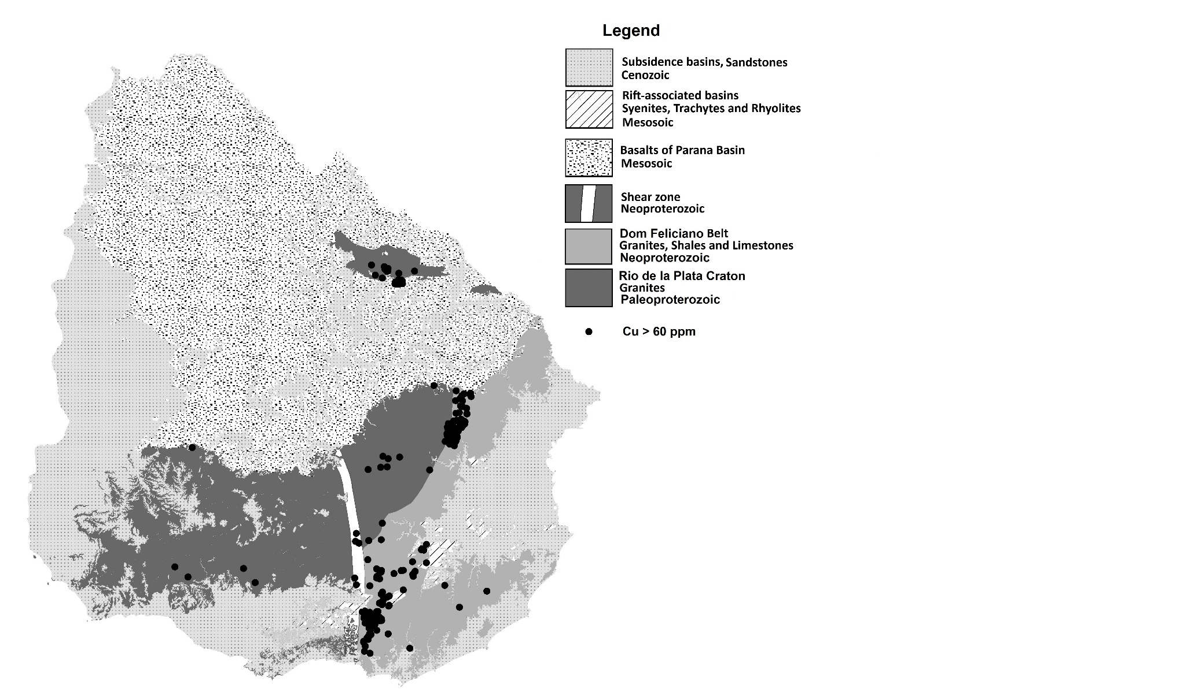

Figure 3. Anomalies of Cu in Uruguayan territory overlapping to the main geological units.

1. **Conclusion**

The influence of geology on geochemical signature was discussed, including 75% of the total regional geochemical samples from Uruguay. Discard of samples was due to poor geochemical reply as with soil samples or scarce number of samples for a specific geological domain (lesser than 30).

A previous geochemical study showed similarities with the current study, however only 17 geological domains were included (Filippini-Alba, 2022), exactly half of domains than this article. The units DOL, HOS, LIB and PUE showed low geochemical contrast in both studies. Five units detached (CAM, CSAB, CSAG, PAV and VCH); PAV presented enrichment in Cr, Ni and V in both studies, however, the units CAM, CSAB, CSAG and VCH did not occur in the previous study area. These five geological domains presented characteristic geochemical signatures (Table 2).

CHU was the poorest geological group since a geochemical point of view. MAL joined to PUE, DOL, F3I, LIB, HOS, RKG, RAI, CCA, MOG, SBZ, PGF, GMB, MIG, RCH, COL, BRZ, ARE, CRP, GTP, BNG, NIC, GPS, YIZ, GLA, VAL and ZTI deriving on a moderately geochemical reply (Geochemical background?). Future detailed studies will be necessary for better discrimination.

The geochemical amplitude of the geological groups (Table 3) converted as percentage of the standard deviation (SD, Table 2) was greater than 180% for Ba, Be, Cr, Cu, Fe2O3, Nb, Ni, P, Y and Zn; greater or equal than 100% for As, Co, Mn, Pb and V and, finally, equal to 51% for B. It was not possible calculate it for Ag, Cd, Mo, Sb, Sn and W by absence of geochemical variation for the geological groups, but too, due to the strong effect of detection limits for these elements. Therefore, the environmental dispersion of each element would depend on methodological aspects, geological and geochemical factors. Main anomalies were 1.7% of total with Ag, As, Cd, Cu, Mo, Sn, Pb, W and Zn as significant elements. 3.1% of anomalies related to Cr and Ni with Co and V occasionally, associated to mafic rocks.

**Acknowledgements**

To geologist Agustin Soto because provided part of geochemical data used.

To DINAMIGE, the executive institution.

**COMPETING INTERESTS:**

Authors have declared that they have no known competing financial interests OR non-financial interests OR personal relationships that could have appeared to influence the work reported in this paper.

**Disclaimer (Artificial intelligence)**

Option 1:

Author(s) hereby declare that NO generative AI technologies such as Large Language Models (ChatGPT) have been used during the writing or editing of manuscripts.

**References**

1. Abre, P.; Blanco, G.; Gaucher, C.; Frei, D.; Frei, R. (2020). Provenance of the Late Ediacaran Rocha Formation, Cuchilla Dionisio Terrane, Uruguay: Tectonic implications for the assembly of Gondwana. Precambrian Research v. 342.
2. Bettuci, L. S.; Cordani, U.; Loureiro, J.; Peel, E.; Fort, S.; Sato, K. (2021), The Nico Pérez terrain (Uruguay) and its Archean and Paleoproterozoic inheritance. Andean Geology, 48 (3), 442-471.
3. CEIC – Global economic Data, Indicators, Charts and Forecasts. Uruguay, mineral production. Retrived from: https://www.ceicdata.com/pt/indicator/uruguay/minerals-production. 14 Mar. 2025.
4. Demarco, P.N., Masquelin, H., Peel, E., Betucci, L.S. (2019). Stratigraphy and tectonic setting of the Barriga Negra Formation in Uruguay: an update. Brazilian Journal of Geology 49(1): 1-24. Retrived from: https://doi.org/10.1590/2317-4889201920180047. 25 Mar. 2025.
5. ESRI. ArcGIS Desktop: Release 100. Redlans, CA: Environmental Systems Research Institute, 2011.
6. Fesefeldt, K.; Vaz, N.; Arrighetti, R. (1988). Preliminary geotectonic interpretation of the “Serie de Minas” formation and proximal areas. In: Fesefeldt, K., ed. (1988). HANNOVER: BGR, 1 map.
7. Filippini-Alba, J.M. (2022). Geochemical stream sediment signatures from Precambrian terrains of Uruguay. Geochimica Brasiliensis 36: e-22004. Retrieved from: https://www.geobrasiliensis.org.br/geobrasiliensis/article/view/696. 25 Mar. 2025.
8. IBM Corp. (2017). Statistical Package for Social Sciences. IBM SPSS Statistics for Windows (Version 25.0) [Computer software]. IBM Corp.
9. Spoturno, J.; Oihantcabal, P. (2023). Charter of mineral resources of the department of San Jose. Retrieved from: https://www.gub.uy/ministerio-industria-energia-mineria/communicacion/publicaciones/carta-recursos-minerales-del-departamento-san-jose. December 4, 2024.
10. Wikipedia. Rapakivi granite. Retrived from: <https://en.wikipedia.org/wiki/Rapakivi_granite>. April 10, 2025