The efficiency of antitranspirants in the enhancement of the physiology of *Brassica napus* L under different water stress levels

**Abstract**

Rapeseed is a crucial crop in India, contributing 23.7% and 27% to oilseed acreage and production, respectively. With an estimated population of 1.32 billion, 21.12 million tonnes of edible oil are required, with about 20% to be met by rapeseed-mustard equivalent to 12.7 Mt. Water stress due to several causes is the limiting factor for increasing productivity. The main objective of performing this work is to evaluate the potential of anti-transpirants and study the underlying mechanism asserted by the anti-transpirants on the physiology of rapeseed. Three levels of stress were applied viz. Irrigation at 100% FC (Field Capacity), 75% FC and 50% FC. The research work was carried out in the agriculture field of Lovely Professional University. The experiment was carried out with 3 main plot treatments (Irrigation levels) and 5 sub-plot treatments (Anti-transpirants) carried out in 3 replications with total 45 plots. The layout was split-plot design, and statistical analysis was done using STATISTIX 10 and OPSTAT. After doing the experiment, it was found that increasing stress resulted in lower total chlorophyll content, greater proline accumulation, and higher stomatal count per unit area of fresh leaf. The crops treated with Kaolin 6% exhibited the least stress, with reduced proline buildup, higher total chlorophyll content, and fewer stomata per unit area. Plants treated with 6% Kaolin shown increased nutrient absorption (N, P, and K). Through this experiment we can say that with anti-transpirants (specially Kaolin 6%) plants able to tolerate reduced moisture availability most efficiently. From the overall prospect, amonh anti-transpirants, Kaolin 6% observed to be the most effective anti-transpirant. The difference between the result obtained in irrigation at 100% FC and irrigation at 75% FC is less, which indicates that an increase in water availability was not too much beneficial for the physiological development of the crop.

**Keywords:** Anti-transpirants, Irrigation, Rapeseed (*Brassica napus* L.), Gobhi Sarson, Water conservation, Field capacity, Physiology.

**Introduction**

Rapeseed-mustard is a vital crop in India, contributing 23.7% and 27% to oilseed acreage and production. To meet the demand, efforts are being made to expand the crop's productivity. Photosynthesis is a crucial and economically important process for preserving life on Earth, using less than 1% of plant’s water. However, between 3% and 4% of absorbed water is lost by the stomata or cuticle, causing follicity and blocking vital processes. Transpiration, on the other hand, regulates the temperature of leaves and the functions of the body of plants, making them a necessary evil for plants. Several anti-transpirants are available, including Kaolin 6%, Acetylsalicylic acid 10-3 M, Cycocel 1000 ppm, and Hexadecanol 5%. Basically, the role of anti-transpirants is to increase the leaf resistance to the water vapor transfer by covering of stomata, by reflecting a large amount of radiation, by forming thin oily layer on the leaf surface, and the growth retardant type anti-transpirant reduces shoot growth and increases root growth, thus resisting the water stress by absorbing moisture from the soil depth. It has been observed in the research performed by [1] that foliar application of anti-transpirants, kaolin (3 or 6%), and Cycocel 1000ppm leads to a significantly positive increase in the growth rate, yield components and biochemical aspects like carbohydrates, antioxidant enzymes, photosynthetic pigments and mineral contents (N,P,K, Ca) with wheat cultivar Gimeza 7. Different research works are carried out by researchers to cope with the water deficit condition for increasing productivity by decreasing the transpiration loss so that maximum returns can be obtained under minimum water availability. Water stress during reproductive growth reduces the seed yield by reducing the number of siliqua per plant by [10]. Under stress conditions, during anthesis to maturity, a remarkable reduction of oil concentration occurs by [4]. Under water-deficient conditions, antitranspirants like pusa hydrogel and chitosan along with 60% irrigation were found most effective in boosting the growth, reproductive parameters, yield, and yield attributing characteristics as pusa hydrogel can retain a larger quantity of water, and chitosan was known to reduce the transpirational rate observed by [2]. Research work, thus, is undertaken in the direction of conserving soil water and maintaining increased water balance as far as possible in plants through checking transpiration. In this research, proline content estimation in is crucial because it shows how plants react to stress. A high proline levels indicate severe stress, while a low level indicates a better tolerance to stress. Monitoring proline can help to identify stress early, compare the resilience of plant varieties, and develop strategies to effectively manage stress, ultimately increasing the productivity of crops in difficult conditions. The number of stomata is essential because it affects the efficiency of photosynthesis, water regulation, plant health indicators, adaptation and reproduction, environmental interactions, and nutrient absorption. It helps optimize agricultural practices and improve crop productivity by changing the photosynthesis rate, water regulation, plant health indicators, adaptation and reproduction, understanding plant’s response to climate change, and providing insights into the efficiency of nutrient absorption. Chlorophyll content is vital for agricultural experiments as it indicates plant health, nutrient status, stress detection, yield prediction, environmental impact monitoring, and precision agriculture. It measures photosynthesis efficiency, nitrogen levels, and helps identify stress from water, pests, disease, or extreme conditions. It also supports targeted interventions like variable rate fertilization to optimize inputs and enhance crop performance. Analyzing plant nitrogen, phosphorus, and potassium uptake is essential to managing nutrients, crop yield, environmental protection, economic advantages, crop physiology and genetics, adaptation to climate change, and scientific advances. It ensures the efficient use of fertilizers, maintains soil fertility, maximizes crop yields, reduces pollution, and supports the innovation of fertilizers and precision agricultural technologies. The experiment uses irrigation scheduling based on soil field capacity, with irrigation at 100%, 75%, and 50% field capacity. Anti-transpirants, such as Kaolin 6% and Cycocel 1000ppm, improve physiological parameters even at low irrigation levels. The study suggests that irrigation at 100% FC is more efficient in reducing stress, and Keolin 6% is the most effective anti-transpirant that helps the plant tolerate and adapt to stress. The objective of this experimental work is to study the underlying mechanism asserted by the anti-transpirants on the physiology of rapeseed. This study aims to evaluate rapeseed under water stress conditions and study the mechanism asserted by the anti-transpirants on rapeseed physiology. In this paper, a research performed on a possible way to reduce water or moisture stress in agriculture practice. This is significant because performing agriculture by keeping in mind its effects on the environment is very important to maintain its quality and sustainability of production. If the moisture stress effect on crops can be reduced, healthy plants can be grown which will be beneficial for mankind.

**Method and materials:**

**Experimental site:** The experiment was conducted on the Agricultural Research Farm LPU in Phagwara, Punjab. The area is in the central plain region, with a sub-tropical monsoon climate and a semi-arid zone.

**Season and climatic condition:** The research was carried out during the winter season and the sowing was done on the third week of October. The average temperature was between 10-15°C. Winter in Punjab begins approx. last week of October when the temperature gets chilly and continues to be cold from December and last upto approximately February. The temperature becomes very low between December and January, and Punjab is severely cold throughout the winter. Very less rainfall occurred in the cropping season.

**Cropping material:** The rapeseed variety here considered was GSC-07 which gets matured and ready to harvest within 160 days from the day of sowing. The sowing time of this crop is second fort night of October. This medium-tall variety is resistant to Alternaria blight and white rust, yields 8.9 qu per acre with nearly 36-40% oil content, and has lustrous brownish-black seeds.

**Treatments and experimental design:** The study aims to investigate the potential of different anti-transpirants under three irrigation levels scheduled at 100%, 75%, and 50%FC denoted as I1, I2, and I3 respectively. The anti-transpirants here used are reflectant type (Kaolin 6%) denoted as S1, stomatal closing type (Acetylsalicylic acid 10-3M) denoted as S2, growth retardant type (Cycocel 1000ppm) denoted as S3 and film forming type (Hexadecanol 5%) denoted as S4 on rapeseed variety GSC-07. The control (no anti-transpirant) was denoted as S0. The field plot design was based on a split-plot design and the statistical analysis was carried out using STATISTIX 10 and OPSTAT. The data for the estimation of chlorophyll, proline, and stomata count per unit area was taken at 40, 60, and 120 days after sowing respectively and the plant nitrogen, phosphorus, and potassium uptake was done after the harvest of the crop. The treatment combinations are as follows: I1S0 (Irrigation at 100% FC + Control (No Anti-transpirants)), I1S1 (Irrigation at 100% FC + Kaolin 6%), I1S2 (Irrigation at 100% FC + Acetylsalicylic acid 10-3 M), I1S3 (Irrigation at 100% FC + Cycocel 1000 ppm), I1S4 (Irrigation at 100% FC + Hexadecanol 5%), I2S0 (Irrigation at 75% FC + Control (No Anti-transpirants)), I2S1 (Irrigation at 75% FC + Kaolin 6%), I2S2 (Irrigation at 75% FC + Acetylsalicylic acid 10-3 M), I2S3 (Irrigation at 75% FC + Cycocel 1000 ppm), I2S4 (Irrigation at 75% FC + Hexadecanol 5%), I3S0 (Irrigation at 50% FC + Control (No Anti-transpirants)), I3S1 (Irrigation at 50% FC + Kaolin 6%), I3S2 (Irrigation at 50% FC + Acetylsalicylic acid 10-3 M), I3S3 (Irrigation at 50% FC + Cycocel 1000 ppm), I3S4 (Irrigation at 50% FC + Hexadecanol 5%).

**Calculations:**

For chlorophyll estimation: DMSO or Hiscox method. [13] (Hilcox and Israelstam, 1979)

For total chlorophyll estimation: (8.02 x OD at 663)+(20.2 x OD at 645) xv/((1000xW))

For Chlorophyll A estimation: (12.7 x OD at 663) – (2.69 x OD at 645) x v/((1000xW))

For Chlorophyll B estimation: (22.9 x OD at 645) – (4.68 x OD at 663) x v/((1000xW))

Here OD is Optical Density by Spectrophotometer, v=final volume of the supernatant (25ml), and w=weight of leaf sample in grams (1g). The unit is mg g-1

For stomata count per unit area:

It was done using a stereo microscope by calculating number of stomata in the area of the field of view and then converting it into mm2.

To calculate the area of observation:

The field of view formula= Field number ÷ Objective magnification

If using a stereo microscope with an auxiliary lens, the magnification factor of this lens should also be employed in the equation by multiplication with the objective magnification. You will have to multiply the eyepiece magnification by the objective magnification to find the total magnification before dividing the field number.

Field of View = FN ÷ (Objective Magnification x Auxiliary Lens Magnification)

For example, if your eyepiece reads 10X/18, and the magnification of your objective lens is 40X. Then field number is 18, and objective magnification is 40. So, divide 18 by 40 to get a FOV diameter of 0.45 millimeters. The value obtained is the measure of the diameter of the field of view. To find the radius we have to divide it by 2. Now the radius of the field of view is obtained. The formula to find the area of circle is A=πr2

So the area of the leaf we are viewing is obtained. Now multiply the value by the area of the whole leaf and you will get the number of stomata present in that leaf.

For proline estimation:

By calculating the Optical density of the spectrophotometer at 520nm and comparing them with the standard curve the proline content in ppm was obtained. PPM can also be described as µg g-1. The unit of proline accumulation is µg g-1. It can be calculated by using the formula x/2 x 10/500 x 1000 µg g-1 where x is the standard curve value (µg), an aliquot (2 ml), extraction buffer (10 ml), leaf weight 500mg, and 1000 is for converting mg to g. (Bates et al. 1973) [3]

N, P, and K uptake: N, P, and K content in grain and stover separately, both multiplied with their respective yields and then added. Total N, P, K uptake (kg ha-1) =N, P, K conc. in grain (%) x grain yield + N, P, K conc. in stover (%) x stover yield.

**Results:**

1. **Physiological observations:**
   1. **Proline content:**

Observations were taken at 40, 80, and 120 DAS intervals. The observations are recorded in Tables 1 and 2, the graphical representation is in Fig 1.

At **40 DAS,** significantly less proline was obtained in the I1 (Irrigation at 100% FC) level of irrigation (2.103 µg g-1) compared to the I3 (Irrigation at 50% FC) level of irrigation (4.231 µg g-1) which produced significantly higher proline accumulation. Proline accumulated in I2 (Irrigation at 75% FC) level of irrigation (2.569 µg g-1) is at par with I1. Among the anti-transpirants, a significantly highest proline accumulation was observed in S0 (Control) (4.505 µg g-1) followed by S2 (Acetylsalicylic acid 10-3M) (3.053 µg g-1) which was statistically at par with S3 (Cycocel 1000ppm) (2.901 µg g-1). The significantly lowest proline accumulation was observed in S1 (Kaolin 6%) (2.028 µg g-1) which was statistically at par with S4 (Hexadecanol 5%) (2.352 µg g-1). Anti-transpirant S3 was higher than S4 but statistically, they are at par.

At **80 DAS,** the significantly highest proline accumulation was observed in the I3 (Irrigation at 50%FC) level of irrigation (5.718 µg g-1) followed by I2 (Irrigation at 75%FC) level of irrigation (3.978 µg g-1), and the significantly lowest proline accumulation was observed in the I1 (Irrigation at 100%FC) level of irrigation (2.473 µg g-1). Among the anti-transpirants, a significantly highest proline accumulation was observed in S0 (Control) (5.615 µg g-1) followed by S2 (Acetylsalicylic acid 10-3M) (4.155 µg g-1) which was statistically at par with S3 (Cycocel 1000ppm) (3.836 µg g-1) and S4 (Hexadecanol 5%) (3.521 µg g-1). The significantly lowest proline accumulation was observed in S1 (Kaolin 6%) (3.154 µg g-1) which was statistically at par with S4 (Hexadecanol 5%) (3.521 µg g-1) and S3 (Cycocel 1000ppm) (3.836 µg g-1). Anti-transpirant S3 was higher than S4 but statistically, they are at par.

A similar trend was observed at **120 DAS**, as indicated in the Tables 1 and 2.

* 1. **Stomata count (per mm2 fresh leaf) :**

The data were taken at 40, 80, and 120 DAS intervals. The observations are recorded in Tables 3 and 4 and the graphical representation is in Fig 2 and 3.

At **40 DAS**, a significantly higher stomata count was observed in the I3 (Irrigation at 50% FC) level of irrigation (122.487) followed by the I2 (Irrigation at 75%FC) level of irrigation (118.825). A significantly lower number of stomata was observed in the I1 (Irrigation at 100%FC) level of irrigation (100.959). Among the anti-transpirants, significantly the highest stomata count was observed in S0 (Control) (116.227) which was statistically at par with S2 (Acetylsalicylic acid 10-3M) (115.776). A significantly lower stomata count was observed in S1 (Kaolin 6%) (109.751). Antitranspirant S3 (Cycocel 1000ppm) (114.623) and S4 (Hexadecanol 5%) (114.075) were statistically at par but both of them were significantly lower than S2 (Acetylsalicylic acid 10-3M) (115.776).

The stomata count per mm2 of fresh leaf recorded significant differences between the interaction effects of the different levels of irrigation and anti-transpirants. When plants were treated with only different irrigation levels, the highest stomata count per mm2 of fresh leaf was observed in I3 (Irrigation at 50%FC) level of irrigation (122.487). However, when anti-transpirants were applied with this level of irrigation, it reduced the stomata count to 120.932 per mm2 of fresh leaf as observed in I3S1 (Irrigation at 50%FC + Kaolin 6%), which shows a symptom of reducing stress effect. The significantly highest stomata count per mm2 of fresh leaf was obtained in the plots where irrigation was applied at 50% FC with no anti-transpirants (I3S0) producing 123.708 stomata per mm2 of leaf. Similarly, the lowest stomata count per mm2 of fresh leaf was obtained from I1 (Irrigation at 100%FC) level of irrigation (100.959) but when anti-transpirants were applied with it, the treatment combination I1S1 (90.488) produced significantly lowest stomata count per mm2 of fresh leaf, which was again less than the number of stomata obtained from only irrigation treatment. This shows that at all irrigation levels, the anti-transpirants positively affected the water stress, in other words, increased water use efficiency. Similar interaction effects were observed in the observations taken at 80 and 120 DAS and are shown in Table 4.

At **80 DAS,** a significantly higher stomata count was observed in the I3 (Irrigation at 50%FC) level of irrigation (165.463) followed by the I2 (Irrigation at 75%FC) level of irrigation (152.641). A significantly lower number of stomata was observed in the I1 (Irrigation at 100%FC) level of irrigation (122.828). Among the anti-transpirants, a significantly highest stomata count was observed in S0 (Control) (156.246) followed by S2 (Acetylsalicylic acid 10-3M) (151.839) followed by S3 (Cycocel 1000ppm) (146.511) followed by S4 (Hexadecanol 5%) (142.4). A significantly lower stomata count was observed in S1 (Kaolin 6%) (137.890).

At **120 DAS,** a significantly higher stomata count was observed in the I3 (Irrigation at 50%FC) level of irrigation (177.039) followed by the I2 (Irrigation at 75%FC) level of irrigation (167.555). A significantly lower number of stomata was observed in the I1 (Irrigation at 100%FC) level of irrigation (145.320). Among the anti-transpirants, a significantly highest stomata count per mm2 was observed in S0 (Control) (171.231) which is statistically at par with S2 (Acetylsalicylic acid 10-3M) (169.091). A significantly lower stomata count per mm2 was found in S1 (Kaolin 6%) (154.982) which is statistically at par with S4 (Hexadecanol 5%) (157.850). Among the anti-transpirants S3 (Cycocel 1000ppm) and S4 (Hexadecanol 5%), S3 was observed to be significantly higher (163.369).

* 1. **Chlorophyll content:**

The chlorophyll content was estimated at 40, 80, and 120 DAS intervals. The observations are recorded in Tables 5 and 6 and are represented graphically in Fig 4 and 5.

At **40 DAS,** significantly higher chlorophyll content was observed in the I1 (Irrigation at 100%FC) level of irrigation (0.771 mg g-1) followed by the I2 (Irrigation at 75% FC) level of irrigation (0.590 mg g-1). The significantly lowest chlorophyll content was observed in the I3 (Irrigation at 50%FC) level of irrigation (0.507 mg g-1). Among the anti-transpirants, significantly the highest chlorophyll content was observed in S1 (Kaolin 6%) (0.690 mg g-1) which is statistically at par with S4 (Hexadecanol 5%) (0.667 mg g-1). Among anti-transpirants S3 (Cycocel 1000ppm) and S4 (Hexadecanol 5%), S4 (0.667 mg g-1) is significantly higher than S3 (0.621 mg g-1). Significantly lowest chlorophyll content was observed in S0 (Control) (0.553 mg g-1) which is statistically at par with S2 (Acetylsalicylic acid 10-3M) (0.581 mg g-1).

The chlorophyll content of fresh leaf recorded significant differences between the interaction effects of different irrigation levels and anti-transpirants. The significantly highest chlorophyll content (0.771 mg g-1) was observed under irrigation at 100% FC (I1). However, when anti-transpirants were applied with this, showed an increasing chlorophyll content (0.843 mg g-1) as of treatment combination I1S1 (Irrigation at 100% FC + Kaolin 6%). This shows that the plants were facing less stress when irrigation and anti-transpirants were combined compared to only irrigation. Similarly, the significantly lowest chlorophyll content (0.507 mg g-1) was obtained from I3 (irrigation at 50% FC) level of irrigation which means, the plants were under high stress but when anti-transpirants were applied with it, the chlorophyll content increased to 0.536 mg g-1 as observed in the treatment combination I3S1 (Irrigation at 50% FC + Kaolin 6%), which showed an increasing trend of chlorophyll content even when minimum irrigation is provided to the plants. This overall interaction effect shows that anti-transpirants when applied with different levels of irrigation help to reduce the stress level and eventually increase the content of chlorophyll. A similar trend of interaction effect was observed in the data taken at 80 and 120 DAS. The interaction effect is shown in Table 6.

At **80 DAS,** significantly higher chlorophyll content was observed in the I1 (Irrigation at 100%FC) level of irrigation (1.017 mg g-1) followed by the I2 (Irrigation at 75% FC) level of irrigation (0.949 mg g-1). The significantly lowest chlorophyll content was observed in I3 (Irrigation at 50%FC) level of irrigation (0.857 mg g-1). Among the anti-transpirants, the significantly highest chlorophyll content was observed in S1 (Kaolin 6%) (1.083 mg g-1) followed by S4 (Hexadecanol 5%) (0.979 mg g-1) followed by S3 (Cycocel 1000ppm) (0.930 mg g-1) followed by S2 (Acetylsalicylic acid 10-3M) (0.885 mg g-1) and significantly lowest chlorophyll content was observed in S0 (Control) (0.829 mg g-1).

At **120 DAS,** significantly higher chlorophyll content was observed in the I1 (Irrigation at 100%FC) level of irrigation (0.846 mg g-1) followed by the I2 (Irrigation at 75% FC) level of irrigation (0.643 mg g-1). The significantly lowest chlorophyll content was observed in I3 (Irrigation at 50%FC) level of irrigation (0.527 mg g-1). Among the anti-transpirants, the significantly highest chlorophyll content was observed in S1 (Kaolin 6%) (0.757 mg g-1) followed by S4 (Hexadecanol 5%) (0.685 mg g-1) which was statistically at par with S3 (Cycocel 1000ppm) (0.663 mg g-1) and S2 (Acetylsalicylic acid 10-3M) (0.652 mg g-1). Among anti-transients S3 (Cycocel 1000ppm) and S2 (Acetylsalicylic acid 10-3M), S3 (0.663 mg g-1) is higher than S2 (0.652 mg g-1) but statistically, they are at par. Significantly lowest chlorophyll content was observed in S0 (Control) (0.602 mg g-1).

1. **Crop Nitrogen (N), Phosphorus (P), and Potassium (K) uptake:**

The plant analysis was done after the harvest was done. The plant samples were oven dried, then grinded, and then the analysis was done. The observations are recorded in Tables 7 and 8 and the graphical representation is in Fig 6.

**2.1** **Nitrogen (N) uptake by crops:**

After analyzing the dried plant sample, it has been observed that the crops under the I1 (Irrigation at 100%FC) level of irrigation absorbed significantly higher N (109.736 kg ha-1) which was statistically at par with the N uptake by the crops under the I2 (Irrigation at 75% FC) level of irrigation (108.057 kg ha-1). The significantly lower N uptake was done by the crops under the I3 (Irrigation at 50%FC) level of irrigation (92.576 kg ha-1). Among the anti-transpirants, the significantly highest N uptake was done by the crops under treatment S1 (Kaolin 6%) (109.534 kg ha-1) followed by S4 (Hexadecanol 5%) (105.202 kg ha-1) followed by S2 (Acetylsalicylic acid 10-3M) (103.039 kg ha-1) which was statistically at par with S0 (Control) (102.025 kg ha-1). The significantly lowest N uptake was done by the crops under treatment S3 (Cycocel 1000ppm) (97.481 kg ha-1).

**2.2 Phosphorus (P) uptake by crops:**

The oven-dried and grinded plant samples were analyzed and was observed that the crops under the I1 (Irrigation at 100%FC) level irrigation uptake significantly higher P (46.325 kg ha-1) which was statistically at par with the P uptake by the crops under the I2 (Irrigation at 75% FC) level of irrigation (42.732 kg ha-1). The crops under the I3 (Irrigation at 50%FC) level of irrigation had significantly lower P uptake (30.700). Among the anti-transpirants, significantly higher P uptake was observed in the crops under S1 (Kaolin 6%) (44.041 kg ha-1) followed by S4 (Hexadecanol 5%) (40.826 kg ha-1) followed by S2 (Acetylsalicylic acid 10-3M) (38.935 kg ha-1) which was statistically at par with S0 (Control) (38.722 kg ha-1). The significantly lowest P uptake was obtained from S3 (Cycocel 1000ppm) (37.071 kg ha-1).

* 1. **Potassium (K) uptake by crop:**

After analyzing the dried plant sample we observed that the crops under the I1 (Irrigation at 100%FC) level irrigation uptaken significantly higher K (98.539 kg ha-1) followed by the I2 (Irrigation at 75% FC) level of irrigation (94.055 kg ha-1). The significantly lower K uptake was done by the crops under the I3 (Irrigation at 50%FC) level of irrigation (73.320 kg ha-1). Among the anti-transpirants, a significantly higher K uptake was observed in the crops treated with S1 (Kaolin 6%) (96.564 kg ha-1) which was statistically at par with S4 (Hexadecanol 5%) (94.424 kg ha-1). A significantly lower K uptake was observed in the crops treated with S3 (Cycocel 1000ppm) (80.316 kg ha-1) which was at par with S0 (Control) (83.183 kg ha-1). S2 (Acetylsalicylic acid 10-3M) (88.702 kg ha-1) was significantly higher than S3 (Cycocel 1000ppm) (80.316 kg ha-1) and S0 (Control) (83.183 kg ha-1) but significantly lower than S1 (Kaolin 6%) (96.564 kg ha-1) and S4 (Hexadecanol 5%) (94.424 kg ha-1).

The N, P, and K uptake by crops recorded significant differences between the interaction effects of the levels of irrigation and anti-transpirants. After analyzing the data, it was observed that the plants treated with only I1 (Irrigation at 100% FC) level of irrigation, uptake significantly highest N, P, and K thus having the capacity to produce the highest biomass. But when the anti-transpirants are applied with this irrigation level (I1), it was observed that (S1) Kaolin 6% efficiently increases the N, P, and K uptake, which means I1S1 (Irrigation at 100% FC + Kaolin 6%) increases N, P, and K uptake compared to only irrigation. This showed that the stress level can be reduced with the application of anti-transpirants, as a result, plants can grow efficiently even after reducing irrigation level, thus increasing the nutrient uptake. Similarly, in the I3 (Irrigation at 50% FC), the significantly lowest N, P, and K uptake was observed which shows that the plants are under stress but when anti-transpirants were applied with it, again increase in N, P, and K uptake was observed. These interaction effects showed that anti-transpirants under the different levels of irrigation help the plants to adapt or tolerate the increasing stress levels and thus plants can uptake more nutrients for their growth and development as compared to control plots. The interaction effect is represented in Table 8.

**Discussion**

**Crop physiological parameters:** Crop physiological observations are essential for agricultural experiments, assessing health and stress responses, predicting yield and quality, and assessing environmental impacts. The physiological observations of crops provide important data for the study and improvement of agricultural practices, improving crops' performance, sustainability, and resilience to various challenges. These observations bridge the gap between theoretical research and practical application in the field and ensure that agricultural practices are scientifically and effectively grounded. In the physiological observations, the observations of proline, chlorophyll, and stomata count were taken at an intervals of 40, 80, and 120 DAS. The proline content was observed to be higher at I3 (Irrigation at 50%FC) level of irrigation and that gradually decreased with the increasing irrigation level. This shows that proline content at no stress I1 (Irrigation at 100%FC) accumulated lesser proline compares to high stressed I3 (Irrigation at 50%FC). This is because increased irrigation reduces proline levels in plants. Proline buildup is a physiological reaction to water stress. Proline is an osmoprotectant that accumulates in plant tissues during water stress to preserve cellular osmotic equilibrium. Irrigation increases water availability, which reduces stress signals and allows plants to concentrate on growth and development [17],[19],[20]. Similarly, a higher stomata count per mm2 of the fresh leaf was observed in the I3 (Irrigation at 50%FC) level of irrigation and it decreased with the increase in irrigation level, and lower stomata count per mm2 was obtained in I1 (Irrigation at 100%FC). This may be because, under water stress, plants increase stomatal density as an adaptive response to balance CO₂ intake for photosynthesis and water conservation, assuring life and sustaining metabolic activities. This phenomenon of increasing stomatal density and decreasing stomatal length under water stress was also observed [6],[25],[9],[28],[21]. Soil water content decreased, leading to increased stomatal production and density, but decreased stomatal size and aperture was observed by [28]. Stomata count of the fresh leaf of crops under I3 (Irrigation at 50% FC), I2 (Irrigation at 75% FC), and I1 (Irrigation at 100% FC) level of irrigation respectively under the microscope showing increasing stomata count per unit leaf area with decreasing irrigation level and vice-versa are given in the Fig 7.

In the observation related to chlorophyll content, significantly higher chlorophyll content was observed in the I1 level of irrigation and it has been observed that with increasing stress the chlorophyll content decreases. This is because Increased irrigation improves nutrient absorption, photosynthesis, growth conditions, and cellular activity, all of which contribute to higher chlorophyll levels in plants. Water supply enables effective photosynthesis, allowing plants to spend more resources on making chlorophyll. [14],[27],[5],[16],[26]. The main reason behind the loss of chlorophyll with increasing water stress is photo-oxidation which leads to oxidative damage. Similar reason observed by [15].

Among the anti-transpirants, significantly lowest proline accumulation was observed in S1 (Kaolin 6%) compared to the control. This is because of Kaolin treatment inhibits proline buildup in plants by reducing heat and water stress. It creates a reflective coating on plant surfaces, limiting sunlight and heat absorption, lowering leaf temperature, and decreasing transpiration and water loss. This minimizes the demand for proline, an osmoprotectant and stress-related molecule, in less stressed plants. [16],[1],[18]. Similarly, the lowest stomata count per mm2 was obtained from anti-transpirant treatment S1 (Kaolin 6%) in which the lowest proline accumulation was observed which means it is the treatment that showed the lowest water stress, by [8]. The phenomenon of decreasing stomatal count per mm2 under reducing water stress was also observed [6],[25]. This might be because, under increasing water stress, plants increase stomatal density as an adaptive response to balance CO₂ intake for photosynthesis and water conservation, assuring life and sustaining metabolic activities. Comparison between the microscopic observations of stomata count of fresh leaf “at different levels of irrigation without anti-transpirants” and “at different levels of irrigation with the most effective anti-transpirant in terms of reducing maximum possible stress are given in the Fig 8.

From the above observations it has been observed that with the increasing stress the stomata count per unit area increases. Anti-transpirant S1 (Kaolin 6%) showed significantly the highest chlorophyll content in fresh leaves. This might be because treatment S1 showed lower proline accumulation which means lower water stress and reducing the water stress improves nutrient absorption, photosynthesis, growth conditions, and cellular activity, all of which contribute to higher chlorophyll levels in plants. Water supply enables effective photosynthesis, allowing plants to spend more resources on making chlorophyll [16],[11],[7],[12] also observed that when exposed to sun radiation, kaolin increased the amount of photosynthetic pigments much more than the control. The highest increases in chlorophyll a and b and carotenoids were achieved with 6% kaolin.

**Crop N, P, and K uptake:** Analyzing crops' nitrogen (N), phosphorus (P), and potassium (K) uptake is essential to managing nutrients, crop yield, environmental protection, economic advantages, crop physiology and genetics, adaptation to climate change, and scientific advances. It ensures the efficient use of fertilizers, maintains soil fertility, maximizes crop yields, reduces pollution, and supports the innovation of fertilizers and precision agricultural technologies. The plant analysis was carried out after the harvest was done. It has been observed that the crops of I1 have uptaken higher N compared to other irrigation levels. With increasing water stress the growth and nutrient uptake decreases, by [24]. They also stated that supplemental irrigation does not mean crops will uptake nutrients proportionally. With the increasing irrigation level the nutrient uptake increases. Similar concept observed by [22]. A similar result was reported [23], Crop N uptake under I1 and I2 levels of irrigation was at par. It has also been observed that the crops with higher biological yield uptake higher N. A similar result was observed in the case of P and K uptake by crop.

In the case of anti-transpirants, the plants under S1 treatment uptakes higher N, P, and K. When compared with biological yield it was observed that higher biological yield obtained in crops treated with S1 anti-transpirant uptake higher N, P, and K. By comparing all of these, it is observed that higher biological yield leads to higher nutrient uptake.

**Conclusion**

After performing the experiment, it was observed that among the anti-transpirants, the reflectant type anti-transpirant Kaolin 6% (S1) produced lesser stress effect by accumulating lower proline, lesser stomata count per unit area of fresh leaf and higher chlorophyll content which are the properties of an improved physiology of a crop. This shows that anti-transpirants can reduce the stress effect on the plants that leads to improvement of physiological characters. Similarly, when crops treated with irrigation at 100% FC (I1) and irrigation at 75% FC (I2) the difference was minimum, which shows that increasing water availability is not beneficial after a certain limit or range. The N, P, and K uptake by the plants treated with irrigation at 100% FC (I1) was at par with the plants treated with irrigation at 75% FC (I2). This might be because higher irrigation availability under irrigation at 100% FC (I1) leads to more vegetative growth and medium level of irrigation (irrigation at 75% FC) leads to more economic yield which leads to total nutrient uptake amount at par. Here, we observed that in the high irrigated areas plants utilizing more nutrients for vegetative growth whereas in medium irrigated areas the plants utilizing more nutrients for the purpose of economic yield. This causes the total uptake of nutrients under both treatments at par. Similarly, while interaction effects were analysed it was observed that plants treated with Kaolin 6% under irrigation at 75% FC levels leads to improve N, P, and K uptake, and accumulating lower proline, lesser stomata count per unit area of fresh leaf and higher chlorophyll content which showed improvement the physiology of the crop. Thus, based on the objective of this experiment it can be conclude that application of Kaolin 6% under irrigation at 75% FC have the maximum potential to improve the physiological growth and development of the crop.

**Disclaimer for Preprint:**

This paper is an extended version of a preprint document of the same author.

The preprint document is available in this link: <https://assets-eu.researchsquare.com/files/rs-5275978/v1/021eb164-f4a8-4009-82f0-c77222880cd4.pdf?c=1730256623>

[As per journal policy, preprint /repository article can be published as a journal article, provided it is not published in any other journal]

**Abbreviation**

|  |  |
| --- | --- |
| % | Percentage |
| Mt | Metric-ton |
| FC | Field Capacity |
| N | Nitrogen |
| P | Phosphorus |
| K | Potassium |
| M | Molarity |
| ppm | Parts per million |
| DAS | Days after sowing |
| kg | Kilogram |
| µg | Microgram |
| g | Gram |
| kg ha-1 or kg/ha | Kilogram per hectare |
| µg g-1 or µg g-1 | Microgram per gram |
| mg g-1 or mg g-1 | Milligram per gram |
| ml | Millilitre |
| mg | Milligram |
| mm | Millimetre |
| SEm | Standard Error Mean |
| CD | Critical Difference |
|  |  |

**Disclaimer (Artificial intelligence)**

Author(s) hereby declare that NO generative AI technologies such as Large Language Models (ChatGPT, COPILOT, etc.) and text-to-image generators have been used during the writing or editing of this manuscript.

**References**

1. Abdallah, M.M.S., El-Bassiouny, H.M.S. & AbouSeeda, M.A. (2019) Potential role of kaolin or potassium sulfate as anti-transpirant on improving physiological, biochemical aspects and yield of wheat plants under different watering regimes. Bull Natl Res Cent 43, 134. <https://doi.org/10.1186/s42269-019-0177-8>
2. Burondkar, S.S., Sharma, R., Singh, A.S. and Akshay, S.M. 2018. Efficacy of pusa hydrogel and chitosan on wheat (Triticum aestivum L.) growth and yield under water deficit condition. J. Pharmacogn. & Phytochem. 7(5): 501-505.
3. Bates, L. S., Waldren, R. P. A., & Teare, I. D. (1973). Rapid determination of free proline for water-stress studies. *Plant and soil*, *39*, 205-207.
4. Champolivier, L., & Merrien, A. 1996. Effects of water stress applied at different growth stages to Brassica napus L. var. oleifera on yield, yield components and seed quality. European J. Agron. 5(3-4): 153-160
5. Chavan, K., & Bodake, P. (2023). Response of stress irrigation management on chlorophyll content, water potential, PAR and canopy temperature in tomato (Lycopersicum Esculentum Mill.). *Journal of Agrometeorology*, *25*(3), 419-424.
6. Driesen, E., De Proft, M., & Saeys, W. (2023). Drought stress triggers alterations of adaxial and abaxial stomatal development in basil leaves increasing water-use efficiency. *Horticulture Research*, *10*(6), uhad075.
7. Dinis, L. T., Malheiro, A. C., Luzio, A., Fraga, H., Ferreira, H., Gonçalves, I., ... & Moutinho-Pereira, J. (2018). Improvement of grapevine physiology and yield under summer stress by kaolin-foliar application: Water relations, photosynthesis and oxidative damage. *Photosynthetica*, *56*, 641-651.
8. Elmasrya, H. M., & Abd El-Radyb, A. G. (2024). http://ejss. journals. ekb. eg.
9. Fraser, L. H., Greenall, A., Carlyle, C., Turkington, R., & Friedman, C. R. (2009). Adaptive phenotypic plasticity of Pseudoroegneria spicata: response of stomatal density, leaf area and biomass to changes in water supply and increased temperature. *Annals of Botany*, *103*(5), 769-775.
10. Ghobadi, M., Bakhshandeh, M., Fathi, G., Gharineh, M.H., Alami-Said, K., Naderi, A. & Ghobadi, M.E. 2006. Short and Long Periods of Water Stress During Different Growth Stages Of Canola (Brassica napus L.): Effect on Yield, Yield Components, Seed Oil and Protein Contents. J. Agron. 5(2): 336-341
11. Gharaghani, A., Javarzari, A. M., & Vahdati, K. (2018). Kaolin particle film alleviates adverse effects of light and heat stresses and improves nut and kernel quality in Persian walnut. *Scientia Horticulturae*, *239*, 35-40.
12. Hamdy, A. E., Abdel-Aziz, H. F., El-Khamissi, H., AlJwaizea, N. I., El-Yazied, A. A., Selim, S., ... & Elkelish, A. (2022). Kaolin improves photosynthetic pigments, and antioxidant content, and decreases sunburn of mangoes: Field study. *Agronomy*, *12*(7), 1535.
13. Hiscox, J. D., & Israelstam, G. F. (1979). A method for the extraction of chlorophyll from leaf tissue without maceration. *Canadian journal of botany*, *57*(12), 1332-1334.
14. Khaleghi, E., Arzani, K., Moallemi, N., & Barzegar, M. (2012). Evaluation of chlorophyll content and chlorophyll fluorescence parameters and relationships between chlorophyll a, b and chlorophyll content index under water stress in Olea europaea cv. Dezful. *International Journal of Agricultural and Biosystems Engineering*, *6*(8), 636-639.
15. Karimi, S., & Tavallali, V. (2017). Interactive effects of soil salinity and boron on growth, mineral composition and CO 2 assimilation of pistachio seedlings. *Acta physiologiae plantarum*, *39*, 1-10.
16. Mahmoudian, M., Rahemi, M., Karimi, S., Yazdani, N., Tajdini, Z., Sarikhani, S., & Vahdati, K. (2021). Role of kaolin on drought tolerance and nut quality of Persian walnut. *Journal of the Saudi Society of Agricultural Sciences*, *20*(6), 409-416
17. Nazar, R., Umar, S., Khan, N. A., & Sareer, O. (2015). Salicylic acid supplementation improves photosynthesis and growth in mustard through changes in proline accumulation and ethylene formation under drought stress. South African Journal of Botany, 98, 84-94.
18. Noor El-Deen, T. M., Elbohy, N. F., Attia, K. E., & Mokhtar, N. A. Y. (2018). Synergistic impact of soil mulching and kaolin concentration on Zinnia elegans plants grown under different irrigation levels. *Egyptian Journal of Agricultural Sciences*, *69*(4), 403-425.
19. Pospisilova, J., Haisel, D., & Vankova, R. (2011). Responses of transgenic tobacco plants with increased proline content to drought and/or heat stress. *American Journal of Plant Sciences*, *2*(03), 318.
20. Sahoo, C. R., Dash, M., & Acharya, N. (2019). Biochemical Responses of Indian Mustard to Water Stress. *Int. J. Curr. Microbiol. App. Sci*, *8*(2), 1711-1718.
21. Shekari, F., Soltaniband, V., Javanmard, A., & Abbasi, A. (2016). The impact of drought stress at different stages of development on water relations, stomatal density and quality changes of rapeseed (Brassica napus L.). *Iran Agricultural Research*, *34*(2), 81-90.
22. Singh, A. K., Roy, A. K., & Kaur, D. P. (2007). Effect of irrigation and NPK on nutrient uptake pattern and qualitative parameter in winter maize+ potato intercropping system.
23. Verma, H. P., Sharma, O. P., Shivran, A. C., Yadav, L. R., Yadav, R. K., Yadav, M. R., ... & Minkina, T. (2023). Effect of irrigation schedule and organic fertilizer on wheat yield, nutrient uptake, and soil moisture in Northwest India. *Sustainability*, *15*(13), 10204.
24. Wang, Z. H., & LI, S. X. (2002). Effects of water deficit and supplemental irrigation at different growing stage on uptake and distribution of nitrogen, phosphorus and potassium in winter wheat. *Journal of Plant Nutrition and Fertilizers*, *8*(3), 265-270.
25. Xu, Z., & Zhou, G. (2008). Responses of leaf stomatal density to water status and its relationship with photosynthesis in a grass. *Journal of experimental botany*, *59*(12), 3317-3325.
26. Xu, Q., Ma, X., Lv, T., Bai, M., Wang, Z., & Niu, J. (2020). Effects of water stress on fluorescence parameters and photosynthetic characteristics of drip irrigation in rice. *Water*, *12*(1), 289.
27. Yildirim, E., Agar, G., Ors, S., Yuksel, E. A., Aydin, M., Ekinci, M., & Kul, R. (2023). Growth, physiological, biochemical and DNA methylation responses to cadmium stress of bean (phaseolus vulgaris L) grown under different irrigation levels. *Plant Growth Regulation*, *101*(2), 537-556.
28. Zhao, W., Sun, Y., Kjelgren, R., & Liu, X. (2015). Response of stomatal density and bound gas exchange in leaves of maize to soil water deficit. *Acta Physiologiae Plantarum*, *37*, 1-9.

**Figures:**

a b

Fig 1: Graph representing the effects of anti-transpirants (a) and Irrigation levels (b) on proline content in µg g-1 (microgram per gram). The data sets were taken from three replications. (DAS: Days After Sowing).

Fig 2: Graph representing the interaction effects between Irrigation levels and anti-transpirants on stomata count per mm2 (square millimeter) of fresh leaf. The data sets taken from three replications. (DAS: Days After Sowing).

a b

Fig 3: Graph representing the effects of anti-transpirants (b) and Irrigation levels (a) on stomata count per mm2 (square millimeter) of fresh leaf. The data sets taken from three replications.

Fig 4: Graph representing the interaction effects of Irrigation levels and anti-transpirants on fresh leaf total chlorophyll content mg g-1 (milligram per gram). The data sets taken from three replications.

a b

Fig 5: Graph representing the effects of anti-transpirants (a) and Irrigation levels (b) on Total chlorophyll content mg g-1 (milligram per gram) fresh leaf. The data sets taken from three replications.

Fig 6: Graph representing the effects of anti-transpirants (S) and Irrigation levels (I) on N, P, and K uptake by crop in kg ha-1 (kilogram per hectare). The data sets are collected from three replications.

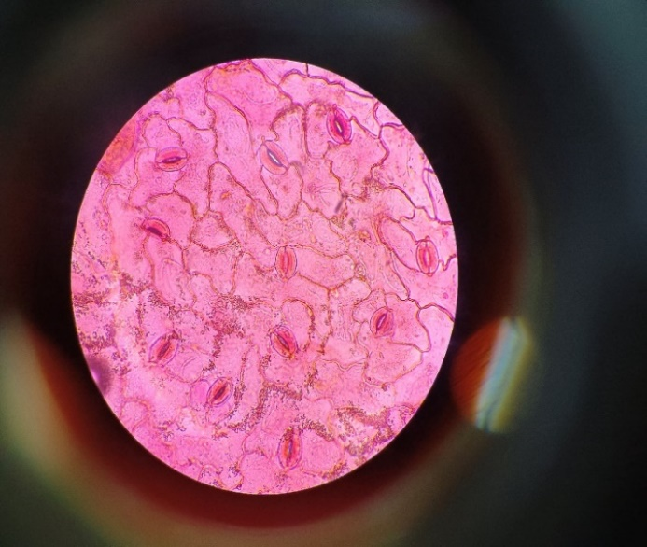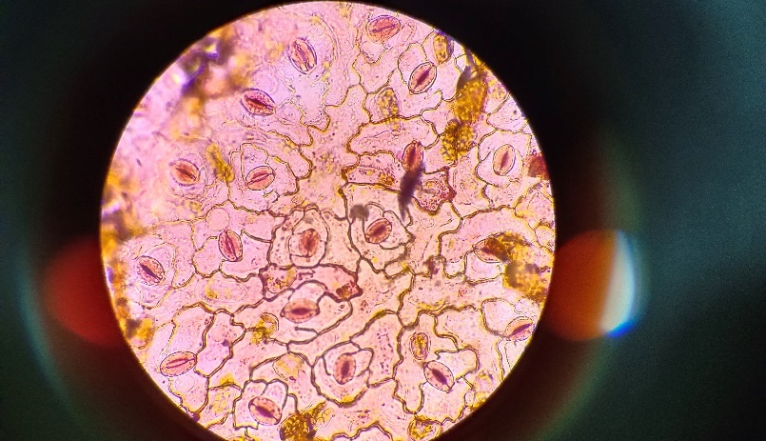 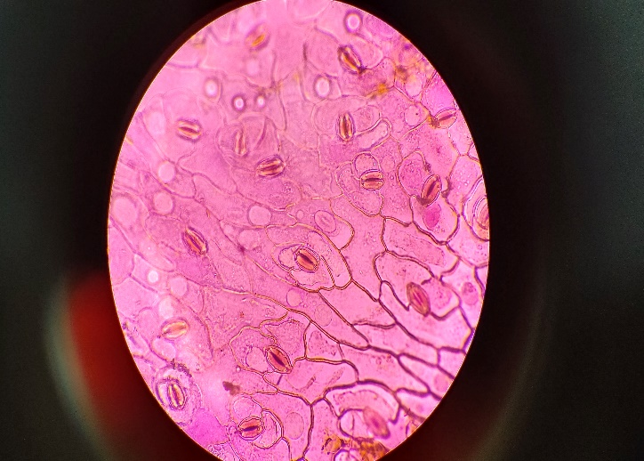

Stomata

A B C

Fig 7: Stomata count of the fresh leaf of crops under I3 (Irrigation at 50% FC) (A), I2 (Irrigation at 75% FC) (B), and I1 (Irrigation at 100% FC) (C) level of irrigation respectively under the microscope. Here we observed the increasing stomata count per unit leaf area with decreasing irrigation level and vice-versa.

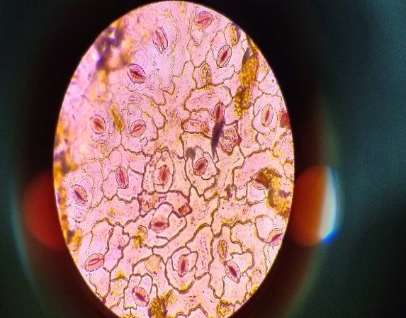 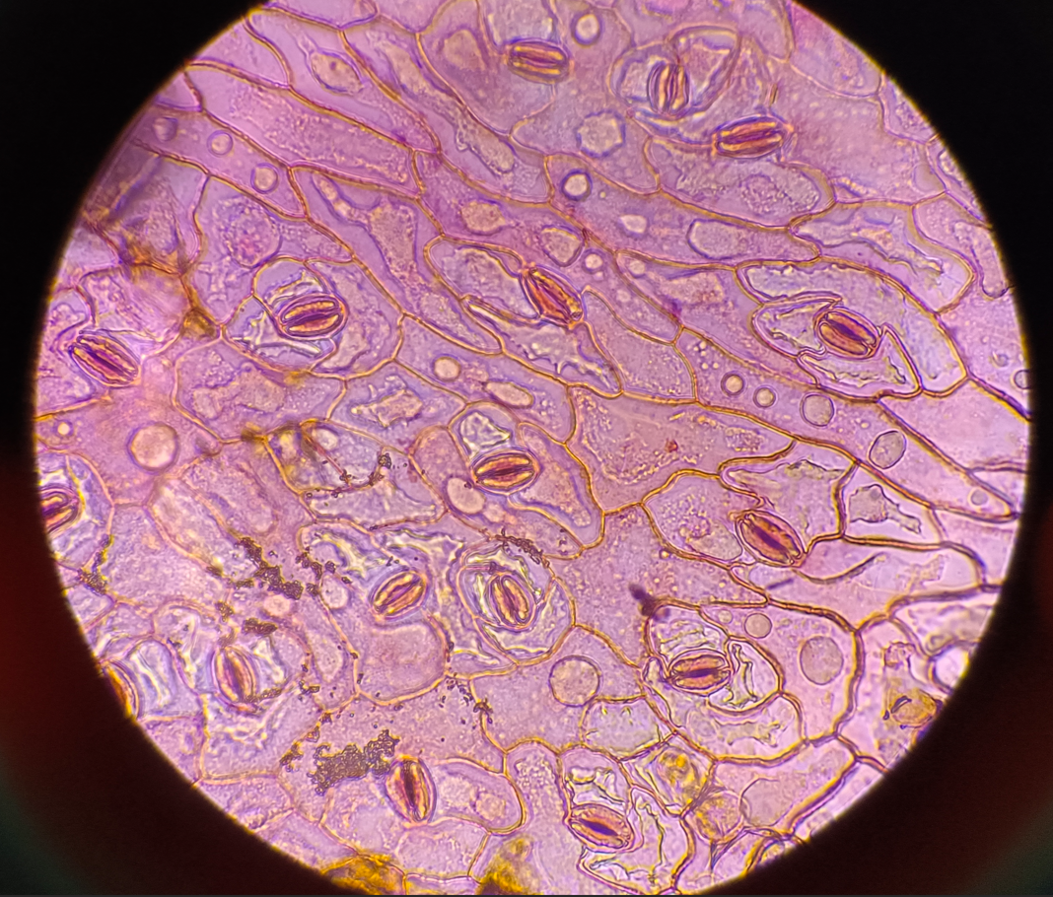

a.Irrigation at 50% FC + No anti-transpirants b. Irrigation at 50% FC + Kaolin 6%

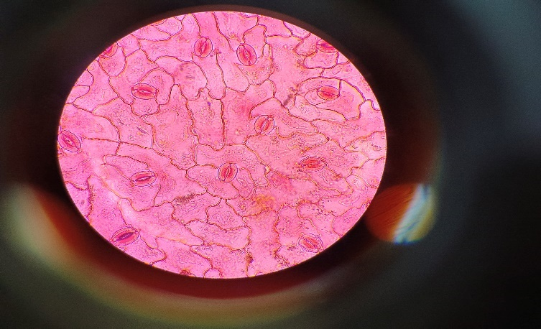

c. Irrigation at 75% FC + No anti-transpirants d. Irrigation at 75% FC + Kaolin 6%

 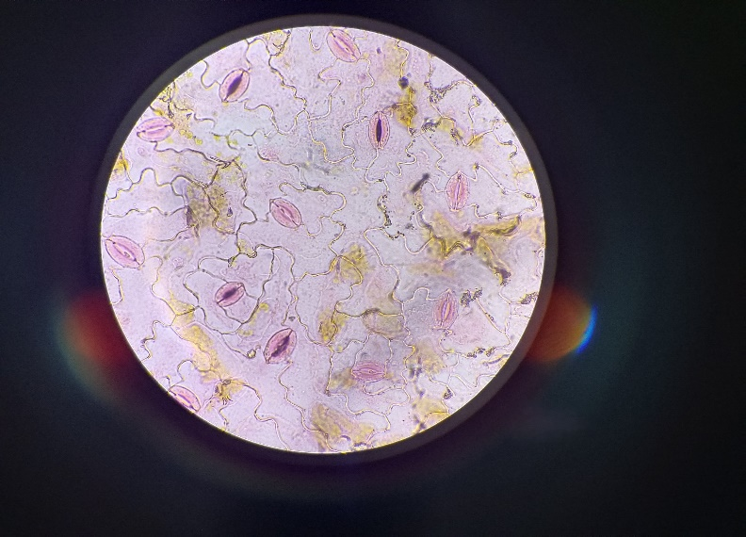

e. Irrigation at 100% FC + No anti-transpirants f. Irrigation at 100% FC + Kaolin 6%

Fig 8: Comparison between the microscopic observations of stomata count of fresh leaf “at different levels of irrigation without anti-transpirants” and “at different levels of irrigation with the most effective anti-transpirant in terms of reducing maximum possible stress”. (a,b) shows the comparison between irrigation at 50% FC and irrigation at 50% FC with Kaolin 6%. (c,d) shows the comparison between irrigation at 75% FC and irrigation at 75% FC with Kaolin 6%. (e,f) shows the comparison between irrigation at 100% FC and irrigation at 75% FC with Kaolin 6%. When compared between only irrigated plots and irrigation with anti-transpirants treatment plots we observed reducing stress due to anti-transpirants leading to decreasing in number of stomata per unit area of fresh leaf.

**Table legends:**

|  |  |  |  |  |  |
| --- | --- | --- | --- | --- | --- |
| **Tr. No Treatments 40 DAS 80 DAS 120 DAS** | | | | | |
| **A. IRRIGATION** | | | | | |
| I1  I2  I3 | At 100% FC  At 75% FC  At 50% FC  SEm (±)  CD(P=0.05) | | 2.103 ± 0.440b  2.569 ± 0.453b  4.231 ± 0.525a  0.264  1.066 | 2.473 ± 0.162b  3.978 ± 0.326b  5.718 ± 0.429a  0.307  1.239 | 3.010 ± 0.242c  5.733 ± 0.368b  8.540 ± 0.108a  0.250  1.007 |
| **B. ANTI-TRANSPIRANTS** | | | | | |
| S0  S1  S2  S3  S4 | | Control (No anti-transpirants)  Kaolin 6%  Acetylsalicylic Acid 10-3M  Cycocel 1000 ppm  Hexadecanol 5%  SEm(±)  CD(P=0.05) | 4.505 ± 0.297a  2.028 ± 0.542c  3.053 ± 0.551b  2.901 ± 0.469bc  2.352 ± 0.454bc  0.213  0.627 | 5.615 ± 0.160a  3.154 ± 0.490b  4.155 ± 0.404b  3.836 ± 0.156b  3.521 ± 0.317b  0.306  0.899 | 7.597 ± 0.155a  4.659 ± 0.436b  6.251 ± 0.127ab  5.268 ± 0.345b  5.029 ± 0.410b  0.441  1.294 |
| **INTERACTION(AxB)** | | | | | |
| SEm(±) 0.591 0.687 0.558  CD(P=0.05) NS NS NS | | | | | |
| **Table 1: The influence of different irrigation levels (I) and anti-transpirants (S) on the proline content of fresh leaf (µg g-1). The data sets are analysed using split plot technique. Data sets are collected from three replications.** | | | | | |

|  |  |  |  |
| --- | --- | --- | --- |
| Treatment interaction 40 DAS 80 DAS 120 DAS | | | |
| I1S0  I1S1  I1S2  I1S3  I1S4  I2S0  I2S1  I2S2  I2S3  I2S4  I3S0  I3S1  I3S2  I3S3  I3S4  SEm(±)  CD(P=0.05) | 3.616 ± 0.401  1.432 ± 0.462  2.035 ± 0.540  1.953 ± 0.417  1.481 ± 0.445  4.246 ± 0.413  1.776 ± 0.618  2.535 ± 0.462  2.247 ± 0.556  2.040 ± 0.422  5.652 ± 0.258  2.876 ± 0.668  4.590 ± 0.754  4.502 ± 0.532  3.536 ± 0.511  0.591  NS | 4.092 ± 0.373  1.925 ± 0.239  2.326 ± 0.100  2.078 ± 0.056  1.941 ± 0.250  5.497 ± 0.199  3.126 ± 0.458  4.170 ± 0.822  3.754 ± 0.207  3.362 ± 0.264  7.273 ± 0.483  4.410 ± 0.810  5.968 ± 0.471  5.677 ± 0.299  5.261 ± 0.446  0.687  NS | 3.437 ± 0.174  2.539 ± 0.279  3.102 ± 0.290  3.063 ± 0.311  2.909 ± 0.098  7.457 ± 0.321  4.849 ± 0.159  5.665 ± 0.570  5.487 ± 0.292  5.207 ± 0.288  11.899 ± 0.483  6.588 ± 0.687  9.984 ± 0.585  7.254 ± 0.611  6.972 ± 0.378  0.558  NS |

**Table 2: Effect of interaction between different levels of irrigation and anti-transpirants on the proline content of fresh leaf (µg g-1). The data sets are analysed using split plot technique. Data sets are collected from three replications.**

|  |  |  |  |  |
| --- | --- | --- | --- | --- |
| **Tr. No Treatments 40 DAS 80 DAS 120 DAS** | | | | |
| **A. IRRIGATION** | | | | |
| I1  I2  I3 | At 100% FC  At 75% FC  At 50% FC  SEm (±)  CD(P=0.05) | 100.959 ± 0.369c  118.825 ± 0.040b  122.487 ± 0.175a  0.268  1.081 | 122.828 ± 0.402c  152.641 ± 0.827b  165.463 ± 0.465a  1.244  5.014 | 145.320 ± 0.369c  167.555 ± 0.100b  177.039 ± 0.235a  0.425  1.713 |
| **B. ANTI-TRANSPIRANTS** | | | | |
| S0  S1  S2  S3  S4 | Control (No anti-transpirants)  Kaolin 6%  Acetylsalicylic Acid 10-3M  Cycocel 1000 ppm  Hexadecanol 5%  SEm(±)  CD(P=0.05) | 116.227 ± 0.458a  109.751 ± 0.664c  115.776 ± 0.682a  114.623 ± 0.789b  114.075 ± 0.765c  0.213  0.626 | 156.246 ± 0.180a  137.890 ± 0.399e  151.839 ± 0.129b  146.511 ± 0.291c  142.400 ± 0.620d  0.946  2.776 | 171.231 ± 0.460a  154.982 ± 0.664c  169.091 ± 0.682a  163.369 ± 0.790b  157.850 ± 0.765c  1.069  3.139 |
| **INTERACTION(AxB)** | | | | |
| SEm(±)  CD(P=0.05) | | 0.600  1.245 | 2.781  5.560 | 0.950  5.562 |

|  |  |  |  |
| --- | --- | --- | --- |
| Treatment  interaction 40 DAS 80 DAS 120 DAS | | | |
| I1S0  I1S1  I1S2  I1S3  I1S4  I2S0  I2S1  I2S2  I2S3  I2S4  I3S0  I3S1  I3S2  I3S3  I3S4  SEm(±)  CD(P=0.05) | 104.672 ± 0.666defg  90.488 ± 1.296h  104.091 ± 1.219efg  103.009 ± 1.704gh  102.537 ± 0.812h  120.302 ± 0.923ab  117.833 ± 0.904fg  119.591 ± 0.455abc  118.303 ± 1.140abcd  118.096 ± 0.758cdef  123.708 ± 1.091a  120.932 ± 0.703cde  123.646 ± 0.760a  122.558 ± 0.463abcd  121.592 ± 1.150bcde  0.600  1.245 | 135.193 ± 0.934f  107.730 ± 1.557h  132.220 ± 0.936f  123.017 ± 0.845g  115.980 ± 0.757gh  161.347 ± 0.634abc  144.777 ± 0.902ef  154.370 ± 1.178cd  152.577 ± 0.893cde  150.133 ± 1.367de  172.197 ± 0.614a  161.163 ± 1.296bcd  168.927 ± 0.720ab  163.940 ± 0.993abc  161.080 ± 1.322bcd  2.781  5.56 | 153.807 ± 0.670de  136.900 ± 1.300f  153.300 ± 1.220de  144.307 ± 1.704ef  138.287 ± 0.812f  176.383 ± 0.923ab  155.250 ± 0.904d  176.297 ± 0.460ab  168.853 ± 1.140bc  160.990 ± 0.758cd  183.503 ± 1.100a  172.797 ± 0.703b  177.677 ± 0.760ab  176.947 ± 0.463ab  174.273 ± 1.150ab  0.950  5.562 |

**Table 3: Influence of different irrigation levels (I) and anti-transpirants (S) on the stomata count per mm2 of fresh leaf. The data sets are analysed using split plot technique. Data sets are collected from three replications.**

**Table 4: Effect of interaction between different levels of irrigation and anti-transpirants on the stomata count per mm2 of fresh leaf. The data sets are analysed using split plot technique. Data sets are collected from three replications.**

|  |  |  |  |  |
| --- | --- | --- | --- | --- |
| **Tr. No Treatments 40 DAS 80 DAS 120 DAS** | | | | |
| **A. IRRIGATION** | | | | |
| I1  I2  I3 | At 100% FC  At 75% FC  At 50% FC  SEm (±)  CD(P=0.05) | 0.771 ± 0.002c  0.590 ± 0.005b  0.507 ± 0.005a  0.007  0.030 | 1.017 ± 0.004a  0.949 ± 0.002b  0.757 ± 0.004c  0.006  0.024 | 0.846 ± 0.007a  0.643 ± 0.005b  0.527 ± 0.006c  0.011  0.045 |
| **B. ANTI-TRANSPIRANTS** | | | | |
| S0  S1  S2  S3  S4 | Control (No anti-transpirants)  Kaolin 6%  Acetylsalicylic Acid 10-3M  Cycocel 1000 ppm  Hexadecanol 5%  SEm(±)  CD(P=0.05) | 0.553 ± 0.007d  0.690 ± 0.001a  0.581 ± 0.004cd  0.621 ± 0.010bc  0.667 ± 0.08ab  0.014  0.040 | 0.829 ± 0.006d  1.083 ± 0.010a  0.885 ± 0.002c  0.930 ± 0.007bc  0.979 ± 0.005b  0.013  0.039 | 0.602 ± 0.008c  0.757 ± 0.005a  0.652 ± 0.004bc  0.663 ± 0.007b  0.685 ± 0.007b  0.012  0.036 |
| **INTERACTION(AxB)** | | | | |
| SEm(±) | | 0.017  0.072 | 0.013  0.069 | 0.025  0.069 |
| CD(P=0.05) | |

**Table 5: Influence different irrigation levels (I) and anti-transpirants (S) on the total chlorophyll content of fresh leaves (mg g-1). The data sets are analysed using split plot technique. Data sets are collected from three replications.**

|  |  |  |  |
| --- | --- | --- | --- |
| Treatment interaction 40 DAS 80 DAS 120 DAS | | | |
| I1S0  I1S1  I1S2  I1S3  I1S4  I2S0  I2S1  I2S2  I2S3  I2S4  I3S0  I3S1  I3S2  I3S3  I3S4  SEm(±)  CD(P=0.05) | 0.667 ± 0.033bc  0.843 ± 0.008a  0.737 ± 0.006ab  0.773 ± 0.012ab  0.835 ± 0.011a  0.509 ± 0.006e  0.691 ± 0.005bc  0.510 ± 0.007e  0.589 ± 0.019cde  0.650 ± 0.008bcd  0.484 ± 0.008e  0.536 ± 0.001de  0.497 ± 0.005e  0.501 ± 0.003e  0.518 ± 0.020e  0.017  0.072 | 0.859 ± 0.009de  1.242 ± 0.031a  0.956 ± 0.008cd  0.972 ± 0.007bcd  1.058 ± 0.017bc  0.858 ± 0.008de  1.088 ± 0.005b  0.882 ± 0.010de  0.953 ± 0.018cd  0.965 ± 0.004cd  0.770 ± 0.011g  0.919 ± 0.006ef  0.819 ± 0.006fg  0.865 ± 0.008efg  0.914 ± 0.006ef  0.013  0.069 | 0.795 ± 0.009bcd  0.998 ± 0.009a  0.806 ± 0.011bc  0.813 ± 0.007b  0.817 ± 0.011b  0.540 ± 0.014fg  0.691 ± 0.011bcde  0.644 ± 0.012ef  0.667 ± 0.013de  0.675 ± 0.011cde  0.470 ± 0.026g  0.583 ± 0.007efg  0.506 ± 0.006g  0.510 ± 0.010fg  0.564 ± 0.011efg  0.025  0.069 |

**Table 6: Effect of interaction between different levels of irrigation and anti-transpirants on the total chlorophyll content of fresh leaf (mg g-1). The data sets are analysed using split plot technique. Data sets are collected from three replications.**

|  |  |  |  |  |
| --- | --- | --- | --- | --- |
| **Tr. No Treatments N uptake P uptake K uptake** | | | | |
| **A. IRRIGATION** | | | | |
| I1  I2  I3 | At 100% FC  At 75% FC  At 50% FC  SEm (±)  CD(P=0.05) | 109.736 ± 0.436a  108.057 ± 0.316a  92.576 ± 1.944b  1.845  7.439 | 46.325 ± 0.783a  42.732 ± 0.095a  30.700 ± 0.607b  1.202  4.845 | 98.539 ± 0.175a  94.055 ± 0.040b  73.320 ± 0.369c  0.347  1.398 |
| **B. ANTI-TRANSPIRANTS** | | | | |
| S0  S1  S2  S3  S4 | Control(No anti-transpirants)  Kaolin 6%  Acetylsalicylic Acid 10-3M  Cycocel 1000 ppm  Hexadecanol 5%  SEm(±)  CD(P=0.05) | 102.025 ± 0.769c  109.534 ± 0.400a  103.039 ± 0.832bc  97.481 ± 1.057d  105.202 ± 0.907b  0.708  2.079 | 36.722 ± 0.145c  44.041 ± 0.394a  38.935 ± 0.057c  37.071 ± 0.058d  40.826 ± 0.162b  0.357  1.048 | 83.183 ± 0.765c  96.565 ± 0.458a  88.702 ± 0.789b  80.316 ± 0.664c  94.424 ± 0.682a  1.075  3.157 |
| **INTERACTION (AxB)** | | | | |
|  | SEm(±)  CD(P=0.05) | 4.126  NS | 2.687  2.373 | 0.775  NS |

**Table 7: Influence of different irrigation levels (I) and anti-transpirants (S) on the Nitrogen (N), Phosphorus (P), and Potassium (K) uptake by crops in kg ha-1. The data sets are analysed using split plot technique. Data sets are collected from three replications.**

|  |  |  |  |
| --- | --- | --- | --- |
| Treatment interaction N uptake P uptake K uptake | | | |
| I1S0  I1S1  I1S2  I1S3  I1S4  I2S0  I2S1  I2S2  I2S3  I2S4  I3S0  I3S1  I3S2  I3S3  I3S4  SEm(±)  CD(P=0.05) | 108.034 ± 0.869  115.976 ± 0.388  108.651 ± 1.209  104.467 ± 0.749  111.553 ± 0.777  106.481 ± 0.339  115.873 ± 0.324  108.044 ± 0.304  100.882 ± 0.291  109.003 ± 1.160  91.560 ± 1.173  96.752 ± 1.889  92.423 ± 2.489  87.095 ± 2.205  95.050 ± 2.255  4.126  NS | 43.392 ± 0.906  55.047 ± 1.391  43.519 ± 0.716  42.276 ± 0.905  47.390 ± 0.068  42.413 ± 0.254  44.987 ± 0.274  42.613 ± 0.282  40.094 ± 0.215  43.554 ± 0.194  30.363 ± 0.285  32.089 ± 0.606  30.673 ± 0.796  28.843 ± 0.685  31.533 ± 0.731  2.687  2.373 | 94.273 ± 1.150  104.383 ± 1.091  96.947 ± 0.463  92.797 ± 0.703  104.297 ± 0.760  88.990 ± 0.758  103.503 ± 0.923  96.853 ± 1.140  83.250 ± 0.904  97.677 ± 0.455  66.287 ± 0.812  81.807 ± 0.666  72.307 ± 1.704  64.900 ± 1.296  81.300 ± 1.219  0.775  NS |

**Table 8: Effect of interaction between different levels of irrigation and anti-transpirants on the soil available Nitrogen (N), Phosphorus (P) and Potassium (K) in kg ha-**1**. The data sets are analysed using split plot technique. Data sets are collected from three replications.**

**APPENDIX- I: Daily evaporation data (mm)**

|  |  |  |  |  |  |  |  |  |  |  |  |
| --- | --- | --- | --- | --- | --- | --- | --- | --- | --- | --- | --- |
|  | **Evaporation** |  | **Evaporation** |  | **Evaporation** |  | **Evaporation** |  | **Evaporation** |  | **Evaporation** |
| **Day 1** | 4.4 | **Day 31** | 3.2 | **Day 61** | 0 | **Day 91** | 1.2 | **Day 121** | 2 | **Day 151** | 2.5 |
| **Day 2** | 4.5 | **Day 32** | 3.2 | **Day 62** | 0.1 | **Day 92** | 0.8 | **Day 122** | 4 | **Day 152** | 3 |
| **Day 3** | 4.6 | **Day 33** | 3.3 | **Day 63** | 0.1 | **Day 93** | 1 | **Day 123** | 3.6 | **Day 153** | 3.5 |
| **Day 4** | 4.7 | **Day 34** | 3.4 | **Day 64** | 0.2 | **Day 94** | 0.7 | **Day 124** | 3.8 | **Day 154** | 4 |
| **Day 5** | 5.2 | **Day 35** | 3 | **Day 65** | 0.1 | **Day 95** | 1 | **Day 125** | 3.2 | **Day 155** | 2 |
| **Day 6** | 4.5 | **Day 36** | 2 | **Day 66** | 0.2 | **Day 96** | 1.2 | **Day 126** | 3 | **Day 156** | 2.5 |
| **Day 7** | 4.4 | **Day 37** | 1.7 | **Day 67** | 0 | **Day 97** | 1 | **Day 127** | 2.8 | **Day 157** | 1.6 |
| **Day 8** | 4.5 | **Day 38** | 1.9 | **Day 68** | 0.5 | **Day 98** | 0.9 | **Day 128** | 2.9 | **Day 158** | 2 |
| **Day 9** | 4 | **Day 39** | 2 | **Day 69** | 0 | **Day 99** | 0.8 | **Day 129** | 1.5 | **Day 159** | 3.5 |
| **Day 10** | 4.2 | **Day 40** | 1.8 | **Day 70** | 0 | **Day 100** | 0.5 | **Day 130** | 3 | **Day 160** | 2.5 |
| **Day 11** | 3.5 | **Day 41** | 1.5 | **Day 71** | 0 | **Day 101** | 0.9 | **Day 131** | 2.5 |  |  |
| **Day 12** | 3.4 | **Day 42** | 2 | **Day 72** | 0 | **Day 102** | 0.6 | **Day 132** | 1.5 |  |  |
| **Day 13** | 3.4 | **Day 43** | 1.7 | **Day 73** | 0.5 | **Day 103** | 1 | **Day 133** | 1.8 |  |  |
| **Day 14** | 3.3 | **Day 44** | 1.5 | **Day 74** | 0 | **Day 104** | 1.3 | **Day 134** | 1.9 |  |  |
| **Day 15** | 3.4 | **Day 45** | 2 | **Day 75** | 1 | **Day 105** | 1.4 | **Day 135** | 2 |  |  |
| **Day 16** | 3.5 | **Day 46** | 1.3 | **Day 76** | 0.4 | **Day 106** | 1.2 | **Day 136** | 1.6 |  |  |
| **Day 17** | 3.4 | **Day 47** | 1.8 | **Day 77** | 0.6 | **Day 107** | 1 | **Day 137** | 2 |  |  |
| **Day 18** | 3.5 | **Day 48** | 1.5 | **Day 78** | 0.6 | **Day 108** | 1.6 | **Day 138** | 1 |  |  |
| **Day 19** | 3.4 | **Day 49** | 1.5 | **Day 79** | 0.5 | **Day 109** | 2.5 | **Day 139** | 0.5 |  |  |
| **Day 20** | 3.4 | **Day 50** | 1.3 | **Day 80** | 0.5 | **Day 110** | 2 | **Day 140** | 1.6 |  |  |
| **Day 21** | 3.5 | **Day 51** | 1.7 | **Day 81** | 0.3 | **Day 111** | 2.5 | **Day 141** | 1.2 |  |  |
| **Day 22** | 3.6 | **Day 52** | 1.5 | **Day 82** | 1.2 | **Day 112** | 2 | **Day 142** | 2 |  |  |
| **Day 23** | 3.2 | **Day 53** | 1.5 | **Day 83** | 0.7 | **Day 113** | 1.8 | **Day 143** | 2.5 |  |  |
| **Day 24** | 3.3 | **Day 54** | 1.3 | **Day 84** | 0.6 | **Day 114** | 1.3 | **Day 144** | 4 |  |  |
| **Day 25** | 3.5 | **Day 55** | 1.5 | **Day 85** | 0.7 | **Day 115** | 1.5 | **Day 145** | 3.5 |  |  |
| **Day 26** | 3.4 | **Day 56** | 1.8 | **Day 86** | 0.6 | **Day 116** | 2 | **Day 146** | 2.5 |  |  |
| **Day 27** | 3.3 | **Day 57** | 1.2 | **Day 87** | 0.4 | **Day 117** | 2 | **Day 147** | 2.8 |  |  |
| **Day 28** | 3.2 | **Day 58** | 1 | **Day 88** | 0.5 | **Day 118** | 2.3 | **Day 148** | 2.6 |  |  |
| **Day 29** | 3.1 | **Day 59** | 0.5 | **Day 89** | 0.6 | **Day 119** | 2.2 | **Day 149** | 2 |  |  |
| **Day 30** | 3.3 | **Day 60** | 0.3 | **Day 90** | 1.2 | **Day 120** | 2.4 | **Day 150** | 3 |  |  |

**APPENDIX -II: Calculation of crop evapotranspiration**

|  |  |  |  |
| --- | --- | --- | --- |
| **Experimental period** | **Evaporation (mm)** | **ET0** | **Crop ET** |
| Week 1 | 32.3 | 22.61 | 24.6449 |
| Week 2 | 26.3 | 18.41 | 20.0669 |
| Week 3 | 24.1 | 16.87 | 18.3883 |
| Week 4 | 23.5 | 16.45 | 17.9305 |
| Week 5 | 22.5 | 15.75 | 17.1675 |
| Week 6 | 12.9 | 9.03 | 12.5622 |
| Week 7 | 11.3 | 7.91 | 17.402 |
| Week 8 | 10.6 | 7.42 | 16.324 |
| Week 9 | 3.2 | 2.24 | 4.928 |
| Week 10 | 1 | 0.7 | 1.54 |
| Week 11 | 2.5 | 1.75 | 3.85 |
| Week 12 | 4.4 | 3.08 | 5.4635 |
| Week 13 | 5.2 | 3.64 | 5.278 |
| Week 14 | 6.6 | 4.62 | 6.699 |
| Week 15 | 6.5 | 4.55 | 6.5975 |
| Week 16 | 12.8 | 8.96 | 12.992 |
| Week 17 | 13.1 | 9.17 | 13.2965 |
| Week 18 | 22 | 15.4 | 22.33 |
| Week 19 | 16 | 11.2 | 16.24 |
| Week 20 | 10.6 | 7.42 | 10.759 |
| Week 21 | 18.5 | 12.95 | 18.7775 |
| Week 22 | 20.6 | 14.42 | 20.909 |
| Week 23 | 14.1 | 9.87 | 14.3115 |
| **Total** | 320.6 |  | 308.4578 |

**APPENDIX -III: Irrigation scheduling**

The three levels of irrigation were I1 (Irrigation at 100%FC), I2 (Irrigation at 75%FC), and I3 (Irrigation at 50%FC). After saturating the soil, the soil samples were collected every 24hr and the moisture percentage was observed and was noted. On the 3rd and 4th day, the soil moisture percentage remains constant, this is regarded as 100% field capacity (FC).

The soil moisture percentage at 100% FC was 17.64%.

The soil moisture percentage at 75% FC was 13.23%

The soil moisture percentage at 50% FC was 8.82%

Now this was done under a closed environment where no evaporation losses were there but this experiment was performed in open soil. So, In the open soil, after almost saturating the open soil, irrigation was discontinued, as a result, the moisture percentage started to decline. when the soil moisture percentage of open soil was equal to the soil moisture percentage at any of the 100%, 75%, or 50%FC, irrigation was delivered to the respective main plots that were marked to receive irrigation at the respective FC (100%, 75%, or 50%).

when soil moisture percentage of open soil = soil moisture percentage at 100%FC (17.64%), Irrigation was provided to the main plots denoted to apply irrigation at 100%FC (identified as I1). Typically, within 7 days, the soil moisture percentage approaches 100% FC. So irrigation scheduling was done at an interval of 6-7 days.

when soil moisture percentage of open soil = soil moisture percentage at 75%FC (13.23%), Irrigation was provided to the main plots denoted to apply irrigation at 75%FC (identified as I2). Within 14-18 days, the soil moisture percentage reaches 75%FC. Thus the irrigation scheduling was done at an interval of 14-18 days.

when soil moisture percentage of open soil = soil moisture percentage at 50%FC (8.82%), Irrigation was provided to the main plots denoted to apply irrigation at 50%FC (identified as I3). Usually, within 30-35 days, the soil moisture percentage reaches 50%FC. So the irrigation scheduling was done at an interval of 30-35 days.

**APPENDIX- IV: Rainfall and temperature data of the experimental site:**

|  |  |  |  |  |
| --- | --- | --- | --- | --- |
| SMW | *Max Temp (°C)* | *Min Temp (°C)* | *Rain (mm)* | *Evaporation (mm)* |
| Week 1 | 30 | 18 | 0 | 32.3 |
| Week 2 | 30 | 17 | 0 | 26.3 |
| Week 3 | 29 | 14 | 0 | 24.1 |
| Week 4 | 27 | 13 | 0 | 23.5 |
| Week 5 | 26 | 12 | 0 | 22.5 |
| Week 6 | 25 | 10 | 0 | 12.9 |
| Week 7 | 28 | 8 | 0 | 11.3 |
| Week 8 | 29 | 10 | 0 | 10.6 |
| Week 9 | 27 | 9 | 0 | 3.2 |
| Week 10 | 23 | 7 | 2 | 1 |
| Week 11 | 15 | 6 | 0.2 | 2.5 |
| Week 12 | 13 | 5.2 | 0 | 4.4 |
| Week 13 | 17 | 3 | 0 | 5.2 |
| Week 14 | 19 | 3 | 0 | 6.6 |
| Week 15 | 22 | 6 | 8.8 | 6.5 |
| Week 16 | 22.3 | 2 | 0.6 | 12.8 |
| Week 17 | 24.4 | 2.9 | 0 | 13.1 |
| Week 18 | 23.8 | 3.5 | 1 | 22 |
| Week 19 | 25.5 | 4.3 | 64 | 16 |
| Week 20 | 25.34 | 4.59 | 0 | 10.6 |
| Week 21 | 27.97 | 6.59 | 0 | 18.5 |
| Week 22 | 30.56 | 7.85 | 0 | 20.6 |
| Week 23 | 33.99 | 13.67 | 14 | 14.1 |