The study on Bio-Mass: A great source of non-fossil energy and its contribution in reducing greenhouse gases

**Abstract:**

The objective of this study is to estimate the average availability of bio-mass in India in year 2010 and prediction in year 2025 with the help of high-resolution imagery through Google Earth Engine and GIS, also estimating release of CO2 into atmosphere, if the same bio-mass is not utilized. The range of average above ground bio-mass(agb) in 2010 varies from 0.5338 - 93.644, below ground bio-mass (bgb)1.015- 22.474, and Total bio mass (TBM) 1.5488- 116.118 kg*C/m^2 as computed from MODIS. Corresponding Total Biomass quantity in year 2010 is 4.39179 billion Ton and CO2 release in atmosphere is 11.539218400000001 billion Ton. However, the Gross Primary Production is 4.79646005 billion Ton. However, prediction was made with NASA imagery in conjunction with Vegetation indices, Land Cover and FPAR/LAI, the results obtained are in the range of average above ground bio-mass(agb) in 2010 varies from 0.000 – 79, below ground bio-mass(bgb) 0.000-   
22, and Total bio mass (TBM) 0- 101 mg/Ha. Corresponding Total Biomass quantity in year 2010 is 4.112982692983341 billion Ton and Co2 release in atmosphere is 13.25737496044534 billion Ton. However, predicted figures in year 2025: the above ground bio-mass (agb) 85.73578643798828 mg/Ha, below ground bio-mass(bgb) 22.05862045288086 mg/Ha, and Total bio mass (TBM) 4.83646174936528 billion Ton. Correlation and R-squared values are 0.9882423543764696 and 0.9766229509835477.

Keywords: Living organisms, species biomass, Organic material, NPP, GPP.

Introduction:

India's arable land area of 1,597,000 km2 (394.6 million acres) is the second largest in the world, after the United States. Its gross irrigated crop area of 826,000 km2 (215.6 million acres) is the largest in the world, followed by US and China. Of the 160 million hectares of cultivated land in India, about 39 million hectares can be irrigated by groundwater wells and an additional 22 million hectares by irrigation canals. In 2010, only about 35% of agricultural land in India was reliably irrigated. About 2/3rd cultivated land in India is dependent on [monsoons](https://en.wikipedia.org/wiki/Monsoon_of_South_Asia).

“Land-surface process (LSP) models describe the physiological and biophysical processes of soil and vegetation, including ecosystem Net Primary Productivity (NPP). Models of this type have assumed greater importance in recent years, and are now commonly incorporated to global climate models” (Cox et al., 1999, Cramer et al., 2001). “Land-surface process (LSP) models are also analysed in their own right to understand better the global carbon cycle” (Kimball et al., 1997a, Kimball et al., 1997b, Potter et al., 2003).

Net Primary Productivity (NPP), or the production of plant biomass, is equal to all of the carbon taken up by the vegetation through photosynthesis (called Gross Primary Production or GPP) minus the carbon that is lost to respiration.

NPP = GPP - respiration

In terrestrial systems, NPP is often calculated by determining the carbon storage increment. Therefore, using the data from your sample site along with the biomass and carbon storage equations, aboveground NPP can be calculated by taking the difference in carbon storage of each individual tree between years, and summing the resulting values to get plot NPP.

NPP is one of the most frequently measured ecosystem processes, because it is central to the storage and accumulation of carbon in ecosystems, as well as the yield of usable products (lumber, etc.). From the NPP calculation, you can also calculate the annual CO2 uptake from your sample site using the instructions at the end of this document.

Annual CO2 uptake can be calculated using simple math and a bit of chemistry knowledge. Use the equation below to calculate CO2 uptake from NPP.

CO2 Uptake (g/m2/yr) = NPP (g/m2/yr) * 3.664

Equation Rational

A carbon dioxide molecule is made up of one carbon and two oxygen atoms.

From the periodic table, we know the atomic weight of carbon atom = 12.011 and the atomic weight of an oxygen atom = 15.999. Therefore, the atomic weight of CO2 molecule = 12.011 + 2*15.999 = 44.009.

We then find the ratio of CO2 to C, which is 44.009/12.011 = 3.664.

The carbon dioxide uptake of a sample site plot is equal to the carbon stored that year (i.e. NPP) * 3.664.

As the global community transitions towards more sustainable energy sources, bioenergy has emerged as a promising solution, particularly for countries with substantial agricultural resources like India. With its vast reserves of organic waste and residues, India holds significant potential to transform biomass into clean, renewable energy.

India’s increasing population, rapid urbanisation, and industrial expansion have dramatically escalated energy demands. Traditionally, this growing need has been met through fossil fuels, leading to soaring import costs and contributing significantly to carbon emissions. The environmental and economic challenges posed by such reliance have spurred the Indian government to set ambitious targets, such as producing 5 million metric tonnes of green hydrogen annually by 2030.

One of the most promising technologies to achieve these targets is **biomass gasification**, which offers a renewable and low-carbon solution to meet India’s energy requirements. Biomass can be converted into multiple forms of energy, such as biogas, ethanol, and biodiesel, which are crucial for transportation, electricity generation, and heating. Unlike fossil fuels, bioenergy is considered carbon-neutral, as the carbon dioxide (CO2) released during its combustion is offset by the CO2 absorbed by plants during their growth.

**Biomass feedstocks** are organic materials derived from agricultural residues, forestry by-products, purpose-grown energy crops, and organic waste (e.g., municipal solid waste, sewage sludge). These feedstocks represent a rich, underutilised source of renewable energy that could contribute significantly to India’s energy mix. However, one of the key challenges is optimising the energy density of these raw materials. Wet biomass, for instance, contains high moisture levels, which reduce its energy efficiency and require additional energy for evaporation.

The solution lies in **biomass palletisation**. This process involves drying the biomass to reduce its moisture content to 10-15%, followed by grinding to reduce the size of the material for easier compression. The final step is the palletisation itself, where the material is compressed against a heated die. This step softens the biomass’s natural lignin, which acts as a binding agent, forming dense energy pellets. These pellets can then undergo torrefaction – a thermal process that further enhances their energy density, combustion properties, and shelf life.

The Indian government has introduced policies to promote **co-firing** of biomass pellets in coal-fired power plants. Substituting up to 20% of coal with biomass in such plants not only reduces carbon emissions but also increases farmers’ incomes by creating a viable market for agricultural residues.

Several technologies have been developed to convert biomass into energy, each offering unique benefits. Below are some of the key technologies used in bioenergy production:

**Gasification**:  
Biomass gasification is a process that converts organic materials into **syngas** (a mixture of carbon monoxide, hydrogen, and other gases) by heating them in a low-oxygen environment. The two primary types of gasification are:

**Thermal Gasification**: In this process, biomass is heated in the presence of limited oxygen to produce syngas, which can be further converted into electricity, heat, and even biofuels such as ethanol and methanol.

**Oxy-fuel Gasification**: Here, oxygen is used instead of air, resulting in a higher concentration of carbon monoxide and hydrogen in the syngas. This is particularly useful for producing **green hydrogen** – a key component of India’s future energy plans.

**Pyrolysis**:  
Pyrolysis involves heating biomass in the absence of oxygen, breaking it down into bio-oil, biochar, and syngas. The bio-oil produced can be refined into hydrocarbon fuels like diesel, gasoline, and jet fuel. Pyrolysis is a versatile technology, providing options for both solid fuel and liquid fuel production, depending on the operating conditions.

**PlasmaGasification**:  
Plasma gasification utilises extremely high temperatures (above 2,000°C) to convert organic materials into syngas or other valuable products. This advanced technology is efficient in waste-to-energy conversion, producing high yields of syngas, which can be further processed into hydrogen or other fuels. A significant advantage of this method is that it destroys pathogens, reduces emissions, requires less conversion time, and allows for the recovery of nutrients (Harshita Negi et al).

# Literature Review:

“The quantification, mapping and monitoring of biomass are now central issues due to the importance of biomass as a renewable energy source in many countries of the world. The estimation of biomass is a challenging task, especially in areas with complex stands and varying environmental conditions, and requires accurate and consistent measurement methods. To efficiently and effectively use biomass as a renewable energy source, it is important to have detailed knowledge of its distribution, abundance, and quality. Remote sensing offers the technology to enable rapid assessment of biomass over large areas relatively quickly and at a low cost” (*Lalit Kumar, et al*).

“One study assessed the effectiveness of four popular models (traditional multiple linear regression (MLR), support vector machine (SVM), artificial neural network (ANN), and deep neural network (DNN)) with various input combinations (geospatial variables [GV], vegetation types [VT], field measurements [FM], meteorological variables [MV] and observation time [OT]) for AGB estimation based on a new framework for AGB modelling and mapping using Google Earth Engine. The results showed that the input feature of GV had a poor performance in AGB estimation (0.121 < *R*2 < 0.591). FM improved the accuracy the most when incorporated with GV (0.815 < *R*2 < 0.833). Although MV, VT and OT improved the accuracy (*R*2) only by 0.112–0.216 with an importance rank order of MV > VT > OT for machine learning models, their outputs could be used to map AGB” ([Yan Shi](https://onlinelibrary.wiley.com/authored-by/Shi/Yan) et al).

A study adopted a novel approach that “combines open-access Global Ecosystem Dynamics Investigation (GEDI) LiDAR data with satellite observation datasets to estimate and map the AGB and to enhance the accuracy and availability of biomass assessments, ultimately contributing to better insights into forest carbon dynamics” (Hamdi A. Zurqani ).

It was emphasized in a study that accurate Forest Aboveground Biomass (AGB) mapping is essential for understanding carbon storage in ecosystems, global carbon cycles, and effective forest management. Remote sensing (RS) technologies and advanced machine learning algorithms (MLAs) provide a reliable way to estimate AGB. This study explores using National Agriculture Imagery Program (NAIP) data, field measurements, and topographic variables for estimating AGB in Drew County, Arkansas, USA ([Prajwol Babu Subedi](https://ieeexplore.ieee.org/author/833015820147967) et al).

“A study proposes a fine-scale method for inter-species carbon-stock assessment, integrating mangrove three-dimensional structural information and spectral characteristics through Google Earth Engine (GEE). By combining GEDI data and Sentinel-2 imagery, this approach incorporates both vertical structure and spectral characteristics, overcoming the limitations of traditional models that neglect inter-species differences and vertical structural information. As a result, the accuracy of carbon-stock estimation is significantly improved” (Ruiwen Zhang et al).

A study discusses about “a methodology to generate wall-to-wall aboveground biomass density (AGBD) maps that exclusively relies on open access earth observation (EO) data. Specifically, spaceborne Global Ecosystem Dynamics Investigation (GEDI) LiDAR data were fused with Sentinel-1 synthetic-aperture radar, Sentinel-2 multispectral, elevation, and land cover data to produce biomass maps of Australia and the United States for 2020. The gradient boosting machine learning framework was applied to predict AGBD and its uncertainty at the resolutions of 100 m and 200 m” (Yuri Shendryk).

“Developed regression equations to estimate aboveground biomass of individual trees as a function of diameter at breast height, total height, wood density, and Holdridge life zone” (sensu Holdridge 1967).

“With the point intercept method, contacts are registered between plants and the tips of narrow pins passed into the vegetation. The summed number of contacts over a large number of pin positions has been used to estimate plant cover and leaf areas. This study shows that number of point intercepts also correlates highly with biomass. The intercepts can, therefore, be used as a regression variable to predict the mass of both stems and leaves in plant stands” (S Jonasson - Oikos, 1988 – JSTOR).

“Use GIS to assess biomass in Peninsular Malaysia, a country with very good inventories and maps, and in Continental South/Southeast Asia, a region with very sparse inventory information. In the later case, GIS is used to model forest biomass using a suite of map layers that most influence biomass” (Sandra Brown et al).

“The visible bands of the Landsat Thematic Mapper (TM) sensor were used in an empirical assessment of seagrass biomass on shallow banks near Lee Stocking Island in the Bahamas. The TM bands were transformed to minimize the depth-dependent variance in the bottom reflectance signal. Regression analyses were performed between the transformed bands and field measurements of seagrass standing crop (above-ground biomass). Regression equations using spectral data accounted for up to 80 per cent of the variability in seagrass biomass” ( ARMSTRONG, R. A., 1993).

“The texture parameters of two high-resolution (10 m) optical sensors (Advanced Visible and Near Infrared Radiometer type 2 (AVNIR-2) and SPOT-5) in different processing combinations for biomass estimation. Multiple regression models are developed between image parameters extracted from the different stages of image processing and the biomass of 50 field plots, which was estimated using a newly developed “allometric model” for the study region. The results demonstrate a clear improvement in biomass estimation using the texture parameters of a single sensor” (. E. Nichol and M. L. R. Sarker, 2011)

“Combined field sampling with remote sensing data and calculated five vegetation indices (VIs). Using this combined information, quantified a remote sensing estimation model and estimated biomass in a temperate grassland of northern China”. ( Yunxiang Jin, et al).

“To estimate above-ground biomass of tropical secondary forest from canopy spectral reflectance using satellite optical data. Landsat Thematic Mapper data were acquired concurrent with field surveys conducted in secondary forest fallows near Manaus, Brazil and Santa Cruz de la Sierra, Bolivia. Measurements of age and above-ground live biomass were made in 34 regrowth stands. Satellite data were converted to surface reflectance and compared with regrowth stand age, biomass and structural variables. Among the Brazilian stands, significant relationships were observed between middle-infrared reflectance and stand age, height, volume and biomass” (Steininger,M. K., doi: 10.1080/014311600210119).

# Methodology

## **Data and Methodology:**

The below mentioned methodology is adopted in processing the spatial data to achieve the goal of estimating accurately the above ground biomass(agb) and below ground biomass(bgb) along with emission of carbon di oxide in environment, which otherwise can be prevented.

NASA Collection

NASA Collection

MODIS Data Collection

NDVI,EVI

LAI,FPAR

Below Ground Biomass(bgb)

Above Ground Biomass(agb)

Extracting GPP

Extracting NPP

Land Cover

Release of Co2 in atmosphere

DEM

Below Ground Biomass(bgb)

Correlation

0.98824235437646

R Square Value

0.97662295098354

Prediction of Biomass in 2025

Smile Random Forest Model

Fig 1. Google earth Engine platform and GIS utilized to process the satellite imageries

The dataset of NASA provides temporally consistent and harmonized global maps of aboveground and belowground biomass carbon density for the year 2010 at a 300-m spatial resolution. The aboveground biomass map integrates land-cover specific, remotely sensed maps of woody, grassland, cropland, and tundra biomass. Input maps were amassed from the published literature and, where necessary, updated to cover the focal extent or time period. The belowground biomass map similarly integrates matching maps derived from each aboveground biomass map and land-cover specific empirical models. Aboveground and belowground maps were then integrated separately using ancillary maps of percent tree cover and landcover and a rule-based decision tree. Maps reporting the accumulated uncertainty of pixel-level estimates are also provided.

Aboveground living biomass carbon density includes carbon stored in living plant tissues located above the earth’s surface (stems, bark, branches, twigs). It does not include leaf litter or coarse woody debris that was once attached to living plants but have since been deposited and are no longer living. Belowground living biomass carbon density includes carbon stored in living plant tissues located below the earth’s surface (roots). This does not include dead and/or dislocated root tissue, nor does it include soil organic matter. Woody cover includes any vegetation whose biomass is primarily composed woody biomass (e.g. trees and shrubs). Herbaceous cover includes any vegetation whose biomass is primarily composed of leaf-like matter (e.g. grasses and many crops)( Spawn, S.A., Sullivan, C.C., Lark, T.J. et al. Harmonized global maps of above and belowground biomass carbon density in the year 2010. Sci Data 7, 112 (2020). [doi:10.1038/s41597-020-0444-4](https://doi.org/10.1038/s41597-020-0444-4),Spawn, S.A., and H.K. Gibbs. 2020. Global Aboveground and Belowground Biomass Carbon Density Maps for the Year 2010. ORNL DAAC, Oak Ridge, Tennessee, USA.)

The MODIS product provides information about annual Gross and Net Primary Productivity (GPP and NPP) at 500m pixel resolution. Annual NPP is derived from the sum of all 8-day Net Photosynthesis (PSN) products (MOD17A2H) from the given year. The PSN value is the difference of the Gross Primary Productivity (GPP) and the Maintenance Respiration (MR) (GPP-MR) (Running, S., Zhao, M. (2021). *MODIS/Terra Net Primary Production Gap-Filled Yearly L4 Global 500m SIN Grid V061* [Data set]. NASA EOSDIS Land Processes Distributed Active Archive Center. Accessed 2025-05-06 from <https://doi.org/10.5067/MODIS/MOD17A3HGF.061>)

“The MODIS vegetation indices (VIs) will provide consistent, spatial and temporal comparisons of global vegetation conditions that will be used to monitor the Earth's terrestrial photosynthetic vegetation activity for phonologic, change detection, and biophysical derivation of radiometric and structural vegetation parameters. The MODIS vegetation index (VI) products will play a major role in several EOS studies as well as be an integral part in the production of many global and regional biospheric models and biogeochemical cycles. Currently, satellite-derived vegetation indices are being integrated in interactive biosphere models as part of global climate modelling” (Sellers et al. 1994; Raich and Schlesinger, 1992; Fung et al., 1987; Tans et al., 1990) and production efficiency models (Prince et al., 1994; Prince, 1991). They are also used for a wide variety of land applications, including natural resource management, agriculture, the Global Health and Human Monitoring Program (NASA, 1988), and operational Famine Early Warning Systems (Prince and Justice, 1991; Hutchinson, 1991).

The simple ratio (SR) was the first index to be used (Jordan, 1969), formed by dividing the NIR response by the corresponding ‘red’ band output, SR= X nir/ X red (1) where X can be digital counts, at- satellite radiances, top of the atmosphere apparent reflectance, land leaving surface radiances, surface reflectance, or hemispherical spectral albedos. However, for densely vegetated areas, the amount of red light reflected approaches very small values and this ratio, consequently, increases without bounds. Deering (1978) normalized this ratio from -1 to +1, with the normalized difference vegetation index (NDVI), by ratioing the difference between the NIR and red bands by their sum; NDVI = X nir − X red /X nir + X red

Canopy background influences on vegetation indices are also atmosphere-sensitive, Huete and Liu (1994) found “background influences on the NDVI to decrease greatly with increases in atmospheric aerosol contents and that at a horizontal visibility of 5km (turbid atmosphere), background influences became nearly zero”. This was also observed with satellite imagery (Qi et al., 1993). Consequently, canopy background problems to become more pronounced in MODIS-NDVI imagery due to the improved atmospheric correction algorithms being implemented. A feedback problem is evident whereby the improvement of one form of noise increases other forms of noise. Liu and Huete (1995) developed “a feedback-based approach to correct for the interactive canopy background and atmospheric influences, incorporating both background adjustment and atmospheric resistance concepts. This enhanced, soil and atmosphere resistant vegetation index (EVI) was simplified to: EVI = 2 ⋅ ( ρ nir − ρ red ) (L + ρ nir + C 1 ρ red + C 2 ρ blue ) where ρ is ‘apparent’ (top-of-the-atmosphere) or ‘surface’ directional reflectance, L is a canopy background adjustment term, and C1 and C2 weigh the use of the blue channel in aerosol correction of the red channel” (Huete and Liu, 1996)( *ASTER Mount Gariwang image from 2018 was retrieved on YYYY_MM_DD from https://lpdaac.usgs.gov, maintained by the NASA EOSDIS Land Processes Distributed Active Archive Center (LP DAAC) at the USGS Earth Resources Observation and Science (EROS) Center, Sioux Falls, South Dakota. 2018,*[*https://lpdaac.usgs.gov/resources/data-action/aster-ultimate-2018-winter-olympics-observer/*](https://lpdaac.usgs.gov/user_resources/data_in_action/aster_ultimate_2018_winter_olympics_observer)*.)*

MODIS combined Leaf Area Index (LAI) and Fraction of Photosynthetically Active Radiation (FPAR) product is an 8-day composite dataset at 500m resolution.

Leaf Area Index (LAI) can be estimated using the Enhanced Vegetation Index (EVI) and a simple linear equation. The formula is typically: LAI = (3.618 * EVI) - 0.118.

Photosynthetically Active Radiation (FPAR) in Google Earth Engine typically involves using vegetation indices like NDVI and then applying a linear or non-linear transformation to estimate FPAR. The specific formula depends on the vegetation type and the satellite sensor used. Some common formulas include:

* **NDVI-based FPAR:** fPAR = 1.24 * NDVI - 0.168 (Winter wheat)
* **Red Edge NDVI-based FPAR:** fPAR = 1.25 * Red Edge NDVI - 0.10; fPAR = fPARmax * f(NDVI) (Corn, Soybean)
* **NDVI-based FPAR with limits:** f NDVI = max (min ((ndvi - 0.1) / (0.9 - 0.1), 1), 0) (Grassland, farmland, forest

**Results and Discussions:**

It is evident from the below graphs that NPP (Net Primary Production) and GPP (Gross Primary Production) have been increased over a period of time till 2022, afterward a slight reduction has been observed.

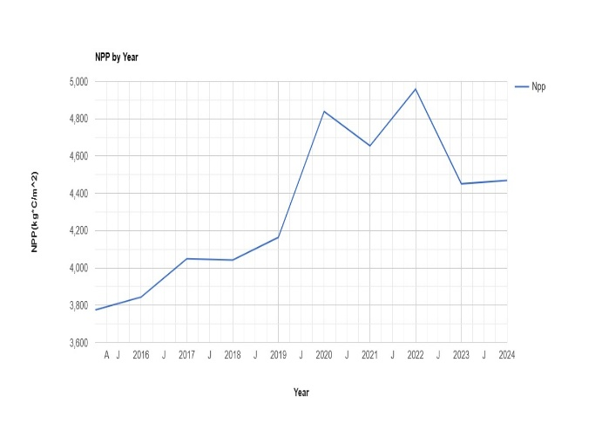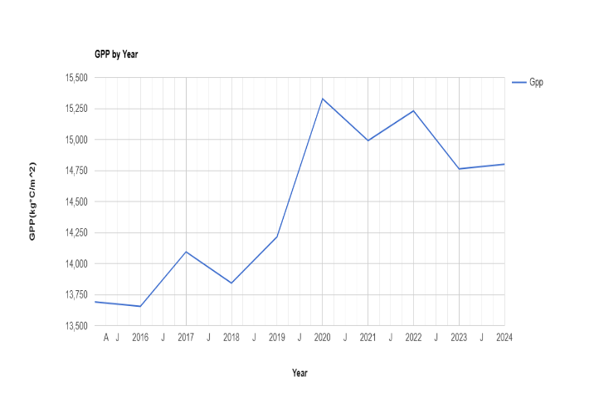

Fig.2 Net Primary Production and Gross Primary Production

Maps of Net Primary Production(NPP) and Gross Primary Production(GPP) in Kg*C/cm^2 are shown below.

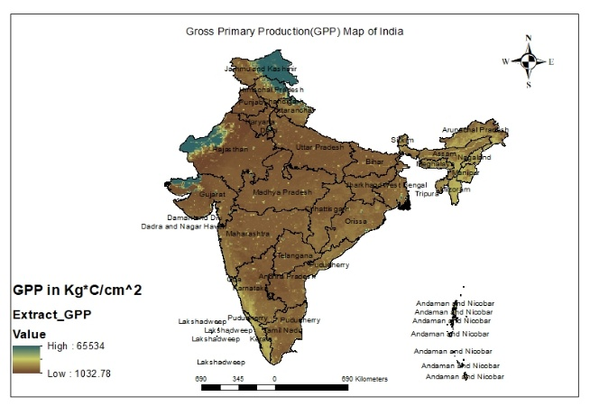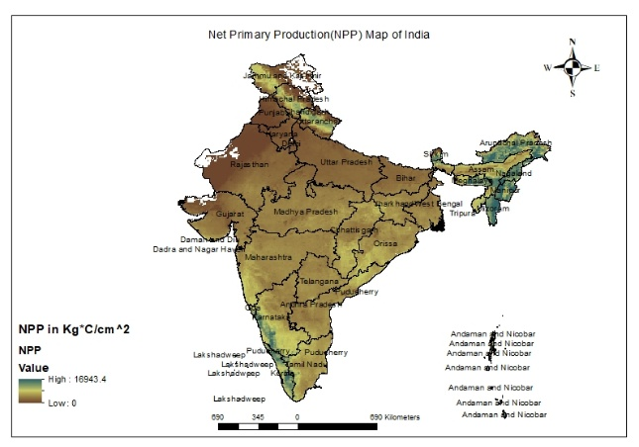

Fig.3 Gross and Net Primary Production map of India

NPP in billion Ton was 1.574675 in year 2022

GPP in billion Ton was 4.79646005 in year 2022

CO2 release to atmosphere in year 2022 was 13.25737496044534 billion Ton

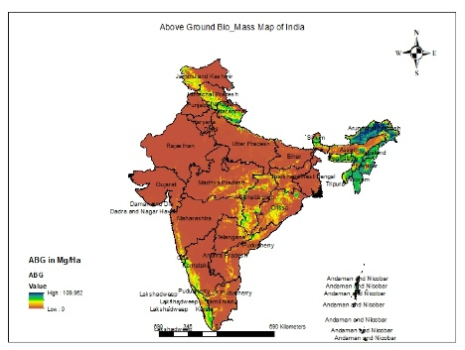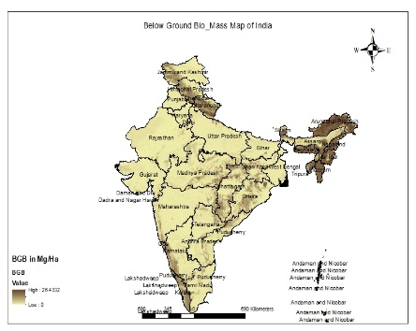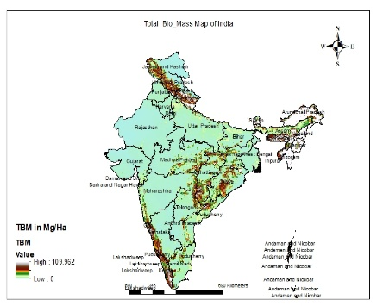

Fig.4. Above Ground Biomass, Below Ground Biomass and Total Biomass in mg/Ha

Above Ground Biomass in billion Ton : 3.3245442783757557

Below Ground Biomass in billion Ton : 1.0672484713077333

Total Biomass in billion Ton : 4.391792749772013

Smile Random Forest Model was prepared on NASA/ORNL using vegetation indices, Leaf Area index, Par, Land Cover and Dem as independent variable. The base data for the year 2010 has been considered and with the help of the model, prediction for above ground, below ground and total bio mass has been made for the year, 2025. 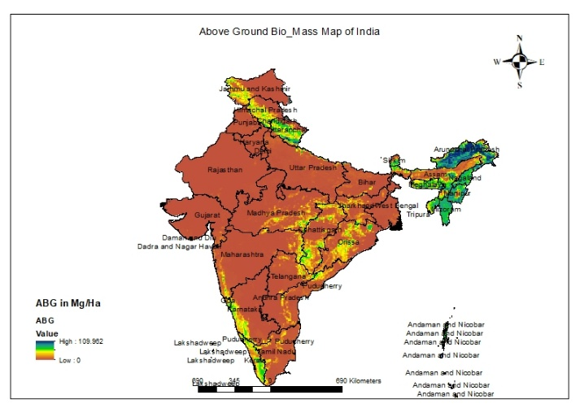

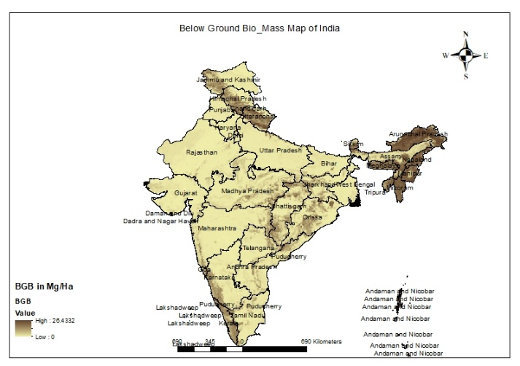

Fig.5: Original Above and Below Ground Biomass in mg/Ha

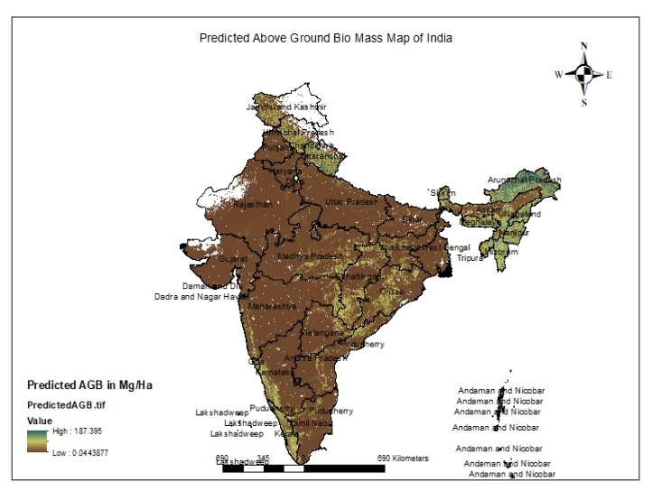

4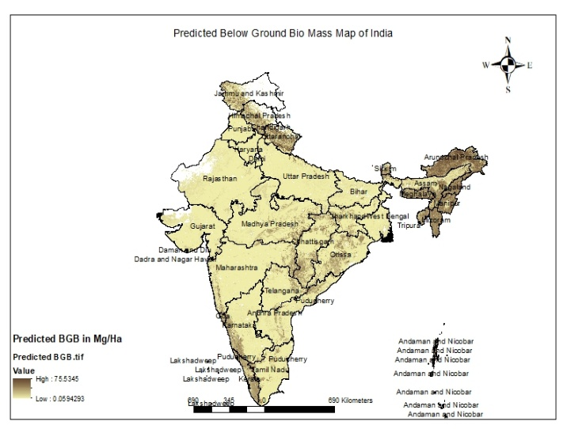

Fig.6: Predicted Above and below Ground Biomass in mg/Ha

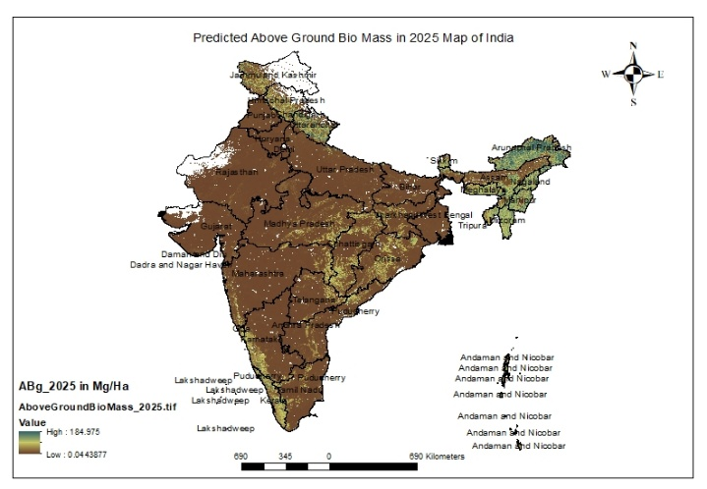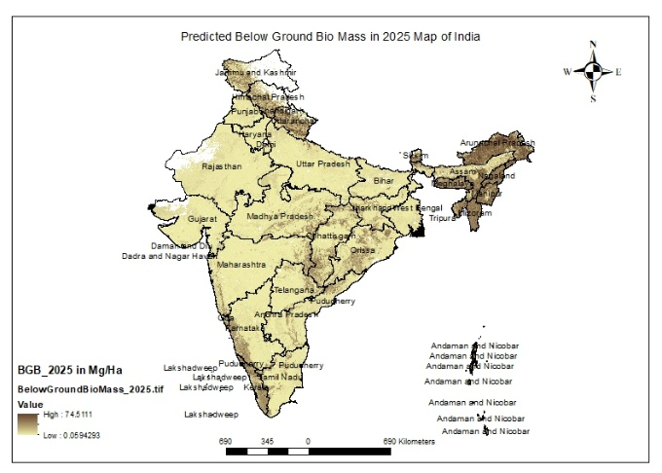

Fig.7: Predicted Above and below Ground Biomass in mg/Ha in year 2025

Above Ground Biomass in billion Ton in 2025 : 3.642135978144324

Below Ground Biomass in billion Ton in 2025 : 1.194325771220956

Total Biomass in billion Ton in 2025 : 4.83646174936528

**Model Parameters for base data:**

**Correlation : 0.9882423543764696**

**R-Squared value : 0.9766229509835477**

**Parameters for predicted model:**

**Correlation : 0.9790501792925359**

**R-Squared value : 0.9585392535727467**

**Table 1: Random Forest Model data**

|  |  |  |  |  |  |  |
| --- | --- | --- | --- | --- | --- | --- |
| Sr.No. | MODIS imagery | | NASA/ORNL Imagery | | Smile Random Forest Model | |
| 1. | AGB (billion Ton) | - | AGB (billion Ton) | 3.3245442783757557 | AGB (billion Ton) | 3.642135978144324 |
| 2. | BGB (billion Ton) | - | BGB (billion Ton) | 1.0672484713077333 | BGB (billion Ton) | 1.194325771220956 |
| 3. | TBM (billion Ton) | 4.79646005 | TBM (billion Ton) | 4.391792749772013 | TBM (billion Ton) | 4.83646174936528 |

# Conclusion:

Remote sensing, being an advanced technology, is quite useful for quick and reliable estimations of vegetation biomass and carbon over large areas. Furthermore, remote sensing is also useful for stratification of forests and in selection of proper sample plots for enumeration. which is otherwise not possible through conventional methods, (G. M. DEVAGIRI1 et al)

The instant study suggests that Above Ground, Below Ground and Total Biomass are present in abundance in the Himalayas region, North East region, Eastern part of India and Western ghats of India.

The results obtained from different methods are almost similar, however the results obtained from Smile Random Forest Model are well reliable, which is established from the robust parameters.

Further, Co2 released to atmosphere in case of non-utilization of available bio mass would be around 13.25737496044534 billion Ton, which will be equivalent to 13 billion carbon credits. Each carbon credit typically represents one MT of CO2 equivalent (CO2e) emissions. The price of these credits can vary significantly depending on the market (voluntary or compliance) and other factors

Biomass can be directly converted into power production through methods like direct combustion, gasification, pyrolysis, and anaerobic digestion. These methods can be used to generate electricity, heat, or biofuels. Biomass can also be used as a supplementary fuel for existing power plants, a process called co-firing. Thus, The available bio mass potential in India can generate power around 2.5GW/hour.

# Future Research Direction:

An accurate and spatially explicit estimation of biomass is required for sustainable forest management, prevention of biodiversity loss, and carbon accounting for climate change mitigation.

Biomass estimation, which involves quantifying the total organic matter in a given area or population, has a wide range of crucial uses across various fields. As enumerated below:

**Carbon Sequestration:** Forests and other ecosystems play a vital role in absorbing carbon dioxide from the atmosphere. Biomass estimation helps to quantify the amount of carbon stored in these ecosystems (carbon stock) and track changes over time, which is essential for understanding and mitigating climate change.

* **Greenhouse Gas (GHG) Inventories:** Accurate biomass data is critical for national and international reporting on GHG emissions and removals, particularly for activities related to land use, land-use change, and forestry (LULUCF).
* **REDD+ (Reducing Emissions from Deforestation and Forest Degradation):** Biomass estimation is fundamental for monitoring and verifying the effectiveness of REDD+ initiatives, which aim to reduce emissions from forest loss.
* **Carbon Markets:** Direct biomass measurement can improve the integrity and transparency of voluntary carbon markets by providing robust and accurate data on carbon stock changes.
* **Forest Productivity and Health:** Biomass is an indicator of site productivity and can be used to assess the overall health and vigor of forests.
* **Sustainable Forest Management:** Estimating biomass helps in planning sustainable harvesting levels, assessing the impact of forest management practices, and ensuring the long-term health of forest ecosystems.
* **Forest Fire Risk Assessment:** Biomass estimations provide important information for assessing the amount of fuel available, which is crucial for predicting and managing forest fire risks.
* **Biodiversity and Ecosystem Understanding:** Biomass data contributes to a better understanding of forest structure, ecological processes, and the distribution of living organisms within an ecosystem.
* **Resource Assessment:** It helps in estimating the amount of wood, fuel, and other forest products available.
* **Crop Growth and Health Monitoring:** Biomass is a key indicator of crop growth status, vigor, and the effectiveness of agricultural management practices.
* **Nutrient and Water Management:** Biomass measurements can reveal spatial and temporal variations, indicating crop stress due to nutrient or water deficiencies, thus guiding fertilizer and irrigation decisions.
* **Yield Forecasting:** Biomass correlates with critical physiological crop processes, making it a pivotal factor in yield prediction models that inform supply chains and marketing.
* **Weed Control:** Uniformity of biomass distribution can aid in weed management.
* **Crop Phenotyping:** It assists scientists in evaluating the performance of different genetic varieties under diverse conditions.
* **Biomass Resource Assessment:** Accurate estimation is a preliminary exercise for biomass-based power production, identifying the quantity and quality of biomass available from agricultural fields, forests, and waste products.
* **Supply Chain Planning:** It helps in establishing efficient biomass supply chains for bioenergy plants, considering factors like availability, transport, and pre-treatment.
* **Optimizing Bioenergy Production:** Understanding the calorific value and quality of biomass through estimation is essential for increasing the efficiency of bioenergy conversion processes (e.g., gasification, combustion).
* **Ecological Studies:** Biomass data is fundamental for research on ecosystem functioning, carbon cycles, and the impact of environmental changes.
* **Model Validation:** It serves as crucial ground truth data for validating and improving remote sensing models and other predictive models for biomass mapping.
* **Spatial and Temporal Dynamics:** Biomass estimation, particularly with remote sensing, allows for monitoring changes in biomass distribution over large areas and across different time scales, providing insights into drivers of change.

Therefore, biomass estimation is a versatile tool that provides essential information for environmental management, climate action, sustainable resource utilization, and advancing our understanding of natural and agricultural ecosystems.

There is enormous scope in carrying out further research work in the above said areas. The future of biomass estimation data research lies in leveraging cutting-edge technologies, addressing existing methodological gaps, improving data integration and ensuring that the generated information is directly applicable to pressing environmental and societal challenges.

**Disclaimer (Artificial intelligence)**

Option 1:

Author(s) hereby declare that NO generative AI technologies such as Large Language Models (ChatGPT, COPILOT, etc.) and text-to-image generators have been used during the writing or editing of this manuscript.

Option 2:

Author(s) hereby declare that generative AI technologies such as Large Language Models, etc. have been used during the writing or editing of manuscripts. This explanation will include the name, version, model, and source of the generative AI technology and as well as all input prompts provided to the generative AI technology

Details of the AI usage are given below:

1.

2.

3.

# References :

[Yan Shi](https://onlinelibrary.wiley.com/authored-by/Shi/Yan), [Jay Gao](https://onlinelibrary.wiley.com/authored-by/Gao/Jay), [Gary Brierley](https://onlinelibrary.wiley.com/authored-by/Brierley/Gary), [Xilai Li](https://onlinelibrary.wiley.com/authored-by/Li/Xilai), [George L. W. Perry](https://onlinelibrary.wiley.com/authored-by/Perry/George+L.+W.), [Tingting Xu](https://onlinelibrary.wiley.com/authored-by/Xu/Tingting),First published: 31 March 2023, <https://doi.org/10.1111/gfs.12607>

@article{ZURQANI2025103052,title = {A multi-source approach combining GEDI LiDAR, satellite data, and machine learning algorithms for estimating forest aboveground biomass on Google Earth Engine platform},journal = {Ecological Informatics},volume = {86},pages = {103052},year = {2025},issn = {1574-9541},doi = {https://doi.org/10.1016/j.ecoinf.2025.103052},url = {https://www.sciencedirect.com/science/article/pii/S1574954125000615},author = {Hamdi A. Zurqani},

P. B. Subedi and H. A. Zurqani, "Estimating Above Ground Forest Biomass Using High-Resolution NAIP Imagery, Machine Learning, and Google Earth Engine," *2024 IEEE Asia-Pacific Conference on Geoscience, Electronics and Remote Sensing Technology (AGERS)*, Manado, Indonesia, 2024, pp. 92-101, doi: 10.1109/AGERS65212.2024.10932891.

Zhang, R.; Fan, J. Classification and Carbon-Stock Estimation of Mangroves in Dongzhaigang Based on Multi-Source Remote Sensing Data Using Google Earth Engine. *Remote Sens.* **2025**, *17*, 964. <https://doi.org/10.3390/rs17060964>

@article{SHENDRYK2022103108,title = {Fusing GEDI with earth observation data for large area aboveground biomass mapping},journal = {International Journal of Applied Earth Observation and Geoinformation},volume = {115},pages = {103108},year = {2022},issn = {1569-8432},doi = {https://doi.org/10.1016/j.jag.2022.103108},url={https://www.sciencedirect.com/science/article/pii/S1569843222002965},author = {Yuri Shendryk},

Cramer, W., Bondeau, A., Woodward, F.I., Prentice, I.C., Betts, R.A., Brovkin, V., Cox, P.M., Fisher, V., Foley, J.A., Friend, A.D. and Kucharik, C., 2001. Global response of terrestrial ecosystem structure and function to CO2 and climate change: results from six dynamic global vegetation models. *Global change biology*, *7*(4), pp.357-373.

Amthor, J.S., Chen, J.M., Clein, J.S., Frolking, S.E., Goulden, M.L., Grant, R.F., Kimball, J.S., King, A.W., McGuire, A.D., Nikolov, N.T. and Potter, C.S., 2001. Boreal forest CO2 exchange and evapotranspiration predicted by nine ecosystem process models: Intermodel comparisons and relationships to field measurements. *Journal of Geophysical Research: Atmospheres*, *106*(D24), pp.33623-33648.

Kumar, L. and Mutanga, O., 2017. Remote sensing of above-ground biomass. *Remote Sensing*, *9*(9), p.935.

Brown, S., Gillespie, A.J. and Lugo, A.E., 1989. Biomass estimation methods for tropical forests with applications to forest inventory data. *Forest science*, *35*(4), pp.881-902.

Jonasson, S., 1988. Evaluation of the point intercept method for the estimation of plant biomass. *Oikos*, pp.101-106.

Negi, H., Suyal, D.C., Soni, R., Giri, K. and Goel, R., 2023. Indian scenario of biomass availability and its bioenergy-conversion potential. *Energies*, *16*(15), p.5805.

Brown, S., 1997. *Estimating biomass and biomass change of tropical forests: a primer* (Vol. 134). Food & Agriculture Org.

Armstrong, R.A., 1993. Remote sensing of submerged vegetation canopies for biomass estimation. *International Journal of Remote Sensing*, *14*(3), pp.621-627.

Nichol, J.E. and Sarker, M.L.R., 2010. Improved biomass estimation using the texture parameters of two high-resolution optical sensors. *IEEE Transactions on Geoscience and Remote Sensing*, *49*(3), pp.930-948.

Jin, Y., Yang, X., Qiu, J., Li, J., Gao, T., Wu, Q., Zhao, F., Ma, H., Yu, H. and Xu, B., 2014. Remote sensing-based biomass estimation and its spatio-temporal variations in temperate grassland, Northern China. *Remote Sensing*, *6*(2), pp.1496-1513.

Steininger, M.K., 2000. Satellite estimation of tropical secondary forest above-ground biomass: data from Brazil and Bolivia. *International journal of remote sensing*, *21*(6-7), pp.1139-1157.

Spawn, S.A., Sullivan, C.C., Lark, T.J. and Gibbs, H.K., 2020. Harmonized global maps of above and belowground biomass carbon density in the year 2010. *Scientific Data*, *7*(1), p.112.

Running, S. and Zhao, M., 2019. MOD17A3HGF MODIS/Terra net primary production gap-filled yearly L4 global 500 m SIN grid V006. *(No Title)*.

Raich, J.W. and Potter, C.S., 1995. Global patterns of carbon dioxide emissions from soils. *Global biogeochemical cycles*, *9*(1), pp.23-36.

Qi, J., Huete, A.R., Moran, M.S., Chehbouni, A. and Jackson, R.D., 1993. Interpretation of vegetation indices derived from multi-temporal SPOT images. *Remote Sensing of Environment*, *44*(1), pp.89-101.

Devagiri, G.M., Money, S., Singh, S., Dadhawal, V.K., Patil, P., Khaple, A., Devakumar, A.S. and Hubballi, S., 2013. Assessment of above ground biomass and carbon pool in different vegetation types of south western part of Karnataka, India using spectral modeling. *Tropical Ecology*, *54*(2), pp.149-165.