# Impacts of Drip Fertigation levels on Asiatic Lily Performance Under Field Conditions in a Non-Traditional Indian Region

# ABSTRACT

# Lilies belonging to the Liliaceae family are captivating flowering plants with a long history and cultural significance. With more than 100 species and thousands of cultivars, these plants have been cultivated for millennia and hold diverse symbolic meanings across cultures. In India, lilies grow well in temperate Himalayan regions, Uttarakhand, Himachal Pradesh, and Jammu and Kashmir. The floriculture sector in India is growing rapidly, especially for export-oriented and high-value crops, i.e. lily. Drip fertigation will support commercial lily cultivation in non-traditional regions like the Himalayan Tarai region. With increasing water scarcity and the need for sustainable floriculture, efficient fertigation practices are essential to improve flower yield and quality with minimal input use. This study aimed to investigate the effects of different drip fertigation levels on the quality of Asiatic lilies produced under open field conditions in the Himalayan Tarai region in India. This study, “Impact of different drip fertigation levels on the quality of Asiatic lilies cultivated under open field conditions of the Himalayan Tarai region in India”, compared four treatments were compared: fertigation levels 120, 100 and 80 per cent RDF, and one control (conventional method of manuring and fertilisation). The study provides a comprehensive view of the impacts of different drip fertigation levels on various plant growth parameters, i.e. plant height, number of leaves per plant, leaf area per plant, and stem diameter. The study was carried out using a randomized block design (RBD) consisting of four treatments (120% RDF, 100% RDF, 80% RDF, control) and five replications. The results showed that the fertigation level 120 per cent RDF (Recommended dose of fertilizer) treatment significantly increased plant height, leaf area, and biomass, whereas the fertigation level 100 per cent RDF treatment had early bud initiation, maximum floret diameter, and shelf life of the spike. The fertigation level 120 per cent RDF through drip fertigation system had taller plant height (104.00 cm) and maximum leaf area (1291.54 cm²), whereas the fertigation level 100 per cent RDF was found superior in bud number per spike (5.50 per plant) and the shelf life of spike (27.70 days). Moreover the results demonstrated that fertigation level 120 per cent RDF treatment resulted in the largest bud sizes, indicating that higher nutrient levels facilitate better floral development. The conventional method of manuring and fertilisation consistently underperformed across all the plant growth and spike quality parameters. These findings underscore the importance of fertigation in improving both growth and floral quality, providing practical guidelines for growers aiming to increase economic viability and sustainability in lily cultivation. Therefore, growers should carefully consider their specific needs and objectives when selecting fertiliser treatments to achieve the best possible outcomes for plant development and flower quality.

# Key words: Drip fertigation, conventional method, spike quality, vegetative growth, shelf life, fresh biomass and dry biomass

1. **INTRODUCTION**

The demands of ornamental plants as cut flowers as well as pot plants, have been increasing day by day. Lily is the most important graceful flowering bulbous plant in the world and is native to the Northern Hemisphere and mainly spreads over Asia, North America, and Europe (Kumari et al., 2022). Lilies belonging to the Liliaceae family are captivating flowering plants with a long history and cultural significance. With more than 100 species and thousands of cultivars, these plants have been cultivated for millennia and hold diverse symbolic meanings across cultures. In ancient Greece, lilies were associated with the goddess Hera, whereas in Christianity, they symbolised purity and divinity. In Japan, they represent good fortune and happiness. Their genetic diversity contributes to a wide array of cultivars, with origins spanning the Balkans, the Middle East, parts of Asia, Mexico, Europe, North Africa, and the Canary Islands. In India, lilies grow well in temperate Himalayan regions (Uttarakhand, Himachal Pradesh, Jammu and Kashmir) and the Nilgiri Hills under natural open field condition whereas lily cultivated under protected conditions in various states, including Uttarakhand, Uttar Pradesh, Punjab, Haryana, Karnataka, Maharashtra, West Bengal, and North Eastern states [1& 2]. Lilium holds a significant position as a commercial bulbous cut flower cultivated worldwide. Belonging to the family Liliaceae, the genus Lilium encompasses over 80 species spread across North America, Asia, and Europe, showcasing notable diversity in plant structure, flower characteristics, bulb types, and fragrances. Lilium ranks fourth among the bulbous plants after Tulipa, Gladiolus, and Narcissus (Geethan et al., 2024). Lilies rank second in area and production among bulbous cut flowers, following tulips, with the Netherlands being the leading producer [3]. Floriculture, particularly cut flowers, is an ever-shining and enterprising industry in terms of utility towards potential value for trade, business, and aesthetic sense. Lilium is a commercial cut flower bulbous crop, truly representing purity as a symbol of love because of its flower value. The oriental lily is now the fourth significant crop worldwide (Karthikeyan et al.,2023). The demand for lily flowers has been increasing annually, driven by both local and international markets. However, fertiliser requirements pose a significant challenge for lily cultivation in the temperate and Tarai regions of India. To increase fruit and flower quality, it is essential to supply optimal amounts of fertiliser through drip irrigation systems, which efficiently deliver nutrients directly to the plant's active root zone, thus conserving both fertilisers and water [4-7]. Flower crops, including lilies, are highly responsive to fertilisers, necessitating increased and balanced fertiliser applications to maximise flower production [8]. Fertiliser requirements significantly influence plant growth, spike quality, and bulb production [9-10]. Recent studies have indicated that different drip fertigation levels can significantly affect plant vegetative and spike quality traits such as plant height, leaf number, leaf area, and spike quality characters, etc. For example, research shows that optimal nutrient levels can increase these parameters, thereby improving overall quality and marketability [11-12]

This study aimed to investigate the effects of different drip fertigation levels on the quality of Asiatic lilies produced under open field conditions in the Himalayan Tarai region in India. The primary objectives include determining the optimal fertigation levels that maximise flower quality without compromising plant vegetative growth, evaluating the effects on spike quality and aesthetic appeal, and contributing to sustainable agricultural practices. Ultimately, this research seeks to provide practical guidelines for growers, fostering an integrated approach to horticulture that promotes both economic viability and environmental sustainability.

1. **MATERIALS AND METHODS**

This experiment was conducted during the rabi season of 2017 at the Modern Floriculture Centre, Department of Horticulture, College of Agriculture, Govind Ballabh Pant University of Agriculture and Technology, Pantnagar, Uttarakhand, India. Pantnagar is located at the foothills of the Himalayas (Shivalik range) and falls within the humid subtropical climate zone, situated at 29° North latitude and 79.3° East longitude, with an altitude of 243.84 m above sea level. The agro-meteorological conditions in Pantnagar over the past decade indicate a dynamic climate characterised by a wide temperature range. In the summer season, temperatures reach 42-45°C, whereas in the winter season temperatures are 2-4°C. The average annual rainfall is approximately 145 cm, occurring primarily during the monsoon season from June to September, as recorded by the weather station at Govind Ballabh Pant University of Agriculture and Technology. The average soil pH in the region ranges from 6.5 to 7.0. The experiment was laid out as a randomised block design with four treatments and five replications. The treatments are three fertigation levels: 120, 100, 80 per cent of the recommended dose of fertiliser (RDF), and a control (conventional method). For Asiatic lily cv. Indian Diamond is 135:120:80 NPK kg/ha. Nitrogen, phosphorus, and potassium were applied through water-soluble fertilisers via a drip irrigation system in three splits. The first split (20 per cent of the fertigation level) was applied three weeks after bulb sprouting, the second split (40 per cent of the fertigation level) was applied following the first fertigation, and the third split (40 per cent of the fertigation level) was applied three weeks after the second fertigation. The meteorological data collected during the experimental period (November 2016 - March 2017) are presented in Figs. 1 and 2. The data for vegetative growth and spike quality parameters are plant height (cm), number of leaves per plant, leaf area per plant (cm²), stem diameter (mm), number of buds per plant, and length and diameter of both the basal and upper buds (cm) were recorded at the spike harvesting stage. However, the fresh weight of the plant was recorded when all florets were fully opened in the field. The same samples were subsequently dried at 60°C in an oven until a constant weight was achieved, after which the dry weight of the plants was measured via a digital balance. The plant height and bud length were measured with a standard ruler, whereas the stem and bud diameters were recorded via a vernier calliper. The data were analysed via ANOVA with Tukey’s test via SPSS version 20.0 software.

1. **RESULTS AND DISCUSSION**
   1. ***IMPACT OF FERTIGATION LEVELS ON PLANT VEGETATIVE GROWTH*:** Our study provides a comprehensive view of the impacts of different drip fertigation levels on various plant growth parameters**,** i.e. plant height, number of leavesper plant, leaf areaper plant, and stem diameter. Compared among treatments, fertigation level 120per cent RDF consistently resulted in greater plant height, with plants averaging 104.00 cm, which was significantly greater as compared other treatments and the conventional method of fertilization (Fig. 3A). In terms of leaf area, fertigation level 120 per cent RDF had a larger average leaf area per plant, measuring 1291.54 cm². This value was notably greater than the leaf area recorded for plants receiving fertigation level 100 per cent RDF, which was 1304.54 cm², indicating a slightly better performance in terms of leaf area (Fig. 3B). The number of leaves per plant was highest in the fertigation level 100 per cent RDF treatment, with an average of 88.80 leaves, which was greater than the 86.20 leaves per plant observed in the fertigation level 120 per cent RDF treatment (Fig. 3C). However, the stem diameter was slightly greater in the fertigation level 80 per cent RDF (10.70 mm) than in the 120 per cent RDF treatment (10.68 mm), but the difference between treatments was statistically nonsignificant (Fig. 3D). The conventional method, on the other hand, produced the shortest plants (84.90 cm), smallest leaf area (1098.86 cm²), and fewest leaves per plant (77.90), with a stem diameter of 10.34 mm. The statistical significance of these results indicates that fertigation level 120 per cent RDF consistently produced the taller plants and larger leaf areas, whereas the conventional method yielded the least favourable growth outcomes across these measured parameters.

Our results indicated that fertigation level 120 per cent RDF resulted in taller plants and the maximum leaf areas (Fig. 3). This observation aligns with findings of [13], who reported that enhanced nutrient availability through fertigation can substantially increase plant growth and photosynthetic efficiency and noted improved grape yields with increased fertilization levels, whereas [14] demonstrated that optimal nutrient management through drip fertigation significantly increased plant growth and water productivity. The larger leaf area observed with fertigation level 120 per cent RDF suggests that higher nutrient availability supports increased photosynthesis and overall plant vigour.

Conversely, the conventional method resulted in shorter plants with smaller leaf areas, indicating insufficient nutrient supply. These findings corroborate those of [15-16], reporting that conventional fertilisation methods often fail to meet the nutrient demands for optimal plant growth and can lead to suboptimal development. Fertigation at 80 per cent RDF treatment, while slightly improving stem diameter, did not match the growth levels achieved with fertigation levels of 120 or 100 per cent RDF. This result suggests that while reduced nutrient levels can benefit certain traits, such as stem thickness, they are inadequate for overall growth and leaf production, a conclusion that is consistent with studies by [17-18], which highlights the importance of balanced nutrient applications for optimal plant development. [19] reported that *Z. elliottiana* produced higher biomass with greater nutritional requirements than *Z. rehmannii.*

The results provide a comprehensive overview of how different fertiliser treatments affect plant growth, flowering characteristics, and postharvest quality. Fertigation level 120 per cent RDF treatment was the most effective for improving overall plant height, leaf area, and biomass, indicating its significant impact on plant growth. This treatment also promoted larger bud sizes, although the floret diameter was not as pronounced as it was with fertigation level 100 per cent RDF. On the other hand, fertigation level 100 per cent RDF resulted in notable advantages in terms of bud formation, flowering quality, and vase life, making it particularly beneficial for flower longevity and quality. The conventional method consistently underperformed for all measured parameters, including plant growth, bud size, and vase life. These findings suggest that while fertigation level 120 per cent RDF provides the best growth metrics, fertigation level 100 per cent RDF create a more balanced approach for achieving high-quality flowering and extended vase life. Therefore, selecting the appropriate fertiliser treatment should be based on the plant growth and flowering performance, with fertigation level 120 per cent RDF being preferable for overall growth and fertigation level 100 per cent RDF being preferable for superior floral attributes and longevity. Our results revealed that fertigation level 100 per cent RDF produced the greatest number of buds per plant, reflecting its effectiveness in promoting bud formation (Figure 4).

* 1. **IMPACT OF FERTIGATION LEVEL ON BUD NUMBER AND SPIKE HARVESTING TIME:** Our results provide insights into how various drip fertigation treatments and conventional methods influence spike quality. Compared among the fertigation levels and control, fertigation level 100 per cent RDF resulted in the highest average number of buds per plant, with 5.50 buds, where the bud count ranged from 4.30 to 4.80. These findings suggest that fertigation level 100 per cent RDF treatment is particularly effective at promoting bud formation (Fig. 4A). There was minimal variation in the duration of bud initiation across the treatments, with the number of days ranging from 41.86 to 46.70, indicating that bud initiation was relatively consistent regardless of the fertilizer treatment (Fig. 4B). However, the time required for spike harvest varied, with fertigation level 100 per cent RDF achieving the fastest harvest time of 62.42 days. In contrast, the conventional method resulted in a longer harvesting time of 65.76 days (Fig. 4C). In terms of plant biomass, fertigation level 120 per cent RDF led to the highest fresh weight of 183.68 grams and dry weight of 128.73 grams, highlighting its effectiveness in enhancing overall plant growth. Conversely, the conventional method produced the lowest fresh weight (171.07 grams) and dry weight (26.11 grams), suggesting less efficient growth under these conditions. The significant differences in fresh and dry weights further highlight the superior performance of fertigation level 120 per cent RDF in promoting plant growth and biomass (Fig. 5A & 5B).
  2. **IMPACT OF FERTIGATION LEVELS ON BUD SIZE AND SPIKE QUALITY:** The results of the study, as presented in **Table 1**, show that fertiliser treatments significantly influenced the growth characteristics and vase life of flowers. Key parameters measured included bud length, bud diameter, floret diameter, and vase life. The **length of the bud** and **diameter of the bud** were significantly greater under the fertigation level **120 per cent RDF** compared to all other treatments. The fertigation level **120 per cent RDF** resulted in the longer buds (116.56 mm for basal and 53.60 mm for upper buds), followed by the fertigation level **100 per cent RDF** (114.64 mm and 52.40 mm for basal and upper buds, respectively). In contrast, the fertigation level **80 per cent RDF** and **conventional method** treatments showed significantly smaller bud lengths and diameters. Fertigation level **80 per cent RDF** produced buds of 111.24 mm (basal) and 50.09 mm (upper), while the **conventional method** resulted in the smallest buds (108.79 mm and 45.77 mm for basal and upper buds, respectively). This finding indicates that higher fertiliser doses promote better bud growth, which is consistent with previous studies that have shown a positive correlation between fertilisation and flower bud development, flower quality [20-21]. This finding is consistent with the work [11], which reported that balanced nutrient regimes enhance reproductive development by providing adequate resources for bud and flower formation. However, the times to bud initiation and spike harvest were significantly affected by treatments. This observation aligns with findings of [22], who noted that while nutrient levels impact growth and flowering, the timing of these processes may be less sensitive to variations within a certain range. Interestingly, fertigation level 120 per cent RDF resulted in the highest fresh and dry weights of the plants, indicating greater biomass accumulation (Figure 5). This result is in line with the findings of [23-25], who suggested that relatively high nutrient levels contribute to increased biomass and improved floral attributes. However, despite superior biomass production, the fertigation level 120 per cent RDF did not result in the shortest time to spike harvest, likely because of resource allocation toward growth rather than accelerated flowering.

The **diameters of florets were** significantly affected by the fertiliser treatments. The largest florets were observed under fertigation level **120** per cent **RDF** treatment, with basal and upper florets measuring 44.66 mm and 18.32 mm, respectively. Fertigation level **100** per cent **RDF** treatment was followed by slightly smaller floret sizes (43.95 mm and 16.41 mm for basal and upper florets, respectively). Fertigation level **80** per cent **RDF** and **conventional method** treatments produced even smaller florets, with basal florets measuring 41.36 mm and 39.20 mm, respectively. The observed increase in floret size with higher fertiliser doses suggests that adequate nutrient supply supports optimal floret expansion, aligning with findings from other studies that indicate higher fertiliser applications can enhance flower quality [26].

Vase life, an important post-harvest quality attribute, was significantly affected by fertiliser treatments. Fertigation level **100 per cent RDF** treatment resulted in the longest vase life of 27.70 days, which was significantly higher than that of fertigation level **120 per cent RDF** (25.50 days). Fertigation level **80 per cent RDF** and **conventional method** resulted in minimum vase lives, with fertigation level **80 per cent RDF** having a vase life of 25.90 days, while the **conventional method** only lasted 22.80 days. Interestingly, although fertigation level **120 per cent RDF** produced the maximum length buds and florets, it did not result in the maximum vase life, suggesting that while high fertilisation enhances initial growth and size, but less vase life. Our results demonstrated that fertigation level 120 per cent RDF treatment resulted in the largest bud sizes, indicating that higher nutrient levels facilitate better floral development (Table 1). These findings are supported by findings from [27] who reported that increased nutrient levels improve flower size and quality, and also reported [28], that application of poultry manure with fertigation of ½ N and total K of RDF at deficit irrigation proved to be highly beneficial for growth and yield improvement in tuberose flower. [29-30] reported that application of excessively high fertiliser levels can sometimes lead to faster senescence and reduced vase life due to nutrient imbalances. In contrast, fertigation level 100 per cent RDF resulted in greater floret diameter and longer vase life, suggesting that it provides a balanced nutrient supply that supports both floral quality and longevity. This balance is crucial for commercial purposes, as extended vase life and visually appealing flowers are important for market value, a conclusion supported by [22, 29]. The conventional method, which results in the smallest bud sizes and shortest vase life, is inadequate for supporting optimal floral attributes and longevity. This observation reinforces the need for improved fertilisation practices to increase flower quality and market appeal, which is consistent with the findings of [15, 25].

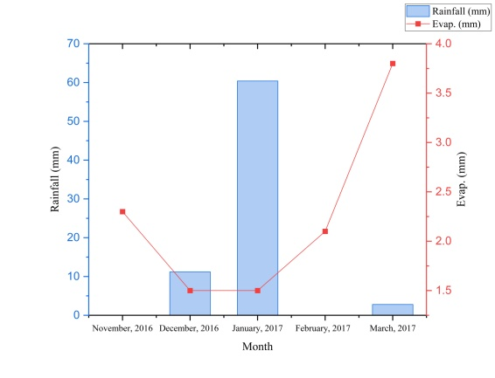

**Fig. 1**. Monthly rainfall and evaporation trends from November 2016 to March 2017 (The maximum rainfall occurred in January 2017, and the maximum evaporation trend occurred in March 2017).

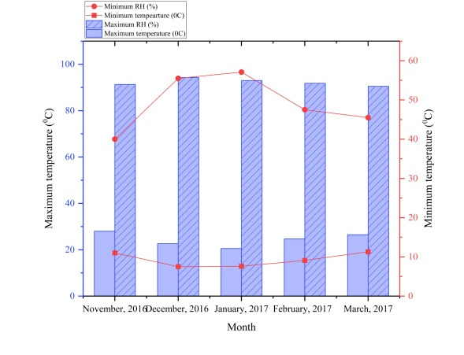

**Fig. 2**. Monthly variations in temperature and relative humidity from November 2016 to March 2017 (The blue bars represent the maximum relative humidity (RH %) on the left Y-axis. The red line shows the minimum relative humidity (RH%) on the right Y-axis. The dashed blue lines represent the maximum temperature (°C) on the left Y-axis. The red dots and lines represent the minimum temperature (°C) on the right Y-axis. This figure shows that the maximum RH decreases during winter, whereas the minimum RH varies. Both the maximum and minimum temperatures peaked in January 2017 before declining.).

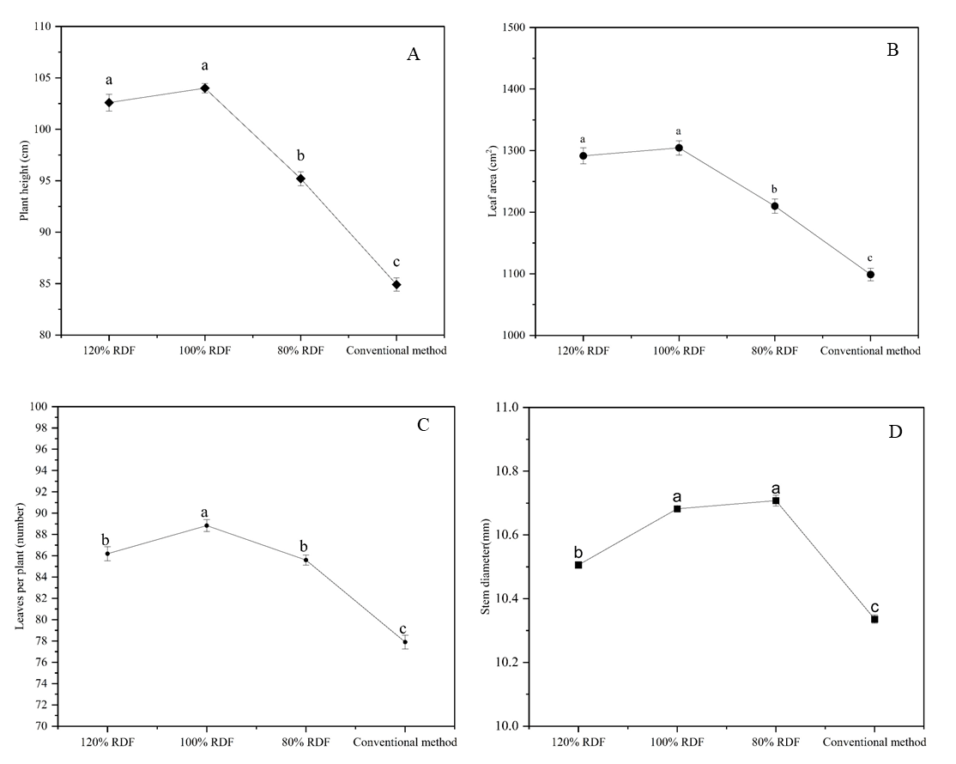

**Fig. 3**: Effects of different fertilizer treatments, namely, 120% RDF (recommended dose of fertilizer), 100% RDF, 80% RDF, and the conventional method, on the plant height, leaf area, number of leaves, and stem diameter. (A) Plant height was greatest under 120% and 100% RDF, with no significant difference. It decreases under 80% RDF and further decreases with the conventional method. **(B)** Leaf area is similar under 120% and 100% RDF. It significantly decreases for 80% RDF and the conventional method. **(C)** The number of leaves is highest with 100% RDF, followed by 120% RDF and 80% RDF, and lowest with the conventional method. **(D)** Stem diameter is highest for 100% and 80% RDFs. It is lower for 120% RDF and lowest for the conventional method. The mean difference is significant at the 0.05 level. The means followed by the same letter do not differ significantly at p<0.05.

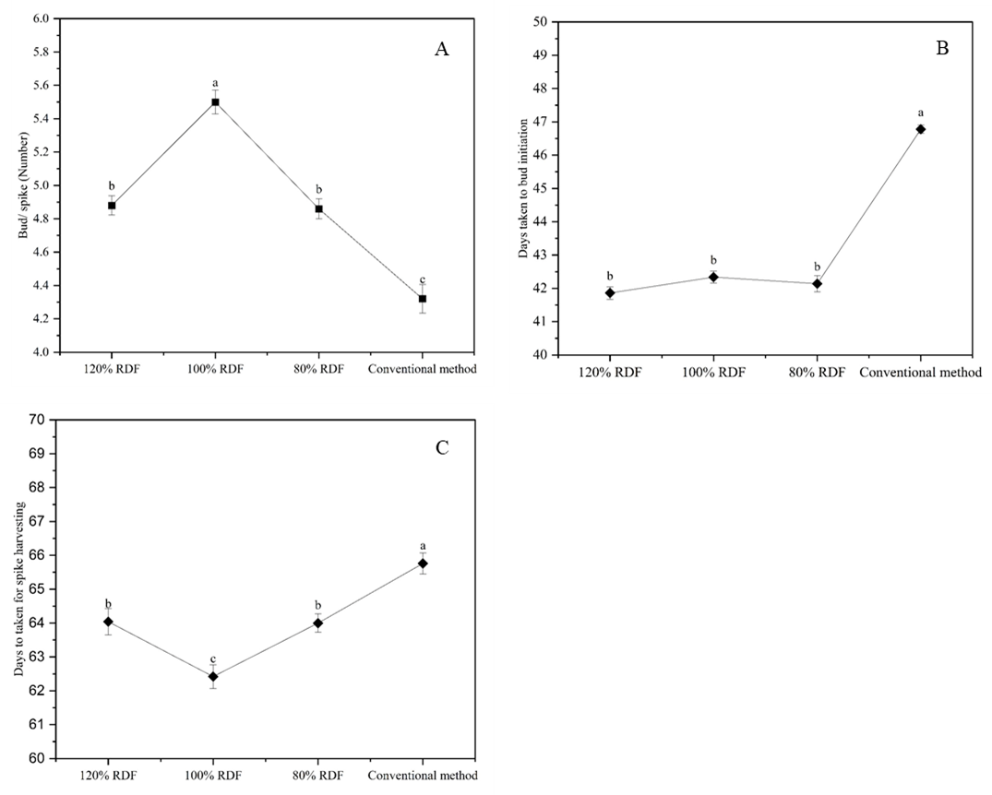

**Fig. 4**: Effects of Different Fertilizer Treatments on Bud/Spike (Number), Days to Bud Initiation, and Days to Spike Harvesting. **(A)** Bud/spike (number) was highest under 100% RDF treatment. It is lower under both 120% and 80% RDF and lowest with the conventional method. **(B)** Days to bud initiation are similar for 120%, 100%, and 80% RDFs. The conventional method results in the longest time to bud initiation. **(C)** Days to spike harvesting are shortest under 80% RDF. It increases by less than 120% and 100% RDF, and is the longest with the conventional method.

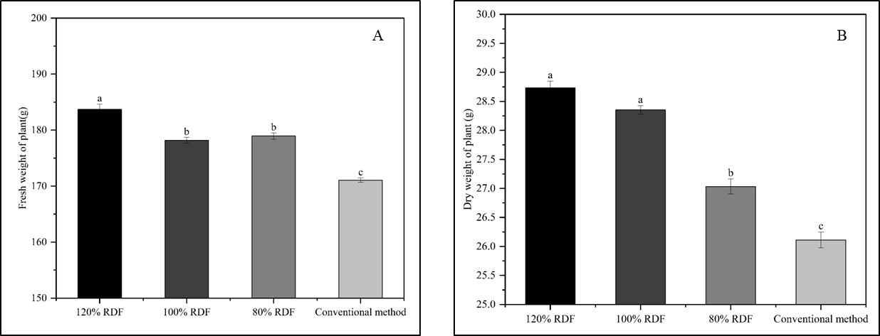

**Fig. 5**: Effects of different fertilizer treatments on the fresh and dry weights of plant. (A) The fresh weight of the plant is highest under 120% RDF. It decreases with 100% RDF and 80% RDF treatments and is lowest with the conventional method. **(B)** The dry weights of the plants were similar and were highest under 120% and 100% RDF. It decreases significantly with 80% RDF and is lowest with the conventional method.

**Table 1:** Effect of different drip fertigation levels on spike quality of Asiatic lily

|  |  |  |  |  |  |  |  |
| --- | --- | --- | --- | --- | --- | --- | --- |
| Treatments | Length of bud, mm | | Diameter of bud,  mm | | Diameter of florets,  cm | | Vase life, days |
| Basal | Upper | Basal | Upper | Basal | Upper |
| 120 % RDF | 116.56a | 53.60a | 44.66a | 18.32a | 20.18a | 15.63a | 25.50b |
| 100 % RDF | 114.64a | 52.40a | 43.95a | 16.41b | 19.52a | 15.58a | 27.70a |
| 80 % RDF | 111.24b | 50.09b | 41.36b | 14.17c | 19.43a | 15.14b | 25.90b |
| Conventional method | 108.79b | 45.77c | 39.20c | 13.58d | 18.43b | 15.05b | 22.80c |
| The mean difference is significant at the 0.05 level.  Means followed by the same letter do not differ significantly at p<0.05. | | | | | | |  |

1. **CONCLUSION:** The findings from this study highlight the importance of selecting appropriate fertiliser treatments because of specific growth and flowering objectives. Fertigation level 120 per cent RDF treatment is advantageous for achieving superior plant height, leaf area, and overall biomass, making it suitable for scenarios where vigorous plant growth is desired. On the other hand, fertigation level 100 per cent RDF treatment offers a balanced approach, promoting a high bud count, larger florets, and extended vase life, which is beneficial for increasing floral quality and longevity. The conventional method, while potentially cost-effective, was less effective in achieving the desired growth and flowering outcomes. This suggests that for optimal plant and floral performance, investing in enhanced fertiliser regimes such as fertigation level 120 per cent RDF or fertigation level 100 per cent RDF could yield better results, aligning with both growth and aesthetic goals. Therefore, growers should carefully consider their specific needs and objectives when selecting fertiliser treatments to achieve the best possible outcomes for plant development and flower quality.

**Disclaimer (Artificial intelligence)**

Option 1:

Author(s) hereby declare that NO generative AI technologies such as Large Language Models (ChatGPT, manuscript.

Option 2:

Author(s) hereby declare that generative AI technologies such as Large Language Models, etc. have been used during the writing or editing of manuscripts. This explanation will include the name, version, model, and source of the generative AI technology and as well as all input prompts provided to the generative AI technology

Details of the AI usage are given below:

1.

2.

3.

1. **REFERENCES**
2. Kumari, S, Kumar, S, Singh, CP. Comparative performance of Oriental Hybrid Lily cv. White Cup under protected conditions. International Journal of Current Microbiology and Applied Sciences, 2019; 8(1):2451-2455. <https://doi.org/10.20546/ijcmas.2019.801.258>
3. Kumari S, Kumar S, Singh CP, Rao VK. Effect of Irrigation Water Levels on plant Growth and Spike Quality of Asiatic Lily cv. Indian Diamond. Agricultural Mechanization in Asia, 53 (2):5545-55.
4. Grossetti A, Gemelli F. Bulb and cut flower production in the genus Lilium: current status and the future. In II International Symposium on the Genus Lilium, 2010 August 30; 900:21-35. [10.17660/ActaHortic.2011.900.1](http://dx.doi.org/10.17660/ActaHortic.2011.900.1)
5. Li H, Mei X, Wang J, Huang F, Hao W, Li B. Drip fertigation significantly increased crop yield, water productivity and nitrogen use efficiency with respect to traditional irrigation and fertilization practices: A meta-analysis in China. Agricultural Water Management. 2021 Feb 1; 244:106534. [10.1016/j.agwat.2020.106534](http://dx.doi.org/10.1016/j.agwat.2020.106534)
6. Sun ZeDong SZ, Ma XingHua MX. Research progress on effects of drip fertilization on plant growth and soil nitrogen characteristics. [Journal of Agricultural Science and Technology (Beijing)](https://www.cabidigitallibrary.org/action/doSearch?do=Journal+of+Agricultural+Science+and+Technology+%28Beijing%29)**,** 2016; 18 (5):164-170.
7. Ma S, Meng Y, Han Q, Ma S. Drip fertilization improve water and nitrogen use efficiency by optimizing root and shoot traits of winter wheat. Front Plant Sci. 2023 Jun 30; 14:1201966. 10.3389/fpls.2023.1201966.
8. Mingo DM, Theobald JC, Bacon MA, Davies WJ, Dodd IC. Biomass allocation in tomato (Lycopersicon esculentum) plants grown under partial rootzone drying: enhancement of root growth. Functional Plant Biology. 2004 Oct 18; 31(10):971-8. <https://doi.org/10.1071/FP04020>
9. Ahmed Z, Nazir A, Nazki IT. Growth and flower production of lilium as influenced by precise application of mineral nutrients. SKUAST Journal of Research. 2023;25(1):96-100. [10.5958/2349-297X.2023.00011.9](http://dx.doi.org/10.5958/2349-297X.2023.00011.9)
10. Giri TK, Sashikala Beura SB. Flowering and bulb production of LA lilium hybrid cv. Fangio influenced by different groups of nutrients.[Journal of Soils and Crops](https://www.cabidigitallibrary.org/action/doSearch?do=Journal+of+Soils+and+Crops)**.** 2018; 28 (1):26-30.
11. Walling N, Keditsu R, Maiti CS. Effect of planting time and nitrogen levels on growth, flowering and bulb production of lilium cv. blackout. Journal of Pharmacognosy and Phytochemistry. 2020; 9(3):1265-9. https://doi.org/10.22271/phyto.2020.v9.i3u.11482
12. Al-Ajlouni MG, Ayad JY, Othman YA. Increasing nutrient levels promote growth and flower quality in lilies grown under soilless culture. Horticultural Science. 2017 Oct 1;44(4). 10.17221/166/2016-HORTSCI
13. Al-Ajlouni MG, Othman YA. Volcanic tuff substrate improves growth and flower quality of Asiatic lily. InXXX International Horticultural Congress IHC2018: II International Symposium on Soilless Culture and VIII International 1273. 2018 Aug 12; pp. 53-58.  [10.17660/ActaHortic.2020.1273.8](https://doi.org/10.17660/ActaHortic.2020.1273.8)
14. Peng X, Chen D, Zhou Z, Zhen J, Xu C, Hu X, Wang Y. Optimizing drip fertigation management to simultaneously improve the yield, water productivity and fertilizer agronomic utilization efficiency of grapes in different precipitation year patterns. Agricultural Water Management. 2024 April 30; 295:108749. <https://doi.org/10.1016/j.agwat.2024.108749>
15. Li H, Mei X, Wang J, Huang F, Hao W, Li B. Drip fertigation significantly increased crop yield, water productivity and nitrogen use efficiency with respect to traditional irrigation and fertilization practices: A meta-analysis in China. Agricultural Water Management. 2021 Feb 1;244:106534. [10.1016/j.agwat.2020.106534](https://econpapers.repec.org/scripts/redir.pf?u=https%3A%2F%2Fdoi.org%2F10.1016%252Fj.agwat.2020.106534;h=repec:eee:agiwat:v:244:y:2021:i:c:s0378377420320813)
16. Prasad SS, Kurubar AR, Hugar A, Ramesh G, Umesh MR, Meena MK. Response of Gladiolus (Gladiolus grandiflora Linn.) cv. White Prosperity to Varying Fertigation Levels and Planting Geometry. Mysore Journal of Agricultural Sciences. 2023 Jul 1;57(3).
17. Gajbhiye BR, Vetal RA, Puri AN, Adsul PB. Response of FYM, N, P and K levels on growth and flowering of gladiolus (Gladiolus gradiflorus) cv white prosperity. The Journal of Rural and Agricultural Research. 2013;13(2):94-7.
18. Kushwaha Y, Bhuj BD, Srivastava R, Chand S, Kastury C. *Effect of NPK through drip fertigation on vegetative growth and flowering attributes of Gladiolus cv. White Prosperity under tarai region of Uttarakhand* (Doctoral dissertation, GB Pant University of Agriculture and Technology, Pantnagar-263145 (Uttarakhand)).
19. Ahmed Z, Nazir A, Nazki IT. Growth and flower production of lilium as influenced by precise application of mineral nutrients. SKUAST Journal of Research. 2023;25(1):96-100.[10.5958/2349-297X.2023.00011.9](http://dx.doi.org/10.5958/2349-297X.2023.00011.9)
20. Fonseca AS, Segeren MI. Nutrient uptake in two species of calla lily (*Zantedeschia* sp.) under fertigation. In VII International Symposium on New Floricultural Crops 1000 2011 Nov 22 (pp. 377-384). [10.17660/ActaHortic.2013.1000.52](https://doi.org/10.17660/ActaHortic.2013.1000.52)
21. Patra SK, Sengupta S. Effect of gravity-fed drip irrigation and nitrogen management on flowering quality, yield, water and nutrient dynamics of gladiolus in an Indian inceptisol. Journal of Plant Nutrition. 2022 Aug 9;45(13):2049-67. <https://doi.org/10.1080/01904167.2022.2057327>
22. Rani N, Kumar R, Dhatt KK. Effect of nitrogen levels and growing media on growth, flowering and bulb production of Lilium cultivars. Journal of Ornamental Horticulture. 2005;8(1):36-40.
23. Elhindi K, El-Hendawy S, Abdel-Salam E, Elgorban A, Ahmed M. Impacts of fertigation via surface and subsurface drip irrigation on growth rate, yield and flower quality of Zinnia elegans. Bragantia. 2016;75(1):96-107.  <https://doi.org/10.1590/1678-4499.176>
24. Zhou T, Zhang D, Lei D, Shan D, Wu Z, Yang X, Teng N. Effects of different fertilization schemes on the quality of cut lily under the condition of frame-type soilless culture. Technology in Horticulture. 2023;3(1):1-7. doi: [10.48130/TIH-2023-0001](https://doi.org/10.48130/TIH-2023-0001)
25. Treder J. Growth and quality of oriental lilies at different fertilization levels. InIX International Symposium on Flower Bulbs 673 2004 Apr 19; pp. 297-302. [10.17660/ActaHortic.2005.673.37](https://doi.org/10.17660/ActaHortic.2005.673.37)
26. Treder J. Influence of fertilization on growth, flowering and mineral nutrient content of oriental lilies. Zeszyty Naukowe Instytutu Sadownictwa i Kwiaciarstwa w Skierniewicach (Poland). 2000;7:375-380.
27. Giri TK, Beura S, Acharjee S, Palai SK. Impact of various nutrients on flowering and bulb production of oriental Lilium hybrid cv. Sorbonne. The Pharma Innovation Journal. 2018;7(4):103-6.
28. Alsaleh T, Awadh A. The Effect of the Size of the Bulbs and the Type of Fertilizer in the Number and Length of Leaves and Flower Production in Lilium longiflorum. Marsh Bull. 2020;15:92-102.
29. Hasna PM, Rafeekher M, Priyakumari I, Reshmi CR, Leno N, Gopinath PP. Optimization of manuring and fertigation in tuberose hybrid Arka Prajwal. Journal of Applied Horticulture. 2024;26(3):387-91. <https://doi.org/10.37855/jah.2024.v26i03.74>
30. Treder J. Growth and quality of oriental lilies at different fertilization levels. In IX International Symposium on Flower Bulbs 673 2004 Apr 19 (pp. 297-302). [10.17660/ActaHortic.2005.673.37](https://doi.org/10.17660/ActaHortic.2005.673.37)
31. Mehra, S. and R. Rathi, 2020. Impact of Fertilization on Post-Harvest Longevity of Flowers. Post-Harvest Biology and Technology, 28(1): 56-62.
32. Kumari, S., Kumar, S., Singh, C. P., & Rao, V. K. (2022). Effect of irrigation water levels on plant growth and spike quality of Asiatic Lily cv. Indian Diamond. Journal of Research, 53(2), 5545–5552 Geethan, A., Bahadur, V., & Joseph, A. V. (2024). Effect of Potting Mixture and Polybag Size on Growth and Flowering of Asiatic Lily (Lilium asiaticum var. Nashville) under Protected Condition. International Journal of Plant & Soil Science, 36(6), 850–859.
33. Karthikeyan, S., Thamaraiselvi , S. P., Ganga , M., Jawaharlal , M., Visalakshi , M., & Sivakumar, V. (2023). Studies on the Upper Leaf Necrosis in Orientalliliums. International Journal of Plant & Soil Science, 35(23), 579–584.