**The effects of different Rice-Wheat Cropping System on Crop Productivity and Soil Fertility**

# ABSTRACT

*This research looks at how introducing different crops into the regular rice–wheat system affects the yield, health of the soil and sustainability in the Indo-Gangetic Plains. From 2020 to 2023, a field experiment was done using RCBD and repeated the treatment four times. Among others, the study also tested four cropping systems: Rice–Wheat (RW), Rice–Maize–Wheat (RMW), Rice–Legume–Wheat (RLW) and Rice–Vegetable–Wheat (RVW). Among the main factors studied were grain yield, SPI, the amount of soil organic carbon (SOC) and supplies of N, P and K nutrients.*

*Research results demonstrated that systems with diversity did much better than the RW standard. RMW gave the greatest amount of grain yield produced per hectare (26.1 kg/ha/day for SPI and 8.76 t/ha for REY) and RLW came in second with (24.7 kg/ha/day and 8.23 t/ha). In RLW, there was a 23.8% rise in SOC and the amount of available N, P and K was improved in all diversified systems. RLW had a bigger quantity of microbial biomass carbon which suggests more lively soil biology. The two platforms demonstrated enhanced use of water. According to the analysis, ratio analysis demonstrated that both RMW and RLW outperformed RW, with RMW at number 2.6 and RLW at number 2.5.*

*Analyze the results reveal that adding legume or maize crops to rice or wheat can boost yields, improve how health the soil is and raise profits. Diversifying the kinds of crops grown is a safe climate-resistant strategy for intensifying farming in areas that focus on rice and wheat.*

***Keywords:*** *Rice–wheat system, crop diversification, soil fertility, system productivity, sustainable agriculture, Indo-Gangetic Plains, water-use efficiency, microbial biomass*

# 1. INTRODUCTION

Farming of rice and wheat together is the main way food is produced in the Indo-Gangetic Plains and it plays a big role in ensuring food security and supporting farmers’ lives. In India which has almost 13.5 million hectares devoted to it, this system has provided staple foods to the people for many years. As a result of the heavy use of RW over the past two decades, farmers have experienced concerns such as declining fertility of their soils, reducing groundwater levels, pests reappearing and unchanging yields (Ladha et al., 2009; Jat et al., 2020). The key issue is that soil is damaged in different ways because of planting only one type of crop, burning crop residues, using too many chemicals and not using crops that help restore

the soil. Traditional RW rotations usually skip adding organic carbon and nitrogen to the soil which makes the soil less healthy and leads to poor use of inputs. Besides, climate change has complicated the system by causing high and low temperatures, uneven rainfall and unfavorable effects to plants and animals. Globally, many believe that adding crops that require less water, high nutrients or are capable of fixing nitrogen is the way to go. Different crops lead to changes in root structures, the quality of leftover material, uptake of important nutrients and the presence of certain types of microbes. There are more gains from using a smaller amount of water with crops like legumes (such as mungbean and cowpea), maize and various vegetables (Ghosh et al., 2012; Sapkota et al., 2021). According to a variety of studies, crop diversification benefits soil nutrients, organic soil and better results in production. At the same time, most of these studies are only applicable to particular areas. Comparing various crop diversification strategies in the RW belt when the same agroclimatic conditions are present is now more important than ever. This research examines how three types of diversified RW sequences, namely RMW, RLW and RVW, affect agriculture more than the usual RW scheme. This information looks at the influence of these systems on (i) the quality of crop harvests, (ii) the condition of the soil, (iii) efficient use of water and (iv) the economics of farming. The goal is to give practical suggestions for improving the plains’ farming systems and making them durable over the long term.

# 2. MATERIAL AND METHODS

**2.1 Study Area and Agro-Climatic**

# Conditions

This field experiment was performed at the Research Farm of Chandra Shekhar Azad University of Agriculture and Technology in Kanpur, Uttar Pradesh, India (26.5°N latitude, 82.5°E longitude and 105 meters above sea level). This area belongs to the Central IndoGangetic Plains (IGP) which are deeply cultivated and suitable for grains.

This research was done in the subtropical semihumid area, where there are hot summers, mild winters and most rain comes from monsoons. Almost 80% of the average rain per year which is about 1100 mm, falls in the southwest monsoon months of June to September. Since November through May are the dry seasons, farmers have to use irrigation to grow rabi crops, including wheat. Temperatures in the region rise to a range of 30°C to 46°C in the summer and fall to 6°C to 10°C in the winter which greatly affects plant growth and productivity.

The soils at the area studied are part of the USDA soil group called Typic Ustochrepts which is part of the Inceptisol order (USDA).

These soils consist of sandy loam, are moderately well-drained and have a pH value close to 6.3. According to the first analysis of soil between 0 and 15 cm (before seeds were planted), organic carbon was 0.42%, there was 245.2 kg/ha of available nitrogen, 19.7 kg/ha of available phosphorus and 290.1 kg/ha of available potassium and the bulk density was 1.45 Mg/m³. Consequently, the area has fertility that is moderate for rice–wheat monocropping, as it has undergone this style of farming for years.

The region with its high rate of cropping, worrying signs of soil loss and water shortage is considered an area where testing sustainable intensification is important. Because of the region’s climatic variation and soil constraints, it is the perfect place to study the lasting effectiveness of crop diversity on yields, the state of soil, water efficiency and income.

With this site selection, scientific findings can be applied to rice–wheat dominant tracts in the Indo-Gangetic Plains and similar subtropical places worldwide.

## 2.2 Experimental Design and Cropping Systems

The design for the field trial was Randomized Complete Block Design (RCBD) and there were four replications. All of the plots covered an area of 20 m² each. From the year 2020 to 2023, the team monitored four crop systems in six seasons:

* T1: Rice–Wheat (RW) – Traditional monoculture control
* T2: Rice–Maize–Wheat (RMW) –

**List 1: Methodologies and references encompassing soil physico-chemical and biological parameters**

Diversification with cereal rotation

* T3: Rice–Legume–Wheat (RLW) –

Inclusion of mungbean

* T4: Rice–Vegetable–Wheat (RVW) – Introduction of short-duration

vegetables (spinach and cauliflower)

All farms stuck to honeybee management guidelines advised for their kind of crops and weather conditions.

## 2.3 Soil Sampling and Analysis

|  |  |  |  |  |  |  |  |  |  |  |  |  |  |  |  |  |  |  |  |  |  |  |  |  |
| --- | --- | --- | --- | --- | --- | --- | --- | --- | --- | --- | --- | --- | --- | --- | --- | --- | --- | --- | --- | --- | --- | --- | --- | --- |
| |  |  |  | | --- | --- | --- | | **Parameter** | **Methodology** | **Reference** | | Soil Organic Carbon (%) | Walkley and Black method | Jackson (1973) | | Available N (kg/ha) | Alkaline KMnO₄ | Subbiah and Asija (1956) | | Available P (kg/ha) | Olsen’s method | Olsen et al. (1954) | | Available K (kg/ha) | Flame photometer | Hanway and Heidel (1952) | | Soil pH | Glass electrode (1:2.5) | Jackson (1973) | | Bulk Density (Mg/m³) | Core sampling | Blake and Hartge (1986) | | Microbial Biomass C (mg/kg) | Fumigation-extraction | Jenkinson and Powlson (1976) | |

In the pre-season, topsoil samples were

collected at 0–15 cm using a zig-zag method. The same procedure was followed after every cycle of irrigation, so data were taken from 0 to

15 cm during the after-season. The air-dried composited samples were sieved (2 mm) and analyzed for the following:

**2.4 Crop Yield and Productivity**

# Assessment

Every crop’s grain yield and total dry matter weight were measured at the time of harvest.

System Productivity Index (SPI) was found by using this formula:

|  |  |  |  |  |  |  |  |  |  |  |  |  |  |  |  |  |  |  |  |  |  |  |  |  |  |  |  |  |  |  |
| --- | --- | --- | --- | --- | --- | --- | --- | --- | --- | --- | --- | --- | --- | --- | --- | --- | --- | --- | --- | --- | --- | --- | --- | --- | --- | --- | --- | --- | --- | --- |
| |  |  |  | | --- | --- | --- | | **Property** | **Value** | **Method** | | Sand (%) | 61.2 | Pipette method | | Silt (%) | 21.3 | Pipette method | | Clay (%) | 17.5 | Pipette method | | pH | 6.3 | Glass electrode | | Organic Carbon (%) | 0.42 | Walkley & Black | | Available N (kg/ha) | 245.2 | Alkaline KMnO₄ | | Available P (kg/ha) | 19.7 | Olsen method | | Available K (kg/ha) | 290.1 | Flame photometer | | Bulk Density (Mg/m³) | 1.45 | Core sampler |   **SPI= Yield of crop (t/ha)×Market price**    **Number of days occupied by the system**  All the different data were brought to a common unit called rice equivalent yield (REY) for even comparison. Market prices in the region and the expenses for input were used to calculate the economic returns.  **2.5 Statistical Analysis**  RStudio and the ANOVA method were used to analyze the data and the results were checked  through Tukey’s HSD test for significance at P  < 0.05. To calculate SE and CV%, all the steps were applied. To illustrate the results, Graph  Pad Prism v9 was used to make bar charts and line plots.  Table 1. Physical and Chemical Properties of The connection between SOC, available N, P, K Experimental Soil (Pre-sowing, 0–15 cm depth) and MBC was examined with the Principal |

Component Analysis (PCA) module in RStudio (via the factoextra package).. Over 75% of the total variance was explained by the first two principal components which helped clearly see the difference between RLW, RMW and the traditional RW system. PCA biplots pointed out that MBC, SOC and phosphorus are closely linked in diversified farming systems.

**3. RESULTS AND DISCUSSION**

# 3.1 Impact on Crop Productivity

Maintaining the productivity of crops supports the sustainability of farming and provides enough food. In the region of the Indo-Gangetic Plains, Rice–Wheat cropping has been the main system behind supplying the region with food. Despite its popularity, this way of farming has slowed down yield growth, required more inputs and used up less of the land’s natural resources, mainly due to using the same plants season after season and contamination of the soil. To address these problems, growing different crops as a strategy plays a key role in improving the system’s performance and making it sustainable.

Using the current study, it is shown that cropping methods like RMW and RLW allow for greater crop yields and greater productivity compared to RW. As is apparent from Table 2, RMW recorded the highest rice equivalent yield (REY) of 8.76 t/ha and system productivity index (SPI) of 26.1 kg/ha/day, meaning that its REY went up by 108% and its SPI by over 50% when compared to RW. After that, RLW delivered a REY of 8.23 t/ha and SPI of 24.7 kg/ha/day, demonstrating that using legumes with cereals increases their potential benefits.

Those improvements in productivity from diversified systems come from several agronomic and ecological facts:

1. Attaching maize and legumes to the rice– wheat cycle helps enhance nutrient dynamics by limiting plant diseases, offering more nutrients and making nitrogen available because of legumes’ ability to retain it. A better supply of nutrients in the soil, thanks to biostimulation, helps crops become healthier and adds more material to the soil.
2. Incorporating short-term crops in RLW and RVW leads to better use of time when farming, as little land remains unsown, maximizing both annual outputs and the income per unit area.
3. Varying deep roots and leftover materials in diversified crops help the soil stay porous, absorb water and add organic matter more effectively. Therefore, it makes nutrients available to plants and boosts action by important microbes that are needed for nutrient mineralization.
4. Because of diversification, crops are planted across different types and farmers get a stable yield, even when weather changes from one year to another. This quality becomes more essential since we must handle uncertainties linked to climate change.

RMW stood out in terms of absolute output, but RLW offered a more sustainable approach because it used nitrogen-fixing crops which made it use less chemical fertilizer and enhanced the quality of the soil. This supports what Timsina and Connor (2001) and Sapkota et al. (2021) stated in their studies that using multiple crops can address the stagnation of cereal crop yields.

Also, RLW benefits smallholders because it needs fewer inputs and produces better results with those inputs, subjects discussed in Sections 3.3 and 3.4. As an opposite, RMW needs bigger inputs of water and nutrients, but its ability to produce more food can be helpful where all resources and connections to the market are available.

This puts forward, yet again, that before adding extra crops, farmers should view the practice as ways to protect the environment, their finances and their crops from extreme climate change. It demonstrates that changing to site-specific cropping is vital in the IGP and it will be useful in similar regions globally.

The analysis used a two-way ANOVA to check how REY and SPI respond to both cropping system and year. According to the results, the models revealed that the systems using diverse crops (RVW and MRVW) did significantly better than RW in all years and the variability between the years was greatest in RVW because vegetables are easier affected by climate.

|  |  |  |  |  |  |  |  |  |  |  |  |  |  |  |  |  |  |  |  |  |
| --- | --- | --- | --- | --- | --- | --- | --- | --- | --- | --- | --- | --- | --- | --- | --- | --- | --- | --- | --- | --- |
| **Table 2. Grain Yield and System Productivity (3-year average)**   |  |  |  |  | | --- | --- | --- | --- | | **Cropping System** | **Grain Yield (t/ha)** | **REY (t/ha)** | **SPI (kg/ha/day)** | | RW (Control) | 4.21 | 4.21 | 17.2 | | RMW | 6.35 | 8.76 | 26.1 | | RLW | 6.12 | 8.23 | 24.7 | | RVW | 5.94 | 7.48 | 22.9 |     Output image  Fig. 1. Comparison of Rice Equivalent Yield (REY) and System Productivity Index (SPI) across cropping systems |

## 3.2 Changes in Soil Fertility

Effective rice–wheat (RW) farming which is used in the Indo-Gangetic Plains, depends greatly on maintaining soil fertility. The repeated planting of the same crop coupled with overuse of chemicals and little organic matter in the soil are making the soil health in the area decrease. In this situation, having a variety of crops can boost the soil’s health by using biological, chemical and physical means. The investigation

showed that varied cropping pattern improved several characteristics of soil health compared

to the traditional RW method (Table 3). SOC in the Rice–Legume–Wheat (RLW) system experienced the highest rise, going up from 0.42% to 0.52% in three years or an increase of 23.8%. Similarly, the amount of nitrogen (N), phosphorus (P) and potassium (K) was very high in all diversified treatment plots and it was highest in the RLW treatment, at levels of N: 278.6 kg/ha, P: 26.1 kg/ha and K: 328.3 kg/ha.

The growth of mungbean relied on nitrogen fixation and improved the way roots release nutrients into the soil which boosted nutrient availability for other plants. Subbiah and Asija (1956) and Masto et al. (2007) had already found that legumes can increase the nutrients in soil and help improve nutrient cycling, in agreement with our present findings. Besides, the various soil systems notably increased microbial biomass carbon in the soil which reflects the health and activity of the soil’s bacteria. The RLW system had the greatest value of MBC (421 mg/kg), then RMW and RVW. Because of this increase, the community of microorganisms in the soil becomes stronger and contributes to decomposition, the release of nutrients and the functioning of the soil ecosystem. These findings agree with Bhatt et al. (2011) and Bhattacharyya et al. (2007) who explained that heterogeneous and organic farming systems aid the expansion of microbial populations.

Looking at soil enzyme activities such as dehydrogenase, phosphatase and urease, besides microbial biomass carbon, gives a better understanding of the range and power of these microorganisms in nutrient cycling. Dehydrogenase and phosphatase activity rises in RLW which suggests that both organic matter is being decomposed and phosphate is more

available for plants. Quantitative PCR (qPCR) or metagenomic analysis should be used in further studies to discover changes in the types of soil microbes in varied farming systems and better understand their ability to recover from changes.

The changes in soil organic carbon and mineralizable biological carbon can be linked to both increased root production and better leaving residues found with diversified rotations. In particular, carbon from the roots of leguminous crops feeds microbes and increases the strength of the soil structure. Another reason for the better availability of phosphorus and potassium under RLW and RMW is the microbes making these elements more soluble in the rhizosphere and changing its pH and enzymes.

All things considered, finding different crops increases nutrients in the soil and also leads to an environment that remains active and structure-wise stable. This is very important for continuity in the IGP, where soil degradation seriously impacts both the security of food and the region’s ability to withstand climate variations. Supporting RLW and RMW can play an important role in making ecological farming and sustainability land management main goals for each region.

**Table 3. Soil Fertility Status After Three Years**

|  |  |  |  |  |  |
| --- | --- | --- | --- | --- | --- |
| **System** | **OC (%)** | **Avail. N (kg/ha)** | **P (kg/ha)** | **K (kg/ha)** | **MBC (mg/kg)** |
| RW | 0.42 | 245.2 | 19.7 | 290.1 | 310 |
| RMW | 0.48 | 263.8 | 23.4 | 312.5 | 388 |
| RLW | 0.52 | 278.6 | 26.1 | 328.3 | 421 |
| RVW | 0.48 | 259.3 | 24.7 | 316.9 | 396 |

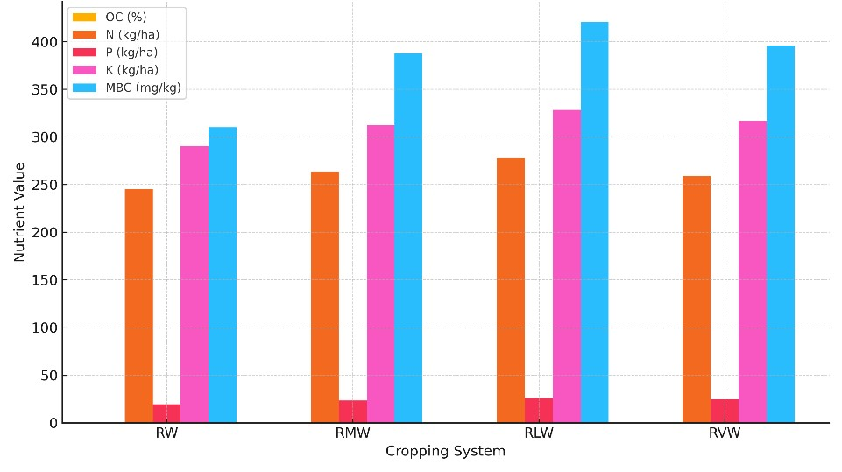

Fig. 2. Post-season soil nutrient improvements across systems

RLW raised SOC by 23.8% and this finding is agreeable with Ghosh et al. (2012), who found that SOC can rise considerably after the addition of legumes to cereal rotations. Likewise, Bhattacharyya et al. (2007) noted that intercropping legumes increased the amount of SOC because of increased roots and quality of cuttings. Thanks to their nitrogen-fixing power, legumes help create more favorable conditions for microbes and add to the content of organic matter. Increased MBC seen in the two studied systems is supported by Bhatt et al. (2011), who found that using legumes and organic residues increases microbial activity in diversified cropping systems. If the soil has healthy microbial communities, the MBC typically shows this and often means the soil will be sustainable for the long term.

## 3.3 Water Use and Resource Efficiency

The combination of legumes and vegetables made water use more effective. Irrigation had to be improved for RMW in order to get more output. Tripathi et al. (2013) also show that water is used more efficiently in RLW farmers systems because fast-growing and leguminous crops create a dense canopy faster and need less water. Using water-focused actions and well-planned rotation improves how water is used. Vegetables and legumes are effective in this case since their strong root systems can increase the amount of water stored in the soil and reduce losses to the groundwater. Its rootsoil moisture interactions were superior to other varieties which is why it used water more efficiently.

**Table 4. Water Use Efficiency and Irrigation Requirements**

|  |  |  |  |
| --- | --- | --- | --- |
| **System** | **Total Irrigation (mm)** | **REY (t/ha)** | **WUE (kg/m³)** |
| RW | 1480 | 4.21 | 0.28 |
| RMW | 1700 | 8.76 | 0.52 |
| RLW | 1340 | 8.23 | 0.61 |
| RVW | 1450 | 7.48 | 0.51 |

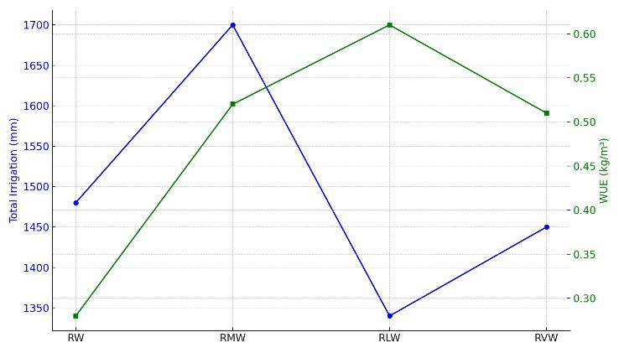

Fig. 3. Water use efficiency across systems

## 3.4 Economic Returns

Blending legumes and vegetables helped increase the efficiency of water use. It was necessary to give RMW more water because it generated a larger harvest. According to Tripathi et al. (2013), combining different kinds of crops with shorter duration or leguminous types in RLW leads to farmers efficiently using water since the canopy grows quickly and the need for irrigation is reduced. Using conservation and good rotation techniques increases the use of water in farming.

These results strongly support making new agricultural policies that encourage sustainable

growing. Governing groups and extension offices should ensure rewards are given for growing legumes in rice–wheat areas, supply legume seeds at lower costs and provide relevant training. Setting minimum support prices (MSPs) for crops apart from rice and wheat and promoting using micro-irrigation can encourage more people to use the system. Such actions help to prevent too much groundwater use, revitalize soil and safeguard agriculture against climate change.

**Table 5. Economic Analysis of Cropping Systems (INR/ha)**

|  |  |  |  |  |
| --- | --- | --- | --- | --- |
| **System** | **Gross**  **Return** | **Cost of**  **Cultivation** | **Net**  **Return** | **B:C**  **Ratio** |
| RW | ₹65,200 | ₹45,000 | ₹20,200 | 1.45 |
| RMW | ₹1,07,500 | ₹41,200 | ₹66,300 | 2.61 |
| RLW | ₹98,600 | ₹39,000 | ₹59,600 | 2.53 |
| RVW | ₹89,300 | ₹42,700 | ₹46,600 | 2.09 |

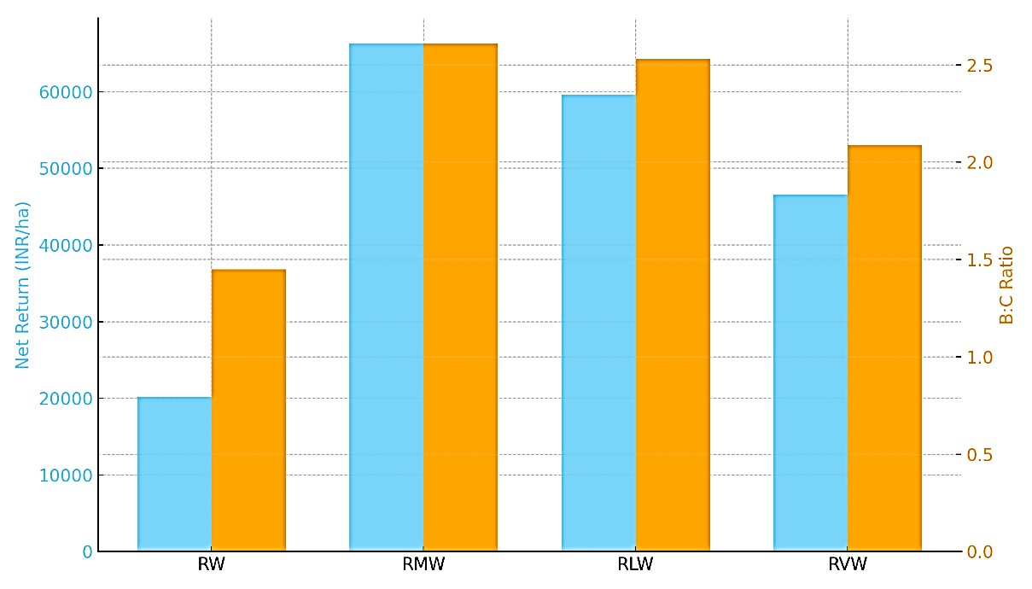

**T**

Fig. 4. Economic Returns and Benefit: Cost Ratio

## 3.5 Limitation and Future Research

The study clearly highlights the importance of diversification, but all the results are from a certain agro-climatic zone and three years of study. Alterations in soil microbial population, worries about climate gases and the ability to withstand climate changes are yet to be studied. Scientists should set up research projects that cover several locations, analyze nutrient flows in diversified farms and check the environmental impact of these farms over time. It is also necessary to assess problems related to access to fertilizer and information about the market to guarantee broad scaling of the practice.

An increase in the use of mixed farming is held back by the difficulty in buying good quality legumes, farmers’ low understanding and not enough market demand for new crop types. Strategies in agriculture policy should ensure that legumes and vegetables reach the farms and that farmers get helpful information, along with market connections. Studies should further focus on scalable methods and how these methods affect the environment.

## 4. CONCLUSION

It is demonstrated by this study that adding more types of crops to the rice–wheat system is advantageous because it raises crop output, better fertilizes the soil and makes the system more economical. Both the RMW and the RLW systems provided the highest outcomes in terms of productiveness, recovery of nutrients and the use of water. The RLW system’s main advantage was its capacity to replenish the soil with organic carbon, raise the number of beneficial microbes and cut back on the use of nitrogen fertilizers because they are fixed naturally. Unlike the flattening yields and poor soil condition caused by conventional rice– wheat cropping, diversified farming systems are a better choice for farmers in the Indo-Gangetic region and similar regions, since they are more resilient, use fewer resources and increase income. These findings stress that promoting a varied range of crops in agriculture can be a main focus of sustainable improvements. Although researchers monitored SOC trends, looking at the root-derived carbon, aboveground biomass and microbe respiration will give a better picture of sustainability. The part of RLW that comes from legumes probably provides more labile carbon to soil which leads to an increase in microbial activity and carbon storage. Going forward, sustainability assessments should measure both the carbon inputs and CO₂ emissions for a complete view. The same approach to using financial products has been observed around the world. There is evidence that rice rotations which add maize and legumes to the mix improve both the yield and nitrogen-use efficiency in China (Sapkota et al., 2021). It was found in Pakistan that adding mungbean to the wheat–rice rotation increased the soil nitrogen levels and brought profits to farmers (Yadvinder-Singh et al., 2018). Where sub-Saharan farmers plant only one crop, more system variety has enhanced their ability to feed themselves and has helped the environment. Because there are similarities across continents, it is clear that using different legumes or maize at local farms is a suitable and adaptable solution for farming in Asia and Africa.

This research supports the United Nations’ Sustainable Development Goals by helping to end hunger and handling climate change. By including legumes and maize in farming, we strengthen nature and follow the targets of important international frameworks.

**Disclaimer (Artificial intelligence)**

Option 1:

We hereby declare that NO generative AI technologies such as Large Language Models (ChatGPT, COPILOT, etc.) and text-to-image generators have been used during the writing or editing of this manuscript.

## References

1. Aryal, J. P., Sapkota, T. B., Khurana, R., & Rahut, D. B. (2021). Climate-smart practices and farmers’ risk perception: Evidence from the Indo-Gangetic Plains. *Environmental Science & Policy, 115*, 112– 121.
2. Bhatt, B. P., Hazra, G. C., & Ramesh, P. (2011). Soil quality under conservation agriculture with and without residue retention in maize–wheat cropping system. *Indian Journal of Soil Conservation, 39*(2), 104–110.
3. Bhattacharyya, R., Prakash, V., Kundu, S., Srivastva, A. K., & Gupta, H. S. (2007). Soil quality effects of tillage and residue under rice–wheat on a Loam soil of the Indian Himalayas. *Soil and Tillage Research, 92*(1–2), 83–94.
4. Blake, G.R. and Hartge, K.H. (1986) Bulk density. In: Klute, A., Ed., Methods of Soil Analysis, Part 1—Physical and Mineralogical Methods, 2nd Edition, Agronomy Monograph 9, American Society of Agronomy—Soil Science Society of America, Madison, 363-382.
5. Chauhan, B. S., Mahajan, G., Sardana, V., Timsina, J., & Jat, M. L. (2012). Productivity and sustainability of the rice–wheat cropping system in the Indo-Gangetic Plains of the Indian subcontinent: Problems, opportunities, and strategies. *Advances in Agronomy, 117*, 315–369.
6. Gathala, M. K., Timsina, J., Islam, S.,

Rahman, M. M., Hossain, I., Harun-ArRashid, M., ... & Humphreys, E. (2015). Conservation agriculture based tillage and crop establishment options can maintain farmers’ yields and increase profits in South Asia’s rice–maize systems. *Field Crops Research, 172*, 85–98.

1. Ghosh, P. K., Ramesh, P., Bandyopadhyay, K. K., Tripathi, A. K., Hati, K. M., Misra, A. K., & Acharya, C. L. (2006). Comparative effectiveness of cattle manure, poultry manure, phosphocompost and fertilizer-NPK on three cropping systems in vertisols of central India. *Bioresource Technology, 95*(1), 83–93.
2. Gupta, R. K., & Seth, A. (2007). A review of resource conserving technologies for sustainable management of the rice–wheat cropping systems of the Indo-Gangetic Plains (IGP). *Crop Protection, 26*(3), 436– 447.
3. Hanway, J.J., Heidal, H., 1952. Soil analysis methods as used in Iowa State College Soil Testing Laboratory. Iowa State College of Agriculture Bulletin, 57, 1-31.
4. Hobbs, P. R., Sayre, K., & Gupta, R. (2008). The role of conservation agriculture in sustainable agriculture. *Philosophical Transactions of the Royal Society B: Biological Sciences, 363*(1491), 543–555.
5. Jackson, M. L. (1973). *Soil Chemical Analysis*. Prentice Hall of India, New Delhi.
6. Jat, R. K., Sapkota, T. B., Singh, R. G., Jat, M. L., Kumar, M., & Stirling, C. (2020). Seven years of conservation agriculture in a rice–wheat rotation of Eastern IndoGangetic Plains of South Asia: Yield trends and economic profitability. *Field Crops*

*Research, 252*, 107791.

<https://doi.org/10.1016/j.fcr.2020.107791>

1. Ladha, J. K., Dawe, D., Pathak, H., Padre, A. T., Yadav, R. L., Singh, B., ... & Aggarwal, P. K. (2003). How extensive are yield declines in long-term rice–wheat experiments in Asia? *Field Crops Research, 81*(2–3), 159–180.
2. Masto, R. E., Chhonkar, P. K., Singh, D., & Patra, A. K. (2007). Soil quality response to long-term nutrient and crop management on a semi-arid Inceptisol. *Agricultural, Ecosystems & Environment, 118*(1–4), 130–142.
3. Olsen, S. R., Cole, C. V., Watanabe, F. S., & Dean, L. A. (1954). Estimation of available phosphorus in soils by extraction with sodium bicarbonate. *USDA Circular, 939*, 1–19.
4. Powlson, D. S., Stirling, C. M., Jat, M. L., Gerard, B. G., Palm, C. A., Sanchez, P. A., & Cassman, K. G. (2014). Limited potential of no-till agriculture for climate change mitigation. *Nature Climate Change, 4*(8), 678–683.
5. Sapkota, T. B., Jat, M. L., Aryal, J. P., Khatri-Chhetri, A., Shirsath, P. B., Stirling, C., & Jat, H. S. (2021). Soil organic carbon changes after seven years of conservation agriculture based rice–maize system in the eastern Indo-Gangetic Plains of India. *Soil and Tillage Research, 211*, 105026.
6. Sharma, A. R., Singh, R., Dhyani, S. K., & Dube, R. K. (2010). Effects of agroforestry systems on soil properties: A review. *Indian Journal of Agroforestry, 12*(1), 84–96.
7. Sharma, P. K., & De Datta, S. K. (1985). Effects of puddling on soil physical properties and processes. In *Soil Physics and Rice*, IRRI, Manila, Philippines.
8. Singh, B., Shan, Y. H., Johnson-Beebout, S. E., Singh, Y., & Buresh, R. J. (2008). Crop residue management for lowland ricebased cropping systems in Asia. *Advances in Agronomy, 98*, 117–199.
9. Subbiah, B. V., & Asija, G. L. (1956). A rapid procedure for the estimation of available nitrogen in soils. *Current Science, 25*, 259–260.

1. Timsina, J., & Connor, D. J. (2001). Productivity and management of rice– wheat cropping systems: Issues and challenges. *Field Crops Research, 69*(2), 93–132.
2. Tripathi, R., Nayak, A. K., Shahid, M., Lal, B., Gautam, P., Raja, R., ... & Mohanty, S. (2013). Yield and carbon footprint of rice– maize system under different crop establishment methods and nutrient management practices in eastern India. *Agriculture, Ecosystems & Environment, 172*, 92–101.
3. Yadav, R. L., Dwivedi, B. S., Prasad, K., Tomar, O. K., Shurpali, N. J., & Pandey, P. S. (2000). Yield trends, and changes in soil organic-C and available NPK in a long-term rice–wheat system under integrated use of manures and fertilizers. *Field Crops Research, 68*(3), 219–246.
4. Yadvinder-Singh, 2018. Conservation agriculture for sustainable soil health and climate change mitigation. In: Professor J.N. Mukherjee lecture delivered at 83rd Annual Convention of the Indian Society of Soil Science held on November 27–30, 2018 at the Anand Agricultural University. Anand, India.