**Understanding youth’s action in Mitigation and Adaptation to Climate Change: A case study of Kamrup, Assam, India**

**Abstract**

Climate change is a global phenomenon that calls for collective action. In the present decade, the youth has demonstrated their concern over the growing climate issue as they are the future and they will have to feel the burn of today’s climate dismissive actions. Adaptation and mitigation are the climate responses through which we can deal with the changing climate attributes. Mitigation means acting towards reducing the source of emissions, hence targeting the source. While adaptation means adjusting our ways of living in accordance to the changing climate attributes. The study is an attempt to understand the factors that are responsible for youth’s decision regarding adaptation and mitigation to climate change. For this purpose, a sample of age group 19 -29 college-going undergraduate students was considered. Binary logistic regression result reveals that the model is statistically significant at 5% level of significance. Among the independent variables, the climate awareness is highly significant at 0.001 % level of significance. The study reveals that the more climate aware the youth is, the more likely he/she is to adopt mitigation and adaptation strategies to climate change. The climate aware youth are more likely to adopt adaptation mitigation strategies. There is no denying fact that the youth or the younger generation is a crucial voice in climate related issues and sustainable development. The study recommends that the government to adopt climate policies that are bottom-up instead of top-down approach in order to make the younger generation more aware and therefore incorporate them in bringing solutions to the climate-related issues.

Keywords: Climate change, climate awareness, social movements, climate adaption

**Introduction**

Climate change as a global phenomenon has brought in the changes in climate attributes, thereby changing the ways in which life functions on this planet. ‘Earth will warm to at least 2ºC (3.6ºF) over the preindustrial average; that rainfall patterns will change; that extreme weather events will become more frequent; that sea levels will rise, with increased flooding in coastal areas; and so forth;’ (Hanna, R., & Oliva, P., 2016). Ever since it has come across as a serious concern, the whole world is coming together to participate in their own ways to cater the climate issues. Asdaptation and mitigation are the climate responses through which we can deal with the changing climate attributes. Mitigation means acting towards reducing the source of emissions, hence targeting the source. While adaptation means adjusting our ways of living in accordance with the changing climate attributes. In a changing climate, youth are in a dual position. On one side, there are specific vulnerabilities associated with being young. Youth are still developing, physically and psychologically, and will be impacted by climate change over their lifetimes. This means that youth will be exposed longer and more harshly to climate change impacts than older generations (Chan et al., 2021). This prolonged exposure increases risk factors at the individual level (e.g., disease, malnutrition), at the household level (e.g., increased family stress), at the community level (e.g., incapacity of public services to meet water demand), and at the national and regional levels (e.g., forced migration, social violence). Young people have a good overview of climate change, particularly at the global level, and many are engaged in tackling climate risks. When confronted with potential climate impacts, youth are often willing to make uncomfortable life changes, such as accepting a lower level of well-being than older generations (IPCC, 2022).

Climate change is a global phenomenon affecting each and every individual across the world. Similarly, the solution towards its impacts also involves collective action. Mitigation, for instance, will be more fruitful when more and more people participate in it. The younger generation has a larger role to play in this scenario. The youth of today is tomorrow’s future. The climate-related decisions taken today are going to impact the future. Therefore, the responsible and climate-aware youth’s actions and decisions will nurture the idea of ‘sustainable development’ even further. Many youths across the world, upon recognizing their role, have raised their concerns in climate-related issues. Their fight against climate change through various forms of activism have managed to create a presence worldwide, for instance, ‘the youth climate movement that swept the world in the years 2018 and 2019, which became one of the most widespread environmental social movements in history’ (Han, H., & Ahn, S. W. (2020). If the youth’s day-today choices are climate driven, then the idea of sustainability will be ensured to much greater heights. It is also observed that young people support their peers, which helps them to make an impact worldwide (Han, H., & Ahn, S. W. (2020). Therefore, it is important to understand the factors impacting the youth’s decision to adopt adaptation and mitigation strategies.

Halder, P., & Singh, H. (2018) in their analysis on the youth’s intentions of recycling from the perspective of developing economies, mentions the importance of promoting recycling as a social trend through policies in India since the findings indicated the role of social factors being the driving force behind recycling intentions of India’s youth. The study also stressed the role of educational institutions like schools in increasing students’ awareness of recycling and motivating them to participate in household waste management practices. Skeirytė, A., Krikštolaitis, R., & Liobikienė, G. (2022) through their chi-square analysis revealed that younger people in the EU tend to place responsibility of solving climate change on the business/industrial sectors and environmental groups more often than the preceding generations do. The younger generations are found to be more responsible towards climate issues, assuming responsibility like using environment-friendly alternatives to personal cars, and considering [carbon footprint](https://www.sciencedirect.com/topics/economics-econometrics-and-finance/greenhouse-gas-emissions) before purchasing a product, as compared to older generations. But in case of waste separation and reducing the use of disposables, the older generations seem to perform better than the younger generations. Their binary logistic regression results revealed that responsibility of placement on the government and business/industrial sectors reduced the probability of carrying out waste reduction behaviour. Therefore, the young people are not always climate-friendly, and this study provides insights into how to promote climate-friendly behaviour among youths. Jürkenbeck, K., Spiller, A., & Schulze, M. (2021) in their study about climate change awareness of the younger generation and its impact on their choice of diet, mentions three climate awareness groups with highly climate aware (half of the sample), in denial (13.9%) and group that lies in between (29.4%) who recognize climate change but thinks of it as a low risk. Their study reveals that the climate aware group have a higher probability of following a climate-friendly diet, while, the undecided group’s dietary patterns and attitudes are found to be similar with the climate deniers.

It has been established from the existing literatures that the younger generations have an opinion regarding climate-related issues, which are very crucial to understand in a topic like climate change, where collective action is the need of the hour. Their perception and opinion regarding climate change is shaped by variables like education, climate awareness (Jürkenbeck, K., Spiller, A., & Schulze, M., 2021), their place of living etc. Therefore, more studies focused on the younger generation’s inclusiveness is very important. Further, the developing economies are widely accepted as the climate-vulnerable areas. Therefore, studies that analyse the youth’s behaviour and the factors that shape their climate-related choices in developing economies will bridge the gap. Therefore, the present study is a sincere attempt to contribute to the research area to bridge the available gap. The objectives of this study are:

1. To identify the mitigation and adaptation strategies applicable for youth.
2. To estimate the factors impacting the decision of youth related to adaptation mitigation decision

**Methodology:**

The study is being carried out in a climate-vulnerable state- Assam of a developing nation India. The study is being conducted using both primary as well as secondary sources. Primary data is collected through a mailed questionnaire method from undergraduate students of Kamrup District, Assam. 300 samples were considered for the study. Sample size is determined using the Taro & Yamane method at 10% margin of error. Calculating Sample Size using Taro & Yamane Method:

n = N/ (1+N (e)2

where, n signifies the sample size

N signifies the population under study

e signifies the margin error (it could be 0.10, 0.05, or 0.01)

The comprehensive sample consists of undergraduate youth within the age group 19 – 30 years. Stratified random sampling is used to draw the sample from the population of youth in the study area. Binary logistic regression analysis is carried out to satisfy the objective of the study.

Kamrup

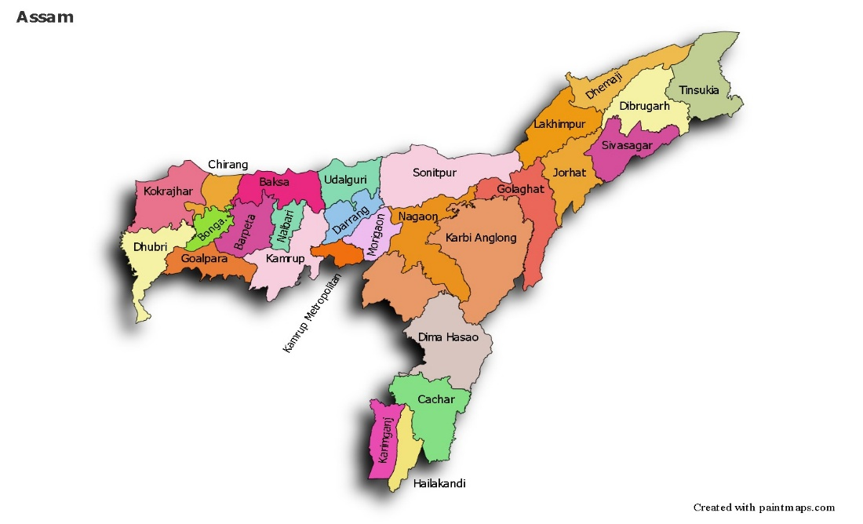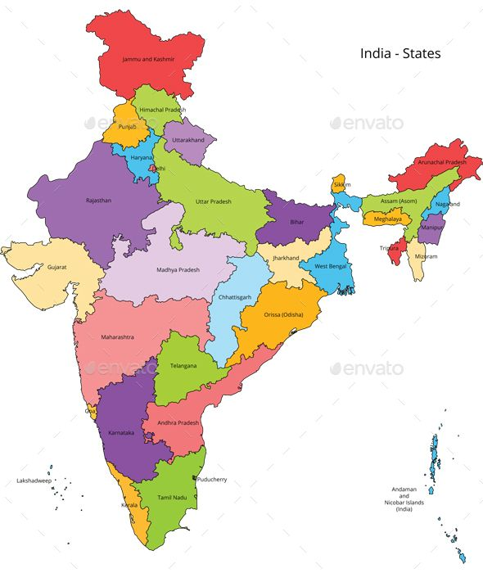

Assam

*Fig1: Map showing the study area*

*Source: google images*

The adaptation and mitigation strategies applicable for youth are identified on the basis of the available literatures and the observed strategies of the youth in the study area. Strategies to adaptation includes:

1. Planting of trees: It captures whether the individual has planted trees or not.
2. Food choices: This is the choice of food habit between vegetarian and non- vegetarian food.
3. Transportation choices: This captures the transportation choices of the individual between public transport and private transport
4. Vehicle choices: The choice of vehicle by the individuals i.e; either petrol/ diesel operated, electric vehicles or bicycle

If the sample chooses any of these strategies is considered as choosing to adopt to climate change strategies otherwise, it is considered as not adopting.

In order to estimate the factors influencing the youth’s decision to adopt, binary logistic regression analysis is carried out with the help of SPSS 16. Binary logistic regression is a statistical method used to predict a binary outcome based on one or more predictor values. The dependent variable considered in this study is a dichotomous variable therefore binary logistic regression has been used to find out the factors impacting the decision to adopt or not adopt any adaptation and mitigation strategies

The binary logistic regression equation considered for this analysis is as follows:

$$Y= β_{0 }+ β_{1}X_{1}+ β_{2}X_{2}+β_{3}X_{3}+ β_{4}X_{4}+ β_{5}X_{5}+ β_{6}X_{6}+ μ_{i}$$

An individual’s decision to adopt or not depends on various factors. The decision to adopt or to not adopt any adaptation mitigation strategy is taken as dependent variable.

Y = 1, if Yes (adopting)

= 0, if No (not adopting)

The decision of choosing to adopt or not adopt are dependent on factors like climate awareness, age, gender, education level, family income, locality etc. Therefore, independent variables considered are:

X1= climate awareness

X2 = age

X3 = gender

X4 = education level

X5 = family income

X6 = locality

The variable climate awareness indicates the respondents’ awareness about climate change and its related issues. For this, the respondents were asked the following questions:

1. Do you think climate change is real?
2. Climate change as a real concern.

The respondents were asked to answer among: strongly disagree, disagree, neutral, agree & strongly agree. Likert scale has been used for calculating the value of climate awareness.

The variable age captures the age of the respondents. Here, only the respondents with age 19 – 30 years of age were considered to fulfil the purpose of the study.

*Education level* captures the level of academic year the respondents are currently pursuing. This study only considers the educated youth.

The variable *locality* captures the place of residence of the respondents i.e; whether they reside in an urban area, rural or semi-urban areas.

**Result & Discussion:**

The respondents considered were undergraduate students within the age group of 19- 30 years. Among 300 respondents, 32% were male and 68% were female.

The binary logistic regression analysis results to estimate the factors impacting the decision of youth related to adaptation mitigation decision are discussed as follows:

|  |  |  |  |  |
| --- | --- | --- | --- | --- |
| **Table .1. Omnibus Tests of Model Coefficients** | | | | |
|  | | Chi-square | df | Sig. |
| Step 1 | Step | 20.263 | 6 | .002 |
| Block | 20.263 | 6 | .002 |
| Model | 20.263 | 6 | .002 |

|  |  |  |  |
| --- | --- | --- | --- |
| **Table 2. Hosmer and Lemeshow Test** | | | |
| Step | Chi-square | df | Sig. |
| 1 | 3.179 | 8 | .923 |

|  |  |  |  |
| --- | --- | --- | --- |
| **Table 3. Model Summary** | | | |
| Step | -2 Log likelihood | Cox & Snell R Square | Nagelkerke R Square |
| 1 | 60.582a | .065 | .276 |
| a. Estimation terminated at iteration number 8 because parameter estimates changed by less than .001. | | | |

Table 1, 2 & 3 shows the test results showing the goodness of fit of the model.

The omnibus tests of model coefficients show whether the data fits the model. From the table we can observe that the model is statistically significant at 1% level of significance. Therefore, our model is a good fit. (Table 1)

Hosmer and Lemeshow test is also used to test the goodness of fit of the model. It shows poor fit if its value is less than 0.005. From table we know that the results are statistically significant, which indicates that the data fits the model. (Table 2)

In a binary logistic regression using SPSS, pseudo R2 values like Cox& Snell R2 and Nagelkerke R2 can be used. The pseudo R2 values indicate how much of the variation in the dependent variable can be explained by the independent variables in the model.  The model summary shows that the Cox& Snell R2 value is .065 and Nagelkerke R2 value is .276. (Table 3)

|  |  |  |  |  |  |  |  |  |  |
| --- | --- | --- | --- | --- | --- | --- | --- | --- | --- |
| **Table 4. Variables in the Equation** | | | | | | | | | |
|  | | B | S.E. | Wald | Df | Sig. | Exp(B) | 95% C.I.for EXP(B) | |
| Lower | Upper |
| Step 1a | Age | .371 | .305 | 1.482 | 1 | .223 | 1.450 | .797 | 2.637 |
| gender(1) | -1.430 | .787 | 3.303 | 1 | .069 | .239 | .051 | 1.119 |
| Income | 1.224 | 1.048 | 1.363 | 1 | .243 | 3.400 | .436 | 26.525 |
| Education | -.589 | .511 | 1.329 | 1 | .249 | .555 | .204 | 1.510 |
| Locality | -1.516 | .558 | 7.381 | 1 | .007 | .220 | .074 | .655 |
| Clm_awareness | 1.219 | .366 | 11.110 | 1 | .001 | 3.382 | 1.652 | 6.924 |
| Constant | 1.506 | 8.557 | .031 | 1 | .860 | 4.509 |  |  |
| a. Variable(s) entered on step 1: age, gender, income, education, locality, Clm_awareness. | | | | | | | | | |

The regression results (Table 4) show that the independent variables are able to explain the dependent variable. The model is statistically significant at 5% level of significance. Among the independent variables, climate awareness is highly significant at 0.001 % level of significance. This means that increasing climate awareness among youths can increase the individuals choosing to adopt any adaptation and mitigation strategies. While the remaining variables under consideration i.e; age, gender, income and level of education are not statistically significant.

The odds ratio of the statistically significant variable, climate awareness, is >1. This means that better climate awareness among individuals will encourage them to adopt adaptation and mitigation strategies. The odds of a climate-aware youth choosing to adopt adaptation and/or mitigation strategies is 3.38 times higher than a climate-unaware youth of choosing not to adopt with 95% CI of 1.652 to 6.924.

The climate aware youth, therefore, are more likely to adopt adaptation mitigation strategies like choosing public transport, choosing to buy EVs (Electronic Vehicle) over petrol or diesel driven vehicles, planting trees etc. The result confirms the existing literatures (Jürkenbeck, K., Spiller, A., & Schulze, M., 2021), that emphasises in promoting climate awareness among youth.

Also, the respondents’ locality also influences their decision to adopt or not. Whether the respondent is from a rural area, urban area or living in a semi- urban area has impacted their decision to choose to adopt or not.

Climate change risks compel to migrate which impinge upon the collective capacity to curb losses through effective resource mobilisation. The seeming incapacity to manage impending disasters lead to climate anxiety and distress, particularly among young people. Youth are not only victims of climate change but are also the harbingers of climate action. With a growing youth population, young people are the most vulnerable section of society who are forced to migrate, thereby causing displacements due to extreme weather disasters, nutritional deficiencies and communicable diseases spread from the environment (Sanson et al., 2018). **The first pillar** of **stakeholder activism** involves persistent advocacy and lobbying by young people, jeopardised by climate risk to gain greater legitimacy, involvement, and leadership in climate action. Consequently, stakeholder activism can be the driving force for businesses and governments to act voluntarily and become more transparent by disclosing climate change related information. There are numerous forms of stakeholder activism that the youth can engage in. The easiest form, perhaps, is to participate in detailed negotiations with influential organisations that entail raising issues, extensive deliberations and debating recommendations to attain a common ground (Pickering et al., 2020).

The participation of youth in the project, from design to implementation, fostered a professional community on climate adaptation. This community of young professionals has enabled climate adaptation, moving from technical issues to political positions. In this way, it has influenced subsequent projects supported by other climate finance organizations (i.e., Green Climate Fund) (Ma et al., 2025). Youth actively participating in adaptation projects show open-mindedness for several main reasons. They are receptive to new ideas and knowledge and ready to learn, experiment, and develop new tools and approaches – when given the time, space, and support to do so. When working in adaptation projects, youth also show leadership qualities, such as motivation, collaboration, problem-solving, passion, and communication (Zakour, 2024).

**Conclusion**:

The analysis reveals that the explanatory variables are able to explain the response variables. However, only the variable climate awareness and locality of the individuals is statistically significant. This means that increasing climate awareness among the youths will increase their decision to adopt any of the adaptation and mitigation strategies. The climate-aware youth are more likely to adopt adaptation mitigation strategies. There is no denying fact that the youth or the younger generation is a crucial voice in climate-related issues and sustainable development. It is the younger generation who are at the higher stakes of any climate dismissive behaviour. Keeping all these factors in mind, conscious efforts should be made to make the younger generation aware of the climate issues. For instance, parents should educate their children about the importance of separating waste, educational institutes should encourage their students to plant trees, arrange seminars on climate action. The study therefore agrees with the existing literature in the area (Halder, P., & Singh, H. (2018) that acknowledges the role of educational institutions in inculcating the climate-friendly behaviour in the minds of the youths. The government should adopt climate policies that are bottom-up instead of top-down approach in order to make the younger generation more aware and therefore incorporate them in bringing solution to the climate-related issues.

Disclaimer (Artificial intelligence)

Option 1:

Author(s) hereby declare that NO generative AI technologies such as Large Language Models (ChatGPT, manuscript.

Option 2:

Author(s) hereby declare that generative AI technologies such as Large Language Models, etc. have been used during the writing or editing of manuscripts. This explanation will include the name, version, model, and source of the generative AI technology and as well as all input prompts provided to the generative AI technology

Details of the AI usage are given below:

1.

2.

3.

REFERENCES:

Bekabil, U. T., & Bedemo, A. (2015). Dynamics of farmers’ participation in conservation agriculture: binary logistic regression analysis. *Dynamics*, *13*, 74-83.

Dyanty, T., Agholor, I. A., Nkambule, T. B., Nkuna, A. A., Nkosi, M., Ndlovu, S. M., ... & Makhubu, T. H. (2025). Socio-Economic Determinants of Climate Change Adaptation Strategies Among Smallholder Farmers in Mbombela: A Binary Logistic Regression Analysis. *Climate*, *13*(5), 90.

Hanna, R., & Oliva, P. (2016). Implications of climate change for children in developing countries. *The Future of Children*, 115-132.

Han, H., & Ahn, S. W. (2020). Youth mobilization to stop global climate change: Narratives and impact. *Sustainability*, *12*(10), 4127.

Halder, P., & Singh, H. (2018). Predictors of recycling intentions among the youth: A developing country perspective. *Recycling*, *3*(3), 38.

Jürkenbeck, K., Spiller, A., & Schulze, M. (2021). Climate change awareness of the young generation and its impact on their diet. *Cleaner and Responsible Consumption*, *3*, 100041.

Kolenatý, M., Kroufek, R., & Činčera, J. (2022). What triggers climate action: The impact of a climate change education program on students’ climate literacy and their willingness to act. *Sustainability*, *14*(16), 10365.

MacKay, M., Parlee, B., & Karsgaard, C. (2020). Youth engagement in climate change action: Case study on indigenous youth at COP24. *Sustainability*, *12*(16), 6299.

Maharjan, K. L., & Joshi, N. P. (2011). Determinants of household food security in Nepal: A binary logistic regression analysis. *Journal of Mountain Science*, *8*, 403-413.

Nongqayi, L., Risenga, I., & Dukhan, S. (2022). Youth’s knowledge and awareness of human contribution to climate change: the influence of social and cultural contexts within a developing country. *Educational and Developmental Psychologist*, *39*(1), 44-57.

Pickering, G. J., Schoen, K., & Botta, M. (2021). Lifestyle decisions and climate mitigation: current action and behavioural intent of youth. *Mitigation and Adaptation Strategies for Global Change*, *26*, 1-27.

Shutaleva, A., Martyushev, N., Nikonova, Z., Savchenko, I., Abramova, S., Lubimova, V., & Novgorodtseva, A. (2021). Environmental behavior of youth and sustainable development. *Sustainability*, *14*(1), 250.

Skeirytė, A., Krikštolaitis, R., & Liobikienė, G. (2022). The differences of climate change perception, responsibility and climate-friendly behavior among generations and the main determinants of youth's climate-friendly actions in the EU. *Journal of environmental management*, *323*, 116277.

Tukur, K., & Usman, A. U. (2016). Binary logistic regression analysis. *Journal of Current Research*, *8*(01), 25235-25239.

Pickering, G. J., Schoen, K., Botta, M., & Fazio, X. (2020). Exploration of youth knowledge and perceptions of individual-level climate mitigation action. *Environmental Research Letters*, *15*(10), 104080.

Sanson, A. V., Wachs, T. D., Koller, S. H., & Salmela-Aro, K. (2018). Young people and climate change: The role of developmental science. *Developmental science and sustainable development goals for children and youth*, 115-137.Ma, Y., Al Mamun, A., Hoque, M. E., Masukujjaman, M., & Ja’afar, R. (2025). Modeling behavioral insights to mobilize private investment in climate change adaptation: Evidence from Chinese investors. *Environment, Development and Sustainability*, 1-32.

Zakour, C. (2024). Loss & Damage Youth Grant-Making Council-a climate justice case study. *The Round Table*, *113*(4), 361-373.

Chan, S., Singh, S., Chang, K., Tailor, P., Joshi, M., Mohan, M., and Amponsem, J. (2021). Young People and Drivers and Barriers to Climate Adaptation Action. Report. Global Center on Adaptation/ Centre for Environment Education/Kai Analytics/Foundation for Environmental Education.

Intergovernmental Panel on Climate Change (2022). Climate Change 2022: Impacts, Adaptation, and Vulnerability. Contribution of Working Group II to the Sixth Assessment Report of the Intergovernmental Panel on Climate Change [H.-O. Pörtner, D.C. Roberts, M. Tignor, E.S. Poloczanska, K. Mintenbeck, A. Alegría, M. Craig, S. Langsdorf, S. Löschke, V. Möller, A. Okem, B. Rama (eds.)]. Cambridge University Press. In Press.