Influence of Weather Parameters on Helicoverpa armigera Monitoring Using Pheromone and Light Traps in Sunflower Ecosystem

ABSTRACT
Impact of climatic factors on pheromone and light trap catches of Helicoverpa armigera in sunflower crop and their correlation with various weather parameters was assessed during kharif 2012 and 2013 at the ZARS, UAS, GKVK, Bengaluru. Moth catches were recorded from August to December in both years, with peak activity observed in October and November. In 2012, pheromone traps recorded maximum catches during the 48th standard meteorological week (SMW), while light traps showed peak captures in the 40th SMW. In 2013, both traps recorded highest moth activity around the 41st SMW. Correlation and multiple linear regression analyses revealed significant relationships between trap catches and weather variables of corresponding week. In 2012, minimum temperature showed a strong negative correlation with pheromone trap catches (r = -0.671), while soil temperature was positively correlated with light trap catches (r = 0.624*). In 2013, minimum temperature again showed a significant negative correlation with both trap types. When data were pooled, multiple regression models indicated that weather parameters accounted for 79.80 and 63.39 per cent of the variability in pheromone and light trap catches, respectively.
Keywords: Pheromone and light traps; Helicoverpa armigera; sunflower; Moth catches.
1. INTRODUCTION
Sunflower (Helianthus annuus L.) is one of the most important oilseed crops cultivated in India, known for its adaptability to diverse agro-climatic conditions, high-quality edible oil, and relatively short growing period. Among the oilseeds, sunflower holds a prominent place due to its high oil content (38-45%) and favorable fatty acid profile, which meets the nutritional demands of the population [1]. However, sunflower cultivation is increasingly challenged by a variety of insect pests, among which the gram pod borer, Helicoverpa armigera (Hubner), stands out as the most destructive species during the flowering and seed-setting stages [2]. This pest is highly polyphagous and has a remarkable ability to adapt to different host plants, thereby posing a severe threat to the economic yield of sunflower crops.
The larvae of H. armigera bore into the sunflower heads and feed on developing seeds, leading to both quantitative and qualitative losses [3]. Due to its nocturnal habits and cryptic larval behavior, early detection of this pest in the field remains a significant challenge. As a result, farmers often resort to indiscriminate insecticide applications, contributing to resistance development, environmental contamination and ecological imbalances. In this context, efficient monitoring techniques are critical components of integrated pest management (IPM) programs for reducing pesticide use while ensuring timely pest control.
Effective pest management strategies necessitate accurate monitoring of pest populations. Pheromone and light traps are widely employed tools for this purpose. Pheromone traps are species-specific and target male moths by mimicking the sex pheromones emitted by females, providing reliable information about pest incidence and seasonal population trends [4]. Light traps, in contrast, are broader in their catch spectrum, attracting both male and female moths based on phototactic behaviour [5]. Several studies have demonstrated that data from these traps can be correlated with field populations and help predict pest outbreaks when integrated with weather parameters [6,7].
The influence of environmental factors on moth activity is well documented. Weather parameters such as temperature, humidity, rainfall, sunshine hours and wind speed have been reported to significantly affect H. armigera trap catches across different cropping systems [8,9]. Forecasting models developed using these relationships have the potential to improve pest prediction and decision-making for chemical control measures, thereby reducing economic losses and promoting sustainable agriculture.
2. METHODOLOGY
The monitoring studies were carried out during Kharif 2012 (20th August- 31st December) and Kharif 2013 (12th August- 30th November) at the Zonal Agricultural Research Station, University of Agricultural Sciences, GKVK, Bengaluru. The pheromone traps and light were placed in one-acre sunflower crop, by maintaining two replications. The sex pheromone traps used for monitoring H. armigera were procured from the M/s Bio-Pest Management Pvt. Limited, Bengaluru. The trap consisted of a smooth plastic funnel (10 cm diameter) and a plastic sleeve of 60 cm length. Each lure was replaced once in three weeks. The counts were recorded on a daily basis and then the trapped moths were killed after each count and then expressed as number of moths trapped per week.
Subsequently the data was subjected to correlation and multiple linear regression analysis with meteorological parameters viz., total rainfall, number of rainy days, maximum temperature, minimum temperature, morning and afternoon relative humidity and bright sunshine hours. Except in case of number of rainy days and total rainfall, where the total was considered, all other weather parameters the mean was considered and then correlated with the weekly trap catches. The weekly pheromone trap catches of H. armigera was correlated with the weather variables of the preceding week, as well as with that of the same or corresponding week.
3. RESULTS AND DISCUSSION
3.1 Monitoring of H. armigera with pheromone and light traps
3.1.1 Kharif 2012
The moth activity of H. armigera was monitored through sex pheromone traps and light traps from 20th August to 31st December, 2012 (Fig. 1). Moth activity was noticed from 34th SMW. However, the maximum male moth catches through pheromone trap were recorded during last week of November (48th SMW) with 4.00 moths/trap/week, followed by second week of November i.e., 46th SMW (3.50) and 49th SMW (3.00). H. armigera moth catches was also monitored through light traps. The maximum moth catches were found during first week of October (40th SMW) with 13.00 moths/trap/week, followed by 39th (9.00) and 43rd SMW (9.00).
3.1.2 Kharif 2013
The moth activity of H. armigera was monitored from 12th August to 30th November 2013 (Fig. 2). Moth activity was noticed from 33rd SMW. The pheromone trap catches were found throughout the crop growth with highest during 41st SMW i.e., second week of October (13.50 moth/trap/week), followed by 43rd and 40th SMW (8.00). In case of H. armigera moth catches monitored through light traps, maximum moth catches were observed 41st SMW (19.00 moth/trap/week), followed by 47th SMW (13.00).
Results of the present study aligns closely with findings from earlier work by Jagadish et al. [10] who reported peak moth catches (49.90 moths/trap) in a sunflower ecosystem during October, based on pooled data from a five-year monitoring period using pheromone traps. Similarly, Kumar et al. [11] recorded peak adult emergence of H. armigera during the late crop season, with the highest trap catches during the 51st (8.25 moths/trap/week) and 52nd (8.00 moths/trap/week) standard meteorological weeks (SMWs), followed by a notable catch in the 1st SMW (7.25 moths). Further, Shinde et al. [12] observed two distinct peaks of larval population in chickpea: the first between the 47th and 50th SMWs, and the second between the 10th and 14th SMWs. In a similar pattern, Singh and Ali [13] also reported two larval activity peaks of H. armigera- one occurring from the 46th to 49th SMWs and another between the 5th and 13th SMWs.
3.2 Correlation and multiple linear regression between pheromone trap catches of H. armigera with weather parameters of corresponding week
3.2.1 Kharif 2012
The correlation between the pheromone trap catches of H. armigera was found to be significantly negative with minimum temperature (r=-0.671**). Morning relative humidity (r=-0.490), total rainfall (r=-0.237), number of rainy days (r=-0.357), afternoon relative humidity (r=-0.081), soil temperature (r=-0.360) and wind speed (r= -0.191) was found to have negative effect on the pheromone trap catches. Moreover, sunshine hours (r=0.336) was found to have non-significant positive effect on the pheromone trap catches of H. armigera (Table 1). Multiple linear regression equation suggested that these weather parameters influence the H. armigera moth catches in pheromone traps to an extent of 50.70 per cent (Table 2).
3.2.2 Kharif 2013
In Kharif 2013 the correlation between the pheromone trap catches of H. armigera with the weather parameters of corresponding week was also found to be a significant only with minimum temperature (r=-0.621*), whereas total rainfall (r=-0.136), number of rainy days (r=-0.032), afternoon relative humidity (r=-0.033) and wind speed (r= -0.033) was found to have a negative impact on the moth catches. However, maximum temperature (r=0.076), morning relative humidity (r=0.075), sun shine hours (r=0.155) and soil temperature (r=0.195) was found to have positive effect on the trap catches of H. armigera (Table 1). Multiple linear regression equation indicated that these weather parameters influenced the H. armigera moth catches to an extent of 66.10 per cent (Table 2).
3.2.3 Pooled mean of Kharif 2012 and 2013
From the pooled mean analysis of the pheromone trap catch data, the correlation between the pheromone trap catches of H. armigera with the weather parameters of corresponding week was also found to be a significant only with minimum temperature (r=-0.637**) at 0.01 level (2- tailed), whereas, number of rainy days (r=-0.038), maximum temperature (r=-0.283) and morning relative humidity (r=-0.124) was found to have a negative impact on the moth catches. However, total rainfall (r=0.044), afternoon relative humidity (r=0.167), sun shine hours (r= 0.048), soil temperature (r=0.218) and wind speed (r=0.214) was found to have positive effect on the trap catches of H. armigera (Table 1). Multiple linear regression equation indicated that these weather parameters influenced H. armigera moth catches to an extent of 79.80 per cent (Table 2).
3.3 Correlation and multiple linear regression between light trap catches of H. armigera with weather parameters of corresponding week
3.3.1 Kharif 2012
When light trap catches of H. armigera were correlated with weather parameters of corresponding week, it was found to be significant only with soil temperature (r=0.624*). The total rainfall (r=0.032), number of rainy days (r= 0.214), maximum temperature (r=0.230) minimum temperature (r= 0.268) and morning relative humidity (r=0.216) was found to have a positive effect on the total light trap catches of H. armigera. However, afternoon relative humidity (r=-0.216), sunshine hours (r=-0.035) and wind speed (r=-0.234) was found have a negative effect on the light trap catches of H. armigera (Table 3). An impact of 37.50 per cent due to weather factors was felt on the light trap catches of H. armigera moth as revealed by the multiple linear regression equation (Table 4).
3.3.2 Kharif 2013
During Kharif 2013 correlation between the light trap catches including both male and female moths with weather parameters of corresponding week was found to be significantly negative correlated with minimum temperature (r=-0.813**). The total rainfall (r=0.013), number of rainy days (r= 0.018), maximum temperature (r=0.022), sunshine hours (r=0.029) and soil temperature (r=0.180) were found to have a positive effect on the light trap catches of H. armigera. However, the morning relative humidity (r=-0.154), afternoon relative humidity (r=-0.357) and wind speed (r=-0.317) was found to have a negative effect on the total light trap catches of H. armigera (Table 3). An impact of 85.10 per cent due to weather factors was felt on the light trap catches of H. armigera moths as revealed by the multiple linear regression equation (Table 4).
3.3.3 Pooled mean of Kharif 2012 and 2013
From the pooled mean analysis of the light trap catches, the correlation between the light trap catches of H. armigera with the nine weather parameters of corresponding week was found to be a non significant. However, total rainfall (r= -0.066), number of rainy days (r= -0.085), maximum temperature (r= -0.014), minimum temperature (r= -0.595), morning relative humidity (r= -0.336), afternoon relative humidity (r=-0.106) and wind speed (r= -0.371) was found to have a negative impact on the moth catches, whereas, sun shine hours (r= 0.243) and soil temperature (r= 0.340) was found to have positive effect on the trap catches of H. armigera (Table 3). Multiple linear regression equation indicated that these weather parameters influenced the H. armigera moth catches to an extent of 63.39 per cent (Table 4).
3.4 Correlation and multiple linear regression between sex pheromone trap catches of H. armigera with weather parameters of preceding week
3.4.1 Kharif 2012
The correlation between the pheromone trap catches of H. armigera with corresponding week was found to be negatively significant with the minimum temperature (r= -0.580**), morning relative humidity (r=-0.533*) and wind speed (-0.517). Total rainfall (r= -0.313), number of rainy days (r=-0.297), maximum temperature (r=-0.215), afternoon relative humidity (r= -0.225) and soil temperature (r=-0.165) were found to have negative effect on the pheromone trap catches. Moreover, sunshine hours (r= 0.413) was found to have non-significant positive effect on the pheromone trap catches of H. armigera (Table 5). Multiple linear regression equation suggested that the weather parameters of preceding week influence the H. armigera moth catches in pheromone traps to an extent of 56.10 per cent (Table 6).
3.4.2 Kharif 2013
The correlation between the pheromone trap catches of H. armigera with all the weather parameters of the corresponding week was found to be non-significant. Total rainfall (r= -0.300), number of rainy days (r=-0.370), morning relative humidity (r=-0.153) and wind speed (r=-0.216) was found to have negative effect on the pheromone trap catches. However, the maximum temperature (r= 0.252), minimum temperature (r= 0.127), sunshine (r= 0.311) and soil temperature (r=0.268) was found to have non-significant positive effect on the pheromone trap catches of H. armigera (Table 5). Multiple linear regression equation suggested that the weather parameters of preceding week influence the H. armigera moth catches in pheromone traps to an extent of 68.60 per cent (Table 6).
3.4.3 Pooled mean of Kharif 2012 and 2013
Pheromone trap catches of H. armigera from both the Kharif seasons of 2012 and 2013, when subjected to correlation with all the weather parameters showed a non-significant negative correlation between pest activity and total rainfall (r= -0.428), morning relative humidity (r=-0.332), afternoon relative humidity (r=-0.061) and wind speed (r-0.424). However, the maximum temperature (r= 0.112), minimum temperature (r= 0.012), sunshine (r= 0.301) and soil temperature (r=0.337) was found to have non-significant positive effect on the pheromone trap catches of H. armigera in preceding week (Table 5). Multiple linear regression equation suggested that the weather parameters of preceding week influence the H. armigera moth catches in pheromone traps to an extent of 82.70 per cent (Table 6).
3.5 Correlation and multiple linear regression between light trap catches of H. armigera with weather parameters of preceding week
3.5.1 Kharif 2012
During the Kharif season of 2012 correlation between the light trap catches adult moths with weather parameters showed a significant positive correlation with the number of rainy days(r=0.500*) and soil temperature (r=0.628**). However, the total rainfall (r=0.259), maximum temperature (r=0.169), minimum temperature (r=0.169), morning relative humidity (r=0.208), afternoon relative humidity (r=0.109) and sunshine (0.093) was found to have non-significant positive effect on the pheromone trap catches of H. armigera. However, only the wind speed (r=-0.196) recorded non-significant negative effect on the pheromone trap catches of H. armigera (Table 7). An impact of 60.50 per cent due to weather factors of preceding week was felt on the light trap catches of H. armigera as revealed by the multiple linear regression equation (Table 8).
3.5.2 Kharif 2013
The correlation between the pheromone trap catches of H. armigera with all the weather parameters of the preceding week of Kharif 2013 was found to be non-significant. Total rainfall (r=-0.338), number of rainy days (r=-0.475), morning relative humidity (r=-0.218), afternoon relative humidity (r=-0.005) and wind speed (r= -0.275) was found to have negative effect on the light trap catches of H. armigera. Moreover, maximum temperature (r=0.260), minimum temperature (r=0.036), sunshine hours (r=0.485) and soil temperature (r=0.152) was found to have non-significant positive effect on the light trap catches of H. armigera (Table 7). Multiple linear regression equation suggested that the weather parameters of preceding week influence the H. armigera moth catches in light traps to an extent of 59.90 per cent (Table 8).
3.5.3 Pooled mean of Kharif 2012 and 2013
Light trap catches of H. armigera from the both seasons of Kharif 2012 and 2013 correlated with the nine weather parameters revealed a non-significant relationship. Wind speed (r=-0.598*), total rainfall (r=-0.242), number of rainy days (r=-0.253), minimum temperature (r= -0.214), morning relative humidity (r=-0.467) and afternoon relative humidity (r=-0.009) were having a negative influence on the light trap catches of H. armigera. However, the other parameters like maximum temperature (r= 0.150), sunshine (r=0.413) and soil temperature (r=0.389) was found to be positively influencing the H. armigera light trap catches (Table 7). The regression equation indicated that the moth catches of H. armigera was influenced to an extent of 81.60 per cent by the different weather factors (Table 8).
Several studies have demonstrated the influence of climatic factors on Helicoverpa armigera populations. Jagadish et al. [10] and Prasannakumar et al. [14] reported a negative impact of rainfall on moth catches. Kumar and Durairaj [15] observed a significant negative association between the emergence of H. armigera and minimum temperature, while other weather parameters showed no significant influence. Chatar et al. [16] found that the larval population of H. armigera exhibited a highly significant negative correlation with maximum temperature and a significant negative correlation with minimum temperature, along with a highly significant positive correlation with relative humidity. Similarly, Ugale et al. [17] reported a significant negative correlation between H. armigera population and mean atmospheric temperature, which is consistent with the findings of the present study.
4. CONCLUSION
The present study underscores the significant influence of climatic variables on the population dynamics of Helicoverpa armigera. Among the various weather parameters examined, temperature-particularly maximum and minimum-emerged as a key factor negatively affecting pest abundance, while relative humidity showed a positive association. Rainfall also demonstrated a suppressive effect on moth catches. Understanding these relationships is essential for developing timely and location-specific pest management strategies. Integrating weather-based forecasting models into pest management programs can enhance their efficiency and help reduce crop losses due to H. armigera infestation.

Disclaimer:
We, the author(s) of this manuscript, take full responsibility for any "False Positive Similarity Score" generated by plagiarism detection software or tools. We believe that such a similarity score may be due to technical errors related to the software’s internal data storage system, repository, or other system-related issues. We hereby affirm and guarantee the originality and authenticity of our manuscript.
Disclaimer (Artificial intelligence)
Option 1:
Author(s) hereby declare that NO generative AI technologies such as Large Language Models (ChatGPT, manuscript.

REFERENCES
- Chaudhary RG, Deshmukh DV, Deshmukh SS. Sunflower: A potential oilseed crop for future. Journal of Oilseeds Research. 2018;35(2):63–68.
- Kranthi KR, Russell DA, Wanjari RR, Kranthi S. Insecticide resistance and resistance management in Helicoverpa armigera. Crop Protection. 2002;21(6):449–460.
- Reddy KD, Rao NV. Seasonal incidence of Helicoverpa armigera on sunflower in relation to weather parameters. Indian Journal of Plant Protection. 2003;31(1):28–31.
- Srivastava CP, Pimbert MP, Reed W. Monitoring of Helicoverpa armigera moths with light and pheromone traps in India. International Journal of Tropical Insect Science. 1992;13(2):205–210.
- Barrett BA, McCaffery AR. The influence of moonlight and weather on catches of Helicoverpa armigera (Hübner) in light and pheromone traps. Bulletin of Entomological Research. 1988;78(3):365–377.
- Aheer GM, Ali A, Akram M. Effect of weather factors on populations of Helicoverpa armigera moths at cotton-based agro-ecological sites. Entomological Research. 2008;38(3):182–186.
- Sonkar J, Ganguli J, Ganguli RN. Correlation of pheromone trap catch of H. armigera with larval population in field and weather parameters. Agricultural Science Digest. 2012;32(3):204–208.
- Sivakumar MVK, Prasad VR. Influence of weather parameters on the population dynamics of Helicoverpa armigera in cotton. Indian Journal of Agricultural Sciences. 1998;68(6):341–344.
- Sagar D, Nebapure SM, Chander S. Validation of weather-based forewarning model for Helicoverpa armigera in chickpea. The Indian Journal of Agricultural Sciences. 2019;89(11):1801–1805.
- Jagadish KS, Karuna K, Geetha KN, Shadakshari YG, Puttarangaswamy KT, Nagarathna TK. Monitoring of capitulum borer, Helicoverpa armigera (Hub.) and tobacco caterpillar, Spodoptera litura Fab. in sunflower using sex pheromone traps. Environment and Ecology. 2007;25(4):1399–1402.
- Kumar JR, Durairaj C. Population dynamics of gram pod borer (Helicoverpa armigera) in relation to weather factors under Tamil Nadu condition. Journal of Food Legumes. 2012;25(1):83–85.
- Shinde YA, Patel BR, Mulekar VG. Seasonal incidence of gram caterpillar, Helicoverpa armigera (Hub.) in chickpea. Current Biotica. 2013;7(1&2):79–82.
- Singh R, Ali S. Seasonal incidence of Helicoverpa armigera and Campoletis chlorideae on chickpea. Annals of Plant Protection Sciences. 2006;14(1):234–235.
- Prasannakumar NR, Chakravarthy AK, Naveen AH. Influence of weather parameters on pheromone trap catches of potato cutworm, Spodoptera litura (Fabricius) (Lepidoptera: Noctuidae). Current Biotica. 2012;5(4):508–512.
- Kumar JR, Durairaj C. Population dynamics of gram pod borer (Helicoverpa armigera) in relation to weather factors under Tamil Nadu condition. Journal of Food Legumes. 2012;25(1):83–85.
- Chatar VP, Raghvani KL, Joshi MD, Ghadge SM, Deshmukh SG, Dalave SK. Population dynamics of pod borer, Helicoverpa armigera (Hübner) infesting chickpea. International Journal of Plant Protection. 2010;3(1):65–67.
- Ugale TB, Toke NR, Shrisath MS. Population dynamics of gram pod borer, Helicoverpa armigera (Hübner). International Journal of Plant Protection. 2011;4(1):204–208.

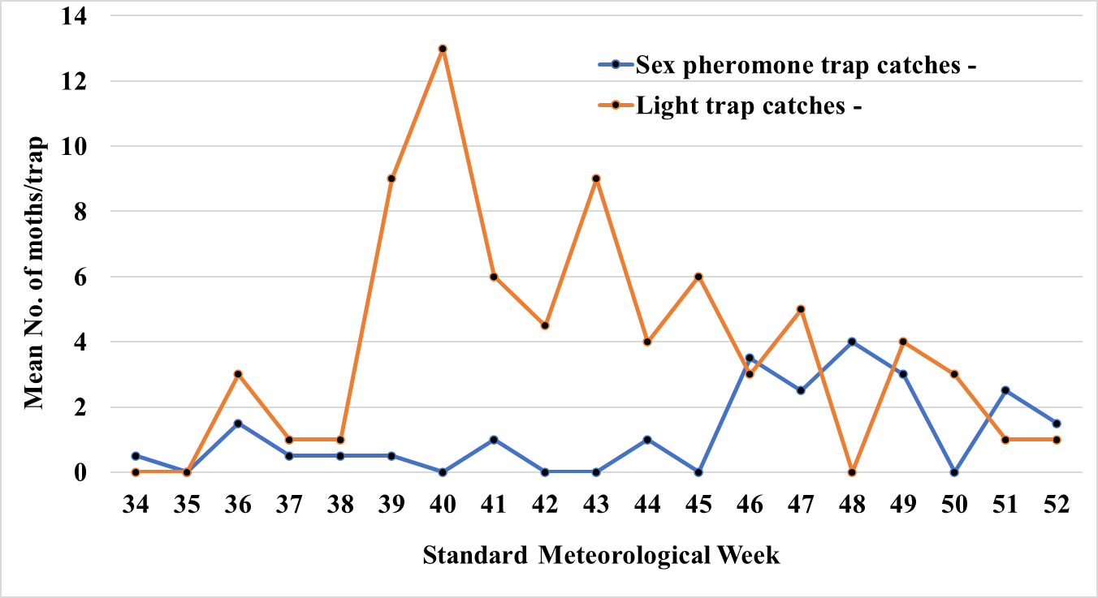
Fig. 1. Weekly sex pheromone trap and light trap catches of H. armigera in sunflower crop during 2012

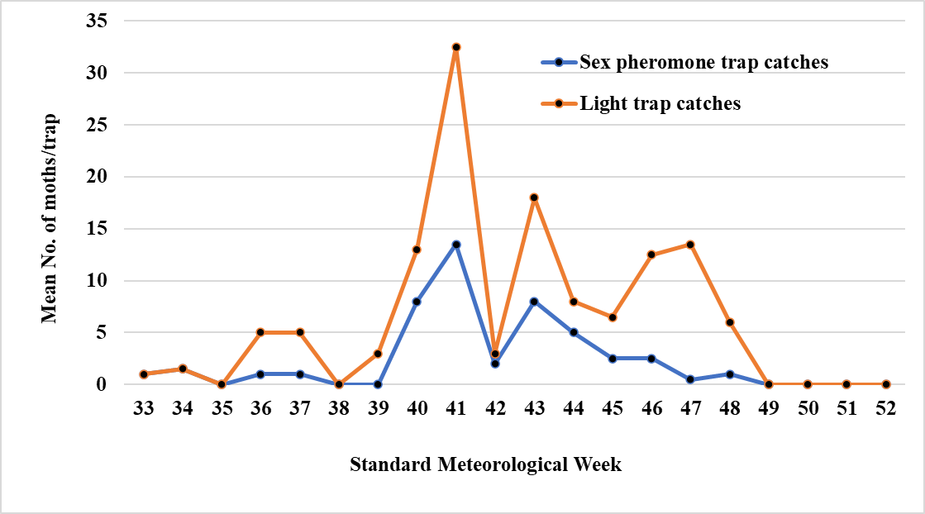
Fig. 2. Weekly sex pheromone trap and light trap catches of H. armigera in sunflower crop during 2013

Table 1. Correlation between sex pheromone trap catches of H. armigera with weather parameters of corresponding week
Pest | Total  rainfall (mm) | No. of rainy days | Temp. (ºC) |  | RH (%) |  | Sunshine  (Hrs.) | Soil temp  (5cm,  Morn) | Wind speed  (Km/day)
Pest | Total  rainfall (mm) | No. of rainy days | Max. | Min. | Morn. | A/N | Sunshine  (Hrs.) | Soil temp  (5cm,  Morn) | Wind speed  (Km/day)
H. armigera moth catches in 2012 | -0.237 | -0.357 | -0.338 | -0.671** | -0.490 | -0.081 | 0.336 | -0.360 | -0.191
H. armigera moth catches in 2013 | -0.136 | -0.032 | 0.076 | -0.621* | 0.075 | -0.033 | 0.155 | 0.195 | -0.033
Mean moth catches | 0.044 | -0.038 | -0.283 | -0.637** | -0.124 | 0.167 | 0.048 | 0.218 | 0.214
** Correlation is significant at the 0.01 level (2-tailed)
* Correlation is significant at the 0.05 level (2-tailed)

Table 2. Regression equation between pheromone sex trap catches of H. armigera with weather parameters of corresponding week
Pest | Regression equation | R² value
H. armigera moth catches in 2012 | Y²= 20.472+0.007X₁-0.175X₂-0.166X₃-0.389X₄ -0.038X₅-0.063X₆-0.087X₇-0.024X₈+0.012X₉ | 50.70
H. armigera moth catches in 2013 | Y²= -88.509-0.088X₁+0.344X₂+1.217X₃-1.209X₄ +0.516X₅ +0.508X₆+0.425X₇+0.155X₈-0.604X₉ | 66.10
Mean moth catches | Y²= -47.147+0.011X₁-0.958X₂+1.285X₃-0.265X₄ +0.220X₅ +0.381X₆-0.626X₇+0.133X₈-0.588X₉ | 79.80
X₁=Total rainfall (mm), X₂= No. of rainy days, X₃= Maximum temperature (ºC), X₄= Minimum temperature (ºC)
X₅= Relative humidity (morning) (%), X₆= Relative humidity (afternoon) (%), X₇= Sunshine hours, X₈ = Soil temperature,
X₉= Wind speed

Table 3. Correlation between light trap catches of H. armigera with weather parameters of corresponding week
Pest | Total  rainfall (mm) | No. of rainy days | Temp. (ºC) |  | RH (%) |  | Sunshine  (Hrs.) | Soil temp  (5cm,  Morn) | Wind speed  (Km/day)
Pest | Total  rainfall (mm) | No. of rainy days | Max. | Min. | Morn. | A/N | Sunshine  (Hrs.) | Soil temp  (5cm,  Morn) | Wind speed  (Km/day)
H. armigera moth catches in 2012 | 0.032 | 0.214 | 0.230 | 0.268 | 0.216 | -0.216 | -0.035 | 0.624* | -0.234
H. armigera moth catches in 2013 | 0.013 | 0.018 | 0.022 | -0.813** | -0.154 | -0.357 | 0.029 | 0.180 | -0.317
Mean moth catches | -0.066 | -0.085 | -0.014 | -0.595 | -0.336 | -0.106 | 0.243 | 0.340 | -0.371
** Correlation is significant at the 0.01 level (2-tailed)
* Correlation is significant at the 0.05 level (2-tailed)

Table 4. Regression equation between light trap catches of H. armigera with weather parameters of corresponding week
Pest | Regression equation | R² value
H. armigera moth catches in 2012 | Y²= -6.202-0.008X₁+0.097X₂-1.047X₃ +0.465X₄ +0.118X₅-0.248X₆+0.043X₇+1.756X₈-0.296X₉ | 37.50
H. armigera moth catches in 2013 | Y²=190.50-0.010X₁+0.498X₂-3.089X₃-1.801X₄-0.680X₅-0.025X₆+0.567X₇-0.109X₈-1.634X₉ | 85.10
Mean moth catches | Y²=-47.292-0.003X₁-0.387X₂+2.244X₃-1.624X₄-0.042X₅ +0.429X₆-0.762X₇+0.330X₈-1.285X₉ | 63.39
X₁=Total rainfall (mm), X₂= No. of rainy days, X₃= Maximum temperature (ºC), X₄= Minimum temperature (ºC),
X₅= Relative humidity (morning) (%), X₆= Relative humidity (afternoon) (%), X₇= Sunshine hours, X₈ = Soil temperature,
X₉= Wind speed

Table 5. Correlation between sex pheromone trap catches of H. armigera with weather parameters of preceding week
Pest | Total  rainfall (mm) | No. of rainy days | Temp. (ºC) |  | RH (%) |  | Sunshine  (Hrs.) | Soil temp  (5cm,  Morn) | Wind speed  (Km/day)
Pest | Total  rainfall (mm) | No. of rainy days | Max. | Min. | Morn. | A/N | Sunshine  (Hrs.) | Soil temp  (5cm,  Morn) | Wind speed  (Km/day)
H. armigera moth catches in 2012 | -0.313 | -0.297 | -0.215 | -0.580** | -0.533* | -0.225 | 0.413 | -0.165 | -0.517
H. armigera moth catches in 2013 | -0.300 | -0.370 | 0.252 | 0.127 | -0.153 | 0.147 | 0.311 | 0.268 | -0.216
Mean moth catches | -0.428 | -0.553* | 0.112 | 0.012 | -0.332 | -0.061 | 0.301 | 0.337 | -0.424
** Correlation is significant at the 0.01 level (2-tailed)
* Correlation is significant at the 0.05 level (2-tailed)

Table 6. Regression equation between pheromone trap catches of H. armigera with weather parameters of preceding week
Pest | Regression equation | R² value
H. armigera moth catches-2012 | Y²=14.712-0.006X₁-0.182X₂-0.292X₃-0.265X₄ +0.106X₅-0.011X₆-0.208X₇-0.219X₈-0.412X₉ | 56.10
H. armigera moth catches-2013 | Y²=-164.47+0.007X₁-2.276X₂ +3.160X₃ + 0.113X₄ +0.678X₅ +0.448X₆-1.401X₇ +0.429X₈-1.149X₉ | 68.60
Mean moth catches | Y²=-30.549-0.007X₁-1.531X₂-0.569X₃-0.139X₄ +0.099X₅ +0.261X₆-0.626X₇+0.331X₈-0.931X₉ | 82.70
X₁=Total rainfall (mm), X₂= No. of rainy days, X₃= Maximum temperature (ºC), X₄= Minimum temperature (ºC),
X₅= Relative humidity (morning) (%), X₆= Relative humidity (afternoon) (%), X7= Sunshine hours, X₈ = Soil temperature,
X₉= Wind speed

Table 7. Correlation between light trap catches of H. armigera in with weather parameters of preceding week
Pest | Total  rainfall (mm) | No. of rainy days | Temp. (ºC) |  | RH (%) |  | Sunshine  (Hrs.) | Soil temp  (5cm,  Morn) | Wind speed  (Km/day)
Pest | Total  rainfall (mm) | No. of rainy days | Max. | Min. | Morn. | A/N | Sunshine  (Hrs.) | Soil temp  (5cm,  Morn) | Wind speed  (Km/day)
H. armigera moth catches in 2012 | 0.259 | 0.500* | 0.169 | 0.169 | 0.208 | 0.109 | 0.093 | 0.628** | -0.196
H. armigera moth catches in 2013 | -0.338 | -0.475 | 0.260 | 0.036 | -0.218 | -0.005 | 0.485 | 0.152 | -0.275
Mean moth catches | -0.242 | -0.253 | 0.150 | -0.214 | -0.467 | -0.009 | 0.413 | 0.389 | -0.598*
** Correlation is significant at the 0.01 level (2-tailed)
* Correlation is significant at the 0.05 level (2-tailed)

Table 8. Regression equation between light trap catches of H. armigera with weather parameters of preceding week
Pest | Regression equation | R² value
H. armigera moth catches-2012 | Y²=-59.979-0.061X₁ +1.982X₂ +0.576X₃+0.148X₄ -0.266X₅ +0.312X₆ +0.635X₇ +2.254X₈+0.572X₉ | 60.50
H. armigera moth catches-2013 | Y²=-7.313+0.001X₁-2.857X₂-0.229X₃-0.232X₄ +0.84X₅ +0.584X₆-0.552X₇ +0.063X₈-2.086X₉ | 59.90
Mean moth catches | Y²=2.732-0.006X₁-0.620X₂+2.508X₃-0.203X₄-1.223X₅ +0.793X₆-0.429X₇+0.593X₈-0.592X₉ | 81.60
X₁=Total rainfall (mm), X₂= No. of rainy days, X₃= Maximum temperature (ºC), X₄= Minimum temperature (ºC),
X₅= Relative humidity (morning) (%), X₆= Relative humidity (afternoon) (%), X₇= Sunshine hours, X₈ = Soil temperature,
X₉= Wind speed

