**Urbanization and Land Use Change Impact on Climate: A Case Study of Owerri West, Nigeria**

**ABSTRACT**

Land Use and Climate changes are major drivers of global environmental changes. Land use changes influences climatic changes at various temporal and spatial scales. Both earlier and present researches have shown significant effects of land use land cover changes on climate. High urbanization and industrialization derived land use changes have resulted in reducing available forested and vegetated lands in developing-country cities. This study analyzed the dynamics and effects of land use land cover changes on climate considering changes in variation of temperature, pressure and rainfall amount in Owerri West, Imo State Nigeria. Landsat image analysis was employed to assess the effect of land use/land cover (LU/LC) changes overtime with climatic variables in Owerri West, Imo State Nigeria for 20years. Climatic data of three series (2002, 2012 and 2022) and remote sensing data (Landsat 7 ETM+ imagery of 2002 and 2012; Landat 8 OLI of 2022) were analyzed to determine the trend and statistical significance of the variables relationship across the 20year study period. Result showed significant land use land cover and climatic changes on built-up, forest and farmland/fallow areas across the 20year period. Urbanization derived built-up increase in the study area led to reduction of available forest and agricultural lands. Temperature increase across the 20year period was also observed as a major climatic change. Correlation of land use change against climatic change showed strong significant positive correlation justifying that land use changes affected climatic changes within the study area. It is recommended that proper land-use planning and management be adopted by relevant authorities to reduce climate change impacts which are capable of posing a global risk, affecting terrestrial ecosystems, food security, deforestation and land degradation activities.

**Keywords:** Land Use, Land Cover Change, Climate Change, Urbanization, Ecosystem, Remote Sensing

**1 Introduction**

In recent decades, the need for global economic growth has directly increased the rate of urbanization and industrialization, making land use changes inevitable and worldwide phenomenon. In developing countries, rapid economic growth has triggered significant population growth (Basommi *et al.*, 2016; Singh *et al*., 2018; Hassan *et al.*, 2020; ESSAP, 2022). In addition, the United Nations has projected about 90% and 66% rise of the world’s urbanization and population respectively from developing countries of Africa and Asia by 2050 (UN, 2018; UN 2021). Thus, developing-countries cities officials should develop action plans for future urbanization expansion by providing essential services and increasing infrastructural accommodations to allow citizens’ growth (World Bank, 2022).

Climate and land-use changes have been identified over three decades as two major causes of global ecological changes for the future (Turner *et al*. 1993; Virginia, 1997). These changes are likely to have major impacts on socioeconomic, ecological, and political aspects of human society resulting to changes in productivity, biodiversity, migration, and sustainability. Hence, the causes and consequences of human-induced climate change and land-use activities need to be carefully and independently examined for future planning and sustainability (Bashir et al., 2022; Ronald et al., 2023). While climate and land use changes interact and affect each other, urbanization causes changes in land-use distribution regarding impermeable urban materials and land-surface processes which could promote societal well-being (Lo and Quattrochi, 2003) but can also impact the local climate (Doan *et al.,* 2019). Additionally, Nguyen *et al.,* (2022) in (Maza *et al.,* 2020 and Srivastava *et al.,* 2020) identified land cover’s major significant changes effect on climate through hydrological streamflow alterations due to the variations in the physical-based characteristics of the land surface, soil, and vegetation cover.

In Imo State Nigeria, the city capital “Owerri Municipal” has expanded into major part of Owerri West, due to the state government economic policy resulting in rapid urbanization, migration and population/social growth. In 1991, 78,948 people were recorded (NPC, 1991), which stands projected to 168,000 by 2022 due to urbanization triggered population growth resulting to significant deforestation and expansion of the city capital to accommodate influx of people for economic benefits (Elijah, 2022; Eziham 2022). This situation became more intense due to the presence of three Federal Universities in the study area.

However, the remarkable increase in population has resulted in the increase in paved surfaces, infrastructural developments and private and public vehicular transportation leading to higher demand for energy consumption and increased concentration of heat emission in the atmosphere from autos and air conditioning equipment (Doan *et al.*, 2019). These are capable of raising the mean land surface temperature when compared with result from neighbouring sub-urban cities where population growth and urbanization are slow. Future climates are likely to be more severe due to the significant impacts of increasing land surface temperature particularly in built-up regions (Nguyen *et al.*, 2022). Therefore, managing land surface temperature is important not only to predict extreme weather events but also to understand urbanization’s impacts on land-use distribution, which relates to urban thermal patterns (Chen *et al*., 2006; Rinner and Hussain 2011; M Tran *et al.,* 2017). Previous studies have indicated that increased land surface temperatures impact not only on the air quality of the environment but also on the health of people within the ambient environment (Kikegawa *et al.*, 2003; Tan *et a.l*, 2003; Grimmond, 2007).

This study assessed the effects of land use land cover changes on climate and established relationship between LULC and climatic variables (temperature, pressure and rainfall amount) using statistical correlation.

**2 Materials and Method**

**2.1 Study Area**

Owerri West is a Local Government Area in Imo State Nigeria with headquarters in Umuguma, located on a geographic coordinate of longitude 6°52΄30΄΄E to 7°3΄0΄΄E and latitude 5°16΄0΄΄N to 5°33΄0΄΄N (Fig 1). It occupies an area of 29,453.9haon a relief range of 14-120 meters. A very large portion of Owerri West constitutes the capital city of Imo State, Nigeria and habours three Federal Universities where urbanization through infrastructural development is predominant.

Owerri West has Otamiri River as the only stream draining the study area. It also has notable towns of Umuguma, Oforola, Obinze, Orogwe, Ihiagwa, Avu, Okuku Irete, Amakohia, Ohi, Ndegwu Eziobodo, Okolochi Nekede and Emeabiam. Its climate is characterized by high relative humidity, high temperatures and high annual rainfall. The mean annual temperature is between 24oC and 27oC while the mean annual rainfall is over 2500 mm. Relative humidity is normally over 90% in the early morning but falls to between 60% and 80% in the afternoon (NIMET, 2015). The ecological condition is threatened by urbanization, deforestation, pollution, and climate change.

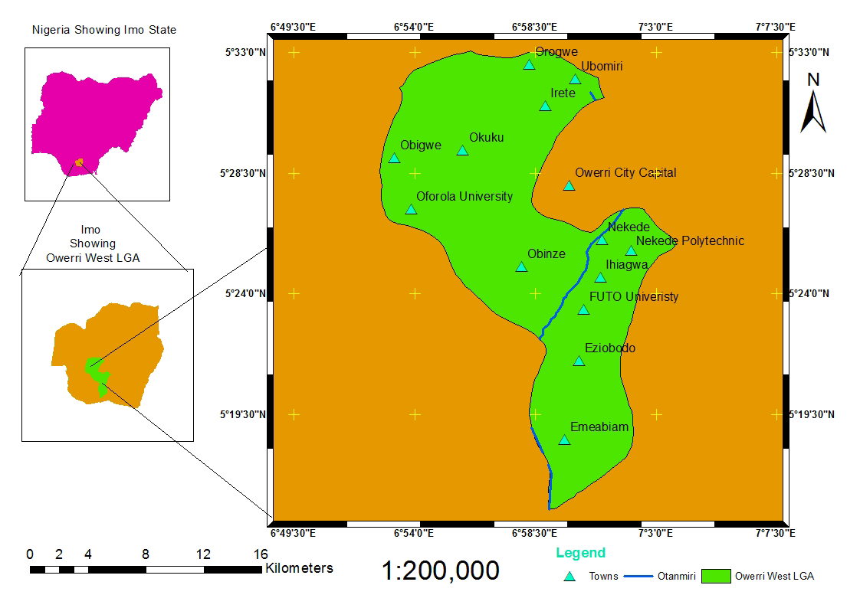

**Fig1. Study area map (Owerri West)**

**2.2 Data Collection**

The study assessed Landsat data acquired mainly through remote sensing techniques and climatic data (rainfall amount, temperature and pressure) collected from the Nigerian Meteorological Agency Office, Sam Mbakwe airport Owerri, Imo State.Field observation and ground truthing were carried out on the selected region of interest for classification accuracy assessment and kappa coefficient determination.For LU/LC change analysis, Landsat imageries (Landsat 7ETM+) of 2002, 2012 and landsat (Landsat 8OLS) of 2022 were used. GPS was used for ground verification. For climatic data, mean annual rainfall amount, relative humidity, and temperature for the period of 2002, 2012 and 2022 respectively were used.

**2.3 Image Classification**

Image preprocessing analysis such as cloud cover removal, composite bands creation to correct the surface features reflectance characteristics and delineation to study area were carried out. Supervised Maximum LULC classification method in ENVI 4.7 using region of interest on screen image digitization created for each of the three Landsat series (2002, 2012 and 2022) on five training samples of Built-up, Open space, Forested, Farmlands/fallows and Water body. Post classification analysis such as vectorization was carried out on each of the classified Landsat image year and exported to ARC GIS 10.5 for final processing and map production.

The supervised maximum likelihood classification method requiring onscreen digitization of training sample areas for each category was preferred because of prior knowledge of study area and availability of study area data. In addition, this classification has been found to be the most commonly and widely used classifier. (Dewan and Yamaguchi 2015: Chandola and Vatsavai 2017). The training areas were used to define spectral reflectance pattern of each land use land cover category. The digitized spectral reflectance of each category region of interest was used to classify the Landsat based on their group pixels uniqueness into a certain category which has spectral patterns.

Change detection being the process of identifying differences in the state of an object or phenomenon by observing it at different times was carried out. In this study, the post-classification comparison method for land use land cover changes in the periods of 2002, 2012 and 2022 were carried out by applying intersection toolbox of the ArcGIS software and vectorization where differences in calculated area of the region of interest detect the changes across the years of interval.

**2.4 Data Analysis and Accuracy Assessment**

ArcGIS 10.5 software was used for final processing of the Landsat data to determine LU/LC change. Abate (2011) proposed formula was employed in estimating the rate of change for each LU/LC. Rate of change (ha/year) = (A-B)/C Where: A = Recent area of LU/LC in ha, B = Previous area of LU/LC in ha, C = Time interval between A and B in years.

Accuracy assessment which measures the corresponding likelihood of true existence was done for the recent satellite image (Landsat8 OLI 2022) with the ground truth data of each region of interest selected for image classification. An overall accuracy of 80% with a Kappa coefficient of 0.79 was achieved.

**3.0 Results and Discussion**

**3.1 Land Use Land Cover Changes**

This study assessed land use land cover changes for a period of 20years (2002-2022) Three series Landsat data (Landsat 7 ETM+ imagery of 2002 and 2012; Landsat 8 OLI of 2022) were used to evaluate the land use change over the study period. For this purpose, five regions of interest were selected. These included; water body, open space, built up, forest and farmland/fallow. As shown in Table 1 and Figure 2, the highest LULC in 2002 was forest (47.9%) followed by farmland/fallow (33.4%) and built-up (9.7%), while open space was (8.7%) and waterbody (0.3%) was the least class. The analysis of LULCC showed that the built-up area increased from 2,852.5 ha (9.7%) in 2002 to 12,010.8ha (40.78%) in 2012. The forested and farmland/fallow areas decreased from 14,123.5ha (47.9%) and 9,833.1ha (33.4%) in 2002 to 7,144ha (24.25%) and 9,561.8 ha (32.46%) respectively in 2012. In similar way, waterbody increased from 75.1ha (0.3%) in 2002 to 100ha (0.35%) in 2012 (this is attributable to the increased dredging and sand mining activities on the Otamiri river to service increased demand for sand used in construction activities. This has consequently led to the expansion of the river channel) while open space decreased from 2,569.7ha (8.7%) in 2002 to 637.3 ha (2.16%) in 2012 (fig 3). Across these years (2002-2012), there has been a transformation from forested land, open space land and farmland/fallows to built-up area caused by rapid urbanization created by presence of three federal universities in the study area and government policies that expanded the State capital city to major parts of the study area habouring both State and Federal Secretariat complexes and host to many hotels servicing the hospitality industry. Similar observation was reported by (Guan *et al*., 2011; Esayas 2013: Mosammam *et al.*, 2017; Abebe *et al*., 2019) on urbanization triggered reduction on forested land and farmlands. In 2022 (fig 4), the LULC classification of Owerri West showed significant proportion changes in built-up (58.8%), forest (22.3%) and farmland/fallow (16.1%), areas, followed by open space (2.3%) and waterbody (0.5%). The built-up land increased between 2012 and 2022 from 12,010.8ha in 2012 to 17,305.7 ha in 2022, while the forested areas and farmlands/fallow decreased from 14,123.5ha and 9,833.1ha in 2012 to 6,564.5 ha (22.3%) and 4,742.6 ha in 2022. The increment of built-up area over the study period was associated with rapid population growth, migration of people from rural areas and neighboring towns. These results are consistent with (te Lintelo *et al*., 2018 and Mosammam *et al*., 2017) who reported that the rapid urban population is a key challenge of the twenty-first century.

Several studies have explored Land Use and Land Cover Change (LULCC) in Owerri West and its connection with climate variables. For instance, Okoro, Igwe, and Onyekuru (2018) investigated the relationship between LULCC and climate variables in Owerri West using remote sensing data and climate records. Their findings indicated a significant increase in built-up areas and a decrease in vegetation cover between 1986 and 2016, with associated changes in temperature and precipitation patterns, including an overall temperature rise and reduced rainfall. Similarly, Ukaegbu *et al,* (2017) examined the impact of LULC changes on climate variables in Owerri, employing satellite imagery and climate data spanning the same period. Their study revealed increasing trend in paved surfaces (built-up areas) which showed significant relationship with climatic changes, particularly in increasing surface temperatures attributed to loss of vegetation cover.

Furthermore, Njoku *et al.* (2020) assessed the consequences of LULCC on climate variables in Owerri West using Landsat data and climate records from 1986 to 2016. Their study indicated that the transformation of natural land cover into built-up areas had a substantial impact on temperature and precipitation patterns, leading to the conclusion that LULCC contributed to observed changes in climate variables in Owerri West.

**3.2 Climatic Changes**

## Climate represents long-term amalgamation of various atmospheric components, which, in the short term, constitute weather. These components encompass solar radiation, wind (both speed and direction), temperature, humidity, precipitation (including type, frequency, and quantity), and atmospheric pressure (Fritz, Joseph and Krishamurti 2015). In 2002 (Table 2), the average annual temperature of Owerri west was 25.2°C, pressure 1109mb and rainfall 2053.7mm. Subsequently there appeared to be a lot of changes that affected the climatic variables. Between 2012 and 2022, Owerri West experienced increase in temperature at 26.8°C and 27.6°C respectively, due to high decrease in the forested and farmland areas from 2002 to 2022. Forests provide shade and through transpiration process, releases water vapor which cools the surrounding air, clearing forests or natural vegetation can expose bare soil to heat which increases the surface air temperature. There has been extremely increase in built-up area across the study period (2002-20022) from 2852.5 ha in 2002 to 17305.7 ha in 2022 attributed to significant urbanization in the study area. Urban areas are characterized by concrete, asphalt, and buildings which tend to absorb and retain heat, creating "urban heat island" effect. This effect leads to higher temperatures in urban regions compared to surrounding rural areas. Urban surfaces absorb sunlight during the day and release heat at night, keeping urban areas warmer even after sunset.

Atmospheric pressure varied from 1109mb in 2002 to 1110mb in 2012 and 1108mb in 2022. These changes can be attributed to increase in the land surface temperature which is caused by land use changes such as urbanization. Urban areas with high concentrations of buildings, roads, and other structures can lead to the creation of "urban heat islands." These areas tend to have higher temperatures than their surroundings. The increased temperature can lead to localized low-pressure areas as warm air rises and creates a partial vacuum at the surface. This effect is more noticeable during calm weather conditions. Also the reduction of the thick forest and farmlands/fallow across 2002 -2022 was the major cause of the increase and reduction of the pressure within the study area because large-scale deforestation can impact atmospheric pressure in forested regions. These changes can affect pressure patterns, although they might be relatively small and confined to the deforested area.

The average rainfall as at 2002 was 2053.7mm, which increased to 2412.0mm in 2012 and reduced to 2290.7mm in 2022. This observation can be attributed to the reduction in forest and vegetation cover because rainfall variation leads to changes in land cover. For instance, replacing natural grasslands with impervious surfaces like roads and buildings can reduce infiltration and cause more rapid rainwater accumulation during storms, which might result in increased surface runoff and higher rainfall intensity in affected areas. Deforestation for farmlands, urban development, or other purposes, causes the land to lose its ability to absorb and retain water. Trees play a crucial role in intercepting rainfall and allowing it to evaporate back into the atmosphere through evapotranspiration. Without trees, more rainwater reaches the ground, leading to increased surface runoff and potentially higher rainfall intensities during storms. Findings from the climatic changes influence on land use dynamics observed in the study area is consistent with reports from earlier researchers (Kikegawa *et al.,* 2003; Tan *et al.,* 2003; Chen *et al.*, 2006; Grimmond, 2007; Rinner and Hussain 2011; M Tran *et al.*, 2017; Doan, 2019; Nguyen *et al.,* 2022).

**3.3 Land Use Land Cover and Climate Changes Effects**

Several studies have recorded complex interaction between landuse landcover changes and climatic changes (Lambin et *al.,* 2003; Verburg, 2006; Verburg *et al.*, 2011; Hibbard *et al.*, 2010; Estes *et al.*, 2012; Hansen *et al*., 2012, Houghon *et al.,* 2012; Yifang *et al.*, 2015). This interaction led to the formation of a macro system whose components interrelate with sub-systems of the land use and climate components (Baratia, *et al.*, 2023). Significant changes in climate has been observed with noticeable increase in surface temperature and emitted carbon dioxide while deforestation and urbanization activities triggering major changes of forested and vegetated lands resulting to major changes on land use land cover (Baratia, *et al.,* 2023). Earlier studies on the study area between 1986-2016 investigated the effects of LULC changes on climate variables, result revealed substantial increase in built-up area at the expense of forested and farmland/fallow areas as major drivers of increase CO2 and temperature and reduced precipitation (Ukaegbu *et al,* 2017; Okoro, Igwe, and Onyekuru 2018; Njoku *et al.*, 2020). Findings from this study between 2002-2022 are consistent with earlier reports both from the study area (Ukaegbu *et al*, 2017; Okoro, Igwe, and Onyekuru 2018; Njoku *et al.,* 2020) and outside the study area (Niyogi *et al*.*,* 2009; Lambin and Meyfroidt 2011; Baratia, *et al.*, 2023). These observations bother most on increase surface temperature and significant increase in built-up area resulting to urbanization and reduction of available lands for forest and agricultural purposes.

Imo State capital rapid urbanization and increasing structural activities have taken over major parts of Owerri West, as the study area habours both the State and Federal Secretariat complexes, numerous hotels with many other projects activities such as the presence of three Federal Universities. Combined these activities puts pressure on available lands for agriculture, fallows and forest reserve due to increasing need to accommodate economic demands and increased migration of people from rural areas and nearby states. Estes *et al.,* (2012) observed similar trend that drivers of land use climate changes started over five decades with direct human involvement in land use decisions by searching to meet up with increasing demands resulting from population increase and economic benefits for urbanization purposes, with little or no regards to environmental conservation and sustainability. Observed complex changes in this study resulted from direct human involvement through State Government policies over five decades to expand the city capital to accommodate urbanization and other developmental project capable of yielding revenue to the state. However, this decision was taken without cognizance that improper land use change decisions reflects in land cover changes, resulting to climate change (Lambin *et al.*, 2003; Hibbard *et al.*, 2010). It has also been reported that land areas dominated by increasing deforestation and urbanization impacts on weather and climate at varying scales (Niyogi *et al.*, 2009). In the last three centuries, many developing countries are moving through transition economics, increasing demand for food and energy due to a growing population that has caused deforestation, cropland increase, and urbanization (Lambin and Meyfroidt, 2011). Several studies in China, Asia, India, Africa, and Europe (Lambin *et al.*, 2003; Wang *et al.*, 2019; Thapa, 2020; Cao *et al.,* 2020) observed decrease in forested and cropland areas and increase in built-up due to economic and population growth which has impacted on climate change. Climate change makes rainfall prediction difficult and often leads to extreme weather events, which increases risk in the long term.

Land use changes correlation with climatic variables (Table 3) showed strong positive significant correlation coefficient. Temperature, pressure and rainfall amount were all significant and maintained correlation coefficient with land use 99.8%, 100% and 99.6% respectively.

Climate change adverse impact extends to global warming effect on terrestrial ecosystems, food security, deforestation, and land degradation (Sunderland and Rowland, 2019; Smith *et al.*, 2020). Land degradation processes affects yield of crops while deforestation activities results in increased surface air temperature which poses threat to lands, risks to livelihoods, human and ecosystem health, biodiversity, food systems and infrastructure (Sunderland and Rowland, 2019, IPOC, 2014). Increasing impacts on climate changes resulting from land use changes may pose more risks than previously anticipated (Patz *et al.*, 2005; Huong and Pathirana, 2013). Thapa, (2023) observed that in most cases, climate change response to land use and land-cover change may be global effect, exceeding the contribution from increasing deforestation and land degradation activities.

Table 1: LULC Changes between 2002, 2012 and 2022

|  |  |  |  |  |  |  |  |  |  |  |
| --- | --- | --- | --- | --- | --- | --- | --- | --- | --- | --- |
| **Class_Name** | **Area (Ha) 2002** | **% Occurrence** | **Area (Ha) 2012** | **% Occurrence** | **Area (Ha) 2022** | **% Occurrence** | **Change (Ha) 2002-2012** | **Rate of Change (2002-2012)** | **Change (Ha) 2012-2022** | **Rate of Change (2012-2022)** |
|
| Water Body | 75.1 | 0.3 | 100.0 | 0.35 | 149.3 | 0.5 | 24.9 | 2.48589 | 49.3 | 4.93322 |
| Built-up | 2852.5 | 9.7 | 12010.8 | 40.78 | 17305.7 | 58.8 | 9158.3 | 915.834 | 5294.9 | 529.49 |
| Farmland/Fallow | 9833.1 | 33.4 | 9561.8 | 32.46 | 4742.6 | 16.1 | -271.3 | -27.127 | -4819.2 | -481.918 |
| Open Space | 2569.7 | 8.7 | 637.3 | 2.16 | 691.8 | 2.3 | -1932.4 | -193.2414 | 54.5 | 5.4522 |
| Forested | 14123.5 | 47.9 | 7144.0 | 24.25 | 6564.5 | 22.3 | -6979.5 | -697.951 | -579.5 | -57.949 |
| **TOTAL** | **29453.9** | **100** | **29453.9** | **100.00** | **29453.9** | **100.0** |  |  |  |  |

Table 2: Different climatic variables for 20 year period

|  |  |  |  |  |
| --- | --- | --- | --- | --- |
| Climatic variables | 2002 Average | 2012 Average | 2022 Average | Unit |
| Temp | 25.2 | 26.8 | 27.6 | °c |
| Pressure | 1109 | 1110 | 1108 | mb |
| rainfall | 2053.7 | 2412 | 2290.7 | mm |

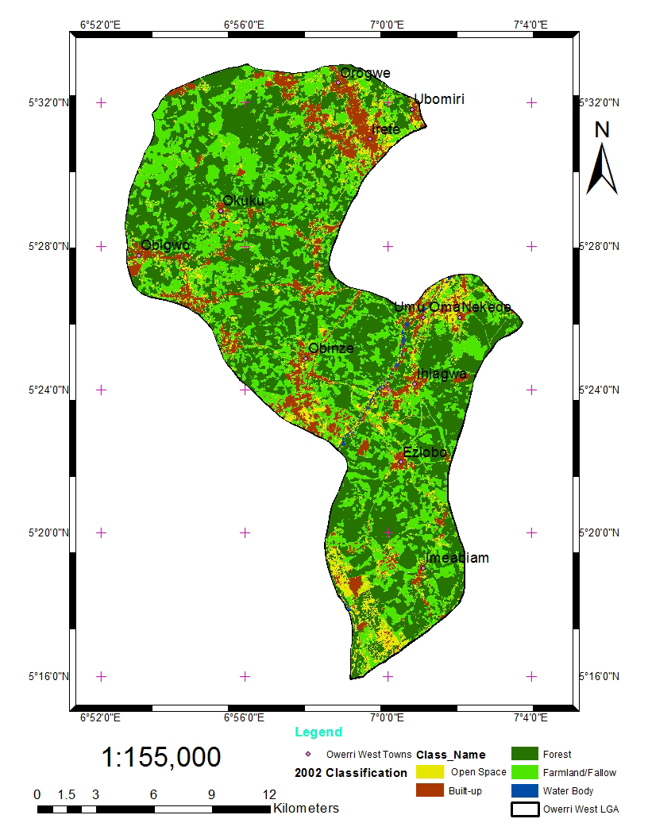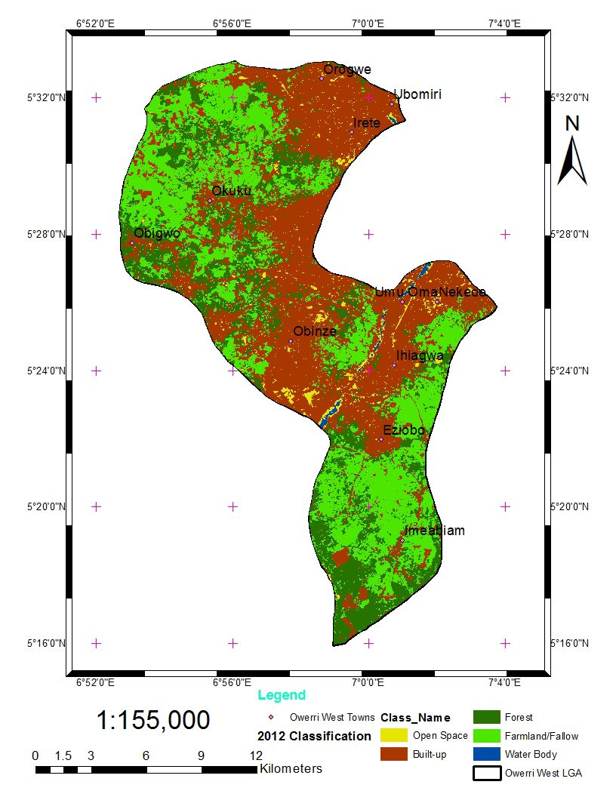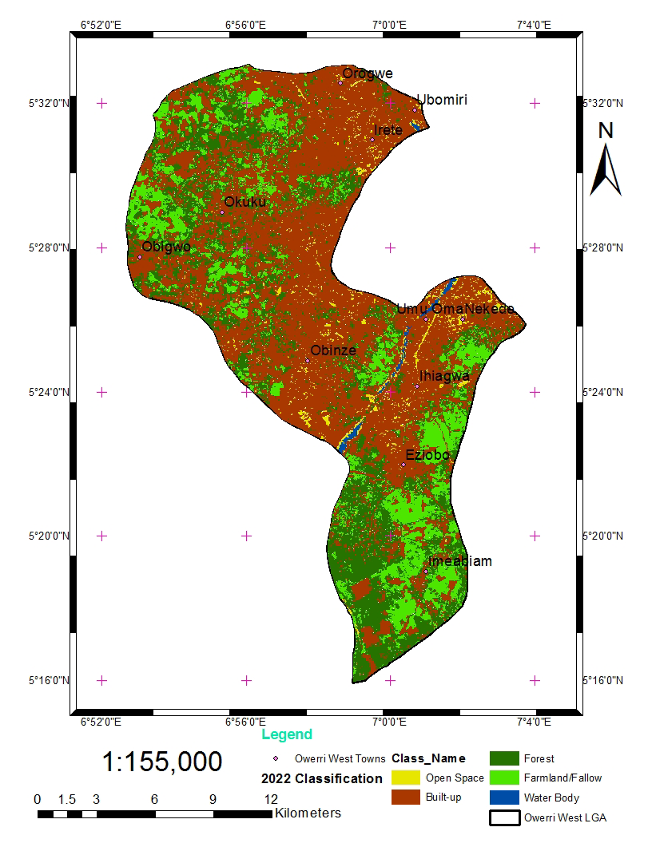

Fig 2. 2002 LULC Classification Fig 3. 2012 LULC Classification Fig 4. 2022 LULC Classification

| Table 3. climate variable land use Correlations | | | | | |
| --- | --- | --- | --- | --- | --- |
|  |  | Landuse | Temperature | Pressure | Rainfall Amount |
| Landuse | Pearson Correlation | 1 | .998** | 1.000** | .996** |
| Sig. (2-tailed) |  | .000 | .000 | .000 |
| N | 15 | 15 | 15 | 15 |
| Temperature | Pearson Correlation | .998** | 1 | .998** | .998** |
| Sig. (2-tailed) | .000 |  | .000 | .000 |
| N | 15 | 15 | 15 | 15 |
| Pressure | Pearson Correlation | 1.000** | .998** | 1 | .996** |
| Sig. (2-tailed) | .000 | .000 |  | .000 |
| N | 15 | 15 | 15 | 15 |
| Rainfal_Amount | Pearson Correlation | .996** | .998** | .996** | 1 |
| Sig. (2-tailed) | .000 | .000 | .000 |  |
| N | 15 | 15 | 15 | 15 |
| **. Correlation is significant at the 0.01 level (2-tailed). | | | |  |  |

**4 Conclusions**

Land use land cover changes between 2002-2012 and climatic variable changes between 2012-2022 analysis gave insight on the interrelationship and likely effect of improper management of one factor on the other. The dynamics of these changes were studied for the last 20 years in Owerri West Local Government Area of Imo State Nigeria. Significant changes in land use/ land cover was observed on increased built-up and decreased forest and available farmlands/fallow for agriculture. This influenced climatic changes triggering increase in temperature across the period of study as a result of rapid urbanization at the expense of forest and farm/fallow lands. This study showed that climatic changes and LU/LC changes interrelate and affect each other, calling for proper land use management to address negative impacts associated with climate change in the study area.

**Disclaimer (Artificial intelligence)**

Option 1:

Author(s) hereby declare that NO generative AI technologies such as Large Language Models (ChatGPT, COPILOT, etc.) and text-to-image generators have been used during the writing or editing of this manuscript.

Option 2:

Author(s) hereby declare that generative AI technologies such as Large Language Models, etc. have been used during the writing or editing of manuscripts. This explanation will include the name, version, model, and source of the generative AI technology and as well as all input prompts provided to the generative AI technology

Details of the AI usage are given below:

1.

2.

3.

**References**

Abebe, M. S.; Derebew, K. T. and Gemeda D. O. (2019). Exploiting Temporal-Spatial Patterns of Informal Settlements Using GIS and Remote Sensing Technique: A Case Study of Jimma city, Southwestern Ethiopia, *Environmental system research (2019) 8:6,* [*https://doi.org/10.1186/s40068-019-0133-5*](https://doi.org/10.1186/s40068-019-0133-5)

Abate, S. (2011). Evaluating the Land Use and Land Cover Dynamics in Borena Woreda of South Wollo highlands, Ethiopia. *Journal of Sustainable Development in Africa*. 13(1): 87-105

Baratia, A., A., Zhoolideha, M., Azadi, H., Lee, H. and Scheffran J. (2023). Interactions of land-Use Cover and Climate Change at Global Level: How to Mitigate the Environmental Risks and Warming Effects, *Ecological Indicators 146 (2023) 109829,* [*www.elsevier.com/locate/ecolind*](http://www.elsevier.com/locate/ecolind)

Basommi, G., Guan, Q. F., Cheng, D. Singh, S. K. (2016). Dynamics of Landuse Change in Aminingarea: Acase Study of Nadowli District, *Ghana. J. Mt. Sci.13, 633–642*

Cao, Q. Liu, Y. Georgescu, M and Wu, J (2020). Impacts of Landscape Changes on Local and Regional Climate: A Systematic Review,” Landsc. *Ecol., vol. 35, no. 6, pp. 1269-1290, 2020*

Chandola, Varun and Vatsavai, Ranga. (2017). Multi-Temporal Remote Sensing Image Classification - A Multi-View Approach. *Proceedings of the 2017 Conference on Intelligent Data Understanding, CIDU 2017. 258-270*

Chen, X.L.; Zhao, H.M.; Li, P.X.; Yin, Z.Y. (2006). Remote Sensing Image-Based Analysis of the Relationship between Urban Heat Island and Land Use/Cover Changes*. Remote Sens. Environ. 2006, 104, 133–146. [CrossRef]*

Dewan, A.M. and Yamaguchi, Y. (2015) Land Use and Land Cover Change in Greater Dhaka, Bangladesh: Using Remote Sensing to Promote Sustainable Urbanization. *Journal of Geographic Information System*, Vol.7 No.6, December 4, 2015

Doan, V.Q.; Kusaka, H.; Nguyen, T.M. (2019). Roles of Past, Present, and Future Land Use and Anthropogenic Heat Release Changes on Urban Heat Island Effects in Hanoi, Vietnam: *Numerical Experiments with a Regional Climate Model. Sustain. Cities Soc. 2019, 47, 101479. [CrossRef*]

Lambin, E. E. Geist, H. J. and Lepers, E. (2003). Dynamics of land-use and land-cover change in tropical regions,” *Annu. Rev. Environ. Resour., vol. 28, no. 1, pp. 205-241, 2003*.

Elijah K. S. (2023). Nexus Of Land Use Land Cover Change with Population Dynamics in Owerri West, Nigeria. *An Unpublished B. Tech Thesis Submitted to The Department of Environmental Management, School of Environmental Sciences, Federal University Of Technology Owerri***.**

Esayas E (2013) Urban Planning and Land Management Challenges in Emerging Towns of Ethiopia: *the case of Arba Minch. J Urban Environ Eng 7(2):340–348*

ESSAP (2022). Economic and Social Survey of Asia and the Paciﬁc. *Available online: https://www.unescap.org/ (accessed on 2 August 2022).*

Estes, A. B. Kuemmerle, T. Kushnir, H. Radeloff, V. C and Shugart, H. H. (2012). Land-Cover Change and Human Population Trends in The Greater Serengeti Ecosystem from 1984-2003,” *Biol. Conserv., vol. 147, no. 1, pp. 255-263, 2012*.

Eziham C. C. (2022). Landuse Landcover Changes in Relation to Some Climatic Variables in Owerri West, Nigeria. *An Unpublished B.Tech. Thesis Submitted to The Department of Environmental Management, School of Environmental Sciences, Federal University of Technology Owerri.*

Fritz P. Loewe, Joseph Gentili and T.N Krishamurti. (2015). Climate and Climate Change. *International Geophysics, 18(2), 123-135.*

Grimmond, S. (2007). Urbanization and Global Environmental Change: Local Effects of Urban Warming. *Geogr. J. 2007, 173, 83–88. [CrossRef*]

Guan DJ, Li HF, Inohae T, Su WC, Nagaie T, Hokao K (2011). Modeling Urban Land Use Change by The Integration of Cellular Automaton and Markov Model. *Ecol Model 222:3761–3772. https ://doi.org/10.1016/j.ecolm odel.2011.09.009*

Hassan A. A., Sudhir, K. S., Mukesh K., Mustapha, S. M, Rimuka D., and Deepak L (2020). Impact of Urbanization and Land Cover Change on Urban Climate: Case study of Nigeria, Urban Climate 32(2020)100600

Hansen, J. Sato, M and Ruedy, R (2012). Perception of Climate Change,” *Proc. Natl. Acad. Sci., vol. 109, no. 37, pp. E2415–E2423, 2012.*

Hibbard K. Janetos A., Vuuren D. P. and Pongratz J. (2010)., “Research priorities in Land Use and Land-Cover Change for The Earth System and Integrated Assessment Modelling,” *Int. J. Climatol., vol. 30, no. 13, pp. 2118-2128, 2010.*

Houghton R. A. House J. I., Pongratz J., van der Werf G. R., DeFries, R. S., Hansen, M. C., Le Qu´er´e, . C. and Ramankutty, N. (2012). Carbon Emissions from Land Use and Land-Cover Change,” Biogeosciences, vol. 9, no. 12, pp. 5125-5142, 2012.

Huong H. T. L., and Pathirana, A. (2013). Urbanization and Climate Change Impacts on Future Urban Flooding in Can Tho city, Vietnam,” *Hydrol. Earth Syst. Sci., vol. 17, no. 1, pp. 379-394, 2013.*

I. P. O. C. (2014). Change, “Ipcc,” Clim. Change, 2014.

Kikegawa, Y.; Genchi, Y.; Yoshikado, H.; Kondo, H. (2003). Development of a Numerical Simulation System toward Comprehensive Assessments of Urban Warming Countermeasures Including Their Impacts upon the Urban Buildings’ Energy-Demands. *Appl. Energy 2003, 76, 449–466. [CrossRef]*

Lambin E. F. and Meyfroidt, P (2011). Global Land Use Change, Economic Globalization, and the Looming Land Scarcity,” *Proc. Natl. Acad. Sci., vol. 108, no. 9, pp. 3465-3472, 2011.*

Lo, C.P. and Quattrochi, D.A. (2003). Land-Use and Land-Cover Change, Urban Heat Island Phenomenon, And Health Implications. Photogramm. *Eng. Remote Sens. 2003, 69, 1053–1063. [CrossRef]*

Maza, M.; Srivastava, A.; Bisht, D.S.; Raghuwanshi, N.S.; Bandyopadhyay, A.; Chatterjee, C.; Bhadra, A. (2020). Simulating Hydrological Response of a Monsoon Dominated Reservoir Catchment and Command with Heterogeneous Cropping Pattern Using VIC Model. *J. Earth Syst. Sci. 2020, 129. [CrossRef*

Mosammam HM, Nia JT, Khani H, Teymouri A, Kazemi M (2017). Monitoring Land Use Change and Measuring Urban Sprawl Based on Its Spatial Forms. *Egypt J Rem Sens Space Sci 20:103–116. https :// doi.org/10.1016/j.ejrs.2016.08.002*

Nguyen, B.Q.; Tran, T.-N.-D.; Grodzka-Łukaszewska, M.; Sinicyn, G.; Lakshmi, V. (2022). Assessment of Urbanization-Induced Land-Use Change and Its Impact on Temperature, Evaporation, and Humidity in Central Vietnam. *Water 2022, 14, 3367. https://doi.org/ 10.3390/w14213367*

NIMET, (2015). Nigerian Meteorological Agency, Daily, Quarterly and Annual Climate Review 2015, *https://nimet.gov.ng/weather/owerri/nigeria*

Niyogi, D., Mahmood, R., and Adegoke, J. O. (2009). Land-Use/Land-Cover Change and Its Impacts on Weather and Climate Bound. *Layer Meteorol., vol. 133, no. 3, p. 297, 2009*

Njoku, J.C., Okechukwu, O.I., Ekeoma. G. (2020). Assessing the Impact of Land Use and Land Cover Changes on Climate Variables in Owerri West. *International Journal of Climatology*, 35(5), 321-335

NPC (1991). National Population Commission. *Census ’91 Final Results, Imo State*.

Okoro, B. C., Igwe, O., & Onyekuru, S. O. (2018). Land Use and Land Cover Change and Its Impact on Climate Variables in Owerri West, Nigeria. Applied Ecology and Environmental Research, 16(5), 6195-6210.

Patz, J. A., Campbell-Lendrum, D., Holloway, T. and Foley, J. A. (2005). Impact of Regional Climate Change on Human Health,” *Nature, vol. 438, no. 7066, pp. 310-317, 2005.*

Rinner, C.; Hussain, M. (2011). Toronto’s Urban Heat Island-Exploring the Relationship between Land Use and Surface Temperature. *Remote Sens. 2011, 3, 1251–1265. [CrossRef]*

Smith P.,  [Calvin](https://onlinelibrary.wiley.com/authored-by/Calvin/Katherine), K.,  [Nkem](https://onlinelibrary.wiley.com/authored-by/Nkem/Johnson), J.,   [Campbell](https://onlinelibrary.wiley.com/authored-by/Campbell/Donovan), D., [Cherubini](https://onlinelibrary.wiley.com/authored-by/Cherubini/Francesco), F.,  [Grassi](https://onlinelibrary.wiley.com/authored-by/Grassi/Giacomo), G., [Korotkov](https://onlinelibrary.wiley.com/authored-by/Korotkov/Vladimir), V.,   [Hoang](https://onlinelibrary.wiley.com/authored-by/Le+Hoang/Anh), A., [Lwasa](https://onlinelibrary.wiley.com/authored-by/Lwasa/Shuaib), S., [McElwee](https://onlinelibrary.wiley.com/authored-by/McElwee/Pamela), P., [Nkonya](https://onlinelibrary.wiley.com/authored-by/Nkonya/Ephraim), E. [Saigusa](https://onlinelibrary.wiley.com/authored-by/Saigusa/Nobuko), N., [Soussana](https://onlinelibrary.wiley.com/authored-by/Soussana/Jean%E2%80%90Francois), J., [Taboada](https://onlinelibrary.wiley.com/authored-by/Taboada/Miguel+Angel), M. A.,  [Manning](https://onlinelibrary.wiley.com/authored-by/Manning/Frances+C.), F. C.,   [Nampanzira](https://onlinelibrary.wiley.com/authored-by/Nampanzira/Dorothy), D.,  [Arias-Navarro](https://onlinelibrary.wiley.com/authored-by/Arias%E2%80%90Navarro/Cristina), C.   [Vizzarri](https://onlinelibrary.wiley.com/authored-by/Vizzarri/Matteo), M.,  [House](https://onlinelibrary.wiley.com/authored-by/House/Jo), J.,  [Roe](https://onlinelibrary.wiley.com/authored-by/Roe/Stephanie), S.,  [Cowie](https://onlinelibrary.wiley.com/authored-by/Cowie/Annette), A., [Rounsevell](https://onlinelibrary.wiley.com/authored-by/Rounsevell/Mark), M. and [Arneth](https://onlinelibrary.wiley.com/authored-by/Arneth/Almut) A.(2020). Which Practices Co-Deliver Food Security, Climate Change Mitigation and Adaptation, And Combat Land Degradation and Desertification, *Glob. Change Biol., vol. 26, no. 3, pp. 1532-1575, 2020.*

Singh, S. K., Basommi, B. P., Mustak, Sk, Srivastava P. K., Szabo, S., (2018). Modeling Of Land Use Land Cover Change Using Earth Observation Data-Sets of Tons River Basin, MadhyaPradesh, *India. Geocarto Int. 33(11), 1202–1222. https://doi.org/10.1080/10106049.2017.1343390*

Srivastava, A.; Kumari, N.; Maza, M. (2020). Hydrological Response to Agricultural Land Use Heterogeneity Using Variable Inﬁltration Capacity Model. Water Resour. *Manag. 2020, 34, 3779–3794. [CrossRef]*

Sunderland T. C. and Rowland, D. (2019). Forests, Land Use, And Challenges to Climate Stability and Food Security,” in Sustainable Food and Agriculture, *Elsevier, 2019, pp. 95-116*

Tan, J.; Zheng, Y.; Song, G.; Kalkstein, L.S.; Kalkstein, A.J.; Tang, X. (2007). Heat Wave Impacts on Mortality in Shanghai, 1998 and 2003. *Int. J. Biometeorol. 2007, 51, 193–200. [CrossRef] [PubMed*

te Lintelo DJH, Gupte J, McGregor JA, Lakshman R, and Jahan F (2018). Wellbeing and Urban Governance: Who Fails, Survives or Thieves in Informal Settlements In Bangladeshi Cities? *Cities 72:391–402.inttps ://doi.org/10.1016/j. citie s.2017.10.002*

Thapa, P. (2020) Spatial Estimation of Soil Erosion Using RUSLE modeling: A Case Study of Dolakha district, Nepal,” *Environ. Syst. Res., vol. 9, no. 1, pp. 1-10, 2020.*

Thapa P. (2023). The Relationship between Land Use and Climate Change: A Case Study of Nepal. *Available at intechopen.com and online at file:///C:/Users/Imo%20SFNGO-Daniel/Desktop/LULC%20CHANGE/LULC%20CHANGE%20ON%20CLIMATE/76898.pdf*

Tran, D.X.; Pla, F.; Latorre-Carmona, P.; Myint, S.W.; Caetano, M.; Kieu, H.V. (2017). Characterizing the Relationship between Land Use Land Cover Change and Land Surface Temperature. ISPRS J. Photogramm. *Remote Sens. 2017, 124, 119–132. [CrossRef]*

Turner, B. L., R. H. Moss, and D. L. Skole. (1993). Relating Land Use and Global Land-Cover Change: A Proposal for an IGBP-HDP core project. HDP Report Number 5. *International Geosphere-Biosphere Programme, Stockholm, Sweden.*

Ukaegbu, K. O. E., Iwuji1, M. C. , Uche, C. C., Osumgborogwu, I. E. and Amangabara G. T. (2017). Spatial Assessment of Temperature and Land Cover Change as Climate Change Monitoring Strategies in Owerri, Nigeria, *Journal of Geography, Environment and Earth Science International, JGEESI, 11(1): 1-9,*

United Nations (2018). The United Nations Revision of World Urbanization Prospects; *UN: New York, NY, USA, 2018.*

United Nations (2021). The United Nations World Population Prospect 2021. 2021. *Available online: https://www.un.org/development/desa/pd/sites/www.un.org. development.desa.pd/ﬁles/unpd-egm-fer-2020-10-session_ii_b_unpd_2020_wpp2021-adolescentfertility.pdf (accessed on 22 July 2022).*

Verburg P. H., (2006). Simulating Feedbacks in Land Use And Land Cover Change Models,” *Landsc. Ecol., vol. 21, no. 8, pp. 1171-1183, 2006*.

Verburg, P. H.; Neumann, K. and Nol, L. (2011). Challenges in Using Land Use and Land Cover Data for Global Change Studies,” *Glob. Change Biol., vol. 17, no. 2, pp. 974-989, 2011.*

Virginia H. D. (1997). The Relationship Between Land-Use Change and Climate Change, Environmental Sciences Division, *Oak Ridge National Laboratory, Oak Ridge, Tennessee 37831-6038 USA*

Wang, Y. Wu, N. Kunze, C. Long, R. and Perlik, M (2019). Drivers Of Change to Mountain Sustainability in the Hindu Kush Himalaya*,” in The Hindu Kush Himalaya Assessment, Springer, 2019, pp. 17-56.*

World Bank (2022). The World Bank Urban Development. *Available online: https://www.worldbank.org/en/topic/urbandevelopment/overview#1 (accessed on 8 December 2022).*

Yifang, B. Gong, P. and Gini, C (2015). Global land cover mapping using Earth observation satellite data: Recent progresses and challenges,” *ISPRS J. Photogramm. Remote Sens. Print, vol. 103, no. 1, pp. 1-6, 2015.*

Bashir, Owais, Shabir Ahmad Bangroo, Nasir Bashir Naikoo, Sandeep Kumar, Rehana Rasool, Aamir Hassan Mir, Sheikh Amjid, Omer Reshi, Roohi Jan, Irfan gani, and Larieb Mir. 2022. “Effect of Land Use Change on Total Phosphorus and Its Fractions in North-Western Himalayas”. International Journal of Plant & Soil Science 34 (23):1214-20. <https://doi.org/10.9734/ijpss/2022/v34i232535>.

Ronald, K., K. J. Singh, and M. S. Lodhi. 2023. “Land Use and Land Cover Change Study Using RS-GIS and Its Impact on Biodiversity: Study from Arunachal Pradesh, India”. Asian Journal of Environment & Ecology 22 (4):120-32. <https://doi.org/10.9734/ajee/2023/v22i4514>.