*Original Research Article*

Nephrotoxic and Oxidative Effects of Edible Camphor and *Azadirachta indica* Leaf Extract in Albino Wistar Rats

.

ABSTRACT

|  |
| --- |
| **Aim:** To evaluate the toxicological effect of *Azadirachta indica* (Neem) leaf extract and edible camphor on kidney injury molecule (KIM-1), 8-hydrodeoxguanosine (8-OHdG) and superoxide dismutase (SOD) of albino Wistar rats.  **Study design:** Experimental study.  **Place and Duration of Study:** Department of Clinical Chemistry, Faculty of Medical Laboratory Science, Rivers State University, Port Harcourt, Nigeria, between October and December 2024.  **Methodology:** Thirty albino Wistar rats were used for the study. They were divided into six groups randomly of 5 rats each. Group 1 served as control group, group 2 served as the vehicle group and was administered daily dose of coconut oil, while group 3 received 500mg/kg of Neem dissolved in coconut oil, group 4 received 50mg/kg of camphor dissolved in coconut oil, group 5 received 100mg/kg of camphor dissolved in coconut oil and group 6 received 50mg of Neem and 50mg of camphor dissolved in coconut oil daily for 30 days. At the end of the administration of the extract, the rats were sacrificed, and samples were taken and examined for the determination of 8-hydrodeoxguanosine (8-OHdG), superoxide dismutase (SOD), kidney injury molecule (KIM-1), using ELISA method, and kidney tissues were collected for histological examination. GraphPad Prism Version 9.04 of Windows statistical package was used for statistical analysis. Results were considered statistically significant at 95% confidence interval (p<0.05).  **Results:** The results showed a significant dose-dependent increase (p<0.0001) in 8-OHdG and KIM-1 levels and SOD levels significantly decreased (p<0.0001) in the camphor treated groups.  **Conclusion:** These results suggest that edible camphor poses a nephrotoxic risk, warranting stricter safety evaluation in traditional medicine. |

*Keywords: Azadirachta indica (Neem) Leaf Extract, Edible Camphor,* 8-OHdG, SOD, KIM-1*, kidney, Albino Wistar Rats*

1. INTRODUCTION

Herbal medications rarely meet the required essential standards of consistency in composition and biological activity, because of problems in identifying plants, variable growing conditions, differences in harvesting procedures and processing of extracts, and lack of information about the pharmacologically active principles [24]. Herbal preparations can be contaminated with pesticides and heavy metals. Contaminants, adulterants, or incorrect formulations in herbal medication products may lead to adverse reactions, toxicity, or other health complications [1].

Kidney toxicity because of alternative medicine is mostly reported as case reports and case series, although some excellent reviews dealing with herbal remedies have recently been published [2]. Acute kidney injury from alternative medicine is caused by direct toxicity of the incriminated substance, the toxicity of contaminants and/or adulterants of alternative medicine, and the toxic effects of misidentified herbal constituents or dehydration because of diarrhea or vomiting after the use of alternative medicine. The previous study reports that the neem leaf extract has toxic effects on the kidney [3], however, other reports show that the neem extract can protect the kidney from damage [4].

The kidney is an essential organ of the body which performs several vital functions such as maintaining the body’s homeostasis and organizing the extracellular environment which include detoxification, excretion of toxins and drugs. The kidney constitutes less than 0.5% of the body’s weight and they receive 20% to 25% of cardiac output, thus the kidney is more prone to toxic damage [5]. The kidney has a significant role in excreting most drugs, since some drugs may have side effects on kidney function.

The main complication induced is nephrotoxicity. Nephrotoxicity is defined as the poisonous effect of substances on renal function [6]. The production of free radicals, decrease of antioxidant defenses and acute tubular necrosis which consequently reduces glomerular filtration rate (GFR) and renal impairment [7].

Camphor is a natural antioxidant and a ketone terpenoid that is found in the cinnamomum camphora tree. Camphor trees have many applications in various fields, such as industry, cosmetics, pesticides, pharmaceuticals, timber, ornamental, and many cultural purposes stretching back thousands of years [8]. Researchers have shown that camphor effectively reduces pain, removes warts, treats hemorrhoids and osteoarthritis. Furthermore, it is suggested that it has anti-inflammatory, [9] antifungal, [10] and antimicrobial properties [11].

The safety of neem leaves to date is still unclear; *Azadirachta indica* is one of the most promising medicinal plants, having a spectrum of biological activities, well known for its biological activities, well known for its insecticidal properties. Several studies have been undertaken on the protective effects of neem [12][13]. Every part of neem tree has been known to possess a wide range of pharmacological properties, especially as antibacterial, antifungal, and antiulcer [14]. In a study by Akinola et al. [15], they found that leaf extract of *Azadirachta indica* ameliorates hyperglycemia and diabetic nephropathy in rats. Therefore, the aim of this study was to evaluate the toxicological effect of *Azadirachta indica* (Neem) leaf extract and edible camphor on kidney injury molecule (KIM-1), 8-hydrodeoxguanosine (8-OHdG) and superoxide dismutase (SOD) of albino Wistar rats.

2. materialS and methods

**2.1 Experimental Animals**

Thirty male albino Wistar rats weighing 95 ± 5 g were obtained from The Holding Company for Biological Products and Vaccines and transported to the Department of Clinical Chemistry, Faculty of Medical Laboratory Science, Rivers State University, Port Harcourt, Nigeria.

**2.2 Experimental Design**

The study is an experimental study. After an acclimatization period of one week, the animals were divided into six groups (5 rats per group) and housed in wire bottomed cages in a room under standard conditions of illumination with a 12-hour light-dark cycle at 25 ± 1°C. They were provided with water and a balanced diet *ad libitum*. All animals received care in compliance with the health rules for animal protection.

• Group I served as negative control (untreated control).

• Group II animals served as vehicle control and were only administered 2ml of coconut oil daily for 30days, through gavage.

• Group III received a daily oral administration of Neem leaves extract 500mg/kg body weight for 30 days through gavage.

• Group IV received a daily oral administration of camphor extract 50mg/kg body weight orally for 30 days, through gavage.

• Group V received a daily oral administration of camphor extract 100mg for 30 days through gavage.

• Group VI received a daily oral administration of the 50mg neem and 50mg camphor extract for 30 days through gavage.

**2.3 Sample Collection and Preparation**

Twenty-four hours after the last administrations, animals were sacrificed. They were handled and used in accordance with the international guide for the care and use of laboratory animals. Kidney tissues were harvested and then fixed in 10% formal saline for histopathology. Blood samples were also collected for kidney function tests (Kidney injury molecule (KIM-1) and oxidative stress markers (Superoxide dismutase (SOD) and 8-hydrodeoxguanosine). The animals of all groups were sacrificed by fast decapitation; blood samples were collected into plain bottles for ELISA test and allowed to stand for half an hour and then centrifuged at 3000 rpm for 15 min at 4°C to separate serum which was stored at −20°C for different biochemical measurements.

**2.4 Plants Materials**

The neem leaves were harvested. The samples were identified in the Botany Department, Faculty of Science, Rivers State University. The leaves were cleaned and sun-dried for three days on hygienic cement floors until they became crispy but still retaining the greenish tint and after then they were powdered. Preparation of plant extract was done through maceration method. Edible camphor tablets were bought from herbs suppliers in Port Harcourt, Rivers State Nigeria.

**2.5 Pilot Study**

A total of 27 rats weighing approximately 95g were used in this study. The albino rat used in this study were obtained from the Department of Animal and Environmental biology, River State University, Port-Harcourt. Feeding of the animals were achieved using rat pre-mix feed and water ad libitum and were housed in well-ventilated cages. All animals received care in compliance with the rules for animal protection and guidance.

2.6 Determination of LD50 of edible camphor

The LD50 of edible camphor administered orally was obtained using the arithmetic method of Karber after determining the LD100 from the pilot toxicity study.

The arithmetic method of Kerber for calculating LD50 was given as follows.

= 1.2-0.567

=0.633g/body weight

After the administration of the edible camphor in the pilot study, the treated rats were monitored within 24hours for signs and symptoms of camphor toxicity such as respiratory distress, sedation, coma until death occurred. The minimum dose that caused 100% death was seen as the LD100

Determination of Minimum Dose That Caused 100% Deaths (LD100) of camphor Orally Treated albino rats.

Groups No of rats Volume (ML) Dose (g/kg) Alive? Death?

1 3 2 0 Yes No

2 3 2 0.01 Yes No

3 3 2 0.10 Yes No

4 3 2 0.20 Yes No

5 3 2 0.40 Yes Yes

6 3 2 0.60 Yes Yes

7 3 2 0.80 Yes Yes

8 3 2 1.00 Yes Yes

*9 3 2 1.20 No Yes

N/B; The volume of the preparations administered are from different stock having different concentration as indicated on the table.

Determination of LD50

Group Dose (g/kg) Dose diff. No, of death Mean death Dose diff *mean death

1 0.00 0.00 0 0 0

2 0.01 0.01 0 0 0

3 0.10 0.09 0 0 0

4 0.20 0.10 0 0 0

5 0.40 0.20 1 0.5 0.1

6 0.60 0.20 2 1.5 0.3

7 0.80 0.20 2 2 0.4

8 1.00 0.20 2 2 0.4

9 1.20 0.20 3 2.5 0.5

Total 1.7

Determination of LD50 of edible camphor

The arithmetic method of Kerber for calculating LD50 was given as follows.

= 1.2-0.567

=0.633g/ body weight

According to LD50 rating of chemicals toxicity, Edible camphor given orally could be rated

as a practically slightly toxic substance. Acute exposure to edible camphor at 1.2g/kg body weight provoked convulsions and lethality in the experimental mice following oral administration. Behavioral abnormal observed included difficulty in breathing, decreased locomotor activities, body jerks and death.

Meanwhile, the dose of Neem (500mg/kg body weight) used was calculated from a previous study [26].

**2.6 Biochemical Estimation**

**2.6.1 Kidney Injury Molecule (KIM-1)**

- *Test Method:* Kidney Injury Molecule (KIM-1) was analyzed using Elabscience ELISA kit.

- *Test principle:* This ELISA Kit uses the sandwich-ELISA principle. The micro-ELISA plate provided in this kit has been pre-coated with an antibody specific to human KIM-1. Samples (or standards) are added to the micro-ELISA plate wells and combined with the specific antibody. then a biotinylated detection antibody specific for human KIM-1 and Avidin Horseradish Peroxidase (HRP) conjugate are added successively to each micro plate well and incubated. free components are washed away. The substrate solution is added to each well. Only those wells that contain Human KIM-1, biotinylated detection antibody and Avidin-HRP conjugate will appear blue in color. The enzyme-substrate reaction is terminated by the addition of stop solution and the color turns yellow. The optical density (OD) is measured spectrophotometrically at a wavelength of 450 ± 2 nm. The OD value is proportional to the concentration of Human KIM-1, you can calculate the concentration of the Human KIM-1 in the samples by comparing the OD of the samples to the standard curve. Reference range 0-500pg/ml

**2.6.2 Superoxide dismutase (SOD) and 8-hydrodeoxguanosine**

*- Test Method:*Superoxide Dismutase (SOD) and 8-hydrodeoxguanosine were assayed using Elabscience ELISA kit.

* 8-hydroxydeoxyguanosine (8-OHdG) ELISA Kit

-*Test principle:* This ELISA Kit uses the competitive-ELISA principle. The micro-ELISA plate provided in this kit has been pre-coated with 8-0HdG. During the- reaction, 8-0HdG in samples or standard competes with fixed amount of 8-OHdG on the solid phase supporter for sites on the Biotinylated Detection Ab specific 8-0HdG. Excess conjugate and unbound sample or standard are washed from the plate, and Avidin conjugated to Horseradish peroxidase (HRP) are added to each microplate and incubated. Then a TMB substrate solution is added to each well. The enzyme-substrate reaction is terminated by the addition of stop solution and the color change is measured spectrophotometrically at a wavelength of 450 ± 2nm. The concentration of 8-0HdG in the sample is then determined by comparing the OD of the samples to the standard curve. Reference range 0-50ng/ml

2.6.3 Superoxide Dismutase1 (SOD 1) soluble ELISA Kit

*Test principle:* This ELISA kit uses the competitive ELISA principle. The micro-ELISA plate provided in this kit has been pre- coated with rat SOD1. During the reaction, rat SOD1 in samples or standard competes with a fixed amount of rat SOD1 on the solid phase supporter for sites on the biotinylated detection Ab specific to rat SOD1. Excess conjugate and unbound sample or standard are washed from the plate, and Avidin conjugated to Horseradish Peroxidase (HRP) are added to each microplate well and incubated. Then a TMB substrate solution is added to each well. The enzyme-substrate reaction is terminated by the addition of a stop solution and the color change is measured spectrophotometrically at a wavelength of 450 ± 2nm. The concentration of rat SOD1 in the samples is then determined by comparing the OD of the samples in the standard curve. Reference range 0-50ng/ml

**2.6.4 Histopathology Study**

Organs of the kidney of one animal per group were sacrificed during the chronic study, were placed in labelled plastic bottles containing 10% formalin fixative. The tissues were sliced and dehydrated with different, increasing concentrations (50, 70, 80, 95 and 100%) of ethanol for about 24 hours. After that they were cleared with xylene, to remove the alcohol and improve their refractive index. It was then imbedded in the molten paraffin wax, allowed to solidify inside the wax. The resulting blocks were sectioned with a Shandon AS 325 rotary microtome, and later slides were prepared with the best of the sections. The slides were stained with hematoxylin /eosin solution, and the stained slides were carefully studied for any histological lesions because of the toxicant (paraquat). Photomicrographs were made using a Leitz Wetzlar (model Dialux 20) at 100, 200 and 400 magnifications, depending on the size of the organ under examination.

**2.7 Statistical Analysis**

GraphPad Prism Version 9.04 of Windows statistical package was used for statistical analysis. Data was expressed as mean ± standard deviation (SD). Comparison of the mean and standard deviation values were made for the various parameters for the various groups using the one-way ANOVA and Tukey`s multiple comparison tests was used to assess differences in mean values between groups. Results were considered statistically significant at 95% confidence interval (p<0.05).

3. results and discussion

**Table 1: Results for 8-OHdG, KIM-1 and SOD for all Experimental Groups**

|  |  |  |  |
| --- | --- | --- | --- |
| **Group/Parameter** | **8-OHdG(ng/ml)** | **KIM-1(ng/ml)** | **SOD (ng/ml)** |
| **Mean ± SD** | **Mean ± SD** | **Mean ± SD** |
| Control Group (N=5) | 34.40 ± 6.521 | 230.2 ± 7.889 | 44.28 ± 4.641 |
| Group 2  (Coconut Oil) (N=5) | 31.40 ± 6.773 | 229.5 ± 9.488 | 34.66 ± 2.705 |
| Group 3  (Neem Leaf Dissolved in Coconut Oil) (N=5) | 40.60 ± 7.835 | 229.2 ± 7.412 | 34.48 ± 3.734 |
| Group 4  (Camphor 50mg Dissolved in Coconut Oil) (N=5) | 61.60 ± 7.4482,3 | 372.3 ± 50.1712 | 24.66 ± 4.3761,2 |
| Group 5  (Camphor 100mg Dissolved in Coconut Oil) (N=5) | 69.20 ± 8.1051,2,3,4 | 414.3 ± 48.8211,2,3 | 25.28 ± 5.0781,2 |
| Group 6  (Neem and Camphor Dissolved in Coconut Oil) (N=5) | 47.40 ± 5.5741,2,3,4 | 304.5 ± 54.7521,2,3,4 | 27.68 ± 5.2861,2,3,4,5 |
| p-value | <0.0001 | <0.0001 | <0.0001 |
| F-value | 22.81 | 24.50 | 14.50 |
| Remark | S | S | S |

*Key: KIM-1 -Kidney Injury Molecule 1, SOD- Superoxide Dismutase, 8-OHdG- 8-oxohydroxylguanine. S – significant. Superscripts indicate groups (1,2,3,4,5) with mean values significant with those highlighted.*

**Fig 1-Photomicrographs of group 1 and group 2**

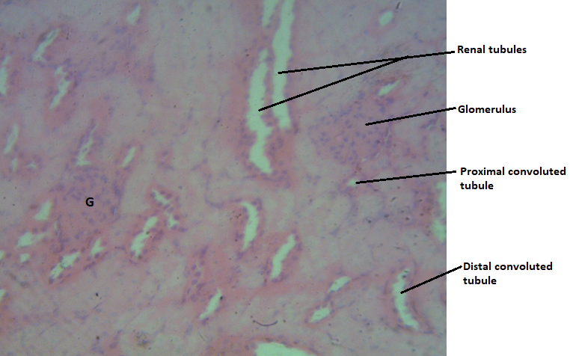

Slide; 3.1 Slide; 3.2

**Slide 3.1:** H & E stain, Mag. ×400. Group 1. Control group. Photomicrograph of the kidney tissue showing distinct glomerulus (G), proximal and distal convoluted tubules. Tissue shows normal microstructural appearance.

**Slide 3.2:** H & E stain, Mag. ×400. Group 2. vehicle group (coconut oil). Photomicrograph of the kidney tissue showing distinct glomerulus (G), proximal and distal convoluted tubules. Tissue shows normal microstructural appearance.

**Fig2- Photomicrographs of group 3 and group 2**

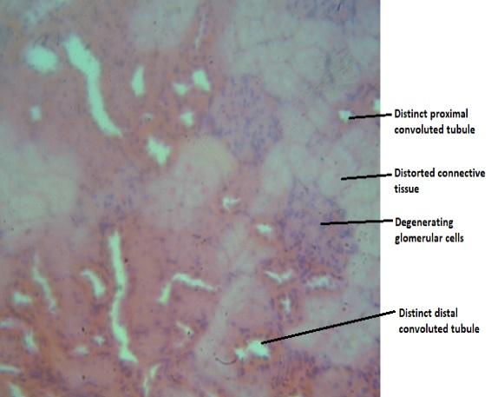

Slide 4.3 Slide 4.2

**Slide 3.3:** H & E stain Mag ×400. Group 3(50mg neem leaf dissolved in coconut oil). Photomicrograph of the kidney tissue showing degenerating glomerular cells, distorted connective tissues. The convoluted tubules (proximal and distal) appear normal.

**Slide 3.2:** H & E stain, Mag. ×400. Group 2. vehicle group (coconut oil). Photomicrograph of the kidney tissue showing distinct glomerulus (G), proximal and distal convoluted tubules. Tissue shows normal microstructural appearance.

**Fig 3- Photomicrograph of group 4 and group 2**

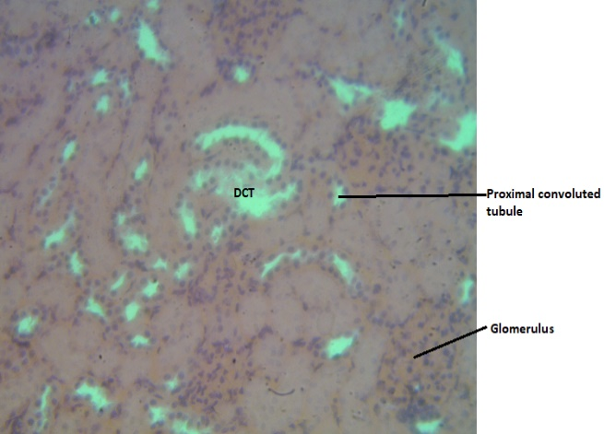  
Slide 3.4 Slide 3.2

**Slide 3.4:** H&E stain, Mag ×400 group 4 (50mg of edible camphor dissolved in coconut oil) Photomicrograph of the kidney tissue showing distorted distal convoluted tubule. The proximal convoluted tubules show distinct appearance. Mild distortion of tissue microstructure is indicated.

**Slide 3.2:** H & E stain, Mag. ×400. Group 2. vehicle group (coconut oil). Photomicrograph of the kidney tissue showing distinct glomerulus (G), proximal and distal convoluted tubules. Tissue shows normal microstructural appearance.

**Fig 4-Photomicrographs of group 5 and group 2**

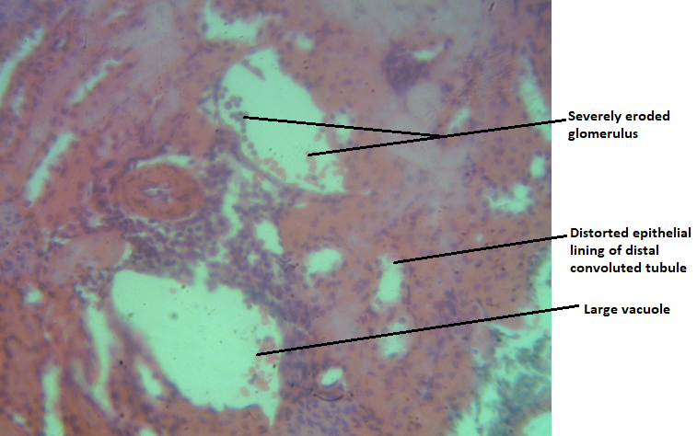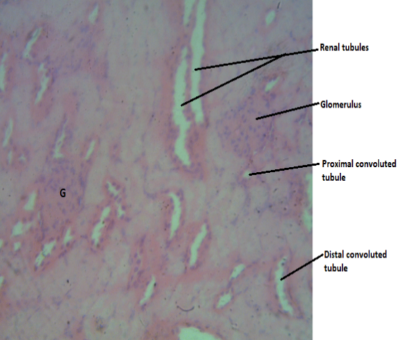

Slide 3.5 Slide 3.2

**Slide; 3.5**: H&E stain, Mag ×400. group 5 (100mg of edible camphor dissolved in coconut oil) Photomicrograph of the kidney tissue showing severely eroded glomeruli (large vacuoles), distorted epithelial lining of distal convoluted tubules. Distortion of tissue microstructure is indicated.

**Slide 3.2:** H & E stain, Mag. ×400. Group 2. vehicle group (coconut oil). Photomicrograph of the kidney tissue showing distinct glomerulus (G), proximal and distal convoluted tubules. Tissue shows normal microstructural appearance.

**Fig 5- Photomicrograph of group 6 and group 2.**

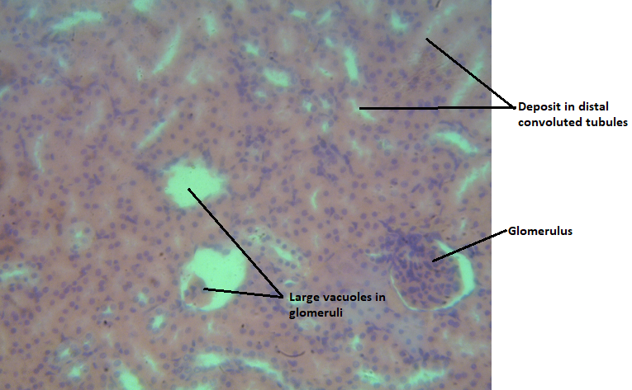

Slide 3.6 Slide 3.2

**Slide 3.6:** H&E stain, Mag ×400. Group 6 (50mg of neem leaf and 50mg of edible camphor dissolved in coconut oil) Photomicrograph of the kidney tissue showing severely eroded glomeruli (large vacuoles), deposit in distal convoluted tubules is also observed. Distorted glomerular content is indicated.

**Slide 3.2:** H & E stain, Mag. ×400. Group 2. vehicle group (coconut oil). Photomicrograph of the kidney tissue showing distinct glomerulus (G), proximal and distal convoluted tubules. Tissue shows normal microstructural appearance.

**Fig 6-Photomicrographs of group 4 and group 5**



Slide 3.4 slide 3.5

**Slide 3.4** H&E stain, Mag ×400 group 4 (50mg of edible camphor dissolved in coconut oil) Photomicrograph of the kidney tissue showing distorted distal convoluted tubule. The proximal convoluted tubules show distinct appearance. Mild distortion of tissue microstructure is indicated.

**Slide 3.5**: H&E stain, Mag ×400. group 5 (100mg of edible camphor dissolved in coconut oil) Photomicrograph of the kidney tissue showing severely eroded glomeruli (large vacuoles), distorted epithelial lining of distal convoluted tubules. Distortion of tissue microstructure is indicated.

**Fig 7-Photomicrographs of group 6 and group 3**

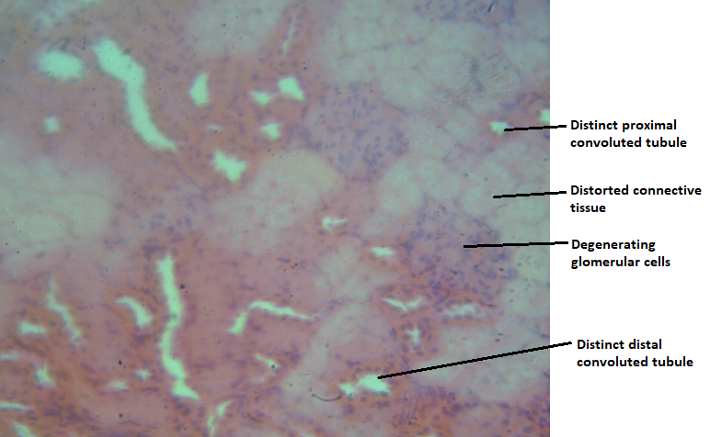

Slide 3.6 slide 3.3

**Slide 3.6:** H&E stain, Mag ×400. Group 6 (50mg of neem leaf and 50mg of edible camphor dissolved in coconut oil) Photomicrograph of the kidney tissue showing severely eroded glomeruli (large vacuoles), deposit in distal convoluted tubules is also observed. Distorted glomerular content is indicated.

**Slide 3.3:** H& E stain Mag ×400. Group 3 (neem leaf dissolved in coconut oil). Photomicrograph of the kidney tissue showing degenerating glomerular cells, distorted connective tissues. The convoluted tubules (proximal and distal) appear normal.

**Fig 8-Photomicrograph of group 6 and group 4**

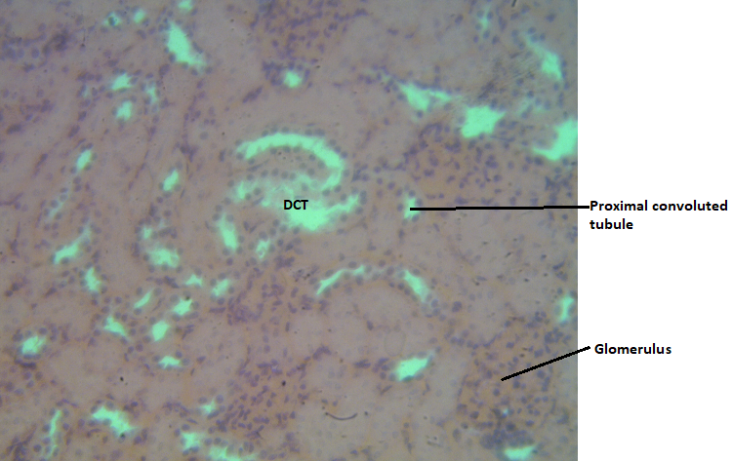

Slide 3.6 slide 3.4

**Slide 3.6:** H&E stain, Mag ×400. Group 6 (50mg of neem leaf and 50mg of edible camphor dissolved in coconut oil) Photomicrograph of the kidney tissue showing severely eroded glomeruli (large vacuoles), deposit in distal convoluted tubules is also observed. Distorted glomerular content is indicated.

**Slide 3.4:** H&E stain, Mag ×400 group 4 (50mg of edible camphor dissolved in coconut oil) Photomicrograph of the kidney tissue showing distorted distal convoluted tubule. The proximal convoluted tubules show distinct appearance. Mild distortion of tissue microstructure is indicated.

KIM-1 levels rise significantly with the addition of camphor, particularly at higher doses. These findings raise important concerns regarding the safety of edible camphor, this suggests that camphor, particularly in higher concentrations, may cause more kidney injury. The p-value (<0.0001) and F-value (24.50) confirm significant differences. The significant increase in KIM-1 molecule suggests that while camphor may have beneficial applications in certain contexts, its risks must be thoroughly assessed to ensure consumer safety. Camphor's nephrotoxicity can be attributed to several potential mechanisms that lead to kidney damage. This includes oxidative stress, Camphor metabolism can generate reactive oxygen species, leading to oxidative stress. Excess ROS can damage cellular components, including lipids, proteins, and DNA, resulting in cellular dysfunction and death. The increased oxidative burden may deplete endogenous antioxidants, such as glutathione, reducing the kidney's ability to combat oxidative damage.and also Inflammatory Response, Camphor exposure may trigger the release of pro-inflammatory cytokines, leading to an inflammatory response in the kidneys. This inflammation can exacerbate tissue injury and promote further oxidative stress.

This study has shown that edible camphor induces oxidative stress conditions as well as structural damage to the kidney of exposed albino rats. Oxidative stress results when the steady-state equilibrium of pro-oxidants and antioxidants favors the path of the former, thereby creating an enabling environment for oxidative damage. Superoxide dismutase (SOD) constitutes a very important antioxidant defense against oxidative stress in the body. The enzyme acts as a good therapeutic agent against reactive oxygen species mediated diseases; the enzyme can serve as an anti-inflammatory agent and can also prevent precancerous cell changes. Natural SOD levels in the body drop as the body becomes prone to oxidative stress- related disease [16]. SOD is an enzyme that contributes to the first line of antioxidant pathway as it removes oxygen radicals, repairs cell and reduces the damage done to them by superoxide, the most common free radical in the body [17]. In a previous study on the effects of camphor on hepatic enzymes, and antioxidant capacity of male rats. The decreased levels of MDA and SOD in camphor treated rats can be referred to that constituents of the *Cinnamomum camphora* had shown antioxidant activities [18][25]. Although camphor has insecticidal, antimicrobial, antiviral, anticoccidial, anti-nociceptive, anticancer and antitussive activities, in addition to its use as a skin penetration enhancer, camphor is considered a very toxic substance [19].

These studies show a decrease in superoxide dismutase level based on the toxicity level. Group 4 (50mg of edible camphor dissolved in coconut oil) group 5 (100mg of edible camphor dissolved in coconut oil) and group 6(neem and camphor dissolved in coconut oil) show a decrease in SOD levels, thereby creating an environment for oxidative damage. This finding agrees with the observation of Somade et al. [20], who reported the significant reduction of CAT (catalase) levels in the kidney of camphor- treated rats.

Alteration in redox mechanism in favor of a decline in antioxidant capacity inversely supports excessive pooling of reactive oxygen species (ROS) leading to peroxidation and nucleic acid oxidation with consequent damage to biomolecules, cellular organelles and retardation of cellular function [20].

8-OHdG, a product of nucleic acid oxidation directly reflects the severity of oxidative stress and its concentration in tissue and the degree of cellular damage in such tissue. Many studies have shown an increased level of 8-OHdG in oxidative stress-associated diseases, oxidized deoxyguanosine is notorious for inducing mutagenesis, therefore, most researchers have felt that 8-OHdG might have mutagenic or at least harmful effects in cells [21]. The significant increase in KIM-1 levels in groups treated with camphor aligns with findings in the literature that link camphor exposure to renal toxicity, suggesting that camphor may exacerbate kidney injury through mechanisms such as oxidative stress and inflammation.

The significant increase in KIM-1 molecule suggests that while camphor may have beneficial applications in certain contexts, its risks must be thoroughly assessed to ensure consumer safety. High doses of camphor are associated with increased oxidative stress (8-OHdG) and renal injury (KIM-1), while simultaneously reducing the body’s antioxidant capacity (SOD). The results demonstrate a clear response relationship for biomarkers of oxidative stress and kidney injury molecule.

The kidney histopathology observations after administration of the 50mg neem leaves dissolved in coconut oil (group 3) showed no difference compared to the control. The kidney in group 3 rats showed the normal general structure of the kidney and normal appearance of the glomerulus and tubules. This finding is supported by the results of KIM -1 in rat blood which showed no significant difference between the control and treatment groups. This is in line with some of the previous reports that the neem leaf extract has potential nephroprotective effects [22].

This study also revealed some histological abnormalities and cytoarchitectural distortion on the renal cells, which may be ascribed to the camphor administration on the kidney. The obvious signs of severely eroded glomeruli distorted distal and proximal convoluted tubules and distortion of tissue microstructure in the kidney. These findings implicate camphor as a precursor of kidney disease by causing severely eroded glomeruli and distortion of the tissue microstructure. These findings are also in consonance with the findings in previous studies, where it was noted that camphor administration has a cytoarchitectural distortion on the microstructure of the kidney of albino Wistar rats [23].

In this study, camphor may have acted as a toxin to the cells of the kidney resulting in severely eroded glomeruli and tubular necrosis observed. Group vi (50mg of neem leave and 50mg of camphor) showing severely eroded glomeruli, deposit in distal convoluted tubules compared to group iii (50mg of neem leave).

4. Conclusion

This study showed that 50mg of neem leaves dissolved in coconut oil (group 3) did not cause damage to the kidney of the Wistar albino rats as indicated by the results of kim-1 concentration and histopathological kidney. However, further investigation is required for comprehensive safety evaluation of the neem leaf extract at various doses to obtain a clear picture of the safety of neem leaves for medicine, when administered alone, suggesting its potential nephroprotective properties. However, the combination with camphor resulted in noticeable structural damage, reinforcing the idea that camphor may act as a toxin that exacerbates renal injury.

This study has demonstrated that edible camphor induces significant kidney injury and oxidative stress in albino rats, particularly at higher doses. The significant increase in Kidney Injury Molecule-1 (KIM-1) levels, a biomarker of kidney injury, and 8-hydroxy-2'-deoxyguanosine (8-OHdG), a marker of oxidative stress, suggests that camphor may exacerbate kidney damage through mechanisms such as oxidative stress and inflammation. The decrease in superoxide dismutase (SOD) levels, an antioxidant enzyme, further supports the notion that camphor compromises the body's antioxidant capacity, leading to an increased susceptibility to oxidative damage. The histopathological observations of the kidney tissues support the biochemical findings, revealing severe erosion of glomeruli, distortion of tissue microstructure, and tubular necrosis in camphor-treated groups.

Overall, this study suggests that edible camphor may be a nephrotoxin that requires careful evaluation of its safety profile, particularly at higher doses. The findings also underscore the importance of considering the potential interactions between camphor and other substances, such as neem leaves, to ensure safe consumption and minimize adverse effects on human health.

Ethical approval

All authors hereby declare that Principles of laboratory animal care (NIH publication No. 85-23, revised 1985) were followed, as well as specific national laws where applicable. All experiments have been examined and approved by the appropriate ethics committee.

Disclaimer (Artificial intelligence)

Option 1:

Author(s) hereby declare that NO generative AI technologies such as Large Language Models (ChatGPT, COPILOT, etc.) and text-to-image generators have been used during the writing or editing of this manuscript.

Option 2:

Author(s) hereby declare that generative AI technologies such as Large Language Models, etc. have been used during the writing or editing of manuscripts. This explanation will include the name, version, model, and source of the generative AI technology and as well as all input prompts provided to the generative AI technology

Details of the AI usage are given below:

1.

2.

3.

References

1. Chen C., Liu Z., Zou L., Liu X., Chai C., Zhao H.. Quality evaluation of apocyni veneti folium from different habitats and commercial herbs based on simultaneous determination of multiple bioactive constituents combined with multivariate statistical analysis. Molecules, 2018; 23, 573-9.
2. Bagnis, C.I., Deray, G, Baumelou, A., Le Quintrec, M. and Vanherweghem, J.L. Herbs and the kidney. Am. J. Kidney Dis. 2004; 44: 1-11.
3. Sitasiwi A. J., Isdadiyanto S., Mardiati S. M. Effect of ethanolic neem (Azadirachta indica) leaf extract as an herb contraceptive on hepato-somatic index of the male mice (Mus musculus) Journal of Physics: Conference Series. 2018; 1025:1–5.
4. Moneim A. E. A., Othman M. S., Aref A. M. Azadirachta indica attenuates cisplatin-induced nephrotoxicity and oxidative stress. BioMed Research International, 2014: 11-9.
5. Hoenig M.P,, & Zeidel M.L. Homeostasis, the milieu intérieur, and the wisdom of the nephron. Clin J Am Soc Nephrol., 2014; 9(7): 1272–81.
6. Perazella M.A., Coca S.G., Kanbay M., Brewster U.C., Parikh C.R. Diagnostic value of urine microscopy for differential diagnosis of acute kidney injury in hospitalized patients. Clin J Am Soc Nephrol, 2008; 3: 1615–9.
7. Baumgaertel M. W., Kraemer M., Berlit P. Neurologic complications of acute and chronic renal disease. Handbook of Clinical Neurology, 2014; 119: 383–93.
8. Zhou Y., Yan W. Conservation and applications of camphor tree (Cinnamomum camphora) in China: Ethnobotany and genetic resources. Genet. Resour. Crop Evol., 2016; 63: 1049–61.
9. Guo S., Geng Z., Zhang W., Liang J., Wang C., Deng Z., Du S. The chemical composition of essential oils from Cinnamomum camphora and their insecticidal activity against the stored product pests. Int. J. Mol. Sci., 2016; 17: 1836-9.
10. Pragadheesh V., Saroj A., Yadav A., Chanotiya C., Alam M., Samad A. Chemical characterization and antifungal activity of Cinnamomum camphora essential oil. Ind. Crops Prod., 2013; 49: 628–33.
11. Shi S., Wu Q., Su J., Li C., Zhao X., Xie J., Gui S., Su Z., Zeng H. Composition analysis of volatile oils from flowers, leaves and branches of Cinnamomum camphora chvar. Borneol in china. J. Essent. Oil Res., 2013; 25: 395–401.
12. Mbah A. U., Udeinya I. J., Shu E. N., Chijioke C. P., Nubila T., Udeinya F., et al. Fractionated Neem Leaf Extract Is Safe and Increases CD4+ Cell Levels in HIV/AIDS Patients. Am. J. Ther., 2007; 14(4): 369–74.
13. Gupta S. C., Prasad S., Tyagi A. K., Kunnumakkara A. B., and Aggarwal B. B. Neem (*Azadirachta indica*): an indian traditional panacea with modern molecular basis, *Phytomedicine,* 2017; 34: 14–20.
14. Gandhi M., Lal R., Sankaranarayanan A., Banerjee C.K., Sharma P.L. Acute toxicity study of the oil from Azadirachta indica seed (neem oil) Journal of Ethnopharmacology, 1980; 23(1): 39–51.
15. Akinola O.B., Zatta L., Dosumu O.O., Akinola O.S., Dini L., Caxton-Martins E.A. Ameliorative effects of ethanolic leaf extract of azadirachta indica on renal histologic alterations in streptozotocin-induced diabetic rats. The American Journal of Chinese Medicine, 2011; 39(5): 903–16.
16. Inal, M.E., Kanbak, G. & Sunal, E. Antioxidant enzyme activities and malondialdehyde levels related to aging. *Clinica chimica acta,* 2001;305: 75-80.
17. Ayres, S., Abplanalp, W., Liu, J.H. & Ravi, S. M.T. Mechanisms involved in the protective effect of estradiol-17b on lipid peroxidation and DNA damage. *American Journal of Physiology, Endocrinology and Metabolism*, 1998; 274: 1002-8.
18. Lee, H.J., Hyuna, E.A., Yoon, W.J., Kim, B.H., Rhee, M.H., Kang, H.K., Cho, J.Y. & Yoo, E.S. In vitro Antiinflammatory and Anti-oxidative Effects of Cinnamomumcamphora Ethnopharmacology, *Extracts journal*., 2006; 41103, 208-16.
19. Chen, W., Vermaak, I, & Viljoen. A. Camphor-A fumigant during the black death and a coveted fragrant wood in ancient Egypt and Babylon. *A review of* *Molecules,* 2013; 18: [5434](tel:5434)–54.
20. Somade O.T., Adeniji K.D., Adesina A.R.A., Olurinde O.J. Oral acute toxicity study as well as tissues oxidative stress and histopathological disorders in edible camphor administered rats. Experimental and Toxicological Pathology, 2017; 69(2): 99-108
21. Park E.J., Ji K.A., Jeon S.B., Choi W.H., Han I.O., You H.J., Kim J.H., Jou I., Joe E.H., Rac1 contributes to maximal activation of STAT1 and STAT3 in IFN-gamma-stimulated rat astrocytes. J Immunol., 2004; 173: 5697–03.
22. Rahmani A., Almatroudi A., Alrumaihi F. & Khan A. Pharmacological and therapeutic potential of neem (*Azadirachta indica*) Pharm Rev, 2018; 12(24): 250–5.
23. Adjene, J.O and Enaibe, B.U. Histological studies of the teratogenic effects of camphor on the developing liver of the Wistar rats. Annals Biomedical Sciences, 2002; 1(2): 88 -93.
24. Lin, L., & Wang, C. Toxicity studies of traditional Chinese herbal medicines: Applications and prospects. Toxicology Letters, 2014; 230(2): 245–51.
25. Duraipandiyan, V., & Ayyanar, M. Thin layer chromatography of medicinal plants: A review. Journal of Medicinal Plants Research, 2009; 3(12): 809–19.
26. Kanagasanthosh K., Shanmugapriyan S., Kavirajan V. Evaluation of Acute Toxicity, Anti-inflammatory Activity and Phytochemical Screening of Ethanolic Extract of Azadirachta indica Leaves. Int. J. Res. Dev. Pharm. Life Sci., 2015; 4 (5): 1737–45.