Original Research Article

Analysis of Association Between Blood Lead Levels, Packed Cell Volume, and Blood Group in Blood Donors: An Experience from Tertiary Healthcare Facility in Port Harcourt

.

ABSTRACT

|  |
| --- |
| **Background:** Packed cell volume and blood group are two parameters which are key in blood transfusion services, and as such, reduced packed cell volume or incompatible blood group will affect the outcome of transfusion. Blood lead may or may not affect the concentration of blood, as has been demonstrated in studies in other parts. However, this association has not been confirmed in the blood of donors in Port Harcourt; likewise, the association between blood lead and blood group is also not known.  **Aims:** To identify if any relationship exists between blood lead levels, packed cell volume and blood group of blood donors in a tertiary hospital in Port Harcourt.  **Study design:** A descriptive, cross-sectional study.  **Place and Duration of Study:** Blood bank of the department of Haematology and Blood Transfusion of the University of Port Harcourt Teaching Hospital, Port Harcourt, Nigeria, between March 2023 to May 2023.  **Methodology:** We included 246 donors, all were male, aged 18-55 years. Biodata and other relevant information were obtained using a semi-structure questionnaire, after consent to participate in the study was obtained. 5mls of blood was drawn from the antecubital fossa and Packed Cell Volume and blood group was determined. Blood Lead concentration was measured using Solaar thermo elemental atomic absorption spectrophotometer. Statistical analysis was done by SPSS version 21. Ethical approval was obtained.  **Results:** The relationship between donor blood lead levels, and packed cell volume and blood group were both statistically insignificant at P =0.238 and 0.061 respectively. However, the age of donors showed a significant relationship with blood lead levels, P = 0.013.  **Conclusion:** No statistically significant association was found to exist between blood lead levels, packed cell volume or the blood group of blood donors. |

*Keywords: [Packed cell volume, blood donors, blood group antigens, blood lead levels, Port Harcourt]*

1. INTRODUCTION

Lead, Pb is one of the heavy metals that is found in abundance in the earth’s crust1 and it is readily available for use in a number of sectors. The levels of lead in soil, undersurface water, and ambient air have increased significantly due to population explosion and increased anthropologic activities such as mining, use of lead in petroleum products, artisanal refining of petroleum products, and use of lead in paint manufacturing;2 and with these, there is the attendant increase in the levels of lead that gets into the human body by inhalation of contaminated air, ingestion of water and other edible items which are common sources of food, and by permeation through the skin following contact with leaded products.3 Lead is stored in tissues and organs in the body like bone marrow, kidneys, skin, and plasma including red cells, white cells and platelets.4, 5 While there is no known beneficial use of lead in tissues, there is ample evidence of its harmful effects.6, 7

Lead is a divalent metal like ferrous iron, the form in which dietary iron is absorbed from the lining of the small intestine. This organic ferrous iron first binds to a divalent metal transporter 1 (DMT1) protein which is found on the luminal surface of the small intestine; the DMT1 serves to transport ferrous iron into the enterocytes. In the enterocytes, iron passes through ferroportin, a transmembrane channel found on the basolateral surface of enterocytes, into the portal circulation, and is transported to tissues which have need for iron. Lead is known to compete with iron for binding to DMT1,8, 9 inhibit the enzymes ferrochelatase and delta aminolaevulinic acid dehydratase, δ-ALAD which plays critical role in the process of formation of haemoglobin,10 and also generates reactive oxidation species, ROS.11 Overall, high BLLs can cause iron deficiency anaemia; as such, patients with higher-than-normal BLLs are expected to have haemoglobin concentrations which are smaller than the lower limit of normal for patients age and sex, and vice versa.

The WHO and other regulatory organizations have identified that the risk of lead toxicity is high when blood lead levels exceed 5μg/dl. This means BLLs which are equal to or higher than this value could cause abnormal erythropoiesis, eventually leading to iron deficient erythropoiesis or frank iron deficiency anaemia, an effect that has been documented.12

Blood groups are defined by antigens which are expressed either directly on the cell surface or bound to other molecules found on the surface of the cells.13 The presence of these antigens predisposes patients to a number of health conditions,14 and at the same time, may protect against other kinds of diseases like infectious diseases.15 These blood group antigens are glycoproteins and some of them are susceptible to enzyme modification; enzymes are known to use iron as cofactor in their metabolism, so, it is plausible that if Pb replaces iron in the enzymes, there could be a modification of the activity of these enzymes, and by extension, the structure and possible function of the antigens on cells. While it is tempting to think that certain blood groups predispose individuals to higher BLLs than others, there is documented evidence to support this.

The aim of this study was to compare BLLs with packed cell volume (PCV) and blood group of those who donate blood and assess if there is a statistically significant relationship between high BLLs and PCV and blood group of donors.

2. METHODOLOGY

The study is a descriptive, cross-sectional study carried out on 246 blood donors at the blood bank of a tertiary healthcare facility in Port Harcourt, that gave consent to participate. Sociodemographic data of participants were collected using a locally developed questionnaire. Following routine antiseptic measures, 5mls of blood was drawn from the antecubital fossa of the participants and transferred into labelled tri-potassium EDTA bottles. Less than 0.5mls was used to measure the packed cell volume, and forward blood grouping was by the tile method; the remainder of the samples were pooled and transported in a cold chain to a peripheral laboratory for measurement of BLLs using Solaar thermos elemental atomic absorption spectrophotomer. Statistical analysis was conducted by SPSS version 21, and the Chi square test was used to determine the association between blood group, packed cell volume, and BLLs in the study participants. Ethical approval was obtained from the institution.

3. RESULTS and discussion

Male donors made up 100% of participants. Most donors, 65.4% of participants, were aged 18 – 25 years, with the age of 26 – 35 years making up the next highest participation at 25.2%. Others were 36 – 45 years at 8.1% and 46 – 55 years making up 1.3% of donors. Those who had completed or were enrolled in a tertiary institution of learning were 93.1%, while 6.5% only had secondary education; 0.4% had only primary level education. The result shows a statistically significant relation between BLL >5μg/dl and age of the participants (P = 0.013), while participants’ level of education did not show statistically significantly relation to BLLs (P = 0.615).

**Table 1. Age and level of education of participants**

|  |  |  |
| --- | --- | --- |
| **Variables** | **Frequency (n=246)** | **Percentage** |
| **Age** |  |  |
| 18-25 years | 161 | 65.4 |
| 26-35 years | 62 | 25.2 |
| 36-45 years | 20 | 8.1 |
| 46-55 years | 2 | 0.8 |
| Nil | 1 | 0.4 |
| **Level of education** |  |  |
| Primary | 1 | 0.4 |
| Secondary | 16 | 6.5 |
| Tertiary | 229 | 93.1 |

**Table 2. Association between sociodemographic characteristics with lead levels of participants**

|  |  |  |  |  |  |
| --- | --- | --- | --- | --- | --- |
| **Variables** | **Lead Levels** | | **Total** | **Chi square** | ***P* value** |
|  | **<5µg/dl**  **n(%)** | **>5µg/dl**  **n(%)** | **N (%)** |  |  |
| **Age group** |  |  |  |  |  |
| 18-25 years | 6 (46.2) | 155 (66.5) | 161 (65.4) | 12.622 | 0.013* |
| 26-35 years | 3 (23.1) | 59 (25.3) | 62 (25.2) |  |  |
| 36-45 years | 3 (23.1) | 17 (7.3) | 20 (8.1) |  |  |
| 46-55 years | 1 (7.7) | 1 (0.4) | 2 (0.8) |  |  |
| **Education level** |  |  |  |  |  |
| Primary | 0 (0.0) | 1 (0.4) | 1 (0.4) | 1.608 | 0.615 |
| Secondary | 1 (7.1) | 15 (6.4) | 16 (6.5) |  |  |
| Tertiary | 12 (92.3) | 217 (93.1) | 229 (93.1) |  |  |

Participants PCV showed mean ±SD of 41.12 ± 2.57, median PCV of 41.0 and range (min-max) of 36-49. More of donors had PCV of either 40% or 42% and association between BLLs and PCV was insignificant (P =0.238); in the same vein, Pearson correlation coefficient showed coefficient of 0.0046; a value which shows absence of a meaningful relation between BLLs in these donors and their PCV.

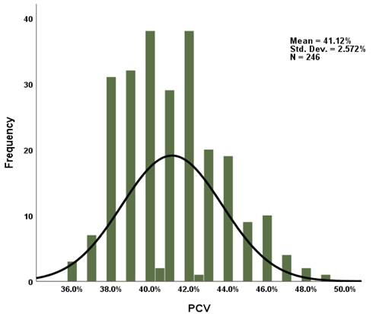

**Figure 1: Normal distribution of the packed cell volume of participants**

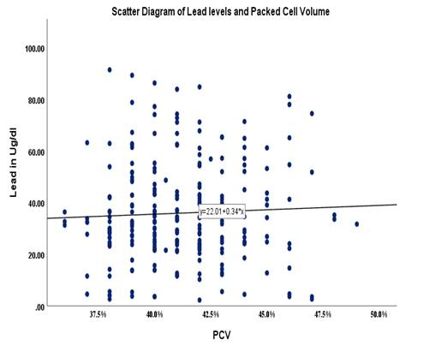

**Figure 2: Correlation between packed cell volume and blood Lead levels of participants (Pearson=0.046; p value=0.238)**

The blood group characteristics of the participants are O Rh D+ve donors made up 65.0%, followed by A Rh D+ve donors making up 13.4%; B Rh D +ve donors were 9.8%, followed by O Rh D-ve donors making 7.3%, A Rh D-ve of 2.4%, while B Rh D-ve was 1.6% and AB Rh D+ve was 0.4%.

**Table 3. Proportion of various blood groups among participants of the study**

|  |  |  |
| --- | --- | --- |
| **Blood group** | **Frequency(n=246)** | **Percentage** |
| A Negative | 6 | 2.4 |
| A Positive | 33 | 13.4 |
| AB Positive | 1 | 0.4 |
| B Negative | 4 | 1.6 |
| B Positive | 24 | 9.8 |
| O Negative | 18 | 7.3 |
| O Positive | 160 | 65.0 |

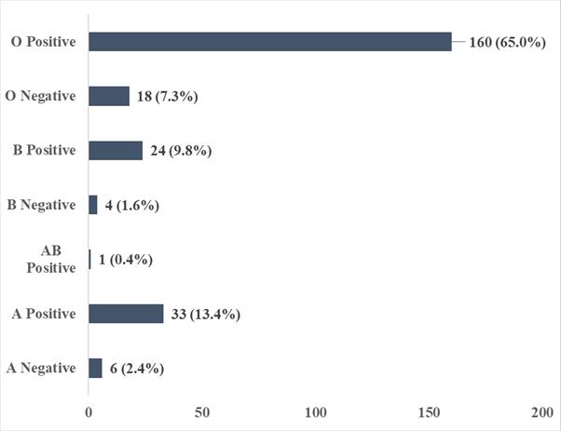

**Figure 3: Blood group distribution among study participants**

BLL measured in micrograms per deciliter (ug/dL), showed a mean ±SD value of 35.94 ± 19.09, a median of 32.0ug/dL, and a range (Min-Max) = 2.30 - 91.40. The BLLs of the participants showed a normal distribution, with the highest values between 20ug/dl and 40ug/dl. Values as high as 80ug/dl are also noted, though these are seen in very few participants.

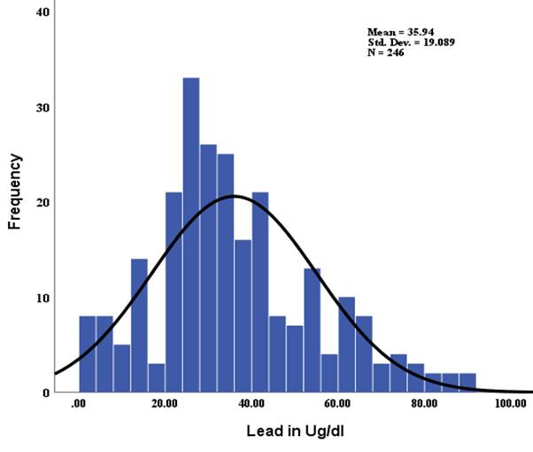

**Fig 4: Blood Lead levels of study participants showing normal distribution**

BLL of >5ug/dL is the value above which lead toxicity is likely to occur. Using this value in the study, the results show that 94.7% of participants have BLLs above the safe limit, while the remainder 5.3% of the participants had acceptable BLLs. This suggests that most of the blood donated in the bank has significantly high mean BLLs.

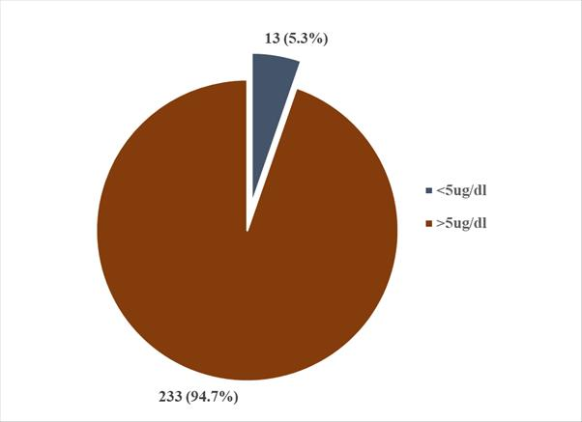

**Figure 5: Pie chart showing proportion of normal and toxic lead levels among study participants (<µg/dl denotes acceptable Lead level while >5µg/dl denotes levels at which toxicity has been proven to occur)**

**Table 4. Association between significant blood Lead and blood group among participants**

|  |  |  |  |  |  |
| --- | --- | --- | --- | --- | --- |
| **Variables** | **Lead Levels** | | **Total** | **Chi square** | ***P* value** |
|  | **<5µg/dl**  **n(%)** | **>5µg/dl**  **n(%)** | **N (%)** |  |  |
| **Blood group** |  |  |  |  |  |
| A Negative | 2 (15.4) | 4 (1.7) | 6 (2.4) | 12.025 | 0.061 |
| A Positive | 0 (0.0) | 33 (14.2) | 33 (13.4) |  |  |
| AB Positive | 0 (0.0) | 1 (0.4) | 1 (0.4) |  |  |
| B Negative | 0 (0.0) | 4 (1.7) | 4 (1.6) |  |  |
| B Positive | 2 (15.4) | 22 (9.4) | 24 (9.8) |  |  |
| O Negative | 1 (7.7) | 17 (7.3) | 18 (7.3) |  |  |
| O Positive | 8 (61.5) | 152 (65.2) | 160 (65.0) |  |  |

All donors that participated in this study were males. This may not be unconnected with the fact that males tend to have higher PCV than females, because of physiologic reasons, for which reason they are more likely to have the required minimum PCV for blood donation to take place. The study also shows that donors aged 35 years and below are the most involved in donation, making up more than 9/10th of the total population. This is consistent with other studies done in these parts which showed that most blood donors are male.16, 17 The age of donors relates significantly to BLLs (p = 0.013). This may be so because Pb is a ready source of pollution18, 19 and readily gains entry into the body by a lot of means. In the body, more Pb tends to accumulate in tissues/organs than is excreted in sweat and faeces, and as such, there is a net positive in the quantities in the body, as we age;20 this is corroborated by the study in over 3400 individuals in over 49 sites in Quebec.21 Of the few available studies which assess the relationship between BLLs and PCV, conclusions differ on whether there is statistically significant association between them. Our study showed P = 0.238 and a Pearson correlation coefficient of 0.046 for BLLs and PCV of donors, suggesting that blood lead does not cause reduced or increased PCV or vice versa. This is consistent with findings obtained from an older study amongst refinery workers and marketers of petroleum products in the outskirts of Port Harcourt, in which the PCV of the control group was slightly lower compared with the non-exposed, control group, but not statistically significant (P >0.05).22 However, in a more recent study on haemorrheologic parameters in Spray-painters in Port Harcourt, it was identified that the PCVs of the painters were higher than in the control group.23 Though both of these Port Harcourt studies in review did not directly measure BLLs, marketing of petroleum products, working in refinery, and spray-painting are jobs which increase exposure to Pb, so it can be safely assumed that the study population had higher BLLs compared with controls. This same explanation can be adduced to the findings in a study done among bakery workers and administrative staff that was carried out in another State in the Niger Delta of the country; the study in reference assessed the PCV in both groups and identified that it was significantly lower (p = 0.002) for the exposed than the control groups.24

In the South Eastern parts of the country, findings also differ; in a study among battery workers in Nnewi,25 it was identified that BLLs in exposed individuals was significantly higher than control populations, with these exposed individuals showing significantly lower PCV (P<0.000). Among automobile workers, generator mechanics and petrol station attendants in Abuja, it was identified that BLLs in automobile workers and generator mechanics was significantly higher than in the non-exposed population (P <0.04). Further, the study showed reduced PCV in the generator mechanics category compared with controls, with p < 0.001.26 Similar findings were obtained among automobile workers in Lagos, Nigeria; this study identified that apprentices who had less exposure to the job, and so smaller BLLs compared with masters and join-men, had significantly higher PCV (P <0.001).27 This negative correlation was also reported in a study done on battery-repair workers in Lagos State, however, in this study, the compared parameters were BLLs and RBC count (P = 0.008);28 RBC count can be considered an indirect measure of PCV as low RBC reflects low PCV and vice versa, if every other haematologic parameter are normal.29 Similarly, in an Indian study involving 43 children aged 4 – 12 years, in which a BLL of >10μg/dl was taken as significant, it was shown that children with BLLs >10ug/dl showed lower PCV as opposed to those with <10μg/dl who were used as control population. This Indian study also documented significant relationship between BLL >10μg/dl and derangements in liver function.30 Using petrol station workers versus a non-exposed, control group in the Middle-East, a study showed that BLLs are related significantly with reduced red blood cell parameters like haematocrit (P = 0.006).31

Between waste-collectors and occupationally non-exposed control group, a study in Pakistan showed that blood levels of heavy metals, including Pb, were significantly elevated in the exposed group and that Pb had the highest blood levels compared with other heavy metals assessed; study also noted significantly (p<0.05) reduced haemoglobin concentration in the workers as opposed to the control group.32

These findings are totally contrary to those of a study done to assess haematologic and cardiovascular damage among electronic waste workers in Bangladesh, wherein it was noted that with confounding variables considered, these workers had significantly higher levels of PCV and RBC count (P < 0.05), compared with those who were not exposed;33 similar increase in PCV was noted in the study among spray-painters in Port Harcourt.23 A plausible explanation is that the toxicity of Pb, and indeed other heavy metals, causes an immediate compensatory increase in erythropoiesis, so that more RBCs are produced, as is evident in another study which showed increased percentage of reticulocytes (%RET) among patients who were exposed to Pb via inhalation;34 however, this was not the case in the Bangladeshi study as only those who had been involved in e-waste management for minimum of 5 years were included in the study.

Regarding blood group and BLLs, a search of the literature does not show any result of an association between blood groups and BLLs. However, our study reports an absence of a significant relationship between these parameters (P = 0.061). This suggests that no blood group can raise the tendency to increase blood lead levels or to reduce it.

4. Conclusion

Donor blood group and PCV remain very important and considered parameters in transfusion medicine, and the findings in this study shows there is no significant association between BLLs, PCV, and blood group of donors, further adding to the opposing views regarding the relationship between BLLs and PCV.

Consent

Duly obtained from all participants.

Ethical approval

Ethical approval was obtained from University of Port Harcourt Ethics and Research committee.

COMPETING INTERESTS DISCLAIMER:

Authors have declared that they have no known competing financial interests OR non-financial interests OR personal relationships that could have appeared to influence the work reported in this paper.

DISCLAIMER (Artificial intelligence)

Authors hereby declare that NO generative AI technologies such as Large Language Models (ChatGPT, COPILOT, etc.) and text-to-image generators have been used during the writing or editing of this manuscript.

References

1. Watson GP, Martin NF, Grant ZB, Batka SC, Margenot AJ. Soil lead distribution in Chicago, USA. Geoderma regional. 2022 Mar 1;28:e00480.
2. Mielke HW, Gonzales CR, Powell ET, Egendorf SP. Lead in air, soil, and blood: Pb poisoning in a changing world. International Journal of Environmental Research and Public Health. 2022 Aug 2;19(15):9500.
3. World Health Organization. Exposure to lead: a major public health concern. Preventing disease through healthy environments. World Health Organization; 2023 Aug 16.
4. Aktepe N, Baran MF, Baran A. Effects of chronic exposure to lead on some organs. Assistant. 2022;18:45.
5. Collin MS, Venkatraman SK, Vijayakumar N, Kanimozhi V, Arbaaz SM, Stacey RS, Anusha J, Choudhary R, Lvov V, Tovar GI, Senatov F. Bioaccumulation of lead (Pb) and its effects on human: A review. Journal of Hazardous Materials Advances. 2022 Aug 1;7:100094.
6. Mandal GC, Mandal A, Chakraborty A. The toxic effect of lead on human health: A review. Human Biology and Public Health. 2022;3.
7. Kumar A, Kumar A, Chaturvedi AK, Shabnam AA, Subrahmanyam G, Mondal R, Gupta DK, Malyan SK, Kumar SS, A. Khan S, Yadav KK. Lead toxicity: health hazards, influence on food chain, and sustainable remediation approaches. International journal of environmental research and public health. 2020 Apr;17(7):2179.
8. Mani MS, Dsouza VL, Dsouza HS. Evaluation of divalent metal transporter 1 (DMT1)(rs224589) polymorphism on blood lead levels of occupationally exposed individuals. Toxicology Letters. 2021 Dec 15;353:13-9.
9. Li Y, Peng JC, Fang YY, Qin LM, Aschner M, Jiang YM. Effects of Subchronic Manganese and Iron Exposure, Alone or in Combination, on Elemental Distribution in Rats. Biological Trace Element Research. 2025 Apr 22:1-4.
10. Qader A, Rehman K, Akash MS. Genetic susceptibility of δ-ALAD associated with lead (Pb) intoxication: sources of exposure, preventive measures, and treatment interventions. Environmental Science and Pollution Research. 2021 Sep;28(33):44818-32.
11. Zhang S, Sun L, Zhang J, Liu S, Han J, Liu Y. Adverse impact of heavy metals on bone cells and bone metabolism dependently and independently through anemia. Advanced Science. 2020 Oct;7(19):2000383.
12. Ugwuja EI, Vincent N, Ikaraoha IC, Ohayi SR. Zinc ameliorates lead toxicity by reducing body Pb burden and restoring Pb-induced haematological and biochemical derangements. Toxicology Research and Application. 2020 Sep 1;4:2397847320956562.
13. Anyiam AF, Arinze-Anyiam OC, Irondi EA, Obeagu EI. Distribution of ABO and rhesus blood grouping with HIV infection among blood donors in Ekiti State Nigeria. Medicine. 2023 Nov 24;102(47):e36342.
14. Dai X. ABO blood group predisposes to COVID-19 severity and cardiovascular diseases. European journal of preventive cardiology. 2020 Sep;27(13):1436-7.
15. Kariuki SN, Marin-Menendez A, Introini V, Ravenhill BJ, Lin YC, Macharia A, Makale J, Tendwa M, Nyamu W, Kotar J, Carrasquilla M. Red blood cell tension protects against severe malaria in the Dantu blood group. Nature. 2020 Sep 24;585(7826):579-83.
16. Nnachi OC, Akpa CO, Onwe OE, Nwani EI, Nwani FO, Ekpagu V, Onoh TJ. Community survey on the knowledge, attitude, and practice of blood donation in Ebonyi State, Southeast Nigeria. International Journal of Community Medicine and Public Health. 2022 Nov;9(11):3999.
17. Ndukwu CL, Chinedu-Madu JU. The Seroprevalence of Transfusion-Transmissible pathogens: A retrospective study in Port Harcourt, Nigeria. Int J Res Rep Hematol. 2024 Nov 15;7(2):138-47.
18. Abayomi O, Olayemi TE, Ogungbade T. Environmental pollution and its ecological consequences on the Niger Delta: A review of the literature. African Journal of Environment and Natural Science Research. 2021;4:27-42.
19. Onwuka C, Eboatu AN, Ajiwe VI, Morah EJ. Pollution studies on soils from crude oil producing areas of rivers state, Niger delta region, Nigeria. Open Access Library Journal. 2021 Aug 27;8(9):1-7.
20. Charkiewicz AE, Backstrand JR. Lead toxicity and pollution in Poland. International journal of environmental research and public health. 2020 Jun;17(12):4385.
21. Delage G, Gingras S, Rhainds M. A population‐based study on blood lead levels in blood donors. Transfusion. 2015 Nov;55(11):2633-40.
22. Ezejiofor TN, Ezejiofor AN, Iwuala MO. Haematological indicators of exposure to petroleum products in petroleum refining and distribution industry workers in Nigeria. J Clin Toxicol. 2016;6(1):276.
23. Christian SG, Joshua PO, Eze EM. Evaluation of Some Haemorheologic Parameters amongst Automotive Spray Painters in Port Harcourt, Nigeria.
24. Oko'Ose JN, Oko-Ose NO. Comparative Study of Haematological Parameters in Exposed Fossil Fuel Bakery Workers and Administrative Officers of a Government Ministry in Benin City Nigeria. Journal of Medical and Basic Scientific Research. 2023 Jan 12;4(1-2):57-63.
25. Isife CT. Occupational Hazard and Sustainable Development: A Case Study of Battery Workers in Nnewi South, Eastern Nigeria. Isife, Chima Theresa. Journal of Environmental Management and Safety. 2012;3(2):17
26. Friday EA, Douglas MM, Erhunmwunse UR, Eghosa UN, Joy E, Imuetiyan EA, Kester DA, Isaac EP. Cadmium and Lead Induced Proinflammatory Cytokine Polarization in Petroleum Products Occupationally Exposed Nigerians.
27. Adejumo M, Olaiya YV, Sridhar MK. Blood lead levels among automobile mechanics in a megacity, Lagos, Nigeria. International journal of health sciences. 2017 Jun;5(2):17-27.
28. Ogbenna AA, Ayandokun OA, Roberts AA, Adewoyin AS, Famuyiwa CO. Hematologic profile of battery repair workers occupationally exposed to lead in Lagos, Nigeria. Annals of Tropical Pathology. 2017;8(2):68-74.
29. Khan Z, Nawaz M, Khan A, Bacha U. Hemoglobin, red blood cell count, hematocrit and derived parameters for diagnosing anemia in elderly males. Proceedings of the Pakistan Academy of sciences. 2013 Sep 15;50(3):217-26.
30. Rawat PS, Singh S, Zahid M, Mehrotra S. An integrated assessment of lead exposure in children: Correlation with biochemical and haematological indices. Journal of Trace Elements in Medicine and Biology. 2021 Dec 1;68:126835.
31. Binsaleh NK, Eltayeb R, Bashir EM, Idris HM, Althobiti MM, Ahmed HG, Khan MW, Qanash H. Insight into hematological parameters of petrol station workers. European Review for Medical & Pharmacological Sciences. 2024 Apr 15;28(8).
32. Rasool U, Thomson P. Level of Trace Metals and Associated Impact on Biochemical, Hematological, and Genotoxic Effects in Occupationally Exposed Waste-Collecting Workers. Biomedical Journal of Scientific & Technical Research. 2024 Aug 20;58(2):50170-83.
33. Parvez SM, Huda MM, Rahman M, Jahan F, Fujimura M, Hasan SS, Aich N, Hares A, Islam Z, Raqib R, Knibbs LD. Hematological, cardiovascular and oxidative DNA damage markers associated with heavy metal exposure in electronic waste (e-waste) workers of Bangladesh. Toxicology. 2024 Dec 1;509:153978.
34. Caciari T, Casale T, Ciarrocca M, Capozzella A, Gioffrè PA, Corbosiero P, Tomei G, Scala B, Andreozzi G, Nardone N, Tomei F. Correlation between total blood lead values and peripheral blood counts in workers occupationally exposed to urban stressors. Journal of Environmental Science and Health, Part A. 2013 Oct 15;48(12):1457-69.