***Original Research Article***

**Prevalence and Quantification of Aflatoxins in *Nsinjiro* from Local Markets in Central and Southern Malawi**

.

ABSTRACT

|  |
| --- |
| **AIMS: The study aimed to assess the prevalence and quantification of aflatoxin levels in groundnut flour sold in local markets in the central and southern regions of Malawi. Specifically, to determine aflatoxin (B1, B2, G1, and G2) levels in groundnut flour *(nsinjiro*). Liver cancer caused by aflatoxins is to blame for 6,344 deaths in Malawi, yet nsinjiro is the cheapest means of confectionery for many Malawians.**  **STUDY DESIGN: The research was conducted intentionally in two specific regions, among the most productive groundnut regions in Malawi, where groundnuts are also consumed in substantial quantities.**  **PLACE AND DURATION OF STUDY: This study was conducted in local markets in the Central and Southern Regions of Malawi between January and February 2023.**  **METHODOLOGY: Aflatoxin levels were assessed in 38 groundnut flour samples. The local market list was obtained from the Ministry of Local Government Office. Samples were randomly purchased from vendors/sellers in the local markets. Aflatoxin (b1, b2, g1, and g2) levels in groundnut flour were analyzed using the high-performance liquid chromatography method to quantify the true preponderance of each aflatoxin. The data were analyzed using the statistical program for social scientists (SPSS), and results were reported as means and standard deviation (mean ± SD).**  **RESULTS: The findings revealed that 37 of the 38 samples examined were contaminated with aflatoxin, with total aflatoxin levels ranging from 0 to 77.08 ± 16.50 ppb, which is higher than the permitted 3-ppb limit in Malawi. Twenty-eight samples overall exceeded the thresholds for the Malawi Bureau of Standards.**  **CONCLUSION: The study has generated baseline information for Government Sectors and Agencies to enact policies aimed at improving food Safety Regulations, and these results indicate that the Groundnut Flour Studied Was Susceptible to Aflatoxin Contamination; Hence, Aflatoxin Monitoring In Groundnut Flour before Marketing is required.** |

*Keywords: Aflatoxin contamination, groundnut flour, local markets, Vendors/sellers.*

1. INTRODUCTION

The world's most significant food crop is groundnut (Arachis hypogaea L.). In 2019, it was projected that the world would produce 47.09 million metric tons [1].

The world’s total groundnut production was 39.75 million metric tons, and Sub-Saharan African countries contributed 27.6% [2].

Malawi is one of the top groundnut-producing countries in East and Southern Africa, and it is mostly cultivated by local farmers [3].

It is produced for consumption, trade, and animal feed [3, 4].

However, a survey done in Malawi found that farmers, in particular, have very little access to information about aflatoxin [4].

Vendors process some groundnuts into flour (nsinjiro) for sale [5].

They sell it in various local markets [6].

Groundnut flour can be consumed in various forms in Malawi [7].

Malawians consume groundnut flour mostly daily [8].

Regular consumption of groundnut flour leads to aflatoxin exposure [9].

Aflatoxins are poisonous metabolic substances produced by Aspergillus parasiticus and Aspergillus flavus [10].

Aflatoxins cause cancer and stunted growth, and are lethal [11].

Temperature, relative humidity, and moisture content are some of the favorable conditions for the production of aflatoxins [12].

In Malawi, aflatoxin contamination mostly affects groundnut output and consumption.

There are more than 18 different varieties of aflatoxins that have been discovered so far, but only aflatoxins B1, B2, G1, and G2 are deadly and common [13].

Numerous studies indicate that the various types of aflatoxins exhibit a toxicity hierarchy (from chronic to acute), and aflatoxin poisoning goes in the following order: B1 > G1 > B2 > G2 [14].

Because of the reports of major health issues, food and feed that contain aflatoxins are dangerous to consume [15].

Due to the risks involved with consuming food and feed that contain aflatoxin, aflatoxins have emerged as a significant global problem for food safety, compelling experts to continue their investigations [16].

The deleterious effects of aflatoxins have attracted global attention [16]. Studies reveal that liver cancers brought on by aflatoxin are to blame for 6,344 deaths in Malawi [6].

Aflatoxin exposure in children promotes stunting and puts them at risk for additional illnesses, including malaria [17].

Unsafe levels of aflatoxin-contaminated groundnut products purchased from local markets beyond the global regulatory limit have been identified and reported by researchers [18].

ISO 16050 states that the allowable level of aflatoxin B1 and total aflatoxins in nsinjiro in Malawi shall not be greater than 5 ppb and 10 ppb, respectively [19].

It is for this reason that, for food intended for human consumption, regulatory maximum restrictions are already in place in the majority of nations [20].

Around the world, various tropical and subtropical countries, including Malawi, widely cultivate and consume groundnuts and their derived products.

The world's top groundnut producers include China, India, the United States, Nigeria, and Sudan [21, 22].

The world's groundnut production has increased as a result of its nutritional and economic relevance [23].

Groundnut production accounts for more than half of the nation's entire output and is produced in the Central region [6].

Groundnuts add nutritious value to the predominantly maize-based diet of Malawi [24]. Vendors or middlemen usually buy unshelled groundnuts from farmers in remote areas, bring them to local markets, where they shell them either manually or using an electronic groundnut shelling machine, and then mill some of them into nsinjiro for sale [25].

Agricultural households in Malawi consume groundnuts and groundnut-derived products such as nsinjiro at least three times per week [9].

Local markets, particularly the informal, poorly regulated groundnuts flour markets, have emerged as significant targets for groundnuts that don't adhere to the standards for food safety set by export markets [8].

The majority of peanuts purchased locally are sold in markets with lax regulations and are not regularly checked or tested for aflatoxin contamination [26].

Several research investigations that examined groundnuts, including groundnut product samples collected from different local markets, found that aflatoxin contamination is still a significant issue in Malawi [8, 27].

The groundnut production and consumption in Malawi varied from 2014 to 2020.

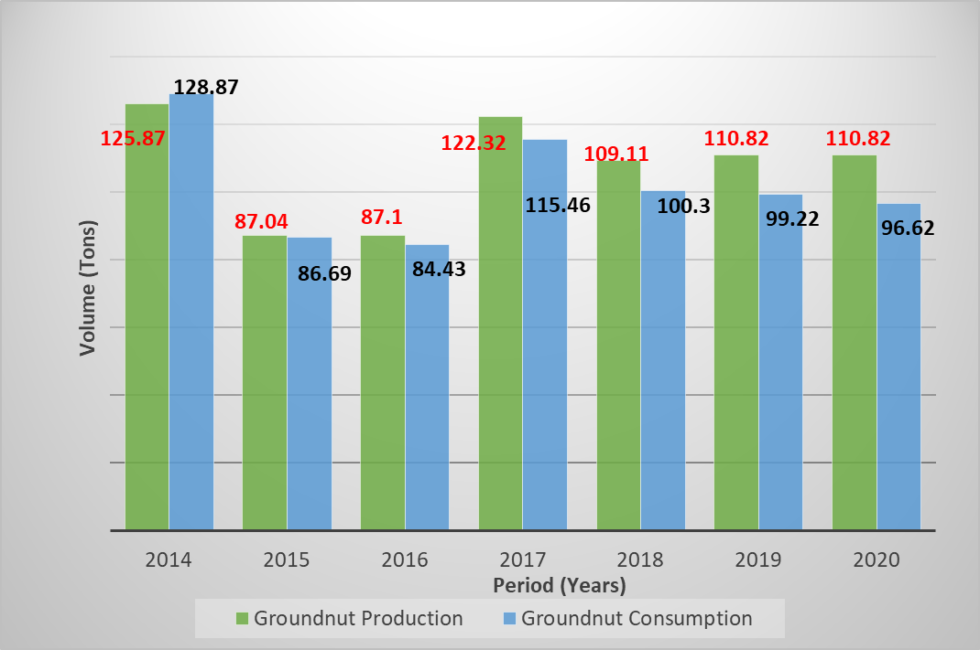The graph (Figure 1) depicts groundnut local production and consumption in Malawi.

**Figure 1. Groundnut production versus consumption in Malawi**

Source: FAO Statistics database [2]

There were significant fluctuations in both groundnut production and consumption. Groundnut output was smaller at the beginning of the analysis period than local consumption.

This indicates that there were not enough groundnut reserves to meet Malawi's rising consumption in the 2013–2014 growing season.

Due to the extreme drought circumstances prevalent in that particular time frame, less groundnut was grown during the 2015–16 growing season, which may be the reason for the production decline.

This also shows that during 2017 through 2020, the local production of groundnuts was slightly higher than their consumption. Nevertheless, the duration of the study finally ended with higher groundnut production that was just a little bit above local consumption for the 2019–20 growing season.

For human nutrition, nsinjiro is a good source of nutrients, and its typical amount is 48 % fat, 26 % protein, 17 % carbohydrates, 2 % fiber, and 2 % ash content [7].

Groundnut flour is used as a condiment or groundnut oil in traditional recipes by households [7].

Groundnut flour is normally combined with conventional foodstuffs and consumed almost 3 times per week [28].

Groundnut flour is consumed together with leafy vegetables, even sometimes it is also added to porridge made from other cereals [8].

According to Onawo and Adamu [29], groundnut oil lowers cholesterol and considerably reduces the risk of heart disease.

Aflatoxin B1 is the most frequently found in cereal and legume foodstuffs [30].

Aflatoxin levels in groundnut flour sold in Malawian markets are not yet known due to a lack of published information or insufficient data in the literature [31].

Hence, their nature and extent of distribution need to be documented as the basis for intervention programs in Malawi.

Previous comparable research formed the basis for the conceptualization, design, and execution of this investigation.

This study, therefore, aims to assess the prevalence and quantification of aflatoxin levels in groundnut flour offered in local retail market outlets around central and southern regions of Malawi.

2. Materials and methods

2.1 Study design

The research was conducted on purpose in 2 specific regions among Malawi's most productive groundnut regions, where groundnuts are consumed in substantial quantities.

They comprised Central and Southern, which harbour the majority of local markets, such as Nkhamenya, Chatoloma, Chamama, Kasungu, Nkanda, Mchinji, Kamwendo, Mponela, Nambuma, Dowa, Lumbadzi, Mvera, Mitundu, Lilongwe, Dedza, Salima, Manjawira, Balaka, Ulongwe, Liwonde, Mwanza, Zalewa, Chingale, Zomba, Govara, Lunzu, Mbulumbuzi, Njuri, Chiradzulu, Ndirande, Blantyre, Limbe, Nkando, Goliati, Bvumbwe, Thyolo, Mulanje, and Muloza.

A purposive sampling technique was used to select the local markets where groundnut flour marketing takes place.

The vendors/sellers in each local market were selected following simple random sampling techniques.

Data was collected three times during the study.

**2.2 Study Area**

A partial map of Malawi showing some local markets where groundnut flour samples were purchased (Figure 2).

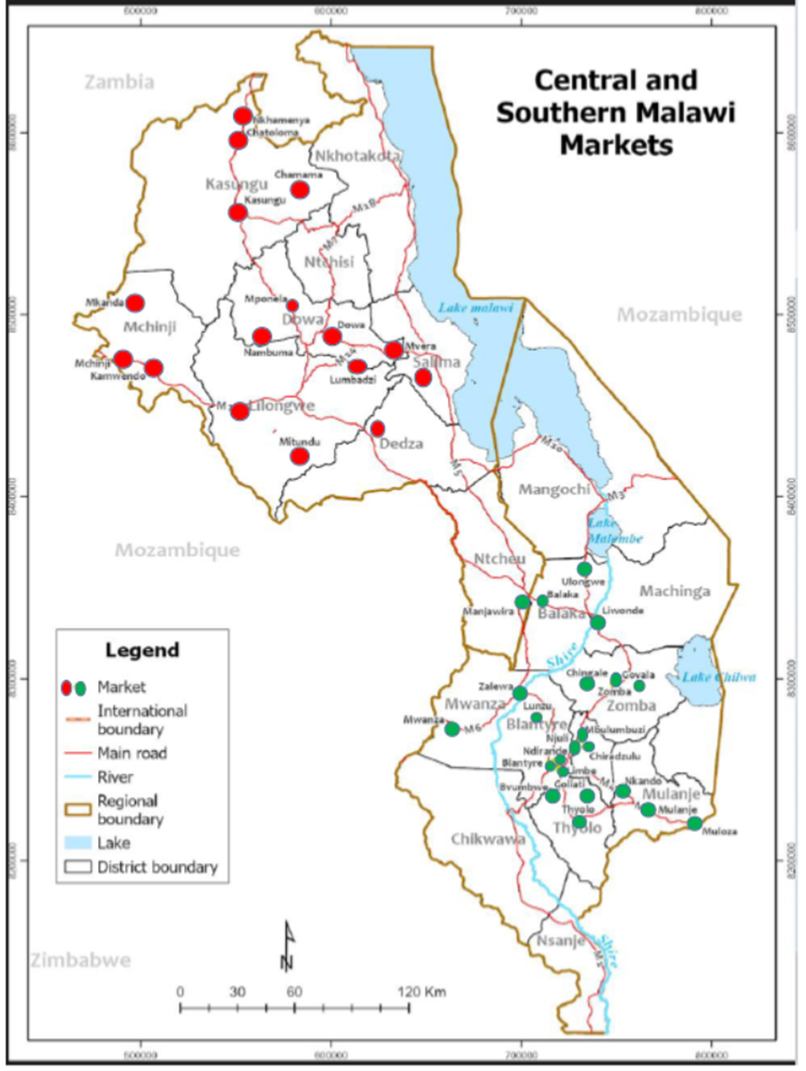

**Figure 2. A partial map of Malawi displaying the study markets**

Source: Author’s construct (2023)

Malawi is found in the southern part of Africa.

It is a landlocked country that borders Tanzania, Zambia, and Mozambique.

Both land and water, mostly Lake Malawi, make up its 118,480 sq. km of total land area.

It is situated between longitudes 32° and 36° E and latitudes 9° and 18° S.

Politically, Malawi is divided into three regions: the North, the Centre, and the South.

The weather of Malawi is typically tropical, with warm temperatures between November and April, and 90 % of the year's precipitation comes from equatorial rains.

From September to April, maximum temperatures in the lower Shire Valley and along the lake average around 27 to 29 °C (80.6 to 80.6 °F) [32].

With typical annual temperatures ranging between 22 and 18 degrees Celsius and rainfall varying between 900 to 1,500 mm every year, Malawi's central region is located at an elevation of between 1,300 and 1,700 meters above sea level [33].

A rain shadow zone covers most of Malawi's southern area; it experiences minimum and maximum temperatures of 14 and 32 °C receives about 800 mm of rainfall on average every year.

The primary food crop is maize, which is occasionally interplanted with groundnuts [34].

The groundnut growing season lasts from mid-April until the end of May, with crops being seeded in November or December.

This study was conducted in local markets in the Central and Southern Regions of Malawi.

Based on literary sources, the Central Region of Malawi produces more than half of the nation's groundnuts [7].

**2.3 Sampling Procedure**

**2.3.1 Sampling Approach**

The purposive sampling technique was used for the selection of the local markets in three regions.

However, the selection of vendors in the markets was done using a simple random sampling technique after the observational survey.

Due to their predominance in the production of groundnuts and groundnut flour marketing, 2 of the 3 regions were purposefully selected.

From each region, formal local markets from the list of markets obtained from the Ministry of Local Government office were picked based on where groundnut flour marketing takes place.

In the last stage, at least 5 and ut most 10 groundnut flour vendors/sellers were selected in each local market.

Then, vendors/sellers from whom the groundnut flour was purchased were picked.

A total of thirty-eight (n = 38) of 71 local markets were selected for the study.

**2.3.2 Data collection procedure**

Immediately after being granted the Ethical Clearance Approval for the study by the Institutional Review Board of the University of Cape Coast (ID (UCCIRB/CANS/2022/53)), primary data collection from various retail local market outlets in Malawi started (during the daytime) between January and February 2023.

A total of thirty-eight (n = 38) dry and processed groundnut flour samples were randomly purchased from vendors/sellers.

The Ministry of Local Government Office provided a list of the local markets in each region, which was then used to compile a representative sample.

In the Central region, samples were purchased from sixteen (16) of thirty-two (32), while in the Southern region, twenty-two (22) samples were purchased from thirty-nine (39) local markets, respectively.

One kilogram (1 kg) of groundnut flour was purchased for each sample, gathered from various locations in the vendor's container, and well mixed.

The sample was purchased based on the samples that each vendor/seller had on hand.

Samples were collected, tagged with the market's code name, divided into two halves, and then packed in polyethylene plastic Zip-Lock sachets (made in China).

The first portion was kept as a backup while the second portion was used directly for determining the levels of aflatoxin.

To rule out any risk of leakage, the package's zip was carefully examined and kept in an insulated cooler box to prevent moisture changes caused by the environment.

Later, samples were transferred to the University of Cape Coast’s Africa Centre of Excellence for Food Fraud and Food Safety (AFriFoodinTegrity Centre) laboratories in Ghana.

While awaiting analysis, samples were stored in a deep freezer.

2.4.3 Determination of Aflatoxin Levels in Groundnut Flour Samples

**2.3.3 Sample Extraction**

Using the European Council for Standardization (CEN) methodology EN14123 [35] for aflatoxin extraction, AFB1, AFB2, AFG1, and AFG2 were removed from samples accordingly.

Precisely 25 g of groundnut flour samples were extracted in an 80:20 ratio of methanol and distilled water with 5 g of analytical-grade sodium chloride (NaCl) and 200 mL of methanol in a distilled water mixture.

Samples with more than 50 % fat were mixed with hexane (100 mL) and homogenized for 3 minutes at 3000 and 3500 revolutions per minute, respectively.

Two organic layers resulted from the mixture: a top layer made of hexane and a bottom layer made of methanol.

Whatman number 4 filter paper (Whatman International Ltd., Maidstone, Kent, UK) was used to remove the lowest layer of methanol from the liquid.

60 mL of phosphate buffer saline (PBS) and 10 mL of methanol were added, and the extracts were filtered.

Aflatoxin-specific immunoaffinity columns for AFB1, AFB2, AFG1, and AFG2 were pre-conditioned for solid-phase extraction.

Using columns attached to vacuum manifolds, 10 mL of Phosphate Buffer Saline (PBS) was eluted through them at a flow rate of 3 mL/minute to activate the antibodies in the columns.

The pre-conditioned immunoaffinity column that was designed to be specific for aflatoxins was loaded with the full filtrate-PBS mixture in 70 mL and gravity-drained.

After the columns had been cleaned three times with 15 mL of distilled water, methanol (HPLC grade) was allowed to elute from the columns at a flow rate of 5 mL/minute.

To remove all wash solvent molecules from the column, the air was pumped through it using a vacuum pump.

After eluting aflatoxins with 0.5 mL of methanol (HPLC grade) and 0.75 mL of methanol after a minute, aflatoxins were extracted in two steps into a 5 mL vial and then allowed to elute naturally by gravity.

The air was blown through the column to gather all of the eluates.

Five milliliters of distilled water were used to create the eluate and eluate vortexes, and two milliliters were then injected into HPLC vials for measurement.

**High-performance liquid chromatography configuration;**

HPLC system: Agilent 1260 Infinity Quaternary Pump LC (Germany) with Fluorescence Detection Column: TC-C18 (2), 170, 5 μm, 4.6 × 250 mm; thus, the pore size of 170, the particle size of 5.0 μm, inner diameter of 4.6 mm, length of 250 mm and carbon load of 12 %, column temperature: 35 °C, injection volume: 10 μl, flow rate: 1 ml/minute, fluorescence detector at excitation wavelength: 360 nm, emission wavelength: 440 nm, mobile phase composition: water/acetonitrile/MeOH (65:15:20 v/v/v), post-column derivatization: Kobra cells.

**Column Parameters for HPLC**

Spherisorb ODS1-Excel (4.6 mm x 25 cm), 5 μm particle size, 250 thus pore size.

Supplier of Column R-Biopharm, Block 10 campus, West Scotland Science Park, Acre Road, Glasgow, Scotland G20 OXA.

**2.3.4 Sample Analysis**

HPLC was employed to estimate the levels of aflatoxins present in groundnut flour samples (Agilent 1260 Infinity Quaternary Pump LC, Open-Lab software, X-bridge column, 250 mm x 4.6 mm, i.d., 5 μm), USA, using a fluorescence detector and post-column derivatization using Kobra cells, which produce bromine electrochemically.

LOD values for AFB1, AFB2, AFG1, and AFG2 were 0.20 ppb, 0.17 ppb, 0.26 ppb, and 0.36 ppb, respectively, at the Council for Scientific and Industrial Research (CSIR)-Food Research Institute, Ghana.

*2.3.4.1 Limit of detection/quantification (LOD/LOQ)*

The limit of detection and quantification of the HPLC was calculated by building a calibration curve around the smallest standard used for spiking, 5 ppb (the lowest concentration range of the calibration curve).

Since Blank did not produce any signal, the LOD and LOQ were determined as follows:

$$LOD=3×\frac{Standard deviation}{slope}$$

LOQ=3 × LOD

*2.3.4.2 Measurement of precision*

To verify the measurement accuracy of the assay, a pure aflatoxin standard (provided by Trilogy Lab, USA) solution was spiked.

Pure aflatoxin standards at concentrations of 2.5 ppb, 5 ppb, 10 ppb, 15 ppb, and 20 ppb were used to perform a five-point calibration.

Pure standards' peak volumes were computed as:

$$\frac{sampleweight \left(g\right) ×spike concentration (ppb)}{Concentration of standard (ppb)}$$

Typical HPLC chromatograms of aflatoxin standards at concentrations of 2.5, 5, 10, 15, and 20 ppb used to perform a five-point calibration are presented in Figure 3.

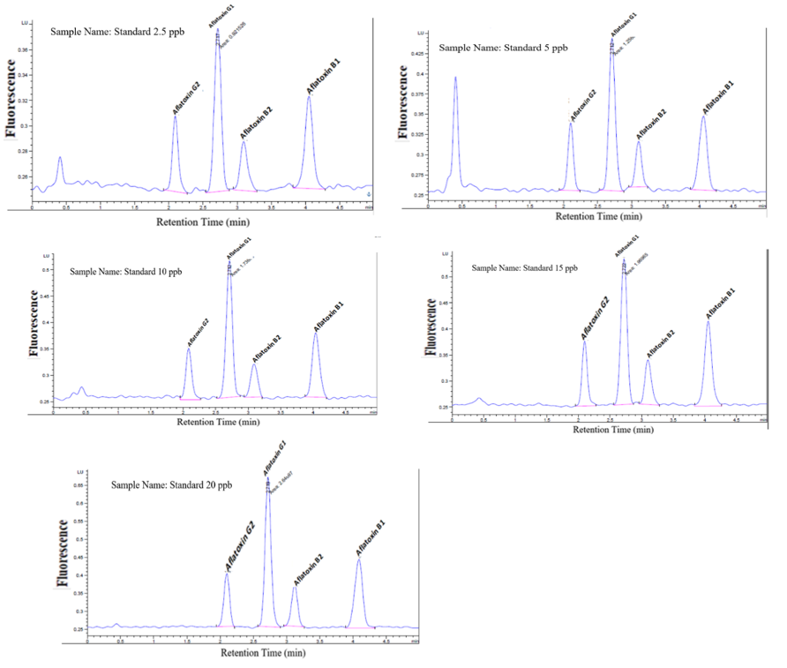

**Figure 3. HPLC Chromatograms of standards at different concentrations**.

*2.3.4.3 Measurement of precision*

To confirm the measurement accuracy of the procedure, repeatability and intermediate precision evaluations of an Internal Reference Material (IRM) were performed.

For the repeatability analysis, the same analyst simultaneously performed 10 parallel IRM extractions using the same HPLC, and the relative standard deviation of the data was computed.

For intermediate precision, 10 IRM extractions were performed on various days by analysts, and the relative standard deviation of the results was calculated.

The following calculations for the relative standard deviations were made:

$$\frac{Standard deviation }{Mean}×100$$

*2.3.4.4 Required performance standards for precision and accurac*

Repeatability: Among repeatable outcomes, the relative standard deviation must be under 15 %.

Reproducibility: Results acquired under settings of intermediate precision should have a relative standard deviation smaller than 20 %.

Recovery: The percentage recovery for the measuring technique should fall between 80 and 120 %.

Linearity: For AFB1, AFB2, AFG1, and AFG2, the linearity from the regression curves should not be less than 0.90 (Fig 4).

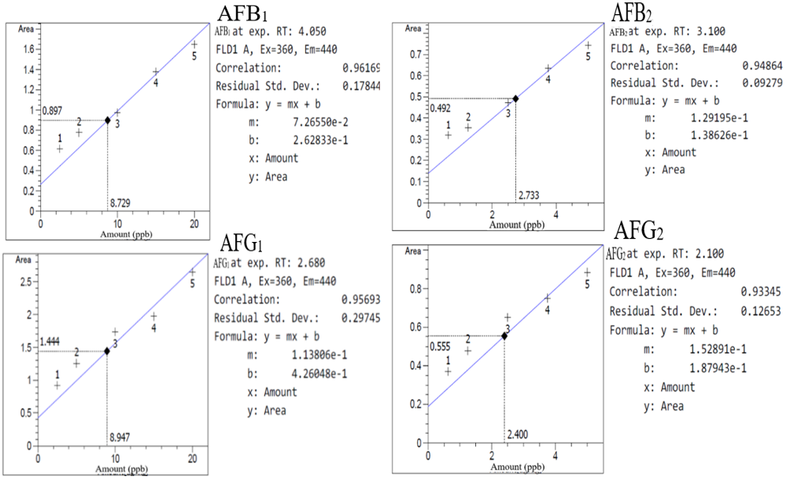

**Figure 4.: Regression curves of aflatoxins (B1, B2, G1 and G2) respectively**

*2.3.4.5 Results of experimental data*

Good linearity or coefficients of correlations (R² > 0.90) within the tested range was obtained for groundnut flour samples, as shown in Figure 5.

Repeatability for aflatoxin: Standard deviation calculated was AFB1 = 4.71 %, AFB2 = 6.88 %, AFG1 = 6.47 %, AFG2 = 8.07%, and AFtotal = 5.98 %.

Reproducibility: Standard deviation calculated was AFB1 = 13.23 %, AFB2 = 13.41 %, AFG1 = 13.71 %, AFG2 = 12.16%, and AFtotal = 13.33 %.

Recovery: The measuring procedure's recovery percentage was, at low concentration, AFB1 = 102.8 %, AFB2 = 113.6 %, AFG1 = 98.8%, AFG2 = 100.8%, and AFtotal = 108.2%, and at high concentration, AFB1 = 98.3 %, AFB2 = 95 %, AFG1 = 102.15 %, AFG2 = 98.8%, and AFtotal = 102.3 %.

Linearity: A regression curve's linearity revealed; AFB1 = 0.96169, AFB2 = 0.94864, AFG1 = 0.95693, and G2 = 0.93345.

Chemicals;

Methanol, hexane, and acetonitrile of HPLC grade were bought from VWR Chemicals in France; deionized water was purchased from Millipore Co. in Bedford, Massachusetts, in the United States of America.

Using PBS tablets from Sigma-Aldrich, distilled water was used to create a phosphate-buffered solution (PBS).

Sourced from Sigma-Aldrich was sodium chloride (reagent grade, 99.0 %). Trilogy Lab, located in the United States, supplied a mixed standard solution of AFB1, AFB2, AFG1, and AFG2 dissolved in methanol.

*2.3.4.6 Safety precautions and limitations*

Since aflatoxins are cancer-causing substances, only well-ventilated fume hoods were used to handle solutions, extracts, and samples, and disposable latex gloves were worn at all times.

Laboratory equipment, pipette tips, and reagent components were cleaned of any remaining aflatoxin residues using a 10 % solution of regular household bleach before being discarded.

Aflatoxin spills were unintentionally cleaned up with 5 % NaOCl bleach.

**2.5 Data Analysis**

The statistical analysis was performed using the IBM Statistical Program for Social Scientists (SPSS), version 20 (IBM Inc.).

Descriptive statistics were used to summarize the data.

The aflatoxin concentrations were calculated using regression analysis from the curves derived from the standards of the aflatoxins with Excel for Microsoft Windows (version 10).

Mean and standard deviation (Mean ± SD) of triplicates and ranges, including percentages, were used to report descriptive statistical analysis.

The discrepancies between the sample mean values were compared using analysis of variance (ANOVA).

3. Results and discussion

Typical HPLC chromatograms of the aflatoxin (B1, B2, G1, and G2) separation of the components from groundnut flour samples were presented in Figure 5

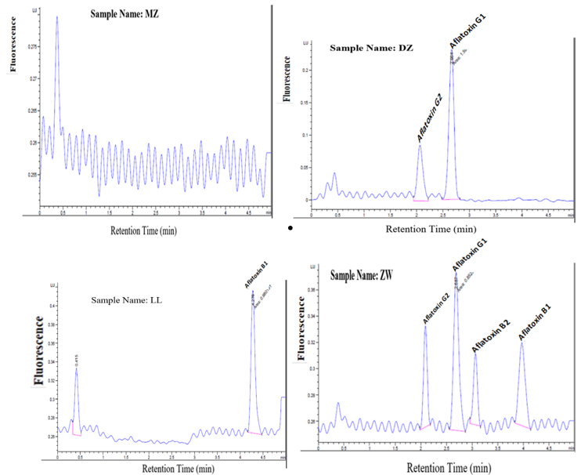**Figure 5*.* Typical HPLC Chromatograms of aflatoxins separation**

Levels of aflatoxin contamination in groundnut flour are presented in Tables 1 and 2, respectively.

**Table 1: Levels of Aflatoxin in Groundnut Flour (Central Region)**

|  |  |  |  |  |  |
| --- | --- | --- | --- | --- | --- |
| **Aflatoxin concentrations (ppb)** | | | | | |
| Market | AFB1 | AFB2 | AFG1 | AFG2 | AFtotal |
| CA | 8.45±0.51 | 3.91±0.09 | 0.60±0.53 | n.d | 12.96±1.13 |
| CMA | 1.94±0.15 | 0.97±0.06 | 1.00±1.73 | n.d | 3.90±1.94 |
| DA | 0.33±0.58 | n.d | n.d | n.d | 0.33±0.58 |
| DZ | n.d | n.d | 10.88±1.21 | 3.23±0.42 | 14.11±1.62 |
| KO | 5.90±0.27 | 3.67±0.58 | 3.47±0.99 | 1.33±0.58 | 14.37±2.41 |
| KU | 2.20±0.46 | 3.67±2.08 | 1.32±0.89 | 0.33±0.58 | 7.52±4.02 |
| LD | 0.33±0.58 | n.d | n.d | n.d | 0.33±0.58 |
| LL | 10.49±1.18 | n.d | n.d | n.d | 10.49±1.18 |
| MA | 6.67±2.52 | 1.00±0.00 | n.d | n.d | 7.67±2.52 |
| MC | 0.33±0.58 | n.d | n.d | n.d | 0.33±0.58 |
| MD | 0.67±1.16 | 0.33±0.58 | n.d | n.d | 1.00±1.73 |
| MP | 1.33±1.53 | 0.33±0.58 | n.d | n.d | 1.67±2.11 |
| MV | 7.32±2.09 | 3.67±0.58 | 2.00±0.00 | 1.00±0.00 | 13.98±2.67 |
| NA | 1.00±1.00 | n.d | n.d | n.d | 1.00±1.00 |
| NKA | 9.39±0.56 | 4.40±0.44 | 1.33±1.15 | 0.33±0.58 | 15.45±2.73 |
| SA | 1.72±0.15 | 6.99±0.06 | 2.13±0.01 | 0.33±0.58 | 11.18±0.82 |

Notes: The means ± standard deviations of triplicate determination values were presented.

N. d. = not detected

Key: CA = Chamama, CMA = Chatoloma, DA = Dowa, DZ = Dedza, KO = Kamwendo, KU = Kasungu, LD = Lumbadzi, LL = Lilongwe, MA = Mkanda, MC = Mchinji, MD = Mitundu, MP = Mponela, MV = Mvera, NA = Nambuma, NKA = Nkhamenya, and SA = Salima local market.

**Table 2: Levels of Aflatoxin in Groundnut Flour (Southern Region)**

|  |  |  |  |  |  |
| --- | --- | --- | --- | --- | --- |
| **Aflatoxin concentrations (ppb)** | | | | | |
| Market | AFB1 | AFB2 | AFG1 | AFG2 | AFtotal |
| BA | 5.90±0.10 | 0.27±0.12 | 2.67±0.58 | 0.33±0.58 | 9.17±1.37 |
| BE | 0.33±0.58 | n.d | n.d | n.d | 0.33±0.58 |
| BT | 4.00±0.01 | 2.00±1.00 | 0.67±0.58 | n.d | 6.67±1.58 |
| CE | 0.67±0.58 | 0.10±0.17 | n.d | n.d | 0.77±0.75 |
| CU | 2.92±0.27 | 1.85±0.17 | n.d | n.d | 4.77±0.44 |
| GA | 7.01±0.11 | 2.68±0.41 | 1.33±0.58 | 0.33±0.58 | 11.36±1.67 |
| GI | 3.06±0.04 | 1.00±0.00 | 0.33±0.58 | n.d | 4.39±0.61 |
| LB | 11.82±0.75 | 3.52±0.17 | 13.00±0.67 | n.d | 28.34±1.58 |
| LE | 9.60±0.21 | 6.00±0.05 | 8.97±0.06 | 2.78±0.36 | 27.35±0.68 |
| LU | 5.90±0.32 | n.d | 5.17±0.36 | n.d | 11.07±0.68 |
| MJ | 11.54±1.56 | 8.00±1.00 | 6.00±0.00 | 2.33±0.58 | 27.87±3.14 |
| ML | 66.00±14.73 | 3.49±0.45 | 5.59±1.32 | 2.00±0.00 | 77.08±16.50 |
| MN | 6.67±1.16 | 3.67±0.58 | 0.67±0.58 | n.d | 11.00±2.31 |
| MR | 5.59±1.08 | 4.33±0.58 | 4.63±1.27 | 1.00±0.00 | 15.56±2.93 |
| MZ | n.d | n.d | n.d | n.d | n.d |
| NJ | 7.78±0.29 | 4.30±0.52 | 3.57±0.41 | 2.33±0.58 | 17.99±1.79 |
| NO | 9.51±2.08 | 5.33±1.53 | 3.46±0.07 | 2.33±0.58 | 20.63±4.25 |
| NX | 5.27±1.06 | n.d | 5.20±0.33 | n.d | 10.47±1.39 |
| TO | 2.54±0.34 | n.d | n.d | n.d | 2.54±0.34 |
| UL | 9.83±0.15 | 3.84±0.29 | 1.33±0.58 | 0.33±0.58 | 15.33±1.59 |
| ZA | 19.44±0.49 | 4.02±0.09 | 1.00±0.00 | 0.33±0.58 | 24.79±1.16 |
| ZW | 3.33±0.48 | 1.13±0.13 | 3.48±0.42 | 1.18±0.13 | 9.11±1.16 |

Notes: The means ± standard deviations of triplicate determination values were presented.

N.d. = not detected

Key: BA = Balaka, BE = Bvumbwe, BT = Blantyre, CE = Chingale, CU = Chiradzulu, GA = Govala, GI = Goliati, LB = Limbe, LE = Liwonde, LU = Lunzu, MJ = Mulanje, ML = Muloza, MN = Mwanza, MR = Manjawira, MZ = Mbulumbuzi, NJ = Njuri, NO = Nkando, NX = Ndirande, TO = Thyolo, UL = Ulongwe, ZA = Zomba, and ZW = Zalewa local market.

Typical HPLC chromatograms of the aflatoxins (B1, B2, G1, and G2) separation of the components of samples (Figure 5).

Sample code MZ illustrates the HPLC chromatogram of an aflatoxin-free groundnut flour sample, while ZW shows a contaminated sample with AFB1 (3.33 ± 0.48 ppb), AFB2 (1.13 ± 0.13 ppb), AFG1 (3.48 ± 0.42 ppb), and AFG2 (1.18 ± 0.13 ppb), respectively.

Sample MZ depicts an HPLC chromatogram of the aflatoxin-free groundnut flour, while sample LL depicts an HPLC chromatogram of the aflatoxin contamination with AFB1 (10.49 ± 1.18 ppb), DZ AFG2 (3.23 ± 0.42 ppb), and AFG1 (10.88 ± 1.21 ppb), and ZW contaminated with all 4 types of AFs studied: AFB1 (3.33 ± 0.48), AFB2 (1.13 ± 0.13), AFG1 (3.48 ± 0.42), and AFG2 (1.18 ± 0.13), respectively.

The results of various levels of aflatoxin contamination in groundnut flour have been illustrated in Tables 1 and 2, respectively.

In almost every local market, there are AFB1, AFB2, AFG1, and AFG2.

In this investigation, 97.37% of the samples were contaminated with aflatoxin of a particular type. However, not every sample that tested positive for aflatoxins included AFB1, as was commonly expected [36].

Aflatoxin B1 was found in 94.74% of the samples alongside AFB2, AFG1, and AFG2, respectively.

Groundnut samples from the homesteads of Nkhotakota, Mchinji, and Kasungu in the central region of Malawi were found to contain 98.03% of aflatoxin B1 [27].

Aflatoxin B1 was the most prevalent pollutant, followed by AFB2, AFG2, and AFG1 in that order [37].

The very dangerous aflatoxin B1 is the prevalent aflatoxin in groundnuts and cereals [36].

The contamination level of AFB1, ranging from 0 to 66.00 ± 14.73 ppb, with a total aflatoxin of 77.08 ± 16.50 ppb, was found in the samples, and this was interestingly 65.79 than the regulatory limits used in Malawi (3 ppb) and the EU (4 ppb), respectively.

These findings concur with those presented in the literature, which reported that contamination by AFB1 ranged from 273 to 18,423 ppb in 50% of the groundnut samples obtained from the nearby peanut butter processing industry [38].

The contamination level of AFB2 in groundnut flour samples ranged from 0 ppb to as high as 8.00 ± 1.00 ppb, with AFtotal of 27.87 ± 3.14 ppb, and this was higher than the 4-ppb limit set by the EU.

The contamination levels of AFG1 (mean = 10.88 ± 1.21 ppb) were higher than the levels of AFB1 and AFB2 for samples purchased from Dedza (DZ) and Limbe (LB) local markets, respectively.

Only 25 samples (65.79%) detected the contaminant AFG1 with a mean concentration ranging from 0 ppb to 13.00 ± 0.67 ppb, with AFtotal of 28.34 ± 1.58 ppb.

The contaminant AFG2 was only present in 17 samples (44.74%) of G/nut flour, with a mean concentration ranging from 0 ppb to 3.23 ± 0.42 ppb, and total aflatoxin was 14.11 ± 1.62 ppb.

Groundnut flour samples used in southwestern Ugandan recipes contained aflatoxins up to 100% [39].

Nevertheless, all 38 samples in this investigation had total aflatoxin levels ranging from 0 ppb to 77.08 ppb.

In the present study, 97.37% of samples yielded a total aflatoxin of about 15.45 ± 2.73 ppb from the Central Region and 77.08 ± 16.50 ppb obtained from Southern Region local markets, respectively.

All these results were significantly (p < 0.05) greater than mandated toxin quantity limitations set by the MBS (3 ppb) and EU (4 ppb) for total aflatoxin. The Codex Alimentarius Commission's limitations were acknowledged by the World Trade Organization's Sanitary and Phytosanitary (SPS) Agreements as the benchmarks that will be used to resolve international trade disputes [50]. The WHO/FAO joint Codex Alimentarius Commission, the global food safety regulatory organization, sets stricter regulations, while developed nations with superior scientific and technical capabilities typically accept lower restrictions [50].

Overall, 28 of 38 samples were above the regulatory limit for Malawi (3 ppb) and the EU (4 ppb), respectively.

It can be inferred that there is still a problem with aflatoxin contamination in Malawi despite the various warnings and education programs provided to farmers as well as traders by stakeholders.

These findings were particularly in agreement with the observations recorded by other researchers in the literature, who reported above 30 ppb of aflatoxin content in all the raw groundnut samples analyzed and demonstrated that the aflatoxin level was above the permitted universal limit of 4 ppb issued by the EU [16].

Furthermore, groundnuts and groundnut-derived products purchased from Malawian farms and neighborhood retail markets have been shown to contain high contamination levels of aflatoxin [8].

Aflatoxin prevalence and concentrations in Malawian commercial groundnut products showed that groundnut flour from vendors had total aflatoxin contamination levels ranging from 83 to 820 ppb, and these levels were found in approximately 93, 88, 78, and 72% of the samples investigated [26].

According to the locations of the samples, the types and amounts of aflatoxin often followed this pattern: AFB1, AFB2, AFG1, and AFG2 are listed in that order [40].

According to several types of studies conducted over the past ten years, groundnut aflatoxin poisoning is a major problem in several countries in Southern Africa, including Malawi [41].

Aflatoxin was more prevalent in groundnut products, such as nsinjiro, than in unprocessed dried seeds, due to the possibility of exposure to many environmental variables, such as high temperatures, humidity, oxygen, and mold. Processed groundnut, which is typically created from subpar groundnut, may become more contaminated with aflatoxin [18].

Wide variations in total aflatoxin, ranging from the limit of detection (LOD) to 15.45 ± 2.73 ppb and LOD to 77.08 ± 16.50 ppb, were observed among the samples purchased from various local markets across the 2 regions under study.

Interestingly, samples from the same region showed high and low levels of aflatoxin concentration.

For instance, samples from the Mbulumbuzi (MZ) local market in the Southern Region did not contain any aflatoxin, whereas samples from Muloza (ML) in the same region (Table 2) had the greatest aflatoxin contamination (mean = 77.08 ppb).

Additionally, while Dowa (DA), Lumbadzi (LD), and Mchinji (MC) local markets (Table 1) registered low aflatoxin (mean = 0.33 ppb) contamination in the Central Region, Nkhamenya (NKA) local market belonging to the same region recorded 15.45 ppb mean total aflatoxin, respectively.

However, total aflatoxin levels in different marketplaces were generally greater in Southern Region local markets than in Central Region.

According to Njoroge et al. [8], normally, vendors/sellers use visual assessment of groundnut kernels to check their quality and milling into flour, which is impractical.

The tendency of vendors sprinkling water to soften the groundnut pods before shelling enhances the moisture content in the kernel, which eventually produces conditions that are favorable for the growth of mold and the generation of aflatoxin [42].

Groundnuts obtained from the local markets were highly contaminated with aflatoxin (73%), exceeding the European Union's acceptable limit [43].

The aflatoxin levels in the G/nut flour used in this study (up to 77.08 ppb) are significantly lower than the levels (1,600-12,000 ppb) that resulted in deaths in the two fatal outbreaks of aflatoxin poisoning in Kenya [44].

Cumulative intakes of small amounts of aflatoxin may exacerbate other clinical conditions [45]. In comparison to AFB and AFG, AFB1 contributes significantly to the general population's risk of developing aflatoxin-induced cancer, according to a United Nations report by the WHO and FAO [46].

The findings of this research (77.08 ppb) were somewhat lower, comparable to the aflatoxin levels (91.2 ppb) found in Nigeria [45].

This may be owing to certain advantageous intrinsic characteristics, such as nutrient composition and moisture content, as well as external factors, such as temperature, relative humidity, and mechanical damage brought on by insect and rodent attacks [47, 48].

The milling procedure used by vendors/sellers in the local markets to make the groundnut flour is thought to have a dilution effect, causing low amounts of aflatoxin to be found in a significant majority of the samples [49].

Compared to type B aflatoxin, type G aflatoxin is a far less common pollutant.

As noted in Tables 1 and 2, thirteen (13) samples contain very low levels of total aflatoxin, ranging from 0 to 4.77 ppb.

Nonetheless, a substantial level of contamination, surpassing 20 ppb of total aflatoxin, was also found in 6 samples, which is a hint that the groundnut flour may contain levels of aflatoxin that pose a health risk.

More research would be required on the variables that may increase aflatoxin contamination at various phases of the production of groundnut flour to reduce this risk.

Although these 6 samples, surpassing 20 ppb, included in the study (15.79%) came from the Southern Region, it is important to note that this does not represent the prevalence of aflatoxin in Malawi because the Southern Region of Malawi is where the aflatoxin issue is most severe [5]. According to Jallow et al. (50), aflatoxin is a significant issue for food safety, particularly in Malawi, where regulations are either nonexistent or insufficiently enforced.

Even though this study used a small sample size, the results nonetheless demonstrate that the groundnut flour offered in local markets in Malawi's Central and Southern Regions was contaminated with levels of aflatoxin that were higher than tolerable, exposing people to the risk of harm.

4. Conclusion

The present findings confirm the general status of aflatoxin in groundnut flour (nsinjiro) sold from various local marketplaces in Malawi.

There is still a problem with aflatoxin contamination in the studied regions of Malawi.

About 97.37% of the samples studied were positive for aflatoxin.

Aflatoxin contamination of groundnut flour from various local markets of Malawi is thus a concern for food security, public health, and economic gains.

The presence of aflatoxin in groundnut flour at the local market level indicates that current groundnut flour handling procedures are ineffective.

To better convey the benefits of purchasing and consuming low-risk products, promotion of awareness is required throughout the value chain for groundnuts, particularly for consumers.

As a result, the processed nsinjiro contains aflatoxin safety risks, which must be eliminated (or reduced) by using quality management techniques like HACCP and raw groundnut seed supply quality assurance.

This would greatly prevent contamination that may be brought on by consuming groundnut-derived products, such as nsinjiro, that have been incorrectly manufactured, while also increasing public awareness of the product's nutritional advantages.

Furthermore, these results indicate that the groundnut flour studied was susceptible to aflatoxin contamination; hence, aflatoxin monitoring in groundnut flour before marketing is required.

**Ethical Approval:**

As per international standards or university standards written ethical approval has been collected and preserved by the author(s).

Disclaimer (Artificial Intelligence)

The author(s) hereby declare that NO generative AI technologies such as Large Language Models (ChatGPT, COPILOT, etc.) and text-to-image generators have been used during the writing or editing of this manuscript.

References

1. United States Department of Agriculture (USDA) (2020). World Agricultural Production; USDA: Washington, DC, USA.
2. Food and Agriculture Organization Statistics (FAOSTAT) (2022). Food and Agriculture Organization of the United Nations.
3. Ngwira Amos, Chunga Paul, Siyeni Donald, Chintu Justus, & Chunga Paul (2019). "Guide for Groundnut, Pigeon Pea, Sorghum, and Finger Millet Production in Malawi."
4. Scheme, Gezira, Babiker O., Mahgoub, Sara A. E., Ali, Omima A., Mirghani (2017). “Technical Efficiency Analysis of Groundnut Production.” 7(1):6–11.
5. Matumba, L., Poucke, C., Van Monjerezi, M., Ediage, E. N., De Saeger, S. (2015). Concentrating aflatoxins on the domestic market through groundnut export: a focus on Malawian groundnut value and supply chain. Food Control. 236–239. DOI: 10.1016/j.foodcont.2014.11.035.
6. Chisinga B, Matita M. (2021). The political economy of the groundnut value chain in Malawi: its re-emergence amidst policy chaos, strategic neglect, and opportunism. (March).
7. Vroegindewey, R., Theriault, V., Richardson, R., & Chung, K. (2019). Feed the Future Innovation Lab for Food Security Policy. Res Pap 147;1–30.
8. Njoroge S.M.C., Matumba L., Kanenga K., Siambi M., Waliyar F., & Maruwo J., et al. (2017). Aflatoxin B1 levels in groundnut products from local markets in Zambia. Mycotoxin Res [Internet];33(2):113–9. http://dx.doi.org/10.1007/s12550-017-0270-5
9. Gama A.P., Adhikari K., & Hoisington D. A. (2018). Peanut consumption in Malawi: An opportunity for innovation. Foods;7(7):1–13.
10. Anitha, S., Tsusaka, T. W., Njoroge, S. M. C., Kumwenda, N., Kachulu, L., & Maruwo et al. (2019). Knowledge, attitude, and practice of Malawian farmers on pre- and post-harvest management to mitigate aflatoxin contamination in groundnut, maize, and sorghum—implication for behavioral change. Toxins, 2; 11(12). https://doi.org/10.3390/toxins11120716.
11. Khlangwiset P, Shephard GS, & Wu F. (2011). Aflatoxins and growth impairment: A review. Crit Rev Toxicol.; 41(9):740–55.
12. Lilongwe M. (2013). Advancing collaboration for effective aflatoxin control in Malawi. Malawi Program Aflatoxin Control [Internet]; 1–52. http://www.aflatoxinpartnership.org/uploads/MAPAC_STDF_PPG_400_FinalReport_Sep-13_0.pdf
13. Chitu, Justus, Wills Munthali, Rick Brandenburg, & Dave Hoisington (2021). “Guide to Groundnut Production in Malawi.” (August):15.
14. Zamrodah Y. (2021). Key limitations of fish feeds, feed management Afr. J. Food Agric. Nutr. Dev.; 21(2): 17415-17434 https://doi.org/10.18697/ajfand.97.20455 practices and opportunities in Kenya’s aquaculture enterprise. 2016;15(2):1–23.
15. Tahir, N. I., Hussain, S., Javed, M., Rehman, H., Shahzady, T. G., & Parveen et al. (2018). Nature of aflatoxins: Their extraction, analysis, and control. 2018.
16. Odeniyi, O., Ojo, C., Adebayo-Tayo, B., & Olasehinde, K. (2019). Mycological, toxigenic, and nutritional characteristics of some vented groundnut and groundnut products from three Northern Nigerian ecological zones. African Journal of Biomedical Research; 22 (1), 65–71.
17. Misihairabgwi, J. M., Ezekiel, C. N., Sulyok, M., Sherpard, G. S., & Krska, R. (2019). Mycotoxin contamination of foods in Southern Africa: A 10-year review (2007-2016). Critical Reviews in Food Science and Nutrition 59: 43-58.
18. Udomkun, P., Mutegi, C., Wossen, T., Atehnkeng, J., Nabahungu, N. L., & Njukwe et al. (2018). Occurrence of aflatoxin in agricultural produce from local markets in Burundi and the Eastern Democratic Republic of Congo. Food Science and Nutrition; 6(8), 2227–2238. https://doi.org/10.1002/fsn3.787.
19. Anon (2022). The Malawi draft “Groundnut Flour – Specification Groundnut Flour – Specification.”
20. Kortei, N. K., Annan, T., Akonor, P. T., Richard, S. A., Annan, H. A., Kwagyan et al. (2021). Aflatoxins in randomly selected groundnuts (Arachis hypogaea) and their products from some local markets across Ghana: Human risk assessment and monitoring. Toxicology Reports; 8, 186–195. https://doi.org/10.1016/j.toxrep.01.002
21. Dhanasekaran, D., Shanmugapriya, S., Thajuddin, N., & Panneerselvam, A. (2011). Aflatoxins and aflatoxicosis in humans and animals. Bharathidasan University. https://doi.org/DOI:10.5772/22717
22. Tiwari, S., & Joshi, E. (2019). Breeding for foliar disease resistance in groundnut using conventional and molecular approaches. 2019.
23. Food and Agriculture Organization Statistics (FAOSTAT) (2019). Food and Agriculture Organization of the United Nations.
24. Derlagen, C., & Phiri, H. (2019). Analysis of incentives and disincentives for groundnuts in Malawi (version 1; not peer-reviewed). Gates Open Research; 3(1021). https://doi.org/10.21955/gatesopenres.1115952.1.
25. Chisinga, Blessings, & Mirriam Matita (2021). “The Political Economy of the Groundnut Value Chain in Malawi: Its Re-Emergence amidst Policy Chaos, Strategic Neglect, and Opportunism.”
26. Magamba, K., Matumba, L., Matita, G., Gama, A. P., Singano, L., & Monjerezi, et al. (2017). Aflatoxin risk management in commercial groundnut products in Malawi (Sub-Saharan Africa): a call for a more socially responsible industry. Journal Fur Verbraucherschutz Und Lebensmittelsicherheit, 2017; 12 (4), 309–316. https://doi.org/10.1007/s00003-017-1129-6.
27. Seetha, A., Monyo, E. S., Tsusaka, T. W., Msere, H. W., Madinda, F., & Chilunjika, et al. (2018). Aflatoxin-lysine adducts in blood serum of the Malawian rural population and aflatoxin contamination in foods (groundnuts, maize) in the corresponding areas. Mycotoxin Res.; 34(3):195–204. DOI: 10.1007/s12550-018-0314-5.
28. Jere, A. D., Mwangwela, A. M., Mlotha, V., Phan, U. T. X., & Adhikari, K. (2020). Acceptability of traditional cooked pumpkin leaves seasoned with peanut flour processed from blanched, deshelled, and raw peanuts of different varieties. Scientific African; 10, e00598. https://doi.org/10.1016/j.sciaf.e00598.
29. Onawo, A. S., & Adamu, M. O. (2018). Microbiological Profile and Quality Assessment of Unbranded Groundnut Oil Marketed in a Major City in Nigeria, Sub-Saharan Africa. Invention Journal of Research Technology in Engineering and Management; 2 (1): 36-43.
30. European Food Safety Authority (EFSA) (2022). Aflatoxins (Sum of B1, B2, G1, and G2) in Cereals and Cereal-Derived Food Products; Wiley Online Library: Hoboken, NJ, USA, 2022; 2013; pp. 2397–8325. https://www.efsa.europa.eu/en/supporting/pub/en-406
31. Mwalwayo, D. S., & Thole, B. (2016). Prevalence of aflatoxin and fumonisins (B1 + B2) in maize consumed in rural Malawi, (3) 173–179. DOI: 10.1016/j.toxrep.01.010.
32. Moore & Heather (2019). Malawi is located in Africa as a landlocked country that borders Tanzania, Zambia, and Mozambique. “Malawi Location.” 1–8.
33. Adam Andreski, Charles Kaira & Jephthah Chagunda. (2005). Accessibility, Rural, The Rural Accessibility, Travel Project, Road Engineer. “Seminar: Sustainable Access and Local Resource Solutions Date: 28–30 November: Rural Accessibility and Mobility in Ntchisi District, Malawi.
34. Makate, C., & Mango, N. (2017). Diversity amongst farm households and achievements from the multi-stakeholder innovation platform approach: Lessons from Balaka, Malawi. Agriculture and Food Security; 6(1), 1–15. https://doi.org/10.1186/s40066-017-0115-7.
35. European Committee for Standardization (2003). Foodstuffs—Determination of Aflatoxin B1 and the Sum of Aflatoxin B1, B2, G1, and G2 in Peanuts, Pistachios, Figs, and Paprika Powder—High-Performance Liquid Chromatographic Method with Post-column Derivatization and Immunoaffinity Column Clean-up. 2003. <https://doi.org/https://doi.org/10.1016/j.gfs.2019.09.006>.
36. Oliveria, C. A. F., Goncalves, N. B., & Rosim, R. E. (2009). Determination of aflatoxins in peanut products in the northeast region of São Paulo, Brazil. Int J Mol Sci 2009; 10:174e83.
37. Mutegi, C. K., Ngugi, H. K., Hendriks, S. L., & Jones, R. B. (2008). Prevalence and factors associated with aflatoxin contamination of peanuts from Western Kenya. International Journal of Food Microbiology, 2009; 130, 27–34. https://doi.org/10.1016/j.ijfoodmicro.12.030.
38. Patil, H., Shah, N. G., Hajare, S. N., Gautam, S., & Kumar, G. (2009). Combination of microwave and gamma irradiation for reduction of aflatoxin B1 and microbiological contamination in peanuts (Arachis hypogaea L.); 12(3), 269–280. https://doi.org/10.3920/WMJ.2384.
39. Omara, T., Nassazi, W., Omute, T., Awath, A., Laker, F., Kalukusu, R., Musau, B., Nakabuye, B., V., Kagoya, S., Otim, G., & Adupa, E. (2020). Aflatoxins in Uganda: An Encyclopedic Review of the Etiology, Epidemiology, Detection, Quantification, Exposure Assessment, Reduction, and Control. International Journal of Microbiology. https://doi.org/10.1155/4723612.
40. Quinto, M., Spadaccino, G., Palermo, C., & Centonze, D. (2009). Determination of aflatoxins in cereal flours by solid-phase microextraction coupled with liquid chromatography and post-column photochemical derivatization-fluorescence detection. J. Chromatogr. A 1216, 8636–8641.
41. Monyo, E. S., Njoroge, S. M. C., Coe, R., Osiru, M., Madinda, F., Waliyar, F., & Anitha, S. (2012). Occurrence and distribution of aflatoxin contamination in groundnuts (Arachis hypogaea L.) and population density of aflatoxigenic Aspergilli in Malawi. Crop Protection, 42, 149-155. doi: 10.1016/j.cropro.07.004.
42. Mupunga, I., Mngqawa, P., & Katerere, D. R. (2017). Peanuts, aflatoxins, and undernutrition in children in Sub-Saharan Africa. Nutrients 9(12), 1–12. https://doi.org/10.3390/nu9121287.
43. Waliyar, F., Osiru, M., Siambi, M., & Chinymunyamu, B. (2010). Assessing the occurrence and distribution of aflatoxins in Malawi. ICRISAT; 1–40.
44. Codex Alimentarius Commission (2019). Discussion paper on the establishment of maximum levels for total aflatoxins in cereals (wheat, maize, sorghum, and rice), flour, and cereal-based foods for infants and young children. http://www.fao.org/fao-who-codexalimentarius/sh-proxy/en/?lnk=1&url=https%253A%.
45. Oyedele, O. A., Ezekiel, C. N., Sulyok, M., Adetunji, M. C., Warth, B., & Atanda et al. (2017). Mycotoxin risk assessment for consumers of groundnut in domestic markets in Nigeria. International Journal of Food Microbiology, 251, 24–32, doi: 10.1016/j.ijfoodmicro.03.020.
46. Joint FAO; World Health Organization; WHO Expert Committee on Food Additives (2021). Evaluation of Certain Contaminants in Food: Eighty-Third Report of the Joint FAO/WHO Expert Committee on Food Additives; World Health Organization: Geneva, Switzerland.
47. Atanda, S. A., Pessu, P. O., Agoda, S., Isong, I. U., Adekalu, O. A., & Echendu, M. A. (2011). Fungi and mycotoxins in stored foods. Afr J Microbiol Res; 5(25):4373e82.
48. Smith, L. E., Stasiewicz, M., Hestrin, R., Morales, L., Mutiga, S., & Nelson, R. J. (2016). Examining environmental drivers of spatial variability in aflatoxin accumulation in Kenyan maize: potential utility in risk prediction models. Afr J Food, Agric Nutr Dev, 16(3), 11086-105.
49. Sugri, I., Moses, O., Asamoah, L., Samuel, B. S. J., Stephen, N. K., Yahaya, A., & Lamini, S. (2015). Journal of Stored Products and Postharvest Research Aflatoxin management in Northern Ghana: Current prevalence and prioritization Aflatoxin management in Northern Ghana: Current prevalence and priority strategies in maize (Zea mays L.). Journal of Stored Products and Postharvest Research, 6(6), 48–55. <https://doi.org/10.5897/JSPPR2015.0184>.
50. Jallow, A., Li, P., & Xie, H. (2021). Worldwide aflatoxin contamination of agricultural products and foods: From occurrence to control. August 2020, 2332–2381. https://doi.org/10.1111/1541-4337.12734