*Review Article*

Nature’s Therapeutic Marvel: Resveratrol’s Journey from Plant Defense to Human Health

**ABSTRACT**

Resveratrol is a natural polyphenol found in plants and fruits like grapes, berries, and peanuts, and is notably present in red wine. It acts as a phytoalexin, produced in response to stress or pathogen attack. Its content is influenced by eco-geographic factors such as humidity and soil type, both affected by climate change. Resveratrol gained scientific interest due to its antioxidant potential and cardiovascular benefits, initially linked to the 'French paradox'—a phenomenon where low coronary heart disease incidence in France was observed despite high saturated fat intake. This prompted investigations into wine components as protective agents. Subsequent epidemiological and laboratory studies suggested resveratrol may reduce cardiovascular risk by inhibiting platelet aggregation and oxidative damage to LDL cholesterol, thus preventing arterial plaque formation. These findings proposed a mechanism for its cardio protective effects. On-going in vitro and in vivo research continues to explore resveratrol's role in aging and disease prevention. Resveratrol is noted for its antioxidant, anti-inflammatory and cardioprotective actions, as well as its anticarcinogenic and neuroprotective potential. However, its main limitation is its low bioavailability: it is rapidly absorbed and eliminated by the body, which reduces its real effectiveness. The main objective of the study was to review the available scientific evidence to understand the health benefits of resveratrol and, above all, to analyze how to overcome its main limitation: low bioavailability. Among the most significant findings, it stands out that new formulations such as nanoparticles, controlled-release systems, the use of derivatives like pterostilbene, and the interaction with gut microbiota can improve its absorption and prolong its effect in the body, thus increasing its real effectiveness.

**Keywords:** Resveratrol, polyphenol, antioxidant, disease, oxidative stress, grapes and climate change.

**INTRODUCTION**

Resveratrol is a non-flavonoid polyphenol possesses many biological properties with great potential to develop into various products. The highest concentrations of resveratrol, a polyphenol, are found in the roots of an Asian plant called *Polygonum japonicum,* a Japanese knotweed used in oriental medicine and in various tea products (Yousef *et al*., 2017). Grapes, peanuts, and red wine also have a high content of this natural polyphenol (Guthrie *et al*., 2017). The actions of this important natural phytonutrient include various biological effects such as antioxidant, anti-inflammatory, cardioprotective, neuroprotective, anti-diabetic, hepatoprotective, cytotoxic effects on numerous tumour cells and anti-ageing (Zhou *et al.*, 2021). During the 20th century, it was observed that it was possible to extend the lifespan of cells in certain organisms by calorie restriction. However, a simple low-calorie diet was not enough to achieve the same results in humans (Ozonas and Angosto, 2016). In response to this, researchers began to investigate a family of enzymes known as Sirtuins (Guarente, 2011), aiming to find alternatives capable of replicating the effects of calorie restriction to extend human lifespan. Human SIRT1 was found to be essential for regulating the health and longevity of human cells, supporting the body's natural defences and increasing the body's reparative functions, and consequently its natural survival capacity (Bridger *et al.*, 2016). Resveratrol in high concentrations can activate human SIRT1 and extend cell life. Among the three enzymes tested (yeast Sir2, human SIRT1 and human SIRT2), only SIRT1 showed significant enzyme activation (Side *et al.*, 2011). Sirtuins are able to decrease oxidative stress in cells while supporting their survival under adverse conditions, promoting DNA repair and increasing their energy efficiency (López-Otin *et al.*, 2013; Fontana and Partridge, 2015). Plant foods rich in antioxidants are the ones that predominantly activate SIRT1. They do not contain Sirtuins, rather, they contain compounds, such as resveratrol, quercetin, curcumin and catechins, that can activate its production (LLacuna and Mach, 2012). Therefore, foods not only have energetic and plastic functions, but may also have the ability to protect us against free radicals, preventing cellular oxidation, a process that would lead to general physiological ageing and the onset of cardiovascular and degenerative diseases, as well as different types of cancer (Tomás-Barberan, 2003).

Antioxidants in food can help to prevent some of these processes, but also to alleviate or slow down some of these diseases (Mishra *et al.*, 2019; Pradhan *et al*., 2020; Serra Bisbal*et al*., 2020). Since the initial approach in the 1990s following the French paradox of high saturated fat consumption and low incidence of coronary heart disease, an increasing number of studies, both *in vitro* and *in vivo*, have been conducted with the aim of discovering the mechanism by which resveratrol can slow the ageing process (Raederstorff *et al.*, 2013). The antioxidant capacities of resveratrol (Bai *et al.*, 2013; Raederstorff *et al.*, 2013) protect the DNA of cells by increasing the activity of telomerase (Liu *et al.*, 2013), an enzyme in cells that helps them stay alive by adding DNA to telomeres (the ends of chromosomes). Each time a cell multiplies, telomeres lose a small amount of DNA and shorten. Over time, the chromosomes become damaged, and the cells die. Telomerase helps prevent this from happening (Liu *et al.*, 2013). Cancer cells typically have more telomerase than most normal cells. Moreover, resveratrol also protects mitochondria, in addition to its anti-inflammatory action (Olesen *et al.*, 2013) and its ability to affect the expression of certain longevity-related genes, crucial to its protective and anti-aging mechanism (Das *et al.*, 2011).

**MATERIALS AND METHODS**

**Methodological design**

A literature review was conducted on scientific studies indexed in the main scientific databases: PubMed, Google Scholar, SciELO, Academia.edu, Springerlink, Dialnet and Medline.

**Information search strategy**

The literature search was limited, preferably to the last few years, including papers written in Spanish or English. The keywords "resveratrol", "polyphenol", "antioxidant", "oxidative stress", "resveratrol diseases", including their Spanish translations, were used.

**Inclusion and exclusion criteria**

In the literature review process, a number of papers from various scientific sources were considered, all related to the topic in question. For the scientific articles, the inclusion criterion was the presentation of conclusive studies on the use and effects of resveratrol on human health. For the inclusion and exclusion of articles, the title and abstract of the published document were initially reviewed, selecting those publications relevant to the research. The selected articles were read in their entirety to determine the relevant aspects for the literature review.

**RESVERATROL: CHEMICAL STRUCTURE AND MAIN SOURCES**

Resveratrol, a naturally occurring polyphenol member of the stilbene family, exhibits a wide variety of biological activities. Although this compound was found in medicinal preparations such as *darakchasava* or *manakka* more than 2000 years ago (Paul *et al.*, 199), its chemical structure was not identified until 1940, when Japanese researcher Takaoka succeeded in isolating it from the roots of *Veratrum grandiflorum* (Takaoka, 1940), a plant that grows in mountain meadows, a year earlier. The active ingredient was identified in the 1960s in the Japanese knotweed *Polygonum japonicum* (Yousef *et al*., 2017) a plant used in traditional Asian medicine to combat various pathologies, including inflammatory and cardiovascular diseases (Guthrie *et al*., 2017). In Europe, the benefits of resveratrol became famous, as mentioned above, because of the so-called "French paradox" (Sun *et al*., 2004; Yilmaz and Toledo, 2004). In the 1960s and 1970s, British epidemiologists observed that their fellow citizens had more cardiovascular complications than their French neighbours. However, traditional French cuisine was recognised at the time as being very rich in fat and therefore not without risk to the cardiovascular system. It was in 1992 that a first explanation was given for the "French paradox": regular and moderate wine consumption associated with a specific lifestyle would be at the origin of protective effects on the cardiovascular system (Sun *et al*., 2004). Further studies showed that these cardioprotective effects were more likely to be attributable to the antioxidant and anti-inflammatory potential of resveratrol present in large quantities in grape skin and seeds polyphenol (Guthrie *et al*., 2017). In the WHO MONICA study, cardiovascular mortality in men and women in Toulouse (South of France) was 78 and 10 per 100,000 inhabitants, five to ten times lower than in Stanford (USA) Belfast or Glasgow (UK), despite equivalent fat intake (15% of energy) and similar cholesterolaemia, blood pressure, and smoking in the four populations studied polyphenol (Frankel *et al*., 1993; Rayo and Marín, 1998).

**Chemical characteristics and biosynthesis**

Resveratrol (3,4',5-Trihydroxystilbene) is a polyphenolic phytoalexin. It is produced in plants with the help of the enzyme stilbene synthase. It exists as cis-(Z) and trans-(E) isomerspolyphenol (Henz *et al*., 2020). The trans- form can undergo isomerisation to the cis- form when heated or exposed to ultraviolet irradiation (Fig. 1). Resveratrol is not an easy molecule to protect from oxidation. It is readily degraded by exposure to light, heat, and oxygenpolyphenol (Rigon *et al*., 2019). However, studies find that Trans-resveratrol undergoes negligible oxidation in normal atmosphere at room temperature (Trela and Waterhouse, 1996). Resveratrol is a stilbenol that is stilbene in which the phenyl groups are substituted at positions 3, 4', and 5 by hydroxy groups (Carradori *et al*., 2022). It has a role as an antioxidant, a glioma-associated oncogene inhibitor and a geroprotector. It is a stilbenol, a polyphenol and a member of resorcinols (Yang *et al*., 2020).

Its base structure consists of two phenolic rings joined by a styrene double bond to form 3,4',5-Trihydroxystilbene, with a molecular weight of 228.25 g/mol. This double bond is responsible for the cis- and trans-isomeric forms of resveratrol (Fig. 1), with the trans isomer being the most sterically stable (Gambini *et al*., 2013).

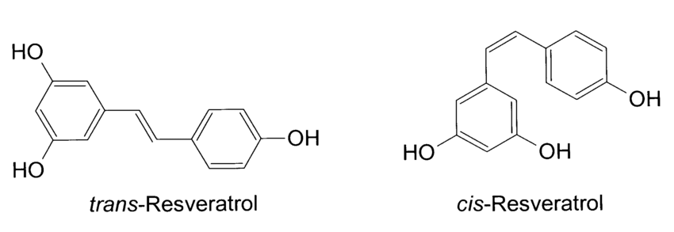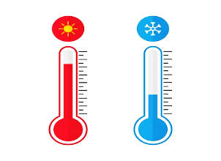

**Fig. 1.** Trans to cis form of resveratrol by heat or exposure to ultraviolet irradiation

The biosynthesis of trans-resveratrol begins with the transformation of phenylalanine (essential amino acid), leading to the condensation of a coumaryl-CoA molecule, which plays a role in several biosynthetic pathways, especially in the production of phenolic compounds, such as flavonoids and stilbenes. It is a derivative of coenzyme A (CoA), a key molecule in cellular metabolism and three of malonyl-CoA. This reaction is facilitated by resveratrol synthetase, an enzyme classified within the stilbene synthetase family (Fig. 2) (Gambini *et al*., 2013; Hasan and Baek, 2013).

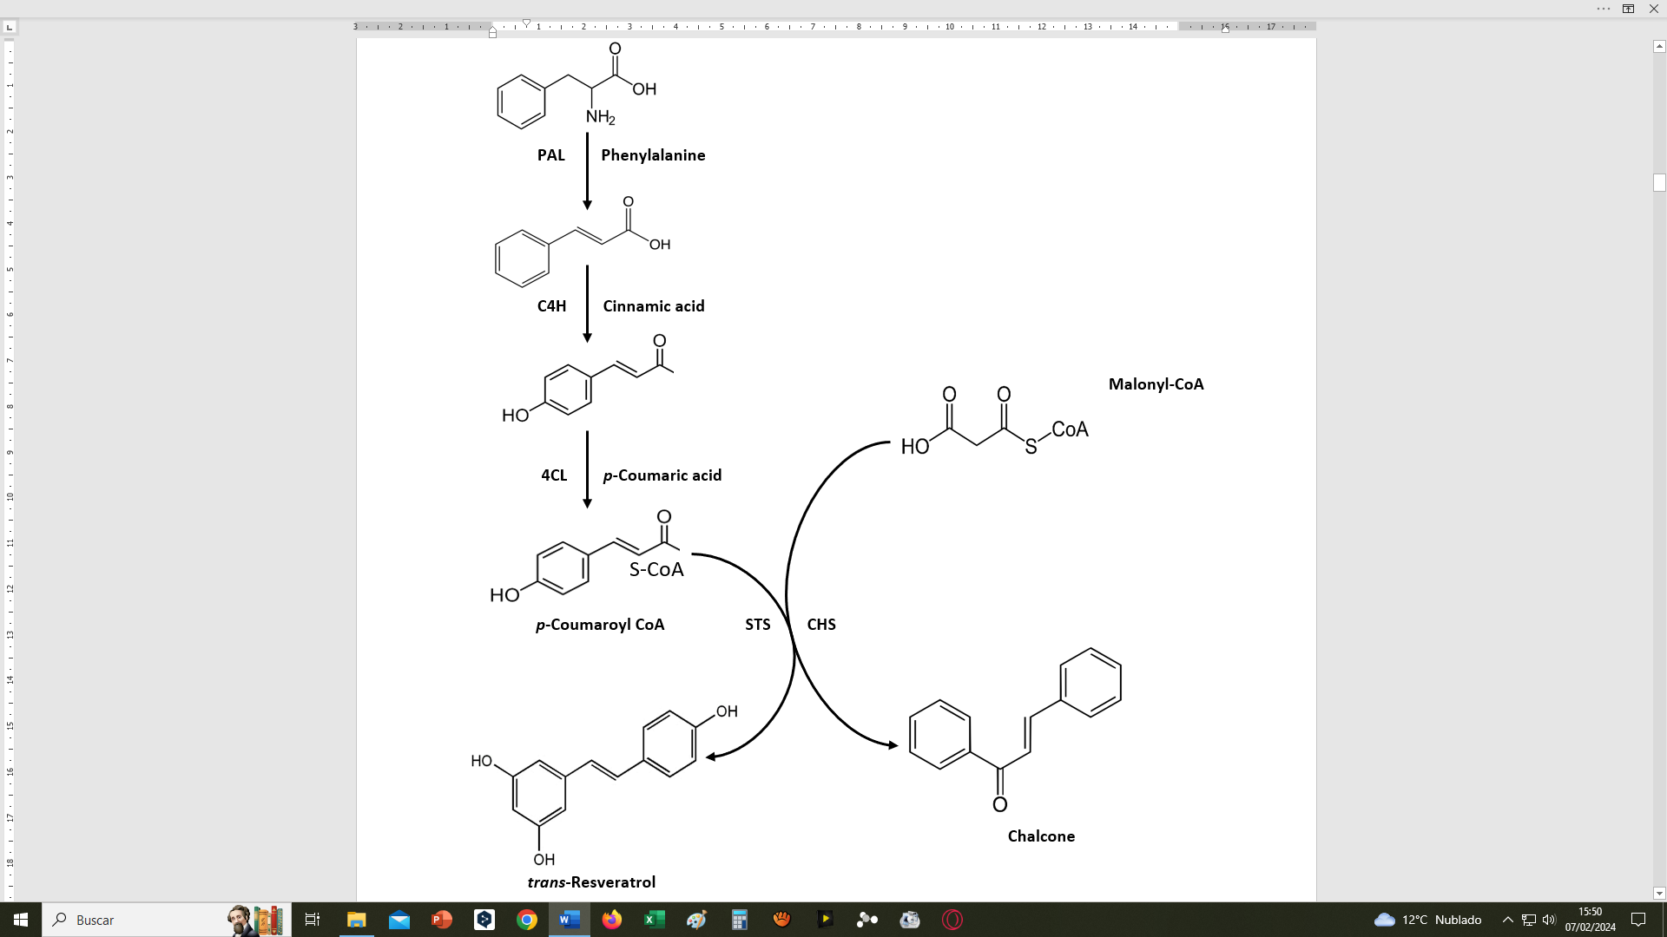

**Fig. 2.** Biosynthesis of resveratrol. Resveratrol synthesised from phenylalanine. PAL, Phenylalanine Ammonia Lyase; C4H, Cinnamic Acid 4-Hydroxylase; 4CL, 4-Coumarate: CoA Ligase; STS, Stilbene Synthase/Resveratrol Synthase; CHS, Chalcone Synthase.

**Main plant sources**

Resveratrol is considered one of the most effective substances from plant extracts. But this substance, like most natural extracts, can vary in quality, depending on where it is grown, the time of harvest, the agricultural techniques used. Within the same plant species, it also varies according to the variety, as in viticulture, and also the form of extraction (Cortiñas *et al*., 2020; Cortiñas *et al*., 2022); Jang *et al*., 2022). Resveratrol is not routinely included in food composition analyses. Various scientific studies have been carried out to analyse the composition of this phytochemical in different types of vegetables (Di *et al*., 2004; Jang *et al*., 2022) (Table 1) (Fig. 3).

**Table 1.** Resveratrol content in different foods and content in different types of wine and wine varieties.

|  |  |  |  |
| --- | --- | --- | --- |
| **Food** | **Resveratrol** | **Wine** | **Resveratrol** |
| Red cranberry | 3.00 mg/100 g | Red wine | 0.84 -7.33 mg/1000 ml |
| Red currant | 1.57 mg/ 100 g | Rosé wine | 0.29 mg/1000 ml |
| Blueberry | 0.67 mg/ 100 g | White wine | 0-1.089 mg/ 1000 ml |
| Strawberry | 0.35 mg/ 100 g | Pinot noir | 6.25 mg/ 1000 ml |
| Peanuts | 0.07 mg/ 100 g | Merlot | 5.05 mg/1000 ml |
| Pure cocoa | 0.04 mg/ 100 g | Cabernet sauvignon | 1.71 mg/1000 ml |
| Peanut butter | 0.04 mg/ 100 g | Garnacha | 2.86 mg/1000 ml |
| Apple | 400 µg / 1000 g | Tempranillo | 4.14 mg/1000 ml |
| Tomato skins | 19 µg / 1 g | trans-Resveratrol | 3.06 mg/1000 ml |
| Beer | 1.34-77.0 µg / 1000 ml | cis-Resveratrol | 1.08 mg/1000 ml |
| Dark chocolate | 350 µg/ 1000 g | Wines with Carbonic | 4.96 mg/1000 ml |
| Milk chocolate | 100 µg/ 1000 g |
| Itadori tea | 68 µg/ 100 ml | Wines aged in oak | 1.98 mg/1000 ml |
| Black grapes | 0.15 mg/ 100 g |  |  |
| White grapes | 0.03 mg/ 100 g |  |  |

**Source**: (Cvejic*et al.*, 2010; Weiskirchen *et al.*, 2016)

The foods with the highest content of this phytonutrient are blueberries, currants, strawberries and black grapes. The global area of blueberries is approximately 235,000 ha, currants 139,089 ha and strawberries around 384,668 ha (FAO, 2023). The largest cultivated area is undoubtedly vineyards, some 7.3 million ha (OIV, 2023).

**Bioavailability**

In nature, resveratrol exists in cis and trans forms. These terms refer to the spatial relationships of the atoms in the molecular structure. In the trans form, the functional groups are on opposite sides. We know that trans-resveratrol is the more biologically active of the two isomers, being the more widely available and believed to have the greatest therapeutic value (Berman *et al.,* 2017; Orallo, 2006). The bioavailability of resveratrol is limited; however, it can be synthesised into various derivatives to promote better absorption and greater therapeutic potential. In this regard, to increase the bioavailability of this compound, the pterostilbene (3,5-dimethoxy-4′-hydroxy-trans-stilbene), a trans stilbene compound with bioactivity, was extracted and isolated from the heartwood of *Pterocarpus marsupium* for the first time in 1940 (Kosuru *et al.*, 2016).

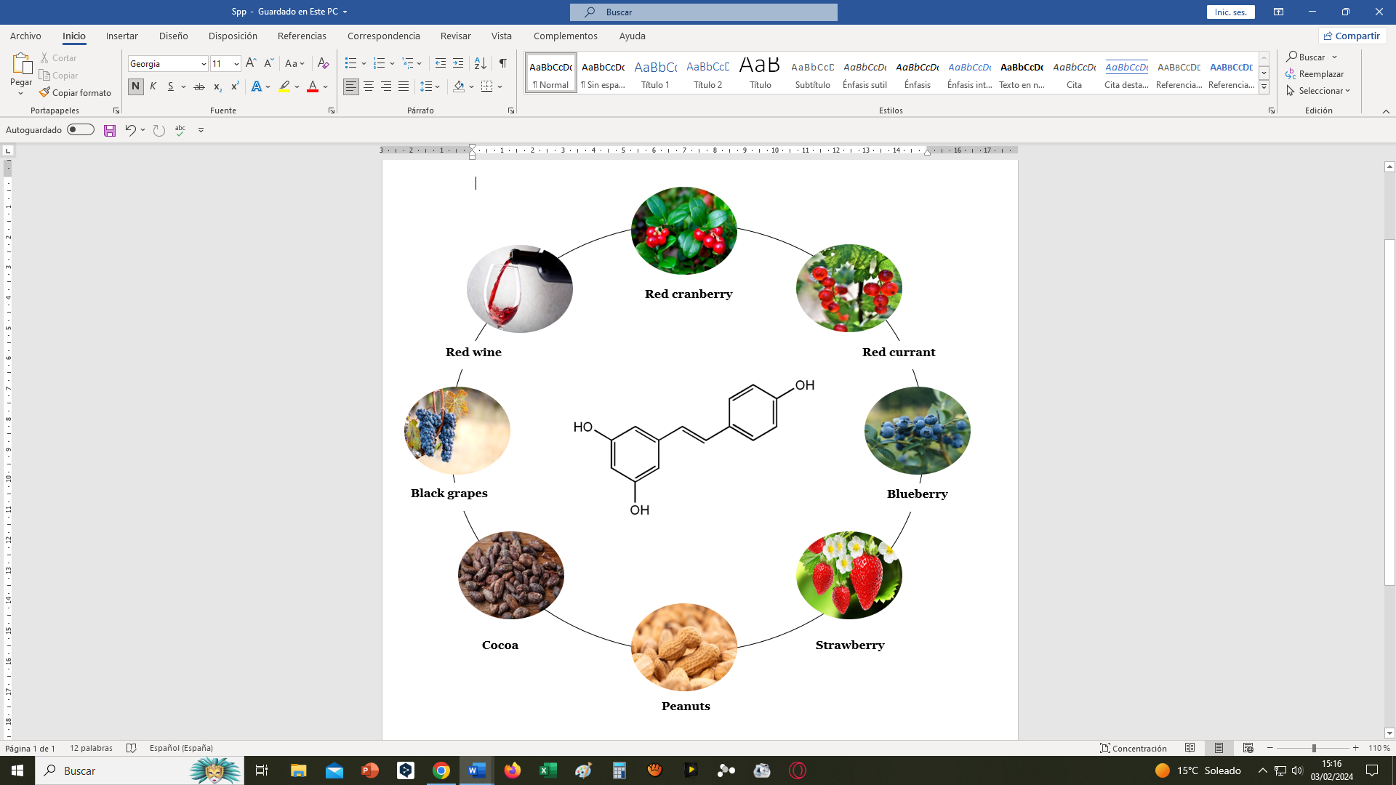

**Fig. 3.** Main Resveratrol-rich foods

Pterostilbene has been found to have a higher affinity for fats, which implies a greater ability to dissolve in oils, fats and other lipids. Taking advantage of these findings, researchers have been able to modify resveratrol to increase its bioavailability and absorbability by up to 3.5-fold, cementing resveratrol's position as a potent nutraceutical (Liu *et al.*, 2020; Walle, 2011). Resveratrol and pterostilbene have similar structures. Although many biological similarities exist between pterostilbene and resveratrol, pterostilbene shows better bioactivity and bioavailability, hence, the properties of pterostilbene are used to improve the bioavailability of resveratrol. A pharmacokinetic study showed that with a single oral dose (pterostilbene 56 mg/kg versus resveratrol 50 mg/kg), peak plasma concentration values of pterostilbene were up to 36 times higher than those of resveratrol, and peak plasma concentration was also reached twice as fast in pterostilbene as in resveratrol (Fig. 4) (Liu *et al.*, 2020). The oral bioavailability of pterostilbene was 66.9%, while that of resveratrol was 29.8% (Kapetanovic *et al.*, 2011). Resveratrol bioavailability is also known to be influenced by the role of gut microbiota in the resveratrol metabolization process, specifically the intestinal bacteria *Bifidobacterium infantis* and *Lactobacillus acidophilus*, thus increasing its bioavailability, making the resveratrol/microbiota interaction a key element in the effectiveness of any treatment. From the above, we deduce that the main problem with resveratrol is related to its bioavailability, so there is a wide field of work in the search for activators to improve this property (Chaplin *et al.*, 2018).

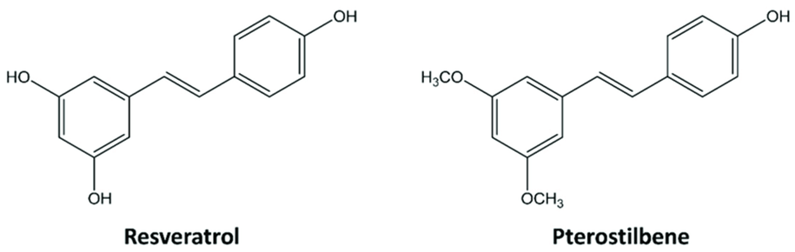

**Fig. 4.** Structure of the Resveratrol and Pterostilbene molecule

**PHYSIOLOGICAL FUNCTIONS OF RESVERATROL**

The remarkable research interest in resveratrol has been significantly driven by its powerful antioxidant and anti-aging effects (Filgueira and González, 2022; Siddiqui *et al.,* 2025). Resveratrol has been shown to have beneficial effects in many respects, with substantial evidence supporting its impact on the circulatory, skeletal and nervous systems. It is also being widely investigated for its ability to prevent and treat cancer (Table 2) (Stanevičienė *et al*., 2016). Among the leading causes of death worldwide, according to the World Health Organisation, are cardiovascular disease, cancer, neurodegenerative diseases and diabetes.

**Effect of Resveratrol in cardiovascular health**

Among the effects of resveratrol is the inhibition of low-density lipoprotein (LDL) oxidation, which in turn delays the onset of atherosclerosis. This effect is due to the close association between LDL-cholesterol oxidation and the development of cardiovascular disease (Wada-Hiraike, 2021). In addition, it exhibits an antithrombotic (platelet aggregation) effect through its vasodilatory capacity, while reducing serum levels of total cholesterol and triglycerides, as revealed by several studies on lipid metabolism. These compounds are also associated with an increase in high-density lipoproteins (HDL) and inhibition of low-density lipoproteins (LDL) (Wada-Hiraike, 2021; Parraguez and Andrés, 2022). Extensive research has focused on Resveratrol due to its positive effects on cardiovascular protection, primarily attributed to its ability to increase nitric oxide (NO) production in endothelial cells. The compound demonstrates the ability to upregulate the expression of endothelial NO synthase (eNOS), stimulatese NOS activity, and prevents NOS uncoupling, as supported by various studies (Man *et al*., 2020). Another aspect to consider is the gut microbiota, due to its involvement in the production of a number of bioactive substances, known as gut microbiota-derived metabolites, which contribute to normal physiological function and cause diseases (Wang *et al*., 2018). In recent years, several studies have suggested an association between cardiovascular disease and gut microbiota-derived metabolites (Wang *et al*., 2011; Wang *et al*., 2018). Although identification and modulation of a specific gut microbiota population may be challenging, a treatment that interferes with the derived metabolites is possible. One of the richest sources of resveratrol are red grapes and red wine. The physicochemical constituents of grapes, *Vitis vinifera*, are minerals and phenolic compounds such as resveratrol, flavonoids and tannins. The resveratrol present in the red grape *Vitis vinifera* was identified using the HPLC (High Performance Liquid Chromatography) method. The consumption of grapes contributes to several pharmacological activities, including cardioprotective properties (Cortiñas *et al*., 2020; Sabra *et al.*, 2021; Fernández-Conde *et al.,* 2024).

**Effect of Resveratrol on cancer**

One of the strategies in combating cancer involves identifying anticancer agents that induce cancer cell death (Ghirdani*et al.*, 2005). Among the most extensively studied substances in this endeavour is resveratrol. This polyphenol exhibits the ability to inhibit the activation of several factors that regulate the expression of genes associated with inflammation, cytoprotection and carcinogenesis (Aggarwal *et al.*, 2004). It also shows the ability to suppress several proteins, including those involved in the different phases of the cell cycle (Yu *et al.*, 2003). It was in the late 1990s that topical resveratrol was reported to show activity against tumorigenesisin a mouse model of skin cancer, thus highlighting its potential use as a new anticancer drug (Jang *et al.*, 1997). Resveratrol is involved in slowing down cellular aging and strengthening the immune system and has anti-obesity effects by limiting calorie restriction. It also plays an important role in preventing or mitigating diseases such as diabetes, neurodegenerative and cardiovascular diseases, as we saw earlier (Wahab *et al.*, 2017). With regard to its cancer-suppressive action, resveratrol acts as a chemo preventive agent during the four stages of carcinogenesis, from initiation to metastasis through promotion and progression (Jang *et al.*, 1997; Rivera-Aguilar *et al.*, 2023), demonstrating its effectiveness in both *in vitro* and *in vivo* studies in the treatment of cancer (Ren *et al.*, 2021). Due to its multiple properties, it is presented as an important complementary molecule to conventional chemotherapy, demonstrating effectiveness against different types of cancerrelated to obesity, pancreatic, liver, breast, prostate and colorectal cancer, as well as haematological, lung and skin malignancies (Vázquez, 2021; Cruz-Rosales, 2023; Hernández and Marina, 2003). Resveratrol targets several important mechanisms and signalling pathways as new therapeuticstrategies in cancer treatment, through which the molecule exerts its effects. (Ashrafizadeh *et al*., 2020; Ren *et al.*, 2021). The anti-tumour effect of resveratrol is well established, as evidenced by numerous studies. Its effect on cancer occurs at all four stages of carcinogenesis, thus preventing the proliferation of tumour cells (Jang *et al.*, 1997; Hsieh and Wu, 1999).

**Table 2.** Main biological effects of resveratrol (Gambini *et al.*, 2013)

|  |  |
| --- | --- |
| **Biological actions of resveratrol to be highlighted** | **Reference** |
|  | |
| ***In vitro* studies** |  |
| Actions against cancer at different stages (initiation, promotion and progression of tumour cells). | Rivera-Aguilar *et al*., 2023 |
| Antithrombotic effect (platelet aggregator). | Wada-Hiraike, 2021 |
| Action on lipid metabolism, regulating lipolysis by increasing the mobilisation of fats in adipocytes. | Lasa *et al*.,2011  Parraguez and Andrés, 2022 |
| Has anti-allergic effects. | Cheong *et al.,* 1999  Santos, 2010 |
| Osteogenesis and prevention of adipogenesis in stem cells | CoveñasVilchez, 2023 |
| Elimination of human cancer cells through programmed cell death (PCD) mechanisms such as apoptosis, autophagy, and necroptosis. | Sung *et al.*, 2016 |
| Treatment of diabetic retinopathy. | González-Pérez, 2023 |
| Anti-inflammatory action, regulatory mechanisms and immunomodulatory function. | Meng *et al.*, 2021 |
|  | |
| ***In vivo* studies** |  |
| Chemoprotective agent against different diseases such as retinal degeneration. | Baur and Sinclair, 2006  Londoño and Torres, 2021 |
| Diabetes in mechanisms related to insulin secretion and obesity related to insulin resistance. | Su *et al.*, 2022  Hoca*et al.*, 2023 |
| Platelet anti-aggregant. | Wang *et al.,* 2002  [Wada-Hiraike, 2021](https://www.elsevier.es/es-revista-revista-espanola-geriatria-gerontologia-124-articulo-resveratrol-distribucion-propiedades-perspectivas-S0211139X12001023#bib0485) |
| Mechanism of human SIRT1 activation by resveratrol. | Agarwal and Baur, 2011 |
| Mimetic effects of calorie restriction. | Agarwal and Baur, 2011 |
| Anti-inflammatory action, regulatory mechanisms and immunomodulatory role. | Meng *et al.*, 2021 |
| Action on cognitive functions. | Sánhez-Nieto *et al.*, 2023 |

**Effect of Resveratrol on neurodegenerative diseases**

Neurodegenerative diseases are diseases in which cells of the central nervous system stop functioning or die. Neurodegenerative disorders usually worsen over time and cannot be cured. They may be genetic or caused by a tumour or stroke. Examples of neurodegenerative disorders include Alzheimer's disease and Parkinson's disease (Tovar, 2022). Resveratrol is a compound that has been shown to have some biological activity in slowing the progression of neurodegenerative diseases. Its antioxidant power contributes to the reduction of oxidative stress, which is responsible for several neurodegenerative diseases such as Alzheimer's and Parkinson's (SienesBailo *et al.*, 2022). This antioxidant also inhibits nuclear factor kB (NFKB), which is involved in the toxicity of β-amyloid plaques that is associated with neurodegenerative diseases such as Alzheimer's. The molecule also expresses neuroprotective effects due to its antioxidant capabilities, providing protection to mitochondria. It has the ability to modulate crucial genes involved in the regulation of antioxidant enzymes, mitochondrial dynamics and cell survival. In addition, this molecule also positively regulates mitophagy through multiple pathways, including the SIRT-1 pathway (Bastianeto *et al.*, 2015; Wuet *al.*, 2023). Further clinical research is needed to establish the efficacy of resveratrol in clinical settings (Kung *et al.*, 2021) (Fig. 5).

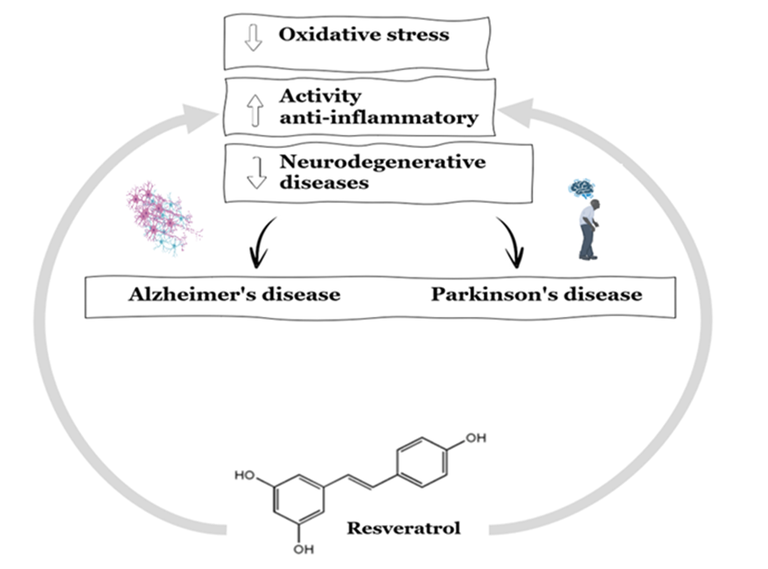

**Fig. 5.** Neuroprotective mechanisms of resveratrol

**Effect of Resveratrol on diabetes**

Diabetes mellitus is a health challenge caused by chronic hyperglycaemia due to the lack of adequate insulin production or its inability to function effectively. Recently, various techniques, both medical and alternative, have been introduced to improve pancreatic insulin production and insulin resistance (Hoca *et al.,* 2023). Polyphenols, present in grapes and therefore in wine as well as other foods, are beneficial in preventing and fighting diabetes due to their anti-inflammatory, antioxidant and vasodilatory effects (Cáceres *et al.,* 2020). Resveratrol has shown potential in the treatment of diabetes. Studies in animals and people with diabetes have shown beneficial effects, as well as an increased ability to improve insulin sensitivity by regulating levels of visceral fat-derived adipokines. Combining resveratrol with anti-diabetic treatments or alone may represent a valuable option for addressing diabetes mellitus. Resveratrol is the most studied polyphenolic compound and has been shown to lower blood glucose, preserve pancreatic β-cells and improve insulin action in patients with type 2 diabetes (T2DM), a chronic degenerative disorder that occurs when the pancreas does not produce enough insulin or when the body does not use insulin properly (Öztürk *et al.,* 2017; Diaz Costilla, 2021).

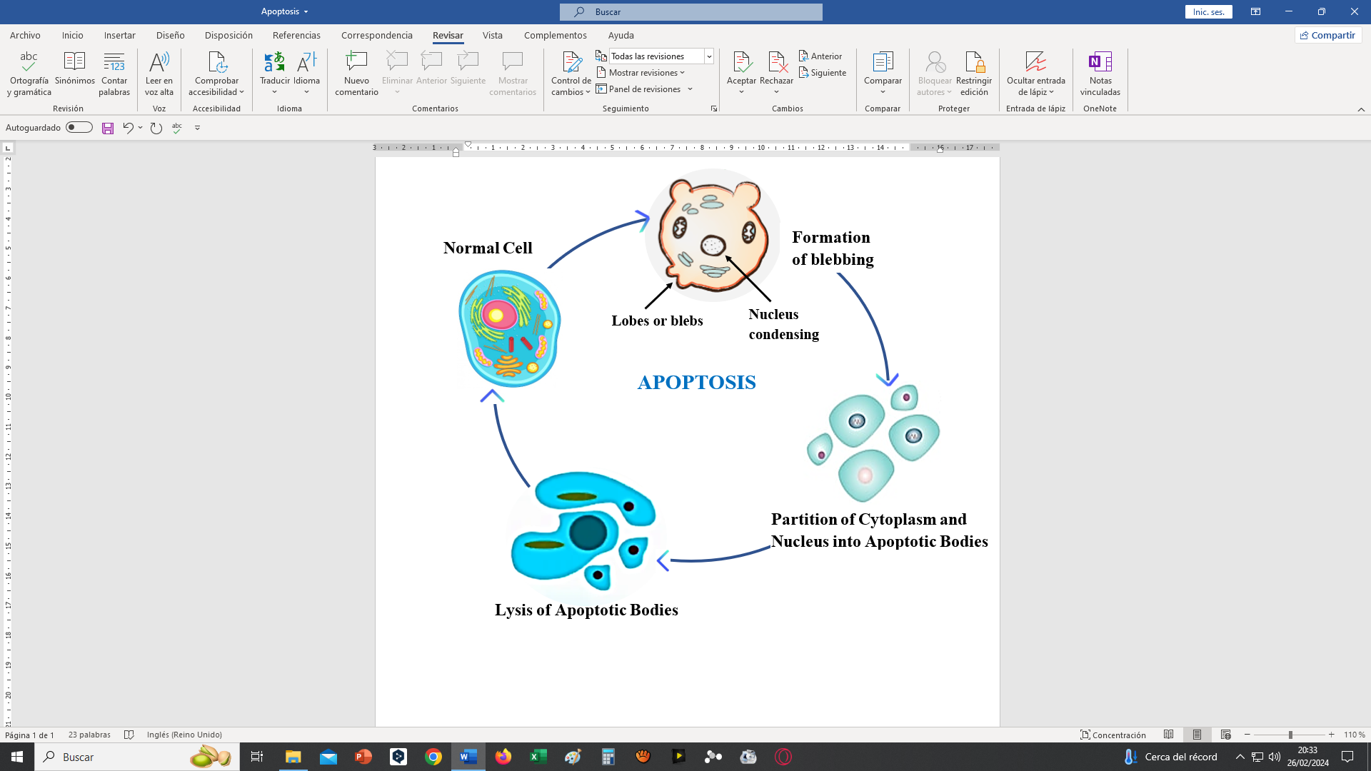

**Fig. 6.** Apoptosis as a mechanism of programmed cell death (PCD)

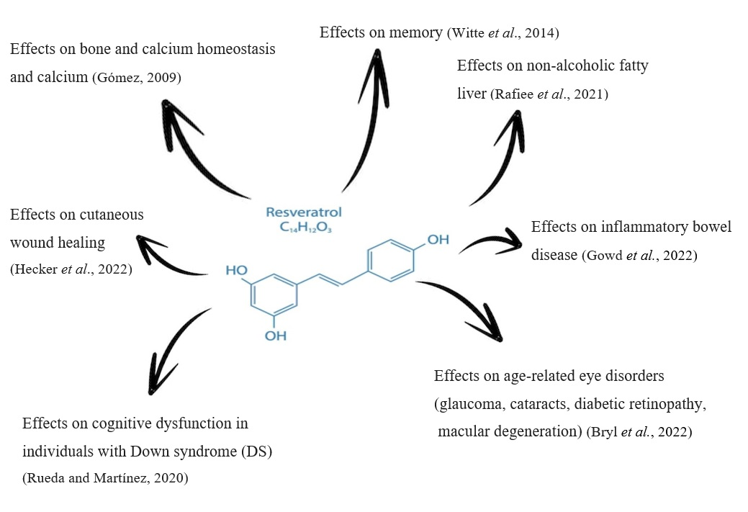

**Fig. 7.** Effects of resveratrol on different types of pathologies

Numerous animal studies have demonstrated its benefits and thus its potential to act as an anti-diabetic, cardioprotective, neuroprotective, antioxidant, renoprotective agent and mechanisms such as apoptosis (Gowd *et al*., 2020) (Fig. 6). In humans, the most prevalent effects of resveratrol supplementation in patients with T2DM were found to be related to improved insulin sensitivity, glycaemic control, as well as a possible reduction in oxidative stress. There is still controversy in the literature about its actual effectiveness in diabetic patients. However, the use of resveratrol as an adjunct to hypoglycaemic therapy is not ruled out (de Lima *et al*., 2020). Positive effects of resveratrol have also been observed on other diseases which, although they do not affect such a high percentage of the population as those described above, are nevertheless less relevant (Fig. 7).

In addition to the areas already known (cardiovascular, neurodegenerative, cancer, diabetes, etc.) we can mention indications of other potential pharmacological uses of resveratrol, although they are less developed. Here we can indicate some different diseases or systems related to Diabetic Retinopathy, Bone System, Kidney Diseases and Scarring and Dermatology.

On diabetic retinopathy and eye diseases, in vitro studies on resveratrol formulations as a possible treatment for diabetic retinopathy, protecting the retina from oxidative and inflammatory damage, have previously been mentioned. In addition, there are studies on its protective role in macular degeneration and ocular oxidative stress in general (Bryl *et al*., 2022). With regard to the bone system, the osteogenic action of resveratrol and its ability to prevent fat formation in stem cells have been described, suggesting applications in osteoporosis or degenerative bone diseases (Coveñas Vilchez, 2023). Kidney diseases are another field of action of Resveratrol, where some recent studies point to a nephroprotective effect, especially in diabetic nephropathy, helping to protect kidney function through its antioxidant and anti-inflammatory action (Gowd *et al*., 2020). Finally on wound healing and dermatology, resveratrol also has potential applications in wound healing, scar reduction and skin ageing, thanks to its antioxidant and anti-inflammatory properties that promote skin regeneration (Hecker *et al*., 2022).

**Strategies for Commercial production of Resveratrol**

As discussed in the above sections Resveratrol has various properties which help maintain overall human health. It can be even considered as an “Elixir of health” which can promote overall body function but relying on natural extraction from plants alone cannot meet the current demand as the extraction is cost intensive and yields only low amounts of Resveratrol which varies according to the environment (Sáez-Sáez *et al*., 2020). Chemical synthesis is an alternative route for Producing Resveratrol, but it is often discouraged as the synthetic pathway is complex, and the yield quality does not meet the industry standards (Fan *et al*., 2010). The most efficient approach for resveratrol production is by harnessing biotechnological approaches. Currently biotechnological approaches such as engineered Microbes for Resveratrol production is best bet to produce high quality resveratrol (Nandagopal *et al.,*2018; Fernández-Conde *et al.,* 2024). Advances in biotechnology allow scientists to integrate pathways from plants to host strain using genetic engineering techniques (Halls and Yu, 2008). The advances in genome editing can pave the way for gene edited plants for high resveratrol production.

**Chemical synthesis of Resveratrol**

Resveratrol production via chemical synthesis can be achieved by numerous reactions. some of the most important reactions involved in chemical synthesis of resveratrol are 1) Perkin reaction 2) Heck reaction and 3) Wittig reaction (Tian and Liu, 2020).

The first to succeed in chemically synthesizing resveratrol was Spath and Kromp in 1941 by utilizing Perkin reaction. Generally, Perkin’s reaction involves the production of α-β unsaturated carboxylic acid when an aldehyde is heated with an acid anhydride in the presence of sodium salt of same acid. For the synthesis of resveratrol, Perkin’s condensation of Benzaldehyde and phenylacetic acids result in the formation of cinnamic acids which then undergoes decarboxylation to produce *cis* stilbenes (Thompson *et al.,*2016). The major constraint on depending on Perkin reaction is the presence of multiple stages for obtaining resveratrol. The requirement of extreme temperature during condensation limits its application (Tian and Liu, 2020).

The Heck reaction can be defined as a C-C cross coupling reaction occurring between aryl halide and activated alkene in the presence of a base under the catalysis of palladium (Heravi and Zadsirjan, 2021). Andrus and Coworkers synthesized resveratrol by having the acid chloride undergo carbonylative Heck reaction. For Resveratrol synthesis, acid chloride obtained from 3,5 dihydroxybenzoic acid (a secondary metabolite found in various plants) was cross coupled with 4-acetoxystyrene under catalysis of palladium acetate in the presence of N, N-bis-dihydroimidazolium to produce stilbene (Andrus *et al.,* 2003). Various other protocols were developed for synthesizing resveratrol by using Heck reaction. A study which involved combining aryl boronic acids with styrenes via palladium catalysed Heck reaction resulted in synthesis of resveratrol derivatives (Uzura *et al.,*2016). Even though various protocols for synthesizing resveratrol using Heck reaction have been devised, the major challenge in achieving sustainable resveratrol production is the nature of catalyst being used (Tian and Liu,2020). refining of catalysts such as palladium can take a heavy toll on the environment (McCarthy *et al.,*2021).

Wittig reaction is an organic reaction which yields an alkene and a triphenylphosphine oxide upon the reaction between aldehyde or a ketone with triphenylphosphonium ylide (Wang, 2010). The main advantage is that this reaction allows scientists to select and predict the synthesis of alkenes (Heravi *et al.,*2020). Šmidrkal and coworkers produced methoxystilbenes as a result of wittig-horner reaction which were then further demethylated using boron trichloride to obtain trans resveratrol (Šmidrkal *et al.,*2008). Even though various other chemical reactions were identified, and alterations were made to the existing reaction for resveratrol synthesis the quality of the product affected due to the presence of byproducts in the chemical reaction. The adoption of chemical synthesis method for sustainability is questionable as this approach is not so eco-friendly. However, chemical synthesis approach could be adopted once there are proper guidelines for effective reuse and recycling of waste and byproducts as well as the quality of final product is strictly maintained. As of now the most feasible approach for resveratrol production is to harness the biotechnological tools to facilitate biosynthesis.

**Microbial engineering for Resveratrol production**

Harnessing microbes for resveratrol production is one of the most efficient techniques in practice. Most excellent and preferred hosts include yeast (*Saccharomyces cerevisiae*, *Yarrowia lipolytica,*) (Ibrahim *et al.,*2021), *Escherichia.coli* and *Corynebacterium glutamicum* (Abo-Kadoum *et al.,*2022). Advances in biotechnology and synthetic biology have enabled researchers to redesign and integrate the biosynthetic pathway into microbes. The basic principle in engineering microbes for resveratrol production is to ensure that ample amount of resveratrol precursor is present in the hosts which can be achieved by inducing overproduction (Feng *et al.,*2022). Sufficient production of precursors in microbes can be achieved by pathway engineering and overexpression of enzymes (Cravens *et al.,*2019). Pathway engineering involves integrating a whole biosynthetic pathway into the microbe. This involves incorporating genes from foreign organisms (Horizontal gene transfer) to produce target metabolites. Engineering microbes in such a way that supply of aromatic amino acids (Phenylalanine and tyrosine) and malonyl-CoA is sufficient ensures enhanced resveratrol production as these are key compounds in the biosynthetic pathway of resveratrol (van Summeren-Wesenhagen *et al.,*2015). Qin *et al.* (2020) integrated tyrosine and phenylamine pathway in *Yarrowia lipolytica* which resulted in improved resveratrol production (Qin *et al.,*2020). Malonyl CoA is a key compound in fatty acid biosynthesis thus suppressing fatty acid biosynthesis which will lead to improvement in accumulation of malonyl CoA. An alternate strategy to improve malonyl CoA content is the carboxylation of acetyl CoA to malonyl CoA by using acetyl CoA carboxylase (ACC) which will result in expansion of cytoplasmic malonyl CoA pool (Feng *et al.,*2022). A study reported improved intracellular malonyl CoA concentration after overexpressing ACC (Zha *et al.,*2009). Incorporating enzyme engineering strategies can also be effective in resveratrol production. Skjoedt *et al.* 2019 engineered 4-coumarate-CoA ligase (4CL) and stilbene synthase which resulted in an improvement in resveratrol production.

**CONCLUSIONS**

Available evidence suggests that resveratrol, a polyphenolic antioxidant compound found in certain foods such as grapes and red wine, and other foods, may have a number of beneficial effects on human health. *In vitro* and animal studies have demonstrated its potential to improve cardiovascular health, modulate the immune system, reduce inflammation and provide neuroprotective effects. In addition, it has been observed that resveratrol may have anti-cancer, anti-aging, and anti-diabetic properties. However, more research is needed to fully understand resveratrol's mechanisms of action and its efficacy in different health conditions as its evidence in humans is still limited. Despite promising research, it is important to note that more studies are needed to confirm previous results and to determine the optimal dose for each individual. Some small clinical trials have shown promising results in areas such as cardiovascular health, cognitive function, and metabolism. In cardiovascular disease, it induces the reduction of inflammation, improves endothelial function and protects against blood clot formation. In cancer, it inhibits growth and promotes apoptosis of cancer cell. In neurodegenerative diseases such as Alzheimer's, it induces protection against cognitive decline and neurodegeneration. It also improves insulin sensitivity and reduces blood sugar levels in type 2 diabetics (T2DM). Anti-aging effects include increased protection against cell damage and improved mitochondrial function. In terms of safety and tolerability, it is considered a safe compound for most people, with mild side effects. The optimal dose has not yet been established, as the doses used in different studies vary widely. We can conclude that resveratrol has the potential to improve human health in a number of areas, such as those described above. Further research in humans is needed before this polyphenol can be used to its full potential.

**Future prospects**

In the current scenario resveratrol is majorly sourced from chemical and microbial synthesis but in the recent years genome editing has gained popularity in all fields of science. The use of CRISPR/Cas systems enables us to improve the biosynthesis capacity of plants by targeted gene editing. These technologies can also be utilized to gain new insights into the biosynthesis of resveratrol at molecular level.

**DISCLAIMER**

This article is an extended version of a preprint paper published at <https://www.preprints.org/frontend/manuscript/875f4c0890d68400b6343dd5a30458df/download_pub>

The preprint paper has been published with a different title, a smaller number of authors and in a shorter version. According to journal policy, the preprint paper may be published as a journal article provided it is not published in any other journal.

Disclaimer (Artificial intelligence)

Option 1:

Author(s) hereby declare that NO generative AI technologies such as Large Language Models (ChatGPT, COPILOT, etc.) and text-to-image generators have been used during the writing or editing of this manuscript.

Option 2:

Author(s) hereby declare that generative AI technologies such as Large Language Models, etc. have been used during the writing or editing of manuscripts. This explanation will include the name, version, model, and source of the generative AI technology and as well as all input prompts provided to the generative AI technology

Details of the AI usage are given below:

1.

2.

3.

**REFERENCES**

Agarwal, B., & Baur, J. A. 2011. Resveratrol and life extension. *Annals of the New York Academy of Sciences*, *1215*(1), 138-143. <https://doi.org/10.1111/j.1749-6632.2010.05850.x>

Aggarwal, B. B., Bhardwaj, A., Aggarwal, R. S., Seeram, N. P., Shishodia, S., & Takada, Y. 2004. Role of resveratrol in prevention and therapy of cancer: preclinical and clinical studies. *Anticancer research*, *24*(5A), 2783-2840.

Andrus, M. B., Liu, J., Meredith, E. L., & Nartey, E. (2003). Synthesis of resveratrol using a direct decarbonylative Heck approach from resorcylic acid. Tetrahedron Letters, 44(26), 4819–4822. <https://doi.org/10.1016/S0040-4039(03)01131-6>

Ashrafizadeh, M., Ahmadi, Z., Farkhondeh, T., & Samarghandian, S. 2020. Resveratrol targeting the Wnt signaling pathway: A focus on therapeutic activities. *Journal of cellular physiology*, *235*(5), 4135-4145. <https://doi.org/10.1002/jcp.29327>

Bai, T., Dong, D. S., & Pei, L. 2013. Resveratrol mitigates isoflurane-induced neuroapoptosis by inhibiting the activation of the Akt-regulated mitochondrial apoptotic signaling pathway. *International Journal of Molecular Medicine*, *32*(4), 819-826.

Bastianetto, S., Ménard, C., & Quirion, R. 2015. Neuroprotective action of resveratrol. *Biochimica et Biophysica Acta (BBA)-Molecular Basis of Disease*, *1852*(6), 1195-1201.

Baur, J. A., & Sinclair, D. A. 2006. Therapeutic potential of resveratrol: the in vivo evidence. *Nature reviews Drug discovery*, *5*(6), 493-506. <http://dx.doi.org/10.1038/nrd2060>

Berman, A. Y., Motechin, R. A., Wiesenfeld, M. Y., & Holz, M. K. (2017). The therapeutic potential of resveratrol: a review of clinical trials. npj Precision Oncology, 1(1), 35. <https://www.nature.com/articles/s41698-017-0038-6>

Bisbal, J. J. S., Lloret, J. M., Lozano, G. M., & Fagoaga, C. 2020. Plant species as food antioxidants. Nereis. Interdisciplinary Ibero-American Journal of Methods, Modelling and Simulation., (12), 71-90. <https://doi.org/10.46583/nereis_2020.12.577>

Bryl, A., Falkowski, M., Zorena, K., & Mrugacz, M. 2022. The role of resveratrol in eye diseases—A review of the literature. *Nutrients*, *14*(14), 2974. <https://doi:10.3390/nu14142974>

Cáceres, M. I. R., Vasco, M. P., Sánchez, M. B., & Botello, M. D. R. P. 2020. Review of the beneficial/harmful effects of wine intake on patients with diabetes. In 41st Viticulture and Oenology Conference of Tierra de Barros (pp. 143-191). Santa Ana Cultural Center.

Carradori, S., Fantacuzzi, M., Ammazzalorso, A., Angeli, A., De Filippis, B., Galati, S., ... & Supuran, C. T. 2022. Resveratrol analogues as dual inhibitors of monoamine oxidase b and carbonic anhydrase vii: a new multi-target combination for neurodegenerative diseases?. *Molecules*, *27*(22), 7816. <https://doi:10.3390/molecules27227816>

Chaplin, A., Carpéné, C., & Mercader, J. 2018. Resveratrol, metabolic syndrome, and gut microbiota. *Nutrients*, *10*(11), 1651. <https://doi:10.3390/nu10111651>

Cheong, H., Ryu, S. Y., & Kim, K. M. 1999. Anti-allergic action of resveratrol and related hydroxystilbenes. *Planta medica*, *65*(03), 266-268. Cheong, H., Ryu, S. Y., & Kim, K. M. (1999). Anti-allergic action of resveratrol and related hydroxystilbenes. *Planta medica*, *65*(03), 266-268. <https://doi:10.1055/s-2006-960773>

Cortiñas, J. A., Fernández-González, M., González-Fernández, E., Vázquez-Ruiz, R. A., Rodríguez-Rajo, F. J., & Aira, M. J. 2020. Phenological behaviour of the autochthonous godello and mencía grapevine varieties in two designation origin areas of the NW Spain. *Scientia Horticulturae*, *265*, 109221. <https://doi:10.1016/J.SCIENTA.2020.109221>

Cortiñas, J. A., Fernández-González, M., González-Fernández, E., Vázquez-Ruiz, R. A., Rodríguez-Rajo, F. J., & Aira, M. J. 2020. Potential fertilization capacity of two grapevine varieties: effects on agricultural production in designation of origin areas in the Northwestern Iberian Peninsula. *Agronomy*, *10*(7), 961. <https://doi:10.3390/agronomy10070961>

Cortiñas, J. A., Fernández-González, M., Vázquez-Ruiz, R. A., Aira, M. J., & Rodríguez-Rajo, F. J. 2022. The understanding of phytopathogens as a tool in the conservation of heroic viticulture areas. *Aerobiologia*, *38*(2), 177-193. <https://doi:10.1007/s10453-022-09741-y>

Coveñas Vilchez, C. L. 2023. Evaluation of the effect of resveratrol on the cryopreservation of spermatogonial stem cells from Vicugna pacos (Linnaeus, 1758) “alpaca”.

Cravens, A., Payne, J. & Smolke, C.D. Synthetic biology strategies for microbial biosynthesis of plant natural products. Nat Commun 10, 2142 (2019). <https://doi.org/10.1038/s41467-019-09848-w>

Cruz Rosales, E. S. 2023. Effect of resveratrol on the regulation of LIN28A in the T47D breast cancer cell line (Master's thesis, Tesis (MC)--Center for Research and Advanced Studies of the IPN Department of Genetics and Molecular Biology).

Cvejic, J. M., Djekic, S. V., Petrovic, A. V., Atanackovic, M. T., Jovic, S. M., Brceski, I. D., & Gojkovic-Bukarica, L. C. 2010. Determination of trans-and cis-resveratrol in Serbian commercial wines. *Journal of chromatographic science*, *48*(3), 229-234. <https://doi:10.1093/chromsci/48.3.229>

Das, D. K., Mukherjee, S., & Ray, D. 2011. Erratum to: resveratrol and red wine, healthy heart and longevity. *Heart failure reviews*, *16*, 425-435. <https://doi.org/10.1007/s10741-011-9234-6>

De Lima, V. S., Bezerra, A. N., Albuquerque, N. V., Pereira, C. P., da Costa Alencar, C. M., Lima, A. T. A., & de Assis Ferreira, K. C. 2020. Effects of resveratrol polyphenol supplementation in patients with type 2 diabetes mellitus: a systematic review. Research, Society and Development, 9(10), e3639108659-e3639108659.

Di, S., Zhang, Z., Wang, Y., & Shi, W. 2004. Analysis for four isomers of resveratrol in red wine by high performance liquid chromatography. *Se pu= Chinese Journal of Chromatography*, *22*(4), 424-427.

Diaz Costilla, K. S. 2021. Critical review: Effect of resveratrol supplementation in patients diagnosed with type II diabetes mellitus.

Fan, E., Zhang, K., Zhu, M., & Wang, Q. (2010). Obtaining resveratrol: from chemical synthesis to biotechnological production. Mini-Reviews in Organic Chemistry, 7(4), 272-281.

Fernández-Conde, M. E., Bisarya, D., Perlado Taglinao, L., Cortiñas Rodríguez, J.A. Effects of Climate Change and Phenological Monitoring of the Indigenous Godello Variety in a Territory of Heroic Viticulture and Biosphere Reserve. Prime Archives in Agricultural Research: Volume 2. Hyderabad, India: Vide Leaf. 2024. [https:videleaf.com](https://videleaf.com/wp-content/uploads/2024/03/Effects-of-Climate-Change-and-Phenological-Monitoring-of-the-Indigenous-Godello-Variety-in-a-Territory-of-Heroic-Viticulture-and-Biosphere-Reserve.pdf)

Fernández-Conde, M. E., Cortiñas Rodriguez, J. A., Taglinao, L. P., Bisarya, D., & Pérez, L. R. 2024. Exploring the Versatile Nature of Resveratrol: A Comprehensive Review. <https://doi:10.20944/preprints202404.1394.v1>

Figueira, L., & González, J. C. 2022. Anti-inflammatory and antioxidant effect of resveratrol in atherosclerosis. Role of the platelet-endothelial cell adhesion molecule. Journal of the Faculty of Pharmacy, 85(1 and 2).

Fontana, L., & Partridge, L. 2015. Promoting health and longevity through diet: from model organisms to humans. *Cell*, *161*(1), 106-118. <https://doi:10.1016/j.cell.2015.02.020>

Food and Agriculture Organization of the United Nations (FAO). FAOSTAT. 2023. Food and agriculture data. <https://www.fao.org/about/who-we-are/departments/statistics-division>

Frankel, E. N., Waterhouse, A. L., & Kinsella, J. E. 1993. Inhibition of human LDL oxidation by resveratrol. *The Lancet*, *341*(8852), 1103-1104. <https://doi:10.1016/0140-6736(93)92472-6>

Gambini, J., López-Grueso, R., Olaso-González, G., Inglés, M., Abdelazid, K., El Alami, M., ... & Viña, J. 2013. Resveratrol: distribution, properties and perspectives. *Spanish journal of geriatrics and gerontology* , *48* (2), 79-88. <https://doi:10.1016/j.regg.2012.04.007>.

Gillespie, Z. E., Pickering, J., & Eskiw, C. H. 2016. Better living through chemistry: caloric restriction (CR) and CR mimetics alter genome function to promote increased health and lifespan. *Frontiers in Genetics*, *7*, 196701. <https://doi.org/10.3389/fgene.2016.00142>

Girdhani, S., Bhosle, S. M., Thulsidas, S. A., Kumar, A., & Mishra, K. P. 2005. Potential of radiosensitizing agents in cancer chemo-radiotherapy. *Journal of cancer research and therapeutics*, *1*(3), 129-131. <https://doi:10.4103/0973-1482.19585>.

Gómez, J. E. 2009. Effects of resveratrol isomers on calcium and nitric oxide homeostasis in vascular cells. University of Santiago de Compostela. http://hdl.handle.net/10347/2583

González Pérez, J. 2023. In vitro evaluation of a resveratrol formulation as a possible treatment for diabetic retinopathy. <https://repository.eia.edu.co/handle/11190/6322>

Gowd, V., Jori, C., Chaudhary, A. A., Rudayni, H. A., Rashid, S., & Khan, R. 2022. Resveratrol and resveratrol nano-delivery systems in the treatment of inflammatory bowel disease. *The Journal of Nutritional Biochemistry*, *109*, 109101. <https://doi:10.1016/j.jnutbio.2022.109101>.

Gowd, V., Kang, Q., Wang, Q., Wang, Q., Chen, F., & Cheng, K. W. 2020. Resveratrol: Evidence for its nephroprotective effect in diabetic nephropathy. *Advances in Nutrition*, *11*(6), 1555-1568. <https://doi:10.1093/advances/nmaa075>.

Guarente, L. 2011, January. Sirtuins, aging, and metabolism. In *Cold Spring Harbor symposia on quantitative biology* (Vol. 76, pp. 81-90). Cold Spring Harbor Laboratory Press. <https://doi:10.1101/sqb.2011.76.010629>.

Guthrie, A. R., Chow, H. H. S., & Martinez, J. A. 2017. Effects of resveratrol on drug‐and carcinogen‐metabolizing enzymes, implications for cancer prevention. *Pharmacology research & perspectives*, *5*(1), e00294. <https://doi:10.1002/prp2.294>.

Halls, C., & Yu, O. (2008). Potential for metabolic engineering of resveratrol biosynthesis. Trends in Biotechnology, 26(2), 77-81.

Hasan, M. M., & Baek, K. H. 2013. Induction of resveratrol biosynthesis in grape skins and leaves by ultrasonication treatment. *Horticultural Science & Technology*, *31*(4), 496-502. <https://doi.org/10.7235/hort.2013.12229>

Hecker, A., Schellnegger, M., Hofmann, E., Luze, H., Nischwitz, S. P., Kamolz, L. P., & Kotzbeck, P. 2022. The impact of resveratrol on skin wound healing, scarring, and aging. *International Wound Journal*, *19*(1), 9-28. <https://doi:10.1111/iwj.13601>

Henz, T., Tres, L., Pagotto, P., & Carminatti, B. 2020. Nanotechnologies applied to cosmetics and resveratrol synthesis: a review. <https://doi.org/10.5335/ciatec.v12i2.10453>

Heravi, M. M., & Zadsirjan, V. (2021). Chapter 4 - Recent advances in applications of Heck reaction in the total synthesis of alkaloids. In M. M. Heravi & V. Zadsirjan (Eds.), Recent Applications of Selected Name Reactions in the Total Synthesis of Alkaloids (pp. 107–152). Elsevier. <https://doi.org/10.1016/B978-0-12-824021-2.00006-6>

Heravi, M. M., Zadsirjan, V., Hamidi, H., Daraie, M., & Momeni, T. (2020). Chapter Three - Recent applications of the Wittig reaction in alkaloid synthesis. In H.-J. Knölker (Ed.), The Alkaloids: Chemistry and Biology (Vol. 84, pp. 201–334). Academic Press. <https://doi.org/10.1016/bs.alkal.2020.02.002>.

Hernández, A., & Marina, A. 2023. Analysis of the effect of resveratrol as a chemosensitizer in cervical cancer cell lines through the inhibition of the NHEJ repair pathway (Master's thesis, Tesis (MC)--Centro de Investigación y de Estudios Avanzados del IPN, Departamento de Geneticas y Biología Molecular). <https://repositorio.cinvestav.mx/handle/cinvestav/4353>

Hoca, M., Becer, E., & Vatansever, H. S. 2023. The role of resveratrol in diabetes and obesity associated with insulin resistance. *Archives of physiology and biochemistry*, *129*(2), 555-561. <https://doi:10.1080/13813455.2021.1893338>

Hsieh, T. C., & Wu, J. M. 1999. Differential effects on growth, cell cycle arrest, and induction of apoptosis by resveratrol in human prostate cancer cell lines. *Experimental cell research*, *249*(1), 109-115. <https://doi:10.1006/excr.1999.4471>.

Ibrahim, G. G., Yan, J., Xu, L., Yang, M., & Yan, Y. (2021). Resveratrol Production in Yeast Hosts: Current Status and Perspectives. Biomolecules, 11(6), 830. <https://doi.org/10.3390/biom11060830>

Iside, C., Scafuro, M., Nebbioso, A., & Altucci, L. 2020. SIRT1 activation by natural phytochemicals: an overview. *Frontiers in pharmacology*, *11*, 551744. [https://doi.org/10.3389/fphar.2020.01225. eCollection 2020](https://doi.org/10.3389/fphar.2020.01225.%20eCollection%202020).

Jang, J. Y., Im, E., & Kim, N. D. 2022. Mechanism of resveratrol-induced programmed cell death and new drug discovery against cancer: A Review. *International journal of molecular sciences*, *23*(22), 13689. <https://doi:10.3390/ijms232213689>.

Jang, M., Cai, L., Udeani, G. O., Slowing, K. V., Thomas, C. F., Beecher, C. W., ... & Pezzuto, J. M. 1997. Cancer chemopreventive activity of resveratrol, a natural product derived from grapes. *science*, *275*(5297), 218-220. <https://doi:10.1126/science.275.5297.218>.

Jara Parraguez, S. A. 2022. Antiplatelet activity of mitochondrial inhibitors (Doctoral dissertation, University of Talca (Chile). School of Medical Technology.). <http://dspace.utalca.cl/handle/1950/13250>

Kapetanovic, I. M., Muzzio, M., Huang, Z., Thompson, T. N., & McCormick, D. L. 2011. Pharmacokinetics, oral bioavailability, and metabolic profile of resveratrol and its dimethylether analog, pterostilbene, in rats. *Cancer chemotherapy and pharmacology*, *68*, 593-601. <https://doi:10.1007/s00280-010-1525-4>.

Kosuru, R., Rai, U., Prakash, S., Singh, A., & Singh, S. 2016. Promising therapeutic potential of pterostilbene and its mechanistic insight based on preclinical evidence. *European journal of pharmacology*, *789*, 229-243. <https://doi:10.1016/j.ejphar.2016.07.046>.

Kung, H. C., Lin, K. J., Kung, C. T., & Lin, T. K. 2021. Oxidative stress, mitochondrial dysfunction, and neuroprotection of polyphenols with respect to resveratrol in Parkinson’s disease. *Biomedicines*, *9*(8), 918. <https://doi.org/10.3390/biomedicines9080918>.

Kuršvietienė, L., Stanevičienė, I., Mongirdienė, A., & Bernatonienė, J. 2016. Multiplicity of effects and health benefits of resveratrol. *Medicina*, *52*(3), 148-155. <https://doi:10.1016/j.medici.2016.03.003>.

Larrubia, J. R., Lokhande, M. U., García-Garzón, S., Miquel, J., Subirá, D., & Sanz-de-Villalobos, E. (2013). Role of T cell death in maintaining immune tolerance during persistent viral hepatitis. *World Journal of Gastroenterology: WJG*, *19*(12), 1877. <http://dx.doi.org/10.3748/wjg.v19.i12.1877>

Lasa, A., Schweiger, M., Kotzbeck, P., Churruca, I., Simón, E., Zechner, R., & del Puy Portillo, M. 2012. Resveratrol regulates lipolysis via adipose triglyceride lipase. *The Journal of nutritional biochemistry*, *23*(4), 379-384. <https://doi:10.1016/j.jnutbio.2010.12.014>.

Liu MengYuan, L. M., Yin Yu, Y. Y., Ye XiaoYing, Y. X., Zeng Ming, Z. M., Zhao Qiang, Z. Q., Keefe, D. L., & Liu Lin, L. L. 2013. Resveratrol protects against age-associated infertility in mice. <https://doi:10.1093/humrep/des437>

Liu, Y., You, Y., Lu, J., Chen, X., & Yang, Z. 2020. Recent advances in synthesis, bioactivity, and pharmacokinetics of pterostilbene, an important analog of resveratrol. *Molecules*, *25*(21), 5166. <https://doi.org/10.3390/molecules25215166>.

Llacuna, L., & Mach, N. 2012. The role of antioxidants in cancer prevention. Spanish Journal of Human Nutrition and Dietetics, 16(1), 16-24. https://doi.org/10.14306/renhyd.16.1.102

Llerena, I. R., & Huerta, E. M. 1998. Wine and heart. Spanish Journal of Cardiology, 51(6), 435-449. https://doi.org/10.1016/S0300-8932(98)74772-4

Londoño David, L. M., & Torres Rivas, S. L. 2021. Docosahexaenoic acid (DHA) and resveratrol in the management of ocular angiogenesis: A bibliographic review. <http://repositorio.uan.edu.co/handle/123456789/2667>.

López-Otín, C., Blasco, M. A., Partridge, L., Serrano, M., & Kroemer, G. 2013. The hallmarks of aging. *Cell*, *153*(6), 1194-1217. <https://doi:10.1016/j.cell.2013.05.039>

Man, A. W., Li, H., & Xia, N. 2020. Resveratrol and the interaction between gut microbiota and arterial remodelling. *Nutrients*, *12*(1), 119. <https://doi:10.3390/nu12010119>

Meng, T., Xiao, D., Muhammed, A., Deng, J., Chen, L., & He, J. 2021. Anti-inflammatory action and mechanisms of resveratrol. *Molecules*, *26*(1), 229. <https://doi:10.3390/molecules26010229>

Mishra, R. C., Goel, M., Barrow, C. J., & Deshmukh, S. K. 2020. Endophytic fungi-an untapped source of potential antioxidants. *Current Bioactive Compounds*, *16*(7), 944-964. <https://doi:10.2174/1573407215666191007113837>

Nandagopal, K., Halder, M., Dash, B., Nayak, S., & Jha, S. (2018). Biotechnological approaches for production of anti-cancerous compounds resveratrol, podophyllotoxin and zerumbone. Current Medicinal Chemistry, 25(36), 4693-4717.

Olesen, J., Ringholm, S., Nielsen, M. M., Brandt, C. T., Pedersen, J. T., Halling, J. F., ... & Pilegaard, H. 2013. Role of PGC-1α in exercise training-and resveratrol-induced prevention of age-associated inflammation. *Experimental gerontology*, *48*(11), 1274-1284. <https://doi:10.1016/j.exger.2013.07.015>.

Orallo, F. 2006. Comparative studies of the antioxidant effects of cis-and trans-resveratrol. *Current medicinal chemistry*, *13*(1), 87-98. <https://doi:10.2174/092986706775197962>

Ozonas, B. R., & Angosto, M. C. 2016, October. Calorie restriction and longevity. In Annals of the Royal National Academy of Pharmacy (Vol. 82).

Öztürk, E., Arslan, A. K. K., Yerer, M. B., & Bishayee, A. 2017. Resveratrol and diabetes: A critical review of clinical studies. *Biomedicine & pharmacotherapy*, *95*, 230-234. <https://doi:10.1016/j.biopha.2017.08.070>.

Paul, B., Masih, I., Deopujari, J., & Charpentier, C. 1999. Occurrence of resveratrol and pterostilbene in age-old darakchasava, an ayurvedic medicine from India. *Journal of ethnopharmacology*, *68*(1-3), 71-76. <https://doi:10.1016/s0378-8741(99)00044-6>.

Pradhan, B., Nayak, R., Patra, S., Jit, B. P., Ragusa, A., & Jena, M. 2020. Bioactive metabolites from marine algae as potent pharmacophores against oxidative stress-associated human diseases: A comprehensive review. *Molecules*, *26*(1), 37. <https://doi:10.3390/molecules26010037>

Raederstorff, D., Kunz, I., & Schwager, J. 2013. Resveratrol, from experimental data to nutritional evidence: the emergence of a new food ingredient. *Annals of the New York Academy of Sciences*, *1290*(1), 136-141. <https://doi:10.1111/nyas.12147>.

Rafiee, S., Mohammadi, H., Ghavami, A., Sadeghi, E., Safari, Z., & Askari, G. 2021. Efficacy of resveratrol supplementation in patients with nonalcoholic fatty liver disease: A systematic review and meta-analysis of clinical trials. *Complementary therapies in clinical practice*, *42*, 101281. <https://doi:10.1016/j.ctcp.2020.101281>.

Ren, B., Kwah, M. X. Y., Liu, C., Ma, Z., Shanmugam, M. K., Ding, L., ... & Goh, B. C. 2021. Resveratrol for cancer therapy: Challenges and future perspectives. *Cancer letters*, *515*, 63-72. <https://doi:10.1016/j.canlet.2021.05.001>.

Rigon, R. B., Fachinetti, N., Severino, P., Durazzo, A., Lucarini, M., Atanasov, A. G., ... & Souto, E. B. 2019. Quantification of trans-resveratrol-loaded solid lipid nanoparticles by a validated reverse-phase HPLC photodiode array. *Applied Sciences*, *9*(22), 4961. <https://doi.org/10.3390/app9224961>

Rivera-Aguilar, J. O., Calderón-Santoyo, M., Barros-Castillo, J. C., & Ragazzo-Sanchez, J. A. 2023. High-value biological compounds in jackfruit (Artocarpus heterophyllus Lam.) and their relationship with carcinogenesis. *Revista Bio Ciencias*, *10*. <https://doi.org/10.15741/revbio.10.e1403>

Rothen, F. 2006. International Organization of Vine and Wine. Fruit and Viticulture. Swiss Journal of Fruit and Viticulture of the Federal Research Station Waedenswil (Switzerland), 142(19).

Rueda Revilla, N., & Martínez-Cué, C. 2020. Antioxidants in down syndrome: From preclinical studies to clinical trials. *Antioxidants*, *9*(8), 692. <https://doi.org/10.3390/antiox9080692>

Sabra, A., Netticadan, T., & Wijekoon, C. 2021. Grape bioactive molecules, and the potential health benefits in reducing the risk of heart diseases. *Food Chemistry: X*, *12*, 100149. <https://doi:10.1016/j.fochx.2021.100149>.

Sáez-Sáez, J., Wang, G., Marella, E. R., Sudarsan, S., Pastor, M. C., & Borodina, I. (2020). Engineering the oleaginous yeast Yarrowia lipolytica for high-level resveratrol production. Metabolic Engineering, 62, 51-61.

Sánchez-Nieto, J. M., Itzel Sierra-Zurita, D., Ruiz-Ramos Mirna, M., & Mendoza-Núñez, V. M. 2023. Effect of resveratrol on cognitive functions in older adults: a systematic review and meta-analysis. Hospital Nutrition, 40(6), 1253-1261. https://doi:10.20960/nh.04479.

Santos, P. B. D. 2010. Imunomodulatory effect of resveratrol in cells of the immune system in vitro and oral administration of ovalbumin in camundongos (Doctoral dissertation, Universidade de São Paulo). <https://doi.org/10.11606/D.9.2011.tde-06082010-142006>

Siddiqui, A., Timalwar, M., Bhuruk, S., Tandale, R., & Chaudhari, S. (2025). Resveratrol, Reactive Oxygen Species, and the Science of Aging: A Mini Review. European Journal of Medicinal Plants, 36(3), 52–61. <https://doi.org/10.9734/ejmp/2025/v36i31263>

Sienes Bailo, P., Llorente Martín, E., Calmarza, P., Montolio Breva, S., Bravo Gómez, A., Pozo Giráldez, A., ... & Fort Gallifa, I. 2022. Involvement of oxidative stress in neurodegenerative diseases and potential antioxidant therapies. Advances in Laboratory Medicine/Avances en Medicina de Laboratorio, 3(4), 351-360. <https://doi.org/10.1515/almed-2022-0022>

Skjoedt ML, Snoek T, Kildegaard KR, Arsovska D, Eichenberger M, Goedecke TJ, Rajkumar AS, Zhang J, Kristensen M, Lehka BJ, Siedler S, Borodina I, Jensen MK, Keasling JD. Engineering prokaryotic transcriptional activators as metabolite biosensors in yeast. Nat Chem Biol. 2016 Nov;12(11):951-958. doi: 10.1038/nchembio.2177. Epub 2016 Sep 19. PMID: 27642864. <https://pubmed.ncbi.nlm.nih.gov/27642864/>

Šmidrkal, J., Filip, V., Vokáč, K., & Harmatha, J. Resveratrol and its derivatives prepared by new synthetic approach.

Su, M., Zhao, W., Xu, S., & Weng, J. 2022. Resveratrol in treating diabetes and its cardiovascular complications: a review of its mechanisms of action. *Antioxidants*, *11*(6), 1085. <https://doi:10.3390/antiox11061085>.

Sun, A. Y., Simonyi, A., Wang, Q., & Sun, G. Y. 2004, August. Beyond the French paradox: Protection of grape poly-phenols against neurodegenerative processes. In *ALCOHOLISM-CLINICAL AND EXPERIMENTAL RESEARCH* (Vol. 28, No. 8, pp. 55A-55A). COMMERCE PLACE, 350 MAIN ST, MALDEN 02148, MA USA: WILEY-BLACKWELL PUBLISHING, INC. <https://doi:10.1097/00000374-200408002-00290>

Sung, B., Chung, H. Y., & Kim, N. D. 2016. Role of apigenin in cancer prevention via the induction of apoptosis and autophagy. *Journal of cancer prevention*, *21*(4), 216. <https://doi:10.15430/JCP.2016.21.4.216>

Takaoka, M. J. J. F. S. H. I. U. 1940. Of the phenolic substrate of hellebore (Veratrum grandiflorum Loes. fil.). *J Fac Sci Hokkaido Imper Univ.*, *3*, 1-16. <https://doi.org/10.1246/NIKKASHI1921.60.1090>

Thompson, C. M., Orellana, M. D., Lloyd, S. E., & Wu, W. (2016). Stereo specific synthesis of cis-stilbenes from benzaldehydes and phenylacetic acids via sequential Perkin condensation and decarboxylation. Tetrahedron Letters, 57(43), 4866-4868.

Tian, B., & Liu, J. (2020). Resveratrol: A review of plant sources, synthesis, stability, modification and food application. Journal of the Science of Food and Agriculture, 100(4), 1392-1404.

Tomás Barberán, F. 2003. Polyphenols in food and health.5 Tovar, L. B. 2022. The death of neurons and Alzheimer's and Parkinson's diseases.

Trela, B. C., & Waterhouse, A. L. 1995. Resveratrol: isomeric molar absorptivities and stability. <https://doi:10.1021/jf9504576>

Uzura, S., Sekine-Suzuki, E., Nakanishi, I., Sonoda, M., & Tanimori, S. (2016). A facile and rapid access to resveratrol derivatives and their radioprotective activity. Bioorganic & Medicinal Chemistry Letters, 26(16), 3886–3891. <https://doi.org/10.1016/j.bmcl.2016.07.018>.

Wada-Hiraike, O. 2021. Benefits of the Phytoestrogen Resveratrol for Perimenopausal Women. *Endocrines*, *2*(4), 457-471. <https://doi.org/10.3390/endocrines2040041>

Wahab, A., Gao, K., Jia, C., Zhang, F., Tian, G., Murtaza, G., & Chen, J. 2017. Significance of resveratrol in clinical management of chronic diseases. *Molecules*, *22*(8), 1329. [https://doi:10.3390/molecules22081329](https://doi:doi:10.3390/molecules22081329)

Walle, T. (2011). Bioavailability of resveratrol. *Annals of the New York Academy of Sciences*, 1215(1), 9–15. <https://doi.org/10.1111/j.1749-6632.2010.05842.x>

Wang, Q., Xu, J., Rottinghaus, G. E., Simonyi, A., Lubahn, D., Sun, G. Y., & Sun, A. Y. 2002. Resveratrol protects against global cerebral ischemic injury in gerbils. *Brain research*, *958*(2), 439-447. <https://doi:10.1016/s0006-8993(02)03543-6>

Wang, Z. (2010). Wittig Reaction. In Comprehensive Organic Name Reactions and Reagents, Z. Wang (Ed.). <https://doi.org/10.1002/9780470638859.conrr674>

Wang, Z., & Zhao, Y. 2018. Gut microbiota derived metabolites in cardiovascular health and disease. *Protein & Cell*, *9*(5), 416-431. <https://doi:10.1007/s13238-018-0549-0>.

Wang, Z., Klipfell, E., Bennett, B. J., Koeth, R., Levison, B. S., DuGar, B., ... & Hazen, S. L. 2011. Gut flora metabolism of phosphatidylcholine promotes cardiovascular disease. nature, 472(7341), 57-63. <https://doi:10.1038/nature09922>.

Vázquez, A. P. 2021. Therapeutic strategies in an experimental model of cancer cachexia: effects of the polyphenols curcumin and resveratrol (Doctoral dissertation, Pompeu Fabra University).

Weiskirchen, S., & Weiskirchen, R. 2016. Resveratrol: how much wine do you have to drink to stay healthy?. *Advances in Nutrition*, *7*(4), 706-718. <https://doi:10.3945/an.115.011627>

Witte, A. V., Kerti, L., Margulies, D. S., & Flöel, A. 2014. Effects of resveratrol on memory performance, hippocampal functional connectivity, and glucose metabolism in healthy older adults. *Journal of Neuroscience*, *34*(23), 7862-7870. doi:<https://doi:10.1523/JNEUROSCI.0385-14.2014>.

Wu, L., Chen, Q., Dong, B., Geng, H., Wang, Y., Han, D., ... & Jin, J. 2023. Resveratrol alleviates lipopolysaccharide-induced liver injury by inducing SIRT1/P62-mediated mitophagy in gibel carp (Carassius gibelio). *Frontiers in Immunology*, *14*, 1177140.  <https://doi.org/10.3389/fimmu.2023.1177140>

Yang, J., Peng, S., Zhang, B., Houten, S., Schadt, E., Zhu, J., ... & Tu, Z. (2020). Human geroprotector discovery by targeting the converging subnetworks of aging and age-related diseases. *Geroscience*, *42*, 353-372. <https://doi:10.1007/s11357-019-00106-x>

Yilmaz, Y., & Toledo, R. T. 2004. Health aspects of functional grape seed constituents. *Trends in food science & technology*, *15*(9), 422-433. <https://doi:10.1016/j.tifs.2004.04>.

Yousef, M., Vlachogiannis, I. A., & Tsiani, E. 2017. Effects of resveratrol against lung cancer: In vitro and in vivo studies. *Nutrients*, *9*(11), 1231. <https://doi:10.3390/nu9111231>

Yu, L., Sun, Z. J., Wu, S. L., & Pan, C. E. 2003. Effect of resveratrol on cell cycle proteins in murine transplantable liver cancer. *World Journal of Gastroenterology*, *9*(10), 2341. <https://doi:10.3748/wjg.v9.i10.2341>

Zhou, D. D., Luo, M., Huang, S. Y., Saimaiti, A., Shang, A., Gan, R. Y., & Li, H. B. 2021. Effects and mechanisms of resveratrol on aging and age‐related diseases. *Oxidative medicine and cellular longevity*, *2021*(1), 9932218. <https://doi:10.1155/2021/9932218>