**PROXIMATE AND PHYSICAL PROPERTIES OF TIDBITS PRODUCED WITH FLOUR FROM CASSAVA AND BAMBARA NUT**

**Abstract**

Physical properties of food determine the consumer perception, which is instrumental in influencing preference for such food, while proximate properties depict the nutritional value that food can provide. This study was conducted to determine the physical and proximate composition of tidbits produced with flour from cassava and Bambara nut. Cassava (IITA-TMS-IBA070593) roots were processed into high quality cassava while wholesome Bambara nut seeds were processed into flour (BNF). A total of eight (8) samples/runs were generated as depicted by a simple lattice mixture using Design Expert software (Version 12.0). Each flour blend and proportionate ingredients were mixed thoroughly in 200 ml of water. Each sample was being extruded into the groundnut hot oil to which sliced onion was added for additional flavor, fried in a deep hot vegetable oil until golden brown at 190 °C for 12 mins using a deep fryer (Model: Moulimex). The cooled tidbits produced were evaluated for proximate and physical properties. Results showed that the moisture, ash, crude fiber, crude fat, protein, carbohydrate and energy content of the tidbit ranged from 4.45-7.43%, 1.92-2.73%, 2.70-4.30%, 22.40-26.63%, 7.65-11.57%, 50.51-56.82% and 463.45-494.78% respectively. An increase in the proportion of Bambara groundnut flour in the composite flour significantly (p<0.05) affected the colour properties (lightness, redness, and yellowness) of the tidbit. It ranged from 38.61-49.96, 15.15-21.85, and 36.69 -66.03, respectively. In conclusion, acceptable tidbits can be produced with flour from cassava and Bambara groundnut based on some pre-determined processing conditions. A tidbit of acceptable quality was produced with blends of flours from cassava and Bambara groundnut, but the optimized ingredient blend formulation obtained was high quality cassava flour of 70% and Bambara nut flour of 30%, while the calculated desirability was 0.53.

**Keywords**: Bambara nut, food security, malnutrition, nutritional value, tidbits

**Introduction**

Developing new food products with enhanced nutritional value is crucial for combating malnutrition and achieving the third Sustainable Development Goal. Nutrient-rich flours derived from crops like cassava and Bambara nuts are pivotal in improving dietary quality and effectively addressing malnutrition.

Cassava, scientifically known as *Manihot esculenta*, is a tropical root crop native to South America. It was domesticated thousands of years ago and spread globally, becoming a staple food in many tropical regions. Cassava is valued for its ability to thrive in poor soils and its resistance to drought.

Cassava plays a significant role in the economy, particularly in tropical regions. Its cultivation and processing create jobs, support rural livelihoods, and contribute to food security. Cassava processing adds value to the crop, enabling the production of high-demand products like starch, flour, ethanol, and biofuels. These products are used in industries such as textiles, pharmaceuticals, and biodegradable plastics. Additionally, cassava's export potential boosts revenue for producing countries.

Bambara nut is a legume that is highly valued for its nutritional content and resilience. Traditionally, it has been cultivated, processed, and sold predominantly by women, contributing to its reputation as a "women's crop. The Bambara nut has spread beyond Africa due to trade and migration, and it is now grown in parts of Asia and the Indian Ocean islands. Its versatility and adaptability have earned it recognition as a "crop of the new millennium."

The Bambara nut (*Vigna subterranea*) is a nutritionally dense leguminous crop with multifaceted applications in food processing and product development. It can undergo various unit operations such as boiling, roasting, and milling to produce flours that are incorporated into diverse food matrices. Research highlights its potential role in combating food insecurity and alleviating malnutrition due to its superior functional and nutritional properties. Bambara nuts are a rich source of macronutrients like proteins and carbohydrates, as well as dietary fiber, and micronutrients including iron, calcium, and potassium. These bioactive components contribute to enhanced gastrointestinal functionality, increased metabolic energy, and overall physiological well-being.

Bambara nuts are a rich source of bioactive phytochemicals, including tannins, flavonoids, and phytic acids, which exhibit significant antioxidative activity. These natural antioxidants mitigate oxidative stress by neutralizing free radicals, thereby lowering the risk of chronic conditions such as diabetes mellitus, cardiovascular diseases, and oncological disorders. Additionally, Bambara nuts possess intrinsic antimicrobial properties, inhibiting the proliferation of pathogenic microorganisms, which contributes to enhanced food safety and extended shelf life in preservation systems. Given their comprehensive nutrient composition, they represent a functional food ingredient aligned with Sustainable Development Goal 3 (SDG-3), addressing malnutrition and promoting sustainable dietary practices in food-insecure regions with constrained access to diversified food sources.

Proximate properties of food refer to the fundamental components that make up its nutritional profile, analyzed through proximate analysis. This is equally essential for nutritional labeling, product formulation, and ensuring regulatory compliance. It plays a pivotal role in food quality control and innovation.

The physical property of color in food is a critical quality attribute assessed both subjectively and instrumentally. From a food science and technology perspective, color arises from the interaction of light with food components, influenced by pigments such as chlorophyll, carotenoids, anthocyanins, and Maillard reaction products. Spectrophotometric and colorimetric techniques are commonly used to quantify color in terms of parameters such as hue, chroma, and lightness (L*, a*, b* values). These measurements are essential for quality control, ensuring consistency, and predicting consumer acceptance, as color often serves as an indicator of freshness, ripeness, or degree of processing. This study was carried out to determine the proximate and physical properties of tidbits produced with blends of flour from cassava and Bambara nuts.

**Materials and Methodology**

**Materials**

Cassava roots IITA-TMS-0700593 (Sunshine) was obtained from International Institute of Tropical Agriculture (IITA) Ibadan and Bambara groundnut from a local farm at Mokwa, Niger State. Other ingredients, such as vegetable oil, crayfish, spices, and salt, were procured from Mandate Market, Ilorin, Kwara State.

**Methods**

**Preparation of high-quality cassava flour (HQCF)**

The high-quality cassava flour (HQCF) used for the study was produced from four varieties of low PPD and one variety of high PPD cassava as described by Alimi *et al*. (2022). The flow chart for the production of HQCF is presented in Figure 1.

**Production of Bambara nut flour**

Wholesome Bambara nut seeds were procured from Mokwa, Niger State. The seeds were manually sorted to remove broken, insect-infested seeds and other foreign materials. The selected variety of Bambara groundnut (SAMNUT 21) was soaked for 24 h and dried at 70 ºC for 14 h to obtain a moisture content of 12% or below. The soaking water was decanted at 6 h intervals to facilitate dehulling, reduce nutrient loss associated with soaking, and also the anti-nutritional component from the nut into the soaking water. The soaking process was followed by sprouting for up to 72 h (James *et al*., 2018) purposely to reduce the carbohydrate and lipid content of the sprouts (Lyimo *et al*., 2004), enhance the protein content and amino acid profile. The malted nuts were allowed to drain properly, spread on the drying trays, and dried using the NSPRI parabolic-shaped solar dryer (PSSD) at 60 ºC for 24 h. The dried Bambara nuts were packed, allowed to cool, milled into fine flour, sieved with a 250-micron mesh, and packaged in high density polyethylene bags for subsequent analyses.

**Flour Blending**

The high-quality cassava flour and Bambara nut flour were blended as depicted by Design Expert (Version 12). The mixed flour was used for the production of the tidbits, as indicated in the formulation and recipe.

**Table 1: Blending Ratio of the Constituent Flours**

|  |  |  |
| --- | --- | --- |
| **S/N** | **HQCF (g)** | **BNF(g)** |
| 1 | 80.00 | 20.00 |
| 2 | 65.00 | 35.00 |
| 3 | 70.00 | 30.00 |
| 4 | 60.00 | 40.00 |
| 5 | 75.00 | 25.00 |
| 6 | 80.00 | 20.00 |
| 7 | 60.00 | 40.00 |
| 8 | 70.00 | 30.00 |

Harvesting cassava root

Sorting/Weighing/Peeling

Washing

Grating

Slicing/Chipping

Dewatering/Pressing

Cake breaking/Granulation

Drying

Milling/Sieving/Cooling

HQCF

**Chart 1**. Flow chart for the production of high quality cassava flour

**Table 2. Recipe for the Production of Tidbits**

|  |  |  |  |  |
| --- | --- | --- | --- | --- |
| Sample | Cray fish  (g) | Onion and pepper mix  (g) | Salt  (g) | Maggi  (g) |
| HQCF80BNF20 | 4 | 136 | 4 | 4 |
| HQCF65BNF35 | 4 | 136 | 4 | 4 |
| HQCF70BNF30 | 4 | 136 | 4 | 4 |
| HQCF60BNF40 | 4 | 136 | 4 | 4 |
| HQCF75BNF25 | 4 | 136 | 4 | 4 |
| HQCF80BNF20 | 4 | 136 | 4 | 4 |
| HQCF60BNF40 | 4 | 136 | 4 | 4 |
| HQCF70BNF30 | 4 | 136 | 4 | 4 |

**Production of Tidbits**

The formulation and processing methodology for the tidbits are detailed in Table 2. A total of eight (8) experimental runs were developed using a simple lattice mixture design, facilitated through Design Expert software (Version 12.0). Each flour blend, along with its corresponding ingredients, was homogenized in 200 mL of water to ensure uniform hydration and distribution. The resulting dough was extruded directly into preheated groundnut oil infused with sliced onion for enhanced organoleptic properties. Deep-fat frying was conducted at 190 °C for 12 minutes using a Moulimex deep fryer, ensuring optimal Maillard reactions for desirable color and texture development. Post-frying, the tidbits were cooled under ambient conditions before being packaged in high-density polyethylene to maintain product stability and prevent moisture ingress.

**Determination** **of the proximate composition of tidbits**

The proximate composition of the tidbits formulated with composite flours derived from cassava and Bambara groundnut seeds (IITA-TMS-IBA 011368) was quantified by the standardized analytical protocols outlined by AOAC (2019). Parameters analyzed included moisture, ash, fiber, protein, and lipid content. The carbohydrate percentage was extrapolated utilizing Equation (1), while the energy value, expressed in either Kcal/kg or KJ/kg, was computed based on a predefined energy conversion factor, as represented in Equation (2).

Carbohydrate (%) = 100 - % (protein + fat + moisture + ash) (1)

Energy value Kcal/kg = (Protein cont. x 4 + fat cont. x 9 + carbohydrate cont. x 4) (2)

Cont: Content

**Color attributes of the tidbits**

Color properties of the tidbit samples were measured instrumentally using a Minolta colorimeter. The color was expressed as the average of three L*, a* and b* readings, where L* stands for brightness, + a* redness, - a* greenness, +b* yellowness, - b* blueness

**Optimization Procedure**

A mixture design (simple lattice design) was used to optimize the ingredient blends. Two levels of each of the independent variables were chosen for the study. The ingredient was optimized with respect to the responses. A numerical optimization technique was used for the simultaneous optimization of multiple responses. The desired goal for each processing parameter and response was chosen. All the processing parameters were kept within the specified parameter ranges, and in order to search for a solution, goals were combined into an overall composite function, D(x), called the desirability function.

**Table 3: The desired goal for each processing parameter and responses**

|  |  |
| --- | --- |
| **Name** | **Goal** |
| A: High quality cassava flour (g) | is in range |
| B: Bambara nut flour (g) | is in range |
| Lightness | Maximize |
| Yellowness  Redness | Minimize  Minimize |
| Moisture content (%) | Minimize |
| Fat content (%) | Minimize |
| Ash content (%) | Maximize |
| Fibre content (%) | Maximize |
| Protein content (%) | Maximize |
| Carbohydrate content (%)  Energy value (%) | Maximize  Maximize |

**Data analysis**

Data obtained for proximate and physical composition were statistically analyzed for the significant effect of the independent variable on the responses at 5% level using analysis of variance (ANOVA) of SPSS version 21, while the means were separated using Duncan Multiple Range Test (DMRT) at 95% confidence level. The effect of ingredient combination and optimization procedure was investigated using Design Expert version 12.0.1 based on a simple lattice design. Regression analysis was performed, models were generated, and the significance of the ingredient combination at 5 % level was determined.

**Results and Discussion**

**Proximate composition of the tidbits**

Table 4 shows the results of the proximate composition of the tidbits produced from different combinations of high-quality cassava and Bambara nut flour. The moisture content ranged from 4.45 to 7.43%, with tidbits with 70% high quality cassava flour (HQCF) and 30 % Bambara nut flour (BNF) having the least, while 60% HQCF and 40% BNF had the highest moisture content. There was a significant (p<0.05) difference in the moisture content of the tidbits. Table 5 presents the results obtained using multiple quadratic regression. The main effect of high-quality cassava flour and Bambara nut flour was significant (p<0.05) on moisture content. The interactive effect of flour blends had a significant (p<0.05) effect on moisture content. The regression coefficient parameter showed that the quadratic model developed for moisture content had a coefficient of determination (R2) of 0.78, indicating 78% predictive accuracy and an F-value of 8.65. The model graph depicting the trend of moisture content as influenced by high quality cassava and Bambara nut flour as substitution ratio changes is shown in Figure 1. As high-quality cassava flour increased, the moisture content decreased. But the inclusion of Bambara nut flour increased the moisture content of the tidbits. The increase in moisture with higher Bambara nut flour inclusion could be attributed to the hygroscopic nature of legume flour, which retains more water. Generally, moisture content below 10% is desirable for shelf stability in baked or fried snacks, as it reduces the risk of microbial spoilage (Onabanjo *et al*., 2009).

The total ash content varied between 1.92 and 2.73%, with 75% HQCF and 25% BNF.

The tidbits sample had the least, while 70% HQCF and 30% BNF tidbits samples had the highest total ash content. There was a significant (p<0.05) difference between the tidbit samples. Table 5 presents the results of the data obtained using multiple quadratic regression. The main effect of HQCF and BNF was significant (p<0.05) on total ash content. The interactive effect (AB) of HQCF and BNF blends had a significant (p<0.05) effect on total ash content. The regression coefficient parameter showed that the quadratic model developed for ash content had a coefficient of determination (R2) of 0.70, indicating 70% predictive accuracy and an F-value of 5.81. The model graph depicting the trend of ash content as influenced by flour blends at substitution ratio changes is shown in Figure 1, indicating that as the inclusion of HQCF increased, a decrease in ash content was observed. But the inclusion of BNF increases the ash content of the tidbits. This is consistent with findings by Adebayo *et al*. (2012), who reported that legumes contribute significantly to mineral content in composite flours due to their naturally high mineral profile. Ash content is an indicator of mineral presence.

The fibre content varied between 2.70 and 4.30%, with tidbit prepared with 80% HQCF and 20% BNF having the least value, while 75% HQCF and 25% BNF had the highest. There was a significant (p<0.05) difference in fibre contents of the tidbits as indicated in Table 4.The main effect of HQCF and BNF was significant p<0.05) on fibre content. Also, the interactive effect of HQCF and BNF had no significant (p>0.05) effect on the fibre content. The regression coefficient parameter showed that the quadratic model developed for fibre had a coefficient of determination (R2) of 0.48, indicating a 48% predictive accuracy and an F-value of 2.27. The model graph depicting the trend of the fibre content as influenced by the flour blends when the substitution ratio changes is presented in Figure 2. This shows a decrease as HQCF inclusion increases.

Inclusion. But an increase in fibre content was observed as BNF inclusion increased. This observation aligns with the findings of research by Murevanhema & Jideani (2013), indicating BNF’s contribution to dietary fiber. Food rich in fiber content improves gastrointestinal health and reduces the risk of cardiovascular diseases.

The fat content of the tidbits ranged from 22.40 to 26.63% as indicated in Table 4. There was a significant (p<0.05) difference in the fat content of the tidbits. Table 5 presents the results of data obtained using multiple quadratic regression. The main effect of HQCF, as well as BNF, had a significant (p<0.05) effect on fat content, respectively. However, the interactive effect of the blends shows a negative, non-significant (p>0.05) effect on fat content. The regression coefficient parameter showed that the quadratic model developed for fat content had a coefficient of determination (R2) of 0.61, indicating a 61% predictive accuracy and an F-value of 3.98. An increase was observed in the fat content of the tidbit as HQCF inclusion increased, while a decrease was observed as the inclusion in BNF increased (Figure 2). The relative increase in fat content in tidbit samples with high BNF may not be unconnected with the fact that BNF contains relatively high fat content when compared with HQCF, hence, the observed increase in fat content at increased BNF inclusion in the blends. Bambara nut is known for its relatively high lipid content (Oyeyinka *et al*., 2017; Alimi *et al*., 2024b), which contributes to the overall increase in fat when incorporated at higher levels.

The protein content ranged from 7.65 to 11.57%, with tidbits with 80% HQCF and 20% BNF having the least, while 60% HQCF and 40% BNF had the highest protein content. There was a significant (p<0.05) difference between the tidbits concerning protein content. Table 5 presents the results of data obtained using multiple quadratic regression. The main effect of HQCF and BNF was significant (p<0.05) on protein content. The interactive effect of flour blends had a negative significant (p<0.05) negative effect on protein content. The regression coefficient parameter showed that the quadratic model developed for protein content had a coefficient of determination (R2) of 0.76, indicating 76% predictive accuracy and an F-value of 8.05. The model graph depicting the trend of protein content as influenced by HQCF and BNF as substitution ratio changes is shown in Figure 2. A decrease was observed in the protein content of tidbits as the inclusion of HQCF increased in the blends, whereas the addition of BNF increased the protein content of the tidbit samples. This trend of improved protein content was reported by Sanni *et al*. (2024) when Bambara nut flour was blended with HQCF for the production of chinchin. The above highlights the protein-boosting effect of Bambara nut. Bambara nut contains around 18–24% protein (Murevanhema & Jideani, 2013), making it a valuable supplement to HQCF from cassava, which is inherently low in protein.

T**able 4: Proximate composition of tidbits made with a blend of flour from HQCF and BNF**

|  |  |  |  |  |  |  |  |
| --- | --- | --- | --- | --- | --- | --- | --- |
| Samples | Moisture  (%) | Ash  (%) | Crude Fiber (%) | Crude  Fat  (%) | Crude  protein  (%) | Carbohydrate  (%) | Energy value  (KJ/kg) |
| HQCF80.00 BNF20.00 | 4.93±0.06b | 2.00±0.19 ab | 2.70±0.09a | 26.61±0.12c | 7.65±0.18a | 56.10±0.54c | 494.50±0.83d |
| HQCF65.00 BNF35.00 | 6.96±0.05d | 2.45±0.08 cd | 3.61±0.43bc | 24.26±0.18b | 9.16±0.12b | 53.55±0.61b | 469.23±1.01b |
| HQCF70.00 BNF30.00 | 4.45±0.07a | 2.23±0.76bc | 3.31±0.18b | 23.93±0.12b | 9.27±0.20b | 56.81±051c | 479.72±0.41c |
| HQCF60.00 BNF40.00 | 7.42±0.12e | 2.61±0.10de | 4.00±0.24cd | 23.91±0.33b | 11.55±0.07d | 50.51±0.07a | 463.45±1.20a |
| HQCF75.00 BNF25.00 | 5.71±0.04c | 1.92±0.23a | 4.30±0.36d | 22.40±0.66a | 10.08±0.13c | 55.58±1.31c | 464.28±2.06a |
| HQCF80.00 BNF20.00 | 4.94±1.07b | 2.03±0.19ab | 2.71±0.08a | 26.63±0.11c | 7.67±0.18a | 56.11±0.55c | 494.78±0.82d |
| HQCF60.00 BNF40.00 | 7.43±0.12e | 2.72±0.0e | 3.99±0.23cd | 23.92±0.33b | 11.57±0.08d | 50.52±0.07a | 463.63±1.18a |
| HQCF70.00 BNF30.00 | 4.46±0.06a | 2.73±0.0e | 3.31±0.18b | 23.94±0.12b | 9.28±0.20b | 56.82±0.51c | 479.86±0.47c |

*Values are mean ± standard deviation. Mean values with different superscripts within the same column are significantly different at the 5% level.*

*HQCF: High quality cassava flour; BNF: Bambara nut flour; WF: Wheat Flour; CPF: Cowpea flour*

**Table 5: Regression coefficient for the proximate composition of tidbits made with a blend of flour from HQCF and BNF**

|  |  |  |  |  |  |  |  |
| --- | --- | --- | --- | --- | --- | --- | --- |
| Parameter | Moisture  (%) | Ash (%) | Crude fiber (%) | Crude Fat (%) | Crude protein (%) | Carbohydrate  (%) | Energy value (KJ/kg) |
| A-HQCF | 5.05* | 1.97* | 2.90* | 26.19* | 8.00* | 55.91* | 491.35* |
| B- BNF | 7.54* | 2.67* | 3.90* | 24.20* | 11.26* | 50.49* | 464.80* |
| AB | -4.63* | 0.15* | 0.84 | -6.80 | -0.93* | 11.87* | -17.47 |
| R2 | 0.78 | 0.70 | 0.48 | 0.61 | 0.76 | 0.95 | 0.68 |
| F-Value | 8.65 | 5.81 | 2.27 | 3.98 | 8.05 | 44.77 | 5.21 |
| p-value | 0.02 | 0.05 | 0.19 | 0.09 | 0.03 | 0.00 | 0.06 |

*HQCF: High quality cassava flour; BNF: Bambara nut flour*

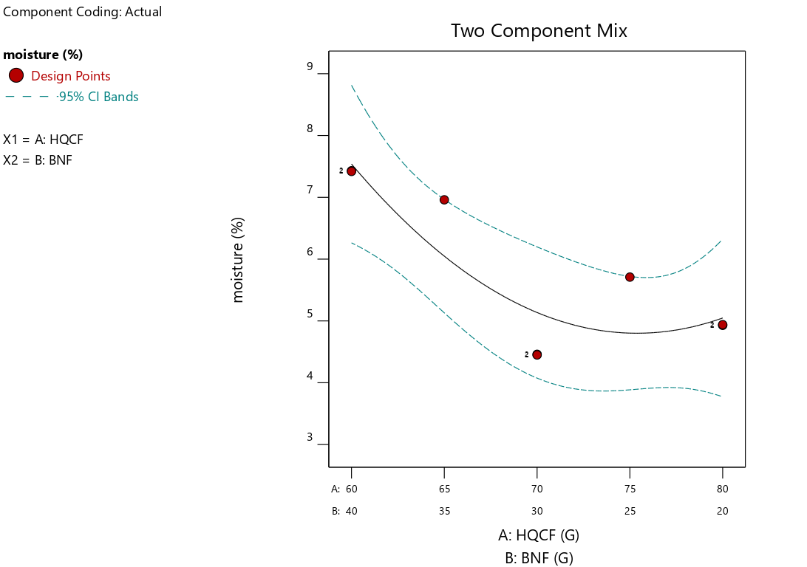 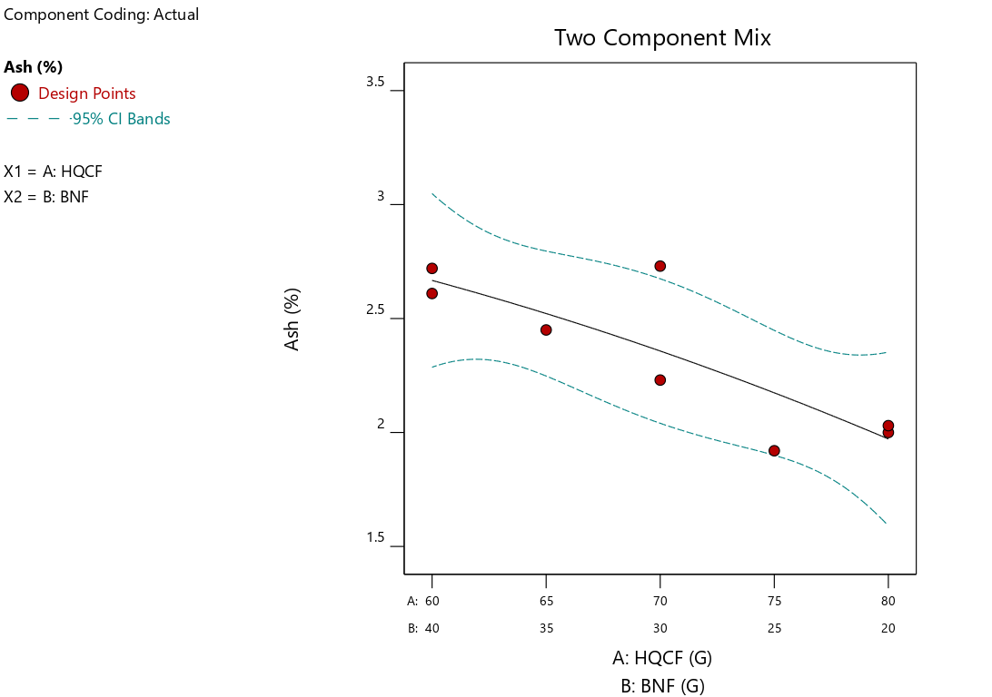

**Figure 1: Model graph depicting the trend of moisture and ash (%) contents of tidbit as influenced by HQCF and BNF at different blending ratios**

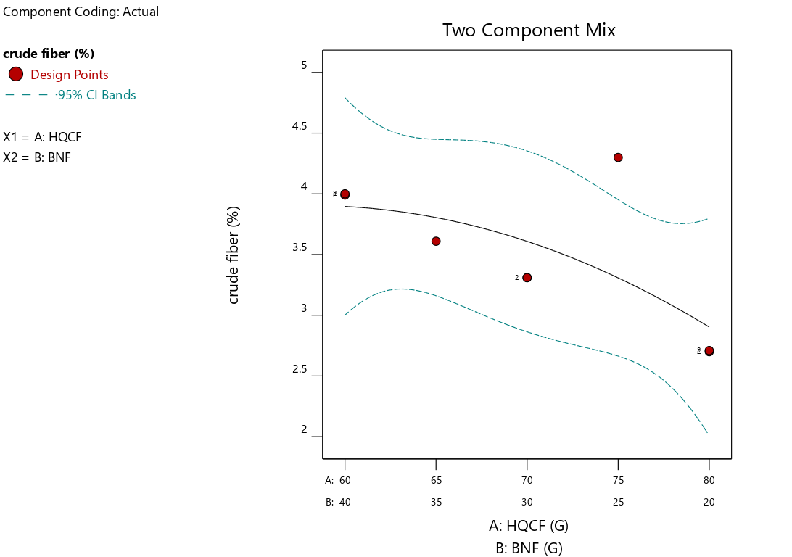 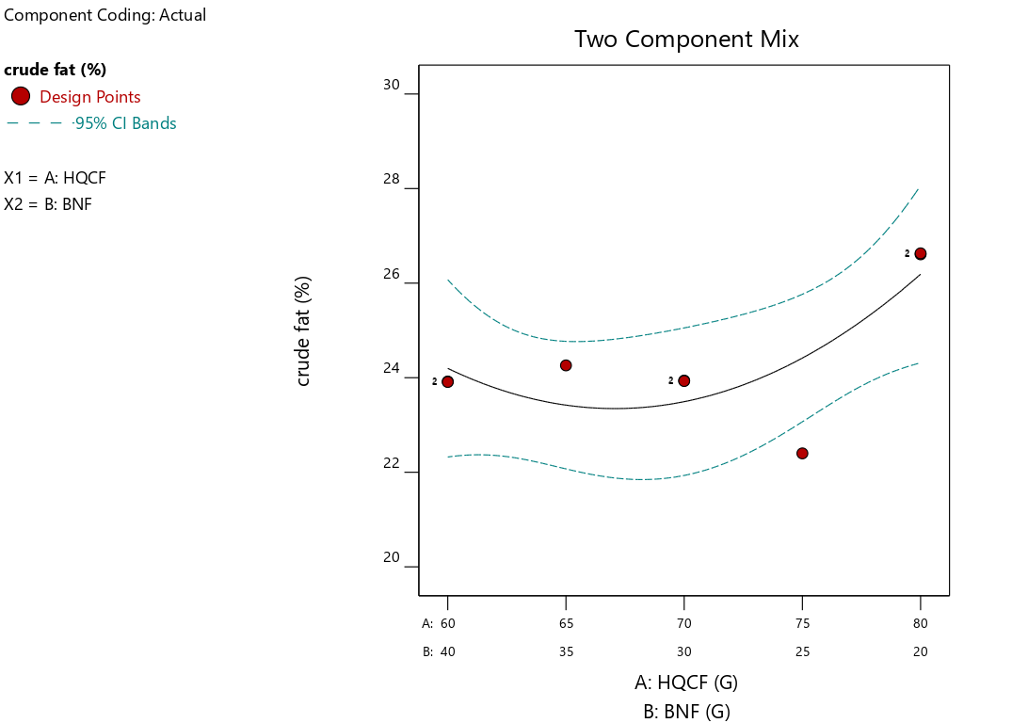

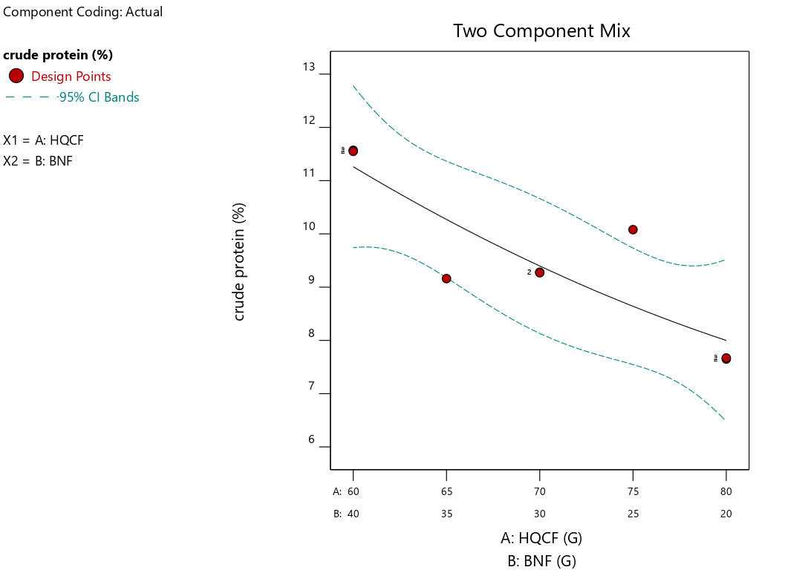 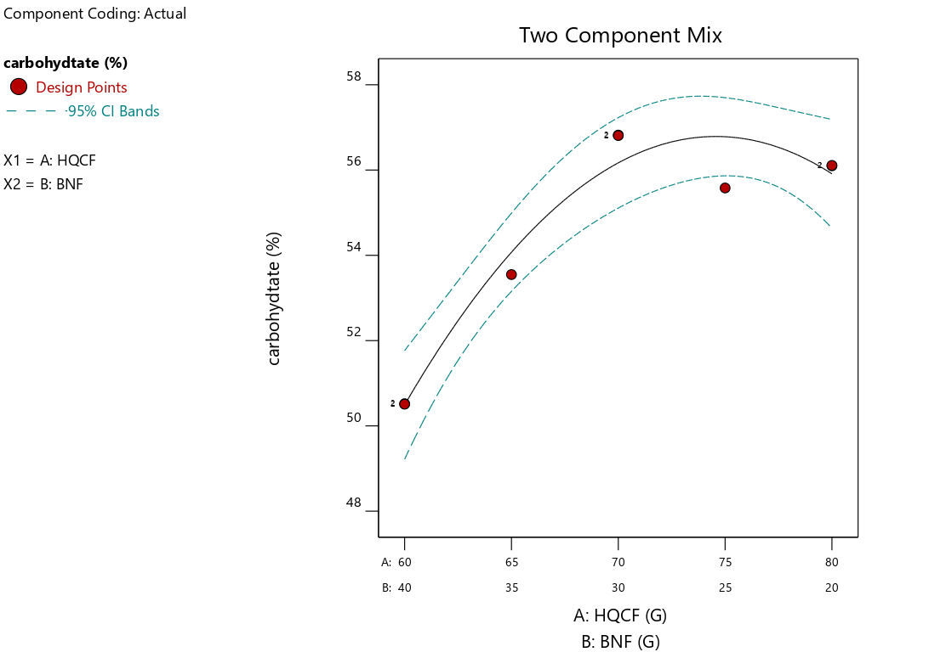

**Figure 2: Model graph depicting the trend of crude fiber, crude fat, crude protein, and carbohydrate (%) contents of tidbits as influenced by HQCF and BNF at different blending ratios**

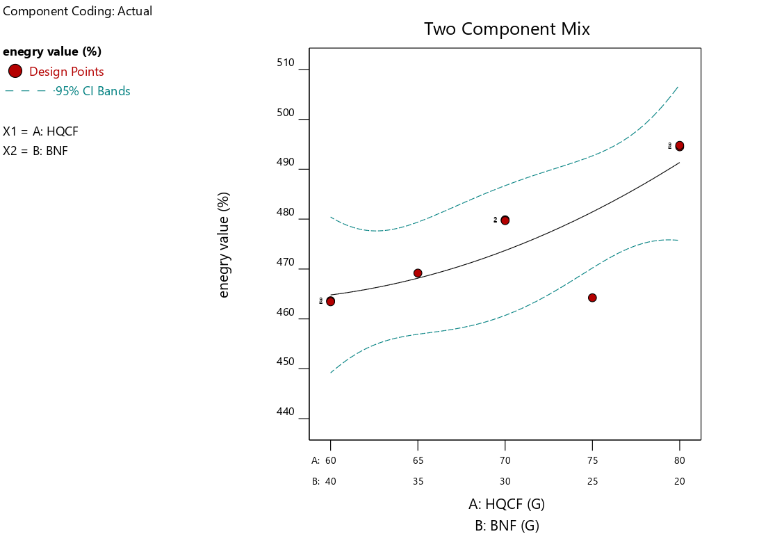

**Figure 3: Model graph depicting the trend Energy (KJ/kg) content of tidbit as influenced by HQCF and BNF at different blending ratios**

The carbohydrate content of the tidbit ranged from 50.52 to 56.82%, as indicated in Table 4. There was a significant (p<0.05) difference between the tidbit samples concerning carbohydrate content. The results of the data obtained using multiple quadratic regression are presented in Table 5. The main effect of HQCF, as well as BNF, had a significant (p<0.05) effect on the carbohydrate content. Also, the interactive effect of the blends showed a significant (p<0.05) effect. The regression coefficient parameter showed that the quadratic model developed for carbohydrate content had a coefficient of determination (R2) of 0.95, indicating a 95 % predictive accuracy and an F-value of 44.71. An increase was observed in the carbohydrate content of the tidbits as HQCF inclusion increased. But the inclusion of Bambara nut flour lowers the level of the carbohydrate content (Figure 2). This inverse relationship is expected since Bambara nut has lower carbohydrate content compared to cassava (Ijarotimi & Esho, 2009).

The energy content of the tidbits follows the nutrient composition, ranging from 463.45 to 494.50 K/cal as indicated in Table 4. There was a significant (p<0.05) difference between the tidbits concerning energy content. The results of the data obtained using multiple quadratic regression are presented in Table 5. The main effect of HQCF, as well as BNF, had a significant (p<0.05) effect on the carbohydrate contents of the samples. However, the interactive effect of the blends shows a negative, non-significant (p>0.05) effect. The regression coefficient parameter showed that the quadratic model developed for carbohydrate content had a coefficient of determination (R2) of 0.68, indicating a 68% predictive accuracy and an F-value of 5.21. An increase was observed in the energy content of the tidbits as HQCF inclusion increased. This suggests that the product is energy-dense and may serve well as a snack or complementary food (Alimi *et al*., 2024a), but the inclusion of Bambara nut flour lowers the level of the energy content (Figure 3).

**Physical properties of the Tidbits**

The crust lightness (L*) ranged from 38.61 to 49.96, with the tidbit sample prepared with 65% HQCF and 35% BNF being the least light, while the sample produced with 80% HQCF and 20% BNF had the highest lightness value, as indicated inTable 6. There was no significant (p>0.05) difference in all lightness parameters of the tidbit.

T**able 6: Physical attributes of tidbits made with a blend of flour from HQCF and BNF**

|  |  |  |  |
| --- | --- | --- | --- |
| Sample | Lightness | Redness | Yellowness |
| HQCF80.00 BNF20.00 | 45.97±3.30a | 16.58±0.88a | 47.10±2.69a |
| HQCF65.00 BNF35.00 | 38.61±19.39a | 20.58±11.23a | 66.03±30.00a |
| HQCF70.00 BNF30.00 | 46.33±1.08a | 16.91±6.43a | 51.16±5.46a |
| HQCF60.00 BNF40.00 | 38.99±0.78a | 19.24±0.97a | 52.75±0.86a |
| HQCF75.00 BNF25.00 | 44.17±4.36a | 17.34±3.01a | 50.52±4.76a |
| HQCF80.00 BNF20.00 | 49.96±3.60a | 17.82±4.71a | 49.13±5.97a |
| HQCF60.00 BNF40.00 | 45.89±2.65a | 15.15±2.43a | 43.76±7.58a |
| HQCF 70.00 BNF30.00 | 41.16±1.27a | 21.85±1.04a | 36.69±29.50a |

*Values are means of duplicates ± standard deviation. Mean values with different superscripts within the same column are significantly different at the 5% level.*

*HQCF: High quality cassava flour; BNF: Bambara nut flour*

**Table 7: Regression coefficient for colour attributes of tidbits made with a blend of flour from HQCF and BNF**

|  |  |  |  |
| --- | --- | --- | --- |
| **Parameter** | **Lightness** | **Redness** | **Yellowness** |
| A-HQCF | 48.06* | 16.85* | 47.44* |
| B- BNF | 41.92* | 17.57* | 51.07* |
| AB | -10.10 | 8.93 | 3.80 |
| R2 | 0.48 | 0.25 | 0.03 |
| F-Value | 2.27 | 0.82 | 0.08 |
| p-value | 0.20 | 0.49 | 0.92 |

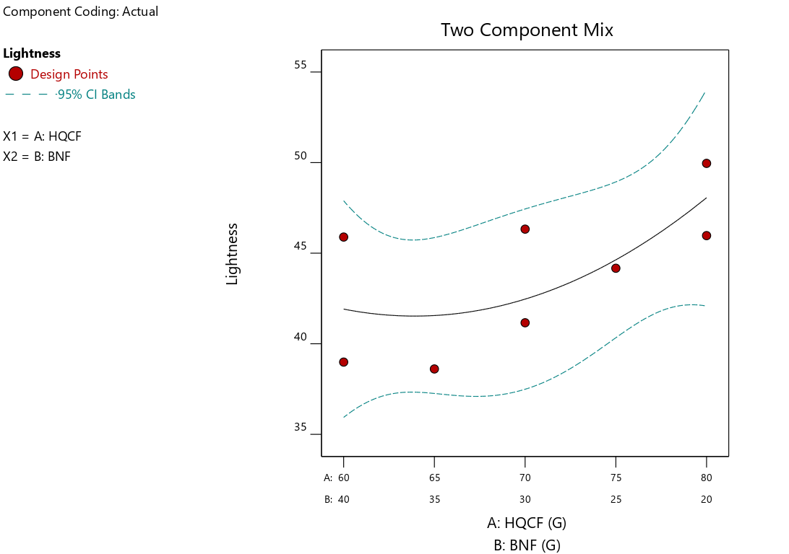 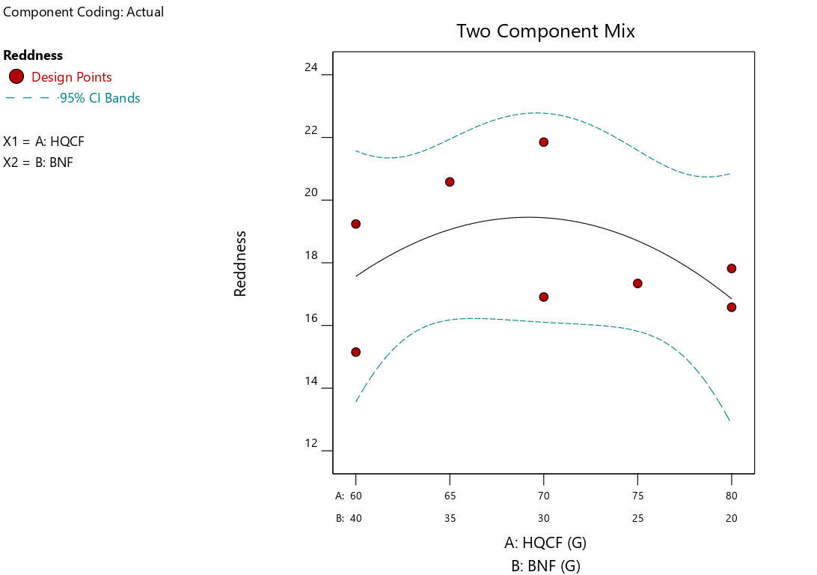

**Figure 4: Model graph depicting the trend of lightness and redness contents of tidbit as influenced by HQCF and BNF at different blending ratios**

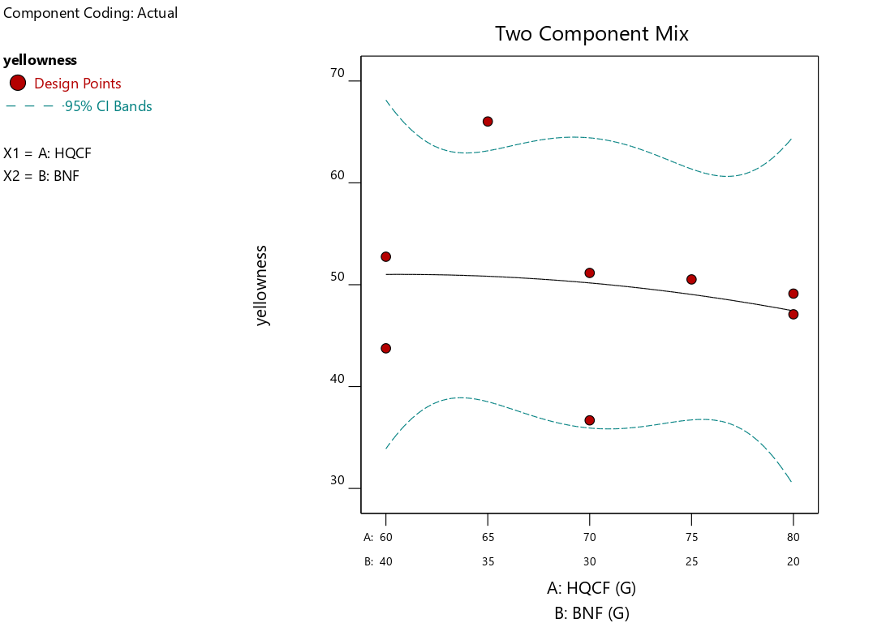

**Figure 5: Model graph depicting the trend yellowness (%) content of tidbit as influenced by HQCF and BNF at different blending ratios**

The results of the data obtained using multiple quadratic regression are presented in Table 7. The main effect of HQCF and BNF significantly (p<0.05) affect lightness. The interactive effect of HQCF and BNF had a negative, non-significant (p>0.05) effect on lightness. The regression coefficient parameter showed that the quadratic model developed for lightness had a coefficient of determination (R2) of 0.48, indicating a 48% predictive accuracy, and an F-value of 2.27. The model graph depicting the trend of lightness as influenced by HQCF and BNF at different blending ratios is shown inFigure 4. Lightness increased as HQCF inclusion increased, while as BNF increased, lightness decreased. A decrease in the lightness value could be attributed to thermal degradation of pigment that gives vibrancy colour, as noted by Liu *et al.* (2016) and Alimi *et al*. (2016). Again, the decreases in lightness colour of the tidbits produced from blends of HQCF and BNF could also be attributed to the genetic make-up of Bambara nut, with its distinctive composition that includes proteins, oils, and pigments. These observations are also supported by previous reports of Nawaz *et al.* (2021). The crust redness (a*) varied between 15.15 and 21.85, with tidbit prepared with 70 % HQCF and 30 % BNF having the highest, while the sample produced with 60% HQCF and 40% BNF had the least. There was no significant (p>0.05) difference between the tidbits concerning crust redness (a*) as indicated in Table 6.The main effect of HQCF and BNF was significant (p<0.05) on redness (a*). However, the interactive effect of HQCF and BNF had no significant (p>0.05) effect on redness. The regression coefficient parameter showed that the quadratic model developed for redness had a coefficient of determination (R2) of 0.25, indicating a 25% predictive accuracy and an F-value of 0.82. The model graph depicting the trend of redness as influenced by the flour blends at different blending ratios is shown in Figure 4. A decrease was observed as HQCF inclusion increased; meanwhile, an increase was observed in redness value as BNF increased in the blends. The increase in redness value was observed as the BNF incorporation increased in the blends. This could be linked with the increased protein content of some of the formulations, which has a propensity to favour Maillard-type browning reactions in carbohydrate-rich food matrices (Obatolu *et al.,* 2006; Alimi *et al*., 2016). The crust yellowness (b*) of the tidbits ranged from 36.69 to 66.03, with the sample prepared with 65% HQCF and 35% BNF having the highest, while the tidbits sample with 70% of HQCF and 30% of BNF had the least value. There was no significant (p>0.05) difference between the tidbits concerning crust yellowness as indicated in Table 6, while Table 7 presents the results of data obtained using multiple quadratic regression. The main effect of HQCF and BNF had a significant (p<0.05) effect on yellowness. Similarly, the interactive effect of the constituent flour in the blends had a non-significant (P>0.05) effect on yellowness. The regression coefficient parameter showed that the quadratic model developed for yellowness had a coefficient of determination (R2) of 0.03, indicating 30% predictive accuracy, and an F-value of 0.08. The model graph depicting the trend of yellowness as influenced by HQCF and BNF at different blending ratios is shown in Figure 5. An increase in yellowness was observed when BNF increased, but the reverse is the case when HQCF increased. The relatively high sugar and free amino acid contents of the constituent flours making up the blend could be adduced as a reason for the observed Millard reaction resulting in an increase in yellowness value of the tidbits (Islam *et al*. 2012; Alimi *et al*., 2016).

**Optimum level of the constraint for the optimization of ingredient combination of HQCF and BNF composite bread.**

The conditions of the optimization process that would give a desirable processing condition using the following constraints are presented in Table 8. Redness and yellowness were minimized. Lightness was maximized, while moisture (%) and fat content (%) were minimized. Also, crude protein, fibre, carbohydrate (%), and energy (k/cal) were all maximized. The optimized ingredient blend formulation obtained was HQCF of 70% and BNF 30%, while the calculated desirability was 0.53.

**Table 8: Optimum level of the constraints for the optimization of ingredient combination for tidbits made with a blend of flour from**

|  |  |  |  |  |  |  |
| --- | --- | --- | --- | --- | --- | --- |
| Name | Goal | Lower Limit | Upper Limit | Lower Weight | Upper Weight | Importance |
| A: HQCF | is in range | 60 | 80 | 1 | 1 | 3 |
| B: BNF | is in range | 20 | 40 | 1 | 1 | 3 |
| Lightness | Maximize | 38.61 | 49.96 | 1 | 1 | 3 |
| Redness | Minimize | 15.15 | 21.85 | 1 | 1 | 3 |
| Yellowness | Minimize | 36.69 | 66.03 | 1 | 1 | 3 |
| Moisture | Minimize | 4.45 | 7.43 | 1 | 1 | 3 |
| Ash | Maximize | 1.92 | 2.73 | 1 | 1 | 3 |
| Crude fiber | Maximize | 2.7 | 4.3 | 1 | 1 | 3 |
| Crude fat | Minimize | 22.4 | 26.63 | 1 | 1 | 3 |
| Crude protein | Maximize | 7.65 | 11.57 | 1 | 1 | 3 |
| Carbohydrate | Maximize | 50.51 | 56.82 | 1 | 1 | 3 |
| Energy value | Maximize | 463.43 | 494.79 | 1 | 1 | 3 |

**Conclusion**

The study demonstrated the effect of HQCF fortified with Bambara nut flour on the proximate and physical properties of quality tidbits. The proximate and physical properties of the tidbits were significantly affected by the fortification of HQCF with BNF**.** The incorporation of Bambara nut flour significantly enhanced the protein, fiber, and mineral content as measured by the ash contents of the cassava-bambara tidbits while slightly reducing carbohydrate content. A tidbit of acceptable quality concerning physical and proximate properties was successfully produced with blends of flours from cassava and Bambara nut. The optimized ingredient blend formulation obtained was high quality cassava flour of 70% and Bambara nut flour of 30%, while the calculated desirability was 0.53.

**ACKNOWLEDGEMENT**

The authors sincerely acknowledge and appreciate the management of Nigerian Stored Products Research Institute (NSPRI) for the approval to use the International Standard Organization (ISO) certified laboratory of the Institute. The authors appreciate the cassava unit of the International Institute of Tropical Agriculture (IITA) for technical support and provision of cassava roots used for the research.

**Disclaimer (Artificial intelligence)**

Author(s) hereby declare that NO generative AI technologies such as Large Language Models (ChatGPT) was used in the manuscript.

**Reference**

Adebayo, S. F., Itiola, O. A., & Adeoye, B. K. (2012). Effect of Bambara nut flour addition on the functional and sensory properties of cassava starch. African Journal of Food Science and Technology,3(6):143–146.

Alimi, J.P., Ahemen, S. A., Alimi, J. O., Ngunoon, T.P.Yepshak, N. B. (2022). Comparative study on chemical and functional properties of flours produced from selected clones of low and high postharvest physiological deterioration cassava (*Manihot esculenta Crantz*). *Journal of Current Research in Food Science,* 3 (1): 51-57. DOI:<https://doi.org/10.22271/foodsci.2022.v3.i1a.60>

Alimi, J.P., Akanni, A.A., Aina, J.A., Ashonibare, A.R., Kurrah, A.G., Okparavero, N.F., and Okunade, S.O. (2024b). Quality characteristics of bread produced with blends of flour from cassava, wheat, and bambara groundnut (*Vigna Subterranea*). *European Journal of Nutrition & Food Safety*, 16 (12):124-48. <https://doi.org/10.9734/ejnfs/2024/v16i121608>.

Alimi, J.P., Otitodun, O.G., Akanni, A.A., Jimoh, M.O., Adegbola, R.Q., Haruna, P.B., Akande, E.J., Ishola, D.T., Ajayi, O.A., Yissa, A.I. & Odutola, B.S. (2024a). Quality characteristics of cake produced with blends of flour from bambara nut seeds (*Vigna Subterranea*) and cassava (Manihot Esculenta). *Asian Food Science Journal*, 23(12):99-116. <https://doi.org/10.9734/afsj/2024/v23i12762>.

Alimi, J.P., Shittu, T.A., Oyelakin, M.O., Olagbaju, A.R., Sanu, F.T., Alimi, J.O., Abel, O.O., Ogundele, B.A., Ibitoye, O., Ala, B.O., Ishola, D.T. (2016). Effect of cowpea flour inclusion on the storage characteristics of composite wheat-cowpea bread. Journal of Agricultural and Crop Research. 2016;4(4): 49-59. Available:http://sciencewebpublishing.net/j acr/archive/2016/June/pdf/Alimi%20et%20

Ijarotimi, O. S., & Esho, T. R. (2009). Comparison of nutritional composition and anti-nutrient status of fermented, germinated, and roasted Bambara groundnut seeds. British Food Journal, 111(4),376–386.

Islam, M. Z., Taneya, M. L. J., Shams-Ud-Din, M., Syduzzaman, M., & Hoque, M. (2012). Physicochemical and functional properties of brown rice (*Oryza sativa*) and wheat (*Triticum aestivum*) flour and quality of composite biscuit made thereof. *Scientific Journal of Krishi Foundation*, *10*, 20–28. https://doi.org/10.3329/agric.v10 i2.13135

James, S., Nwokocha L., James Y., Abdulsalam R.A., Amuga S.J., Ibrahim I. B. (2018). Chemical composition and sensory acceptability of partially gelatinized pasta produced from blends of wheat, bambara nut, and cassava flours. Agro-Science, 16:26-30.

Liu, T., Hamid, N., Kantono, K., Pereira, L., Farouk, M. M. & Knowles, S.O. (2016). Effects of meat addition on pasta structure, nutrition, and in vitro digestibility. Food Chem. 2016, 213, 108–114.

Lyimo, M.E., Berling, S. and Sibuga, K.P. (2004). Evaluation of the nutritional quality and acceptability of germinated bambara nut (Vigna subterranea (L) verle) based products. Ecol Food Nutr. 43:181 191 doi: 10.1080/03670240490446795

Alamu, E. O., Maziya-Dixon, B., & Dixon, A. G. (2017). Evaluation of proximate composition and pasting properties of high quality cassava flour (HQCF) from cassava genotypes (Manihot esculenta Crantz) of β-carotene-enriched roots. LWT, 86, 501-506.

Murevanhema, Y. Y., & Jideani, V. A. (2013). Potential of Bambara groundnut (Vigna subterranea (L.) Verdc) milk as a probiotic beverage—A review. Critical Reviews in Food Science and Nutrition,53(9),954–967.

Nawaz, A., Khalifa, I., Walayat, N., Lorenzo, J. M., Irshad, S., Ahmed, S. & Li, E. (2021). Whole fish powder snacks: Evaluation of structural, textural, pasting, and water distribution properties. Sustainability, 13(11), 6-10.

Obatolu, V. A., Omueti, O. O., and Adebowale, E. A. (2006). Qualities of extruded puffed snacks from maize/soybean mixture. Journal of food process engineering, 29(2), 149-161

Official methods of analysis, AOAC (2019). Association of Official Analytical Chemists. Vol. I, 21st Edition.

Onabanjo, O. O., Oguntona, C. R. B., & Fakoya, E. O. (2009). Nutritional evaluation of complementary food developed from plant and animal sources. Nutrition & Food Science, 39(6),643–653.

Oyeyinka, S. A., Oyeyinka, A. T., & Karim, O. R. (2017). Quality evaluation of stiff dough “amala” prepared from plantain (Musa spp.) flour and Bambara groundnut (Vigna subterranea) protein concentrate blend. Journal of Food Measurement and Characterization, 11, 928–935.

Sanni, L. O., Alimi, J. P., Jimoh, M. O., Aremu, M. B., Ihum, T. A. Fashanu, T. A., Okunade, S. O., and Akanni, A. A. (2024). quality attributes of chinchin produced with blends of flour from cassava (Manihot Esculenta) and bambara groundnut (*Vigna subterranea*). *European Journal of Nutrition & Food Safety,* 16 (7):134-50. <https://doi.org/10.9734/ejnfs/2024/v16i71463>.