### European Journal of Nutrition & Food Safety

#### Volume XXX, Issue XX, Page XX-XX, 20YY; Article no.EJNFS.138084

***ISSN: 2347-5641***

# Evaluation of the *In-vivo* Antiparasitic Effects of the Aqueous Extract of the Leaves of *Alchornea Cordifolia* (AEAC)(Euphorbiaceae) as an Alternative in Poultry Farming in Côte d'Ivoire

***Authors’ contributions***

*This work was carried out in collaboration among all authors. ‘Author A’ designed the study, performed the statistical analysis, wrote the protocol, and wrote the first draft of the manuscript. ‘Author B’ and ‘Author C’ managed the analyses of the study. ‘Author C’ managed the literature searches. All authors read and approved the final manuscript.*

***Article Information***

DOI: 10.9734/EJNFS/2025/XXXXX

**Open Peer Review History:**

This journal follows the Advanced Open Peer Review policy. Identity of the Reviewers, Editor(s) and additional Reviewers, peer review comments, different versions of the manuscript, comments of the editors, etc are available here:

***Received: DD/MM/20YY***

***Accepted: DD/MM/20YY***

***………… Article***

***Published: DD/MM/20YY***

## ABSTRACT

|  |
| --- |
| Coccidiosis is a major parasitic disease affecting chickens and is a significant factor in the decline of their zootechnical performance. Conventional control methods rely on synthetic anticoccidial drugs, which pose risks to both animal and human health. This has prompted growing interest in natural alternatives, particularly medicinal plants. Alchornea cordifolia, a plant native to Côte d'Ivoire and widely used in traditional medicine, is known for its diverse therapeutic properties. Phytochemical screening of the aqueous leaf extract revealed the presence of sterols, polyterpenes, polyphenols, quinones, alkaloids, and catechic tannins. The LD₅₀, determined in accordance with OECD guideline 423, indicated that the extract is non-toxic at doses of 2000 and 5000 mg/kg body weight in Wistar rats. The study evaluated the effects of *A. cordifolia* aqueous extract on weight gain, feed conversion ratio, lesion scores, and clinical appearance in broiler chickens. The results showed no adverse impact on zootechnical performance. Furthermore, the extract demonstrated anticoccidial efficacy against *Eimeria*-induced coccidiosis. After seven days of treatment, oocyst counts dropped significantly across the three experimental groups: from 102,300 to 200 OPG in the control group (treated with a conventional anticoccidial), from 86,350 to 4,200 OPG in the group treated with 5 g/L of the extract, and from 21,400 to 3,500 OPG in the group treated with 10 g/L. These results suggest that *A. cordifolia* leaf extract exhibits promising anticoccidial activity and may be considered as a potential alternative in poultry health management. |

*Keywords: Alchornea cordifolia; aqueous extract; anticoccidial activity; poultry farming; oocysts per gram (OPG).*

**1. INTRODUCTION**

Coccidiosis is a protozoan disease caused by obligate intracellular parasites of the *Apicomplexa* phylum, a group of pathogens of significant economic, veterinary, and medical concern (Aitfella, 2012). In poultry farming, coccidiosis remains a major constraint, adversely affecting productivity, food security, and economic development. To manage this disease, many farmers rely on veterinary drugs. However, the improper and uncontrolled use of these anticoccidial agents has led to the emergence of *Eimeria* strains resistant to commonly used medications (Dakpogan et al., 2012).

Given the growing problem of resistance and the associated health risks for both consumers and animals, there is an urgent need to explore alternative strategies (Kouamé et al., 2004; Ouattara-Soro et al., 2023). Among these alternatives, medicinal plants have received increasing attention. *Alchornea cordifolia*, in particular, is widely used in traditional medicine for its anti-inflammatory, antifungal, antibacterial, analgesic, and antioxidant properties (Traoré, 2005; M'Bra, 2017).

The objective of this study was to evaluate the in vivo antiparasitic effects of the aqueous extract of *Alchornea cordifolia* leaves in broiler chickens (Wagner & Bladt, 2001).

**2. MATERIALS AND METHODS**

**2.1 Materials**

**2.1.1 Plant** **materials**

The plant material consisted of Alchornea cordifolia leaves, which were air-dried in the shade and then ground into a fine powder. This powder was used to prepare the aqueous extract.

**2.1.2 Animal materials**

* Wistar strain *Rattus norvegicus* (Muridae) rats, weighing between 100 g and 130 g, were used for acute toxicity assessment.
* Fifty-one (51) one-day-old *Gallus gallus domesticus* chicks of the Cobb 500 strain, averaging 43 g in weight, were obtained from IVOGRAIN on August 23, 2022, and monitored from day 1 to day 32.

**2.2 Methods**

**2.2.1 Preparation of aqueous extract of Alchornea cordifolia leaves**

The aqueous extract was prepared following the protocol described by Bagré et al. (2011). Briefly, 100 g of leaf powder was macerated in 1000 mL of sterile distilled water for 24 hours at room temperature on a magnetic stirrer set at 3000 rpm. The resulting mixture was filtered successively through poplin cloth, cotton wool, and Whatman filter paper. The filtrate was then dried in an oven at 40°C to obtain the dry extract.

**2.2.2 Phytochemical screening**

Phytochemical analyses were conducted according to the methods of Lazureski et al. (2007), Abo (2013), and Mea et al. (2017) at the Animal Physiology and Phytotherapy Laboratory, Biosciences UFR (UFHB).

**2.2.3 Acute toxicity testing by oral gavage**

This experimental procedure was adapted from OECD guideline 423 (2001). Wistar rats (100–130 g) were divided into three groups of six animals each. Two groups received increasing doses of the aqueous extract orally via gavage, while the control group received distilled water. Animals were closely monitored for any toxic effects.

**2.2.4 Induction and treatment of coccidiosis**

Fifty-one one-day-old chicks were randomly divided into three groups of 17 birds each:

* **Group 1 (Control):** reared with conventional prophylaxis and received standard anticoccidial treatment.
* **Group 2:** reared with conventional prophylaxis, but received the aqueous extract of Alchornea cordifolia (AEAC) at 5 g/L instead of conventional anticoccidials, without antibiotics.
* **Group 3:** reared with conventional prophylaxis, but received AEAC at 10 g/L instead of conventional anticoccidials, without antibiotics.

Prior to artificial infestation, the presence of coccidia was confirmed microscopically. The chicks were infected via their drinking water after a 12-hour water deprivation.

Two treatment phases were applied: preventive treatment starting on day 2 of the rearing cycle (Groups 2 and 3 received AEAC instead of antibiotics) and curative treatment starting on day 22 (five days post-infestation on day 17). During curative treatment, Groups 2 and 3 received 5 g/L and 10 g/L AEAC, respectively, while the control group received a conventional anticoccidial at 1 g/L. Treatments lasted according to standard prophylaxis protocols.

Chicks were weighed individually every 7 days. Droppings were analyzed on days 7, 14, 18, 21, 24, and 27. At the end of the treatment, intestinal lesion scores were assessed.

The bedding was regularly changed to minimize recontamination risks. Monitoring parameters included weight gain, feed conversion ratio, coccidiosis-related mortality, oocyst excretion, intestinal lesion scores, clinical signs, and faecal appearance.

**2.3 Statistical Analysis**

The results were analyzed using a one-way analysis of variance (ANOVA) performed with appropriate statistical software. Data processing and graphical representations were generated using Microsoft Excel and XLSTAT.

**3. RESULTS**

**3.1 Phytochemical Screening**

The phytochemical screening of the aqueous extract of *Alchornea cordifolia* leaves revealed the presence of several bioactive compounds, including sterols and polyterpenes, polyphenols, quinone compounds, alkaloids, and catechic tannins. These secondary metabolites are known for their diverse pharmacological properties such as anti-inflammatory, antimicrobial, antioxidant, and antiparasitic activities. The presence of these compounds supports the traditional use of *Alchornea cordifolia* in treating various ailments and suggests its potential efficacy as a natural anticoccidial agent.

**3.2 Acute Toxicity**

A single oral gavage dose of 2000 mg/kg body weight administered to female rats had no observable effect on their behavior. However, a single dose of 5000 mg/kg body weight caused a temporary reduction in motor activity, with the rats gathering in a corner of the cage for approximately 30 minutes. After this period, normal behavior resumed. No mortality was observed at any dose during the 14-day observation period. All animals survived, indicating that the LD₅₀ is greater than 5000 mg/kg body weight. According to the Globally Harmonized System of Classification and Labelling of Chemicals (GHS, 2003), the aqueous extract of *Alchornea cordifolia* leaves is considered non-toxic when administered orally to Wistar rats (Table 1).

**3.3** **Zootechnical and Parasitological Parameters**

**3.3.1 Average daily earnings**

The average daily weight gains of batches 2 and 3, which were treated with the aqueous extract of *Alchornea cordifolia* (EAAC), were 33.51 g and 31.98 g, respectively. The control group had an average daily gain of 33.15 g. Statistical analysis showed no significant difference (P > 0.05) between the average gains of the treated groups and the control group (Fig. 1).

**3.3.2 Consumption index**

The feed conversion ratios (FCR) of the control group and the batches treated with 5 g/L and 10 g/L AEAC were 1.4, 1.42, and 1.4, respectively. The FCR of the two batches treated with AEAC showed a slight increase over the course of the study. However, this increase was not statistically significant (P > 0.05) compared to the control group (Fig. 2).

**Table 1. Results of phytochemical screening of the aqueous extract of *Alchornea cordifolia***

|  |  |  |  |
| --- | --- | --- | --- |
| **Compounds sought** | | **Test or reagents** | **Results** |
| Sterols and polyterpenes | | Liebermann | **+** |
| Polyphenols | | Ferric chloride | **+** |
| Flavonoids | | Cyanidine | **-** |
| Saponosides | | Vigorous agitation | **-** |
| Quinonic compounds | | Borntraeger | **+** |
| Alkaloids | | Dragendorff | **+** |
| Bouchardat | **+** |
| Tannins | Catechics | Stiasny | **+** |
| Galliques | Hydrochloric acid | **-** |

*(+) : Presence of compound*

*(–) : Absence of compound*

**Table 2. Number of rats and mortality rate as a function of the dose of *Alchornea cordifolia* extract**

|  |  |  |  |  |
| --- | --- | --- | --- | --- |
| **Lots** | **EAAC dose**  **(mg/kg PC)** | **Number of rats tested** | **Number of dead rats** | **Mortality rate** |
| 1 | 2000 | 3 | 0 | 0% |
| 2 | 5000 | 3 | 0 | 0% |

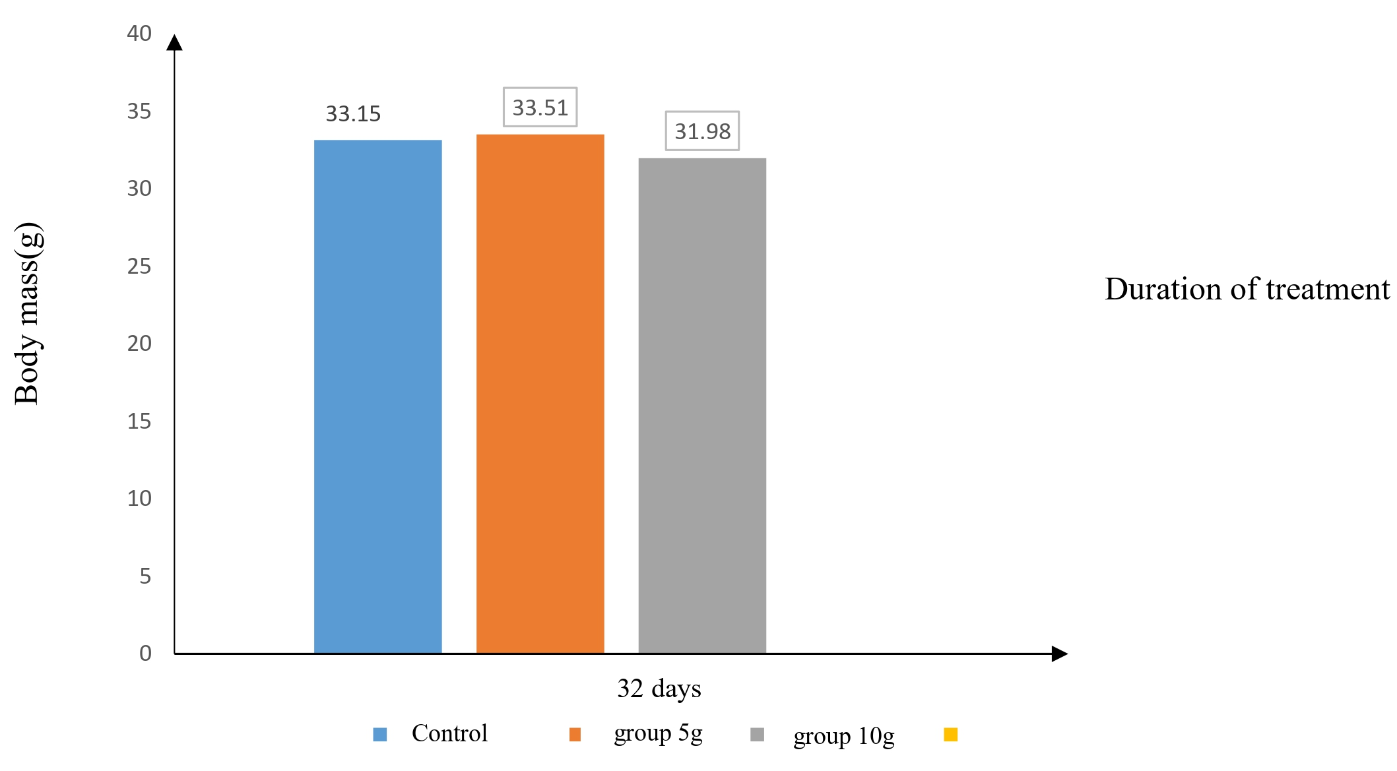

**Fig. 1. Evolution of weight gain in treated chickens**

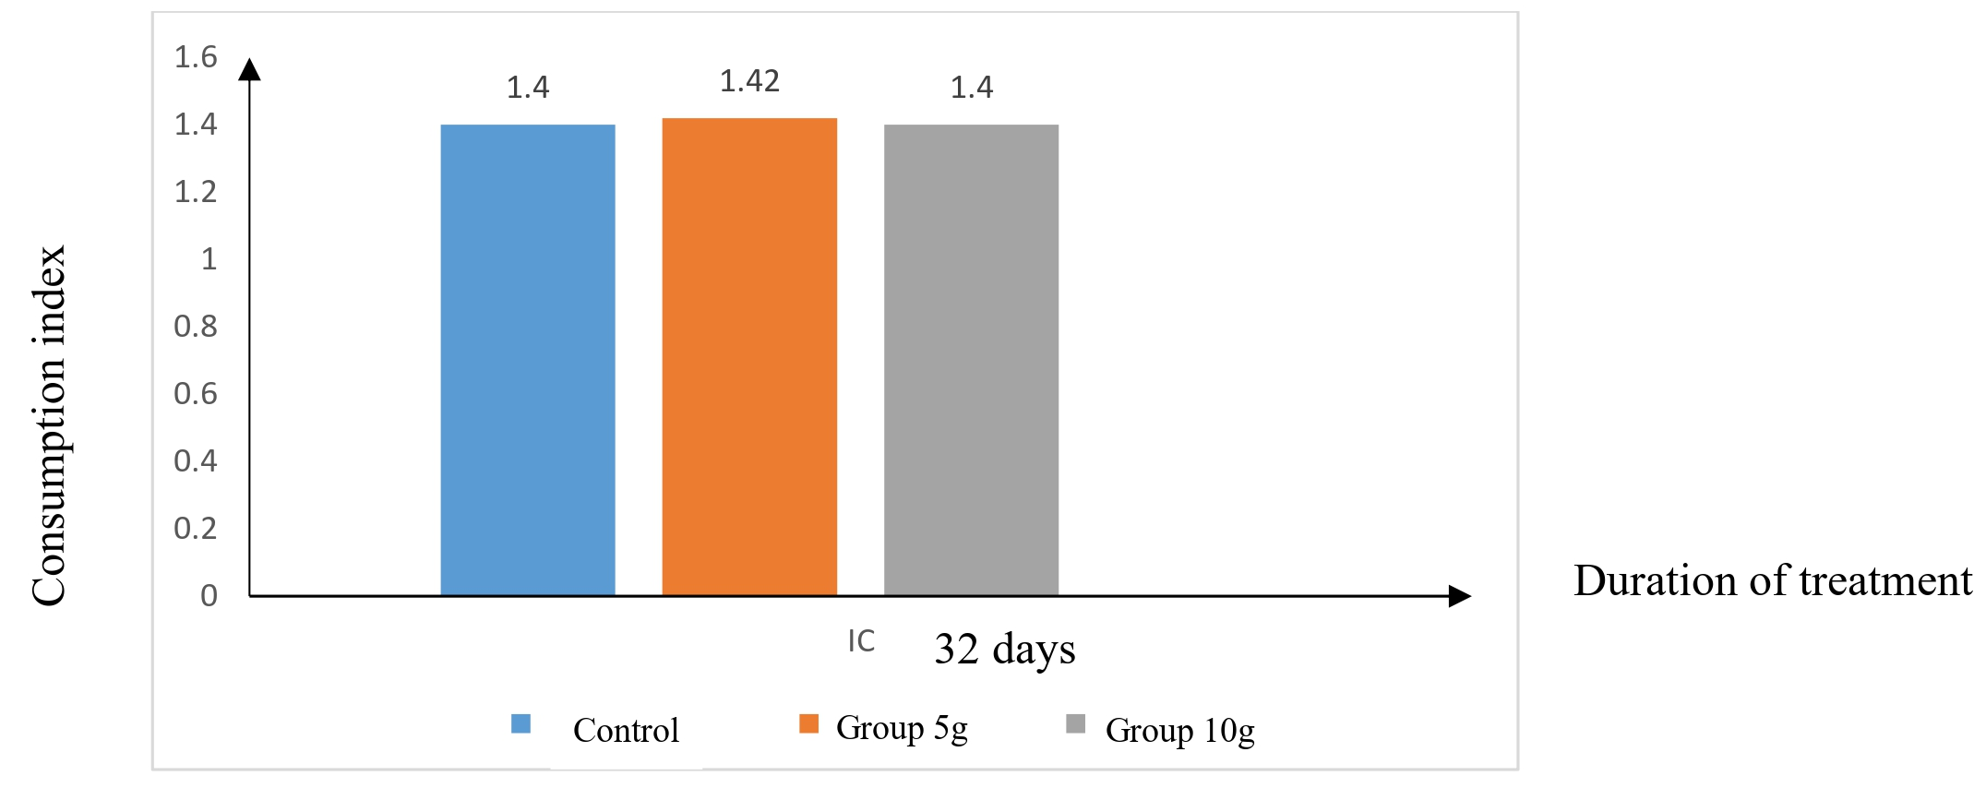

**Fig. 2. Change in feed conversion rate for treated chickens**

(n=17)

**3.3.3 Mortality rate**

During the rearing period, no mortality was observed in any of the three experimental batches. The overall mortality rate throughout the experiment was 0%.

**3.3.4 Oocyst excretion**

*3.3.4.1 Analysis before artificial infestation and treatment*

From day 1 to day 7 of rearing, coprological analysis of the droppings revealed no presence of coccidia in either the treated groups or the control group. However, starting from the second week, low levels of coccidia were detected in all batches. Specifically, in the groups treated with AEAC at 5 g/L and 10 g/L, the oocysts per gram (OPG) were 50 and 7,250 respectively, while the control group showed 650 OPG. (Fig. 3).

*3.3.4.2 Analysis after artificial infestation and treatment*

Five days after infestation, coprological analysis revealed a high presence of coccidia in the droppings of all three batches. The control batch showed 86,350 oocysts per gram (OPG), while the batch treated with 10 g/L AEAC had a lower count of 21,400 OPG. The batch treated with 5 g/L AEAC had a higher count of 102,300 OPG.

By day 26, four days after treatment, a marked decrease in coccidia oocysts was observed in all batches. In the control batch and the batch treated with 5 g/L AEAC, OPG dropped from 86,350 to 1,600 and from 102,300 to 1,800 respectively. However, in the batch treated with 10 g/L AEAC, the decrease was less pronounced, from 21,400 to 13,900 OPG. At the end of the seven-day treatment period, infestation levels were low in all batches. Microscopic examination showed OPG values of 200 in the control batch, 4,200 in the 5 g/L AEAC batch, and 3,500 in the 10 g/L AEAC batch (Fig. 4).

**3.3.5 Clinical index**

Chickens from the three infected batches exhibited clinical signs characteristic of coccidiosis, including prostration with a hunched posture, drooping wings, and ruffled feathers. Their droppings varied considerably, ranging from normal to visibly bloody.

**3.3.6 Lésion index**

At necropsy after the treatment period, intestinal and duodenal lesions as well as cecal dilatation were observed in the control batch. In contrast, the batches treated with the aqueous extract of *Alchornea cordifolia* showed no intestinal lesions. However, slight duodenal lesions and mild cecal dilatation were noted.

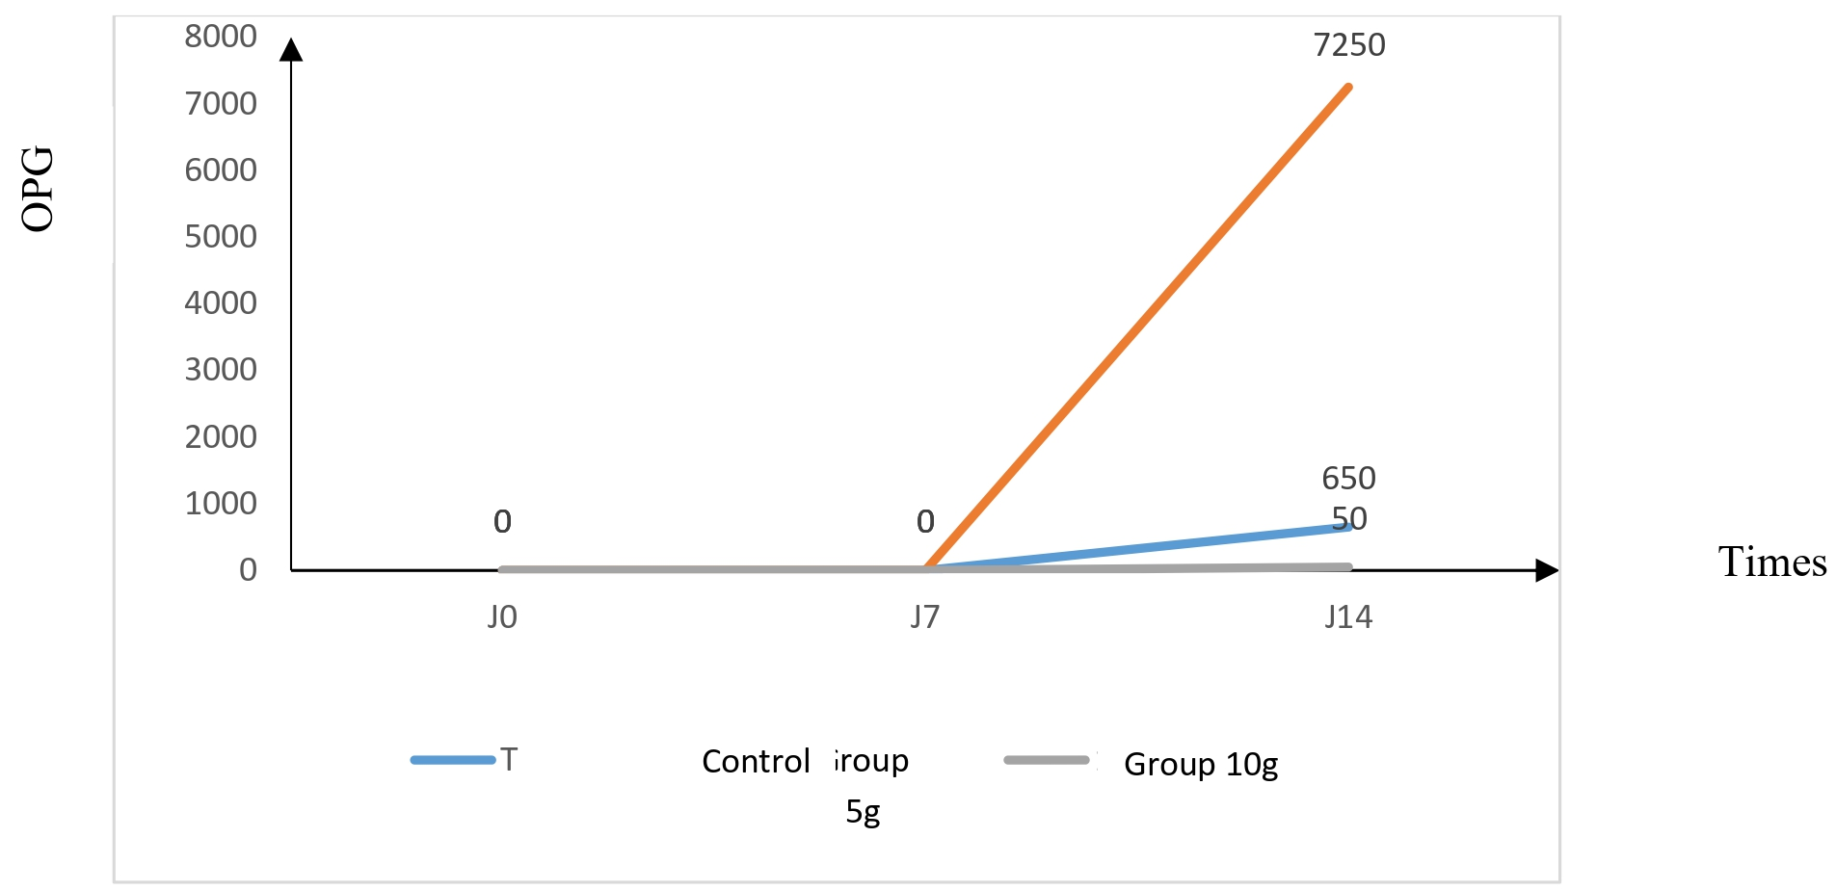

**Fig. 3. Changes in OPG before artificial infestation**

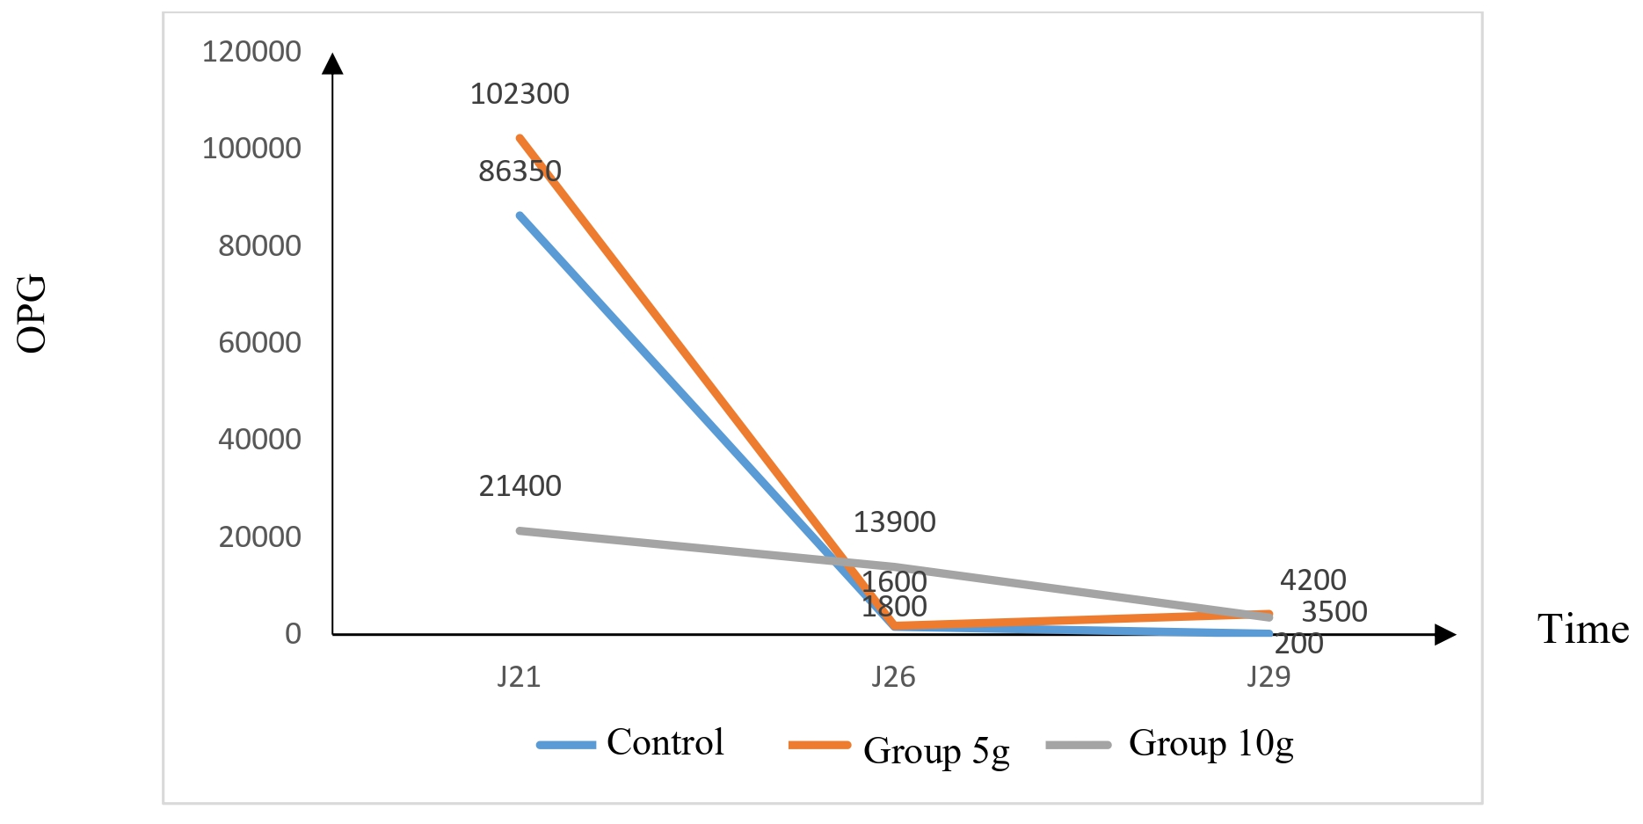

**Fig. 4. Changes in OPG after artificial infestation**

**4. DISCUSSION**

Phytochemical screening revealed that the aqueous extract of fresh *Alchornea cordifolia* leaves contained sterols and polyterpenes, polyphenols, quinone compounds, alkaloids, and catechic tannins. These results suggest that the extract is rich in bioactive compounds that may contribute to the plant’s therapeutic properties. This profile differs from that reported by Saraka et al. (2018), who, using ethanolic extraction, identified flavonoids and gall tannins but no quinone compounds in fresh *A. cordifolia* leaves. Such differences may be attributed to the extraction solvent used, which plays a key role in determining the chemical composition of plant extracts.

The acute oral toxicity test indicated that the aqueous extract of *A. cordifolia* leaves caused no mortality in rats at doses of 2000 and 5000 mg/kg body weight. The extract was well tolerated, with no major behavioural changes, suggesting an LD₅₀ greater than 5000 mg/kg. This finding aligns with the results of Traoré (2004) in female mice. According to the OECD Globally Harmonized System (OECD, 2001), the extract can therefore be classified in Category 5, indicating low toxicity via the oral route.

Body weight measurements showed that the average weights of the batches treated with 5 g/L and 10 g/L AEAC increased, although the differences were not statistically significant (P > 0.05) compared to the control group treated with 1 g/L SUPERCOX PLUS. This suggests that AEAC does not impair growth performance. These results differ from those reported by Kouakou et al. (2010), who observed significant differences in weight gain between hens treated with *Thonningia sanguinea* and those receiving conventional anticoccidials. Such discrepancies may be explained by the different pharmacological properties of the plant species used.

Average daily gains were comparable across all groups, with values of 33.51 g and 31.98 g for the groups treated with 5 g/L and 10 g/L AEAC, respectively, and 33.15 g for the control. Statistical analysis revealed no significant differences (P > 0.05). These results indicate that AEAC does not negatively affect feed intake or growth. Unlike Chaabna (2014), who observed significant differences in turkeys treated with *Artemisia herba-alba*, our findings suggest that AEAC maintains normal growth trajectories in broilers.

Although the feed conversion ratio (FCR) slightly increased in the AEAC-treated groups, the differences were not significant (P > 0.05) compared with the control. This indicates that appetite and feed efficiency were not compromised by AEAC. In contrast, Essomba (2003) reported deteriorated FCRs in chickens infected with coccidiosis. Notably, mortality during the entire experimental period was zero across all batches, contrary to the findings of Bakli (2020), who observed mortality post-infestation. According to Patra et al. (2010), peak mortality typically occurs between the sixth and eighth day post-infection due to hemorrhagic diarrhea. In the present study, although clinical signs were observed, all birds responded well to treatment, mirroring the results of Kouakou et al. (2010).

During the first week of rearing, no oocysts were detected in the feces, consistent with the known incubation period of coccidia and with Essomba's (2003) findings. From the second week onward, a low-level coccidia infestation was observed in all groups, confirming that the incubation period had been reached.

Following artificial infestation, all groups showed high levels of oocysts: 86,350 OPG in the control, 102,300 OPG in the 5 g/L AEAC group, and 21,400 OPG in the 10 g/L AEAC group. Four days after treatment, these numbers significantly decreased to 1,600 OPG, 1,800 OPG, and 13,900 OPG, respectively. By the end of the 7-day treatment, infestation levels dropped further to 200 OPG in the control group, 4,200 OPG in the 5 g/L AEAC group, and 3,500 OPG in the 10 g/L AEAC group. These reductions suggest that AEAC possesses anticoccidial properties, likely due to the bioactive compounds present in the extract.

Tannins, for instance, can bind microbial cell walls, inhibit protease activity, and disrupt parasite metabolism by interacting with proteins through hydrogen bonding, hydrophobic interactions, and covalent bonds (Bakli, 2020). Their proposed mode of action against *Eimeria* species includes oxidative stress induction and interference with enzyme systems and transport proteins.

Phenolic compounds in AEAC may also contribute to its activity. Their antimicrobial effects are known to compromise cell membrane integrity, disturb proton gradients, and interfere with ATP synthesis, ultimately leading to parasite lysis (Bakli, 2020). Nevertheless, the oocyst count in the control group treated with SUPERCOX PLUS (200 OPG) was lower than in the AEAC groups, possibly due to the higher concentration of active ingredients in the synthetic drug (Ola-Fadunsin & Ademola, 2014).

Clinically, infected chickens exhibited typical signs of coccidiosis, including lethargy, ruffled feathers, and bloody droppings, as previously reported by Kouakou et al. (2010). Necropsy revealed intestinal and duodenal lesions and caecal dilation in the control group, whereas only minor duodenal lesions and mild caecal dilation were observed in the AEAC-treated groups. The reduced lesion scores indicate that *A. cordifolia* effectively mitigates intestinal damage caused by *Eimeria* spp. This aligns with findings from Saarinen et al. (2001), who demonstrated that plant extracts can reduce oxidative stress and intestinal lesions in chickens, thereby limiting parasite development.

**5. CONCLUSION**

This study highlighted the antiparasitic potential of *Alchornea cordifolia* leaves. Phytochemical screening of the aqueous extract revealed the presence of several bioactive compound classes, which may be responsible for the various therapeutic properties traditionally attributed to the plant. The acute toxicity test demonstrated that the extract is well tolerated when administered orally, with an estimated LD₅₀ greater than 5000 mg/kg body weight, suggesting a relatively safe profile for therapeutic use.

Evaluation of the efficacy of the aqueous extract of *Alchornea cordifolia* at concentrations of 5 g/L and 10 g/L in the treatment of avian coccidiosis experimentally induced by *Eimeria* in broiler chickens showed that the plant possesses anticoccidial activity comparable to that of SUPERCOX PLUS, a synthetic anticoccidial used at 1 g/L. These doses significantly reduced the oocyst count and helped preserve the integrity of the intestinal mucosa against parasitic damage.

Moreover, the extract had no adverse effects on feed conversion ratio or zootechnical performance in treated chickens when compared to the control group. These findings suggest that the aqueous extract of *Alchornea cordifolia* leaves may serve as a promising natural alternative for the prevention and treatment of avian coccidiosis. Nevertheless, further studies—particularly on subacute and chronic toxicity—are recommended to support its safe and effective use in traditional veterinary medicine.

**DISCLAIMER (ARTIFICIAL INTELLIGENCE)**

***Please write this section***

**Option 1:**

Author(s) hereby declare that NO generative AI technologies such as Large Language Models (ChatGPT, COPILOT, etc) and text-to-image generators have been used during writing or editing of this manuscript.

**Option 2:**

Author(s) hereby declare that generative AI technologies such as Large Language Models, etc have been used during writing or editing of this manuscript. This explanation will include the name, version, model, and source of the generative AI technology and as well as all input prompts provided to the generative AI technology.

**Details of the AI usage are given below:**

1.

2.

3.

Competing interests

Authors have declared that no competing interests exist.

**REFERENCES**

Abo, K. J. C. (2013). From plant to molecule: Toxicity, pharmacological effects and mechanism of action of Justicia secunda (Acanthaceae), an antihypertensive plant, on the cardiovascular system of mammals (PhD thesis, Université Félix Houphouët-Boigny). 351 pages.

Aitfella, R. (2012). Study of the anticoccidial activity of extracts of Peganum harmala, Retama sphaerocarpa and pollen grains (Master’s thesis, Université Ferhat Abbas Sétif 1, Faculty of Natural and Life Sciences). 139 pages.

Bakli, S. (2020). Antimicrobial, antioxidant and anticoccidial activities of phenolic extracts from some local medicinal plants (PhD thesis, Université Ferhat Abbas Sétif 1, Faculty of Natural and Life Sciences). 216 pages.

Bagré, I., Bahi, C., Ouattara, K., Zirihi, G. N., Djaman, A. J., Coulibaly, A., & N’Guessan, J. D. (2011). Botanical study and antifungal activity of Morinda morindoides (Baker) Milne-Redh against the in vitro growth of Cryptococcus neoformans. Phytothérapie, 9, 136–141.

Chaabna, N. (2014). Anticoccidial activity of Artemisia herba alba extracts (Master’s thesis, Université Ferhat Abbas Sétif 1, Faculty of Natural and Life Sciences). 91 pages.

Dakpogan, H. B., Salifou, S., Mensah, G. A., Gbangbaotche, A., Youssao, I., Naciri, M., & Sakiti, N. (2012). Issues in the control and prevention of chicken coccidiosis. International Journal of Biological and Chemical Sciences, 6(6), 6088–6105.

Essomba, L. I. (2003). Improving poultry production through the use of traditional medicine against avian coccidiosis in Cameroon (Master’s thesis, Université Cheikh Anta Diop, Dakar, Senegal). 44 pages.

Kouakou, K. S., Touré, A., Ouattara, K., & N’Guessan, J. D. (2010). In vivo anticoccidial activity of aqueous extract from the inflorescences of Thonningia sanguinea (Balanophoraceae) in laying hens. International Journal of Biological and Chemical Sciences, 4(4), 864–870.

Kouamé, R. O., Coffi, K., Guessend, N., Séri, Y., Koukoua, G., Dosso, M., N’Guessan, Y. T., Figueredo, G., & Chalchat, J. C. (2004). Antibacterial activities of essential oils from three aromatic plants of Côte d'Ivoire. Comptes Rendus Chimie, 7, 1081–1086.

Lazureski, G. V., Terenteva, I. V., & Chamchurin, A. A. (2007). Praticheskii raboti po khimii soedinienii. Vischaya Chkola, Moscow, Russia. 334 pages.

M’Bra, V. D. P. (2017). Evaluation of the hepatoprotective activity of Alchornea cordifolia and Sarenta, a plant-based preparation (Doctoral thesis in Pharmacy, Université Félix Houphouët-Boigny, Faculty of Pharmaceutical and Biological Sciences). 120 pages.

Mea, A., Ekissi, Y. H. R., Abo, K. J. C., & Kahou, B. G. P. (2017). Hypoglycemic and antihyperglycemic effect of Justicia secunda M. Vahl (Acanthaceae) on blood glucose levels in Wistar rats. International Journal of Development Research, 7(6), 13178–13183.

Organisation for Economic Co-operation and Development [OECD]. (2001). Guidelines for the testing of chemicals, acute oral toxicity – Acute toxic class method (No. 423). Paris: Masson.

Saarinen, M. T., Kettunen, H., Pulliainen, K., Peuranen, S., Tiihonen, K., & Remus, J. (2001). A novel method to analyze betaine in chicken liver: Effect of dietary betaine and choline supplementation on hepatic betaine concentration in broiler chicks. Journal of Agricultural and Food Chemistry, 49, 559–563.

Saraka, A. I., Abo, K., Coulibaly, K., & Zirihi, G. N. (2018). Phytochemical study and antifungal activity of extracts from some medicinal Euphorbiaceae used by the Baoulé in Yamoussoukro District (Côte d’Ivoire). European Scientific Journal, 14, 1857–7431.

United Nations. (2003). Globally harmonized system of classification and labelling of chemicals (GHS): Acute toxicity. United Nations Publications, Sales No. F.03.II.E.25, New York and Geneva. 547 pages.

Ouattara-Soro, F. S., Camara, D., Acray-Zengbe, P., Djile, J. R., & Yao Konan, B. (2023). Aqueous extract of the leaves of Ocimum gratissimum (Lamiaceae) (False basil) as an alternative to chemical antibiotics used in breeding Cobb-500 broiler chickens in the Department of Azaguie, Côte d’Ivoire. European Journal of Nutrition and Food Safety, 15(5), 30–40. https://doi.org/10.9734/EJNFS/2023/v15i51310

Traoré, M. (2004). Alchornea cordifolia Schumach. (Euphorbiaceae): Review of biological activities and toxicity (PhD thesis in Pharmacy, Faculty of Medicine, Pharmacy and Odonto-Stomatology, University of Bamako, Mali). 107 pages.

Wagner, H., & Bladt, S. (2001). Plant drug analysis: A thin-layer chromatography atlas (2nd ed.). Springer.

**Disclaimer/Publisher’s Note:** The statements, opinions and data contained in all publications are solely those of the individual author(s) and contributor(s) and not of the publisher and/or the editor(s). This publisher and/or the editor(s) disclaim responsibility for any injury to people or property resulting from any ideas, methods, instructions or products referred to in the content.

*© Copyright (2025): Author(s). The licensee is the journal publisher. This is an Open Access article distributed under the terms of the Creative Commons Attribution License (http://creativecommons.org/licenses/by/4.0), which permits unrestricted use, distribution, and reproduction in any medium, provided the original work is properly cited.*