**Exploring *Nymphaea Alba Linn*: A Potential Aquatic Herb**

**ABSTRACT**

*Nymphaea alba*, or European White-Water Lily, is a well-known aquatic herb that has been noted to carry high concentrations of bioactive phytochemicals. This plant has a scattered distribution in countries of Asia, Europe, and Africa. Its variety of therapeutic uses has made it gain traditional and pharmacological importance. This review summarizes the botanical identity, best practices for cultivating the plant, morphology, phytochemical characteristics, and other therapeutic potential of the plant. Different parts of *N. alba*, especially its rhizome and flowers, contain a lot of compounds, including flavonoids, glycosides, tannins, and alkaloids, that have been traditionally used for decades. A pharmacological study revealed it to be an antioxidant, anti-inflammatory, hepatoprotective, anti-ulcer, and antimicrobial. It is worth mentioning that the plant also demonstrates the potential for cardiorenal and renal complications and metabolic syndrome management. This review serves as a bridge connecting the gap between the common claim and the scientific evidence. This review demonstrates how incorporating traditional knowledge with modern pharmacological research can form a point of reference on which researchers can base when they want to explore plant-based therapeutics. In addition, by filling out the lack of toxicity data, the growing conditions, and the reliability of phytochemicals, this review helps pharmacologists, botanists, and drug scientists in the choice of *N. alba* as a promising candidate for further preclinical and clinical studies.

**Keywords:** *Nymphaea alba*, Aquatic Herb, bioactive phytochemicals, pharmacological importance

1. **INTRODUCTION**

*Nymphaea alba* *Linn*. is a perennial aquatic herb, and it mostly grows in lakes and ponds. It is distributed worldwide, but in particular countries such as India, China, Russia, North Africa, and Southwest Asia. In India, it is normally distributed at a height of more than 1800 meters around the Kashmir lakes. A multitude of Phytomolecules, including alkaloids, glycosides, flavonoids, hydrolysable tannins, lignans, polysterols, and saponins, are present in different species of the Nymphaea genus (Bakr et al., 2017). The flower *Nymphaea alba* has been extracted to produce some powerful products that contain Nupharin, Nymphaeine, and Nymphalin. This plant contains a high level of bioactive compounds, and they include glycosides, tannins, flavonoids, phytosterols, and polyphenols, since they are the ones that make this plant have plenty of uses. *Nymphaea alba* has been considered to be used during times of fatigue, tiredness, and burning sensations, and also for the relief of diarrhea and bleeding (Chauhan, n.d.). Chemicals help with bioactive ingredients, decreased oxidative stress and inflammation, and their antidepressant and hepatoprotective effects were also established (Selvakumari et al., 2016; Bakr et al., 2017; Haripriya et al., 2021).

1. **HABITAT**

It is spread globally, even in China, Russia, India, North Africa, and Southwest Asia. It is located in India with an altitude of less than 1,800m, in the Kashmir lakes. It is also kept up for aesthetic purposes in lakes and ponds(Khan et al., 2019).

**3. DESCRIPTION**

Lakes and ponds are home to the perennial aquatic plant *Nymphaea alba* *Linn* (Figure 1). Its lobes are continuous, its rhizome is black, and its leaves are spherical, 12–25 cm in diameter, cordate, whole, or sub-orbiculate. The petals are around ten, outer linear-oblong, and equal to the sepals; the sepals are linear, oblong, and nerve-reticulate; flowers are solitary, white, and floating, measuring 10–13 cm across. The seeds are tiny, punctuated, and embedded in pulp, while the fruits are spongy and ripe below water(Matta et al., 2017).

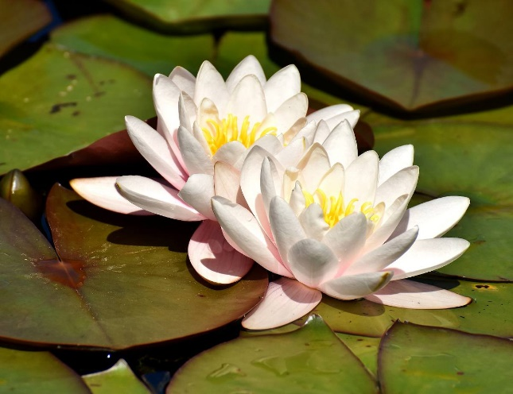

Fig. 1. *Nymphaea alba* flower

**3.1. TAXONOMIC CLASSIFICATION**

Kingdom : Plantae

Subkingdom : Tracheobionta

Super division : Spermatophyta

Division : Magnoliophyta

Class : Magnoliopsida

Subclass : Magnoliidae

Order : Nymphaeales

Family : Nymphaeaceae

Genus : *Nymphaea*

Species : *N. alba*

**3.2. VERNACULAR NAMES**

English : European White Water-lily

Urdu : Nilofer

Ayurveda : Kumuda, Utpala (White flowered var.)

Hindi : Neelophal, Kanwal

Bengali : Sweet Padma, Kamal

Kashmir : Brimposh

Tamil : Tamarai

Kannada : Kamala

1. **CULTIVATION AND AGRONOMIC REQUIREMENTS**(Rankel, 2025)

| **Parameter** | **Optimal Requirement** |
| --- | --- |
| Soil Type | Loamy, nutrient-rich, slightly acidic to neutral (pH 6.0–7.5) |
| Sunlight | Full sun exposure (≥6–8 hours per day) |
| Water Depth | 30–60 cm above the crown/rhizome |
| Water Conditions | Clean, still, or slow-moving freshwater bodies (ponds, lakes) |
| Humidity | High humidity due to aquatic setting |
| Temperature Range | Optimal water temperature(20ºC) |

**Table 1. Cultivation parameters and optimal requirements for the growth of *N. alba***

1. **MORPHOLOGY**

**Macroscopic**

*Nymphaea alba* *Linn*. flowers include many stamens and abortive ovules, as well as four to five deciduous sepals and many petals arranged in two to three rows or more. The outer facet of the oval to lanceolate sepals is leathery and darker than the inner. Its white petals have longitudinal striations and are thin and hardly membrane-like. Stamens are long, golden, and dehiscence occurs through a longitudinal slit(Selvakumari et al., 2016).

**Microscopic**

Polygonal parenchymatous cells are seen on the calyx's exterior. On the long axis of the sepal, isolated sclereids were seen. Sclereids and stomata are located near the base of the round cells and closer to the middle of the sepal. These sclereids are basic and branching. In comparison to sepals, there are fewer stomata on the exterior and interior surfaces. Two kidney-shaped guard cells protect the stomata. These are anomocytic stomata. Four distinct chambers are suggested by the anther's transverse section. A thin layer of cuticle covers the single-layered, almost isodiametric cells that make up the dermis. The grains of pollen are smooth, spherical, and have thin walls(Khan et al., 2019).

1. **NUTRITIONAL VALUE OF *NYMPHAEA ALBA***

**Table 2. Nutritional value per 100 g of water lilies**(Aung et al., n.d.)

|  |  |  |
| --- | --- | --- |
| **Constituents** | ***N. alba* flowers** | ***N. alba* stalk** |
| Calories (kcal) | 276.39 | 276.44 |
| Carbohydrate % | 59.89 | 65.30 |
| Protein % | 15.63 | 7.12 |
| Fat % | 2.9 | 3.1 |
| Fibre % | 0.3 | 0.93 |
| Sodium (mg) | 210.2 | 216.6 |
| Zinc (mg) | 2.18 | 1.68 |
| Iron (mg) | 5.09 | 5.83 |
| Magnesium (mg) | 51.96 | 50.23 |
| Calcium (mg) | 74.22 | 63.38 |
| Phosphorus (mg) | 120 | 220 |
| Potassium (mg) | 505.6 | 505.8 |
| Phytate (mg) | 456 | 475 |

1. **PHYTOCHEMICAL CONSTITUENTS**

The many species of the genus *Nymphaea* are reported to contain distinct kinds of Phytomolecules, including triterpene, saponins, alkaloids, glycosides, flavonoids, hydrolysable tannins, lignans, and phytosterols (Figure.1).

Nymphaeine and Nupharin are two compounds detected in the blooms of *Nymphaea alba*. Gallic acid, β-Sitosterol are also detected in the flowers.Nymphalin, a cardiac glycoside, has been identified in the alcoholic floral extract of *Nymphaea alba*(Selvakumari et al., 2016).

The alcoholic extract of *Nymphaea alba* flowers is the source of gallic acid, and it has been shown that among the several species of the genus *Nymphaea*, flavonoids such as anthocyanins, flavanols, and flavones exist as flavonoid glycosides with a distinct glycone moiety(Agnihotri et al., 2020).

The alcoholic floral extract of *Nymphaea alba* has been found to contain β-Sitosterol. *N. alba* flowers are mostly composed of aglycons such as isoquercetin, kaempferol, 3-methylkaempferol (isokaempferide), and apigenin(Jambor and Skrzypczak, 1990).

**8. TRADITIONAL USES**

* The rhizomes and flowers have astringent, spasmolytic, somewhat sedative, antibacterial, and antiseptic qualities.
* For internal use as a douche for leucorrhea and vaginitis, as a gargle for sore throats, and as an infusion for chronic diarrhoea, given internally as well(T et al., 2013).
* Seeds can help with diabetes and skin conditions. Menorrhagia and bleeding piles are treated with astringent and soothing filaments(Meraj, 2024).
* Other therapeutic uses include relieving burning sensation, tiredness, and fatigue, helpful in bleeding disorders(Kamdem et al., 2022).
* It also helps in improving intellect and calming the mind. In ayurvedic treatment, it is indicated for giddiness and epilepsy(C.P., 2007).

1. **TOXICITY AND SAFETY PROFILE**

Studies have evaluated the acute toxicity of ethanol extract on *Nymphaea alba* as per the OECD guidelines. They started with a dose of 200mg/kg and subsequently increased the dose every 24 hours, observing the animals for clinical signs and mortality. The upper dose limit was set to be 200mg/kg, where no toxicity signs or mortality were noted. Hence, the oral median lethal dose (LD50) was detected to be >2000mg/kg(Bose et al., 2012; Mushtaq et al., 2019).

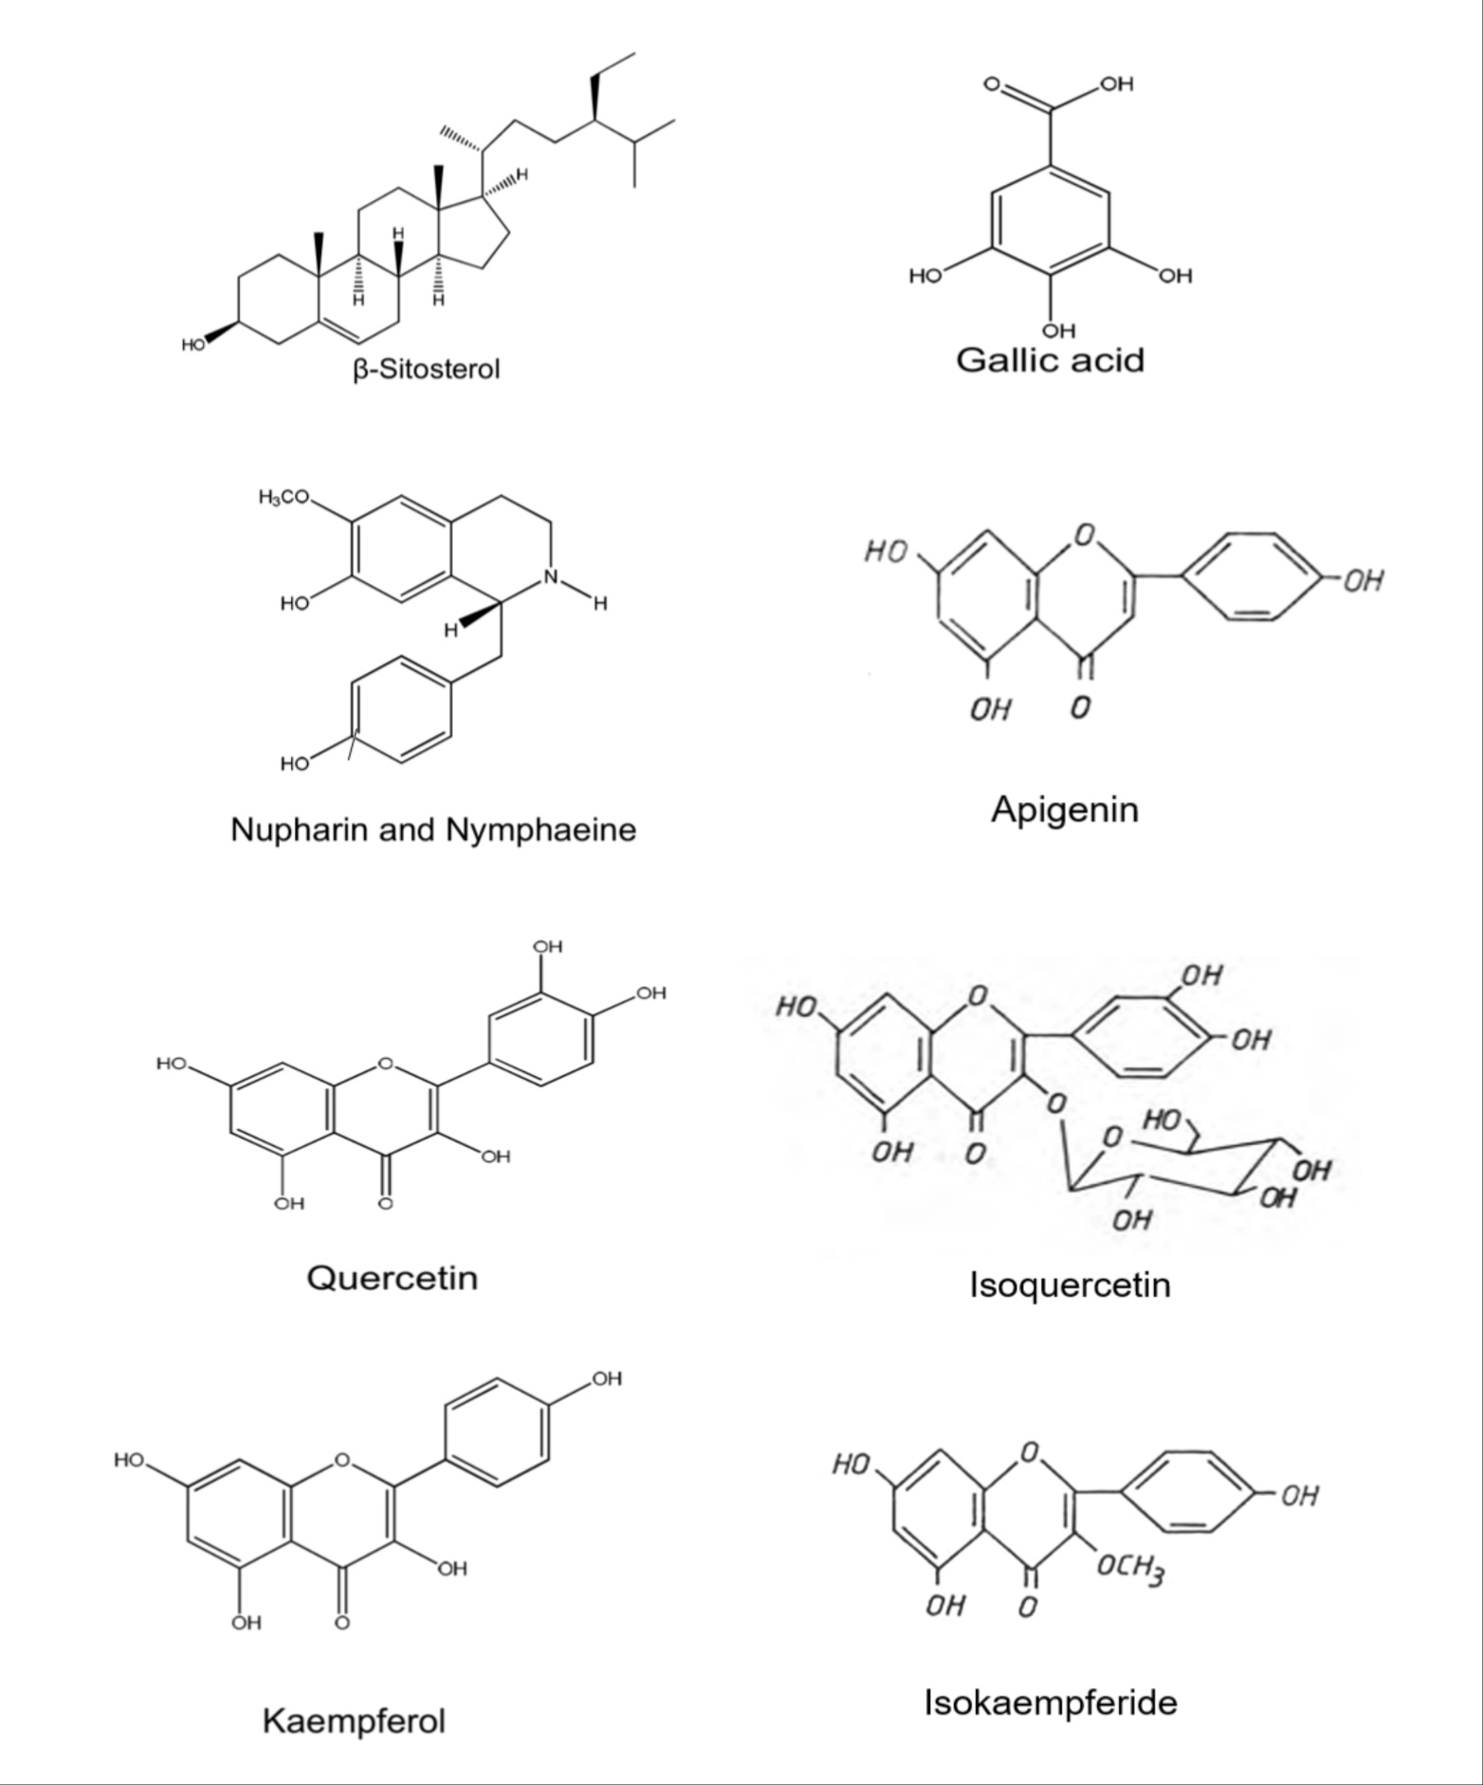

Fig. 2. Isolated bioactive compounds from the flower of *Nymphaea alba*

**10. PHARMACOLOGICAL STUDIES**

**ANTIOXIDANT ACTIVITY**

Both cytotoxic and radical scavenging activities have been assessed using the 3-(4, 5-dimethyl thiazol-2-yl)-2, 5-diphenyl tetrazolium bromide (MTT) test and 2,2Di (4-tert-octylphenyl)-1-picryl-hydrazyl (DPPH) assay, respectively. Staphylococcus aureus was inhibited by *N. alba* rhizomes with a Minimum Inhibitory Concentration (MIC) of 0.25 mg/mL, whereas the MIC of methyl gallate was found to be 0.1 mg/ml. Besides having the strongest cytotoxic (IC50 9.61 ± 0.3 µg/mL) and radical scavenging (IC50 3 µg/mL) properties, methyl gallate also showed the largest decrease in biofilm formation (84.9%)(Riham et al., 2016).

**ANTI-ULCER ACTIVITY**

On evaluating the anti-ulcer effects of the ethanolic extract of the *Nymphaea alba* flowers on rats using the pylorus ligation and ethanol-induced ulcer models, it is observed that the *Nymphaea alba* ethanolic extract at doses 200 & 400 mg/kg has reduced the Ulcer and significantly stopped the stomach lesions formed. There was also a big drop in the volume of the stomach, the amount of free acid, and the ulcer index compared to the control. This study has concluded that both ulcer healing and anti-ulcerogenic effects of ethanolic extract on *N. alba* might be due to its anti-secretory action(Paharia and Pandurangan, 2020).

**CARDIOPROTECTIVE ACTIVITY**

Rats were given Isoproterenol to induce myocardial infarction. They were also pretreated with hydroalcoholic extract of *Nymphaea alba* *Linn*, flowers. Cardiac marker enzymes were deranged and the normal architecture of the heart muscle is also damaged by Isoproterenol, which were found to be reversed by treating with the extract. This shows that the flower extract at a higher dose (400mg/kg) was highly effective in restoring the biochemical and histopathological parameters of the infarcted hearts(Haripriya et al., 2021).

**HEPATOPROTECTIVE ACTIVITY**

Carbon tetrachloride-induced hepatotoxicity in experimental rats is used to test the ethanolic leaf extract from *Nymphaea alba* for hepatoprotective properties. *Nymphaea alba* ethanolic extract (100 and 200 mg/kg) significantly decreased the wet liver weight and restored normal levels of bilirubin, cholesterol, and the enzymes SGOT, SGPT, and ALP(Bakr et al., 2017).

**ANTI-BACTERIAL ACTIVITY**

Flower extracts of *Nymphaea alba* inhibited the growth of four bacterial species. It was discovered that *Nymphaea alba* leaf extracts were very effective against *Staphylococcus aureus*, *Escherichia coli*, and *Bacillus subtilis*. The plant extract's efficacy against different bacteria was consistent with that of the positive control (gentamycin). Contributing to a comparative analysis of the antibacterial action of *Nymphaea alba* hydroalcoholic extract with negative and positive controls, it can be stated that the extract has a wide antimicrobial spectrum and high antibacterial potential. As evident, *N. alba* flowers would be effective when it comes to the source of antibacterial agents(Koushik et al., 2015).

**ANTIDIARRHEAL ACTIVITY**

On being researched as to whether ethanol extract of rhizome of *N. alba* had any antidiarrheal effect or not in the range of two different doses (100 and 200 mg/kg), *N. alba* extract was found to have significant reduction both in the number of defecation and also there was significant reduction in the magnitude of the diarrhoeal episodes as well as reduction in the intestinal transit with a single dose of 100mg/kg. All these point to the fact that *Nymphaea alba* has high anti-diarrheal potential and can be applied as a prospective, high anti-diarrheal medication in the future (Bose et al., 2012).

**ANTIDIABETIC ACTIVITY**

The extracts of *Nymphaea alba* white flower andrhizome by aqueous ethanol were administered in doses of 200 mg/kg and 400 mg/kg in comparison with alloxan (130 mg/kg i.p.) induced hyperglycemic rats. Blood glucose concentration was recorded regularly, and it showed significant improvement at the end of the trial(Mushtaq et al., 2019)**.**

**HYPERPROLIFERATIVE AND RENAL CARCINOGENIC ACTIVITY**

*Nymphaea alba*'s ability to protect Wistar rats against ferric nitrile triacetate-induced renal oxidative stress, hyperproliferative response, and renal carcinogenesis is being investigated. Production of hydrogen peroxide, lipid peroxidation, Glutamyl transpeptidase, xanthine oxidase, blood urea nitrogen, serum creatinine, DNA synthesis, and tumour incidence all significantly decreased after oral treatment with *Nymphaea alba* extract at 100 & 200 mg/kg. In Wistar rats, *Nymphaea alba* inhibits kidney carcinogenesis and the hyperproliferative response, making it a powerful chemopreventive agent(Khan and Sultana, 2005).

**CENTRAL DEPRESSANT ACTIVITY**

Ethanolic extract of the rhizome of *N. alba* has been tested for its antidepressant activity at dosages of 75, 150, and 300 mg/kg. To evaluate the extract's behavioural impact in mice, the hole-board test, beam walking assay, staircase test, open field test, a diazepam-induced sleep test, and elevated plus maze assay were performed. Following the results of the study, it can be seen that there are some bioactive substances in the *N. alba* rhizome extract that possess sedative effects (Bose et al., 2013).

**ANTIUROLITHIAC ACTIVITY**

A zinc disc was placed in the bladder to cause urolithiasis, and then 1% ethylene glycol was added to the drinking water. Wistar albino rats were given an ethanolic extract of dried *N. alba* *Linn* leaves orally, and the weight loss of the stones was utilized as a criterion for evaluating the prophylactic or curative treatment. According to the study, *N. alba* *Linn*. decreased the weight of bladder stones significantly as compared to the control(Lakshmi and Devaraj, 2017).

1. **CONCLUSION**

*Nymphaea alba Linn.* is more than just an aquatic herb with ornamental value, it carries an extensive background of traditional healing and a promising future in modern medicine. This review brings together the botanical and pharmacological aspects of the plant, allowing researchers to dive deep into the therapeutic exploration of the plant and also encourages them to uncover the full therapeutic potential of the plant. Furthermore, researches are needed to fully understand the mechanism, standardized preparations, clinical efficacy, and incorporation *of N. alba* into therapeutic use in the human population.

**Disclaimer (Artificial intelligence):**

Author(s) hereby declare that NO generative AI technologies such as Large Language Models (ChatGPT, COPILOT, etc.) and text-to-image generators have been used during the writing or editing of this manuscript.

**REFERENCES**

1. Aung, T.T., Myat, Y.Y., Mar, M.M., Kyu, K.K., n.d. Nutritional Compositions, Elemental Compositions and Antinutrient Factor in Different Varieties of Water Lily 3.
2. Bakr, R.O., El-Naa, M.M., Zaghloul, S.S., Omar, M.M., 2017. Profile of bioactive compounds in *Nymphaea alba* L. leaves growing in Egypt: hepatoprotective, antioxidant and anti-inflammatory activity. BMC Complement Altern Med 17, 52. https://doi.org/10.1186/s12906-017-1561-2
3. Bose, A., Ray, S.D., Sahoo, M., 2013. Central depressant activity of ethanol extract of *Nymphaea alba* rhizome in mice. Orient Pharm Exp Med 13, 159–164. https://doi.org/10.1007/s13596-013-0108-4
4. Bose, A., Sahoo, M., Ray, S.D., 2012. *In vivo* evaluation of anti-diarrheal activity of the rhizome of *Nymphaea alba* (Nymphaeaceae). Orient Pharm Exp Med 12, 129–134. https://doi.org/10.1007/s13596-012-0062-6
5. Chauhan, M., n.d. The Graceful Water Lily: Exploring Kumuda (*Nymphaea alba*).
6. C.P., K., 2007. Indian medicinal plants. Springer US.
7. Haripriya, S., P, S., K, S., J, F., 2021. Cardioprotective effect of hydro-alcoholic extract of Nymphea alba *Linn*. Against isoproterenol induced myocardial infarction in rats. WORLD JOURNAL OF PHARMACY AND PHARMACEUTICAL SCIENCES Volume 10. https://doi.org/10.20959/wjpps20214-18691
8. Jambor, J., Skrzypczak, L., 1990. Flavonois from the flowers of *Nymphaea alba* L.
9. Kamdem, B.P., Doux Kamto, E.L., Aboubakar, Dieudonné, 2022. Ethnomedicinal Uses, Phytochemistry, Pharmacology, and Toxicity of the Genus Nymphaea L.: A Review. Current Bioactive Compounds 18, 2–40. https://doi.org/10.2174/1573407218666220111110352
10. Khan, A., Siddiqui, A., Jamal, A., 2019. GULE NILOFER (*Nymphaea alba*) an influential drug in unani medicine: a review with immence therapeutic potential and phyto-pharmacological perspective. International Journal of Advance and Innovative Research Volume 6, 62–68.
11. Khan, N., Sultana, S., 2005. Inhibition of potassium bromate-induced renal oxidative stress and hyperproliferative response by *Nymphaea alba* in Wistar rats. Journal of Enzyme Inhibition and Medicinal Chemistry 20, 275–283. https://doi.org/10.1080/14756360400028119
12. Koushik, O.S., Himaja, V., Babu, P.S., Karthikeyan, R., 2015. *In Vitro* anti-bacterial activity of flowers of *Nymphaea alba*.
13. Lakshmi, T., Devaraj, E., 2017. Antiurolithiatic activity of phytochemical extracts: A review 7.
14. Matta, D., Nanda, H., Mahalingam, G., 2017. Phytopharmaceutical potentials of prosopis laevigata, symplocos cochinchinensis and *nymphaea alba*: a review. Asian J Pharm Clin Res 10, 63. https://doi.org/10.22159/ajpcr.2017.v10i10.20316
15. Meraj, M., 2024. Comprehensive Review on Nilofar (*Nymphaea alba* *Linn*): Unani Perspectives and Therapeutic Potentials. IJPDA 25–33. https://doi.org/10.47957/ijpda.v12i3.599
16. Mushtaq, A., Iqbal, N., Jamil, M., Khawaja, N., Gohar, U., Mehmood, M., 2019. Anti-diabetic and anti-hyperlipidemic action of aqueous ethanolic extracts of Mentha spicata (leaves), Plumeria alba (leaves) and *Nymphaea alba* (flowers and rhizomes).
17. Agnihotri, S., Singh, G., Narwal, S., Balram., 2020. *Nymphaea alba*: a detailed study,IJBPAS 9. https://doi.org/10.31032/ijbpas/2020/9.9.5194
18. Paharia, A.K., Pandurangan, A., 2020. Evaluation of Anti-ulcer activity of Ethanolic Extract of *Nymphaea alba* *Linn* Flower in experimental rats. AJPTR 10, 1–14. https://doi.org/10.46624/ajptr.2020.v10.i1.001
19. Rankel, K., 2025. Introduction to European White Water Lilly. Greg.
20. Riham, O.B., Reham, W., Noha, S., Ibrahim, E.S., 2016. Characterization of the bioactive constituents of *Nymphaea alba* rhizomes and evaluation of anti-biofilm as well as antioxidant and cytotoxic properties. J. Med. Plants Res. 10, 390–401. https://doi.org/10.5897/JMPR2016.6162
21. Selvakumari, E., Shantha, A., Kumar, C.S., Prabhu, T.P., 2016. Phytochemistry and Pharmacology of the Genus Nymphaea 5.
22. T, L., N, M., R, R., 2013. *Nymphaea alba* *Linn*-An Overview. Research Journal of Pharmacy and Technology 6, 974–977.