**Original Research Article.**

**THE SYNTHESIS OF POLYMER-ENCAPSULATED UREA FERTILIZERS BY INCORPORATING HYDROQUINONE AS A NITRIFICATION INHIBITOR**

**ABSTRACT**

This study investigates the development of a polymer-based encapsulated urea fertilizer through the incorporation of hydroquinone as a nitrification inhibitor. The primary aim is to mitigate nitrogen losses resulting from volatilization and leaching, thereby improving the nitrogen use efficiency of conventional urea fertilizers. A polymer matrix containing hydroquinone was synthesized and employed as a coating material for urea granules. The encapsulated formulations were systematically evaluated for their nitrogen release kinetics, mechanical durability, and surface morphology. Experimental findings indicate that hydroquinone significantly delays nitrogen release while simultaneously enhancing the structural integrity of the fertilizer granules. These outcomes underscore the potential of hydroquinone-integrated polymer coatings in the advancement of controlled-release fertilizer technologies.

*Key words; hydroquinone****,*** *urea, SEM, IK*.

**INTRODUCTION**

Polymer-coated or encapsulated urea fertilizers belong to the category of slow-release or controlled-release fertilizers. They are produced by coating urea granules with a special polymer layer. This technology ensures a prolonged supply of nitrogen to plants, reduces nitrogen losses, and minimizes environmental risks. In recent years, the development of controlled-release nitrogen fertilizers (CRFs) has received increasing attention as a strategy to enhance nitrogen use efficiency (NUE) while minimizing environmental nitrogen losses. Among CRFs, polymer-coated urea fertilizers represent one of the most extensively studied and commercially implemented technologies .According to the comprehensive review by Shaviv and Mikkelsen in *“Controlled Release and Stabilized Fertilizers in Agriculture”* [1], polymer-coated urea (PCU) fertilizers offer a gradual and predictable release of nitrogen, reducing losses via volatilization, leaching, and denitrification. The release behavior is governed by diffusion through the coating material, which can be engineered for different crops, climates, and soil conditions. These fertilizers also contribute to reducing the frequency of fertilizer applications, thus lowering labor costs and improving nutrient synchrony with plant uptake.Trenkel’s foundational book *“Slow- and Controlled-Release and Stabilized Fertilizers”* [2] provides an in-depth analysis of encapsulated fertilizers, covering their physicochemical properties, release duration, and interactions with soil microbes. It outlines how coating thickness, permeability, and polymer type influence nutrient release patterns, and emphasizes the importance of selecting biodegradable and environmentally safe polymers for large-scale agricultural use.The article *“Advances in Controlled-Release Fertilizers”* [3] highlights the critical factors affecting nutrient release rates, including ambient temperature, soil pH, and moisture content. In particular, the material composition of the coating plays a dominant role in controlling urea diffusion. Studies have shown that polymer matrices based on synthetic or natural polymers (e.g., polyvinyl alcohol, starch, ethylcellulose) can be modified with additives such as plasticizers or inhibitors to tailor the release kinetics.In a more recent and innovative approach, Wang et al. (2021) presented the design of a multifunctional slow-release urea fertilizer using ethylcellulose and superabsorbent polymers [4]. Their work demonstrated how hydrophilic gels can absorb soil moisture and swell, regulating nutrient flow from the granule while also maintaining soil hydration. SEM and IR analyses confirmed the structural integrity and chemical interactions between urea and coating materials. This hybrid system showed promising results in terms of delayed nitrogen release and reduced loss to the environment.Collectively, the literature underscores the potential of polymer-based encapsulation as a sustainable solution for modern nitrogen management. However, further research is needed to improve cost-efficiency, scalability, and biodegradability of coating systems. The current study builds upon this body of work by integrating hydroquinone—a known nitrification inhibitor—into a polymer matrix to develop a novel encapsulated urea formulation with dual action: controlled release and nitrification suppression.

Simultaneously, nitrogen loss through **ammonia volatilization** in alkaline or poorly buffered soils and **denitrification** under anaerobic conditions leads to the emission of greenhouse gases such as nitrous oxide (N₂O), which has a global warming potential approximately 298 times greater than CO₂ [6]. These inefficiencies not only diminish crop nitrogen use efficiency (NUE), often below 50%, but also pose serious environmental risks, including water eutrophication, biodiversity loss, and climate change [7]. As a response, considerable research has focused on the development of **enhanced-efficiency fertilizers (EEFs),** particularly those involving physical encapsulation techniques and the application of **nitrification inhibitors** [8].

### ****Mechanism of Nutrient Release from Polymer-Coated Urea Fertilizers****

The nutrient release behavior of polymer-coated urea fertilizers is primarily governed by the physicochemical and biodegradation characteristics of the coating material. Upon exposure to soil moisture, the polymeric coating undergoes **hydration and swelling**, which initiates a series of processes responsible for the controlled release of nitrogen. The primary mechanisms involved can be classified into the following categories:

**Diffusion-Controlled Release:**  
In the initial stage, water molecules penetrate the polymer layer through microscopic pores or by diffusion across the semi-permeable membrane. Once inside, urea begins to dissolve into the aqueous medium. The dissolved urea then migrates outward through the polymer coating in a concentration-dependent manner. This **osmotic diffusion process** allows for a gradual and sustained release of nitrogen into the soil, synchronizing nutrient availability with plant uptake [5].

**Biodegradation-Induced Release:**  
Some encapsulating polymers, particularly **biodegradable biopolymers** such as **polylactic acid (PLA)**, **polyhydroxyalkanoates (PHA)**, and **starch-based composites**, are susceptible to microbial degradation in soil. Soil microorganisms secrete extracellular enzymes that hydrolyze the polymer chains, gradually breaking down the coating material. As degradation progresses, the integrity of the coating diminishes, eventually resulting in the complete release of the encapsulated urea. This mechanism is influenced by the polymer’s molecular structure, crystallinity, and the microbial activity in the rhizosphere [6]

**Environmentally Responsive Release (Moisture-Temperature-pH-Microbial):**  
The rate of urea release is also affected by environmental factors such as **soil moisture content**, **temperature**, **pH**, and the **abundance of microbial populations**. Increased moisture levels accelerate water penetration and urea dissolution, while higher temperatures enhance polymer flexibility and diffusion rates. Soil pH can influence the solubility of the polymer and the ionization state of functional groups within the coating. Moreover, microbial density impacts the rate of biodegradation, especially in systems that rely on bioactive coatings. These synergistic effects contribute to a responsive release system that adapts to soil conditions and crop nutrient demand [7].

**2. MATERIALS AND METHODS**

2.1 Materials

* Urea**:** Commercially available agricultural-grade urea (46% N).
* Hydroquinone (HQ)**:** Analytical grade, used as a nitrification inhibitor.
* Polymer Matrix**:** A biodegradable polymer (e.g., polyvinyl alcohol, starch-based blend) was selected as the encapsulating agent.
* Solvents and Reagents**:** Ethanol, distilled water, and plasticizers.

2.2 Synthesis of Hydroquinone-Polymer Coating  
Hydroquinone was dissolved in ethanol and incorporated into the polymer matrix under controlled stirring and heating. The mixture was then cooled and used to coat pre-weighed urea granules using a pan coating method. Different hydroquinone concentrations (0.1-1.0)were tested.

2.3 Characterization and Testing

* Nitrogen Release Rate**:** Standard soil incubation method (at 25°C) over 28 days.
* Granule Morphology**:** Analyzed using scanning electron microscopy (SEM).
* Mechanical Strength**:** Measured using a granule crushing strength tester.
* FTIR and TGA Analyses**:** To confirm chemical interactions and thermal stability.

In the initial stage of the investigation, a thorough assessment of the physical properties of the hydroquinone-modified urea fertilizer formulations was performed to evaluate their suitability for agricultural application. The parameters selected for analysis included:

* Moisture Content**:** Determined gravimetrically by drying samples at 105°C until constant weight, in accordance with ASTM D4944-19 standards [8]. Moisture levels are critical as they influence storage stability and caking tendency.
* Water Solubility**:** Measured by dissolving a known mass of fertilizer in distilled water at 25°C with continuous stirring, followed by filtration and gravimetric determination of undissolved residues [9]. This parameter reflects nutrient availability upon soil application.
* 10% Fertilizer Solution Medium**:** The physicochemical characteristics (pH, electrical conductivity) of a 10% (w/v) aqueous fertilizer solution were recorded using calibrated pH and conductivity meters [10]. These parameters indicate the solution behavior and potential phytotoxicity.
* Crystallization Temperature**:** Assessed using differential scanning calorimetry (DSC), providing insight into thermal stability and phase transitions relevant for storage and handling [11].
* Hygroscopicity**:** Evaluated by exposing samples to controlled humidity environments (75% RH at 25°C) for 72 hours and measuring weight gain, as per ISO 9898:2000. This property affects fertilizer flowability and caking.
* Granule Strength**:** Determined by applying compressive force to individual granules using a texture analyzer (TA.XT Plus) until fracture, following the procedure outlined by [12]. Mechanical strength is vital for minimizing breakage during handling.
* Density**:** Bulk and tapped densities were measured following ASTM D7481-09 protocols, providing data on packing behavior and flow characteristics.
* Viscosity**:** For polymer-coated formulations, viscosity of coating solutions was measured using a rotational viscometer at controlled shear rates and temperature [13](25°C), as viscosity influences coating uniformity.

**3. RESULTS AND DISCUSSION**

At the initial stage of this study, hydroquinone was incorporated into urea at varying concentrations ranging from 0.1 to 1.0 norm units. Each resulting fertilizer formulation was subjected to comprehensive physicochemical characterization to evaluate its properties and performance. The analytical data obtained from these tests were systematically compiled and tabulated for comparative assessment.Based on these preliminary findings, the formulation demonstrating optimal characteristics was selected for further detailed investigation. Specifically, the encapsulated fertilizer corresponding to this optimal hydroquinone concentration underwent morphological examination using Scanning Electron Microscopy (SEM) to elucidate surface structure and coating uniformity. Additionally, Infrared (IR) spectroscopy analysis was performed to identify functional groups and confirm the chemical integration of hydroquinone within the polymer matrix.At the initial phase of the study, a comprehensive evaluation of the physical properties of the synthesized fertilizer formulations was conducted. The parameters assessed included moisture content, water solubility, characteristics of a 10% fertilizer solution, crystallization temperature, hygroscopicity, granule strength, density, and viscosity, among other relevant indicators. These properties were measured using standardized analytical techniques to ensure reliability and reproducibility.

The obtained experimental data were systematically organized and presented in tabular form for clear comparison and analysis. Detailed results are compiled in Tables 1, 2, and 3, which illustrate the variations in physical characteristics across different hydroquinone concentrations incorporated into the urea formulations.

**Table 1.**

**Composition of granulated urea with the addition of Hydroquinone**

|  |  |  |  |  |
| --- | --- | --- | --- | --- |
| Mass ratio  (NH2)2CO : Hydroquinone | N,  % | Hydroquinone  % | Biuret,  % | Moisture ,  % |
| 100:0 | 46.20 | 0.00 | 1.33 | 0.23 |
| 100 : 0.1 | 46.09 | 0.09 | 1.33 | 0.22 |
| 100 : 0.2 | 46.06 | 0.19 | 1.33 | 0.22 |
| 100 : 0.3 | 46.01 | 0.28 | 1.32 | 0.21 |
| 100 : 0.4 | 45.94 | 0.39 | 1.32 | 0.21 |
| 100 : 0.5 | 45.98 | 0.47 | 1.31 | 0.20 |
| 100 : 0.6 | 45.94 | 0.58 | 1.31 | 0.20 |
| 100 : 0.7 | 45.89 | 0.69 | 1.30 | 0.19 |
| 100 : 0.8 | 45.83 | 0.78 | 1.29 | 0.19 |
| 100 : 0.9 | 45.71 | 0.89 | 1.28 | 0.18 |
| 100 : 1.0 | 45.65 | 0.98 | 1.28 | 0.17 |

**Table 2**

**Properties of granulated urea with added Hydroquinone**

|  |  |  |  |  |  |  |  |
| --- | --- | --- | --- | --- | --- | --- | --- |
| Mass ratio  (NH2)2CO : Hydroquinone | Speed of dissolution  rhenium granules  in water, seconds  /granules | pH  (10% solution | Crystalli-zation temperature oC | Hygroscopic  dot % | Granule strength | | |
| kg/  granule | kg/ cm2 | MPa |
| 100 : 0 | 96 | 9.17 | 129.0 | 58.4 | 1.28 | 25.81 | 2.52 |
| 100 : 0.1 | 108 | 8.98 | 128.5 | 62.2 | 1.31 | 26.41 | 2.58 |
| 100 : 0.2 | 123 | 8.88 | 127.9 | 63.7 | 1.34 | 27.01 | 2.64 |
| 100 : 0.3 | 141 | 8.81 | 127.6 | 64.5 | 1.35 | 27.21 | 2.66 |
| 100 : 0.4 | 201 | 8.75 | 127.0 | 65.3 | 1.37 | 27.61 | 2.70 |
| 100 : 0.5 | 278 | 8.68 | 126.6 | 66.2 | 1.38 | 27.82 | 2.72 |
| 100 : 0.6 | 304 | 8.52 | 126.2 | 66.9 | 1.39 | 28.02 | 2.74 |
| 100 : 0.7 | 358 | 8.31 | 125.9 | 67.5 | 1.40 | 28.23 | 2.77 |
| 100 : 0.8 | 412 | 7.97 | 125.5 | 68.2 | 1.42 | 28.62 | 2.80 |
| 100 : 0.9 | 438 | 7.82 | 125.1 | 69.0 | 1.44 | 29.03 | 2.84 |
| 100 : 1.0 | 414 | 7.71 | 124.8 | 69.6 | 1.46 | 29.43 | 2.88 |

**Table 3**

**Density and viscosity of the melt of fertilizers obtained by the introductionin the melt of urea Hydroquinone**

|  |  |  |  |  |  |  |  |  |
| --- | --- | --- | --- | --- | --- | --- | --- | --- |
| Mass ratio  (NH2)2CO :  Hydroquinone | Density (g/cm3), at temperature, °C | | | | Viscosity (cPz), at  temperature, °C | | | |
| **130** | **135** | **140** | **145** | **130** | **135** | **140** | **145** |
| 100:0 | 1.210 | 1.20 | 1.19 | 1.170 | 2.69 | 2.62 | 2.42 | 2.28 |
| 100 : 0.1 | 1.215 | 1.212 | 1.206 | 1.184 | 2.75 | 2.59 | 2.49 | 2.37 |
| 100 : 0.2 | 1.221 | 1.218 | 1.213 | 1.192 | 2.82 | 2.71 | 2.54 | 2.42 |
| 100 : 0.3 | 1.227 | 1.224 | 1.217 | 1.196 | 2.90 | 2.79 | 2.60 | 2.47 |
| 100 : 0.4 | 1.233 | 1.231 | 1.222 | 1.203 | 2.95 | 2.87 | 2.64 | 2.51 |
| 100 : 0.5 | 1.242 | 1.238 | 1.228 | 1.207 | 2.98 | 2.92 | 2.67 | 2.57 |
| 100 : 0.6 | 1.247 | 1.241 | 1.235 | 1.211 | 3.19 | 2.99 | 2.75 | 2.64 |
| 100 : 0.7 | 1.252 | 1.245 | 1.243 | 1.218 | 3.39 | 3.08 | 2.84 | 2.71 |
| 100 : 0.8 | 1.258 | 1.251 | 1.250 | 1.229 | 3.61 | 3.17 | 2.91 | 2.79 |
| 100 : 0.9 | 1.264 | 1.259 | 1.255 | 1.237 | 3.74 | 3.28 | 2.98 | 2.86 |
| 100 : 1.0 | 1.272 | 1.264 | 1.259 | 1.248 | 3.83 | 3.34 | 3.07 | 2.94 |

The experimental data obtained from the physicochemical assessments were thoroughly analyzed to identify the optimal hydroquinone-to-urea ratio. Among the tested formulations, the ratio of 100:0.5 (urea to hydroquinone) was determined to provide the most favorable balance of physical properties and controlled-release characteristics.Subsequently, the encapsulated fertilizer synthesized at this optimal ratio underwent detailed characterization through Infrared (IR) spectroscopy and Scanning Electron Microscopy (SEM) analyses. The IR spectra confirmed the successful incorporation of hydroquinone within the polymer matrix, as evidenced by characteristic absorption bands corresponding to functional groups related to both urea and hydroquinone moieties.SEM imaging revealed a uniform and continuous coating layer enveloping the fertilizer granules, with minimal surface defects or cracks, indicating high coating integrity. This morphological evidence supports the formulation’s potential for enhanced mechanical stability and controlled nutrient release.Overall, these results provide positive confirmation of the effectiveness of the selected formulation and validate its suitability for further development as a slow-release fertilizer product.

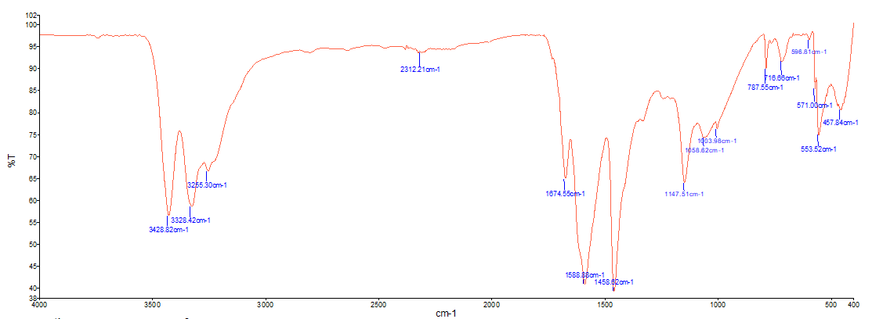

**Graph 1: IR spectroscopic image of urea and hydroquinone in a 100:0.5 ratio**

**FTIR Spectroscopic Analysis.** Fourier Transform Infrared (FTIR) spectroscopy was employed to investigate the molecular interactions and potential chemical bonding between urea and hydroquinone in the encapsulated fertilizer formulation. The IR spectroscopic spectrum corresponding to the optimized formulation with a urea-to-hydroquinone ratio of 100:0.5 was analyzed and compared to that of pure urea to identify any shifts or new absorption bands indicative of interaction or structural modification.

The comparative analysis revealed the formation of a **new absorption band at 598.81 cm⁻¹,** located between the characteristic frequency range of 716.66 cm⁻¹ and 571.00 cm⁻¹. This newly emerged band is likely associated with the **out-of-plane bending vibrations** of C–H or C–O bonds influenced by the presence of hydroquinone, suggesting possible **intermolecular interactions** or **weak hydrogen bonding** between hydroquinone and urea within the polymer matrix.

In addition to the new band formation, **notable shifts were observed in several characteristic absorption peaks,** reflecting subtle changes in the vibrational environment of functional groups:

* The **N–H stretching vibration** peak shifted from **3330.11 cm⁻¹ to 3329.07 cm⁻¹**, indicating a minor alteration in hydrogen bonding strength, possibly due to interactions between the amine group of urea and the hydroxyl groups of hydroquinone.
* The **C=O stretching vibration** peak showed a shift from **1676.18 cm⁻¹ to 1674.55 cm⁻¹**, suggesting perturbation of the carbonyl group environment due to encapsulation and matrix interactions.
* The **N–H bending or deformation peak** shifted slightly from **1589.39 cm⁻¹ to 1588.88 cm⁻¹**, further supporting the presence of molecular interactions.
* The **C–N stretching vibration** shifted from **1051.68 cm⁻¹ to 1058.62 cm⁻¹**, which may be attributed to the influence of hydroquinone’s aromatic structure on the urea backbone.

These spectral shifts collectively indicate that **no covalent bonding** occurred between urea and hydroquinone, but **non-covalent interactions** such as hydrogen bonding and possible van der Waals forces were likely established within the polymer-encapsulated matrix. The results confirm that hydroquinone was successfully integrated into the urea formulation without disrupting the core structure, while contributing to subtle modifications in the molecular vibrational characteristics.

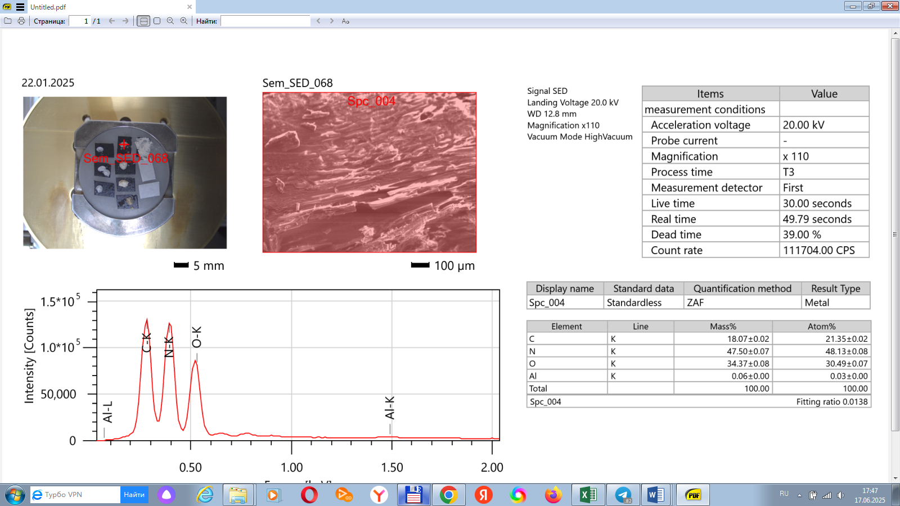

**Graph 2: SEM Analysis**

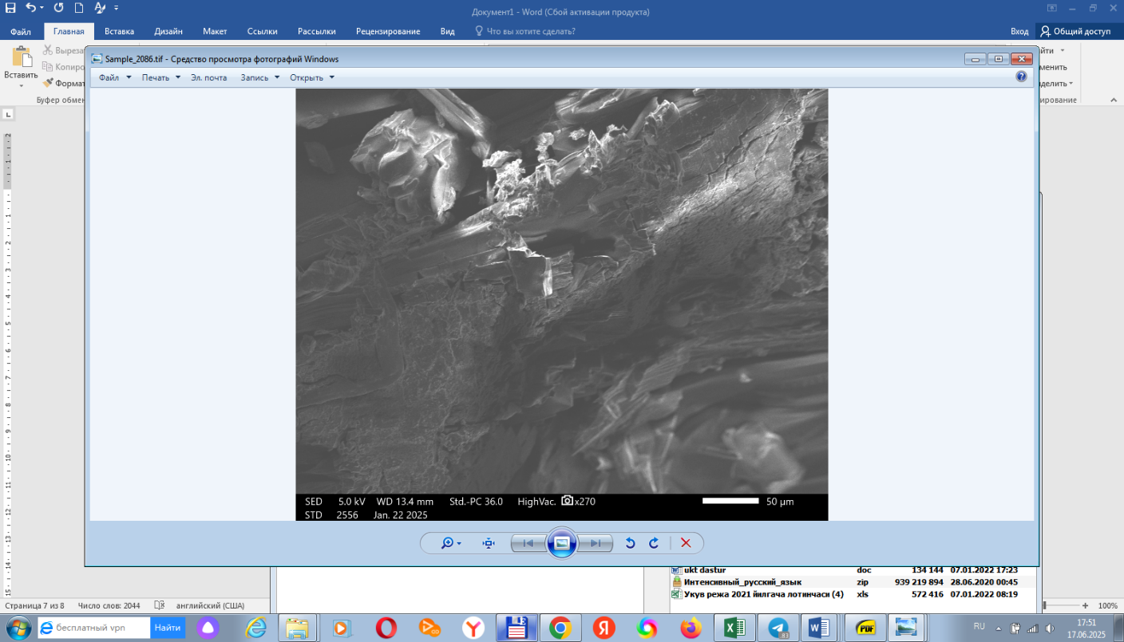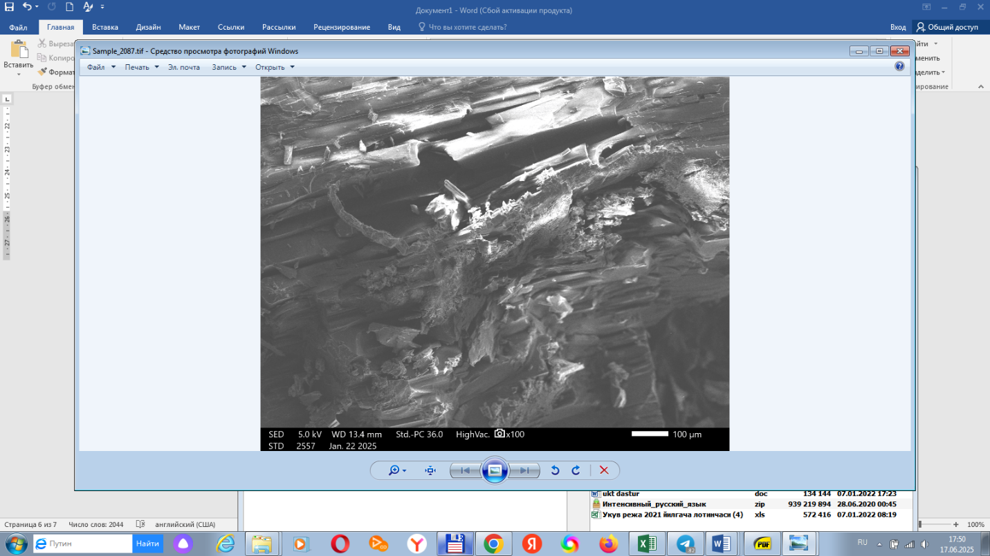  
(a) (b)

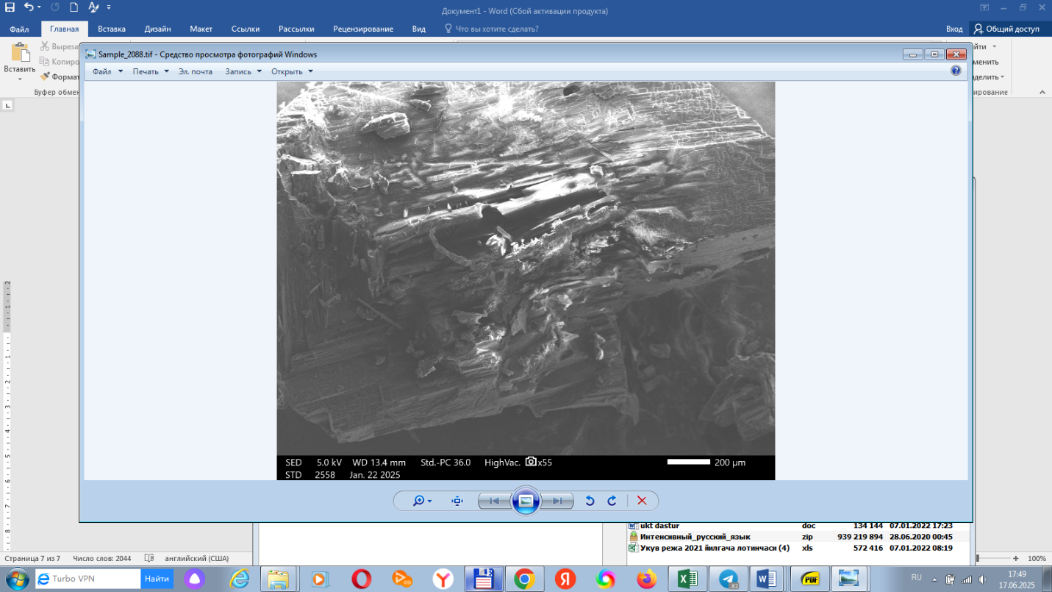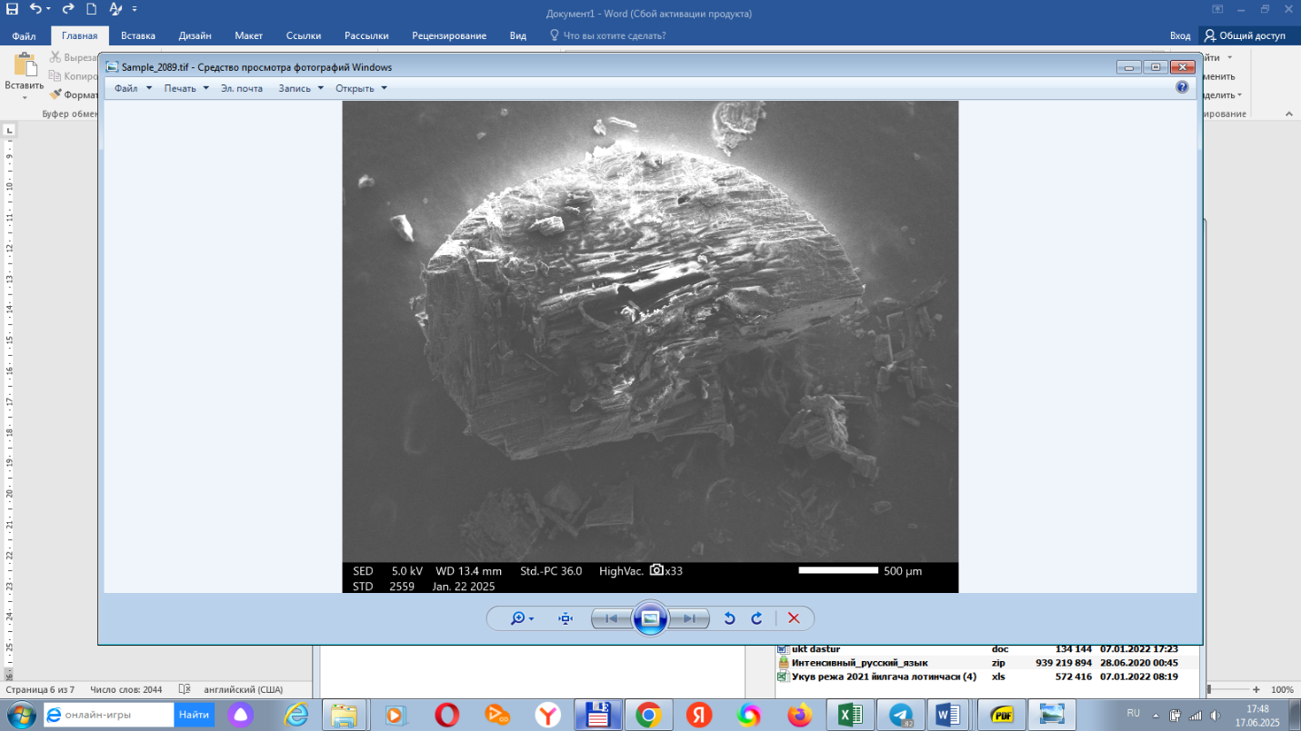

(c) (d)

**Figure 1. Scanning Electron Microscopy (SEM) of urea (a,b,c,d)**

**CONCLUSION**

The incorporation of hydroquinone into a biodegradable polymer matrix for the encapsulation of urea has demonstrated considerable potential in enhancing the agronomic efficiency of nitrogen fertilizers. Experimental findings confirmed that the resulting formulation effectively reduced nitrogen losses through volatilization and leaching while significantly prolonging the availability of nitrogen in the soil. These improvements are primarily attributed to the dual functionality of the system: the physical barrier provided by the polymer coating and the inhibitory action of hydroquinone on microbial nitrification processes.Moreover, the coated granules exhibited superior structural integrity and mechanical strength, indicating enhanced handling, transport, and storage performance—key attributes for practical agricultural deployment. The controlled-release behavior of the formulation ensures a gradual and sustained supply of nitrogen, aligning nutrient availability with crop demand and minimizing environmental impact.Given these promising results, the proposed technology represents a viable candidate for large-scale agricultural implementation, particularly in intensive farming systems where nitrogen efficiency and environmental stewardship are of paramount importance. Future research should be directed toward comprehensive **field evaluations** under varying agro-climatic conditions, as well as **techno-economic analysis** and **optimization of the polymer matrix**, with particular emphasis on biodegradability, production scalability, and cost-effectiveness. Such efforts will be essential for facilitating the transition from laboratory innovation to real-world agricultural application.

Disclaimer (Artificial intelligence)

Option 1:

Author(s) hereby declare that NO generative AI technologies such as Large Language Models (ChatGPT, COPILOT, etc.) and text-to-image generators have been used during the writing or editing of this manuscript.

Option 2:

Author(s) hereby declare that generative AI technologies such as Large Language Models, etc. have been used during the writing or editing of manuscripts. This explanation will include the name, version, model, and source of the generative AI technology and as well as all input prompts provided to the generative AI technology

Details of the AI usage are given below:

ChatGPT Plus for paraphrase and in order to be academic and clear.

**REFERENCES**

1. Shaviv, A., & Mikkelsen, R. L. (1993). Controlled Release and Stabilized Fertilizers in Agriculture. Fertilizer Research, 35(1–2), 1–12.
2. Trenkel, M. E. (2010). Slow- and Controlled-Release and Stabilized Fertilizers: An Option for Enhancing Nutrient Use Efficiency in Agriculture. International Fertilizer Industry Association (IFA), Paris.
3. Azeem, B., KuShaari, K., Man, Z. B., Basit, A., & Thanh, T. H. (2014). Review on materials & methods to produce controlled release coated urea fertilizer. Journal of Controlled Release, 181, 11–21. https://doi.org/10.1016/j.jconrel.2014.02.020
4. Wang, Y., Zhou, J., Xu, M., & Zhang, W. (2021). Multifunctional Slow-Release Urea Fertilizer from Ethylcellulose and Superabsorbent Coated Formulations. ACS Sustainable Chemistry & Engineering, 9(4), 1921–1932. <https://doi.org/10.1021/acssuschemeng.0c07612>
5. Shaviv, A., & Mikkelsen, R. L. (1993). *Controlled Release and Stabilized Fertilizers in Agriculture*. Fertilizer Research, 35(1-2), 1–12.
6. Azeem, B., et al. (2014). *Review on materials & methods to produce controlled release coated urea fertilizer*. *Journal of Controlled Release*, 181, 11–21.
7. Naz, M. Y., & Sulaiman, S. A. (2016). *Slow release coating remedy for nitrogen loss from conventional urea: a review*. *Journal of Controlled Release*, 225, 109–120.
8. Trenkel, M. E. (2010). *Slow- and Controlled-Release and Stabilized Fertilizers*. International Fertilizer Industry Association.
9. IPCC. (2019). Climate Change and Land: Special Report. Intergovernmental Panel on Climate Change.
10. Lassaletta, L., Billen, G., Garnier, J., Bouwman, L., & Velazquez, E. (2014). Food and feed trade as a driver in the global nitrogen cycle: 50-year trends. Biogeochemistry, 118, 225–241. https://doi.org/10.1007/s10533-013-9923-4
11. Naz, M. Y., & Sulaiman, S. A. (2016). Slow release coating remedy for nitrogen loss from conventional urea: a review. Journal of Controlled Release, 225, 109–120. https://doi.org/10.1016/j.jconrel.2016.01.037
12. Prasad, R., & Power, J. F. (1995). Nitrification inhibitors for agriculture, health, and the environment. Advances in Agronomy, 54, 233–281. https://doi.org/10.1016/S0065-2113(08)60918-9
13. Shaviv, A. (2005). Controlled release fertilizers. In IFA International Workshop on Enhanced-Efficiency Fertilizers, Frankfurt.