The Role of Artificial Intelligence in Enhancing the Occupational Safety and Health Management Systems

.

ABSTRACT

|  |
| --- |
| **Aim:** This study aimed to investigate the role of Artificial Intelligence (AI) in enhancing the occupational health and safety of workers within Oman context.  **Study design:** A quantitative approach was used to collect and analyse data on participants’ perceptions, on benefits, challenges, and preferences among professionals engaged in safety.  **Methodology:** A self-administered questionnaire was distributed to 125 health and safety professionals across selected workplace in Oman. The study sample included engineers, healthcare professionals, and health and safety practitioners who use artificial intelligence within their daily tasks. The study sample was chosen purposively. SPSS software version 26.0 was used to analyze quantitative data.  **Results**: The results of this study indicate a wide support for the deployment of Artificial Intelligence within safety management domain, with some concerns regarding privacy, data reliability, and job security. There were no statistically significant differences in perception among participants roles, indicating consistent views on AI adoption in the Occupational Health and Safety (OHS) domain. However, the results might have been influenced by the predominance of younger more technologically savvy participants.  **Conclusion:** Artificial intelligence is considered a valuable addition to Occupational Health and Safety (OHS) systems in Oman, and by extension, in the GCC and the world. To guarantee an effective integration of AI into OHS in Oman, it is essential to establish national training and readiness initiatives to enhance workforce skills and digital proficiency across various sectors. This study proposes a clear roadmap for the deployment of AI within OHS in Oman by highlighting the relevant concerns. It also provides practical guidance for policymakers and practitioners in support of safer and more resilient workplaces while incorporating advanced technologies into OHS practices. |

***Keywords:*** *Artificial Intelligence, Occupational Safety and Health, Safety Management System, Predictive Analytics, Technology Acceptance Model, Oman*

1. **INTRODUCTION**

The emerging technology of Artificial Intelligence (AI) is transforming the occupational health and safety (OHS) domain and positively enhancing safety performance. By using predictive analytics to support intelligent decision making to prevent accidents, this advanced technology predicts equipment failure and promotes proactive safety practices across various industries. Furthermore, AI technology analyzes and process previous incident data, to suggest trends of future surveillance and monitoring (Abdelrahim et al., 2024; Ferrara et al., 2024; Koh & Tan, 2024; Maleki Varnosfaderani & Forouzanfar, 2024; Park & Kang, 2024).

Obtaining data from Scopus, it is evident that the integration of AI technologies within OHS is becoming progressively common and valuable. The AI deployment in the last 25 years has grown substantially. The annual publications rising from 20 to 83 from 2019 – 2024, a fourfold increase in six years. See Figure 1

Figure : The growth of AI usage within OHS domain: Source Scopus

The contribution of AI in predictive maintenance, diagnostics, and immersive safety training was underlined by several authors including (Ferrara et al., 2024; Maleki Varnosfaderani & Forouzanfar, 2024; Park & Kang, 2024). However, the success of these systems often depends on several factors that differ from place to place the. These factors include technological infrastructure of the country, organizations readiness, and the levels of digital literacy. In the context of Oman, although regulatory body such as (OSHAD), the Occupational Safety and Health Authority, which is responsible for setting national OHS standards (Al-Jabri et al., 2021), yet the integration of AI depends entirely on organization.

The Gulf Cooperation Council (GCC) countries including Oman, utilize AI to drive economic diversification and promote societal advancement (Albous et al., 2025). Nonetheless, vital economic sectors in Oman, including oil and gas, construction, and healthcare, stated to use AI in OHS that demonstrated positive and encouraging results (Al Kuwaiti et al., 2023; Kashoub et al., 2023; Komorowski et al., 2018). Although AI clearly has the possibility to enhance OHS performance in Oman, there is limited research on the subject, the use of AI in workplace safety is still at an early stage.

This is evident when analyzing data from Scopus database on AI publications that intersect with OHS, it was noted that Oman accounts for only 8% of publication from Gulf region countries excluding Kuwait that did not appear in the search results. The results indicates that Oman falls behind Saudi Arabia and the UAE. See Table 1

*Table 1: Emerging trends of AI research within gulf region*

|  |  |  |  |  |  |  |
| --- | --- | --- | --- | --- | --- | --- |
| Id | Country | Documents | Documents % | Citations | Average Citation Per Document | Total Link Strength |
| 1 | Saudi Arabia | 119 | 51% | 2401 | 20.2% | 43 |
| 2 | United Arab Emirates | 66 | 28% | 1236 | 18.7% | 26 |
| 3 | Qatar | 22 | 9% | 805 | 36.6% | 26 |
| 4 | Oman | 18 | 8% | 168 | 9.3% | 10 |
| 5 | Bahrain | 8 | 3% | 150 | 18.8% | 3 |

To address this gap, considering factors such as collectivism and organizational hierarchy that further restrict dual feedback, which is essential for adaptive and participatory AI safety, this study aims to adapt global AI and OHS frameworks to Oman’s environment and explore the views of Omani professionals on using AI for workplace safety.

1. Analyse stakeholder perceptions of AI in OHS.
2. Identify barriers to AI integration in workplace safety systems.
3. Assess how AI enhances safety management across industries.

* H₀₁: No significant difference in AI perception across occupational roles.
* H₀₂: No significant association between professional experience and AI trust.
* H₀₃: No significant variation in AI application preferences based on demographics.

This research uses Risk Management Theory as its main framework to analyze how AI is adopted in OHS. The key ideas are Perceived Risk (such as worries about privacy and job loss due to automation) and Trust, both especially relevant in safety-critical workplaces. Demographic variables—like age, gender, job role, and experience—are considered as factors that shape how individuals weigh the risks and benefits of using AI for workplace safety. Figure 2 depicts the relationship between this study variables.

**METHODOLOGY**

Figure : Conceptual Framework for AI Adoption in Occupational Health and Safety (OHS)

* 1. **Research Design**

A quantitative descriptive approach was used to collect and analyse data on AI perceptions, challenges, and preferences among professionals engaged in OHS. Figure 3 depicts the methodology followed in this study.

* 1. **Participants and Sampling**

125 professionals were selected using purposive sampling across engineering, healthcare, IT, education, and administration. The sample included both early-career and experienced professionals, reflecting a broad perspective on OHS technology adoption.

* 1. **Research Instrument**

The questionnaire comprised five sections: demographics, AI familiarity, perceived usefulness and trust, concerns about AI integration, and application preferences. Items were scored on a 5-point Likert scale. Expert validation and a pilot study ensured reliability and clarity.

* 1. **Data Collection Procedure**

Data were collected online in April 2025. Informed consent was obtained, and participant anonymity was guaranteed. Data were cleaned and coded for statistical analysis.

* 1. **Data Analysis**

Statistical package for social science (SPSS) version 26.0 was used for descriptive and inferential analysis. The descriptive statistics summarized participant demographics and response trends. The inferential Chi-square tests explored associations between perception and variables such as occupation and experience. While this study did not conduct regression analysis, it lays the groundwork for future inferential studies.

* 1. **Ethical Considerations**

The study received ethical clearance from the institutional review board. Participants were informed of their rights, and participation was voluntary.

Figure : research methodology

**3. RESULTS AND DISCUSSION**

**3.1 Demographic Summary**

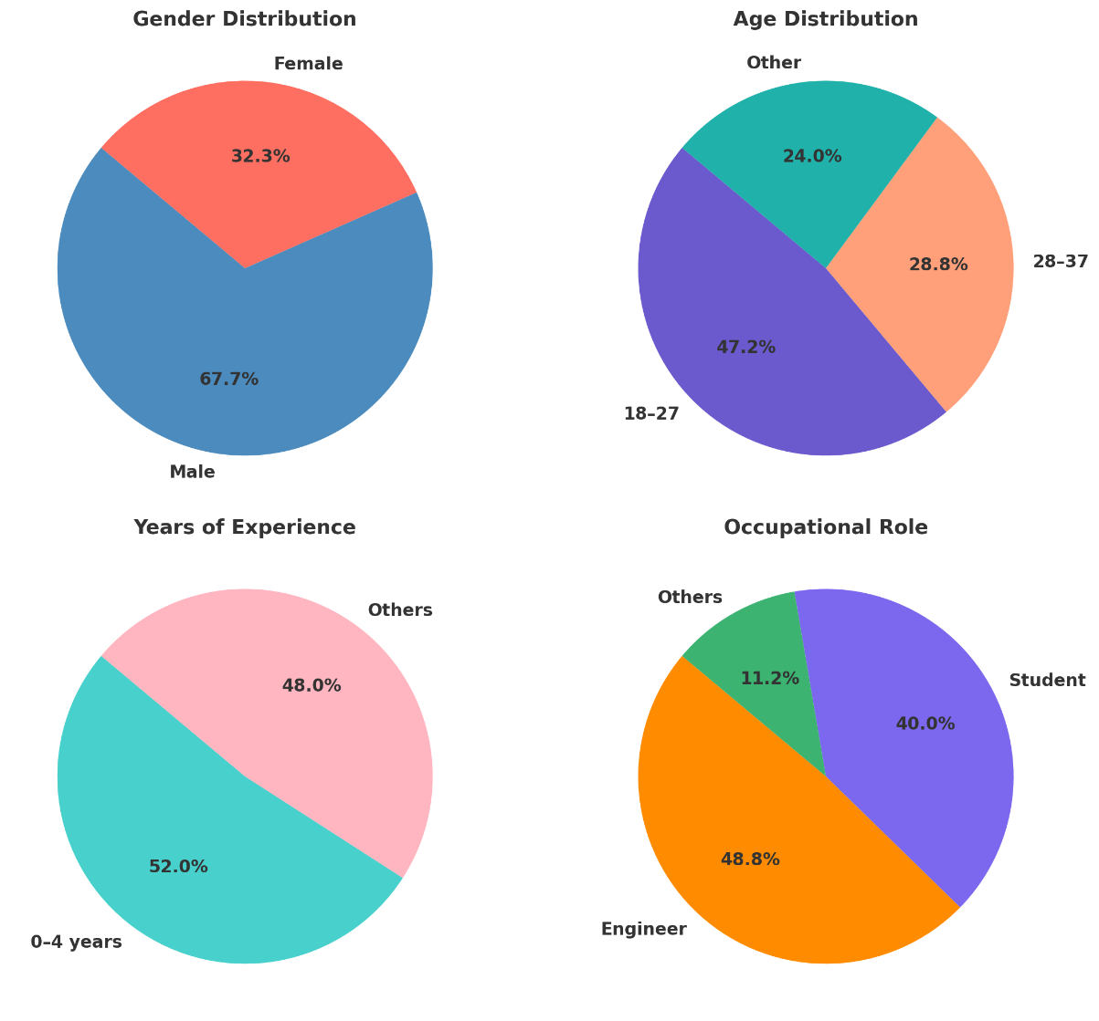

Figure : Demographic Profile of Respondents

Looking at the gender distribution of the demographic profile of respondents reveals that 67.2% were male, a figure aligning with the gender imbalance observed in Omans industrial and technological sectors. Age wise, nearly half (47.2%) of participants were between the ages of 18 and 27, with 28.8% falling within the 28 to 37 age brackets. Showing that a more youthful, digitally native cohort make up a majority of the respondents, possibly skewing the data. In terms of professional experience, 52% had 0 to 4 years of experience, while 48% reported 5 or more years. Providing a balanced response from both early-career perspectives and seasoned professionals. The sample was primarily composed of engineers (48.8%) and students (40%), reflecting the strong representation of these occupations within the participant pool. This distribution reflects a technologically literate, early-career workforce well-positioned to adopt digital tools. See Figure 4.

**3.2 Inferential analysis**

Inferential analysis was conducted to test the proposed hypotheses and assess the significance and strength of the observed effects.

*Table 2: Perceived Usefulness of AI in Occupational Health and Safety*

| **Item** | **Mean Score** | **Standard Deviation** | **Verbal Interpretation** |
| --- | --- | --- | --- |
| Technology improves decision-making | 2.82 | 1.16 | Agree |
| Technology is trustworthy | 2.54 | 1.07 | Agree |
| Ease of completing tasks using technology | 1.18 | 0.83 | Disagree |
| Technology poses health risk | 1.95 | 1.10 | Neutral |
| Technology reduces workload | 2.45 | 1.16 | Neutral |

As seen in Table 2, there is a high perceived usefulness with AI but a lacking perceived ease of use on one hand, participants generally agree to AI being an aid to decision making, perceiving it as trustworthy, with high Mean Scores of 2.82 and 2.54 respectively. On the other hand, participants generally disagreed (Ms=1.18) with the ease of completing tasks using said technology perceiving a neutral effect on workload reduction (Ms=2.45)

*Table 3: Primary Concerns about AI Integration in OHS*

| Concern | Frequency | Percentage (%) |
| --- | --- | --- |
| AI reliability | 67 | 53.6% |
| Data privacy | 66 | 52.8% |
| Job displacement | 65 | 52.0% |
| Lack of transparency | 46 | 36.8% |
| Other (please specify) | 12 | 9.6% |

These concerns echo with broader global discourse on AI ethics and trustworthiness, underscoring the need for a governance framework. As seen in table 3 primary concerns surrounding AI’s integration in OHS include its reliability, data privacy, and job displacement, all scoring percentages over 50%.

Table 4 illustrates the perception of participants regarding the applications of AI within their workplace. The real-time monitoring of worker safety is the most frequently reported AI application in occupational settings, followed by accidents prevention predictive analytics (48.8%) and training and education (47.2%).

*Table 4: AI Applications Perceived as Most Beneficial to OHS in Oman*

|  |  |  |
| --- | --- | --- |
| AI Application | Frequency | Percentage (%) |
| Real-time monitoring of worker safety | 76 | 60.8% |
| Predictive analytics for accident prevention | 61 | 48.8% |
| AI-powered training and education | 59 | 47.2% |
| Automated risk assessment and management | 53 | 42.4% |
| Other (please specify) | 4 | 3.2% |

These results affirm demand for AI tools that support proactive and adaptive safety management. The Chi-square tests revealed no significant association between perception and occupation (χ²=12.21, p=0.4286) or experience (χ²=13.04, p=0.3664). Thus, H₀₁ and H₀₂ were retained. Preferences were consistent across age and gender, supporting H₀₃.

1. **Discussion**

This study explored the potential of artificial intelligence (AI) to enhance Occupational Safety and Health (OSH) management systems in Oman. As seen in Figure 2.0 despite the diversity in respondents, there is a lack of variation in answers between demographic groups. The demographic profile of participants shows the following, with most respondents being male 67.7%, with females comprising 32.3%. Most respondents were aged 18–27 47.2%, followed by ages 28–37 28.8%, and 24.0% falling in smaller age groups. In terms of experience, 52.0% had 0–4 years, while 48.0% had 4 years or more. Occupational roles were primarily engineers (48.8%) and students (40.0%), with 11.2% representing other professions. This uniformity in answers despite the evident demographic variety shows that AI is viewed as a valuable tool across OSH management systems. Therefore, national strategies for AI integration in OSH systems in Oman can be adopted using standardized training modules and policies, with a minimal need for demographic tailoring.

This is aided by our findings, which indicate that respondents feel a strong support and agreeability to the enhancement AI can bring to decision-making within safety management processes. As seen in statements like “Technology improves decision-making” & “Technology is trustworthy an aid to decision making, perceiving it as trustworthy” receiving agreements with high Mean Scores of 2.82 and 2.54 respectively *(Table 2).*

However, reliability and privacy emerged as major concerns, consistent with Risk Management Theory. With statements like “AI reliability, Data privacy and Job displacements” receiving high scores in *(Table 3),* relating to respondent’s primary concerns with AI’s implementation. Distrust in AI systems could hinder implementation unless mitigated through transparency and ethical safeguards (Ferrara et al., 2024; Mukhamediev et al., 2022). Increasing anxiety over Job displacement also reflects a need for workforce reskilling and digital literacy initiatives, ensuring that the workforce can become more comfortable with new technologies.

The findings of this study highlight the strong preference for real-time monitoring, predictive analytics, and training validates AI's relevance in both reactive and proactive safety management (Shah & Mishra, 2024; Visschers & Siegrist, 2008). Moreover, the absence of significant demographic variation suggests broad alignment on AI’s value in OHS, streamlining national policy and training program design.

The findings of this study carry important implications for policy, practice, training, and technological development within Oman’s occupational health and safety landscape. At the policy level, there is a clear need to establish a national governance framework for AI integration in OHS, encompassing ethical guidelines, compliance mechanisms, and data protection standards (Ferrara et al., 2024; Shah & Mishra, 2024).

From (Ferrara et al., 2024; Shah & Mishra, 2024) a practical standpoint, organizations should prioritize the deployment of intuitive, user-friendly, and explainable AI systems to ensure accessibility and trust among diverse workforce groups (Komorowski et al., 2018) In terms of capacity building, targeted digital literacy and upskilling programs are essential to prepare employees, especially those in safety-critical roles, for AI-supported environments.

One limitation of this study is the overrepresentation of engineers and students in the sample, which may influence the results toward younger, more technologically savvy participants. Hence, perspectives from older and less familiar with technology professionals may potentially limit the generalization of the conclusions to the broader workforce.

In line with previous literature this study confirms the role of Artificial intelligence in enhancing the workplace safety for example (Zhong et al., 2024). However, technologically, immediate attention should be directed toward implementing high-utility applications such as real-time monitoring systems and simulation-based training tools, which are both impactful and widely supported by end users. Together, these implications provide a roadmap for ethical, effective, and inclusive AI adoption in Oman’s evolving workplace safety ecosystem.

1. **CONCLUSION**

In conclusion, artificial intelligence (AI) is broadly recognized as a valuable enhancement to Occupational Health and Safety (OHS) practices in Oman. Practitioners across various sectors expressed strong support for AI’s in improving decision-making, real-time monitoring, and predictive analysis. However, limitations related to perceived ease of use and concerns about reliability, data privacy, and job displacement endure. These matters reflect key themes from Risk Management Theory and underscore the need for ethical, transparent, and context-sensitive approaches to AI implementation in safety-critical environments.

Several strategic actions are suggested to ensure a successful integration of advanced artificial intelligence into OHS systems. These actions include a national AI training to build the workforce competence and to foster digital fluency across sectors. Furthermore, revising existing OHS policies to incorporate ethical frameworks and relevant AI standards to strengthen governance and accountability. These measures ultimately will position Oman at the forefront of AI-driven occupational safety in the Gulf region and serve as a model for responsible digital transformation in emerging economies.

Disclaimer (Artificial intelligence)

Authors hereby declare that NO generative AI technologies such as Large Language Models (ChatGPT, COPILOT, etc.) and text-to-image generators have been used during the writing or editing of this manuscript.

**REFERENCES**

Abdelrahim, R., Katzis, K., Boustras, G., & Panayidou, K. (2024). The occupational safety, health, and well- being risks associated with industry 4.0 application: A systematic literature review. Multidisciplinary Reviews, 8(4), 2025106. https://doi.org/10.31893/multirev.2025106

Albous, M. R., Al-Jayyousi, O. R., & Stephens, M. (2025). AI Governance in the GCC States: A Comparative Analysis of National AI Strategies. *Journal of Artificial Intelligence Research*, *82*, 2389–2422. https://doi.org/10.1613/jair.1.17619

Al Kuwaiti, A., Nazer, K., Al-Reedy, A., Al-Shehri, S., Al-Muhanna, A., Subbarayalu, A. V., Al Muhanna, D., & Al-Muhanna, F. A. (2023). A Review of the Role of Artificial Intelligence in Healthcare. Journal of Personalized Medicine, 13(6), 951. https://doi.org/10.3390/jpm13060951

Al-Jabri, F., Kvist, T., Sund, R., & Turunen, H. (2021). Quality of care and patient safety at healthcare institutions in Oman: quantitative study of the perspectives of patients and healthcare professionals. BMC Health Services Research, 21(1), 1109. https://doi.org/10.1186/s12913-021-07152-2

Davis, F. D. (1989). Perceived Usefulness, Perceived Ease of Use, and User Acceptance of Information Technology. MIS Quarterly, 13(3), 319. https://doi.org/10.2307/249008

Ferrara, M., Bertozzi, G., Di Fazio, N., Aquila, I., Di Fazio, A., Maiese, A., Volonnino, G., Frati, P., & La Russa, R. (2024). Risk Management and Patient Safety in the Artificial Intelligence Era: A Systematic Review. Healthcare, 12(5), 549. <https://doi.org/10.3390/healthcare12050549>

D., & Tan, A. (2024). Applications and Impact of Industry 4.0: Technological Innovations in Occupational Safety and Health. *Safety and Health at Work*, *15*(4), 379–381. https://doi.org/10.1016/j.shaw.2024.09.001

Kashoub, M., Al Abdali, M., Al Shibli, E., Al Hamrashdi, H., Al Busaidi, S., Al Rawahi, M., Al Rasbi, S., & Al Alawi, A. (2023). Artificial Intelligence in Medicine: A Double-edged Sword or a Pandora’s Box? Oman Medical Journal, 38(5), e542–e542. https://doi.org/10.5001/omj.2023.129

Komorowski, M., Celi, L. A., Badawi, O., Gordon, A. C., & Faisal, A. A. (2018). The Artificial Intelligence Clinician learns optimal treatment strategies for sepsis in intensive care. Nature Medicine, 24(11), 1716–1720. https://doi.org/10.1038/s41591-018-0213-5

Maleki Varnosfaderani, S., & Forouzanfar, M. (2024). The Role of AI in Hospitals and Clinics: Transforming Healthcare in the 21st Century. Bioengineering, 11(4), 337. https://doi.org/10.3390/bioengineering11040337

Mukhamediev, R. I., Popova, Y., Kuchin, Y., Zaitseva, E., Kalimoldayev, A., Symagulov, A., Levashenko, V., Abdoldina, F., Gopejenko, V., Yakunin, K., Muhamedijeva, E., & Yelis, M. (2022). Review of Artificial Intelligence and Machine Learning Technologies: Classification, Restrictions, Opportunities and Challenges. Mathematics, 10(15), 2552. https://doi.org/10.3390/math10152552

Park, J., & Kang, D. (2024). Artificial Intelligence and Smart Technologies in Safety Management: A Comprehensive Analysis Across Multiple Industries. Applied Sciences, 14(24), 11934. https://doi.org/10.3390/app142411934

Shah, I. A., & Mishra, S. (2024). Artificial intelligence in advancing occupational health and safety: an encapsulation of developments. Journal of Occupational Health, 66(1). https://doi.org/10.1093/joccuh/uiad017

Visschers, V. H., & Siegrist, M. (2008). Exploring the Triangular Relationship Between Trust, Affect, and Risk Perception: A Review of the Literature. Risk Management, 10(3), 156–167. https://doi.org/10.1057/rm.2008.1

Vivian, G. A., Bauder, R. A., & Khoshgoftaar, T. M. (2025). A comprehensive survey on machine learning for workplace injury analysis: risk prediction, return to work strategies, and demographic insights. Journal of Big Data, 12(1), 167. https://doi.org/10.1186/s40537-025-01229-z

Wang, B. (2021). Safety intelligence as an essential perspective for safety management in the era of Safety 4.0: From a theoretical to a practical framework. Process Safety and Environmental Protection, 148, 189–199. https://doi.org/10.1016/j.psep.2020.10.008

Yamin, T., & Murwaningsari, E. (2023). Exploring the Interplay Between Digital Technology, Transformational Leadership and Agility for Enhancing Organisational Performance. Business Ethics and Leadership, 7(4), 73–88. https://doi.org/10.61093/bel.7(4).73-88.2023

Zhong, X., She, J., & Wu, X. (2024). Tech for social good: Artificial intelligence and workplace safety. Technology in Society, 79, 102745. <https://doi.org/10.1016/j.techsoc.2024.102745>.