Bridging Agronomy and Public Health: The Role of Crop Quality in Nutritional Security

ABSTRACT

Aim: This review investigates the critical intersection between agronomy and public health, with a specific focus on how the nutritional quality of staple crops influences dietary health outcomes and contributes to nutritional security in the United States.
Study Design: The article employs a multidisciplinary review approach, analyzing recent literature on crop science, nutrient density, and public health interventions, particularly in underserved U.S. communities affected by food insecurity and chronic health disparities.
Methodology: A systematic literature review was conducted using peer-reviewed sources published between 2020 and 2025, accessed from databases such as Google Scholar, Scopus, ScienceDirect and Web of Science. Studies were selected based on relevance to crop nutrient composition, food policy, and public health impacts.
Results: Findings reveal that conventional agricultural models largely driven by yield maximization often compromise crop nutrient density, thereby perpetuating micronutrient deficiencies and exacerbating chronic diseases such as diabetes and hypertension in low-income populations. Innovations such as biofortification, precision farming, and health-aligned food policy demonstrate potential in addressing these nutritional gaps, though they remain underutilized in current systems.
Conclusions: There is a pressing need to reorient agricultural priorities toward nutrition-sensitive approaches that integrate public health goals. Bridging the gap between crop science and health policy can support the development of food systems that not only provide caloric sustenance but also promote long-term wellness, particularly in vulnerable communities. Future research and policymaking must embrace this interdisciplinary framework to achieve equitable nutritional security.

Keywords: Biofortification, Public Health, Agronomy, Health Policy, Health Disparities.

1. INTRODUCTION

Food security concept has significantly expanded from the earlier focus on food availability and caloric sufficiency [1, 2]. Indeed, nutritional security is also included in food security thereby guaranteeing not just that individuals have enough to eat but that their diets provide rich amounts of the nutrients essential for good health [3]. This has again brought renewed emphasis to the significance of staple crops and their nutritional content in shaping public health impacts [4]. Rice, wheat, and maize are the foods that are accountable for taking over diets across the world and are the cornerstone foods of food systems in most countries, including America. Though these staple foods are consumed considerably across the world, and especially in their processed state, they have a tendency to be linked with high-energy but low-micronutrient diets. This imbalance has created a silent epidemic of "hidden hunger" which reflects micronutrient deficiencies in spite of caloric adequacy [5].

Overtime, agronomic research and food production systems have prioritized yield, pest resistance, and shelf-life over the nutrient content of crops. While this has been used to meet world food demand and end hunger, it ignored long-term health consequences of diet quality. Extremely refined grains, rice, for example, are more storage-stable and marketable but usually devoid of essential vitamins and minerals in the processing stage [6]. In under-resourced populations across the United States, where healthy and diverse food is not easily available, the availability of low-quality staples is a major catalyst for chronic illnesses such as obesity, type 2 diabetes, cardiovascular disease, and certain cancers [7]. Such diet-related illnesses afflict marginalized populations disproportionately, widening existing health disparities and creating an increasing public health cost.

Bridging the gap between crop science and public health is being considered an essential component of solving these problems increasingly. The emerging concept of nutrition-sensitive agriculture is likely to address these problems by introducing health targets into farm production. This approach encourages the growth of nutrient-rich crops and using approaches such as biofortification, where the micronutrient content of staple foods is enhanced through conventional breeding or emerging biotechnology [8]. Examples include zinc-enriched rice and iron-enriched beans being grown in various parts of the world to combat mineral deficiencies. Meanwhile, advances in precision agriculture allow farmers to enhance soil health and nutrient application better, which has a direct impact on the nutritional value of crop yields [9].

Despite all these technologies, current U.S. food and agricultural policy is not yet altered enough to give priority to health goals. Even subsidy programs continue to subsidize monoculture agriculture and commodity crop production without any incentives for improving nutritional quality [10]. As a result, food outlets in many low-income communities are saturated with unhealthful yet inexpensive foods, with few sources for healthy grocery shopping. Public health programs, such as the Supplemental Nutrition Assistance Program (SNAP), have succeeded to some degree in expanding food access, but integration with agriculture for enhancing the quality of crops is typically not present, creating a gap between what is consumed, what is produced, and the effect on health [11].

This gap needs to be bridged through interdisciplinary involvement. Agronomists, public health experts, food policymakers, and community organizations must come together to create and enact interventions that increase the amount of food and its quality. Nutritional issues have been discovered to be integrated into food systems of production and distribution with significant reductions in disease burden, improved cognitive ability in children, and overall quality of life [12]. But most of the policy intervention and literature stay isolated with few frameworks to move forward with integral food systems for agricultural productivity as well as public health.

The research gap in this study lies in the lack of integration among agronomic research and public health policy, particularly with respect to crop quality and how it can contribute to nutritional security. few studies exist that thoroughly examine the relationship between the physical and biochemical properties of crops and the resulting health among under-resourced populations. Insufficient exploration also exists of how agriculture and food policy can be redirected to emphasize nutrient quality in addition to yield. Satisfying this deficiency is in need of additional policy innovation and interdisciplinary research with the goal of coordinating farm practices with public health goals to build a more nutrition-sensitive and equitable food system.

2. METHODOLOGY

In conducting this review on the role of crop quality in nutritional security and its relevance to public health, a systematic literature searching strategy was utilized. The objective was to identify suitable, recent, and peer-reviewed studies investigating interactions between agronomic management, staple food crop nutrient density, and public health outcomes. The search was conducted on four top-tier academic databases with wide interdisciplinary coverage: Google Scholar, Scopus, ScienceDirect, and Web of Science. These databases have been selected to yield a broad and inclusive set of sources covering crop science, food systems, and public health perspectives.

This database search yielded a total of 178 records, with 65 in Google Scholar, 50 in Scopus, 38 in ScienceDirect, and 25 in Web of Science. Following the removal of duplications, 134 unique records remained. These records were then screened for titles and abstracts to establish how pertinent they were to the objectives of the review. Screening by title and abstract was to select studies with particular emphasis on the nutritional value of staple foods, their contribution to dietary health, and their connection to broad issues of food systems and public health. It is at this point that 98 records were eliminated. Exclusion criteria included those studies that were focused on non-crop-related areas such as non-food crops, livestock production, or general environmental sustainability with no strong linkage to crop nutrition and public health. Exclusion was also made for the previously published studies before 2020 to make sure the review was current, and non-primary research such as opinion columns, editorials, or systematic reviews, which were also excluded to maintain empirical data focus.

Following the initial screening, 36 full-text articles were assessed for eligibility. The articles were carefully read to determine whether they met the inclusion criteria, which required distinct emphasis of the nutritional quality of staple crops, confluence of agronomic and public health concepts, and relevance to policy or practice in the United States context. Studies that provided data on biofortification, nutrient content, or the impact of agricultural paradigms on human health were prioritized. The process allowed for a particular and pertinent body of literature to guide the objectives of the review.

This review used the PRISMA analysis framework. Titles and abstracts were screened based on whether studies addressed crop nutrient quality, public health outcomes (especially micronutrient deficiencies and chronic disease), and relevance to U.S. food systems. Trends showed increasing publications from 2020–2024. Overall, 12 different studies were included in the qualitative analysis thereby giving informed decisions on bridging agronomy and public health in U.S.

The process has a number of limitations despite being systematic. First, while the review searched across multiple databases, some relevant studies may have been omitted, most notably those published in lesser-known journals or not included in the databases selected. Also, by eliminating non-original studies, even while attempting empirical focus, potentially significant syntheses or theory may have been eliminated. Additionally, only studies published after 2020 were included in the review, possibly excluding important prior background research that remains relevant today. Finally, since the review excluded foreign-language literature, equivalent useful studies published in other languages may have been omitted. Still, the literature search approach and selection process were designed to sort out only the most crucial and recent studies to establish a good foundation for understanding the nexus of crop quality with public health outcomes. Outcomes of the chosen articles yield relevant data on how reframing farm production into nutrient-rich crops can help public health, particularly among disadvantaged communities.

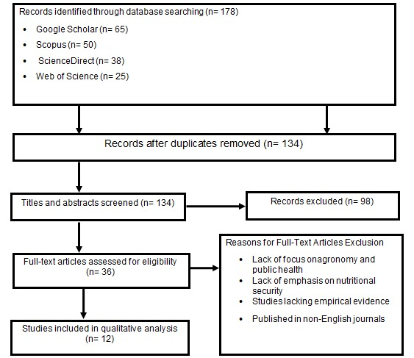

Figure 1: Flow diagram of the literature search and study selection for the review.

3. RESULTS AND DISCUSSION

This section synthesizes knowledge from shortlisted literature to elucidate how agronomic management influences the nutritional content of staple crops and its influence on America's public health outcomes. The argument is set within four overlapping themes: biofortification and strategies for micronutrient enrichment; nutrient dilution in high-yielding crops; technological and agronomic innovation towards nutrition-sensitive agriculture; and socio-political disconnection between food production and public health policy.

3.1 Nutrient Dilution in High-Yield Crops and Its Public Health Implications

One of the most recurring findings in the reviewed studies is that traditional agricultural systems that emphasize maximizing yield tend to come at the expense of nutrient content in crops, a process referred to as nutrient dilution. With improvements in crop yields through the use of high-yielding varieties, synthetic fertilizers, and irrigation, levels of valuable micronutrients such as iron, zinc, and magnesium in staple crops have declined significantly [13, 14]. Singh et al. [15], wrote that wheat varieties bred to yield more grain contain less iron and zinc than varieties that were grown in the 1960s. This loss of nutrient quality has significant policy implications for public health, particularly among populations that rely heavily on energy-dense and nutrient-poor staples. In the United States, low-income groups tend to fall behind because they have restricted access to food variety, with greater consumption of processed grains and greater susceptibility to micronutrient deficiency [16, 17]. These deficiencies are not merely subclinical entities; they are causes of a host of chronic diseases. Inordinately low magnesium and potassium intake, common among individuals with limited access to fresh fruits and vegetables, has been linked with elevated blood pressure and cardiovascular disease risk [18]. These revelations underscore the pressing need to move beyond production-oriented models and put crop micronutrient composition at the forefront.

3.2 Biofortification and Micronutrient Enhancement Strategies

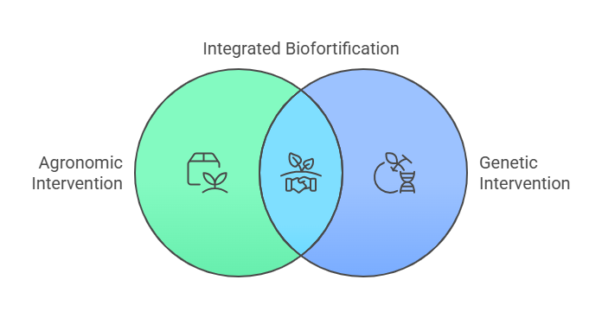

Figure 2: Biofortification Strategies for Micronutrient Alleviation.

Biofortification has been a potential strategy to alleviate micronutrient deficiencies on a large scale through agronomic or genetic intervention (See Figure 1). Considerable progress has been made in breeding crops for enhanced iron, zinc, and provitamin A content over the last decade or so. Whereas most of the biofortification programs have targeted low- and middle-income economies, many pilot projects in the United States indicate local adaptation potential. Rodríguez-Carmona et al. [19], demonstrated that zinc-dense biofortified maize varieties increased serum zinc levels in children in a controlled feeding experiment in New Mexico. Similarly, iron-biofortified beans grown in community plots in North Carolina possessed much greater iron bioavailability than usual cultivars, illustrating the fact that specialized biofortification procedures can be both feasible and beneficial [20]. Despite such advances, challenges are present. Public familiarity and uptake of biofortified crops in the US are relatively low, especially when such crops are introduced without good public health communication. Furthermore, regulatory issues concerning genetically modified organisms (GMOs) still hinder the introduction of transgenic biofortified varieties such as Golden Rice to the US market [21, 22]. The evidence, therefore, is in support of non-GMO biofortification through conventional breeding as a viable means of increasing nutritional effects.

Beyond nutritional outcomes, the overall health consequences of genetically modified crops for food security must also be taken into account. While transgenic biofortified crops such as Golden Rice have been genetically engineered to address vitamin A deficiency, their safety remains a contentious issue that continues to be a barrier for widespread acceptance. However, comprehensive reviews by both National Academies of Sciences, Engineering, and Medicine [30], and Raza [31], have found no conclusive evidence of adverse health effects associated with approved GM crops. Similarly, a study by Yadav et al. [32], affirmed the safety of genetically modified foods currently on the market. These findings suggest that, when properly regulated, GM crops can safely contribute to addressing micronutrient deficiencies. However, public concerns and differing regulatory frameworks continue to influence their role in food systems, with important consequences for nutritional security and consumer trust.

3.3 Technological and Agronomic Innovations for Nutrition-Sensitive Farming

Precision agriculture and sustainable soil management technologies have delivered new avenues of improving the nutritional content of crops. Soil nutrient mapping, remote sensing, and variable rate application of nutrients enable farmers to maximize soil micronutrient levels, which directly affects crop composition [23]. On a research on Midwest corn farms, targeted application of zinc and boron fertilizers was associated with increase in grain micronutrient content at zero cost to yield [24].

Furthermore, organic farming systems and regenerative agriculture have been found to increase nutrient density in foods. A long-term field experiment by Chadzinikolau et al. [25], revealed vegetables grown organically were 25–30% richer in antioxidants and trace minerals than vegetables grown conventionally. The possible reasons behind this could be elevated soil microbial activity, better organic matter content, and the lack of synthetic inputs. These synthetic inputs could potentially suppress micronutrient uptake. Notably, these innovations also intersect with climate resilience. Plants grown in well-fed, diverse soils are not just more nutrient-dense but also better able to withstand stresses imposed by the climate, such as drought or infestations by pests thereby benefiting food security and public health simultaneously [26, 27].

3.4 Policy Gaps and the Misalignment between Agriculture and Public Health

While there has been scientific advancement in crop nutrition, incorporation of agronomic progress into public health policy remains underdeveloped (See Figure 2). Current U.S. farm subsidies largely benefit corn, soybean, and wheat monocultures cultivation that is likely to have little nutritional diversity and supplies the raw materials for ultra-processed foods [28]. The policy environment indirectly favors the mass production of inexpensive but low-nutrient calories with disproportionate burden among vulnerable groups.

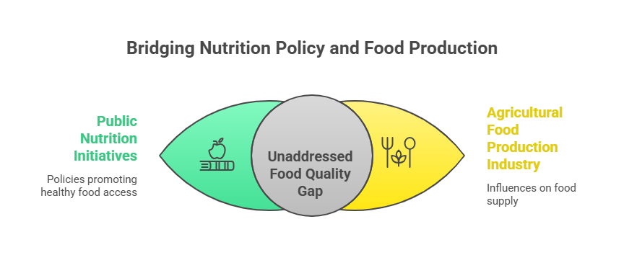

Figure 3: Bridging Nutrition Policy and Food Production

Public nutrition initiatives such as the National School Lunch Program (NSLP) and Supplemental Nutrition Assistance Program (SNAP) have introduced policies to encourage the buying of healthy foods, but these hardly consider how the agricultural food production industry influences the quality of food available in retail markets [11]. Thus, efforts to combat diet-related illness via behavior change are insufficient without concomitant changes in the agricultural policy. Others advocate systems-oriented policy reform that bridges the need for nutrition into agricultural incentives. Adeyemi et al. [29], developed a model of "nutrient density subsidies" that would reward farmers to plant crops of proven higher micronutrient content. Pilot interventions of this model in California urban agricultural cooperatives showed increased production of leafy greens with high calcium and folate content, which increased local dietary diversity. In essence, the nature of agricultural and public health policy remains at the core bottleneck. Bridging this gap will require strong intersectoral coordination, coordinated funding mechanisms, and food policies that recognize food's twin identity as an agricultural commodity and a health determinant.

3.5 Toward a Holistic Framework for Nutritional Security

The conclusions in this review highlight the need for an integrated system that bridges crop science, food policy, and public health. Rather than addressing agricultural productivity, food consumption, and health status in isolation, this calls for systemic intersectoral coordination to ensure that food systems deliver quantity and quality. Currently operating programs operate in silos as food subsidy programs seek quantity, and public health programs seek behavior change. A nutrition-sensitive agricultural policy will promote the production of micronutrient crops, integrate crop quality metrics into dietary guides and support programs, and promote diverse, locally adapted food systems, like urban and Indigenous agriculture. New models like the USDA's "Food is Medicine" and the CDC's Healthy Food Financing Initiative demonstrate such integration is possible, if their scope is limited. These must be scaled up through political will, interagency collaboration, and shifting the valuation of food; not merely as a commodity but as a determinant of health and engine of equity. Only by synthesizing nutritional goals into food system basics can we move toward inclusive and resilient nutritional security.

4. CONCLUSION

The review highlights the need to redirect the agricultural systems of the United States to nutrition-sensitive production that enhances crop quality as well as yield. General declines in the micronutrient composition of staple foods, largely resulting from yield-oriented agronomic practices, have contributed to the production of diet-associated health disparities more common among low-income and underserved groups. While innovations like regenerative soil management, precision agriculture, and biofortification have the potential to enhance crop nutritional content, their effectiveness relies on successful complementary policy reforms and system integration. A comprehensive framework of nutritional security linking crop science, food policy, and public health is needed to address these linked challenges. This will require a shift in agricultural incentives to prefer nutrient-rich food production, incorporating crop quality standards into public food systems, and further interdisciplinary cooperation within sectors. Interweaving nutrition as a core objective of food systems is not merely necessary for maximizing health benefits but also for enhancing equity and sustainable food resilience in the United States.

Disclaimer (Artificial intelligence)

Author(s) hereby declare that NO generative AI technologies such as Large Language Models (ChatGPT, COPILOT, etc.) and text-to-image generators have been used during the writing or editing of this manuscript.

REFERENCES

1. Iversen TO, Westengen OT, Jerven M. The history of hunger: Counting calories to make global food security legible. World Development Perspectives. 2023;30:100504.

2. Mozaffarian D, Fleischhacker S, Andrés JR. Prioritizing nutrition security in the US. Jama. 2021 Apr 27;325(16):1605-6.

3. Ingram J. Nutrition security is more than food security. Nature food. 2020;1(1):2.

4. Mrabet R. Sustainable agriculture for food and nutritional security. InSustainable agriculture and the environment 2023 Jan 1 (pp. 25-90). Academic Press.

5. Srivastava S, Bisht A, Laxmaiah A, Seetha A. Global Health Challenges: Nutrition and Management. CRC Press; 2024.

6. Deka G, Goyat J, Dutta H. Nutraceutical potential and techno-functional properties of pearl millet (Pennisetum glaucum). InNutri-cereals 2023 Aug 14 (pp. 91-117). CRC Press.

7. Abrignani V, Salvo A, Pacinella G, Tuttolomondo A. The mediterranean diet, its microbiome connections, and cardiovascular health: a narrative review. International Journal of Molecular Sciences. 2024;25(9):4942.

8. Banerjee S, Roy P, Nandi S, Roy S. Advanced biotechnological strategies towards the development of crops with enhanced micronutrient content. Plant Growth Regulation. 2023;100(2):355-71.

9. Getahun S, Kefale H, Gelaye Y. Application of precision agriculture technologies for sustainable crop production and environmental sustainability: A systematic review. The Scientific World Journal. 2024;2024(1):2126734.

10. Shahzad I. The Impact of Agricultural Subsidies on Farming Practices. International Journal of Scientific Discoveries. 2024;1(01):41-53.

11. Engel K, Ruder EH. Fruit and vegetable incentive programs for supplemental nutrition assistance program (SNAP) participants: a scoping review of program structure. Nutrients. 2020;12(6):1676.

12. Miller GD, Kanter M, Rycken L, Comerford KB, Gardner NM, Brown KA. Food systems transformation for child health and well-being: the essential role of dairy. International Journal of Environmental Research and Public Health. 2021;18(19):10535.

13. Yilmaz H, Yilmaz A. Hidden Hunger in the Age of Abundance: The Nutritional Pitfalls of Modern Staple Crops. Food Science & Nutrition. 2025;13(2)1-15.https://doi.org/10.1002/fsn3.4610

14. Gashu D, Nalivata PC, Amede T, Ander EL, Bailey EH, Botoman L, Chagumaira C, Gameda S, Haefele SM, Hailu K, Joy EJ. The nutritional quality of cereals varies geospatially in Ethiopia and Malawi. Nature. 2021;594(7861):71-6.

15. Singh SK, Kumar S, Kashyap PL, Sendhil R, Gupta OP. Wheat. InTrajectory of 75 years of Indian agriculture after independence 2023 Aug 29 (pp. 137-162). Singapore: Springer Nature Singapore.

16. Byker Shanks C, Andress L, Hardison-Moody A, Jilcott Pitts S, Patton-Lopez M, Prewitt TE, Dupuis V, Wong K, Kirk-Epstein M, Engelhard E, Hake M. Food insecurity in the rural United States: an examination of struggles and coping mechanisms to feed a family among households with a low-income. Nutrients. 2022;14(24):5250.

17. Ambikapathi R, Schneider KR, Davis B, Herrero M, Winters P, Fanzo JC. Global food systems transitions have enabled affordable diets but had less favourable outcomes for nutrition, environmental health, inclusion and equity. Nature Food. 2022;3(9):764-79.

18. Madsen H, Sen A, Aune D. Fruit and vegetable consumption and the risk of hypertension: a systematic review and meta-analysis of prospective studies. European journal of nutrition. 2023;62(5):1941-55.

19. Rodríguez-Carmona Y, Denova-Gutiérrez E, Sánchez-Uribe E, Muñoz-Aguirre P, Flores M, Salmerón J. Zinc supplementation and fortification in Mexican children. Food and nutrition bulletin. 2020;41(1):89-101.

20. Cichy K, Chiu C, Isaacs K, Glahn R. Dry bean biofortification with iron and zinc. InBiofortification of staple crops 2022 Mar 10 (pp. 225-270). Singapore: Springer Singapore.

21. Hefferon K. Prospects and challenges associated with GM biofortified crops. Genetic Engineering and Genome Editing for Zinc Biofortification of Rice. 2023:153-65.

22. Nawaz T, Nelson D, Saleem A, Bibi M, Joshi N, Fahad S, Saud S, Adnan M, Rasheed Khan MN, Hassan S, Rahman TU. Genetic Engineering for Crop Biofortification. Crop Biofortification: Biotechnological Approaches for Achieving Nutritional Security Under Changing Climate. 2025:263-94.

23. Raza I, Zubair M, Zaib M, Khalil MH, Haidar A, Sikandar A, Abbas MQ, Javed A, Liaqat MM, Ain AT, Nafees M. Precision nutrient application techniques to improve soil fertility and crop yield: A review with future prospect. International Research Journal of Educational and Tecnology. 2023;5.

24. Stewart ZP, Paparozzi ET, Wortmann CS, Jha PK, Shapiro CA. Effect of foliar micronutrients (B, Mn, Fe, Zn) on maize grain yield, micronutrient recovery, uptake, and partitioning. Plants. 2021;10(3):528.

25. Chadzinikolau T, Formela-Luboińska M. Nitrogen metabolism and antioxidant capacity of selected vegetables from organic and conventional crops. Applied Sciences. 2023;13(20):11170.

26. Mutale B, Dai S, Chen Z, Maulu S. Enhancing food security amid climate change: assessing impacts and developing adaptive strategies. Cogent Food & Agriculture. 2025;11(1):2519800.

27. He X, Batáry P, Zou Y, Zhou W, Wang G, Liu Z, Bai Y, Gong S, Zhu Z, Settele J, Zhang Z. Agricultural diversification promotes sustainable and resilient global rice production. Nature Food. 2023;4(9):788-96.

28. Waite A. United States Farm Policy Reform in Supporting Dietary Diversity and Combating Monocropping. U. Tol. L. Rev.. 2022;54:327.

29. Adeyemi O, Adejoh V, Anjorin O, Ariyo O, Makanjuola B, Sablah M, Onabolu A. Nutrition capacity assessment of agriculture extension services in Nigeria. Food and Nutrition Bulletin. 2023 Sep;44(1_suppl):S92-102.

30. National Academies of Sciences, Engineering, and Medicine. Genetically engineered crops: Experiences and prospects. Washington (DC): The National Academies Press; 2016.

31. Raza A. Genetically Modified Crops: Benefits, Risks, and Regulatory Perspectives. Frontiers in Agriculture. 2024;1(2):252-82.

32. Yadav V, Pal D, Poonia AK. A study on genetically engineered foods: need, benefits, risk, and current knowledge. Cell Biochemistry and Biophysics. 2024;82(3):1931-46.

