Current application status and trends in paravertebral block for thoracic surgery: A 2004–2024 bibliometric analysis

.

ABSTRACT

|  |
| --- |
| **Aims:** To elucidate the current application status and research trends of paravertebral block (PVB) regional anesthesia in thoracic surgery.  **Methodology:** Using bibliometric methods, we analyzed 931 publications from Web of Science (2004-2024) with CiteSpace 6.2.R4 to map knowledge networks and evolving trends in paravertebral block for thoracic surgery. Visual knowledge mapping was employed to identify core researchers, research hotspots, and keyword clustering in thoracic PVB applications.  **Results:** Research output demonstrated significant growth over the past decade. Visualization analysis reveals that Canada and the United States dominated the field's intellectual development. While inter-institutional collaboration was active, overall research cohesion remained suboptimal. PVB research primarily focused on pain management and anesthesia protocol optimization, with high-centrality keywords including pain, anesthesia, postoperative pain, surgery and analgesia. Emerging trends revealed a shift from traditional agent toward minimally invasive techniques and novel nerve blocks.  **Conclusion:** PVB exhibits significant analgesic efficacy in thoracic procedures. Future research prioritizes continuous paravertebral block and multimodal analgesia protocols. PVB holds substantial promise for postoperative analgesia and enhanced recovery pathways, with AI-assisted protocols potentially optimizing clinical implementation. Strengthening multinational and cross-institutional collaboration is essential to advance research synergy. |
|  |

*Keywords: Paravertebral block; thoracic surgery; CiteSpace; Visualization analysis*

1. INTRODUCTION

Paravertebral block (PVB), a pivotal regional anesthesia technique, has garnered significant and growing attention in the realm of thoracic surgery (Novak-Jankovic V, 2011). By delivering local anesthetics into the paravertebral space, PVB effectively blocks both the anterior and posterior rami of spinal nerves, providing targeted somatic and visceral analgesia (Fyeung, JHY., et al, 2016). Compared to conventional general anesthesia and thoracic epidural analgesia (TEA), PVB offers distinct advantages, including a favorable safety profile with potentially fewer complications (e.g., reduced risks of hypotension, urinary retention, and epidural hematoma), minimal perturbation to respiratory and hemodynamic function, and relative technical accessibility (Yuan et al, 2023; Jin et al, 2020). Crucially, in the context of minimally invasive procedures like video-assisted thoracoscopic surgery (VATS), PVB has been consistently demonstrated to significantly attenuate acute postoperative pain, reduce opioid consumption, and contribute to enhanced recovery after surgery (ERAS) pathways (Teruya, K., et al, 2014; Yang HH, et al, 2024). Given its expanding clinical adoption and the critical need for optimized pain management strategies in thoracic surgery, a comprehensive analysis of the evolving research landscape surrounding PVB is warranted.

Bibliometric analysis provides a powerful quantitative framework for mapping the structure, evolution, and emerging trends within a specific scientific domain by analyzing large volumes of publication data, including citations, co-authorships, keywords, and institutional affiliations. CiteSpace, a leading software tool for visualizing and analyzing trends in scientific literature, excels at transforming complex bibliographic datasets into intuitive knowledge maps (e.g., co-citation networks, co-occurrence networks, cluster views, timeline visualizations) (Chen, 2006). This methodology has proven highly applicable and insightful in analyzing research trends across various surgical and anesthesia subspecialties, including thoracic surgery and regional anesthesia techniques (Ruan et al, 2023; Alejandra C-V, MD, et al, 2023). By enabling the identification of key contributors, influential institutions, research hotspots, thematic clusters, and temporal shifts in focus, CiteSpace facilitates a macro-level understanding of a field's development.

Leveraging the Web of Science Core Collection database, this study employs CiteSpace to conduct a comprehensive bibliometric analysis of the global scientific literature focusing on paravertebral block in thoracic surgery. We systematically retrieved relevant publications, constructed detailed knowledge maps encompassing publication trends, collaborative networks among authors and institutions, keyword co-occurrence patterns, thematic cluster formation, and their evolution over time via timeline analysis. By systematically analyzing the current status, research fronts, and knowledge structure pertaining to PVB application in thoracic surgery, it aims to offer valuable insights to guide clinical practice and resource allocation in the application of PVB for thoracic surgical patients.

2. methodology

**2.1 Data Collection**

The literature data were retrieved from the Web of Science Core Collection (WOS-CC) using the search strategy: TS=(thoracic OR thoracoscopic) AND TS=(surgery OR procedure) AND TS=(paravertebral) AND TS=(block* OR analgesia). Publications from January 1, 2004, to October 3, 2024, were initially identified (n=6,152). After limiting to English-language articles published within the last 20 years and removing duplicates, 931 articles were included for analysis.

**2.2 Data Processing**

Bibliometric analysis was performed using CiteSpace 6.2.R4. Data processing included: (1) Exporting records from WOS in plain text format (labeled "download_*.txt"); (2) Converting data formats within CiteSpace; (3) Setting parameters: Time slicing is 2004–2024 (1-year intervals), term sources include Title, Abstract, Keywords; and selection criteria is top 50 most cited or occurring items per slice.

3. results

**3.1 Publication Trends and Country Co-occurrence Analysis**

The annual publication volume trend in the field of paravertebral block shows that from 2004 to 2013, the average number of publications per year was less than 20, with a relatively flat growth rate. After a brief decline in 2016, the number of publications continued to rise, reaching a peak of 108 in 2022, and remained at a high level in 2024. This indicates a significant growth trend in the research on the application of PVB in thoracic surgery.

In the country co-occurrence network (Fig. 1), the larger the radius of a node, the higher the number of publications, and the thicker the outer ring, the higher the centrality. The results show that among the top 10 countries with the highest number of publications, Canada had the highest centrality (0.49), followed by the United States (0.48) and China (0.14). Canada and the United States are the main drivers of development in this field, while China, despite leading in output, has a centrality of 0, indicating that its academic influence still needs to be enhanced. China, although late in starting research in this field, has seen increasing achievements in PVB research in recent years under the guidance of national policies and scientific innovation. Over the past two decades, China has ranked first internationally in terms of total publications, with 230 papers, followed by the United States with 155 papers. Additionally, 60 countries/regions have actively participated in this field of study, with 17 countries/regions having at least 10 publications included in this statistical analysis. China and the United States form the core collaborative axis, while other major collaborators include Japan, Turkey, Egypt, India, and other countries.

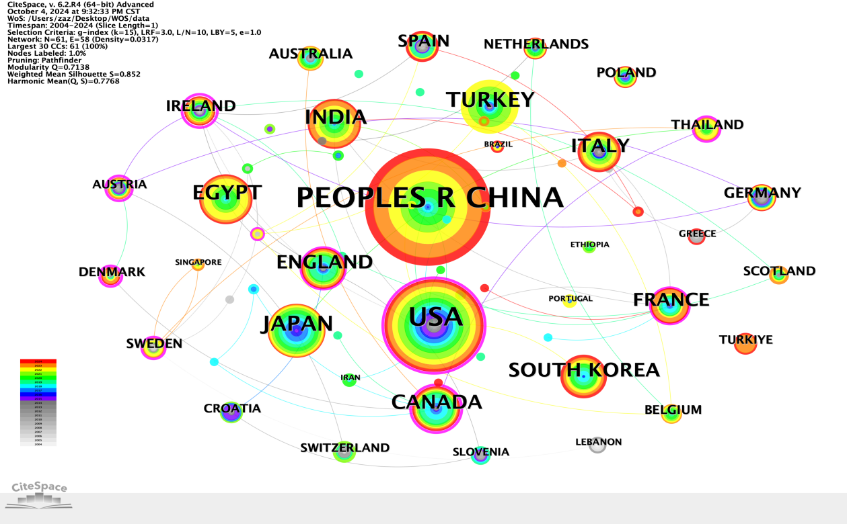

**Fig. 1. Country collaboration network for PVB research in thoracic surgery**

**3.2 Institutional Co-occurrence and Author Collaboration Network Analysis**

The visualization of institutional co-occurrence networks in the field of paravertebral block (PVB) is shown in Fig. 2, with a total of 277 nodes and 338 connections, indicating a network density of 0.0088. This suggests that there is moderate collaboration among institutions. The English literature included in this statistical analysis was sourced from 277 institutions, with 7 institutions (2.5%) publishing 10 or more papers and 24 institutions (8.7%) publishing between 5 and 10 papers. High-output institutions include the Egyptian Knowledge Bank (44 papers), Shanghai Jiao Tong University (15 papers), and the University of Health Sciences Turkey (14 papers), among others.

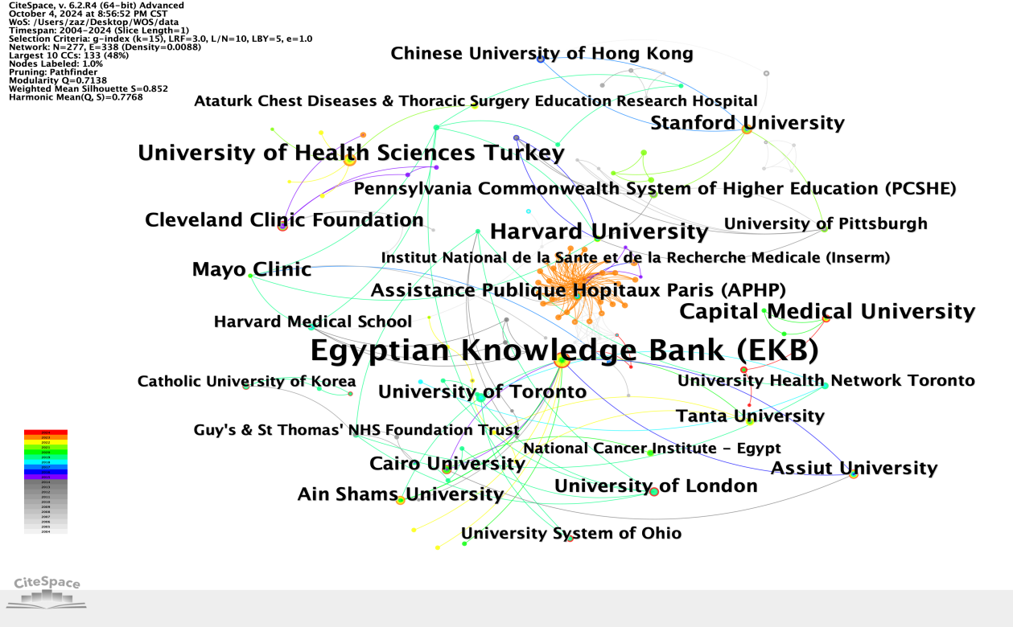

**Fig. 2. Institutional co-occurrence networks for PVB research in thoracic surgery**

A visualization of the author collaboration network, with authors as nodes, is shown in Fig. 3. This network includes 401 authors and 534 collaborative relationships. In the figure, the size of the nodes and fonts is proportional to the number of publications by the authors. Among the 401 authors, 10 (2.5%) published 4 or more papers. The team led by Ali Alagoz and Musa Zengin demonstrated the closest collaboration. However, the overall network density (0.0067, with 401 nodes and 534 connections) is relatively low, indicating that the overall level of collaboration among authors is not very close.

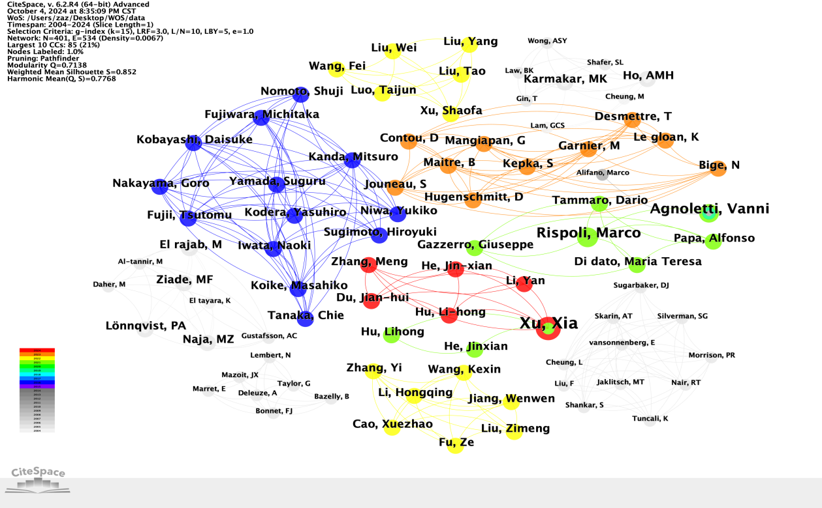

**Fig. 3. Author collaboration networks for PVB research in thoracic surgery**

**3.3 Keyword Co-occurrence, Clustering, and Burst Analysis**

(1) Keyword Co-occurrence Analysis

Keywords are a highly summarized representation of the content of a document, enabling readers to quickly grasp the research topic of the literature. In the field of paravertebral block, the keyword co-occurrence map in the WOS database consists of 296 nodes and 559 connections. The top 10 keywords by frequency are: paravertebral block, analgesia, thoracic paravertebral block, efficacy, surgery, postoperative pain, thoracotomy, anesthesia, pain, and postoperative analgesia. This indicates that these keywords have high co-occurrence frequencies with other keywords.

Betweenness centrality is a key metric for evaluating the importance of nodes in a network. In the keyword co-occurrence network knowledge map of the PVB field, keywords with high centrality include pain (0.18), anesthesia (0.13), postoperative pain (0.13), surgery (0.11), and analgesia (0.1). This suggests that anesthesia, postoperative pain, and surgical procedures are central topics in the application of PVB in thoracic surgery research, particularly focusing on research in paravertebral block, thoracic paravertebral block, thoracic surgery, and analgesia.

(2) Keyword Clustering Analysis

Based on keyword co-occurrence in CiteSpace, the LLR algorithm was used to generate a clustering map (Fig. 4). Further statistical analysis of the keyword clustering map yielded a clustering information table, with 15 clusters formed. Each cluster had an outline value greater than 0.8, indicating high consistency and good homogeneity. The core directions of high-frequency keywords include: #0 brachial plexus block, #1 management, #2 pain management, #3 postoperative pain, #4 video-assisted, #5 thoracic surgery, #6 serratus anterior plane block, #7 general anesthesia, #8 local anesthesia, #9 acute pain, #10 breast cancer, #11 modified radical mastectomy, #12 regional anesthesia, #13 outpatient, and #14 postoperative analgesia. In this field, research on PVB primarily focuses on postoperative pain, thoracic surgery, general anesthesia, and local anesthesia.

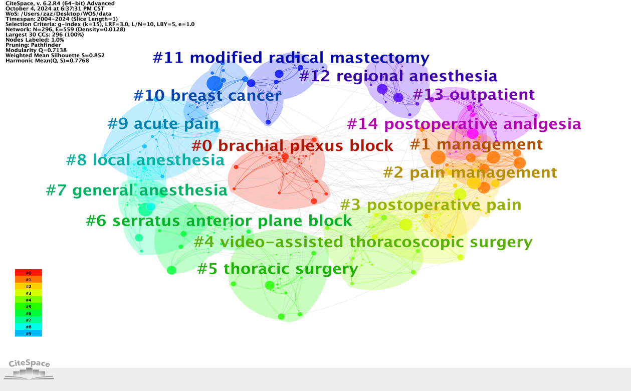

**Fig. 4. Keyword Clustering for PVB research in thoracic surgery**

(3) Keyword Burst Analysis

From the burst intensity of keywords (Fig. 5), the top 5 bursting keywords are: bupivacaine (15.62), randomized controlled trials (9.91), postthoracotomy pain (9.7), thoracotomy (9.1), and infusion (6.9). Early research hotspots (before 2014) were concentrated on bupivacaine, postoperative pain, general anesthesia, surgical treatment, and nerve block, with bupivacaine exhibiting the highest burst intensity (15.62). After 2014, research hotspots shifted to patient-controlled analgesia, children, single-injection techniques, thoracic nerve conduction block, video-assisted thoracic surgery (VATS), and serratus anterior plane block. Among these, video-assisted thoracic surgery exhibited relatively high activity in research on the application of PVB in thoracic surgery, with a burst intensity of 6.26. The changes in bursting keywords indicate a shift in research focus from traditional drugs (e.g., bupivacaine) to minimally invasive techniques (e.g., VATS) and novel blocking technologies. Bupivacaine, postoperative analgesia, general anesthesia, and video-assisted thoracic surgery may become key research hotspots in the future application of PVB in thoracic surgery (Zhang YY, et al, 2022).

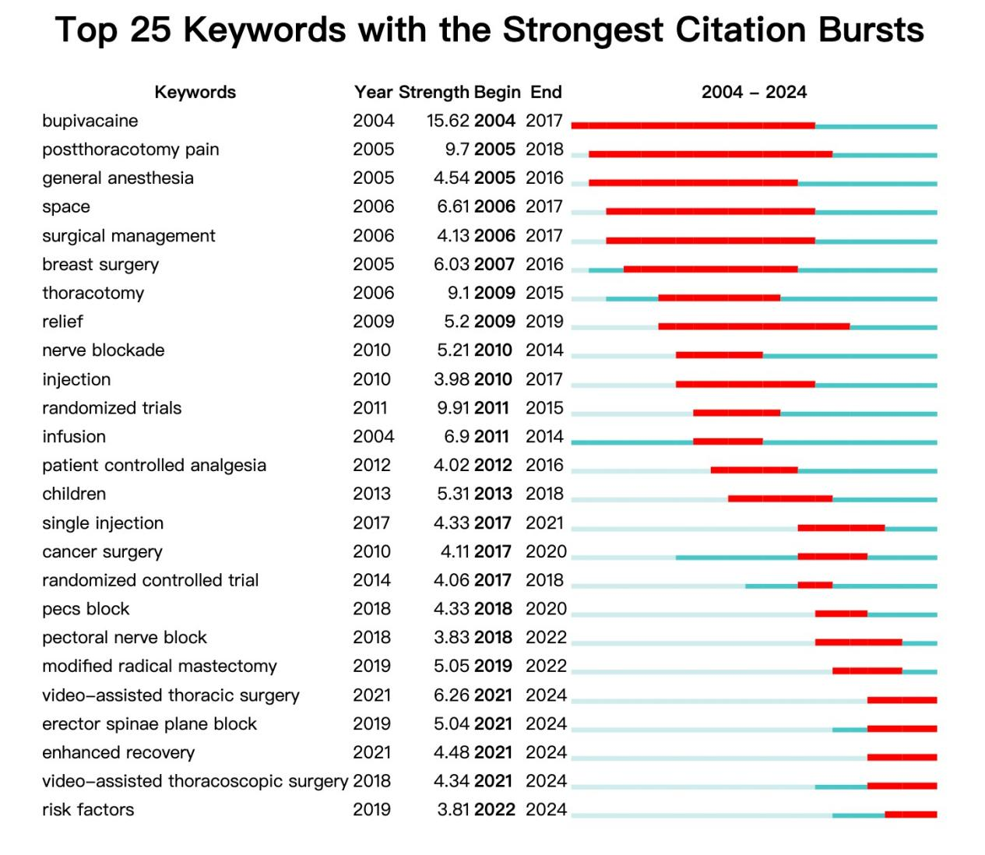

**Fig. 5. Top 25 Keywords with strongest citation bursts for PVB research in thoracic surgery**

Based on the keyword co-occurrence map generated by CiteSpace software for 2004-2024, we further constructed a timeline clustering diagram (Figure 6). The visualization analysis results demonstrate a significant increase in research activity during 2014-2024, which is specifically manifested in: (1) a remarkable growth in keyword node density; (2) high levels of both intra-cluster and inter-cluster connectivity. This highly dense academic network structure indicates that research during this period not only formed several distinct research hotspots but also exhibited significant interdisciplinary integration across different research directions.

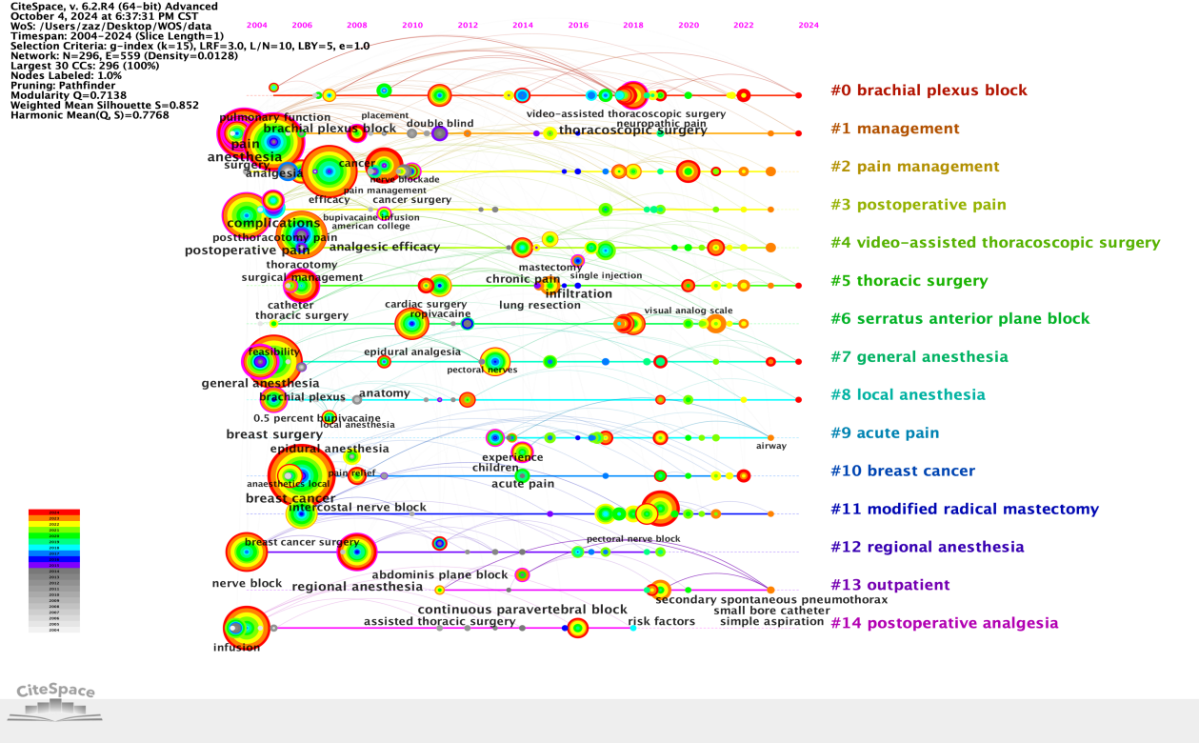

**Fig. 6. Keywords timeline clustering diagram of PVB research in thoracic surgery**

**3.4 Co-Citation and Journal Overlap Analysis**

Citation co-occurrence analysis can identify research hotspots in specific research fields. Table 1 lists the top 10 most frequently cited references, which to some extent represent the most popular research directions in the field of paravertebral block applications. Mauricio et al (Mauricio Forero, et al, 2016) has the highest citation frequency, laying a solid theoretical foundation for PVB. Regional anesthesia and pain are also key research focuses in this field.

**Table 1. Cited reference statistics on the application of PVB in thoracic surgery**

|  |  |  |  |
| --- | --- | --- | --- |
| **No.** | **Citations** | **Centrality** | **Cited Reference** |
| 1 | 58 | 0.03 | Mauricio Forero, 2016, REGION ANESTH PAIN M, V41, P621, DOI 10.1097/AAP.0000000000000451 |
| 2 | 54 | 0 | DErcole F, 2018, J CARDIOTHOR VASC AN, V32, P915, DOI 10.1053/j.jvca.2017.10.003 |
| 3 | 40 | 0.07 | Kulhari S, 2016, BRIT J ANAESTH, V117, P382, DOI 10.1093/bja/aew223 |
| 4 | 38 | 0.03 | Batchelor TJP, 2019, EUR J CARDIO-THORAC, V55, P91, DOI 10.1093/ejcts/ezy301 |
| 5 | 35 | 0.11 | Adhikary SD, 2018, REGION ANESTH PAIN M, V43, P756, DOI 10.1097/AAP.0000000000000798 |
| 6 | 34 | 0.11 | Krediet AC, 2015, ANESTHESIOLOGY, V123, P459, DOI 10.1097/ALN.0000000000000747 |
| 7 | 33 | 0.05 | Ivanusic J, 2018, REGION ANESTH PAIN M, V43, P567, DOI 10.1097/AAP.0000000000000789 |
| 8 | 32 | 0.02 | Pace MM, 2016, ANESTH ANALG, V122, P1186, DOI 10.1213/ANE.0000000000001117 |
| 9 | 31 | 0.03 | Chen N, 2020, J CLIN ANESTH, V59, P106, DOI 10.1016/j.jclinane.2019.07.002 |
| 10 | 31 | 0.05 | Taketa Y, 2020, REGION ANESTH PAIN M, V45, P10, DOI 10.1136/rapm-2019-100827 |

Journal overlap analysis reveals that the top 10 cited references are concentrated in journals specializing in regional anesthesia and pain medicine (e.g., Br J Anaesth, Anesth Analg). Most studies were published in journals related to health, healthcare, nursing, medicine, and molecular biology, particularly those associated with surgical fields. Highly cited journals are primarily categorized under molecular biology, psychology, and medicine.

4. discussion

Paravertebral block (PVB), as a regional anesthesia technique, is increasingly gaining attention in thoracic surgery. Based on bibliometric analysis and recent research progress, PVB demonstrates significant advantages over traditional epidural anesthesia. First, PVB avoids complications associated with dural puncture, such as epidural hematoma and infection (Li, et al, 2025). Additionally, unilateral block reduces widespread sympathetic inhibition, maintaining more stable blood pressure (Jack, JM., et al, 2020). These characteristics make PVB safer in thoracic surgery, particularly excelling in minimally invasive procedures like video-assisted thoracic surgery (VATS) (Komatsu, T., et al, 2014; Moorthy, A., et al, 2022). Furthermore, PVB has minimal effects on hemodynamics, making it highly valuable for elderly patients or high-risk populations with comorbidities such as cardiopulmonary diseases (Forero, M., et al, 2016).

According to keyword timeline analysis, PVB research can be broadly divided into two phases: (1) 2004–2013: This period focused on foundational explorations of PVB techniques and validations of postoperative pain management. Studies primarily compared the safety and efficacy of PVB with traditional anesthesia methods (e.g., general anesthesia and epidural anesthesia), particularly emphasizing its potential to reduce postoperative analgesic use and improve patient comfort. (2) 2014–2024: With the widespread adoption of thoracoscopic surgery, research shifted toward continuous PVB (continuous paravertebral block) and precise management of acute pain (Chen WC, et al, 2023). There is a growing emphasis on integrating analgesia with the Enhanced Recovery After Surgery (ERAS) concept (Er, et al, 2021). The application of “patient-controlled analgesia (PCA)” and “serratus anterior plane block (SAPB)” reflects a trend toward more personalized and multimodal analgesic strategies (Hu, et al, 2022).

From keyword co-occurrence and burst analysis, the research core revolves around "postoperative analgesia" and "thoracoscopic surgery". As the preferred anesthetic agent, bupivacaine's long-acting analgesic properties significantly reduce postoperative opioid consumption and related complications in VATS procedures (Wang, et al, 2018). The combination of VATS and PVB not only shortens hospital stay but also improves postoperative quality of life (Suksompong, S., et al, 2020).

Despite China’s leading position in terms of the number of publications in the PVB field globally, its influence in the international academic community remains relatively low. Chinese research primarily focuses on single-center retrospective studies, lacking large-scale multicenter prospective clinical trials. This limits the authority of research findings in the international academic community. Additionally, China has a low proportion of publications in high-impact international journals, and collaboration density among research institutions is insufficient. This leads to partiality and imbalance in research, particularly in interdisciplinary collaboration between anesthesiology and thoracic surgery (Komatsu, T., et al, 2014). It is essential to strengthen domestic and international collaborations, promote interdisciplinary and inter-institutional joint research, improve research quality, and overcome existing limitations.

In the future, PVB research will continue to focus on personalized analgesia and precise analgesia. Continuous paravertebral block (CPVB) utilizes catheters for sustained drug delivery to prolong analgesic effects, and therefore is particularly suitable for patients undergoing thoracotomy or complex thoracoscopic surgeries. Furthermore, the combined application of PVB with serratus anterior plane block (SAPB) and other regional anesthesia techniques aims to achieve broader analgesic coverage and improve postoperative recovery outcomes for patients. With advancements in artificial intelligence (AI), AI-assisted ultrasound localization and nerve stimulation techniques will enhance the precision of PVB procedures and reduce the risk of complications (Park, M., et al, 2023).

This study has several limitations. First, the bibliometric analysis was based on the WOS database, which may not include some regionally significant studies. Second, there was heterogeneity in the quality of included literature, encompassing study designs with lower evidence levels such as retrospective studies. Finally, the visualization results were influenced by parameter settings of the CiteSpace algorithm. These limitations suggest that our findings still require further validation through large-scale prospective clinical trials.

5. Conclusion

Paravertebral block (PVB), as an effective regional anesthesia technique, has been widely applied in thoracic surgery, particularly demonstrating significant analgesic effects in thoracoscopic surgery. With the widespread adoption of ultrasound-guided techniques and the rapid development of thoracoscopic surgery, the application of PVB in postoperative analgesia and Enhanced Recovery After Surgery (ERAS) holds even greater promise. As thoracoscopic surgery becomes more prevalent, the application of PVB in minimally invasive procedures will be further optimized. The combined use of continuous paravertebral block (continuous PVB) and multimodal analgesic regimens is expected to become a key focus of future research.

Advancements in artificial intelligence (AI), such as real-time ultrasound-guided localization and nerve stimulation techniques, will provide more efficient auxiliary support for PVB procedures. By strengthening multicenter collaborations and international academic exchanges, the promotion of PVB research findings on a global scale will be facilitated. This will establish PVB as the “gold standard” for postoperative analgesia and patient recovery in thoracic surgery.

ma

Competing interests

Authors have declared that no competing interests exist.

Disclaimer (Artificial intelligence)

Author(s) hereby declare that NO generative AI technologies such as Large Language Models (ChatGPT, COPILOT, etc.) and text-to-image generators have been used during the writing or editing of this manuscript.

References

Alejandra C-V, M.D., Hartzell V, S. M.D. (2023). Assessing the impact of publications: A bibliometric analysis of the top-cited articles from The Journal of Thoracic and Cardiovascular Surgery. The Journal of Thoracic and Cardiovascular Surgery, 165(5), 1901-1916. https://doi.org/10.1016/j.jtcvs.2022.09.031

Chen, C. (2006). Citespace ii: detecting and visualizing emerging trends and transient patterns in scientific literature. Journal of the American Society for Information Science and Technology, 57(3), 359-377. DOI: 10.1002/asi.20317

Chen WC, Bai YY, Zhang LH, Liu YB, Liu CY, Liang JW, et al. (2023). Prevalence and Predictors of Chronic Postsurgical Pain After Video-Assisted Thoracoscopic Surgery: A Systematic Review and Meta-analysis. Pain and Therapy, 12(1), 117-139. DOI: 10.1007/s40122-022-00439-0

ER J, XIA J, GAO R, & Yu YH. (2021). A randomized clinical trial: optimal strategies of paravertebral nerve block combined with general anesthesia for postoperative analgesia in patients undergoing lobectomy: a comparison of the effects of different approaches for serratus anterior plane block. Ann Palliat Med, 10(11), 11464-11472. DOI: 10.21037/apm-21-2597

Forero, M., Adhikary, SD., Lopez, H., Tsui, C., Chin, KJ. (2016). The Erector Spinae Plane Block: A Novel Analgesic Technique in Thoracic Neuropathic Pain. Regional Reg Anesth Pain Med, 41(5), 621-627. DOI: 10.1097/AAP.0000000000000451

Fyeung, JHY., Gates, S., Naidu, BV., Wilson, MJA. & Smith, FG. (2016). Paravertebral block versus thoracic epidural for patients undergoing thoracotomy. Cochrane Database Syst Rev, 2(2): CD009121. DOI: 10.1002/14651858.CD009121.pub2

Hu J, Tan Y, Chen Y, Mo S, Hekking B, Su J, et al. (2022). Role of (pro)renin receptor in cyclosporin A-induced nephropathy. Am J Physiol Renal Physiol, 322(4), F437-F448. DOI: 10.1152/ajprenal.00332.2021

Jack, JM., Mclellan, E., Versyck, B., Englesakis, MF. & Chin KJ. (2020). The role of serratus anterior plane and pectoral nerves blocks in cardiac surgery, thoracic surgery and trauma: a qualitative systematic review. Anaesthesia, 75(10), 1372-1385. DOI: 10.1111/anae.15000

Jin ZS, Durrands, T., Li R, Gan, T.J., Lin J. (2020). Pectoral block versus paravertebral block: a systematic review, meta-analysis and trial sequential analysis. Reg Anesth Pain Med, 45(9), 727-732. doi: 10.1136/rapm-2020-101512

Komatsu, T., Kino, A., Inoue, M., Sowa, T. & Takahashi, K. (2014). Paravertebral block for video-assisted thoracoscopic surgery: analgesic effectiveness and role in fast-track surgery. Int J Surg, 12(9), 936-939. DOI: 10.1016/j.ijsu.2014.07.272

Li Y, Zhang WX, Liang HS, Sun L, Gao XY, Feng Y. (2025). Preoperative thoracic paravertebral block provides greater benefits for body temperature protection in patients undergoing thoracoscopic lung surgery: a retrospective cohort study. BMC anesthesiology, 25(1), 295. DOI: 10.1186/S12871-025-03164-1

Mauricio Forero, MD, FIPP., Sanjib, DA, MD., Hector Lopez, MD., Calvin T, BMSc., Ki JC. (2016). The Erector Spinae Plane Block: A Novel Analgesic Technique in Thoracic Neuropathic Pain. Regional Anesthesia & Pain Medicine, 41(5), 621-627. DOI: 10.1097/AAP.0000000000000451

Moorthy, A., Ní Eochagáin, A., Dempsey, E., Wall, V., Marsh, H., Murphy, T., et al. (2022). Postoperative recovery with continuous erector spinae plane block or video-assisted paravertebral block after minimally invasive thoracic surgery: a prospective, randomised controlled trial. Br J Anaesth, 130(1), e137-e147. doi: 10.1016/j.bja.2022.07.051

Novak-Jankovic, V. (2011). Update on Thoracic Paravertebral Blocks. Collegium antropologicum, 35 (2) , 595-598. PMID: 21755736

Park M, Moon KJ. (2023). Web-based delirium prevention application for long-term care facilities. Randomized Controlled Trial, 24(4), 559-563. DOI: 10.1016/j.jamda.2022.12.023

Ruan D, Tang X, Li X, Li L, Hua J. (2023). Trends and bibliometric analysis on pediatric anesthesia from 2002 to 2022: A review. Medicine (Baltimore), 102(43): e35626. doi: 10.1097/MD.0000000000035626.

Suksompong, S., Bormann, S. & Bormann, B. (2020). Regional Catheters for Postoperative Pain Control: Review and Observational Data. Anesth Pain Med, 10(1), e99745. DOI: 10.5812/aapm.99745

Teruya, K., Atsunari, K., Mari, I., Terumasa, S., Koji, T. & Takuji, Fujinaga. (2014) Paravertebral block for video-assisted thoracoscopic surgery: analgesic effectiveness and role in fast-track surgery, 12(9):936-939. DOI: 10.1016/j.ijsu.2014.07.272

Wang, K., Wang, LJ., Yang, TJ., Mao, QX., Wang, Z., Chen, LY. (2018). Dexmedetomidine combined with local anesthetics in thoracic paravertebral block: A systematic review and meta-analysis of randomized controlled trials. Medicine (Baltimore), 97(46), e13164. DOI: 10.1097/MD.0000000000013164

Yang HH, Zhang Q, Gao K, Zha P, Gong HQ, Dai XM, et al. (2024). Evaluating Modified Ultrasound-Guided Serratus Anterior Plane Block for Enhanced Postoperative Recovery in Thoracoscopic Lobectomy Patients. Med Sci Monit, 30, e942757. DOI: 10.12659/MSM.942757

Yuan, YJ., Li, XY. & Xue, FS. (2023). Continuous paravertebral block combined with multilevel single-shot intercostal nerve blocks for pain control after thoracotomy, JOURNAL OF ANESTHESIA, 38, 150-151. https://doi.org/10.1007/s00540-023-03300-6

Zhang YY, Zhou R, Hou BL, Tang SH, Hao J, Gu XP, et al. (2022). Incidence and risk factors for chronic postsurgical pain following video-assisted thoracoscopic surgery: a retrospective study.BMC Surg, 22(1), 76. doi: 10.1186/s12893-022-01522-1