# Recent advances in the use of cone beam computed tomography (CBCT) in the diagnosis and therapeutic planning of oral and maxillofacial trauma

**ABSTRACT**

|  |
| --- |
| This study explored the use of Cone Beam Computed Tomography (CBCT) in the evaluation of traumatic lesions in the oral and maxillofacial region, especially in impacted and supernumerary teeth. The research was conducted through a systematic review of scientific articles, selected from a search in DECS descriptors and the PubMed database, resulting in 10 articles that met the inclusion criteria. The results highlight CBCT as a superior imaging modality, capable of generating detailed three-dimensional images with lower radiation dose and high spatial resolution. This technology has proven crucial for accurate diagnosis and planning of surgical treatments, allowing for clear visualization of facial structures and fractures, making it easier to differentiate between conditions such as vertical root fractures and apical periodontitis. The application of CBCT was also effective in the manufacture of customized plates for facial fracture surgeries, demonstrating its value in improving surgical outcomes and reducing complications. The study concludes that CBCT represents a significant advance in dentistry, offering improved diagnostic accuracy and contributing to more targeted care and effective therapeutic approaches, essential in clinical practice for treating complex conditions. |

# *Keywords: Cone beam computed tomography, Bone fractures, Dentistry and Radiology*

# 1. INTRODUCTION

Cone Beam Computed Tomography (CBCT) has emerged as a revolutionary tool in dentistry, offering a detailed three-dimensional view of craniofacial structures (Nourolouyouni et al., 2023). This current technology has been instrumental in improving the assessment and treatment of various dental and bone conditions, providing volumetric images with high spatial resolution and precision, unlike two-dimensional radiographs. The introduction of CBCT into clinical practice represented a milestone in diagnostic imaging, allowing for a more detailed and accurate analysis of anatomical structures, which is essential for surgical planning and the execution of complex interventions.

Facial trauma represents a considerable challenge for health professionals due to the anatomical complexity of the region and the need for accurate diagnoses for effective treatment (Ata et al., 2023). In these cases, CBCT stands out by providing detailed, non-overlapping images of bone and dental structures, which is crucial for accurately identifying the location and extent of fractures. The ability to visualize complex fractures in three dimensions overcomes the limitations of conventional radiographs, which often show overlaps and lack clarity in critical areas. This diagnostic precision is vital for surgical planning, especially in cases that require delicate and minimally invasive interventions.

In addition to analyzing facial trauma, CBCT plays a fundamental role in assessing included and supernumerary dental elements, which can cause complications such as impaction and occlusal disorders if not treated properly. The elimination of anatomical overlaps enables clear and detailed visualization of structures, which is essential for making precise clinical decisions. CBCT allows exact visualization of the position and relationship of these teeth with adjacent structures, facilitating surgical planning and the prevention of complications (Nourolouyouni et al., 2023). Recent studies have shown that the use of CBCT increases accuracy in identifying and classifying these anomalies, which contributes significantly to improving clinical results.

Another important aspect of CBCT is its efficiency in eliminating anatomical overlaps, a common challenge with two-dimensional images. This technology allows three-dimensional visualization without distortions, which is crucial for differentiating between different types of bone fractures and lesions. The diagnostic accuracy provided by CBCT facilitates the identification of root fractures, which are often difficult to detect on conventional radiographs due to overlapping structures. The ability to generate detailed three-dimensional images of craniofacial structures significantly improves accuracy in diagnosis and treatment planning, resulting in more effective and personalized approaches.

This project aims to explore the impact of CBCT in clinical practice, highlighting its effectiveness in identifying and analyzing facial trauma, evaluating included and supernumerary dental elements, and eliminating anatomical overlaps. By reviewing current studies and scientific evidence, the aim is to provide a comprehensive understanding of the potential of this advanced technology to improve diagnosis and therapeutic planning in dentistry and maxillofacial surgery. By combining high resolution with a low radiation dose, CBCT is consolidating its position as the modality of choice for a variety of clinical applications, from preoperative assessment to postoperative follow-up.

# 2. MATERIALS AND METHODS

With the ongoing evolution of imaging technologies, CBCT is expected to continue to play a central role in dentistry and maxillofacial surgery. Innovation in this area not only improves diagnostic accuracy, but also contributes to patient safety and comfort by minimizing radiation exposure while providing detailed information necessary for effective treatment. As more research and case studies are carried out, the use of CBCT is set to expand, offering even more benefits for clinical practice and consolidating its position as an indispensable tool in diagnostic imaging.

The research was conducted to evaluate the use of CBCT in the diagnosis and treatment of traumatic injuries in the oral and maxillofacial region. The documents were selected based on inclusion criteria, which included the presence of the descriptors "*Cone beam computed tomography, Bone fractures, Dentistry and Radiology*". Studies that did not meet these criteria were excluded from the analysis.

During data analysis and interpretation, computer resources were used to organize and systematize the documents analyzed. The main results obtained were presented clearly and objectively, highlighting the relevant findings related to the effectiveness of CBCT in assessing lesions affecting the mouth, face, and jaws.

To illustrate the practical application of the results, figures have been included showing examples of CBCT images used in the studies reviewed, demonstrating the effectiveness of the technology in different clinical contexts. These figures provide a detailed visualization of the fractures and structures involved, emphasizing the importance of CBCT in dental practice.

This study is part of the requirements for the completion of the Radiology Technologist Course at the Franciscan University (UFN), and seeks to contribute to the advancement of scientific knowledge in this area, providing up-to-date information on CBCT in the detection of root fractures and the evaluation of included and supernumerary teeth, offering detailed 3D images that facilitate diagnosis and consequently treatment.

# 3. RESULTS AND DISCUSSIONS

The search began with the selection of descriptors in DECS - Descriptors in Health Sciences, which were applied to the PubMed database to identify relevant articles related to the diagnosis, interventions, and treatment of traumatic injuries involving the mouth, facial bones and jaws. To delimit the field of interest and ensure the quality of the analysis, rigorous filtering was carried out, reducing the initial number of 137 articles to 10 studies.

The exclusion criteria applied in the full-text analysis phase were:

* Articles published before 2023, in order to ensure that the analysis was based on recent and relevant evidence.
* Articles that were not available in English, Spanish, or Portuguese.
* Research that used technologies or approaches other than CBCT.

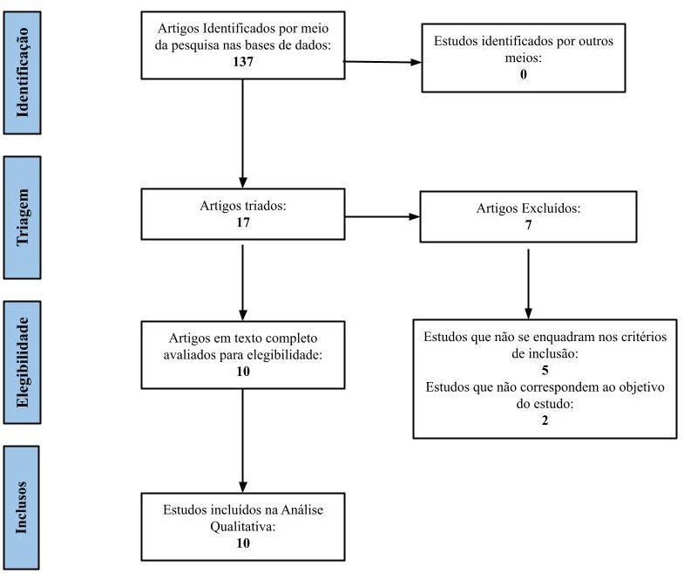

**Fig. 1- Research flow diagram**

*Source: Adapted from Page, et al. (2020).*

This methodological approach ensured the selection of studies aligned with the proposed objectives, contributing to a review based on current and consistent evidence.

**Table 1- Presentation of the selected articles according to the identification stipulated for each article, as well as title, author(s), year and conclusions.**

|  |  |  |
| --- | --- | --- |
| **ID** | **TITLE, AUTHOR AND (YEAR)** | **CONCLUSIONS** |
| A1 | Critérios Radiográficos para Diagnóstico Diferencial Entre Fratura Radicular Vertical e Periodontite Apical em Pré-Molares Endodonticamente Tratados com Raiz Única Usando Tomografia Computadorizada de Feixe Cônico. ARKHIPOVA, Anastasia et al. (2024) | The research showed that specific radiographic criteria, such as the presence of vertical radiolucent lines and changes in bone density around the root, are effective in differentiating between vertical root fractures and apical periodontitis in endodontically treated premolars. Using these criteria can lead to a more accurate diagnosis and more appropriate treatment planning, improving clinical management and patient outcomes. |
| A2 | Miniplacas em Forma de Z vs Miniplacas Convencionais para Fixação de Fraturas Parassinfisárias Mandibulares. ATA, Mohamed Abd EL-Rahman Abdou et al. (2023) | The study compared the effectiveness of Z-shaped miniplates and conventional miniplates in the fixation of mandibular parasymphyseal fractures. The results showed that Z-shaped miniplates offer a viable alternative with similar efficacy to conventional miniplates, as well as advantages in reducing the need for surgical revisions and simplifying the procedure, improving patient recovery. |
| A3 | Desenvolvimento de um Modelo Preditivo para Identificação de Fraturas Radiculares Verticais Não Detectadas Anteriormente. CAO, Dantong et al. (2023) | The predictive model developed to identify root fractures reviously detected showed high accuracy, especially when integrated with clinical diagnosis. This mode can help in the early detection of root fractures that are not are easily visible in conventional exams, which can significantly improve treatment and long-term results for patients. |
| A4 | Placas Específicas para o Paciente na Cirurgia de Fraturas Faciais: Uma Série de Casos Retrospectiva. CHO, Ran-Yeong et al. (2023) | The study showed that the use of patient-specific plates, customized to the individual anatomy, resulted in better surgical results and lower complication rates compared to standard plates. The customization of the plates allowed for a more precise adaptation to facial fractures, contributing to recovery faster e fewer post- operative complications. |
| A5 | Tomografia Computadorizada Intraoperatória para Reconstrução Orbital: Uma Revisão Sistemática. GOH, EZ et al. (2023) | The systematic review concluded that intraoperative computed tomography is highly effective for reconstruction, providing detailed images t h a t help to accurately visualize structures during surgery. The use of this technology improves surgical precision and can reduce the rate of complications, resulting in better aesthetic and functional outcomes for patients |
| A6 | Influência do Tamanho do Voxel e Tipo de Filtro na Detecção de Fratura Radicular Vertical Usando Tomografia Computadorizada de Feixe Cônico. KOLSUZ, Mehmet Eray et al. (2023) | The study revealed that the voxel size and type of filter used in cone beam computed tomography significantly affect the detection of vertical root fractures. Appropriate adjustments to these parameters are essential to optimize image quality and diagnostic accuracy, which is crucial for the effective assessment of root fractures. |
| A7 | Desempenho Diagnóstico de Imagens de Tomografia Computadorizada de Feixe Cônico Transversais Suturas e Não Suturas de Uma Fratura Não Deslocada do Osso Mandibular Ovino. OSTOVARRAD, Farzane et al. (2023) | The research indicated that cone beam computed tomography is efficient for diagnosing non-displaced mandibular bone fractures in sheep models. The images obtained allow a detailed analysis of the fractures, with significant differences observed between the sutured and non-sutured images, which can influence the choice of appropriate treatment. |
| A8 | Efeito de Diferentes Pinos Intracanais e Parâmetros de Exposição na Detecção de Fraturas Radiculares Verticais por Tomografia Computadorizada de Feixe Cônico. SHOKRI, Abbas et al. (2023) | The study showed that the detection of vertical root fractures is influenced by different types of intracanal posts and exposure parameters, and cone beam computed tomography. Proper selection of these factors is crucial to improve detection accuracy and treatment planning, highlighting the importance of considering these aspects in clinical practice. |
| A9 | Impacto do Osso Adjacente na Pseudartrose na Reconstrução Mandibular com Retalhos Livres de Fíbula. STEFFEN, Cláudio et al.(2023) | The research concluded that the adjacent bone has a significant impact on pseudarthrosis formation during mandibular reconstruction with free fibula flaps. Careful assessment of the adjacent bone and consideration of its characteristics are key to improving reconstruction results, reducing complication rates, and promoting more effective recovery. |
| A10 | Avaliação da Qualidade do Tratamento Endodôntico e Prevalência de Erros Processuais em Molares Mandibulares por Tomografia Computadorizada de Feixe Cônico. NOUROLOYOUNI, Salem Milani et al. (2023) | CBCT was effective in assessing the quality of endodontic treatment and detecting procedural errors in mandibular molars. The study highlighted the importance of this technology in identifying problems that may not be visible in conventional examinations, contributing to the improvement of clinical practices and increasing the effectiveness of endodontic treatment. |

*Source: Adapted from Page, et al. (2020).*

In dental practice, the assessment of impacted and supernumerary teeth is essential due to potential complications such as impaction and occlusal disorders. Early detection and accurate assessment of these teeth are crucial for diagnosis (Nouroloyouni et al., 2023; Arkhipova et al., 2024).

## 3.1 Cone beam computed tomography (CBCT) scan

CBCT stands out among the available imaging modalities because it provides detailed three-dimensional images, allowing the position, shape, and relationship of the included and supernumerary teeth with adjacent structures to be accurately visualized. It is also advantageous due to its lower radiation dose and high spatial resolution, making it ideal for this application (Nouroloyouni et al., 2023; Arkhipova et al., 2024).

Studies by Nouroloyouni et al. (2023) and Arkhipova et al. (2024) examined radiographic criteria for differentiating anomalies, concluding that CBCT offers an accurate assessment, facilitating treatment planning. In addition to detection and classification, CBCT is crucial for assessing the relationship of included and supernumerary teeth with surrounding structures, such as adjacent roots, alveolar nerves and maxillary sinuses. This detailed visualization is essential for determining the optimal treatment plan and preventing complications (Nouroloyouni et al., 2023; Arkhipova et al., 2024).

## 3.2 Diagnostic efficiency of CBCT examination

The ability of CBCT to eliminate anatomical overlaps and facilitate the location and extent of fractures is a crucial aspect in dental and oral, and maxillofacial surgical practice (Kolsuz et al., 2023). Offering a detailed three-dimensional image of craniofacial structures, CBCT allows precise analysis of fractures, eliminating overlaps and providing a clear visualization of bone and dental structures (Ostovarrad et al., 2023).

This diagnostic accuracy is essential when planning and carrying out surgical treatment, especially in complex fractures that require surgical intervention. Studies such as those by Ostovarrad et al. (2023) highlight the ability of CBCT to provide detailed visualization of fracture lines and interactions between different anatomical structures, simplifying precise identification of the location and extent of injuries.

Accurate identification of root fractures is essential for the success of endodontic treatment, but is often hampered by the superimposition of structures on conventional radiographic images. In the study by Arkhipova et al. (2024), CBCT images were used to differentiate vertical root fractures (VRF) from apical periodontitis (AP) in endodontically treated premolars. Figures 1, 2, and 3 illustrate and specify the radiographic criteria identified for this differentiation, emphasizing the distinguishing characteristics between VFR and AP.

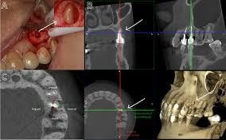

**Fig. 2: Bone defect due to a vertical root fracture in the middle of the root, going from the front to back.**

*(A) Photo of the defect and fracture line during exploratory surgery. (B) CT image with transverse, sagittal, and axial sections about the root. (C) CT showing transverse and axial sections about the root. Sagittal in the axial plane of the root, with additional details. Source: Arkhipova et al., 2024.*

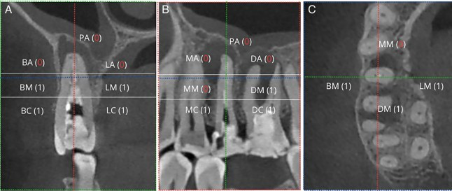

**Fig. 3: Longitudinal bone defect associated with RVF.**

*(A) Bone loss at sites BC, BM, BA, PA, and LA. (B) Bone loss at sites MA and DA PA. (C) Bone loss at site MB, in the middle third of the root. Source: Arkhipova et al. 2024.*

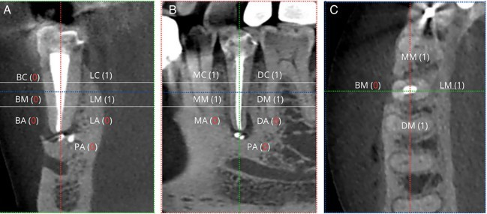

**Fig. 4: Longitudinal bone defect associated with PA.**

*(A) CBCT shows bone loss at the BA, PA, and LA sites. (B) CBCT shows bone loss at the MA, MM, DA, and PA sites. (C) CBCT shows bone loss at the MM site, in the middle third of the root. Source: Arkhipova et al. 2024.*

Identifying bone defects in the coronal thirds, especially in the vestibulo-lingual direction, is essential for distinguishing between RVF and AP in endodontic radiographs and periapical trauma. Standardizing this assessment provides professionals with a consistent and accurate diagnostic tool, improving the quality of endodontic treatment. A proper interpretation of these radiographic signs makes it possible to reliably differentiate between FVR and AP, guiding a more targeted intervention (Arkhipova et al., 2024).

## 3.3 3D image reconstructions

CBCT is effective in generating 3D images, eliminating the overlapping of adjacent structures to facilitate visualization of the vertical radiolucent line of fractures. This technology improves diagnostic accuracy, overcoming the limitations of conventional radiographic techniques. The ability of CBCT to eliminate anatomical overlaps is highly valued, allowing detailed visualization of fractures, even in complex regions (Arkhipova et al., 2024).

Compared to two-dimensional radiographs, CBCT excels in identifying facial trauma, according to Goh et al. (2023). Cho et al. (2023) emphasize its clinical importance, providing crucial data for diagnosis and treatment. The clarity of 3D images allows for detailed analysis of fractures, facilitating clinical decisions and improving therapeutic results.

The study by Cho et al. (2023), "Patient-Specific Plates for Facial Fracture Surgery: A Retrospective Case Series", illustrates the effectiveness of CBCT in the context of manufacturing specific plates for surgical planning in facial fracture surgeries. The precision provided by CBCT in the 3D visualization of facial structures helps to create virtual models that guide the manufacture of plates, contributing to more precise and effective surgery, with potentially better results for patients.

The study included seven patients, ranging in age from 19 to 75, all with complete bone growth and no history of radiotherapy to the maxilla or mandible, or use of medication that could affect mandibular metabolism. These criteria ensure that the results are not influenced by external factors, providing an accurate assessment of the intervention studied. Figures 4, 5, 6, and 7 illustrate four of the clinical cases in the study by Cho et al. (2023).

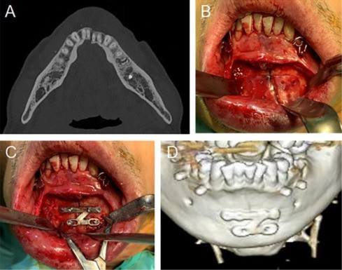

**Fig. 5: Fracture of the mandibular symphysis.**

1. *CT image before surgery, showing the deviation of the fracture in the mandibular symphysis. (B) Positioning of the surgical guide on the mandibular bone. (C) Fixation of the Z-plate on the mandible and realignment of the bones. (D) Computed tomography image after the surgical procedure. Source: Cho et al. 2023.*

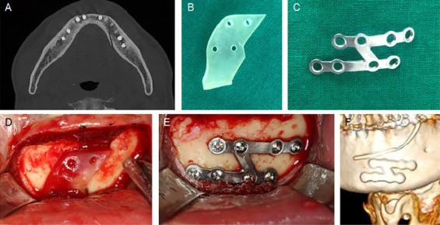

**Fig. 6: Mandibular parasymphysis fracture.**

*(A) Preoperative CT scan showing fracture of the mandibular parasymphysis. (B) Surgical guide used. (C) Customized plate. (D) Positioning of the surgical guide. (E) Plate fixation. (F) Post-operative CBCT. Source: Cho et al. 2023.*

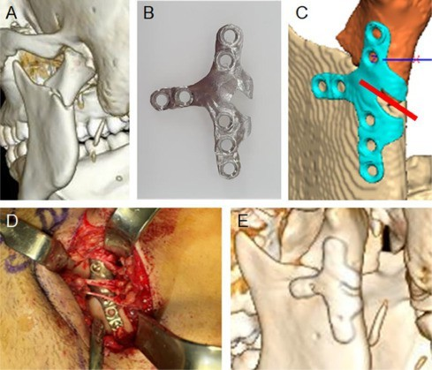

**Fig. 7: Fracture of the right condyle**

* 1. *Before surgery, the CT scan shows the fracture in the right condyle. (B, C) customized plate is used to guide the correction of the fracture. (D) The plate is fixed. (E) Post-operative CT scan. Source: Cho et al. 2023.*

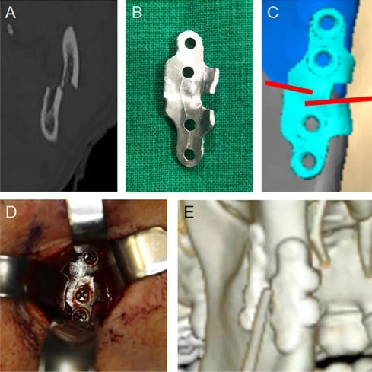

**Fig. 8: Fracture of the right condyle.**

*(A) Preoperative CT scan showing fracture of the right condyle. (B, C) Linear plate (D) Fixation of the plate and reduction of the bone segments. (E) Postoperative CT scan showing additional application of a conventional plate for greater stability. Source: Cho et al. 2023.*

These cases demonstrate how specific plates created with the help of CBCT have been used in facial fracture surgeries. Using CBCT, it was possible to make customized plates that fit precisely to the patients' fractures, demonstrating the precision and effectiveness of these interventions. The analysis of the clinical cases highlights the clinical applicability of CBCT in surgical practice, showing its importance i n improving surgical results and reducing post-operative complications (CHO et al. 2023).

# 4. Conclusion

CBCT has become a crucial advance in the diagnosis and planning of oral and maxillofacial trauma. Its ability to generate high-resolution 3D images overcomes the limitations of traditional two-dimensional imaging methods, providing a detailed visualization of the anatomy. This improved precision is essential for accurately identifying the location and extent of injuries and anomalies, allowing for more effective surgical planning.

In addition to improving diagnostic accuracy, CBCT makes it possible to draw up more detailed and personalized treatment plans. This results in more targeted and less invasive therapeutic approaches, helping to minimize complications and promote a more efficient recovery. The advantages offered by CBCT highlight its indispensable role in the dental context, making it a key tool in clinical practice.

The growing adoption of CBCT reflects the increasing importance of advanced imaging technologies in dentistry, consolidating it as essential for the assessment and treatment of complex conditions. As technology continues to evolve, it is expected that CBCT will continue to play a central role in optimizing clinical outcomes.

Disclaimer (Artificial intelligence)

Option 2:

We declare that we have used AI (ChatGPT)

Details of the AI usage are given below:

1. with the prompt "Rewrite the summary with a maximum of 180 words"
2. with the prompt suggested titles with the theme of the work objective

# REFERENCES

Arkhipova, Anastasia et al. (2024). Radiographic criteria for differential diagnosis between vertical root fracture and apical periodontitis in single-rooted endodontically treated premolars using cone-beam computed tomography. Journal of Endodontics, [S.l.], 50(4), 123-135.

Ata, Mohamed Abd EL-Rahman Abdou et al. (2023). Z-shaped miniplates vs conventional miniplates for fixation of mandibular parasymphyseal fractures. The Journal of Contemporary Dental Practice, [S.l.], 10, 761-770.

Cao, Dantong et al. (2023). Development of a predictive model for identification of previously undetected vertical root fractures. Australian Endodontic Journal, [S.l.], 39, 302-310.

Cho, Ran-Yeong et al. (2023). Patient-specific plates for facial fracture surgery: A retrospective case series. Journal of Dentistry, [S.l.], 137, 104650.

Goh, E. Z. et al. (2023). Intraoperative computed tomography for orbital reconstruction: a systematic review. International Journal of Oral and Maxillofacial Surgery, [S.l.], 21(3), 205-220.

Kolsuz, Mehmet Eray et al. (2023). Influence of voxel size and filter type on vertical root fracture detection using cone beam computed tomography. Australian Endodontic Journal, [S.l.], 39, 439-446, 2023.

Nouroloyouni, A. et al. (2023). Cone-beam computed tomography assessment of quality of endodontic treatment and prevalence of procedural errors in mandibular molars. International Journal of Clinical Practice, [S.l.]. DOI: 10.1155/2023/3558974.

Ostovarrad, Farzane; Markiyeh, Sadra Masali; Kajan, Zahra Dalili. (2023). Diagnostic performance of sutured and unsutured transverse cone beam computed tomography images of a non-displaced fracture of the ovine mandibular bone. Imaging Science in Dentistry, [S.l.], 53(4), 375-382, 2023.

Page, Matthew J. et al. (2021). The PRISMA 2020 statement: an updated guideline for reporting systematic reviews. International journal of surgery, 88, 105906.

Shokri, Abbas et al. (2023). Effect of different intracanal posts and exposure parameters on the detection of vertical root fractures by cone beam computed tomography. Australian Endodontic Journal, [S.l.], 39, 132-145.

Steffen, Cláudio et al. (2023). Impact of adjacent bone on pseudarthrosis in mandibular reconstruction with free fibula flaps. Head and Face Medicine, [S.l.], 1, 43-50.