**Pheochromocytoma-induced Myocarditis: A Case Report and Literature Review**

**Abstract:**

**Background:**Pheochromocytoma is a rare catecholamine-secreting tumor that may present with various cardiovascular manifestations, including acute myocarditis. The excessive release of catecholamines can cause direct myocardial injury through mechanisms such as vasospasm, oxidative stress, and calcium overload, leading to myocardial inflammation and dysfunction.

**Case presentation:**  
We report the case of a 28-year-old woman with no prior history who presented with acute chest pain, hypotension, and elevated cardiac enzymes. Cardiac MRI revealed findings consistent with acute myocarditis. During hospitalization, she exhibited paroxysmal hypertension, tachycardia, and sweating, prompting an endocrine work-up. Imaging revealed a right adrenal mass, and urinary metanephrines were markedly elevated, confirming a diagnosis of pheochromocytoma. Following alpha-blockade, laparoscopic adrenalectomy was performed. At three-month follow-up, the patient showed complete normalization of cardiac function.

**Discussion:**  
Pheochromocytoma-induced myocarditis remains a rare but potentially reversible form of myocardial injury. Cardiac MRI is crucial for identifying non-ischemic patterns of inflammation, while biochemical and imaging studies aid in establishing the underlying cause. Recent case reports emphasize the importance of considering pheochromocytoma in patients with atypical myocarditis, particularly when accompanied by labile blood pressure or adrenergic symptoms. Early diagnosis and surgical treatment typically result in favorable outcomes.

**Conclusion:**  
This case illustrates the importance of including pheochromocytoma in the differential diagnosis of acute myocarditis. Awareness of this entity is essential, as timely identification and tumor resection can lead to full cardiac recovery. A multidisciplinary approach is crucial for optimal diagnosis and management.

**Keywords :** Pheochromocytoma, Myocarditis, Catecholamines, Cardiac MRI, Adrenergic crisis, Reversible cardiomyopathy

**Introduction:**

Pheochromocytoma is a rare neuroendocrine tumor arising from the adrenal medulla, characterized by excessive secretion of catecholamines, predominantly norepinephrine and epinephrine. While it is classically associated with the triad of episodic headache, sweating, and palpitations, its clinical presentation can be highly variable. Among its cardiovascular manifestations, the most commonly described are paroxysmal hypertension, arrhythmias, stress-induced cardiomyopathy (Takotsubo syndrome), and, more rarely, acute myocarditis.

Myocarditis induced by pheochromocytoma represents an underrecognized but potentially life-threatening entity. It often mimics acute coronary syndromes or viral myocarditis and may present with chest pain, troponin elevation, and left ventricular dysfunction. The underlying pathophysiology involves direct catecholamine toxicity to cardiomyocytes, driven by oxidative stress, coronary vasospasm, calcium overload, and overstimulation of β-adrenergic receptors. These mechanisms result in myocardial inflammation, focal necrosis, and potentially reversible ventricular remodeling.

Diagnosis can be challenging, especially in the absence of classic signs of pheochromocytoma. Cardiac magnetic resonance imaging (MRI) plays a central role in identifying non-ischemic inflammatory myocardial injury, while biochemical assays—particularly urinary or plasma metanephrines—confirm the neuroendocrine origin. Early recognition of this specific cause of myocarditis is critical, as definitive treatment via surgical resection—following appropriate alpha-adrenergic blockade—often leads to complete recovery of cardiac function.

Several recent case reports and systematic reviews have highlighted this rare but increasingly documented association. They have contributed to a better understanding of at-risk clinical profiles, sensitive diagnostic tools, and optimal management strategies. In this context, we report a case of acute myocarditis revealing an underlying pheochromocytoma in a young woman, followed by a review of the recent literature. Our objective is to discuss the pathophysiological mechanisms, diagnostic approach, and therapeutic considerations in this uncommon but significant clinical scenario.

**Case Presentation:**

We report the case of a 28-year-old woman with no significant medical history who presented to the emergency department with acute chest pain, shortness of breath, and episodes of palpitations. She denied any recent viral illness, fever, or drug use. On admission, the patient was hypotensive (BP 85/55 mmHg), with sinus tachycardia at 115 bpm and oxygen saturation at 96% on room air. Physical examination revealed no murmurs or signs of heart failure.

The ECG demonstrated diffuse ST-segment depression and T-wave inversions in the anterolateral leads. High-sensitivity troponin I was markedly elevated (2450 ng/L), and NT-proBNP was 1870 pg/mL. Transthoracic echocardiography revealed a moderately reduced left ventricular ejection fraction (LVEF: 40%) with global hypokinesia and no valvular abnormalities. Inflammatory markers were within normal limits, and coronary angiography excluded obstructive coronary artery disease.

Given the elevated cardiac biomarkers and echocardiographic findings, cardiac magnetic resonance imaging (MRI) was performed. It showed evidence of acute myocarditis, with subepicardial late gadolinium enhancement and myocardial edema, predominantly in the lateral wall, consistent with non-ischemic inflammatory injury.

During hospitalization, the patient developed paroxysmal hypertensive episodes alternating with hypotensive phases, associated with episodic headache and sweating. This clinical pattern raised suspicion for a catecholamine-secreting tumor. Abdominal ultrasound followed by contrast-enhanced CT revealed a well-defined, heterogeneous mass of 4.5 cm in the right adrenal gland. Biochemical evaluation showed significantly elevated urinary metanephrines and normetanephrines, confirming the diagnosis of pheochromocytoma.

The patient was started on alpha-adrenergic blockade (phenoxybenzamine), followed by low-dose beta-blocker therapy. After two weeks of hemodynamic stabilization, she underwent successful laparoscopic adrenalectomy. Histopathology confirmed the diagnosis of pheochromocytoma without malignancy.

At 3-month follow-up, the patient was asymptomatic. Repeat echocardiography showed normalization of LVEF (60%) with no residual wall motion abnormalities. NT-proBNP levels returned to normal, and cardiac MRI showed resolution of prior inflammatory findings.

This case highlights the importance of considering pheochromocytoma in patients with unexplained myocarditis, particularly when accompanied by labile blood pressure, sympathetic symptoms, or lack of response to standard heart failure therapies. Early identification and tumor resection can lead to complete cardiac recovery.

**Discussion:**

Catecholamine-induced myocarditis related to pheochromocytoma represents an atypical but potentially severe cardiac manifestation. It can mimic acute coronary syndromes, stress cardiomyopathy (Takotsubo syndrome), or viral myocarditis. Diagnosis requires a high index of suspicion based on clinical, biological, and radiological findings.

Cardiac MRI is essential in demonstrating signs compatible with non-ischemic inflammatory myocardial injury. Literature review identifies approximately 70 cases with wide clinical variability ranging from pseudo-infarction to fulminant heart failure.

Pathogenesis involves multiple mechanisms: direct catecholamine toxicity on cardiomyocytes, ischemia due to intense vasoconstriction, oxidative stress, and myocardial inflammation. Excessive β-adrenergic receptor activation causes harmful intracellular calcium influx and cellular remodeling.

Management primarily targets pheochromocytoma resection after alpha-adrenergic blockade. Cardiac function recovery is often dramatic, highlighting the reversibility if diagnosis is timely.

It is noteworthy that myocarditis may precede classical pheochromocytoma symptoms, complicating diagnosis. Thus, paroxysmal hypertension, unexplained sweating, tachycardia, or young age should prompt targeted endocrine evaluation.

Studies such as Zhang et al. (2020) and Prejbisz et al. (2011) confirm this clinical heterogeneity and emphasize MRI and hormonal assay importance. A 2022 systematic review by Xie et al. showed nearly 40% of cases were initially misdiagnosed as infarction or viral myocarditis. Other reports, including Wiesmann et al., demonstrate rapid normalization of cardiac parameters post-tumor removal.

Pheochromocytoma-induced myocarditis represents a rare but clinically significant subtype of catecholamine-mediated cardiac injury. Recent cases underscore its heterogeneous presentation, ranging from recurrent fulminant myocarditis to stress-induced cardiomyopathy and cardiogenic shock, reflecting a severe spectrum necessitating prompt recognition. For instance, a detailed analysis of recurrent fulminant myocarditis in a young adult highlighted the necessity of a multidisciplinary diagnostic and therapeutic approach, including early adrenalectomy, which facilitated full clinical recovery . Similarly, pediatric cases have documented pheochromocytoma presenting with QT prolongation followed by fulminant myocarditis, underlining that this pathology affects all age groups and may mimic primary cardiac disease.

Diagnostic imaging, particularly cardiac MRI, often reveals nonischemic patterns of inflammation with late gadolinium enhancement and edema—a hallmark that aligns with the myocarditis phenotype seen in COVID-19 differential diagnosis . The pathophysiological mechanism involves catecholamine-induced direct cardiomyocyte toxicity, coronary vasospasm, oxidative stress, and calcium overload, as well as β-adrenergic receptor–mediated signaling cascades—analogous to stress cardiomyopathy . Compellingly, histologic and clinical studies have confirmed resolution of myocardial dysfunction following tumor removal, reinforcing the reversibility of the condition.

Therapeutically, optimal management requires alpha-adrenergic blockade prior to adrenalectomy; in cases of cardiogenic shock, mechanical support such as Impella or ECMO has enabled stabilization and recovery. This integrative strategy is crucial in recurrent cases, as demonstrated by resolutions in both adult and pediatric patients. The need for such aggressive treatment reflects the life-threatening potential of pheochromocytoma-induced cardiac injury.

Growing evidence emphasizes that early identification—especially in patients presenting with atypical myocarditis, arrhythmias, unexplained cardiogenic shock, or hypertensive crisis—can markedly affect prognosis. Recent reviews advocate for routine biochemical screening and adrenal imaging in selected scenarios to avoid diagnostic delays.

In summary, the recent literature consolidates the profile of pheochromocytoma-induced myocarditis as a striking, yet treatable cardiomyopathy that may mimic other cardiac syndromes. The combination of advanced imaging, biomarker analysis, aggressive medical stabilization, and prompt surgical intervention has redefined the prognosis of this condition. As our understanding expands, clinical awareness remains the cornerstone of early intervention and optimal outcome.

**Conclusion:**

Pheochromocytoma remains a rare and often elusive diagnosis, traditionally characterized by the classic Menard's triad of headaches, palpitations, and paroxysmal hypertension. However, as illustrated in our case of a 28-year-old female patient admitted for recurrent myocarditis, this classical presentation is far from universal. Instead, pheochromocytoma may manifest through atypical and misleading clinical scenarios, particularly when cardiovascular involvement predominates the initial picture.

Our case underscores the importance of maintaining a high index of suspicion for pheochromocytoma in young patients with unexplained or recurrent myocarditis, especially in the absence of clear infectious, autoimmune, or toxic etiologies. The pathophysiological mechanisms linking catecholamine excess to myocardial injury are complex and include direct cardiotoxicity, coronary vasospasm, and tachyarrhythmia-induced myocardial strain — all of which may mimic or trigger inflammatory cardiac syndromes.

This report highlights the necessity for clinicians to broaden their differential diagnoses when faced with myocarditis of unclear origin, particularly when standard investigations fail to identify a cause. Early identification and management of pheochromocytoma are crucial, as delayed diagnosis can lead to progressive cardiac damage and increased morbidity. Ultimately, this case reinforces the critical role of integrating clinical vigilance with advanced imaging and biochemical screening in uncovering rare but treatable conditions like pheochromocytoma, even in the absence of classical features.

Given the rarity of myocarditis as an initial presentation of pheochromocytoma, we believe this case adds meaningful insight to the existing literature. While several reports have described catecholamine-induced cardiomyopathies such as Takotsubo syndrome or hypertensive crises, isolated and recurrent myocarditis-like episodes remain exceedingly uncommon and are underrepresented in large case series. Our case underscores the need to consider pheochromocytoma in the differential diagnosis of unexplained or atypical myocarditis, especially in younger patients without traditional cardiovascular risk factors. By documenting this rare but clinically significant manifestation, we aim to contribute to the broader understanding of the protean cardiac presentations of pheochromocytoma. We believe that this report merits inclusion in the literature not only for its educational value but also as a reminder of the diagnostic challenges and therapeutic implications associated with such atypical presentations.

**Consent**

As per international standards or university standards, patient(s) written consent has been collected and preserved by the author(s).

Disclaimer (Artificial intelligence)

Author(s) hereby declare that NO generative AI technologies such as Large Language Models (ChatGPT, COPILOT, etc.) and text-to-image generators have been used during the writing or editing of this manuscript.

**References:**

1. Zhang L, et al. Pheochromocytoma-induced myocarditis: a rare cardiac manifestation. Int J Cardiol. 2020;306:97–100.
2. Prejbisz A, Lenders JWM, Eisenhofer G, Januszewicz A. Cardiovascular manifestations of phaeochromocytoma. J Hypertens. 2011;29(11):2049–2060.
3. Xie Y, et al. Myocarditis as an initial manifestation of pheochromocytoma: a systematic review. BMC Cardiovasc Disord. 2022;22(1):115.
4. Wiesmann F, et al. Myocardial involvement in patients with pheochromocytoma: insights from MRI. Eur Radiol. 2013;23(3):738–744.
5. Quansah R, Wang W, Khalil R, Grewal A, Satija N, Pejman B, et al. Recurrent Fulminant Myocarditis Due to a Pheochromocytoma. JACC Case Rep. 2024;6(6):101009. doi:10.1016/j.jaccas.2024.101009
6. Fu W, O'Connell K, Lacey J, Perkins M, Bagdure S. Fulminant Myocarditis as the Initial Presentation of Pheochromocytoma in a Pediatric Patient. J Pediatr Intensive Care. 2023 Oct 10. doi:10.1055/s-0043-1777067
7. Xie Y, et al. Myocarditis as an initial manifestation of pheochromocytoma: a systematic review. BMC Cardiovasc Disord. 2022;22(1):115. doi:10.1186/s12872-022-02567-9
8. Prejbisz A, Lenders JWM, Eisenhofer G, Januszewicz A. Cardiovascular manifestations of phaeochromocytoma. J Hypertens. 2011;29(11):2049–2060. doi:10.1097/HJH.0b013e32834b6f8c
9. Zhang L, et al. Pheochromocytoma-induced myocarditis: a rare cardiac manifestation. Int J Cardiol. 2020;306:97–100. doi:10.1016/j.ijcard.2019.12.031
10. Wiesmann F, et al. Myocardial involvement in patients with pheochromocytoma: insights from MRI. Eur Radiol. 2013;23(3):738–744. doi:10.1007/s00330-012-2657-5
11. Siqueira JS, Oliveira BG, Lins RS, et al. Pheochromocytoma-induced stress cardiomyopathy mimicking myocarditis: case report and review. Eur Heart J Case Rep. 2022;6(3):ytac028. doi:10.1093/ehjcr/ytac028
12. Chen YC, et al. Impella-assisted hemodynamic stabilization for pheochromocytoma-induced cardiogenic shock. Front Cardiovasc Med. 2023;10:1188744. doi:10.3389/fcvm.2023.1188744
13. Batra J, et al. Mechanical circulatory support in catecholamine-induced cardiomyopathy: role of ECMO. J Thorac Dis. 2021;13(2):971–975. doi:10.21037/jtd-20-2716
14. Pang Y, Xu H, He Y, Wang Y, et al. Adrenal tumors presenting with cardiovascular events: diagnostic challenges and management. Hypertens Res. 2024;47(1):45–52. doi:10.1038/s41440-023-01402-w

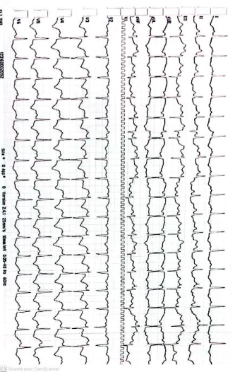  
figure 1 : electrocardiogram showing sinus tachycardia and diffuse ST-segment depression and T-wave inversions in the anterolateral leads.

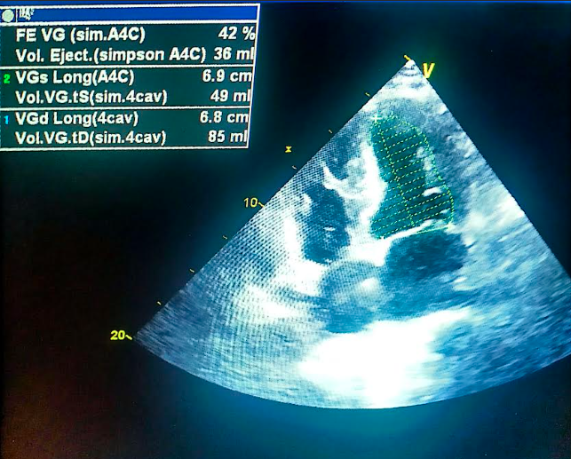

Figure 2 : Non-dilated hypokinetic cardiomyopathy with moderate left ventricular systolic dysfunction.

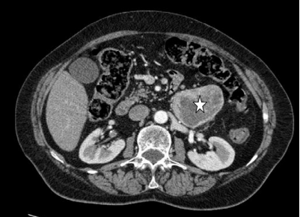

Figure 3 : Axial CT image showing an adrenal mass suggestive of a pheochromocytoma.