***Case report***

**Acute Upper Limb Ischemia in a Young Female with Polycythemia Rubra Vera: A Rare Case Managed in a Resource-Limited Settings**

**Abstract:**

Acute limb ischemia (ALI) is mainly caused by thrombosis or embolism which commonly occurs in the elderly population with various comorbidities. But young people may also present with ALI especially who suffer from various types of hypercoagulable diseases. Among the inherited hypercoagulable diseases Polycythemia Rubra Vera (PRV) is an extremely rare entity. A 35 year old lady came to the Vascular Surgery Department of Dhaka medical College Hospital with the complaints of gangrene of right middle finger 7 days. She also gave auto amputation of part of small finger two weeks back due to gangrene. On examination her ulnar pulse was absent. Her blood picture showed increased RBC, WBC and platelet count with raised fibrinogen degradation product (FDP) and D-dimer level. Her echocardiography was unremarkable. There was no evidence of small vessel vasculitis. Duplex ultrasound and computed tomography (CT) angiogram both showed thrombotic occlusion of ulnar and digital arteries. Besides diagnosis of PRV was confirmed by presence JAK 2 mutation. She underwent open catheter guided thrombectomy through proximal ulnar artery as endovascular facilities were unavailable. Post operatively she was on anticoagulant. She was also administered hydroxyurea and aspirin for management of PRV. Follow up after one month showed there was no sign of ischemia.

Key words:*acute limb ischemia, Polycythemia Rubra Vera*

**Introduction:**

Acute limb ischemia (ALI) is mainly caused by thrombosis or embolism which commonly occurs in the elderly population with various comorbidities.1 But young people may also present with ALI especially who suffer from various types of hypercoagulable diseases.2 Among the inherited hypercoagulable diseases Polycythemia Rubra Vera (PRV) is an extremely rare entity which can be both primary and secondary mainly due to chronic hypoxia. Primary polycythaemia, also known as polycythaemia vera (PCV), polycythaemia rubra vera (PRV), or erythraemia, is a condition in which the bone marrow produces an excess of red blood cells.3 In addition. Excess platelets and white blood cells are also produced as well.3 PRV belongs to the group of myeloproliferative disorders which includes essential thrombocythemia, primary myelofibrosis and chronic myeloid leukemia in addition to PRV.4

Both normal stem cells and abnormal clonal stem cells are present in bone marrow OF PRV patients, which inhibit the growth and maturation of normal stem cells. Panmyelosis is brought on by unchecked neoplastic growth.4 A mutation in JAK2 kinase most likely causes the signaling abnormalities that cause PRV.4 Bone marrow biopsy reveals pleomorphic, adult megakaryocytes together with strong erythroid, granulocytic, and megakaryocytic proliferation, as well as hypercellularity for age with trilineage growth (panmyelosis).Finding a mutation in JAK2V617 results in a definitive diagnosis.5

There is no definitive cure for PRV. In addition to phlebotomy and aspirin, cytoreductive treatment is advised.6 Hydroxyurea is the first-line treatment (HU) as a cytoreductive agent.7 Pegylated interferon or busulfan may be used by patients who are intolerant or who are not responding to hydroxyurea therapy.7 Radioactive phosphorus, anagrelide, pipobroman, and ruxolitinib are additional options.7

Hypercoagulability due to PRV is rare etiology of ALI that can be difficult to diagnose. Other complications may include stroke, venous thromboembolism, and pulmonary hypertension because of high viscosity of blood resulting from hypercellularity. Incidence of thrombotic events in individuals with PRV varies from 4 to 11.4 events/100 individuals.8 Moreover, the rate of thrombosis is highly influenced by age and prior thrombotic events.8 Here we present a case of a 35 year old female presented with upper limb ALI due to PRV.

**Case Presentation:**

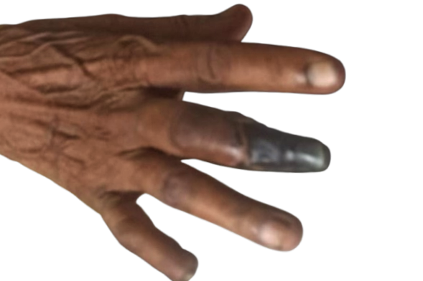A 35 year old lady came to the Vascular Surgery Department of Dhaka medical College Hospital with the complaints of gangrene of right middle finger 7 days. She also gave history auto amputation of part of small finger two weeks back due to gangrene.(Fig-1) Initially, there was sudden severe pain followed by coldness of the finger. Later on the finger became bluish and ultimately it became gangrenous. Her other fingers were also becoming bluish and cold. She did not any history of chest pain, syncope. Pain in lower limb. Three was no history of smoking. She did not have any significant past history and none of her family members suffered from such type of illness.

Fig-1 Showing gangrene of the middle finger of the patient

On examination pulse radial pulse was present but ulnar pulse was absent. Her middle finger was gangrenous up to proximal interphalangeal (PIP) joint. Other finger tips were cold and capillary refill time was more than 3 seconds indicating features of ischemia. There was also decrease sensation on finger tips too. But joints movement were possible but it was associated with pain.SpO2 of other fingers were below 90%. Her blood picture showed elevated Hb level (18.6 gm/dl) with pancytosis (red blood cells- 8.6 million/cu mm, white blood cells-20,000/cu mm and platelet-8, 75,000 /cu mm). Bone marrow study showed increased number of cells of all lineage. Her fibrinogen degradation product (FDP) and D dimer were also elevated. Her echocardiography was within normal limit. Her Duplex ultrasound showed decreased vascularity in ulnar artery and digital arteries due to thrombosis. Similar findings were also observed in computed tomography (CT) angiogram were no vascular markings were present in the forearm ulnar artery and digital artery. Palmar arches were also non-visualized. (Fig-2)

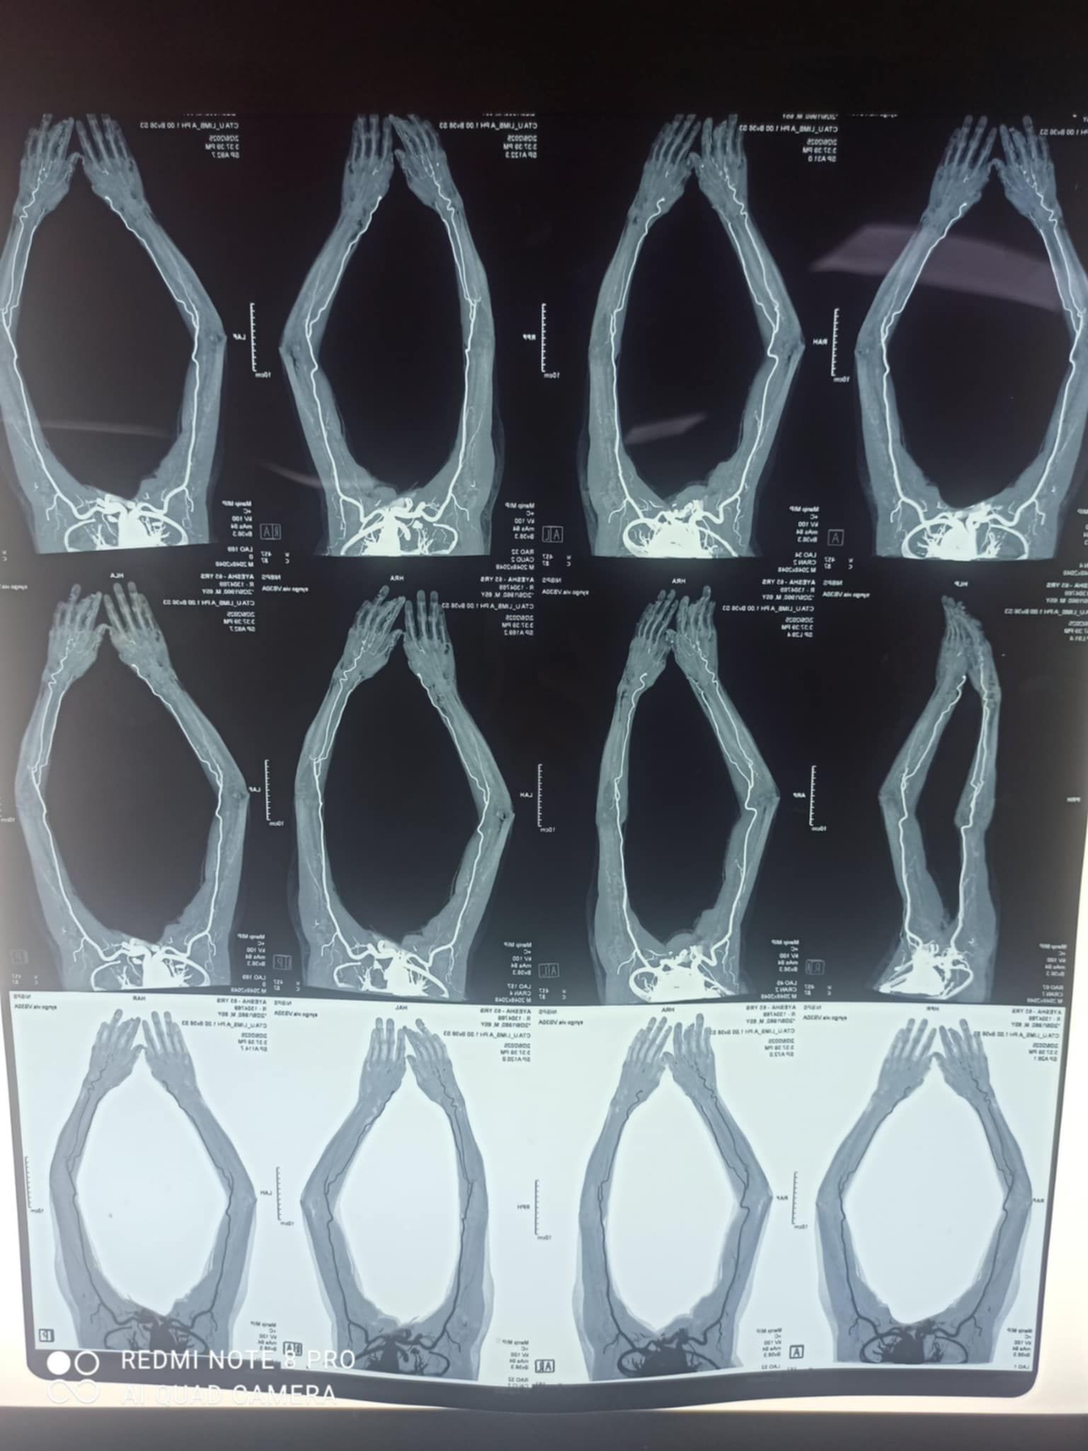

Fig-2 Showing CT angiogram of the patient

She was suspected to have myeloproliferative disorder and underwent genetic study for proper diagnosis. She had negative CARL (calreticulin) and MLP (myeloproliferative leukemia protein) gene mutation but positive for JAK2 V617F mutation confirming the diagnosis of Polycythemia rubra vera. Her ANA and Anti DS DNA was negative excluding small vessel vasculitis. She underwent fogerty thrombectomy followed by heparin administration in subcutaneous route for 7 days. At first brachial artery was exposed and proximal radial and ulnar artery were identified. Distal ulnar artery was also exposed and catheter directed thrombectomy was done.(fig-2)

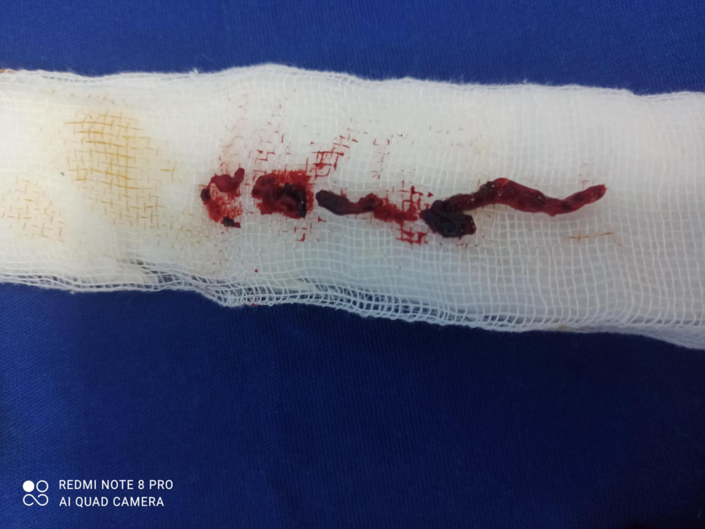

Fig-3 Showing thrombus evacuated by fogerty embolectomy

Surgical debridement of the necrotic tissue was performed. After 7 days, heparin was switched to tab rivaroxaban for one month. Her gangrenous part was also surgically removed. He was also given hydroxyurea (HDX) and aspirin for PRV. After one month his blood picture was normal and there was no sign of ischemia in her fingers. Currently she is on oral antiplatelet and hydroxyurea for management of PRV.

**Discussion:**

ALI can lead to tissue loss and jeopardize limb viability, is caused by a rapid, acute (less than two weeks) decrease in arterial perfusion of the limb.9 The limb typically does not have enough time to produce collaterals resulting tissue death unlike critical limb ischemia (CLI) where there is tissue vascularity partly established by neoangeogenesis.. In order to prevent limb loss, ALI, a vascular emergency, needs to be promptly revascularized by endovascular, surgical, or hybrid methods.10 In this current case a young lady of 35 years presented with ALI due to hypercoagulable state resulting from PRV.

PRV can occur in all age groups. One study found although the incidence increases with age, the median age at diagnosis to be 60 years.11 A common and frequent complication of PRV is thrombotic events. Thrombosis is the first symptom to appear in as many as 49% of PRV patients.12 According to a study that tracked the progression of patients with PRV over a 20-year period, up to 40% of patients with PRV experience a thrombotic event during the course of their illness, and up to 15% of patients experience one within the two years before being diagnosed.12 Similarly, our patient came to us with a thrombotic event which lead to her diagnosis of PRV. Venous thrombosis makes up a quarter of this, while arterial thrombosis accounts for three-quarters.13 Stroke, myocardial infarction, deep vein thrombosis, and pulmonary embolism are among the features.13 The patient in our case also had an acute arterial thrombosis in ulnar and digital artery due to PRV.

Increased blood viscosity is known to contribute to PRV complications. Arterial blood flow falls when blood viscosity and hemoglobin levels rise.14 Another mechanism is formation of cardiac ‘micro-emboli’ embolic events.14 In our patient, blood picture showed pancytosis of all mature cells leading to increased blood viscosity causing occlusion of ulnar artery and digital artery by thrombus.

Genetic study is the key to confirm the diagnosis of PRV. Negative CARL and MLP mutation with positive JAK2 mutation indicates PRV.15 Our patient had similar findings with high cellular count in blood and bone marrow separating it from other myeloproliferative disorders.

Though digital subtraction angiography (DSA) is the gold standard for diagnosis for ALI, CT angiogram is also getting popularity to identify ALI.15 As DSA was not available in our current settings, we performed CT angiogram to diagnosis ulnar artery occlusion leading to ALI

In case of limb threatening ischemia, fogerty catheter directed thrombectomy is the treatment of choice in addition to parenteral anticoagulant administration like heparin.16 Though many endovascular procedures are available now a days, we did not have endovascular facilities. So and open thrombectomy was performed.

Hydration, phlebotomy, antiplatelet and cytoreductive drugs are very effective in managing patients with PV and reducing rates of thrombotic events.17 That’s why our patient was also advised for hydroxyurea and antiplatelet for further prevention of thrombosis.

**Conclusion:**

ALI is a surgical emergency which needs to manage promptly in order to save limb and life. PRV is rare disease which may present with ALI in limbs. Vascular surgeons should always keep in mind regards PRV as an important differential diagnosis of ALI and manage accordingly to provide a better outcome to the patients.

**Patient Consent for Publication:** Approval received.

**Data Sharing Statement:** The data that support the findings of this study are available from the corresponding author upon reasonable request.

**Disclaimer (Artificial intelligence)**

Author(s) hereby declare that NO generative AI technologies such as Large Language Models (ChatGPT, COPILOT, etc.) and text-to-image generators have been used during the writing or editing of this manuscript.

**Reference:**

1. Nugroho J, Gunadi R. Acute limb ischemia in the young: a rare case of essential thrombocytosis. Case Rep Cardiol. 2021;2021:1–5.
2. Braun R, Lin M. Acute limb ischemia: a case report and literature review. J Emerg Med. 2015;49(6):1011–1017
3. Zhang J, DeMeo D, Silverman E, Make B, Wade R, Wells J, et al. Secondary polycythemia in chronic obstructive pulmonary disease: prevalence and risk factors. BMC Pulmon Med. 2021;21(1):235.
4. Edgar G. Timbo M. Ahererra J.Critical limb ischemia in the setting of polycythemia vera in a 63 year old male . European Journal of Heart Failure.2024;16:16-16
5. Griesshammer, M., Kiladjian, J. J., & Besses, C. (2019). Thromboembolic events in polycythemia vera. Annals of hematology, 98(5), 1071–1082.
6. Mariana P, Marchetti M,Bouro S.JAK2V617F mutation and hydroxyurea treatment as determinants of immature platelet parameters in essential thrombocythemia and polycythemia vera patients.Blood.2011; 118(9):2599-601.
7. Fruchman SM, Mack K, Kaplan ME et al. From efficacy to safety. polycythemia vera study Group Report on Hydroxyuria in patients with polycythemia vera. Semin Hematology. 2017;34:17-23.
8. Finazzi G. Risk stratification , staging and treatment of patients with Polycythemia Vera: Italian and Europian Collaberation on low dose aspirin in Polycythemia Vera.Semin Thromb Hemost. 2019;32:276-82.
9. Nezu T, Aoki S, Ochi K, Sugihara S, Takahashi T, Hosomi N, Maruyama H, Matsumoto M. A Case of Recurrent Ischemic Stroke Involving Subacute, Progressive Intracranial Cerebral Arterial Sclerosis Prior to Diagnosis with JAK2-mutated Polycythemia Vera. J Stroke Cerebrovasc Dis. 2015;24:4–6.
10. Chatzidavid S, Giannakopoulou N, Diamantopoulos PT, Gavriilaki E, Katsiampoura P, Lakiotaki E, Sakellariou S, Viniou N, Dryllis G. JAK2V617F positive polycythemia vera with paroxysmal nocturnal hemoglobinuria and visceral thromboses: a case report and review of the literature. Thromb J. 2021;19(1):12-15
11. Hernández-Boluda J, Arellano-Rodrigo E, Cervantes F, Alvarez-Larrán A, Gómez M, Barba P, Mata M, González-Porras J, Ferrer-Marín F, García-Gutiérrez V, et al. Oral anticoagulation to prevent thrombosis recurrence in polycythemia vera and essential thrombocythemia. Ann Hematol. 2015;94:911–8.
12. Lengfelder E, Merx K, Hehlmann R. Diagnosis and therapy of polycythemia vera. Semin Thromb Hemost. 2021;32(3):267-75.
13. Guglielmelli P, Vannucchi AM. Current management strategies for polycythemia vera and essential thrombocythemia. Blood Rev. 2020;42:1007-14.
14. Kroll MH, Michaelis LC, Verstovsek S. Mechanisms of thrombogenesis in polycythemia vera. Blood Rev. 2015;29:215–21.
15. Conley CL. Polycythemia vera. JAMA 2000;263:2481-4.
16. Berk PD, Goldberg JD, Donovan PB, et al. Therapeutic recommendations in polycythemia vera based on polycythemia vera study group protocols. Semin Hematol 2016;23:132-43.
17. Tefferi A, Barbui T. Polycythemia vera and essential thrombocythemia: 2017 update on diagnosis, risk-stratification, and management. Am J Hematol 2024;92:94–108.