*Original Research Article*

Textural Analysis and GIS mapping of Agricultural Soil Samples from the Karha River Basin, Pune District, Maharashtra, India

**ABSTRACT:**

Understanding soil texture is vital for sustainable agriculture, as it directly affects water retention, nutrient dynamics, and root development. This study aims to assess and map the spatial variability of agricultural soil texture in the Lower Karha River Basin using granulometric analysis and GIS techniques. A total of 48 soil samples were collected using a 10×10 fishnet grid overlay and analyzed using mechanical sieving method for proportion ofgranule (0.49%–50.42%), sand (25.24%–64.40%), and silt-clay (21.91%–49.94%) fractions. The soils are predominantly sand-rich, with localized zones of finer textures in the southern and lower basin areas. Grain-size statistical parameters were computed to evaluate sedimentological behavior. Mean grain size ranged from –0.73 to 2.20 ϕ, indicating a spectrum from coarse to fine textures. Sorting indices varied between 1.45 ϕ and 2.75 ϕ, classifying most soils as moderately to poorly sorted. Skewness (–0.23 ϕ to 0.83 ϕ) and kurtosis (0.55 ϕ to 1.76 ϕ) values showed diverse asymmetry and peakedness, reflecting heterogeneous depositional environments across the basin. Spatial distribution maps were generated using Inverse Distance Weighting (IDW) in a GIS environment, enabling high-resolution visualization of texture classes and statistical patterns. The results offer critical insights for precision agriculture, informing crop suitability, irrigation scheduling, and localized land-use planning. The study underscores the significance of integrating geostatistical tools with soil texture analysis for effective soil resource management in semi-arid river basins.

***Keywords:***

*Soil texture, grain-size analysis, GIS, spatial distribution, textural mapping*

**1. INTRODUCTION:**

Soil texture – the relative proportions of sand, silt, and clay – is a fundamental physical property that governs soil fertility, water retention, and crop productivity (FAO, 2015; Brady & Weil, 2016). It influences key agronomic factors such as infiltration rates, nutrient holding capacity, and root penetration depth, thereby playing a critical role in agricultural land use and sustainability (ICAR, 2014; FAO, 2015; Chakraborty & Mistri, 2015). Understanding the textural composition of soils is especially important in intensively farmed regions, as variability in texture can lead to differential moisture availability and nutrient status across a landscape. Recent studies in the Pune district of India have underscored that improper management of soil properties (e.g. excessive fertilization) can degrade soil health and reduce yields, highlighting the need for detailed soil characterization (Torane et al., 2022). Soil texture is widely included as a key indicator of soil quality in assessment frameworks (Karlen et al., 1997; Abdellatif et al., 2021).

Accurate mapping of soil texture is essential for effective agricultural planning and resource management (Blott & Pye, 2001; Abdellatif et al., 2021). Conventional soil surveys and laboratory analyses, while reliable, are time‐consuming, labor intensive, and often limited to point samples, failing to capture spatial heterogeneity in large areas (Abdellatif et al., 2021; Rajalakshmi et al., 2025). Geographic Information System (GIS) and remote sensing techniques offer a robust approach to overcome these limitations by enabling digital soil mapping of textural classes over extensive landscapes. Integrating laboratory measurements with geospatial data allows for the generation of high-resolution soil texture maps that can be regularly updated. Recent advances, such as machine learning and deep learning applied to satellite imagery, have demonstrated high accuracy in classifying soil texture classes across diverse terrains (Rajalakshmi et al., 2025). Internationally, studies by Abdellatif et al. (2021) and Nabiollahi et al. (2017) show how integrating lab-based soil analysis with GIS can create soil quality indices and identify areas requiring intervention. For example, Abdellatif et al. applied this method to Egyptian semi-arid regions, while Rajalakshimi et al. (2025) mapped soil texture variations in Tamil Nadu using kriging interpolation, showing significant influence on soil hydraulic conductivity. These approaches underscore the importance of precision agriculture using spatially explicit soil data.

The Karha River Basin, located in the Pune District of Maharashtra, is an agriculturally important region that exemplifies the need for detailed soil texture assessment. The basin lies in a semi-arid part of the Deccan Volcanic Province, characterized by basaltic parent material and monsoonal climate (Kale & Pawar, 2012). Soils in this area are predominantly black calcareous in nature with textures ranging from clayey to loamy, owing to the weathering of basalt and alluvial deposits in valley floors (Kale & Pawar, 2012). The region receives modest annual rainfall (~550 mm, mostly between June and October) and supports cultivation of staple crops like sorghum (jowar), wheat, maize, pulses, and oilseeds, as well as sugarcane in irrigated zones. Variations in soil texture across the basin can significantly influence moisture distribution and crop performance, especially under rain-fed conditions. Current knowledge gap: Although general soil surveys exist for Pune district, there is a lack of high-resolution, spatially explicit information on soil textural variability within the Karha basin. Previous studies have highlighted the importance of soil texture in determining soil quality and its spatial variability across different landscapes (Gadekar et al., 2024; Ingale et al., 2024). However, the Karha Basin itself has not been comprehensively studied for soil texture distribution. Most prior studies in the basin have focused on groundwater potential, geomorphology, and water conservation (Kale & Pawar, 2012) rather than detailed soil physical properties. Additionally, localized soil analyses have been limited to chemical fertility aspects (Torane et al., 2022) without producing spatial maps of soil texture. This presents a research gap, as an understanding of soil texture patterns is crucial for managing irrigation, predicting runoff and erosion, and optimizing crop allocation in the basin.

Previous studies have highlighted the importance of analysis of physical properties in determining soil quality and its spatial variability across different landscapes (Choi et al., 2022; Nengi-Benwari et al., 2023; Ali et al., 2024; Dewangan et al., 2024; Gadekar et al., 2024; Wankmüller et al., 2024; Lwin et al., 2025).

In this context, the present study provides a systematic textural analysis of agricultural soils in the Lower Karha River Basin (catchment area 730 km2), employing laboratory particle-size evaluations integrated with GIS-based mapping. The goal is to generate a detailed soil texture map and to elucidate the spatial variability of soil texture classes across the basin. This study provides valuable insights into the spatial variability of soil texture in a semi-arid basaltic basin using a combination of grain-size analysis and GIS-based mapping techniques. The detailed maps and findings can guide more efficient farming practices, land use, and better soil conservation efforts. This work also lays the groundwork for future studies and policy formulation in similar semi-arid regions.

Given this background, the present study addresses two objectives:  
1. To assess soil quality through textural analysis with determining grain-size parameters   
2. To map the spatial variation in soil texture across the Lower Karha River Basin using ArcGIS

By addressing the above objectives, this study fills a critical gap in regional soil data and contributes to the broader application of GIS in soil resource assessment. The resulting soil texture map and analysis will support sustainable agriculture in the Karha River Basin by guiding irrigation planning, crop selection according to soil suitability, and soil conservation measures. Moreover, the methodology demonstrated here – integrating classical soil analysis with modern geospatial tools – can be replicated in similar river basins or semi-arid agricultural regions, aligning with national efforts to use geoinformatics for better land and water management (ICAR, 2014; Ingale et al., 2024). Ultimately, a clearer understanding of soil textural variability at the basin scale will help optimize land use and improve agricultural resilience in the face of climatic and environmental challenges.

**2. MATERIAL AND METHODS:**

A systematic sampling strategy was employed to collect soil samples across the Lower Karha River Basin. A 10 × 10 fishnet grid, with each cell measuring 2.5' × 2.5', was generated using ArcMap on a geo-referenced toposheet to guide sample site selection. Midpoints of selected grid cells were chosen, resulting in 48 representative sampling locations Fig.1). At each site, surface litter was cleared, and soil was collected from a depth of 0–30 cm using a post-hole auger or shovel, depending on soil conditions. Approximately 1 kg of soil was collected for geochemical analysis and 500 g for physical analysis. Samples were air-dried, homogenized, and stored in labeled polythene bags for laboratory testing.

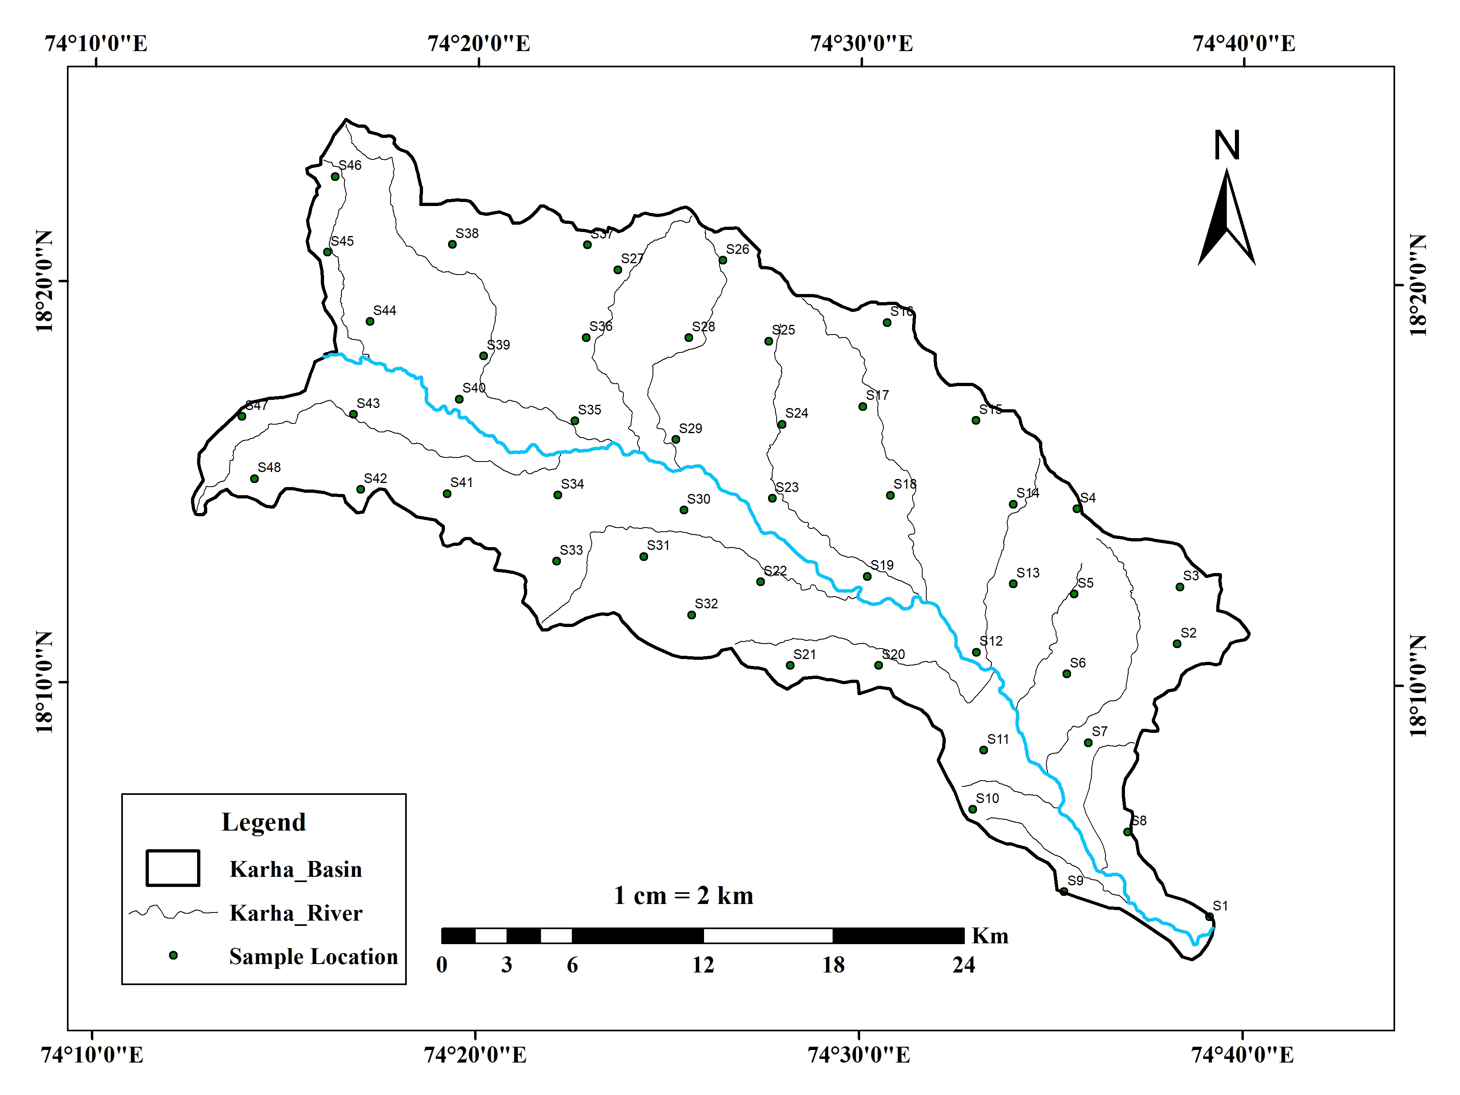

Fig. 1. Map showing the location of soil samples in the Lower Karha River Basin

For textural analysis, 150–200 g of each soil sample was oven-dried at 100–120°C for 48 hours, disaggregated with a pestle and mortar, and 100 g of the dried sample was subjected to mechanical sieve analysis. A sieve stack ranging from −2 ϕ (4 mm) to 2 ϕ (0.250 mm), including a base pan, was used in an automatic sieve shaker for 10–15 minutes. Post-sieving, each grain-size fraction was weighed. Based on sieve fractions, the relative proportions of granules, sand, and silt-clay were calculated. The cumulative weight percentages were then plotted on probability graph paper to derive grain-size parameters such as mean grain size, sorting index, skewness, and kurtosis. The formulae given in Table 1, proposed by Folk and Ward in 1957, were used to calculate the statistical parameters of grain size (Pettijohn, 1975), providing insights into the uniformity, symmetry, and peakedness of grain-size distributions.

Table 1. Graphical measures and their descriptive terminology. After Folk and Ward (1957)

|  |  |  |  |  |  |  |  |  |
| --- | --- | --- | --- | --- | --- | --- | --- | --- |
| **Mean** | | **Standard deviation** | | | **Skewness** | | **Kurtosis** | |
| 16+50+84  3  *Mz =* | | 84-16  4  *I =*  95-5  6.6  + | | | 5+95 - 250  2(95 – 5)  *+*  16+84 - 250  2(84 – 16)  *SkI =* | |       95+5  2.44(75 – 25)  *kG =* | |
| **Sorting *(I*)** | | | **Skewness (*SkI*)** | | | **Kurtosis (*KG*)** | | |
| < 0.35 | very well sorted | | 0.3 to 1.0 | very fine skewed | | < 0.67 | | very platykurtic |
| 0.35-0.50 | well sorted | | 0.1 to 0.3 | fine skewed | | 0.67-0.90 | | platykurtic |
| 0.50-0.71 | moderately well sorted | | 0.1 to -0.1 | symmetrical | | 0.90-1.11 | | mesokurtic |
| 0.71-1.00 | moderately sorted | | -0.1 to -0.3 | coarse skewed | | 1.11-1.50 | | leptokurtic |
| 1.00-2.00 | poorly sorted | | -0.3 to -1.0 | very coarse skewed | | 1.50-3.00 | | very leptokurtic |
| 2.00-4.00 | very poorly sorted | |  |  | | >3.00 | | extremely leptokurtic |
| > 4.00 | extremely poorly sorted | |  |  | |  | |  |

Finally, spatial interpolation of the derived textural and grain-size parameters was performed using the Inverse Distance Weighting (IDW) technique in ArcGIS. This enabled the creation of continuous surface maps depicting the spatial distribution of key soil quality indicators across the study area.

3. results and discussion:

**3.1 Textural properties of soil:**

Table 2 presents the relative proportions of granule, sand, and silt-clay fractions in 48 agricultural soil samples collected across the Karha River Basin. The granule content ranges from 0.49% to 50.42%, with an average of 13.52%. This indicates substantial spatial variability, with the highest values observed in sample 44 (50.42%) and the lowest in sample 30 (0.49%). High granule content (>30%) recorded at sites such as 4, 5, 44, and 48 (Fig. 2) suggests the presence of coarser textures, likely influenced by proximity to rocky uplands and upper basin zones. However, the overall moderate average implies that most soils are not gravely, making them generally suitable for plough-based agriculture. Nevertheless, soils with extremely high granule proportions may require specific management practices to ensure proper seed-soil contact and to reduce the risk of runoff or erosion.

Table 2. Textural properties of agricultural soil samples

| **Sample No.** | **Granule (%)** | **Sand (%)** | **Silt-Clay (%)** | **Texture Type** |
| --- | --- | --- | --- | --- |
| 1 | 2.43 | 61.19 | 36.39 | Sandy Clay |
| 2 | 17.31 | 56.46 | 26.23 | Sandy Clay Loam |
| 3 | 23.06 | 49.80 | 27.14 | Sandy Clay Loam |
| 4 | 30.59 | 37.67 | 31.74 | Clay Loam |
| 5 | 33.50 | 35.39 | 31.12 | Clay Loam |
| 6 | 1.37 | 49.73 | 48.90 | Clay |
| 7 | 1.16 | 64.40 | 34.45 | Sandy Clay Loam |
| 8 | 0.80 | 58.87 | 40.33 | Clay |
| 9 | 0.55 | 63.74 | 35.72 | Sandy Clay |
| 10 | 3.84 | 60.08 | 36.09 | Sandy Clay |
| 11 | 0.66 | 58.07 | 41.28 | Clay |
| 12 | 10.38 | 57.11 | 32.52 | Sandy Clay Loam |
| 13 | 11.42 | 46.97 | 41.61 | Clay |
| 14 | 17.71 | 44.03 | 38.26 | Loam |
| 15 | 2.43 | 61.19 | 36.39 | Sandy Clay |
| 16 | 18.11 | 46.37 | 35.52 | Sandy Clay |
| 17 | 13.48 | 58.22 | 28.30 | Sandy Clay Loam |
| 18 | 1.41 | 58.04 | 40.56 | Clay |
| 19 | 1.41 | 55.94 | 42.66 | Clay |
| 20 | 18.35 | 31.71 | 49.94 | Clay |
| 21 | 14.74 | 57.05 | 28.21 | Sandy Clay Loam |
| 22 | 5.55 | 54.38 | 40.08 | Clay |
| 23 | 11.56 | 55.27 | 33.17 | Sandy Clay Loam |
| 24 | 13.44 | 57.74 | 28.82 | Sandy Clay Loam |
| 25 | 16.29 | 47.20 | 36.51 | Sandy Clay |
| 26 | 1.58 | 64.08 | 34.34 | Sandy Clay Loam |
| 27 | 23.33 | 38.01 | 38.66 | Loam |
| 28 | 23.41 | 47.10 | 29.49 | Sandy Clay Loam |
| 29 | 22.22 | 45.85 | 31.93 | Sandy Clay Loam |
| 30 | 0.49 | 63.86 | 35.65 | Sandy Clay |
| 31 | 22.80 | 44.19 | 33.01 | Sandy Clay Loam |
| 32 | 14.96 | 39.92 | 45.13 | Clay |
| 33 | 23.46 | 39.12 | 37.42 | Loam |
| 34 | 0.98 | 62.62 | 36.40 | Sandy Clay |
| 35 | 0.96 | 55.59 | 43.45 | Clay |
| 36 | 14.30 | 42.04 | 43.66 | Clay |
| 37 | 27.20 | 50.90 | 21.91 | Sandy Clay Loam |
| 38 | 2.70 | 58.83 | 38.47 | Sandy Clay |
| 39 | 11.62 | 62.36 | 26.02 | Sandy Clay Loam |
| 40 | 20.27 | 37.88 | 41.86 | Clay |
| 41 | 18.06 | 57.47 | 24.47 | Sandy Clay Loam |
| 42 | 2.06 | 61.87 | 36.07 | Sandy Clay |
| 43 | 14.81 | 56.96 | 28.23 | Sandy Clay Loam |
| 44 | 50.42 | 25.24 | 24.34 | Clay Loam |
| 45 | 31.08 | 46.37 | 22.55 | Sandy Clay Loam |
| 46 | 12.09 | 56.35 | 31.56 | Sandy Clay Loam |
| 47 | 4.16 | 61.01 | 34.83 | Sandy Clay Loam |
| 48 | 34.64 | 38.07 | 27.29 | Clay Loam |
| **Minimum** | **0.49** | **25.24** | **21.91** |  |
| **Maximum** | **50.42** | **64.40** | **49.94** |  |
| **Average** | **13.52** | **51.71** | **34.76** |  |

Fig. 2. Proportion of granule in the agricultural soil samples

The sand content among the samples ranges from 25.24% to 64.40%, with a mean value of 51.71%, suggesting that sand is the dominant textural component in most parts of the basin (Table 2). Samples such as 7, 9, 26, and 30 show sand content exceeding 60%, indicating a strong influence of alluvial processes and basaltic parent material (Fig. 3). These sand-rich soils are mostly found in the well-drained upper and middle parts of the basin, making them suitable for crops that thrive in loose, well-aerated conditions. However, their high permeability often causes rapid water loss and nutrient leaching, which means they require more frequent irrigation and the addition of organic matter, especially in rain-fed farming systems

Fig. 3. Proportion of sand in the agricultural soil samples

Fig. 4. Proportion of silt-clay in the agricultural soil samples

Silt-clay content varies from 21.91% to 49.94%, with an average of 34.76% (Table 2). Higher silt-clay proportions were observed at sites like 6, 20, 32, and 36, indicating the presence of fine-textured soils, likely located in valley bottoms and depositional zones within the lower basin (Fig. 4). These soils typically exhibit better moisture retention and nutrient-holding capacity, making them more suitable for water-intensive crops such as wheat and sugarcane. However, such soils may also present challenges related to poor drainage and compaction if not properly managed.

The wide range observed in all three textural fractions reflects the heterogeneity in the textural classes of soil in the Karha River Basin. Sand-dominated soils, though favourable for tillage, may require improved soil fertility practices, while finer soils demand attention to drainage and structure maintenance. A high granule content in certain areas may also indicate shallow or erosion-prone soils, highlighting the need for appropriate conservation practices. Overall, the diversity in soil texture across the basin emphasizes the need for location-specific agricultural strategies. Adapting crop selection, irrigation frequency, and tillage practices to local soil texture can enhance soil productivity and sustainability.

3.2 Statistical parameters of soil:

The statistical grain-size parameters i.e. mean (ϕ), sorting index (ϕ), skewness (ϕ), and kurtosis (ϕ), provide valuable insights into the sedimentological and depositional characteristics of the agricultural soils in the Karha River Basin. The mean grain size, which reflects the central tendency of particle sizes, ranges from –0.73ϕ to 2.20ϕ, with an average value of 0.69ϕ (Table 3). These values indicate that the soil textures span from coarse to medium sand, with finer grains observed in downstream areas and coarser particles in upper reaches. Samples such as 36 and 37, showing negative mean values, represent coarser grain dominance, while higher positive values in samples like 6 and 32 indicates presence of finer sediments (Fig. 5).

Table 3. Statistical parameters of agricultural soil samples

| **Sample No.** | **Mean (**ϕ) | **Sorting Index (**ϕ) | **Skewness (**ϕ) | **Kurtosis (**ϕ) |
| --- | --- | --- | --- | --- |
| 1 | 1.00 | 1.75 | 0.35 | 0.85 |
| 2 | 0.07 | 1.66 | 0.13 | 1.76 |
| 3 | -0.10 | 2.11 | 0.05 | 1.02 |
| 4 | 0.23 | 2.59 | 0.36 | 0.70 |
| 5 | 0.10 | 2.57 | 0.39 | 0.63 |
| 6 | 2.20 | 1.85 | -0.10 | 0.56 |
| 7 | 0.57 | 1.64 | 0.55 | 0.89 |
| 8 | 1.07 | 2.19 | 0.44 | 0.55 |
| 9 | 1.03 | 1.45 | 0.83 | 0.89 |
| 10 | 1.33 | 1.69 | 0.19 | 0.97 |
| 11 | 1.77 | 1.68 | 0.59 | 0.80 |
| 12 | 0.93 | 1.85 | 0.22 | 1.08 |
| 13 | 1.13 | 2.25 | 0.33 | 0.77 |
| 14 | 0.87 | 2.60 | 0.30 | 0.74 |
| 15 | 0.90 | 1.78 | 0.33 | 0.83 |
| 16 | 0.70 | 2.37 | 0.23 | 0.82 |
| 17 | 0.27 | 1.97 | 0.26 | 1.18 |
| 18 | 1.40 | 1.93 | 0.26 | 0.88 |
| 19 | 1.50 | 1.93 | 0.29 | 0.70 |
| 20 | 1.57 | 2.66 | -0.23 | 0.56 |
| 21 | 0.30 | 1.99 | 0.24 | 1.19 |
| 22 | 1.43 | 2.00 | 0.21 | 0.86 |
| 23 | 0.80 | 2.06 | 0.17 | 0.84 |
| 24 | 0.43 | 1.95 | 0.24 | 0.89 |
| 25 | 0.77 | 2.36 | 0.31 | 0.80 |
| 26 | 1.07 | 1.61 | 0.21 | 0.85 |
| 27 | 0.60 | 2.75 | 0.15 | 0.67 |
| 28 | 0.23 | 2.28 | 0.24 | 0.86 |
| 29 | 0.20 | 2.39 | 0.34 | 0.87 |
| 30 | 0.93 | 1.74 | 0.60 | 0.76 |
| 31 | 0.40 | 2.42 | 0.18 | 0.76 |
| 32 | 1.53 | 2.64 | -0.09 | 0.75 |
| 33 | 0.57 | 2.63 | 0.30 | 0.71 |
| 34 | 1.47 | 1.53 | 0.04 | 0.85 |
| 35 | 1.40 | 2.02 | 0.42 | 0.68 |
| 36 | -0.53 | 1.68 | 0.28 | 1.40 |
| 37 | -0.73 | 1.82 | 0.11 | 1.27 |
| 38 | 1.27 | 1.85 | 0.17 | 0.82 |
| 39 | 0.10 | 1.67 | 0.46 | 1.10 |
| 40 | 1.03 | 2.71 | 0.08 | 0.68 |
| 41 | -0.40 | 1.57 | 0.36 | 1.73 |
| 42 | 1.20 | 1.65 | 0.21 | 0.84 |
| 43 | 0.30 | 1.93 | 0.36 | 0.83 |
| 44 | -0.43 | 2.57 | 0.60 | 0.66 |
| 45 | -0.47 | 2.14 | 0.25 | 0.97 |
| 46 | 0.53 | 1.99 | 0.30 | 0.85 |
| 47 | 0.80 | 1.78 | 0.36 | 0.82 |
| 48 | -0.20 | 2.48 | 0.39 | 0.71 |
| **Minimum** | **-0.73** | **1.45** | **-0.23** | **0.55** |
| **Maximum** | **2.20** | **2.75** | **0.83** | **1.76** |
| **Average** | **0.69** | **2.06** | **0.28** | **0.88** |

Fig. 5. Mean grain size in the agricultural soil samples

The sorting index, a measure of the uniformity of grain sizes, ranges from 1.45ϕ (well sorted) to 2.75ϕ (very poorly sorted), with a mean value of 2.06ϕ (Table 3). Most of the samples are classified as moderately to poorly sorted according to Folk and Ward’s classification. This indicates variable soil formation and depositional environments. Well-sorted samples, such as sample 9 (1.45ϕ), typically reflect consistent depositional energy, whereas poorly sorted samples like 27 and 20 (Fig. 6) point to high-energy or mixed-source environments where soil materials were transported and deposited under variable conditions

Fig. 6. Sorting index of agricultural soil samples

Skewness values range from –0.23ϕ to 0.83ϕ, with an average of 0.28ϕ (Table 3), indicating a general tendency toward fine-skewed distributions. Most of the soils display symmetrical to moderately fine-skewed grain-size curves, suggesting a prevalence of finer particles. Negative skewness values, observed in a few samples such as 20, 6, and 32, suggest coarser fractions (Fig. 7).

Fig. 7. Skewness of agricultural soil samples

Kurtosis values, reflecting the peakedness or flatness of grain-size distributions, range from 0.55ϕ to 1.76ϕ, with an average of 0.88ϕ (Table 3). This suggests that most samples fall within the mesokurtic to platykurtic categories. The moderately peaked distributions in samples such as 2 and 41 (kurtosis >1.7) may indicate well-defined soil formation environment, whereas flat-topped distributions in samples like 8 and 20 (kurtosis <0.6) suggest more variable conditions during the soil formation (Fig. 8).

Overall, the grain-size statistics demonstrate the diverse soil environments within the Karha River Basin. Coarser, poorly sorted soils observed in some locations suggest active erosion zones, whereas finer and better-sorted soils in other areas point to more stable, low-energy depositional environments. These variations are significant for understanding infiltration rates, erosion potential, and overall soil quality, all of which are essential for designing location-specific soil and crop management practices.

Fig. 8. Kurtosis of agricultural soil samples

Statistical relationship between **mean grain size (ϕ)** and the **sorting index (ϕ)** of the soil samples shows a weak negative correlation, as indicated by the regression equation y=−0.0609x+2.0989 and a very low coefficient of determination R2=0.0119 (Fig. 9.).

This suggests that **as the mean grain size increases (i.e., as the soil becomes finer), there is a slight tendency for the sorting index to decrease,** indicating marginal improvement in sorting. However, the very low R2 value implies that this trend is statistically insignificant and that **mean size is not a strong predictor of sorting** within this dataset.

The observed dispersion of points reflects the **high textural heterogeneity** across the basin.

Fig. 9. Relationship between Mean size and Sorting

The regression line represented by the equation y=−0.0133x+0.8828, along with a near-zero coefficient of determination R2=9×10−5, indicates an **extremely weak negative correlation (Fig. 10)** between skewness (ϕ) and kurtosis (ϕ) for the 48 agricultural soil samples. The values are widely scattered around the trend line, which suggests that the peakedness (kurtosis) of the grain-size distribution is **independent of the degree of symmetry (skewness).**

The independence of these two parameters further reinforces the observation that **soil textural variability in the Karha River Basin is driven by multiple factors,** including parent material, geomorphic setting, and anthropogenic influences like tillage and irrigation.

In conclusion, the weak correlation depicted in Fig. 9 and 10 supports the complexity of the soil formation processes in the study area.

Fig. 10. Relationship between Skewness and Kurtosis

3.3 Spatial distribution of textural properties of soil:

Fig. 11 illustrates the spatial distribution of granule content (%) in the agricultural soils of the Karha River Basin, derived using Inverse Distance Weighting (IDW) interpolation in ArcGIS. The map delineates four major granule classes, ranging from 0.50% to 50.35%, highlighting the heterogeneity of coarse fragments across the landscape.

The lowest granule content class (0.50–12.95%), highlighted in green, is widespread across the southern and eastern parts of the basin, especially along the lower stretches of the Karha River (Fig. 11). These areas, characterized by minimal gravel content, likely reflect more mature alluvial deposits or well-developed soils, which are generally favourable for agriculture due to easier tillage and improved moisture retention. The second class (12.96–25.42%), represented in yellow, is extensively distributed across the central parts of the basin and appears as a transition zone between the finer-textured and coarser-grained landscapes (Fig. 11). These areas likely reflect mixed depositional regimes, with inputs from both colluvial and fluvial sources. The higher granule classes (25.43–37.88% and 37.89–50.35%), indicated in brown and pink respectively, are concentrated in the northwestern, western, and isolated central upland zones (Fig. 11). These areas correspond to rocky uplands and shallow soils where the weathering of basaltic bedrock and erosional processes result in a significant accumulation of coarse particles.

Agronomically, zones with high granule content pose limitations for traditional agriculture due to reduced water-holding capacity, poor seed-soil contact, and the potential for erosion. In contrast, areas with lower granule percentages are generally more suitable for intensive cropping, especially for cereals and horticultural crops requiring deeper, well-structured soils.

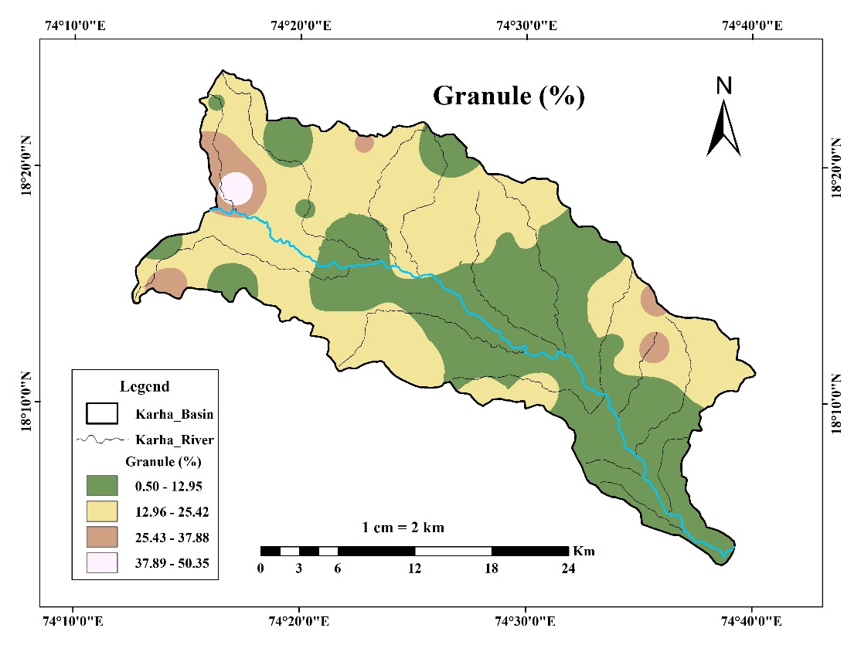

Fig. 11. Spatial distribution of granule in the soil of Karha River Basin

The sand distribution pattern (Fig. 12) shows a clear dominance of sand-rich soils in various parts of the basin, likely shaped by regional variations in topography, parent material, and geomorphic processes.

The highest sand content class (57.89–64.40%), represented in dark brown, is concentrated in the southern and southeastern portions of the basin. These areas, being closer to active fluvial channels, likely receive coarser alluvium during high-flow periods, resulting in well-drained, sandy soils. Such textures are advantageous for deep-rooted crops and horticulture but may require frequent irrigation due to lower water retention. Intermediate sand content classes (44.85–57.88%) dominate the central and northeastern sectors of the basin. This spatial pattern suggests relatively well-drained soils with moderate fertility, suitable for a variety of crops under appropriate nutrient management. Areas showing moderate to low sand content (25.30–44.84%), highlighted in yellow and orange, are concentrated in pockets across the upper western and northwestern basin, including plateau edges and interfluves (Fig. 12).

The spatial heterogeneity evident in this map reflects the complex sedimentation and transport dynamics of the Karha River Basin. From an agronomic perspective, sand-dominated soils require careful water and nutrient management to minimize leaching and erosion, while moderate sand areas offer better moisture retention and nutrient-holding capacity, making them more versatile for agriculture.

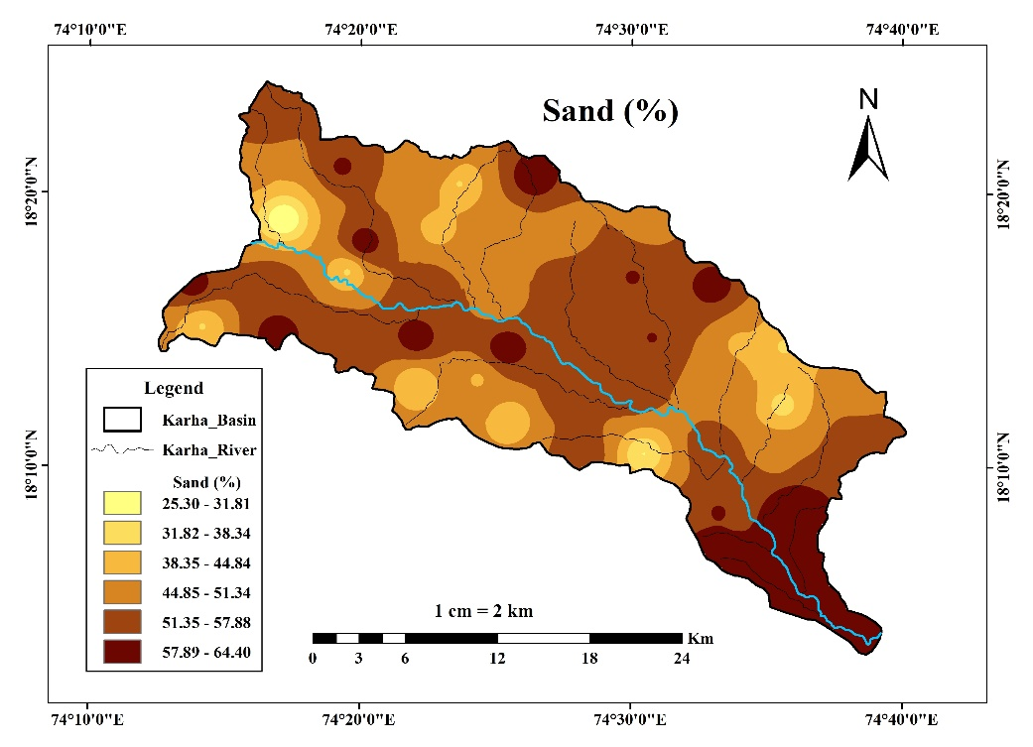

Fig. 12. Spatial distribution of sand in the soil of Karha River Basin

The silt and clay content (%) data, classified into six intervals ranging from 21.92% to 49.82%, reveals significant spatial heterogeneity across the basin, largely influenced by topographic gradients, environmental settings, and land-use practices (Fig. 13).

The highest silt-clay class (45.17–49.82%), shown in dark blue, is concentrated primarily in the southern and southeastern parts of the basin, especially along the lower reaches of the Karha River and valley bottoms (Fig. 13). These zones are indicative of low-energy depositional environments, where finer particles tend to accumulate due to reduced runoff velocity. The moderately high classes (40.52–45.16% and 35.87–40.51%) appear extensively throughout the central and western sectors of the basin. These areas represent transition zones, possibly influenced by a mix of fluvial deposition and pedogenic clay formation. Soils in these regions generally possess better water retention capacity, making them suitable for crops such as wheat, pulses, and sugarcane. Conversely, areas with lower silt-clay content (21.92–31.22%), shown in lighter shades, are more widespread in the north-central and peripheral regions of the basin (Fig. 13). These likely correspond to upland or sloping terrains, where erosional processes dominate, and coarser fractions such as sand and granules are more prevalent.

Agronomically, fine-textured soils with higher silt-clay proportions have superior nutrient-holding capacity and water retention. In contrast, soils with lower silt-clay content may need frequent irrigation but are generally easier to cultivate and less prone to compaction.

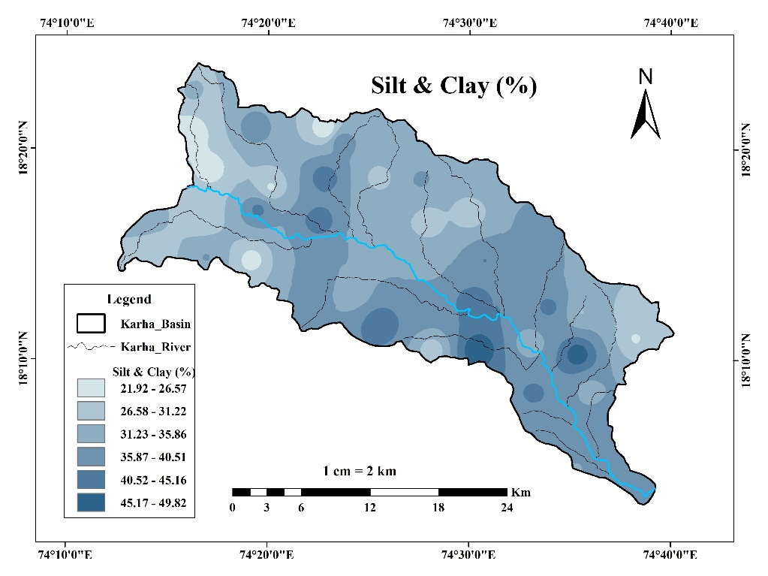

Fig. 13. Spatial distribution of silt-clay in the soil of Karha River Basin

3.4 Spatial distribution of statistical parameters of soil

The spatial distribution of mean grain size is shown in Fig. 14. The values, expressed in phi (ϕ) units derived from grain-size analysis, provide a quantitative indication of particle coarseness, where lower values correspond to coarser grains (e.g., sand or gravel) and higher values indicate finer materials (e.g., silt or clay).

The map reveals a relatively uniform distribution of mean grain size across the basin, with slight spatial variation. Most of the basin is shown in lighter shades, representing lower phi values (coarser textures). This reflects the dominance of sandy soils throughout much of the landscape, consistent with the findings in Figs 12 and 13. A notable zone of higher mean grain size (finer particles) is observed in the southern tip of the basin, as indicated by darker green shading. This area coincides with the downstream alluvial deposition where low-energy depositional settings allow for the accumulation of fine sediments. Agriculturally, areas with coarser mean grain size are well-drained but require supplemental irrigation and organic matter for optimal productivity. Conversely, finer-textured soils in the lower basin may offer better water retention, but could require drainage management to avoid waterlogging.

Overall, the map confirms the soil textural gradient from coarser upstream to finer downstream, a typical pattern in semi-arid fluvial basins.

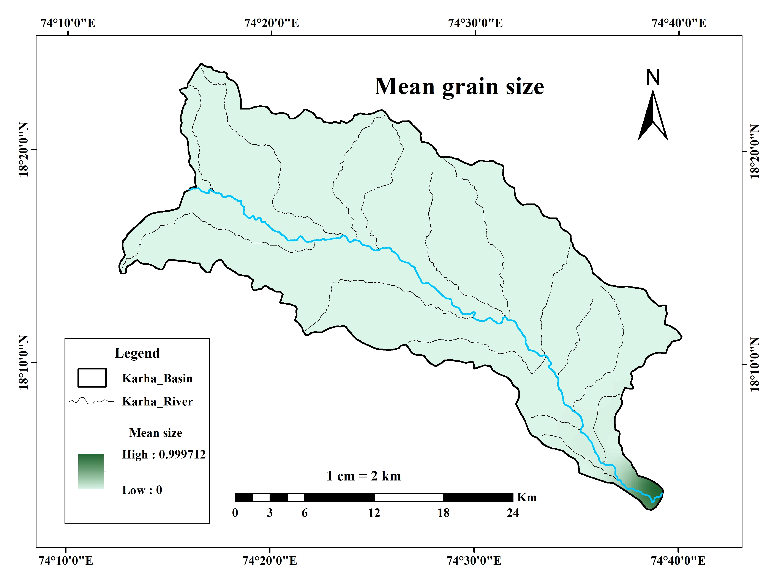

Fig. 14. Spatial distribution of Mean grain size in soil of Karha River Basin

Fig. 15 illustrates the spatial distribution of the sorting index (ϕ) of soil samples. Sorting index is a key sedimentological parameter that reflects the uniformity of particle sizes in each soil sample i.e. lower values indicate better sorting, while higher values represent poorly sorted materials.

The sorting values across the basin range from 1.45 to 2.75, revealing a moderately to poorly sorted sediment regime. The best-sorted soils (1.45–1.70ϕ), represented in green, appear as isolated pockets in the southern and eastern margins of the basin, especially near the lower course of the Karha River (Fig. 15). The dominant sorting class (1.71–1.95ϕ), shown in yellow, covers extensive portions of the central and northeastern basin, suggesting moderately sorted soils. The poorest sorting indices (2.51–2.75ϕ), indicated in light purple, are concentrated in central, southwestern, and isolated upland zones. These soils typically contain a mixture of grain sizes, which may hinder root penetration, reduce porosity, and complicate water infiltration.

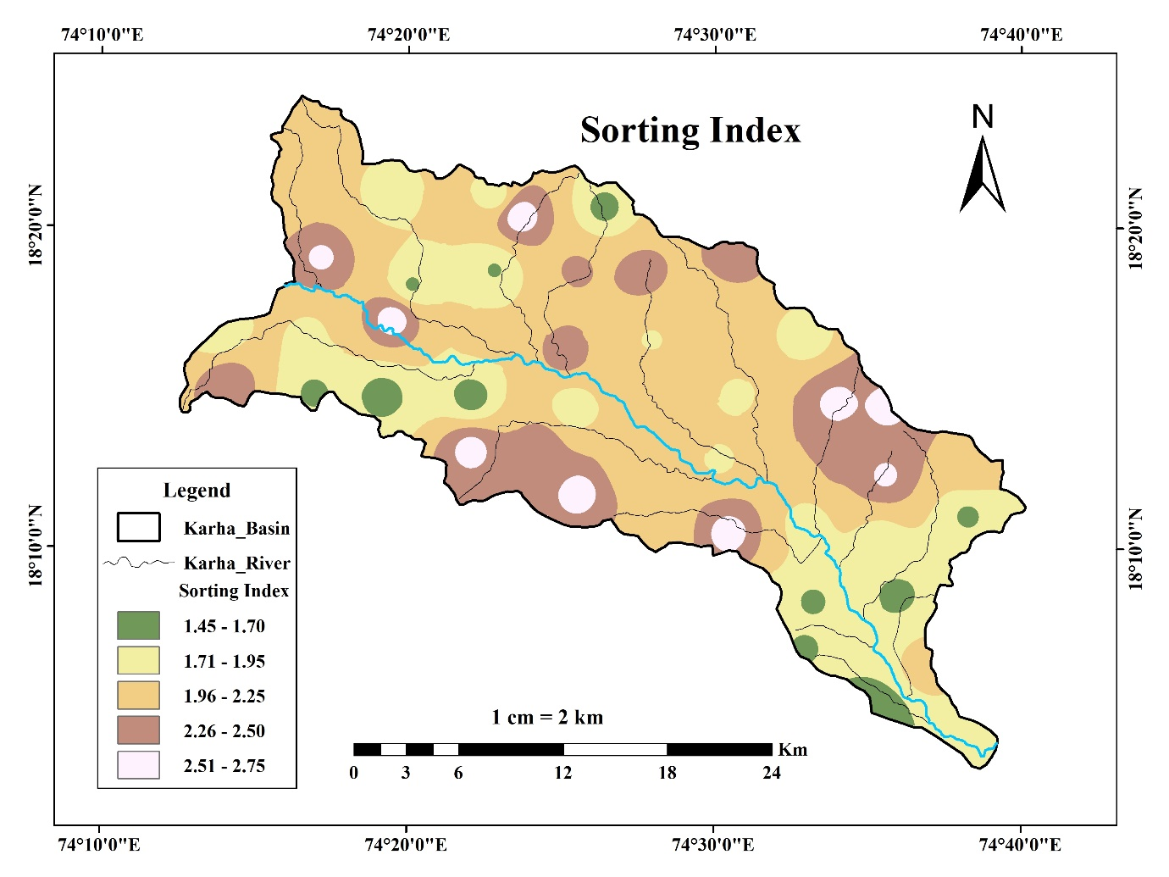

Fig. 15. Spatial distribution of sorting index of soil of Karha River Basin

The spatial variation in the skewness (ϕ) of soil grain-size distributions is presented in Fig. 16. Skewness is a statistical measure that indicates the asymmetry of the grain-size distribution curve. Positive values represent fine-skewed distributions (more fine particles than coarse), while negative values suggest coarse-skewed profiles.

The skewness values in the basin range from –0.22 to 0.83, and have been classified into six classes in the map. The most positively skewed soils (0.66–0.83), represented by dark blue, are located primarily in the southern downstream zones, where fine particle deposition is dominant. This skewness reflects low-energy fluvial environments favoring the accumulation of finer fractions like silt and clay. Moderate skewness values (0.13–0.48) dominate the central and eastern areas, indicating symmetrical to moderately fine-skewed grain distributions. Such soils may support a wide range of agricultural activities, given their balance between drainage and water retention. Negative skewness values (–0.22 to –0.05), shown in lightest blue shades, are scattered in north-central and western upland regions. These regions reflect the presence of coarser soil textures (Fig. 16).

From an agricultural and sedimentological perspective, fine-skewed soils (positive skewness) are generally more fertile and water-retentive, whereas coarse-skewed soils may be more prone to runoff and drought stress, especially in semi-arid zones.

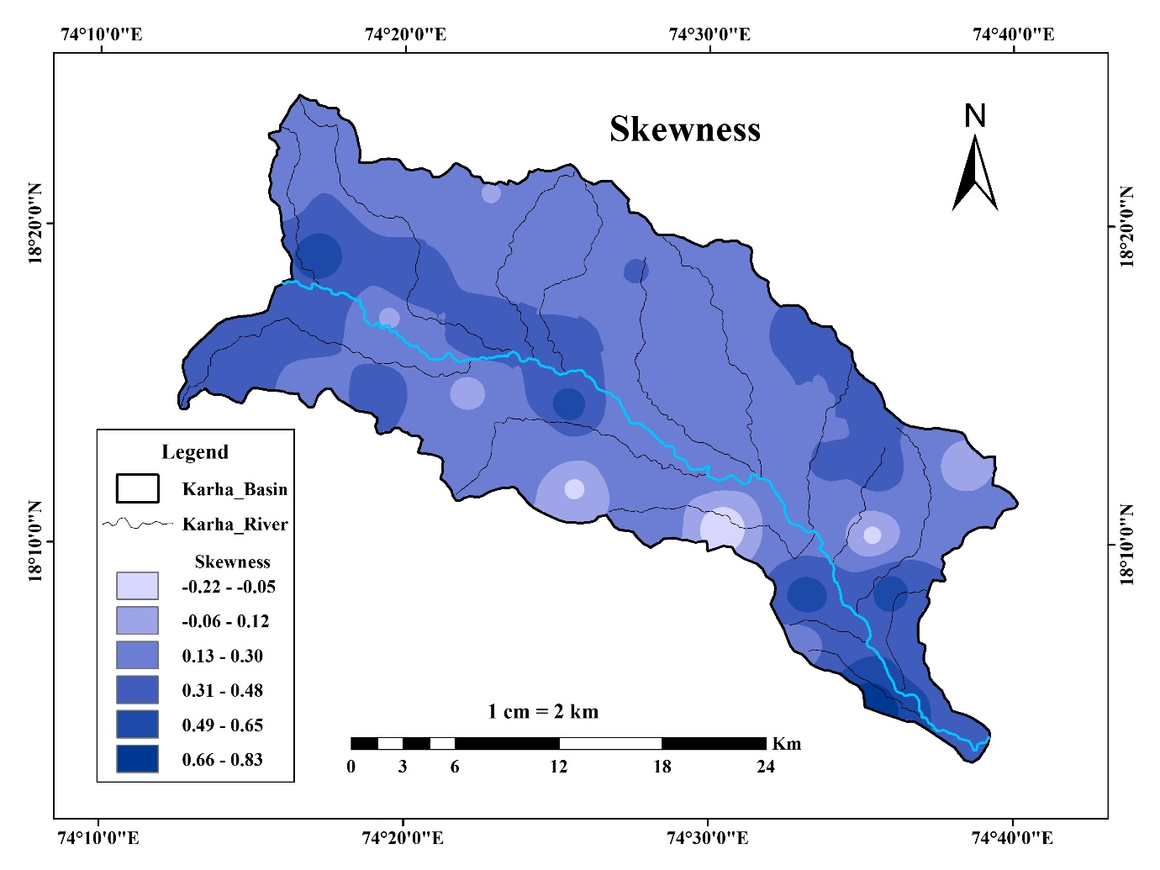

Fig. 16. Spatial distribution of skewness of soil of Karha River Basin

Fig. 17 presents the spatial variation of the kurtosis (ϕ) parameter in the soils. Across the basin, kurtosis values range from 0.55 to 1.75, divided into five classes. The dominant range (0.81–1.30ϕ), shown in yellow and orange, covers most of the central and eastern parts of the basin. These areas exhibit mesokurtic to slightly leptokurtic profiles, indicating moderately consistent depositional energy and relatively well-graded soils. These are ideal for balanced infiltration and crop rooting, making them agriculturally productive zones. Higher kurtosis values (1.31–1.75ϕ), shown in red, are observed in distinct clusters in the southwestern, central, and northeastern corners of the basin. Lower kurtosis values (0.55–0.80ϕ), represented in light yellow, are found in pockets across the western and lower-central basin, reflecting platykurtic distributions with broader grain-size ranges (Fig. 17).

The variation in kurtosis values across the Karha Basin suggests a complex interplay of geomorphic, hydrologic, and soil forming processes influencing soil development.

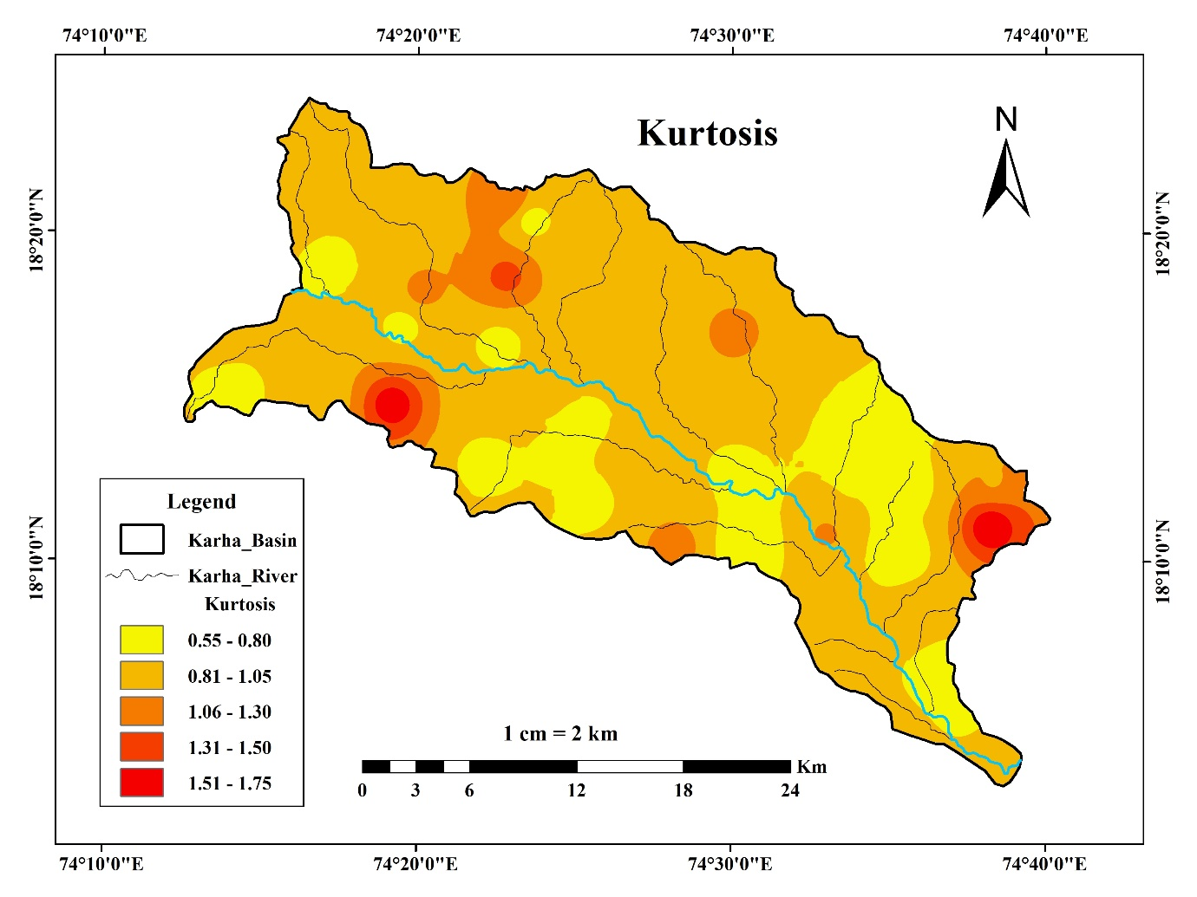

Fig. 17. Spatial distribution of kurtosis of soil of Karha River Basin

4. Conclusion

This study presents a detailed textural analysis and spatial mapping of 48 agricultural soil samples from the Karha River Basin in the semi-arid region of western Maharashtra. Through grain-size distribution data and spatial interpolation techniques in GIS, the research elucidates the variability and complexity of soil textures across the basin.

The soils in the study area are dominated by sand and silt-clay fractions, with granules playing a minor but locally significant role. The granule content varied from 0.49% to 50.42%, with elevated values near rocky uplands. Sand content, averaging 51.71%, reflects fluvial deposition from basaltic terrain and relatively young soils, while silt-clay was more prominent in downstream and low-lying areas, enhancing the water-holding capacity of those zones.

Grain-size statistical parameters further revealed the sedimentological behavior of the basin. The mean grain size ranged from –0.73 to 2.20ϕ, indicating a spectrum from coarser to finer textures. Sorting indices predominantly indicated moderately to poorly sorted soils, while skewness and kurtosis exhibited wide variability, reflecting the diverse soil development processes shaped by geomorphic and hydrologic factors.

Spatial distribution maps of texture and statistical parameters demonstrated clear textural gradients, with finer sediments concentrated in the southern and lower basin and coarser materials in upland and central zones. This heterogeneity points to the combined influence of parent material, basin topography, runoff dynamics, and anthropogenic activities like irrigation and tillage.

The findings highlight the agronomic implications of soil textural variability. Sandy soils, while offering good drainage, require frequent irrigation and organic amendments. Finer soils retain moisture and nutrients but may suffer from compaction or waterlogging without proper management. Spatially explicit knowledge of these properties enables precision agriculture, improved land use planning, and soil conservation practices suited to local conditions.

Overall, this integrated approach combining laboratory-based granulometry with GIS-based mapping provides a valuable framework for understanding and managing soil resources in fluvial landscapes such as the Karha River Basin. It also underscores the utility of geostatistical and geospatial tools in soil quality assessment, agricultural planning, and environmental monitoring in semi-arid regions.

This study provides valuable insights for various stakeholders. Agricultural departments can use the findings for crop planning and soil management, while environmental and water resource agencies may apply the data for erosion control and watershed development. The detailed textural maps support better land use decisions. Farmers can benefit by adopting precision farming practices suited to their local soil conditions. Overall, the results promote sustainable agriculture and resource conservation in the Karha River Basin.

DISCLAIMER (ARTIFICIAL INTELLIGENCE)

Authors hereby declare that no generative AI technologies such as Large Language Models (ChatGPT, COPILOT, etc.) and text-to-image generators have been used during writing or editing of this manuscript.

**REFERENCES**

* Abdellatif, M. A., El Baroudy, A. A., Arshad, M., Mahmoud, E. K., Saleh, A. M., & Moghanm, F. S. (2021). A GIS-based approach for the quantitative assessment of soil quality and sustainable agriculture. Sustainability, 13(23), 13438.
* Ali, A., Ismael, I. O., Mustafa, H. T., Krwanji, D., & Esmail, A. O. (2024). Enhancing Soil Texture and Bulk Density Mapping Using Soil Grids and Machine Learning: A Comparative Analysis with Observed Data. Asian Soil Research Journal, 8(4), 61–78.
* Blott, S. J., & Pye, K. (2001). Gradistat: A grain size distribution and statistics package for the analysis of unconsolidated sediments. Earth Surface Processes and Landforms, 26(11), 1237–1248.
* Brady, N. C., & Weil, R. R. (2016). *The Nature and Properties of Soils* (15th ed.). Pearson Education.
* Chakraborty, K., & Mistri, B. (2015). Importance of soil texture in sustenance of agriculture: A study in Burdwan-I CD Block, West Bengal. Eastern Geographer, 21(1), 475–482.
* Dewangan, S. K., Gupta, K., Kushwaha, A., & Chakraborty, P. (2024). Characterization of soil physical properties: insights into texture, structure, porosity, bulk density and water retention. International Research Journal of Modernization in Engineering Technology and Science, 6(12), 2129–2141.
* FAO. (2015). Revised World Soil Charter. Rome: Food and Agriculture Organization of the United Nations.
* Gadekar, D. J., Ingale, M. M., Mali, N. R., Mule, K. R., & Pawar, S. S. (2024). Impact of geographical factors on soil classification and distribution in Baramati Tehsil, District Pune: Using GIS technique. *International Research Journal of Modernization in Engineering Technology and Science*, 6(2).
* ICAR. (2014). Vision 2050: Natural Resource Management. Indian Council of Agricultural Research, New Delhi.
* Ingale, M. M., Mali, N. R., Mule, K. R., Pawar, S. S., & Gadekar, D. J. (2024). Impact of geographical factors on soil classification and distribution in Baramati Tehsil, District Pune: Using GIS technique. International Research Journal of Modernization in Engineering, Technology and Science, 6(2), 1805–1813.
* Kale, S. S., & Pawar, N. J. (2012). Origin of salinity in the groundwater of semi-arid Karha Basin, Maharashtra. Journal of the Geological Society of India, 80(1), 145–166.
* Karlen, D. L., Mausbach, M. J., Doran, J. W., Cline, R. G., Harris, R. F., & Schuman, G. E. (1997). Soil quality: A concept, definition, and framework for evaluation. Soil Science Society of America Journal, 61(1), 4–10.
* Lwin, P. P., Ngwe, K., Mar, S. S., & Oo, H. H. (2025). Effect of Organic and Inorganic Fertilizer on Physico-chemical Properties of Soil and Yield of Rice (Oryza sativa L.). Asian Soil Research Journal, 9(2), 1–7.
* Nabiollahi, K., Taghizadeh-Mehrjardi, R., & Zeraatpisheh, M. (2017). Digital mapping of soil quality indicators using remote sensing and terrain analysis: A case study in the semi-arid region of western Iran. *Geoderma Regional, 10*, 154–162.
* Nengi-Benwari, A. O., Udom, B. E., & Akpan, E. (2023). Physico-chemical Properties in Rhizosphere of Some Field Crops at Different Growth Stages in a Sandy Clay Loam Soil in Sourthern Nigeria. Asian Soil Research Journal, 7(1), 1–8.
* NRSC. (n.d.). Indian Soil Datasets – Soil Texture, Depth and Carbon. Bhuvan Geoportal.
* Press Information Bureau (PIB). (2014, July 19). GIS based soil fertility maps prepared for 19 states [Press release]. Ministry of Agriculture, Government of India.
* Rajalakshimi, P., Mahendran, P. P., Nirmala Mary, P. C., Ramachandran, J., Kannan, P., Chelvi Ramessh, & Selvam, S. (2025). Spatial analysis of soil texture using GIS-based geostatistics and its influence on soil hydraulic conductivity in Madurai District, Tamil Nadu. Agricultural Science Digest, 45(1), 91–96.
* Torane, S. N., Chavan, S. J., Mali, B. S., Patil, V. S., & Shete, R. S. (2022). Physico-chemical characteristics of soil supporting the growth of wheat, jowar and maize in Baramati Tehsil, Pune District. IOSR Journal of Agriculture and Veterinary Science, 15(12), 01–06.
* Wankmüller, F. J. P., Delval, L., Lehmann, P., Baur, M. J., Cecere, A., Wolf, S., Or, D., Javaux, M., & Carminati, A. (2024). Global influence of soil texture on ecosystem water limitation. Nature, 635(8039), 631–638.