**TISSUE CULTURE AND ITS APPLICATIONS IN MULBERRY PROPAGATION**

**ABSTRACT**

Mulberry is an economically important crop in sericulture industry, as it provides the only food source for the silkworm (*Bombyx mori* L.). Despite its importance, traditional methods of propagation like stem cuttings and grafting have several limitations including low success rates, seasonal dependency and vulnerability to diseases. To overcome these challenges, tissue culture offers a reliable and efficient alternative for mass multiplication, genetic improvement, and long-term preservation of mulberry varieties. Techniques such as micropropagation, somatic embryogenesis and organogenesis make it possible to produce healthy, high-quality planting material on a large scale. In addition, tissue culture plays a crucial role in conserving rare or valuable germplasm under controlled environments, helping to safeguard genetic diversity for breeding and research purposes. This review explores how tissue culture is contributing to the advancement and preservation of mulberry and discusses the latest developments and future potential of these biotechnological approaches in promoting sustainable sericulture.

**Key words**: Mulberry; Tissue culture; Micropropagation;Somatic embryogenesis; *In-vitro* conservation;Germplasm preservation;Genetic improvement;Organogenesis

1. **INTRODUCTION**

Mulberry (*Morus* spp.) is a fast-growing, woody perennial plant of significant economic importance, especially in countries where sericulture is a major rural industry. Its leaves are the sole food source for the silkworm (*Bombyx mori* L.), making mulberry cultivation critical to the success of silk production. The perennial nature of mulberry, along with its extended juvenile phase hampers the pace of its genetic improvement (Kavyashree *et al*., 2001). Although mulberry can reproduce both sexually and asexually, its high heterozygosity makes seed propagation unsuitable for commercial purposes due to the resulting genetic variability. Furthermore, the dioecious habit, long juvenile period and pronounced inbreeding depression make the development of stable inbred lines particularly challenging (Vijayan *et al*., 2011).

Vegetative propagation methods such as stem cuttings, grafting and budding are commonly used for mulberry. However, the success of these techniques is influenced by factors like the plants genetic constitution, age and physiological state of the parent material, climatic conditions and cultivation practices. Moreover, newly developed mulberry varieties cannot be propagated immediately through stem cuttings, as the parent plants require a maturity period of at least 6-7 months before suitable cuttings can be harvested (Kapur *et al*., 2001).

The propagation of mulberry through stem cuttings is commonly followed method of planting mulberry crop. The success of stem cuttings is dependent on many factors *viz*., origin of genotype, age of stem, rooting ability of plant, physiological condition of plant and environmental conditions (Taha *et al*., 2020). The other methods of propagation include grafting, budding, layering also implicit some complexity at commercial scale. Vegetative propagation of mulberry through grafting is not economically viable (Attia *et al*., 2014). Mulberry tree improvement through conventional breeding is slow and also difficult due to its heterozygous nature.

To overcome these challenges, plant tissue culture has emerged as a powerful and reliable tool (Guha *et al*., 2010; Taha *et al*., 2020). Tissue culture exploits the totipotency of plant cells their inherent ability to regenerate into whole plants under aseptic and controlled environmental conditions (Hussain *et al*., 2012). It enables the rapid production of a large number of true-to-type, disease-free plants throughout the year. Over the decades, various tissue culture techniques have been refined for mulberry, including micropropagation through axillary bud proliferation, organogenesis from callus, somatic embryogenesis and production of synthetic seeds.

These biotechnological approaches not only ensure mass multiplication but also play a vital role in conserving elite germplasm, introducing desirable traits, and developing improved cultivars with enhanced productivity and stress resistance (Kavyashree *et al*., 2001; Thirugnanakumar *et al*., 2001; Islam *et al*., 2012). The application of tissue culture techniques has therefore become indispensable in modern mulberry improvement programs and in ensuring a sustainable and productive sericulture industry (Vijayan *et al*., 2011; Taha *et al.,* 2020).

**2. Challenges in Conventional Propagation of Mulberry**

1. **Low multiplication rate and seasonal dependence**

Mulberry is commonly propagated through stem cuttings, grafting and budding. However, these methods are slow and limited by the natural growth cycle they cannot supply large quantities of plants year-round (Chowdary and Bindroo, 2013).

1. **Genetic heterozygosity and variability**

Mulberry is a highly heterozygous, dioecious species and seed propagation leads to significant genetic variability. This makes it unsuitable for maintaining uniform, true-to-type plants in commercial cultivation (Hussey, 1978).

1. **Prolonged juvenile phase**

Newly bred or selected plants require a long period to reach reproductive maturity, which delays the production of viable propagules and slows down breeding programs (Bharath Kumar *et al*., 2024).

1. **Poor rooting of cuttings in some varieties**

Rooting success depends heavily on genotype, physiological status and environmental conditions and some desirable cultivars are particularly difficult to root through cuttings (Taha *et al*., 2020).

1. **Susceptibility to pests and diseases in nurseries**

Cuttings and young plants grown in conventional nurseries are vulnerable to soil-borne pathogens, pests and abiotic stress, reducing survival and quality of planting material (Attia *et al.*, 2014).

1. **Delayed propagation of new varieties**

Newly developed cultivars cannot immediately supply large numbers of cuttings, because the parent plants need to grow and mature for at least 6-7 months before sufficient material can be harvested (Kapur *et al*., 2001).

The limitations of conventional propagation techniques such as low multiplication rate, genetic variability, long juvenile phases, poor rooting in some genotypes, susceptibility to diseases and delayed availability of planting material so, there is a critical need for more efficient and reliable methods to produce large quantities of uniform, healthy mulberry plants throughout the year.

One such promising approach is plant tissue culture which enables the rapid, large-scale and disease-free propagation of true-to-type plants irrespective of season or genotype limitations. Tissue culture has successfully addressed many of the limitations of traditional propagation methods and is now widely applied for both mulberry improvement and large-scale multiplication.

1. **Tissue culture**

Tissue culture is the technique of maintaining and growing plant or animal cells, tissues or organs in an artificial, nutrient-rich medium under controlled aseptic conditions (Thorpe, 2007)

**3.1 Importance of tissue culture in mulberry**

**1. High Multiplication Rate in Limited Resources**

Tissue culture allows for the rapid multiplication of mulberry plants using a small piece of tissue (explant), enabling the production of a large number of plantlets in a short period and within a confined space.

**2. Conservation of Rare Germplasm**

The process does not harm the source plant, making it ideal for cloning rare or endangered mulberry varieties without depleting natural populations.

**3. Efficient Trait Selection**

Desirable traits can be identified and selected directly in the laboratory environment, significantly reducing the need for extensive field trials and land use.

**4. Year-Round Plant Production**

Once a tissue culture protocol is established, it provides a constant supply of young plants throughout the year independent of seasonal constraints.

**5. Reduced Generation Time**

The method bypasses the lengthy seed-to-plant cycle, speeding up propagation and allowing for quicker turnover in breeding and cultivation programs.

**6. Disease-Free Plant Material**

Plants developed through in-vitro techniques are typically free from bacterial and fungal infections. It also supports virus elimination and the maintenance of virus-free stock, which is essential for international plant transport.

**8. Long-Term Preservation**

Plant tissue culture enables the storage of plant material in cryopreservation systems. This helps preserve genetic resources like pollen and cells, which can later be regenerated into full plants when needed.

(Qadir *et al*., 2024)

**Fig.1 : Tissue culture technique in mulberry**

**3.2 Tissue culture technique in mulberry has developed and ramified into different areas such:**

* Micropropagation
* Callus culture
* Organogenesis
* Screening of genotypes for stress tolerance
* Induction of polyploids
* Cryopreservation
* Transgenesis

**3.4 There are three methods widely used in tissue culture which includes:**

* Micro propagation
* Organogenesis
* Somatic embryogenesis

**3.4.1 MICROPROPAGATION**

Numerous explant sources including shoot tips and axillary, solitary or winter buds, have been used to micropropagate mulberry (*Morus spp*.). The first reports come from Japan and one of them is from (Ohyama, 1970) who grew the first full-grown plantlets from axillary bud tissue on MS (Murashige and Skoog, 1962) substrate that had growth regulators added to it. Sub terminal buds showed the highest responsiveness to multiple-shoot induction (Hossain, 1999).

Mulberry is commonly propagated through vegetative means such as stem cuttings, grafting and budding. However, the effectiveness of these traditional techniques can vary depending on several factors including the plant's genetic characteristics, maturity, health of the parent material and prevailing environmental conditions. Newly released mulberry varieties often require a maturation period of at least 6-7 months before suitable cuttings can be obtained. In contrast, micropropagation offers a rapid and efficient alternative, enabling the multiplication of plants under controlled laboratory settings (Suraksha Chanotra, 2019). Unlike conventional stem cuttings where each piece yields a single plant, micropropagation can generate thousands of plantlets from a single explant. Additionally, this technique supports continuous plantlet production year-round, unaffected by seasonal changes. It is therefore a highly effective and space-efficient method for large-scale propagation. Furthermore, using apical meristem tissue in micropropagation allows for the development of virus-free planting material.

**3.4.2 ORGANOGENESIS**

Regeneration of plants from somatic cells plays a crucial role in improving woody tree species, as it enables the production of transgenic plants, the identification of somaclonal variants and the development of stress-tolerant lines through cell line selection and propagation of superior genotypes (Bajaj,1986; Gupta, 1988). Consequently, several efforts have been made in mulberry to establish protocols for direct regeneration from explants such as leaves, cotyledons and embryos, as well as indirect regeneration via callus culture. Direct organogenesis from explants offers the benefit of minimal genetic variation among the regenerated plants, ensuring true-to-type clonal propagation, whereas organogenesis through callus culture tends to enhance plant productivity (Desai *et al*., 2022) . Moreover, plants derived from callus are an important source of genetic variability, enabling the selection of somaclonal variants with desirable characteristics.

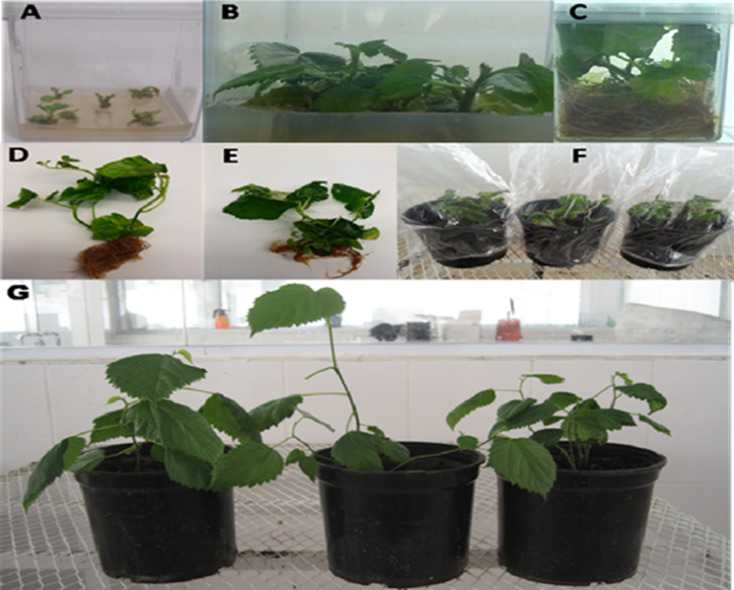

**Explants**

Winterbuds, Nodal segments, Shoot tips

**Surface Sterilization**

Treat with mild detergents for 10 min; wash thoroughly with sterile water 3 times; treat with 7% NaOCl2 for 10 min; wash thoroughly with sterile water 3 times; treat with 0.1% HgCl2 for 10 min; wash thoroughly with sterile distilled water 3-4 times

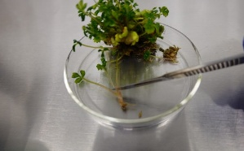

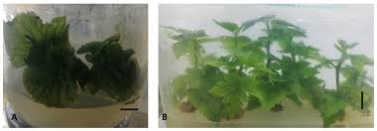

**Shoot initiation**

MS+BA(2.0mg/L)+fructose (3%)+0.8% agarose, pH ≥5.8



**Shoot Multiplication**

MS+BA(2.0mg/L)+fructose (3%)+0.8% agarose, pH ≥5.8

**Rooting**

MS+NAA(0.1-0.2 mg/L)+ Fructose (3%)+0.8% agarose, pH ≥5.8

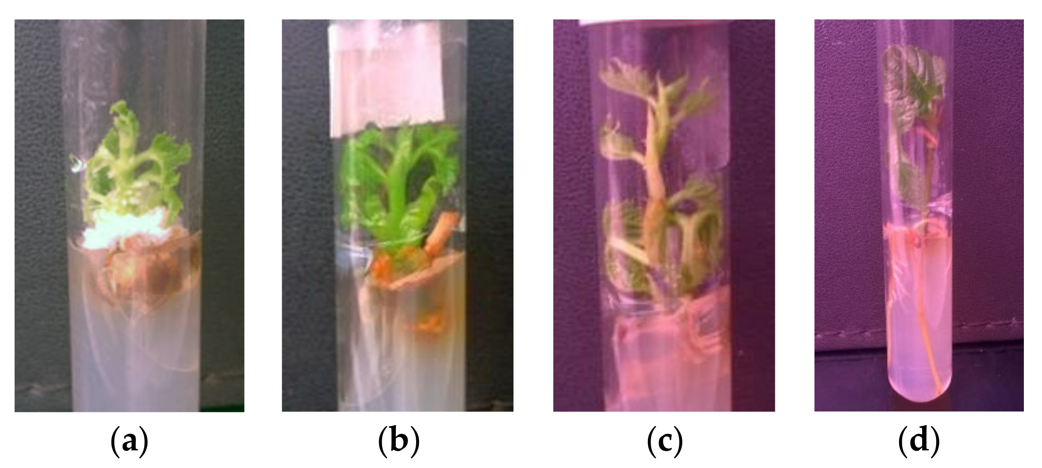

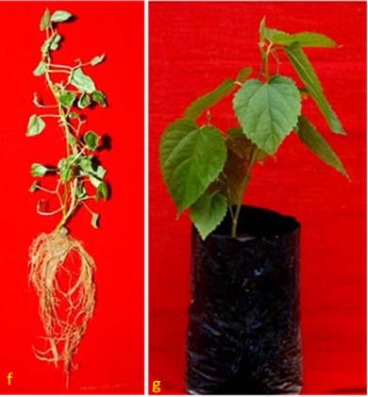

**Hardening**

80-85 % humidity, 25-27 ◦C for 15 days, Normal condition under shade for 60 days, transfer to earthen pot containing fine soil

**Fig. 2: Schematic representation of the procedure of micro propagation in mulberry**

Organogenesis refers to the intricate biological process through which new organs are formed (Machi, 1992). Its success is influenced by several factors, including the type and developmental stage of the explant, composition of the culture medium, presence and balance of plant growth regulators, plant’s genetic makeup, carbohydrate sources and the nature of gelling agents used. Environmental conditions such as light intensity, temperature and humidity also play critical roles. Based on these variables, plant regeneration can occur *via* two pathways: direct or indirect organogenesis (Chitra and Padmaja, 2005). In direct organogenesis, shoots or roots are formed directly from the explant tissues without the intermediate formation of callus. In contrast, indirect organogenesis involves an initial callus phase from which plant structures subsequently emerge. The formation of callus itself is affected by several factors, including the type of explant, the genetic background of the plant, and the specific components of the culture medium (Srinivasa *et al*., 2001). Various types of explants have been experimented with to successfully induce callus formation in mulberry.

**3.4.3 SOMATIC EMBRYOGENESIS**

Somatic embryogenesis refers to the process where a single cell or a group of cells initiates a developmental pathway, resulting in the consistent regeneration of non-zygotic embryos that can germinate into complete plants. This technique is an important tool for accelerating the genetic improvement of commercial crop species. Although several research groups have attempted to induce somatic embryos in mulberry, the success rate has been relatively low. Shajahan *et al*. (1995) reported the formation of heart-shaped embryos from *Morus alba* hypocotyl segments cultured on MS medium supplemented with 2,4-D (0.45–4.52 μM) and BAP (2.2 μM). Agarwal (2002) obtained primary and secondary somatic embryos by culturing zygotic embryos on MS medium containing 0.05 mg/L 2,4-D, 0.1 mg/ L BAP, and 6% sucrose. Because of difficulties in hormonal regulation of adventitious shoot and root formation in mulberry, somatic embryogenesis has not been as successful as in many other crop plants (Tiku *et al*., 2021). Therefore, coordinated efforts are required to establish an effective somatic embryogenesis protocol in mulberry.

1. **HAPLOID PRODUCTION**

Haploid plants, originating from gametophytic tissue contain only a single set of chromosomes, which is half the diploid number found in the parent plant. These plants are particularly useful for generating completely homozygous lines, making them highly valuable in breeding programs especially for tree species that have lengthy generation times and exhibit significant genetic variability. (Guha & Maheshwari, 1964; Kasha & Maluszynski, 2003). Since the first successful report on regeneration of haploid plants from pollen grains of cultured anthers of *Datura* (Guha & Maheshwari, 1964), this technique has been extensively applied in many agriculturally important plant species. However, only limited success has been achieved in tree species (Bonga, 1987). In mulberry (*Morus* spp.), although anther culture was attempted as early as the 1980s (Sastri *et* *al*., 1983; Kavyashree *et* *al*., 2001), no regenerated plants were obtained. However, gynogenic haploids were successfully regenerated by culturing immature female catkins on MS medium (Chauhan *et al.,* 1984).No further reports on haploidy in mulberry are available, despite the potential value of doubled haploidy in mulberry breeding (Kavyashree *et al*., 2001; Tiku *et al*., 2021).

**Explants**

(Cotyledons, Hypocotyl, Epicotyl, Stem segment, Roots, Leaves)

**Surface Sterilization**

Treat with mild detergents for 10 min; Wash thoroughly with sterile water 3 times; treat with 7% NaOCl2 for 10min; wash thoroughly with sterile water 3 times; treat with 0.1% HgCl2 for 10 min;wash thoroughly with sterile distilled water 3-4 times

**Pre-soaking**

MS+BA (1-2 mg/l) for 48-72 h

**Direct shoot induction**

MS+BA (1-2 mg/l) +Sucrose (3%) +0.8% agarose pH ≥ 5.8

MS+NAA (0.1-0.2 mg/l) + Sucrose (3 %) 0.8% agarose pH ≥ 5.8

**Callus induction**

MS+2, 4-d (2 mg/l) + BA (0.1-0.5 mg/l) + Casein hydrolysate (100 mg/l) + Coconut water (150 ml/l +Sucrose (3 %) +0.8% agarose pH ≥ 5.8

**Hardening**

80-85 % humidity, 25-27 ◦C for 15 days, Normal condition under shade for 60 days, transfer to earthen pot containing fine soil

**Shoot initiation**

MS+ BA (2 mg/l) + TBA (0.1 mg/l) Sucrose (3 %) +0.8% agarose pH ≥ 5.8

**Fig. 3: Flowchart illustrating the organogenesis process in mulberry**

1. **Other Applications of Tissue Culture in Mulberry**

**5.1 Induction of Tetraploidy**

In general, the mulberry is propagated through vegetative means hence, sterile high yielding varieties/cultivars do not pose any problems for their true to type multiplication. Triploid in mulberry is considered as the optimum level of ploidy because triploids show several advantages over plants of other ploidy (Chakraborti *et al*.,1998). Triploids are superior in leaf yield, stress resistance and chemical components of the leaf (Yang and Yang, 1989).  Considering these advantages, tetraploids are developed from diploids by colchicine treatment of the growing shoots (Park *et al*., 2021). In this method, small cotton pads soaked with 1.0-2.0% colchicine solution is applied over the growing buds for 2-3 consecutive days. Though this method is easier to apply, it suffers from quick drying of the cotton pad, excessive loss of colchicine and difficulty in maintaining the uniform concentration of the colchicine solution.

An alternative approach to induce triploidy in mulberry involves culturing the endosperm, a naturally triploid tissue formed through the process of double fertilization in angiosperms. In mulberry, triploid plants were successfully generated for the first time from the endosperm of the cultivar S36.

**5.2 SCREENING FOR STRESS TOLERANCE**

In mulberry, salt tolerance is a complex trait that involves morphological, physiological and biochemical mechanisms. Therefore, screening genotypes for salt tolerance should be carried out under conditions where the impact of external factors is minimized (Vijayan *et al*., 2011). Using *in vitro* systems is considered an ideal approach, as they allow for the maintenance of uniform salinity levels and better control over environmental conditions. To isolate salt tolerant genotypes, scientists in India sterilized the nodal explants and grew them on MS medium containing 2 mg/ L BAP, 30 mg/l sucrose and 0.0 % to 1.0 % NaCl.

**5.3 SYNTHETIC SEEDS**

These artificially created seeds, formed by encapsulating somatic embryos, simulate the behavior of natural seeds and can successfully germinate into plantlets in controlled, sterile conditions. More broadly, the term also includes encapsulated buds or other meristematic tissues that can regenerate into whole plants (Redenbaugh *et al*., 1986). In mulberry (*Morus* spp.), synthetic seeds have primarily been produced by encapsulating apical or axillary buds or somatic embryos in a 3-5 % sodium alginate matrix with 100 mM calcium chloride serving as the complexing agent (Sharma *et al*., 2010). The sodium alginate solution is prepared by mixing it with a culture medium containing the necessary nutrients and hormones for optimal growth. This technology for artificial seed production in mulberry has been successfully developed (Sharma *et al.,* 2010; Ara *et al*., 2013). However, its application for large-scale propagation has been limited to a few *M. indica* genotypes. Since it is challenging to induce somatic embryogenesis in mulberry, researchers have explored the use of *in vitro*-derived vegetative propagules such as shoot tips and buds for synthetic seed production.

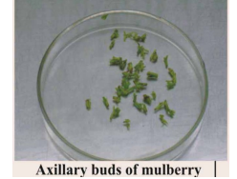 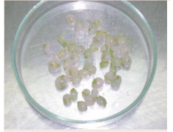 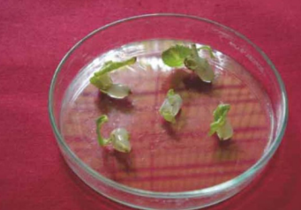

Axillary buds of mulberry Synthetic seeds of mulberry Germination of

synthetic seeds

**Fig. 4: Synthetic seeds produced by encapsulating apical or axillary buds or somatic embryos**

**5.4 CRYOPRESERVATION OF GERMPLASM**

The high heterozygosity of mulberry makes conservation of its germplasm through seeds challenging, as the resulting progenies are highly heterogeneous and rarely true-to-type (Rao *et al.,* 2007). Therefore, *ex-situ* conservation is commonly done in field gene banks which is labor-intensive, costly and susceptible to damage from natural disasters, pests and diseases. To address these challenges, safer and more economically viable alternatives are being explored. Cryopreservation offers a promising option where plant materials are stored at ultra-low temperatures (−196 °C) in liquid nitrogen. At this temperature, all metabolic processes including cell division are halted, allowing the material to remain viable and genetically stable over long periods (Reed, 2008)

In *Morus alba* (mulberry), various explants such as cotyledons, leaves, hypocotyls, and shoot tips—obtained from embryos cultured with benzyladenine (BA)—successfully produced adventitious shoots when grown on media enriched with high concentrations of BA, either alone or combined with a low dose of naphthaleneacetic acid (NAA). These shoots primarily emerged from the cut base regions of the cotyledons and leaves. Microscopic examination revealed the development of a wound-induced cambium beneath the emerging bud primordia. In shoot-tip explants, axillary buds were also observed along with the adventitious ones. However, when NAA levels were increased significantly, the shoot-inducing effect of BA was completely suppressed. For proper elongation of the buds, BA levels in the medium were gradually reduced. Root development was successfully induced on these shoots using indole-3-butyric acid, leading to the formation of complete plantlets (Kim *et* *al*., 1985).

1. **Studies on Tissue Culture Techniques in Mulberry:**

Bhau and Wakhlu (2003) reported that multiple shoots were initiated within two weeks from nodal and shoot tip explants of *Morus alba* cultivars (Chinese White, Kokuso-27, Ichinose) and *M. multicaulis* cultivars (Goshoerami, Rokokuyaso). Nodal explants were more responsive than shoot tips. Murashige and Skoog (MS) medium supplemented with 6-benzylaminopurine (BAP) was found most suitable for shoot induction. Explants collected between April and September showed better responses. Shoot multiplication was achieved by culturing nodal segments from in vitro-grown shoots on cytokinin-enriched medium, with sucrose identified as the most effective carbon source. Multiplication efficiency increased up to the 4th or 5th subculture. Rooting was induced on auxin-supplemented medium, and acclimatized plants were successfully established in the field.

A protocol for plant regeneration from leaf explants was developed for tropical mulberry varieties. Effect of sugars, 6-benzyladenine and genotype on shoot regeneration was studied. Highest percentage of shoot regeneration (80±6) was obtained with genotype S799 on medium containing glucose and 8.9 µM 6-benzyladenine. Genotypes Mandalaya and MIHP, having thicker leaves with waxy cuticle, showed poorer regeneration ability than S799 and Sujanpur-5, which have thinner leaves and cuticle. Histological studies revealed that shoots regenerated from sub-epidermal cells (Vijayan *et al*., 2000).

Vijayan *et* *al*. (2000) developed a regeneration protocol from leaf explants of tropical mulberry, examining the effects of sugar type, genotype and 6-benzyladenine (BA). The highest regeneration rate (80 ± 6 %) was observed in genotype S799 on glucose-containing medium with 8.9 µM BA. Genotypes with thinner leaves (S799, Sujanpur-5) responded better than those with thicker, waxy leaves (Mandalaya).

Sajeevan *et al*. (2011) developed an efficient protocol for mass propagation of mulberry using nodal segments. Multiple shoots were induced after 45 days on MS medium containing BAP (1.0 mg/l), TDZ (0.1 mg/l) and NAA (0.25 mg/l). Shoot elongation and bud proliferation were enhanced on MS medium supplemented with BAP, NAA and GA₃ (0.5 mg/l). Rooting was successfully achieved on MS with IBA (0.5 mg/l), with or without activated charcoal. Hardened plantlets showed a 98 % survival rate under greenhouse conditions, indicating the protocol is suitability for large-scale propagation and transgenic applications.

Chattopadhyay *et al*. (2011) evaluated the micropropagation potential of diploid and triploid cytotypes of mulberry variety S1 using axillary buds through organogenesis. Optimal shoot lengths of 4.8 cm (diploid) and 5.6 cm (triploid) were achieved with 8.8 μM and 4.4 μM 6-BAP, respectively. Regenerated shoots were rooted on auxin-supplemented media. Diploids exhibited more vigorous rooting than triploids. Maximum rooting in diploids (15 roots/shoot; 4.2 cm root length) occurred on MS medium with 4.0 μM NAA, while triploids showed 8.3 roots/shoot at 4.4 μM NAA after 21 days of culture.

Lalitha *et al*. (2014) evaluated the efficiency of three plant-derived gelling agents i.e. corn flour, cassava powder and arrowroot powder as cost-effective alternatives to agar in the micropropagation of *Morus indica* L., S-1635. Among the tested treatments corn flour (2.2% w/v) combined with low-dose agar (0.35% w/v) yielded the best in vitro shoot growth showing shoot lengths comparable to those on agar alone. This combination also produced vigorous, healthy plantlets with a high survival rate (83.3 %). The findings suggest that corn flour based media can effectively replace agar, reducing micropropagation costs by up to 42.95 %, thereby supporting low-cost tissue culture technology in developing countries.

Taha *et al*. (2020) developed an efficient and reproducible *in*-*vitro* propagation protocol for various *Morus alba* cultivars. Optimal sterilization was achieved using 0.2 % mercuric chloride for 10 minutes. Maximum shoot multiplication, shoot number and shoot length were observed when explants were cultured on Murashige and Skoog (MS) medium supplemented with 1.5 mg/l BA. Rooting was most effective with 1 mg/l NAA, producing the highest number and length of roots. Successful acclimatization and hardening were achieved using a peatmoss:sand:perlite mixture (1:1:1 v/v), with survival rates reaching up to 90 %. This protocol supports rapid, year-round propagation of true-to-type mulberry plants for large-scale cultivation.

Anis *et al*. (2003) reported successful in vitro regeneration and multiplication of *Morus alba* L. A high frequency of sprouting 80 % from nodal and 70 % from shoot tip explants along with shoot differentiation was observed in primary cultures on MS medium supplemented with BAP and Kn. Rapid shoot multiplication was achieved by culturing shoot tips and nodal explants on MS medium containing BAP (2 mg/l) and NAA (0.2 mg/l), which proved to be the most effective combination for multiple shoot formation. Further enhancement in shoot elongation and axillary bud sprouting was obtained by adding asparagine (25 mg/l) and glutamine (1 mg/l) to the same medium. Rooting was induced in about 80 % of the shoots on MS medium supplemented with NAA (1.0 mg/l) and approximately 70 % of the rooted plantlets successfully acclimatized to soil conditions.

**Future Perspectives:**

While significant progress has been made in applying tissue culture to mulberry, there remains vast potential for further research and development. Future efforts could focus on:

* Optimizing protocols for somatic embryogenesis and haploid production to improve efficiency and reproducibility
* Developing robust cryopreservation methods for long-term conservation of diverse mulberry germplasm
* Integrating tissue culture with molecular breeding tools, such as marker-assisted selection and genetic engineering, to accelerate the development of stress-resistant and high-yielding cultivars
* Exploring genome editing technologies such as CRISPR/Cas9, in combination with tissue culture to introduce precise genetic improvements
* Scaling up synthetic seed technology and automation of *in vitro* propagation systems to make them more cost-effective for commercial application

Continued research in these areas will further enhance the role of tissue culture in mulberry improvement, ensuring sustainable sericulture and contributing to rural livelihoods.

1. **CONCLUSION**

Tissue culture techniques have revolutionized mulberry propagation and improvement by enabling rapid, large-scale and disease-free production of true-to-type plants irrespective of season or genotype. Methods such as micropropagation, organogenesis, somatic embryogenesis, synthetic seed production and cryopreservation have successfully addressed many limitations of conventional propagation methods, such as low multiplication rates, genetic heterogeneity and susceptibility to pests and diseases. These biotechnological approaches not only support the sericulture industry by ensuring a reliable supply of high-quality planting material but also contribute to conserving valuable germplasm and developing improved cultivars with desirable traits.

Disclaimer (Artificial intelligence)

Author(s) hereby declare that NO generative AI technologies such as Large Language Models (ChatGPT, manuscript.

Competing interests

Authors have declared that no competing interests exist.

1. **REFERENCES**
2. Ara, H., Jaiswal, U. & Jaiswal, V. S. (2013). Synthetic seed: prospects and limitations. *Current Science*, 104(8),1126–1134.
3. Asmeena Qadir, Shalini Aryan, Somagaini Pavankumar, Sumiya Afreen & Neha Sudan. (2024). An overview of tissue culture techniques for crop improvement in mulberry. *International journal of Research in Agronomy*, 7(8), 763-768.
4. Bajaj, Y. P. S. (1986). Biotechnology of tree improvement for rapid propagation and biomass energy production in tress: *Biotechnlogy in Agriculture and Forestry*, 1- 23.
5. Bharath Kumar, B. M., Chandana, H. S., Mili Gajendra Pusdekar, K., Mani Bharathi, B., Garai, I. & Shruthi, G. H. (2024). A study to analyse pros and cons of different propagation methods in mulberry (*Morus sp*.). *International Journal of Advanced Biochemistry Research*, 8(9), 28-32
6. Bhau, B. S. & Wakhlu, A. K. (2003). Rapid micropropagation of five cultivars of mulberry. *Biologia Plantarum*, 46(3), 349-355.
7. Bonga, J. M. (1987). Clonal propagation of mature trees: problems and possible solutions. *Cellular and Molecular Life Sciences*, 43, 1031–1038.
8. Chakraborti, S. P., Vijayan, K., Roy, B. N. and Qadri, S. M. H. (1998). In vitro induction of tetraploidy in mulberry (*Morus alba* L.). *Plant Cell Reports*, 17(10), 799-803.
9. Chattopadhyay, S., Doss, S. G., Halder, S., Ali, A. K. & Bajpai, A. K. (2011). Comparative micropropagation efficiency of diploid and triploid mulberry (*Morus alba cv. S1*) from axillary bud explants. *African Journal of Biotechnology*, 10(79), 18153-18159.
10. Chauhan, S. S., Thomas, E. & Devarumath, R. M. (1984). In vitro production of gynogenic haploids in mulberry (*Morus* spp.). *Indian Journal of Sericulture*, 23(2), 31–35.
11. Chitra, D. V. and Padmaja, G. (2005). Shoot regeneration via direct organogenesis from in vitro derived leaves of mulberry using thidiazuron and 6-benzylaminopurine. *Scientia Horticulturae*, 106(4), 593-602.
12. Chowdary, N. B. & Bindaroo, B. (2013). Causes for poor rooting of mulberry cuttings.The Hindu, p. 4.
13. Desai, P., Desai, S., Rafaliya, R. & Patil, G. (2022). Plant tissue culture: Somatic embryogenesis and organogenesis. Advances in Plant Tissue Culture. *Academic Press*, 109-130.
14. Guha, S., & Maheshwari, S. C. (1964). In vitro production of embryos from anthers of *Datura*. *Nature*, 6(5), 204-497.
15. Gupta, P, K. (1988). Advances in biotechnology of conifers. *Current Science*. P. 629-637.
16. Hossain, M., Rahman, S. M., Zaman, A., Joarden, O. I. & Islam, R.(1991). Effect of Nature of Explant and pH on *In-vitro* Propagation of Some Mulberry Genotypes. *Bulletin of Sericulture Research*, 2,13-22.
17. Hussey, G. (1978). The application of tissue culture to the vegetative propagation of plants. *Science Progress,* 65 (258),185–208.
18. Islam, R., Saha, S. & Rahman, M. S. (2012). In vitro clonal propagation of mulberry (*Morus alba* L.) through nodal explants. *Plant Tissue Culture and Biotechnology*, 22(1), 65–71.
19. Kasha, K. J., & Maluszynski, M. (2003). Production of doubled haploids in crop plants. *An introduction*. Kluwer Academic Publishers. 8, 1-10
20. Kavyashree, R., Bhagwat, K. A., & Thippeswamy, T. (2001). Somatic embryogenesis and plant regeneration in mulberry (*Morus indica* L.). *Sericologia*, 41(1), 99–106.
21. Kim, H. R., Patel, K. R. & Thorpe, T. A.(1985). Regeneration of mulberry plantlets through tissue culture. *Botanical Gazette*, 146(3), 335-340.
22. Lalitha, N., Devi, L. M., Banerjee, R., Chattopadhyay, S., Saha, A. K. & Bindroo, B. B. (2014). Effect of plant derived gelling agents as agar substitute in micropropagation of mulberry (Morus indica L. cv. S-1635). *International Journal of Advanced Research*, 2(2), 683-690.
23. Machii, H. (1992). Organogenesis from immature leaf cultures in mulberry, *Morus alba* L. *The Journal of Sericultural Science of Japan*, 61(6), 512-519.
24. Murashige, T. & Skoog, F. (1962). A Revised Medium for Rapid Growth and Bioassays with Tobacco Tissue Cultures. *Physiologia Plantarum*, 15, 473- 497.
25. Ohyama, K. (1970). Tissue Culture in Mulberry Tree. *Japan Agriculture Research Quarterly*, 5, 30-34.
26. Park, C. H., Park, Y.E., Yeo, H. J., Yoon, J. S., Park, S. Y., Kim, J. K. and Park, S.U. (2021). Comparative analysis of secondary metabolites and metabolic profiling between diploid and tetraploid *Morus alba* L. *Journal of Agricultural and Food Chemistry*, 69(4), 1300-1307.
27. Redenbaugh, K., Paasch, B., Nichol, J., Kossler, M., Viss, P., & Walker, K. (1986). Somatic seeds: encapsulation of asexual plant embryos. *Nature Biotechnology*, 4(9), 797–801.
28. Sajeevan, R.S., Singh, S.J., Nataraja, K.N. & Shivanna, M.B., (2011). An efficient in vitro protocol for multiple shoot induction in mulberry, *Morus alba* L variety V1. *International Research Journal of Plant Science*, 2(8), 254-261.
29. Sastri, B. N., Singh, P., & Sastry, K.S. (1983). In vitro anther culture in mulberry. *Current Science*, 52, 1123–1124.
30. Shajahan, A., Kathiravan, K. & Ganapathi, A.( 1995). Induction of embryo-like structures by liquid culture in mulberry (*Morus alba* L.). *Japanese Journal of Breeding*, 45(4),413-417.
31. Sharma, T. R., Sharma, R. K. & Sharma, A. K. (2010). Synthetic seed technology in mulberry. In: *Biotechnology and Sericulture*, Central Silk Board, Bangalore, pp. 67–75.
32. Srinivasa, M., Revanasiddaiah, H., Gayatri, M. and Kavyashree, R. (2001). Indirect organogenesis through stem callus in mulberry variety Berhampore local. *Sericologia*, 41(1), 101-104.
33. Suraksha Chanotra, S. (2019). Role of biotechnology in mulberry improvement. *Journal of Pharmacognosy and Phytochemistry*, 1,1126-1129.
34. Taha, H., Ghazy, U. M., Gabr, A. M. M., El-Kazzaz, A. A. A., Ahmed, E. A. M. M. & Haggag, K. M. (2020). Optimization of in vitro culture conditions affecting propagation of mulberry plant. *Bulletin of the National Research Centre*, 44(1), 60.
35. Taha, R. M., Wafa, M. I., & Mohd, W. W. (2020). Vegetative propagation techniques in mulberry: A review. *Agricultural Reviews*, 41(3), 221–228.
36. Thirugnanakumar, S., Ramalingam, S. & Ramesh, M. (2001). Soma clonal variation in micro propagated mulberry (*Morus* spp.) plants. *Plant Cell, Tissue and Organ Culture*, 66(3), 287-293.
37. Thorpe, T. A. (2007). History of plant tissue culture. *Molecular biotechnology*, 37(2), 169-180.
38. Tiku, A. R., Khurana, P. & Sharma, T. R. (2021). Advances in mulberry improvement: genomics and biotechnological interventions. *Biotechnology in Tree Crops*, 4, 441-449.
39. Tiku, A. R., Thomas, T. D. & Razdan, M. K.( 2021). Plant tissue culture in mulberry improvement. In: Mulberry. *CRC Press*, p. 108-121.
40. Vijayan, K., Chakraborti, S. P. & Ghosh, P. D. (2004). Screening of mulberry (Morus spp.) for salinity tolerance through in vitro seed germination. *Indian Journal of Biotechnology*, 3, 47-51.
41. Vijayan, K., Chakraborti, S. P. & Sarkar, A. (2011). Biotechnological advances in mulberry (*Morus* spp.) improvement: Progress and prospects. *Tree and Forestry Science and Biotechnology*, 5(1), 1–12.
42. Vijayan, K., Chakraborti, S. P. and Roy, B. N. (2000). Plant regeneration from leaf explants of mulberry: influence of sugar, genotype and 6-benzyladenine. *Indian Journal of Experimental Biology*, 38(5), 504-508.
43. Vijayan, K., Srivastava, P. P., Raghunath, M. K. & Saratchandra, B. (2011). Enhancement of stress tolerance in mulberry. *Scientia Horticulturae*, 129(4), 511-519
44. Yang, J. H. & X. H. Yang. (1989). Breeding of artificial triploids in mulberry. *Sericulture* *Science Japan,* 15, 65-70.
45. Kapur, A., Bhatnagar, S. and Khurana, P. (2001). Efficient regeneration from mature leaf explants of Indian mulberry via organogenesis. *Sericologia*, 41(2), 207-218.
46. Anis, M., Faisal, M. and Singh, S.K. (2003). Micropropagation of mulberry (*Morus alba* L.) through in vitro culture of shoot tip and nodal explants. *Plant Tissue Culture*, 13(1), 47-51.
47. Rao, A. A., Chaudhury, R., Kumar, S., Velu, D., Saraswat, R. P. and Kamble, C.K. (2007). Cryopreservation of mulberry germplasm core collection and assessment of genetic stability through ISSR markers. *International Journal of Industrial Entomology and Biomaterials*, 15(1), 23-33.