**A Decade of Human-Wildlife Conflict in India: Systematic Review of Trends, Hotspots, and Key Species**

**Abstract**

Human-wildlife conflict (HWC) is becoming a progressively pressing issue for conservation and society in India. Often, it’s misunderstood as just wildlife causing harm to humans and their property, without considering the impacts that humans have on wildlife as well. As human populations grow and habitats become more fragmented, incidents of HWC are on the rise in various regions. This review aimed to identify temporal trends, geographic hotspots, and the main taxa involved in HWC, and to assess research gaps. We screened 246 peer-reviewed articles using tools such as Web of Science, Google Scholar and Scopus, and analysed 172 relevant studies from 166 different journals. The findings reveal that Karnataka, Kerala, and West Bengal are the states with the most HWC research, with elephants, wild boars, and leopards being the species most often involved. The main types of conflict include crop damage, livestock loss, and human injuries or fatalities. Our spatial and time-based mapping indicates that interest in HWC has grown in recent years, although there was a noticeable decline during the COVID-19 pandemic. A bibliometric analysis highlights keywords such as "HWC," "conservation," and "compensation," showcasing the current research priorities. Despite the increase in studies, there’s still a significant lack of research from north-eastern and central Indian states, particularly regarding retaliatory killings of wildlife. This review emphasizes the importance of interdisciplinary, community-focused, and policy-driven research to create sustainable strategies for coexistence. Empathetic, the socio-ecological dynamics are essential for reducing conflict and balancing conservation efforts with local livelihoods.

Keywords: Human-Wildlife Conflict, Conservation, livestock depredation, crop damage, India

1. **Introduction**

The spread of civilisation and the rapid increase in the human population worldwide have exploited natural resources beyond sustainable levels. This has further accelerated extinction rates and threatened numerous species and their ecosystems (Gomez *et al.,* 2021). Ecological interactions, including competition and predation over resources and survival, have shaped human evolution. Given the increasing overlap between human and wildlife habitats, fostering coexistence is no longer optional but essential, demanding a comprehensive examination of the social, ecological, and management dimensions of human-wildlife interactions (Jolly *et al*., 2022; Pooley *et al.,* 2020). Human-wildlife conflict (HWC) necessitates an interdisciplinary approach that encompasses understanding human thoughts and behaviours, as well as social psychology, among other fields (Teel *et al*., 2022). Such an approach underscores the importance of collaboration and a comprehensive understanding of the various aspects of HWC. The increasing dependence on natural resources, especially near protected areas, has led to negative interactions between humans and animals (Prasad *et al.,* 2020). Wild animals dispersing from protected regions often cause conflicts with communities residing in forest fringes (Turner *et al.,* 2022). They encroach on human settlements, raid crops, damage property, attack livestock, or kill them for food. In retaliation, humans sometimes kill wildlife, posing a threat to both the species involved and the ecological balance (Sharma et al., 2021).

Furthermore, rapid land cover changes driven by human activity, particularly in developing countries, cause habitat fragmentation within natural environments. This fragmentation restricts the movement of large-bodied, free-ranging mammals such as elephants, leopards, and tigers, leading to various forms of HWC that further threaten local livelihoods (Karanth, 2017; Mandal *et al*., 2021). The encroachment of natural areas for agriculture and settlements on the edges of forests jeopardises the ecological stability of wildlife habitats, resulting in intense pressure and competition for resources (Billah, 2021).

India has a total forest cover of 7,13,789 km², accounting for 21.71% of the country’s geographical area (FSI 2021). Forest types, ranging from tropical evergreen to dry deciduous forests, support a diverse array of endemic fauna and flora. However, forest resources are also being utilised to improve the economic status of the local population. Many buildings and high infrastructure, such as roads and flyovers, are being constructed for better connectivity, which eventually reduces forest cover. This invariably leads to forest fragmentation and the loss of the priceless gene pool, and also causes disturbance to free-ranging wild animals in their natural habitat. This, in turn, escalates into negative human-animal interactions (Desai *et al.,* 2021).

HWC is one of the major issues that policymakers and conservationists find challenging to address in order to develop lasting solutions. These problems have contributed to the extinction and decline of many abundant species worldwide (Sime *et al.,* 2022). HWC has become a crucial aspect of conservation nowadays. To achieve conservation goals comprehensively, we must approach HWC from a socio-ecological perspective, considering cultural, political, geographical, and wildlife factors. Conservation and human welfare are like two sides of a coin; focusing on one without the other is unproductive. Therefore, it is vital to understand the root causes of such conservation issues and develop scientific management solutions to minimise their impact. Before implementing new techniques to reduce HWC to some extent, it is necessary to understand the driving forces behind the increasing HWC cases in India. The primary driving force behind HWC is the rise in human population, and to accommodate them, forest cover and other habitats are being diminished, leaving wildlife with no choice but to interact with humans for survival. People living near wildlife habitats are more vulnerable due to their livestock, which attracts predators, and the nutritious crops they grow, which attract crop raiders (Sharma *et al*., 2021).

This review examines a diverse range of data analysis that highlights the HWC studies conducted across Indian states, the species involved, conflict types, the annual number of studies, and the connectivity of keywords in India over the past decade. This manuscript presents a systematic, decade-long review of HWC trends in India, addressing a vital gap by synthesising information from all states and species. By covering all aspects of HWC—such as spatial distribution, species involved in conflicts, conflict types, and including a bibliometric analysis—the manuscript offers a comprehensive view that identifies patterns and highlights knowledge gaps across India. For the scientific community, it aims to consolidate disparate data and establish a clear framework for future interdisciplinary research and informed decision-making. Consequently, it highlights some prominent hubs of HWC as well as under-researched areas, serving as a foundation for ecologists, conservation biologists, sociologists, and policymakers to plan innovative strategies for HWC—not only to mitigate conflicts but also to promote humane coexistence between humans and wildlife in one of the most biodiverse and densely populated countries on earth.

**Materials and Methods**

We conducted a comprehensive review of published articles related to HWC in India. We used search engines such as ScienceDirect (www.sciencedirect.com), Web of Science (www.webofscience.com), and Google Scholar (www.scholar.google.com). We focused on studies conducted across India over the past decade, from 2012 to 2022. These included keywords such as human-wildlife conflict, wildlife, animal, crop depredation, crop loss, crop raiding, crop damage, livestock depredation, and livestock mortality. Other keywords and phrases, such as a human attack, retaliatory killing, human-leopard conflict, human-elephant conflict, and human-wild boar conflict, were also used. The screening of abstracts was the first step in selecting research papers for inclusion in this review. Further, the articles were collected for India and categorised accordingly to achieve each objective. The publications were limited to journal articles. Additionally, we used a spreadsheet to enter data chronologically and organise it into authors, year of publication, species, type of conflict, states, etc. The articles with multiple species records were assigned to each species category separately.

**2.1. Analysis**

We mapped conflict zones based on literature articles and categorised the number of studies state-wise. We converted that data into spatial data and plotted it in the India state shape files. We classified the conflicts into high and low categories based on the conflict studies reported across the country. The highly categorised states across the country are considered high-conflict zones. Based on the years of publications, we created a graph of year-wise studies, which illustrates the temporal pattern of HWC studies conducted in India. We prepared a bar graph showing the relationship between the number of studies and the distribution of conflict species. We categorised types of conflicts into animal death/injury, crop damage, human death/injury, and livestock/property damage, and quantified the number of species involved in each conflict. To visualise and construct a bibliometric network, we used VOSviewer (<https://www.vosviewer.com>). In this figure, we imagined the frequency of keywords to understand the most focused area of research related to HWC in India. The lines in the graph indicate the connectivity of the keywords, and the intensity of the link provides the number of articles that used similar keywords. We used RStudio (version 2022.07.1) to perform all the other mentioned analyses, utilising the ggplot2 package.

1. **Findings**

***3.1. Spatial and temporal pattern***

In this systematic review, the highest number of studies were found to be published in states such as Karnataka (9.02%), Kerala (8.27%), West Bengal (7.89%), Tamil Nadu (7.51%) and Uttarakhand (7.51%). Moderate studies were published from states such as Assam (6.39%), Madhya Pradesh (6.01%), Odisha (5.61%), Jammu and Kashmir (5.63%), Rajasthan (5.26%), Himachal Pradesh (4.13%) and Maharashtra (3.75%). Few studies were published in states such as New Delhi (0.37%), Meghalaya (0.37%), and Mizoram (0.37%), among others (Fig. 1).

The temporal graph indicated that more studies were published in 2018. Due to the COVID situation, there was a sharp decline during 2019-20, and after 2020, there was a sharp increase (Fig 2).

* 1. ***Biological components***

From the generated data, we found that 100 species were recorded as being involved in HWC. These include mammals, reptiles, rodents, birds, and other animals. Elephants (n=94), wild boars (n=65), leopards (n=63), and tigers (n=42) are found to be the most conflict species, whereas Indian grey mongoose (n=1), hog deer (n=1), spotted deer (n=1), etc., are the most minor conflict species (fig 3).

Of those 100 species, 45 were involved in crop damage, 34 caused livestock depredation and property damage, 24 involved human killing/ injury or attacks, and eight involved animal death/ injury (fig 4). Elephants were found to be involved in almost all types of conflicts.

* 1. ***Bibliometric network analysis***

The bibliometric network analysis revealed that 161 keywords were frequently used. Out of these, the keyword "India" was repeated 93 times, "HWC" 78 times, "conservation" 53 times, "Western Ghats" 37 times, and "compensation" was repeated 37 times. Among those keywords, carnivores such as the leopard and the tiger were repeated 57 and 50 times, respectively. In the type of conflict terms, such crop damage was mentioned 29 times, livestock depredation 20 times, crop raiding 13 times, elephants 28 times and human casualties were repeated six times, etc. [fig 5]

Compared to keywords with low occurrence, frequently occurring keywords, such as India, have high link strength. HWC, compensation, conservation, wildlife, and mitigation were among the top keywords with high link strength.

* 1. ***Conflict type***

Crop damage is the most prevalent type of conflict, followed by livestock attacks and property damage [fig 4]. The studies report moderate human deaths/ injuries. Very few studies reported animal deaths/injuries. Elephants, bears, leopards, and wild boars are found to be involved in all types of conflicts. Other species, such as tigers, gaurs, macaques, jackals, and wolves, reportedly involve at least three types of conflicts.

1. **Discussion**

The review identifies felids as a significant family involved in HWC in India. Conflict with humans affects 75% of the world’s Felidae species, and the severity increases with their body masses (Ranade *et al.,* 2015). Due to their more extensive habitat range and dietary preferences, felids are mainly involved in conflict with humans (Inskip and Zimmermann, 2009). They mostly conflict with humans while attacking livestock (Garrote *et al.,* 2012). To prevent felid attacks on livestock, retaliation of the affected people causes death or injuries to these species. This has posed several threats to numerous endangered felid species (e.g., tigers and leopards). Among the felids, leopards have been studied most extensively for conflicts in India. They have adapted to live in the forest fringes of India due to their behavioural plasticity and wide range of dietary choices, which often leads them to enter human habitats in search of food and become involved in conflicts (Athreya *et al.,* 2013). Leopard conflicts have a long history in India, and during the 20th century, reports emerged of leopard attacks on humans, with some leopards being killed as man-eaters (Naha *et al.,* 2020). The second most studied species is the tiger. There is a negative attitude towards tiger conservation across the states due to their involvement in livestock depredation and human attacks. This has reduced local people’s support and help towards tiger conservation (Goodrich, 2010). The well-managed protected areas provide sufficient food and shelter; however, young tigers disperse to human-dominant landscapes in search of territories, and older or wounded tigers become involved in conflicts. Worldwide, field human conflict is the most urgent conservation problem, yet the effort to synthesise its knowledge is less (Inskip and Zimmermann, 2009).

Elephantidae is the second-highest family studied in India for HWC. Studies have found that elephant conflicts occur due to the expansion of human settlements and agricultural fields across Asia and Africa, as well as the loss of natural forests and habitat fragmentation (Shaffer *et al.,* 2019). Globally, Sri Lanka had the highest elephant fatality and the second highest number of human deaths (Prakash *et al.,* 2020). According to the Project Elephant Census 2017, India is home to 29,964 elephants, the largest in Asia. With increasing human population densities, elephants and people are forced to share land and resources, leading to frequent and often fatal conflicts. In India, only 22 per cent of elephant habitat is found within our protected area network; the remaining elephant range lies outside, in places now overrun by people (Chartier *et al.,* 2011). Elephants are involved in crop raiding, property damage, house damage, injuries, and human deaths (Gubbi, 2012). Apart from that, poaching is also a significant conflict for elephant conservation in India.

Wild boars are the most studied conflict species, second only to elephants. They are distributed across all the states of India. The population of feral pigs is increasing as they are prolific breeders and breed throughout the year (Senthilkumar, 2016). Crop damage is the most severe issue reported in human-wild boar conflict studies, and it primarily occurs in areas adjacent to the forest boundary (Milda *et al.,* 2022). Other species, such as deer, are also studied in conflict and observed to be more involved in crop damage. Crops and fruit orchards are often raided by wild ungulates, primates, granivores and frugivorous birds, which cause damage to both food crops and young shoots of other crops and plantations (Manral *et al*., 2016). These types of conflicts often lead to substantial economic losses, and as a result, there is an increase in a negative attitude towards protecting these wild animals.

1. **Conclusion**

This article provides a comprehensive analysis of HWC studies in India. It emphasizes that felids, particularly leopards and tigers, frequently conflict with humans due to livestock depredation and habitat encroachment. Elephants are similarly involved in conflicts, often due to habitat fragmentation and human encroachment, leading to crop raiding and human fatalities. Wild boars are another major species involved in conflict, causing crop damage across India. Other species, such as macaques and nilgai, are also increasingly involved in HWC. However, few studies have investigated the patterns and underlying causes of these conflicts. Therefore, it is essential to conduct more species-specific research, particularly focusing on lesser-studied but conflict-prone species that are emerging.

The research emphasises the need for more studies in less-explored states despite the higher number of HWC studies in Karnataka, Kerala, and West Bengal. It identifies key areas for further investigation, including animal deaths caused by retaliatory actions and poaching, which require more attention. The temporal analysis of published research articles over the past decade shows a growing focus on HWC.

Effective HWC management requires a multifaceted approach that involves policy-making, conservation education, legal enforcement, and the management of economic and natural resources. The article advocates for prioritising conservation education and awareness among local and tribal communities, emphasising the importance of understanding ecosystem services and promoting sustainable forest use. The ultimate goal is to balance human needs with wildlife conservation, ensuring coexistence and mitigating conflicts for the benefit of both humans and wildlife.

**Disclaimer for Pre-print:**

This paper is an extended version of a preprint document of the same author.

The preprint document is available in this link: <https://www.researchsquare.com/article/rs-3776626/v1>

[As per journal policy, preprint /repository article can be published as a journal article, provided it is not published in any other journal]

**Disclaimer (Artificial intelligence)**

The author (s) hereby declare that NO generative AI technologies, such as Large Language Models, are used in the development of this manuscript.

**References**

Mandal M. and Chatterjee N.D. (2021). Spatial alteration of fragmented forest landscape for improving structural quality of habitat: a case study from Radhanagar Forest Range, Bankura District, West Bengal, India. *Geology, Ecology, and Landscapes*, *5*(4), 252–259.

Gomez L., Wright B., Shepherd C.R. and Joseph T. (2021). An analysis of the illegal bear trade in India. *Global Ecology and Conservation*, *27*, e01552.

Pooley S., Bhatia S. and Vasava A. (2020) Rethinking the study of human-wildlife coexistence.

Jolly H., Satterfield T., Kandlikar M., Tr S. Indigenous insights on human-wildlife coexistence in southern India. Conserv Biol. 2022 Aug 24: e13981.

Prasad S., Singh D.K. and Choudhary S.K. (2020). Residential Population Structure and Abundance of Nilgai, Boselaphus tragocamelus, (Pallas) in Bihar, India. *Current Journal of Applied Science and Technology*, *39*(13), 110-117.

Karanth K.K. and Kudalkar S. (2017). History, Location, and Species Matter: Insights for Human-Wildlife Conflict Mitigation from India. *Human Dimensions of Wildlife*, *22*(4), 331–346.

Teel T.L., Adams M., Don Carlos A.W., Bonnell M.A. and Breck S.W. (2022). A Mixed-Methods Social Psychology Application Evaluating the Role of Citizen Science in Mitigating Human-Wildlife Conflict. *Society and Animals*, *205*(6178).

Turner W.C., Périquet S., Goelst C.E., Vera K.B., Cameron E.Z., Alexander K.A., Belant J.L., Cloete C.C., du Preez P., Getz W.M., Hetem R.S., Kamath P.L., Kasaona M.K., Mackenzie M., Mendelsohn J., Mfune J.K.E., Muntifering J.R., Portas R., Scott H.A., Strauss W.M., Versfeld W., Wachter B., Wittemyer G., Kilian J.W. (2022). Africa’s drylands in a changing world: Challenges for wildlife conservation under climate and land-use changes in the Greater Etosha Landscape. *Global Ecology and Conservation*, *38*, e02221.

Sharma P., Chettri N. and Wangchuk K. (2021). Human-wildlife conflict in the roof of the world: Understanding multidimensional perspectives through a systematic review. *Ecology and Evolution*, *11*(17), 11569-11586.

Billah M. M., Rahman Md.M., Abedin J. and Akter H. (2021). Land cover change and its impact on human-elephant conflict: a case from Fashiakhali forest reserve in Bangladesh. *SN Applied Sciences*, *3*(6), 649.

Desai S., Talluri H. and Dharaiya N. (2021). An assessment of farmers’ attitudes towards crop damage by wildlife and its prevention methods in the arid landscape of Gujarat. 42, 52–60.

Ahmed R.A., Prusty K., Jena J., Dave C., Das S.K.R., Sahu H.K., Rout S.D. (2012). Prevailing Human Carnivore Conflict in Kanha-Achanakmar Corridor, Central India.

Suryawanshi K.R., Bhatnagar Y.V., Redpath S. and Mishra C. (2013), People, predators and perceptions: patterns of livestock depredation by snow leopards and wolves. J Appl Ecol, 50: 550-560.

Beisner B.A., Heagerty A., Seil S.K., Balasubramaniam K.N., Atwill E.R., Gupta B.K., Tyagi P.C., Chauhan N.P., Bonal B., Sinha P. and McCowan B. (2015). Human-wildlife conflict: Proximate predictors of aggression between humans and rhesus macaques in India. Am. J. Phys. Anthropol., 156: 286-294.

Govind S. and Jayson E. (2016). *Crop damage by wild animals in Thrissur District, Kerala, India*.

Rao V.V., Naresh B., Reddy V.R., Sudhakar C., Venkateswarlu P. and Rao D.R. (2015). Traditional management methods used to minimize wild boar (Sus scrofa) damage in different crops at Telangana state, India. *International Journal of Multidisciplinary Research and Development*, *2*(2), 32–36.

Mishra S., Sethy J. and Bisht H. (2015). *Study on Human-Elephant Conflict in Baripada Division of Mayurbhanja, Odisha, India*.

Senthilkumar K., Mathialagan P., Manivannan C., Jayathangaraj M.G., Gomathinayagam S. (2016). A study on the tolerance level of farmers toward human-wildlife conflict in the forest buffer zones of Tamil Nadu. Vet World. 2016 Jul;9(7):747-52.

Mukherjee N. (2016). A Brief Appraisal of HWC in Jalpaiguri and Alipurduar districts of West Bengal. *Int J Sci Res Pub*, *6*, 131–136.

Dharmaraj J. and Ramakrishnan B. (2017). People’s perception on human-elephant conflicts in Gudalur Forest Division, Tamilnadu. *International Journal of Advanced Research in Biological Sciences*, *4*(11), 55–65.

Kumara V. and Diandra L. (2018). Study on human‐macaque conflict in the Hosanagara taluk of Shivamogga district, Karnataka. *International Journal of Life Sciences*, *6*, 605–614.

Balodi K.N. and Anwar M. (2018). Community Attitude and Religious Bonding in Human-Wildlife Conflict Mitigation: A Study of Kilpura-Khatima-Surai Corridor, Terai Arc Landscape, India. *Asian Journal of Environment & Ecology*, *7*, 1–13.

Nair R.P. and Jayson E.A. (2019). Occurrence of the Indian Crested Porcupine (Hystrix indica Kerr. 1792) and the Damage on Plantation Crops in the Nilambur Forest Divisions of Southern Western Ghats, Kerala, India. *Agricultural Science Digest-A Research Journal*, *39*(4), 301–305.

Srivathsa A., Puri M., Karanth K.K., Patel I., Kumar N.S. (2019) Examining human – carnivore interactions using a socio-ecological framework: sympatric wild canids in India as a case study. R. Soc. open sci. 6: 182008.

Bharali K., Bordoloi K., Singha K., Sahariah D., Sharma D. and Singh Y. (2020). Identification of Human-Leopard Conflicts, Conservation Threats and Habitat Suitability in the Urban Landscapes of Guwahati City, Assam, India using Field-based and Geospatial Techniques. *International Journal of Advanced Science and Technology*, *29*, 4064–4073.

Naik M.I., Basavadarshan A.V., Boraiah B., Harsha H.K. (2020). Impact of human-animal conflict on farming in and around the protected areas of Savanadurga (Magadi), Karnataka. J Entomol Zool Stud 2020;8(5):266-274.

Maheshwari A., Kumar A.A. and Sathyakumar S. (2021). Assessment of changes over a decade in the paterns of livestock depredaton by the Himalayan Brown Bear in Ladakh, India. Journal of Threatened Taxa 13(7): 18695–18702.

Islary M., Biswas S. and Nautiyal S. (2021). India in Twenty First Century: Human Wildlife Conflicts Still Unsolved. *Journal of Human Ecology (Delhi, India)*, *76*, 23–31.

Das G., Selvan K., Lahkar B. and Gopi G.V. (2022). Effectiveness of physical barriers in mitigating human– elephant negative interactions in North-East India. Front. Conserv. Sci. 3:956568.

Majumder R. (2022). Human-elephant conflict in West Bengal, India: present status and mitigation measures. *Eur J Wildl Res* **68**, 33.

Sime D., Siraj Z., Teklemariam A. and Tilahun B. (2022). Human-Wild Animals Conflict in and around Amba Forest, Ezha District, Gurage Zone, Southern Ethiopia. *International Journal of Zoology*, *2022*, 7002645.

Ranade P., Londhe S., Mishra A. and Bhatnagar P. (2015). Geo-informatics approach to human-leopard conflict in urban forest areas case review of Sanjay Gandhi National Park (SGNP), Borivali, Mumbai. *International Journal of IT, Engineering and Applied Sciences Research*, *4*(3), 12–15.

Inskip C. and Zimmermann A. (2009). Human-felid conflict: A review of patterns and priorities worldwide. *Oryx,* *43*(1), 18-34.

Garrote G., López G., Gil-Sánchez J.M. *et al.* (2013). Human–felid conflict as a further handicap to the conservation of the critically endangered Iberian lynx. *Eur J Wildl Res* **59**, 287–290.

Bhatia S., Athreya V., Grenyer R. and Macdonald D.W. (2013). Understanding the Role of Representations of Human–Leopard Conflict in Mumbai through Media-Content Analysis. *Conservation Biology*, *27*(3), 588–594.

Naha D., Dash S.K., Chettri A. *et al.* (2020). Landscape predictors of human–leopard conflicts within multi-use areas of the Himalayan region. *Sci Rep* **10**, 11129.

Chapron G., Miquelle D.G., Lambert A., Goodrich J.M., Legendre S. and Clobert J. (2008). The impact on tigers of poaching versus prey depletion. *Journal of Applied Ecology*, *45*(6), 1667–1674.

Zimmermann A., Baker N., Inskip C., Linnell J., Marchini S., Odden J., Rasmussen G. and Treves A. (2009). Contemporary Views of Human–Carnivore Conflicts on Wild Rangelands. In *Wild Rangelands: Conserving Wildlife while Maintaining Livestock in Semi-arid Ecosystems* (pp. 129–151).

Shaffer L.J., Khadka K.K., van den Hoek J. and Naithani K.J. (2019). Human-Elephant Conflict: A Review of Current Management Strategies and Future Directions. *Frontiers in Ecology and Evolution*, *6*.

Chartier L., Zimmermann A. and Ladle R.J. (2011). Habitat loss and human–elephant conflict in Assam, India: does a critical threshold exist? *Oryx*, *45*(4), 528–533.

Gubbi S. (2012). Patterns and correlates of human–elephant conflict around a south Indian reserve. *Biological Conservation*, *148*(1), 88–95.

Kumar K.S., Mathialagan P., Chinnaiyan M., Sankaralingam G. and Thangaraj M. (2016). HUMAN-ELEPHANT CONFLICT: CASE STUDY FROM TAMIL NADU. *International Journal of Science, Environment and Technology*, *5*, 445–448.

Milda D., Ramesh T., Kalle R., Gayathri V., Thanikodi M. and Ashish K. (2022). Factors driving human–wild boar interactions: implications for wildlife conflict management in southern parts of India. *Biological Invasions*.

Prakash T.G.S., Wijeratne A. and Fernando P. (2020). *Human-Elephant Conflict in Sri Lanka: Patterns and Extent*. *51*, 16–25.

Manral U., Sengupta S., Hussain S.A., Rana S. and Badola R. (2016). HWC in India:A Review of Economic Implication of Loss and Preventive Measures. **Indian Forester**, [S.l.], p. 928-940, oct. 2016.

Moher D., Stewart L. and Shekelle P. (2016). Implementing PRISMA-P: recommendations for prospective authors. *Systematic Reviews*, *5*(1), 1–2.

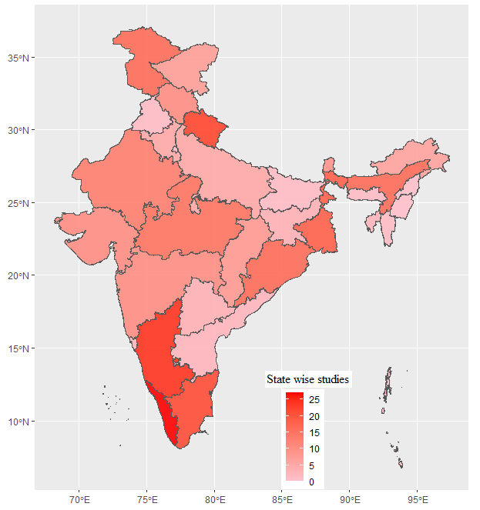

**Fig 1. Map showing the number of studies across Indian states**

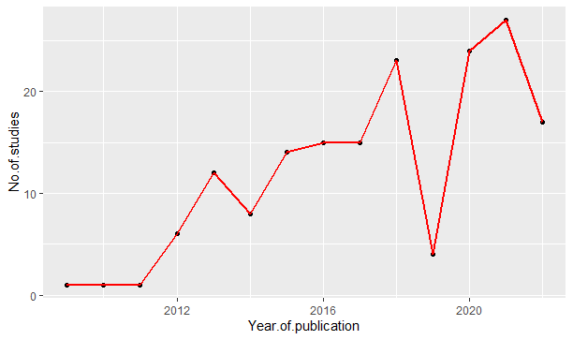

**Fig 2. Temporal pattern of studies on HWC in India**

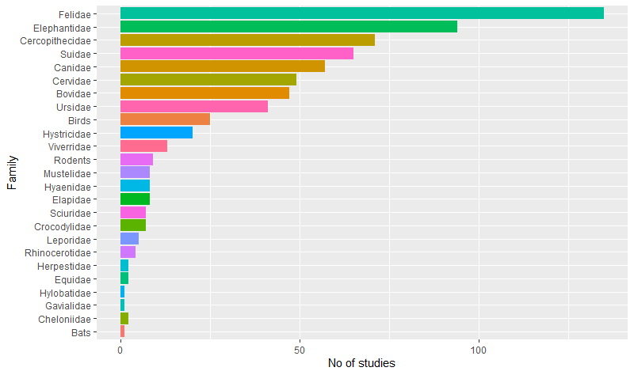

**Fig 3. Distribution of family-wise conflict species**

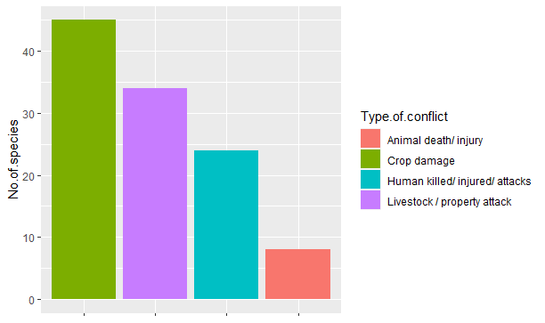

**Fig 4. Graph showing the type of conflicts of HWC**

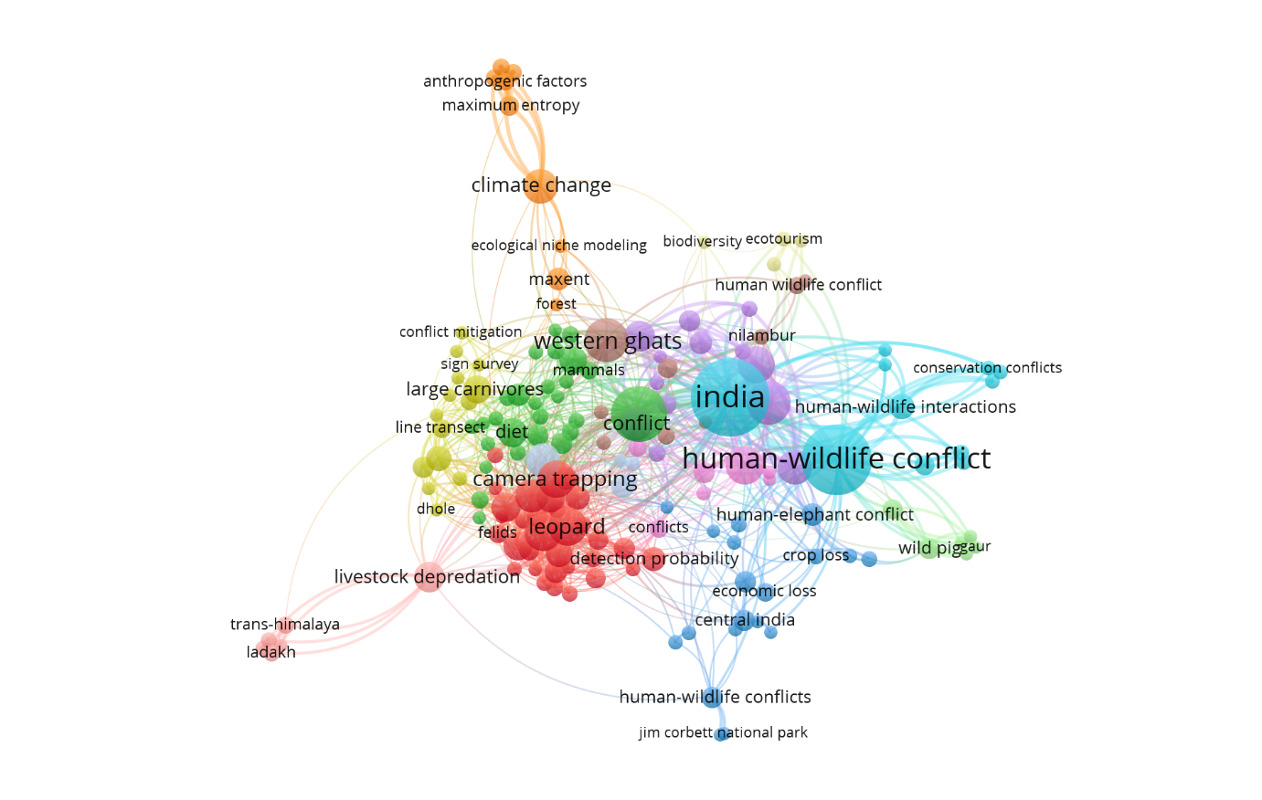

**Fig 5. VOSViwer network of keywords co-occurrence for HWC articles published in India.**