**Response of Plant Growth Regulators and Organic Manures on Growth and Yield of Okra (*Abelmoschus esculentus* L.)**

# ABSTRACT

A field experiment was conducted during the Kharif season of 2024–25 at the Research Farm, Faculty of Agriculture and Veterinary Sciences, Mewar University, Chittorgarh, Rajasthan, to evaluate the effects of plant growth regulators (PGRs) and organic manures on the growth and yield performance of okra (*Abelmoschus esculentus* L.) cv. ‘Pusa Sawani’. The experiment was laid out in a randomized block design with three replications and 16 treatment combinations comprising foliar sprays of GA₃ (50 ppm), NAA (50 ppm), and their combination, along with applications of farmyard manure (FYM), vermicompost, and their integrated use. Results revealed significant improvements in vegetative growth, flowering, and yield attributes under combined application of GA₃ 50 ppm + NAA 50 ppm with FYM 10 t/ha + vermicompost 5 t/ha (P₃O₃). This treatment recorded maximum plant height (74.51 cm), number of branches (4.29), number of leaves per plant (21.54), early flowering (36.90 days to 50% flowering), and the highest yield parameters, including number of fruits per plant (22.62), fruit length (14.43 cm), fruit girth (6.45 cm), average fruit weight (13.22 g), and fruit yield (144.82 q/ha). These findings demonstrate the synergistic role of plant growth regulators and organic manures in enhancing okra productivity through improved physiological growth and reproductive efficiency. The integrated treatment (P₃O₃) significantly outperformed individual applications and the control, suggesting its practical relevance for eco-friendly and sustainable okra cultivation. Hence, foliar application of GA₃ and NAA in conjunction with FYM and vermicompost offers an effective agronomic strategy to boost yield and ensure soil health. Further multi-seasonal studies are recommended to validate these findings across different agro-ecological regions.

***Keywords****: Okra, Plant Growth Regulators, GA₃, NAA, FYM, Vermicompost, Yield enhancement*

1. **INTRODUCTION**

Vegetable cultivation plays a vital role in Indian Agriculture; it is helpful to meet food and nutritional security and provide livelihood as well as income to rural areas. It also generates foreign trade meets export demand and raw material for processing industries. Total area under vegetables cultivation is 2855254 hectares with a production of 335245 million tons (Anonymous, 2024-25). Okra is one of the important vegetable crops of India. Okra (*Abelmoschus esculentus* (L.) is an annual vegetable crop of Malvaceae family. It grows quickly, tall and bears maximum number of fruits, which contributes to the maximum yield per unit area. In India total area under okra crop is 531000 hectares with the production of 646000 million tonnes and productivity of 11.84 tonnes per hectare (Anonymous, 2022). Yield enhancement is one of the most important objectives of any vegetable crop. It can be achieved by two ways. Primarily increase in yield through high yielding and resistant varieties, secondary through achieving higher productivity potential of variety by good seed quality, plant nutrient application and cultural practices and environmental conditions (Kusvuran, 2012). “PGRs are now a days becomes an important contributor which influence the plant physiology and yield. It may apply at different stages. It stimulates or retards natural growth from germination to senescence” (Das and Das, 1995). It can be applied in various ways *viz.* seed treatment, foliar application, shoot and root dipping, drenching, flower and stem injection (Khandaker *et al*., 2018). “Plant growth regulators are the chemical substance, when applied in small amounts modify the growth of plants by stimulating or inhibiting part of the natural growth regulatory system. The growth regulators include both growth promoters and retardants, which have shown to modify the canopy structure and however, yield. The response of growth regulators depends upon the amount of particular compound absorbed by the plant and ability of the plant to respond to the stimulus of the chemical applied” (Edwards *et al*., 2004). Growth regulators are considered to be a key factor in vegetative growth, flowering, pod setting and high yield in okra. Various PGRs were found effective in okra productivity like Gibberellins, IAA, NAA, Triacontanol and Salicylic acid etc. GA3 is a natural plant hormone. GA3 has many effects on plant growth such as enhance stem and internodes elongation, fruit setting and fruit growth and enzyme production during germination. “The role of GA3 in cell elongation in plants has been well stabilizing which resulted in increasing the plant height. GA3 also enhance, early flowering in many plant species. Contrary to GA3, cycocel has been found to retard plant height by reducing internodes length and also simultaneously induces the formation of lateral shoots thereby plant possess a greater number of fruits bearing shoots” (Babu et al., 2022). Organic manure has been identified as one of the potential processes in managing waste. Since it is a natural process, cost effective and required only for shorter duration. “Organic manures are very cheap and easily available, apart from partially fulfilling the nutrient demand, improve soil structure, enhance fertility and promote biological activity. The organic manure gives better quality produce as compared to those grown with the inorganic source of fertilizer. But the release of nutrients from organic sources is much slower than chemical fertilizers, for which rapid demand of crop needs cannot be met through organic manures alone” (Shiriyappagoudar, T., & Saikia, J. 2019).

# MATERIALS AND METHODS

### **2.1 Experimental Site and Conditions**

The field experiment was conducted during the Kharif season of 2024–25 at the Research Farm, Department of Agriculture (Horticulture), Faculty of Agriculture and Veterinary Sciences, Mewar University, Gangrar, Chittorgarh, Rajasthan, India. The experimental site is situated at an altitude of approximately 394 meters above mean sea level, characterized by a semi-arid climate with moderate rainfall and high temperature during the cropping season. The soil of the experimental field was sandy loam in texture, saline in reaction (pH 7.6), and low in fertility status. It was poor in organic carbon (0.16%), deficient in available nitrogen (176 kg/ha), phosphorus (20.2 kg/ha), zinc (0.48 ppm), and iron (1.2 ppm), while medium in potassium (320 kg/ha).

### **2.2 Experimental Design and Treatments**

The experiment was laid out in a **Randomized Block Design (RBD)** with three replications and 16 treatment combinations involving plant growth regulators (PGRs) and organic manures. The treatments were as follows:

* **Plant Growth Regulator Levels (P):**
  + P₀: Control (no PGR)
  + P₁: GA₃ @ 50 ppm
  + P₂: NAA @ 50 ppm
  + P₃: GA₃ @ 50 ppm + NAA @ 50 ppm
* **Organic Manure Levels (O):**
  + O₀: Control (no organic manure)
  + O₁: FYM @ 10 t/ha
  + O₂: Vermicompost @ 5 t/ha
  + O₃: FYM @ 10 t/ha + Vermicompost @ 5 t/ha

Each treatment was randomly assigned in 48 plots (16 treatments × 3 replications), with a uniform plot size maintained for consistency.

### **2.3 Crop and Cultural Practices**

The okra variety **‘Pusa Sawani’**, known for its high yielding ability and wide adaptability, was used as the test crop. Seeds were sown at a spacing of 45 cm × 30 cm. Recommended agronomic practices for okra cultivation including seed treatment, irrigation, weeding, and pest control were uniformly followed across all experimental plots. Organic manures (FYM and vermicompost) were thoroughly mixed into the soil 15 days prior to sowing as per the respective treatment combinations. Foliar application of plant growth regulators (GA₃ and NAA) was done at 30 and 45 days after sowing (DAS) using a hand sprayer.

### **2.4 Data Collection and Statistical Analysis**

Observations were recorded on various growth and yield parameters such as plant height, number of branches per plant, number of leaves per plant, days to 50% and 100% flowering, number of fruits per plant, fruit length, fruit girth, average fruit weight, and total fruit yield per hectare. Data were statistically analyzed using **Analysis of Variance (ANOVA)** appropriate for a randomized block design to test the significance of differences among treatment means. Critical Difference (CD) at 5% level of significance was calculated for comparing treatment means where the F-test was significant.

1. **RESULTS AND DISCUSSION**

# 3.1 Growth parameters

Response of plant growth regulators and organic manures on growth parameters of okra tabulated in Table 1 and illustrated in fig. 1**.** Significant differences were found of plant growth regulators were observed among the treatments for plant height at 30 and 60 DAS. The maximum plant height was recorded with P3-GA3 50 ppm + NAA 50 ppm (27.25 and 71.33 cm), it was found at par with P1-GA3 50 ppm (26.67 and 69.87 cm) and P2-NAA 50 ppm (26.34 and 69.00 cm). The minimum plant height was recorded with P0-Control (25.68 and 67.29 cm), respectively. Significant differences were found of organic manures were observed among the treatments for plant height at 30 and 60 DAS. The maximum plant height was recorded with O3-FYM 10 t/ha + Vermicompost 5 t/ha (28.44 and 74.51 cm), closely followed by treatments O2-Vermicompost 5 t/ha (26.83 and 70.22 cm). The minimum plant height was recorded with P0-Control (24.56 and 64.35 cm), respectively. Significant differences were found of plant growth regulators were observed among the treatments for number of branches per plant at 90 DAS. The maximum number of branches per plant was recorded with P3-GA3 50 ppm + NAA 50 ppm (3.88), closely followed by P1-GA3 50 ppm (3.63). The minimum number of branches per plant was recorded with P0-Control (3.42). Significant differences were found of organic manures were observed among the treatments for number of branches per plant at 90 DAS. The maximum number of branches per plant was recorded with O3-FYM 10 t/ha + Vermicompost 5 t/ha (4.29), closely followed by treatments O2-Vermicompost 5 t/ha (3.71). The minimum number of branches per plant was recorded with P0-Control (3.02). Significant differences were found of plant growth regulators were observed among the treatments for number of leaves per plant at 90 DAS. The maximum number of leaves per plant was recorded with P3-GA3 50 ppm + NAA 50 ppm (20.42), it was found at par with P1-GA3 50 ppm (19.82). The minimum number of leaves per plant was recorded with P0-Control (18.91). Significant differences were found of organic manures were observed among the treatments for number of leaves per plant at 90 DAS. The maximum number of leaves per plant was recorded with O3-FYM 10 t/ha + Vermicompost 5 t/ha (21.54), closely followed by treatments O2-Vermicompost 5 t/ha (19.86). The minimum number of leaves per plant was recorded with P0-Control (17.94). Significant differences were found of plant growth regulators were observed among the treatments for days required to 50% flowering. The minimum days required to 50% flowering was recorded with P3-GA3 50 ppm + NAA 50 ppm (38.89 days), it was found at par with P1-GA3 50 ppm and P2-NAA 50 ppm (39.18 and 39.46 days). The maximum days required to 50% flowering was recorded with P0-Control (39.98 days). Significant differences were found of organic manures were observed among the treatments for days required to 50% flowering. The minimum nu days required to 50% flowering was recorded with O3-FYM 10 t/ha + Vermicompost 5 t/ha (36.90 days), closely followed by treatments O2-Vermicompost 5 t/ha (39.42 days). The maximum days required to 50% flowering was recorded with P0-Control (41.19 days). Significant differences were found of plant growth regulators were observed among the treatments for days required to 100% flowering. The minimum days required to 100% flowering was recorded with P3-GA3 50 ppm + NAA 50 ppm (43.17 days), it was found at par with P1-GA3 50 ppm and P2-NAA 50 ppm (43.46 and 43.74 days). The maximum days required to 100% flowering was recorded with P0-Control (44.26 days). Significant differences were found of organic manures were observed among the treatments for days required to 100% flowering. The minimum nu days required to 100% flowering was recorded with O3-FYM 10 t/ha + Vermicompost 5 t/ha (41.18 days), closely followed by treatments O2-Vermicompost 5 t/ha (43.70 days). The maximum days required to 100% flowering was recorded with P0-Control (45.47 days). Similar result also reported by Kumari (2022), Choudhary *et al.* (2024), Abdullah *et al.* (2024), Yadav *et al.* (2023), Gupta *et al*. (2019), Meena *et al*. (2019) and Kumar *et al.* (2024).

* 1. **Yield attributes**

Response of plant growth regulators and organic manures on yield parameters of okra tabulated in Table 2 and illustrated in Fig. 2. Significant differences were found of plant growth regulators were observed among the treatments for number of fruits per plant. The maximum number of fruits per plant was recorded with P3-GA3 50 ppm + NAA 50 ppm (20.44), closely followed by P1-GA3 50 ppm and P2-NAA 50 ppm (19.36 and 18.81). The minimum number of fruits per plant was recorded with P0-Control (17.96). Significant differences were found of organic manures were observed among the treatments for number of fruits per plant. The maximum number of fruits per plant was recorded with O3-FYM 10 t/ha + Vermicompost 5 t/ha (22.62), closely followed by treatments O2-Vermicompost 5 t/ha (19.58). The minimum number of fruits per plant was recorded with P0-Control (16.12). Significant differences were found of plant growth regulators were observed among the treatments for fruit length. The maximum fruit length was recorded with P3-GA3 50 ppm + NAA 50 ppm (13.74 cm), it was found at par with P1-GA3 50 ppm (13.22 cm). The minimum fruit length was recorded with P0-Control (12.50 cm). Significant differences were found of organic manures were observed among the treatments for fruit length. The maximum fruit length was recorded with O3-FYM 10 t/ha + Vermicompost 5 t/ha (14.43 cm), closely followed by treatments O2-Vermicompost 5 t/ha (13.49 cm). The minimum fruit length was recorded with P0-Control (11.54 cm). Significant differences were found of plant growth regulators were observed among the treatments for girth of fruit. The maximum girth of fruit was recorded with P3-GA3 50 ppm + NAA 50 ppm (5.71 cm), it was found at par with P1-GA3 50 ppm (5.85 cm). The minimum girth of fruit was recorded with P0-Control (5.56 cm). Significant differences were found of organic manures were observed among the treatments for girth of fruit. The maximum girth of fruit was recorded with O3-FYM 10 t/ha + Vermicompost 5 t/ha (6.45 cm), closely followed by treatments O2-Vermicompost 5 t/ha (6.04 cm). The minimum girth of fruit was recorded with P0-Control (5.04 cm). Significant differences were found of plant growth regulators were observed among the treatments for average fruit weight. The maximum average fruit weight was recorded with P3-GA3 50 ppm + NAA 50 ppm (12.73 g), it was found at par with P1-GA3 50 ppm and P2-NAA 50 ppm (12.45 and 12.32 g). The minimum average fruit weight was recorded with P0-Control (11.92 g). Significant differences were found of organic manures were observed among the treatments for average fruit weight. The maximum average fruit weight was recorded with O3-FYM 10 t/ha + Vermicompost 5 t/ha (13.22 g), closely followed by treatments O2-Vermicompost 5 t/ha (12.62 g). The minimum average fruit weight was recorded with P0-Control (11.32 g). Significant differences were found of plant growth regulators were observed among the treatments for fruit yield. The maximum fruit yield was recorded with P3-GA3 50 ppm + NAA 50 ppm (142.35 q/ha), it was found at par with P1-GA3 50 ppm and P2-NAA 50 ppm (141.09 and 139.48 q/ha). The minimum fruit yield was recorded with P0-Control (137.30 q/ha). Significant differences were found of organic manures were observed among the treatments for fruit yield. The maximum fruit yield was recorded with O3-FYM 10 t/ha + Vermicompost 5 t/ha (144.82 q/ha), it was found at par with O2-Vermicompost 5 t/ha (142.18 q/ha). The minimum fruit yield was recorded with P0-Control (132.92 q/ha). Similar findings also observed by Singh *et al.* (2017), Khandaker *et al.* (2018), Kushwaha *et al.* (2020), Gadade *et al.* (2021), Afrose *et al.* (2024) and Abdullah *et al.* (2024).

# CONCLUSION

The present investigation demonstrated that the combined application of plant growth regulators (GA₃ and NAA) and organic manures (FYM and vermicompost) significantly influenced the growth and yield attributes of okra. Among all treatment combinations, the integrated treatment P₃O₃ (GA₃ 50 ppm + NAA 50 ppm + FYM 10 t/ha + Vermicompost 5 t/ha) consistently recorded superior performance across all key parameters. This treatment resulted in the highest plant height, maximum number of branches and leaves per plant, and early flowering. Additionally, it significantly improved yield-related traits such as number of fruits per plant, fruit length, fruit girth, fruit weight, and total fruit yield (144.82 q/ha), indicating enhanced physiological and reproductive efficiency. The findings underscore the synergistic role of exogenous plant growth regulators in combination with nutrient-rich organic amendments in optimizing plant metabolism, structural development, and productivity. The combined use of GA₃ and NAA likely enhanced cell elongation, early flowering, and fruit set, while FYM and vermicompost improved soil structure, microbial activity, and nutrient availability. The control and individual treatments were inferior compared to the integrated approach, reaffirming the importance of holistic nutrient and growth management. Hence, it can be concluded that foliar application of GA₃ and NAA, along with the integrated use of FYM and vermicompost, constitutes a promising eco-friendly strategy for enhancing okra growth and yield sustainably. Further long-term trials across diverse agro-climatic zones are recommended to validate and standardize these results for large-scale adoption by farmers.

**DISCLAIMER (ARTIFICIAL INTELLIGENCE)**

Author(s) hereby declare that NO generative AI technologies such as Large Language Models (ChatGPT, manuscript.

**REFERENCES**

Abdullah, M., Anik, S. M., Nishi, N. J., Jahan, I., Khatun, M. A., Akther, F., & Rahman, M. H. (2024). Application of combined GA3 and NAA treatments to improve yield and quality of Okra (*Abelmoschus esculentus* L.). *Discover Agriculture*, *2*(1), 45.

Adebooye, O. C., & Oputa, C. O. (1996). Effects of galex (r) on growth and fruit nutrient composition of okra (Abelmoschus esculentus (L.) Moench). *Ife Journal of Agriculture*, *18*(1), 1-9.

Afrose, S. N., Akand, M. H., Abira, Z., Haque, M. I., Manik, M. M. H., Islam, Z. & Syfullah, K. (2024). Effect of Potassium and Gibberellic Acid on Some Growth Parameters and Yield of Okra. *International Journal of Plant & Soil Science*, 36(9), 712-722.

Anonymous, (2022). Indian Horticulture Database, published by National Horticulture Board.

Babu, R. S. H., Srilatha, V., & Joshi, V. (2022). Plant growth regulators in mango (*Mangifera indica* L.). In *Plant growth regulators in tropical and sub-tropical fruit crops* (pp. 315-468). CRC Press.

Choudhary, S., Poonia, S., Moond, S. K., Raiger, P. R., Ram, M., & Kuri, R. (2024). Optimal Use of Plant Growth Regulators for Improved Growth, Yield, and Economic Returns of Winter Tomato (Solanum lycopersicum) in arid regions: Optimization of plant growth regulators use in tomato. *Annals of Arid Zone*, 63(1), 107-112.

Das, B.C. and Das, T.K. 1995. Efficacy of GA3, NAA and ethrel on seed expression in pumpkin (*Cucurbita moschata*Poir.) cv. guamala local. *Orissa Journal of Horticulture*, 23(1,2), 87-91.

Gadade, S.B., Kahate, N.S. and Magar, A.S. (2021). Effect of plant growth regulators on biochemical and quality aspects of lady’s finger (*Abelmoschus esculentus* L. Moench), *The Pharma Innovation Journal,* 10(6), 844-846.

Gemede, H.F., Ratta, N., Haki, G.D., Woldegiorgis, A.Z. and Beyene, F. 2015. Nutritional quality and health benefits of okra (*Abelmoschus esculentus*): A Review. *J. Food Process Technol*., 6(6), 458.

Gupta, R., Swami, S. and Rai A.P. 2019. Impact of integrated application of vermicompost, farmyard manure and chemical fertilizers on okra (*Abelmoschus esculentus* L.) performance and soil biochemical properties. *International Journal of Chemical Studies*, 7, 1714-1718.

Khandaker, M.M., Azam, H.M., Rosnah, J., Tahir, D. and Nashriyah, M. 2018. The effects of application of exogenous IAA and GA3 on the physiological activities and quality of *Abelmoschus esculentus* (Okra) *var*. Singa 979. *Pertanika J. Trop. Agric. Sci*., 41(1), 209-224.

Kumar, S., Chopra, S., Ayub, A., & Sharma, D. 2024. Enhancing nutrient utilization in eggplant (*Solanum melongena* L.) through integrated management approaches.

Kushwaha, R., Singh, V.K., Shukla, K.C. and Sahu, M.P. 2020. Effect of plant growth regulators on growth, yield and yield attributing characters of okra (Abelm*oschus esculentus* L.), *International Journal of Chemical Studies* 8(5), 143-145.

Meena, D.C., Meena, M.L. and Kumar, S. 2019. Influence of organic manures and biofertilizers on growth, yield and quality of okra (*Abelmoschus esculentus* L. Moench). *Annals of Plant and Soil Research*, 21, 130-134.

Singh, D., Vadodaria, J.R. and Morwal, B.R. 2017. Effect of GA3 and NAA on Yield and Quality of Okra (*Abelmoschus esculentus* L), *J Krishi Vigyan* 6(1), 65-67.

Yadav, S. L., Topno, S. E., Bahadur, V., Prasad, V. M., & Kerketta, A. (2023). Effect of Different Organic Manure and Inorganic Fertilizer on Growth, Yield and Quality of Okra (*Abelmoschus esculentus* L.). *International Journal of Environment and Climate Change*, 13(8), 1990-1997.

Shiriyappagoudar, T., & Saikia, J. (2019). Performance of chilli (Capsicum annuum) cv.‘Krishna Jolokia’as influenced by organic inputs and microbial consortium under Assam condition. International Journal of Current Microbiology and Applied Sciences, 8(05), 2038-2042.

**Table 1: Response of plant growth regulators and organic manures on growth parameters of okra**

|  |  |  |  |  |  |  |
| --- | --- | --- | --- | --- | --- | --- |
| **Treatments** | **Plant height (cm)** | | **Number of branches per plant at 90 DAS** | **Number of leaves per plant at 90 DAS** | **Days required**  **50% flowering** | **Days required**  **100% flowering** |
| **30 DAS** | **60 DAS** |
| **Plant growth regulators** | | | | | | |
| **P0-Control** | 25.68 | 67.29 | 3.42 | 18.91 | 39.98 | 44.26 |
| **P1-GA3 50 ppm** | 26.67 | 69.87 | 3.63 | 19.82 | 39.18 | 43.46 |
| **P2-NAA 50 ppm** | 26.34 | 69.00 | 3.53 | 19.55 | 39.46 | 43.74 |
| **P3-GA3 50 ppm + NAA 50 ppm** | 27.25 | 71.33 | 3.88 | 20.42 | 38.89 | 43.17 |
| **S. Em. ±** | **0.37** | **0.79** | **0.06** | **0.30** | **0.27** | **0.27** |
| **CD%** | **1.06** | **2.28** | **0.19** | **0.86** | **0.78** | **0.78** |
| **Organic manures** | | | | | | |
| **O0-Control** | 24.56 | 64.35 | 3.02 | 17.94 | 41.19 | 45.47 |
| **O1-FYM 10 t/ha** | 26.11 | 68.41 | 3.43 | 19.36 | 39.99 | 44.27 |
| **O2-Vermicompost 5 t/ha** | 26.83 | 70.22 | 3.71 | 19.86 | 39.42 | 43.70 |
| **O3-FYM 10 t/ha + Vermicompost 5 t/ha** | 28.44 | 74.51 | 4.29 | 21.54 | 36.90 | 41.18 |
| **S. Em. ±** | **0.37** | **0.79** | **0.06** | **0.30** | **0.27** | **0.27** |
| **CD%** | **1.06** | **2.28** | **0.19** | **0.86** | **0.78** | **0.78** |

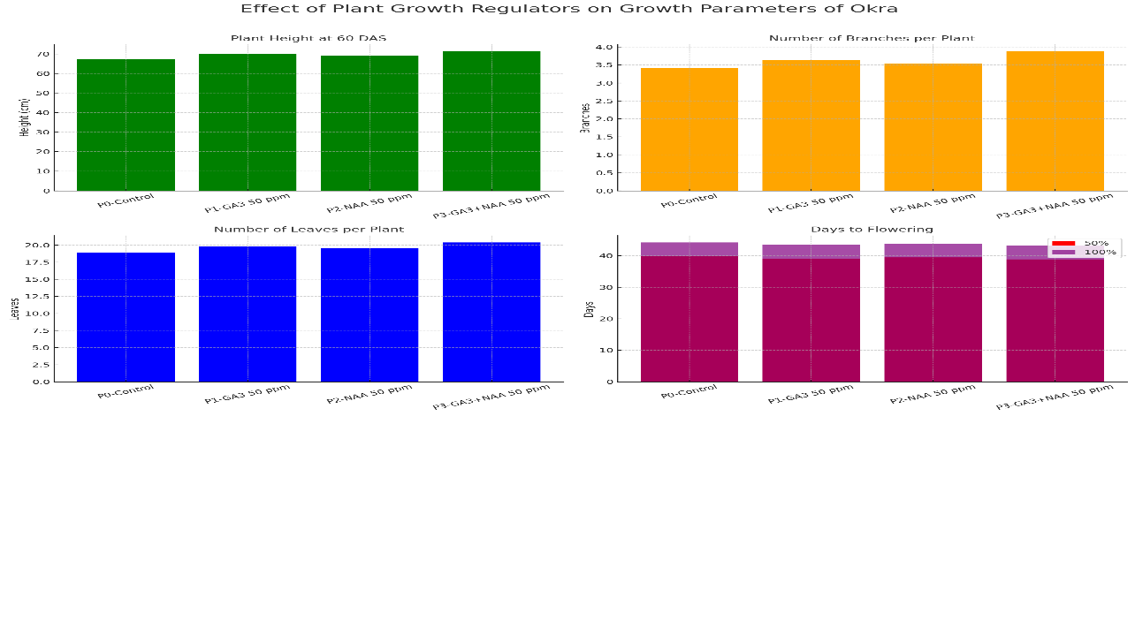

**Fig. 1 Graph represent the response of plant growth regulators and organic manures on growth parameters of okra**

**Table 2: Response of plant growth regulators and organic manures on yield parameters of okra**

|  |  |  |  |  |  |
| --- | --- | --- | --- | --- | --- |
| **Treatments** | **Number of fruits per plant** | **Fruit length (cm)** | **Girth of fruit (cm)** | **Average fruit weight (g)** | **Fruit yield (q/ha)** |
| **Plant growth regulators** | | | | | |
| **P0-Control** | 17.96 | 12.50 | 5.56 | 11.92 | 137.30 |
| **P1-GA3 50 ppm** | 19.36 | 13.22 | 5.85 | 12.45 | 141.09 |
| **P2-NAA 50 ppm** | 18.81 | 12.97 | 5.71 | 12.32 | 139.48 |
| **P3-GA3 50 ppm + NAA 50 ppm** | 20.44 | 13.74 | 6.09 | 12.73 | 142.35 |
| **S. Em. ±** | **0.30** | **0.22** | **0.10** | **0.15** | **1.23** |
| **CD%** | **0.85** | **0.63** | **0.30** | **0.44** | **3.56** |
| **Organic manures** | | | | | |
| **O0-Control** | 16.12 | 11.54 | 5.04 | 11.32 | 132.92 |
| **O1-FYM 10 t/ha** | 18.26 | 12.97 | 5.68 | 12.26 | 140.30 |
| **O2-Vermicompost 5 t/ha** | 19.58 | 13.49 | 6.04 | 12.62 | 142.18 |
| **O3-FYM 10 t/ha + Vermicompost 5 t/ha** | 22.62 | 14.43 | 6.45 | 13.22 | 144.82 |
| **S. Em. ±** | **0.30** | **0.22** | **0.10** | **0.15** | **1.23** |
| **CD%** | **0.85** | **0.63** | **0.30** | **0.44** | **3.56** |

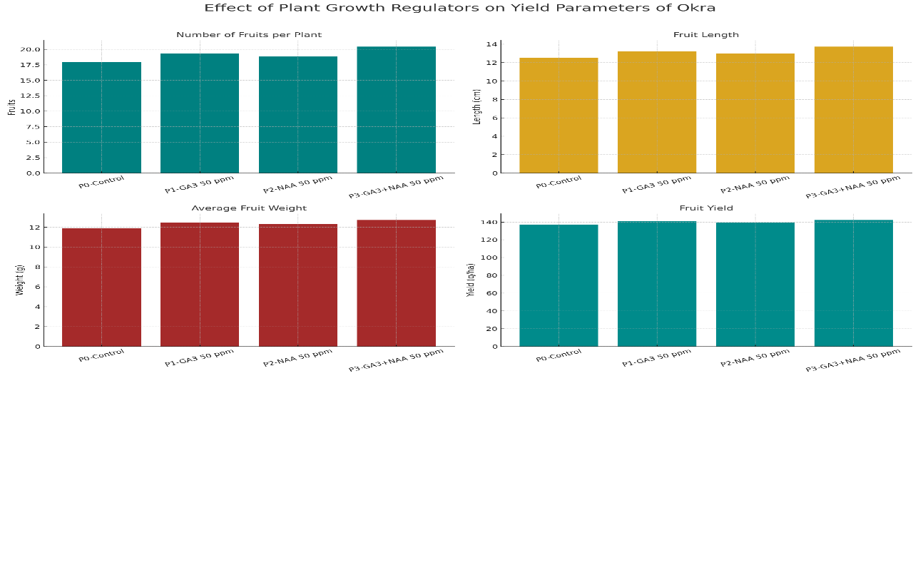

**Fig. 2 Graph represent the response of plant growth regulators and organic manures on yield parameters of okra**