A Review on Microsporidia causing Pebrine disease in Mulberry Silkworm (Bombyx mori L.)

Abstract: The major constraints in silk cocoon production are occurrence of the diseases in silkworm. Silkworm, Bombyx mori L. is poikilothermic hence, it is unable to regulate its body temperature. So, even minute changes in the rearing environment makes the silkworm susceptible to many viral, bacterial, fungal and protozoan diseases. Pebrine (protozoan disease) is a major disease of the silkworm, B. mori caused by microsporidian parasite, Nosema bombycis N. Microsporidian disease remained as a threat to the silk industry since time immemorial, because it is the only disease of silkworm which is transmitted both vertically and horizontally. The literature reveals that, the disease has become more complex now because of the occurrence of different strains, alternate hosts and cross infectivity of microsporidians. So, development of early detection and elimination techniques of pebrine disease is essential for sustenance of cocoon crop production.
Keywords: Mulberry Silkworm, Microsporidia, Pebrine disease, parasite
Introduction: Disease is a condition in which a state of physiological equilibrium of the host with the environment become unbalanced. The major constraints in silk cocoon production are occurrence of the diseases in silkworm. In India, the annual crop loss due to silkworm diseases is to an extent of 15-20%. Silkworm, Bombyx mori L. is poikilothermic hence, it is unable to regulate its body temperature. So, even minute changes in the rearing environment makes the silkworm susceptible to many viral, bacterial, fungal and protozoan diseases. Pebrine (protozoan disease) is a major disease of the silkworm, B. mori caused by microsporidian parasite, Nosema bombycis N. The name pebrine was coined by De Quadrefagues in 1860. It is named because, appearance of pepper like spots on the diseased larvae in advanced stage of infection. This disease is also known as Kata or Matha kata in Bengali and Gantu or Gantu roga in Kannada. “Microsporidian disease remained as a threat to the silk industry since time immemorial, because it is the only disease of silkworm which is transmitted both vertically and horizontally. The disease spreads quickly and takes a heavy toll of silkworm and even results in total crop failure when the infection is severe”. (Govindan et al., 1998).
Causitive agent: The infective form of the parasite is a spore. Microsporidia is a primitive eukaryote with polaroplast, ribosome, posterior vacuole, well defined nuclei and plasma membrane, but lack some typical organelles like mitochondria, stacked golgi and peroxisomes. “The spore wall is composed of three layers: Protective exospore made up of proteins, endospore made up of chitin and a plasma membrane. The unique extrusion apparatus inside the spore consists of coiled polar tube (the number of coils depends on the particular species and varies from a few to 30 or more) that is ending at the apical part of the spore in an anchoring disc”. (Frazen and Muller, 1999).
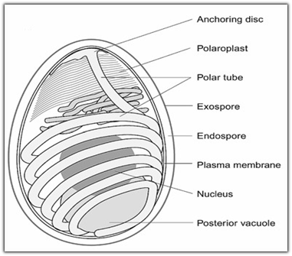
Figure 1. Structure of microsporidia. Adopted from (Frazen and Muller, 1999)

The spores examined under light microscope appear as bright spots because of their highly refractile spore coat, outerline of spore is smooth and also exhibit Brownian movement. “Mature spore is oval to ovo-cylindrical in shape and measure approximately 3.8 × 2.2µm (L × W). They can remain infective even after three years in dried body of female moth and remain active after being submerged in water for five months” (Rahul et al., 2021).

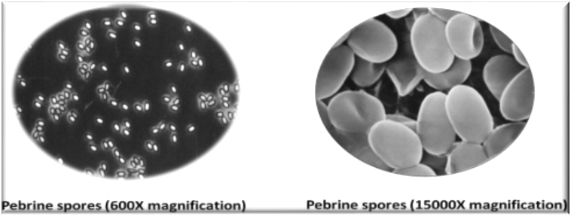
Figure 2: pebrine spores under 600X and 15000X magnification. Adopted from (Rahul et al., 2021).
HISTORY OF THE DISEASE: “The history of sericulture reveals devastating impact of microsporidiosis in several sericultural countries resulting in severe damage to sericulture industry. The first scientific record of occurrence of the disease came from France in 1845, subsequently the French and Italian silk industry collapsed. Later the disease spread to Spain, Syria and Romania” (Steinhaus, 1949). In India, the first report of occurrence of the disease was from Mysore in 1866 followed by an epidemic level outbreak of the disease in Kashmir in 1878 due to this out break, the Kashmir lost its productive indigenous univoltine breed “Kashmir Race”.

CLASSIFICATION OF MICROSPORIDIA: The taxonomy of microsporidia has undergone several revisions since its original description in the middle of the 19th century, when Nageli considered Nosema to be yeast like fungus. Nageli considered Nosema to be a member of the schizomycetes fungi although classification at that time did not reflect the true diversity of microbial life and schizomycetes were considered as a grab of yeast and bacteria. After further study, Balbiani in 1882 created a new group “Microsporidia” for Nosema. Microsporidia are unusual group of eukaryotic, obligate intracellular parasites causing microsporidiosis in insects. Bhat et al. (2009) reported that modern taxonomists follow the system developed by Sprague (1991)
List 1: Classification of Microsporidia
Phylum | Microspora
Class | Microsporea
Order | Microsporida
Sub-order | Apanosporoblastina
Family | Nosematidae
Genus | Nosema
Species | Bombycis

Bhat et al. (2017) stated that “by the end of 19th century, N. bombycis alone was known as causative agent of microsporidiosis in silkworm but present research work has revealed that there are several other microsporidia belonging to different genera, causing microsporidiosis in silkworm. These spores are different in spore shape, size as well as in pathogenicity” (Table 1 & 2).
Table 1: Pathogenicity of different microsporidia infecting mulberry silkworm (Bhat et al., 2017)
Microsporidian isolates | Pathogenicity | Spore form | Spore size (µm)
Microsporidian isolates | Pathogenicity | Spore form | Length | Width
N. bombycis | High | Oval | 3.8 | 2.6
Nosema sp. M11 | Low | Oval | 3.9 | 1.9
Nosema sp. M12 | Low | Ovo-cylindrical | 4.5 | 2.0
Pleistophora sp | High | Oval | 2.7 | 1.6
Thelophania sp. (M 32) | Low | Oval | 3.4 | 1.7
NIK-2r | Low | Oval | 3.6 | 2.8
NIK-4m | Low | Oval | 5.0 | 2.1
NIK-5hm | High | Ovo-cylindrical | 5.0 | 3.1
Nosema sp. Lb_{ms} | Low | Ovo-cylindrical | 4.36 | 2.14
Microsporidian sp. S_{I} | High | Oval | 1.73 | 1.01
NIAP-6p | - | Oval | 5.00 | 2.40
NIAP-7g | - | Oval | 4.60 | 2.50
NIK-5d | - | Oval | 3.70 | 2.70
NIK-1Pr | High | Ovo-cylindrical | 5.41 | 2.85
NIK-1Cc | Low | Oval | 4.60 | 2.77
NIK-1Cpy | High | Oval | 4.96 | 2.85
NIK-1So | High | Ovo-cylindrical | 5.26 | 2.61
NIK-1Dp | Low | Oval | 4.27 | 2.79
Msp | - | Ovo-cylindrical | 5.38 | 2.92

Table 2: Site of infection of different microsporidians in silkworm (Bhat et al., 2017).
Microsporidia | Host tissues
Microsporidia | Gut epithelium | Malpighian tube | Muscle | Fat body | Silk gland | Gonad
N. bombycis NIS-001 | + | + | + | + | + | +
Nosema sp. NIS-M11 | - | + | + | + | + | -
Vairimorpha sp.  NIS-M12 | - | + | + | + | + | -
Nosema sp. NIS-M14 | - | + | + | + | + | -
Microsporidian  NIS-M25 | - | + | + | + | + | -
Plistophora sp.  NIS-M27 | + | - | - | - | - | -
Thelohania sp.  NIS-M32 | - | + | - | - | - | -
Nosema sp. NIK-is | + | + | + | + | + | +
Nosema sp. NIK-2r | + | + | + | + | + | +
Nosema sp. NIK-3h | - | + | + | - | + | -*
Vairimorpha sp. NIK-4m | +* | - | - | - | - | -
(-*): Cyst formation on the surface of gut, (+*): Formation of spores only in heavily infected larvae,
(-): No infection, (+): Infection.

PREVALENCE OF THE DISEASE IN THE FIELD: “The prevalence of the microsporidiosis in India was about 15% in 1983. In 1991 - 1992 an outbreak of microsporidiosis was witnessed in southern sericultural states of India causing a loss of over 200 crores. In Jammu and Kashmir the disease inflicts an annual loss of 5%. Normally microsporidiosis occurrence in India is of low intensity during summer and high in winter season due to increase in the lepidopteron insects. In temperate sericultural areas like Jammu and Kashmir, the incidence of microsporidiosis is high in summer and low in spring. The incidence of microsporidian disease varies with the race of silkworm, the developmental stages and the rearing environment” (Singh et al., 2003).
Rahmathulla et al. (2012) from his study reported that “during the year 2008, the infection was recorded very low (January-February and March- April months and succeeding months (May-June) infection was not at all recorded. After onset of monsoon, the infection was reappeared and further increased and reached maximum during the month of October-November (13.96 %). Similar, observations were recorded in 2009 and results showed that infection was recorded low (5.49 and 0.43%, respectively for December-January and February-March). During summer months, (April-June) infection was not recorded. The infection was again noticed during rainy season and it was reached peak stage during the period of October-November l 1.49 %). The observation was in similar line during the year 2010 and the results revealed that as usual the infection was started with a low intensity during January (3.20%) and further disease incidence was reduced during the months of February-March (1.67%). Summer it was recorded significantly very low (0.08% for April-May and 0.06% for Jun-July) and the infection were increased during the succeeding months and highest was recorded during October-November period (20.7%). The three years of data clearly indicated that during October-November months recorded maximum infection and highest values of high humidity coincide with minimum temperature experienced to contribute the multiplication of pathogen”.
MODE OF INFECTION AND TRANSMISSION METHODS
A. Transovarial/Embryonic/Vertical Transmission: Embryonic infection occurs when the pathogen infects fourth or fifth instar larvae in which it invades the epithelial cells of the ovaries and then parasites are transferred to the oogonia, oocytes and nutritive cells. Parasitism of the oocytes may result in death of the resultant eggs after being laid. If non-infected oocytes absorbs the nutrient material from infected nutritive cells, the protozoan will pass over to the oocytes and may cause infection to the embryos (Govindan et al., 1998).
B. Horizontal Transmission: i) Contamination in rearing bed: Secondary contamination takes place in the rearing bed through the faecal matter of the infected larvae, contaminated tray, dust from the contaminated room and dead larvae infected with disease. ii)Through mulberry leaf: Improper disposal of silkworm litter, infected larvae and use of incompletely decomposed silkworm bed refuse in mulberry fields as manure may form a source of contamination to the mulberry leaves. iii)Through layings: Incubation of layings in contaminated room without proper disinfection, results in surface contamination of eggs and larvae get infected (Govindan et al., 1998).
INFECTION CYCLE OF MICROSPORIDIA
- The spore, when swallowed by the silkworm through contaminated food, germinates under alkaline conditions inside the midgut of host with the help of digestive juice and produces a long polar filament on the end of which grows a sporoplasm
- The sporoplasm has one or two nuclei and other cell organs and possesses limited membrane
- The polar filaments are anchor firmly to the gut wall by penetrating the epithelial cells of the alimentary canal
- The sporoplasm emerging from the spore invades the cytoplasm of the host
- The two nuclei of the sporoplasm unite to form a uninucleate planont, which reproduces by binary fission
- The planont which initially infects the gut later passes through the gut wall and invades the various tissues
- Once the planont penetrates the host cell, it transforms into a sedentary form and becomes localized This stage is known as meront
- Meront is an intracellular stage and has a definite cell wall which absorbs nutrients from host cell. The meront is formed within 2-3 days after infection. It reproduces by binary fission and multiple budding
- Meronts develop into sporonts, which are characterized by a dense surface coat. Sporonts multiply by binary or multiple fission and divide into sporoblasts
- Sporoblasts are ovoid bodies that will mature to spores by synthesis of spore organelles
- When cytoplasm of the host cell is exhausted, sporonts are arranged in parallel rows
- The sporonts after massive proliferation fills up the host cells and when nutrients are depleted, sporulation takes place
- The spore completes its life cycle within 4 days(Frazen and Muller, 1999)

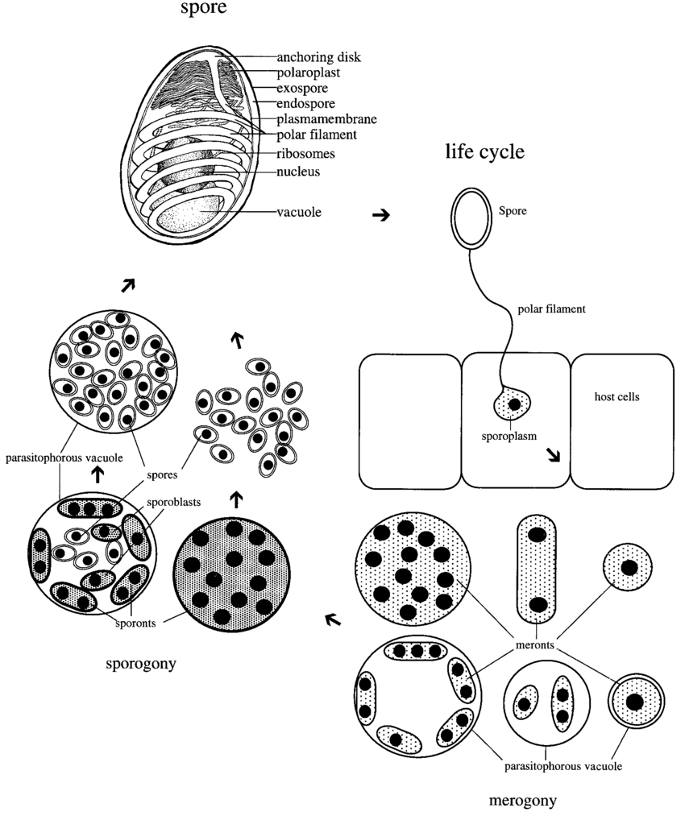
Figure 3: Infection cycle of microsporidia. Adopted from (Frazen and Muller, 1999)

SYMPTOMS OF THE DISEASE: Govindan et al., 1998 stated that symptoms of this disease are observed in all the developmental stages of silkworm as given below
- Egg Stage: The egg count of the infected moth are very less and eggs fail to attach to the egg sheets firmly. The eggs laid by infected moth are mostly unfertile and may be dead. Heavily infected eggs are generally seen in lumps.
- Larval stage
- The infected larvae shows poor appetite, Irregular moulting retarded growth and development results in disparity of size
- Black pepper like spots are also noticed on the skin of heavily infected larvae
- Pebrinised larvae generally die
- Pupal stage
- Infected pupae have swollen and blackish abdomen
- Heavily infected pupae fail to metamorphose into an adult
- Cocoons spun by infected silkworm may become flimsy and malformed
- Moth stage
- Infected moths have deformed wings, distorted antennae and discoloured body
- Infected moths do not exhibit typical mating behaviour and have poor fecundity
- In pebrinised moths, accessory glands are infected, which results in laying loose egg

ALTERNATE HOSTS: Most microsporidians prefer to have an alternate hosts because of many advantages for them like dispersal, transmission and survival. The perpetual incidence of microsporidian infection in silkworm may be due to various sources of secondary contaminations including alternate hosts in and around mulberry garden. Talukdar, (1980) stated that N. bombycis is infectious to Eri silkworm, Indian tasar silkworm, Muga silkworm Chinese tasar silkworm and also found to infect a number of other insect species like Telchinia violae, Pieris rapae, Choristoneura fumiferana, Bombyx mandarina, Arctia caja, Chilo suppressalis.
CROSS INFECTIVITY: Different insects harbouring in and around mulberry garden have been observed to carry microsporidia which are cross-infective to silkworm. Mandal et al. (1994) reported “certain speices of catopsilia which are frequent visitors around mulberry gardens which carry enormous quantity of spores of microsporidia”. In recent studies in SSTL, Bangalore has reported two butterflies i.e Eurena hecabe and Zizina otis which contains microsporidian spores cross infective to silkworm. Further, Spilosoma obliqua a mulberry pest also contains microsporidian spores which are found infective to silkworm.

Bashir et al. (2011) “Screening of different insect pests of mulberry and other agricultural crops for microsporidian infection and revealed that out of eleven insect pests screened for the microsporidian infection, only five were infected namely Pieris rapae, Catopsilia crocale, Catopsilia pyranthe, Spilosoma obliqua and Diaphania pulverulentalis . The microsporidia isolated from these mulberry and agricultural pests were tentatively designated as NIK-1Pr, NIK-1Cc, NIK-1Cpy, NIK-1So and NIK-1Dp wherein NIK represents “National Institute Karnataka” and Pr, Cc, Cpy, So and Dp represent the first letters of the generic and species name of the insect pests, namely, P. rapae, Catopsilia crocale, Catopsilia pyranthe, Spilosoma obliqua and D. pulverulentalis respectively from which these microsporidia were isolated”. From the above study Bashir et al. (2011) reported that isolated microsporidians were serologically different from N. bombycis, Nosema spp. M11, M12 and Lbms and these microsporidians constitute a potential threat to silkworm rearing and mother moth examination.

BREED SUSCEPTIBILITY: Bhat et al. (2009) stated that “tolerance to the microsporidian disease is greater in Chinese breeds, less in Japanese and least in European breeds. In India a silkworm breed namely lamerin is reported to be comparatively tolerant to microsporidian disease as compared to other bivoltine and multivoltine breeds of silkworm. Multivoltine breeds are relatively more resistant than bivoltines”.
MANAGEMENT OF THE DISEASE: For successful prevention and timely curtailing of pebrine disease all the possible detective methods should be employed effectively. Govindan et al. (1998) stated that the pebrine disease is transmitted both vertically and horizontally, this unique characteristic of the disease has made it difficult to completely eliminate it from the silkworm crops. The disease has become more complex now because of the occurrence of different strains of microsporidians infecting the silkworm. So, it is essential that one should have a thorough knowledge of the available methods of detection of pebrine pathogen can be detected timely and effectively which further helps to plan for successful prevention of the disease.
Conclusion: N. bombycis infection causing pebrine in silkworm is transmitted both horizontally and vertically, any lapse in monitoring the progeny could result in serious damage to the sericulture industry. The literature reveals that, the disease has become more complex now because of the occurrence of different strains, alternate hosts and cross infectivity of microsporidians. So, development of early detection and elimination techniques of pebrine disease is essential for sustenance of cocoon crop production.

Disclaimer (Artificial intelligence)
Option 1:
Author(s) hereby declare that NO generative AI technologies such as Large Language Models (ChatGPT, manuscript.
Option 2:
Author(s) hereby declare that generative AI technologies such as Large Language Models, etc. have been used during the writing or editing of manuscripts. This explanation will include the name, version, model, and source of the generative AI technology and as well as all input prompts provided to the generative AI technology
Details of the AI usage are given below:
1.
2.
3.

References:
Bashir, I., Sharma, S. D. & Shabir, A. (2011). Screening of different insect pests of mulberry and other agricultural crops for microsporidian infection. Int. J. Biotech. Mol. Biol. Res., 2(8): 138-142.
Bhat, S. A., Bashir, I. & Kamili, A. S. (2009). Microsporoidiosis of silkworm, Bombyx mori L. (Lepidoptera-Bombycidae). Afr. J. Agric. Res., 4 (13): 1519-1523.

Bhat, I. A., Buhroo, Z. I. & Bhat, M. A.( 2017). Microsporidiosis in silkworm with reference to mulberry silkworm (Bombyx mori L,) Int. J. Entomol. Res., 2(1): 01-09.

Franzen, C. & Mueller, A. (1999). Molecular techniques for detection, species differentiation and phylogenetic analysis of microsporidia. Clin. Microbiol. Rev., 19(7): 4-11.

Govindan, R., Narayanaswamy, T. K. & Devaiah, M. C.(1998). Principles of Silkworm Pathology. Seri Scientific Publishers. pp. 293-351.
Mandal, D. K., Kishore, N., & Brewer, C. F. (1994). Thermodynamics of lectin-carbohydrate interactions. Titration microcalorimetry measurements of the binding of N-linked carbohydrates and ovalbumin to concanavalin A. Biochemistry, 33(5), 1149-1156.
Rahmathulla, V.K., Kishor kumar, C. M., Angadi, B.S. & Sivaprasad, V. (2012). Influence of weather factors on incidence and intensity of microsporidiosis in Silkworm (Bombyx mori L.). J. Entomol., 9 (5): 266-273.

Rahul, K., Manjunatha, G. R. & Sivaprasad, V. (2021). Pebrine monitoring methods in sericulture. Int. J. Indust. Entomol., 5(1): 79-96.

Singh, T. & Saratchandra, B. (2003). Microsporidian disease of the silkworm, Bombyx mori L. (Lepidoptera: Bombycidae). Int. J. Indust. Entomol., 6(1): 1-9.
Sprague Jr, G. F. (1991). [5] Assay of yeast mating reaction. In Methods in enzymology (Vol. 194, pp. 77-93). Academic Press.
Talukdar, J. N. 1(980). Prevalence of tranaovarian infection of microspoidian parasite infecting muga silkworm, Antheraea assamensis. J. Invertebr. Pathol, 36: 273-275.

