**Evaluation of selected silkworm hybrid (FC1XFC2 and FC2XFC1) for rearing performance under sub-temperate conditions of Poonch district of Jammu and Kashmir.**

**ABSTRACT:** Sericulture is an integral part of Indian textile sector contributing significantly for economy combining both farm and industrial aspects. Silkworm *Bombyx mori* (L.) is one of the insects known for production of most versatile silk protein. The growth pattern showed considerable variation from first to last day of the entire larval period for the trail conducted for the study. Evaluation was made for morphological characters of cocoon and results were recorded with phenotypic variation in cocoon colour, shape, shell weight, grains, shell ratio, pupal percentage and pupal weight. Study revealed exponential increase in the larval weight and length until the 5th instar with maximum value on 7th day as 8.5cm & 7.4 cm in FC1xFC2 and FC2xFC1. The maximum and minimum evaluation for larval weight for single and 10 larvae ranged from 45.20g to 0.52g and 36.91g to 0.12g in case of FC1xFC2 and FC2xFC1 respectively. Similarly, maximum single cocoon weight was recorded as 1.46g for FC1xFC2 and 1.30g for FC2xFC1. Thus, the current study holds potential for screening of region and season specific breeds aided with future breeding programmes.

**Keywords:** Silkworm, racial, phenotypic, logarithmical, spinning, cocoon, floss, economic traits, FC1XFC2 and FC2XFC1.

**INTRODUCTION**

**Silk:** Mulberry silk secreted by silkworm larvae of *Bombyx mori* L. primarily composed to sericin the gluey protein and fibroin the core protein. Both sericin and fibroin makes silk as the most versatile natural fiber of insect origin. India is the second largest contributor of global silk production after China and Karnataka is the state sharing largest contribution in country’s production. Mulberry silkworm being monophagous insect, feeds only on mulberry foliage and this preference is due to presence of morin content. As a sector with significant economic potential, sericulture plays a crucial role in rural employment, poverty, alleviation and livelihood generation particularly for marginal farmers. The industry offers substantial entrepreneurial opportunities across its diverse activities. The sericulture sector employed approximately 8.25 million individuals in rural and semi urban areas of India during the year 2015-2016 (Absar et al., 2015). India occupies a distinctive position in the global silk industry as the sole producer of all commercially known silk varieties-namely mulberry, tropical tasar, oak tasar, Eri and Muga. Mulberry sericulture is predominantly practiced in five states namely Karnataka, Andhra Pradesh, West Bengal, Tamil Nadu and Jammu and Kashmir. The North-East region holds a unique distinction as the exclusive producer of golden Muga silk confined primarily to the Assam district only (Bari, et al., 2019).

The advent of new technologies in tropical sericulture has led to the adoption of multivoltine x multivoltine and multivoltine x bivoltine crosses in rearing systems. To compete globally India must adopt bivoltine and bivoltine x bivoltine to improve silk processing technology and overall quality. Despite these efforts, production of international-grade raw silk is only feasible through the use of bivoltine hybrids and double hybrids, processing, the quality of multivoltine x bivoltine silk can be improved marginally. But, production of raw silk of international grade is possible only through introduction of new bivoltine silkworm hybrids and double hybrids, necessitating the development and evaluation of new silkworm hybrids with improved cocoon yield and gradable raw silk (Murthy; 2015). Reports suggest that nutritional efficiency and duration required to produce one gram of cocoon shell fluctuated widely under field conditions (Yokoyama; 2016). These differences are attributed to the physiological adaptation of silkworm to seasonal environments (Yamashita and Majumdar; 2013). Therefore, an attempt has been carried out in this study to evaluate the rearing performance and major quantitative traits of cocoons under sub-temperate conditions of Jammu and Kashmir specifically in Poonch district.

**MATERIALS AND METHODS**

The experiment rearing trial was carried out during the month of March-April 2021 with commercial hybrids namelyFC1XFC2 and FC2XFC1 under the sub-temperate conditions of Poonch district of Jammu and Kashmir. The study was designed and executed at rearing lab of Department of Sericulture, Poonch Campus, University of Jammu, by utilizing the local mulberry variety.

**MATERIAL UTILIZED IN THE STUDY:**

1. Local Mulberry variety (un-identified)
2. FC1XFC2 and FC2XFC1; Silkworm hybrids

**METHODOLOGY FOLLOWED FOR THE STUDY:**

1. **FEED UTILISATION STUDIES**

50 larvae each from 3 replications along control batches were taken for experimental rearing

Feeding frequency @3 times daily at 10:00 AM, 2:00PM and 5:00PM was followed.

Known Feed quantity was provided to measure to ingesta: larval weight gain values

The dry weight of left over leaf, excreta and larval weight will be recorded daily after oven drying at 80°C.

Plastic collapsible mountages applied for spinning of cocoons

On 7th day, cocoons were harvested to evaluate the cocoon parameters

Various cocoon parameters studied included:

1. Larval weight.
2. Larval size.
3. Green cocoon weight.
4. Cocoon with floss.
5. Deflossed cocoon.
6. Dry cocoon weight.
7. Shell weight.
8. Pupal weight.
9. Cocoon shell ratio.
10. Cocoon grains.
11. Cocoon compactness.
12. Cocoon size.
13. Pupal percentage
14. **Statistical Analysis**: The data obtained from current investigation was pooled and subjected to Analysis of Variance (ANOVA) using Statistical Package for the Social Sciences (SPSS) software (Version; 2021), for validation of results. The formulas used for calculation of values are as:

**Cocoon shell ratio:** Weight of the cocoon shell/ Weight of cocoon x 100 (Kumari et al., 2011).

**RESULTS AND DISCUSSION**

1. **Larval Weight:** The weight of the larvae is directly proportional to the amount of food consumed to the amount of food consumed During the feeding (Chakraborty, et al. 2020). The weight (in mg) of the larvae was measured using a sensitive, digital electronic weighing balance. Each day the larval weight for individual larvae and sets of 10 larvae at different instars were recorded showing significant increase (Table-01). The maximum and minimum values for larval weight for single and 10 larvae ranged from 45.20g to 0.52g and 36.91g to 0.12g in FC1 × FC2 and FC2 × FC1 respectively on 5th and 3rd instar for both the hybrids. Interestingly, these findings align well with previous results by (Gatin et al., 1965; Das et al., (2011) and Kunhamed et al., 2013). A Similar experiment on feed utilization was reported by (Chakraborty et al., 2020 & Yu and Fraisse; 2021).

**Table 1: larval weight recorded for single and 10 larvae from 3rd instar, 4th instar and 5th instar (per day) FC1 × FC2 and FC2 × FC1 silkworm hybrid.**

**3RD INSTAR**

|  |  |  |  |
| --- | --- | --- | --- |
| **3rdInstar** | **Number of Days** | **FC1×FC2 silkworm hybrid** | **FC2×FC1**  **silkworm hybrid** |
| **Weight of Single Larva (g)** | **01** | 0.52±0.02b | 0.12±0.11 b |
| **02** | 0.54±0.04c | 0.15±0.22 bc** |
| **03** | 0.60±0.06c | 0.21±0.43 c |
| **04** | **-** | **-** |
| **Weight of 10 Larvae(g)** | **01** | 3.61±1.16b | 2.74±1.17 b |
| **02** | 3.92±1.11c | 3.02±1.85 bc** |
| **03** | 4.01±1.14c | 3.22±1.64 c |
| **04** | **-** | **-** |

**4TH INSTAR**

|  |  |  |  |
| --- | --- | --- | --- |
| **4th Instar** | **Days** | **FC1 × FC2** | **FC2 × FC1** |
| **Weight of Single Larva(g)** | **01** | 0.62±0.05a | 0.24±0.08 a |
| **02** | 0.78±0.04ab** | 0.31±0.22 ab** |
| **03** | 0.86±0.03ab** | 0.39±0.22 bc** |
| **04** | 0.89±0.07ab** | 0.45±0.21 c |
| **05** | 0.95±0.02a | 0.57±0.11 d |
| **Weight of 10 Larvae(g)** | **01** | 4.21±2.33a | 3.28±2.15 a |
| **02** | 5.2±3.568b | 4.12±2.15 a |
| **03** | 6.43±3.56c | 4.73±2.22 b |
| **04** | 7.08±4.67c | 5.58±1.85 c |
| **05** | 8.12±4.57d | 6.24±4.76 d |

**5TH INSTAR**

|  |  |  |  |
| --- | --- | --- | --- |
| **5th Instar** | **Days** | **FC1×FC2** | **FC2×FC1** |
| **Weight of Single Larva** | **01** | 1.29±0.95a | 0.92±0.66 a |
| **02** | 1.95±0.22ab** | 1.21±0.66 a |
| **03** | 2.01±0.12b | 1.48±0.66 b |
| **04** | 2.65±0.12b | 2.02±0.67 b |
| **05** | 3.07±0.12c | 2.18±0.21 b |
| **06** | 4.21±0.95cd** | 3.45±0.14 c |
| **07** | 4.52±0.11d | 3.69±0.13 c |
| **Weight of 10 Larvae** | **01** | 12.91±0.46a | 9.11±0.66 a |
| **02** | 19.57±0.46a | 12.87±11.9 b |
| **03** | 20.11±0.46b | 14.01±16.55 b |
| **04** | 26.51bc±3.99** | 20.24±18.90 c |
| **05** | 30.71±12.66c | 21.66±14.6 c |
| **06** | 42.01±12.56d | 34.52±18.76 d |
| **07** | 45.22d | 37.99 |

**Figure-01:** Graph depicting the maximum and minimum values for larval weight during the different instars and their subsequent day.

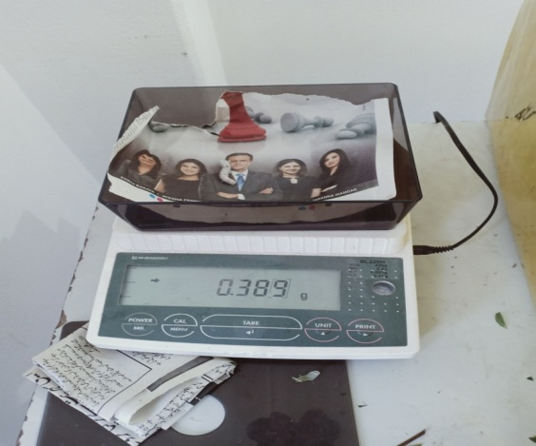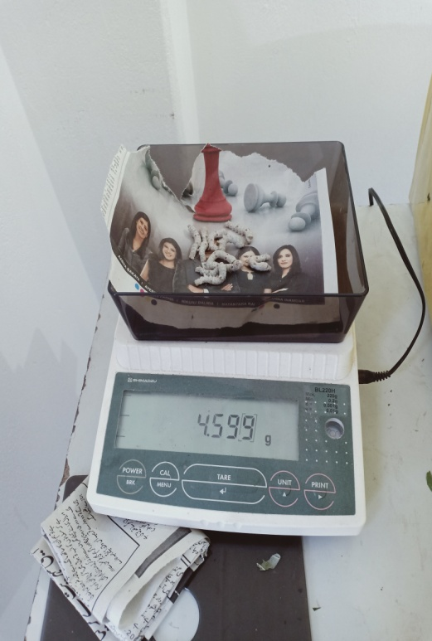

1. **Single larva B. 10 larvae**

**Plate- 01:Weighing larval weight of FC1xFC2 and FC2xFC1 (5th instar)**

1. **Larval Size:** The larvae size was measured in centimeter (cm) with using dividers and a scale when the larva was in fully stretched position. Similar to larval weight, variations in larval size were observed across different days and instars (Kurniasansyah and Hamamura; 2020).

**Table 02: Numerical values of larval size recorded from 3rd, 4th and 5th instar (per day) in FC1 × FC2 and FC2 × FC1 silkworm hybrids.**

**3RD INSTAR**

|  |  |  |  |
| --- | --- | --- | --- |
| **3rdInstar** | **Days** | **FC1×FC2** | **FC2×FC1** |
| **Larval length (cm)** | **01** | 2.8±1.11b | 2.3±1.55 b |
| **02** | 3.1±1.16c | 2.6±1.97 bc** |
| **03** | 3.1±1.79c | 2.8±1.2 c |
| **-** | **-** | **-** |
| **Larval width (cm)** | **01** | 0.5±0.9b | 0.3±0.07 b |
| **02** | 0.7±0.77b | 0.6±0.8 c |
| **03** | 0.7±0.77b | 0.6±08 c |
| **-** | **-** | **-** |

# 4TH INSTAR

|  |  |  |  |
| --- | --- | --- | --- |
| **4th Instar** | **Days** | **FC1×FC2** | **FC2×FC1** |
| **Larval length (cm)** | **01** | 3.0±2.11a | 2.8±1.4 a |
| **02** | 3.2±2.77a | 2.8±1.4 ab** |
| **03** | 3.2±2.77ab** | 3.2±1.7 b |
| **04** | 3.7±2.77b | 3.9±1.4 c |
| **05** | 4.8±2.67c | 4.2±2.01 c |
| **Larval width (cm)** | **01** | 0.4±0.45a | 0.3±0.08 a |
| **02** | 0.7±0.43ab** | 0.3±0.04 a |
| **03** | 0.8±0.66bc** | 0.4±0.04 a |
| **04** | 0.90.19c | 0.7±0.56 b |
| **05** | 1.20.23d | 1.0±0.35 c |

**5TH INSTAR**

|  |  |  |  |
| --- | --- | --- | --- |
| **5th Instar** | **Days** | **FC1×FC2** | **FC2×FC1** |
| **Larval length (cm)** | **01** | 4.6±2.21a | 4.7±3.21 a |
| **02** | 5.8±2.23a | 4.5±3.22 a |
| **03** | 6.9±2.44b | 5.8±3.01 b |
| **04** | 6.3±2.12b | 6.4±3.36 c |
| **05** | 7.8±2.02c | 6.8±3.54 c |
| **06** | 7.7±2.88c | 7.3±3.95 d |
| **07** | 8.4±2.64c | 7.6±3.44 d |
| **Larval width(cm)** | **01** | 1.4±1.11a | 1.2 ±1.01 a |
| **02** | 1.9±1.04b | 1.8±1.53 b |
| **03** | 1.9±1.04b | 1.9±1.43 bc |
| **04** | 2.0±1.77bc** | 2.0±1.93 bc |
| **05** | 2.1±1.98bcd*** | 2.0±1.73 bc |
| **06** | 2.4±1.97cd** | 2.1±1.01 bc |
| **07** | 2.5±1.21d | 2.2±1.01 c |

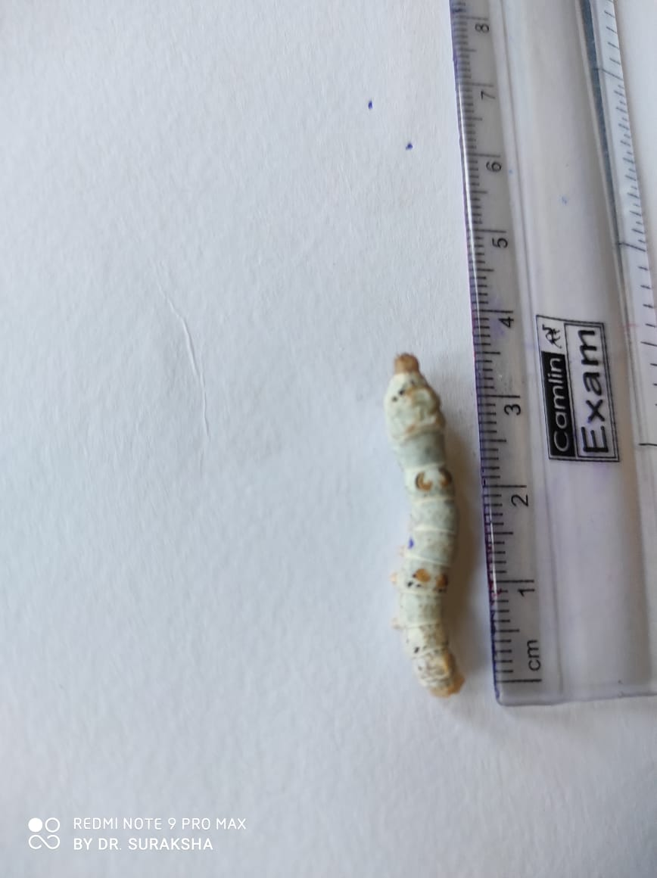 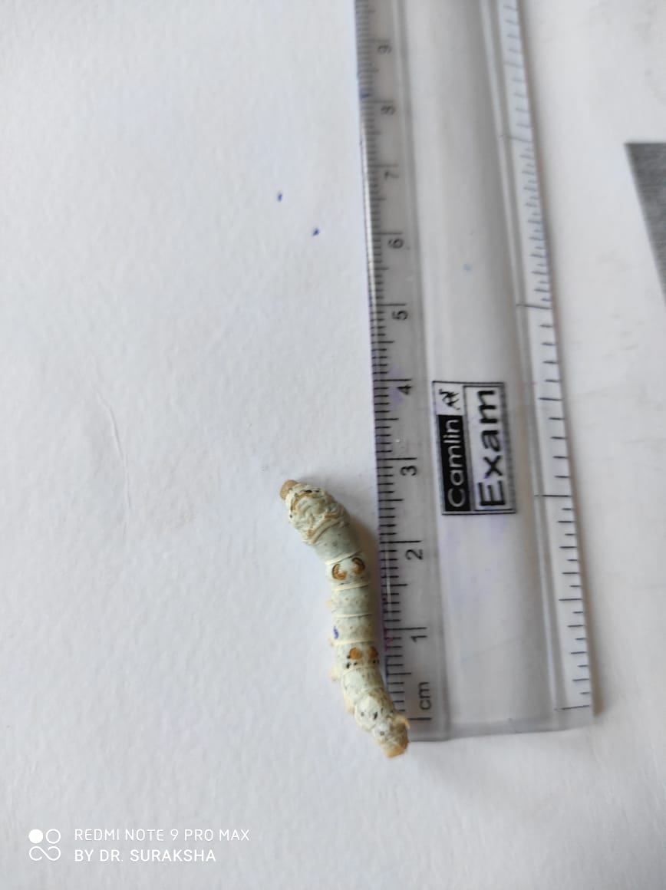

**Plate-02 Plate-03**

**Plate-2&3: Measuring larval length of silkworm (FC1xFC2 and FC2xFC1).**

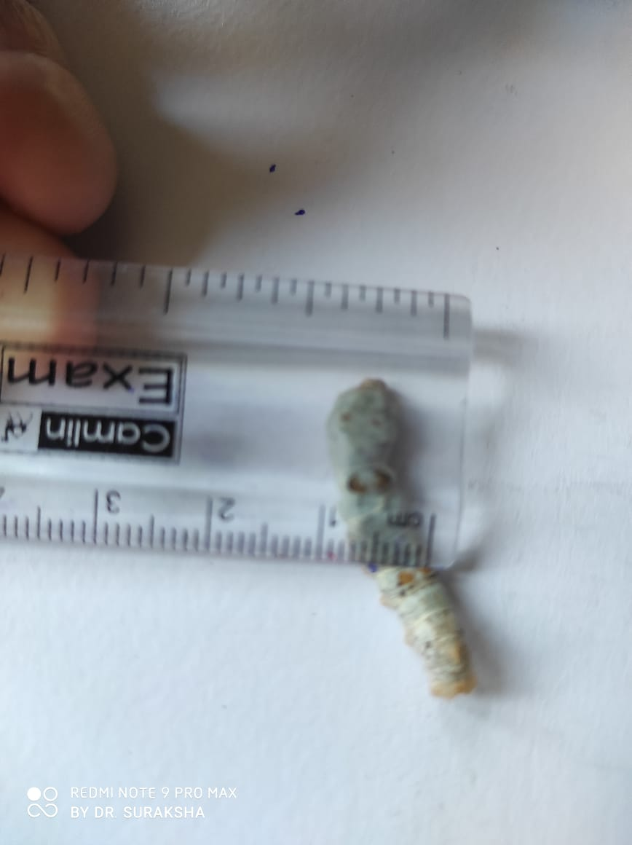

**Plate-04 Plate-05**

**Plate-4& 5: Measuring larval width of silkworm (FC1xFC2 and FC2xFC1).**

**Some of the important morphological characters of cocoons recorded includes:**

1. **Green cocoon weight**

The cocoon harvested on 6th day of spinning (FC1 x FC2 and FC2 x FC1) were recorded to possess (1.46gm ,1.30 gm) of single and (14.61gm ,13.36 gm) for ten cocoons for green cocoon weight (Kurutulmus et al., 2021).

1. **Cocoon with floss**

The same cocoons harvested from FC1 x FC2 and FC2 x FC1 was determined to evaluate cocoon weight with floss and recorded to possess (1.38gm, 1.19gm) of single and (15.54gm, 13.32gm) for ten cocoons in case of FC1 x FC2 and FC2 x FC1respectively.

1. **Deflossed cocoon**

The cocoons observed on the 6th day of spinning (FC1 x FC2 and FC2 x FC1) were subjected to deflossing by manual deflossing method with help of woollen stick and the studied hybrids were recorded to possess (1.40gm, 1.08gm) of single cocoon and (14.98 gm, 10.81gm) of 10 cocoons in case of FC1 x FC2 and FC2 x FC1, respectively.

1. **Dry cocoon weight**

Dry weight of single cocoon was observed as (0.55gm, 0.44gm) and (5.94gm, 4.44gm) for 10 cocoons on 6th day of spinning (FC1 x FC2 and FC2 x FC1silkworm hybrids).

1. **Shell weight**

Shell weight of the single cocoon and 10 cocoons was recorded as (0.78gm, 046gm) and (7.89gm, 4.63gm) on the 6th day spinning (FC1xFC2 and FC2xFC1), respectively.

1. **Pupal weight**

The cocoon harvested on 6th day of spinning (FC1xFC2 and FC2xFC1) were evaluated for determination of pupal weight and values depicting (1.55gm, 1.27 gm) of pupal weight for single cocoon and (15.92gm, 12.73gm) for ten cocoons, respectively.

1. **Cocoon shell ratio**

The results showed higher cocoon shell ratio for the hybrid FC1xFC2 as (53.42 per cent, 35.38 per cent) as to that of FC2xFC1 as (54.41 per cent, 36.41 per cent).

1. **Cocoon grains**

The cocoon harvested on 6th day of spinning (FC1x FC2 and FC2xFC1) were observed to possess as deep and coarse grains, depicting the comparatively good quality of cocoons.

1. **Cocoon compactness**

The same cocoons were observed as hard and compact in texture showing the superior quality of the cocoons on the basis of visual examination descriptor.

1. **Cocoon size**

For both the hybrids the cocoons were recorded to possess oval shaped cocoon with slight constriction at the centre as shown in the plate.

1. **Pupal percentage**

Pupal percentage were determined after stifling process and the studied hybrid were recorded to possess high pupal percentage with values as (100 per cent, 100 per cent) and (100 per cent, 90 per cent) for FC1xFC2 and FC2xFC1 respectively.

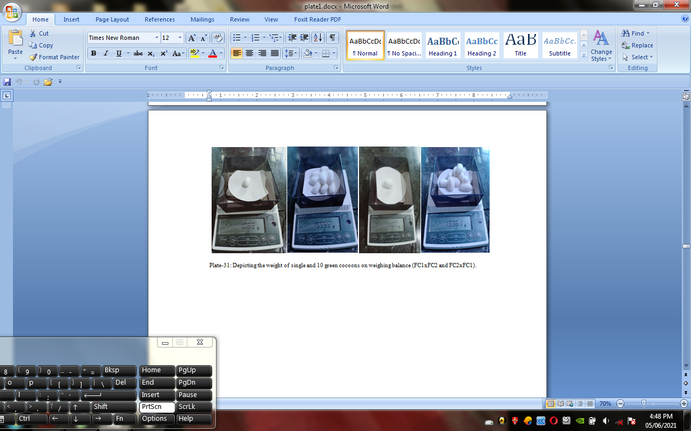

**Plate-06: Weight of single and 10 green cocoons on weighing balance (FC1xFC2 and FC2xFC1).**

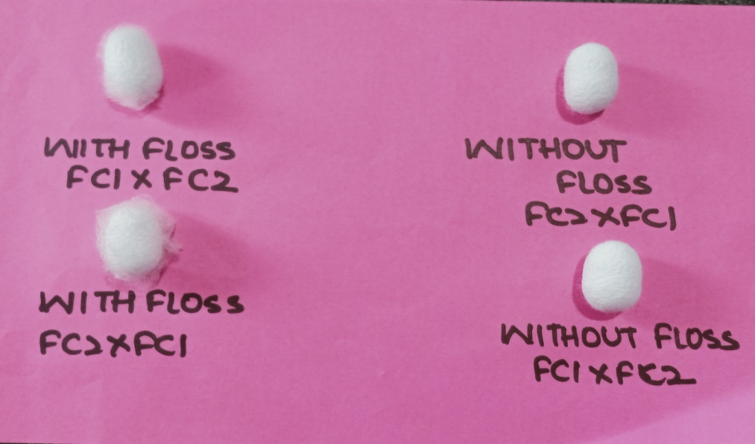

**Plate-07: Cocoon with floss and without floss-FC1xFC2 and FC2xFC1.**

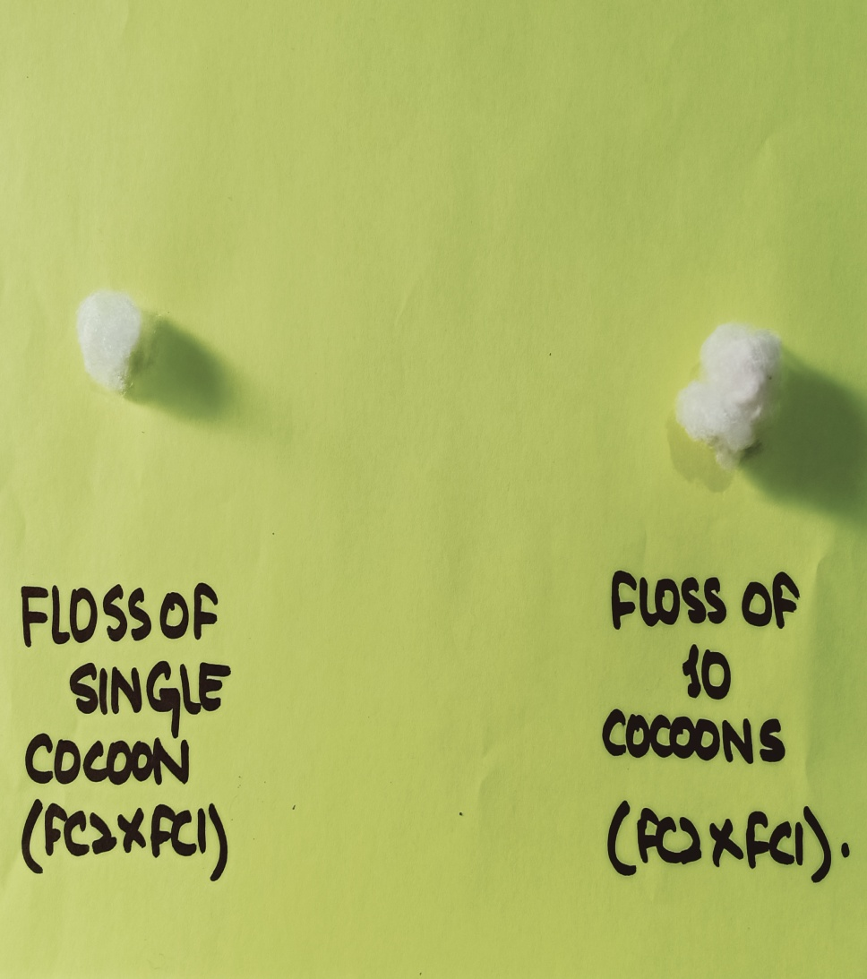

**Plate-08: Depicting the floss of single and 10 cocoons of FC2xFC1.**

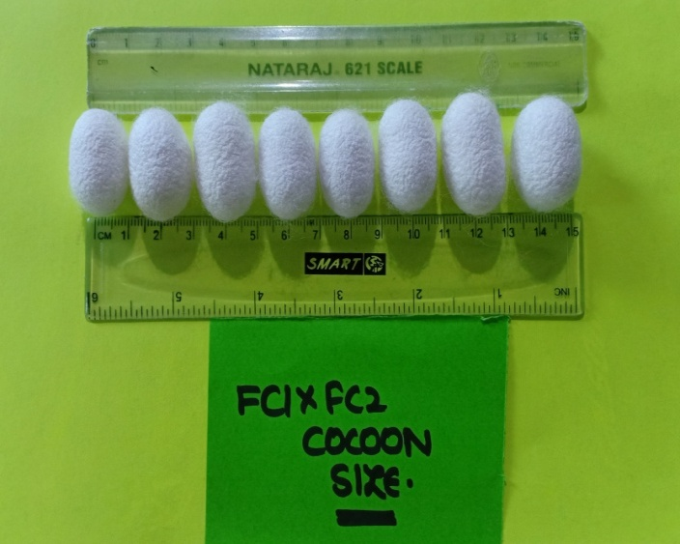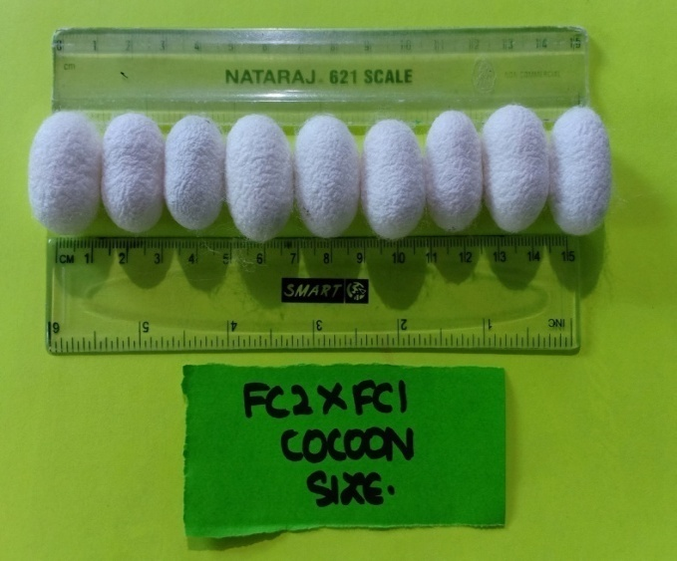

**Plate-09: Measurement of Cocoon Size for Selection of Equal cocoons.**

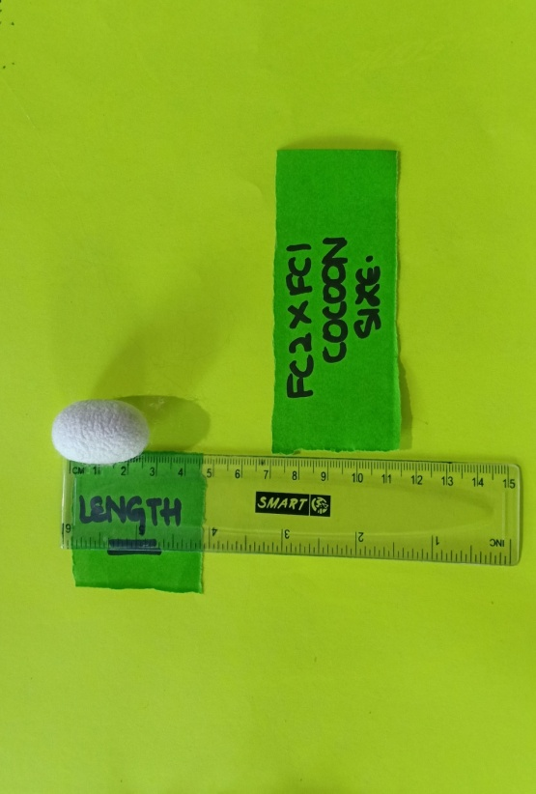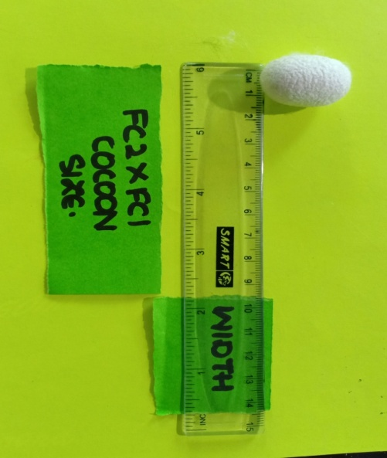

**Plate-10: Measurement of Cocoon size (length and width).**

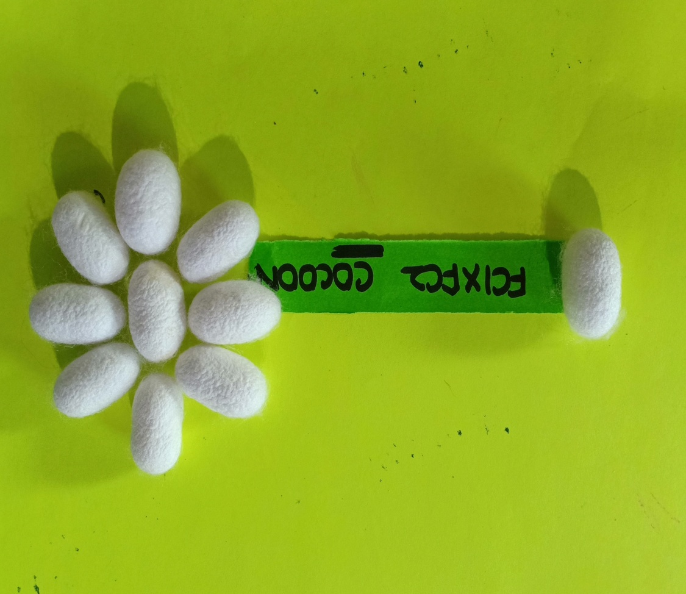

**Plate-11: Cocoons of FC1xFC2.**

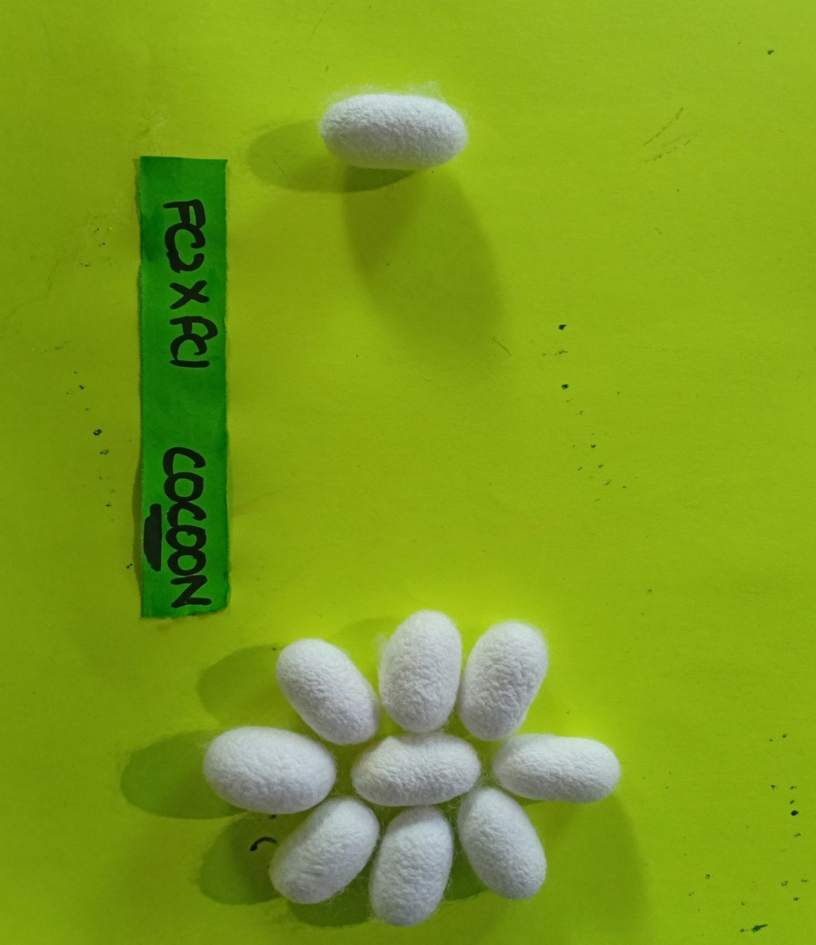

**Plate-12: Cocoons of FC2xFC1.**

**CONCLUSION**

The present investigation suggests FC1×FC2 hybrid as better performer with respect to larval, cocoon and post cocoon parameters. Being a bivoltine double hybrid it exhibited improved hybrid vigor, resulting in higher silk production, better disease resistance, seed crop performance and higher seed recovery and has better crop stability as a result of genetic diversity inherited from both parent races i.e. FC1 and FC2. Therefore, this work would be of great importance for future breeding programmes in development of region and season specific hybrids.

**REFERENCES**

Absar, G.K. and Kale, R. D. 2015. Studies on Micronutrient effect on mulberry varieties. *Indian Journal of Sericulture.* 4(**24**): 1317- 1320.

Bari, G. J., Horie, Y. and Nakasone, S. 2019. Effect of dietary biotin on fatty acid composition of the silkworm, *Bombyx mori* L. *Journal of Insect Physiology*. 3(**14**): 1381 – 1387.

Chakraborty, A., Sarkar, K., Majumdar, M. and Kumar, V. 2020. Studies on Performance Of Bivoltine Hybrids SK6 X SK7 And Its Reciprocal Crosses During April Crop In West Bengal. *International Journal of Advanced Research in Biological science.* 7(**6**): 134-140.

Das, B.K., Nanavaty, M. And Vijayan, K. 2011. Estimation of leaf yield in mulberry. *Biochemical Journal*.4 (**6**): 7-12.

Gatin, S. G., Horie, Y. and Ito, T. 1965. Nutrition of the silkworm, Bombyx mori. Mineral requirements and the effects of several analogues. *Journal of Insect Physiology.* 2(**11**): 1585-1593.

Kumar, W. G., Hirayama, C., Konno, K. and Shinbo, H. 2020. Utilization of ammonia as a nitrogen source in silkworm, *Bombyx mori L*. *Journal of Insect Physiology*. 42(**10**): 983-988.

Kumari, Nitu. and Roy, S.P. 2011. Some aspects of the identification of nutritionally efficient silkworms (Insecta: Lepidoptera: Bombycoidea), their metabolic rate and sustainable development as energy resources. *Journal of Insect Science.* 6(**3**): 475-481.

Kunhamed, Ramathullavk., Mathur, V.B.and Geetha, R. G. 2013. Growth and dietary efficiency of mulberry silkworm (Bombyx mori) under various nutritional and environmental conditions*. Phillpine Journal of Science*. 133(**1**): 0031-7683. -

Kurniasansyah, S. I. and Hamamura, Y. 2020. Food Selection by silkworm larvae. *Indian Journal of Sericulture*. 7(**183**): 1746-1747.

Kurutulmus, D., Gabriel, B.P. and Rapusas, H. R. 2021. The growth and development of *Bombyx mori (L.)* at different leaf maturity and variety of mulberry. *The Philippine Agriculturist*. 3(**60**): 139-146.

Murthy, Y. N. V. 2015. Studies on the effect of different mulberry varieties and seasons on the larval development and cocoon characters of silkworm, *Bombyx mori* (L.). *Indian Journal of Sericulture*. 5(**29**): 44-53.

Yamashita, G.M. and Majumdar, A. C.2013. Note on the physiological effects on the growth and reproduction of silkworm fed on mulberry leaves. *Journal of Agricultural Science,* 6(**52**): 250-252.

Yokoyama, W. 2016. Morphological parameters posses significant impact on leaf quality and Matric trait. . *Indian Journal of Sericulture.* 5(**44**): 231-233.

Yu, S. J. and Fraisse, R. 2021. The correlation between the mulberry leaves taken by the silkworm, the silk protein in the silk gland and the silk filament. *Indian Journal of Sericulture*. 1(**15)**: 595-610.