**Evaluation of Portulaca (*Portulaca grandiflora*) for Vegetative, Floral Traits and Precision Environment**

## ABSTRACT

*Portulaca oleracea* (common purslane), is valued for its nutritional and medicinal properties, being rich in omega-3 fatty acids, vitamins and antioxidants. The plant thrives in warm climates with well-drained soil and requires full sunlight for optimal blooming. Recent studies highlight its medicinal and economic potential. This study explores their botanical characteristics, cultivation requirements and applications in horticulture and medicine, emphasizing their significance in sustainable agriculture and skincare industries. The experiment was conducted during the Kharif season of 2024–2025 at the Department of Horticulture, Rajasthan College of Agriculture, MPUAT, Udaipur, to evaluate the vegetative and floral traits of eight genotypes of *Portulaca grandiflora*. The genotypes (PG-1, PG-2, PG-3, PG-4, PG-5, PG-6, PG-7 and PG-8) were planted in a Completely Randomized Design with ten replications in 6-inch plastic pots containing a 2:1:1 (v/v) mixture of soil, sand and vermicompost. Results revealed significant genotypic variation across all traits. The genotype PG-5 consistently performed best, recorded maximum vine length at 30, 60 and 90 DAP (24.02cm, 27.18 cm and 30.05cm), plant spread east to west and north to south (21.29cm and 21.68cm), earliest flower bud appearance (27.18 days), bud break (33.15 days), buds per plant (29.38), flowers per plant(29.13), flower weight (0.83g), petals per flower (38.35) and longest flower duration (85.85 days). PG-1 recorded the highest leaves /branch (35.35), leaves /plants (312.13), branches /plant (12.15) and chlorophyll content (2.30mg). The study identified PG-5 and PG-1 as promising genotypes for pot plant, ornamental and landscape purposes. Environmental analysis indicated that optimal performance occurred under 26.6°C temperatures, 3.8 hours of sunshine, moderate relative humidity (83.3%) for the vegetative phase and 27.7°C temperatures, 4.5 hours of sunshine, relative humidity (73.9%) for floral phase. The findings can assist in the selection of climate-resilient *Portulaca grandiflora* genotypes with high ornamental potential. The study contributes valuable insights for breeders, floriculturists and landscape designers seeking climate-resilient and low-maintenance flowering plants with commercial and ecological potential.

**Keywords:** *Portulaca grandiflora,* vine length, flower bud appearance, flower number per plant and flower duration

## INTRODUCTION

Optimizing the potential of antioxidant activity in medicinal plants is necessary needed considering the number of emerging diseases nowadays. The antioxidant capacity of plants improves with the increase in the production of polyphenolic compounds (Nurcholis et al., 2023). *Portulaca* species (*Portulaca* spp.) are globally distributed and rich in bioactive compounds, including alkaloids, flavonoids, betalains, and fatty acids. These compounds exhibit antioxidant, antibacterial, anti-inflammatory, and anticancer activities (Liew et al., 2025). The Portulacaceae family comprises over 100 species, including *Portulaca oleracea* and *Portulaca grandiflora* (Christenhusz & Byng, 2016). *Portulaca grandiflora*, commonly known as moss rose or sun rose, is a succulent ornamental plant native to southern Brazil, Argentina and Uruguay (Setiawan *et al.,* 2016). It is widely cultivated for its vibrant flowers, which come in various colors such as red, yellow, pink and white, making it a popular choice for gardens, containers and hanging baskets (De, 2019). *Portulaca* species also contribute to sustainable agriculture and environmental remediation. Their remarkable adaptability enables them to thrive in environments ranging from arid deserts to humid tropics (Nyame-Tawiah et al., 2019; Liew et al., 2025). The plant thrives in warm climates (20–35°C) with well-drained soil and requires full sunlight for optimal blooming. Recent studies highlight its medicinal and economic potential. Certain varieties, particularly those with magenta flowers, contain high levels of flavonoids, making them promising candidates for natural sunscreen formulations (Budiawan *et al.,* 2023). Additionally, traditional medicine systems have used *P. grandiflora* for treating sore throats, skin rashes and detoxification (Uddin *et al.,* 2020). Another notable species, *Portulaca oleracea* (common purslane), is valued for its nutritional and medicinal properties, being rich in omega-3 fatty acids, vitamins and antioxidants (Simopoulos, 2013). Both species exhibit remarkable adaptability, with *P. oleracea* being drought-resistant and capable of growing in poor soils (Ocampo & Columbus, 2012). Given their ecological resilience, ornamental appeal and therapeutic potential, *Portulaca* species are subjects of increasing research interest. This study explores their botanical characteristics, cultivation requirements and applications in horticulture and medicine, emphasising their significance in sustainable agriculture and skincare industries.

## MATERIALS AND METHODS

The present study was conducted during the year 2024–2025 at the rooftop of the Department of Horticulture, Rajasthan College of Agriculture (RCA), MPUAT, Udaipur, situated at 24.58° N and 73.70° E with an elevation of 602 meters above mean sea level. The climate is typically sub-tropical with mild winters, moderate summers and monsoon-dominated rainfall. The experiment was laid out in a Completely Randomized Design (CRD) comprising eight genotypes (PG-1, PG-2, PG-3, PG-4, PG-5, PG-6, PG-7 and PG-8) with ten replications, totalling 400 pots. Vegetative observations such as vine length were recorded at 30, 60 and 90 days after planting (DAP), plant spread (east west and north south), number of leaves per plant and branch, number of branches, nodes per branch and chlorophyll content. While, floral observations included days to flower bud appearance and break, number of buds

and flowers per plant, flower diameter, petal count, flower weight, duration, opening/closing time and color using the RHS color chart. Environmental parameters like daily temperature, relative humidity and sunshine hours were recorded throughout the crop period (August 2024–January 2025) to assess their influence on vegetative and floral traits. Data were statistically analysed using ANOVA as per the method outlined by Panse and Sukhatme (1985) to evaluate treatment significance and genotype performance.

## CLIMATE AND WEATHER CONDITIONS

The climate of this zone is typically subtropical, characterised by mild winter and moderate summers associated with high relative humidity during the months of August 2024 to January 2025. The total annual rainfall 637 mm is received during 2024-25. The minimum to maximum temperature ranges from 4.3°C to 24.1°C, 22.7 °C to 34.7°C and relative humidity range from 23.9 to 81.6%, 66.1 to 94.7%, sunshine hours range from 1.2 to 9.2 hours and evaporation rate range from 1.3 to 5.2 mm during *Portulaca grandiflora* vegetative and floral phase i.e August 2024 to January 2025, respectively.

### Source of planting material-

The cuttings of *Portulaca grandiflora* were procured from AICRP Floriculture Department of Horticulture, RCA Campus, MPUAT Udaipur (Raj.)

### Collection site-

5 Local collection from Mount Abu latitude 24°59' North and longitude 72°71' East with an elevation of 1,219 meters above mean sea level and three genotypes were collected from Kochi Airport latitude 10°09' north and longitude 76°24' East with an elevation of 9 meters above mean sea level by LN Mahawer AICRP Floriculture, MPUAT Udaipur.

### Source of pot and media-

Growing media (Soil, Sand and Vermicompost) and 400 pots of 6 inch size were obtained from AICRP- Floriculture, Department of Horticulture, RCA, Udaipur (Raj.).

### Preparation of Media

The potting media was prepared by thoroughly mixing of various ingredients on volume by volume basis like Soil + Sand + Vermicompost (2:1:1). Prepared media were filled in 6 inch pot by leaving 2 inch place for, irrigation and intercultural operation.

### Planting of cutting

The 4 to 6 cm cutting of *Portulaca grandiflora* were planted in media with 6 inch plastic pot size. After planting of cutting irrigation is given immediately.

## RESULTS AND DISCUSSION

### vegetative traits

* + 1. **Vine length (cm)**

The evaluation of eight genotypes of *Portulaca grandiflora* revealed significant variability in vegetative traits. At 30, 60 and 90 days after planting (DAP), genotype PG-5 consistently exhibited the maximum vine length (24.02 cm, 27.18 cm and 30.05 cm, respectively), followed closely by PG-1 and PG-8, whereas PG-3 and PG-2 showed the minimum values. Suvija *et al*. (2016) in chrysanthemum, Atal *et al*. (2019) in china aster and Raghupathi e*t al*. (2017) in dahlia reported that genotypes with better adaptability to open environments tend to show higher vegetative expansion in ornamental crops with a similar growth pattern.

### Plant spread (East- West, North- South)

For plant spread, PG-5 recorded the widest spread in both East–West (21.29 cm) and North–South (21.68 cm) directions, while PG-3 exhibited the lowest spread (16.22 cm and 15.91 cm, respectively). Rymbai *et al*. (2012) in china aster and Alam *et al*. (2014) found that canopy spread and erect growth habits significantly influenced yield and regeneration potential in *Portulaca oleracea*.

### Number of leaves

In terms of foliage characteristics, PG-1 showed superiority with the highest number of leaves per branch (35.35) and per plant (312.13), followed by PG-2 and PG-3, whereas PG-8 consistently recorded the lowest values. Karkanis and Petropoulos (2017) in *Portulaca oleracea,* Mahanta *et al*. (2020) in marigold emphasized that genotypes exhibiting erect growth habits and higher leaf numbers tend to have superior biomass yield and serving as indirect indicators of plant productivity and physiological fitness.

### Number of branches and nodes

The highest number of branches per plant was also found in PG-1 (12.15), followed by PG-3 (11.75) and PG-5 (10.68), while PG-8 again had the fewest (9.75). Node production was highest in PG-1 (36.20), followed closely by PG-3 and PG-2, with PG-8 recording the lowest (31.88). Similar associations were highlighted by Alam *et al*. (2014) found that leaf area and leaves per branch significantly influenced yield and regeneration potential in *Portulaca oleracea*.

### Chlorophyll content (mg/g FW)

Regarding physiological performance, PG-1 demonstrated the highest total chlorophyll content (2.30 mg/g FW), followed closely by PG-5 (2.29 mg/g) and PG-6 (2.26 mg/g), while PG-8 again showed the lowest (2.06 mg/g). Karkanis and Petropoulos (2017) in *Portulaca oleracea,* Mahanta *et al*. (2020) in marigold emphasized that genotypes exhibiting erect growth habits with elevated chlorophyll content, serve as indirect indicators of plant productivity and physiological fitness

### Floral traits

* + 1. **Days to flower bud appearance and bud break-**

The floral evaluation of eight *Portulaca grandiflora* genotypes revealed significant variation in most traits, highlighting their genetic diversity and adaptability to environmental conditions. Genotype PG-5 consistently outperformed others, showing the earliest flower bud appearance (27.18 DAP) and bud break (33.15 DAP), followed by PG-2, PG-3 and PG-1, while PG-8 exhibited the latest floral initiation and development. These findings are consistent with the research of Maguvu *et al*. (2018) in *Portulaca umbraticola*, Kumar *et al*.

(2014) in chrysanthemum and Gulia *et al*. (2017) in marigold found that extended photoperiods promoted earlier flowering.

### Number of Petals, floral buds and flowers

Petal number was significantly higher in PG-5 (38.35), PG-2 (37.80) and PG-1 (34.30), whereas PG-7 showed the least (24.38). PG-5 also recorded the highest number of floral buds (29.38) and flowers (29.13) per plant, while PG-8 had the lowest in both categories. A high flower count enhances the ornamental beauty in bedding displays, hanging basket and pot arrangements, aligning with the observations of Pasha *et al*. (2021) identified flower quantity as a key factor in assessing *Portulaca* genotypes.

### Diameter (cm) and weight (g) of flower

Flower diameter was maximum in PG-2 (3.38 cm), followed by PG-1 and PG-5 and minimum in PG-7 (2.60 cm). Although flower weight differences were not statistically significant, PG-5 had the heaviest flowers (0.83 g), closely followed by PG-2 and PG-1. Abhishek and Bala (2023) in chrysanthemum and Fujita *et al*. (2024) in *Portulaca oleracea* noted that urban environments favours larger flowers.

### Last day to flower opening and flower duration

PG-5 also exhibited the longest flowering period, with the last flower opening at

122.85 days and a total duration of 85.85 days, followed by PG-1 (84.40 days) and PG-2 (81.95 days), while PG-8 had the shortest duration (62.68 days). Tomar *et al*. (2022) in chrysanthemum and Fujita *et al*. (2024) earlier flowering in *Portulaca oleracea*, suggesting these traits provide ecological and adaptive benefits.

### Flower color

The genotype PG- 1, PG- 2 and PG- 7 exhibited RED PURPLE GROUP (68A, 71C, 72C), PG- 3 exhibited YELLOW ORANGE GROUP 14C, PG- 4 exhibited ORANGE GROUP 29B, PG- 5 exhibited WHITE GROUP NN 155D, PG- 6 poses YELLOW GROUP

3C, PG- 8 exhibited RED GROUP 48C, respectively. Kumar *et al* (2009) in dahlia cultivar and Singh *et al.* (2017) in chrysanthemum reported red colour of flower is due to anthocyanin pigment, orange color is due to presence of anthocyanin on yellow background, yellow

colour is due to chalcones and aurones colouring matter, white colour is due to flavonols and carotenoid pigment.

### 2.3.6 Flower opening and closing time of flower

Flower opening and closing times did not significantly vary; however, PG-5 and PG-4 showed earlier opening (8:00–8:10 AM) and PG-5 also had the latest closing time (4:30–5:00 PM). The genotype PG-5 holds superior potential for ornamental use and environmental resilience. These findings are consistent with the research of Maguvu *et al*. (2018) in *Portulaca umbraticola*, Kumar *et al*. (2014) in chrysanthemum and Gulia *et al*. (2017) in marigold found that extended photoperiods promoted earlier flowering.

### Environmental factors

Environmental factors like temperature, humidity and sunshine hours had a pronounced influence on growth and flowering. Optimum vegetative growth required 26.6°C, relative humidity required 83.3% and an average sunshine duration of 3.8 hours per day. Optimum flowering was observed in September and October with temperatures around 26– 27°C, relative humidity of 63–74% and sunshine duration of 4.5–6.9 hours/day. Low temperatures and reduced sunlight in November and December led to reduced flowering and the onset of dormancy, especially with wide day-night temperature and humidity differences. aligning with findings by Maguvu *et al*. (2018) in *Portulaca umbraticola* and Savitha *et al*. (2016) in China aster and Pasha *et al*. (2021) in *Portulaca* reported that ambient temperature significantly influences flower opening rhythms and overall flowering behavior in this species.

**Table 1: Variation in *Portulaca grandiflora* genotypes for vegetative traits and chlorophyll contents**

|  |  |  |  |  |  |
| --- | --- | --- | --- | --- | --- |
| **Genotype** | **Leaves per branch** | **Leaves per plant** | **Branches per plant** | **Nodes per branch** | **Chlorophyll content (mg/g)** |
| PG-1 | 35.35 | 312.13 | 12.15 | 36.20 | 2.30 |
| PG-2 | 32.73 | 307.45 | 10.65 | 35.13 | 2.11 |
| PG-3 | 33.55 | 305.13 | 11.75 | 35.53 | 2.13 |
| PG-4 | 31.63 | 246.23 | 10.23 | 32.03 | 2.14 |
| PG-5 | 33.53 | 287.18 | 10.68 | 34.68 | 2.29 |
| PG-6 | 32.65 | 270.75 | 10.18 | 32.18 | 2.26 |
| PG-7 | 31.45 | 244.83 | 9.93 | 33.78 | 2.09 |
| PG-8 | 31.03 | 236.03 | 9.75 | 31.88 | 2.06 |
| SEM (±) | 0.48 | 3.76 | 0.17 | 0.63 | 0.02 |
| CD (P=0.05) | 1.35 | 10.62 | 0.47 | 1.77 | 0.05 |

**Table 2: Variation in *Portulaca grandiflora* genotypes for floral traits**

|  |  |  |  |  |  |
| --- | --- | --- | --- | --- | --- |
| **Genotype** | **Flower diameter**  **(cm)** | **Petals per flower** | **Flower weight(g)** | **Days to last flower**  **opening** | **Flower duration** |
| PG-1 | 3.28 | 34.30 | 0.80 | 120.35 | 84.40 |
| PG-2 | 3.38 | 37.80 | 0.82 | 119.03 | 81.95 |
| PG-3 | 2.91 | 28.78 | 0.77 | 116.65 | 78.40 |
| PG-4 | 2.62 | 32.75 | 0.78 | 113.40 | 74.48 |
| PG-5 | 2.99 | 38.35 | 0.83 | 122.85 | 85.85 |
| PG-6 | 2.74 | 27.95 | 0.74 | 115.63 | 74.73 |
| PG-7 | 2.60 | 24.38 | 0.70 | 119.45 | 74.68 |
| PG-8 | 2.67 | 27.53 | 0.71 | 110.00 | 62.68 |
| SEM (±) | 0.04 | 0.32 | 0.02 | 0.75 | 0.56 |
| CD (P=0.05) | 0.10 | 0.91 | N.S. | 2.11 | 1.59 |

**Table 3: Variation *Portulaca grandiflora* genotypes for flower colour, flower opening and closing time**

|  |  |  |  |
| --- | --- | --- | --- |
| **Genotype** | **Flower colour** | **Flower opening**  **time** | **Flower closing**  **time** |
| PG-1 | RED PURPLE GROUP 68A | 8:14AM | 3:59PM |
| PG-2 | RED PURPLE GROUP 71C | 8:13AM | 3:46PM |
| PG-3 | YELLOW ORANGE GROUP 14C | 8:25AM | 3:49PM |
| PG-4 | ORANGE GROUP 29B | 8:10AM | 4:00PM |
| PG-5 | WHITE GROUP NN 155D | 8:06AM | 4:54PM |
| PG-6 | YELLOW GROUP 3C | 8:14AM | 4:30PM |
| PG-7 | RED PURPLE GROUP 72C | 8:12AM | 4:13PM |
| PG-8 | RED GROUP 48C | 8:24AM | 3:53PM |

# UNDER PEER REVIEW

**Table 4: Optimum temperature (˚C), relative humidity (%) and sunshine duration (hrs.) for vegetative and floral phase**

|  |  |  |  |  |  |  |  |  |  |  |  |
| --- | --- | --- | --- | --- | --- | --- | --- | --- | --- | --- | --- |
| **Months (2024)** | **Optimum temperature level for plant phase (ºC)** | | | | **Optimum relative humidity level for plant phase (%)** | | | | **Sun shine duration**  **(hours)** | | |
| **Vegetative** | **Floral** | **Maximum** | **Minimum** | **Vegetative** | **Floral** | **Maximum** | **Minimum** | **Vegetative** | **Floral** | **Cumulative** |
| AUG | 26.6 | - | 24.4-33.5 | 21.4-25.5 | 83.3 | - | 71.0-98.0 | 53.0-95.0 | 3.8 | - | 80.4 |
| SEP | - | 27.7 | 29.0-34.8 | 19.4-25.3 | - | 73.9 | 70.0-97.0 | 47.0-88.0 | - | 4.5 | 109.4 |
| OCT | - | 26.1 | 30.0-34.8 | 16.6-22.4 | - | 63.6 | 67.0-98.0 | 31.0-95.0 | - | 6.9 | 213.9 |
| NOV | - | 21.7 | 35.5-24.6 | 8.0-18.4 | - | 54.9 | 64.0-91.0 | 23.0-37.0 | - | 8.2 | 246.1 |
| DEC | - | 17.4 | 25.1-26.5 | 8.2-10.5 | - | 59.9 | 81.0-86.0 | 59.0-62.0 | - | 8.3 | 41.5 |

# UNDER PEER REVIEW

35

30

25

20

15

10

5

0

PG-1

PG-2

PG-3

PG-4

PG-5

PG-6

PG-7

PG-8

Vine length (cm) 30 DAP

Plant spread (cm) North to South

Vine length (cm) 60 DAP

Plant spread (cm) East to West

Vine length (cm) 90 DAP

**Fig 1: Variation in *Portulaca grandiflora* genotypes for vine length and plant spread (cm)**

60

50

40

30

20

10

0

PG-1

PG-2

PG-3

PG-4

PG-5

PG-6

PG-7

PG-8

Flower bud appearance (DAP) Days to floral bud break Buds per plant

Flowers per plant

**Fig 2: Variation in *Portulaca grandiflora* genotypes for floral bud trait**

# UNDER PEER REVIEW

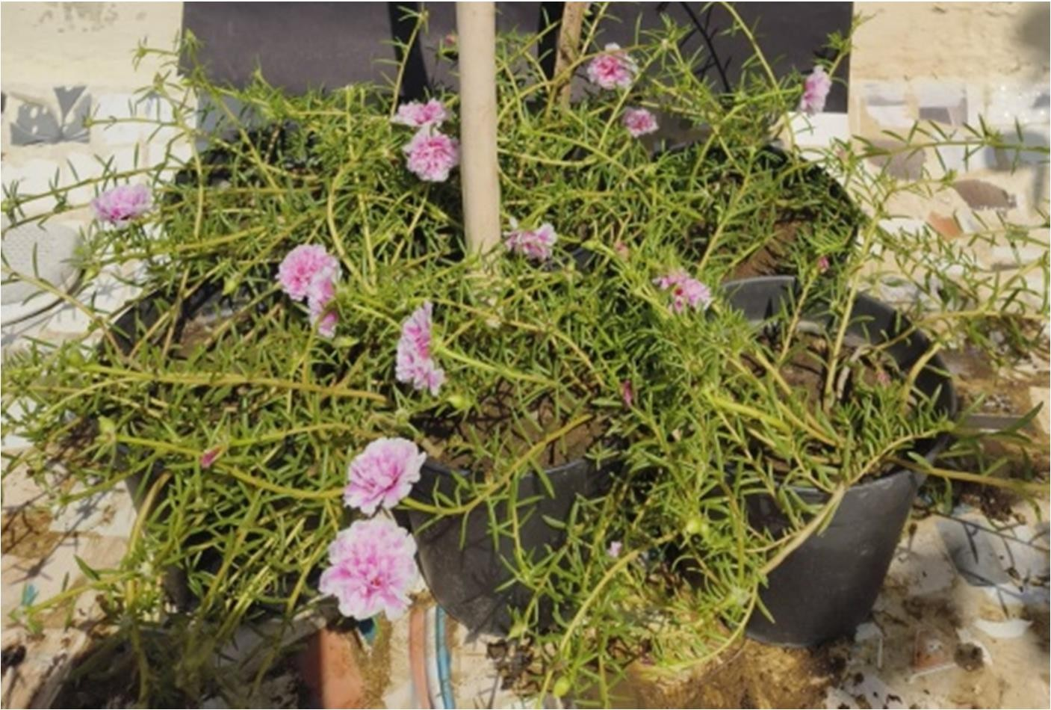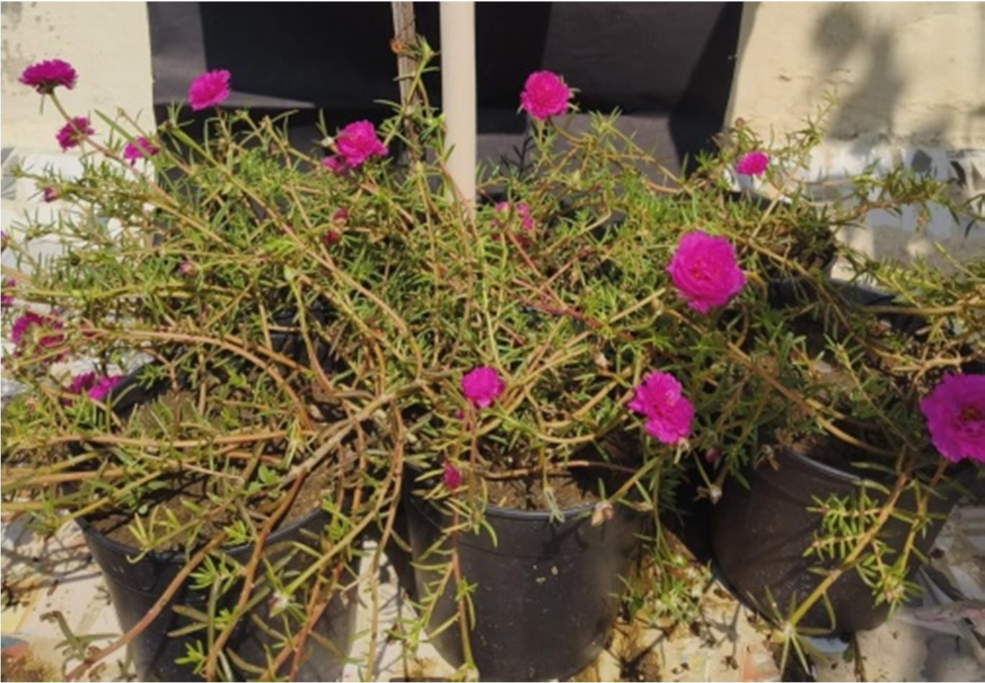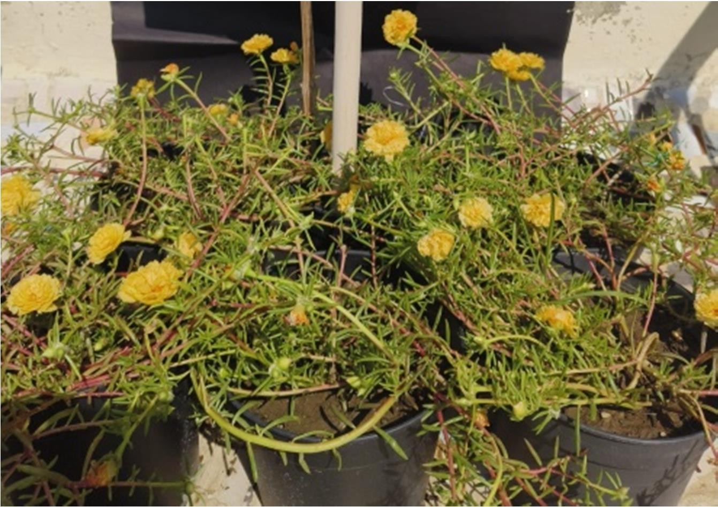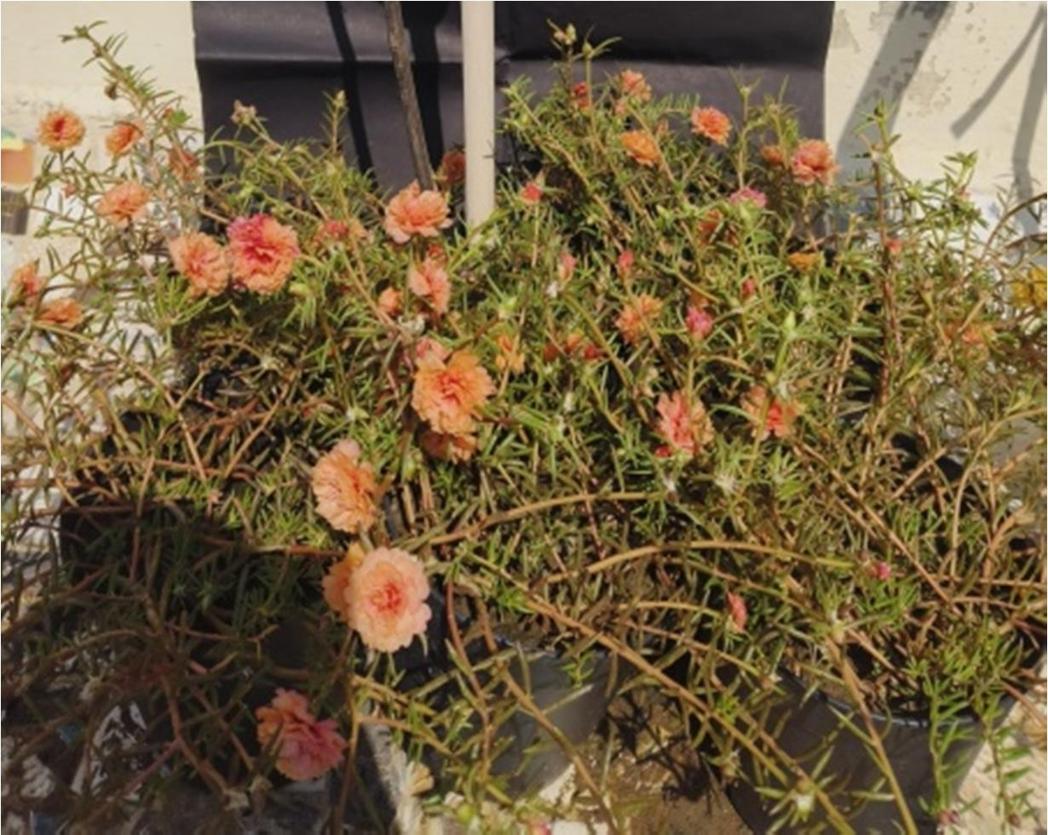



PG-1



PG-2



PG-3



PG-4

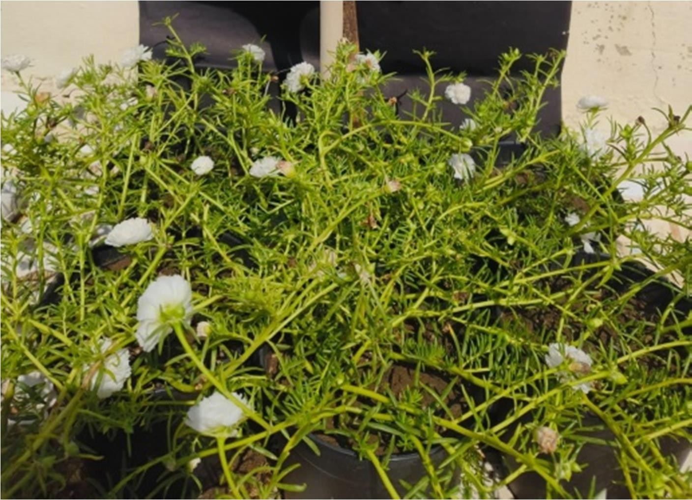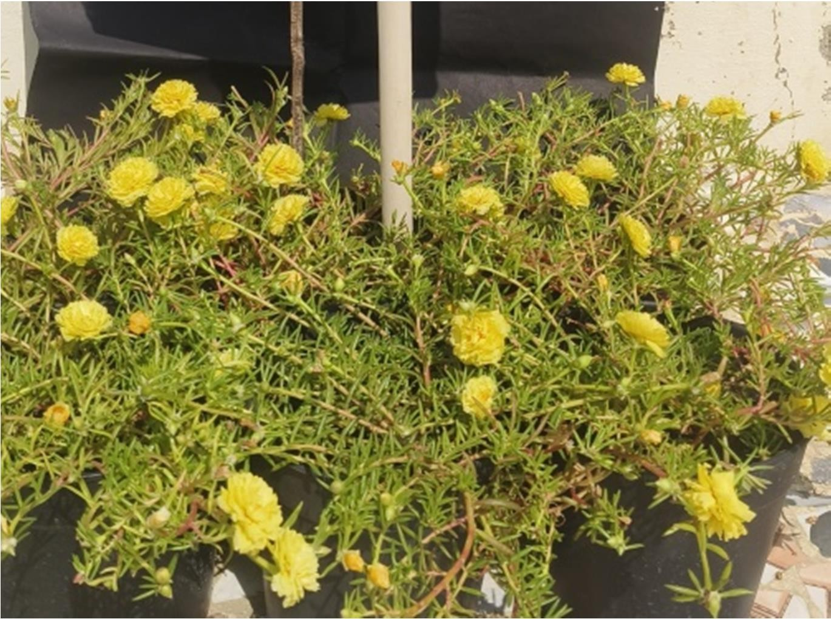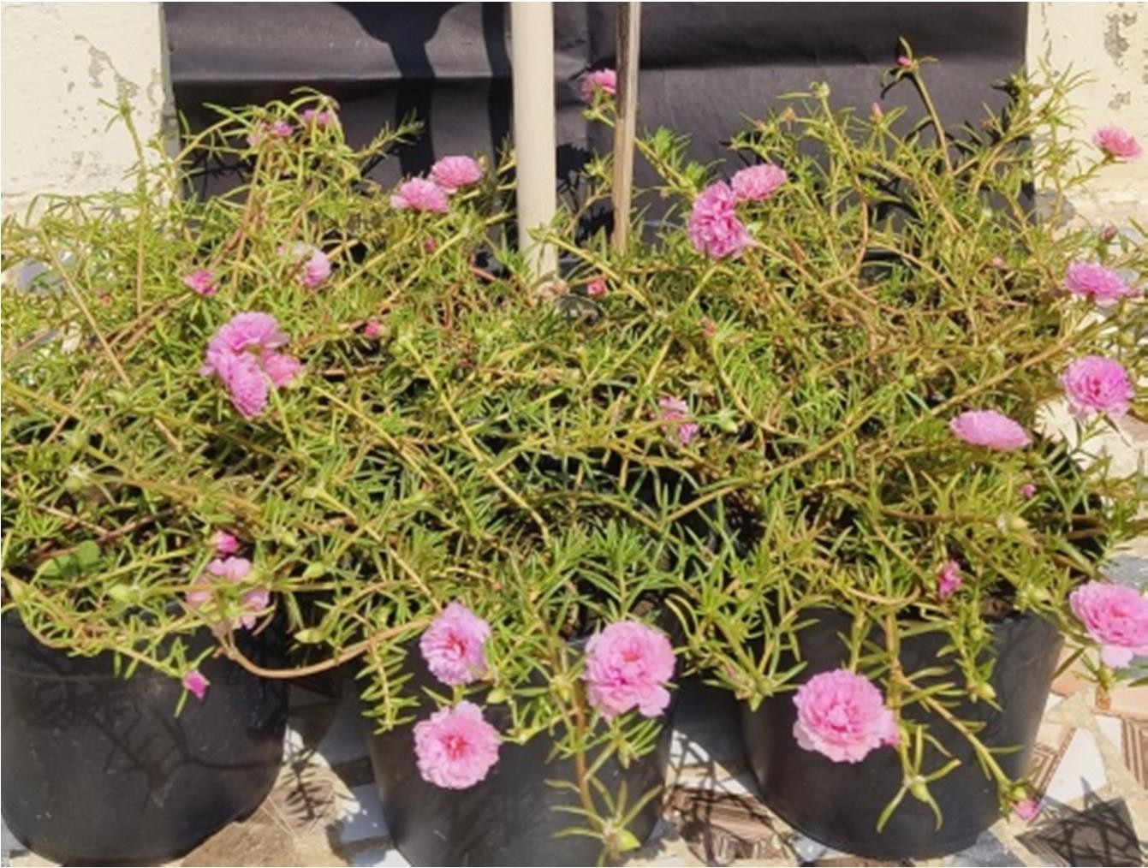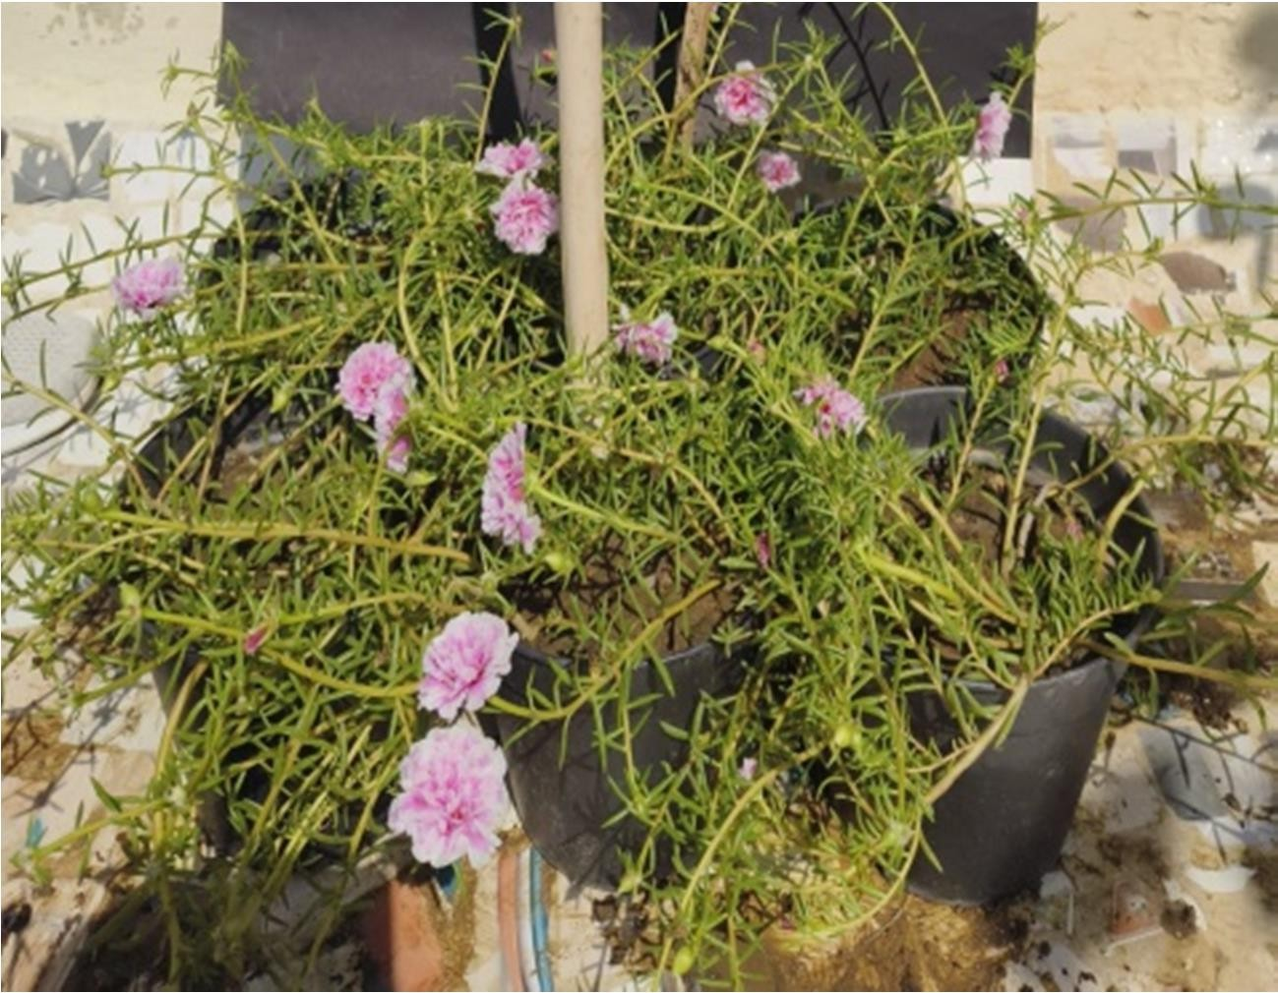



PG-5



PG-6



PG-7



PG-8



Plate 1 : *Portulaca grandiflora* genotype with color code variation

## CONCLUSION

The present study revealed significant variability among *Portulaca grandiflora* genotypes for vegetative and floral characteristics, influenced strongly by environmental conditions. Genotype PG-5 emerged as the most promising due to its superior vine growth, high bud and flower count, large flower size and extended blooming duration, making it ideal for ornamental landscaping. PG-1 and PG-2 also exhibited desirable traits, particularly in foliage and flower quality. The optimal environmental conditions for flowering were identified during September and October, characterised by moderate temperatures (26–27°C), relative humidity (63–74%) and sufficient sunshine (4.5–6.9 hours/day). Conversely, reduced temperature and light intensity in winter months delayed floral activity and induced dormancy. The study contributes valuable insights for breeders, floriculturists and landscape designers seeking climate-resilient and low-maintenance flowering plants with commercial and ecological potential.

## DISCLAIMER (ARTIFICIAL INTELLIGENCE)

Author (s) hereby declare that NO generative AI technologies such as large language models (Chat GPT, COPILOT, etc) and tect-to-image generators have been used during writing or editing of this manuscript.

## REFERENCES

Abhishek, K. and Bala, M. 2023. Morphological characterization of standard chrysanthemum (*Chrysanthemum morifolium* Ramat.). *Journal of Horticultural Sciences*, **18**(1): 240-243.

Alam, M. A., Juraimi, A. S., Rafii, M. Y., Hamid, A. A., Aslani, F. and Mohsin, G. M. 2014. A comparison of yield potential and cultivar performance of 20 collected purslane (*Portulaca oleracea* L.) accessions employing seeds vs. stem cuttings. *Journal of Agricultural Science and Technology*, **16**(7): 1633-1648.

Atal, H. L., Bairwa, H. L., Mahawer, L. N. and Regar, A. L. 2019. Studies on performance of china aster *[Callistephus chinensis* (L.) Nees] varieties in southern Rajasthan agro climatic conditions. *Journal of Ornamental Horticulture*, **22**(1and2): 33-37.

Budiawan, A., Purwanto, A., Puradewa, L., Cahyani, E. D. and Purwaningsih, C. E. 2023. Wound healing activity and flavonoid contents of purslane (*Portulaca grandiflora*) of various varieties. *The Royal Society of Chemistry Advances*, **13**(15): 9871-9877.

Christenhusz, M. J. and Byng, J. W. 2016. The number of known plants species in the world and its annual increase. *Phytotaxa*, **261**(3): 201-217.

De, L.C. 2019. Herbaceous perennial flowering plants for pot culture. In: Production Technology of Commercial Flowers. Pointer Publishers, Jaipur India, pp: 356- 357.

Fujita, T., Tsuda, N., Koide, D., Fukano, Y. and Inoue, T. 2024. The flower does not open in the city: evolution of plant reproductive traits of *Portulaca oleracea* in urban populations. *Annals of Botany*, **135**(1-2): 269-276.

Gulia, R., Beniwal, B. S., Sheoran, S. and Sandooja, J. K. 2017. Evaluation of marigold genotypes for growth, flowering, yield and essential oil content. *Research on Crops*, **18**(2): 299-304.

Karkanis, A. C. and Petropoulos, S. A. 2017. Physiological and growth responses of several genotypes of common purslane (*Portulaca oleracea* L.) under Mediterranean semi- arid conditions. *Notulae Botanicae Horti Agrobotanici Cluj-Napoca*, **45**(2): 569-575.

Kumar, L., Mahawer, L. N., Shukla, A. K., Kaushik, R. A. and Upadhyay, B. 2009. Performance of dahlia (*Dahlia variabilis*) cultivars for vegetative, floral and relative economic parameters under sub-humid southern plains and Aravalli hills of Udaipur. *The Indian Journal of Agricultural Sciences*, **79**(10): 816- 820.

Kumar, S., Kumar, M., Malik, S., Singh, M. K. and Kumar, S. 2014. Evaluation of chrysanthemum (*Dendranthema grandiflora* tzvelev) genotypes using morphological characters under climatic conditions of western UP. *Annals of Horticulture*, **7**(2): 162- 165.

Maguvu, T. E., Higuchi, Y. and Shibata, M. 2018. Effect of different photoperiods on flower opening time in *Portulaca umbraticola*. *The Horticulture Journal*, **87**(1): 124-131.

Mahanta, S., Talukdar, M. C. and Talukdar, P. 2020. Evaluation of marigold varieties for growth, flowering, yield and carotenoid content under Assam condition. *Journal of Soil and Crops*, **30**(2): 231-235.

Ocampo, G. and Columbus, J. T. 2012. Molecular phylogenetics, historical biogeography and chromosome number evolution of *Portulaca* (Portulacaceae). *Molecular Phylogenetics and Evolution*, **63**(1): 97-112.

Panse, V.G. and Sukhatme, P.V. 1985. Statistical Methods for Agricultural Workers. ICAR Publication, New Delhi, pp: 14-33.

Pasha, M. F. K., Ali, S. and Ahmed, A. 2021. Impact of agro-climatic conditions of Faisalabad on growth performance of *Portulaca* genotypes. *Pure and Applied Biology,* **10**(3): 770-780.

Raghupathi, B., Sarkar, M. M., Karim, K. B. and Sil, M. 2017. Varietal evaluation of medium decorative dahlia (*Dahlia variabilis* L.) under subtropical plains of West Bengal. *Environment and Ecology*, **35**(4): 2786-2789.

Rymbai, H., Sharma, R. R. and Srivastav, M. 2012. Growth, flowering and yield characteristics of china aster (*Callistephus chinensis* Ness.) cultivars. *Indian Journal of Horticulture*, **69**(4): 487-491.

Savitha, K. H., Srinivava, V., Ramesha, J. L. and Mathapati, S. 2016. Studies on the vegetative growth, flowering and yield characters of different cultivars of china Aster (*Callistephus chinensis* L. Nees) under hill zone of Karnataka Rev. *Environment Life Science*, **9**(12): 1508-1509.

Setiawan, F. I. D., Aisyah, S. I. and Krisantini, K. 2016. Characterization of thirteen accessions of purslane (*Portulaca* sp.) from Bogor, West Java, Indonesia. *The Journal of Tropical Crop Science*, **3**(3): 67-74.

Simopoulos, A.P. 2013. Common purslane: a source of omega-3 fatty acids and antioxidants.

*Journal of the Americal College of Nutrition*, **11**(4): 374-382.

Singh, A., Mahawer, L. N. and Bairwa, H. L. 2017. Evaluation of perennial chrysanthemum cultivars under sub-humid southern plains and Aravali hills of Rajasthan. *Indian Journal of Horticulture*, **74**(3): 423-428.

Suvija, N. V., Suresh, J., Kumar, R. S. and Kannan, M. 2016. Evaluation of chrysanthemum (*Chrysanthemum morifolium* Ramat.) genotypes for loose flower, cut flower and pot mums. *InternationaL Journal of Innovative Research and Advanced Studies*, **3**(4):100-104.

Tomar, K. S., Kumar, R., Singh, A. K., Patel, R., Dwivedi, S. V. and Kumar, R. 2022. Response of different chrysanthemum (*Chrysanthemum morifolium* Ramat.) cultivars for pot mum under agro-climatic conditions of Banda, Uttar Pradesh. *Journal of Ornamental Horticulture*, **25**(1and2): 9-16.

Uddin, M. K., Quan, L., Hasan, M. M. and Madom, M. S. 2020. Purslane: a perspective plant source of nutrition and antioxidant. *Plant Archives,* **20**(1): 1624-1630.

Nurcholis, W., Aisyah, S. I., Saraswati, R. A. M., & Yudha, Y. S. (2023). Total phenolic, flavonoid contents, and antioxidant activity of three selected Portulaca grandiflora mutants in MV8 generation as a result of recurrent irradiation technique. Journal of Applied Biology & Biotechnology Vol. 11(3), pp. 245-249

Liew, Y. C., Lim, L. W. T., Lau, S. E., & Tan, B. C. (2025). Resilience of Portulaca plants to environmental stresses and the economic potential of their bioactive compounds. Planta, 262(3), 53.

Nyame-Tawiah, D., L. Atuah, and P. K. Tandoh. 2019. “Thermal Performance of Setcreacea Purpurea and Portulaca Grandifora As a Green Roof Material Applied in a Tropical Climate”. Current Journal of Applied Science and Technology 32 (2):1-8. https://doi.org/10.9734/CJAST/2019/45910.