**Enhancing Germination and Storability in *Cordia myxa* Linn.: Insights from Seed Carpology, Viability, Imbibition, Pre-treatment and Storage Behaviour**

**Abstract**

### A comprehensive investigation was carried out on the seed biology, viability, and storability of *Cordia myxa* Linn., a valuable wild fruit species of central India. Carpological analysis revealed globular to ovoid drupes containing wrinkled, ellipsoid seeds. Tetrazolium (TZ) viability testing highlighted that staining duration, particularly 24 hours, significantly influenced viability results (p < 0.001), while TZ concentration had negligible effect. Water imbibition studies demonstrated a slow and steady hydration process, with maximum water uptake (25.35%) observed at 27 hours. Among various pre-sowing treatments tested, hot water soaking (5 min) followed by 500 ppm GA₃ for 48 hours proved most effective, achieving the highest germination (70.70%), vigour index (1043.43), and a lower mean germination time (19.12 days). Acid scarification treatments, however, adversely affected germination. Seed storability trials confirmed the orthodox nature of *C. myxa* seeds, with enhanced germination after desiccation (5.05% moisture) and sustained viability (35.44%) following three months at –20°C. These findings provide vital inputs for improving seed viability testing, germination efficiency, and storage strategies for the propagation and conservation of *Cordia myxa*, thereby contributing to its effective propagation, conservation, and future utilization in afforestation and agroforestry programs.

### ****Keywords:**** Seed germination, seed viability, tetrazolium test, seed storage, water imbibition, orthodox seeds, seed physiology, propagation techniques

**Introduction**

Underutilized fruit species native to the arid and semi-arid regions of India play a crucial role in sustaining local communities by providing nutritional support, traditional medicine, and ecological services. Species such as karonda (*Carissa carandas*), ker (*Capparis decidua*), pilu (*Salvadora oleoides*), phalsa (*Grewia subinaequalis*), lasoda (*Cordia myxa*), and jhar ber (*Ziziphus nummularia*) have long been valued for their drought tolerance, nutritional richness, and adaptability to marginal environments (Bhatnagar et al., 2016). Despite their significance, these species remain neglected in mainstream horticulture due to limited scientific attention, absence of standardized cultivation protocols, and poor availability of improved varieties and quality planting materials.

Among these, *Cordia myxa* L.—commonly known as lasoda, lehsua, or Indian cherry—is a multipurpose, drought-hardy deciduous tree of the family Boraginaceae. It thrives in degraded soils and arid to semi-arid climates (Arbonnier, 2002), and is native or naturalized across India, Sri Lanka, Myanmar, Egypt, Iraq, and parts of tropical Australia. Its wide ecological amplitude underscores its potential for climate-resilient agriculture.

Taxonomically, the genus *Cordia* comprises over 300 species distributed across tropical and subtropical regions of the Americas, Asia, and Oceania. While *C. sinensis* is native to Egypt and the Arabian Peninsula, *C. myxa* likely originated in tropical Asia or the Near East and has become naturalized from Kislev, 2008). Historically, it has served as a windbreak species in agroforestry systems, used to moderate microclimates and reduce soil erosion. Once established, it can survive on residual moisture and requires irrigation only during the initial three years (Meghwal et al., 2014a; Meghwal et al., 2014b).

Economically, *C. myxa* contributes to food and nutritional security through its green, immature fruits, which are consumed as vegetables or pickled—especially during lean seasons when conventional vegetables are scarce (Bhatnagar et al., 2016). Though the ripe fruits are mucilaginous, they are sweet and rich in carbohydrates and ascorbic acid, and have traditional uses in folk liquors and remedies (Pareek & Sharma, 1993). The fruits are also nutritionally valuable, containing significant levels of dietary fiber, glucose, fructose, sucrose, proteins, fats, and essential minerals such as potassium, calcium, and iron (Karami et al., 2015).

Pharmacologically, various parts of the plant have demonstrated medicinal potential. They are traditionally used as astringents, expectorants, anthelmintics, diuretics, and demulcents in the treatment of wounds, stomach pain, urinary tract infections, and respiratory ailments (Abdallah et al., 2011; Kuppast & Vasudeva, 2006; Jamkhande et al., 2013). In recent years, attention has also turned toward the industrial applications of *C. myxa*, particularly its fruit mucilage. Using response surface methodology, Keshani-Dokht et al. (2018) optimized mucilage extraction conditions and reported a composition dominated by carbohydrates (77.51%), with additional protein (8.90%), ash (5.86%), moisture (6.90%), and fat (1.00%). The mucilage exhibited favorable functional properties, including high-temperature stability, excellent water and oil holding capacity, and notable antioxidant activity—highlighting its potential as a natural hydrocolloid in food and pharmaceutical applications.

Despite these valuable attributes, the species remains largely underutilized due to constraints in propagation. *C. myxa* seeds exhibit physical dormancy caused by a hard seed coat, leading to delayed and erratic germination—often requiring 40 to 60 days under natural conditions (Salami & Lawal, 2018). To address this, several studies have evaluated pre-sowing treatments such as mechanical scarification, soaking in acid or water, and hormonal treatments like gibberellic acid (Meghwal, 2007; Ghaba et al., 2024), all of which have shown potential to enhance seed viability and reduce germination time.

Parallel to propagation research, breeding programs have focused on evaluating genetic variability and selecting elite genotypes. Studies across 15 provenances in Rajasthan revealed significant heritability and genetic gain for traits like fruit weight, pulp-to-seed ratio, total soluble solids (TSS), and fruit diameter—indicating high potential for genetic improvement (Nagar, Fageria, & Pareek, 2013). These efforts led to the development and release of improved cultivars such as *Maru Samridhi*, *Karan Lasoda*, and *Thar Bold* by institutions like CAZRI (Meghwal et al., 2021, 2022, 2024). However, large-scale multiplication and commercialization of these varieties remain constrained by the absence of robust nursery propagation technologies and limited access to vegetatively propagated planting material.

Given the ecological, nutritional, pharmacological, and industrial importance of *Cordia myxa*, there is an urgent need to develop integrated strategies for its propagation and conservation. A deeper understanding of its seed carpology, viability, imbibition capacity, dormancy-breaking treatments, and storage behavior is crucial for establishing effective protocols for ex-situ conservation and sustainable cultivation. The present study, therefore, aims to evaluate the influence of various pre-sowing treatments and storage conditions on the germination, seedling vigor, and propagation success of *Cordia myxa* L., contributing to its wider adoption and commercialization as a climate-resilient and economically valuable fruit species.

**Material and Methodology:**

**Study Area:** The research was conducted at Jabalpur, Madhya Pradesh, India (21°17′ to 26°52′ N latitude; 74°08′ to 82°49′ E longitude), characterized by a subtropical climate with distinct seasons: hot summers (April–June), monsoon rains (July–September), and cool winters (October–February). The region receives an average annual rainfall of ~1370 mm, with temperatures ranging from 10°C in winter to 48°C in summer*.*

**Seed Extraction and Processing:** *Cordia myxa*, a perennial deciduous tree, fruits during summer and produces drupes ranging from small (2–8 g) to large (12–20 g). Fruits are harvested when fully ripe—identified by their color change to light yellowish pink color, while the seeds attain a moderate yellow shade. Seeds of *Cordia myxa* are extracted by soaking ripe fruits in water for 48 hours to loosen the mucilage, followed by manual depulping and thorough washing. The cleaned seeds are then shade-dried and stored in cool, dry conditions for further use.

**Seed Viability Testing:** Seed viability was assessed using the tetrazolium (TZ) test following ISTA (2023) protocols. Three concentrations of 2,3,5-triphenyl tetrazolium chloride solution (1.0%, 0.5%, and 0.25%) were prepared. A random sample of 100 seeds per replication was soaked in water for hydration, and transverse cut were made to facilitate TZ solution penetration. Seeds were incubated in the TZ solution in the dark for up to 24 hours, with observations recorded at 1, 2, 4, and 24 hours. Viability was expressed as the percentage of viable seeds.

**Water Imbibition Test:** Fresh seeds were weighed and soaked in distilled water at room temperature for 30 hrs. At specific intervals, seeds were removed, surface moisture was blotted off, and seeds were reweighed. The increase in fresh weight over time was used to analyse seed water uptake patterns.

**Pre-treatment Methods:** Six different pre-treatment methods were applied to break physical dormancy in *Cordia myxa* Linn.seeds:

1. Control (no treatment)
2. Soaking in distilled water at room temperature for 48 hours
3. Acid scarification using concentrated sulfuric acid (H₂SO₄) for 10 minutes, followed by water soaking for 48 hours
4. Hot water (80°C) for 5 minutes followed by soaking in water for 48 hours
5. Hot water (80°C) for 5 minutes followed by soaking in 500 ppm GA₃ solution for 48 hours
6. Acid scarification with H₂SO₄ for 10 minutes, followed by soaking in 500 ppm GA₃ solution for 48 hours

Prior to each treatment, seeds were first surface-sterilized by immersion in a 5% Captan solution for 5 minutes. Following sterilization, three replicates of 25 seeds each were placed in sterilized sand trays lined with moistened filter paper using deionized water. The trays were incubated in a seed germinator at 25°C under a 16/8 h light/dark cycle (Silva et al., 2004). Germination was monitored daily for four weeks, with radicle protrusion of 1cm as the germination criterion. The following germination-related parameters were determined:

1. Final Germination Percentage (FGP) (Scott et al*.,*1984)

FGP= G / T × 100

Where G = No. of germinated seeds and T = No. of seeds sown

1. Mean germination time (MGT) (Orchard, 1977)

MGT = Gt × Dt / G

Where Gt = No. of germinated seeds at day-t, Dt = No. of days at “t” from the day of sowing and G = Total no. of germinated seeds.

1. Root Length (cm): Measured as the average length of 10 primary roots.
2. Shoot Length (cm): Measured as the average height of the 10-seedling shoot.
3. Seedling vigour index I = G% X Seedling length (cm) (Abdul-Baki, and Anderson 1973).

**Seed Desiccation trails:** Seeds were dried using silica gel at a 1:1 weight ratio (silica gel to seeds). At regular intervals, the seeds were removed to measure their moisture content. Once the moisture content dropped below 5%, the seeds were vacuum-packed for storage trials, with a portion set aside for seed germination assessments.

**Moisture Content Determination:** Seed moisture content was determined using the oven-drying method at 103 ±2°C for 17 ±1 hours, following the International Seed Testing Association (ISTA, 2023) guidelines. Four replicates were used, and the calculation was performed on a fresh weight basis. Moisture content was expressed as a percentage.

**Seed Storage Behaviour:** The seed storage behavior was evaluated based on the simplified screening scheme for seed storage developed by Hong and Ellis (1996). Seeds were packaged in vacuum-sealed, three-layered aluminium foil pouches and stored at -20°C in a cold storage facility. A subset of seeds was also stored at +8°C for comparison. The moisture content of seeds was measured using the oven-drying method as per ISTA (2023) guidelines.

**Statistical Analysis:** Data were analysed using ANOVA to determine significant differences among treatments, with the critical difference (C.D.) set at a 5% significance level. Standard error (SEm) and coefficient of variation (C.V.) were calculated to assess variability in the data.

**Results**

**Seed Carpology:** The fruit of *Cordia myxa* is a globular to ovoid drupe (Fig 1) measuring approximately 2–3.5 cm in length. It begins as a pale brown or pink fruit and darkens as it ripens. The pulp is transparent, mucilaginous, and sweet in taste. The seed, or pit, is broadly ellipsoid to globose in shape, deeply wrinkled, and typically contains one to two seeds. Each kilogram contains approximately 3,500 to 4,500 seeds. The seed length ranges from 1.083 to 1.229 cm, while the width varies between 0.9632 and 1.014 cm.

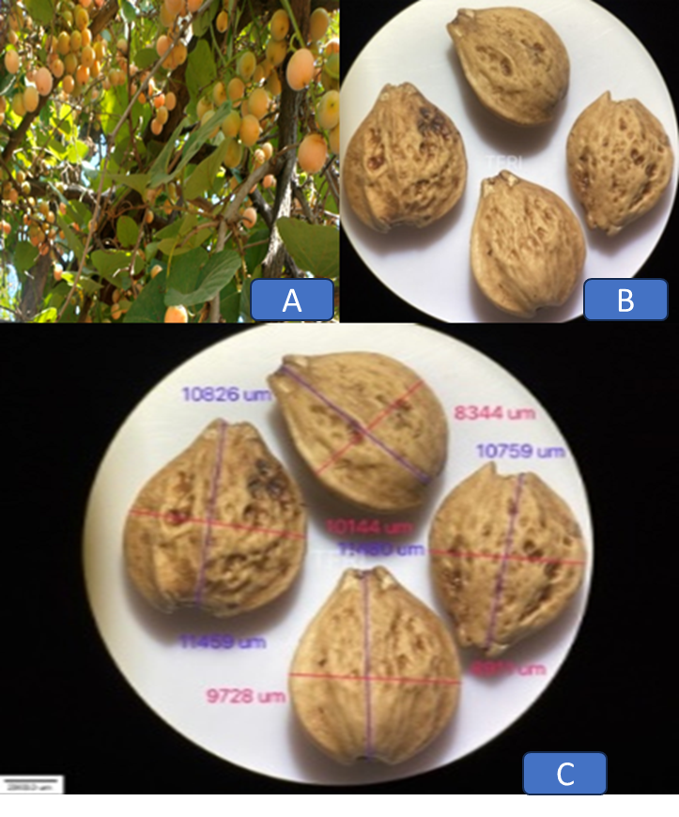

**Fig 1.** Fruit and seed carpology of *Cordia myxa* (A) Follicles (B) Seed with silky hairs (C)Microscopic Seed Image (Scale 2900.00 µm)

**Seed viability:** Table 1 illustrates the impact of different tetrazolium (TZ) concentrations (1%, 0.5%, and 0.25%) and staining durations (1, 2, 4, and 24 hours) on the viability percentage of *Cordia myxa* seeds. The results indicate that staining duration significantly influences viability, with no staining observed at 1 hour across all concentrations, moderate viability at 2 hours (around 54–60%), and a marked increase at 4 and 24 hours, reaching up to 98.33%. While TZ concentration showed some variation, particularly with 0.25% performing slightly lower than 0.5% and 1%, statistical analysis revealed that staining duration was the most critical factor (F = 5.45, p < 0.001), whereas TZ concentration (F = 231.55) and the interaction between concentration and duration (F = 2.05) were not significant. Table 2 further supports these findings through topographic staining patterns: viable seeds exhibited dark staining in the embryonal axis and cotyledons, partially viable seeds showed light staining, and non-viable seeds were completely unstained. These visual staining patterns offer a reliable diagnostic tool to differentiate between viable and non-viable seeds.

**Table 1.** Impact of TZ Concentration and Staining Duration on Viability Percentage of *Cordia myxa*

|  |  |  |  |  |
| --- | --- | --- | --- | --- |
| Staining duration (hrs.) | TZ Conc. (%) | | |  |
| **1** | **0.5** | **0.25** | **Mean** |
| 1 | 0.00 | 0.00 | 0.00 | 0.00d |
| 2 | 60.00 | 54.33 | 55.67 | 56.67c |
| 4 | 90.00 | 98.33 | 71.67 | 86.67b |
| 24 | 95.33 | 98.33 | 82.30 | 91.99a |
| Mean | 61.33a | 62.75a | 52.4b |  |
| Factors | **C.D.** | **SE(d)** | **SE(m)** | **F-Calculated** |
| TZ Conc. | 8.14 | 3.92 | 2.77 | 231.55 |
| Staining Duration | 7.05 | 3.40 | 2.40 | 5.45 |
| TZ Conc. X Staining Duration | N/A | 6.79 | 4.80 | 2.05 |

**Table 2.** TZ staining patterns of viable (1) and non- viable (2,3) seeds in *Cordia myxa*

|  |  |  |
| --- | --- | --- |
| **S. No.** | **Topographic description** | **Topographic pattern** |
|
| 1 | Embryonal axis and cotyledons darkly stained |  |
| 2 | Embryonal axis and cotyledons lightly stained |  |
| 3 | Embryonal axis and cotyledons unstained |  |

**Water Imbibition**

The water imbibition pattern of *Cordia myxa* Linn.seeds show a gradual increase in seed fresh weight over time (Fig 2), indicating a slow water absorption process. Initially, at 0 hours, there is no increase in fresh weight. By 2 hours, the weight increases to 15.80% (SE = 0.37), followed by a slight rise to 17.48% at 4 hours (SE = 0.38) and 18.88% at 8 hours (SE = 0.49). The absorption continues at a slow rate, reaching 19.55% (SE = 0.46) at 10 hours. A more noticeable increase occurs at 24 hours (22.44%, SE = 0.48) and peaks at 25.35% (SE = 0.60) at 27 hours, before slightly declining to 24.07% (SE = 0.57) at 30 hours, possibly indicating stabilization or minor water loss. This pattern suggests a slow and steady imbibition process with a prolonged stabilization phase.

**Fig 2.** Water Imbibition curve of *Cordia myxa*Seeds over Time period

**Seed Pre-treatment**

The effect of various seed pre-treatment methods on the germination and early growth characteristics of *Cordia myxa* was evaluated through multiple parameters, including Mean Germination Time (MGT), germination percentage, root length, shoot length, and Vigour Index I. In the control treatment, seeds exhibited a germination percentage of 44.55%, MGT of 17.82 days, root length of 5.34 cm, shoot length of 11.09 cm, and a vigour index of 732.48. Soaking seeds in water for 48 hours improved germination to 65.00%, increased root and shoot lengths to 5.50 cm and 11.88 cm respectively, and elevated the vigour index to 975.26, though MGT slightly rose to 19.54 days. In contrast, acid scarification for 10 minutes followed by 48 hours water soaking led to poor outcomes, with only 19.87% germination, MGT of 21.36 days, and a reduced vigour index of 246.83. Immersion in hot water (80–100°C) for 5 minutes followed by 48 hours soaking significantly enhanced germination to 55.37%, with a root length of 5.64 cm, shoot length of 9.50 cm, and vigour index of 970.08. The most effective treatment was hot water for 5 minutes combined with 500 ppm GA₃ soaking for 48 hours, which achieved the highest germination rate (70.70%), a relatively low MGT of 19.12 days, and the greatest vigour index of 1043.43. Conversely, acid scarification followed by GA₃ soaking showed limited success, with only 25.08% germination and a lower vigour index (387.89). Statistical analysis confirmed that differences among treatments (Table 3) were highly significant (p < 0.001), highlighting the hot water plus GA₃ treatment as the most promising approach for improving seedling emergence and growth (Fig 3) in *Cordia myxa*.

**Table 3.** Impact of seed pre-treatment methods on seed quality parameters of *Cordia myxa*

|  |  |  |  |  |  |
| --- | --- | --- | --- | --- | --- |
| **Treatment** | **MGT** | **Germination%** | **Root length (cm)** | **Shoot length (cm)** | **Vigour index I** |
| Control | 17.82±0.28 | 44.55±0.69 | 5.34±0.08 | 11.09±0.17 | 732.48±22.44 |
| 48 hrs water soaking | 19.54±0.23 | 65.00±0.75 | 5.50±0.06 | 11.88±0.14 | 975.26±22.52 |
| Acid 10 minute+48 hours soaking in water | 21.36±0.38 | 19.87±0.35 | 4.07±0.07 | 8.34±0.15 | 246.83±8.72 |
| Immersion in hot water (80-100°C) for 5 minutes followed by 48 hours soaking | 20.50±0.25 | 55.37±0.66 | 5.64±0.07 | 9.50±0.11 | 970.08±23.26 |
| Hot water 5 minute+ GA3 500 48 hours soaking | 19.12±0.39 | 70.70±1.46 | 4.95±0.10 | 9.80±0.20 | 1043.43±43.27 |
| Acid 10 minute + GA3 500 PPM 48 hours soaking | 24.88±0.50 | 25.08±0.51 | 4.92±0.10 | 10.54±0.21 | 387.89±15.70 |
| C.D. | 1.09 | 2.54 | 0.26 | 0.52 | 77.85 |
| SE(m) | 0.35 | 0.81 | 0.08 | 0.17 | 24.99 |
| C.V. | 2.96 | 3.02 | 2.85 | 2.86 | 5.96 |
| F-Calculated | 48.68* | 657.08* | 46.34* | 55.27* | 181.41* |

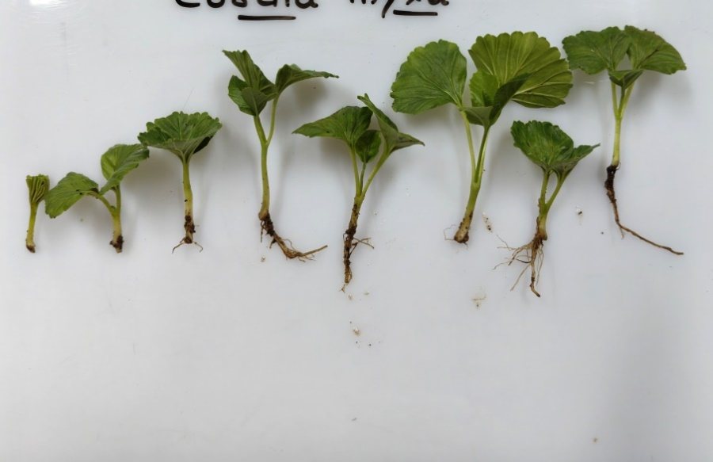

**Fig 3.** Seed germination pattern of *Cordia myxa* Linn.

**Seed Storability Behaviour**

Desiccation trials were conducted to assess the seed storability of *Cordia myxa* Linn**.** using silica gel in desiccators. The initial seed moisture content was 11.49%, with a germination rate of 31.15±1.25%. After desiccation to a safe moisture content of 5.05%, the germination percentage increased to 33.13±1.33%. Seeds stored at –20°C for three months maintained good viability, with a germination rate of 35.44±1.42 %. These findings suggest that *Cordia myxa* Linn**.** seeds are classified under the orthodox storage category, as they demonstrated high storability and maintained viability after prolonged storage under controlled conditions. In conclusion, the seeds of *Cordia myxa* Linn**.** exhibit good storability under orthodox conditions, with improved germination following desiccation and low-temperature storage.

**Table 4.** Different desiccation stages and respective germination percentage after desiccation

|  |  |  |  |  |  |
| --- | --- | --- | --- | --- | --- |
| **Initial seed Moisture Content%** | **Initial seed germination%**  **Mean±SE** | **Desiccated safe moisture content%** | **Germination% Mean±SE** | **3 months after -20 OC storage germination % Mean±SE** | **Seed Storage Categories** |
| 11.49 | 31.15±1.25 | 5.05 | 33.13±1.33 | 35.44±1.42 | Orthodox |

**Discussion**

The present study provides valuable insights into the seed biology, viability, dormancy-breaking treatments, and storability behavior of *Cordia myxa* Linn., a multipurpose and underutilized fruit tree species of ecological and economic importance.

The morphological examination of *C. myxa* fruits and seeds confirms the drupe-like characteristics previously reported by Jasiem et al. (2016). The fruits are globular to ovoid (2–3.5 cm long) with mucilaginous, transparent pulp, enclosing one to two deeply wrinkled seeds. The seed dimensions (length: 1.083–1.229 cm; width: 0.9632–1.014 cm) and high seed count (3,500–4,500/kg) suggest that this species has strong propagation potential, provided quality seed sources are maintained.

Tetrazolium (TZ) staining tests revealed that staining duration was the most significant factor influencing viability, while TZ concentration and its interaction with time showed no significant effects. A 24-hour staining period provided the highest viability values and clearest contrast between viable and non-viable tissues. These findings align with earlier studies (Panse & Sukhatme, 1995) indicating that longer staining durations enhance TZ penetration and staining accuracy. Thus, a 24-hour staining duration is recommended for reliable viability testing of *C. myxa* seeds.

The imbibition behavior showed a gradual increase in seed moisture content, peaking at 25.35% after 27 hours. This slow hydration trend, followed by stabilization, suggests that the seeds possess a semi-permeable seed coat, characteristic of species with physical dormancy. Such a pattern is common in arid-region species where water conservation mechanisms are vital (Hendrickson & Veihmeyer, 1934; Salami & Lawal, 2018). This underlines the need for effective pre-treatment methods to break dormancy and enhance germination.

Significant improvements in germination were observed with pre-treatment protocols (p < 0.001). The control treatment showed the lowest germination (44.55%) and vigour index (732.48), confirming dormancy in untreated seeds. Among the tested treatments, immersion in hot water for 5 minutes followed by 48 hours soaking in 500 ppm GA₃ yielded the highest germination percentage (70.70%), vigour index (1043.43), and a shorter mean germination time (19.12 days). This indicates a synergistic effect of thermal shock and gibberellic acid in promoting germination and seedling vigor. In contrast, acid scarification treatments (alone or with GA₃) resulted in poor germination and vigor, possibly due to embryo damage from excessive chemical exposure. Supportively, Meghwal (2007) reported that GA₃ treatments (250–500 ppm) significantly enhanced germination in *C. myxa*, with the highest rate (66.66%) recorded with sandpaper scarification followed by 500 ppm GA₃ soaking. Likewise, Ghaba et al. (2024) found that soaking seeds in 4000 ppm GA₃ for 24 hours significantly improved germination and seedling growth in Egypt.

Storage trials confirmed that *C. myxa* seeds exhibit orthodox storage behavior. Desiccation using silica gel reduced seed moisture content from 11.49% to 5.05%, improving germination from 31.15% to 33.13%. After three months of –20°C storage, germination further increased to 35.44%, suggesting possible alleviation of residual dormancy. These results validate the classification of *C. myxa* as an orthodox species (Zobel & Talbert, 1984) and affirm findings from Kumar et al. (2022) that dryland trees often tolerate low-moisture storage well. Similar observations were reported by Vijay et al. (2024, 2025a, 2025b) in *Flacourtia indica* and *Commiphora wightii*, where factors such as seed size, maturity stage, and pre-treatment techniques significantly influenced germination behavior and propagation outcomes.

The integration of viability testing, imbibition analysis, pre-treatment efficacy, and storage potential offers a holistic approach to *C. myxa* propagation and conservation. The study affirms that a 24-hour TZ viability test, pre-treatment with hot water and GA₃, and cold storage under desiccated conditions are effective strategies for enhancing propagation success. This can facilitate large-scale multiplication efforts in nurseries and ex situ conservation programs. Further, genetic diversity and regional variability reported by Nagar et al. (2013) and Meghwal et al. (2014a, 2021b) can be better harnessed by using scientifically validated seed handling techniques. These findings also complement earlier discussions on underutilized fruits by Pareek and Sharma (1993), positioning *C. myxa* as a viable candidate for dryland agroforestry, orchard establishment, and genetic resource conservation.

**Conclusion**

This study confirms that *Cordia myxa* benefits significantly from targeted pre-treatments and exhibits robust storability under orthodox seed storage conditions. The recommended protocol—hot water immersion followed by GA₃ treatment, coupled with 24-hour TZ viability testing and low-moisture cold storage—can serve as a model for propagating this valuable yet underutilized species. These findings have strong implications for sustainable nursery practices, afforestation efforts, and biodiversity conservation in arid and semi-arid regions.

**Disclaimer (Artificial intelligence)**

Author(s) hereby declares that NO generative AI technologies such as Large Language Models (ChatGPT, COPILOT, etc.) and text-to-image generators have been used during the writing or editing of this manuscript.

**References**

1. Abdallah, H., Khattaba, A. H., & Heeba, G. H. (2011). Gastroprotective effect of *Cordia myxa* L. fruit extract against indomethacin-induced gastric ulceration in rats. *Life Science Journal, 8*(3), 433–445.
2. Abdul-Baki, A. A., & Anderson, J. D. (1973). Vigor determination in soybean seed by multiple criteria. *Crop Science, 13*(6), 630–633. <https://doi.org/10.2135/cropsci1973.0011183X001300060013x>
3. Arbonnier, M. (2002). *Arbres, arbustes et lianes des zones sèches d’Afrique de l’Ouest*. Cirad/MNHN.
4. Bhatnagar, P., Singh, J., & Meena, C. B. (2016). Lasoda that blooms on tree trunk – A report. *HortFlora Research Spectrum, 5*, 175–176.
5. Ghaba, Z. S., Ebeid, A. F. A., Soliman, W. S., & Gahory, A. (2024). Enhancing *Cordia myxa* germination and seedling growth through breaking seed dormancy techniques. *Aswan University Journal of Science and Technology, 4*(3).
6. Ghaba, Z. S., Ebeid, A. F. A., Soliman, W. S., & Gahory, A. (2024). Enhancing *Cordia myxa* germination and seedling growth through breaking seeds dormancy techniques. *Aswan University Journal of Science and Technology, 4*(3). <https://journals.aswu.edu.eg/stjournal>
7. Hendrickson, A. H., & Veihmeyer, I. M. (1934). *Irrigation experiments with prunes* (Bulletin No. 276). California Agricultural Experiment Station.
8. Hong, T. D., & Ellis, R. H. (1996). *A protocol to determine seed storage behavior* (IPGRI Technical Bulletin No. 1). International Plant Genetic Resources Institute.
9. International Seed Testing Association (ISTA). (2023). *International rules for seed testing: 2023 edition*. ISTA.
10. Jamkhande, S. R., Barde, S. L., Patwekar, S., & Tidke, P. S. (2013). Plant profile, phytochemistry and pharmacology of *Cordia*. *Asian Pacific Journal of Tropical Biomedicine, 3*(12), 1009–1012.
11. Jasiem, T. M., ALmugdadi, S. F. H., Aljubory, I. S., & Latef, Q. N. (2016). Phytochemical study and antibacterial activity of crude alkaloids and mucilage of *Cordia myxa* in Iraq. *International Journal of Pharmaceutical Sciences Review and Research, 39*(1), 232–236.
12. Karami, M. A., Moghimipour, E., & Saafi, S. F. (2015). Preparation and evaluation of *Cordia myxa* fruit topical cream. *World Journal of Pharmaceutical Research, 4*(7), 244–253.
13. Kumar, K., Sarolia, D. K., Saroj, P. L., Samadia, D. K., & Singh, D. (2022). Standardization of seed, rootstock and plant standards of (*Cordia myxa* L.) for commercial orcharding in India. *Journal of Environmental Biology, 43*(2), 267–275. <https://doi.org/10.22438/jeb/43/2/MRN-1927>
14. Kuppast, J., & Vasudeva, P. (2006). Wound healing activity of *Cordia dichotoma* Forst. f. fruit. *Research Article, 5*(2), 99–102.
15. Meghwal, P. R. (2007). Propagation studies in lehsua (*Cordia myxa* L.). *Indian Journal of Agricultural Sciences, 77*(11), 765–767.
16. Meghwal, P. R., Singh, A., & Pradeep-Kumar. (2014a). Evaluation of selected gonda genotypes (*Cordia myxa* L.) on different rootstocks. *Indian Journal of Horticulture, 71*(3), 415–418.
17. Meghwal, P. R., Singh, A., & Singh, D. (2021a). Research status of lasora (*Cordia myxa* L.) in India – A review. *Current Horticulture, 9*(1), 15–19.
18. Meghwal, P. R., Singh, A., & Singh, D. (2021b). Underutilized fruits and vegetables in hot arid regions of India: Status and prospects. *Agricultural Reviews, 43*(1), 38–45. <https://doi.org/10.18805/ag.R-2087>
19. Meghwal, P. R., Singh, A., Pradeep-Kumar, & Morwal, B. R. (2014b). Diversity, distribution and horticultural potential of *Cordia myxa* Roxb.: A promising underutilized fruit species of arid and semi-arid regions of India. *Genetic Resources and Crop Evolution, 61*, 1633–1643. <https://doi.org/10.1007/s10722-014-0161-y>
20. Meghwal, P. R., Sourabh, & Singh, D. (2024). Exploring polybag size, nursery mixtures and rootstocks for optimizing Lasoda (*Cordia myxa* L.) nursery techniques. *Indian Journal of Agricultural Research*. Advance online publication. <https://doi.org/10.18805/IJARe.A-6211>
21. Nagar, B. L., Fageria, M. S., & Pareek, S. (2013). Genetic variation for physicochemical characteristics in lehsua (*Cordia myxa* L.). *African Journal of Agricultural Research, 8*(40), 5047–5050. <https://doi.org/10.5897/AJAR12.2170>
22. Orchard, T. (1977). Estimating the parameters of plant seedling emergence. *Seed Science and Technology, 5*(1), 61–69.
23. Panse, V. G., & Sukhatme, P. V. (1995). *Statistical methods for agricultural workers* (4th ed.). Indian Council of Agricultural Research.
24. Pareek, O. P., & Sharma, S. (1993). Underutilized fruits. *Indian Horticulture, 38*, 47–56.
25. Salami, K. D., & Lawal, A. A. (2018, April 23–27). Description of economical trees and shrubs species in northern part of Nigeria and their potentials. In *Proceedings of the 6th Biennial National Conference of the Forests and Forest Products Society* (pp. 136–144).
26. Scott, S. J., Jones, R. A., & Williams, W. A. (1984). Review of data analysis methods for seed germination. *Crop Science, 24*(6), 1192–1199. <https://doi.org/10.2135/cropsci1984.0011183X002400060043x>
27. Silva, E. A. A., Toorop, P. E., Van Aelst, A. C., & Hilhorst, H. W. M. (2004). Abscisic acid controls embryo growth potential and endosperm cap weakening during coffee (*Coffea arabica* cv. Rubi) seed germination. *Planta, 220*, 251–261. https://doi.org/10.1007/s00425-004-1344-0
28. Vijay, M. K., Rathod, D. U., Singh, N., Tiwari, S., Kahar, L., Malviya, D., & Aharwar, M. (2025a). Assessment of germination dynamics through maturity and pre-treatment studies in *Flacourtia indica* (Burm.f.) Merr. *International Journal of Research in Agronomy, 8*(4), 30–36. <https://doi.org/10.33545/2618060X.2025.v8.i4a.2738>
29. Vijay, M. K., Tiwari, S., Kahar, L., Malviya, D., & Singh, N. (2025b). Fruit and seed development of critically endangered *Commiphora wightii* (Arn.) Bhandari: Insights into physiological maturation and germination potential. *Journal of Scientific Research and Reports, 31*(7), 374–384. <https://doi.org/10.9734/jsrr/2025/v31i73254>
30. Vijay, M. K., Tiwari, S., Kahar, L., Malviya, D., Aharwar, M., & Singh, N. (2024). Impact of seed size on germination parameters in *Flacourtia indica* (Burm.f.) Merr. *International Journal of Research in Agronomy, 7*(9), 23–29. <https://doi.org/10.33545/2618060X.2024.v7.i9a.1432>
31. Zobel, B., & Talbert, J. (1984). *Applied forest tree improvement*. John Wiley and Sons.