Assessing chilli genotypes in vertisols of Andhra Pradesh
----------------------------------------------------------------------------------------------------------
Abstract:
Chilli (Capsicum annuum L.) is one of the most important spice crops in India valued for domestic and export market. Andhra Pradesh ranks first in area, production and productivity of chilli. The present investigation was carried out with thirteen promising chilli genotypes in randomized block design replicated thrice. The thirteen promising genotypes were used to study their performance for growth, yield attributing and yield in chilli. The chilli accessions differed significantly for all the traits evaluated. Among the thirteen lines evaluated, genotype SKAU-128 recorded maximum plant height (97.7cm), genotype ST-37 recorded higher number of primary branches, ST-07 has was earlier in flowering, LCA-334 recorded highest mean fruit weight. The present study revealed that among the genotypes tested for, LCA-334 recorded the highest mean yield (133 q/ha) being on par withRHRCH-10-2 (126.4q/ha).
Key words: chilli, genotypes, growth, yield
Introduction:
India is the major producer, consumer and exporter of chilli, covering an area of 0.852 million hectares with a production of 1.957 million tonnes averaging a productivity of 2.296 metric tonnes per hectare (www.indianspices.com). Chilli (Capsicum annuum L.) is an important valuable commercial spice-cum-vegetable crop grown in India under various agro climatic conditions viz., tropical, sub- tropical and temperate climates (Hazra et al., 2011). Pungency of chilli is due to a crystalline acrid volatile alkaloid called capsaicin, present in the placenta of fruit. It is also a good source of chilli oleoresin, which is the total flavour extract of dried and ground chillies. The natural colour extracts of chilli are also finding their increased value in place of artificial colours in the food items (Katheek et al., 2018) Among the five (5) cultivated species, (Capsicum annuum L.) is the most widely cultivated species for its pungent (hot pepper) and non-pungent (sweet pepper) fruits throughout the world. The chilli is mainly used for imparting pungency both at green stage as well as after maturity. There is variation in fruit size and shape. The popularity of chilli is due to its wide range of shape, size and sensory attributes such as colour and pungency (Govindarajan et al., 1987). There is large variability in respect of fruit size, shape and growth among the chilli genotypes. Hence, there is need to study the growth and yield performance of these genotypes for different agro climatic condition. Hence, the present investigation was carried out to study the performance of different promising genotypes across the country in vertisols of Andhra Pradesh.
Materials and Methods:

The field experiment was carried out in Randomized Block Design with three replications at Horticultural Research Station, Lam Dr.YSRHU during the Kharif seasons of 2020-2021. The study was conducted with thirteen promising genotypes of chilli (Table-1) in randomized block design with three replications. The experimental plot size was kept as 4.0 x 2.4 m with spacing of 75 cm x 50 cm and the FYM @ 25tones / ha was incorporated before transplanting. All the genotypes were fertilized uniformly @ 300:60:120 kg NPK/ha. At the time of transplanting half the dose of nitrogen and potash along with full dose of phosphorus was applied. Remaining nitrogen and potash was top dressed at four equal doses at one month interval. The NPK fertilizers were given through urea, single super phosphate and muriate of potash. Need based plant protection measures were also taken regularly. All the important growth and yield attributing characters were recorded on five randomly selected plants at random to record the observations on eleven characters viz., Plant height (cm), Number of primary branches plant, Number of secondary branches plant, plant spread, Days to first flower initiation, Days to 50% flowering, Number of fruit per plant, fruit length (cm), Fruit girth (cm), mean fruit Weight (g) and fruit yield. The mean data were subjected to analysis of variance techniques as suggested by Panse and Sukhatme (1985).
Results and Discussion:
The results of the performance of different chilli genotypes are presented in table 2 and 3. Significant differences were observed in all the characters under study. The genotypes were diverse with respect to morphological and important economical traits. There is lot of variation was observed in plant height of chilli genotypes which has influence on its final performance (Hosmani, 1982). In the present study, plant height of different lines varied widely and significantly. Plant height and plant spread are significant characters of variety identification especially for identification of off type at the time of field inspection. Plant height among the cultivars studied were ranged from 47.3 cm (Kasi Anmol) to 97.7cm (SKAU-128), Among the thirteen lines evaluated, genotype SKAU-128 recorded maximum plant height (97.7cm) being on par with RHRCH-10-2 (96.3cm), RHRCH-64-1 (94.5cm), DD 98-1(93.3cm) and the lowest plant height was recorded in Kashi Anmol (47.3cm). Plant height is an important growth character in chilli, which has considerable influence on crop yield. The variation in plant height of different chilli genotypes has been reported earlier (Sreelathakumary and Rajamony 2004, Dhaliwal et al. 2015; Dhumal et al. 2020, Dhaliwal et al. 2015, Dhumal et al., 2020). Swati Sah et al 2023 opined that, the genetic potential, environmental factors, especially optimum temperature for good vegetative growth are responsible for the differences in plant height. Among the genotypes, plant spread ranged from 93.6 cm (DPCH-27) to 179.5cm (SKAU-89). Among the thirteen lines evaluated, genotype SKAU-89 recorded maximum spread (179.5cm) being on par with LCAS-10 (171.9cm). Naganirmala Kumari (2019) opined that both plant height and plant spread characters may not be suitable for clear cut characterization, however they can be used to distinguish among the cultivars. Among the genotypes, number of primary branches were maximum in SKAU-89 (4.9) being on par with RHRCH-64-1, RHRCH-10-2 (4.4). With regard to number of secondary, branches were maximum number of secondary, branches were observed in SKAU-89 (4.9) being on par with RHRCH-64-1, RHRCH-10-2 (4.4). Similar results of variation in branching and variation in days to flowering in chilli was reported by Naganirmala Kumari (2019). Among the genotypes, SKAU-128 came to flowering earlier (41.6 and 50.4days days to first flowering and days to 50% flowering respectively) where as LCA -334 was late to flower. The variation in flowering in different chilli genotypes has been reported earlier (Mukesh Awasthi et al .,2021, Karthhek Mukesh Awasthi2018),
Among the genotypes evaluated number of fruits per plant were significantly maximum in IIVRC-18057 where as fruit length and fruit girth were significantly maximum in ACS 18-08 (14.3 and 4.1 cm respectively). The number of fruits per plant was appreciably high for certain lines and thus provides good scope for selection of these genotypes for improvement in chilli for yield characters. The variation in fruit number may be due to the difference in percentage fruit set, genetical and environmental factors. The results obtained are in accordance with Nivedha et al. (2019) and Dhumal et al. (2020). Among the genotypes tested, ACS 18-08 recorded significantly highest mean fruit weight (4.7gm) being on par with LCA-334 (4.4.gm). In the present study, a high range of variability was observed for all the characters under study. Variability was maximum for number of fruits per plant (42.33 to 226.3). The characters showing wide range of variation provide an ample scope for selecting desired types. These results are in accordance with those reported by earlier workers (Naganirmala Kumari (2019) , Naresh et al., 2011; Gupta et al. ,2009).Among the genotypes tested for, ACS 18-08 recorded the highest dry chilli yield (64.5 q/ha) being on par with RHRCH-10-2 (63.0/ha), LCA-334(62.6 q/ha). Large varietal variations in yields were also reported by Smitha and Basavaraja 2006 ,Tembhurne et al.,( 2008), Vijaya et al. (2014), Ashish Kumar Maurya etal (2016), Yatagiri et al. 2017 Nivedha et al. 2019, Swati Saha(2023) who observed variation in growth and yield attributes of chilli.
Conclusion: From the present investigation, it may be concluded that chilli genotype ACS 18-08 resulted in highest dry chilli yield (64.5q/ha) being on par with RHRCH-10-2 (63.0/ha), LCA-334(62.6 q/ha). But the trail needs further evaluation trials, since this is based on one season trial only.
Table 1: Source of the Chilli genotypes (Capsicum annuum L.)
S. No | Name of the genotype | Source
1 | SKAU-89 | SKUA&T, Srinagar
2 | IIVRC-18057 | IIVR, Varanasi
3 | RHRCH-64-1 | MPKV, Rahuri
4 | NDC Sel -1 | NDUA&T, Ayodhya
5 | SKAU-128 | SKUA&T, Srinagar
6 | LCAS-20 | Lam, Guntur
7 | LCAS-10 | Lam, Guntur
8 | ACS 18-08 | AAU, Anand
9 | DPCH-27 | CSKHPKV, Palampur
10 | RHRCH-10-2 | MPKV, Rahuri
11 | DDC-98/1 | Dharwad (UHS)
12 | Kashi Anmol (C) | IIVR, Varanasi
13 | LCA-334 (C) | Lam, Guntur

S.No. | Entry Name | Plant height (cm) | Number of primary branches | Number of secondary  branches | Plant spread (cm) | Days to first flowering | Days to 50%  flowering
 | SKAU-89 | 85.6 | 4.9 | 14.0 | 179.5 | 43.4 | 53.4
 | IIVRC-18057 | 73.7 | 3.0 | 9.4 | 158.9 | 42.9 | 52.1
 | RHRCH-64-1 | 94.5 | 4.4 | 8.7 | 156.9 | 45.5 | 55.5
 | NDC Sel -1 | 75.0 | 3.3 | 9.2 | 139.9 | 46.2 | 56.2
 | SKAU-128 | 97.7 | 3.2 | 8.9 | 135.5 | 41.6 | 51.6
 | LCAS-20 | 85.6 | 3.3 | 8.3 | 140.3 | 45.5 | 55.5
 | LCAS-10 | 83.5 | 3.4 | 9.2 | 171.9 | 44.4 | 54.4
 | ACS 18-08 | 79.0 | 3.7 | 9.3 | 146.2 | 46.9 | 56.9
 | DPCH-27 | 78.9 | 3.1 | 10.6 | 93.6 | 44.2 | 54.2
 | RHRCH-10-2 | 96.3 | 4.4 | 8.7 | 169.5 | 45.3 | 55.3
 | DDC-98/1 | 93.1 | 2.8 | 9.4 | 145.3 | 43.7 | 53.7
 | Kashi Anmol (C) | 47.3 | 4.3 | 10.2 | 122.3 | 45.4 | 55.4
 | LCA-334 (C) | 84.7 | 4.1 | 11.7 | 165.7 | 46.2 | 56.2
 | CD | 15.0 | 0.8 | 1.39 | 36.4 | 1.0 | 0.99
 | C . V % | 10.8 | 12.3 | 8.34 | 14.6 | 1.3 | 1.1
Table 2: Performance of chilli genotypes for growth characters

Table 3: Performance of chilli genotypes for yield and yield attributes
S. No. | Entry Name | Number of fruits | Fruit length (cm) | Fruit girth(cm) | Pedicel length (cm) | Average fruit weight |  | Yield  (q/ha)
 | SKAU-89 | 130.5 | 12.6 | 3.3 | 3.6 | 2.4 |  | 75.5
 | IIVRC-18057 | 226.3 | 10.3 | 3.4 | 3.2 | 2.0 |  | 101.3
 | RHRCH-64-1 | 68.5 | 13.2 | 3.5 | 3.4 | 2.3 |  | 33.4
 | NDC Sel -1 | 42.3 | 11.3 | 2.8 | 3.4 | 2.9 |  | 27.3
 | SKAU-128 | 113.3 | 11.8 | 3.5 | 2.8 | 2.1 |  | 47.2
 | LCAS-20 | 155.7 | 11.3 | 3.4 | 3.5 | 2.8 |  | 66.1
 | LCAS-10 | 105.1 | 12.2 | 3.7 | 3.4 | 2.7 |  | 54.7
 | ACS 18-08 | 159.5 | 14.3 | 4.1 | 3.1 | 4.7 |  | 105.1
 | DPCH-27 | 76.8 | 8.5 | 3.0 | 3.8 | 2.2 |  | 58.9
 | RHRCH-10-2 | 124.6 | 11.8 | 3.5 | 2.4 | 3.4 |  | 126.4
 | DDC-98/1 | 60.4 | 12.4 | 3.5 | 3.0 | 3.5 |  | 63.4
 | Kashi Anmol (C) | 55.7 | 9.6 | 2.9 | 3.3 | 2.0 |  | 31.8
 | LCA-334 (C) | 163.3 | 12.4 | 3.3 | 2.5 | 4.4 |  | 133.0
 | CD | 25.0 | 1.6 | 0.6 | 0.6 | 0.8 |  | 15.7
 | C . V % | 13.0 | 8.4 | 10.9 | 11.7 | 16.3 |  | 13.1

Fig1. Variation in chilli genotypes for number of fruits

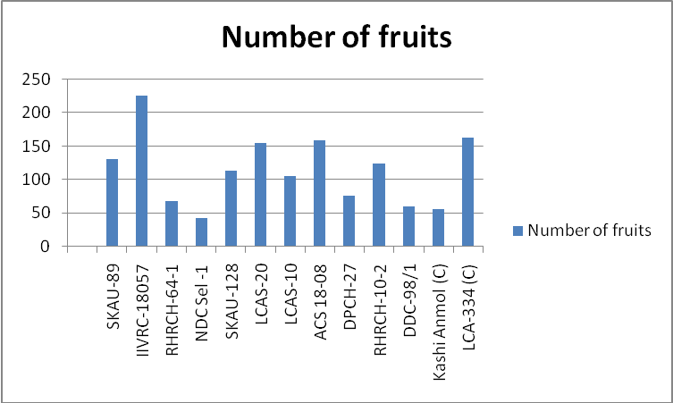

Fig2. Variation in chilli genotypes for mean fruit weight

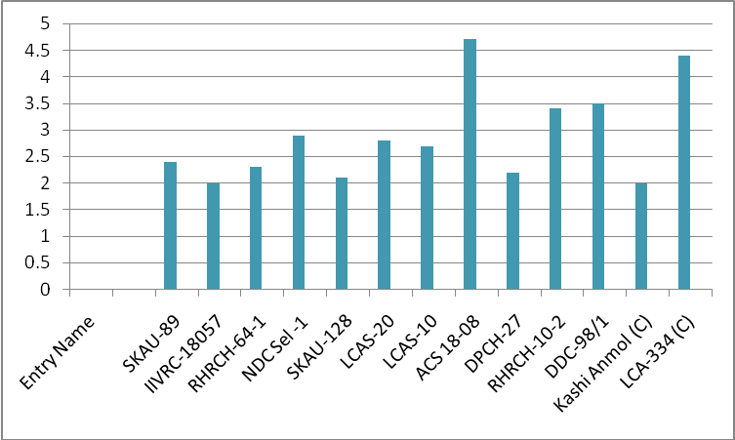
Fig 3: variation in chilli genotypes for yield
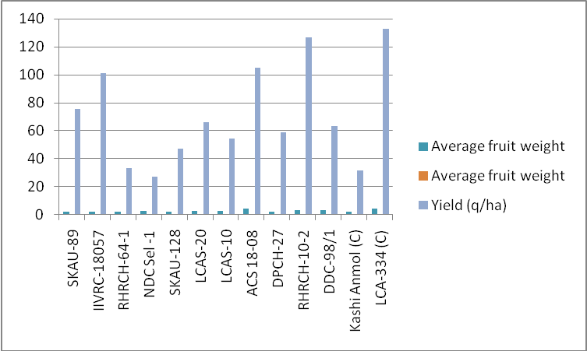

References:
Ashish Kumar Maurya , M.L. Kushwaha, Vikas Kumar Jain and Neeraj Singh 2016 “Evaluation of chilli (capsicum annum L) genotypes for yield and performance against diseases” Progressive Research – An International Journal , 11 (Special-VII) : 4615-4617
Chattopadhyay, A., Sharangi, A.B., Dai, N. and Dutta, N. 2011. Diversity of genetic resources and genetic association analyses of green and dry chillies of eastern india. Chilean journal of agricultural research 71.3
Dhaliwal MS, Garg N, Jindal SK, Cheema DS.2015 “ Growth and yield of elite genotypes of chilli (Capsicum annuum L.) in diverse agro climatic zones of Punjab.” Journal of Spices and Aromatic Crops. 2015;24(2):83-91.

Dhumal VT, Pharle NR, Kapse VD, Naik HP, Vaidya KP, Meshram NA.2020 “ Evaluation of F1 progenies of chilli (Capsicum annuum L.) under Konkan agro climatic condition.” The Pharma Innovation Journal. 2020;9(1):180-182.

Gupta A.M., Singh D. and Kumar A. (2009). Genetic variability, genetic advance and correlation in chilli (Capsicum annuum). Indian Journal of Agricultural Sciences. 79(3): 221-223.

Govidajaran, V. S., Rajalakshmi,D., and N. Chand, (1987). Capsicum production, technology, chemistry and quality, Part IV, Evaluation of quality, CRC Crit. Rev. Food Sci. Nutr., 25: 185-283.

Hazra, P, Chattopadhyay, A, Karmakar, K. and Dutta, S. 2011. Modern Technology in Vegetable Production, New India Publishing Agency, New Delhi, India. p. 478.

Katheek R, Bharadwaza, Prasad VM, Adinarayana M, Narayana Swamy G. 2018 “Evaluation of Chilli (Capsicum annuum L.) Genotypes for Yield and Yield Attributes in Allahabad Agro-Climatic Conditions.” Int. J. Curr. Microbiol. App. Sci 2018;(Special Issue-7):773-776.

Mukesh Awasthi, Devi Singh and Vijay Bahadur2021 “Varietal evaluation of chilli (Capsicum annuum) for growth, yield and quality in Prayagraj Agro climatic condition” The Pharma Innovation Journal 2021; 10(10): 1267-1269
Naganirmala Kumari Bantu and Mallikarjuna Kokkanti 2019 “omparative Morphological Evaluation of Different Chilli (Capsicum annuum L.) Varieties of Andhra Pradesh, India for Agronomic Traits” ournal of Stress Physiology & Biochemistry, Vol. 15, No. 2, 2019, pp. 21-36
Naresh P., Madhavi R.K., Shivashankara K.S. and Christopher G.M. (2013). Genotypic variation for biochemical compounds in capsicum. Indian Journal of Horticulture. 70(1): 43-47

Nivedha P, Rajasree V, Arumugam T, Karthikeyan M, Thiruvengadam V. Evaluation of parents and hybrids of chilli (Capsicum annuum L.) for yield and resistance to chilli leaf curl disease. Journal of Pharmacognosy and Phytochemistry. 2019;8(3):4763-4766

Panse, V. G. and Sukhatme, P. V. 1985. Statistical Methods for Agricultural Workers. ICAR Publications, New Delhi, India, pp. 359.

Smitha RP, Basavaraja N. Variability and correlation studies in chilli (Capsicum annuum L.). Karnataka Journal of Agriculture Sciences. 2006;19(4):888-889
Swati Saha, K Chandrashekar and SS Kushwah 2023 “Evaluation of chilli genotypes for yield, quality traits and tolerance to thrips in Western Ghats agro-climatic region” The Pharma Innovation Journal 2023; 12(9): 1644-1648
Sreelathakumary I, Rajamony L. 2004 “Variability, heritability and genetic advance in Chilli (Capsicum annum L.).” Journal of Tropical Agriculture. 2004;42(1-2):35-37.

Swati Saha, K Chandrashekar and SS Kushwah 2023 “Evaluation of chilli genotypes for yield, quality traits and tolerance to thrips in Western Ghats agro-climatic Region” The Pharma Innovation Journal 2023; 12(9): 1644-1648.

TembhurneBV, Revanappae and PH Kuchanur 2008 “Varietal Performance, Genetic Variability and Correlation Studies in Chilli (Capsicum annuum L.)” Karnataka J. Agric. Sci., 21 (4) (541-543) : 2008

Vijaya, H.M., Gowda, A.P.M., Nehru, S.D. and Jyothi, K. (2014). Performance of chilli (Capsicum annuum L.) genotypes for growth and yield parameters in eastern dry zone of Karnataka. Journal of Spices and Aromatic Crops Vol. 23.2: 250–253.
Yatagiri N, Sanap PB, Telugu RK. Growth, flowering behaviour and physical fruit parameters of chilli (Capsicum annuum L.) genotypes in Coastal Maharashtra. International Journal of Current Microbiology and Applied Sciences. 2017;6(7):2230- 2237

