**EVALUATION OF DIFFERENT VARIETIES OF LEMONGRASS (*Cymbopogon flexuosus* L.) IN KONKAN REGION**

* Abstract:

An experiment on “Evaluation of different varieties of lemongrass (*Cymbopogon flexuosus* L.) in Konkan region conducted at Department of Plantation, Spices, Medicinal and Aromatic Crops, College of Horticulture, Dapoli, Dr. Balasaheb Sawant Konkan Krishi Vidyapeeth, Dapoli during the year 2023-24. Eight treatments and three replications in Randomized Block Design viz. T1: Krishna, T2: Chirharit, T3: Nima, T4: Praman, T5: Cauveri, T6: CIM- Shikhar, T7: CKP- 25, T8: Local with the aim to investigate Evaluation of different varieties of lemongrass with respect to growth and economics in Konkan region. The highest plant height (210.60 cm), number of leaves (232.53), Number of tillers (57.33) and Longest Leaf Length (129.45cm) were recorded in treatment T1 i.e. Krishna variety of lemongrass at 180 days after planting while Longest Leaf Width (2.19 cm)were recorded in T8 i.e. Local Varity of lemongrass. Thus, from the results obtained it can be concluded that Krishna Variety of Lemongrass performs well in Konkan region.

Keywords: Lemongrass, Varieties, Konkan, Performance, *Cymbopogon*

1. Introduction:  
    Lemon grass (*Cymbopogon flexuosus* L.) is an aromatic grass belonging to family Poacee. It is prevalent in the semi-temperate and tropical regions of Asian, American and African continents. Lemon grass is a perennial monocotyledonous grass which can grow up to 6 feet in height. It grows in clusters. It has long, slender, drooping bright green leaves that measures from 1.3-2.5cm in width and 3feet in length. Leaves are simple with entire margins. Flowers grow on spikes. It has a lengthy inflorescence ranging from 30-60cm. A strong fragrance, a predominant feature of lemongrass is due to the high citral content. The redolence of the oil enables its use in soaps, detergents and perfumes. It also finds an application in pharmaceutical industries. India is the largest producer of lemongrass and about 80% of produce is exported to the West Europe, USA and Japan. The essential oil extracted from leaves and flower of lemongrass is used in scenting soaps, detergents and insect repellent preparation (Anon., 2024). According to the WHO, herbal medicine is considered an important part of the healthcare industry by more than 2/3rd of the population in developing countries. Lemon grass contains nutrients such as fats, proteins, fiber, vitamins and minerals. (Fathima, 2023). The health restorative capacity of lemon grass may be ascribed to the diverse. Lemon grass contents medicinal properties which make it a potent herb for pharmacognostic applications. The genus *Cymbopogon* constitutes of approximately 140 species that show widespread growth across the semi-temperate and tropical regions of Asian, American and Africa. Few species of lemon grass found in Australia and Europe. Also known as 'Squinant' in English, lemon grass is known by various other colloquial names throughout the world. The members of the *Cymbopogon* genus produce volatile oils and thus also known as aromatic grasses. Several high yielding varieties of lemongrass have been developed during last two decades by studying their morphological and physiological aspect. These include CKP-25, Praman, Cauvery, Krishna, Pragati, Nima, Chirharit, etc. (Adsul, 2015). Hot and Humid agroclimatic conditions of Konkan region are favourable for growing lemongrass. The performance of different of varieties of lemongrass helps in evaluating the suitable variety for Konkan Region which adapt and perform best in the respective agroclimatic conditions.
2. Research methodology:

The research trial was conducted at Nursery No.4, College of Horticulture, Dapoli, Dr. Balasaheb Sawant Konkan Krishi Vidyapeeth, Dapoli during academic year 2023- 2024. Dapoli is situated on the west coast of Maharashtra State at 17074” N latitude and 73012” E longitude with an altitude of 280 meters above mean sea level and 8 km from the Arabian Sea. The Experiment was laid in Randomized Block Design (RBD) with Eight treatments which are replicated thrice. T1: Krishna, T2: Chirharit, T3: Nima, T4: Praman, T5: Cauveri, T6: CIM- Shikhar, T7: CKP- 25, T8: Local. The slips for planting are collected from different locations of Ratnagiri and Sindhudurg district. The planting of one healthy rooted slip of lemongrass at 60 cm X 60 cm on raised bed having dimensions of 3.6 m X 3 m is done. During field preparation FYM were applied at the rate of 20- 25 t/ha as basal dose and mixed in the soil properly. The basal dose NPK in the proportion of 30:30:30 kg/ha and remaining N is applied 3 months after planting. The plant height was measured using measuring scale at 30,60,90,120 and 180 days after planting. Number of tillers were counted at 30,60,90,120 and 180 days after planting. Number of leaves were counted at 30,60,90,120 and 180 days after planting. Yield per hectare was calculated at the end of experiment. The data were statistically analyzed by the method suggested by Panse and Sukhatme, 1985.

1. Result and Discussion
   1. Plant height:

Plant height significantly increased during the observation period from 30 DAP to 180 DAP. Krishna (T1) variety of lemongrass shows the maximum plant height (210.60 cm) at 180 DAP. Whereas least plant height (110.34 cm) was observed in treatment T2 i.e. Chirharit. Plant height is one of the important factor of growth and development of plant. Although it is determined by genetic factor, environmental conditions also influence the plant height. Present experiment showed that the T1 *i.e.* Krishna positively adapt to the environmental condition of Konkan region with respect to plant height. Lal *et al.* (2006) examined the plant heights of several lemongrass clones and found that four elite clones had plant heights between 100 and 160 cm. According to Yogendra *et al.* (2022), lemongrass plants range in height from 108.47 to 136.75 cm.

* 1. Number Of Leaves

The number of leaves shows the health and environmental adaptability of the plant. The survival and function of plants depends on the leaves. Leaves are the manufacturing unit of plant. The main function of leaves is photosynthesis, which ultimately produce energy for metabolic processes. The highest number of leaves (232.53) was recorded in T1 i.e. Krishna variety of lemongrass at 180 DAP. However lowest number of leaves (163.87) were observed in treatment T6 i.e. CIM- Shikhar at 180 DAP. The more number of leaves of Krishna variety may be due to the higher adaptability towards the environmental conditions of Konkan region as well as due to higher nutrient uptake and soil moisture content. Krishna variety of lemongrass may have larger chlorophyll content in its body, which promotes photosynthesis and energy generation and allows for greater leaf growth. According to Mallikarjun *et al.* (2021) the number of leaves of citronella varies according to the environmental conditions.

* 1. Number of Tillers

The vast deviation was observed in number of tillers during the research trial due to adaptability towards climatic and edaphic conditions. The tillering capacity shows the sign of environmental adaptability. Higher number of tillers helps in absorbing more sunlight and use of more nutrients to produce the energy which is utilized for more herbage production and increase the overall biomass. At 180 DAP highest number of tillers (57.33) was observed in treatment T1 i.e. Krishna variety of lemongrass. Treatment T1 was found superior over other treatments with respect to number of tillers. However, lowest number of tillers (43.53) was recorded in treatment T6 i.e. CIM- Shikhar variety. This variation in number of tillers is due to variation in the genetic constituents of the genotypes and environmental factors, the variations which are in line with earlier reports of Singh and Singh (1999) in lemongrass. According to Yogendra *et al.* (2022), there are between 38.13 and 47.60 tillers per lemongrass plant. Maximum mean numbers of tillers per clump was observed in Mandakini (96.77) followed by Manjusha (80.87) while the minimum were recorded in CIM Jeeva (50.30). his variation in number of tillers was due to variation in the genetic constituents of the genotypes and environmental factors, the variations which are in line with earlier reports of Singh and Singh (1999) in lemongrass, Lynrah and Chakrabarthy (2000) and Sharma *et al.* in (2002) in *Cymbopogan pendulus.* According to Sharma et al. (2002), the ideal number of tillers per plant was discovered in lemongrass during the flowering stage. Lal et al. (2006) found that for four elite clones of lemongrass, the number of tillers per plant ranged from 45 to 65.

* 1. Longest Leaf Length

A longer leaf length in a plant leads to more photosynthetic activity and energy production, which supports general growth and development. The longest leaf length demonstrates a greater degree of flexibility to the geological and environmental circumstances of a particular location. Data for longest leaf length was recorded at the end of the experiment *i.e.*180 DAP. The lemongrass variety known as Krishna, or treatment T1, has the longest leaves (129.45 cm). On the other hand, the Chirharit type of lemongrass i.e. treatment T2, had the shortest leaves (60.79 cm). In accordance to the research findings, the Krishna variety of lemongrass outperformed the other varieties in terms of leaf length, which may be because it was more adaptable to the local environment. The increased soil nutrient uptake contributes to the overall growth of lemongrass. The current study illustrates how environmental factors impact lemongrass growth. In particular, T1 (Krishna) displayed a significantly longer leaf in comparison to the other treatments. The Krishna variety of lemongrass might be better suited to the specific environmental conditions of the experiment, such as the type of soil and soil moisture content. Agroclimatic zones can have an impact on the length of leaf blades. Significant variance was observed in agroclimatic sub-zone V, which might be attributed to a number of edaphic and microclimatic variables. Conversely, less variance in leaf blade length was seen at agroclimatic sub-zone VI, which may be because growth factor conditions there are similar. Agroclimatic subzone IV showed comparatively minimal leaf blade length, which may point to less favourable climatic and edaphic conditions for the ideal leaf blade length of lemongrass. (Apurwa Kumari, 2024)

* 1. **Longest leaf width**

Plant photosynthetic activity is directly correlated with leaf width (Huwang *et al*., 2022). The adaption to the agroclimatic circumstances is demonstrated by the broader leaf lamina. Plant health is indicated by the longest leaf length and the widest leaf lamina. The longest leaf width of lemongrass was recorded at the end of experiment *i.e.* 180 DAP. The variation in various treatment is presented in table 4. The highest leaf width (2.19 cm) was observed in Local variety of lemongrass *i.e.* Treatment T8 at 180 DAP which was at par with treatment T1 (2.17 cm) *i.e.* Krishna, T3 (2.05 cm) *i.e.* Nima, T2 (2.03 cm) *i.e.* Chirharit and T6 (1.99 cm) *i.e.* CIM- Shikhar varieties of lemongrass. However, shortest leaf width (1.85 cm) was observed in treatment T5 *i.e.*Cauveri variety of lemongrass. The significant variation in leaf breadth between treatments demonstrates how genetic and environmental factors impact lemongrass growth. Additionally, T8 (Local) had the widest leaves, which could be because of Konkan climatic conditions and varietal characteristics. Lemongrass leaf breadth can also change depending on the soil's moisture content, sunlight availability, and quality. The local cultivar's superior leaf breadth may make it ideal for the experimental conditions, allowing it to effectively maximize growth. In agroclimatic sub-zone V, a significant variance in leaf blade width was observed. (Apurwa Kumari, 2024).

**Table 1:** **Plant height (cm) of different lemongrass varieties in Konkan region.**

|  |  |  |  |  |  |  |
| --- | --- | --- | --- | --- | --- | --- |
| **Treatments** | **Plant height (cm)** | | | | | |
| 30 DAP | 60 DAP | 90 DAP | 120 DAP | 150 DAP | 180DAP |
| T1: Krishna | 66.95 | 109.97 | 133.10 | 168.79 | 187.84 | 210.60 |
| T2: Chirharit | 54.97 | 54.54 | 73.11 | 92.74 | 98.05 | 110.34 |
| T3: Nima | 64.31 | 89.35 | 117.35 | 149.28 | 168.04 | 186.80 |
| T4: Praman | 45.37 | 62.53 | 85.19 | 125.47 | 144.6 | 165.73 |
| T5: Cauveri | 43.27 | 57.97 | 79.40 | 128.56 | 153.26 | 169.53 |
| T6: CIM- Shikhar | 54.77 | 90.52 | 125.24 | 150.33 | 160.35 | 181.95 |
| T7: CKP- 25 | 41.55 | 60.39 | 83.77 | 122.43 | 137.23 | 156.93 |
| T8: Local | 71.89 | 78.73 | 101.09 | 130.37 | 144.79 | 162.73 |
| **Mean** | **57.88** | **75.50** | **99.78** | **133.50** | **149.27** | **168.08** |
| S.Em.± | 4.91 | 5.57 | 2.63 | 4.45 | 6.07 | 5.78 |
| C.D. at 5% | 14.90 | 16.90 | 7.99 | 13.50 | 18.40 | 17.54 |
| Result | **SIG** | **SIG** | **SIG** | **SIG** | **SIG** | **SIG** |

**Table 2: Number of leaves of different lemongrass varieties in Konkan region.**

|  |  |  |  |  |  |  |
| --- | --- | --- | --- | --- | --- | --- |
| **Treatments** | **Number of leaves** | | | | | |
| 30 DAP | 60 DAP | 90 DAP | 120 DAP | 150 DAP | 180DAP |
| T1: Krishna | 14.4 | 128.8 | 154.13 | 176.13 | 193.73 | 232.53 |
| T2: Chirharit | 9 | 72.67 | 101.8 | 135.93 | 155.74 | 171.33 |
| T3: Nima | 6.27 | 69.47 | 94.4 | 136.93 | 142.33 | 180.87 |
| T4: Praman | 10.8 | 78.67 | 123.2 | 154.73 | 162.2 | 170 |
| T5: Cauveri | 10 | 81.13 | 112.8 | 134.07 | 149 | 164.27 |
| T6: CIM- Shikhar | 6.47 | 48.8 | 86.53 | 119.27 | 147.07 | 163.87 |
| T7: CKP- 25 | 12.4 | 80.2 | 116.47 | 136 | 152.4 | 167.47 |
| T8: Local | 6.73 | 44.6 | 86.47 | 108.27 | 150.67 | 167.53 |
| **Mean** | **9.50** | **75.54** | **109.47** | **137.66** | **156.64** | **177.23** |
| S.Em.± | 1.43 | 8.44 | 1.83 | 5.48 | 2.17 | 8.98 |
| C.D. at 5% | 4.35 | 25.61 | 5.55 | 16.64 | 6.57 | 27.25 |
| Result | **SIG** | **SIG** | **SIG** | **SIG** | **SIG** | **SIG** |

**Table 3: Number of tillers of different lemongrass varieties in Konkan region.**

|  |  |  |  |  |  |  |
| --- | --- | --- | --- | --- | --- | --- |
| **Treatments** | **Number of tillers** | | | | | |
| 30 DAP | 60 DAP | 90 DAP | 120 DAP | 150 DAP | 180DAP |
| T1: Krishna | 1.73 | 32.07 | 36.87 | 44.93 | 52.73 | 57.33 |
| T2: Chirharit | 1.00 | 31.93 | 35.67 | 41.20 | 46.53 | 50.53 |
| T3: Nima | 1.00 | 18.27 | 25.9 | 34.20 | 41.47 | 47.00 |
| T4: Praman | 1.67 | 27.73 | 33.8 | 40.60 | 47.20 | 50.53 |
| T5: Cauveri | 1.20 | 23.87 | 30.4 | 37.73 | 42.40 | 49.27 |
| T6: CIM- Shikhar | 1.33 | 13.67 | 23.13 | 33.13 | 39.73 | 43.53 |
| T7: CKP- 25 | 1.67 | 25.80 | 31.74 | 36.93 | 40.60 | 45.33 |
| T8: Local | 1.67 | 12.00 | 22.57 | 32.33 | 48.07 | 48.47 |
| **Mean** | **1.41** | **23.17** | **30.00** | **37.63** | **44.84** | **49.00** |
| S.Em.± | 0.39 | 2.94 | 2.72 | 2.21 | 2.63 | 2.48 |
| C.D. at 5% | **NS** | 8.92 | 8.24 | 6.69 | 7.98 | 5.33 |
| Result |  | **SIG** | **SIG** | **SIG** | **SIG** | **SIG** |

**Table 4:** **Longest leaf length (cm) of different lemongrass varieties in Konkan region.**

|  |  |
| --- | --- |
| **Treatments** | **Longest leaf length (cm)** |
| T1: Krishna | 129.45 |
| T2: Chirharit | 60.79 |
| T3: Nima | 102.87 |
| T4: Praman | 99.15 |
| T5: Cauveri | 100.70 |
| T6: CIM- Shikhar | 111.35 |
| T7: CKP- 25 | 97.37 |
| T8: Local | 101.61 |
| **Mean** | **100.41** |
| **S.Em.±** | 4.79 |
| **C.D. at 5%** | 14.54 |
| **Result** | **SIG** |

**Table 5: Longest leaf width (cm) of different lemongrass varieties in Konkan region.**

|  |  |
| --- | --- |
| **Treatments** | **Longest leaf width (cm)** |
| T1: Krishna | 2.17 |
| T2: Chirharit | 2.03 |
| T3: Nima | 2.05 |
| T4: Praman | 1.97 |
| T5: Cauveri | 1.85 |
| T6: CIM- Shikhar | 1.99 |
| T7: CKP- 25 | 1.95 |
| T8: Local | 2.19 |
| **Mean** | **2.02** |
| **S.Em.±** | 0.07 |
| **C.D. at 5%** | 0.20 |
| **Result** | SIG |

1. Conclusion

From the present investigation it can be concluded that with respect to growth characteristics such as Plant height, Number of leaves, Number of tillers and Longest leaf length Treatment T1 i.e. Krishna variety of lemongrass shows better results when compared to other treatments. While Treatment T8 i.e. Local variety of lemongrass performed better with widest leaf lamina or longer leaf width. In this investigation it is also observed that in case of Plant height and Leaf width Treatment T2 i.e. Chirharit Variety of lemongrass performed inferior than other varieties of lemongrass. While T6 i.e. CIM- Shikhar variety of lemongrass showed the inferior results for Number of leaves and number tillers than other treatments. From the present investigation it can be summarize that T1 i.e. Krishna variety of lemongrass performs better than other varieties of lemongrass

1. Disclaimer (artificial intelligence)

Author(s) hereby declares that NO generative AI technologies such as Large Language Models (ChatGPT, COPILOYT, etc.) and text-to-image generators have been used during writing or editing of manuscripts.

1. References
2. Adsul, P. B. 2015. Genetic variability and character association in lemongrass (*Cymbopogon flexuosus* L. Stapf.). M.Sc. (Agri). Thesis submitted to MPKV, Rahuri.
3. Anonymous. 2023. World health Organization. <https://www.who.int>
4. Anonymous. 2024. Model report on lemongrass. National Horticulture Board
5. Apurwa Kumari. 2024. Assessment of morpho-biochemical diversity of Lemongrass in Khunti district of Jharkhand. M.Sc. Forestry. Thesis submitted to Birsa Agricultural University, Ranchi.
6. Fathima Thasrin J. and Anitha V. 2023. Nutritional and nutraceutical potentials of lemongrass (*Cymbopogon citratus*). *International Journal of Current Science Research and Review*, 06(05): 2881-2886.
7. Huang, G., Shu, Y., Peng, S. and Yong Li. 2022. Leaf photosynthesis is positively correlated with xylem and phloem areas in leaf veins in rice (*Oryza sativa*) plants. *Annals of Botany*. 129: 619–631.
8. Lal, R. K., Misra, H. O., Sharma, J. R., Singh, N., Shasany, A. K., Naqvi, A. A., Bahl, J. R., Prasad, A. and Khanuja, S. P. S. 2006. Citral Rich High Yielding Lemongrass Plant ‘Nima’ of *Cymbopogon flexuosus*. *United States Plants Patent* (PP16712), Council of Scientific and Industrial Research, New Delhi, India, pp. 1-14.
9. Lal, R. K., Misra, H. O., Sharma, J. R., Singh, N., Shasany, A. K., Naqvi, A. A., Bahl, J. R., Prasad, A. and Khanuja, S. P. S. 2006. Citral Rich High Yielding Lemongrass Plant ‘Nima’ of *Cymbopogon flexuosus*. *United States Plants Patent (PP16712),* Council of Scientific and Industrial Research, New Delhi, India, pp. 1-14.
10. Lal, R. K., Misra, H. O., Sharma, J. R., Singh, N., Shasany, A. K., Naqvi, A. A., Bahl, J. R., Prasad, A. and Khanuja, S. P. S. 2006. Citral Rich High Yielding Lemongrass Plant ‘Nima’ of *Cymbopogon flexuosus*. *United States Plants Patent (PP16712),* Council of Scientific and Industrial Research, New Delhi, India, pp. 1-14.
11. Lynrah, P. G. and Chakrabarty, B. K. 2000*.* Performance of some turmeric and its close relatives/genotypes. *Journal of the Agricultural Science Society of North East India* 13(1): 32- 37
12. Mallikarjun, P. K., K., Singh N and Chethan Kumar, K. B. 2021. Study on variability and stability analyses for essential oil yield and related traits of citronella (*Cymbopogon winterianus* jowitt.) genotypes grown under Meghalaya climatic conditions. *Plant* *Archives* Vol. 24. pp. 1023-1032.
13. Panse, V. G. and Sukhatme, P.V. 1985. Statistical methods for agricultural workers, ICAR, New Delhi, pp:381.
14. Sharma, S. N., Baleshwar and Taneja, S.C. 2002. Growth studies on an elemicin containing grass: *Cymbopogon pendulus* (Nees ex. Steud) Wats in Jammu, *Indian Perfum*., 46(2): 105-108.
15. Singh, O. P. and Singh, T. P. 1999. Genetic variability among some genotypes for morphological characters in lemongrass (*Cymbopogon flexuosus* L. Stapf). *Indian Perfum*., 43(1): 35-36.
16. Yogendra, N. D., Nazeer, M., Yadav, M. K., Baskaran, K., Pragadheesh, V. S., Jnanesha, A. C. and Satya Srinivas, K. V. N. 2022. Comparative morphological assessment of lemongrass (Cymbopogon spp.) cultivars for oil yield, chemical composition and quality parameters under southern region of India. *Madras Agricultural Journal*, 108 (10-12): 1.

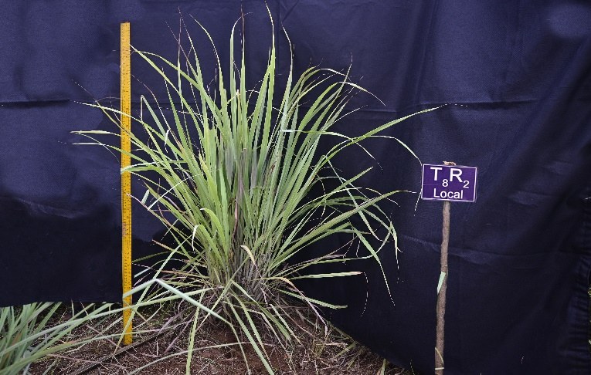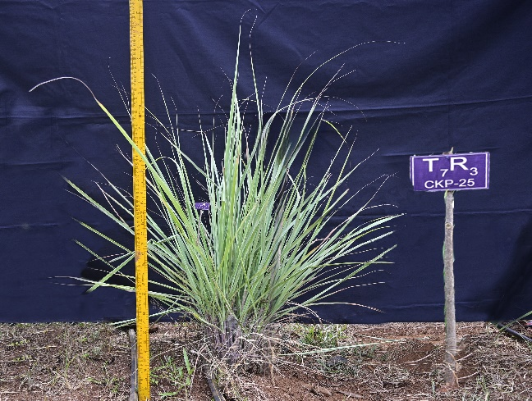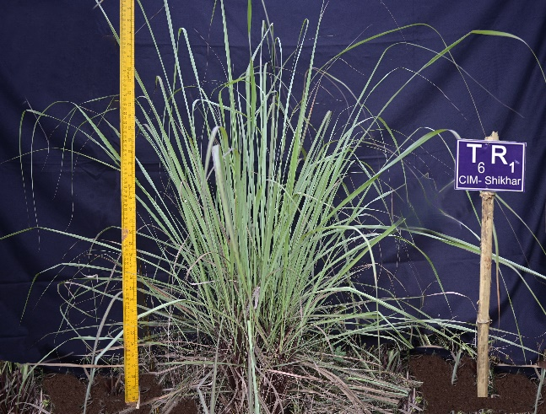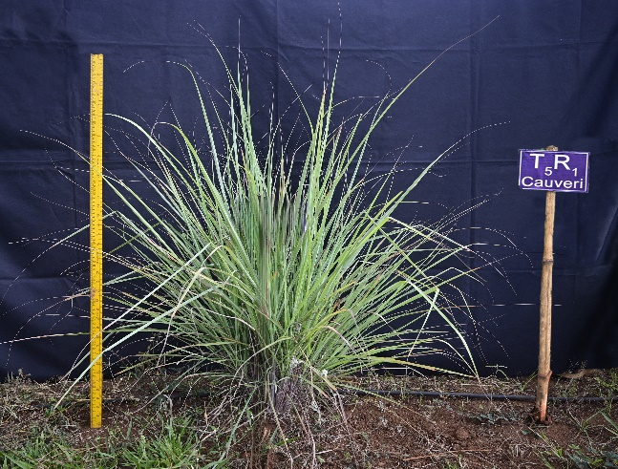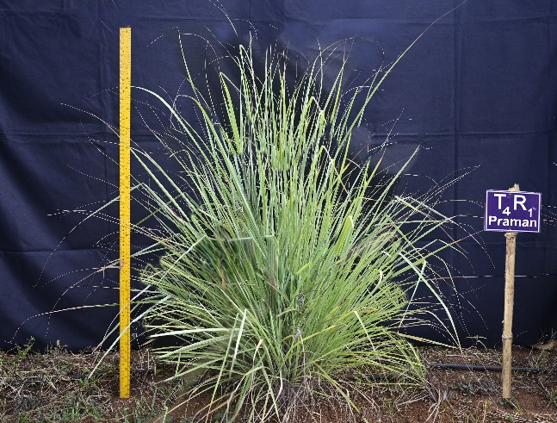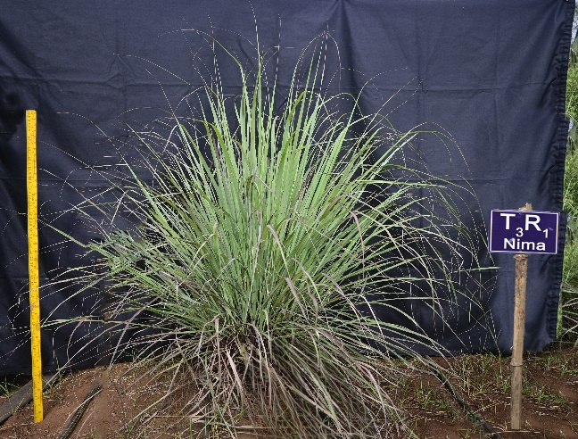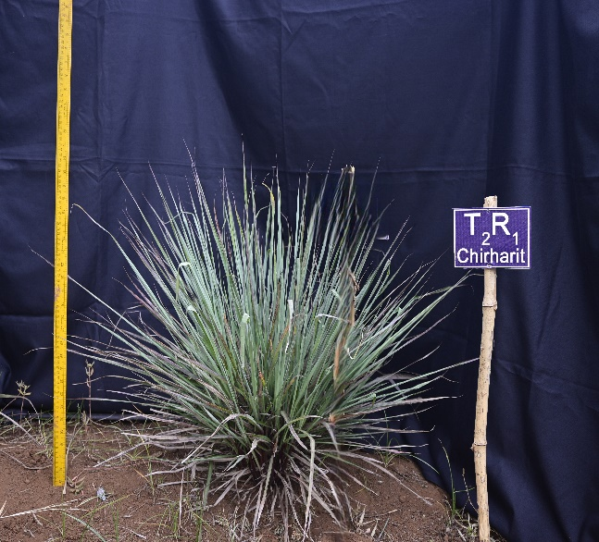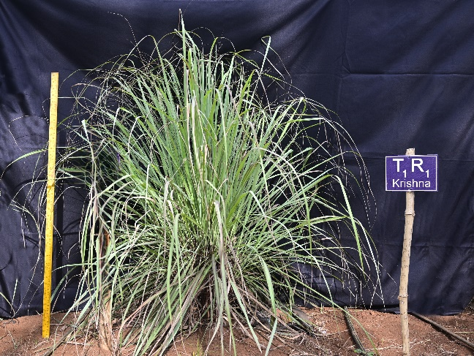

**Plate No. 1: Plant height (cm) of different lemongrass varieties in Konkan region**

**Plate No. 2: Longest leaf length (cm) and longest leaf width (cm) of different lemongrass varieties in Konkan region**

