Original Research Article

Spatial and Socio-Economic Analysis of Scheduled Caste Communities in Palakkad District, Kerala, India.

**Abstract**

In Kerala's Palakkad District, this study looks at the land ownership patterns, land use practices, demographics and spatial distribution of Scheduled Caste (SC) communities in 27 panchayats. The results show notable differences in the patterns of settlement, with sparse distributions in Sholayur and Puthur and concentrated SC populations in panchayats like Chalavara, Vaniyamkulam, and Lakidi Perur, indicating differing levels of community integration and infrastructure development. Though some regions have larger female populations, demographic analysis reveals a generally balanced gender ratio, which may be a sign of male outmigration or different socioeconomic mobility patterns. Chalavara owns significantly more land than Sholayur, indicating historical differences in resource distribution, according to land ownership data, which shows glaring disparities. The average landholding of 13.06 cents per family further demonstrates the region's unequal distribution. Land use patterns vary greatly; some populations continue to make their living from agriculture, while others switch to non-agricultural activities or leave land fallow. These differences highlight both the adaptive strategies employed by SC groups and the challenges of structural marginalization. The report highlights the need for targeted development initiatives that address land access, infrastructure deficiencies and livelihood support while also being tailored to local conditions. This study's identification of specific spatial and socioeconomic gaps can be very helpful to policymakers working on more inclusive and equitable rural development plans. The findings emphasize that effective interventions must account for the diverse realities across different panchayats to meaningfully improve conditions for marginalized communities.

---------------------------------------------------------------------------------------------------------------

**Keywords:** Scheduled Caste Communities, Land Holdings, Land Use Patterns, Marginalization, Panchayats, Policymakers.

**Introduction**

Scheduled Castes (SCs) represent a historically marginalized segment of Indian society, deeply shaped by social exclusion, landlessness and spatial segregation (Kumar, D. 2016). Understanding their demographic composition, settlement patterns and land ownership offers crucial insights into rural development, equity in resource allocation and social justice policies (Asthana, S., Halliday, J., & Gibson, A. 2009). The Palakkad district of Kerala, a region known for its agrarian economy and cultural diversity, presents an illustrative case for studying these patterns at the micro level, especially across its panchayat administrations. The data used in this study offers a granular view of the SC population land possession and land use across 27 panchayats in Palakkad district (Thangaraj, M. 2002). The data reveals significant variations in both demographic distribution and resource possession, reflecting the entrenched inequalities and diverse settlement patterns that characterize the rural SC experience in Kerala. Panchayats like Chalavara, Vaniyamkulam and Lakidi Perur emerge as prominent clusters with large SC populations and corresponding colony counts, while others like Sholayur and Puthur reflect smaller, more dispersed communities. These trends mirror the observations by (Goswami, B. 2024), who noted that spatial clustering of marginalized communities often results from a combination of state-sponsored resettlement schemes and self-driven social cohesion among SC groups in south India, especially in Kerala’s village economies (Benbabaali, D. 2018). Land possession a critical marker of socio-economic stability shows remarkable disparities (Rupavath, R. 2009). Although some panchayats such as Chalavara and Thrikadeeri report relatively high average land holdings, others like Mannarkad and Thachanpara exhibit minimal land possession. This aligns with findings from (Bijukumar, V. 2025). who observed that despite Kerala's progressive land reforms, Scheduled Castes often remained at the margins of land ownership due to historical disenfranchisement and contemporary administrative bottlenecks. The unequal land distribution among SC families, even within a state widely celebrated for social reforms, underscores the persistence of structural inequalities (Chatterjee, A. 2021). Similarly, the land use patterns among these panchayats reveal both adaptive strategies and developmental gaps. For instance, panchayats like Chalavara, which report significant areas under agricultural and housing use, reflect semi-integrated economic landscapes, while others show disproportionate amounts of fallow or unusable land. This echoes the arguments presented by (Sudheesh, R. C. 2025), who highlighted that land use diversity in SC settlements often reflects a lack of institutional support and limited access to credit and agricultural infrastructure.

The Scheduled Caste population's demographic composition also highlights gender-balanced but locally varied patterns, offering policymakers data to tailor interventions in education, healthcare, and social welfare (Leduc, B. 2011). As documented by the Kerala State Planning Board (2022), addressing the spatial and demographic disparities of marginalized communities is central to achieving inclusive development goals under decentralized governance frameworks. This study, therefore, seeks to unpack the relationship between population, land ownership and land use in SC communities of Palakkad, recognizing both historical trajectories and present-day realities (Pathania, G. J., Jadhav, S., Thorat, A., Mosse, D., & Jain, S. 2023). The patterns emerging from this data underscore the need for policy approaches that are not only redistributive but also geographically sensitive and socially inclusive (Lokesha, M. U. 2016). In doing so, the research aims to contribute to the ongoing discourse on social equity and rural development in Kerala.

**Study area**

Ottapalam and Mannarkad are two significant taluks located in the Palakkad district of Kerala, India. Both regions hold considerable importance due to their historical, geographical and socio-cultural characteristics. Ottapalam has a rich historical background, once forming part of the princely state of Valluvanad under the Zamorins of Calicut. The town and its surroundings have historically been important centers for trade, agriculture and cultural activities, especially during the early 20th century. Mannarkad, on the other hand, lies closer to the foothills of the Western Ghats and was historically influenced by various feudal landlords and tribal settlements, creating a distinct socio-economic structure compared to Ottapalam. Geographically, Ottapalam is located along the banks of the Bharathapuzha River, Kerala’s second-longest river, which has shaped its fertile plains and agricultural livelihood. Mannarkad is characterized by its undulating terrain, with portions of it lying in the ecologically sensitive Western Ghats. The taluk is marked by thick forests, hills, and rivers, which makes it an important biodiversity hotspot. The climate in both taluks is classified as tropical monsoon, with Mannarkad receiving relatively higher rainfall due to its proximity to the Western Ghats. Summers are warm and humid, while the monsoon season between June and September brings significant rainfall. Winters are milder, with temperatures ranging between 22°C and 32°C. In terms of population, both taluks are home to a diverse mix of communities. According to recent estimates, Scheduled Caste (SC) and Scheduled Tribe (ST) populations form a significant portion of the demographic landscape, especially in rural and forest-fringe villages of Mannarkad. ST communities such as Irulas, Mudugas and Kurumbas are more concentrated in Mannarkad, whereas SC populations, including Cherumans and Parayans, are widespread in both taluks (John, K. T., Ali, R. T. M., & Rejikumar, G. 2022). The remaining population is composed of Other Backward Classes (OBC) and general category residents, engaged primarily in agriculture, trade and small-scale industries. The drainage system is dominated by the Bharathapuzha River in Ottapalam and the Kunthipuzha River in Mannarkad, along with numerous streams and canals supporting irrigation, drinking water, and ecological balance in these regions

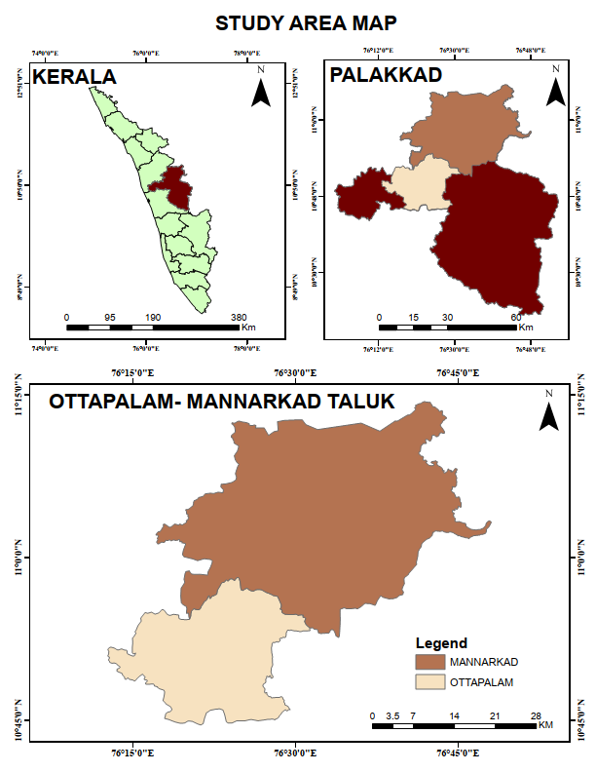

Figure 1. Locational Map of the Study Area.

**Methodology**

With a focus on 27 panchayats, the study used an organized methodology to examine the patterns of marginalized communities in Kerala's Palakkad District. Land possession, land-use categories, population distribution, family count, and colony count were all included in the data classification. Important factors like demographic measurements and the choice of study area were methodically documented. Through patient interpretation, gender population balance, land ownership disparities, land-use efficiency, and family-colony correlations, the analysis looked at patterns in marginalized communities. To evaluate trends, quantitative techniques such as correlation analysis and descriptive statistics (mean, standard deviation) were used. Scheduled Caste and family records were used in the data collection process to guarantee accuracy and applicability. A thorough grasp of socioeconomic disparities was made possible by this methodological framework, which allowed for focused policy recommendations for fair development. Reliability in recognizing important opportunities and challenges within marginalized settlements was guaranteed by the structured approach.

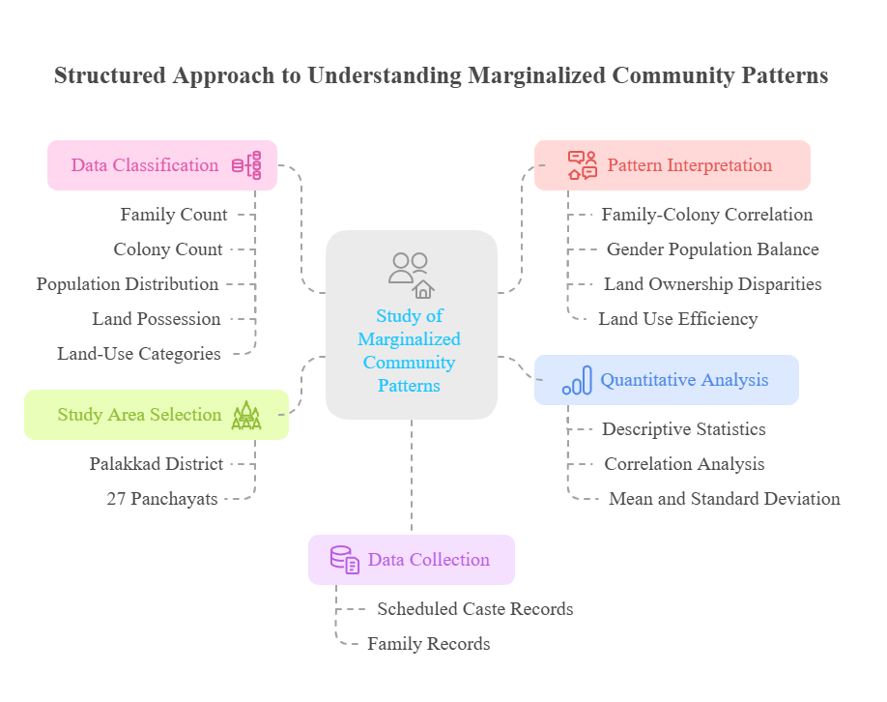

Figure 2. Framework for the study of Marginalized community.

**Review of literature**

1. Goswami, B. (2024) This study explores the spatial distribution and socioeconomic marginalization of Scheduled Castes (SC) in Kerala. Using demographic and spatial data, the authors highlight persistent caste-based inequalities despite Kerala’s progressive social policies. The paper emphasizes how spatial segregation limits SC communities’ access to resources, education, and employment. It provides a detailed analysis of settlement patterns and underscores the need for targeted inclusion strategies within rural development frameworks.

2. Kannan, K.P., & Mohanan, K.P. (2023) This article revisits Kerala’s renowned land reform movement, analyzing its long-term impact on social justice. The authors critique the partial success of these reforms in alleviating caste-based inequalities, especially for Scheduled Castes. They argue that while land redistribution helped reduce absolute poverty, its effectiveness in dismantling deep-rooted social hierarchies remains limited, urging policymakers to address persisting inequalities through complementary welfare policies.

3. Rao, H., & Babu, M. D. (1994) This paper explores demographic shifts and evolving social patterns among Kerala’s rural Scheduled Caste communities. Through census data and field studies, the authors trace changes in family structures, education levels, and migration trends. They conclude that while there’s visible socioeconomic mobility, caste-based disparities in land ownership and social inclusion persist, calling for nuanced policy interventions.

**4. Rao, P., & Kannan, S. (2023)** Rao and Kannan investigate land distribution patterns and inequalities within Kerala's panchayat system. Their analysis shows that despite administrative decentralization, land ownership remains highly skewed against Scheduled Castes. They emphasize that real social transformation requires both structural land redistribution and active community participation in local governance to counteract deeply rooted inequalities.

**Result Analysis and Discussion**

The socio-economic condition of Scheduled Caste (SC) communities is a critical issue in regional planning in India (Chouhan, P. 2011), especially in rural parts of Kerala. This study, focusing on the panchayats of Palakkad district, offers rich insights into demographic patterns, land possession and land use among SC families. The data encompasses 27 panchayats, highlighting trends that inform both social research and policy development. This section critically analyses the results and discusses the broader implications of the findings.Bottom of Form

Table:1. Distribution of Scheduled Caste Families and Colonies.

|  |  |  |
| --- | --- | --- |
| **PANCHAYAT** | **FAMILIES** | **COLONIES** |
| Agali | 204 | 24 |
| Puthur | 117 | 7 |
| Sholayur | 74 | 7 |
| Alanallur | 784 | 62 |
| Karimba | 279 | 25 |
| Kottepadam | 372 | 33 |
| Kumaramputhur | 462 | 41 |
| Kanjirapuzha | 404 | 30 |
| Mannarkad | 215 | 15 |
| Thachanatukara | 415 | 34 |
| Thachanpara | 301 | 23 |
| Thenkara | 335 | 27 |
| Cherupulasseri | 441 | 39 |
| Kadambazhipuram | 535 | 59 |
| Karimpuzha | 482 | 52 |
| Pookotukavu | 584 | 48 |
| Sreekrishnapuram | 413 | 41 |
| Vellinezhi | 405 | 40 |
| Karakurrissi | 602 | 41 |
| Ambalapara | 673 | 65 |
| Ananganadi | 700 | 63 |
| Chalavara | 866 | 78 |
| Lakidi Perur | 769 | 55 |
| Vaniyamkulam | 856 | 82 |
| Nellaya | 442 | 36 |
| Vallapuzha | 380 | 49 |
| Thrikadeeri | 338 | 38 |

Source: Basic Data collection of Scheduled caste shelters and Families (2021-2022)

Figure 3 Represent the number of Families.

Figure 4 Represent the number of Families.

The data on SC families and colonies across the panchayats reveal distinct settlement patterns. Chalavara, Vaniyamkulam, and Lakidi Perur emerge as the three panchayats with the highest SC family concentrations, at 866, 856, and 769 families, respectively. These panchayats also show a proportional rise in the number of colonies, suggesting that larger family counts are typically associated with the creation of more colonies. This trend is indicative of organized settlement policies, possibly shaped by historical land allocation, administrative planning, and the physical carrying capacity of the villages (Dodamani, M., & Natikar, S. C. 2023). In contrast, Sholayur, Puthur, and Agali host the fewest SC families and colonies. While Sholayur’s small SC family count (74) corresponds to only 7 colonies, this low density may reflect geographical isolation, smaller land holdings, or historical marginalization of the community in this area. Agali, though slightly larger with 204 families, also has relatively fewer colonies (24), hinting at denser living arrangements or limited expansion opportunities. An interesting outlier is Vaniyamkulam, which, despite not having the largest SC family count, reports the highest number of colonies (82). This anomaly could be attributed to unique socio-political circumstances, such as land distribution policies, geographical dispersal due to terrain, or deliberate social engineering to reduce intra-community conflict and overcrowding (Mohammad, N. 2006).

Table 2. Scheduled Caste Population: Gender and Distribution Patterns.

|  |  |  |  |  |
| --- | --- | --- | --- | --- |
| **PANCHAYAT** | **MALE** | **FEMALE** | **TOTAL** | **Pct %** |
| Agali | 397 | 402 | 799 | 1.5 |
| Puthur | 200 | 191 | 391 | 0.73 |
| Sholayur | 124 | 139 | 263 | 0.49 |
| Alanallur | 1707 | 1669 | 3403 | 6.39 |
| Karimba | 573 | 586 | 1159 | 2.17 |
| Kottepadam | 819 | 844 | 1663 | 3.12 |
| Kumaramputhur | 945 | 1059 | 2004 | 3.76 |
| Kanjirapuzha | 836 | 910 | 1746 | 3.28 |
| Mannarkad | 527 | 564 | 1091 | 2.05 |
| Thachanatukara | 912 | 965 | 1877 | 3.52 |
| Thachanpara | 636 | 692 | 1328 | 2.49 |
| Thenkara | 734 | 819 | 1553 | 2.91 |
| Cherupulasseri | 977 | 968 | 1945 | 3.65 |
| Kadambazhipuram | 1067 | 1112 | 2189 | 4.11 |
| Karimpuzha | 1015 | 1032 | 2047 | 3.84 |
| Pookotukavu | 1170 | 1276 | 2446 | 4.59 |
| Sreekrishnapuram | 840 | 910 | 1750 | 3.28 |
| Vellinezhi | 820 | 871 | 1691 | 3.17 |
| Karakurrissi | 1197 | 1299 | 2496 | 4.68 |
| Ambalapara | 1443 | 1487 | 2930 | 5.5 |
| Ananganadi | 1455 | 1555 | 3010 | 5.65 |
| Chalavara | 1788 | 1933 | 3721 | 6.98 |
| Lakidi Perur | 1574 | 1708 | 3282 | 6.16 |
| Vaniyamkulam | 1634 | 1691 | 3325 | 6.24 |
| Nellaya | 1016 | 1087 | 2103 | 3.95 |
| Vallapuzha | 795 | 865 | 1660 | 3.11 |
| Thrikadeeri | 661 | 758 | 1419 | 2.66 |

SOURCE: Basic Data collection of Scheduled caste shelters and Families (2021-2022)

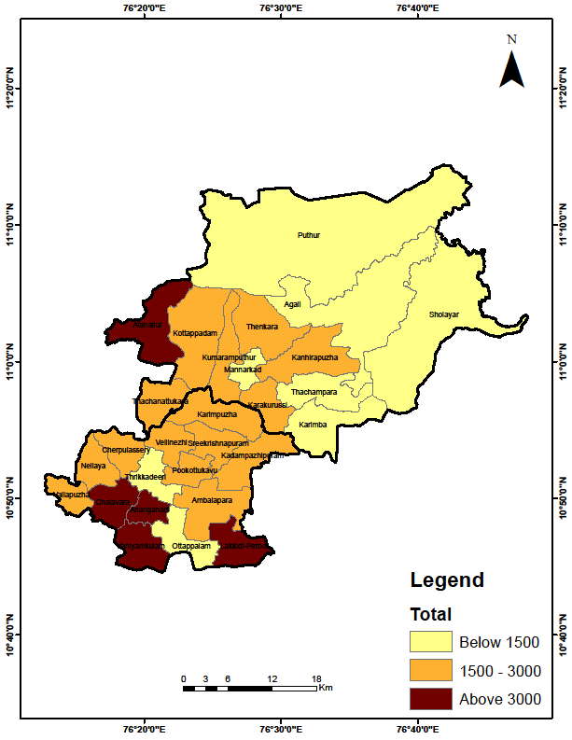

**POPULATION**

Figure 5. Schedule caste Total Population 2011 census.

The total SC population shows wide variation across the panchayats, from as low as 263 in Sholayur to a substantial 3721 in Chalavara. This distribution closely follows the family counts but reveals an added layer when examining gender balance. Across most panchayats, the male-to-female ratio is relatively balanced, but some subtle deviations are noteworthy. For example, in Kumaramputhur, Pookotukavu, and Chalavara, female populations slightly exceed male counts. This could reflect broader demographic trends in Kerala also amongst all state in India (Blomkvist, H. 2003), such as lower male child mortality, female-headed households, or male out-migration for employment. On the other hand, minor male-dominant patterns in a few areas may be influenced by local employment structures or traditional patriarchal settlement preferences. The higher SC populations in Chalavara, Lakidi Perur and Vaniyamkulam likely necessitate proportionately larger investments in public infrastructure, ranging from schools and primary healthcare centres to sanitation facilities and community development schemes (Motkuri, V. 2013). Conversely, areas like Sholayur and Puthur may suffer from underrepresentation and inadequate political clout, which risks their marginalization in regional resource allocation.

Table:3.Land Possession: Size and Distribution Disparities

|  |  |  |  |
| --- | --- | --- | --- |
| **Panchayat** | **Families** | **Possessed land (cent)** | **Pct %** |
| Agali | 204 | 2486 | 1.62 |
| Puthur | 117 | 2203 | 1.43 |
| Sholayur | 74 | 951 | 0.62 |
| Alanallur | 784 | 8529 | 5.55 |
| Karimba | 279 | 2318 | 1.51 |
| Kottepadam | 372 | 4439 | 2.89 |
| Kumaramputhur | 462 | 4796 | 3.12 |
| Kanjirapuzha | 404 | 2934 | 1.91 |
| Mannarkad | 215 | 1049 | 0.68 |
| Thachanatukara | 415 | 5420 | 3.53 |
| Thachanpara | 301 | 2370 | 1.54 |
| Thenkara | 335 | 3037 | 1.98 |
| Cherupulasseri | 441 | 3863 | 2.51 |
| Kadambazhipuram | 535 | 9203 | 5.99 |
| Karimpuzha | 482 | 7672 | 4.99 |
| Pookotukavu | 584 | 8521 | 5.55 |
| Sreekrishnapuram | 413 | 7896 | 5.14 |
| Vellinezhi | 405 | 4727 | 3.08 |
| Karakurrissi | 602 | 5736 | 3.73 |
| Ambalapara | 673 | 7850 | 5.11 |
| Ananganadi | 700 | 7242 | 4.71 |
| Chalavara | 866 | 14461 | 9.41 |
| Lakidi Perur | 769 | 10377 | 6.75 |
| Vaniyamkulam | 856 | 7953 | 5.18 |
| Nellaya | 442 | 4706 | 3.06 |
| Vallapuzha | 380 | 4200 | 2.73 |
| Thrikadeeri | 338 | 8708 | 5.67 |

SOURCE: Basic Data collection of Scheduled caste shelters and Families (2021-2022).

Figure 6 Percentages of Various Land Possession.

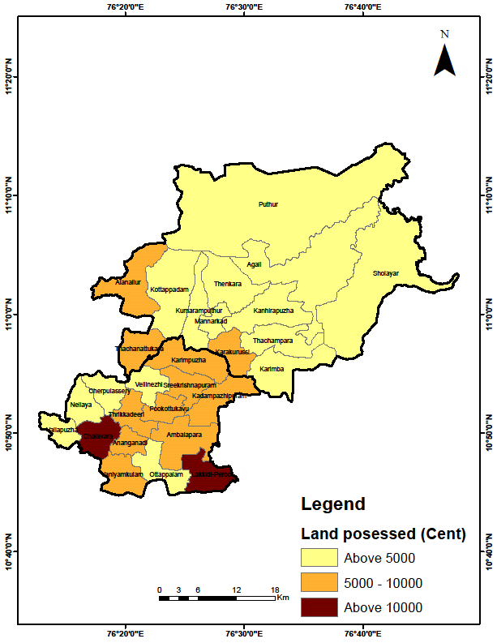

**POSESSION OF LAND**

Figure 7. Land Possessions Distribution.

Land ownership among SC families offers a critical lens through which economic independence and social stability can be measured. The data points to stark disparities both in total land possessed and the average landholding per family. Chalavara stands out with the highest total land possession (14,461 cents), followed by Lakidi Perur (10,377 cents) and Thrikadeeri (8,708 cents). However, when recalculated as land per family, Thrikadeeri tops the list with an average of 25.76 cents per family, suggesting a community with relatively larger land plots per household, which could enable better agricultural and economic prospects. On the lower end, Mannarkad and Thachanpara record much lower land per family averages, 4.88 and 7.87 cents, respectively. This raises concerns about land scarcity, fragmentation, or historical landlessness a common legacy of caste-based oppression and exclusion from agrarian reform benefits (Kumar, R., Kumar, S., & Mitra, A. 2009). Interestingly, the overall mean land possession for SC families across the panchayats is about 13.06 cents per family, and the calculated standard deviation underscores significant variance. This implies that while some panchayats have communities with sufficient land for farming and home construction, others struggle with severely limited holdings, exacerbating their economic vulnerability (Rao, H., & Babu, M. D. 1994). These disparities call for targeted land redistribution programs or support mechanisms, such as land leasing cooperatives or state-aided housing schemes, to ensure more equitable land ownership and improved quality of life for SC families.

Table:4.Land Use Patterns: A Multi-Dimensional Perspective.

|  |  |  |  |  |  |  |  |  |  |  |
| --- | --- | --- | --- | --- | --- | --- | --- | --- | --- | --- |
| PANCHAYAT | HOUSE'S (CENT) | PCT(%) | AGRICULTURE (CENT) | PCT(%) | OTHER ACTIVITIES (CENT) | PCT(%) | USABLE LAND FALLOW (CENT) | PCT(%) | UNUSABLE LAND (CENT) | PCT(%) |
| Agali | 401 | 0.99 | 1419 | 2.66 | 358 | 1.08 | 145 | 0.58 | 163 | 6.43 |
| Puthur | 392 | 0.97 | 958 | 1.79 | 5 | 0.02 | 848 | 3.39 | 0 | 0.00 |
| Sholayur | 175 | 0.43 | 494 | 0.93 | 117 | 0.35 | 165 | 0.66 | 0 | 0.00 |
| Alanallur | 2609 | 6.46 | 1534 | 2.87 | 1730 | 5.24 | 2354 | 9.42 | 301 | 11.87 |
| Karimba | 872 | 2.16 | 877 | 1.64 | 548 | 1.66 | 21 | 0.08 | 0 | 0.00 |
| Kottepadam | 1340 | 3.32 | 324 | 0.61 | 1590 | 4.82 | 1163 | 4.65 | 22 | 0.87 |
| Kumaramputhur | 663 | 1.64 | 1448 | 2.71 | 2406 | 7.29 | 276 | 1.10 | 3 | 0.12 |
| Kanjirapuzha | 1816 | 4.49 | 371 | 0.69 | 661 | 2.00 | 86 | 0.34 | 0 | 0.00 |
| Mannarkad | 485 | 1.2 | 10 | 0.02 | 477 | 1.45 | 65 | 0.26 | 12 | 0.47 |
| Thachanatukara | 1318 | 3.26 | 924 | 1.73 | 1664 | 5.04 | 1514 | 6.06 | 0 | 0.00 |
| Thachanpara | 998 | 2.47 | 726 | 1.36 | 451 | 1.37 | 114 | 0.46 | 81 | 3.19 |
| Thenkara | 1145 | 2.83 | 152 | 0.28 | 1713 | 5.19 | 20 | 0.08 | 0 | 0.00 |
| Cherupulasseri | 1099 | 2.72 | 540 | 1.01 | 2154 | 6.53 | 33 | 0.13 | 36 | 1.42 |
| Kadambazhipuram | 1205 | 2.98 | 4487 | 8.40 | 1802 | 5.46 | 1633 | 6.53 | 76 | 3.00 |
| Karimpuzha | 1738 | 4.3 | 4139 | 7.75 | 855 | 2.59 | 940 | 3.76 | 0 | 0.00 |
| Pookotukavu | 1194 | 2.96 | 2707 | 5.07 | 1856 | 5.62 | 2574 | 10.30 | 190 | 7.49 |
| Sreekrishnapuram | 1728 | 4.28 | 4607 | 8.63 | 1152 | 3.49 | 356 | 1.42 | 53 | 2.09 |
| Vellinezhi | 1394 | 3.45 | 1656 | 3.10 | 974 | 2.95 | 534 | 2.14 | 169 | 6.66 |
| Karakurrissi | 1691 | 4.19 | 1648 | 3.09 | 2266 | 6.87 | 131 | 0.52 | 0 | 0.00 |
| Ambalapara | 2524 | 6.25 | 2750 | 5.15 | 467 | 1.42 | 1898 | 7.59 | 392 | 15.46 |
| Ananganadi | 1917 | 4.74 | 2249 | 4.21 | 1301 | 3.94 | 1550 | 6.20 | 224 | 8.83 |
| Chalavara | 4776 | 11.82 | 6223 | 11.66 | 65 | 0.20 | 3277 | 13.11 | 120 | 4.73 |
| Lakidi Perur | 2405 | 5.95 | 5799 | 10.86 | 1755 | 5.32 | 148 | 0.59 | 270 | 10.65 |
| Vaniyamkulam | 2452 | 6.07 | 3211 | 6.01 | 1004 | 3.04 | 1152 | 4.61 | 134 | 5.28 |
| Nellaya | 2078 | 5.14 | 1002 | 1.88 | 168 | 0.51 | 1236 | 4.95 | 222 | 8.75 |
| Vallapuzha | 869 | 2.15 | 198 | 0.37 | 384 | 1.16 | 2731 | 10.93 | 18 | 0.71 |
| Thrikadeeri | 1119 | 2.77 | 2934 | 5.50 | 5076 | 15.38 | 30 | 0.12 | 50 | 1.97 |

1. SOURCE: Basic Data collection of Scheduled caste shelters and Families (2021-2022)

The land use patterns among SC households reflect not just their economic strategies but also the environmental, cultural, and infrastructural constraints of each panchayat.

**House Plots**: House plots vary significantly, reflecting both population density and settlement policies. Chalavara (4776 cents), Lakidi Perur (2405 cents), and Vaniyamkulam (2452 cents) show the largest allocations, suggesting organized housing layouts and perhaps better living standards. Smaller allocations in Sholayur and Mannarkad highlight issues of constrained living space, which might correlate with overcrowding or substandard housing quality.



Figure 8 Concentration of Houses.

**Agricultural Land:** Agricultural land is a key indicator of economic engagement and livelihood security. Here too, Chalavara (6223 cents), Lakidi Perur (5799 cents), and Karimpuzha (4139 cents) lead the way. These panchayats show strong agrarian foundations, likely supported by irrigation, cooperative farming practices, and market access. In sharp contrast, Mannarkad (10 cents) and Sholayur (494 cents) reveal a virtual absence of agriculture. These figures suggest that many SC families in these areas are either landless laborers, dependent on non-agricultural jobs, or engaged in marginal subsistence farming on public or leased land.

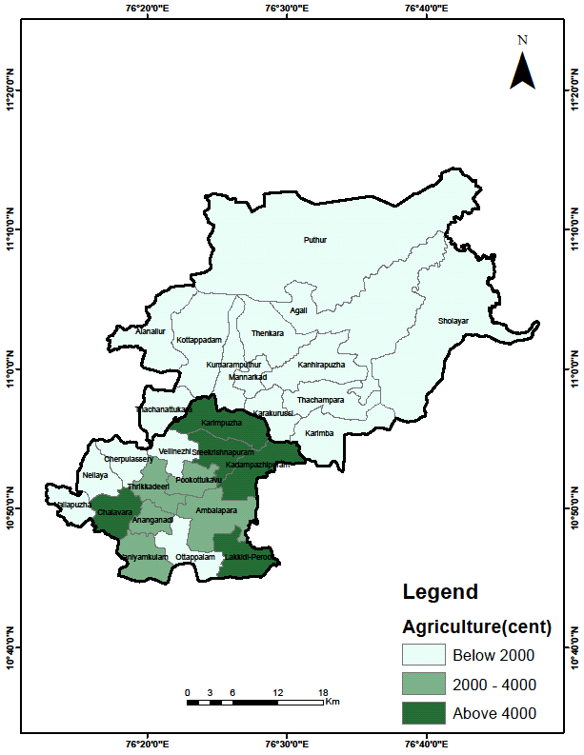

Figure 9 Distribution of Agricultural Land.

**Usable Fallow Land:** The presence of usable fallow land indicates potential for future agricultural expansion. Chalavara and Vallapuzha show high fallow land availability, suggesting both underutilization and future opportunities for agrarian reforms or collective farming initiatives. This could be a key area for policy interventions aimed at enhancing food security and economic resilience.

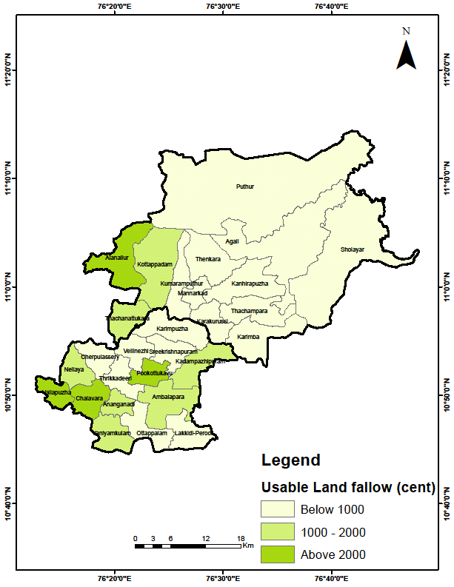

Figure 10 Distribution of Use-able Fallow Land.

**Unusable Land:** Unusable land, which cannot contribute to the economic base, is another crucial metric. Panchayats like Agali (163 cents) and Ananganadi (224 cents) have substantial areas marked as unusable. This constrains economic growth and suggests the need for soil conservation, land reclamation, or alternative use strategies such as afforestation or eco-tourism.

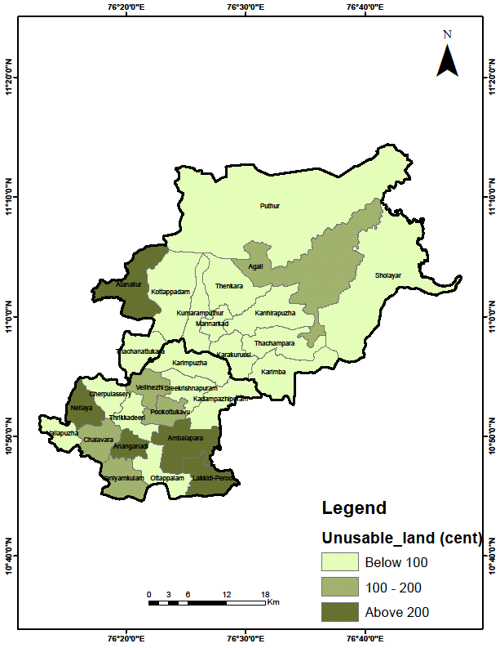

Figure 11 Locational Map of Unusable Land

**5. Discussion: Towards an Inclusive Development Agenda**

The data not only reveals statistical patterns but also prompts a deeper discussion on structural inequities, policy challenges, and developmental possibilities for SC communities in Palakkad. First, the strong correlation between the number of SC families and the number of colonies indicates that settlement policies have traditionally been reactive to population pressure rather than proactive in designing inclusive community layouts. Panchayats with a high number of families but disproportionately fewer colonies may be suffering from overcrowding and insufficient infrastructural planning. Second, the land possession figures underline the on-going issue of land inequality among SC families. Historical marginalization exclusion from land reforms and social discrimination have created a landscape where, even within the same administrative unit, landholdings can differ sharply from one panchayat to another (Khatoon, F. 2013). Third, land use patterns reflect the diversity of livelihood strategies but also the limitations faced by SC households. For example, the low agricultural engagement in Mannarkad and Sholayur indicates either poor land access or a shift away from farming toward wage labour, which may offer short-term income but limited long-term security. Fourth, the gender balance in the SC population suggests a need for more nuanced, gender-sensitive welfare schemes. The slight predominance of females in many panchayats could indicate either male out-migration for work or longer female life expectancy, both of which have implications for policy planning, especially in areas like healthcare, child support, and old-age security. Lastly, the presence of large tracts of fallow and unusable land underscores the need for efficient land management. Panchayats with high fallow land, such as Vallapuzha and Chalavara, could be prioritized for agricultural extension services, community farming initiatives, and soil enhancement projects.

**Conclusion**

The finding reveals critical insights into the structural inequities and developmental challenges faced by Scheduled Caste (SC) communities in Palakkad. First, the correlation between SC families and colony numbers highlights a reactive approach to settlement planning, where infrastructure development has failed to keep pace with population growth. This has resulted in overcrowded colonies with inadequate amenities, underscoring the urgent need for proactive urban planning that prioritizes equitable resource distribution and inclusive community design.

Second, persistent land inequality among SC families reflects historical marginalization and exclusion from land reforms. The uneven distribution of landholdings across panchayats points to systemic barriers that continue to hinder economic mobility. Addressing this issue requires targeted land redistribution policies, legal support for land ownership and measures to ensure SC communities benefit from existing welfare schemes.

Third, shifting livelihood patterns, particularly the decline in agricultural engagement in areas like Mannarkad and Sholayur, indicate either limited land access or a forced transition to unstable wage labour. To mitigate this, interventions should focus on revitalizing agriculture through skill development, access to credit and incentives for collective farming, while also creating alternative livelihood opportunities.

Fourth, the gender imbalance in SC populations, with a slight predominance of females, suggests underlying issues such as male out-migration or disparities in life expectancy. This demographic trend calls for gender-sensitive policies, including enhanced healthcare services, childcare support and social security measures tailored to the needs of women and elderly populations.

Finally, the prevalence of fallow and underutilized land in panchayats like Vallapuzha and Chalavara signals a missed opportunity for agricultural productivity. Implementing land rejuvenation programs, soil health initiatives, and community-based farming projects could unlock the potential of these unused tracts, providing sustainable income sources and improving food security for SC households.

Collectively, these findings emphasize the need for a multi-dimensional approach to development one that integrates equitable land policies, inclusive infrastructure planning, livelihood support and gender-responsive welfare measures. By addressing these interconnected challenges, policymakers can foster meaningful progress toward social and economic equity for Palakkad’s SC communities.

COMPETING INTERESTS DISCLAIMER:

Authors have declared that they have no known competing financial interests OR non-financial interests OR personal relationships that could have appeared to influence the work reported in this paper.

Disclaimer:

Author(s) hereby declare that NO generative AI technologies such as Large Language Models (ChatGPT, COPILOT, etc.) and text-to-image generators have been used during the writing or editing of this manuscript.

**References**

1. Asthana, S., Halliday, J., & Gibson, A. (2009). Social exclusion and social justice: a rural perspective on resource allocation. *Policy & Politics*, *37*(2), 201-214.
2. Benbabaali, D. (2018). Caste dominance and territory in South India: Understanding Kammas’ socio-spatial mobility. *Modern Asian Studies*, *52*(6), 1938-1976.
3. Blomkvist, H. (2003). Traditional communities, caste and democracy: The Indian mystery. In Social capital and participation in everyday life (pp. 73-88). Routledge.
4. Chatterjee, A. (2021). An Analysis of the Caste System in Indian Society. *Indian JL & Legal Rsch.*, *3*, 1.
5. Chouhan, P. (2011). *Socio-economic status of scheduled castes population: a case study of maldah district of west bengal* (Doctoral dissertation, University of North Bengal).
6. Dodamani, M., & Natikar, S. C. (2023). An analysis on socio-economic phenomena of scheduled caste in India. *EPRA International Journal of Multidisciplinary Research (IJMR)*, *9*(8), 328-333.
7. Sudheesh, R. C. (2025). From Land Reform to Landfare: Land Claims and the Welfare State in Kerala, India. Antipode, 57(2), 670-690.
8. Bijukumar, V. (2025). Public Policies, Development Strategies, and Social Change in Kerala, India. In The Palgrave Handbook of Global Social Change (pp. 1-21). Cham: Springer Nature Switzerland.
9. Khatoon, F. (2013). A regional analysis of literacy and educational levels of scheduled caste in Uttar Pradesh. *Journal of humanities and social science*, *6*(4), 8-19.
10. Kumar, D. (2016). Social and economic exclusion among social groups in India. *Journal of Exclusion Studies*, *6*(2), 148-161.
11. Kumar, R., Kumar, S., & Mitra, A. (2009). Social and economic inequalities: Contemporary significance of caste in India. *Economic and Political Weekly*, 55-63.
12. John, K. T., Ali, R. T. M., & Rejikumar, G. (2022). Bowed, bent and broken: investigating enrolments of scheduled castes/tribes to technical higher education programmes in Kerala. Contemporary Voice of Dalit, 2455328X221091621.
13. Kumar, V. (2023). *Agrarian Structures and SC Land Use Trends in Kerala*. Kerala Economic Review.
14. Leduc, B. (2011). *Mainstreaming gender in mountain development: from policy to practice. Lessons learned from a gender assessment of four projects implemented in the Hindu Kush-Himalayas* (pp. 50-pp).
15. Lokesha, M. U. (2016). A STUDY ON THE SOCIO-ECONOMIC CONDITION OF SCHEDULED CASTE WITH SPECIAL REFERENCE TO TUMKUR DISTRICT. *International Journal of Management Research and Reviews*, *6*(3), 371.
16. Mohammad, N. (2006). *Socio-economic Transformation of Scheduled Castes in Uttar Pradesh: A Geographical Analysis*. Concept Publishing Company.
17. Pathania, G. J., Jadhav, S., Thorat, A., Mosse, D., & Jain, S. (2023). Caste identities and structures of threats. CASTE: A Global Journal on Social Exclusion, 4(1), 3-23.
18. Motkuri, V. (2013). Scheduled Castes (SCs) and Tribes (STs) in Andhra Pradesh: A Situation Assessment Analysis.
19. Goswami, B. (2024). Understanding the demographic changes in Kerala: an exploration. Journal of Social and Economic Development, 26(1), 102-121.
20. Rao, H., & Babu, M. D. (1994). *Scheduled Castes and Tribes, socio-economic upliftment programmes*. APH Publishing.
21. Rupavath, R. (2009). *tribal land alienation and political movements: socio-economic patterns from south India*. Cambridge Scholars Publishing.
22. Thangaraj, M. (2002). Access to Land by Scheduled Castes and Scheduled Tribes in India. *Dalits and the State*, 51.