**Pest suppression through diversified cropping system in potato cultivation**

Abstract

This study aims to examine the incidence of major insect pests and beneficial arthropods in potato fields utilizing border crops and intercropping systems. The research also seeks to assess the level of pest infestation under these cropping systems and evaluate the impact of border crops and intercropping on potato yield and gross return. In the intricate web of agricultural ecosystems, potato (*Solanum tuberosum L.)* stands as a vital crop for food security in Bangladesh, second only to rice in production. Yet, this essential crop faces mounting threats from insect pests and declining arthropod biodiversity. This study, conducted at Sher-e-Bangla Agricultural University during the 2019–2020 *winter* season, explores how nature’s own networks—through diversified cropping systems—can help restore ecological balance and reduce pest pressure in potato fields. Employing a Randomized Complete Block Design (RCBD) with eight treatments and three replications, researchers tested intercropping and border cropping combinations involving radish, groundnut, coriander, methi, spinach, and sweet potato. Among them, border cropping with radish (T7) emerged as the most ecologically effective, reducing infestations of aphids by 67.71%, whiteflies by 75.41%, jassids by 29.68%, and epilachna beetles by over 75% compared to sole potato cropping (T8). T7 also fostered the richest arthropod community (Simpson’s D = 4.63; Evenness E = 0.93) and the highest pollinator presence (124.33 honey bees/plant) at the mid-vegetative stage. Agronomically, it delivered the highest marketable yield (12.30 t/ha) and gross return (Tk 373,680/ha). Intercropping with groundnut (T1) and coriander (T3) also showed strong ecological and economic benefits. These results illustrate how aligning farming practices with ecological principles—by weaving nature’s network into crop planning—can strengthen pest regulation, enhance biodiversity, and boost farmer livelihoods. This study advocates for the adoption of such agro-ecological strategies in Bangladesh and similar agro-climatic regions to build more resilient and sustainable farming systems.

Keywords: *Potato, intercropping, border cropping, insect pest management, arthropod diversity, agro ecology, sustainable agriculture*

1. Introduction

Agricultural intensification has led to a drastic simplification and homogenization of agroecosystems, causing biodiversity loss and an increased reliance on chemical pesticides to control arthropod crop pests. However, these pesticides have major negative impacts on biodiversity, ecosystem services, and human health. Restoring plant diversity in agricultural landscapes could revert this trend, promote biological pest control and reduce the reliance on chemical insecticides (N’Woueni & Gaoue, 2022; Jaworski et al., 2023). Potato is a crucial food crop in Bangladesh, ranking as the seventh largest producer globally and the second most significant crop after rice in terms of production. It holds the third position in terms of human consumption, following rice and wheat (FAOSTAT, 2020). Over the past decade, Bangladesh has made remarkable progress in potato production, with an increase in area, production, and yield. In 2019-2020, the area cultivated with potatoes rose to 461 thousand hectares, production reached 9605 thousand metric tons (MT), and the yield reached 20.8 MT/ha, up from 435 thousand hectares, 7930 thousand MT, and 18.25 MT/ha in 2009-2010, reflecting growth rates of 6%, 21%, and 14%, respectively. This progress can be attributed to favorable climatic conditions and the adoption of high-yielding potato varieties (Hossain and Bose, 2000). As production has surpassed domestic demand, Bangladesh has entered the global market, exporting 45,000 MT of fresh potatoes in 2019-2020 (Hortex Foundation, 2020). Additionally, per capita annual potato consumption increased from 23.65 kg in 2010 to 25.66 kg in 2016, marking an 8.5% growth rate over just six years (HIES, 2016). Arthropod pests are responsible for major yield losses worldwide: from 2001 to 2003, yield losses due to pest damage reached 28% in wheat and cotton, 26% in soybean, 37% in rice, 31% in maize, and 40% in potato. Arthropod pest control heavily relies on synthetic chemical insecticides worldwide, which have major negative impacts on the environment and on human health; they are detrimental to non-target organisms and induce pest resistances, further increasing farmers’ dependency on chemical insecticides (Jaworski et al., 2023; Zhang et al., 2025).

Potato is widely consumed across Bangladesh, enjoyed by both rich and poor, and is known for its high nutritional value. Per 100 grams of edible potato, there are 97 kcal, 1.6 grams of protein, minimal fat, 10.07 grams of minerals, and small amounts of iron. It contains 74.7% moisture and 22.6% carbohydrates, alongside other essential nutrients (Hossain and Bose, 2000). Potatoes also have significant levels of phenolic compounds and vitamin C, which act as potent antioxidants, providing health benefits by reducing oxidative damage and improving immune function. These nutrients help lower the risk of cardiovascular diseases, cancer, cataracts, diabetes, and ageing (Kaur et al., 2004; Brown, 2005). Potatoes are consumed in various forms, such as curry, fries, potato crackers, and flour for making bread, biscuits, and chips, both domestically and abroad. Despite its popularity, Bangladesh faces a deficit in producing other nutrient-rich crops, particularly tubers and vegetables. Approximately 80% of potato production in Bangladesh occurs as a Rabi crop, which is sown in October and harvested by March. However, in certain areas, it is grown as a Kharif crop, sown between April and July, with availability from August to October. Despite being a seasonal crop, potatoes are grown throughout the year in different regions, thanks to varying climatic conditions and harvest periods. Potatoes are typically grown in temperate or cool climates, requiring low temperatures, low humidity, minimal wind, and plenty of sunlight. High temperatures, excessive humidity, and heavy rainfall are not ideal for potato growth and can lead to pest and disease outbreaks. Insects, nematodes, rats, and other pests are significant threats to potato crops, especially in tropical countries (Waliullah, 2007; Ghosh and Khan, 2010). Certain insects and nematodes are also vectors for viruses, particularly aphids, Xiphinema, and Longidorus species, which affect the plant's photosynthesis process, further damaging the crops (Chenula, 1984; Banjo, 2010). The presence of these pests can result in substantial crop losses, with some studies indicating that yield losses due to pest and disease attacks can be as high as 100%, depending on crop tolerance, soil conditions, pest type, and weather (Olanya et al., 2002).

Research has shown that more than 100 species of arthropods and 156 species of plant-parasitic nematodes, belonging to 52 genera, attack potato crops worldwide. In India alone, 80 species of arthropods and 93 species of nematodes from 40 genera have been reported (Pandey, 2007). Notable pests affecting potatoes include cutworms, flea beetles, tobacco caterpillars, aphids, potato leafhoppers, lygus bugs, potato tubeworms, whiteflies, wireworms, earwigs, moths, and white grubs. The potato tuber moth is one of the most devastating pests, causing up to 100% yield loss due to its ability to attack both in the field and in storage (Ojero and Mueke, 1985; Okonya and Kroschel, 2016). Nematode species, such as Globodera and Meloidogyne, are also major endoparasites affecting potatoes (Waliullah, 1992). The rapid multiplication of these pests has led to an increased reliance on chemical pesticides, which pose significant risks to human health and the environment. To mitigate these risks, sustainable pest management practices, such as integrated pest management (IPM), must be implemented. Diversifying crops through different cropping systems can help reduce pest populations. Border cropping and intercropping, which involve growing multiple crops in the same field, are economical pest management methods that have gained popularity among small-scale farmers. These practices are particularly well-suited for IPM (Landis et al., 2000). By creating a pest-suppressive agro-ecosystem, border and intercropping systems can enhance pest control by attracting beneficial natural enemies and acting as refuges for them (Landis et al., 2000). Additionally, increasing plant diversity through intercropping can reduce pest migration, transmission of diseases, and pesticide use (Reddy, 2017; Ouma and Jeruto, 2010). In intercropping systems, trap plants are used to lure pests away from the main crop, enabling efficient pest control in a confined area with minimal cost (Gautam and Chhaya, 2017). Non-host plants in intercropping systems may release chemicals or odors that deter pests, providing protection to the host plants (Reddy, 2012). Intercropping systems can also enhance biodiversity, reduce insect pest pressure, lower the need for external inputs, and increase production, thereby improving the sustainability of agricultural systems (Wszelaki, 2014).

Despite the benefits of intercropping and border cropping, these techniques have received limited attention in Bangladesh. This study aims to examine the incidence of major insect pests and beneficial arthropods in potato fields utilizing border crops and intercropping systems. The research also seeks to assess the level of pest infestation under these cropping systems and evaluate the impact of border crops and intercropping on potato yield and gross return. The findings will offer valuable insights into the potential benefits of these agricultural practices for pest management and improved crop productivity in Bangladesh.

**2. Materials and Methods**

2.1 Experimental Site

The experiment was conducted at Sher-e-Bangla Agricultural University (SAU), Dhaka, Bangladesh, from October 2019 to April 2020 during the Rabi season. The study site is located at a geographical position of 23°77ʹ N latitude and 90°33ʹ E longitude, with an altitude of 8.6 meters above sea level. The area falls within the Agro-Ecological Zone (AEZ) of the Modhupur Tract (AEZ-28). The site experienced subtropical climate conditions, characterized by a winter season from November to February and a hot season from March to April.

2.2 Experimental Design

The experiment was conducted using a Randomized Complete Block Design (RCBD) with three replications to evaluate the effects of various intercropping and border cropping systems with potatoes. The study included eight treatments, which were as follows: T1 – Potato + Groundnut (Intercrop), T2 – Potato + Sweet Potato (Border crop), T3 – Potato + Coriander (Intercrop), T4 – Potato + Methi (Fenugreek) (Border crop), T5 – Potato + Spinach (Border crop), T6 – Potato + Coriander (Border crop), T7 – Potato + Radish (Border crop), and T8 – Sole Potato (Control). Each experimental plot was 2.0 m × 1.5 m, and 0.5 m spacing was maintained between plots, with a 1.0 m distance between blocks. A total of 24 experimental plots were arranged across the three blocks, ensuring adequate replication for reliable statistical analysis.

2.3 Soil and Fertilization

Soil samples from the experimental field were collected from the 0-15 cm depth and analyzed for physicochemical properties. The soil had a pH ranging from 5.4 to 5.6. Fertilizers were applied according to the recommended doses for potato cultivation (BARC, 2012). Fertilizers used included Urea (320 kg/ha), Triple Super Phosphate (TSP) (200 kg/ha), Muriate of Potash (MP) (220 kg/ha), Gypsum (100 kg/ha), and Zinc Sulphate (8 kg/ha). Organic manure, such as cow dung (10,000 kg/ha), was applied as basal. Nitrogen (Urea) was applied in two equal doses, at the time of final land preparation and 35 days after planting (DAP).

2.4 Crop Management

The potato variety BARI Potato 7 (Diamond) was used for the experiment. Border crops (sweet potato, methi, spinach, coriander, and radish) were sown 2 weeks before planting the potato tubers. Intercrops (groundnut and coriander) were sown between potato rows. The crops were irrigated three times: 10 days after planting, 15 days after planting, and 35 days after planting. Weeding was performed twice: at 15 and 35 DAP. Earthing up was done at 15 and 35 DAP on both sides of the potato rows.

2.5 Data Collection

Data were collected at different growth stages of potato: early vegetative (30-45 days), mid vegetative (45-75 days), and late vegetative (75-120 days). The parameters measured included:

2.5.1 Insect Pest Incidence: Pest species such as aphids (*Myzus persicae*), jassids (*Amrasca biguttula*), whiteflies (*Bemisia tabaci*), cutworms (*Agrotis ipsilon*), and epilachna beetles (*Epilachna varivestis*) were recorded per plant at each growth stage. Pest incidence was noted based on the number of pests per plant.

2.5.2 Leaf Infestation (%): The percentage of leaves infested by aphids, whiteflies, and jassids was calculated using the formula:

Infested leaves (%) = $\frac{ Number of infested potato leaves}{ Total number of potato leaves} ×100$

2.5.3 Beneficial Arthropod Populations: The incidence of beneficial arthropods, including pollinators (honeybee, carpenter bee, hoverfly) and natural enemies (ladybird beetles, dragonflies, spiders), was recorded per plant. Observations were made through visual counting and sweep-net collection.

2.5.4 Diversity Indices: To assess both the abundance pattern and the species richness, Simpson’s diversity index was used (Simpson, 1949).

Simpson’s Index, D = $\frac{1}{\sum_{i=1}^{s}{{Pi}^{2}}}$

Where, Pi is the proportion of individuals for the i-th insect family and S is the total number of insect family in the community (i.e., the richness). The value of the index depends on both the richness and the evenness (equitability) with which individuals were distributed among the families. Equitability was quantified by expressing Simpson’s index, D as a proportion of the maximum possible value of D.

Equitability, E = $\frac{D}{D max}$ = $\frac{1}{\sum_{i=1}^{s}{{Pi}^{2}}}$ × $\frac{1}{S}$

2.5.5 Yield and Gross Return: The total edible yield of potato and marketable yield per hectare were recorded at harvest. Gross return was calculated based on the market price of potatoes.

2.6 Statistical Analysis

Data were subjected to statistical analysis using Analysis of Variance (ANOVA). Mean differences were compared using the Least Significant Difference (LSD) test at a 5% significance level. The data were analyzed using Statistix 10 software.

3. Results

3.1 Pest Incidence and Infestation

The incidence of major insect pests in potato fields varied significantly across the different cropping systems. The highest pest infestation was observed in the sole potato treatment (T8, control), while both intercropping and border cropping systems reduced pest populations compared to the control.

3.1.1 Aphid Incidence: The results presented in figure1 demonstrate the significant effect of different cropping systems on the leaf infestation of potatoes caused by aphids at the harvesting stage. The highest leaf infestation percentage (16.57%) was observed in treatment T6 (Potato + Coriander as border crop), followed by T8 (sole potato or control) with 15.32% infestation, indicating a minimal reduction in aphid attack when coriander was used as a border crop. In contrast, the lowest infestation (4.74%) was recorded in T7 (Potato + Radish as border crop), showing the highest reduction in aphid infestation (67.71%) compared to the control. This was closely followed by T1 (Potato + Groundnut as intercrop) and T4 (Potato + Methi as border crop), which also demonstrated substantial reductions in aphid infestation by 66.27% and 58.07%, respectively. Intermediate reductions in infestation were recorded in T2 (Potato + Sweet potato as border crop) and T5 (Potato + Spinach as border crop), with percentages of 10.65% and 10.05%, corresponding to reductions of 31.57% and 31.33%, respectively. Statistical analysis revealed that treatments T1, T4, and T7 were significantly more effective in reducing aphid infestation compared to other treatments and the control. These findings suggest that border cropping with radish or methi, and intercropping with groundnut, can serve as effective eco-friendly strategies for managing aphid infestation in potato cultivation.

3.1.2 Whitefly Incidence: Figure 2 shows the effect of different cropping systems on leaf infestation of potato by whitefly at the harvesting stage. The lowest infestation percentage (2.12%) was observed in T7 (Potato + Radish), resulting in the highest reduction in infestation (75.41%) compared to the control. T6 (Potato + Coriander) also showed a significant reduction in infestation (73.77%) with a leaf infestation percentage of 2.75%. Other treatments, including T4 (Potato + Methi) and T3 (Potato + Coriander), recorded leaf infestation percentages of 2.46% and 3.06%, respectively, with reductions of 72.13% and 70.49%. T1 (Potato + Groundnut), T2 (Potato + Sweet Potato), and T5 (Potato + Spinach) exhibited similar infestation percentages (2.85% to 3.80%), with reductions of 68.85%. The highest infestation (8.82%) was observed in the control treatment (T8: Sole potato), with no reduction in infestation. Statistical analysis indicated that cropping systems with radish, coriander, and methi significantly reduced whitefly infestation compared to the control. These results suggest that intercropping with radish and coriander or using methi as a border crop, can effectively manage whitefly infestation in potato cultivation.

3.1.3 Jassid Incidence: Table 1 presents the effect of different cropping systems on potato leaf infestation by jassid at the harvesting stage. The lowest infestation percentage (3.90%) was observed in T7 (Potato + Radish), with a reduction in infestation of 29.68% compared to the control. T2 (Potato + Sweet Potato) showed a moderate infestation percentage of 4.04%, with a reduction of 21.01%. Other treatments, including T3 (Potato + Coriander) and T4 (Potato + Methi), exhibited infestation percentages of 4.98% and 4.27%, respectively, with reductions of 25.48% and 24.84%. T5 (Potato + Spinach) and T6 (Potato + Coriander) also demonstrated moderate reductions in infestation, ranging from 22.29% to 24.46%. The highest infestation percentage (5.80%) was recorded in the control treatment (T8: Sole potato), with no reduction in infestation. Statistical analysis revealed that intercropping with radish, sweet potato, and coriander significantly reduced jassid infestation compared to the sole potato crop. These results indicate that cropping systems with radish and coriander can effectively help manage jassid infestation in potato cultivation.

3.1.4 Cutworm Incidence: Table 2 illustrates the incidence of cutworm infestation per potato plant at various growth stages, comparing different cropping systems. At the early and mid-vegetative stages, no significant cutworm activity was observed in any treatment, except for the control (T8: Sole potato), where a minor presence (0.20 and 0.40 cutworms per plant, respectively) was recorded. However, during the late vegetative stage, the incidence of cutworms was highest in the control (T8) with 0.45 cutworms per plant. The treatments T3 (Potato + Coriander), T4 (Potato + Methi), and T5 (Potato + Spinach) showed low but significant cutworm presence, with 0.33, 0.20, and 0.32 cutworms per plant, respectively. In contrast, the intercropping treatments T1 (Potato + Groundnut), T2 (Potato + Sweet Potato), T6 (Potato + Coriander), and T7 (Potato + Radish) demonstrated no significant cutworm infestation across all growth stages. These results suggest that intercropping, particularly with groundnut, sweet potato, and radish, significantly reduces cutworm incidence in potato cultivation, especially in later growth stages.

3.1.5 Epilachna Beetle: Table 3 presents the incidence of epilachna beetle per potato plant at different growth stages under various cropping systems. During the early vegetative stage, no significant beetle presence was observed in most treatments, except for the control (T8: Sole potato), which had 1.00 beetle per plant. In the mid-vegetative stage, the incidence was highest in the control (T8), with 5.67 beetles per plant, significantly higher than all other treatments. Among the intercropping treatments, T3 (Potato + Coriander) showed a relatively higher infestation (2.01 beetles per plant), followed by T6 (Potato + Coriander) with 1.56 beetles per plant. The least infestation was observed in T7 (Potato + Radish) with just 0.50 beetles per plant. In the late vegetative stage, the control (T8) continued to show the highest infestation (8.25 beetles per plant), followed by T3 (Potato + Coriander) with 4.50 beetles per plant. Treatments T1 (Potato + Groundnut), T2 (Potato + Sweet Potato), and T4 (Potato + Methi) showed significantly lower beetle infestations, suggesting that intercropping with groundnut, sweet potato, and methi helps reduce epilachna beetle incidence.

3.2 Beneficial Arthropods and Pollinators

3.2.1 Pollinators: Table 4 illustrates the effect of different cropping systems on the incidence of pollinators in potato fields. The highest number of honey bees per plant was observed in T7 (Potato + Radish), with 124.33 bees per plant, followed by T3 (Potato + Coriander) with 81.70 honey bees per plant. The control treatment (T8: Sole potato) did not attract any honey bees. For carpenter bees, T7 (Potato + Radish) also exhibited the highest presence, with 3.00 carpenter bees per plant, significantly higher than all other treatments. Hover flies were most abundant in T7 (Potato + Radish), which had 5.80 hover flies per plant, followed by T6 (Potato + Coriander) with 5.67 hover flies per plant. In contrast, treatments such as T2 (Potato + Sweet Potato) and T5 (Potato + Spinach) recorded very low or no pollinator presence across all categories, indicating that intercropping with radish, coriander, and other compatible crops promotes a higher presence of pollinators in the potato field.

3.3.2 Natural Enemies: The figure 3 presents the effect of different cropping systems on the incidence of natural enemies per plant in a potato field. The data show significant variation in the number of natural enemies observed across the different treatments. In terms of ladybird beetles, treatment T7 (Potato + Radish) recorded the highest number (2.84 per plant), followed by T1 (Potato + Groundnut) with 2.62, while T8 (Sole potato) had the lowest count (2.15). For hover flies, T7 also had the highest incidence (5.80 per plant), significantly higher than T6 (Potato + Coriander) at 5.67, while T8 had no hover flies recorded. Regarding dragonflies, T7 again showed the highest count (1.68), followed by T3 (Potato + Coriander), which had 1.48, whereas T8 had the lowest at 0.24. Ground beetles were most abundant in T1 (Potato + Groundnut) with 1.35, while T8 recorded the lowest (0.27). Ants were most frequently observed in T1 (3.10 per plant), while T8 showed the lowest (0.42). Spiders were most numerous in T5 (Potato + Spinach) with 1.85, while T8 had the least (0.23). Lastly, the bird population was most notable in T7 (1.56), significantly higher than all other treatments, while T8 had the lowest number of birds (0.31). Statistically, the treatments that were significantly different from each other were indicated by the letter grouping, where treatments sharing the same letter in a column are statistically similar, while those with different letters differ significantly at the 0.01 level of probability. Overall, the results highlight that intercropping with certain plants, particularly radish (T7), coriander (T3 and T6), and groundnut (T1), tends to support a higher abundance of natural enemies, while sole potato cultivation (T8) consistently resulted in lower numbers of beneficial organisms.

3.3 Diversity of Arthropod Community

Table 5 provides an analysis of the diversity index and equitability of insect communities across different cropping systems at various stages of potato vegetative growth. At the early vegetative stage, treatment T5 (Potato + Spinach) exhibited the highest number of insect species per plant (11), alongside the highest diversity index (D = 3.67) and equitability (E = 0.73). In contrast, treatment T7 (Potato + Radish) had the lowest number of insect species (6), but its diversity index (D = 2.00) and equitability (E = 0.50) were moderate. At the mid-vegetative stage, T7 recorded the highest number of insect species (18), coupled with the highest diversity index (D = 4.63) and equitability (E = 0.93), indicating a highly diverse and balanced insect community. Treatment T5 also showed a strong performance, with 13 insect species, a high diversity index (D = 4.57), and the highest equitability (E = 0.91). For the late vegetative stage, T7 again stood out with the highest number of insect species (18) and an impressive diversity index (D = 4.5) and equitability (E = 0.90). Treatments T1 (Potato + Groundnut) and T2 (Potato + Sweet Potato) maintained high insect diversity throughout the vegetative stages, with relatively consistent diversity and equitability indices. Sole potato (T8), however, consistently showed lower values across all stages, with fewer insect species and lower diversity and equitability indices. Statistically, the treatments that were significantly different were indicated by the letter grouping, showing clear distinctions between various cropping systems at different vegetative stages. The results suggest that intercropping with plants like radish (T7) and spinach (T5) enhances both the number of insect species and the overall biodiversity and equitability of the insect community, particularly in comparison to sole potato cultivation (T8).

3.4 Yield and Gross Return

Figure 4 shows the edible yield of potatoes and various intercrops in different treatments. Treatment T7 (Potato + Radish) had the highest potato yield (12.30 tons/ha) and significant yields from radish, including 2.16 tons of roots. Other treatments like T3 (Potato + Coriander) and T4 (Potato + Methi) also produced high potato yields (12.26 and 12.28 tons/ha, respectively) with moderate intercrop yields. T1 (Potato + Groundnut) and T5 (Potato + Spinach) had lower yields of potato, while T2 (Potato + Sweet Potato) and T8 (sole potato) showed the lowest potato yields, with T8 being the least productive overall. The table indicates that intercropping with radish (T7) provided the highest overall yield performance. Figure 5 shows the gross return (in Tk/ha) from potatoes and intercrops under various cropping systems. Treatment T7 (Potato + Radish) provided the highest gross return of 373,680 Tk, with significant returns from radish roots (72,000 Tk) and seeds (54,000 Tk). Other treatments like T1 (Potato + Groundnut) and T3 (Potato + Coriander) also had high returns, totalling 308,000 Tk and 313,700 Tk, respectively. T1's main income came from potatoes (208,000 Tk) and groundnuts (100,000 Tk), while T3 earned from potatoes (245,200 Tk) and coriander seeds (66,000 Tk). T5 (Potato + Spinach) and T6 (Potato + Coriander) showed moderate returns of 273,600 Tk and 285,050 Tk, with spinach and coriander contributing to the income. Sole potato cultivation (T8) generated the lowest return of 132,200 Tk, limited to just the potato yield. The table highlights that intercropping, especially with radish (T7), significantly increased the 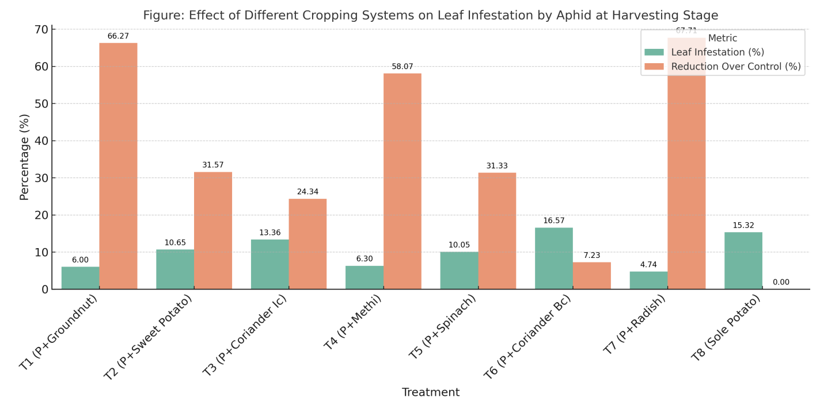overall gross return compared to sole potato cultivation.

Figure1. Effect of different cropping system on leaf infestation of potato caused by aphid at harvesting stage

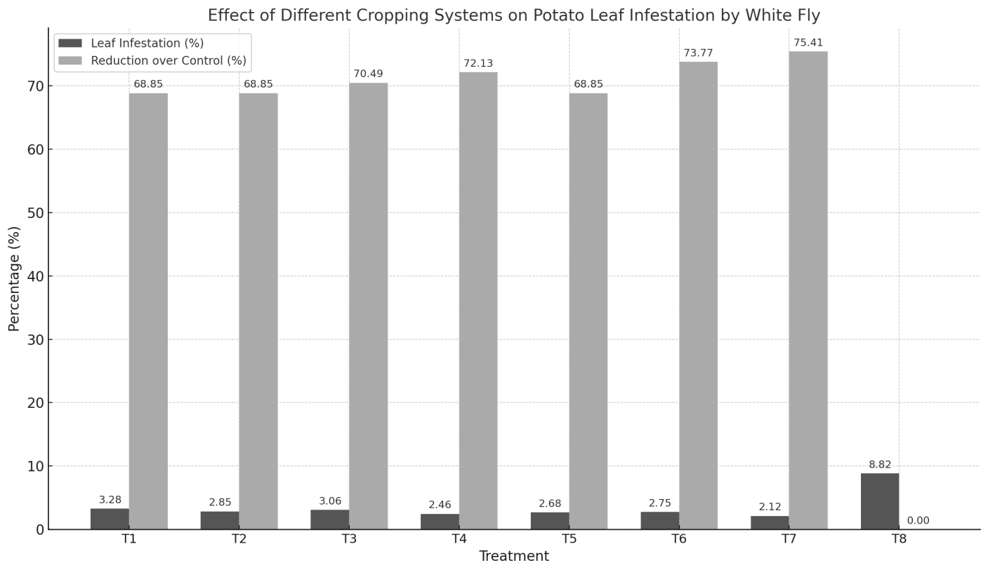Figure 2. Effect of different cropping system on leaf infestation of potato caused by white fly at harvesting stage

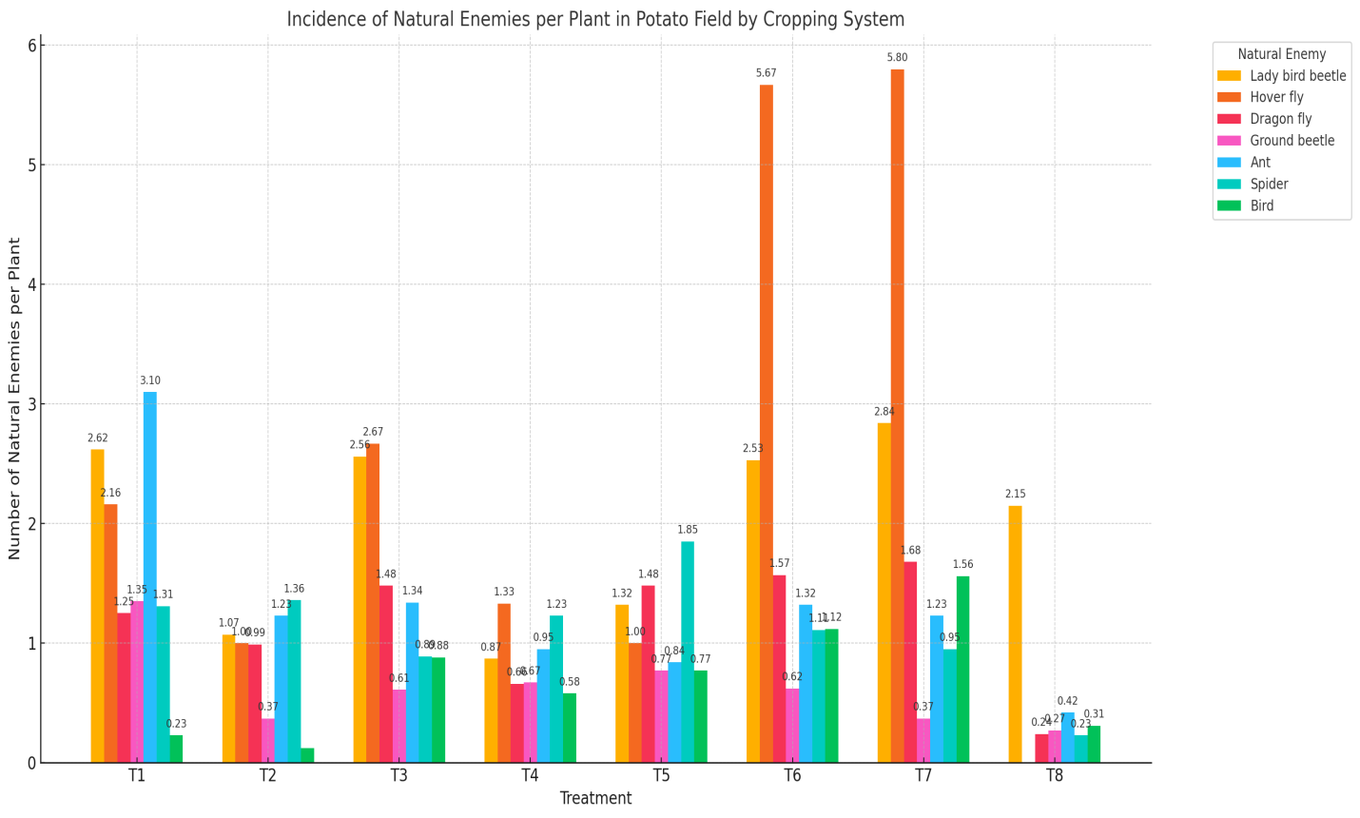Figure 3. Effect of different cropping system on the incidence of natural enemies per plant in potato field

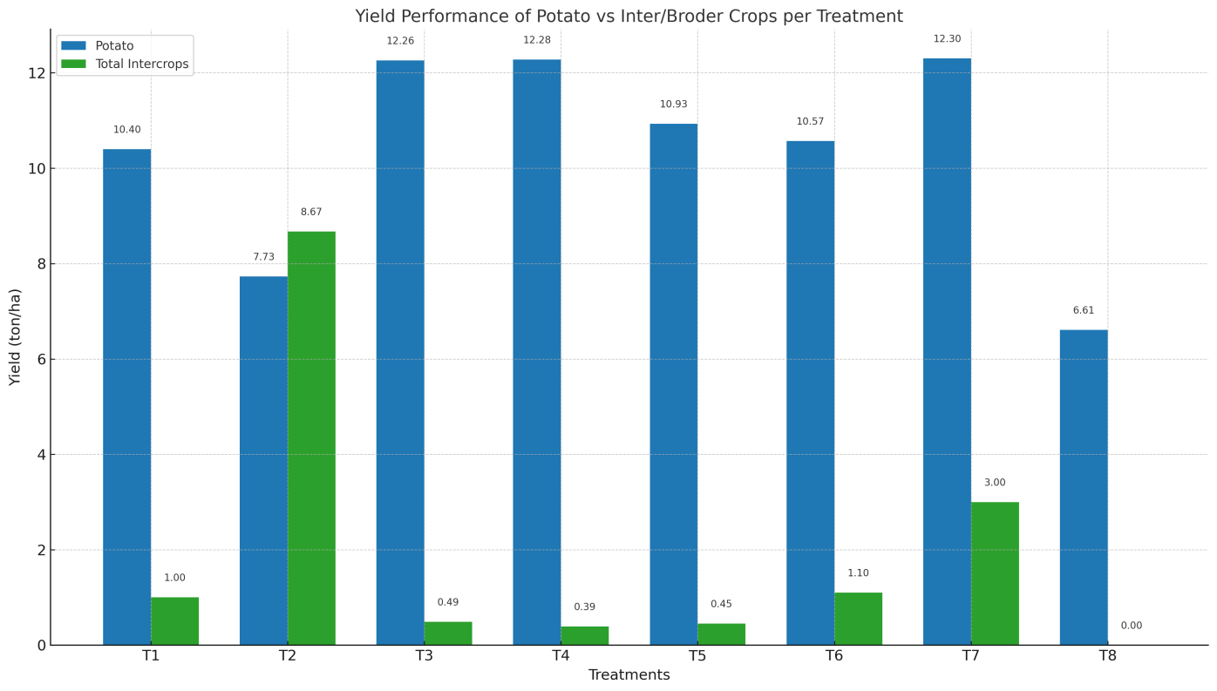Figure 4. Yield performance of potato, border and intercrops under the present study

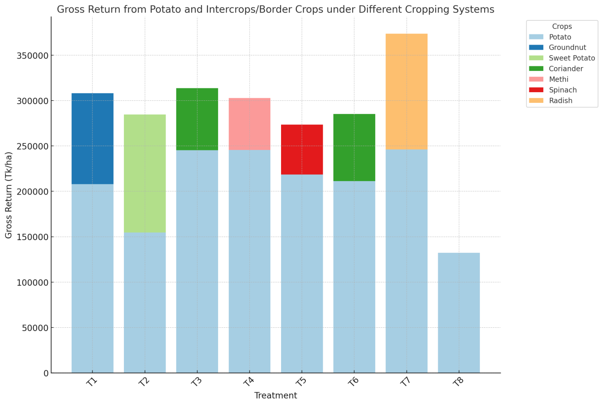Figure 5. Gross return in border crops and intercrops of potato under different cropping system

Table 1. Effect of different cropping system on leaf infestation of potato caused by jassid at harvesting stage

|  |  |  |  |  |
| --- | --- | --- | --- | --- |
| Treatments | Leaf infestation of potato by jassid | | | |
| Total number of leaves/plant | Number of infested leaves/plant | Leaf infestation percentage (%) | Reduction of leaf infestation over control |
| T1 | 116.30 d | 6.70 b | 5.77 a | 14.65 |
| T2 | 153.40 a | 6.20 c | 4.04 cd | 21.01 |
| T3 | 117.50 d | 5.85 e | 4.98 b | 25.48 |
| T4 | 138.20 bc | 5.90 e | 4.27 c | 24.84 |
| T5 | 141.80 b | 6.10 cd | 4.30 c | 22.29 |
| T6 | 116.20 d | 5.93 de | 5.10 b | 24.46 |
| T7 | 141.40 b | 5.52 f | 3.90 d | 29.68 |
| T8 | 135.40 c | 7.85 a | 5.80 a | 0 |
| LSD(0.01) | 5.00 | 0.18 | 0.27 |  |
| CV(%) | 2.16 | 1.65 | 3.26 |  |

[T1= Potato+ Groundnut (Ic), T2= Potato+ sweet potato (Bc), T3= Potato+ Coriander (Ic), T4= Potato+ Methi (Bc), T5= Potato+ Spinach (Bc), T6 = Potato+ Coriander (Bc), T7= Potato+ Radish (Bc) and T8= Sole potato (Control).]

Table 2. Effect of different cropping system on the incidence of cutworm per plant at different growth stage of potato

|  |  |  |  |
| --- | --- | --- | --- |
| Treatments | Incidence of cutworm (No./plant) | | |
| Early vegetative stage | Mid vegetative stage | Late vegetative stage |
| T1 | 0.00 b | 0.00 c | 0.00 e |
| T2 | 0.00 b | 0.00 c | 0.00 e |
| T3 | 0.00 b | 0.00 c | 0.33 b |
| T4 | 0.00 b | 0.00 c | 0.20 d |
| T5 | 0.00 b | 0.20 b | 0.32 bc |
| T6 | 0.00 b | 0.00 c | 0.30 c |
| T7 | 0.00 b | 0.00 c | 0.00 e |
| T8 | 0.20 a | 0.40 a | 0.45 a |
| LSD(0.01) | 0.004 | 0.008 | 0.02 |
| CV(%) | 7.07 | 4.71 | 5.71 |

[T1= Potato+ Groundnut (Ic), T2= Potato+ sweet potato (Bc), T3= Potato+ Coriander (Ic), T4= Potato+ Methi (Bc), T5= Potato+ Spinach (Bc), T6 = Potato+ Coriander (Bc), T7= Potato+ Radish (Bc) and T8= Sole potato (Control).]

Table 3. Effect of different cropping system on the incidence of epilachna beetle per plant at different growth stage of potato

|  |  |  |  |
| --- | --- | --- | --- |
| Treatments | Incidence of epilachna beetle (No./plant) | | |
| Early vegetative stage | Mid vegetative stage | Late vegetative stage |
| T1 | 0.00 c | 1.50 c | 3.87 c |
| T2 | 0.00 c | 1.25 d | 3.40 d |
| T3 | 0.00 c | 2.01 b | 4.50 b |
| T4 | 0.00 c | 0.95 e | 2.85 e |
| T5 | 0.20 b | 1.00 e | 3.10 de |
| T6 | 0.00 c | 1.56 c | 4.07 c |
| T7 | 0.00 c | 0.50 f | 2.05 f |
| T8 | 1.00 a | 5.67 a | 8.25 a |
| LSD(0.01) | 0.03 | 0.12 | 0.36 |
| CV(%) | 11.79 | 3.88 | 5.24 |

[T1= Potato+ Groundnut (Ic), T2= Potato+ sweet potato (Bc), T3= Potato+ Coriander (Ic), T4= Potato+ Methi (Bc), T5= Potato+ Spinach (Bc), T6 = Potato+ Coriander (Bc), T7= Potato+ Radish (Bc) and T8= Sole potato (Control).]

Table 4. Effect of different cropping system on the incidence of pollinators in potato field

|  |  |  |  |
| --- | --- | --- | --- |
| Treatments | Number of pollinators per plant | | |
| Honey bee | Carpenter bee | Hover fly |
| T1 | 0.27 d | 0.07 c | 2.16 d |
| T2 | 0.70 d | 0.00 d | 1.00 f |
| T3 | 81.70 b | 0.33 b | 2.67 c |
| T4 | 1.67 d | 0.00 d | 1.33 e |
| T5 | 0.00 d | 0.00 d | 1.00 f |
| T6 | 38.33 c | 0.08 c | 5.67 b |
| T7 | 124.33a | 3.00 a | 5.80 a |
| T8 | 0.00 d | 0.00 d | 0.00 g |
| LSD(0.01) | 2.52 | 0.03 | 0.13 |
| CV(%) | 3.35 | 2.62 | 2.11 |

[T1= Potato+ Groundnut (Ic), T2= Potato+ sweet potato (Bc), T3= Potato+ Coriander (Ic), T4= Potato+ Methi (Bc), T5= Potato+ Spinach (Bc), T6 = Potato+ Coriander (Bc), T7= Potato+ Radish (Bc) and T8= Sole potato (Control).]

Table 5. Diversity index and equitability of insect community of different families under different cropping system at early mid and late vegetative stage of potato

|  |  |  |  |  |  |  |  |  |  |
| --- | --- | --- | --- | --- | --- | --- | --- | --- | --- |
| Treatments | Early vegetative stage | | | Mid vegetative stage | | | Late vegetative stage | | |
| No. of insect species per plant | Diversity index (D) | Equitability (E) | No. of insect species per plant | Diversity index (D) | Equitability (E) | No. of insect species per plant | Diversity index (D) | Equitability (E) |
| T1 | 7 | 1.81 | 0.36 | 13 | 2.87 | 0.41 | 14 | 3.92 | 0.65 |
| T2 | 9 | 2.08 | 0.35 | 16 | 3.68 | 0.53 | 15 | 3.46 | 0.49 |
| T3 | 10 | 2.78 | 0.56 | 16 | 3.19 | 0.40 | 8 | 2.90 | 0.73 |
| T4 | 10 | 2.5 | 0.42 | 14 | 3.39 | 0.56 | 15 | 3.36 | 0.48 |
| T5 | 11 | 3.67 | 0.73 | 13 | 4.57 | 0.91 | 14 | 3.38 | 0.56 |
| T6 | 9 | 2.61 | 0.52 | 17 | 3.94 | 0.66 | 9 | 1.98 | 0.33 |
| T7 | 6 | 2.00 | 0.5 | 18 | 4.63 | 0.93 | 18 | 4.5 | 0.90 |
| T8 | 9 | 1.98 | 0.33 | 11 | 3.64 | 0.73 | 8 | 2.29 | 0.46 |

[Here, T1= Potato+ Groundnut (Ic), T2= Potato+ sweet potato (Bc), T3= Potato+ Coriander (Ic), T4 = Potato+ Methi (Bc), T5= Potato+ Spinach (Bc), T6= Potato+ Coriander (Bc), T7= Potato+ Radish (Bc) and T8= Sole potato (Control).]

4 Discussions

4.1 Pest Suppression through Diversified Cropping Systems

The study demonstrated that intercropping and border cropping notably reduce the incidence of key potato pests, especially aphids, jassids, whiteflies, and epilachna beetles. The border cropping with radish (T7) consistently exhibited superior suppression, supporting findings from recent studies emphasizing functional plant diversity as a pest regulation strategy (Homulle et al., 2024; Sujayanand et al., 2015). These results reaffirm the *resource concentration hypothesis* (Root, 1973), where pest populations are more concentrated in monocultures due to uniform host availability.

Recent research on strip and intercrop designs also reports reduced pest pressure and increased ecological resilience (Homulle et al., 2024; Emaru et al., 2024). Specifically, crops like radish, due to their allelochemical profile and visual masking, appear to interfere with pest colonization patterns (Lala, 2022).

4.2 Arthropod Diversity and Ecosystem Services

The increased presence of pollinators and predatory arthropods such as ladybird beetles and hoverflies in treatments like T7 and T6 suggests enhanced ecological functioning through *conservation biological control*. According to Al-Kodmany et al., (2024), intercropped systems offer multiple microhabitats and resource niches, encouraging arthropod diversity and stability. These results are consistent with the habitat heterogeneity hypothesis, which states that structurally complex environments support more diverse faunal communities.

A particularly recent study by Waweru et al. (2021) observed that border crops reduced both aphid infestations and virus transmission in vegetable systems, suggesting parallel benefits for potato health in mixed systems.

4.3 Economic and Agronomic Outcomes

Economically, T7 (Potato + Radish) was most successful in combining pest suppression with the highest tuber yield and gross return, corroborating research by Saljoqi et al. (2003) that demonstrated dual benefits of intercropping in terms of pest management and profitability. Moreover, cash-yielding intercrops like coriander and groundnut provided not only pest repellence but also marketable by-products, a principle emphasized in Kroschel et al. (2012) on integrated potato systems. The land-use efficiency and economic returns found in this study resonate with Ouma and Jeruto’s (2010) assertions that intercropping is critical to improving productivity per unit of land under resource-constrained smallholder conditions.

4.4 Implications for Sustainable Agriculture and Future Research

The results of this study suggest that adopting border cropping and intercropping systems can be a sustainable approach for pest management in potato cultivation, particularly in Bangladesh, where pesticide use is high and environmental concerns are growing. These systems provide an eco-friendly alternative to chemical pesticides, reduce pest pressure, and support greater biodiversity, which are crucial for maintaining long-term agricultural sustainability (Sullivan, 2003; Woomer et al., 2004).

Moreover, the integration of border crops like radish not only aids in pest suppression but also provides additional income sources for farmers, making these systems more attractive to smallholders and resource-poor farmers. Future studies should explore the long-term effects of these systems on soil health, pest dynamics, and economic viability to fully understand their potential in different agro-ecosystems. The strong support for intercropping as a sustainable IPM component (Emaru et al., 2024; Singh, 2023) suggests urgent scaling opportunities, but with certain caveats. Challenges may include labor intensiveness, crop compatibility, and market access for secondary crops. Thus, future research should emphasize the temporal dynamics of arthropod interactions, multi-seasonal yield stability and farmer-led adaptive trials.

5. Conclusion

This study highlights the intricate ecological web—Nature’s network—that thrives within potato fields under diverse cropping systems. Intercropping and border cropping strategies, particularly the use of radish as a border crop (T7), proved highly effective in suppressing pest populations while enhancing arthropod biodiversity and optimizing yield outcomes. The radish treatment consistently supported the highest abundance of beneficial arthropods and the lowest pest incidence, leading to superior economic returns. Companion crops such as coriander, methi, and groundnut also contributed positively to pest regulation and biodiversity, though to a lesser degree. These findings reinforce the value of agroecological intensification as a cornerstone of integrated pest management (IPM). By fostering a richer network of beneficial organisms, diversified cropping systems offer a sustainable and economically sound alternative to monoculture-based potato cultivation. To fully unlock the potential of these nature-driven strategies, further research is recommended to explore multi-seasonal dynamics, crop synergy, labor efficiency, and market integration of intercrops. In essence, aligning farming practices with nature’s network not only strengthens resilience against pests but also promotes ecological harmony and long-term agricultural viability.

**Disclaimer (Artificial intelligence)**

Option 1:

Author(s) hereby declare that NO generative AI technologies such as Large Language Models (ChatGPT, COPILOT, etc.) and text-to-image generators have been used during the writing or editing of this manuscript.

Option 2:

Author(s) hereby declare that generative AI technologies such as Large Language Models, etc. have been used during the writing or editing of manuscripts. This explanation will include the name, version, model, and source of the generative AI technology and as well as all input prompts provided to the generative AI technology

Details of the AI usage are given below:

1.

2.

3.

**References**

Al-Kodmany, K., Govind, M., Khan, S., & Kole, C. (Eds.). (2024). *Sustainable urban agriculture: New frontiers*. CRC Press.

Banjo, A. D. (2010). A review on *Aleurodicus dispersus* (Russel) (Spirally whitefly) (Hemiptera: Aleyrodidae) in Nigeria. *Journal of Entomology and Nematology, 2*, 1–6.

BARC. (2012). Fertilizer Recommendation Guide 2012. Bangladesh Agricultural Research Council, Farmgate, New Airport Road, Dhaka-1215. pp. 113.

Brown, C. R. (2005). Antioxidants in potato. *American Journal of Potato Research, 45*, 478–481.

Chenula, V. V. (1984). Plant virology in India: Past, present and future. *Indian Physiopathology, 37*, 1–20.

Emaru, A., Nyaanga, J. G., & Saidi, M. (2024). Integrating *Metarhizium anisopliae* entomopathogenic fungi with border cropping reduces black bean aphids (*Aphis fabae*) damage and enhances yield and quality of French bean. *Heliyon, 10*(13).

FAOSTAT. (2020). *New food balance sheet for Bangladesh, 2020*. Food and Agriculture Organization of the United Nations.

Gautam, H. K., & Chhaya, P. (2017). Effect of intercropping on the insect pest and crop yield: A review. *International Journal of Multidisciplinary Research Review, 1*(33), 113.

Ghosh, S., & Khan, M. R. (2010). Integrated approach for management of major insect pests and nematodes problems of okra *Abelmoschus esculentus* (L.). *Annals of Plant Protection Sciences, 18*, 447–452.

HIES. (2016). *Household Income and Expenditure Survey – 2016*. Bangladesh Bureau of Statistics, Statistics and Informatics Division (SID), Ministry of Planning, Government of the People’s Republic of Bangladesh.

Homulle, Z., Anten, N. P., Kessel, G. J., Stomph, T. J., van der Werf, W., & Douma, J. C. (2024). The potential of strip cropping to suppress potato late blight. *Field Crops Research, 318*, 109595.

Hortex Foundation. (2020). *Brief on potato export in Bangladesh*. Horticulture Export Development Foundation, Ministry of Agriculture, Dhaka, Bangladesh.

Hossain, M., & Bose, M. L. (2000). Growth and structural changes in Bangladesh agriculture: Implication of strategies and policies for sustainable development. In M. A. S. Mandal (Ed.), *Changing rural economy of Bangladesh* (pp. 1–20). Bangladesh Economic Association.

Kaur, C., George, B., Deepa, N., Singh, B., & Kapoor, H. C. (2004). Antioxidant status of fresh and processed tomato: A review. *Journal of Food Science and Technology, 41*, 479–486.

Kroschel, J., Mujica, N., Alcazar, J., Canedo, V., & Zegarra, O. (2012). Developing integrated pest management for potato: Experiences and lessons from two distinct potato production systems of Peru. In *Sustainable potato production: Global case studies* (pp. 419–450).

Lala, A. (2022). Techniques of protecting crops from insect pests in integrated pest management – intercropping and trap cropping. *Uttar Pradesh Journal of Zoology, 43*(12), 48–54.

Landis, D. A., Wratten, S. D., & Gurr, G. M. (2000). Habitat management to conserve natural enemies of arthropod pests in agriculture. *Annual Review of Entomology, 45*, 175–201.

Ojero, M. F. O., & Mueke, J. M. (1985). Resistance of four potato varieties to the potato tuber moth, *Phthorimaea operculella* (Zell.) in storage. *International Journal of Tropical Insect Science, 6*(2), 205–207.

Okonya, J. S., & Kroschel, J. (2016). Farmers’ knowledge and perceptions of potato pests and their management in Uganda. *Journal of Agriculture and Rural Development in the Tropics and Subtropics, 117*(1), 87–97.

Olanya, O. M., El-Bedewy, R., Adipala, E., Hakiza, J. J., Namanda, S., Kakuhenzire, R., Wagoire, W. W., Angiyah, T., Karinga, J., Ewell, P., & Lungaho, C. (2002). Estimation of yield loss caused by late blight and the effects of environmental factors on late blight severity in Kenya and Uganda. *African Crop Science Proceedings, 5*, 455–460.

Ouma, G., & Jeruto, P. (2010). Sustainable horticultural crop production through intercropping: The case of fruits and vegetable crops. *Agriculture and Biology Journal of North America, 1*(5), 1098–1105.

Pandey, S. K. (2007). Potato and tuber crops. In *Vegetable Science* (pp. 1–9).

Reddy, P. P. (2017). *Agro-ecological approaches to pest management for sustainable agriculture* (pp. 1–11). Springer.

Reddy, S. R. (2012). *Agronomy of field crops* (Vol. 1). New Delhi: Kalyani Publishers.

Root, R. B. (1973). Organization of a plant–arthropod association in simple and diverse habitats. *Ecological Monographs, 43*(1), 95–124. <https://doi.org/10.2307/1942161>

Saljoqi, A. U. R., & van Emden, H. F. (2003). Effects of two potential pest management components, intercropping and yellow sticky plastic sheet traps in two differentially resistant potato cultivars for the management of *Myzus persicae* (Sulzer). *Asian Journal of Plant Sciences, 2*(12), 925–931.

Simpson, E. H. (1949). Measurement of diversity. *Nature, 163*, 688.

Singh, D. P. (2023). *Integrated pest management in diverse cropping systems*. Springer. <https://books.google.com/books?id=rjOdEAAAQBAJ>

Sujayanand, G. K., Sharma, R. K., & Shankarganesh, K. (2015). Crop diversification for sustainable pest management in eggplant. *Florida Entomologist, 98*(1), 149–157. <https://doi.org/10.1653/024.098.0149>

Sullivan, P. (2003). Applying the principles of sustainable farming. *National Center for Appropriate Technology*. http://attra.ncat.org/attra-pub/PDF/Transition.pdf

Waliullah, M. I. S. (2007). A race of *Neosakia indica* short tail rat from Kashmir Valley, India. In *Proceedings of 7th National Symposium on Plant Protection: Operation, Implementation and Feasibility* (pp. 155–156). Pune, India.

Waweru, B. W., Rukundo, P., Kilalo, D. C., Miano, D. W., & Kimenju, J. W. (2021). Effect of border crops and intercropping on aphid infestation and the associated viral diseases in hot pepper (*Capsicum* sp.). *Crop Protection, 145*, 105623.

Woomer, P. L., Lan'gat, M., & Tungani, J. O. (2004). Innovative maize-legume intercropping results in above- and below-ground competitive advantages for understorey legumes. *West African Journal of Applied Ecology, 6*(1).

Wszelaki, A. (2014). Trap crops, intercropping and companion planting. *University of Tennessee Institute of Agriculture, Department of Plant Sciences Extension*, W235-F, 1–4.

Jaworski, C. C., Thomine, E., Rusch, A., Lavoir, A. V., Wang, S., & Desneux, N. (2023). Crop diversification to promote arthropod pest management: A review. Agriculture Communications, 1(1), 100004.+

Zhang, Y., Bohan, D. A., Zhang, C., Cong, W. F., Munier-Jolain, N., & Bedoussac, L. (2025). Crop diversity reduces pesticide use more efficiently with refined diversification strategies. Communications Earth & Environment, 6(1), 1-10.

N’Woueni, D. K., & Gaoue, O. G. (2022). Plant diversity increased arthropod diversity and crop yield in traditional agroforestry systems but has no effect on herbivory. Sustainability, 14(5), 2942.