**Soil Temperature Dynamics under Subsurface Water Retention in Light-Textured Soils**

**Abstract**

A field experiment was conducted during the spring season of 2024 to investigate the temporal thermal distribution in the water retention treatment, compare it to other management treatments, and examine the thermal variation with depth in coarse-textured soil. The field soil had a sandy loam texture and flat topography, classified into a subgroup of typical torpsamms according to Soil Taxonomy (19). The experiment was designed according to a randomized complete block design (RCBD) with four replicates and four treatments: water retention, organic matter, tillage, and no-tillage. The treatments were randomly distributed and white corn was planted. The results showed that soil temperatures increased from a depth of 0.15 m and increased with depth. When comparing the water retention treatments T1 with the tillage treatment (control), the highest temperature was 24.9 and 27.1 °C for depths 0.30 and 0.45 m, while the organic matter treatment (T2) recorded higher temperatures, reaching 23.5, 24.9 and 26.6 °C. The no-tillage treatment (control) also produced the lowest temperatures, reaching 20.6 and 21.10 °C.

Keywords: Temporal variation, soil temperature, subsurface water retention, Thermal variation

**Introduction**

Temperature is one of the climatic elements that influence the formation of surface features of the Earth. Therefore, heat is defined as a term that expresses the heat content of a body, or the kinetic energy of the random motion of the particles of matter. Heat capacity is expressed in units of calories or joules. Temperature is a measure of the intensity of heat in a body and is measured in units of Kelvin, Fahrenheit, and Celsius. The amount of heat that flows in the soil affects soil temperature, and soil temperature is related to air temperature. Both soil and atmospheric temperature have significant effects on crop growth (15). There is an inverse relationship between heat flux and tillage depth, as flow decreases with increasing depth, leading to increased soil thermal conductivity. Heat flux may also affect the soil's ability to store heat. The relationship between depth and volumetric heat capacity is directly proportional to density, the heat capacity increases with increasing apparent density and increasing plowing depth. It also determines the depth of the heat wave that penetrates the soil through sunlight. This depends on the heat capacity, moisture content of the soil, and thermal conductivity (6).

Among (5) coarse-textured soils, they do not retain moisture content due to their high porosity and permeability. They contain many minerals, but they lack organic matter or are present in very small quantities, so they are not suitable for agriculture. They also suffer from desertification. They are also characterized by light texture, weak physical, chemical and biological properties, a lack of nutrients, a high rate of evaporation and poor water retention. Therefore, the percentage of sandy soils is estimated at 19% of the arable land in Iraq. These soils have become economically unviable. Several methods have been used to treat coarse-textured soils, but on a limited scale due to the high costs of production, as well as the use of many works related to soil management and maintenance. These soils must be made productive for agriculture, so efficient irrigation systems (drip irrigation) must be used (4). Subsurface water retention is a modern and important method for retaining water in the root zone, and can be used in coarse-textured soils. This technique involves placing plastic membranes under the root zone, which retains nutrients and prevents water seepage and leaching, thus supplying plant roots with water and nutrients. Subsurface drip irrigation systems are also used at a depth of 0.30 m to prevent water evaporation from the soil surface and to prevent capillary action from affecting the water's ability to reach the surface. This increases the cultivated area with less water. (16, 17, 18) (2) indicates that high soil moisture content causes lower soil temperatures, which in turn reduces seed germination and emergence, and also affects production. There is a link between temperature and soil water, as impeding high soil temperatures under humid conditions due to increased soil heat capacity requires more energy to evaporate water from the increased soil temperature (13). The primary factor for estimating heat distribution in soil is the soil's moisture content. If water is available at the soil surface, most of the absorbed heat energy will be used to evaporate water, creating a small gradient for heat flow into the soil. However, if the surface is dry, the absorbed heat energy will heat the surface, resulting in a significant gradual heat flow into the soil. Temperatures increase with depth in winter and decrease until they reach a certain depth, then begin to increase with depth in summer (12). The aim of the study is to understand the thermal behavior using subsurface water retention technology, compare it with other management parameters, and understand the evolution of heat with depth in sandy-textured soil.

**2- Materials and Methods**

A field experiment was conducted to grow white corn (a member of the Poaceae family) during the spring season of July 15, 2024. The field soil had a sandy loam texture and a flat topography, classified as a typical soil type according to (18). Four replicates of soil samples were taken from the field to a depth of 0.30 m. The samples were mixed, and a composite sample was extracted. The samples were air-dried, ground, and passed through a 2 mm sieve to estimate the physical and chemical properties. Volumetric analysis of soil particles was performed to determine the texture using the hydrometer method (8). Apparent and actual soil densities were estimated using the paraffin wax method and the pycnometer, respectively, according to the method mentioned in (7). Total porosity was calculated using the mathematical relationship between the apparent and actual densities, as mentioned in (9).

f=1-ρb/ρs ⋯⋯⋯⋯⋯⋯ (1).

As for the chemical properties of the soil, the electrical conductivity (EC) and pH of the 1:1 soil extract were measured. The dissolved positive and negative ions were also estimated according to the methods mentioned in (14). The organic matter in the soil was estimated using the potassium dichromate method according to the method described by Wakelly and Black as mentioned in (11).

**Table (1) Some of the physical and chemical properties of the field soil.**

|  |  |  |  |
| --- | --- | --- | --- |
| traits | Unit | Unit | |
| pH | ----- | | ----- |
| EC | Ds.m-1 | | 3.48 |
| Calcium | Meq/L | | 10.56 |
| Magnesium | 6.31 |
| Sodium | 16.16 |
| Potassium | 0.17 |
| Sulfate | 10.64 |
| Chloride | 12.17 |
| Bicarbonate | 2.65 |
| Nitrate | 0.27 |
| Phosphate | 0.03 |
| Organic Matter | % | | 0.12 |
| Carbonate Minerals | g.kg-1 | | 182 |
| Sand | g.kg-1 | | 677.4 |
| Silt | 292.5 |
| Clay | 30.1 |
| Texture | ------- | | Sandy Loam |
| Bulk Density | Mg.m-3 | | 1.48 |
| True Density | 2.71 |
| Porosity | --- | | 0.4538 |

**Experimental Treatments and Statistical Design**

Four treatments were used in the experiment: subsoil water retention (T1), organic matter (OM) treatment at a depth of 0.35 m (T2), no-tillageage (N) treatment (T3), and only tillage (T4), which is considered the control treatment. The experiment was designed according to a randomized complete block design (RCBD) with four replicates. Treatments were randomly distributed across experimental plots within the agricultural field. Data were statistically analyzed using the GenStat Discovery Edition program. The least significant difference (LSD) was tested at a level of 0.05 between treatment means.

Soil Temperature Estimation

Soil temperature was estimated using specialized sensors to measure soil temperature at three depths: +0.15, +0.30, and +0.60 m. Readings were taken throughout the growing season and at four-hour intervals throughout the growth of the white corn crop. The crop grains were planted.

**3- Results and Discussion**

**3-1: Thermal Distribution Seasonal soil temperature**

Figures (1 and 2) show the seasonal temperature distribution in a sandy-textured soil. Soil temperature changes at depths of 0.15 to 0.45 m increased throughout the growing season, with the highest temperatures occurring in the water retention treatment compared to the other treatments. The lowest temperature was recorded in no-tillage treatment, ranging from 20.6 to 21.10 m, while the highest temperatures were recorded in the water retention treatment, reaching 24.9 and 27.1 m at depths of 0.30 and 0.45 m. The reason for the increase in soil temperature is due to the increase in the volumetric moisture content of the soil. Water has a high specific heat capacity, which allows it to maintain its temperature for a longer period. Water has a higher specific heat capacity than any other substance, and therefore has the ability to absorb large amounts of heat with minimal temperature changes. Temperatures increased throughout the growing season until they stabilized in the months. The last one. (1).

The organic matter treatment recorded 23.5, 24.9, and 26.6 m0, while tillage treatment yielded 22.2, 23.7, and 25.4 m0 for the three depths, respectively. These temperature changes during the growing season did not affect productivity or the morphological traits of the crop, as they were within the required temperature range for the growth of white corn, between 20-29 m0 (10). When comparing the temperature changes of the water retention treatment with tillage treatment throughout the season, the results indicate higher temperatures at a depth of 0.45 m.

The temperature distribution with soil depth for all treatments during the sorghum cultivation season. Figure 3 shows the temperature distribution across the soil surface for the growing season. Surface temperatures vary depending on the type of treatment and climate. Temperatures began to increase with depth, with the water retention treatment reaching approximately 23.9 m² at the soil surface, but at a depth of 0.45 m it was 26.5 m². Organic matter followed, with approximately 23.2 m² at a depth of 0.30 m and 24.9 m² at a depth of 0.45 m. The tillage treatment, followed by no-tillage treatment, gave the lowest temperature at a depth of 0.45 m, reaching 23.4 m². Temperatures were observed to be in a state of continuous change throughout the growing season.

 **P1 – T1-15 cm/ GS3: °C Temp P2 –T1- 30cm/ GS3: °C Temp P3 – T1- 45cm / GS3: °C Temp**

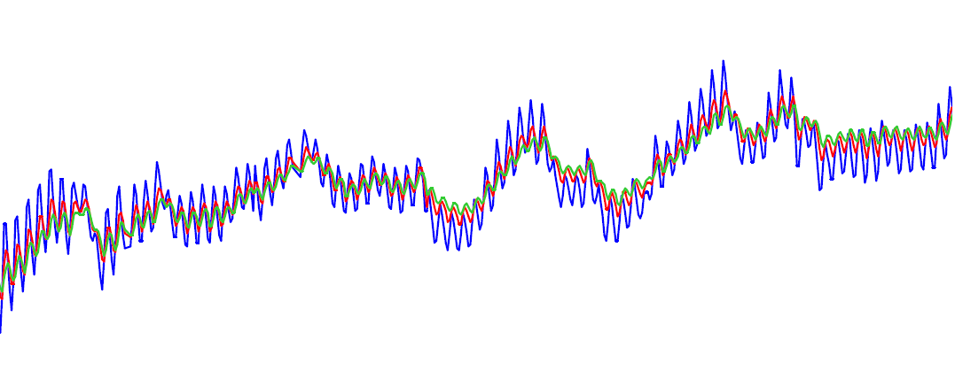

**Temperature (°C)**

30 –

28 –

26 –

24 –

22 –

20 –

18 --

02 Apr 18 Apr 03 May 18 May 03 Jun 29 Jun

2024 2024 2024 2024 2024 2024

12:00 AM 12:00 AM 12:00 AM 12:00 AM 12:00 AM 12:00 AM

**P1 – T2-15 cm/ GS3: °C Temp P2 –T2- 30cm/ GS3: °C Temp P3 – T2- 45cm / GS3: °C Temp**

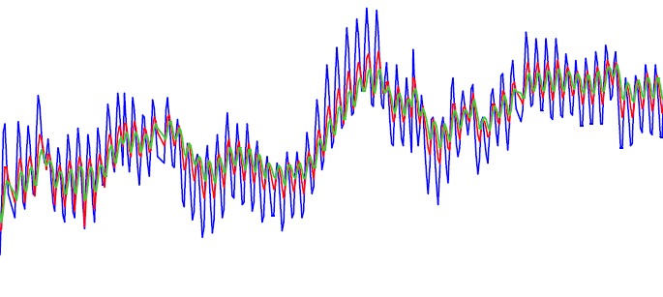

**Temperature (°C))**

30 –

28 –

26 –

24 –

22 –

20 –

18 –

02 Apr 18 Apr 03 May 18 May 03 Jun 29 Jun

2024 2024 2024 2024 2024 2024

12:00 AM 12:00 AM 12:00 AM 12:00 AM 12:00 AM 12:00 AM

Figure 1: Seasonal temperatures throughout the growing season for treatments (water retention technology) T1 and (organic matter) T2

**P1 – T3-15 cm/ GS3: °C Temp P2 –T3- 30cm/ GS3: °C Temp P3 – T3- 45cm / GS3: °C Temp**

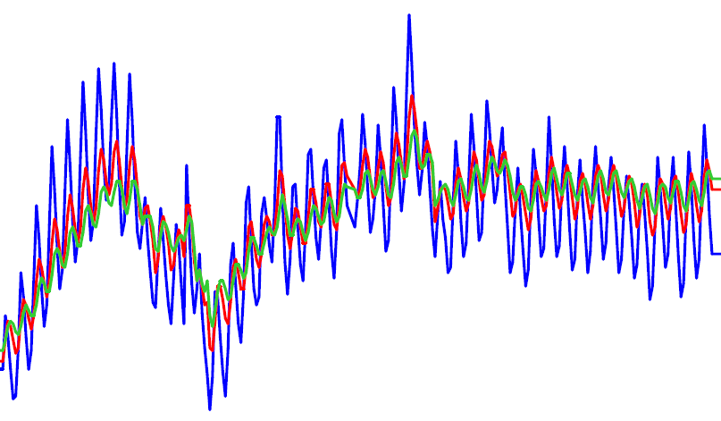

**Temperature (°C)**

30 –

28 –

26 –

24 –

22 –

20 –

18 --

02 Apr 18 Apr 03 May 18 May 03 Jun 29 Jun

2024 2024 2024 2016 2016 2016

12:00 AM 12:00 AM 12:00 AM 12:00 AM 12:00 AM 12:00 AM

**P1 – T4-15 cm/ GS3: °C Temp P2 –T4- 30cm/ GS3: °C Temp P3 – T4- 45cm / GS3: °C Temp**

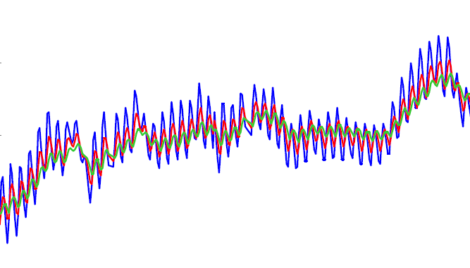

**Temperature (°C)**

30 –

28 –

26 –

24 –

22 –

20 –

18 –

02 Apr 18 Apr 03 May 18 May 03 Jun 29 Jun

2024 2024 2024 2024 2024 2024

12:00 AM 12:00 AM 12:00 AM 12:00 AM 12:00 AM 12:00 AM

Figure 2: Seasonal temperatures throughout the growing season for the tillage (T3) and no-tillage (T4) treatments.

Figure 3: Heat distribution across the soil layer

**3-2: Dry weight of the root system (g plant-1)**

Figure 4 shows the dry weight of the root system of the sorghum crop. There were significant differences between the organic matter and water retention treatments. The dry weight of the root system decreased for the organic matter treatment, and the water retention treatment produced the highest dry weight, 72.9 g plant-1. There were no significant differences between the tillage and no-tillageage treatments

.

Figure 4: Dry weight of the sorghum root system

Root spread density (g root/cm-3 soil)

Figure 5 shows the root spread density of the sorghum crop for the growing season. The organic matter and water retention treatments significantly outperformed each other, producing the highest average root spread of 0.023 g root/cm-3 soil, while the water retention treatment significantly excelled on the tillage treatment, reaching 0.017 g root/cm-3 soil. 3 cm-3 soil. This is due to the organic matter containing nutrients and its ability to retain water.

Figure 5: Root system distribution density of sorghum

Average number of cob (cob, treatment-1)

Figure 6 shows the effect of different treatments on the average number of ear. There were significant differences between treatments. The water retention treatment excelled on the other treatments, producing the highest average number of ear (78.2 cob, treatment-1). There were also significant differences between the two tillage and no-tillage treatments, reaching 50.8 and 44.56 cob, treatment-1.

Figure 6: Average number of ear of sorghum

**4- Conclusions and Recommendations**

From the results, we conclude that the increase in temperatures during the water retention treatment significantly increased the crop's root system throughout the growing season, which helped increase crop yields. This increased yields when soil covers were used, which increased the efficiency of the root system in absorbing water and nutrients, which positively impacted overall productivity. This is consistent with (Al-Salhi, 2018). Therefore, we recommend the use of water retention techniques in agriculture, as they improve soil thermal conditions, increasing the availability of nutrients in the soil while increasing the moisture content of these soils within the root zone. This increases plant productivity per unit area while reducing fertilizer additions and preventing these nutrients from seeping into the groundwater.

**Disclaimer (Artificial intelligence)**

Option 1:

Author(s) hereby declare that NO generative AI technologies such as Large Language Models (ChatGPT, COPILOT, etc.) and text-to-image generators have been used during the writing or editing of this manuscript.

Option 2:

Author(s) hereby declare that generative AI technologies such as Large Language Models, etc. have been used during the writing or editing of manuscripts. This explanation will include the name, version, model, and source of the generative AI technology and as well as all input prompts provided to the generative AI technology

Details of the AI usage are given below:

1.

2.

3.

**5- References**

1- Evett, S. R., Agam, N., Kustas, W. P., Colaizzi, P. D., & Schwartz, R. C. (2012). Soil profile method for soil thermal diffusivity, conductivity and heat flux: Comparison to soil heat flux plates. *Advances in Water Resources*, *50*, 41-54.‏

2- Nkurunziza, L., Chirinda, N., Lana, M., Sommer, R., Karanja, S., Rao, I., ... & Smucker, A. (2019). The potential benefits and trade-offs of using sub-surface water retention technology on coarse-textured soils: Impacts of water and nutrient saving on maize production and soil carbon sequestration. *Frontiers in Sustainable Food Systems*, *3*, 71.‏

3- Heil, K., & Schmidhalter, U. (2017). The application of EM38: Determination of soil parameters, selection of soil sampling points and use in agriculture and archaeology. *Sensors*, *17*(11), 2540.‏

4- Al-Rawi, S., Ibrahim Aoda, M., & Salih Ati, A. (2017). The Role of subsurface water retention technology (SWRT) for growing chili pepper in Iraqi sandy soils. *Journal of Environment and Earth Science*, *7*(1), 81-89.‏

5- Aliwi, S., Almallah, I. A., & Almulla, S. (2025). Hydromorphotectonic Analysis of Al Najaf-Karbala Plateau Using Remote Sensing Techniqe. *The Iraqi Geological Journal*, 202-216.‏

6-Al-Shammary A. A.; J. N. A. Al-Sadoon. 2014. Influence of tillage depth, soil mulching systems and fertilizers on some thermal properties of silty clay soil. Global Journal of Agricultural Research. Vol.2, No.2, pp. 18-32, June 2014. Published by European Centre for Research Training and Development UK ([www.ea-journals.org](http://www.ea-journals.org)).

7-Black, C. A. 1965. Methods of soil analysis . Am. Soc. Agron. Inc. Publisher , Madison , Wis. U.S.A.

88- Day, P. R. 1965. Particle fractionation and particle size analysis . In. Black, C. A. et al., (eds). Methods of soil analysis . Agron. Mono. No. 9(1):454-567.

99- Hillel, D. 1980. Application of soil physics. Academic press, New York.

110- Ismail, S. M. and K. Ozawa. 2007. Improvement of crop yield, soil moisture distribution and water use efficiency in sandy soils by clay application, Applied Clay Science 37:81–89.

111- Jackson, M. L. 1958. Soil chemical analysis . Prentice – hall Inc. Englewood cliff, N.J.

112-Mostafazadeh-Fard, B.; M. Heidarpour; A. Aghakhani; M. Feizi. 2008. Effects of leaching on soil desalinization for wheat crop in an arid region. The Isfahan University of Technology and Isfahan Agricultural Research Center. Plant Soil Environ. , 54, 2008 (1): 20–29.

113-Radke, J. K., 1982. Managing early season soil temperatures in the northern corn belt using configured soil surfaces and mulches. Soil Sci. Soc. Am. J. 46, 1067–1071.

114-Richards, L. A. 1954. Diagnosis and improvement of saline and Alkaline soils. USDA. Hand book 60 USDA, Washington , DC.

115-Shokri, N.; P. Lehmann and D. Or. 2008. Effects of hydrophobic layers on evaporation from porous media. Geophys. Rex. Lett. 35: L19407. doi: 10.1029/2008GL035230.

116-Smucker, A. J. M.; B. Basso and Y. Kavdir. 2012. Optimizing soil water in the root zone for maximum grain and biomass production.Invited manuscript to Vadose Zone Journal.

117-Smucker, A. J. M.; W. Wang; A. N. Kravchenko and W.A. Dick. 2010. Forms and Functions of Meso and Micro-niches for Carbon within Soil Aggregates. Journal of Nematology.42:84 86.

118-Smucker, A. J. M.; Y. Kavdir; B. Basso; S. Kravchenko and T. Zobeck. 2011. New Water Retention Technology Improves Corn Yields and Cellulosic Biomass Production On Highly Permeable Soils. ID# 66395, International Soil Science Conference, San Antonio, Texas, October 19, 2011.

119- Soil taxonomy, Abasic system of soil classification for making and interpreting soil surveys. Second edition, 1999.