Undiagnosed Post-Traumatic Diaphragmatic Hernia Presenting with Colonic Obstruction: A Case Report and Literature Review

Abstract :
Post-traumatic diaphragmatic hernia, also referred to as diaphragmatic rupture, is a rare condition that is often missed during the initial evaluation following trauma. Delayed diagnosis is associated with increased morbidity and mortality. Post-traumatic diaphragmatic hernia is an insidious condition, often characterised by a latent and atypical clinical presentation. It typically results from herniation of abdominal viscera through a diaphragmatic defect, most commonly caused by penetrating trauma.
The case study aims to undiagnosed post-traumatic diaphragmatic hernia revealed by colonic obstruction.
We report the case of a patient with a history of neglected abdominal trauma following a fall, who later presented with signs of intestinal obstruction. An emergency laparotomy revealed herniation and incarceration of the colon within the thoracic cavity through a diaphragmatic defect.
The treatment of diaphragmatic hernia involves surgical reduction of the herniated abdominal contents into the peritoneal cavity and closure of the diaphragmatic defect, either by direct suturing or the use of a prosthetic mesh.
This case highlights the importance of thorough radiologic evaluation following high-energy abdominal trauma to detect potential diaphragmatic injuries early and prevent delayed complications
Key words: diaphragmatic hernia, Case Report, Colonic Obstruction, diaphragm muscle

Introduction :
A diaphragmatic hernia is an abnormal communication between the thoracic and abdominal cavities due to a defect in the diaphragm muscle. Complicated diaphragmatic hernia (DH) is a rare, life-threatening condition. It is a defect in the diaphragm or its attachments, having the risk of the protrusion of the abdominal contents into the thoracic cavity. It can be congenital or acquired. Acquired DH usually occurs following trauma. It occurs in 1–5% of victims of vehicle crashes and in 10–15% of penetrating injuries of the lower chest (Giuffrida et al., 2023). Post-traumatic diaphragmatic hernia, also referred to as diaphragmatic rupture, is a rare condition that is often missed during the initial evaluation following trauma. Delayed diagnosis is associated with increased morbidity and mortality [1]. The left hemidiaphragm is more commonly affected, and diagnosis is frequently made only after the development of complications [2].
Traumatic diaphragmatic rupture is a rare injury in the severely injured patient and is most commonly caused by blunt mechanisms. However, penetrating mechanisms can also dominate depending on regional and local factors. Traumatic diaphragmatic rupture is difficult to diagnose and can be missed by primary diagnostic procedures in the resuscitation room (Weber et al., 2022; Fair et al., 2015). Traumatic diaphragmatic ruptures predominantly occur in young male patients, typically resulting from motor vehicle accidents or violent trauma [3]. Traumatic diaphragmatic hernia is a relatively uncommon clinical entity, especially in children. It is often undiagnosed because of its rarity and coexistence with more obvious and serious injuries. Mortality of traumatic diaphragmatic rupture alone is rare; however, delayed diagnosis may lead to higher mortality and morbidity rates (Špaková et al., 2021).
We report a new case of post-traumatic diaphragmatic rupture that was diagnosed incidentally two years after blunt abdominal trauma, during the evaluation of a colonic obstruction.

Case Presentation :
A 68-year-old male who underwent surgery for a fracture of the right lower limb following a fall from the 3rd floor 2 years ago, and who was an occasional weaned smoker and alcoholic.
Admitted to our department with an occlusive syndrome.
Physical examination revealed a conscious, apyretic patient with a temperature of 37.2°C, a heart rate of 90 beats per minute, blood pressure of 125/70 mmHg, respiratory rate of 18 breaths per minute, and an oxygen saturation of 99% on room air. The patient's body mass index (BMI) was 25 kg/m².
The patient's symptoms had been evolving for five days and included constipation, abdominal distention, nausea, and vomiting. Abdominal examination noted a distended and tympanic abdomen, with tenderness in the left hypochondrium; rectal examination revealed no abnormalities.
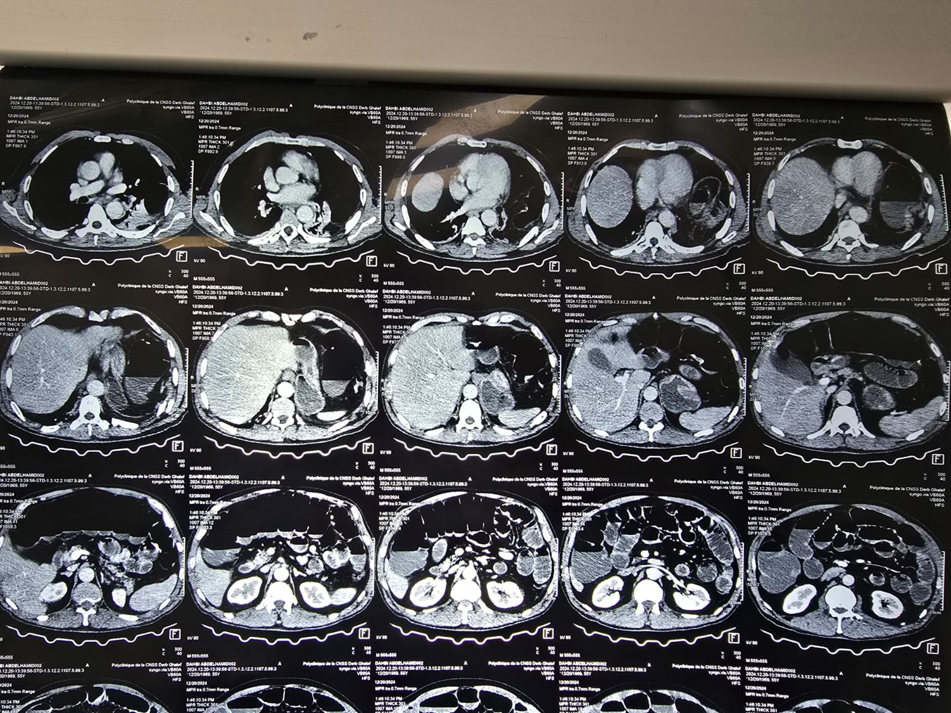
Figure 1 : Intrathoracic incarceration of the left colonic angle
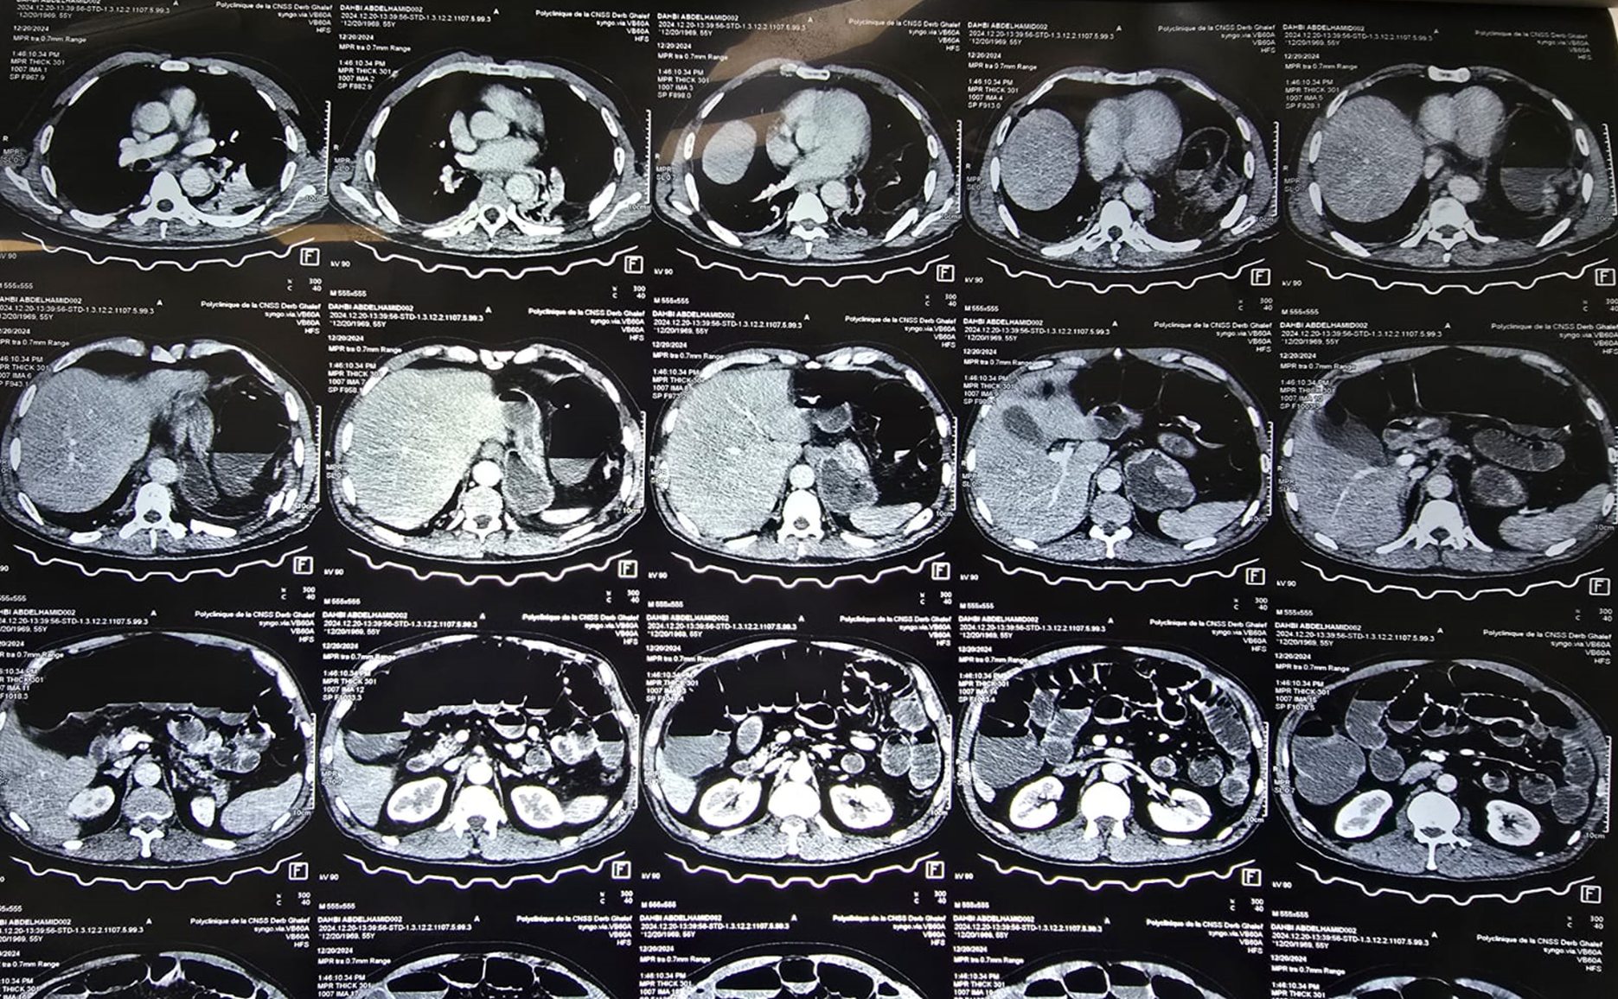
Figure 2: Distension of the transverse colon upstream of the diaphragmatic hernia
Emergency surgical intervention was performed, intraoperative exploration revealed a bowel and colonic distension (Figure 3) and an incarceration of the transverse colon on a 5cm posterior diaphragmatic rupture. After the liberation of the colon within the thorax, the rupture was sutured using silk 2-0 stitches, with placement of a chest drain. The postoperative course was uneventful, and the patient was discharged home on postoperative day 5.

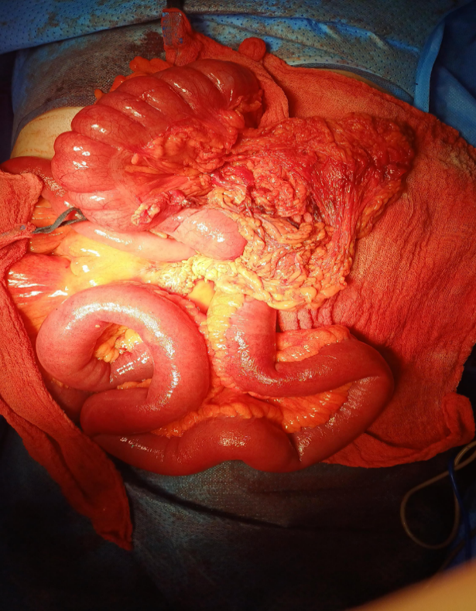
Figure 3: Bowel and colonic distension upstream of transverse colon incarceration

Discussion :
Traumatic diaphragmatic lesions are rare conditions, occurring in around 0.5 to 5% of cases of abdominal trauma, with 2/3 of cases due to penetrating trauma and 1/3 due to blunt trauma [14]. They mainly occur in areas of potential weakness along embryological fusion points due to a sudden increase in the pleuroperitoneal pressure gradient during thoracoabdominal trauma, and lead to the entry of an abdominal viscera into the pleural cavity [15].
A post-traumatic diaphragmatic hernia is defined as the passage of abdominal viscera into the thorax complicating a muscular breach of the diaphragmatic dome occurring in the immediate or late aftermath of severe trauma [2]. The etiologies are dominated by polytrauma and thoracoabdominal wounds, and rarely by laborious childbirth, crushing or postoperative hernia.[4-5]
Once the diaphragmatic defect is created, abdominal organs can migrate into the thorax, leading to increased intrathoracic pressure, pulmonary compression, mediastinal shift, and reduced venous return, all of which can contribute to significant cardiorespiratory compromise [6–7]
Delayed diagnosis of post-traumatic diaphragmatic hernia is well documented in the literature, with some cases identified several decades after the initial trauma. These cases present with a wide range of nonspecific symptoms, including chest pain, abdominal pain, dyspnea, tachypnea, cough, gastroesophageal reflux, and in rare cases, faeco-pneumothorax. The clinical manifestations often emerge when the herniated organs become compromised or strangulated [8].
The delayed presentation is thought to result from post-traumatic devascularization of the diaphragmatic muscle, which leads to scar formation. Over time, this scar may rupture, creating a defect that progressively enlarges due to normal respiratory motion [10]. Although the diaphragmatic tear may form at the time of trauma, visceral herniation can occur much later, explaining the often-late onset of symptoms [11].
These late presentations are associated with increased morbidity and mortality, as surgical intervention becomes more complex due to the presence of adhesions between herniated abdominal organs and thoracic structures [9].
Diagnosis of post-traumatic diaphragmatic hernia can sometimes be made using a simple chest X-ray; however, the gold standard remains thoracoabdominal computed tomography (CT) with multi-planar reconstructions [8]. CT imaging not only confirms the presence of the hernia but also evaluates potential complications involving the herniated organs [12].

Surgical management depends on the side of the diaphragmatic rupture. For left-sided hernias, laparotomy is the preferred approach, as it allows reduction of the herniated organs and direct closure of the diaphragmatic defect. For right-sided diaphragmatic ruptures, thoracotomy is generally required due to the anatomical presence of the liver, which limits abdominal access.

The diaphragmatic breach is typically repaired with non-absorbable interrupted sutures. In most cases, the elasticity of the diaphragmatic muscle permits closure of the defect without excessive tension, regardless of the size of the orifice. However, in cases of large or complex defects, prosthetic reinforcement may be necessary. When prosthetic repair is indicated, non-absorbable meshes are generally used—except in contaminated or septic conditions, where absorbable prostheses are preferred to minimise the risk of infection [10–11].
Conclusion :
Post-traumatic diaphragmatic rupture is a rare and often pauci-symptomatic condition, making diagnosis particularly challenging. If left undiagnosed, it can lead to serious complications, including organ incarceration, respiratory distress, and hemodynamic instability. Delayed diagnosis not only complicates surgical management but also significantly increases morbidity and mortality.
This case underlines the importance of systematic thoracoabdominal CT imaging in the evaluation of any high-energy thoracoabdominal trauma, even in the absence of obvious clinical signs, to ensure timely detection and management of diaphragmatic injuries.
Ethical Approval:
As per international standards or university standards written ethical approval has been collected and preserved by the author(s).
Consent
As per international standards or university standards, patient(s) written consent has been collected and preserved by the author(s).

Disclaimer (Artificial intelligence)
Option 1:
Author(s) hereby declare that NO generative AI technologies such as Large Language Models (ChatGPT, COPILOT, etc.) and text-to-image generators have been used during the writing or editing of this manuscript.
Option 2:
Author(s) hereby declare that generative AI technologies such as Large Language Models, etc. have been used during the writing or editing of manuscripts. This explanation will include the name, version, model, and source of the generative AI technology and as well as all input prompts provided to the generative AI technology
Details of the AI usage are given below:
1.
2.
3.

References :
[1]. Petrone, P., Asensio, J. A., & Marini, C. P. (2017). Diaphragmatic injuries and post-traumatic diaphragmatic hernias. Current problems in surgery, 54(1), 11-32.
[2]. Furák, J., & Athanassiadi, K. (2019). Diaphragm and transdiaphragmatic injuries. Journal of Thoracic Disease, 11(Suppl 2), S152.
[3] Simpson, J., Lobo, D. N., Shah, A. B., & Rowlands, B. (2000). Traumatic diaphragmatic rupture: associated injuries and outcome. Annals of the Royal College of Surgeons of England, 82(2), 97.
[4]. Hammoudi D. Diaphragmatic rupture during labor. Int J ObstetAnesth 2004; 13: 284-286.
[5]. Markogiannakis H. Fecopneumothorax: a rare complication of esophagectomy. Ann Thorac Surg 2007; 84: 651-652
[6] . Ngoga D, Mauffrey C (2007) Undiagnosed delayed traumatic diaphragmatic rupture causing sudden death: case report and review of literature. Eur J Orthop Surg Traumatol. 17:321–3
[7]. Onakpoya U, Ogunrombi A, Adenekan A, Akerele W. Strangulated tension viscerothorax with gangrene of the stomach in missed traumatic diaphragmatic rupture. ISRN Surg. 2011;2011:458390.
[8] Kadou, J., Fobelets, A., Kadou, A., Bochouari, K., & Attou, R. (2017). Post-traumatic diaphragmatic herniation: case report and literature review. Revue Medicale de Bruxelles, 38(3), 148-151.
[9] 7. Kuppusamy A, Ramanathan G, Gurusamy J, Ramamoorthy B, Parasakthi K. Delayed diagnosis of traumatic diaphragmatic rupture with herniation of the liver: a case report. Ulus Travma Acil Cerrahi Derg. 2012;18(2):175-7.
[10]. Gaine, F. A., Lone, G. N., Chowdhary, M. A., & Lone, H. (2013). The etiology, associated injuries and clinical presentation of post traumatic diaphragmatic hernia. Bulletin of Emergency & Trauma, 1(2), 76.
[11]. Ghebouli, K. (2024). Traumatic Rupture of the Diaphragm About 19 Cases. Grn Int J Apl Med Sci, 2(2), 53-57.
[12]. Eren S. Diaphragmatic hernia: diagnostic approaches with review of the literature. Eur J Radiol2005;54:448—59
[13]. Aissa A. Rare complication of a post-traumatic left diaphragmatic hernia. Rev Pneumo clin 2013;69:331-335
[14] Reitano E, Cioffi SPB, Airoldi C, Chiara O, La Greca G, Cimbanassi S. Current trends in the diagnosis and management of traumatic diaphragmatic injuries: A systematic review and a diagnostic accuracy meta-analysis of blunt trauma. Injury. 2022;53(11):3586-3595. doi: 10.1016/j.injury.2022.07.002
[15] El Bakouri A, El Karouachi A, Bouali M, El Hattabi K, Bensardi FZ, Fadil A. Post-traumatic diaphragmatic rupture with pericardial denudation: A case report. Int J Surg Case Rep. 2021 Jun;83:105970. doi: 10.1016/j.ijscr.2021.105970. Epub 2021 May 15. PMID: 34029846; PMCID: PMC8163962.
[16] Giuffrida, M., Perrone, G., Abu-Zidan, F., Agnoletti, V., Ansaloni, L., Baiocchi, G. L., ... & Catena, F. (2023). Management of complicated diaphragmatic hernia in the acute setting: a WSES position paper. World Journal of Emergency Surgery, 18(1), 43.

[17] Weber, C., Willms, A., Bieler, D., Schreyer, C., Lefering, R., Schaaf, S., ... & Committee on Emergency Medicine, Intensive Care and Trauma Management (Sektion NIS) of the German Trauma Society (DGU). (2022). Traumatic diaphragmatic rupture: epidemiology, associated injuries, and outcome—an analysis based on the TraumaRegister DGU®. Langenbeck's Archives of Surgery, 407(8), 3681-3690.

[18] Špaková, B., Gura, M., Molnár, M., Murgaš, D., & Dragula, M. (2021). Traumatic diaphragmatic hernia in children. Journal of Pediatric Surgery Case Reports, 72, 101984.

[19] Fair, K. A., Gordon, N. T., Barbosa, R. R., Rowell, S. E., Watters, J. M., & Schreiber, M. A. (2015). Traumatic diaphragmatic injury in the American College of Surgeons National Trauma Data Bank: a new examination of a rare diagnosis. The American journal of surgery, 209(5), 864-869.

