***Case Report***

**Presacral Dermoid Cyst in a Young Female: Diagnostic Evaluation and Surgical Approach Selection**

**Abstract**

**Background**: Presacral or retro rectal dermoid cysts are rare congenital lesions arising from ectodermal remnants during embryogenesis. Due to their deep pelvic location and nonspecific symptoms, these lesions often pose diagnostic and surgical challenges. Case Presentation: We present a 21-year-old female with persistent lower back pain and constipation. MRI was done as Magnetic Resonance Imaging (MRI) is highly effective in visualizing pelvic anatomy, offering precise delineation of anatomical relationships and potential local invasion. Imaging revealed a large lobulated cystic lesion in the presacral region. The patient underwent complete surgical excision via an anterior transabdominal approach. Histopathology confirmed a dermoid cyst. Postoperative recovery was uneventful. Conclusion: Presacral dermoid cysts, though rare, should be considered in young adults with persistent pelvic symptoms. MRI is essential for preoperative planning. Surgical excision is curative and prevents complications such as infection or malignant transformation. This case report describes the case, diagnostic modality and operative approaches with complications as these lesions often misdiagnosed.

Keywords: Presacral cyst, Dermoid cyst, Retro rectal tumour, Anterior approach, MRI pelvis, Developmental cyst.

**Introduction**

The presacral or retro rectal space is a potential anatomical region bounded by the rectum anteriorly, the sacrum posteriorly, the peritoneal reflection superiorly, and the levator ani and coccygeus muscles inferiorly. It has clinical significance due to its complex embryological development and proximity to vital pelvic structures. Lesions in this region are uncommon and present a diagnostic challenge, accounting for approximately 1 in 40,000 hospital admissions [1,2], with varied etiologies and nonspecific presentations [20]. Among these lesions, developmental cysts are most prevalent. These include epidermoid, enteric, tailgut, and dermoid cysts [3]. Dermoid cysts, or mature cystic teratomas, are benign congenital anomalies that derive from ectodermal components and are characterized by the presence of skin adnexal structures such as sebaceous glands, sweat glands, and hair follicles within a squamous epithelial lining [4]. Dermoid cysts grow slowly and often remain asymptomatic until they compress adjacent organs. Common symptoms include constipation, pelvic pain, or urinary disturbances, depending on the lesion's size and location [5,9]. Although benign, complications such as infection, rupture, or malignant transformation have been reported, particularly in long-standing lesions [6]. Imaging, especially MRI, is pivotal for diagnosing these lesions and for preoperative planning due to its superior soft-tissue resolution [4,7]. This report describes a case of a large presacral dermoid cyst in a young woman, emphasizing diagnostic workup, surgical approach, and histopathological confirmation.

**Case Presentation**

A 21-year-old nulliparous woman presented to the surgical outpatient department with chronic lower back pain and constipation persisting for six months. The pain was dull, non-radiating, and exacerbated by sitting or straining during defecation. She denied fever, weight loss, rectal bleeding, or urinary symptoms. Menstrual cycles were normal. She had no comorbidities or history of gynaecological procedures. The patient has no complaint of urinary incontinence or faecal incontinence.

**Clinical Examination:**

General physical and systemic examinations were within normal limits. Per abdominal examination revealed no masses or tenderness. Digital rectal examination identified a soft, ill-defined, non-pulsatile, compressible mass on the posterior rectal wall, approximately 4–5 cm from the anal verge. On proctoscope examination there was a bulge present over the posterior rectal wall, which was soft and non-tender, the mucosa over bulge is freely mobile and normal.

**Laboratory Investigations:**

Routine haematological and biochemical tests were normal. Tumour markers including carcinoembryonic antigen (CEA), alpha-fetoprotein (AFP), and CA-125 were within reference limits.

**Radiological Imaging:**

After clinical and blood investigations to confirm the diagnosis radiological investigation was done which is mentioned as below:

A well-defined lobulated cystic lesion with multiple septa & linear peripheral wall calcifications is noted in right pre-sacral and pre-coccygeal region extending into right vagino-rectal pouch

The lesion demonstrates mixed intensity on T1W & T2W images. Diffusion weighted images do not reveal any diffusion restriction.

No evidence of internal solid component is noted.

The few of locules of lesion at its posterior aspect shows soft internal proteinaceous contents.

The lesion is seen causing extrinsic compression over rectum on left side with preserved fat planes.

The lesion is seen causing extrinsic compression over vagina and cervix at anterior aspect with preserved fat planes.

The lesion is seen causing mild extrinsic scalloping of anterior cortex of coccygeal vertebra without bone marrow oedema.

No obvious communication with lower sacral or coccygeal spine is noted.

The lesion measures approx. 75 x 49 x 55 mm.

UTERUS & BOTH OVARIES:

A simple ovarian cyst is noted in right ovary. It measures approx. 30 x 20 mm.

Left ovary appears normal.

Uterus is anteverted and appears normal ET measures approx. 4.6 mm1336

REST:

The liver is normal in size, shape and signal intensity with no evidence of any focal lesion.

The intrahepatic biliary radicals, common duct is not dilated.

The portal and hepatic veins are normal in course and calibre with normal flow.

The gall bladder appears normal.

The spleen is normal in size, shape and signal intensity.

Both kidneys are normal in size, shape and outline with normal cortico-medullary differentiation

Both the adrenals are normal in size, shape and signal intensity pattern. No evidence of any adrenal mass lesion.

The pancreas is normal with no evidence of focal lesion. The peripancreatic fat planes and

retroperitoneum appears normal.

There is no evidence of abdominal lymphadenopathy.

Major abdominal blood vessels are normal.

Urinary bladder appears normal. No calculus, mass or diverticulum is seen. Pelvic small bowel loops appear normal.

Iliopsoas and bony pelvis appear normal.

No free / loculated intraperitoneal or pelvic fluid is seen.

IMPRESSION:

The MR findings are:

A well-defined lobulated cystic lesion with multiple septa in right pre-sacral and pre-coccygeal region extending into right vagino-rectal pouch (few of locules of lesion at its posterior aspect shows soft internal proteinaceous contents) with extension as mentioned above, suggest possibility of Benign Cystic Lesion - possibly Dermoid Cyst/Pre-sacral cystic teratoma more likely than Duplication cyst.

In view of absent of extension into lower Sacro-coccygeal spine possibility of Presacral Meningocele appears unlikely.

No evident focal liver lesion, lymphadenopathy or ascites.

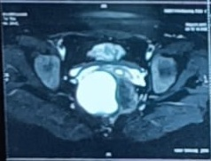

Fig 1. MRI image showing pre sacral cyst

**Preoperative Preparation:**

Multidisciplinary planning was conducted involving colorectal surgery, anaesthesiology, and radiology. The size and location of the lesion indicated a transabdominal (anterior) surgical approach.

**Surgical Procedure:**

Under general anaesthesia, a midline infraumbilical incision was made. Two stay sutures were taken with the broad ligament and the uterus retracted anteriorly. After mobilizing the sigmoid colon laterally and rectum, the retro-rectal space was accessed after dissection of left and right mesorectum. A lobulated cystic mass 6*6*5 cm was visualised displacing the rectum anteriorly. The cyst was confirmed with per rectal examination and intrabdominal examination simultaneously. The cyst was aspirated to facilitate dissection. Adhesions to the levator ani and coccyx were dissected meticulously. The cyst was completely excised without rupture. The rectal wall was intact. A pelvic drain was placed. Haemostasis achieved.

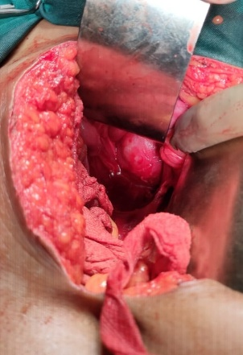 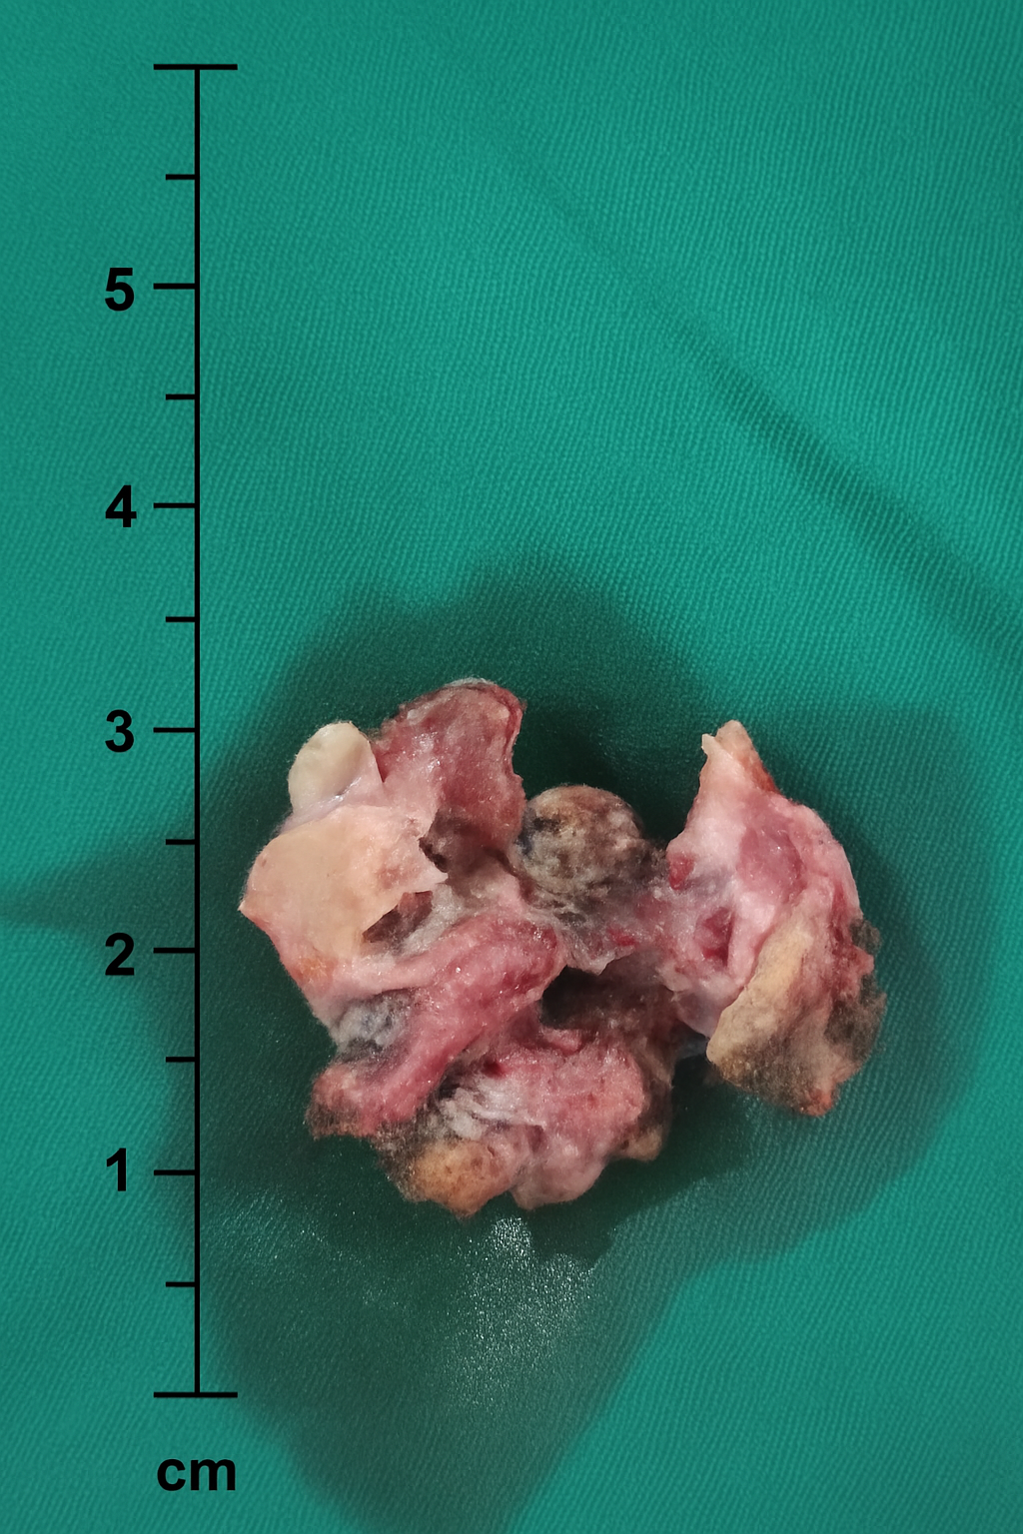 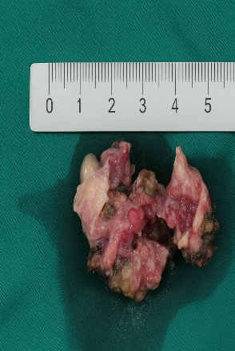

Fig. 2 (a) intra operative image of anterior approach of retro rectal tumour (b, c) excised cyst

**Postoperative Course:**

The patient recovered uneventfully. Oral intake was resumed on day two, and the drain was removed on day four. She was discharged on postoperative day five. Follow-ups at one and three months showed no recurrence or complications. Patient has no complaint of urinary incontinence, faecal incontinence.

**Histopathological Findings:**

Macroscopically, the cyst contained multiple greyish, brownish soft tissue structure. Microscopically, the cyst was lined by keratinizing stratified squamous epithelium. The underlying tissue shows fibromuscular and fatty tissue with presence of acute on chronic inflammation. No dysplasia or malignancy was identified.

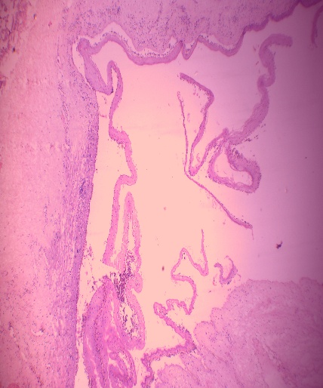 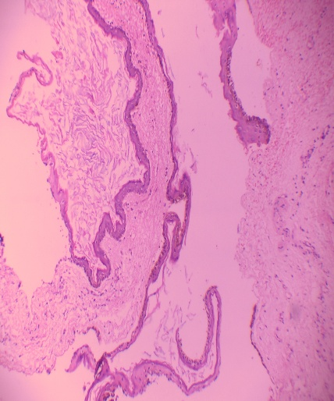

Fig. 3. Histopathology image showing keratinized stratified squamous epithelium

**Discussion**

Presacral dermoid cysts, while rare, must be considered in the differential diagnosis of patients presenting with persistent pelvic or sacral symptoms. These lesions result from the incomplete regression of embryonic ectodermal tissues [8].

**Epidemiology and Classification**

Presacral tumours exhibit a bimodal distribution, occurring most frequently in neonates and again in middle-aged female patients. Developmental cysts constitute approximately 60% of these lesions, with dermoid cysts being among the least common [7,9]. Their clinical significance lies in their potential to grow, cause compressive symptoms, and, rarely, undergo malignant transformation [10].

Clinical Features The presentation is often nonspecific and depends on size and anatomical relationships. Symptoms include:

* Constipation, rectal fullness, or tenesmus.
* Pelvic or sacral pain due to nerve compression.
* Urinary retention or frequency.
* A palpable mass on digital rectal or gynecologically examination.
* Rarely, recurrent perianal abscess or fistula formation in case of secondary infection [6,7,13].

**Differential Diagnosis**

The differential diagnosis includes tailgut cysts, epidermoid cysts, anterior sacral meningocele, rectal duplication cysts, and chordomas. Tailgut cysts and dermoid cysts differ histologically and in malignant potential [11,13]. Hence, definitive diagnosis requires histopathological confirmation.

**Imaging**

MRI is the imaging modality of choice due to its ability to delineate soft-tissue structures, fat components, and cystic septations [4,7]. CT scanning is useful for detecting calcifications and bone involvement [12]. Magnetic Resonance Imaging (MRI) is highly effective in visualizing pelvic anatomy, offering precise delineation of anatomical relationships and potential local invasion. Presacral cysts typically present as thin-walled lesions with low signal intensity on T1-weighted sequences.[12] The risk of malignancy can be estimated based on following features: heterogeneity, solid appearance, ill-defined borders, heterogenous enhancement following gadolinium administration, rapid growth and extension cranially above S3. [13] Endorectal ultrasound and colonoscopy may be considered in select cases to evaluate rectal wall integrity.

**Surgical Management**

Complete surgical excision is the treatment of choice. Incomplete resection risks recurrence, infection, or malignant transformation [12,14].

Approaches:

* **Posterior (trans-sacral/Kraske):** Suitable for lesions below the S3 level.
* **Anterior (transabdominal):** Preferred for lesions above S3 or large masses.
* **Combined approach:** Employed in complex, recurrent, or multiloculated lesions [15,16,17].

**ANTERIOR APPROACH**

The abdominal approach was selected in cases where the tumour was large and located above the S3 vertebral level, making access via the trans sacral route challenging. A midline lower abdominal incision was performed with the patient in the lithotomy position. Dissection proceeded into the retro rectal space based on the tumour’s location. A critical step during mobilization was the careful preservation of the rectal vessels and mesorectum to avoid injury and associated complications. It was recommended that the presacral space be identified before attempting to separate the tumour from surrounding structures. This precaution helps minimize the risk of haemorrhage from the presacral venous plexus (PSVP), which is commonly injured during blind use of electrocautery. The choice of postoperative drainage was tailored according to intraoperative findings and wound characteristics. (19)

COMPLICATION OF ANTERIOR APPROACH

1. Injury to organs: Rectum, bowel, ureter are the vital organs and increased chances of injury due to deep pelvic dissections.
2. **Haemorrhage**: Pre sacral venous plexus is thin-walled veins so they are very vulnerable to injury with dissection. Injury to venous plexus leads to profuse bleeding.
3. **Cyst rupture**: high chances of cyst rupture as compare to other approach
4. **Wound Complications**: The large abdominal incision and deep pelvic dissection increase the risk of postoperative wound infection, pelvic abscess, or delayed wound healing. Adequate drainage and sterile technique are essential to minimize these risks.
5. **Bowel Dysfunction**: Due to injury to nerves near rectum and deep to pelvic cavity leads to temporary bowel movement disturbance
6. **Urinary Dysfunction**: Autonomic nerve injury may also lead to urinary retention or incontinence, especially if the hypogastric plexus is affected during dissection.
7. **Adhesion Formation**: Intraperitoneal dissection can lead to postoperative adhesions, which may cause bowel obstruction or chronic pelvic pain.

**Posterior Approach:**

The presacral lesions were excised using a posterior trans perineal (Kraske) approach, which is a standard method for accessing deep pelvic and retro rectal space. The patient was placed in the prone jackknife position, with the buttocks retracted to optimize surgical exposure of the perineal region.

A midline or presacral incision was made, extending from the lower sacrum and coccyx to the anal verge. After incising the skin and subcutaneous tissue, the anococcygeal ligament was transacted, and the levator ani muscles were retracted laterally to access the presacral space. In order to provide adequate visualization and working space, coccygectomy was performed in each case.

Meticulous and careful blunt and sharp dissection was carried out to safely separate the lesion from surrounding structures, particularly the rectum. Special attention was paid to avoid injury to adjacent pelvic organs and preserve anorectal function.

Following complete excision of the mass, the perineal defect was reconstructed, and closed suction drains were placed to minimize postoperative seroma or hematoma formation. The wound was closed in layers using absorbable sutures for deep tissue and non-absorbable sutures or staples for skin closure, as appropriate. (18)

This approach provided excellent exposure of the presacral space and facilitated safe and complete excision of the lesions with minimal morbidity. (19)

**COMPLICATIONS OF POSTERIOR APPROACH**

**1. Wound-Related Complications**

* **Wound infection:** Due to proximity to the anal canal and potential contamination.
* **Wound dehiscence:** Especially in patients with poor nutrition, obesity, or tension at closure.
* **Wound infection:** Seroma formation is common in this approach

**2. Neurological and Functional Complications**

* **Damage to sacral nerve roots:** May result in bowel, bladder, or sexual dysfunction.
* **Faecal incontinence or urgency:** Due to injury or traction on pelvic floor muscles or pudendal nerves.
* **Urinary retention:** Secondary to nerve injury.

**3. Structural and Organ Injury**

* **Rectal injury or perforation:** Especially if the lesion is adherent or dissection is difficult.
* **Bladder or urethral injury:** Rare but possible in deeply seated lesions.
* **Pelvic organ prolapses:** If the pelvic floor is significantly disrupted and not properly reconstructed.
* **Bleeding:** Presacral venous plexus injury can cause significant intraoperative bleeding.

**Long-Term Complications**

* **Recurrence of the lesion:** Especially in cases of incomplete excision or malignancy.
* **Cosmetic or functional dissatisfaction:** Related to scarring, coccygectomy, or changes in sitting posture.

**Combined approach**

In cases where the tumour extends both below the S3 level and above its cephalic margin, neither the trans-sacral nor the trans-abdominal approach alone provides sufficient access for complete excision. In such scenarios, a combined abdomin-sacral approach is warranted to ensure radical resection. Benign presacral tumours typically achieve clinical cure with complete surgical excision. However, for malignant lesions, adjuvant radiotherapy is often necessary to reduce the risk of local recurrence and improve outcomes. (18)

Regardless of the surgical approach employed, **intraoperative digital rectal examination** is crucial throughout the dissection to avoid inadvertent rectal injury. For trans-sacral and combined approaches, **preservation of at least one S3 nerve root** and **all S1–S2 nerve roots** is essential to maintain pelvic floor function and prevent postoperative neurological deficits [20]

Complication of this approach

The combined abdomin-sacral approach offers superior exposure for large or high-riding presacral tumours that cross the S3 level. However, it is associated with increased complexity and risk of complications due to the involvement of both anterior and posterior pelvic dissections:

1.Injury to neurovascular bundle:

Injury to sacral nerve: chances of lower limb weakness, decrease sensation in perineum

Injury to sacral venous plexus: uncontrolled haemorrhage

Injury to autonomic nerves: urine/ faecal incontinence, erectile dysfunction

2. injury to rectum: leads to perforation or laceration

3. wound infection: higher chances of posterior wound as it is near to anal canal

4. wound dehiscence: due to less vascular supply in sacral region wound dehiscence is common

5. Prolonged recovery and pain: Due to extensive dissection of intra peritoneal and deep pelvic structures

In the present case, the anterior approach facilitated complete excision with minimal morbidity. No intraoperative rupture occurred, thus reducing recurrence risk.

Histology and Prognosis Dermoid cysts are lined by stratified squamous epithelium with adnexal components. Although rare (~1–2%), malignant transformation to squamous cell carcinoma can occur, especially in long-standing or large lesions. Complete excision typically results in excellent prognosis.

**Table 1: Comparison of Surgical Approaches for Presacral Masses**

|  |  |  |  |
| --- | --- | --- | --- |
|  | Anterior Approach | Posterior approach | Combined Approach |
| Indication | Any tumour above S3 level | Any tumour below S3 level | Tumour spans above and below S3 level |
| Route | Transabdominal | Trans-perineal, Trans-sacral | Both trans abdominal and trans sacral level |
| Position of patient | Supine | Prone or jackknife | First supine then prone |
| Advantage | Better operative field, better vision for neurovascular bundle and vital structures, better cosmetics | Intra peritoneal dissection doesn’t required | Complete exposure of tumour |
| Disadvantage | Less accessibility of pre-sacral space, higher chance of cyst perforation | Risk of rectal injury, DVT due to prolonged prone position | Increase operative time, increase dissection |
| Complication | Risk of bowel injury, risk of injury of neuro vascular bundle, infection | Infection  Sacral nerve damage  Rectal injury | Bowel injury  Neurovascular bundle injury  Haemorrhage  Sacral nerve damage  infection |
| Excision of tumour | Complete or partial | Complete if below S3 level | Radical dissection can be done |

**Conclusion**

Presacral dermoid cysts are rare developmental lesions that may cause significant symptoms due to mass effect. MRI is essential for preoperative diagnosis and surgical planning. Surgical excision is curative and prevents future complications. Awareness of differential diagnoses and individualized surgical strategies are key to optimal outcomes.

**Conflicts of Interest:** None declared  
**Funding:** None  
Ethical Approval:

As per international standards or university standards written ethical approval has been collected and preserved by the author(s).

Consent

As per international standards or university standards, patient(s) written consent has been collected and preserved by the author(s).

Disclaimer (Artificial intelligence)

Author(s) hereby declare that NO generative AI technologies such as Large Language Models (ChatGPT, COPILOT, etc.) and text-to-image generators have been used during the writing or editing of this manuscript.

**References:**

1. Uhlig BE, Johnson JW. Presacral tumours and cysts in adults. Dis Colon Rectum. 1975;18(7):581–589.
2. Hobson KG, et al. Tumours of the retro rectal space. Dis Colon Rectum. 2005;48(10):1964–1974.
3. Hjermstad BM, Helwig EB. Tailgut cysts: report of 53 cases. Am J Clin Patho. 1988;89(2):139–147.
4. . Džoić, Martina, Jana Fila, Mislav Čavka, Mirjana Vukelić-Marković, and Boris Brkljačić. "Epidermoid cyst in presacral space." *Medicina Fluminensis* 47, no. 3 (2011): 312-315.
5. K L Mathis, E J Dozois, M S Grewal, P Metzger, D W Larson, R M Devine, Malignant risk and surgical outcomes of presacral tailgut cysts, *British Journal of Surgery*, Volume 97, Issue 4, April 2010, Pages 575–579
6. Wetzel, L.H. and Levine, E., 1990. Pictorial essay. MR imaging of sacral and presacral lesions. *AJR. American journal of roentgenology*, *154*(4), pp.771-775.
7. **Mathis KL, Dozois EJ.** Presacral tumors: diagnosis and management. *Clin Colon Rectal Surg.* 2007;20(2):84–93.
8. Nair RR, Shoukrey MN, Whitlow B. Presacral dermoid: now you see it now you don't. *Gynecological Surgery*. 2007;4(3):229–231
9. Wu, J.S., 2007. Rectal cancer staging. *Clinics in colon and rectal surgery*, *20*(03), pp.148-157.
10. Uhlig, Bennett E. M.D.; Johnson, Roderick L. M.D.. Presacral tumors and cysts in adults. Diseases of the Colon & Rectum 18(7):p 581-596, October 1975. | DOI: 10.1007/BF02587141
11. Tsarkov, P., Barkhatov, S., Shlyk, D. *et al.* Risk factors for rectal perforation during presacral cyst removal: a comparison between transabdominal, perineal, and combined surgical approaches. *Tech Coloproctol* **29**, 23 (2025).
12. Bouts, C. and Van der Speeten, K., 2014. A single center retrospective analysis of Kraske’s transsacral approach: a review. Surgical Science, 5(10), pp.454-466.
13. Hassan, I. and Wietfeldt, E.D., 2009. Presacral tumors: diagnosis and management. *Clinics in colon and rectal surgery*, *22*(02), pp.084-093.
14. Kai, C.H.E.N., Dong, F.U., Xiao-jun, M.A., Meng-xiong, S.U.N., Wei, S.U.N. and Zheng-dong, C.A.I., 2011. Surgical strategy for presacral tumors: analysis of 33 cases. *Chinese Medical Journal*, *124*(23), pp.4086-4091.
15. Saxena, D., Pandey, A., Bugalia, R.P., Kumar, M., Kadam, R., Agarwal, V., Goyal, A., Kankaria, J. and Jenaw, R.K., 2015. Management of presacral tumors: our experience with posterior approach. *International journal of surgery case reports*, *12*, pp.37-40.
16. Brunicardi FC, Andersen DK, Billiar TR, et al., eds. **Schwartz's Principles of Surgery.** 11th ed. New York, NY: McGraw-Hill Education; 2019. Chapter 30: Colon, Rectum, and Anus – Section: Retrorectal Tumors.
17. Uçar, A.D., Erkan, N. and Yıldırım, M., 2015. Surgical treatment of retrorectal (presacral) tumors. *World Journal of Surgical Procedures*, *5*(1), pp.127-136.
18. : Buchs, N., Taylor, S. and Roche, B., 2007. The posterior approach for low retrorectal tumors in adults. *International journal of colorectal disease*, *22*, pp.381-385.
19. : LI, Guo-dong; CHEN, Kai; FU, Dong; MA, Xiao-jun; SUN, Meng-xiong; SUN, Wei; CAI, Zheng-dong. Surgical strategy for presacral tumors: analysis of 33 cases. Chinese Medical Journal 124(23):p 4086-4091, December 2011. | DOI: 10.3760/cma.j.issn.0366-6999.2011.23.044