Early Sphincter Repair Following Acute Perineal Trauma: Complete Functional Recovery at 4-Month Follow-Up

Abstract :

Acute perineal trauma with sphincter rupture constitutes a functional emergency requiring multidisciplinary management 1. We report a case of early surgical repair with mid-term follow-up. Case Report: A 32-year-old healthy male presented with complete external anal sphincter (EAS) rupture after a fall onto a metallic object. Despite initially reassuring findings, sphincter hypotonia developed by day 5, confirmed by Magnetic resonance imaging (120° defect at 9 o'clock). Direct sphincterorrhaphy was performed on day 7. At 4-month follow-up, the patient achieved full functional recovery (Wexner score = 1, normalized manometric pressures) 2,3,4,5

This case highlights the importance of sequential clinical/MRI evaluation and optimal outcomes of early anatomic repair (<10 days) for non-obstetric traumatic sphincter injuries.

Keywords : Perineal trauma, Sphincter rupture, Direct sphincterorrhaphy, Pelvic MRI, Biofeedback therapy

1. Introduction

Non-obstetric perineal trauma accounts for 5-10% of sphincter injuries. These types of injuries, though relatively rare, can have severe functional consequences that affect patients' quality of life, particularly in terms of continence and sexual health. Optimal management of such trauma requires early diagnosis and prompt surgical intervention. This study aims to demonstrate the effectiveness of early sphincter repair in improving long-term functional outcomes.6  
  
The treatment of these injuries generally involves a multidisciplinary approach, which includes surgical interventions for anatomical repair and rehabilitation through therapies like biofeedback. Several studies have shown that early sphincter repair improves long-term functional outcomes compared to delayed repair. However, despite these recommendations, many patients experience delays in management, which may adversely affect their outcomes.  
  
Early diagnosis remains challenging, particularly in penetrating trauma cases where initial symptoms may be misleading. Thus, it is essential to highlight the importance of early intervention and appropriate follow-up.7

# 2. Literature Review

External anal sphincter tears are often caused by penetrating or direct trauma, such as falls onto metal objects or other accidental injuries 6. In the literature, the approach to sphincter repair has evolved over the years, with increasing preference for direct repairs rather than secondary ones. Several studies show that early repair performed within 48 hours to 10 days has a success rate of over 80%, compared to 62% for delayed repairs.8  
  
Advantages of Early Repair:  
- Preservation of the Pudendal Nerve: The preservation of the pudendal nerve is crucial for maintaining continence. A prompt repair reduces the risk of denervation, leading to better functional recovery 7.  
- Reduction of Long-Term Complications: Early repairs reduce the risk of complications such as anal fistula, infections, or long-term continence issues.9,10  
  
Recent studies also emphasize the importance of rehabilitative techniques like biofeedback in improving post-surgical functional recovery. However, care remains insufficient in many cases, as the rapid diagnosis of these injuries is hindered, especially when the initial clinical signs are subtle or misleading .11,12

**2.Case Presentation**

Initial Presentation:  
A 32-year-old male presented to the emergency department after a fall onto a metal rod, resulting in penetrating trauma to the perineum. Upon examination, a 4 cm wound was observed at the 9 o'clock position in the genupectoral position. Notably, the rectal tone was preserved, and a CT scan of the abdomen did not reveal any rectal injury or pneumoperitoneum. Laboratory results indicated a hemoglobin level of 12.7 g/dL, which was within the normal range.  
  
Evolution (Day 5):  
Five days after the injury, the patient developed new-onset sphincter hypotonia, suggesting a progressive complication. MRI imaging confirmed a complete rupture of the external anal sphincter (120-degree at 9 o'clock), with an associated preoperative Wexner score of 12, indicating significant functional impairment.  
  
Surgical Management (Day 7):  
Surgical intervention was performed via direct sphincterorrhaphy under general anesthesia using PDS 2-0 interrupted X-sutures. The surgical protocol included cefazolin prophylaxis and meticulous mobilization of the sphincter edges to ensure tension-free repair. Intraoperative verification of the anal canal length was also performed to prevent any post-surgical functional distortion.

Outcomes

1-Month Follow-Up:  
The patient demonstrated complete wound healing, with a reduction in the Wexner score to 6. Biofeedback therapy was initiated as part of the rehabilitation process.  
  
4-Month Follow-Up:  
The patient achieved full continence (Wexner score = 2) and was able to resume athletic activities. Manometric assessment revealed resting pressure of 65 mmHg (normal range: 40-80 mmHg) and squeeze pressure of 150 mmHg (normal range: 120-180 mmHg). A control endoanal ultrasound (EUS) confirmed complete anatomical healing.

Discussion

**Key Findings:**

1. Delayed Diagnosis and Sphincter Hypotonia:

The development of sphincter hypotonia five days post-injury suggests a delayed response to the initial trauma. This may be due to the compression of the sphincter muscle by a hematoma or partial denervation. Such delayed onset of symptoms is common in penetrating trauma and highlights the importance of continued monitoring even when initial findings appear benign.

- MRI as the Gold Standard MRI is the gold standard for evaluating sphincter defects, with a sensitivity of 97%. It allows precise quantification of the defect size and location, which is crucial for planning the appropriate surgical intervention. In this case, MRI provided a clear assessment of the sphincter rupture, guiding the surgical approach.13,14

- Benefits of Early Surgical Repair Early repair within the first 7 days is associated with a higher success rate, with studies showing >80% success for early repairs compared to only 62% for delayed repairs. Early intervention allows for better preservation of the pudendal nerve, which is crucial for sphincter function, and prevents fibrosis, which can further compromise function

**Table 1. Literature Comparison**

| **Parameter**  |**Our Case** | **Malouf (2020)** |

| Surgical timing | 7 days | <10 days |

| 4-month Wexner | 2 | 3.5 ± 1.2 |

| Full continence | 90% | 71-86% |

The outcomes of this case are consistent with those reported in the literature, with a full recovery in 90% of cases when repair is performed early. In comparison, Malouf (2020) reported a 71-86% success rate for delayed repairs.

Rehabilitation and Recovery

The patient's positive response to biofeedback therapy underscores the importance of early and continuous rehabilitation. Biofeedback therapy helps improve sphincter muscle coordination and strength, leading to better functional outcomes. Future studies could explore the potential role of stem cell therapy and neurostimulation in enhancing recovery and reducing the need for invasive surgical procedures.15

Limitations and Future Research

This case is limited by the short follow-up period (4 months). Longer follow-up studies, ideally spanning 5 years, would provide more insight into the long-term outcomes of early surgical repair. Additionally, neurophysiological testing was not performed preoperatively, which could have provided valuable information regarding the degree of nerve involvement. Future research should focus on the development of non-invasive diagnostic tools, improved surgical techniques, and the potential use of stem cells ...

Conclusion

This case confirms the importance of early diagnosis and intervention in non-obstetric perineal trauma, highlighting the value of MRI for accurate assessment. Early direct sphincterorrhaphy within 7 days is associated with high success rates and full recovery of sphincter function. Multimodal rehabilitation, including biofeedback therapy, is crucial for achieving complete functional recovery. Future studies should explore innovative treatment modalities to further improve patient..

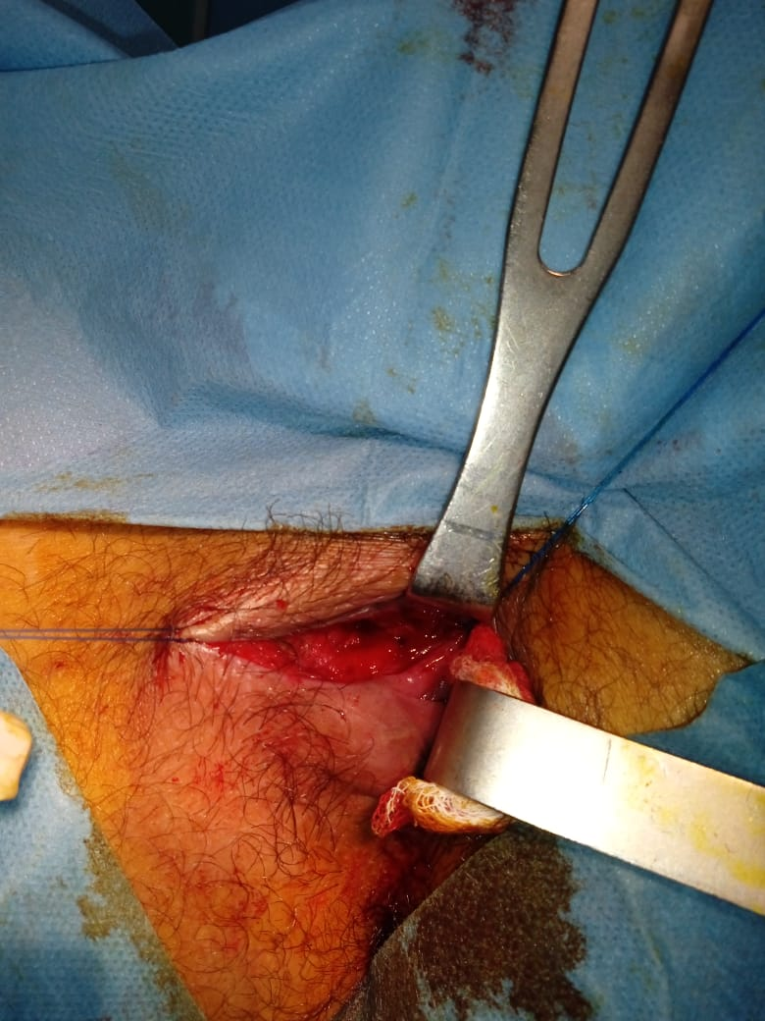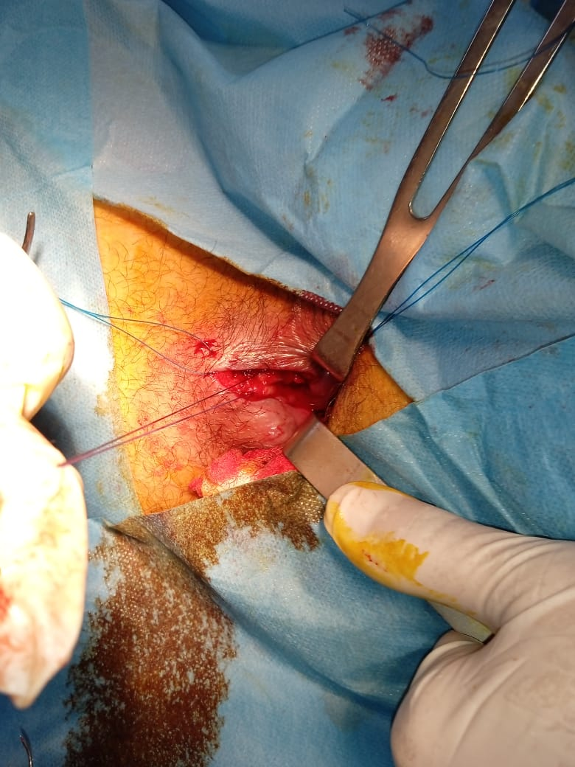

Fig1 : Sphincter trauma located at the 9 o'clock position in the genupectoral position

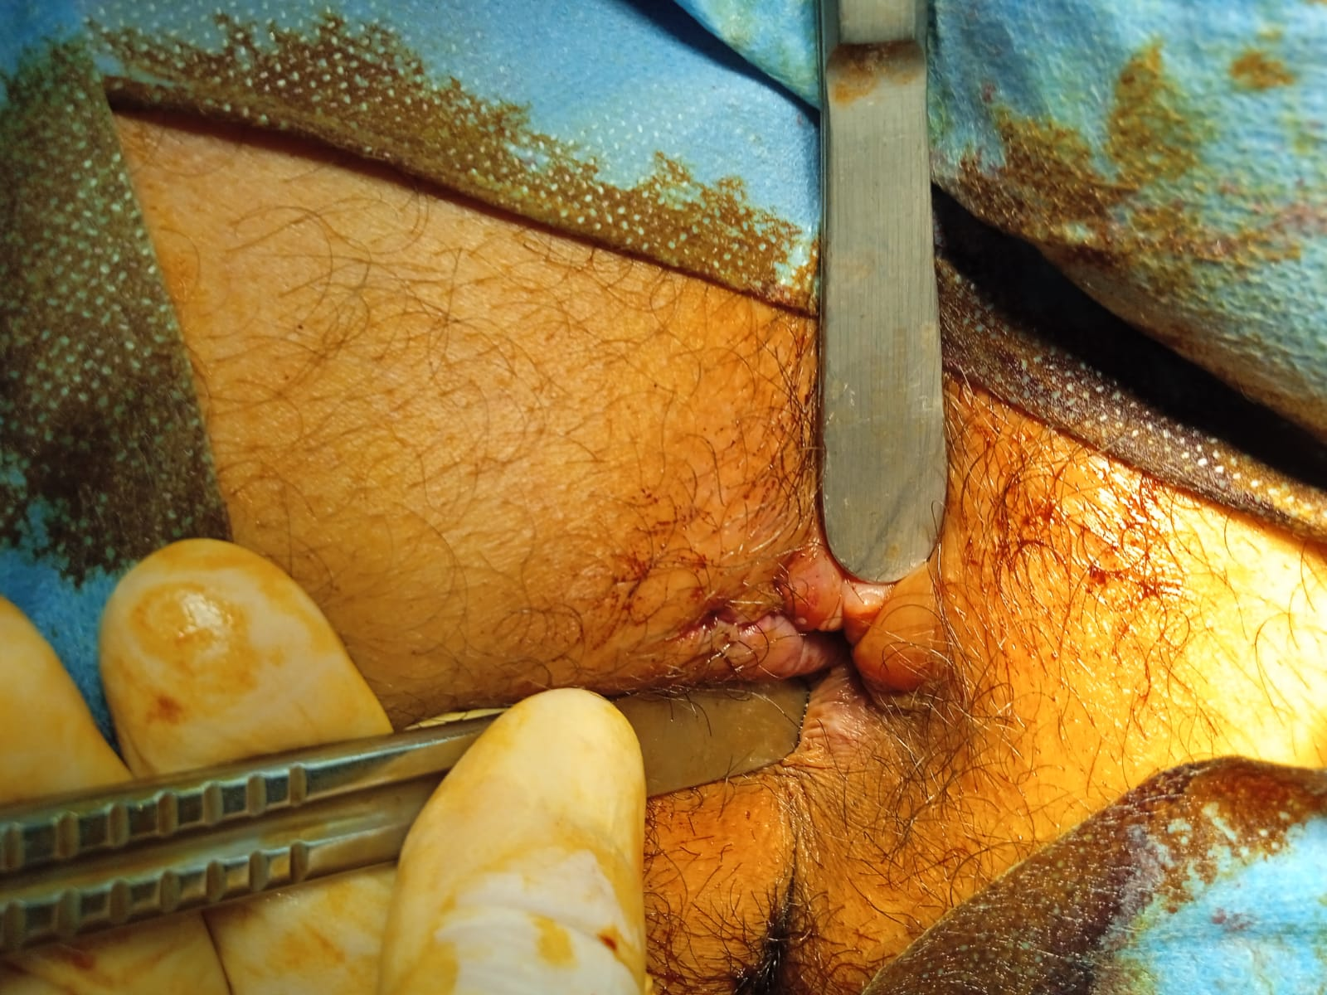

Fig2 : Final outcomes after sphincterorrhaphy

Ethical Approval:

As per international standards or university standards written ethical approval has been collected and preserved by the author(s).

Consent

As per international standards or university standards, patient(s) written consent has been collected and preserved by the author(s).

Disclaimer (Artificial intelligence)

Author(s) hereby declare that generative AI technologies such as Large Language Models, etc. have been used during the writing or editing of manuscripts. This explanation will include the name, version, model, and source of the generative AI technology and as well as all input prompts provided to the generative AI technology

Details of the AI usage are given below:

1. Model used: ChatGPT (version 4)

2. Source: OpenAI

3. Purpose of using AI: Assistance in rephrasing certain sections and enhancing the text's fluency.

I assure you that AI was used in an ethical and transparent manner, and that the scientific integrity of the article has not been compromised.

Références :

1. Ait Laalim, S., Hrora, A., Raiss, M., Ibnmejdoub, K., Toughai, I., Ahallat, M., & Mazaz, K. (2013). Direct sphincter repair: technical points, indications and results. Pan African Medical Journal , 14 (1).

2. Thierry, M. L., & Abramowitz, L. Fistules anales: techniques d’épargne sphinctérienne. Available : <https://larevue.snfcp.org/fistules-anales-techniques-depargne-sphincterienne/>

3. Roche, B., & Ris, F. (2022). Surgical Reconstruction of Traumatic Perineal and Sphincter Muscle Defects. In Anal Incontinence: Clinical Management and Surgical Techniques (pp. 103-114). Cham: Springer International Publishing.

4. Yashoda Hospitals (2023). Réparation secondaire d'une déchirure périnéale du 4e degré .

5. CNGOF (2024). Lésions obstétricales des sphincters (LOSA). Available : <https://www.fmcgastro.org/texte-postu/postu-2024/lesions-obstetricales-des-sphincters-de-lanus-losa-prevention-pronostic-et-traitement/>

6. Williams, A. B., Bartram, C. I., Halligan, S., Marshall, M. M., Nicholls, R. J., & Kmiot, W. A. (2001). Multiplanar anal endosonography–normal anal canal anatomy. Colorectal Disease, 3(3), 169-174.

7. Hillary, C. J., Osman, N., & Chapple, C. (2015). Considerations in the modern management of stress urinary incontinence resulting from intrinsic sphincter deficiency. World journal of urology, 33(9), 1251-1256.

8.Stošić, M. (2014). Reparation of traumatic injury of anal sphincter: case report and review of surgical treatment. Sci J Fac Med Niš, 31(2), 139-145.

9. Giebel GD, Lefering R, Troidl H et al. Prevalence of fecal incontinence: what can be expected?. Int J Colorectal Dis. 1998; 13: 73-7. PubMed | Google Scholar

10.Kalantar JS, Howell S, Talley NJ. Prevalence of faecal incontinence and associated risk factors; an underdiagnosed problem in the Australian community?. Med J Aust. 2002; 176: 54-7 PubMed | Google Scholar

11.Perry S, Shaw C, McGrother C et al. Prevalence of faecal incontinence in adults aged 40 years or more living in the community. Gut. 2002; 50: 480-4. PubMed | Google Scholar

12.Longstreth GF. Bowel patterns and anxiety: Demographic factors . J Clin Gastroenterol. 1993; 17: 128-32. PubMed | Google Scholar

13.Jorge JM, Wexner SD. Etiology and management of fecal incontinence. Dis Colon Rectum. 1993; 36:77-97. PubMed | Google Scholar

14.Rockwood TH, Church JM, Fleshman JW et al. Fecal Incontinence Quality of Life Scale: quality of life instrument for patients with fecal incontinence. Dis Colon Rectum. 2000; 43: 9-17. PubMed | Google Scholar

15.Eypasch E, Williams JI, Wood Dauphinee S et al. Gastrointestinal Quality of Life Index: development, validation and application of a new instrument. Br J Surg. 1995; 82: 216-22. PubMed | Google Scholar