Prognostic factors associated with horizontal strabismus surgery

.

ABSTRACT

|  |
| --- |
| **Background:** Strabismus is the most common childhood visual disorder, with a prevalence estimated at 2% to 5% in the general population. It is characterised by a misalignment of the eyes in which the fixing eye is fixed on what the person intends to look at, and the deviated eye is looking at something else.  **PURPOSE**  The aimed to identify prognostic factors that predict a successful or failed outcome following surgery for horizontal strabismus.**METHODS**  This is a retrospective analytical study of 52 patients treated surgically in the Ophthalmology Department between 2019 and 2023 for horizontal strabismus. Using Pearson's and Spearman's P coefficients, we studied the correlation between long-term postoperative strabismus angle of deviation and age of onset of strabismus, age of strabismus surgery, time to surgery, refraction, preoperative angle of deviation, surgical dosage and angle of deviation at day 1 postoperatively. We also used the Chi2 test for categorical variables.  A multivariate logistic regression analysis was performed to identify factors associated with the occurrence of the success/failure event.  **RESULTS**:  A multivariate logistic regression analysis revealed that the immediate postoperative angle was the only factor that significantly influenced the long-term motor outcome  (r = 1.348, p = 0.025) and Surgical dosage was the only factor significantly influencing long-term motor outcome in the esotropia group (r = 2.051, p = 0.047).  **CONCLUSION:**  The success or failure of surgery may be influenced by several factors that have a prognostic value; these factors include amblyopia, strong hypermetropia, anisometropia, age of onset, time to surgery, surgical dosage, preoperative angle, the presence of a vertical element, and deviation in the immediate postoperative period. |

*Keywords:* Eye, Horizontal Strabismus, Prognostic factors, Strabismus, Surgery, ; *,* Symmetrical bilateral surgery

1. INTRODUCTION

Strabismus, or misalignment of the eyes, is the most common ocular disorder in the pediatric population, affecting approximately 2%–4% of children. Strabismus leads to the disruption of binocular vision, amblyopia, social and occupational discrimination, and decreased quality of life (Martinez Sanchez & Whitman, 2023). Strabismus is the most common childhood visual disorder, with prevalence estimated at 2% to 5% in the general population (1,2). It is characterised by a misalignment of the eyes in which the fixing eye is fixed on what the person intends to look at the deviated eye is looking at something else. This misalignment can manifest in various forms and degrees, and start in most cases in childhood. The etiopathogenesis of strabismus is unclear. The physiology of ocular motility involves extraocular muscles, cranial nerves, supranuclear pathways, and their cerebral controls. All of these have been implicated in the development of strabismus (3,4).

The successful outcome rate for surgery to correct horizontal strabismus is greater than 60% (5). The management of strabismus involves both medical and surgical treatment. Operative protocols are not standardised and are controversial. Strabismus is the misalignment of the eyes in any direction. Paralytic strabismus is a diagnostic and therapeutic challenge in ophthalmology (Dehghan Harati et al., 2014).

Our aim was to identify prognostic factors that predict a successful or failed outcome following surgery for horizontal strabismus.

2. Materials and methods

**2.1 Material**

We conducted a retrospective study of 75 cases of horizontal strabismus that were treated surgically in the Ophthalmology Department between 2019 and 2023, covering a period of four years.

-All cases with horizontal strabismus and operated on by a single operator were included. We excluded from our study cases with insufficient preoperative clinical or orthoptic assessment, patients with less than three months of postoperative follow-up, paralytic strabismus, strabismus with an anatomical (muscular and/or orbital) cause, microtropia and pure accommodative strabismus.

**2.2 Methods**

All patients underwent a complete ophthalmologic examination prior to surgery including the search of associated nystagmus, torticollis or orbito- facial dysmorphology as well as an orthoptic evaluation including motor assessment of corneal reflections, unilateral alternating cover test, ocular motility in the nine gazes, study of horizontal deviation, measurement of the deviation angle, Study of associated vertical deviation (hyperaction of the oblique muscles and search for an alphabetic syndrome) and search for dissociated vertical deviation. The sensory assessment included a detection of neutralisation and diplopia, examination of retinal correspondence, testing of fusion and stereoscopic vision.

We have classified our patients into 7 clinical forms according to their pathophysiology: partial accommodative esotropia (ET) with and without excess convergence, acquired non-accommodative ET, early exotropia (XT), intermittent XT, sensory strabismus, residual strabismus and consecutive strabismus. This approach helps us to develop a coherent and effective therapeutic strategy for all oculomotor disorders.

In all cases, underwent systematic total and permanent optical correction, except for divergent strabismus in hypermetropes with a refraction of less than 2 DP, treatment of amblyopia, and orthoptic re-education before surgery.

In early Strabismus, surgery has been indicated in all cases. For intermittent XT we indicated surgery in cases of increased frequency, poor deviation control or deterioration in stereoscopic acuity. Partial accommodative ET and acquired non-accommodative ET were operated if the angle was unsightly; moreover, the sole purpose of surgery in sensory strabismus was aesthetic.

We operate after treatment of amblyopia and, if possible, after good alternation and at the orthoptic age of 4 years.

Symmetrical bilateral surgery with resection of the horizontal rectus muscles was indicated for: intermittent strabismus, early alternating strabismus with isoacuity. Unilateral surgery on two muscles was indicated for: early non-alternating strabismus, sensory strabismus. Asymmetrical bilateral surgery on three muscles was reserved for large-angle strabismus exceeding 40 DP. Posterior myopexy was performed in cases of ET greater than or equal to 10 DP. Botulinum toxin injections in both medial rectus muscles were indicated in children under 3 years of age with early ET.

We considered a good motor result for ET in case of ET≤10 DP, or consecutive XT ≤10 DP and vertical deviation ≤4 DP, for XT in case of a residual angle of deviation less than or equal to 10DP and 4DP of height. A good sensory result was defined by the achievement of stable binocular fusion and stereoscopic acuity < 200 arcsec.

-We had a follow-up ranging from 5 months to 2 years, with an average of 1.2 years.

The following elements were considered when making prognostic decisions: age of onset of strabismus, time to onset, age at time of surgery, depth of amblyopia, binocular vision, refraction, first day postoperative result, angle of strabismus deviation, vertical and torsional elements.

* 1. **Data Analysis:**

-Data were entered and analysed using IBM© SPSS statistics version 21 software, qualitative variables were studied using the X² test, and quantitative variables were studied using Pearson's correlation coefficient if the distribution was normal, and the Spearman's correlation coefficient if the distribution was abnormal.

3. results

1. Descriptive study

Our patients were divided into 25 males (48.1%) and 27 females (51.9%), giving a ratio of 0.92:1. Half of our patients (50%) had early strabismus (onset before 6 months)

The distribution of patients according to the type of strabismus (Table 1)

**Table 1: The distribution of patients according to the type of strabismus**

|  |  |  |
| --- | --- | --- |
| Types of Strabismus. Number of Cases. Percentage | | |
| - Early ET |  | 20 38.5% |
| - Partially accommodative esotropia. |  | 10 19.2% |
| - Acquired non-accommodative esotropia. |  | 5 9.6% |
| - Early XT. |  | 6 11.5% |
| - Intermittent exotropia. |  | 7 13.5% |
| - Sensory strabismus. |  | 4 7.7% |
| -Consecutive or residual XTor ET |  | 0 0 % |

ET: Esotropia

XT: Exotropia

**2. Factors influencing postoperative results:**

-Relation between age of onset of strabismus and postoperative angle of deviation: In the ET group, there was no statistically significant correlation between age of onset of ET and postoperative angle. (R=0.242; P=0.11). In the XT group, there was no statistically significant correlation between the age of onset of XT and postoperative angle. (R= -0.245; P=0.191).

-Relationship between age at surgery, time to surgery and postoperative angle of deviation: In the ET group: we found no statistically significant correlation either between age at strabismus surgery and postoperative angle of deviation (R= 0.113; P=0.462) or between the time to surgery and the postoperative angle of deviation (R= -0.206; P=0.176). In the XT group, there was no statistically significant correlation between age at surgery and postoperative angle (R=-0.186; P=0.326). The correlation between surgery and postoperative angle was also not significant (R=0.023; P=0.906).

-The correlation between spherical equivalent refraction and postoperative angle: for the ET group, there was no statistically significant correlation (R=-0.247; P=0.102). For the XT group, there was no statistically significant correlation between spherical equivalent refraction and postoperative deviation angle (R = 0.165, P = 0.526).

-Correlation between preoperative angle and postoperative angle: In the ET group, there is a significant correlation between postoperative deviation and preoperative objective angle. Indeed, the greater the preoperative angle, the greater the postoperative residual deviation. (R=0.318; P=0.043). (Fig. 1).

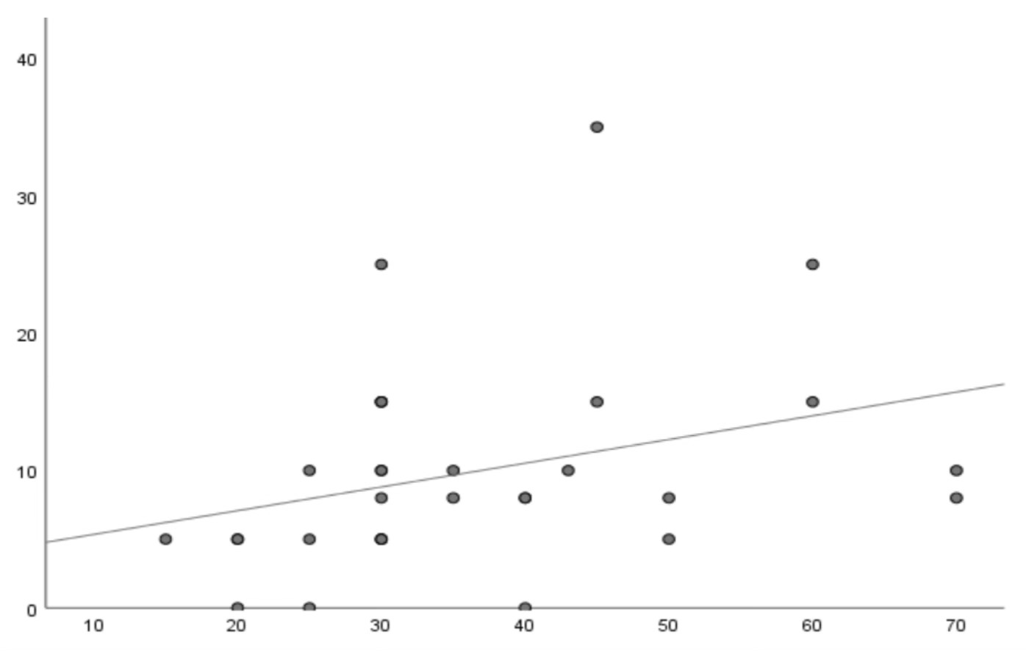

postoperative angle

Preoperative angle

**Figure 1: Correlation between preoperative angle and postoperative angle: in the ET group**

In the XT group, we discovered a statistically significant correlation between the preoperative angle of deviation and the postoperative angle (R = 0.450, P = 0.013). In essence, this means that the greater the preoperative angle, the greater the residual angle. (Fig. 2).

postoperative angle

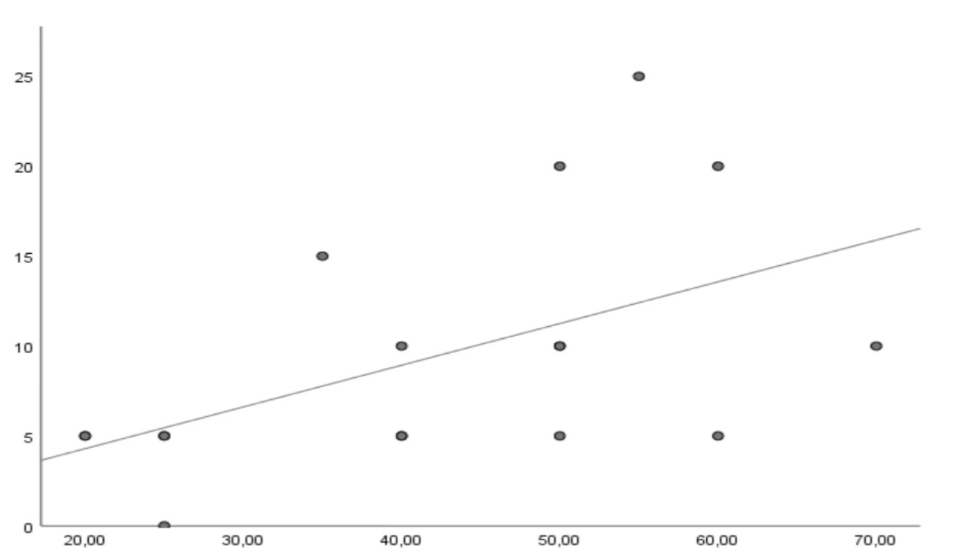 Preoperative angle

**Fig 2 : Correlation between the preoperative angle of deviation and the postoperative angle in the XT group**

Relationship between surgical dosage and postoperative angle: in the ET group: There was a statistically significant correlation between surgical dosage and postoperative angle of deviation (R=0.417; P=0.013), (Fig. 3).

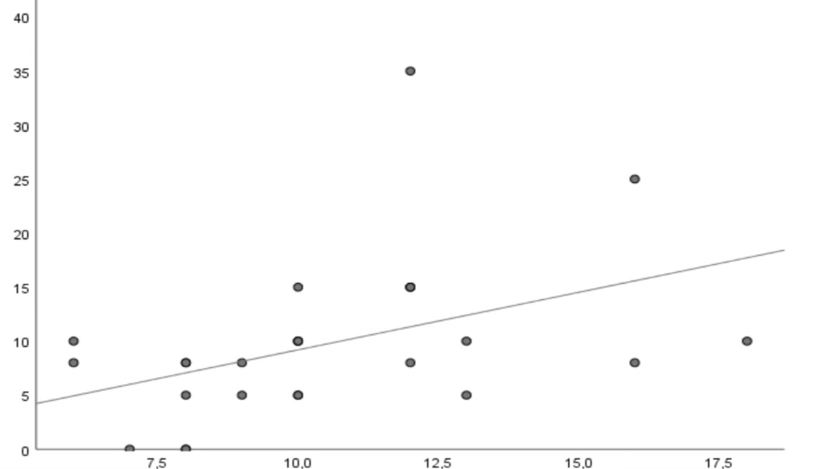

Surgical dosage

postoperative angle

**Fig 3: Relationship between surgical dosage and postoperative angle: in the ET group**

in the XT group, We also found a statistically significant correlation between surgical dosage and postoperative angle (R=0.513; P=0.004), (Fig. 4).

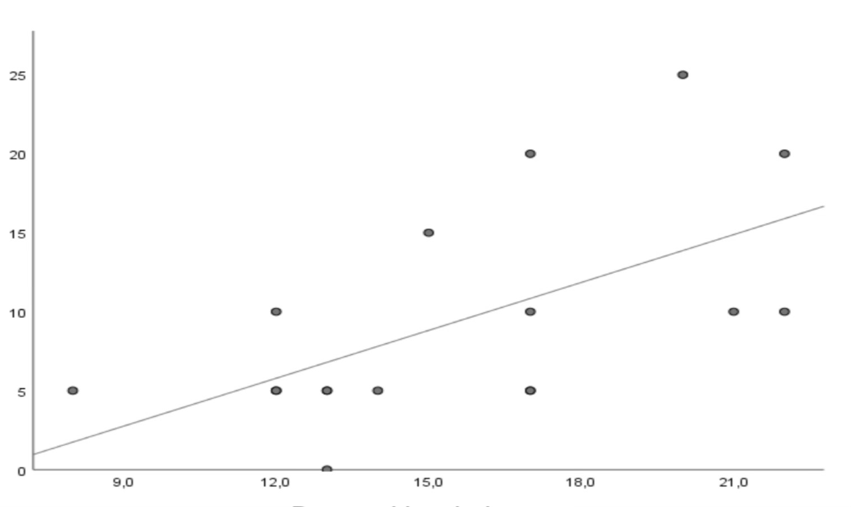

postoperative angle

Surgical dosage

**Fig 4: Relationship between surgical dosage and postoperative angle: in the XT group**

-Relationship between result on d1 post-operative and post-operative angle: in the ET group: There was a statistically significant correlation between the result on d1 post-op and the post-op angle of deviation (R=0.343; P=0.028). The smaller the angle of deviation on postoperative day 1, the smaller the residual angle (Fig. 5).

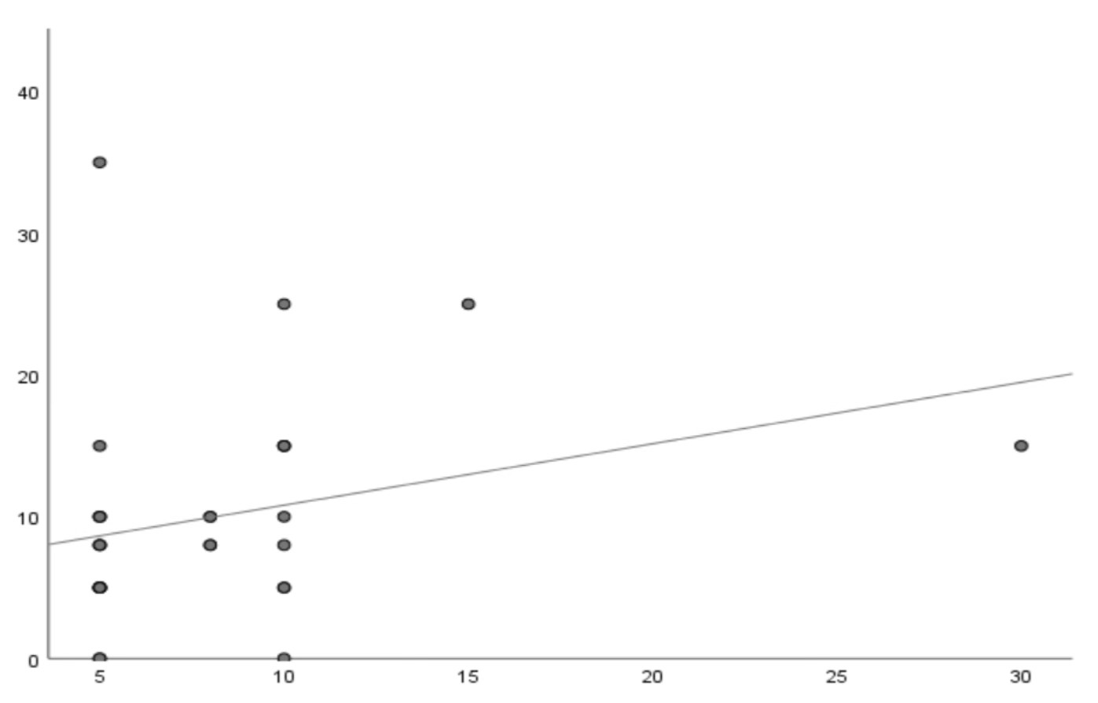

postoperative angle

D1 post-operative

Fig 5: Relationship between the result on d1 post-operative and post-operative angle: in the ET group

In the XT group: We found a statistically significant correlation between the angle at d1 post-op and the post-op angle (R=0.609; P=0,008), (Fig 6).

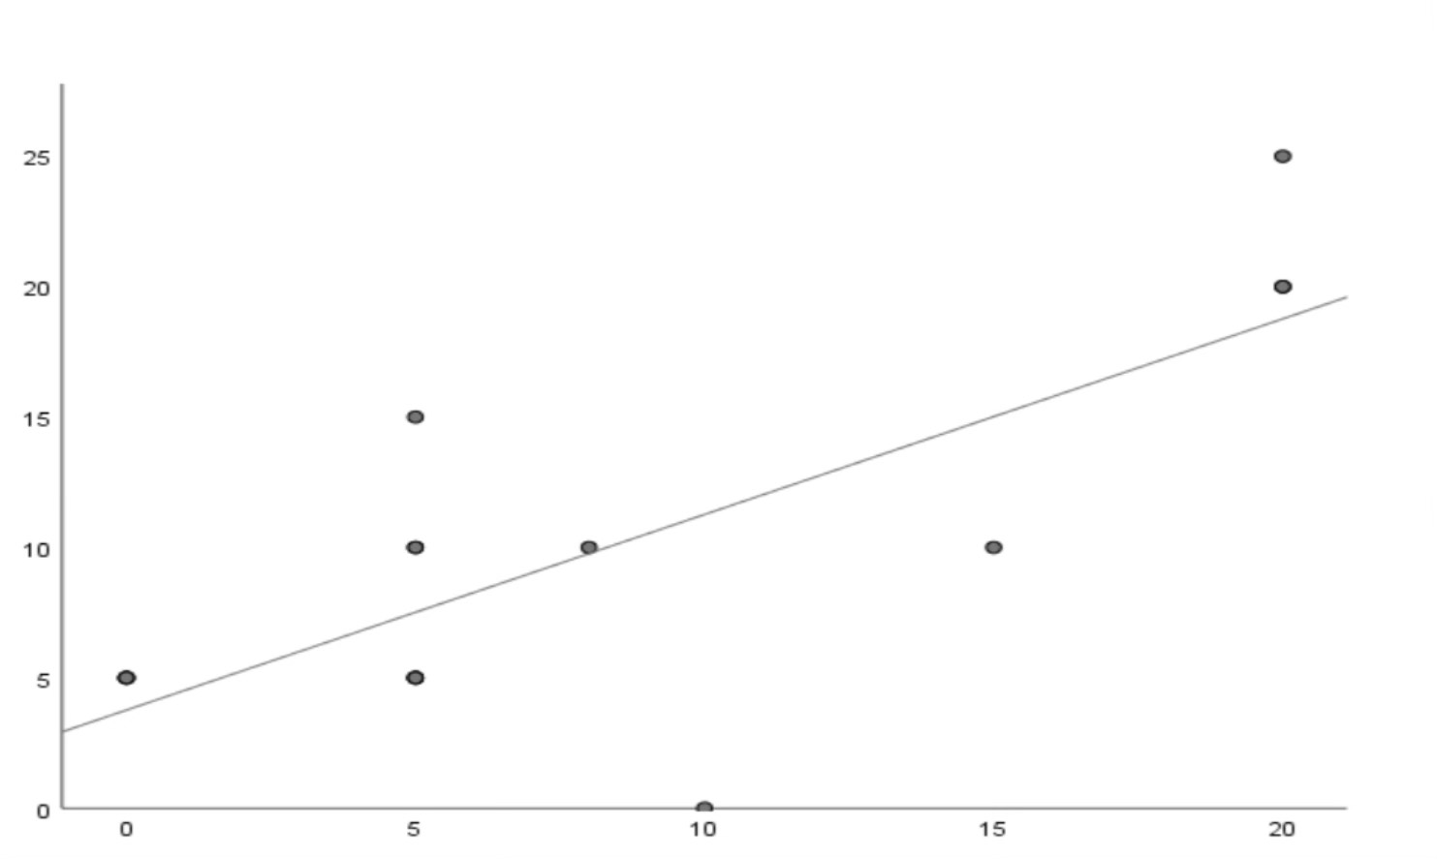

postoperative angle

D1 post-operative

**Fig 6: Relationship between the result on d1 post-operative and post-operative angle: in the XT group**

Association between amblyopia, alternation, presence or absence of vertical syndrome, intermittence of strabismus, type of surgery and postoperative outcome: in the ET group:

There was no significant association between the type of surgery performed and postoperative deviation (P=0.265), between ET alternation and operative outcome (P=0.599) and between ET intermittence and operative outcome (P=0.492).

Similarly, for amblyopia, there was no significant correlation between amblyopia and postoperative deviation (P=0.310), or between the presence or absence of a vertical syndrome and postoperative deviation (P= 0.087). In the XT group, There was no positive association between type of surgery and postoperative deviation (P= 0.403). The presence of alternating strabismus was not significantly associated with surgical outcome (P=0.2). There was no significant association between XT intermittence and operative outcome (P=0.567) or between amblyopia and postoperative deviation (P=0.277) and postoperative deviation (P=0.277).

No significant correlation was observed between the presence of a vertical syndrome and postoperative deviation (P=0.825).

**3. Analysis of Factors Influencing Success or Failure***:*

According to a multivariate logistic regression analysis, surgical dosage was the only factor that significantly influenced long-term motor outcomes in the ET group (R = 2.051; P = 0.047). In the XT group, however, the only influential factor was the immediate postoperative angle (R = 1.348; P = 0.025).

The other variables, including time to surgery, gender, preoperative fusion, stereoscopic vision, intermittent strabismus, degree of amblyopia, preoperative angle, vertical syndrome, vertical surgery, and postoperative fusion and stereoscopic vision, did not significantly influence the probability of motor success.

**DISCUSSION**

Many factors can have a prognostic value and influence the success or failure of surgery. Kuschner et al (6) reported that preoperative deviation significantly influenced response in exotropic patients. Abbasoglu et al (7) noted that preoperative deviation, which was the only discriminating factor for esotropic patients, was not a significant factor for exotropic patients. Umazume (8) in a retrospective analysis of 179 patients paradoxically revealed that a higher value of preoperative deviation angle was associated with surgical success in horizontal strabismus. In our ET group, there was a significant positive correlation between postoperative deviation and preoperative objective angle. The larger the preoperative angle, the more significant the postoperative residual deviation. (r=0.318; p=0.043). In the XT group, we also found a statistically significant correlation between the preoperative deviation angle and the postoperative angle (r=0.450; p=0.013).

Fekih et al (9) found no significant correlation between surgical dosage and postoperative angle in a series of XT cases. In an ET series, Ghorbel found a positive correlation between surgical dosage and postoperative angle. (P=0.003 r=+0.291) Abbasoglu et al (7) also observed a significant correlation between operative dosage and postoperative deviation in esotropic patients (P < 0.0005, R =+ 0.50). In our series, we found a significant correlation between surgical dosage and postoperative deviation in the ET group (R=0.417; P=0.013) and in the XT group (R=0.513; P=0.004).

Several studies have suggested that hyperopia is a risk factor for reoperation. Lee et al (10) found no correlation between refractive error and surgical outcome in patients operated on for early ET. Scattergood et al (11) demonstrated that surgery is more successful in myopic patients than in hyperopic ones. Koklanis and Georglevski (12) and Lim et al (13) found that refractive error in XT was not associated with surgical prognosis, while Gordon and Bachar(14) observed that response was related to mean spherical equivalent. In our series, the relationship between spherical equivalent of refraction and surgical outcome was statistically insignificant in the ET group (R=-0.247; P=0.102) and in the XT group (R=0.165; P=0.526).

Kumari et al (15) found that the absence of severe amblyopia was associated with surgical success in horizontal strabismus (R = 5.90; P = 0.002), while Keenan and Willshaw (16) didn't find a significant correlation between amblyopia and postoperative angle. In a case series of ET. Jung et al (17) observed a relatively high success rate (72.0%) in an XT group with a low prevalence of amblyopia (3%). In our series, we found no statistically significant relationship between postoperative outcome and amblyopia in the XT group (P=0.277). Similarly, in ET cases, no association was observed between amblyopia and motor outcome (P=0.310).

Abbasgolu et al. (7) showed that older patients had a lower surgical effect at the time of onset of deviation. This may be explained by the fact that younger patients have smaller eyes and a greater response. Bateman et al. (18) found that, in an ET group, age at the onset of the deviation, age at surgery, and the interval between the onset of the deviation and surgery had no statistically significant correlation with operative outcome. However, Paik and Yim (19) found that older age at surgery and a longer interval between strabismus onset and surgery were associated with earlier surgical success in XT. One possible explanation is that preoperative deviation is more accurately measured in older children. Similarly, we found no statistically significant relationship between postoperative outcome and age at strabismus onset, age at surgery, or time to surgery.

Kumari et al (15) found in a study of horizontal strabismus cases that the chances of success would decrease with a higher immediate postoperative deviation (P < 0.0001, R= 2.9). Srimanan (20) found that postoperative outcome on Day 1 in esotropic patients was significantly correlated with long-term outcome (P=0.005). In a study of XT, Roh and Paik (21) also found a significant correlation between immediate postoperative outcome and long-term outcome. In our series, the angle of deviation at d1 post-op correlated strongly with long-term motor outcome in both esotropic (R=0.343; P=0.028) and exotropic (R=0.609; P=0.008) cases.

Other factors, such as binocular vision status, vertical syndrome, and vertical element surgery, have been suggested to have prognostic value for surgical outcomes. However, we found no statistically significant association between these factors and postoperative outcomes.

**CONCLUSION**:

Several factors have been suggested to influence long-term motor outcome, including amblyopia, high hyperopia, anisometropia, age of onset, time to surgery, surgical dosage, preoperative angle, existence of a vertical element, and immediate postoperative deviation.

In our study, a multivariate logistic regression analysis revealed that surgical dosage was the only factor significantly impacting long-term motor outcomes in the ET group; however, the only factor influencing outcome was the immediate postoperative angle in the XT group.

Consent

Oral informed consent was obtained from the subjects to participate in this study.

Ethical Approval

All procedures performed in studies involving human participants were in accordance with the ethical standards of the institutional and/or national research committee and with the 1964 Helsinki declaration and its later amendments or comparable ethical standards.

-Patients’ privacy was fully respected.

-There are no identifying details in our study.

**Statement of competing interests**

The authors have no conflicts of interest to declare

Disclaimer (Artificial intelligence)

Option 1:

Author(s) hereby declare that NO generative AI technologies such as Large Language Models (ChatGPT, manuscript.

Option 2:

Author(s) hereby declare that generative AI technologies such as Large Language Models, etc. have been used during the writing or editing of manuscripts. This explanation will include the name, version, model, and source of the generative AI technology and as well as all input prompts provided to the generative AI technology

Details of the AI usage are given below:

1.

2.

3.

References

1. Koc F, Ozal H, Yasar H, Firat E. Resolution in partially accomodative esotropia during occlusion treatment for amblyopia. Eye (Lond). 2006 Mar;20(3):325-8.
2. Donnelly UM, Stewart NM, Hollinger M. Prevalence and outcomes of childhood visual disorders. Ophthalmic Epidemiol. 2005 Aug;12(4):243-50.
3. Bui Quoc E, Milleret C. Origins of strabismus and loss of binocular vision. Front Integr Neurosci. 2014 Sep 25;8:71. doi: 10.3389/fnint.2014.00071.
4. Levi DM. Rethinking amblyopia 2020. Vision Res. 2020 Nov; 176:118-129. doi: 10.1016/j.visres.2020.07.014. Epub 2020 Aug 28.
5. Kampanartsanyakorn S, Surachatkumtonekul T, Dulayajinda D, Jumroendararasmee M, Tongsae S. The outcomes of horizontal strabismus surgery and influencing factors of the surgical success. J Med Assoc Thai. 2005 Nov;88 Suppl 9:S94-9.
6. Bj K, Nj L, Gv M. The influence of axial length on the response to strabismus surgery. Arch Ophthalmol Chic Ill 1960 [Internet]. nov 1989 [cité 2 oct 2024];107(11). Disponible sur: https://pubmed.ncbi.nlm.nih.gov/2818282/
7. Abbasoglu OE, Sener EC, Sanac AS. Factors influencing the successful outcome and response in strabismus surgery. Eye. mai 1996;10(3):315‑20.
8. Umazume F, Ohtsuki H, Hasebe S. Preoperative factors influencing effectiveness of surgery in adult strabismus. Jpn J Ophthalmol. 1997;41(2):89‑97.
9. Fekih LE, Lajmi H, Yakhlef AB. Indications and results of exotropia surgical management. Tunis Médicale. mai 2021;99(5):569‑74.
10. Lee HJ, Kim JA, Kim SJ, Yu YS. Relation between preoperative hyperopia and surgical outcome in infantile esotropia. Int J Ophthalmol. 2018;11(12):1963‑7.
11. Artefacts introduits par les verres de lunettes dans la mesure des déviations strabiques -PubMed [Internet]. [cité 10 mars 2024]. Disponible sur:

https://pubmed.ncbi.nlm.nih.gov/6624825/

1. Récidive de l’exotropie intermittente : facteurs associés aux résultats chirurgicaux - PubMed [Internet]. [cité 9 mars 2024]. Disponible sur: https://pubmed.ncbi.nlm.nih.gov/19301192/
2. Lim SH, Hwang BS, Kim MM. Prognostic factors for recurrence after bilateral rectus recession procedure in patients with intermittent exotropia. Eye Lond Engl. juin

2012;26(6):846‑52.

1. Modèles prédictifs d’analyse de régression multiple dans la chirurgie de l’exotropie - PubMed [Internet]. [cité 5 oct 2024]. Disponible sur: https://pubmed.ncbi.nlm.nih.gov/7446649/
2. Kumari N, Amitava AK, Ashraf M, Grover S, Khan A, Sonwani P. Prognostic preoperative factors for successful outcome of surgery in horizontal strabismus.

Oman J Ophthalmol. 2017;10(2):76‑80.

1. Keenan JM, Willshaw HE. The outcome of strabismus surgery in childhood esotropia. Eye Lond Engl. 1993;7 ( Pt 3):341‑5.
2. Jung EH, Kim SJ, Yu YS. Factors associated with surgical success in adult patients with exotropia. J AAPOS Off Publ Am Assoc Pediatr Ophthalmol Strabismus. déc 2016;20(6):511‑4.
3. Discriminant analysis of acquired esotropia surgery. Predictor variables for short- and longterm outcomes - PubMed [Internet]. [cité 6 oct 2024]. Disponible sur:

https://pubmed.ncbi.nlm.nih.gov/6657189/

1. Paik HJ, Yim HB. Clinical effect of early surgery in infantile exotropia. Korean Ophthalmol KJO. déc 2002;16(2):97‑102.
2. Srimanan W. Surgical Outcomes and Factors Related to Their Success of Infantile Esotropia in a Tertiary Hospital: A Retrospective Study. Clin Ophthalmol Auckl NZ. 20 sept 2024;18:2627‑35.
3. Roh JH, Paik HJ. Clinical Study on Factors Associated with Recurrence and Reoperation in Intermittent Exotropia. J Korean Ophthalmol Soc. 15 juill 2008;49(7):1114‑9.
4. Martinez Sanchez, M., & Whitman, M. C. (2023). Genetics of strabismus. Frontiers in ophthalmology, 3, 1233866.

Dehghan Harati, M., Reza Besharati, M., Abbasi Shavazi, E., Afkhami Ardekani, M., Salimpur, S., & Besharati, S. (2014). Diplopia and Strabismus in Diabetics (Type II) and Non-diabetics in Yazd, Iran. Ophthalmology Research: An International Journal, 3(2), 54–58.