**Rare Association of Eagle Syndrome with Crohn’s Disease**

**ABSTRACT**

**Aim:** The aim of this case report is to report an association of Eagle’s Syndrome and Crohn’s disease.

**Case Presentation:** We present a rare case of a 30-year old woman with a decade-long history of Crohn’s disease, recently diagnosed with Eagle Syndrome following complaints of facial pain exacerbated by cold exposure.

**Discussion:** Eagle Syndrome is a rare clinical condition caused by an elongated styloid process or calcified stylohyoid ligament. It often presents with vague head and neck symptoms such as throat pain, dysphagia, craniofacial discomfort leading to frequently delayed or misdiagnosis. It can be unilateral or bilateral.

**Conclusion:** This case underscores the importance of considering rare differential diagnosis in patients with complex autoimmune or inflammatory conditions, particularly when symptoms deviate from GIT manifestations.

**Keywords:** Stylohyoid, dysphagia, IBD, craniofacial pain.

# INTRODUCTION

Eagle Syndrome is a rare anatomical abnormality involving the elongation of the styloid process, typically defined as longer than 30mm. First described by Watt W. Eagle in 1937, the syndrome can present with diverse symptoms depending on the structures compressed by elongated styloid. In Crohn’s disease (CD) systemic inflammation and chronic medication use may contribute to musculoskeletal symptoms, potentially complicating the clinical picture. Simultaneous occurrence of Crohn’s disease and Eagle syndrome has not been widely reported. This report describes a rare case of Eagle syndrome in a patient with Crohn’s disease who presented with atypical jaw pain and was ultimately diagnosed as Eagle syndrome.

# Case Presentation

A 30-year-old woman with Crohn’s disease, presented after 10 years with jaw pain and facial tenderness, particularly in the early morning aggravated by exposure to cold. Her disease (CD) over the past decade was characterized by alternating periods of remissions and relapses, with symptoms including chronic diarrhea, aphthous ulcers ,weight loss, abdominal pain and elevated inflammatory markers. She was intermittently treated with Mesalamine, Sulfasalazine, Budesonide and Mercaptopurine based on disease activity. In early 2025, she experienced an exacerbation of symptoms with upper abdominal tightness, excessive bloating ,anorexia, shortness of breath and syncopal episodes. The laboratory investigations showed leukocytosis (TLC 13,810), anemia (Hb - 7.8g/dl) and positive Clostridium difficile toxin A in faeces. Colonoscopy revealed multiple aphthous ulcers throughout the colon and terminal ileum. Histopathology confirmed active mucosal ulceration and lymphoplasmacytic infiltration, consistent with active Crohn’s disease. Amidst this flare, she also began experiencing sharp localised pain along jawline worsened by touch and cold exposure, raising suspicion for a non- gastrointestinal etiology. A CT scan of Paranasal sinuses with styloid screening revealed bilateral elongated styloid process measuring 62 mm on right and 60 mm on left confirming the diagnosis of Eagle Syndrome. (Figure 1 and Figure 2)

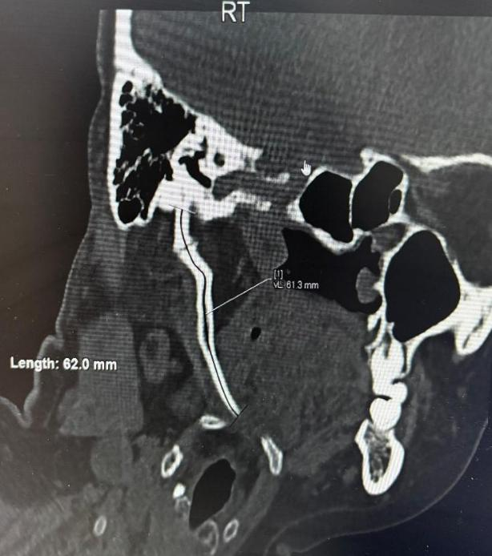

**Figure 1:** Coronal CT of right styloid process measuring 62 mm.

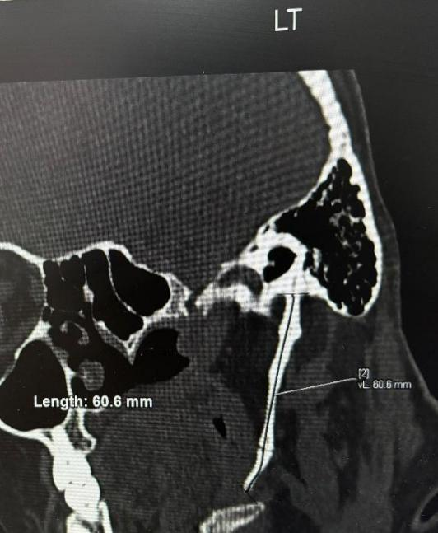

**Figure 2:** Coronal CT of left styloid process measuring 60 mm

She was managed symptomatically with hot compressors, analgesics; budesonide and mesalamine for Crohn’s disease and oral vancomycin for Clostridium difficile infection. Syncopal episodes, and gastrointestinal symptoms recovered gradually. She has been advised close follow up for neurological symptoms.

# DISCUSSION

Ossification of stylohyoid ligament had been observed as early as 1652 by Demanchetis . Eagle Syndrome, first described by Watt W.Eagle in 1973, refers to a constellation of symptoms arising from elongated stylohyoid process >30mm or ossified stylohyoid ligament1 (Figure 3).

The prevalence of elongated styloid process in the general population is estimated to be 4% while 4-10% of this group, approximately are symptomatic2 qualifying as Eagle’s Syndrome with men:women,1:3 10.

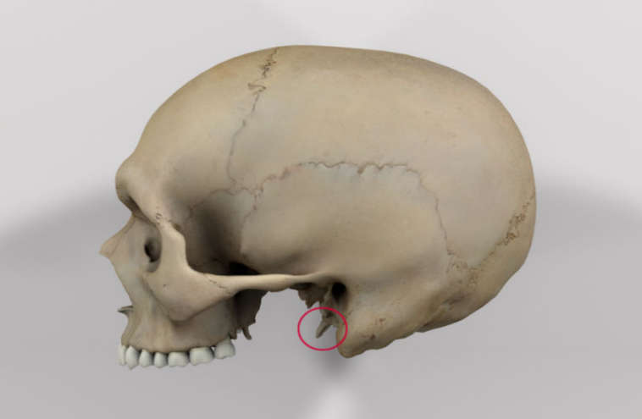

# Figure 3: Normal styloid process

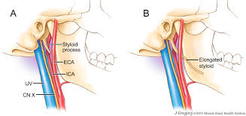

**Figure 4:** Normal styloid process and elongated styloid in Eagle Syndrome5

The Syndrome is categorised into two subtypes: the classic type and vascular type3

1. **Classic or neurological type**: Typically seen in patients with post tonsillectomy; may present as pharyngeal discomfort, unilateral pain, persistent foreign body sensation or dysphagia. It may go unnoticed but can be clinically diagnosed by digital palpation of the tonsillar bed.
2. **Vascular type**: Vascular Syndrome is less common but a clinically significant subtype, often associated with neurological complications due to compression of the internal carotid artery. This compression can provoke pain radiating along arterial distribution often described in jaw, neck, face and may precipitate episodes of dizziness or syncope due to vascular irritation or altered baroreceptor sensitivity. Patients with vascular eagle syndrome typically present with acute symptoms such as headaches, Horner syndrome, and transient ischemic attacks, frequently exacerbated by neck movements. There is a higher prevalence of vascular eagle syndrome in males and identifiable positional trigger as a distinguishing feature, in contrast to the classic form, which is more frequently linked to a history of tonsillectomy 7 .

There is also a radiological classification which is essential in defining the extent and nature of the elongation.4

**Type I Elongated**: Uninterrupted extension > 30mm

**Type II Pseudoarticulated**: Shows an apparent joint within the styloid

**Type III Segmented**: Discontinuous ossified segments

Our patient had bilateral elongation of styloid process exceeding 60 mm which is significantly above the normal threshold (given the normal styloid process length < 25 -30 mm).

The uniqueness of this case lies in the occurrence of Eagle Syndrome in association with Crohn’s disease. While Eagle Syndrome is typically idiopathic, its development in a patient with chronic systemic inflammation raises interesting considerations.

Crohn’s disease is a chronic inflammatory bowel condition which is associated with various extraintestinal manifestations including musculoskeletal abnormalities 6 .

Prolonged systemic inflammation combined with long term corticosteroids and immunosuppressive therapy may contribute to aberrant ossification or ligamentous calcification possibly offering a pathophysiological link to Eagle Syndrome.

There is limited literature exploring the association between systemic inflammatory or autoimmune conditions like Crohn’s and Eagle Syndrome. However, the chronic inflammatory milieu, coupled with recurrent corticosteroid exposure, may facilitate dystrophic calcification of ligaments or hyperplastic bone growth can be a plausible contributor of pain in this patient8 . This case also highlights the diagnostic challenge posed by Eagle Syndrome. Given the nonspecific nature of symptoms such as jaw pain, facial tenderness, cervical pain and dysphagia, patients are often misdiagnosed or overlooked. An OPG X-ray, HRCT with 3D reconstruction and CT Angiography are necessary for a definitive diagnosis as they enable accurate measurement and visualisation of the styloid process 9 .

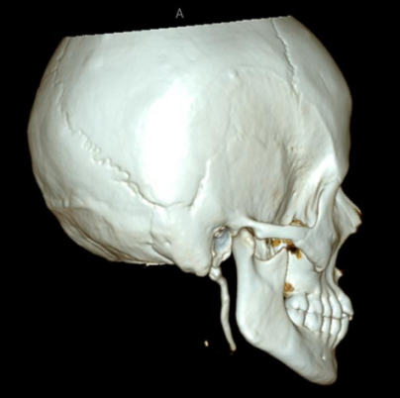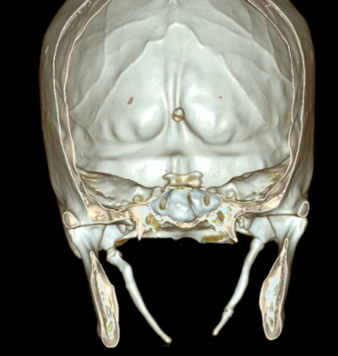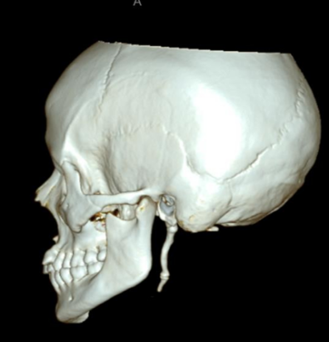

**Fig 5a Fig 5b Fig 5c**

**Figure 5 :** 3D reconstruction CT image of elongated styloid process showing :

**a**- Right view, **b**- Bilateral view, **c**- Left view

Management of Eagle Syndrome ranges from conservative to surgical approach.

The conservative therapy includes NSAIDs, hot fomentation, corticosteroids and/ or physiotherapy.

Recent evidence highlights the superior effectiveness of surgical management in Eagle Syndrome, particularly for patients exhibiting neurological symptoms. Nearly 98% of individuals who underwent styloidectomy reported either complete resolution or significant improvement in symptoms, markedly higher than 66% response rate observed with conservative treatment 7 .

The surgical resection i.e. Styloidectomy remains the gold standard for patients with persistent or severe symptoms7. In this case, the patient was managed conservatively and responded favourably to symptomatic treatment.

**Conclusions:**

This case illustrates a rare but clinically significant presentation of Eagle syndrome in a patient with Crohn’s disease. It emphasizes the need for heightened clinical suspicion in patients with systemic inflammatory conditions like IBD presenting with atypical craniofacial symptoms. Early diagnosis with CT imaging can guide appropriate pain management and improve quality of life.

Consent

As per international standards or university standards, patient(s) written consent has been collected and preserved by the author(s).

# Disclaimer (Artificial intelligence)

# Option 1:

# Author(s) hereby declare that NO generative AI technologies such as Large Language Models (ChatGPT, COPILOT, etc.) and text-to-image generators have been used during the writing or editing of this manuscript.

# Option 2:

# Author(s) hereby declare that generative AI technologies such as Large Language Models, etc. have been used during the writing or editing of manuscripts. This explanation will include the name, version, model, and source of the generative AI technology and as well as all input prompts provided to the generative AI technology

# Details of the AI usage are given below:

# 1.

# 2.

# 3.

# REFERENCES:

# 1.Eagle WW. Elongated styloid processes: report of two cases. Archives of otolaryngology. 1937 May 1;25(5):584-7.

# 2. Pagano S, Ricciuti V, Mancini F, Barbieri FR, Chegai F, Marini A, Marruzzo D, Paracino R, Ricciuti RA. Eagle syndrome: an updated review. Surgical Neurology International. 2023 Nov 3;14:389.

# 3. Bafaqeeh F, Ali S. Eagle syndrome: classic and carotid artery types. Journal of otolaryngology. 2000 Apr 1;29(2).

# 4. Langlais RP, Miles DA, Van Dis ML. Elongated and mineralized stylohyoid ligament complex: a proposed classification and report of a case of Eagle's syndrome. Oral surgery, oral medicine, oral pathology. 1986 May 1;61(5):527-32.

# 5. Badhey A, Jategaonkar A, Kovacs AJ, Kadakia S, De Deyn PP, Ducic Y, Schantz S, Shin E. Eagle syndrome: a comprehensive review. Clinical neurology and neurosurgery. 2017 Aug 1;159:34-8.

# 6. Larsen S, Bendtzen K, Nielsen OH. Extraintestinal manifestations of inflammatory bowel disease: epidemiology, diagnosis, and management. Annals of medicine. 2010 Jan 1;42(2):97-114.

# 7. Hassani M, Grønlund EW, Albrechtsen SS, Kondziella D. Neurological phenotypes and treatment outcomes in Eagle syndrome: systematic review and meta-analysis. PeerJ.

# 2024 Jun 26;12:e17423.

# Salvarani C, Fornaciari G, Beltrami M, Macchioni PL. Musculoskeletal manifestations in inflammatory bowel disease. Eur J Intern Med. 2000 Aug;11(4):210-214. doi: 10.1016/s0953-6205(00)00093-5. PMID: 10967509.

# 9. Başekim CÇ, Mutlu H, Güngör A, Şilit E, Pekkafali Z, Kutlay M, Çolak A, Öztürk E, Kizilkaya E. Evaluation of styloid process by three-dimensional computed tomography. European radiology. 2005 Jan;15:134-9.

# 10.Quereshy FA, Gold ES, Arnold J, Powers MP. Eagle's syndrome in an 11-year-old patient. Journal of oral and maxillofacial surgery. 2001 Jan 1;59(1):94-7.