***Case report***

**Huge Gastro Duodenal Trichobezoar : A *Case report***

**Abstract**

Introduction :

The "Bezoar" designates a rare condition, secondary to the unusual accumulation, in the form of solid masses or concretions, of substances of various kinds inside the digestive tract and more particularly, at the level of the stomach which can extend to the coves. It mainly affects young patients disturbed by psychological disorders. We report this case occupying the entire stomach with a duodenal tail whose management is not surgical.

Clinical observation:

This is a trichobezoar in a 23-year-old patient, operated on at the age of 13 for a trichobezoar. She presented with vomiting, digestive hemorrhage on an epigastric mass. Upper fibroscopy (FOGD) made the diagnosis, which was confirmed by CT scan. Therapeutic management was surgical.

Discussion:

Rare pathology, due to the ingestion of hair and other fibrous matter, by young subjects suffering from psychiatric disorders. It evolves over time, with a varied clinic.

Its diagnosis is endoscopic and CT-scan. The treatment is surgical for the large forms.

Conclusion:

A bezoar is an easy condition to diagnose and treat. Affected patients should be monitored by a psychiatrist.

Key words: Gastroduodenal trichobezoar, fibroscopy, gastrotomy, psychiatry.

Introduction :

« Trichobezoar usually results from the accumulation of hair in the stomach, but in rare cases, it can be caused by papier-mâché, wool from carpets, or clothing. It can sometimes extend to the jejunum. Although rare, but not exceptional, trichobezoar usually affects children or young adolescents with mental disorders. » [1] « Its clinical symptoms are very varied, and the diagnosis is often suspected based on radiology and endoscopy. It is confirmed on CT scans by the detection of a large gastric mass that can extend to the duodenum or even the jejunum. This can cause dilated bile ducts and pancreatic abnormalities. Iron deficiency anemia is the main complication, as is intestinal obstruction. Treatment is essentially surgical combined with psychological support. » [2]

Case Presentation :

We report the case of this patient undergoing visceral surgery. She is a 23-year-old woman with a history of surgical intervention at the age of 13 for a bezoar without psychiatric follow-up. The recent history of the disease dates back approximately 1 year with the onset of abdominal pain in the third trimester of pregnancy. This pain was epigastric in location with no particular radiation associated with vomiting. Ultrasounds, hampered by the gas shield and fetal volume, had been performed but returned unremarkable. She would have benefited from symptomatic treatment. Given the recent worsening of symptoms associated with an episode of hematemesis, she presented for consultation. On admission, the patient was afebrile, with a Glasgow 15/15 count, normal reactive pupils, and normal respiratory function. Her heart rate was 70 bpm with no rhythm disturbances. Normal biology with hemoglobin at 11.5g/dl.

Clinically, she had a painless, dull, distended abdomen. Imaging studies showed epigastric opacity masking the gastric air pocket, with a small fluid-air level in the duodenal region. The endoscopy showed a gaping cardia with the exit of part of the enormous trichobezoar filling the entire gastric cavity, the wall of which was congested with impossible passage. The abdominopelvic CT scan without and then with injection (Figure 1) revealed a gastroduodenal trichobezoar. The patient underwent a longitudinal gastrotomy with extraction of a large trichobezoar (Figure 2). The postoperative course was uneventful. Psychiatric care was suggested.

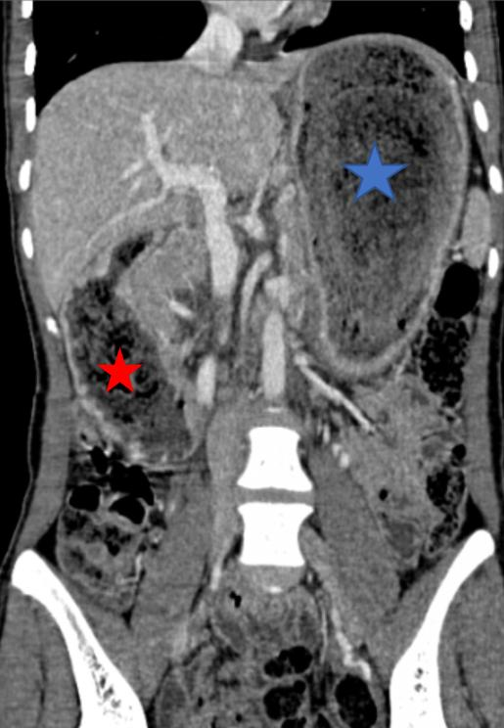

**figure 1 : The abdominal and pelvic scan revealed a gastroduodenal trichobezoar.**

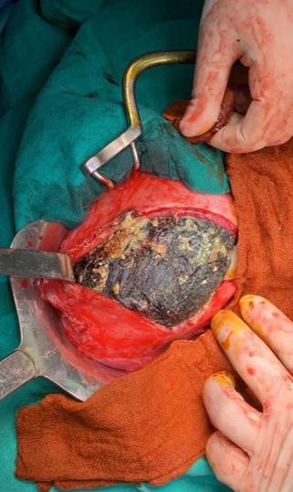

**Figure 2 : The patient underwent a longitudinal gastrotomy with extraction of a large trichobezoar.**

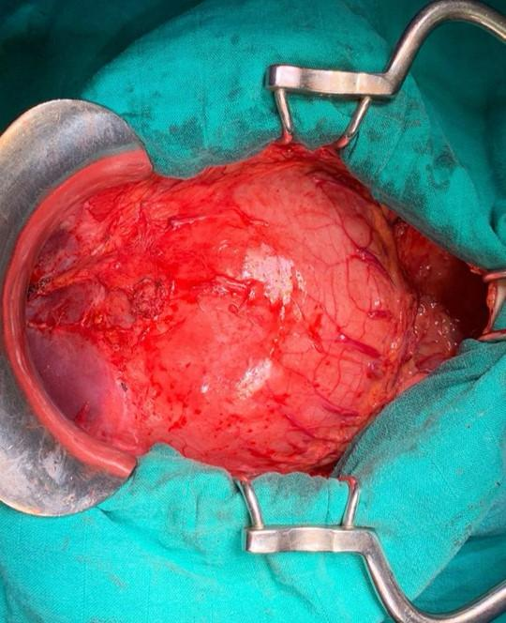

**Fig 3 : inflammatory distended stomach,**

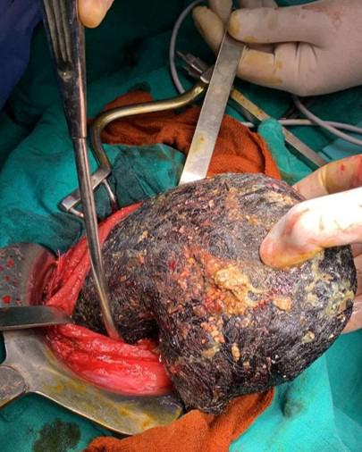

**Fig 4 :**  **gastrostomy exposing the trichobezoar.**

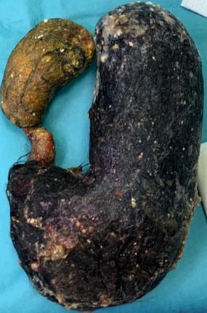

**Fig 5 : trichobezoar extraction.**

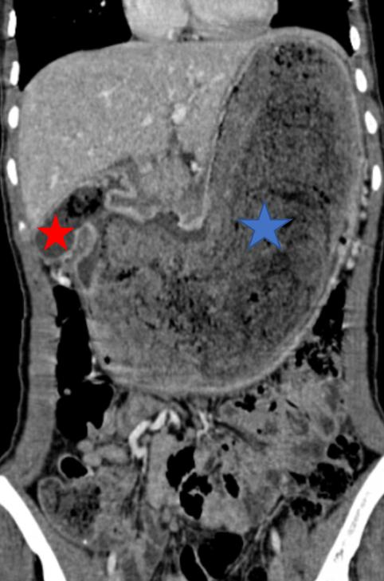

**Fig 6 : large trichobezoar.**

**Discussion:**

**« The term "bezoar" comes from the Persian panzehr, or the Arabic badzehr, meaning antidote or antipoison. It is a rare condition due to the unusual accumulation, in the form of solid masses or concretions, of substances of various kinds within the digestive tract, particularly in the stomach, but also sometimes in the urinary tract. Different types are distinguished depending on the substance ingested. For example, the lacteobezoar, composed of curdled milk, observed in infants ; the phytobezoar, composed of undigested plants; and trichobezoars, which represent 55% of all bezoars, consisting of concretions of hair, fur, or carpet fibers and food debris, usually confined to the stomach. Exceptionally, they can prolapse into the small intestine through the pylorus and cause obstruction. Other bezoars have been described after taking medications that modify digestive behavior: antacids, cholestyramine. The first case of trichobezoar was published in 1779. Its diagnosis is clinical and endoscopic. It should be considered in the presence of chronic digestive symptoms, which are not very specific; especially in young girls with psychological disorders and a history of gastric surgery, trichollomania with tricophagia. »[2]**

**Females are the most affected gender (90% of cases) and 80% of cases are under 30 years of age at onset, with a peak incidence between ten and 19 years of age. Our patient also falls into this age group.**

**Gastric localization is the most common ; the hair loops attach to the gastric mucosa and form a more or less complex tangle, a sort of mesh in which food clumps, creating a compact mass tightly adhered to the gastric wall. The trichobezoar thus formed can extend to the small intestine, sometimes reaching the last loop of the ileum, or even the transverse colon, thus creating Rapunzel syndrome. In our patient, the trichobezoar involves the stomach and duodenum. This condition can remain asymptomatic for a long time, which explains the delay in diagnosis, which can last up to several years. The clinical symptomatology is very varied and non-specific.**

**« Digestive disorders are the most common and include abdominal pain, mainly in the epigastric region, nausea, vomiting, diarrhea, constipation, peptic esophagitis and sometimes an unbearable odor of breath due to food putrefaction. Anorexia and weight loss can sometimes be the major clinical element. It can be revealed immediately by an acute complication; such as digestive hemorrhage, acute intestinal obstruction, digestive perforation, or acute pancreatitis attributed to obstruction of the ampulla of Vater by an extension of the trichobezoar or to reactive edema, cholestatic jaundice, gastric or duodenal ulcer and rarely volvulus of the large intestine. The clinical examination, apart from complications, finds, thanks to careful palpation, an abdominal mass located most often at the level of the left hypochondrium and/or the epigastrium which must not be missed in the diagnosis. » [1,2]**

**« The discovery of a localized, mechanical bald patch is a major sign of orientation and should lead to a search for trichophagia. Endoscopy is the technique of choice for diagnosing and classifying bezoars once the diagnosis has been suggested. Oesophagogastroduodenal fibroscopy, which has diagnostic and therapeutic interest in localized gastric and small-sized forms, not only confirms the diagnosis but also ensures the extraction of the small foreign body. It visualizes tangled hairs, generally black in color, but a color change may occur due to the chemical effect of gastric acidity, a pathognomonic aspect of trichobezoar. » [1,3]**

**Trichobezoars are tar-black, while phytobezoars are multicolored, ranging from yellow to brown or green. Abdominal X-rays may show a mass invading the gastric air sac, but they rarely detect the mass responsible for the obstruction: there is a risk of confusion with stool or an abscess. [4]**

**« In giant trichobezoars, endoscopy is insufficient ; it does not allow assessment of the extension to the jejunoileal loops ; in these cases, imaging becomes more useful. The trichobezoar appears on computed tomography (CT) as a heterogeneous mass of variable volume, occupying almost the entire gastric lumen and consisting of a multitude of concentric circles of varying densities distributed in an onion-shaped pattern. Two pathognomonic and constant signs are the presence of tiny air bubbles scattered within the mass and the absence of any attachment of the latter to the gastric wall. Magnetic resonance imaging (MRI) also allows the diagnosis. The mass has a variable signal in T1 and T2 weighting, without contrast enhancement after gadolinium injection. » [1]**

« Therapeutic management depends on the size and the presence or absence of complications. For a small gastric trichobezoar, it can generally be removed endoscopically. Some authors suggest the use of abundant drinks associated with the use of transit accelerators. Other authors propose fragmentation of the trichobezoar, either endoscopically by laser beam and mini-blast, or by extracorporeal lithotripsy. In addition to incomplete treatment, these methods expose a risk of iatrogenic complications, particularly esophageal, or intestinal obstruction due to a trichobezoar fragment. Treatment is therefore often surgical, even if it is large and heard in the loops or at the stage of complications, surgery, as was the case in our patient. Surgery allows exploration of the entire digestive tract, to extract the trichobezoar by gastrotomy possibly supplemented by an enterotomy in the extended forms (tail) or fragments blocked at a distance from the stomach through one or more enterotomies. Psychiatric care, based on behavioral therapy, parental education and medical treatment, must often be initiated in patients presenting with trichophagia. » [1,5]

Conclusion :

Trichobezoar is a rare condition that occurs in patients with mental fragility.

The clinical presentation, which evolves over time, is nonspecific. Diagnosis is endoscopic, confirmed by CT scan. Management is surgical and psychiatric.

CONSENT

As per international standards or university standards, patient(s) written consent has been collected and preserved by the author(s).

DISCLAIMER (ARTIFICIAL INTELLIGENCE)

Option 1:

Author(s) hereby declare that NO generative AI technologies such as Large Language Models (ChatGPT, COPILOT, etc) and text-to-image generators have been used during writing or editing of this manuscript.

COMPETING INTERESTS

Authors have declared that no competing interests exist.

**Références :**

**1- Khalid Mazine, Pierre Barsotti, Hicham Elbouhaddouti, Ouadii Mouaqit, Elbachir Benjelloun, Khalid Ait Taleb, Abdelmalek Ousadden. Gastroduodenal trichobezoar: about a case; African Medical Journal. 2018; 30:25 doi:10.11604/pamj.2018.30.25.12239**

**2- Mountassir Moujahid, Tarik Ziadi, Issam Ennafae, Hicham Kechna, Omar Ouzzad, Sifeddine EL Kandry. A case of gastric trichobezoar; Pan African Medical Journal. 2011; 9:19 ISSN: 1937- 8688 (www.panafrican-med-journal.com)**

**3- Ousadden, K. Mazaz, I. Mellouki, K.A. Taleb Hospital Al Ghassani.**

**4- Asma Farouk, Azzeddine Diffaa, Khadija Krati.** **GASTRIC BEZOAR: TWO OBSERVATIONS AND LITERATURE REVIEW. Hegel Vol. 3 N° 2 – 2013 ; DOI: 10.4267/2042/51159**

**5- Maryame Ezziti, Fouad Haddad, Mohamed Tahiri, Wafaa Hliwa, Ahmed Bellabah, Wafaa Badre, Rabii Haddouch, Khalid El Hattbi, Mohamed Rachid Elfriyekh, Abdelaziz Fadil. Gastric trichobezoar: about a case; an African Medical Journal. 2017; 26:74 doi:10.11604/pamj.2017.26.74.11826**

**6- Fiorentino Jorge, Oneto Adrian, Salgueiro Fabiàn, Cassella Ricardo**

**Trichobezar, A Rare Entity with Surgical Implications. Department of Surgery. Hospital Unit XV de Niños R. Gutiérez. Buenos Aires, Argentina. Paieda online 2003.**

**7- Bockus Henry C Gastroenterology, vol. 1, Philadelphia, pa, WB. saunders**

**CO: 1963,p86.**

**8- Maingot R.: Maignot’s textbook of abdominal surgery 8th Ed. Appelton**

**century crofts, Norwalk, Connecticut: 1985, 675-81.**

**9- Andrus Ch. Am. J. gastroenterol, 1988, 83 (5): 476-8.**

**10- Thompson K.C. Drug safety.1996; 14(2): 85-93.**

**11- Querchi N.H., Morris K. et McDevitt B. Trichobezoar: A condition to think**

**of in case of mobile abdominal mass.**

**12- Irish Medical Journal, June 1992, Vol. 85, No 274.**

**13- Marinetti P.: Contribution to the study of trichobezoars.**

**14-Thesis. Paris. 1957. No. 584.**

**15- Fühner, Hermann, Bezoarsteine In Jonus, tome 6, Harlem 1901, pp3181.**

**16- W. Ducket Bezoard Dictionary of conversation and reading 1852, Volume 3, p: 136.**

**17- Ahouet, E. J. O., Sidibe, F., Zouita, B., Basraoui, D., & Jalal, H. (2023). Gastroduodenal Trichobezoar: A Case Report. Sch J Med Case Rep, 2, 131-134.**