Case report

Diffuse Large B-Cell Lymphoma Presenting as Pancreatic and Mediastinal Masses in a Young Female: A Diagnostic Challenge

.

ABSTRACT

|  |
| --- |
| Diffuse large B-cell lymphoma (DLBCL) is the most common subtype of non-Hodgkin lymphoma (NHL), which usually manifests as nodal involvement. However, secondary pancreatic involvement is rare, occurs in only 0.2%–2% of NHL cases. DLBCL can develop in the lymph nodes or in “extranodal sites” (areas outside the lymph nodes) such as the gastrointestinal tract, testes, thyroid, skin, breast, bone, brain, or essentially any organ of the body. It may be localized (in one spot) or generalized (spread throughout the body). Despite being an aggressive lymphoma, DLBCL is considered potentially curable. We report the case of an 18-year-old female with no prior significant medical history admitted for a 15-day history of progressive jaundice without abdominal pain, associated with retrosternal chest pain and left shoulder pain evolving over a month, in a context of a general physical decline. Physical examination revealed a generalised jaundice, no enlarged superficial lymph nodes or abdominal masses. Cardiopulmonary examinations were unremarkable. Liver function tests were abnormal, with a normal lipase. A contrast-enhanced thoraco-abdomino-pelvic CT scan revealed multiple, irregular, hypodense and locally advanced masses in the pancreatic head and isthmus (largest 27.7 × 19 mm), with significant biliary tree dilatation. Additional findings included splenic nodules and a mediastinal-pulmonary mass extending 60 mm vertically. Endoscopic ultrasound (EUS) with fine-needle biopsy detected two hypoechoic pancreatic lesions (19 × 27.7 mm) and two nodular splenic lesions (13 × 16 mm and 8 × 11 mm), suspicious for lymphomatous involvement. Histopathological examination revealed a proliferation of large atypical lymphoid cells. Immunohistochemistry confirmed a B-cell lymphoma, with strong CD20 and BCL6 expression, Ki-67 >95%, and absence of CD10, BCL2, and TdT. Scattered reactive T-cells were also noted. The patient started intensive chemotherapy with a good clinical improvement. Although rare, secondary pancreatic involvement in DLBCL should be considered when evaluating pancreatic masses, especially in young patients. The study points out the importance of considering lymphomatous disease in the differential diagnosis of pancreatic masses and bring out the diagnostic value of endoscopic ultrasound-guided biopsy in establishing a timely and accurate diagnosis. |

*Keywords: Obstructive jaundice, Pancreatic mass, Diffuse large B-cell lymphoma, Secondary pancreatic involvement, Adolescent.*

1. INTRODUCTION

Pancreatitis is an inflammatory pancreatic disease; common etiologies include infection, anatomic abnormalities, biliary, inborn errors of metabolism, trauma, and rarely malignancy. Primary mediastinal large B-cell lymphoma commonly presents in younger women with principally mediastinal involvement. Primary mediastinal large B-cell lymphoma (PMBCL) is a rare and aggressive subtype of a non-Hodgkin B-cell lymphoma that originates in the mediastinum. Less than half of PMBCL arise from extranodal sites, including the gastrointestinal tract, skin, soft tissues, genitourinary tract, and rarely bone marrow (Ahmed et al., 2021; Krawczyk et al., 2024). Diffuse large B-cell lymphoma (DLBCL) is the most common subtype of non-Hodgkin lymphoma (NHL), which usually manifests as nodal involvement. However, extranodal disease is observed in approximately 50% of cases (Fujinaga, et al , 2013). Among these, secondary pancreatic involvement, which is particularly rare, occurring in only 0.2%–2% of NHL cases and has been infrequently documented in the literature (Saif et al ,2007). This atypical presentation can be easily mistaken for pancreatic adenocarcinoma, potentially leading to inappropriate treatment strategies (Behrns et al ,1994). The treatment strategies for Primary pancreatic lymphoma include surgery, chemotherapy, radiotherapy, or comprehensive treatment; however, chemotherapy remains the standard treatment option (Venkitakrishnan et al., 2021; Shi et al., 2023).

We report here a rare case of secondary pancreatic involvement by lymphoma in a young patient. The endoscopic ultrasound-guided fine needle aspiration was crucial for establishing the diagnosis, as it is a minimally invasive and effective technique for evaluating pancreatic masses. This case emphasises the critical importance of including lymphoma in the differential diagnosis of pancreatic lesions, as accurate identification significantly changes the therapeutic management.

2. CASE PRESENTATION

An 18-year-old North African female with no prior significant medical history nor family history of hematologic malignancies or lymphoma admitted for a 15-day history of progressive jaundice, accompanied by pruritus and fatigue, unintentional weight loss, and general physical decline. She denied fever, abdominal pain or night sweats. The patient also reported retrosternal chest pain and left shoulder pain for 1 month.

Physical examination revealed that her performance status was 2, and BMI was 19.5 kg/m². She had generalised jaundice with no enlarged superficial lymph nodes or palpable masses in her upper abdomen. Cardiovascular and pulmonary examinations were unremarkable, with normal breath sounds and no signs of respiratory distress at rest.

Laboratory investigations confirmed abnormal liver function tests:

Total bilirubin: ↑ 85,5 μmol/L ; AST (Aspartate Aminotransferase): ↑188 UI/L;

ALT (Alanine Aminotransferase) : ↑488 UI/L; ALP (Alkaline Phosphatase): ↑354 UI/L ;

GGT(Gamma-Glutamyl Transferase) : ↑ 578 UI/L; Lipase correct at 38.

A contrast-enhanced thoracoabdominopelvic CT scan revealed ( fig 1) :

* Multiple, locally advanced pancreatic masses irregular in shape, hypodense, in the pancreatic head and isthmus, the largest measuring approximately 27.7 mm × 19 mm
* Significant dilation of the biliary tree, with a common bile duct (CBD) diameter of 12 mm
* Several splenic nodules.
* A mediastinal-pulmonary mass in the apicodorsal and lingular regions measuring 63 x 20 mm, extending over 60 mm in height, encompassing the upper lobe and lingular branches.
* Mediastinal, hilar, and subcarinal lymphadenopathy with extensive necrosis.
* Low-volume pericardial effusion.

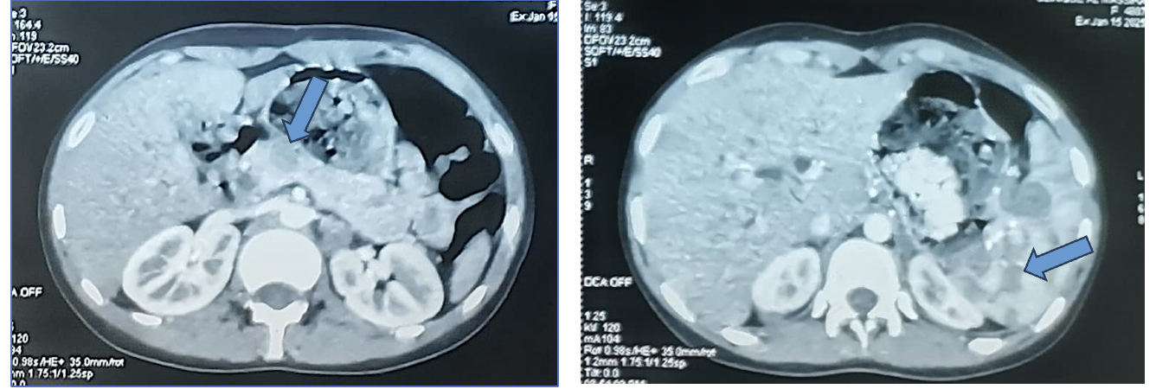

B

A

**Fig. 1. CT (computed tomography) scan showing pancreatic masses in the pancreatic head (A) and splenic nodules (B).**

She underwent flexible bronchoscopy, which revealed second-degree diffuse inflammation of the bronchial tree and a significant reduction in the caliber of the lingular bronchus.

Additionally, an endoscopic retrograde cholangiopancreatography (ERCP) (fig 2) that showed a distal biliary stricture extending to the hilar confluence, likely due to extrinsic compression of the third portion of the duodenum (D3). A biliary stent was successfully placed, resulting in clinical and biochemical improvement.

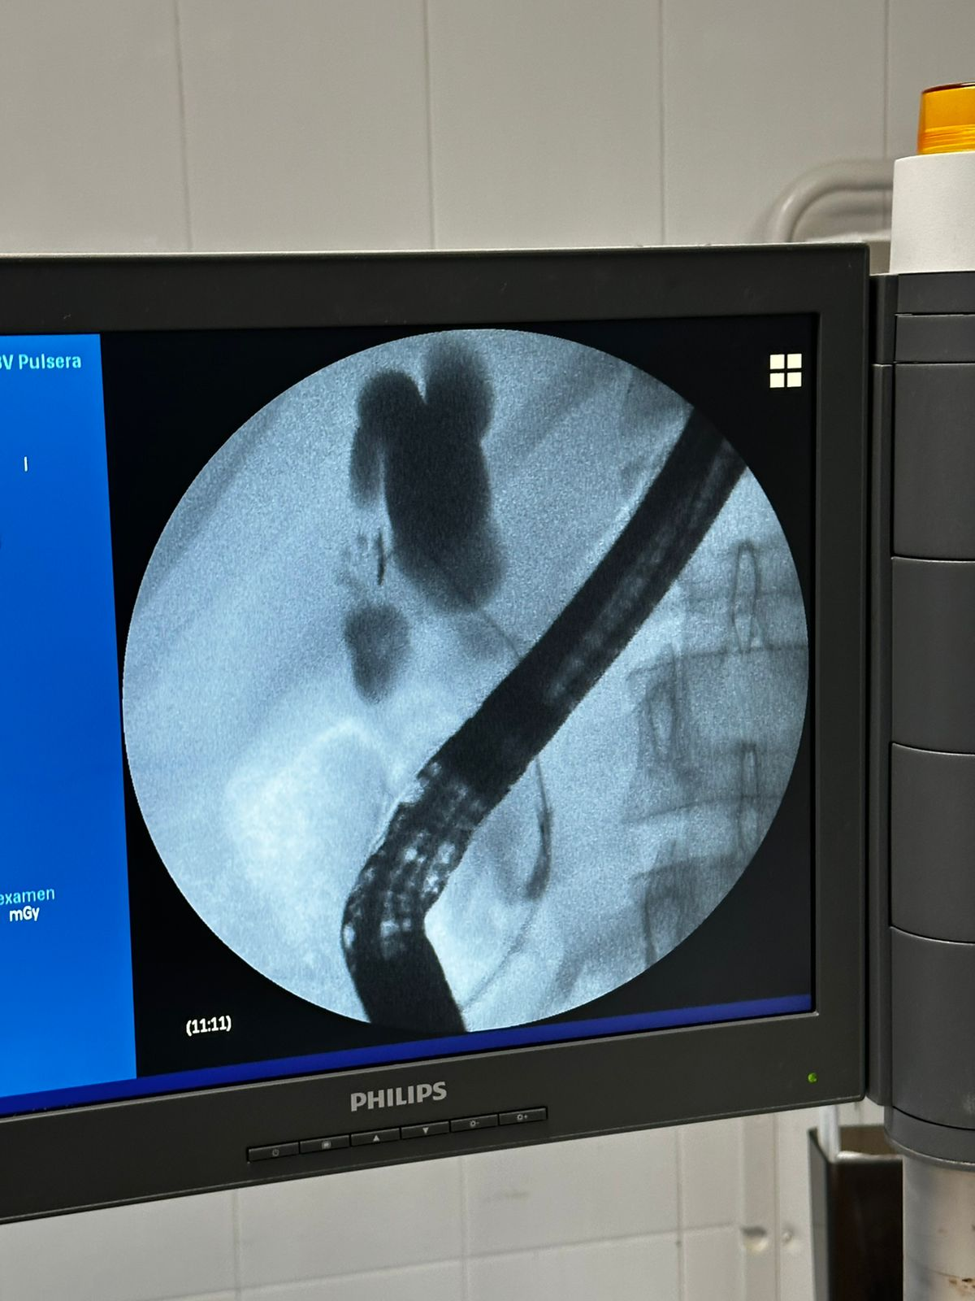

**Fig. 2. ERCP distal biliary stricture extending being catheterize**

Follow-up laboratory results, obtained two days post-drainage, demonstrated:

* Total bilirubin: decreased from 85.5 to 35 μmol/L
* AST: from 188 to 90 U/L
* ALT: from 488 to 144 U/L
* ALP: from 354 to 218 U/L
* GGT: from 578 to 192 U/L

An endoscopic ultrasound (EUS) (fig 3) with fine-needle biopsy was performed and identified two hypoechoic pancreatic lesions (19 x 27.7 mm) in the head and isthmus, as well as two nodular splenic lesions ( 13 x 16 mm and 8x 11 mm ) , all suspicious for lymphomatous involvement .

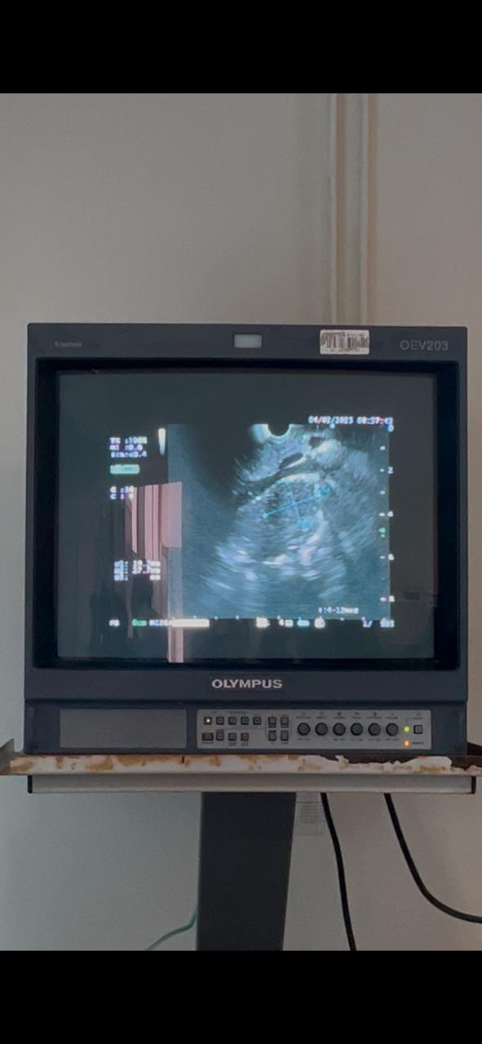

**Fig. 3. endoscopic ultrasound (EUS) showing pancreatic lesions**

Histopathological examination revealed a proliferation of large atypical lymphoid cells. Immunohistochemistry demonstrated diffuse expression of CD20 and BCL6, with negative staining for CD10, BCL2, and TdT. The Ki-67 proliferation index exceeded 95%, and CD3 highlighted scattered reactive T lymphocytes.

The patient received three courses of LMB 02 Protocol and showed a marked improvement of symptoms.

3. discussion

The most frequent form of non-Hodgkin lymphoma is Diffuse large B-cell lymphoma (DLBCL) (Martelli et al , 2013),it mainly affects older adults, but it can also occur in adolescents and young adults, though this is less common (national cancer institute , 2022).

Pancreatic lymphoma is rare and accounting for less than 1% of all pancreatic tumors and less than 2% of extranodal sites in cases of primary lymphoma, however secondary involvement of the pancreas may be seen in as many as 30% of patients with systemic lymphoproliferative disorders, although in this context, a predominant involvement of the pancreas is rare ( Fujinaga, et al , 2013).

The secondary pancreatic involvement by lymphoma, though rare, should be given serious consideration in the differential diagnosis of pancreatic masses, particularly in patients with established or suspected systemic lymphoma. The current gold standard diagnostic approach requires an imaging and a histopathological confirmation, usually involving an endoscopic ultrasound-guided fine-needle aspiration (EUS-FNA) (Friedman et al,2009).

EUS is thus an extremely valuable modality given its high-resolution imaging capability to optimally target pancreatic lesions and peri-pancreatic lymphadenopathy. When considering lymphoma in a secondary involvement context, it is often imperative to differentiate lymphomatous infiltration from other pancreatic pathologies like pancreatic cancer, given the dramatically different management strategies (Johnsson et al,2014) (Sadaf et al , 2017) .

A pertinent case that supports this approach involved a 34-year-old woman who presented with obstructive jaundice and right upper quadrant pain. Initial imaging did not show a mass on the pancreas, but as her symptoms worsened, further imaging and EUS revealed a lesion at the head of the pancreas. A biopsy of the duodenum, as well as FNA, confirmed the diagnosis of DLBCL affecting both the pancreas and the duodenum. Additional findings revealed a right adrenal tumor and a left lower lobe lung lesion, indicating disseminated disease (Friedman et al,2009).

This case reinforces the diagnostic value of EUS-FNA and the need for high clinical suspicion, especially in atypical or unclear presentations.

And another case (Krawczyk et al ,2024) that reinforces our presentation described a 16-year-old girl with no medical history admitted with acute pancreatitis (epigastric pain and significantly elevated lipase level (2,524 U/L)). The imaging revealed a pancreatic head mass, splenic lesion, and a large necrotic mediastinal mass. A biopsy of the mediastinal mass confirmed primary mediastinal B-cell lymphoma (PMBCL) with rare extra-thoracic spread to the pancreas and spleen. This case too highlights the rare but possible metastatic spread of PMBCL beyond the thoracic cavity, underlining the value of taking lymphoma into account when making a differential diagnosis for pancreatic masses in pediatric patients.

Our case is unique not only because of the rare young age of the patient, but also in the significant involvement of multiple organ systems, including the pancreas, mediastinum and spleen, which is rare in such presentations of lymphoma. These atypical presentations underline the need for a careful diagnostic strategy, including modern imaging modalities like EUS.

4. Conclusion

This case displays a rare presentation of secondary pancreatic involvement by aggressive diffuse large B-cell lymphoma in a young patient. It points out the importance of considering lymphomatous disease in the differential diagnosis of pancreatic masses and brings out the diagnostic value of endoscopic ultrasound-guided biopsy in establishing a timely and accurate diagnosis.

Disclaimer (Artificial intelligence)

Option 1:

Author(s) hereby declare that NO generative AI technologies such as Large Language Models (ChatGPT, COPILOT, etc.) and text-to-image generators have been used during the writing or editing of this manuscript.

Option 2:

Author(s) hereby declare that generative AI technologies such as Large Language Models, etc. have been used during the writing or editing of manuscripts. This explanation will include the name, version, model, and source of the generative AI technology and as well as all input prompts provided to the generative AI technology

Details of the AI usage are given below:

1.

2.

3.

Consent

As per international standards or university standards, patient(s) written consent has been collected and preserved by the author(s).

Ethical approval

As per international standards or university standards written ethical approval has been collected and preserved by the author(s).

References

Fujinaga, Y., Lall, C., Patel, A. et al. MR features of primary and secondary malignant lymphoma of the pancreas: a pictorial review. Insights Imaging 4, 321–329 (2013). https://doi.org/10.1007/s13244-013-0242-z.

Saif MW, Khubchandani S, Walczak M. Secondary pancreatic involvement by a diffuse large B-cell lymphoma presenting as acute pancreatitis. World J Gastroenterol 2007; 13(36): 4909-4911.

Behrns KE, Sarr MG, Strickler JG. Pancreatic lymphoma: is it a surgical disease? Pancreas. 1994;9:662Y667.

Martelli M, Ferreri AJ, Agostinelli C, Di Rocco A, Pfreundschuh M, Pileri SA. Diffuse large B-cell lymphoma. Crit Rev Oncol Hematol. 2013;87(2):146–71.

National Cancer Institute. Surveillance, Epidemiology, and End Results (SEER) Program. seer.cancer.gov. Released Apr 2020, based on the Nov 2019 submission (1975–2017). Accessed August 2022.

Friedman M, Mohan I, Brodsky G, Sood V. Diffuse Large B-cell Lymphoma Presenting with Obstructive Jaundice from a Biliary Stricture. American Journal of Gastroenterology. 2009;104(Suppl):S232.

Sadaf S, Loya A, Akhtar N, Yusuf MA. Role of endoscopic ultrasound-guided-fine needle aspiration biopsy in the diagnosis of lymphoma of the pancreas: A clinicopathological study of nine cases. Cytopathology 2017; 28:536-541.

Johnson EA, Benson ME, Guda N, Pfau PR, Frick TJ, Gopal DV. Differentiating primary pancreatic lymphoma from adenocarcinoma using endoscopic ultrasound characteristics and flow cytometry: A case-control study. Endosc Ultrasound **2014**; 3:221-5.

Krawczyk, Karolina MD1; Kwak, Angelika MD, MPH2; Kujalowicz, Christopher BS, BA2; Truszkowska, Karolina BS2; Biank, Vincent MD3; Kamberos, Natalie DO4. Primary Mediastinal Large B-Cell Lymphoma Presenting as Acute Pancreatitis. ACG Case Reports Journal 11(6):p e01394, **June 2024**. | DOI: 10.14309/crj.0000000000001394.

Ahmed Z, Afridi SS, Shahid Z, et al. Primary mediastinal B-cell lymphoma: A 2021 update on genetics, diagnosis, and novel therapeutics. Clin Lymphoma Myeloma Leuk. 2021;21(11):e865–e875. [DOI] [PubMed] [Google Scholar]

Shi, L., Wang, J., Wei, L., Ma, Z., & Liu, X. (2023). Pancreatic diffuse large B-cell lymphoma: a case report and literature review. Frontiers in Oncology, 13, 1294385.

Venkitakrishnan, R., Paul, M., Sleeba, T., Abraham, L., Joshi, M., Augustine, J., ... & Vijay, A. (2021). Expecting the unexpected–primary mediastinal large B cell lymphoma presenting as huge lung parenchymal mass. Respiratory Medicine Case Reports, 32, 101370.