***Review Article***

ROLE OF HELMINTH PARASITES AS BIOINDICATORS OF HEAVY METAL POLLUTION IN ENVIRONMENT

.

ABSTRACT

|  |
| --- |
| Heavy metals pose a threat to the environment and living organisms because they are highly toxic, cannot be broken down by natural processes, bioaccumulates and biomagnifies in the food chain and can damage organs and disrupt vital biological functions even at extremely low concentrations. Thus, there is need for constant monitoring and removal of these toxic heavy metals from the environment.  Because of their diverse responses to anthropogenic pollution, particularly heavy metal pollution, helminth parasites are gaining attention from parasite ecologists as possible markers of environmental quality. These parasites are strong bioindicators in two different ways. Firstly, they are "effect indicators" and help to monitor the changes in whole population structure of parasites depending on the pollution of the environment. Secondly, they are "accumulation indicators" and help to monitor the chemical state of their environment through their ability to concentrate environmental toxins within their tissues which is usually higher than the host tissues . The majority of research revealed that helminth parasites, particularly cestodes and acanthocephalans, are more constant and trustworthy indicators of metal pollution due to their massive capacity to accumulate heavy metals which surpasses that of most known free living bioindicators.  .  The presence of parasite also have a significant impact on reduction of heavy metal accumulation in the host which help in their detoxification . Thus, parasites are advantageous to the both, environment as bioindicator of heavy metal pollution and to its host in reducing the amount of heavy metal from its tissue by accumulating in itself. Therefore, this review summarises the present knowledge on the role of helminth parasites as a bioindicator (biological indicators) in assessing the concentration of heavy metals in terrestrial and aquatic (marine, coastal and freshwater) environment and presents their role as sensitive indicators for environmental monitoring purposes. |

*Keywords:* Bioindicators , Heavy metals, Pollution, Helminths, Parasites, Environmental monitoring, Bioremediation

1. INTRODUCTION

“Heavy metals occur naturally in the environment, but anthropogenic activities(such as mining, burning fossil fuels, dumping industrial waste and other industrial activities) have increased concentrations to toxic levels in some habitats and is not just a localized problem but are able to drift over relatively long distances. This is frightening as heavy metals cannot be broken down, once released they accumulate in the environment and do not degrade to carbon dioxide and water like the majority of organic pollutants. Heavy metals are taken up by organisms that feed in these habitats, becoming increasingly concentrated as one moves up the food chain due to a process termed biomagnification. Heavy metals are the elements having atomic weight of 63.54 and 200.59g/mol and a specific gravity greater than 4g/cm” [ Ghosh & Singh, 2005, Zhang et. al. 2019]. “Heavy metals are categorised into essential and non-essential. Essential heavy metals e.g. Cu, Ni, Co, Fe, Mn, Mo, Zn are required by living organisms in trace amount for for various physiological functions. However any excess amount of these metals can be detrimental to the organism” [ Mishra and Mani, 1991 ]. “In contrast non essential heavy metal eg. arsenic, antimony, cadmium, chromium, mercury, lead etc. are toxic even at extremly low level. They cause cancer and severe disorders of nerous system, kidney,liver, lungs and other parts of body. Thus, there is need for constant monitoring and removal of these toxic heavy metals from the environment. One important way to understand and prevent the outcomes of this harmful environmental degradation is the use of bioindicators. The word bioindicator means using living organisms as biological indicators to identify the quality of environmental conditions, including environmental heavy metal pollution. These may be free-living organisms or parasite that show the environmental impact because they respond to changes in habitat with changes in their numbers, physiology or chemical composition. Biomonitoring is a vital and rapidly growing field that uses several biological groups such as phytoplankton, macrophytes, invertebrates and fish, as bioindicators Parasites are attracting increasing interest from parasite ecologists as potential indicators of environmental quality due to the variety of ways in which they respond to anthropogenic pollution (Fig:1) . Bioindicators are of two kinds ie. effect or accumulation. Effect indicators indicates the effects of various forms of pollution on the abundance and distribution of parasites and we can monitor the changes of the whole population structure depending on the pollution of the environment. Effect bioindicators can show changes from functional,molecular or physiological level to changes in population size. The accumulation indicators show acculmulation of toxins within parasites and we can monitor the chemical state of their environment not through their presence or absence but instead through their ability to concentrate environmental toxins within their tissues which is usually higher than the host tissues . Accumulation bioindicators must accumulate substances from the environment efflciently without showing adverse effects” [ Sures, 2003 ]. “These bioindicators are useful indicators of different effects and measures the presence of pollutants at subcellular to the ecosystem level of organization and” [ Amiard-Triquet et. al., 2013 ].

“Parasites are sensitive to environmental pollution and can inform before pollution levels (especially heavy metal concentrations) reach frighteningly high concentrations as they are able to detect extremly low levels of pollution and serve early warning indicators for variety of pollutants . Parasites can also be used for monitoring the areas for its safe utiliy where industrial activities are operating presently or in past as they can accumulate toxic pollutant of industries present there”( Sures,2004). Thus parasites are incredible organisms that play a major role in the functioning of all major ecosystems

Helminthic parasites can also be considered as a suitable biological indicator for measuring heavy metals because the worms against to their host tissue are the stable and reliable indicator for evaluating the environmental pollution. Also since they have the potential for the accumulation of heavy metals from their surroundings more efficiently than their hosts, so help in bioremediation of environment and also have useful and beneficial effects on their hosts by reducing their toxic content by accumulating in itself ( Fig.2). According to the studies conducted by different researchers, it has been demonstrated that among helminthic parasites acanthocephalan and cestoda have a higher potential for absorption of heavy metals.

Several studies have been performed worldwide in different habitats both polluted and unpolluted terrestrial and aquatic ecosystems, including freshwater, estuarine and marine environments in order to investigate heavy metal pollution using parasitological models especially, acanthocephalans and cestodes of vertebrates mainly fish, mammals and birds. Some significant workers who performed such studies are Sures *et.al.* 1994a, b, c, 1997 ,1999, 2000a,b, 2002a,b ; Sures and Taraschewski, 1995,2001; Galli *et.al*. 1998; Siddall and Sures, 1998; Sures and Siddall, 1999,2001; Scheef *et.al.,* 2000; Tenora *et.al..* 2001; Sures 2001,2003,2004,2006 ; Schludermann *et. al.,* 2003;Sures and Reimann,2003;Torres *et.al.*, 2004 etc.

So, the aim of this study was to review the recently performed studies regarding the role of helminthic parasites as a bioindicator 

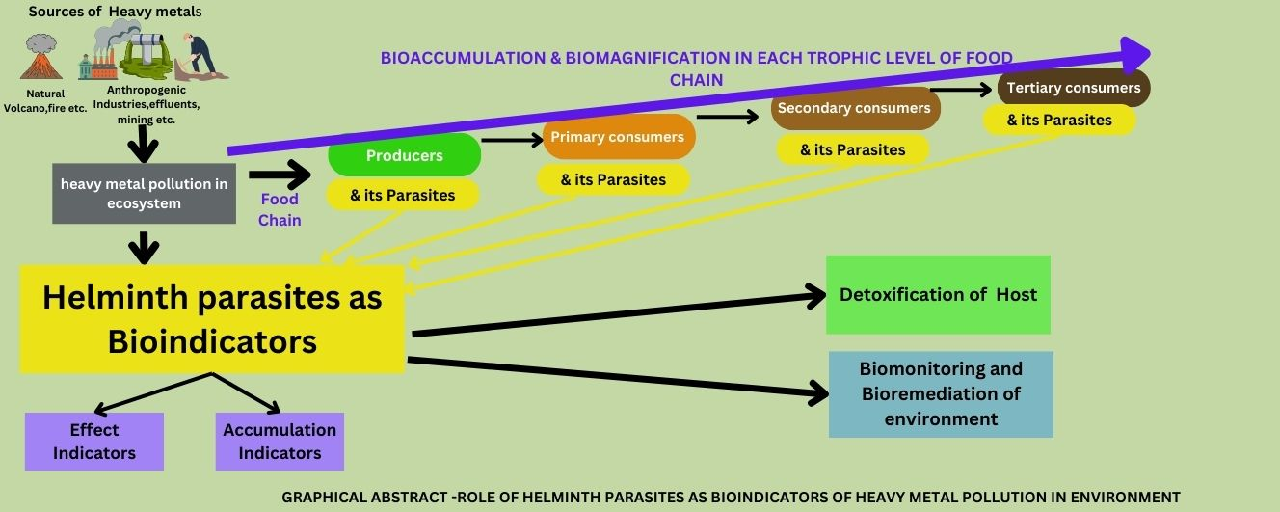

Figure.1: Role of helminth parasites as bioindicators of heavy metal pollution in environment

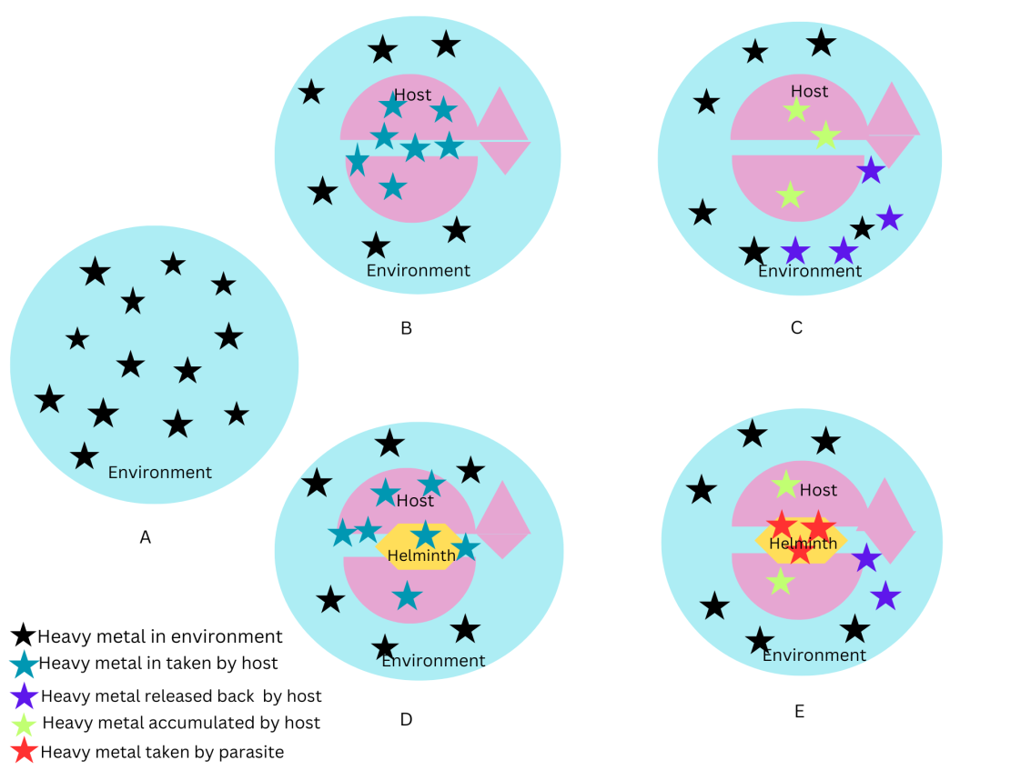

Figure 2. Depicting the role of parasite in detoxification of host and bioremediation of environment polluted with toxic heavy metals.

A. Large no.of heavy metals in environment

B. Intake(oral or respiratory or skin route ) of heavy metals by Living organism (host without parasite) in polluted environment

C. Bioaccumulation of few heavy metals in host (without parasite) and rest released to environment.

D. Intake (oral or respiratory or skin route ) of heavy metals by Living organism (host with helminth parasite in its intestine) in polluted environment

E. Heavy metals are taken up by helminth parasite which reduces the amount of bioaccumulation of heavy metals in host (Detoxification) and also its release in environment ( Bioremediation) .

2. HELMINTH PARASITE AS BIOINDICATORS

“Ecologists have been using free-living organisms as bioindicators to assess the terrestrial and aquatic environmental quality . However, there are limitations to the use of free living organisms as bioindicators, therefore now the focus is on helminth parasites of both terrestrial and aquatic organisms as useful bioindicators because they are affected by anthropogenic and natural environmental factors” [Sures, 2008; Vidal-Martinez *et. al.,*2016]. “There are several advantages of using parasites as bioindicators of environmental quality: (1) their communities are far less speciose than those of free living organisms, especially in benthic marine environments; (2) their taxonomy and life cycles are relatively wellknown; (3) from a parasite point of view, each individual host is an island (or habitat), and statistically, each host becomes a 'sampling unit' with its own set of parasite species and (4) parasites of top predators are also considered top trophic consumers, and consequently good bioindicators of food web accumulation” [Sures *et. al.,*1999;Tellez & Merchant, 2015].

In view of broad aspect of this research, it is possible to categorize studies according to similar environment.

**2.1** Aquatic ecosystems

Toxic heavy element pollution has been more common in aquatic environments .Fish and birds inhabiting aquatic ecosystems have been largely used as organisms for monitoring environmental pollution. Marine ecosystems are continuously threatened by contaminants, including heavy metals, which are frequent products of both anthropogenic activities and natural processes. The biomagnification of metals like mercury along the food chain is a major issue in marine environments iwhich increases chances of human exposure . The use of bioindicators allows evaluating the risk of exposure, acting as early warning systems for environmental deterioration. In the recent years, there has been imore research regarding the role of parasites as bioindicator of heavy metals pollution in aquatic bodies. Table 1 summarizes various parasite bioindicators of heavy metal pollution in aquatic environment.

Some of the workers in these field includes , Sures et al.1994a, b, c; Sures and Taraschewski, 1995,1999; Sures et. al.. 1997; Galli et. al.. 1998;Siddall and Sures, 1998; Sures and Siddall, 1999, 2001; Sures 2001, 2003, 2004, 2006 ;Tenora et. al.. 2001 ; Schludermann et. al.., 2003; Sures & Reimann,2003; Huspeni & Lafferty,2004; Malek, . et. al.. 2007 ;Vidal Martinez, 2007; Eira„ et. al.. 2009 , Mendes 2013 ; Ugbomeh et. Al.,2018 etc. These studies found that several helminths were able to collect considerable amount of heavy metals.

“Workers studied a classic example of accumulation of heavy metals in the acanthocephalan parasite *Pomphorhynchus laevis* in chub *Leuciscus cephalus* and found this model to be effective bioindicator of lead and cadmium in aquatic environment” [Sures et.al. 1999 ]. “Studies on the lead and cadmium concentrations in the tissues of the shark Carcharhinus dussumieri and its cestode parasites, Anthobothrium sp. and Paraorygmatobothrium sp. confirmed the value of cestodes as sensitive bioindicators in environmental monitoring and is also the first such study in a marine elasmobranch” [Malek et. al..2007].

“The results strongly shows that helminth parasites and their elasmobranch fish host are extremely sensitive early warning bioindicators of heavy metal pollution, in sensitive and remote areas such as the Antarctic and ocean depths,where elasmobranch fish are a major component of the fauna.” [Sures, 2003] .

“The model *Tetrabothrius sp.* / *M. bassanus* was studied and proposed as a good bioindicator system to evaluate environmental Cd and Pb pollution in marine environments” [Mendes, 2013]. “Trace element concentrations in *Proteocephalus macrocephalus* (Cestoda) and *Anguillicola crassus* (Nematoda) were analysed in comparison to their fish host, the European eel, *Anguilla anguilla* in the polluted estuarine habitat, concluding that the model *P.macrocephalus* /*A.anguilla* is a promising bioindicator system to evaluate environmental Cr, Ni, Pb and Zn exposure in aquatic areas” [Eira et.al. 2009] . “During the studies of the heavy metal accumulation of alligators (*Alligator mississippiensis*), it was found that in most cases the intestinal parasites accumulated higher concentrations of heavy metals than their reptilian host, which could, in turn, even be beneficial for the top predator and as bioindicator” [Tellez & Merchant ,2015].These observations suggest that these parasites are even more useful as environmental indicators for assessing metal pollution in aquatic habitats than other established indicator organisms

Table.1. : Table showing various Host –Parasite models as effective bioindicators of heavy metal pollution in Aquatic environment.

|  |  |  |  |  |  |  |  |  |  |  |  |  |  |  |  |  |  |  |  |  |  |  |  |  |  |  |  |  |  |  |
| --- | --- | --- | --- | --- | --- | --- | --- | --- | --- | --- | --- | --- | --- | --- | --- | --- | --- | --- | --- | --- | --- | --- | --- | --- | --- | --- | --- | --- | --- | --- |
| |  |  |  |  |  | | --- | --- | --- | --- | --- | | S.No | Parasite | Host | Effective Bioindicator of | References | | 1. | Acanthocephalan parasite *Pomphorhynchus laevis* | Fish *Leuciscus cephalus* | lead and cadmium in aquatic environment. | Sures &Taraschewski, 1999 | | 2. | Cestode parasites, *Anthobothrium sp.* and *Paraorygmatobothrium sp*. | shark *Carcharhinus dussumieri* | lead and cadmium in marine environments including sensitive and remote areas such as the Antarctic | Malek *et.al..*(2007), Sures (2003). | | 3. | Cestode Tetrabothrius sp | Seabird Morus bassanus | Cd and Pb and other marine toxic element pollution. | Mendes (2008) | | 4. | *Proteocephalus macrocephalus* (Cestoda) and *Anguillicola crassus* (Nematoda) | fish host, the European eel, *Anguilla Anguilla* | Cr, Ni, Pb and Zn in the polluted estuarine habitat | Eira *et. al.* (2009) | | 5.. | Intestinal helminthes | Reptile *Alligator mississippiensis* | Toxic heavy metals | Tellez & Merchant (2015) | |

**2.2.**Terrestrial ecosystems

As previously stated, long-term polluting activities (such as tourism and traffic) may disrupt remote or protected habitats, necessitating systematic control with appropriate species or helminthological models as bioindicators of heavy metal pollution. Studies on parasites of vertebrates living in terrestrial ecosystems as sentinels for heavy metal environmental pollution were performed [Sures et. al. 1998; Sures et. al., 2000a,b; Scheef et. al., 2000; Sures et. al., 2002a,b, 2003; Torres et. al., 2004,2006,2010].

Table 2 summarizes various parasite bioindicators of heavy metal pollution in terrestrial environment.

Terrestrial models involving acanthocephalan parasites of vertebrates like large acanthocephalan pig's parasite *Macracanthorhynchus hirudinaceus* was considered as an important cadmium and lead bioaccumulator in terrestrial and urban ecosystems [Sures et. al 2000a ,Torres et.al.2011]. The acanthocephalan *M.moniliformis*, which parasitizes *Rattus norvegicus*, is a highly sensitive bioindicator of cadmium and lead pollution in terrestrial and urban habitats. [Scheef et.al. 2000 and Sures et.al. 2000b, 2002b , Torres et.al.2011]. The first terrestrial model involving a cestode parasite of rodents studied for the possible capacity of lead accumulation *Rattus norvegicus / Hymenolepis diminuta*, is proved to be a promising bioindicator for lead in urban ecosystems [Sures et al. 2002a,2003]. The *A.sylvaticus/ G. arfaai* and*A. sylvaticus/ S. lobata* model of host and helminth were found to be a useful bioindicator of lead in terrestrial habitats [Torres, et.al. 2004,2006]. Thus, it makes an effective biomonitoring tool for terrestrial lead pollution. With respect to models involving parasites of terrestrial birds, the model *Columba livia / Raillietina micracantha* was proposed as another promising bioindicator to evaluate environmental toxic element exposure, particularly Pb and Mn [Torres, et al. 2010].

Table.2. : Table showing various Host –Parasite models as effective bioindicators of heavy metal pollution in Terrrestrial environment.

|  |  |  |  |  |
| --- | --- | --- | --- | --- |
| S.  No | Parasite | Host | Effective Bioindicator of | References |
| 1. | Acanthocephalan *Macracanthorhynchus hirudinaceus* | Pig | Cd and Pb in terrestrial and urban ecosystems | Torres,*. et al.*2011 and Sures, *et al* 2000.. |
| 2. | Acanthocephalan *M. moniliformis* | *Rattus norvegicus* | Cd and Pb pollution in terrestrial and urban ecosystems | Scheef, *et al.* 2000 and Sures, *et al*. 2000 |
| 3. | Cestode *Hymenolepis diminuta* | *Rattus norvegicus* | Pb in urban ecosystems | Sures, *et. al..*2002,2003 |
| 4. | Cestode *Gallegoides arfaai* | Rodent *Apodemus sylvaticus* | Pb in terrestrial habitats | Torres, *et. al..,*2004 |
| 5. | Cestode *Skrjabinotaena lobata* | Rodent *Apodemus sylvaticus* | Pb in terrestrial habitats | Torres, *et. al.* 2006 |
| 6. | Cestode *Raillietina micracantha* | Bird *Columba livia* | Pb & Mn in Terrestrial habitat | Torres, *et. al.* 2010 |

2.3. The mechanism of action in heavy metal uptake by helminthic parasites

Helminthic parasites mostly live in gut of the host and since they cannot build their required cholesterol and fatty acids, they absorb nutrients from the host's intestinal lumen. In the meantime, the organometallic compounds, which have been absorbed by the host along with bile salts after the passage of the bile duct, are ingested in the small intestine of the host by these parasites. The bile salts are essential to activate the larval stage of the parasitic especially acanthocephalan larval stage (cystacanth) and increase the absorption by adult worm. Thus, the mechanism that allows acanthocephalans to absorb heavy metals from the host's intestinal tract is based on the presence of bile acids, which produce organo-metallic complexes that the worms can easily absorb because they are lipophilic. A similar mechanism may also exist in cestoda. ( Fig.3.). Also,it is found that cestodes with a relatively large tegumental surface in respect to its weight reach high bioaccumulation factors and therefore considered potentially good bioindicators. Consequently, endoparasites can reduce heavy metals from the host intestinal wall and store in their own and thus high metal accumulation in worms (cestoda, acanthocephala) affected the metal levels in the tissues of a definitive host [Sures & Siddal, 1999].Overall, helminthic parasites act as a filter to absorb heavy metals from the host tissue and can have beneficial effects on human and animal health as well as surrounding environment due to reduction in their heavy metal concentration. Heavy metals can be hazardous to human health due to consumption of fish and other marine originated proteins as well as their application in the poultry industry, helminthic parasites can be used as filters to absorb heavy metals from the host tissues and have beneficial effects for overall human and animal health 

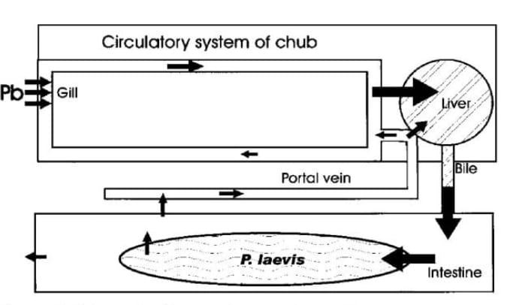

Figure 3. Mechanism of action of heavy metal uptake by parasites :Schematic diagram showing the uptake ,transport, excretion and entero-hepatic cycling of lead in chub (*Leuciscuscephalus* ) and the route of uptake of the metal by intestinal acanthocephalans, *Pomphorhynchus laevis*  (Sures and Siddall, 1999).

3. Conclusion

Thus, parasitic helminths have important role as bioindicators of heavy metal environmental pollutants and several parasitic models are effective bioindicator systems in both aquatic and terrestrial habitats . The heteroxenous digeneans, cestodes, nematodes and acanthocephalans have been shown to have the broadest variety of applications as biological, accumulating and impact indicators and may have beneficial impacts on human and animals. They are sharing more burden of pollutant heavy metal in their body as well as remain persistent in contaminated environment ,therefore act as bioremediator for host (removing heavy metals) and help in the survival of host with toxins/ heavy metals and reducing environmental stress. They also play a role in clearing the surrounding environment (Aquatic and Terrestrial) from metal contaminants or similar heavy metals .

Thus, parasites have broad applications and used as biological indicators for their hosts, accumulation indicators to detect pollutants, impact indicators to describe the relationship between pollution and the parasite and finally as systemic indicators that provide information on the health status of the environment. A proper selection of parasites used and their appropriate life cycle stages is required for all of these uses, which necessitates careful planning and some background knowledge of parasite diversity in each habitat.

**4. CHALLENGES AND FUTURE DIRECTIONS**

However, we still do not have sufficient information regarding the impact of parasites on common bioindicators procedures like biomarker analysis . It will be important to reconsider more suggestions for formulating monitoring studies to enhance the effectiveness of environmental monitoring programs in future.. There is a significant need for further understanding of the fundamental physiological effects parasites exert on their hosts during infection, development, and reproduction.More information is required to establish certain host parasite assemblages, as effect indication system. The need for sentinels in aquatic and terrestrial habitats should encourage scientists to intensify research in this interdisciplinary area of Environmental parasitology . It need contribution from different fields like toxicology, environmental chemistry and parasitology. Furthermore, environmental parasitology should be taken into account in order to increase the efflciency of environmental monitoring programs.

Though several open questions still remain, parasites are ready to be used as indicator organisms for environmental change and should be included in regular monitoring programs that will provide long-term data sets. In combination with other indicator measures, parasites will enable a better estimate of the causes and consequences that underlie environmental change in aquatic and terrestrial habitats.

**ACKNOWLEDGEMENT**

Author is thankful to anonymous reviewers for their constructive feedback and suggestions.

Disclaimer (Artificial intelligence)

Author hereby declare that NO generative AI technologies such as Large Language Models (ChatGPT, manuscript.

References

Ghosh, M. and Singh, S.P.(2005) A Review on Phytoremediation of Heavy Metals and Utilization of Its Byproducts. Applied Ecology and Environmental Research, 3, 1-18 <http://dx.doi.org/10.15666/aeer/0301_001018>

Zhang, X.; Yan, L.; Liu, J.; Zhang, Z.; Tan, C.(2019) Removal of different kinds of heavy metals by novel PPG-nZVI beads and their application in simulated stormwater infiltration facility. Appl. Sci. 9, 4213. [CrossRef]

Misra, S.G. and Mani, D. (1991) Heavy Metals Pollutant in: Soil Pollution. Ashish Publishing House, New Delhi ,60.

Sures, B. (2003) Accumulation of heavy metals by intestinal helminths in fish: an overview and perspective. Parasitology, 126, 53-60.

Amiard-Triquet, C., Amiard, J.C. & Rainbow, P.S. (2013) Ecological biomarkers: indicators of ecotoxicological effects. Boca Raton, FL, CRC Press, Taylor & Francis Group. 434 pp.  [Google Scholar](https://scholar.google.com/scholar_lookup?title=Ecological+biomarkers%3A+indicators+of+ecotoxicological+effects&author=Amiard-Triquet+C.&author=Amiard+J.C.&author=Rainbow+P.S.&publication+year=2013)

Sures, B., Taraschewski, H. & Jackwerth, E. (1994 a) Comparative study of lead accumulation in different organs of perch (*Perca fluviatilis*) and its intestinal parasite *Acanthocephalus lucii*. Bulletin of Environmental Contamination and Toxicology, 52, 269-273.

Sures, B., Taraschewski, H. & Jackwerth, E.(1994 b) Lead accumulation in *Pomphorhynchus laevis* and its host. Journal of Parasitology, 80, 355-357.

Sures, B., Taraschewski, H. & Jackwerth, E.(1994c) Lead content of *Paratenuisentis ambiguus* (Acanthocephala), *Anguillicola crassus* (Nematodes) and their host *Anguilla anguilla.* Diseases of Aquatic Organisms, 19, 105-107.

Sures B, Taraschewski H, Rokick G. (1997) Lead and cadmium content of two cestodes *Monobothrium wageneri* and *Bothriocephaluss corpii* and their fish hosts. Parasitol Res. 83, 618-623.

Sures, B., Slidell, R. & Taraschewski, H. (1999)  Parasites as accumulation indicators of heavy metal pollution. Parasitology Today 15, 16–21.[Google Scholar](https://scholar.google.com/scholar_lookup?title=Parasites+as+accumulation+indicators+of+heavy+metal+pollution&author=Sures+B.&author=Slidell+R.&author=Taraschewski+H.&publication+year=1999&journal=Parasitology+Today&volume=15&pages=16-21)

Sures, B., Franken, M. & Taraschewski,H. Element concentrations in the archiacanthocephalan *Macracanthorhynchus hirudinaceus* compared with those in the porcine host from a slaughterhouse in La Paz, Bolivia. International Journal for Parasitology, 30, 1071-1076.

Sures, B., Jürges, G. & Taraschewski, H . (2000a) Accumulation and distribution of lead in the acanthocephalan *Moniliformis moniliformis* from experimental infected rats. Parasitology, 121, (2000b) 427-433.

Sures, B., Grube, K. & Taraschewski, H.(2002a) Experimental studies on the lead accumulation in the cestode *Hymenolepis diminuta* and its final host, *Rattus norvegicus*. Ecotoxicology, 11, 365-368.

Sures B, Scheef G, Klar B, Kloas W, Taraschewski H.,(2002 b) Interaction between cadmium exposure and infection with the intestinal parasite *Moniliformis moniliformis* (Acanthocephala) on the stress hormone levels in rats. Environ Pollut. 119(3), 333-40. doi: 10.1016/s0269-7491(01)00340-2. PMID: 12166667.

Sures, B. and Taraschewski, H. (1999). Parasites as accumulation indicators of heavy metal pollution. Parasitology Today 15, 16—21.

Sures, B. and Taraschewski, H. (2001) The use of fish parasites as bioindicators of heavy metal in aquatic ecosystems: a review. Aquatic Ecology 35, 245—255.

Galli, P, Crosa, G. and Occhipinti-Ambrogi, A. .(1998) Heavy metals concentrations in acanthocephalan parasites compared to their fish host. Chemosphere 37, 2983—2988.

Siddall, R. & Sures, B.(1998) Uptake of lead by *Pomphorhynchus laevis* cystacanths in *Gammarus pulex* and immature worms in chub (*Leuciscus cephalus*). Parasitology Research, 84, 573-577.

Sures, B. & Siddall, R. (1999) *Pomphorhynchus laevis* the intestinal acanthocephalan as a lead sink for its fish host, chub (*Leuciscus cephalus*). Experimental Parasitology, 93, 66-72.

Sures, B. & Siddall, R. (2001) Comparison between lead accumulation of *Pomphorhynchus laevis* (Palaeacanthocephala) in the intestine of chub (Leuciscus cephalus) and in the body cavity of goldfish (*Carassius auratus auratus*)*.* International Journal for Parasitology, 31, 669.

Scheef G, Sures B, Taraschewski,H. (2000) Cadmium accumulation in *Moniliformis moniliformis* (Acanthocephala) from experimentally infected rats. Parasitol Res, 86, 688-691.

Tenora E, Kraemar S., Prokeé M., Barué V, Sitko J.(2001) Heavy metal concentrations in tapeworms *Diploposthe laevis* and *Microsomacanthus compressa* parasitizing aquatic birds. Helminthologia. 38,36-6.

Sures, B. (2001) The use of fish parasites as bioindicators of heavy metals in aquatic ecosystems: a review. Aquatic Ecology, 35, 245-255.

Sures, B. (2003) Accumulation of heavy metals by intestinal helminths in fish: an overview and perspective. Parasitology, 126, 53-60.

Sures, B.(2004) Environmental parasitology: relevancy of parasites in monitoring environmental pollution. Trends in Parasitology, 20, 170-177.

Sures, B.(2006) How parasitism and pollution affect the physiological homeostasis of aquatic hosts. Journal of Helminthology, 80, 151-157.

Schludermann, C., Konecny, R., Laimgruber, S., Lewis, J.W., Schiemer, E, Chovanec, A. & Sures, B. (2003) Fish macroparasites as indicators of heavy metal pollution in river sites in Austria. Parasitology, 126, 61-69.

Sures, B. and Reimann, N. (2003) Analysis of trace metals in the Antarctic host parasite system *Notothenia coriiceps* and *Aspersentis megarhynchus* (Acanthocephala) caught at King George Island, South Shetland Islands. Polar Biol. 26, 680-686

Torres J, de Lapuente J, Eira C, et al. (2004) Cadmium and Lead concentration in *Galleogides arfaai* (Cestoda: Anoplocephalidae) and *Apodemus sylvaticus* (Rodentia : Muridae) from Spain. Parasitol Res, 94, 468—470.

Sures, B. (2008) Host parasite interactions in polluted environments. J. Fish. Biol.73, 1-10

Vidal-Martinez VM., A-C. Wunderlich. (2016) Parasites as bioindicators of environmental degradation in Latin America: A meta-analysis. Journal of Helminthology,l, 1-9.

Tellez M, Merchant M (2015) Biomonitoring Heavy Metal Pollution Using an Aquatic Apex Predator, the American Alligator, and Its Parasites. PLoS ONE 1 0(11): e0142522. doil 0.1371 /journal.pone.0142522.

Huspeni, T.C. and Lafferty, K.D. (2004) Using larval trematodes that parasitize snails to evaluate a saltmarsh restoration project. Ecol. Appl. 14, 795—804

Malek M, Haseli M, Mobedi I, Gangali MR, Mackenzie K.(2007) Parasites as heavy metal bioindicator in the shark *Carcharhinus dussumieri* from the Persian Gulf. Parasitol. 134, 1053-1059.

Vidal-Martínez, V.M. (2007) Helminths and protozoans of aquatic organisms as bioindicators of chemical pollution. Parassitologia 49, 177–184.[Google Scholar](https://scholar.google.com/scholar_lookup?title=Helminths+and+protozoans+of+aquatic+organisms+as+bioindicators+of+chemical+pollution&author=Vidal-Mart%C3%ADnez+V.M.&publication+year=2007&journal=Parassitologia&volume=49&pages=177-184)

Mendes, Paula & Eira, Catarina & Vingada, José & Miquel, Jordi & Torres, Jordi. (2013). The system *Tetrabothrius bassani* (Tetrabothriidae)/*Morus bassanus* (Sulidae) as a bioindicator of marine heavy metal pollution. Acta parasitologica / Witold Stefański Institute of Parasitology, Warszawa, Poland. 58. 21-5. 10.2478/s11686-013-0102-5.

Eira C., Torres J., Miquel J., Vaqueiro J., Soares A.M.VM., Vingada J.(2009) Trace element concentrations in *Proteocephalus macrocephalus* (Cestoda) and *Anguillicola crassus* (Nematoda) in comparison to their fish host, *Anguilla anguilla* in Ria de Aveiro, Portugal. Sci. Total Environ. 407, 991-998.

Ugbomeh, A. P., Okere, S., Sokari, G. M., Aisien, M. S. O., & Chimela, W. (2018). Helminth Parasites of Gobies from Two Creeklets of the New Calabar River, Rivers State, Nigeria. Asian Journal of Biology, 6(4), 1–10. <https://doi.org/10.9734/AJOB/2018/45024>

Sures B, Gurges G, Taraschewski H. (1998) Relative concentrations of heavy metals in the parasites *Ascarissuum* (Nematoda) and *Fasciola hepatica*(Digenea) and their respective porcine and bovine definitive hosts. Int J Parasitol. 28(8), 1173-1178.

Sures, B., Scheible, T., Bashtar, A.R. & Taraschewski, H. (2003)  Lead concentrations in Hymenolepis diminuta adults and Taenia taeniaeformis larvae compared to their rat hosts (Rattus norvegicus) sampled from the city of Cairo, Egypt. Parasitology 127, 483–487.[Google Scholar](https://scholar.google.com/scholar_lookup?title=Lead+concentrations+in+Hymenolepis+diminuta+adults+and+Taenia+taeniaeformis+larvae+compared+to+their+rat+hosts+(Rattus+norvegicus)+sampled+from+the+city+of+Cairo%2C+Egypt&author=Sures+B.&author=Scheible+T.&author=Bashtar+A.R.&author=Taraschewski+H.&publication+year=2003&journal=Parasitology&volume=127&pages=483-487)

Torres, J., Peig, J., Eira, C., Borrås, M. (2006) Cadmium and lead concentrations in *Skriabinotaenia lobata*(Cestoda: Catenotaeniidae) and in its host,*Apodemus sylvaticus* (Rodentia: Muridae) in the urban dumping site of Garraf (Spain).Environ Pollut.143(1), 4-8.

Torres,J.,Foronda, P, Eira,C., Miquel,J., Feliu,C. (2010) Trace element concentrations in *Raillietina micracantha* in comparison to its definitive host, the feral pigeon Columba livia in Santa Cruz de Tenerife (Canary Archipelago, Spain).Arch.Environ.Contam. Toxicol.,58(1),176-182.

Torres, J., Eira, C., Miquel, J., Foronda, P, Feliu, C. (2011) Cadmium and lead concentrations in *Moniliformis moniliformis* (Acanthocephala) and *Rodentolepis microstoma* (Cestoda), and in their definitive hosts, *Rattus rattus* and *Mus domesticus* in El Hierro (Canary Archipelago, Spain) Acta Parasit. 56, 320.